PERSONAL DEVELOPMENT PLAN
Haseeb Khan 2505377
Masud Siddiqui
Learning in the digital era
ACCA4025
Assignment 2

Contents
PERSONAL DEVELOPMENT PLAN 1
Task 1 self evaluation 3
Task 2 PDP 4
Task 4 unit 4 topic summary 5
Task 4 video presentation 6

Task 1 self-evaluation
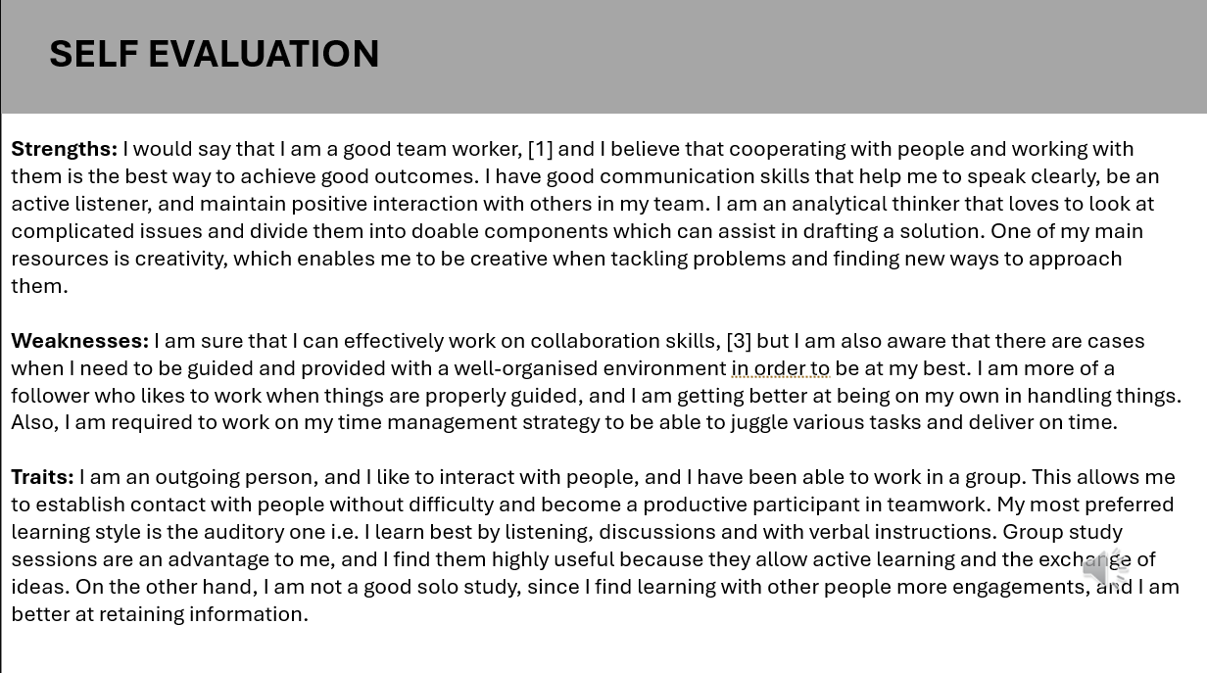

Task 2 PDP
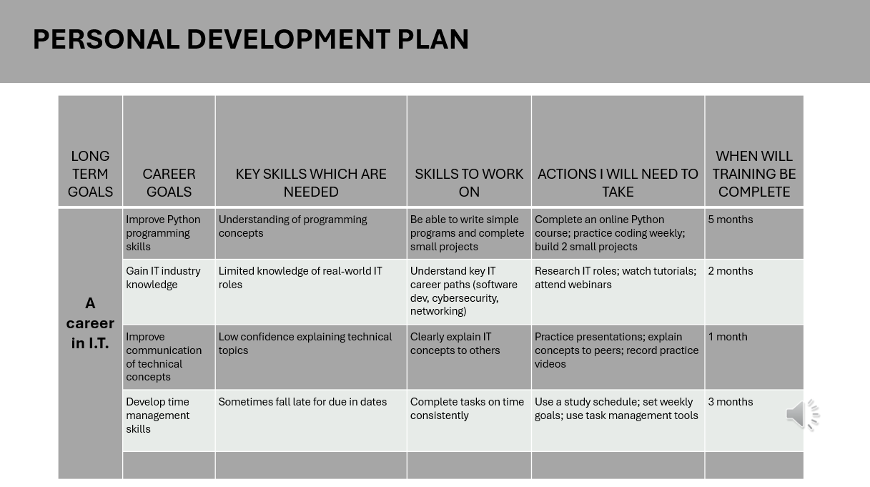
LONG TERM GOALS.docx

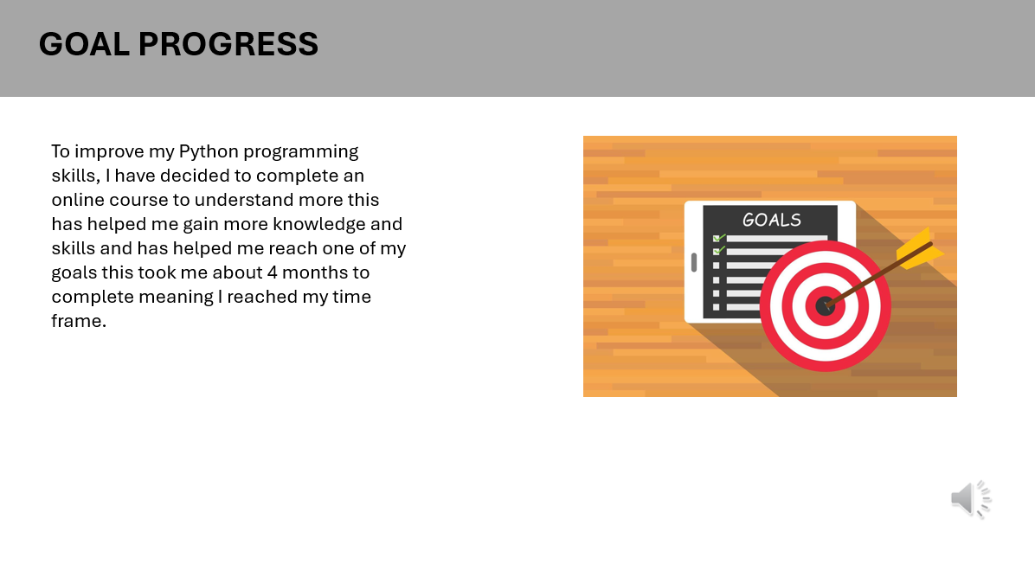

Task 4-unit 4 topic summary
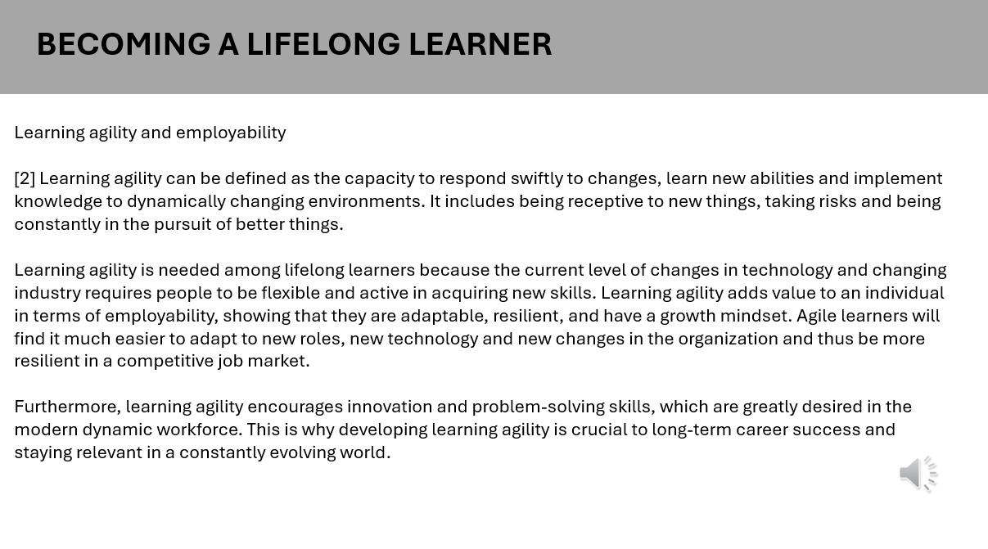

Task 4 video presentation
https://youtu.be/0I-_PvfJJ3M Presentation1 (1).pptx



