

Programme Name: Master of Business Administration
Module Name: Dissertation
Module Code: LCMB7035
Title of the Dissertation: “The Rise of Predictive Marketing: How AI Forecasts Consumer Behaviour Before Purchase Intent”
Student Name: Pankaj Kumar
Student ID: 2418436
Name of the Lecturer: Shengfeng Mei
Word Count: 14,250
Date of Submission: 03-02-2026

Abstract
Predictive Marketing has been used to forecast consumer demand and the changing behaviour and attitudes before purchasing decisions are made. It is significant to analyse the growing complexity of AI algorithms that have played a major role in this shift in technology. The introductory chapter has provided a brief analysis of the research aim, objective, problem, rationale, and the end statement. The literature review has covered the theoretical framework related to consumer behaviour and marketing to understand the cognitive differentiation and changes. The following Diffusion of Innovation and Resource-based Theory highlighted the key factors changing consumer behaviour and dependency. In the methodological chapter, a quantitative strategy has been used to predict marketing effectiveness. A series of numerical data suitable for studying consumer behaviour has been collected. The sample population includes 80 participants, comprising active digital users. Data is collected using a survey-based questionnaire with closed-ended questions, created using Google Forms. Correlation and regression analysis have been used with statistical data analysis techniques, which were chosen by using SPSS. The findings and analysis chapter has shown the correlation and regression between dependent and independent data. Skewness values are largely positive, indicating a tendency towards favourable responses to predictive marketing accuracy and decision-making. The conclusion chapter drew limitations using a small sample size, socially desirable answers and only positive outcomes. The recommendations have been provided for policymakers to use AI for long-term business planning, and understanding the negative side of consumer acceptance has been provided.
Acknowledgements
I would like to thank my mentors and subject representatives who have helped me gather relevant data about the project. All the information I have gathered has been partly helped by my mentors. I would also like to express my gratitude to my parents, who have helped me gain confidence and proceed with my work without fear of repercussions. I want to express my gratitude to Almighty who has given me this opportunity to conduct the project and meet such wonderful people. In support of the task, I am deeply obliged to my subject guides who have helped me to stay progressive.

Table of Contents
Chapter 1: Introduction 8
1.1 Background of study 8
1.2 Research Rationale 9
1.3 Research Significance and Problem Statement 10
1.4 Research Aim and Objectives 11
1.5 Research Questions 11
1.6 Summary of main findings 11
1.7 Dissertation Structure 12
Chapter 2: Literature Review 14
2.1 Introduction 14
2.2 Conceptual Framework 14
2.3 Evolution and Adoption of Artificial Intelligence in Digital Marketing 15
2.4 Role of Predictive Marketing in Shaping Consumer Behaviour and Purchase Intentions 18
2.5 Organisational and Technological Factors Affecting the Integration of AI Tools for Predictive Marketing 20
2.6 Predictive Marketing’s Impact on Business Performance and Competitive Advantage 22
2.7 Ethical, Societal, and Regulatory Implications of AI in Predictive Marketing 24
2.8 Literature Gap 27
2.9 Conclusion 28
Chapter 3: Research Methodology 29
3.1 Introduction 29
3.2 Research Onion 29
3.3 Research Philosophy 30
3.4 Research Approach 30
3.5 Research Strategy 30
3.6 Research Design 31
3.7 Data Collection Method 31
3.8 Sample Population 32
3.9 Data Analysis 32
3.10 Reliability and Validity 32
3.11 Linking Methodology with Objectives 33
3.12 Ethical Consideration 33
3.13 Research Limitation 33
3.14 Conclusion 33
Chapter 4: Findings and Analysis 34
4.1 Introduction 34
4.2 Specification of variables 34
4.3 Descriptive statistics 36
4.4 Graphical Interpretation 1
4.5 Regression Analysis 22
4.6 Correlation Analysis 29
4.7 Conclusion 30
Chapter 5: Discussion 31
5.1 Introduction 31
5.2 Discussion on Graphs 31
5.3 Discussion on Regression Analysis 32
5.4 Discussion on Correlation Analysis 32
5.5 Comparative Analysis with Literature Review 33
5.6 Conclusion 35
Chapter 6: Conclusion and Recommendations 36
6.1 Introduction 36
6.2 Key Understandings from the Study 36
6.3 Limitations of the study 39
6.4 Recommendations for the study 39
6.5 Future scope of the research 40
6.6 Conclusion 40
References 41
Appendices 59
Appendix 1: Survey Questionnaire 59
Appendix 2: Data Table 64
Appendix 3: Code Table 66

List of Figures
Figure 1: Conceptual Framework 14
Figure 2: Technological Acceptance Model (TAM) 15
Figure 3: AI in Digital Marketing 16
Figure 4: Predictive Analytics in Consumer Behaviour Forecasting 18
Figure 5: Diffusions of Innovation theory 21
Figure 6: Resource Based View Theory 23
Figure 7: Varied Functions of AI 25
Figure 8: Research Onion 29
Graph 1: Age 1
Graph 2: Gender 2
Graph 3: Industry Type 3
Graph 4: Education Level 4
Graph 5: Current Location 5
Graph 6: Annual Household Income 6
Graph 7: Online Shopping Frequency 7
Graph 8: AI Familiarity 8
Graph 9: AI Forecast Purchase Impact 9
Graph 10: Behaviour affected by AI Forecasts 10
Graph 11: AI features Experienced 11
Graph 12: AI improving relevance of advertisements 12
Graph 13: Predictive marketing enhancing shopping experience 13
Graph 14: AI recommendation preference 14
Graph 15: Shopping with brands that use AI 15
Graph 16: Predictive marketing increases purchasing 16
Graph 17: Factors affecting marketing acceptance 17
Graph 18: Predictive email marketing 18
Graph 19: Browsing History 19
Graph 20: Predictive purchases 20
Graph 21: Predictive marketing privacy concerns 21
Graph 22: Predictive accuracy 22
List of Tables
Table 1: Specification of Variables 35
Table 2: Descriptive Statistics 37
Table 3: Regression Analysis for H1 24
Table 4: Coefficient Analysis for H1 24
Table 5: Regression Analysis for H2 25
Table 6: Coefficient Analysis for H2 25
Table 7: Regression Analysis for H3 26
Table 8: Coefficient Analysis for H3 26
Table 9: Regression Analysis for H4 27
Table 10: Coefficient Analysis for H4 27
Table 11: Regression Analysis for H5 28
Table 12: Coefficient Analysis for H5 28
Table 13: ANOVA 29
Table 14: Coefficient Analysis 29
Table 15: Correlation Analysis 30

Chapter 1: Introduction

1.1 Background of study
A behavioral change in marketing practice has been initiated by the quick development of artificial intelligence (AI) and associated information technologies. This effort has changed marketing techniques towards prescriptive and predictive capabilities from descriptive and diagnostic analytics. According to Haris, (2024), there has been a significant change in the businesses to understand and react to consumer behavior due to the ability of modern marketers to predict their demands and preferences. Predictive marketing has become a crucial data-driven strategy in this context. Therefore, businesses are able to forecast purchase intent and pre-intent consumer activities by using machine learning, advanced analytics, and behavioral modeling.
Based on Singh and Kaunert, (2024), predictive marketing has grown more crucial for growing competition and digital saturation. The continual growth of consumer data and the growing complexity of AI algorithms have played a major role in this shift in technology. These insights enable organizations to maximize campaign spending, decrease wasteful spending, and enhance return on investment (ROI). Based on the reports of McKinsey, (2023), more than 72% of top companies currently utilize AI-based predictive analytics in at least one marketing function. This enables businesses to gain a marketing ROI of 10-20% and revenue uplift rate of 3-15% (mckinsey.com, 2025). These findings demonstrate the increasing significance of AI systems that can analyze large behavioral datasets, such as browser history, click patterns, device usage, and contextual triggers to predict customer behavior before purchasing.
The potential of predictive marketing has been further enhanced by the development of cutting-edge AI technologies like deep learning, reinforcement learning, and natural language processing (NLP). Based on Kusal et al. (2023), AI systems play a significant role analyzing text-based customer interactions, such as product reviews and social media comments to extract sentiment and emotional cues due to natural language processing (NLP). At the same time, deep learning enables algorithms to handle unstructured data, like voice recordings, videos, and photos, giving a more comprehensive insight of consumer behavior. The capacity of AI to adjust and make better predictions over time based on fresh data and results is improved by this reinforcement learning. These technologies enable marketers to more accurately predict customer demands, which supports a more advanced level of behavioral forecasting.
From this perspective, as said by Singh and Kaunert, (2024), predictive marketing improves consumer experience by providing customized, timely, and relevant interactions based on individual behavior rather than general assumptions. To constantly maintain such an aspect, AI predicts user interest by analyzing browser trends, previous purchases, search habits, and real-time activity. This lessens information overload, which makes it easier for people to locate commodities and content that suit their tastes. For instance, AI-powered suggestions contribute to 35% of Amazon’s overall sales. Amazon’s prediction algorithms advise products that customers are likely to purchase next, making shopping quicker and easier. Meanwhile, Netflix’s recommendation engine forecasts viewing decisions and drives the majority of user activity. This observation is supported by Liu et al. (2024), which noted that predictive recommendations contribute to 80% the content on the Netflix platform is derived from collaborative filtering technology-based personalized recommendations. This highlights the ability of AI to influence behavior early in the decision-making process by showing its effort to direct user choices.

1.2 Research Rationale
Identifying patterns in algorithms based on past data and experience is more difficult than forecasting future trends. The reason for conducting research is to understand the psychological mechanisms, such as perceived value and trust, which influence consumer decision-making, which have not previously been included. Nikolić and Bjelica, (2025) mentioned that AI-powered recommendation helps identify latent and unarticulated consumer needs. On the other hand, Okeleke et al. (2024) stated that AI analytics potentially forecast future consumer behaviors in competitive markets. The existing literature highlights the gap, such as the ethical and privacy-related implications of using predictive marketing. There has been a lack of information regarding the shift from predictive to generative AI in anticipatory marketing, which is covered here.
The existing studies focus on the impact of predictive marketing on optimizing spending by targeting customers, reducing waste, and improving conversion rates. The relationship between predictive AI and consumer behaviour will be evaluated using classification, regression, and neural networks, which have not been used in previous research. The study will be applied to forecast segment consumers, niche market consumers, and real-time marketing campaigns. The study can be credible to analyze consumer behavior, sustainable patterns, and customer value. The current literature would use structural equations related to predictive personalization, trust, and conversion, which were previously absent. Research gaps exist as there are methodological limitations, and the emergence of new trends and practical problems (Büyüközkan et al. 2024).
Previous research has shown that perceived consumer value depends on AI marketing recommendations, not on how it is recommended. The existing literature means to add value to marketing factors to raise concerns around algorithmic bias and consumer autonomy. Leveraging behavioral data requires being accountable and transparent (Bahangulu and Owusu-Berko, 2025). Previous research did not use theoretical frameworks to interpret the anticipatory intelligence of consumers. Existing literature uses empirical studies to validate the effectiveness of predictive marketing in real-world settings.

1.3 Research Significance and Problem Statement
The study has a significance as its focus on the viability of predictive marketing to change organizational marketing based on consumer trends before purchase intentions materialize. AI-driven analytics give marketers the capacity to decipher early behavioral indicators, which enables businesses to identify possible demand. These early insights promote the relevance of client interaction methods and improve the accuracy of marketing decisions (Omowole et al. 2024). Following this, the study demonstrates the effort of organizations to maximize resource allocation considering high-probability customer segments and analyzing predictive models along with their impact on behavior forecasting. Such optimization lowers inappropriate marketing expenditure and improves operational efficiency. At the same time, by matching marketing communications to individual tastes and behavioral patterns, predictive personalization promotes deeper consumer engagement (Gupta et al. 2024). The study expands scholarly knowledge of AI-enabled consumer behavior prediction and its managerial ramifications by investigating these dynamics. It provides insightful information about predictive intelligence to maintain a competitive edge in the field of digital marketing.
Despite a fast integration of AI into contemporary marketing, there is limited empirical evidence regarding the impact of predictive analytics on customer behavior at the pre-intent stage. Organisations increasingly rely on AI-driven systems to recognize behavioural signs long before consumers actively express the intent to purchase. However, there is still a lack of research on the influence of these predictions to understand micro behaviors and encourage final purchase outcomes (Azad et al. 2023). Based on this, the current study focuses on the significance of AI-driven predictive marketing by identifying consumer indicators and evaluating the impact of these early forecasts on later behavior.

1.4 Research Aim and Objectives
Aim
The purpose of this research is to investigate how artificial intelligence facilitates predictive marketing strategies and affects customer purchase behaviour. It aims to assess the many forms of AI utilized in electronic advertising, the variables that influence their adoption, as well as how machine learning in marketing helps businesses develop in today's competitive digital marketplace.
Objectives
- To determine different types of AI techniques that play a role in digital marketing.
- To assess the role of predictive marketing in shaping customer behaviour, particularly purchasing intention.
- To determine the factors affecting the integration of AI tools for better predictive marketing.
- To analyse the relationship between predictive marketing and business growth.

1.5 Research Questions
- How do diversified artificial intelligence techniques contribute to the efficacy of digital marketing strategies?
- What role does predictive marketing play in shaping customer behaviour, particularly purchasing intention?
- What are the different factors influencing the integration of AI tools for better predictive marketing?
- What is the relationship between predictive marketing and business growth?

1.6 Summary of main findings
The findings of this study provide clear answers to all four research questions presented above. The results show that consumers frequently encounter AI techniques such as personalized recommendations, retargeting ads, chatbots and dynamic pricing. These features strongly associate with improved shopping experiences, confirming that AI techniques increase relevance, convenience and engagement in digital marketing. Further, findings demonstrate that predictive marketing significantly influences consumer assumptions, product consideration and final purchase decisions. Most respondents agree that AI forecasts shape behavior and increase purchasing likelihood. As per the study, key acceptance factors include prediction accuracy, brand trust, ease of use, transparency and privacy concerns. Finally, the study found a strong positive association between predictive marketing and increased purchase frequency and consumer engagement, supporting business growth through higher conversions and improved customer retention.

1.7 Dissertation Structure
Chapter 1: Introduction
The chapter will provide a description of the topic of the study, background, rationale, and research problem, and the importance of comprehending AI-enabled predictive marketing in the present digital business environment. It will explicitly outline the goals, objectives, and research questions to explain why AI-assisted forecasting tools should be important in influencing consumer behaviour prior to making a purchase decision.
Chapter 2: Literature Review
The chapter will be a critical analysis of the current academic literature. It will conduct a review of theoretical models to determine the impact of AI predictions on buying intention. This chapter will uncover the gaps in conceptualization of ethical, emotional, and psychological effects of predictive algorithms on consumers by examining the views of several authors.
Chapter 3: Research Methodology
The chapter will outline the chosen research philosophy, approach, design, data collection methods, and data analysis techniques (Sreekumar, 2023). Information on the sampling, survey questions or interviews, analytical software (SPSS or thematic analysis) will also be provided. This portion will guarantee transparency, credibility, and academic rigor by the fact that it will be justified why the selected methodology is the best option to investigate the consumer responses to the AI-enabled prediction systems.
Chapter 4: Findings and Analysis
In this chapter, the data collected will be reported and interpreted to understand the effect of predictive marketing on consumer decision-making prior to purchase. The findings will be compared with past literature research objectives and theories. This will assist in the discovery of patterns, behavioural triggers, trust issues, and marketing efficiency on the basis of AI predictions.
Chapter 5: Conclusion and Recommendations
The following chapter will conclude significant findings, outline practical implications of the study on digital marketers, and give recommendations to increase responsible use of AI in consumer forecasting. It will both realize shortcomings and suggest research directions that can enhance ethical and transparent predictive marketing practices in the digital marketplace.

Chapter 2: Literature Review

2.1 Introduction
This chapter will be dealing with the critical examination of scholarly debates, frameworks of theory and empirical insights majoring in predictive marketing and customer forecasting with the help of artificial intelligence. This chapter will be evaluating the role of artificial intelligence in evolving as a strategic marketing method along with influencing preference of customers before purchasing and analysing different aspects such as ethical and psychological aspects in shaping such adoption. It will study the Ethical, Societal, and Regulatory Implications of AI in Predictive Marketing. Moreover, it will also discuss Predictive Marketing’s Impact on Business Performance and Competitive Advantage.

2.2 Conceptual Framework
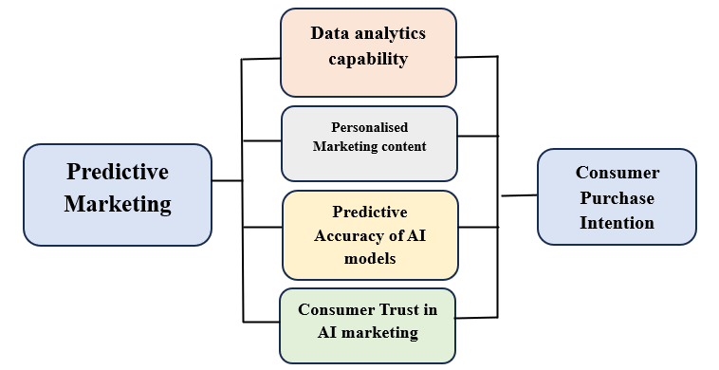

Figure 1: Conceptual Framework
(Source: Self-created)
Based on the research topic, Figure 1 shows that the dependent variable is consumer purchase intention, referring to consumer’s likelihood or willingness to buy a product or service after being exposed to predictive marketing efforts (Noranee and bin Othman, 2023). Data analytics capability, as the independent variable, states how effectively AI systems analyse large volumes of consumer data, like browsing history, past purchases and online interactions (Reed et al. 2025). Strong analytics assist firms to predict future behaviour more accurately. Moreover, under personalised marketing content, another independent factor, AI, enables businesses to deliver personalised advertisements, recommendations and offers related to predicted consumer preferences, thus influencing buying decisions (Ziakis and Vlachopoulou, 2023). Thirdly, predictive accuracy of AI models reflects how accurately AI forecasts consumer needs and timing of purchases, with higher accuracy increasing consumer relevance and engagement (Khan et al. 2022). Lastly, consumer trust in AI marketing plays a key role in whether consumers accept or reject AI-based predictions and recommendations (Aljumah et al. 2024). Overall, when predictive marketing is accurate, personalised and trustworthy, it positively shapes consumer behaviour and increases the likelihood of purchase among the consumers.

2.3 Evolution and Adoption of Artificial Intelligence in Digital Marketing
The evolution of Artificial Intelligence (AI) in digital marketing has transformed how organisations understand and influence consumer behaviour. According to Gobbilla and Kiran, (2025), traditional digital marketing depends on descriptive analytics and resides in the “analog world”, like past sales data and basic customer segmentation. Over time, advances in machine learning, big data analytics and cloud computing enabled marketers to move towards predictive marketing, where AI systems forecast consumer behaviour even before explicit purchase intent is expressed (Ramya et al. 2024). In digital technology, it is observed why marketers choose to adopt AI tools that predict customer behaviour and support marketing decisions. In the initial stages, Jaapar et al. (2024) noted that many organisations were slow to adopt AI in marketing, considering high costs, limited skills and infrastructural and technical complexity created hesitation.
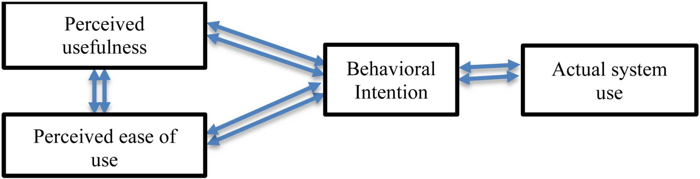

Figure 2: Technological Acceptance Model (TAM)
(Source: Hossain et al. 2024)
In this context, Figure 2 points out the Technological Acceptance Model (TAM) which helps explain how and why AI-based tools are accepted in digital marketing (Hossain et al. 2024). As per Davis, (1989), this model explains technological adoption under perceived usefulness and perceived ease of use. While perceived usefulness means the extent to which users believe technology improves their work performance, perceived ease of use refers to the simplicity and seamlessness with which technology is used (Davis, 1989). In the present times, easier AI accessibility has made platforms, like Google Ads, Meta Business Suites and Salesforce Marketing Cloud, include in-built AI features that support predictive marketing, thus reducing manual work and making AI use easier, especially within small and medium-sized businesses (SMEs) (Hassan and Zeebaree, 2025). Furthermore, Arce et al. (2024) elucidate that this helps such businesses to grow, improve their targeting and marketing dynamics, reduce marketing costs and provide personalized experiences, resulting in viewing AI as a valuable tool that improves marketing performance.
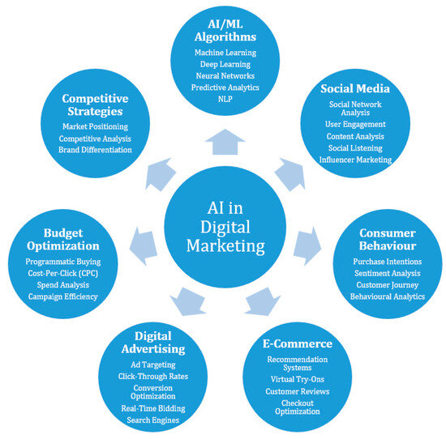

Figure 3: AI in Digital Marketing
(Source: Ziakis and Vlachopoulou, 2023)
While using AI in digital marketing, in congruence with Figure 3, has strengthened consumer behaviour, some marketers are concerned about data quality and accuracy, considering AI predictions rely heavily on reliable data (Ziakis and Vlachopoulou, 2023). Nonetheless, Aljumah et al. (2024) counter that perceived usefulness plays a major role in the adoption of predictive marketing, with AI systems analysing large amounts of consumer data, including browsing behaviour, online searches and social media activity to forecast future actions. For instance, e-commerce platforms, like Amazon, use AI to suggest products which customers can buy in the future, prior to making such searches online (Koppa et al. 2024). On the other hand, mixed perspectives on AI’s ease of use are also presented, with Zhang and Dong, (2024), stating that although AI tools are more automated, some traditional marketers may find them difficult to comprehend.
Considering that many predictive systems work as “black boxes” which users cannot clearly see how decisions are made, Zerilli et al. (2022) mention this lack of transparency being a significant factor in reducing confidence in AI predictions. Attesting to this viewpoint, Naz and Kashif, (2025), further explain that if the data is biased or incomplete, predictions may be incorrect or unfair. For instance, AI-driven advertising may unintentionally ignore certain customer groups, leading to ethical concerns, reducing trust in AI tools and affecting its acceptance. Notwithstanding, Reed et al. (2025) argue that new developments in explainable AI and simple dashboards are making these systems easier to understand and use. Organisational factors, such as companies with strong digital skills and data-driven culture, find it easier to adopt AI marketing tools. In contrast, Booyse and Scheepers, (2024), mention that organisations with limited technical knowledge may resist AI due to the fear of job loss or reduced creativity, followed by over-reliance of predictive marketing on automation, thus reducing human judgement. Noranee and bin Othman, (2023), however, respond that AI should support marketers by providing insights that help in making better decisions, not replace them.
Therefore, the evolution of AI in digital marketing shows a clear move towards predictive marketing. Simultaneously, concerns about ethics, transparency and organizational readiness raise questions on the adoption of suitability of AI tools within companies. With the application of the Technology Acceptance Model (TAM), the adoption can be explained by increasing perceived usefulness and improving ease of use. As these challenges are addressed, the use of AI to predict consumer behaviour before purchase intent is expected to grow in the future.

2.4 Role of Predictive Marketing in Shaping Consumer Behaviour and Purchase Intentions
In the opinion of Alshaketheep et al. (2025), predictive marketing anticipates what consumers are likely to demand prior to actively expressing purchase intent, instead of reacting to consumer actions. This shift has changed how businesses communicate with customers and how consumers make decisions.
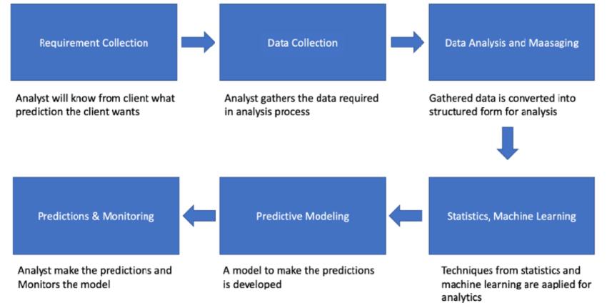

Figure 4: Predictive Analytics in Consumer Behaviour Forecasting
(Source: Wang, 2024)
According to Figure 4, predictive marketing plays an increasingly dominant role in shaping consumer behaviour and purchase intentions by using artificial (AI) to analyse past and real-time data (Wang, 2024). In the opinion of Mecharla et al. (2024), personalisation forms a key factor in the way of predictive marketing influencing consumer behaviour, considering that AI systems study browsing history, previous purchases, search patterns and social media activities to predict consumer preferences. Bano et al. (2025) further states that such relevance improves customer satisfaction and enhances overall shopping experience. For example, platforms, such as Amazon and Netflix, use AI algorithms to recommend products or content before users search for them. However, as per Singh and Kaunert, (2024), these personalised suggestions reduce decision-making effort and often lead consumers to purchase items that they did not originally plan to buy.
Furthermore, in association with personalisation, Xu and Liu, (2024), mention that predictive analytics also influences emotional decision-making as AI can analyse emotions through sentiment analysis and behavioural signals, enabling brands to tailor emotional appeals. More so, the role of consumer trust, as observed by Samishetti, (2025), is central to predictive marketing since consumers trust AI-driven recommendations, making them more likely to act on them. In this context, transparent data usage and ethical AI practices aid in building this trust, with companies, for example, experiencing higher engagement if they clearly explain how data is being used among the consumers. While emotional decision-making creates meaningful connections, Alom et al. (2024) argue that privacy concerns remain a constant challenge, highlighting that predictive marketing relying heavily on personal data and any misuse or data breaches can negatively impact consumer confidence and purchase intention. Additionally, Alom et al. (2024) also agrees that it also raises ethical concerns by exploiting emotional vulnerability. Furthermore, another important role of predictive marketing is in brand engagement and loyalty where AI enables brands to maintain consistent and relevant communication by understanding consumer behaviour patterns, resulting in consumers feeling understood and valued and further strengthens brand loyalty (Ijomah et al. 2024). For example, fashion brands use predictive analytics to forecast style trends and suggest items aligned with individual tastes. However, Singh and Kaunert, (2024), assert that excessive personalisation may feel intrusive, followed by consumers feeling uncomfortable over brand appearing to know too much, reducing trust and leading to disengagement.
In addition to the above, since AI can identify when a consumer is most likely to buy and deliver targeted promotions at the right moment, Vallarino, (2023), explains the scope of purchase timing being shaped by predictive marketing. From a positive perspective, this timely intervention often nudges consumers towards completing a purchase, aiding consumers to access deals that match their needs. However, Ali et al. (2025) argue that this practice can manipulate consumer behaviour by creating artificial urgency, leading to impulsive buying. Furthermore, in today’s digital environment, Ali, (2025), refers to predictive marketing shaping consumer behaviour by reducing information overload as consumers are exposed to countless product options. Since AI filters this information and presents choices that best match predicted preferences, this simplification supports faster decision-making and increases purchase intentions, thus viewing this as consumer-friendly by saving time and effort (Ali, 2025). However, Wilkie et al. (2025) counter that over-filtering limits consumer exposure to alternative products, reducing choice diversity and reinforcing repetitive buying patterns.
Therefore, predictive marketing plays a powerful role in shaping consumer behaviour and purchase intentions by offering personalised, timely and relevant interactions. Despite enhancing convenience and engagement, contrasting views highlight concerns linked to privacy intrusion, manipulation and over-dependence on AI predictions. Hence, the overall impact depends on how responsible and transparently predictive marketing strategies are implemented within organisations for attracting and retaining consumers.

2.5 Organisational and Technological Factors Affecting the Integration of AI Tools for Predictive Marketing
In today’s hyper competitive marketplace, organizations that can be easily augmented with the deploying of artificial intelligence (AI) to actually forecast for consumer behavior that can easily purchase with the intention. As per Naz and Kashif, (2025) the predictive marketing that actually enables the firms that anticipate the consumer needs, personalizing engagement and optimizing resource allocation. This can be shaped by a complex interplay for the organizations with the technological factors for the influencing of how, when and to what extent predictive marketing innovations that actually diffuse across firms. According to Zong and Guan, (2025) by aligning with Diffusions of Innovations Theory that actually provides the useful framework for understanding these factors to actually focus on attributes of the innovation.
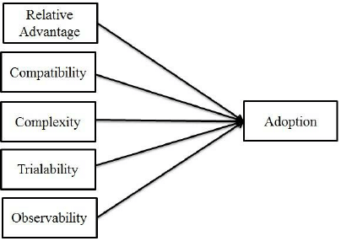

Figure 5: Diffusions of Innovation theory
(Source: Turan et al. 2015)
Rogers’ theory, as termed in Figure 5, actually posits the adoption of an innovation that is influenced by the five core attributes such as relative advantage, compatibility, complexity, triviality and observability (Turan et al. 2015). As stated by Kolesnik, (2025), there is a relative advantage that actually refers to the degree to which AI tools might be perceived by conventional marketing techniques. Firms that see clear benefits such as increased forecasting accuracy, improved customer segmentation, enhanced personalized engagement and higher return on marketing investment are more inclined with the adoption of predictive analysis for predictive marketing. According to Sharma and Sharma, (2025) when leadership recognized that AI driven insights for the outperforming traditional analytics, support for integration strengthened. Moreover, organisations with entrenched legacy practices are resisting the change. Marketing teams are accustomed to institution-based strategies that might question AI significance, perceiving the greater organization to buy in. Conversely, hierarchical firms with rigid routines struggle to embed AI into daily operations. As mentioned by Şenyapar, (2024), marketing professionals might resist the dependence of machine learning outputs for the lack of trust in automated decision making. To improve compatibility, organizations that must invest in change management, align AI projects with the broader strategic initiatives for the cultivating of the culture with the values that might be experimentation and continuous learning.
The integration of AI tools that actually demands significant investment in talent, infrastructure and training. As per Anastasios and Maria, (2024), organizations that can be easily limited with the financial or technical resources might find it to the difficulties that actually deploy AI tools effectively. Senior management plays an essential role in allocating the budget for the AI initiatives and championing across department collaboration. Without leadership support and clear governance structures, AI projects risk stagnation or failure. Organizational readiness that also encompasses for the employees with the skills levels without training that even advanced tools that cannot be used for their full potential. As Vihavainen, (2024) mentioned by Rogers also highlights the importance of communications channels in spreading the awareness of innovations. Within organizations, formal and informal networks influence attitudes towards AI. Early adopters who are respected and influential can easily accelerate the adoption of communities of practice that helps to demystify AI tools, reducing resistance.
According to Chintalapati and Pandey, complexity also refers to the innovation that can be understood and used for the predictive marketing tools for the powering of AI that are often perceived as complex, especially in organisations unfamiliar with learning concepts, when users can easily exist in the customer data platforms. To mitigate complexity, vendors and IT teams should prioritize the user-friendly interfaces, clear communication and tailored training. As mentioned by ROZONY and Vudugula, (2023), by simplifying the model with the interpretations such as explainable AI techniques for the empowering of marketers to trust an act upon the predictions. Technological compatibility with the existing IT infrastructure can be critical with predictive marketing for the solutions that must integrate with the customer relationship management (CRM) systems, data warehouses, marketing the automation platforms and analytics dashboards. As noted by Al Kalach, legacy systems that do not support soiled data impede integration for the efforts. Organizations that must assess their data architecture and invest in modern, scalable platforms that actually facilitate the AI implementation.
Trialability with the degree to which tool that can be experimentation with a limited basis that influences adoption. As per ARINZE, (2025) organizations that can pilot the predictive marketing initiatives in the smaller campaigns or within the specific customer segments that are more likely to scale successful projects with the enterprise. Scalability also matters as the predictive model proves effective, the ability to expand its channels and markets that enhances its organizational impact.

2.6 Predictive Marketing’s Impact on Business Performance and Competitive Advantage
Predictive marketing enhances firms’ ability in anticipating customer demands, identifying latent preferences and targeting prospects before the emergence of purchasing intent. As per Bataineh et al. (2024), with the help of machine learning and practical data processing, firms are involved in transforming basic customer signals into actionable predictions in relation to churn, costing and recommendation by channels. This leads to hyper personalised advertisement, proper timing and correct segmentation that finally reduces the cost of marketing and improves customer acquisition capability. On the other hand, as stated by Dahake et al. (2024), under the Resource Based View, this predictive intelligence results in constituting an important resource as it enhances results of performance and also creates an obstacle for rivals to imitate. The dynamic aspect of changing analytics into strategy also results in robust benefits related to path dependent knowledge that means as long as a firm forms predictive infrastructure, the stronger its informational asymmetry gains relativity to competitors.
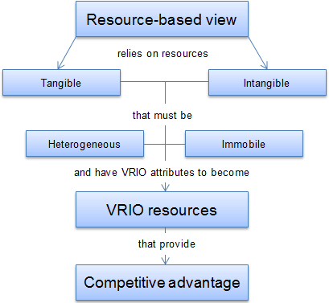

Figure 6: Resource Based View Theory
(Source: Valerio, 2024)
As per the perspective of Resource Based View, mentioned under Figure 6, strategic assets are represented by proprietary data sets, which are rare and lead to the reinforcement of obstacles to replicate (Valerio, 2024). According to Agu et al. (2024), businesses that have exclusive accessibility to behavioural data or innovative algorithm efficiencies are successful in forecasting demand patterns in a preliminary stage and allocating budgets in an efficient manner than competitors who rely on demand systems. Such differences regarding information resources lead to the enhancement of conversion rates that results in different sales and also increases the customer span that are the main sources to sustain the upliftment of performance. Furthermore, as demonstrated by Pratama et al. (2024), AI enabled prediction is also embedded in a cultural way and integration is done in decision making procedures that accelerates suitability and enhances responsiveness. As there is too much volatility in marketing environments, enduring competitiveness is supported by such resource driven agility.
Predictive marketing also makes a contribution regarding a sustained competitive advantage as it reduces uncertainties in different strategic functions, apart from marketing like development of products, inventory, planning, and customer service. According to Segun et al (2024), artificial intelligence data regarding growing demands helps firms in innovative characteristics or bundles before there is a surge in demand that strengthens product market fit. Under the resource-based view, important competencies are made stronger and compliments company’s intangible knowledge resources. By being in accordance with consumer preferences, it leads to minimization of wrong spending and enhancement of operational efficiency that results in improved margins. Businesses that orchestrate their corporate governance structures and analytical talent can lead to the conversion of daily insights into actionable strategies that have a consistent generation of high value over time. Competitors who lack such analytical infrastructure struggle with obstacles to replicate the knowledge effects.
It is also seen that AI driven predictive marketing helps in developing or gaining market leadership with the help of sustainable differentiation based on learning outcomes and technological sophistication. It is argued by this theory that companies protect competitive benefits when resources are valuable, rare, inevitable, and well organised (VRIO). As per Al et al. (2024), predictive analysis leads to the satisfaction of VRIO circumstances as it requires consistent data knowledge, iterative model training, and huge switching expenses in accordance with sales and other functions. Such results lead to the contribution of performance growth with the help of intangible assets like loyalty and not only with the help of sales growth. As a result, predictive marketing is considered as a strategic capability and not only a tactical tool that reshapes the role of competition by companies in data driven markets. In times to come businesses that make a combination of predictive analytics with generative AI, the market anticipation will become stronger along with reduction in uncertainties that will help in accelerating creativity that will position it as a huge player.

2.7 Ethical, Societal, and Regulatory Implications of AI in Predictive Marketing
There are major ethical concerns raised by AI driven predictive marketing specifically regarding data privacy, and surveillance-based targeting. According to Islam et al. (2024), such systems have huge reliance on granular behavioural data gathered with the help of browsing systems, mobile interactions, and behaviors of purchase that do not consist of proper consumer awareness. There is also a contribution of ethical tension due to inference of predict systems of sensitive elements like financial vulnerability and political leanings for manipulating information or shaping behaviors of consumption. As per Alshaketheep et al. (2024), this debate is more over complicated due to dark nudging as it blurs the difference between persuasion and usage.
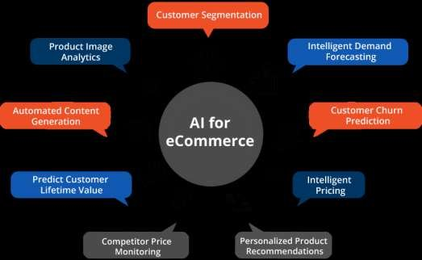

Figure 7: Varied Functions of AI
(Source: Kian, 2021)
Based on Figure 7, highlighting the varied functions of AI in e-commerce, there is a possession of asymmetrical information by marketers, the power of customers and logical choices are majorly compromised (Kian, 2021). Strong structures of governance, accountable AI aspects and moral procedures of auditing are therefore important for ensuring that personalisation is enhanced by predictive marketing without undermining dignity or consumer rights. From the society’s view, predictive marketing also results in digital inequalities as its amplifiers, exclusionary, algorithms, and segmentation biases. Predictive analysis can lead to the categorization of customers into profitable versus nonprofitable groups that limits some groups from promotional schemes, discounts or credit-based opportunities. As stated by Okeleke et al. (2024), this discrimination led by data also affects public discourse by micro-targeted information that leads to the reinforcement of societal segmentation or promotion of harmful content. It is also seen that consistent forecasting regarding preferences leads to normalization of hyper consumption and weakens intrinsic motivation with the use of algorithms that define what individuals ‘should want’. As demonstrated further by Bano et al. (2025), customer identities are majorly influenced with the help of predictive cues that lead to the creation of echo Chambers, in which preferences are recycled. There is also the emergence of concerns to society in relation to surveillance capitalism that shifts autonomy from citizens to atmosphere to platforms. Such risk should be addressed with the help of robust, customer knowledge and digital empowerment.
Scrutiny regulations regarding predictive marketing are Fastly growing as there is responsiveness by governments for mounting concerns related to market concentration and privacy breaches. Structures of regulations like the EU’s GDPR and Digital Markets Act and emergence of new artificial intelligence act brings into light stringent obligations regarding lessening of data, transparency, and consent by customers. As per Kalaivani et al. (2025), Regulators are putting huge attention regarding responsibility for heavy risk AI software’s, specifically those that involve sensitive data and information. Complaints mechanisms demand proper transparency regarding the way of generating predictions, automating decisions and role of profiling in affecting consumer outcomes. But there is creation of complexities due to fragmentation of regulations in different countries for multinational firms that show differences regarding legal interpretations of targeting and fairness. Stringent adherence, architecture by proper and ethical designs and algorithmic audits are considered essential components to align with regulations and frameworks in this changing landscape.
Though there are challenges, responsiveness by society and regulation serves opportunities for shaping predictive marketing, which can help it in making an accountable and human centric use. There can be establishment of standards regarding proper data activities, fairness metrics and openness regarding communication with the help of collaborative governance within policy makers and industry bodies. According to Grewal et al. (2025), businesses get encouragement for balancing creativity with customer well-being from accountable AI practices as it integrates clarification, and privacy enhancing technologies. Redressal and grievance mechanisms on the basis of algorithms also develop confidence. On a normative level, reshaping predictive marketing for creating value and not controlling behaviour leads to the promotion of sustainable customer bonds and enduring brand loyalty. Ultimately, the embodiment of aspects related to society and regulations into predictive marketing strategies makes sure that digital ecosystems are made stronger with the help of AI technologies and not erode rights or democratic values.

2.8 Literature Gap
Although the research focuses on predictive marketing and artificial intelligence (AI) usage in consumer behaviour analysis is growing fast, there are significant gaps that are still present in the literature, in terms of predictive behaviour before explicit purchase intent has developed. The majority of research considers post-intent elements, including click rates, cart additions or transactional histories, and does not provide a great deal of empirical data on the way AI perceives early-stage nuanced behavioural insights, such as passive browsing or content engagement. Furthermore, Choudhary (2025) claims there is a high dependence on big data of the biggest online sources that limits the generalizability of results and excludes the combination of offline and omnichannel consumer data. The contribution of contextual and psychological variables, such as emotions, cultural effects, and situational interactions has received little attention as well, with AI-based models often not directly connected with existing theories concerning consumer behaviour. Moreover, pre-intent prediction raises ethical and privacy issues, including data transparency, algorithmic bias, and consumer autonomy, which are often the focus of discussion and not integrated into predictive marketing solutions. Okeleke et al. (2024) mentioned there is prevalence of cross-sectional studies, since longitudinal and cross-cultural studies on the changes of predictive accuracy and consumer trust with time are lacking.
In addition to the identified gaps, existing research on predictive marketing shows a strong focus on technology rather than on how consumers actually think and feel when they are predicted by AI systems. Most studies concentrate on improving algorithm accuracy, data processing speed and targeting efficiency (Nugroho, 2025). However, very few studies explain how consumers perceive being analysed and predicted before they are even aware of their own purchase intention. From a critical point of view, this creates a gap where technology is treated as more important than human decision-making, while consumers are viewed mainly as data sources, instead of active and conscious participants. Moreover, current studies often fail to clearly distinguish between predicting behaviour and influencing behaviour, with many researchers assuming that accurate predictions naturally benefit consumers by making choices easier (Agarwal et al. 2022). However, this overlooks the possibility that predictive marketing may guide or nudge consumers in certain directions.
Ethical concerns, like manipulation, loss of autonomy and emotional influence, are usually discussed only at a conceptual level. These concerns are rarely included as measurable variables within empirical models, which represents a significant gap in literature. Furthermore, the literature has not sufficiently examined the transition from predictive AI to more advanced forms of AI, such as generative and anticipatory systems. While predictive marketing forecasts what consumers might do, newer AI technologies actively create content and influence choices in real time (Alshaketheep et al. 2024). There is limited academic discussion on how this shift affects consumer trust, control and transparency.
Moreover, there is a lack of diversity in research contexts as most studies focus on large multinational companies that have access to vast amounts of consumer data. Small and medium-sized enterprises (SMEs) and businesses in developing or mixed markets receive little attention which makes it difficult to apply existing findings across different industries and organisational settings. The challenges faced by smaller firms, such as limited data, skills and ethical governance structures, are not adequately addressed in current research. Another important gap is related to research methods, with much of the existing literature relying heavily on cross-sectional surveys, click-through data or transaction records. These methods are useful for measuring outcomes, but they do not capture how consumer behaviour changes over time. There is limited longitudinal research that examines whether repeated exposure to predictive marketing increases trust, dependence, resistance or discomfort among consumers. As a result, the long-term psychological impact of predictive marketing remains underexplored. These limits are to determine whether predictive marketing supports better decision-making or slowly influences behaviour without consumers fully realizing it. Therefore, future studies should focus more on consumer perceptions, long-term behavioral effects, ethical risks and real-world business contexts to better understand the true impact of predictive marketing.

2.9 Conclusion
This chapter critically analyzed the different interpretations in literature, the varying research techniques, and the guiding evidence in regard to predictive marketing and AI customer forecasting. It brought into light the journey of artificial intelligence from mere technological support to a prominent marketing tactic and its role in directing consumer tastes before the sale. Moreover, the chapter has studied the moral, behavioral, and social aspects that restrict the use of AI. Lastly, it demonstrated the role of predictive marketing in relating to the performance of the firm and the market power.

Chapter 3: Research Methodology

3.1 Introduction
This chapter will explain the research methods used to study predictive marketing and AI in digital marketing as well as its impact on consumer behavior towards their purchase intentions. It will outline varied research methodological choices made in association with the topic, followed by ethical considerations and limitations.

3.2 Research Onion
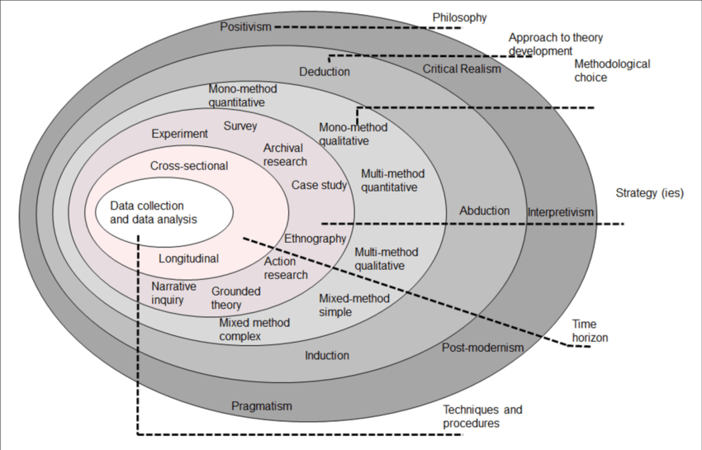

Figure 8: Research Onion
(Source: Saunders et al. 2019)
According to Figure 8, the research onion is used as a guide to plan and organize the study, aiding the research to choose the apt philosophy, approach, strategy, design, data collection method, sampling and data analysis (Saunders et al. 2019). For this study defining the relationship between predictive marketing and AI, each layer of the research onion is selected carefully to match the research objectives. Using the research onion ensures that the study follows a clear and logical structure, helping improve quality, consistency and accuracy of the research process and outcome.

3.3 Research Philosophy
Research philosophy acts as the fundamental belief system which guides the researcher’s views and knowledge on the core assumptions of reality, being categorised under Interpretivism, Positivism and Pragmatism (Kumar et al. 2025).
Justification
This research follows a positive philosophy as this choice believes that reality can be studied using numbers and statistical analysis and by focusing on facts, data and measurable outcomes (Gamage, 2025). Since this study aims to measure how AI and predictive marketing influence consumer behaviour and purchasing intentions, this philosophical choice is most suitable. It also allows objective data collection, reducing personal bias and testing relationships between variables, which, unlike Interpretivism’s subjective nature, helps produce reliable results.

3.4 Research Approach
The research approach surmises the overarching strategy or framework guiding the study, linking broad philosophical assumptions and analysis for tackling research questions (Sreekumar, 2023). This method is sub-divided into a deductive and inductive approach.
Justification
A deductive research approach was pursued by starting with existing theories and ideas about AI, predictive marketing and consumer behaviour, followed by testing them using collected data (Islam et al. 2022). The research objectives are based on well-known concepts, such as purchasing intention and business growth. Using a deductive approach allows the researcher to create hypotheses and test them through statistical analysis, differing from inductive qualitative assumptions, fitting well with positivist philosophy and helps draw clear conclusions.

3.5 Research Strategy
The research strategy refers to the overall roadmap for a research project, detailing the process of answering the research questions, ensuring credibility and relevance (Gamage, 2025). This method is classified into qualitative and quantitative strategies.
Justification
This research has opted for quantitative strategy, involving the collection of numerical data and is suitable for studying consumer behaviour, AI adoption and predictive marketing effectiveness. (Sreekumar, 2023). Data collected through statistical numbers makes it easier to compare responses and identify patterns, while structured questionnaires ensure that all participants answer the same questions to make the findings more accurate, objective and aligned with research objectives.

3.6 Research Design
The research design is subjected to the outline of how research is proposed to be conducted to address a specific research question, segregated into exploratory, descriptive and explanatory designs (Dubey and Kothari, 2022).
Justification
A descriptive research design is used to describe and understand how predictive marketing and AI are currently being used in digital marketing (Singh, 2022). This design helps explain consumer opinions, experiences and behaviors without changing or controlling any variables, focusing on “what is happening”, instead of the reason for the phenomenon’s occurrence. This design is also suitable as the research objectives aim to study existing trends in predictive marketing and its impact on purchasing intention and business growth.

3.7 Data Collection Method
The data collection method is systematically gathering and measuring data from relevant sources to help answer research questions by fulfilling the research objectives (Ajayi, 2023). This method is sub-divided into the primary method, for collecting real-time data from surveys, focus groups and other, and the secondary method, for collecting existing data from reports, academic journals and articles.
Justification
The study uses the primary data collection method to gather information directly from consumers, considering this tool provides up-to-date and relevant information associated with predictive marketing and AI in digital marketing (Kara, 2023). It also allows the researcher to design questions based on research objectives. Data is collected using a survey-based questionnaire with close-ended questions, created using Google Forms, to measure opinions, such as trust in AI, influence in buying decisions and effectiveness of predictive marketing. Moreover, the survey link is shared through Facebook and other online platforms to reach participants who are active digital users. Considering online surveys are easy to distribute, save time and reduce costs, participants can respond anonymously, encouraging honest answers. This method supports the quantitative strategy and allows easy statistical analysis of the data, unlike the qualitative procedure linked with secondary data collection.

3.8 Sample Population
The sample population for this research includes 80 participants, comprising active digital users, and are chosen to use convenience sampling for the easy accessibility of the participants (Golzar et al. 2022). This is suitable for this study because of the regular interaction with digital marketing and AI-based recommendations. A sample size of 80 participants is appropriate for quantitative research as it provides enough data to identify trends and relationships between variables, while remaining manageable. Although a larger sample could improve accuracy, the selected sample population still offers valuable insights into consumer behaviour and predictive marketing.

3.9 Data Analysis
The data analysis technique serves to collect, interpret and analyse raw data and to discover useful information, identify patterns, test hypotheses and draw evidence-based conclusions to answer research questions (Hinton, 2024). This methodological technique is further subcategorized into statistical, thematic and mixed analysis. The statistical data analysis technique has been chosen by using SPSS due to its reliability and its wide usage in quantitative research (Gupta and Gupta, 2022). SPSS helps organise data properly, reduce errors and present results clearly. Tools, such as descriptive statistics, have been used to summarise data under standard deviation, followed by understanding the relationships between the variables associated with predictive marketing and AI using correlation analysis and regression analysis. These tools help understand how predictive marketing and AI affect consumer behaviour and business growth, thereby supporting the research objectives and helping draw accurate conclusions.

3.10 Reliability and Validity
Reliability and validity are important for ensuring accurate results, with reliability being measured through consistency in the responses (Kusmaryono et al. 2022). Validity is ensured by designing questions based on existing research and matching them closely with research questions, aims and objectives, with clear and simple questions aiding to reduce confusion (Kumar et al. 2025). These steps ensure that the real-time data collected through tools, like survey-based questionnaires, truly reflect consumer views on predictive marketing and AI.

3.11 Linking Methodology with Objectives
The research methodology is closely linked to the research objectives, with the positivism philosophy, quantitative strategy, deductive approach aiding to identify different AI techniques used in digital marketing. Primary data collection allows the study to measure how predictive marketing influences purchasing intentions, while statistical analysis, using SPSS, helps examine factors affecting AI integration and its relationship with business growth. Each methodological choice supports the research topic and ensures that the research questions and objectives are achieved in a clear and structured way.

3.12 Ethical Consideration
Ethical guidelines are followed throughout the primary quantitative study, where participation was voluntary and informed consent was obtained from the selected participants prior to the collection of their responses. Respondents were also informed about the purpose of the study and assured that their information will remain confidential, ensuring honesty, fairness and respect for participants (Drolet et al. 2023). No personal or sensitive data is collected, and the collected responses or data will be used solely for academic purposes and stored securely.

3.13 Research Limitation
Certain limitations were detected while implementing the selected research methodological techniques within this study. Considering that the sample size of 80 participants may not completely represent all consumer groups, convenience sampling may limit the ability to generalize findings to a larger population. Responses are based on personal opinion and may trigger biased answers, resulting in complicated outcomes. Time constraints prevent long-term analysis of consumer behaviour. However, despite these limitations, the study provides useful insights into predictive marketing and AI in digital marketing.

3.14 Conclusion
The research methodology has presented a clear and suitable research methodology aligned with the research objectives. The chosen methods supported reliable data collection and analysis on predictive marketing and consumer behaviour. Conclusively, the methodology provides a strong foundation for accurate findings and meaningful outcomes related to AI-driven predictive marketing.

Chapter 4: Findings and Analysis

4.1 Introduction
In the findings and analysis section, the empirical data gathered is thoroughly analysed to determine the predictive marketing role in the prediction of consumer behaviour before purchase intent. This chapter examines the results of surveys and secondary data to assess the impact of tools based on artificial intelligence on the consumer decision-making process. Being the analytical center of the dissertation, it combines statistical and thematic knowledge to explore the connections between AI-informed predictions, consumer attitudes, and marketing performance, which show how far the outcomes can justify or discredit the hypotheses and research aims proposed.

4.2 Specification of variables
Dependent Variable | - PM enhances shopping experience
Independent Variable | - Factors that affect marketing acceptance  - PR make consumer purchase.  - Behavior affected by AI forecasts  - PM increases purchasing  - AI features that you experienced

Table 1: Specification of Variables
The table specifies the key variables used to examine the role of AI-driven predictive marketing in shaping consumer behaviour. The dependent variable of “PM enhances shopping experience” captures consumers’ overall perception of how predictive marketing improves their purchasing journey. The independent variables represent critical dimensions influencing this outcome. “Factor that affect marketing acceptance” reflect consumers’ openness to AI-based marketing practices, including trust and perceived usefulness, while “PR make consumer purchase” and “PM increases purchasing” assess the persuasive power of predictive recommendations in stimulating buying decisions. “Behavior affected by AI forecasts” highlights the extent to which anticipatory insights influence pre-purchase evaluation and choice formation. Lastly, “AI features that you experienced” account for consumers’ direct exposure to AI functionalities, such as personalised
recommendations and dynamic pricing. Overall, the table illustrates a structured framework linking AI-based predictive marketing experiences and acceptance factors to enhance shopping outcomes.

4.3 Descriptive statistics

Table 2: Descriptive Statistics
(Source: Created through SPSS)

The descriptive statistics provide important insights into respondents’ perceptions in AI-driven predictive marketing and their role in forecasting consumer behaviour prior to purchase intent. Across all its variables, valid responses were consistent, with no missing values, strengthening the reliability of the dataset. Mean values for most constructs range between 1.53 and 2.80, indicating generally positive agreement with statements related to AI-s role in personalised recommendations, behavioural tracking, data accuracy and enhanced shopping experiences.
Variables associated with AI-enabled behavioural analysis, recommendation accuracy and personalised engagement report means close to or above 2.0, suggesting that respondents perceive predictive marketing as moderately to strongly effective. Standard deviations mostly lie between 0.84 and 1.35, reflecting acceptable variability and indicating that responses are reasonably consistent across participants. Median and mode values frequently align between 1.00 and 2.00, further reinforcing response stability.
Skewness values are largely positive, indicating a tendency towards favourable responses, particularly for constructions, like consumer satisfaction, comfort with predictive marketing accuracy and improved decision-making. Although some variables exhibit moderate kurtosis, like values above 2.0, these remain within acceptable limits for social science research, suggesting no extreme distributional distortions. The dependent variable of PM enhances shopping experience shops with a mean of approximately 1.65, with a standard deviation near 1.00, highlighting that predictive marketing is perceived to meaningfully enhance the shopping journey, albeit with some variation in user experience.

4.4 Graphical Interpretation
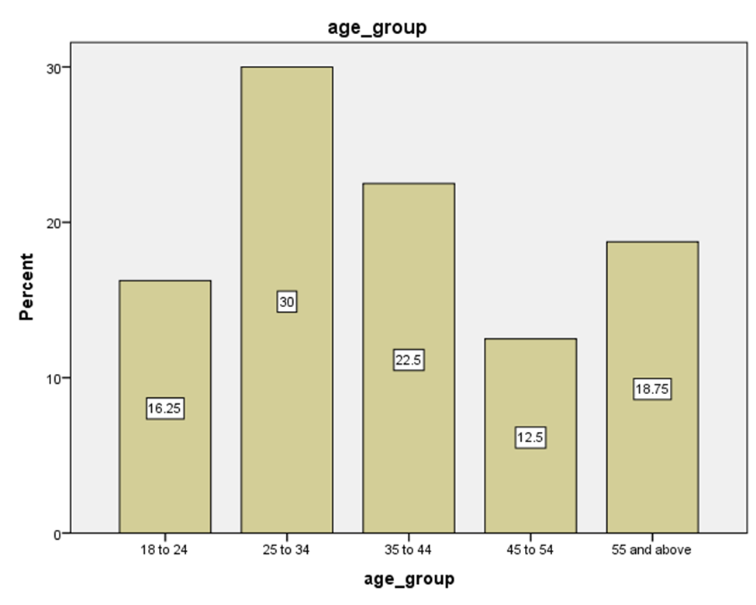

Graph 1: Age
(Source: Created through SPSS)
The bar chart shows the distribution of different age groups of individuals. According to the graph, the largest segment with 30 percent of the population is between the ages of 25-34. After this, there are 22.5 percent of those falling between the 35 to 44 years and the smallest represented is the 45-54 age category at 12.5 percent. This gives an idea of the age involved in the demographics.
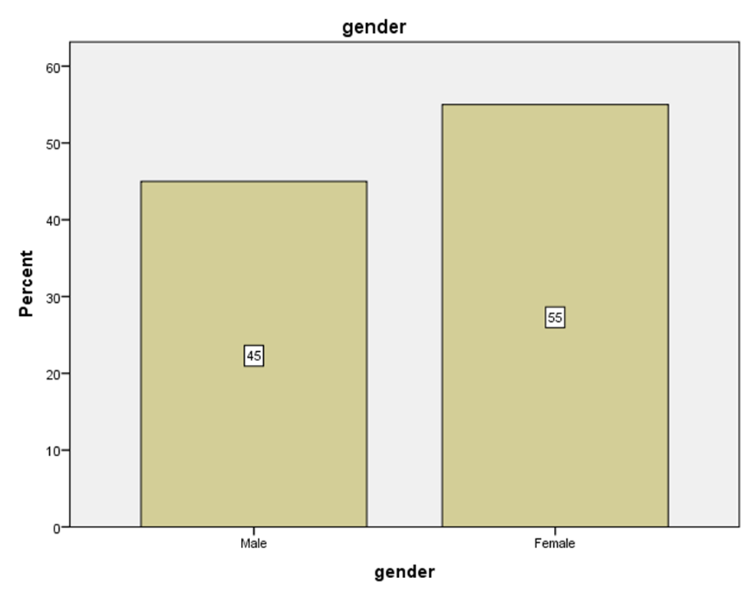

Graph 2: Gender
(Source: Created through SPSS)
In this bar graph, gender distribution of respondents is provided with apparent dominance of female respondents that is 55% on the other hand, males respondents constitute 45% of the respondents. The prevalence of female suggestiveness shows that women are becoming more aware of how AI Forecasts Consumer Behaviour Before making any purchase intent.
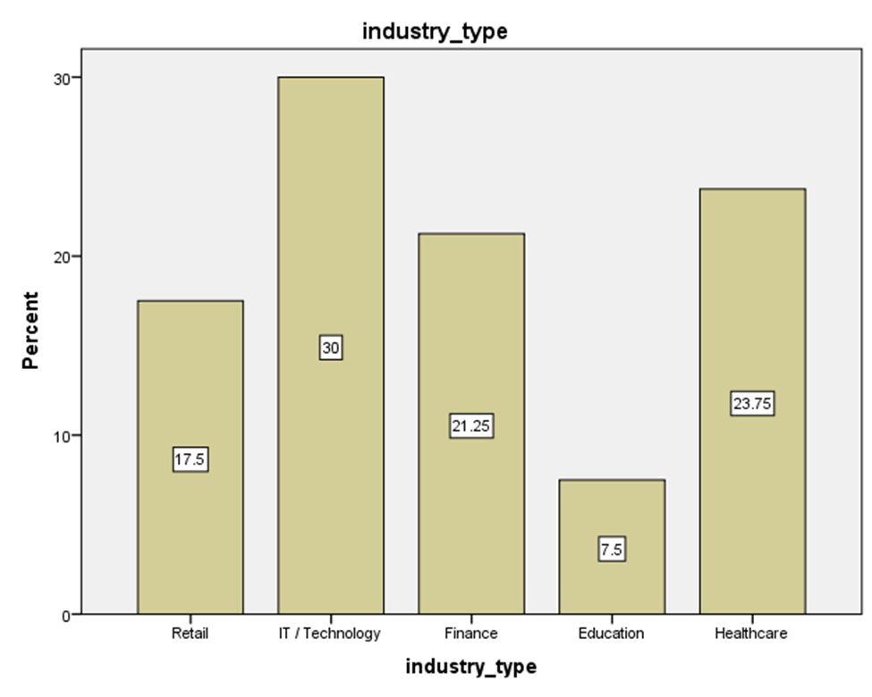

Graph 3: Industry Type
(Source: Created through SPSS)
The graph shows that 30 percent of the largest group is in the field of IT/ Technology department. Subsequently 23.75% of the participants belong to the background of healthcare and then 21.25percent belong to the background of Finance. Only 7.5% of the respondents are observed to be in the field of education. The background of the individuals is necessary to get a clear image of their accessibility to resources.
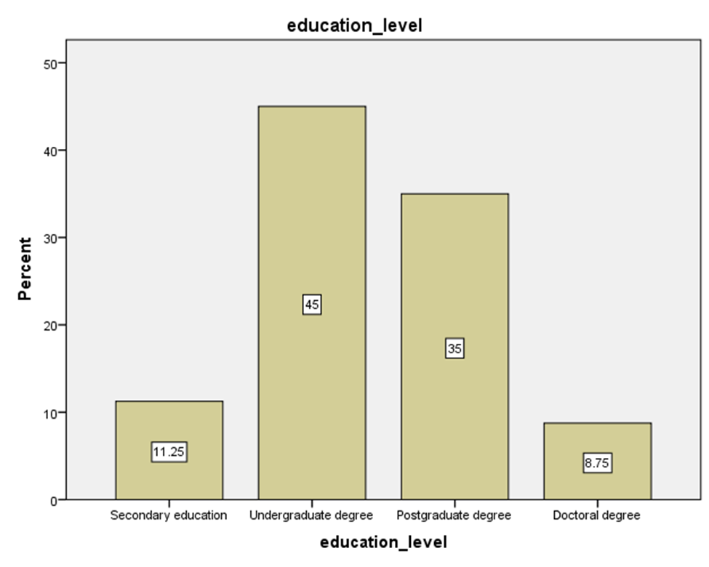

Graph 4: Education Level
(Source: Created through SPSS, 2026)
The bar chart shows the highest level of education attained by the individuals participating in the survey. According to the graph, 45% of the largest group have their undergraduate degree. After that, 35% of participants have their highest degree as postgraduate, 11.25% have their higher secondary education and the smallest percentage, 8.75%, have doctoral studies as their highest level of education.
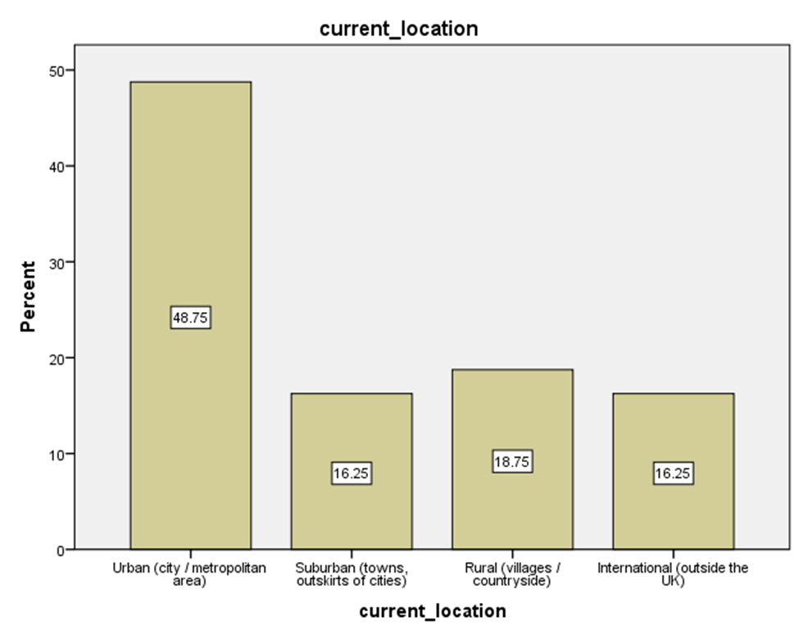

Graph 5: Current Location
(Source: Created through SPSS)
The above graph indicates the current location of all the participants involved. It is clearly evident from the graph that 48.75% of the participants hail from urban areas like metropolitan or some large cities whereas 18.75% of the participants come from rural areas or villages. On the other hand, 16.25% of the population resides in equal areas of suburban and international places. This indicates that the majority of the participants are from urban places.
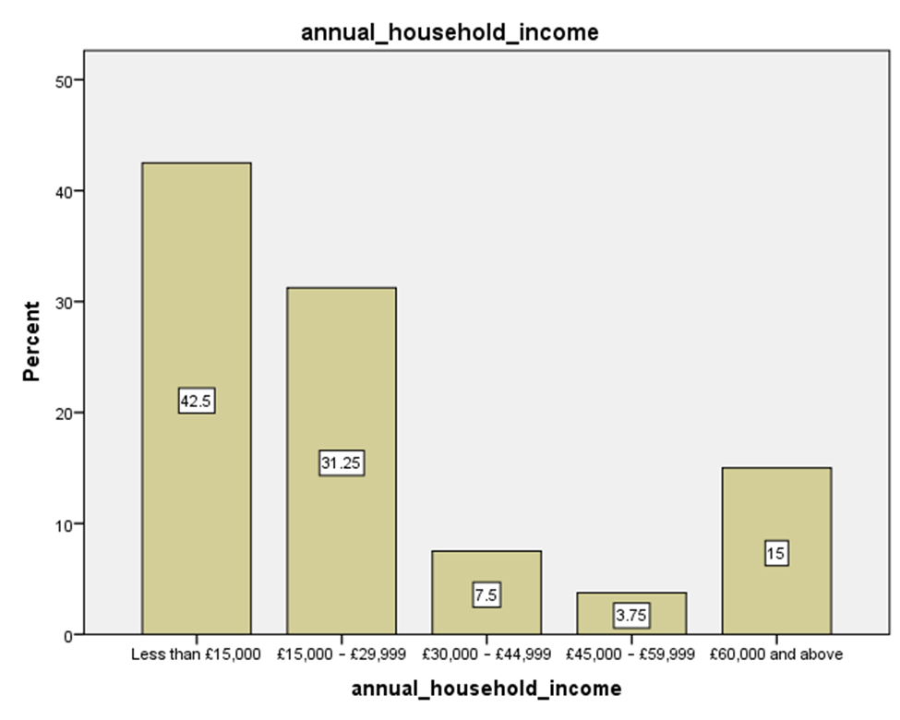

Graph 6: Annual Household Income
(Source: Created through SPSS)
It is illustrated from the bar chart that the majority of the population which counts to 42.5% have their annual income less than £15,000 while 31.25% of the population have their income ranging between £15,000 – £29,999. The bar graph also indicates that 15% have their income £60,000 and above it with only 3.75% and 7.5% of the people having £45,000 – £59,999 and £30,000 – £44,999 respectively. The majority of the population have their annual income minimal and not more than £15,000.

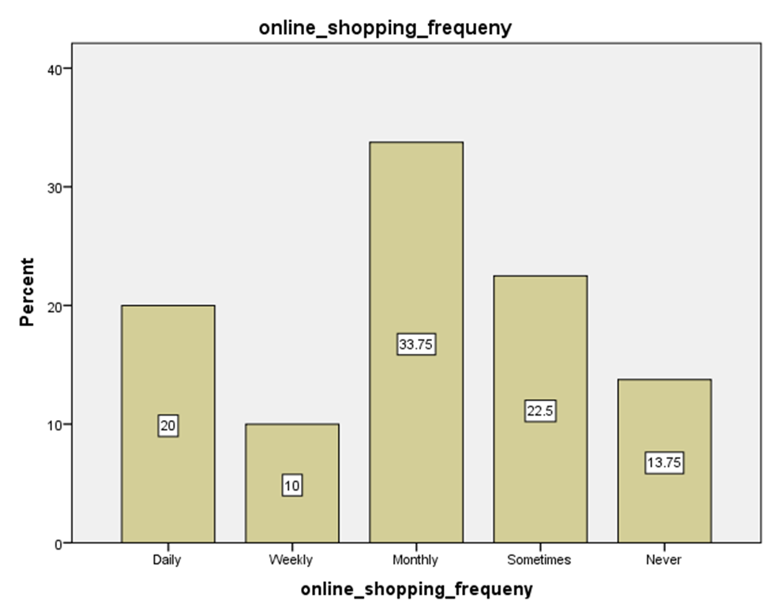

Graph 7: Online Shopping Frequency
(Source: Created through SPSS)
It is demonstrated from the above bar graph that 33.75% of the individuals involved in the survey make online purchases on a monthly basis with the lowest population of 10% spending on shopping weekly. 22.5% of the individuals prefer online shopping "sometimes" with 13.75% going complete null with online shopping experience as they say “never” to any of these experiences.

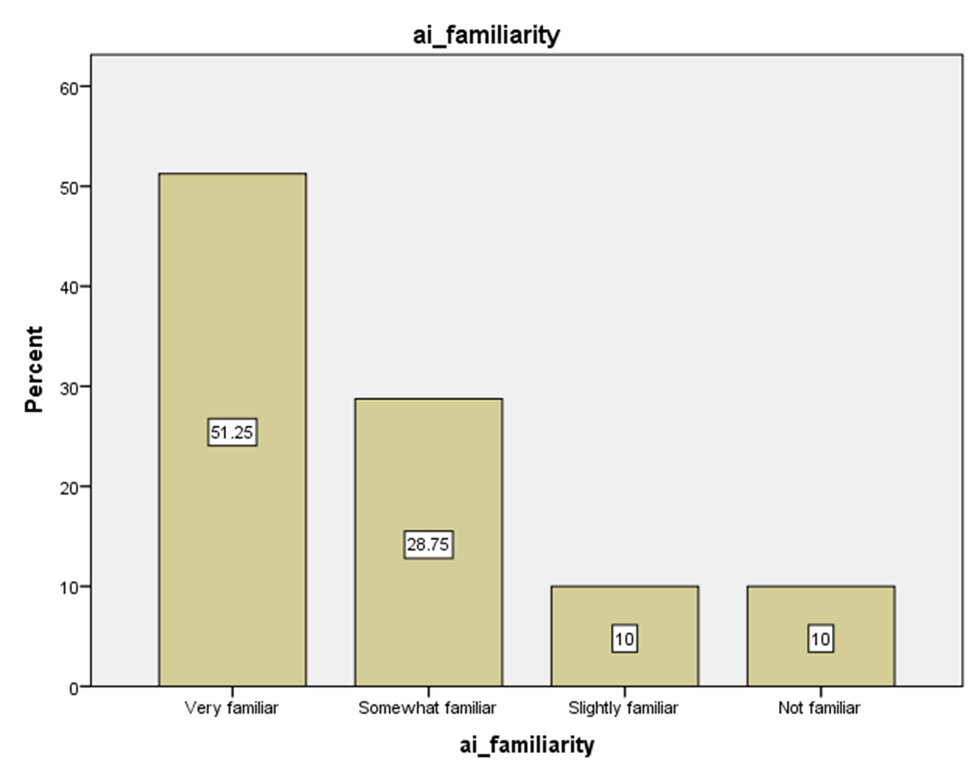

Graph 8: AI Familiarity
(Source: Created through SPSS)
The bar chart highlights the percentage of individuals familiar with AI based familiarity tools required nowadays. It is evident that half of the sample population 51.25% is “very familiar” with these modern cutting-edge tools related to AI and the next 28.75% being “somewhat Familiar”. As per the investigation, 10% of individuals relate to these tools being “slightly familiar” and “not familiar” correspondingly.

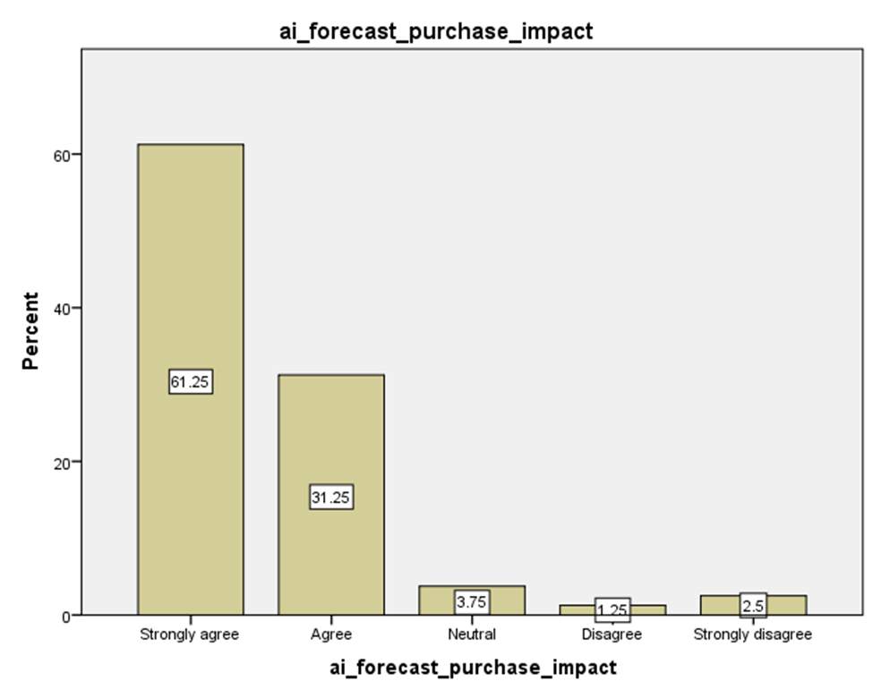

Graph 9: AI Forecast Purchase Impact
(Source: Created through SPSS)
The above displayed graph demonstrates the percentage of whether the Consumer behaviour towards purchases have been affected through following different AI forecasts or not. It is evident that 61.25% of the major population “strongly agree” with the above statement while 1.25% “Disagree” with the fact. Besides this, 31.25% of the individuals “agree” with that consumer behaviour towards making online purchases have been affected through different AI forecasts. While 3.75% comes to a decision of “neutral” and lastly 2.5% “strongly disagree" on the fact.
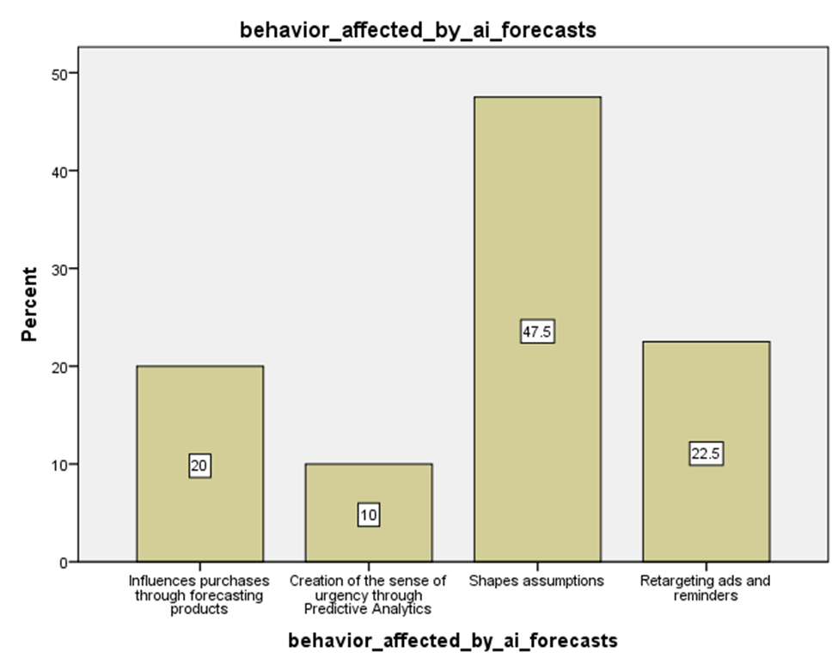

Graph 10: Behaviour affected by AI Forecasts
(Source: Created through SPSS)
The bar chart illustrates in what way behaviour has been affected by different AI forecasts. 47.5% of the population. 47.5% of the population indicates “shapes assumptions” and 22.5% corresponds to “retargeting ads and reminders”. On the other hand, 20% corresponds to “influences purchases through forecasting products”. This indicates how different behavior of the population involved is merely influenced by predictive AI forecasts.
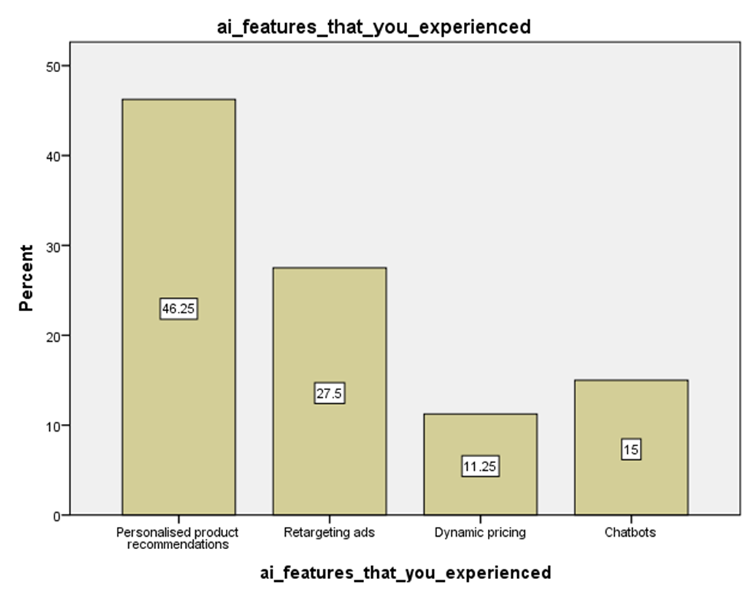

Graph 11: AI features Experienced
(Source: Created through SPSS)
The bar graph illustrates how various AI driven features are experienced during online shopping. 46.25% of the population consider “personalised product recommendations” as the AI feature experienced during online shopping. 27.5% contemplate that "retargeting ads” is one of the AI features experienced while 15% think “chatbots” as the major feature contributing to online shopping. The graph also displays dynamic pricing being another major feature represented by 11.25%.
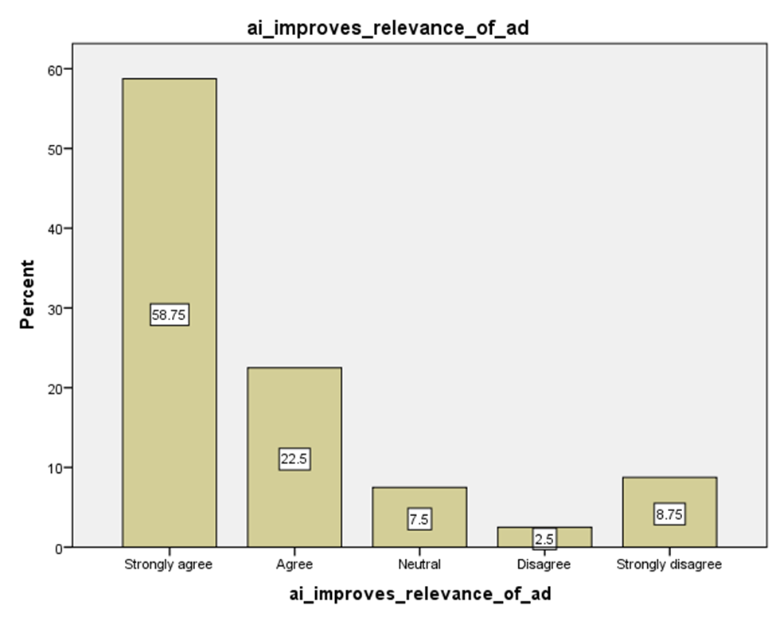

Graph 12: AI improving relevance of advertisements.
(Source: Created through SPSS)
From the above graph, it is evident that 58.75% of the total population taking part in the survey “strongly agree” with the fact that AI overall improves the relevance of advertisements one receives during online. Where the majority of population is on the major agree side, 8.75% “strongly disagree” with the statement made and 7.5% choosing to stay “neutral” when asked about this. The least amount of population that is only 2.5% disagree on this topic and 22.5% choosing to say “agree”.
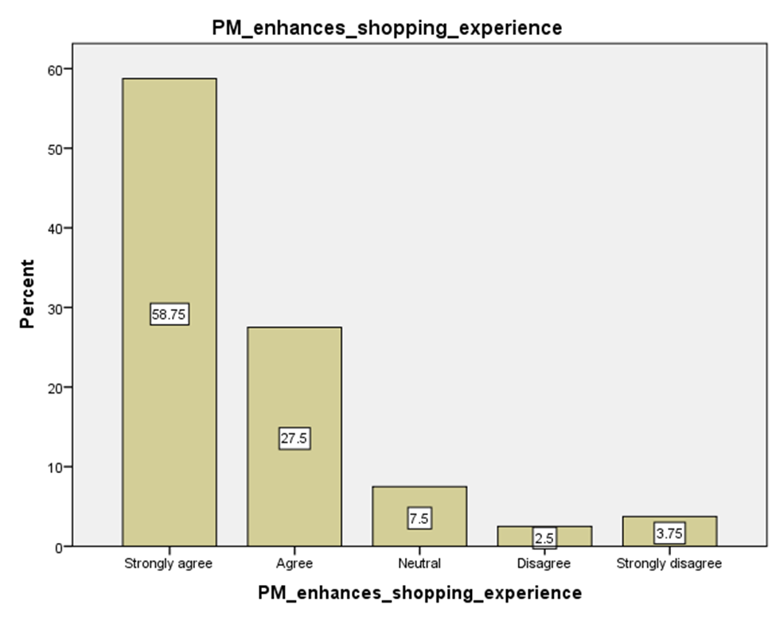

Graph 13: Predictive marketing enhancing shopping experience.
(Source: Created through SPSS)
Based on the graphical representation, 27.5% of the participants vouch for predictive marketing as a demanding tool that helps enhance shopping experience, attested strongly by another 58.75% participants. However, 2.5% disagree with this opinion, followed by 7.5% remaining neutral on this topic. This suggests that predictive marketing plays a significant role in shaping customer behaviour through better shopping experiences.
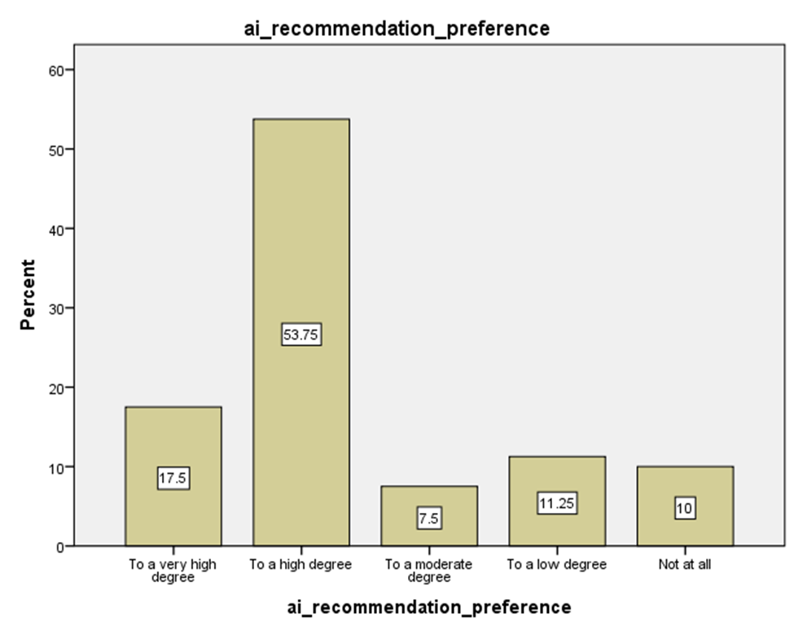

Graph 14: AI recommendation preference
(Source: Created through SPSS)
Over 53.75% believe that AI recommendations have been highly preferred when making purchase through predictive marketing online, while another 17.5% showcase a very high degree of dependence on such preferences linked with consumers’ shopping spree online and strengthening their purchase intentions, disagreed firmly by 11.25% over low degree of influence.
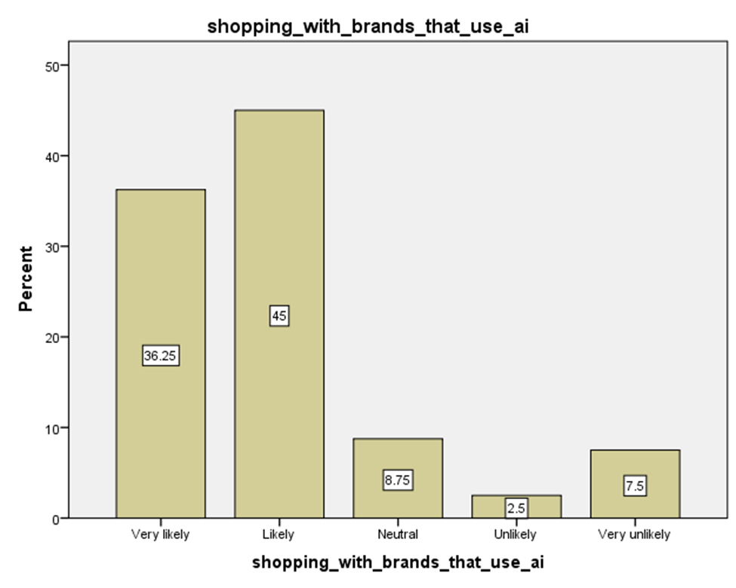

Graph 15: Shopping with brands that use AI.
(Source: Created through SPSS)
According to 45% of participants, followed by another 36.25%, there is a high possibility of shopping with fashion brands using AI-based tools, specifically predictive marketing, thereby enabling consumer engagement and shaping consumer behaviour towards purchase. This aspect is negated by 7.5% of participants who dismiss such tools.
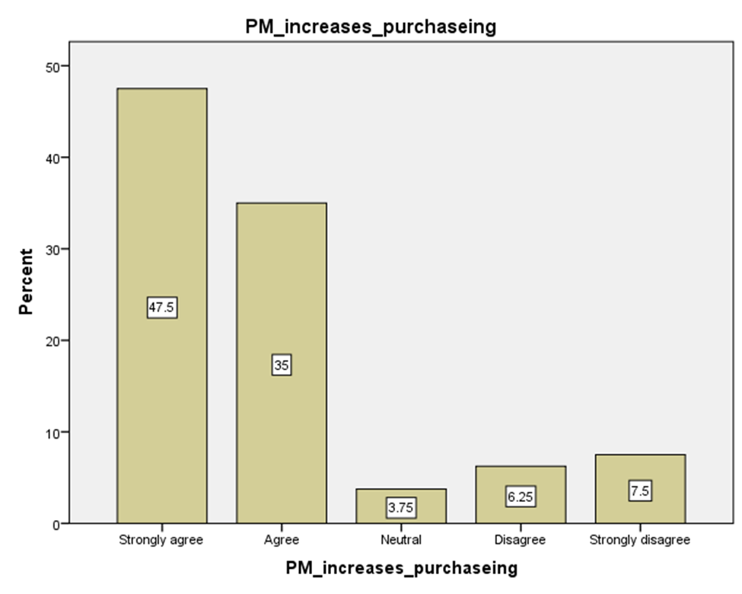

Graph 16: Predictive marketing increases purchasing.
(Source: Created through SPSS)
Based on the opinion of 47.% of participants, a string agreement is drawn on predictive marketing aiding in increasing purchases online, with 35% voicing similar beliefs. However, while 3.75% chose to stay neutral, 7.5% strongly disagreed with this tool’s effectiveness in raising purchasing intent.
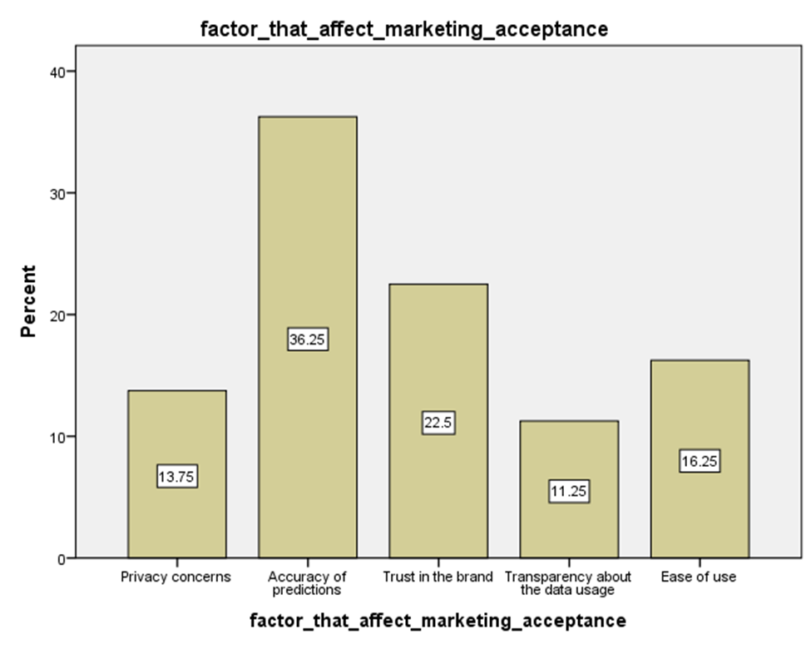

Graph 17: Factors affecting marketing acceptance.
(Source: Created through SPSS)
Among the factors affecting marketing acceptance, 36.25% chose accuracy of predictions as a major element that could shape consumer purchases, followed by 22.5% pointing to brand trust and 16.25% supporting ease of use. Another 13.75% vouched for privacy concerns, while 11.25% stated transparency in data usage as critical factors in this context.
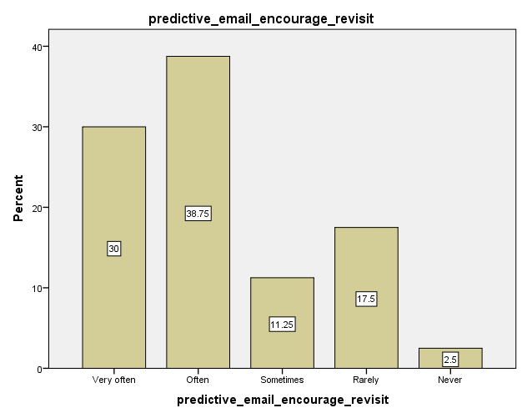

Graph 18: Predictive email marketing
(Source: Created through SPSS)
This graph explains how diversified artificial intelligence techniques contribute to the efficacy of digital marketing strategies. Here, 30% of the respondents accepted that predictive emailing encourages revisits. 2.5% do not acknowledge this. 38.75% of respondents proved that predictive marketing is statistically insignificant. The remaining 11.25% and 17.5% of respondents do not adhere to such beliefs.

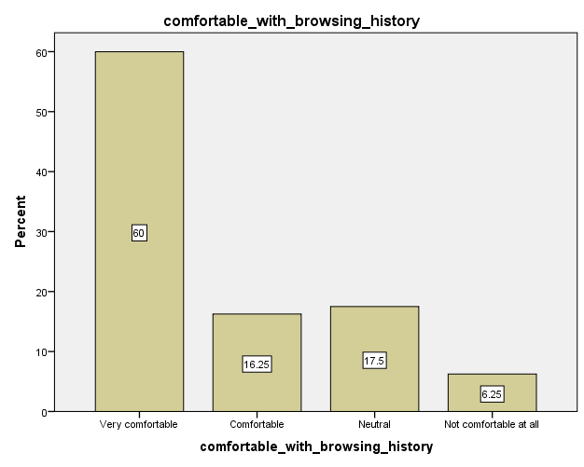

Graph 19: Browsing History
(Source: Created through SPSS)
Here, 60% agree comfortably with browsing history. 16.25% and 17.5% respondents elucidate how predictive marketing shapes consumer behaviour. However, 6.25% show disinterest.

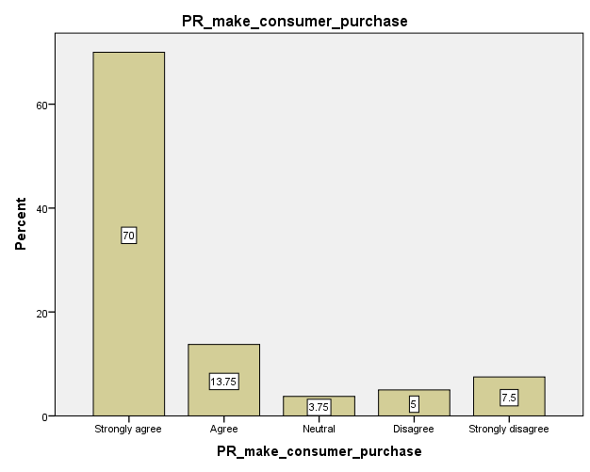

Graph 20: Predictive purchases
(Source: Created through SPSS)
Here, the relationship between predictive marketing and business growth is shown as 13.75% and 70% of respondents agreed that predictive marketing increases consumer purchases. While the rest 7.5% stays uncertain about such assumptions. It helps me reflect on the questions. 3.75% stays neutral to support the statement, and the rest 5% and 7.5% disagree with such statistical assumptions.
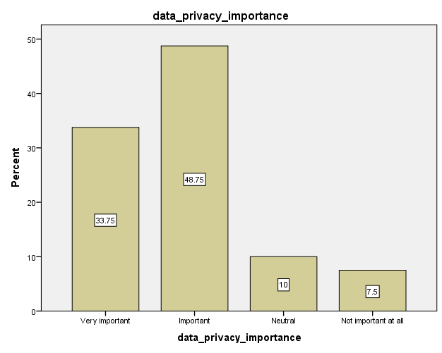

Graph 21: Predictive marketing privacy concerns
(Source: Created through SPSS)
Later, in the graph, it has been shown that 33.75% of the respondents show acceptance if data protection is rigid. It helps meet the research question, stating that AI tools can be used to improve marketing. 7.5% of people still face privacy issues. The remaining 48.75% and 10% remain focused on results rather than assumptions about accepting such concepts.
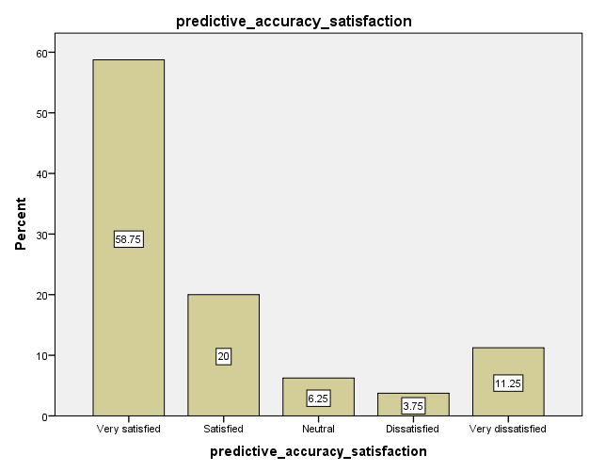

Graph 22: Predictive accuracy
(Source: Created through SPSS)
The graph specifically shows that predictive marketing meets customer satisfaction, as this highlights key trends. 20% and 58.75% respondents agreed that predictive marketing enhances the shopping experience. Whereas. 11.25% shows inconsistency. The remaining 20% are satisfied,6.25% are neutral, and 3.75% are dissatisfied.

4.5 Regression Analysis
Regression analysis is a statistical method used to test the relationship between dependent and independent variables, predict and test theories, and is an essential part of statistical research (Tyagi et al. 2022).
Hypothesis 1: There is a significant positive relationship between consumer behaviour affected by AI predictions and predictive marketing which in turn improves the shopping experience.
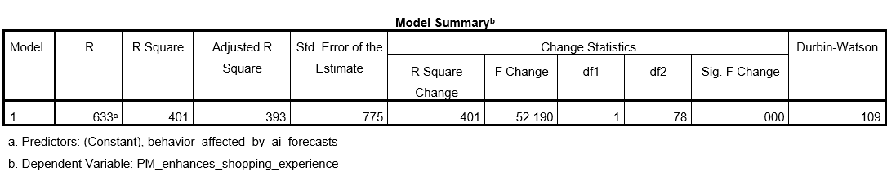

Table 3: Regression Analysis for H1
(Source: Created through SPSS)
Based on the first hypothesis (H1) of “There is a significant positive relationship between consumer behaviour affected by AI predictions and predictive marketing which in turn improves the shopping experience”, the associated p value or significant F Change stood at 0.00, despite a moderate R value (0.633) and low R-Square (0.401) and adjusted R-Square (0.393) values. Through the acceptance of H1, it is found that consumer behavior is greatly molded through AI forecasts.
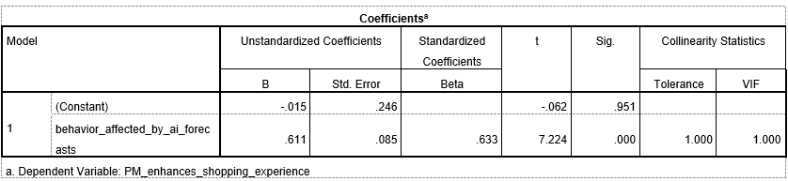

Table 4: Coefficient Analysis for H1
(Source: Created through SPSS)
The coefficient table shows that “behaviour affected by AI forecasts” significantly predicts shopping experience with Beta value 0.633 and p-value 0.000. This strong positive beta indicates that as AI-driven behavioural influence increases, consumers perceive their shopping experience as more enhanced. With VIF = 1.000, there is no collinearity issue, confirming that AI-shaped behavioural cues meaningfully improve consumer experience.
Hypothesis 2: AI driven features as perceived positively by customers greatly improve the prospects of predictive marketing thereby improving shopping experience.
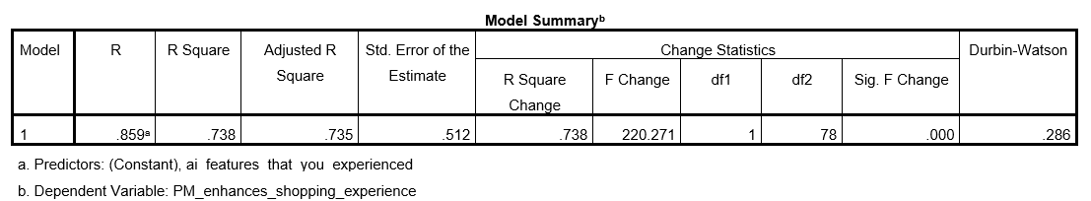

Table 5: Regression Analysis for H2
(Source: Created through SPSS)
A strong regression model fit for the second hypothesis (H2) of “AI driven features as perceived positively by customers greatly improve the prospects of predictive marketing thereby improving shopping experience”, is attested through a high R (0.859), R-Square (0.738) and Adjusted R-Square (0.735) values. The validation of H2, strengthened by significant F Change of 0.00, points to the direct impact of AI features, such as targeted advertisements and personalised recommendations, on customer satisfaction.
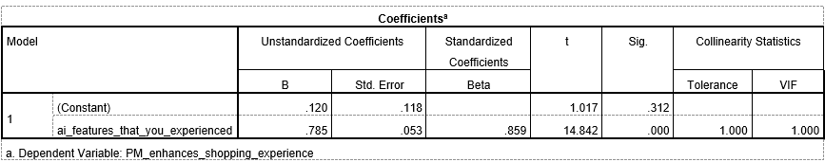

Table 6: Coefficient Analysis for H2
(Source: Created through SPSS)
The results indicate that “AI features experienced” strongly predict improved shopping experience with Beta = 0.859 and p = 0.000. This large beta coefficient shows that features such as personalised recommendations and chatbots significantly enrich user satisfaction. The low VIF value (1.000) confirms model stability. Overall, positive consumer perception of AI features directly boosts predictive marketing effectiveness and enhances the shopping journey.
Hypothesis 3: Predictive marketing helps induce purchase behaviour through predictive recommendations therefore enriching the shopping experience.
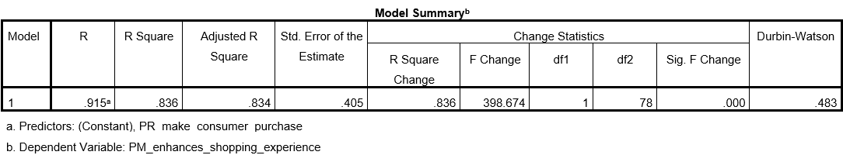

Table 7: Regression Analysis for H3
(Source: Created through SPSS)
For the third hypothesis (H3), “Predictive marketing helps induce purchase behaviour through predictive recommendations therefore enriching the shopping experience”, the regression model is boosted by high R (0.915), R-Square (0.836) and Adjusted R-Square (0.834) values, with the significant F Change being 0.000. Through the acceptance of H3, it becomes evident that predictive marketing helps reinforce repeat purchases and purchase decisions.
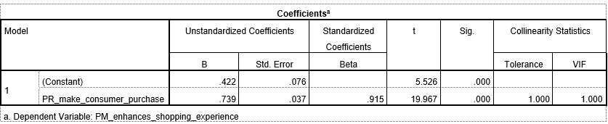

Table 8: Coefficient Analysis for H3
(Source: Created through SPSS)
The coefficient output shows that “predictive recommendations that make consumers purchase” have a very strong effect on shopping experience with Beta = 0.915 and p = 0.000. This demonstrates that when predictive marketing successfully triggers purchase decisions, consumers report a noticeably enhanced shopping experience. The model shows no multicollinearity (VIF = 1.000), confirming that predictive recommendations are a powerful driver of behavioural influence.
Hypothesis 4: Predictive marketing has the potential to enhance shopping experience thereby increasing purchase frequency.
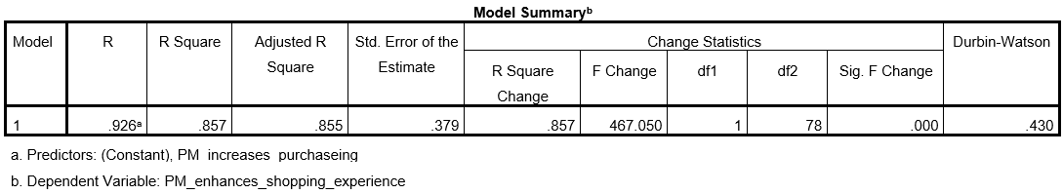

Table 9: Regression Analysis for H4
(Source: Created through SPSS)
The regression analysis of the fourth hypothesis (H4), “Predictive marketing has the potential to enhance shopping experience thereby increasing purchase frequency”, highlights the faith in AI based marketing, based on strong R (0.926), R-Square (0.857) and Adjusted R-Square (0.855) values. This is also in line with the findings of older literature wherein predictive marketing was found to have a positive impact on transactional and relational outcomes.
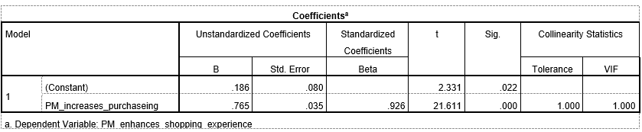

Table 10: Coefficient Analysis for H4
(Source: Created through SPSS)
The variable predictive marketing increases purchasing shows a strong predictive effect on enhanced shopping experience with Beta = 0.926, p = 0.000. This very high beta suggests that as predictive marketing increases purchase frequency, consumer experience improves significantly. With VIF = 1.000, the model is stable. Results confirm that effective predictive marketing positively reinforces engagement and shopping satisfaction.
Hypothesis 5: Factors that affect the acceptance of AI driven marketing have a significant impact on predictive marketing thereby improving the shopping experience.
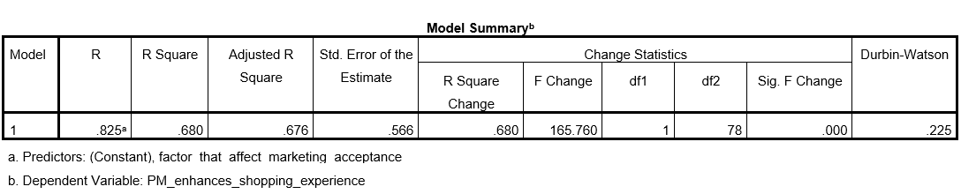

Table 11: Regression Analysis for H5
(Source: Created through SPSS)
The fifth hypothesis (H5) of “Factors that affect the acceptance of AI driven marketing have a significant impact on predictive marketing thereby improving the shopping experience”, is accepted through a strong regression model fit under R (0.825), R-Square (0.680) and Adjusted R-Square (0.676) values. H5 reveals the importance of acceptance factors such as transparency, trust, privacy and accuracy that help shape customer receptivity to AI driven marketing.
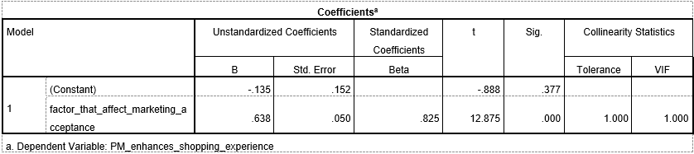

Table 12: Coefficient Analysis for H5
(Source: Created through SPSS)
The coefficient table reveals that factors affecting marketing acceptance strongly influence shopping experience with Beta = 0.825, p = 0.000. This means elements such as trust, transparency, perceived usefulness and privacy concerns significantly shape how consumers perceive predictive marketing. The stable VIF value (1.000) confirms no multicollinearity. Acceptance-related attributes play a crucial role in strengthening overall shopping experience.
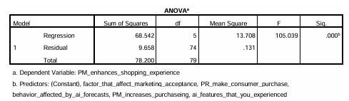

Table 13: ANOVA
(Source: Created through SPSS)
The statistical significance of the model is statistically significant F(5,74) = 105.039, p<0.001) which shows that the independent variables can collectively explain changes in shopping experience. The insignificant standard error (0.361) indicates proper prediction. However, the value of Durbin-Watson is 0.496, which implies the potential positive autocorrelation and the results are to be viewed with caution (Test, 2025). Overall, these results imply that AI-based predictive marketing determines consumer behaviour and purchasing perceptions supporting the study’s objective that predictive marketing enhances customer experience and increases business development.
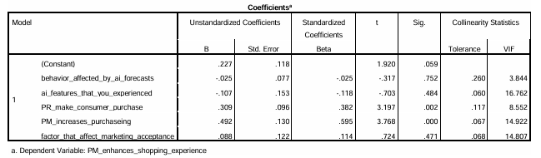

Table 14: Coefficient Analysis
(Source: Created through SPSS)
The presence of positive beta coefficients across key predictors demonstrates the efficacy of interacting with AI driven features in terms of facilitating acceptance of predictive marketing. These findings are synchronous with the assumptions of theoretical frameworks such as Technology Acceptance Model and Resource Based View which state that consumer outcomes can be greatly improved through the strategic deployment and ease of use of AI tools.

4.6 Correlation Analysis

Table 15: Correlation Analysis
(Source: Created through SPSS)
The analysis of the correlation shows that there is a significant and statistically significant relationship between the dependent variable and all the chosen independent variables. The correlation between “PM enhances shopping experience” and "PR makes consumer purchase” (r = 0.915, p < 0.01) is the strongest. It recommends that in cases where predictive or personalised recommendations, when successfully applied in influencing purchasing choices, consumers are likely to view their overall shopping experience as enhanced. This brings out the experiential quality recommendation system, not just the results of transactions. Equally, “PM increased purchasing” indicates a very high positive correlation with shopping experience enhancement (r = 0.926, p < 0.01). It suggests that AI-assisted marketing technologies that effectively induce the frequency of purchases also play a significant role in facilitating an easier, more enjoyable, and fulfilling shopping experience (Zhang, 2024).
There is also a positive relationship between “PM enhances shopping experience” and "ai features that you experienced” (r = 0.859, p < 0.01) which is strong and positive. This implies that direct contact with AI attributes, including personalised product recommendations, virtual assistants, or price rewards, has a positive influence on consumer experiential appraisals of shopping websites (Zimmermann et al. 2023). Moreover, “factors that affect marketing acceptance” have a significant correlation with increased shopping experience (r = 0.825, p < 0.01). It suggests that trust, perceived usefulness, ease of use, and ethical issues related to AI marketing have a great impact on the overall experience of customers in shopping settings, both emotionally and cognitively (Sahut and Laroche, 2025). Finally, the “behavior_affected_by_ai_forecasts” also has a significant positive correlation with the dependent variable (r = 0.633, p < 0.01). It may be less significant than the other relationships, but it is still a pointer to the role of AI-driven demand forecasts and behavioural nudges in influencing the shopping experience via decreasing uncertainty and corroborating decisions.

4.7 Conclusion
This chapter reviewed the practical results to assess the impact of predictive marketing and AI-based analytics on consumer behaviour prior to purchase intent. The findings showed that AI predictive application can play a highly important role in enhancing the capacity of marketers to predict consumer behaviour, personalise interaction, and impact subsequent decision-making processes at initial phases of the purchase cycle. The hypotheses were tested to explain the strength and direction of predictive accuracy, consumer trust and marketing effectiveness relationships. In general, the results form a sound basis of analysis on the dissertation. In the following chapter, final conclusions, practical recommendations, limitations on the study and future research directions will be provided.

Chapter 5: Discussion

5.1 Introduction
AI has influenced the organisation's success and social media interactions, and transactions (Ganesh, 2023). The discussion chapter will justify the behavioural intention before AI inclusion. The research has adopted a quantitative strategy to understand the key factors affecting consumers' behaviour before purchases are made. Additionally. The following chapter will discuss the regression and the correlation analysis that have been taken to elucidate the relationship between the dependent variable, consumer purchase intention, and the independent variable, Data analytics capability. Later, it will be contrasted with the information on how AI determines the marketing performance and variability.

5.2 Discussion on Graphs
The existing graph has provided a comprehensive picture of predictive marketing, which is driven by artificial intelligence. AI shapes consumer behaviour before explicit purchase intent. The demographic dividends and analysis reflect the impact of AI on younger, educated, and digitally active individuals. Gouveia and Santos, (2025) suggest that in a technologically driven culture, AI increases engagement frequency and buying readiness. This graph suggests that the literature findings are strongly inclined towards digitally led consumers. Analysing the use of AI-enabled marketing tools is relevant for contemporary online marketing contexts.
Based on the behavioural findings, AI-driven predictive marketing culture suggests a strong deviation towards assumptions, purchasing decisions and advertisements. Customers are not accustomed to a product, but purchasing decisions eventually get driven by AI tools. Personalised recommendations and retargeting mechanisms are the most common features. The graph states that predictive marketing does not direct consumers but influences them. This aligns with the results that AI influences consumer behaviour before conscious purchase. Valuable insights are obtained for academic research and practical marketing strategy development. As per Skillius and Jacobsson, (2024), predictive marketing increases shopping convenience and reduces coerciveness by increasing brand engagement. Consumers prefer the brand that utilises AI-based marketing tools, indicating that AI has a competitive advantage in e-commerce. However, Alabed et al. (2024) mentioned that consumer acceptance is not unconditional, but it depends on the accuracy of performance. Influential factors such as trust and privacy drive consumer acceptance. However, privacy remains secondary to perceived benefits.
As per the research perspective, the graph has supported the key literature findings and has reflected the predictive marketing functions through a theoretical premise. Choudhary, (2025) stated that such marketing types depend on pre-intent behaviours. On the other hand, Potwora et al. (2024) mentioned that AI anticipates demands and risks rather than responding to them, reshapes preferences and expectations in advance. The interpretation confirms that predictive marketing, when following ethical data practices, significantly impacts consumer behaviour positively.

5.3 Discussion on Regression Analysis
The regression analysis is where the relationship between two or more variables are analysed and determined to fetch the outcomes as either positive or negative (Tyagi et al. 2022). In other words, regression justifies the relationship between two or more independent variables as either positive or negative and the outcomes determine how the rest of the study will follow. As this being said, the study with the application of regression analysis underlines three major tools such as Model Summary, ANOVA analysis, and Coefficient analysis which derives data from the context and determines the relationship between two or more independent variables. The Model summary shows that there is a high correlation between the observed and predicted values as the regression and the dependent variable, “PM enhances shopping experience”, have a high R value of 0.936. The value of R Square is 0.877 which indicates that 87.7% of the variance in enhanced shopping experience is measured by the five predictors, factors influencing marketing acceptance, predictive marketing influence on purchase, AI-influenced behaviour, enhanced purchase with predictive marketing, and perceived AI features respectively. Similarly, ANOVA analysis predicts that there is a meaningful influence of the independent variables to the dependent variables which proves the context of the study. The coefficient analysis on the other hand, is synchronized with the assumptions of theoretical frameworks such as Technology Acceptance Model and Resource Based View that aligns with consumer outcomes which can be positively improved through the strategic deployment and ease of use of AI tools.

5.4 Discussion on Correlation Analysis
Correlation analysis is the tool that determines the relation between two variables at a time having the dependent and one independent variable from the other independent variables together. This can lead to positive or negative relationships between the variables where the negative can be partial or with every independent variable and same for positive. In this study, the correlation statistics between “PM enhances shopping experience” and "PR makes consumer purchase” (r = 0.915, p < 0.01) is the strongest. This resonates with the experiential quality of recommendation system, not just the outcomes of the transactions. Similarly, between the two variables, “PM increased purchasing” and the dependent variable “PM enhances shopping experience”, indicates a very high positive correlation with shopping experience enhancement (r = 0.926, p < 0.01). This shows that predictive marketing increases reliability for the customers, which further enhances their shopping experiences. There is also a positive relationship between “PM enhances shopping experience” and "AI features that you experienced” (r = 0.859, p < 0.01) which is strong and positive. As this being said, the relationship shows that predictive marketing enhances the faith of customers and the inclusion of technologies, making it more absolute such as personalised AI features to cover their interests. The significant value being less than 0.05 for every variable shows that the positive relationship between the dependent and the independent variables are strong. Hence, predictive marketing ensures transparency and customer satisfaction.

5.5 Comparative Analysis with Literature Review
Predictive marketing has become the new era of change for the overall marketing structure. Several organisations are adopting new technologies and developing their strategies to attract new customers or a greater number of customers. Sansome et al. (2025), mentions that customers do prefer transparency and need brands to be more transparent. The recognition of AI as a tool for predictive analysis and marketing has assisted the organisations to fetch this transparency through eliminating obscurity and presenting customer feedback on social media pages regarding the brand through comments and posts. In other words, predictive analysis has provided transparency for the brands which has been enabled through feedback and comment mechanisms. Apart from this, the regression analysis shows a positive relationship between “PR makes consumer purchase”, and “PM enhances shopping experience” which proves the point that predictive marketing does improve customer purchase intentions and approach. Mecharla et al. (2024), on the other hand, remain slightly different with the statements. It states that predictive marketing alone cannot be the reason for enhanced shopping experience of the customers. It requires reach, understanding that is mutual, and quality products to ensure that the faith remains intact. Predictive marketing through AI is just a medium and hence, the era remains the same which is built with trust and understanding while AI pushes it further. This statement also cannot be ignored but also it is to be noted that AI does play a huge role in managing this relationship between customers and organizations.
Being said so, it is noted through the correlation analysis that there is a close relationship between “PM enhances shopping experience” and “Factor that affect marketing acceptance” through its significant value and Person value. This shows that there are also factors that affect the overall predictive marketing and shopping experience for customers. AI ensures behavioral forecasts before active purchase assistance, which is one of the factors that contribute towards the changing era of marketing. Al Khady et al. (2023), mentions in this scenario that real-time analysis, pre-purchase data signals, scroll speed, and in-depth interaction are few more factors that affect the overall market acceptance towards AI. These are some of the positive factors which lead this technology to be accepted in a wider audience and thus ensure that the organizations also accept this for their growth. Vij et al. (2025), on the other hand contradicted by providing certain negative factors such as understanding, experience, visibility, and vision that affects acceptance as several organizations do not have the sight and skill to accept AI and use it for predictive marketing. Thus, this affects the growth of AI acceptance as well. Through this it is understood that there are both negative and positive lights to predictive marketing through AI which needs to be studied more. Again, the correlation analysis shows a connection between the two variables proving the point. Customers, like personalization as well, which is solely provided through technology and AI acceptance, is one of the benchmark measures taken by the organisations.
The organisations use AI for personalizing the contents for customers and attract them towards the brand. It is true that personalisation allows customers to choose what is right or best fitted for them, but it also results in impulsive buying, which is a negative side of predictive analysis or marketing. Alshaketheep et al. (2024), mentions that customers are driven by what is right and choose that aligns with their tastes. However, sometimes personalisation makes them purchase unnecessary products that might not be a prudent decision. Some people blame social media for this as well where brands use predictive marketing through AI the most. However, Roy et al. (2024), chooses a different reason for impulsive buying. It is undeniable that predictive analysis pushes the customers to buy what is right and what is not suitable as well as creating an urgency of impulsive buying but at the same time, it is also true that customers are the most primal objective of impulsive buying. In other words, whether to buy a thing or not to buy a thing depends on the customer’s cognitive and voluntary decision and not solely on the organisations that use predictive marketing. Being said so, it is understood that AI plays a crucial role in predictive marketing but also it depends on the customers whether they desire to purchase or not (Anthony et al. 2025). The descriptive statistics show a broad behaviour of positive influence between “Behaviour affected by AI forecasts”, and “PM enhances shopping experience”. This relation highlights that purchase behaviour is affected by the AI forecasts and this enhances the shopping experience. But certain views suggest that it also drives impulsive buying, which means in a negative or positive light, AI affects purchase behaviour such as whether to drive them in an impulsive manner or to drive them positively for the customers.
Lastly, it is understood that AI is able to detect subtle behaviors and their shifts in the market which triggers emotional aspects that anticipate needs. This further allows brands to intervene with personalised engagement which lies before a formal search or purchase which improves conversion rates. Lopes et al. (2024), in this aspect underlines that AI tracks movements, time on page, and engagement levels to push interests of the customers. This is the first step towards personalized marketing, and this is how AI improves the marketing and experience of buying for the customers. The AI is capable of tracking sentiments as well which analyses language, calls, and social media to identify the emotional states and needs of the customers. This might sound like intervention of personal space, but AI ensures keeping personal data confidential and has the ability to gather only that matters. Das, and Das, (2025), further highlights while agreeing with the statement that AI interprets and identifies urgency and local needs. This assists the organisations to further improve their approach towards the customers and gather data that is required for enhancing their product line as well.

5.6 Conclusion
AI is used in predictive marketing to reduce organisational resistance to technical changes. A consumer's behaviour is not random; rather, it depends on AI’s accuracy and its relevance. From the chapter it can be concluded that AI can be used in marketing to increase the consumer relationship with the business. Regression and correlation analysis has helped us understand how the purchasing intention of customers is influenced by cognitive and voluntary decisions and not solely by organizations. The next chapter will focus on the key findings and the future implications of the research. Also, recommendations will be provided for the limitations drawn.

Chapter 6: Conclusion and Recommendations

6.1 Introduction
The following chapter will elucidate the key understandings of AI-based predictive marketing to enhance consumer service and meet buyers' expectations. AI provides personalised product recommendations and impacts consumer purchase (Alabi, 2024). The core empirical findings from the literature review and analysis chapter will be evaluated. The positive and negative counterattacks of the author in the discussion chapter will be systematically reviewed and analysed in this chapter. The study’s findings support the existing academic arguments. It also speculates on the restricted demography and regional constraints on implementing AI in marketing. Later, limitations will be drawn that occur while conducting their research. Recommendations will be provided to overcome the limitations.

6.2 Key Understandings from the Study
This section presents the key understandings derived from a systematic comparison between the perspectives offered in the literature review and the empirical findings obtained from primary data analysis. The discussion is structured in line with the research objectives and highlights how the study’s findings either support, extend or nuance existing academic arguments.
Objective 1: To determine different types of AI techniques that play a role in digital marketing.
The literature strongly emphasises the diversification of AI techniques as the backbone of predictive marketing. According to Gobbilla and Kiran, (2025), traditional digital marketing relied largely on descriptive analytics, whereas modern AI-driven marketing operates in a predictive and anticipatory space. Similarly, as argued by Ramya et al. (2024), both machine learning and big data analytics enable marketers to forecast consumer behaviour even before explicit purchase intent is expressed. As for Ziakis and Vlachopoulou, (2023), key IA techniques, such as machine learning, natural language processing (NLP), deep learning and recommender systems, are central to this transformation.
These theoretical positions are strongly validated by the primary findings, with the majority of the primary respondents identifying personalised product recommendations as the most experienced AI feature, followed by retargeting advertisements and chatbots. These findings support the perspective of Macharla et al. (2024), stating that AI systems evaluate browsing history, past purchases and search patterns to predict consumer preferences. The dominance of recommendation systems confirms that machine learning-based algorithms are the most visible and influential AI technique in predictive marketing. Further support is provided by the correlation and regression analysis, with the variable of “AI features that you experienced” showing a strong positive relationship with enhanced shopping experience. This aligns with Reed et al. (2025), arguing that explainable AI and accessible dashboards increased perceived usefulness and user confidence. Overall, the findings confirm that AI techniques play a direct and meaningful role in shaping digital marketing techniques instead of remaining limited to backend analytics.
Objective 2: To assess the role of predictive marketing in shaping customer behaviour, particularly purchasing intention.
In the opinion of Alshaketheep et al. (2025), it stated that predictive analytics anticipate the likely demands of the consumers prior to actively expressing their purchase intent. Moreover, Singh and Kaunert, (2024), further noted that personalised AI-driven suggestions reduce decision-making effort and often lead consumers to purchase items they did not originally plan to buy. These arguments suggest that predictive marketing affects early stage thinking and evaluation. Furthermore, the primary analysis supports these claims, with the results demonstrating respondents strongly agreeing to AI forecasts affecting their purchase intentions. This is further validated by Xu and Liu, (2024), mentioning the influence of predictive analytics on emotional and cognitive decision-making by analysing behavioural signals. The graphical analysis reveals that a major portion of the participants stated that AI forecasts shape assumptions, while a significant group indicates that AI influences purchases by forecasting relevant products. This confirms that predictive marketing affects consumers at the pre-intent stage. Thus, the findings demonstrate that AI predictions shape consumer assumptions, preferences and evaluation before an actual purchase decision is made. In addition, correlation analysis shows a very strong relationship between predictive recommendations making consumers purchase and enhanced shopping experience, supporting the claim of Samishetty, (2025), on trust in AI-driven recommendations increasing the likelihood of consumers acting on them. Therefore, predictive marketing both increases purchase intention as well as improves how consumers feel about their overall shopping journey.
Objective 3: To determine the factors affecting the integration of AI tools for better predictive marketing.
Based on the perspective of Jaapar et al. (2024), it is observed that high costs, limited skills and infrastructural complexity initially slowed AI adoption, besides Naz and Kashif, (2025), further arguing that lack of trust in automated decision-making reduces marketers’ willingness to rely on AI outputs. These concerns are often explained using Rogers’ Diffusion of Innovation Theory where Kolesnik, (2025), highlighted relative advantages, compatibility and complexity as the important adoption factors. The primary findings strongly reflect these arguments, with graphs showing accuracy of predictions as the most important factor affecting marketing acceptance, alongside brand trust, ease of use and privacy concerns. These findings directly support Aljumah et al. (2024), expressing that perceived usefulness and trust play a dominant role in AI adoption. Consumers are more willing to accept predictive marketing when they believe that predictions are accurate and the brand is trustworthy.
Regression analysis further confirms that factors affecting marketing acceptance significantly influence enhanced shopping experience, supporting Zerilli et al. (2022) by raising concerns about black-box AI reducing confidence, while also aligning with Reed et al. (2025) who argued that explainability improves acceptance. Overall, the findings show that successful AI integration depends not only on technology but also on transparency, trust, accuracy and ethical data use.
Objective 4: To analyse the relationship between predictive marketing and business growth.
Batainah et al. (2024) stated that predictive analytics transforms customer signals into actionable forecasts that reduce marketing costs and improve acquisition efficiency. From a strategic perspective, Dahake et al. (2024) argued that predictive intelligence, under the Resource-Based View theory, constitutes a valuable and difficult-to-imitate organisational resource, thus positioning predictive marketing as a strategic capability rather than a short-term tool. The empirical findings, especially the survey results, displayed that predictive marketing increases purchasing behaviour, followed by the correlation analysis further revealing a very strong relationship between predictive marketing, increasing purchasing and enhanced shopping experience. This supports Agu et al. (2024) who stated that predictive analytics enhances conversion rates and long-term customer value. Furthermore, regression analysis shows that its high variance in enhanced shopping experience is explained by predictive marketing variables, highlighting its strong impact on consumer outcomes. These findings extend the view of Pratama et al. (2024) on AI-enabled prediction embedded in decision-making accelerating organisational responsiveness. Overall, the results confirm that predictive marketing contributes directly to increased purchases, improved customer experience and sustained business growth.
Therefore, the findings validate the key findings that AI-driven predictive marketing significantly influences consumer behaviour before purchase develops. While concerns over privacy and trust are accepted, predictive marketing is considered as a powerful, experience-enhancing and strategically valued tactic in modern digital marketing.

6.3 Limitations of the study
Despite offering useful insights, the sample size is limited to 80 respondents, which may not fully represent the diverse population of digital consumers. The use of convenience sampling may also restrict the generalisability of the findings, as the participants were selected based on accessibility rather than random selection. Secondly, while the research examined several AI-related factors, it did not explore advanced AI techniques, like generative AI, in detail, which may influence predictive marketing outcomes. Thirdly, the study relied on self-reported survey responses, which may include personal bias or socially desirable answers. Finally, the research adopted a cross-sectional design, capturing consumer perceptions at a single point of time. As a result, changes in consumer behaviour over a longer period could not be observed. Additionally, the study focused mainly on online consumer experiences, limiting insights into offline or omnichannel consumer behaviour.

6.4 Recommendations for the study
Based on the findings of this study, several recommendations are suggested for business and marketers. Organisations should focus on improving accuracy of AI-driven predictive marketing tools, considering accuracy was identified as the most important factor influencing consumer acceptance (Patil et al. 2024). Marketers should also ensure transparency in how consumer data is collected and used, which can help build trust and reduce privacy concerns. Providing clear explanations of AI recommendations can increase consumer confidence and engagement. From a strategic point of view, organisations can integrate predictive marketing into long-term business planning, instead of using it only for short-term sales goals. Businesses should invest in user-friendly AI systems and train marketing teams to effectively interpret and use predictive insights instead of relying solely on automation, further adopting a balanced approach by combining AI predictions with human judgment to enhance decision-making (Rane et al. 2024). Continuous monitoring and evaluation of AI performance are recommended to ensure relevance and fairness. Lastly, ethical guidelines must be established to prevent intrusive personalisation and ensure responsible use of consumer data (Matthew et al. 2025). Therefore, responsible, transparent and customer-centric use of predictive marketing can improve consumer experience, increase purchase intention and support sustainable business growth.

6.5 Future scope of the research
Future research can build upon this study by including a larger and more diverse sample size using probability sampling techniques to improve the generalisability of findings, while also amalgamating semi-structured interviews on in-depth perspectives on this subject. Longitudinal studies could be conducted to observe how consumer trust and behaviour towards predictive marketing evolve over time. Further research could also integrate psychological and emotional variables, like perceived control and autonomy, to deepen understanding of consumer responses (Waqas and Qadri, 2025). Future studies may also explore the role of emerging technologies, such as generative AI and real-time predictive systems, in shaping pre-purchase behaviour (Hemachandran et al. 2024). In addition, researchers can examine predictive marketing across different retail, healthcare and financial services, to identify sector-specific differences. Cross-cultural studies would help understand how cultural values influence consumer acceptance of AI-driven marketing.

6.6 Conclusion
The chapter has analysed the key findings of the research and also has showcased the output of whether all the objectives have met. The chapter has focused on exploring the emerging role of AI in predictive marketing and improving consumer trust. The research examined several AI-related factors. AI is used for predictive analytics and has been mainly associated with improving financial services and cross-cultural collaboration across markets. However, the sample size, research content and the information have faced certain criticism, which limited the output. Recommendations have been provided to overcome the limitations and improve the outcome.

References
Agu, E.E., Chiekezie, N.R., Abhulimen, A.O. and Obiki-Osafiele, A.N., (2024). Building sustainable business models with predictive analytics: Case studies from various industries. International Journal of Advanced Economics, 6(8), pp.394-406.[Available at:https://www.researchgate.net/profile/Angela-Abhulimen/publication/383860897_Building_sustainable_business_models_with_predictive_analytics_Case_studies_from_various_industries/links/66ddb6adfa5e11512ca8ed7c/Building-sustainable-business-models-with-predictive-analytics-Case-studies-from-various-industries.pdf] [Accessed on:13.01.2026]
Ajayi, V.O., (2023). A review on primary sources of data and secondary sources of data. Available at SSRN 5378785. [Available at: https://papers.ssrn.com/sol3/papers.cfm?abstract_id=5378785][Accessed on 13.01.2026]
Al Kalach, N., (2025). AI-Driven Customer Relationship Management: Enhancing Salesforce Efficiency Through Predictive Analytics. International Journal of Advance Industrial Engineering, 13(01), pp.22-35.[Available at: https://ijaie.com/index.php/ijaie/article/view/103 ][Accessed on: 14.01.2026]
Al Khaldy, M.A., Al-Obaydi, B.A.A. and al Shari, A.J., (2023), May. The impact of predictive analytics and AI on digital marketing strategy and ROI. In Conference on sustainability and cutting-edge business technologies (pp. 367-379). Cham: Springer Nature Switzerland. [Available at: https://link.springer.com/chapter/10.1007/978-3-031-42455-7_31] [Accessed on: 20.01.2026]
Alabed, A., Javornik, A., Gregory-Smith, D. and Casey, R., (2024). More than just a chat: A taxonomy of consumers’ relationships with conversational AI agents and their well-being implications. European Journal of Marketing, 58(2), pp.373-409. [Available at: https://research-information.bris.ac.uk/files/403088817/EJM_More_than_just_a_chat.pdf ][Accessed on: 20.01.2026]
Alabi, M., (2024). AI-Powered Product Recommendation Systems: Personalizing Customer Experiences and Increasing Sales. [Available at: https://www.researchgate.net/profile/Moses-Alabi/publication/384931166_AI-Powered_Product_Recommendation_Systems_Personalizing_Customer_Experiences_and_Increasing_Sales/links/670ea9e18e87ce48524e22dc/AI-Powered-Product-Recommendation-Systems-Personalizing-Customer-Experiences-and-Increasing-Sales.pdf ][Accessed on: 18.01.2026]
Ali, F., Maqsood, H. and Janjua, Q., (2025). Psychological Triggers in Online Shopping: The Influence of Scarcity, Urgency, and Personalization on Consumer Buying Behavior. The Critical Review of Social Sciences Studies, 3(2), pp.269-289. [Available at: http://thecrsss.com/index.php/Journal/article/view/443][Accessed on 13.01.2026]
Ali, S.M.S., (2025). Cognitive biases in digital decision making: How consumers navigate information overload (Consumer Behavior). Advances in Consumer Research, 2, pp.168-177. [Available at: https://acr-journal.com/article/cognitive-biases-in-digital-decision-making-how-consumers-navigate-information-overload-consumer-behavior--889/][Accessed on 13.01.2026]
Aljumah, A.I., Nuseir, M.T., El Refae, G. and Qasim, A., (2024), September. Investigating the Impact of Perceived Usefulness, Technological Factors, and Big Data on Digital Marketing Adoption and Tourists’ Purchase Intentions (Case Study). In 2024 International Conference on Multimedia Computing, Networking and Applications (MCNA) (pp. 89-95). IEEE. [Available at: https://ieeexplore.ieee.org/abstract/document/10703907/][Accessed on 13.01.2026]
Alom, N.B., Zakaria, A.F., Rahmat, S.B., Abdullah, S.N.B., Yusof, Z.B., Jamaludin, H.B. and Razak, A.B., (2024). An Examination of Customer Behavior Analytics, Privacy Issues, and Data Protection Laws in the Age of Big Data and Machine Learning. [Available at: https://www.researchgate.net/profile/Zainuddin-Bin-Yusof/publication/386507641_An_Examination_of_Customer_Behavior_Analytics_Privacy_Issues_and_Data_Protection_Laws_in_the_Age_of_Big_Data_and_Machine_Learning/links/6753766db558f41d0fbfd39a/An-Examination-of-Customer-Behavior-Analytics-Privacy-Issues-and-Data-Protection-Laws-in-the-Age-of-Big-Data-and-Machine-Learning.pdf][Accessed on 13.01.2026]
Alshaketheep, K., Al-Ahmed, H. and Mansour, A., (2025). Beyond purchase patterns: harnessing predictive analytics to anticipate unarticulated consumer needs. Acta Psychologica, 257, p.105089. [Available at: https://www.sciencedirect.com/science/article/pii/S0001691825004020][Accessed on 13.01.2026]
Alshaketheep, K., Mansour, A.M., Al-Ma’aitah, I.M., Dabaghia, M.N. and Dabaghie, Y.M., (2024). Leveraging AI predictive analytics for marketing strategy: The mediating role of management awareness. Journal of System and Management Sciences, 14(2), pp.71-89.[Available at: https://www.aasmr.org/jsms/Vol14/No.2/Vol.14.No.2.5.pdf] [Accessed on: 20.01.2026]
Alshaketheep, K., Mansour, A.M., Al-Ma’aitah, I.M., Dabaghia, M.N. and Dabaghie, Y.M., (2024). Leveraging AI predictive analytics for marketing strategy: The mediating role of management awareness. Journal of System and Management Sciences, 14(2), pp.71-89. [Available at: https://www.aasmr.org/jsms/Vol14/No.2/Vol.14.No.2.5.pdf] [Accessed on:12.01.2026]
Al-Shammari, M., Ahmed Al Bin Ali, F., Abdulla AlRashidi, M. and Salem Albuainain, M., (2024). Big data and predictive analytics for strategic human resource management: A systematic literature review. International Journal of Computing and Digital Systems, 17(1), pp.1-9.[Available at:https://www.researchgate.net/profile/Muneera-Albuainain-2/publication/384498996_Big_Data_and_Predictive_Analytics_for_Strategic_Human_Resource_Management_A_Systematic_Literature_Review/links/66fbd021b753fa724d54dd0a/Big-Data-and-Predictive-Analytics-for-Strategic-Human-Resource-Management-A-Systematic-Literature-Review.pdf] [Accessed on:15.01.2026]
Anastasios, P. and Maria, G., (2024). Predictive AI in Business Intelligence Enhancing Market Insights and Strategic Decision-Making. American Journal of Technology Advancement, 1(8), pp.72-90.[Available at: http://eprints.umsida.ac.id/15851/ ][Accessed on: 12.01.2026]
Anthony, R., Dhanaraj, R.K. and Sathyamoorthy, M., (2025), April. Analytically Understanding the Psychology behind Impulsive Buying: A Business Marketing perspective. In 2025 International Conference on Recent Advances in Electrical, Electronics, Ubiquitous Communication, and Computational Intelligence (RAEEUCCI) (pp. 1-5). IEEE. [Available at: https://ieeexplore.ieee.org/abstract/document/11048266] [Accessed on: 20.01.2026]
Arce, C.G.M., Valderrama, D.A.C., Barragán, G.A.V. and Santillán, J.K.A., (2024). Optimizing business performance: Marketing strategies for small and medium businesses using artificial intelligence tools. Migration Letters, 21(S1), pp.193-201. [Available at: https://pdfs.semanticscholar.org/1098/751f1f4c05da8aadd8adbf9aa11977a907fb.pdf][Accessed on 13.01.2026]
ARINZE, E.S., (2025). USING AI-POWERED PREDICTIVE ANALYTICS FOR IMPROVED DECISION MAKINGIN SUPPLY CHAIN MANAGEMENT IN LUBRICANT FIRMS IN ANAMBRA STATE, NIGERIA. INTERNATIONAL JOURNAL OF FINANCE, ACCOUNTING AND MANAGEMENT STUDIES, 1(10), pp.25-40.[Available at: http://www.ijfams.com/index.php/ijfams/article/view/145 ][Accessed on: 11.01.2026]
Azad, M.S., Khan, S.S., Hossain, R., Rahman, R. and Momen, S., (2023). Predictive modeling of consumer purchase behavior on social media: Integrating theory of planned behavior and machine learning for actionable insights. Plos one, 18(12), p.e0296336. [Available at: https://journals.plos.org/plosone/article?id=10.1371/journal.pone.0296336] [Accessed on: 16.11.2025]
Bahangulu, J.K. and Owusu-Berko, L., (2025). Algorithmic bias, data ethics, and governance: Ensuring fairness, transparency and compliance in AI-powered business analytics applications. World J Adv Res Rev, 25(2), pp.1746-63. [Available at: https://www.researchgate.net/profile/Louis-Owusu-Berko-2/publication/389397603_Algorithmic_bias_data_ethics_and_governance_Ensuring_fairness_transparency_and_compliance_in_AI-powered_business_analytics_applications/links/67c1200e207c0c20fa9ab59e/Algorithmic-bias-data-ethics-and-governance-Ensuring-fairness-transparency-and-compliance-in-AI-powered-business-analytics-applications.pdf ] [Accessed on: 19.11.2025]
Bano, R., Azim, F., Mahmood, Z., Sanaullah, A. and Ali, O., (2025). The Role of Artificial Intelligence in Personalized Marketing: Enhancing Customer Experience, Predictive Targeting, and Brand Engagement. The Critical Review of Social Sciences Studies, 3(2), pp.50-65.[Available at:http://thecrsss.com/index.php/Journal/article/view/430] {Accessed on:14.01.2026]
Bano, R., Azim, F., Mahmood, Z., Sanaullah, A. and Ali, O., (2025). The Role of Artificial Intelligence in Personalized Marketing: Enhancing Customer Experience, Predictive Targeting, and Brand Engagement. The Critical Review of Social Sciences Studies, 3(2), pp.50-65. [Available at: http://thecrsss.com/index.php/Journal/article/view/430][Accessed on 13.01.2026]
Bataineh, A.Q., Abu-AlSondos, I.A., Frangieh, R.H., Salameh, A.A. and Alnajjar, I.A., (2024). Predictive modeling in marketing analytics: a comparative study of algorithms and applications in e-commerce sector. Kurdish Studies, 12(1), pp.499-515.[Available at:https://www.researchgate.net/profile/Abdallah-Bataineh-2/publication/376851043_Predictive_Modeling_in_Marketing_Analytics_A_Comparative_Study_of_Algorithms_and_Applications_in_E-Commerce_Sector/links/658c26c73c472d2e8e921434/Predictive-Modeling-in-Marketing-Analytics-A-Comparative-Study-of-Algorithms-and-Applications-in-E-Commerce-Sector.pdf] [Accessed on:11.01.2026]
Booyse, D. and Scheepers, C.B., (2024). Barriers to adopting automated organisational decision-making through the use of artificial intelligence. Management Research Review, 47(1), pp.64-85. [Available at: https://www.emerald.com/insight/content/doi/10.1108/mrr-09-2021-0701/full/html][Accessed on 13.01.2026]
Büyüközkan, G., Uztürk, D. and Ilıcak, Ö., (2024). Fermatean fuzzy sets and its extensions: a systematic literature review. Artificial Intelligence Review, 57(6), p.138. [Available at: https://link.springer.com/content/pdf/10.1007/s10462-024-10761-y.pdf ] [Accessed on: 20.11.2025]
Chintalapati, S. and Pandey, S.K., (2022). Artificial intelligence in marketing: A systematic literature review. International Journal of Market Research, 64(1), pp.38-68.[Available at: https://journals.sagepub.com/doi/abs/10.1177/14707853211018428 ][Accessed on: 09.01.2026]
Choudhary, S., (2025). Predictive Analytics in Marketing: Exploring How AI Can Predict Future Customer Behavior and Trends. [Available at: https://www.theseus.fi/bitstream/handle/10024/881480/Choudhary_Suman.pdf?sequence=2 ][Accessed on: 18.01.2026]
Dahake, N.S., Gajghate, A., Dahake, P.S. and Bansod, S., (2024), November. A Transformative Impact of IoT and AI by Predictive Analytics on Modern Marketing Strategies: A Study of its Significance & Accuracy. In 2024 2nd International Conference on Advances in Computation, Communication and Information Technology (ICAICCIT) (Vol. 1, pp. 1150-1158). IEEE.[Available at:https://ieeexplore.ieee.org/abstract/document/10912388/] [Accessed on:12.01.2026]
Das, P. and Das, S., (2025). AI-Enhanced Retail Experiences and its Impact on Customer Repeat Purchase Intention. In Contemporary Business Practices and Sustainable Strategic Growth (pp. 129-150). Bentham Science Publishers. [Available at: https://www.benthamdirect.com/content/books/9789815322071.chapter-8] [Accessed on: 20.01.2026]
Davis, F.D., (1989). Technology acceptance model: TAM. Al-Suqri, MN, Al-Aufi, AS: Information Seeking Behavior and Technology Adoption, 205(219), p.5. [Available at: https://quod.lib.umich.edu/b/busadwp/images/b/1/4/b1409190.0001.001.pdf][Accessed on 13.01.2026]
Drolet, M.J., Rose-Derouin, E., Leblanc, J.C., Ruest, M. and Williams-Jones, B., (2023). Ethical issues in research: Perceptions of researchers, research ethics board members and research ethics experts. Journal of Academic Ethics, 21(2), pp.269-292. [Available at: https://link.springer.com/article/10.1007/s10805-022-09455-3][Accessed on 13.01.2026]
Dubey, U.K.B. and Kothari, D.P., (2022). Research methodology: Techniques and trends. Chapman and Hall/CRC. [Available at: https://www.taylorfrancis.com/books/mono/10.1201/9781315167138/research-methodology-umesh-kumar-dubey-kothari][Accessed on 13.01.2026]
Gamage, A.N.K.K., (2025). Research design, philosophy, and quantitative approaches in scientific research methodology. Scholars Journal of Engineering and Technology, 13(02), pp.91-103. [Available at: https://www.academia.edu/download/122341245/SJET_132_91_103c_published_paper.pdf][Accessed on 13.01.2026]
Ganesh, A., (2023). The Impact of Social Media on Consumer Behavior: An AI-Enhanced Approach to Marketing Strategies. Available at SSRN 4985407. [Available at: https://papers.ssrn.com/sol3/Delivery.cfm?abstractid=4985407 ][Accessed on: 18.01.2026]
Gobbilla, U. and Kiran, D.S., (2025). A comparative analysis of traditional and digital marketing strategies in era of e-commerce. International Journal of Engineering, Business and Management (IJEBM), 9(3), pp.1-19. [Available at: https://www.researchgate.net/profile/Umamaheswararao-Gobbilla/publication/394241320_A_Comparative_Analysis_of_Traditional_and_Digital_Marketing_Strategies_in_Era_of_E-Commerce/links/688e0d5341943575bcb60ce0/A-Comparative-Analysis-of-Traditional-and-Digital-Marketing-Strategies-in-Era-of-E-Commerce.pdf][Accessed on 13.01.2026]
Golzar, J., Noor, S. and Tajik, O., (2022). Convenience sampling. International Journal of Education & Language Studies, 1(2), pp.72-77. [Available at: https://www.ijels.net/article_162981.html][Accessed on 13.01.2026]
Gouveia, J. and Santos, S., (2025). Rethinking the Customer Journey: Impact of AI for Consumers and Businesses—A Systematic Literature Review and Research Agenda. International Journal of Consumer Studies, 49(6), p.e70136. [Available at: https://onlinelibrary.wiley.com/doi/pdf/10.1111/ijcs.70136 ][Accessed on: 18.01.2026]
Grewal, D., Satornino, C.B., Davenport, T. and Guha, A., (2025). How generative AI is shaping the future of marketing. Journal of the Academy of Marketing Science, 53(3), pp.702-722.[Available at:https://link.springer.com/article/10.1007/s11747-024-01064-3] [Accessed on:15.01.2026]
Gupta, A. and Gupta, N., (2022). Research methodology. SBPD publications. [Available at: https://books.google.com/books?hl=en&lr=&id=PzSYEAAAQBAJ&oi=fnd&pg=PP1&dq=statistical+analysis+of+research+methodology&ots=CrqPu5Gq1k&sig=s8lMwhUshVe4LUpDcE1s0_yIztM][Accessed on 13.01.2026]
Gupta, A., Garg, P., Narooka, P. and Palit, R., (2024), September. Applications of Machine Learning in Marketing: Personalization, Targeting, and Customer Engagement. In International Conference on Sustainable Computing and Intelligent Systems (pp. 145-156). Singapore: Springer Nature Singapore. [Available at: https://link.springer.com/chapter/10.1007/978-981-96-3311-1_12] [Accessed on: 16.11.2025]
Haris, A., (2024). The role of marketing research in understanding consumer behavior and preferences. Advances in Business & Industrial Marketing Research, 2(2), pp.59-71. [Available at: http://advancesinresearch.id/index.php/ABIM/article/view/259] [Accessed on: 16.11.2025]
Hassan, Y.A. and Zeebaree, S.R., (2025). Big Data Cloud Computing and AI-Driven Digital Marketing in Enterprise Systems. [Available at: https://www.researchgate.net/profile/Subhi-Zeebaree/publication/391395475_Big_Data_Cloud_Computing_and_AI-Driven_Digital_Marketing_in_Enterprise_Systems/links/6814e45460241d514021a40e/Big-Data-Cloud-Computing-and-AI-Driven-Digital-Marketing-in-Enterprise-Systems.pdf][Accessed on 13.01.2026]
Hemachandran, K., Choudhury, D., Rodriguez, R.V., Wise, J.A. and Revathi, T. eds., (2024). Predictive Analytics and Generative AI for Data-driven Marketing Strategies. CRC Press. [Available at: https://books.google.com/books?hl=en&lr=&id=K9YuEQAAQBAJ&oi=fnd&pg=PT10&dq=generative+AI+and+real-time+predictive+systems,+in+shaping+pre-purchase+behaviour+under+AI-driven+predictive+marketing+tools&ots=ZbGj77LC2C&sig=PfzDBi2w5-c1wlZqFpFhNr4IrHs][Accessed on 21.01.2026]
Hinton, P.R., 2024. Statistics explained. Routledge. [Available at: https://www.taylorfrancis.com/books/mono/10.4324/9780429353260/statistics-explained-perry-hinton][Accessed on 13.01.2026]
Hossain, M.A., Tiwari, A., Saha, S., Ghimire, A., Imran, M.A.U. and Khatoon, R., (2024). Applying the Technology Acceptance Model (TAM) in Information Technology System to Evaluate the Adoption of Decision Support System. Journal of Computer and Communications, 12(8), pp.242-256. [Available at: https://www.scirp.org/journal/paperinformation?paperid=135663][Accessed on 13.01.2026]
Ijomah, T.I., Idemudia, C., Eyo-Udo, N.L. and Anjorin, K.F., (2024). The role of big data analytics in customer relationship management: Strategies for improving customer engagement and retention. World Journal of Advanced Science and Technology, 6(1), pp.13-24. [Available at: https://www.researchgate.net/profile/Tochukwu-Ijomah-2/publication/383847888_The_role_of_big_data_analytics_in_customer_relationship_management_Strategies_for_improving_customer_engagement_and_retention/links/66dc4c2ffa5e11512ca4ee4a/The-role-of-big-data-analytics-in-customer-relationship-management-Strategies-for-improving-customer-engagement-and-retention.pdf][Accessed on 13.01.2026]
Islam, M.A., Fakir, S.I., Masud, S.B., Hossen, M.D., Islam, M.T. and Siddiky, M.R., (2024). Artificial intelligence in digital marketing automation: Enhancing personalization, predictive analytics, and ethical integration. Edelweiss Applied Science and Technology, 8(6), pp.6498-6516.[Available at:https://d1wqtxts1xzle7.cloudfront.net/120697814/2543_EAST20248_6_6498_6516-libre.pdf?1736311868=&response-content-disposition=inline%3B+filename%3DArtificial_intelligence_in_digital_marke.pdf&Expires=1768470957&Signature=Z-fdFMESG-wYwv~qqDdc54NQ2MCFz8nKDn2Z67bLJyAwLvozzGbs1-eE9HiuUfGV6j1t6VH87QJlTB8Nev-EV4ypk0BAvT8ZKWB-fLyvNyf0mN2e1EsOfMVuW~OUzoc0c46BR28JTXzNPloD9HEuLEOdqRl0GHSoN314PThbHA~Lwv2Ve-zPzK5xj4q3hMGdyxseH-jbqIkmwVF6JEZPMpHSGYVqa5MKbd36tfQKcA5vhq73W89~b8w7By5iK0VCTAiN2DQLgtMDgGaUwlLODkfGSuWLOHIvXkQnwRmSjIMcGoWqXutou-CuL3VioCmyCu69WRsE7YNXhOSUYADOww__&Key-Pair-Id=APKAJLOHF5GGSLRBV4ZA] [Accessed on:11.01.2026]
Islam, M.R., Khan, N.A. and Baikady, R. eds., (2022). Principles of social research methodology. Springer Nature. [Available at: https://link.springer.com/content/pdf/10.1007/978-981-19-5441-2.pdf][Accessed on 13.01.2026]
Jaapar, A., Abdullah, N., Nizam, M.K.N.H., Ismail, A.S. and Abidin, M.Z., (2025). Artificial intelligence in marketing: A review of adoption drivers and barriers in Malaysian businesses. Selangor Business Review, pp.164-180. [Available at: https://sbr.journals.unisel.edu.my/index.php/sbr/article/view/224][Accessed on 13.01.2026]
Kalaivani, M., Suganya, V., Suresh, N.V. and Catherine, S., (2025). The Next Wave in Marketing: Data Science in the Age of Generative AI. In Navigating Data Science (pp. 13-26). Emerald Publishing Limited.[Available at:https://www.emerald.com/insight/content/doi/10.1108/978-1-83608-298-920251002] [Accessed on:15.01.2026]
Kara, H., (2023). Primary data collection: creative methods. In Research and Evaluation for Busy Students and Practitioners (pp. 155-172). Policy Press. [Available at: https://bristoluniversitypressdigital.com/abstract/book/9781447366263/ch010.xml][Accessed on 13.01.2026]
Khan, S., Tomar, S., Fatima, M. and Khan, M.Z., (2022). Impact of artificial intelligent and industry 4.0 based products on consumer behaviour characteristics: A meta-analysis-based review. Sustainable Operations and Computers, 3, pp.218-225. [Available at: https://www.sciencedirect.com/science/article/pii/S2666412722000095][Accessed on 13.01.2026]
Kian, R., (2021). Provide a model for an e-commerce system with the impact of artificial intelligence. International Journal of Innovation in Management, Economics and Social Sciences, 1(3), pp.88-94. [Available at: https://ijimes.ir/index.php/ijimes/article/download/26/37] [Accessed on:13.01.2026]
Kolesnik, Y., (2025). Organizational and technological barriers to AI-driven marketing strategies in FMCG: implications for social media campaign performance enhancement: Y. Kolesnik. Journal of Marketing Analytics, pp.1-16.[Available at: https://link.springer.com/article/10.1057/s41270-025-00444-0 ][Accessed on: 12.01.2026]
Koppa, K.B., Onyx Nathanael Nirmal Raj, S.S., Buvaneswari, R., Bhat, V.A. and Mohideen, A.S., (2024). The Impact Of Ai On Predictive Analytics For Digital Marketing Campaigns. Frontiers in Health Informatics, 13(8). [Available at: https://search.ebscohost.com/login.aspx?direct=true&profile=ehost&scope=site&authtype=crawler&jrnl=26767104&AN=184771501&h=OobZPy3grBeiBfHIzPFCOBo4cx650x39KxdSlDijlJpXjn4Va3h37mAbwKn%2Bs%2FCqPb7TUNpDZzCKgNSC23YUwg%3D%3D&crl=c][Accessed on 13.01.2026]
Kumar, N., Bombale, G.R., Ali, K.F.S., Nagaballi, S. and Shinde, S.D., (2025). Research methodology. RK Publication. [Available at: https://books.google.com/books?hl=en&lr=&id=tlCaEQAAQBAJ&oi=fnd&pg=PA10&dq=research+methodology&ots=_bD-Pge0xZ&sig=gFmeQNDgZby3aRPWaq1U5tOG24g][Accessed on 13.01.2026]
Kusal, S., Patil, S., Choudrie, J., Kotecha, K., Vora, D. and Pappas, I., (2023). A systematic review of applications of natural language processing and future challenges with special emphasis in text-based emotion detection. Artificial Intelligence Review, 56(12), pp.15129-15215. [Available at: https://link.springer.com/article/10.1007/s10462-023-10509-0] [Accessed on: 16.11.2025]
Kusmaryono, I., Wijayanti, D. and Maharani, H.R., (2022). Number of response options, reliability, validity, and potential bias in the use of the likert scale education and social science research: A literature review. International Journal of Educational Methodology, 8(4), pp.625-637. [Available at: https://eric.ed.gov/?id=EJ1369114][Accessed on 13.01.2026]
Liu, Y., Xu, Y. and Zhou, S., (2024). Enhancing user experience through machine learning-based personalized recommendation systems: Behavior data-driven UI design. Authorea Preprints. [Available at: https://www.techrxiv.org/doi/full/10.36227/techrxiv.173337559.97825928] [Accessed on: 16.11.2025]
Lopes, J.M., Silva, L.F. and Massano-Cardoso, I., (2024). AI meets the shopper: Psychosocial factors in ease of use and their effect on e-commerce purchase intention. Behavioral Sciences, 14(7), p.616. [Available at: https://www.mdpi.com/2076-328X/14/7/616] [Accessed on: 20.01.2026]
Matthew, B., Ahmed, M.R., Ahmed, B., Campbell, L., Jeet, V., Soliman, K., Nazneen, A. and El Sayad, S., (2025). Ethical Implications of AI-Powered Predictive Analytics in Customer Personalization Strategies. International Journal of Artificial Intelligence (AI) in Business and Management. [Available at: https://www.researchgate.net/profile/Bamidele-Matthew-2/publication/393506049_Ethical_Implications_of_AI-Powered_Predictive_Analytics_in_Customer_Personalization_Strategies/links/686d59e792697d42903dd732/Ethical-Implications-of-AI-Powered-Predictive-Analytics-in-Customer-Personalization-Strategies.pdf][Accessed on 21.01.2026]
mckinsey.com, (2025), AI-powered marketing and sales reach new heights with generative AI. [Available at: https://www.mckinsey.com/capabilities/growth-marketing-and-sales/our-insights/ai-powered-marketing-and-sales-reach-new-heights-with-generative-ai] [Accessed on: 16.11.2025]
Mecharla, D., Avaldhar, J. and Rukmini, K., (2024). Predictive Analytics Techniques for Marketing. In Predictive Analytics and Generative AI for Data-Driven Marketing Strategies (pp. 53-67). Chapman and Hall/CRC.[Available at: https://www.taylorfrancis.com/chapters/edit/10.1201/9781003472544-5/predictive-analytics-techniques-marketing-deepthi-mecharla-jayasimha-avaldhar-kalal-rukmini] [Accessed on: 20.01.2026]
Naz, H. and Kashif, M., (2025). Artificial intelligence and predictive marketing: an ethical framework from managers’ perspective. Spanish Journal of Marketing-ESIC, 29(1), pp.22-45.[Available at: https://www.emerald.com/insight/content/doi/10.1108/sjme-06-2023-0154/full/html ][Accessed on: 14.01.2026]
Nikolić, M. and Bjelica, D., (2025). Digital product success under the microscope: When artificial intelligence in projects helps—and when it hurts. PLoS One, 20(8), p.e0331229. [Available at: https://journals.plos.org/plosone/article/file?id=10.1371/journal.pone.0331229&type=printable ] [Accessed on: 22.11.2025]
Noranee, S. and bin Othman, A.K., (2023). Understanding consumer sentiments: Exploring the role of artificial intelligence in marketing. JMM17: Jurnal Ilmu ekonomi dan manajemen, 10(1), pp.15-23. [Available at: https://jurnal.untag-sby.ac.id/index.php/jmm17/article/view/8690][Accessed on 13.01.2026]
Okeleke, P.A., Ajiga, D., Folorunsho, S.O. and Ezeigweneme, C., (2024). Predictive analytics for market trends using AI: A study in consumer behavior. International Journal of Engineering Research Updates, 7(1), pp.36-49. [ Available at: https://www.researchgate.net/profile/Daniel-Ajiga/publication/383410055_Predictive_analytics_for_market_trends_using_AI_A_study_in_consumer_behavior/links/66cb61b375613475fe7b68ef/Predictive-analytics-for-market-trends-using-AI-A-study-in-consumer-behavior.pdf ] [Accessed on 12.01.2026]
Omowole, B.M., Olufemi-Philips, A.Q., Ofadile, O.C., Eyo-Udo, N.L. and Ewim, S.E., (2024). Big data for SMEs: A review of utilization strategies for market analysis and customer insight. International Journal of Frontline Research in Multidisciplinary Studies, 5(1), pp.001-018. [Available at: https://www.researchgate.net/profile/Bamidele-Omowole/publication/386276685_Big_data_for_SMEs_A_review_of_utilization_strategies_for_market_analysis_and_customer_insight/links/6762265e2d60b863e279ef60/Big-data-for-SMEs-A-review-of-utilization-strategies-for-market-analysis-and-customer-insight.pdf] [Accessed on: 16.11.2025]
Patil, R., Shivashankar, K., Porapur, S.M. and Kagawade, S., (2024). The role of ai-driven social media marketing in shaping consumer purchasing behaviour: An empirical analysis of personalization, predictive analytics, and engagement. In ITM Web of Conferences (Vol. 68, p. 01032). EDP Sciences. [Available at: https://www.itm-conferences.org/articles/itmconf/abs/2024/11/itmconf_icaetm2024_01032/itmconf_icaetm2024_01032.html][Accessed on 21.01.2026]
Potwora, M., Vdovichena, O., Semchuk, D., Lipych, L. and Saienko, V., (2024). The use of artificial intelligence in marketing strategies: Automation, personalization and forecasting. Journal of Management World, 2, pp.41-49. [Available at: https://www.researchgate.net/profile/Volodymyr-Saienko/publication/380423097_The_use_of_artificial_intelligence_in_marketing_strategies_Automation_personalization_and_forecasting/links/6641ce0308aa54017a055107/The-use-of-artificial-intelligence-in-marketing-strategies-Automation-personalization-and-forecasting.pdf ][Accessed on: 21.01.2026]
Pratama, R.A., Khadija, M.A., Paradhita, A.N. and Nurharjadmo, W., (2024), July. AI-Driven Predictive Analytics to Enhance Digital Marketing Strategies in Domain and Hosting Business. In 2024 International Conference on Data Science and Its Applications (ICoDSA) (pp. 195-200). IEEE.[Available at:https://ieeexplore.ieee.org/abstract/document/10652044/] [Accessed on:14.01.2026]
Ramya, J., Yerraguravagari, S.S., Gaikwad, S. and Gupta, R.K., (2024). AI and Machine Learning in Predictive Analytics: Revolutionizing Business Strategies through Big Data Insights. Library of Progress-Library Science, Information Technology & Computer, 44(3). [Available at: https://search.ebscohost.com/login.aspx?direct=true&profile=ehost&scope=site&authtype=crawler&jrnl=09701052&AN=180918503&h=wQGve72EE%2Fi035H30ALWdjaTxOuCL7f3XYb5t8cKNjpd3ip3BNtLgexfESMbpFt04gwmi1dLR4Gd1TORXcH0jw%3D%3D&crl=c][Accessed on 13.01.2026]
Rane, N.L., Paramesha, M., Choudhary, S.P. and Rane, J., (2024). Artificial intelligence, machine learning, and deep learning for advanced business strategies: a review. Partners Universal International Innovation Journal, 2(3), pp.147-171. [Available at: https://puiij.com/index.php/research/article/view/143][Accessed on 21.01.2026]
Reed, C., Wynn, M. and Bown, R., (2025). Artificial Intelligence in Digital Marketing: Towards an Analytical Framework for Revealing and Mitigating Bias. Big Data and Cognitive Computing, 9(2), p.40. [Available at: https://www.mdpi.com/2504-2289/9/2/40][Accessed on 13.01.2026]
Roy, B., D’Souza, M.S., Bhattacharjee, S., Acharjee, P.B., Thorat, S. and Bhayani, T., (2024), March. Role of Artificial Intelligence in Influencing Impulsive Buying Behaviour. In 2024 International Conference on Trends in Quantum Computing and Emerging Business Technologies (pp. 1-5). IEEE. [Available at: https://ieeexplore.ieee.org/abstract/document/10545278] [Accessed on: 20.01.2026]
ROZONY, F.Z. and Vudugula, S., (2023). Integrating artificial intelligence in strategic business decision-making: A systematic review of predictive models. Available at SSRN 5255980.[Available at: https://papers.ssrn.com/sol3/papers.cfm?abstract_id=5255980 ][Accessed on: 10.01.2026]
Sahut, J.M. and Laroche, M., (2025). Using artificial intelligence (AI) to enhance customer experience and to develop strategic marketing: An integrative synthesis. Computers in Human Behavior, 170, p.108684.[Available at:https://www.sciencedirect.com/science/article/pii/S0747563225001311] [Accessed on: 17.01.2026]
Samishetti, B., (2024). THE IMPACT OF ARTIFICIAL INTELLIGENCE ON CONSUMER BEHAVIOUR AND PERSONALISATION IN DIGITAL MARKETING. International Journal on Customer Relations, 12(2). [Available at: https://search.ebscohost.com/login.aspx?direct=true&profile=ehost&scope=site&authtype=crawler&jrnl=23207515&AN=183768374&h=GxkoscjsvYFyKFzdFshpNzyXK9z4BDImpnb3NOqwikW7LxaCK%2BaV5VzYFGiPcvnE%2FCjxJBFnblA3hbGtRm05Pg%3D%3D&crl=c][Accessed on 13.01.2026]
Sansome, K., Conduit, J. and Wilkie, D., (2025). Consumers demand transparency… but do they actually engage? Exploring motives and interactions with brand transparency information. Journal of Business Research, 194, p.115386. [Available at: https://www.sciencedirect.com/science/article/pii/S0148296325002097] [Accessed on: 20.01.2026]
Saunders, M., Lewis, P., Thornhill, A. and Bristow, A., (2019). Research Methods for Business Students" Chapter 4: Understanding research philosophy and approaches to theory development. Research methods for business students, pp.128-171. [Available at: https://www.researchgate.net/publication/330760964_Research_Methods_for_Business_Students_Chapter_4_Understanding_research_philosophy_and_approaches_to_theory_development][Accessed on: 13.01.2026]
Segun-Falade, O.D., Osundare, O.S., Kedi, W.E., Okeleke, P.A., Ijomah, T.I. and Abdul-Azeez, O.Y., (2024). Utilizing machine learning algorithms to enhance predictive analytics in customer behavior studies. International Journal of Scholarly Research in Engineering and Technology, 4(1), pp.001-018.[Available at:https://www.researchgate.net/profile/Tochukwu-Ijomah-2/publication/383847908_5_Independent_Researcher_Australia_6_Independent_Researcher_USA/links/66dc4d542390e50b2c7214c1/5-Independent-Researcher-Australia-6-Independent-Researcher-USA.pdf] [Accessed on:15.01.2026]
Şenyapar, H.N.D., (2024). The future of marketing: The transformative power of artificial intelligence. International Journal of Management and Administration, 8(15), pp.1-19.[Available at: https://www.ceeol.com/search/article-detail?id=1261825 ][Accessed on: 12.01.2026]
Sharma, A.K. and Sharma, R., (2025). The transformative role of predictive analytics, artificial intelligence and machine learning in digital marketing. Journal of Cultural Marketing Strategy, 9(2), pp.196-212.[Available at: https://www.ingentaconnect.com/contentone/hsp/jcms/2025/00000009/00000002/art00008 ][Accessed on: 11.01.2026]
Singh, B. and Kaunert, C., (2024). Future of digital marketing: hyper-personalized customer dynamic experience with AI-based predictive models. In Revolutionizing the AI-digital landscape (pp. 189-203). Productivity Press. [Available at: https://www.taylorfrancis.com/chapters/edit/10.4324/9781032688305-14/future-digital-marketing-hyper-personalized-customer-dynamic-experience-ai-based-predictive-models-bhupinder-singh-christian-kaunert][Accessed on 13.01.2026]
Singh, B. and Kaunert, C., (2024). Future of digital marketing: hyper-personalized customer dynamic experience with AI-based predictive models. In Revolutionizing the AI-digital landscape (pp. 189-203). Productivity Press. [Available at: https://www.taylorfrancis.com/chapters/edit/10.4324/9781032688305-14/future-digital-marketing-hyper-personalized-customer-dynamic-experience-ai-based-predictive-models-bhupinder-singh-christian-kaunert] [Accessed on: 16.11.2025]
Singh, B. and Kaunert, C., (2024). Future of digital marketing: hyper-personalized customer dynamic experience with AI-based predictive models. In Revolutionizing the AI-digital landscape (pp. 189-203). Productivity Press. [Available at: https://www.taylorfrancis.com/chapters/edit/10.4324/9781032688305-14/future-digital-marketing-hyper-personalized-customer-dynamic-experience-ai-based-predictive-models-bhupinder-singh-christian-kaunert] [Accessed on: 16.11.2025]
Singh, K.K., (2022). Research methodology in social science. KK Publications. [Available at: https://books.google.com/books?hl=en&lr=&id=ZUhZEAAAQBAJ&oi=fnd&pg=PA5&dq=research+methodology&ots=KgX1Tr2No0&sig=qAAQMlgD3gWS_tYums8waxWud64][Accessed on 13.01.2026]
Skillius, E. and Jacobsson, A., (2024). Beyond the Algorithm-How AI-Driven Personalized Ads Shape Consumer Loyalty and Brand Engagement. [Available at: https://lup.lub.lu.se/luur/download?func=downloadFile&recordOId=9166381&fileOId=9166387 ][Accessed on: 18.01.2026]
Sreekumar, D., (2023). What is research methodology? Definition, types, and examples. Paperpal Blog-Academic Writing Guides. [Available at: https://paperpal.com/blog/academic-writing-guides/what-is-research-methodology][Accessed on 13.01.2026]
Test, D.F., 2025. In the multivariate regression model, autocorrelation has been analyzed using the Durbin-Watson test. The Durbin-Watson statistic ranges between 0 and 4, and since 1.296766< 2, the risk of positive autocorrelation is present—suggesting a potential autocorrelation problem in the residuals. EDITOR COORDINATOR, p.11. [Available at: https://www.researchgate.net/profile/Anar-Abdullayev-2/publication/393441240_Basics_of_drone_surveillance/links/68698747e4632b045dca0fd0/Basics-of-drone-surveillance.pdf#page=12] [Accessed on: 16.01.2026].
Turan, A., Tunç, A.Ö. and Zehir, C., (2015). A theoretical model proposal: Personal innovativeness and user involvement as antecedents of unified theory of acceptance and use of technology. Procedia-Social and Behavioral Sciences, 210, pp.43-51. [Available at: https://www.sciencedirect.com/science/article/pii/S1877042815056748/pdf?md5=b96781a59311ded5e8efea03812e63fc&pid=1-s2.0-S1877042815056748-main.pdf&_valck=1] [Accessed on: 15.01.2026]
Tyagi, K., Rane, C. and Manry, M., (2022). Regression analysis. In Artificial intelligence and machine learning for EDGE computing (pp. 53-63). Academic Press. [Available at: https://www.researchgate.net/profile/Kanishka-Tyagi/publication/367711473_Regression_analysis/links/63f89ab40d98a97717b51761/Regression-analysis.pdf] [Accessed on: 20.01.2026]
Tyagi, K., Rane, C. and Manry, M., 2022. Regression analysis. In Artificial intelligence and machine learning for EDGE computing (pp. 53-63). Academic Press. [Available at: https://www.researchgate.net/profile/Kanishka-Tyagi/publication/367711473_Regression_analysis/links/63f89ab40d98a97717b51761/Regression-analysis.pdf] [Accessed on: 15.01.2026].
Valerio, A., (2024). Enhancing Good Governance through Strategic Human Resource Management: A Case Study of Zamboanga City, Philippines. Cognizance Journal of Multidisciplinary Studies, 4(6), pp.10-47760.[Available at:https://papers.ssrn.com/sol3/papers.cfm?abstract_id=4886866] [Accessed on:12.01.2025]
Vallarino, D., (2023). Buy when? Survival machine learning model comparison for purchase timing. arXiv preprint arXiv:2308.14343. [Available at: https://arxiv.org/abs/2308.14343][Accessed on 13.01.2026]
Vihavainen, S., (2024). AI-powered marketing automation: exploring the factors affecting implementation in a large company.[Available at: https://jyx.jyu.fi/jyx/Record/jyx_123456789_94187 ][Accessed on: 10.01.2026]
Vij, M., Vij, A., Kumar, P., Masoud, E.Y., Al Kurdi, B. and Alzoubi, H.M., (2025). Artificial Intelligence in Digital Marketing Strategies in the UAE: The Mediating Role of Predictive Analytics in Enhancing Customer Conversion. International Review of Management and Marketing, 15(4), p.380. [Available at: https://www.proquest.com/openview/e853126283fc76b45b74edb13d1645a3/1?pq-origsite=gscholar&cbl=816339] [Accessed on: 20.01.2026]
Wang, R., (2024). Predictive analytics in consumer behavior forecasting: A literature review. Advances in Economics, Management and Political Sciences, 106(1), pp.34-41. [Available at: https://www.researchgate.net/publication/382811387_Predictive_Analytics_in_Consumer_Behavior_Forecasting_A_Literature_Review][Accessed on 13.01.2026]
Waqas, M. and Qadri, U.A., (2025). When Consumer Autonomy is Compromised: Adopting a Dual-Type View to Understand AI-Driven Marketing and Its Impact on Young Consumers’ Ethical Behavior. Journal of Business Ethics, pp.1-19. [Available at: https://link.springer.com/article/10.1007/s10551-025-06155-x][Accessed on 21.01.2026]
Wilkie, D.C.H., Lipnickas, G. and Pham, N.T.A., (2025). Emotional contagion on social media: pathways, effects, and insights for marketers. Journal of Marketing Management, pp.1-34. [Available at: https://www.tandfonline.com/doi/abs/10.1080/0267257X.2025.2570739][Accessed on 13.01.2026]
Xu, Z. and Liu, S., (2024). Decoding consumer purchase decisions: exploring the predictive power of EEG features in online shopping environments using machine learning. Humanities and Social Sciences Communications, 11(1), pp.1-13. [Available at: https://www.nature.com/articles/s41599-024-03691-1][Accessed on 13.01.2026]
Zerilli, J., Bhatt, U. and Weller, A., (2022). How transparency modulates trust in artificial intelligence. Patterns, 3(4). [Available at: https://www.cell.com/patterns/fulltext/S2666-3899(22)00028-9][Accessed on 13.01.2026]
Zhang, L. and Dong, R., (2024). The application of AI technology to upgrade retailers' traditional marketing means. International Journal of Product Development, 28(4), pp.288-300. [Available at: https://www.inderscienceonline.com/doi/pdf/10.1504/IJPD.2024.143262][Accessed on 13.01.2026]
Zhang, S., (2024). The role of Artificial Intelligence in enhancing online sales and the customer experience. [Available at: https://www.theseus.fi/handle/10024/858780] [Accessed on: 17.01.2026]
Ziakis, C. and Vlachopoulou, M., (2023). Artificial intelligence in digital marketing: Insights from a comprehensive review. Information, 14(12), p.664. [Available at: https://www.mdpi.com/2078-2489/14/12/664][Accessed on 13.01.2026]
Zimmermann, R., Mora, D., Cirqueira, D., Helfert, M., Bezbradica, M., Werth, D., Weitzl, W.J., Riedl, R. and Auinger, A., (2023). Enhancing brick-and-mortar store shopping experience with an augmented reality shopping assistant application using personalized recommendations and explainable artificial intelligence. Journal of Research in Interactive Marketing, 17(2), pp.273-298.[Available at:https://www.emerald.com/insight/content/doi/10.1108/jrim-09-2021-0237/full/html] [Accessed on: 17.01.2026]
Zong, Z. and Guan, Y., (2025). AI-driven intelligent data analytics and predictive analysis in Industry 4.0: Transforming knowledge, innovation, and efficiency. Journal of the knowledge economy, 16(1), pp.864-903. [Available at: https://link.springer.com/article/10.1007/s13132-024-02001-z ][Accessed on: 12.01.2026]
Zou, P.X. and Xu, X., (2023). Research methodology and strategy: theory and practice. John Wiley & Sons. [Available at: https://books.google.com/books?hl=en&lr=&id=2SDNEAAAQBAJ&oi=fnd&pg=PR7&dq=research+methodology&ots=k4GtEZSW2k&sig=AoChgC3xPBN3Z1l5CzaCHaUYZp0][Accessed on 13.01.2026]

Appendices

Appendix 1: Survey Questionnaire
Q1. What is your age?
- 18 to 24
- 25 to 34
- 35 to 44
- 45 to 54
- 55 and above
Q2. What is your gender?
- Male
- Female
- Non binary
- Prefer not to say
Q3. Which industry do you currently work in?
- Retail
- IT / Technology
- Finance
- Education
- Healthcare
- Other
Q4. What is your highest level of education completed?
- Secondary education
- Undergraduate degree
- Postgraduate degree
- Doctoral degree
- Other
Q5. What is your current location?
- Urban (city / metropolitan area)
- Suburban (towns, outskirts of cities)
- Rural (villages / countryside)
- International (outside the UK)
- Prefer not to say
Q6. What is your approximate annual household income?
- Less than £15,000
- £15,000 – £29,999
- £30,000 – £44,999
- £45,000 – £59,999
- £60,000 and above
Q7. How often do you shop online?
- Daily
- Weekly
- Monthly
- Sometimes
- Never
Q8. How familiar are you with AI based marketing tools?
- Very familiar
- Somewhat familiar
- Slightly familiar
- Not familiar
Q9. Consumer behaviour towards purchases have been affected through following different AI forecasts
- Strongly agree
- Agree
- Neutral
- Disagree
- Strongly disagree
Q10. In what way do you think your behaviour has been affected by different AI forecasts
  - Influences purchases through forecasting products
  - Creation of the sense of urgency through Predictive Analytics
  - Shapes assumptions
  - Retargeting ads and reminders
Q11. Which of the following AI driven features have you experienced during online shopping?
- Personalised product recommendations
- Retargeting ads
- Dynamic pricing
- Chatbots
Q12. AI improves the relevance of advertisements you receive online
- Strongly agree
- Agree
- Neutral
- Disagree
- Strongly disagree
Q13. How often do predictive emails or messages encourage you to revisit a product?
- Very often
- Often
- Sometimes
- Rarely
- Never
Q14. How comfortable are you with companies using your browsing history to predict your preferences?
- Very comfortable
- Comfortable
- Neutral
- Not comfortable at all
Q15. Predictive product recommendations make consumer purchase items that was initially not intended to buy.
- Strongly agree
- Agree
- Neutral
- Disagree
- Strongly disagree
Q16. How important is data privacy to you when engaging with AI-driven marketing?
- Very important
- Important
- Neutral
- Not important at all
Q17. How satisfied are you with the accuracy of the predictive recommendations you receive online?
- Very satisfied
- Satisfied
- Neutral
- Dissatisfied
- Very dissatisfied
Q18. AI-based predictive marketing enhances the overall online shopping experience
- Strongly agree
- Agree
- Neutral
- Disagree
- Strongly disagree
Q19. To what extent would you like product recommendations from AI-based systems?
- To a very high degree
- To a high degree
- To a moderate degree
- To a low degree
- Not at all
Q20. How likely are you to continue shopping with brands that use AI to personalise your shopping experience?
a. Very likely
b. Likely
c. Neutral
d. Unlikely
e. Very Unlikely
Q21. AI-based predictive marketing increases the likelihood of purchasing more frequently from a brand
- Strongly agree
- Agree
- Neutral
- Disagree
- Strongly disagree
Q22. Which factor did you believe affect your acceptance of AI driven marketing?
- Privacy concerns
- Accuracy of predictions
- Trust in the brand
- Transparency about the data usage
- Ease of use

Appendix 2: Data Table
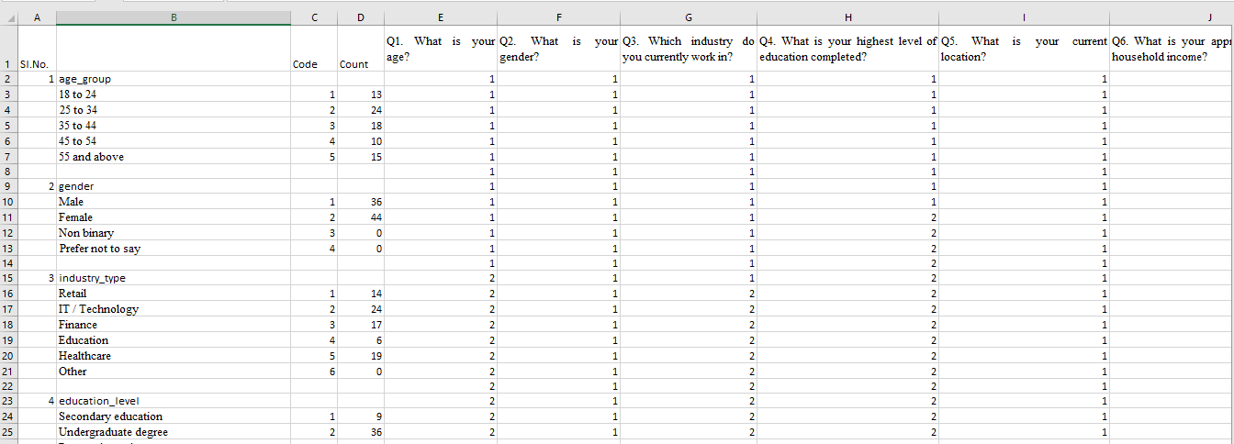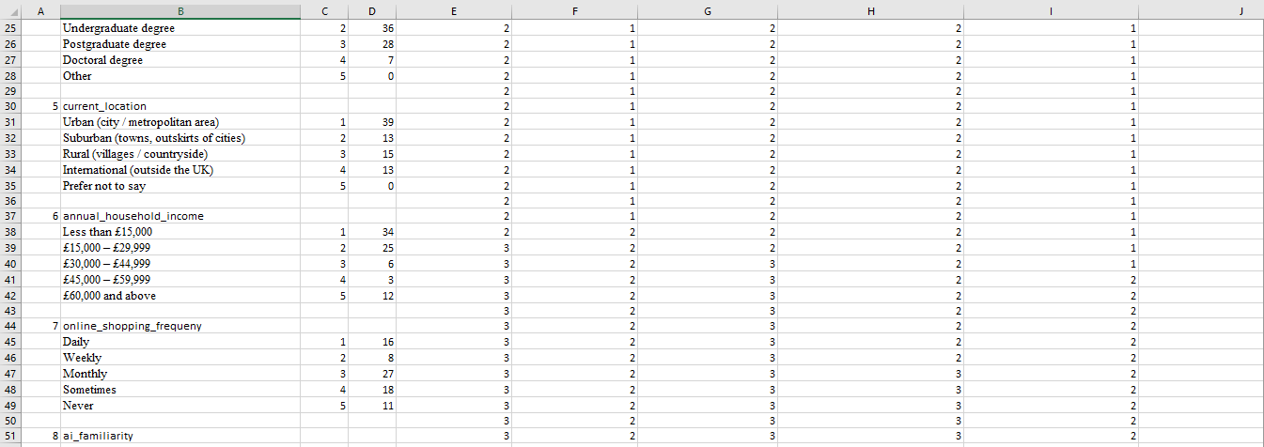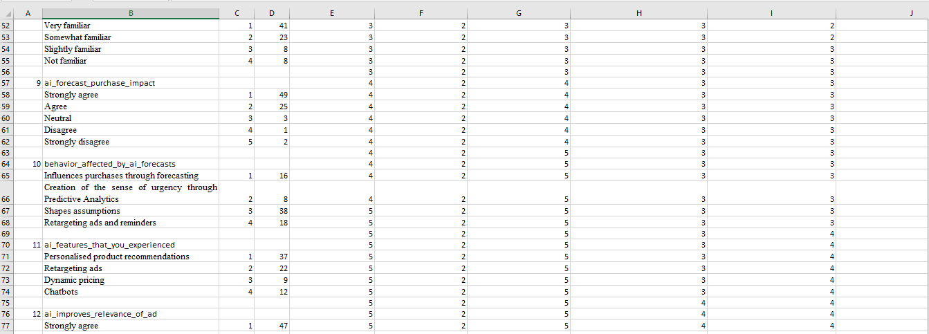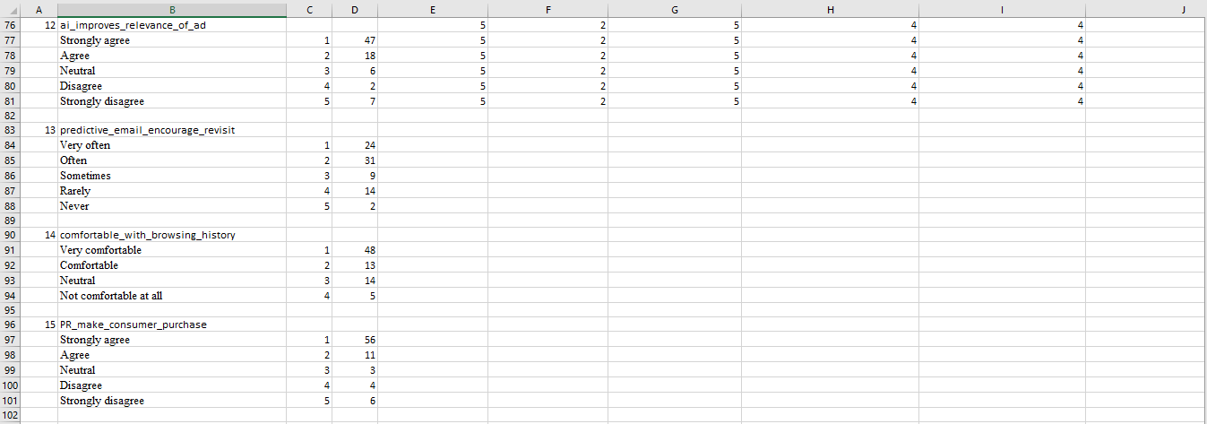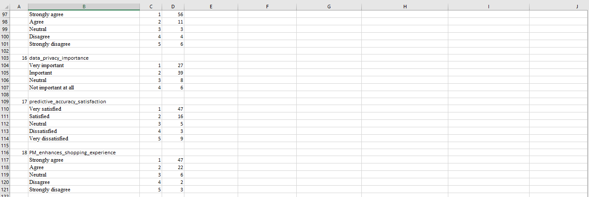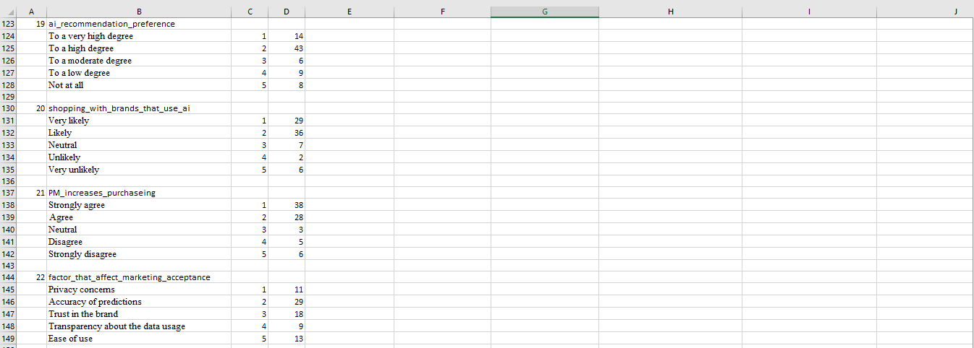

Appendix 3: Code Table


