Certificate of Higher Education in Skills for the Workplace (Health and Social Care)
Module: Psychology in Health and Social Care

Module code: BMHP4003
Lecturer: Diya Ganguly
Internal Verifier: Barbara Chinyani
Assignment Title: Component 2: Report
Name: Joao Pereira
Student Number: 2012063

Table of Contents
Introduction 3
Theory -Piaget’s Theory (1936) 3
Role of heath care practitioners 5
Reflection 7
Conclusion 8
References 9

Table of Figures
Figure 1 - 4 Stages of Cognitive Development
Figure 2 - Piaget’s Stages of Cognitive Development (2022)
Figure 3 - Self and other Carl Jung’s Theory of Personality Types Model
Figure 4 - Erikson’s 8 Stages of Psychosocial Development Theory

Introduction
This report will focus on critical discussion of ways in which psychological theories are applied to Health and Social Care Practice. Discussion will involve an evaluation of Piaget’s Theory of Cognitive Development theory. Furthermore report will explore my role as a health care professional in applying the learnt psychological perspectives which are essential as my duty of care. Lastly, a discussion how to relate this learning to my health and social care practise including my reflection on my future career.

Theory -Piaget’s Theory (1936)
Topic for my presentation was life stage – Infancy, applying Piaget’s Theory.
Jean Piaget was psychologist and one of the most influential figures in human development theories especially on child development. Jean Piaget pioneered a systematic study of the acquisition of understanding in children. His idea was shaped on the aspects that children passively build knowledge as they explore and manipulate the world around them calling a cognitive-development theory. He was intrigued that children provided wrong answers to questions to French intelligence tests, when he was working at Binet Institute in the 1920. (simplypsychology.org.2020)
Piaget studied following development and measure ability to count, spell or solve problems as a way of grading their I.Q on his three children at first. He was fascinated about the fundamental concepts like idea of recognition of a number, time, quality, causality or justice. Some studies were based on controlled observations of his own children as well as others where he has reported in his diary descriptions, charting their progress, current age and development. He has also evaluated his conversations with children, where he was asking them simple questions, revealing problems and at the end forming a picture of children way of viewing the world by analysing their mistaken responses. Piaget theory of cognitive development (1936) is structured with 4 stages of development. Before his final theory was put in place, Piaget has spent years on studying and developing the theme he has first discovered when working at Binet Institute in the 1920 - mind of a child evolves through a series of set stages to adulthood publishing more than 50 books and monograms in that field of science.

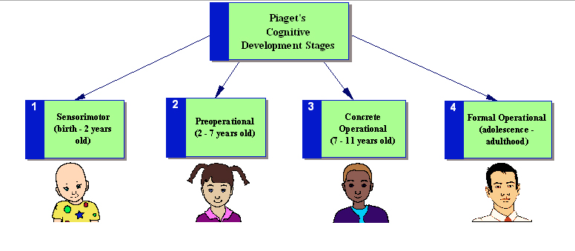
Figure 1 - 4 Stages of Cognitive Development
Source: www.educationaltechnology.net 4 Stages of Cognitive Development (2022)
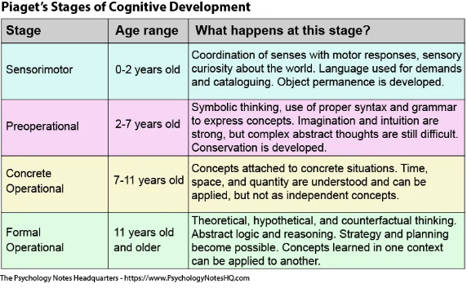
Figure 2 - Piaget’s Stages of Cognitive Development (2022)
Source: www.psychologynoteshq.com Piaget’s Stages of Cognitive Development (2022)
Stages presented above in health and social care practise is referred to as ‘staircase’ model. We can evaluate that each stage got a limitation quote to age this is because Piaget believed that all humans create their own understanding of the world. In theological terms Piaget was psychological constructivist. He based his evaluation on believing that learning is caused by the use of two processes: assimilation and accommodation.
Furthermore, Piaget divided set of assumptions about children’s intelligence:
- Children’s intelligence differs from an adult’s in quality rather than in quantity
- Children actively build up their knowledge about the world.
- The best wat to understand children’s reasoning was to see things from their point of view.
Source: www.simplypsychology.org (2022)

Role of heath care practitioners
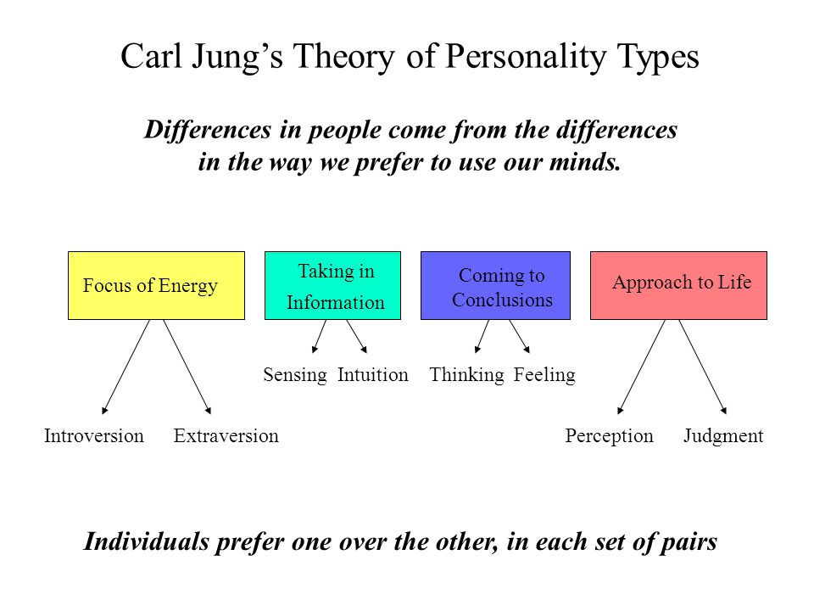
Figure 3 – Self and other Carl Jung’s Theory of Personality Types Model
Source: Presentation Resources Week 5: Self and Other. University of Wales (2022)
Working in health care or and wellbeing filed we need to first evaluate are we ready to become a health care professional. The above Figure 3 presents Cark Jung’s Theory of Personality Types. Each and every individual should consider self-personal evaluation in order to see if they are ready to undertake a course to become a health care professional and take responsibility to care for others.
Not in all cases people are able to work as a health care professional. There are many reason behind it, some individuals are not able to mentally cope with the responsibilities based on any past circumstances. In other situations people do not feel a need of care for others as they have chosen different career type or life style and some people are born to do this job and cannot imagine doing something else.
In Health and Social Care world all employees must value workplace philosophies that actively promote the dignity of everybody and recognise the necessity to challenge care that may reduce the dignity of the individual (Juth, 2013). In other word, the health and social care professional must understand how Equality Act 2010 applies to their work and how non-implementation can lead to severe consequences.
On one side Van Stolk et al (2009). NHS staff perception research stated that 80% of NHS staff believed that their health impacted on the quality of care that they could deliver. On the other side Department of Health (2009). NHS Health and Wellbeing stated that 40% of NHS staff believed that their employer proactively supported their health and wellbeing during their employment.
Theories are fundamental in the Health and Social Care field. According to Healey and Marchese (2012), the application of theories and the use of theories in health and social care help to guide future health and social care researches. Simple example when we go to see a doctor or nurse and we provide symptoms of what we feel, based on their previous experiences and research, studying theories while working for NHS they are able to help us and provide us with correct medication treatment. The application of theory-driven health and social care practice, will enables heath provider organisations and manager to address by issues and multiple factors influencing the practice (Engster, 2013)
Health and social care is a complex field to work in and one of the most important principles of each health care professional is to be able to correctly evaluate patient’s physical and mental needs. According to Maslow (1959), human beings are complex creatures who act upon all of these needs at the time. Maslow (1959) stated that if the bottom stages are not accomplished, there is less energy, motivation to push up on higher stages of the ladder. In this case the theory is used on health care professionals as well as on patients that they care for. We need to have a clear understanding that if health care professional wellbeing is balanced, patients that they taking responsibility for are cared well and recovering with a positive set of mind.
Piaget’s Cognitive development theory (1936) is the most popular theory that is used in health and social care field as it focus on all human stages of life development which we are all going through. Using his research and findings helps the current era reflect on changes in human development and the environment that is in.
It helps to shape patient’s needs and have a better understanding of what they child or adult see, feel, understand or experience. Health and social care professionals use the theory to measure their patient development. It allowed them to allocate their patient current stage of thinking and their ability to develop to achieve their future goal of recovery or more balanced mental wellbeing.
For further analysis health and social care professionals also reflect on Erikson’s Psychosocial Theory. Erikson’s Psychosocial Theory is based on the psychoanalytic approach to individual development. It focuses more on patient’s ability to deal with a sequence of crises throughout his lifespan. This way health care professionals are able to understand their patient’s view of how do they see themselves in society. Helps them to understand and get to know their personality which has been shaped since birth, during childhood and in their adult life by following 8 stages.
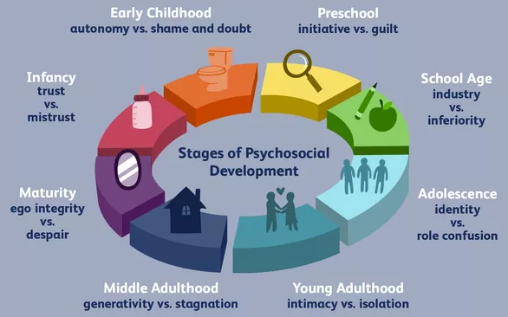
Figure 4 – Erikson’s 8 Stages of Psychosocial Development Theory
Source: www.verywellmind.com (2022)
Some health and social care professionals not always agree with the full concept of the theory as you will never be 100% of what exact type of the experiences are necessary to successfully resolve the conflicts and move to the next stage.

Reflection
My personal reflection on applying theories into health and social care is very important. Based on the previous findings and theories we are able to apply correct medical treatment on to our patients. We are able to reflect their medical history and analyse their symptoms and expand types of illnesses, diseases as well as develop more accurate medical or mental treatment without losing the patient life.
My future career will be a physiotherapist and knowing theories which helps to recognise different types of personalities as well as human development stages I believe I will be more affective in creating physiotherapy recovery treatment plans. Having wide knowledge of other factors that effects patients in their journey of recovery will allows me to understand their mental wellbeing and support them to find balance by setting a positive mind to their future as independent adult who does not have fear to fight to reach their full recover and set up goals.

Conclusion
In conclusion, this report allows reader to understand Piaget’s Cognitive development theory (1936) and all 4 stages that come with in. Evaluation of importance of uses the theories in health and social care employment world. View of health and social care professional what benefits of well balance wellbeing brings when it comes to provide high quality of care to towards patients. Role of heath care practitioners using the theories in real life situations and how effective the theories are when it comes to final evaluation and medical treatment.
Lastly, the report focuses on my personal reflection when it comes to my progress of becoming a physiotherapist in the future. My view of benefits of applying learned theories in patient examination as well as evaluation as a human. To improve the report in the future I would undertake a research by setting an interviews with health and social care professionals to listen and observe their experience and methods of how they apply the above mentioned theories.

References
Simplypsychology.org. 2022. [online] Available at: <https://www.simplypsychology.org/piaget.html> [Accessed 28 December 2021].
Encyclopaedia Britannica. 2022. Jean Piaget | Biography, Theory, & Facts. [online] Available at: <https://www.britannica.com/biography/Jean-Piaget> [Accessed 28 December 2021].
Kurt, S., 2022. Jean Piaget and His Theory & Stages of Cognitive Development - Educational Technology. [online] Educational Technology. Available at: <https://educationaltechnology.net/jean-piaget-and-his-theory-stages-of-cognitive-development/> [Accessed 5 January 2022].
The Psychology Notes Headquarters. 2022. The Jean Piaget Stages of Cognitive Development - The Psychology Notes Headquarters. [online] Available at: <https://www.psychologynoteshq.com/piagetstheory/> [Accessed 5 January 2022].
Eln.co.uk. 2022. 5 Useful tips for following the SMART criteria | ELN Blog. [online] Available at: <https://www.eln.co.uk/blog/5-useful-tips-following-smart-criteria> [Accessed 5 January 2022].
Assets.publishing.service.gov.uk. 2022. [online] Available at: <https://assets.publishing.service.gov.uk/government/uploads/system/uploads/attachment_data/file/277566/Narrative__January_2014_.pdf> [Accessed 5 January 2022].
Engster, D. (2013). The social determinants of health, care ethics and just health care. Contemporary Political Theory, 13(2), pp.149-167.
Healey, B. and Marchese, M. (2012). Foundations of health care management. 1st ed. San Francisco: Jossey-Bass.
2022. [online] Available at: <https://www.verywellmind.com/erik-eriksons-stages-of-psychosocial-development-2795740 05.01.2022> [Accessed 5 January 2022].
Moodle.uwtsd.ac.uk. 2021. UWTSD Moodle 2021/22:. [online] Available at: <https://moodle.uwtsd.ac.uk/course/view.php?id=6668> [Accessed 10 December 2022].

