
NATALIA PATRYCJA KOZAK

STUDENT NUMBER: 2505641

LECTURER: DANIEL HANURA
Moduel title: lchs4003 introduction to health and social care
ASSESSMENT TITLE: PORTFOLIO (COMPONENT 1- POSTER & ESSAY)

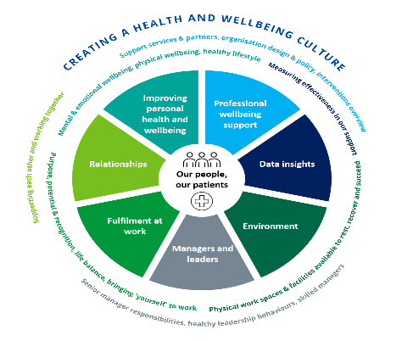
NHS Confederation (2026) The Mental Health Act 2025: what you need to know.
Current functioning
The “2014 care act” is a current legislation protecting individuals in England providing support, care and safeguarding. It involves assessments of an individual’s needs, provides independent advocates to support them, the support is there regardless of if said needs are likely to be eligible to ensure they live their lives the way they want.
The “Mental Health Act 2025” is currently a work in progress and is expected to be enforced within the next eight to ten years allowing a legal framework to detain and treat people with mental health issues who are at risk of harming themselves or others. This will ensure a better approach with supporting individuals, improving their environments and creating more opportunities for them to have a say in their own care and to “challenge decisions”.
Mental health support has started to move towards community based and “socially informed” care. Where many day to day factors contribute to the mental health issue within the community, including: financial difficulty, trauma, housing issues, discrimination and isolation. “The Community Mental Health Framework for adults and older adults in England, promotes integrated and place-based care that is responsive to the full spectrum of an individual’s needs.” Ensuring everyone receives support regardless of their circumstances showing no discrimination which creates a safe space for vulnerable individuals. As Cheney, C.
Community mental health services provide tailored mental health care needs as close to home as possible.
These include support with: NHS England » Community mental health services
-Psychological therapies for people with severe mental health problems (PT-SMHP)
- Individual Placement and Support (IPS)
- Adult Eating Disorders Guidance: Community, Inpatient and Intensive Day Patient Care
- Early Intervention in Psychosis (EIP)
- Improving physical health care for people with severe mental illness (SMI)
- suicide prevention
- Suicide bereavement support
Community mental health care services

Community mental health care services are a part of one big team within the NHS working together to help people with their mental health.
Psychiatrists, psychologists, community psychiatric nurses, social workers, and occupational therapists are all a part of peoples journeys to a healthy life.
Primary care is often introduced vis GP, where individuals can receive therapy from local psychological therapists.
Secondary care is the next level of care which includes community and hospital car, this can be voluntary or detained under the mental health act.
Tertiary care is specialist care within the NHS, covering specialist community and hospital care with assertive outreach teams and specialist national services.

NHS England: community mental health services.

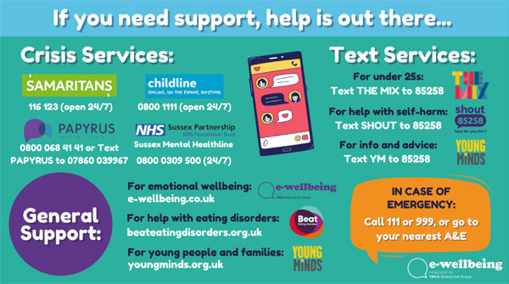
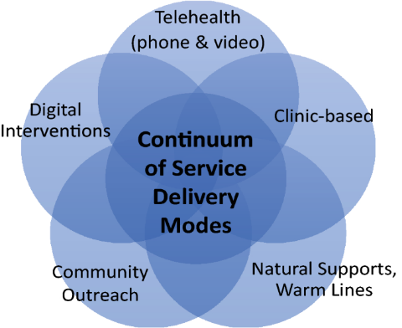
Rethink Mental Illness (2024) NHS mental health teams.
Challenges:
Although mental help support is encouraged one of the main challenges faced by health care services is that there is simply not enough resources to help everyone immediately, resulting in much longer wait than deemed acceptable, with latest estimates of 1.7 million (2025) people on mental help waiting lists. This could result in individual mental health deteriorating even more before being seen and in some cases harm to themselves or others.
Another challenge that mental health services are struggling with is the funding. There is evidence supporting that the NHS is financially supported in regards to mental health services however it is not receiving enough funds to keep up with the demand. It is shown that the funding on mental health has increased at a slower rate than the rest of NHS services and the budget spent on mental health has also fallen since 2016/201. This results in with many individuals still not receiving the proper care they require leading to issues as stated above; mental health deteriorating and potential harm.
Cheney, C. (2025) 'Local Authorities: Leaders in Community Mental Health', GOV.UK
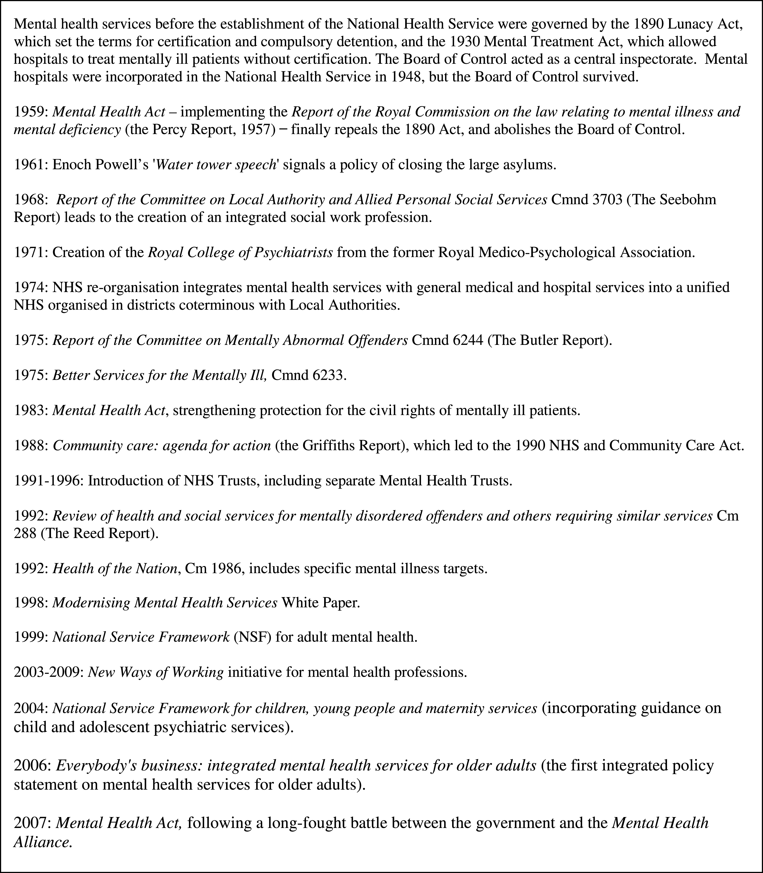
Social care institute for excellence (no date) Assessment of needs under the Care Act 2014.

BMA (no date) Mental health pressures in England
History:
Mental health services have always been developing policies going as far back to the “1959 mental health act” and the “1962 hospital plan” introducing wider psychiatric care into the system, followed by further years of development and continuing with “1975 better services for mentally ill” the shift from large institutions to more locally based services. Between “1997–2010 Labour governments increased spending on mental health” increasing the importance of mental health and declaring it one of three main priorities along with cancer treatments and heart disease. The “2007 mental health act” is introduced after a long debate between the government and the mental health care institutions which reforms the “Mental Health Act 1983”, now there is a compulsory hospitalisation and practice introduced for individuals suffering with severe mental health issues preventing them from causing harm to themselves and to others.
Further continuation of policy changes and developments occur as the years go by where currently the “2014 care act” is in place with an individual’s needs for care and support and a carer’s needs for support.
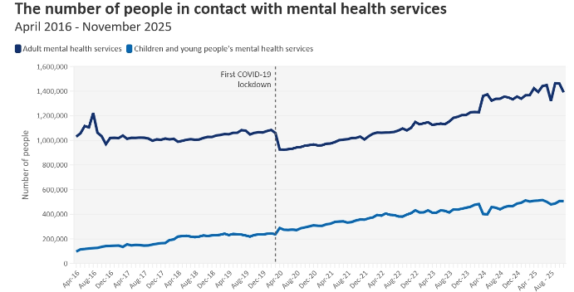
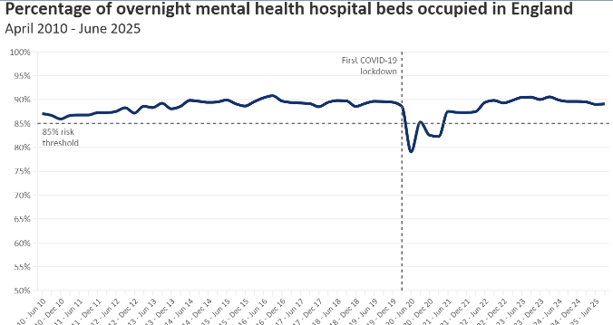

Turner, J. et al. (2015) 'The History of Mental Health Services in Modern England: Practitioner Memories and the Direction of Future Research', Medical History, 59(4), pp. 599-624.
Glover-Thomas, N. (2011) 'THE AGE OF RISK: RISK PERCEPTION AND DETERMINATION FOLLOWING THE MENTAL HEALTH ACT 2007', Medical Law Review, 19(4), pp. 581-605.
TASK 2- ESSAY AMBULACE SERVICES

Ambulance services are an important part in the healthcare system as we know today. They provide transportation to individuals needing urgent medical care. They are an important part of the National Health Services (NHS) saving lives daily. This essay will explore the origins of ambulance services and the historical context that shaped its development, as well as critically evaluate how the services function today and finally discuss their significance in enhancing the quality of life of their service users.

Looking back as far as to WW2 is when auxiliary ambulance service was first introduced, formed by women as part of the “Government’s civil defence service”. A wooden ambulance was used to rescue women and children trapped allowing them to be recused from danger by many fearless women. Following after the war has finished a “National Health Service Act 1948” was introduced requiring ambulances to be available for those who needed them. Beginning with ambulance services in London and improving as the years went by, by 1965 it consisted of 1000 vehicles and over 2500 staff members. Ambulance services have moved from council-run to NHS, with great improvements taking place as time passed by, including helicopter transportation, the first defibrillator in an ambulance and a move in technology allowing call handlers record patient status. Finally, leading to the 21st century where ambulances are accessible to everybody who needs them with no cost, brining more advanced services and transportation options with over 6000 calls being answered daily on a busy day to meet the publics crisis described by the London Ambulance Services NHS (no date) Our history.

Ambulance services in the UK today are successful in what they do, prioritising cases by severity. Calls for emergencies are answered by 999 operators who can assess the category of a call. There are 4 categories of severity, which include the first one being calls which can indicate life threatening emergencies such as cardiac arrest where the average response time is aimed to be 7 minutes. The second category is for emergencies such as epilepsy, burns or strokes with an average response time being 18 minutes. The third category diabetes, non-severe burns or late stages of labour which can take up to 2 hours for an emergency service to arrive. Finally, the fourth category is less severe emergencies such as vomiting, or urine infections with response times that could take up to 3 hours. These categories are important as they are what call handlers look for to asses the severity of the situation and ensure emergency services are distributed to maximise the resources and ensure individuals lives are not put in severe risk as supported by the UK Parliament (20/2/2025) Ambulance service response times.

Ambulance services significantly enhance the quality of life or service users by providing them with fast and professional medical care at thee comfort of one phone call which could be a life of death situation. Looking at response times from the call to the time or arrival at scene it is proven that many cases of cardiac arrest have been effectively delt with on scene reducing mortality rates and reducing long-term issues, the faster the intervention the better the recovery process and prevention of permanent damage supported by East of England Ambulance Services (no date) Ambulance Clinical Quality Indicators.

In conclusion, ambulance services have developed a significant amount from as early as WW2 becoming an important part of individuals day to day lives when in need of an emergency. Providing efficient interventions and professional quality of care with great precision allows to improve the quality of life of those who need it and their communities.

References:

BMA (no date) Mental health pressures in England. Available at: Mental health pressures data analysis (Accessed: 12/2/2026).

Cheney, C. (2025) 'Local Authorities: Leaders in Community Mental Health', GOV.UK, 10/10/2025. Available at: Local Authorities: Leaders in Community Mental Health – Social work with adults (Accessed: 20/2/2026).
East of England Ambulance Services (no date) Ambulance Clinical Quality Indicators. Available at: Ambulance Clinical Quality Indicators | EEAST (Accessed: 20/2/2026).

Glover-Thomas, N. (2011) 'THE AGE OF RISK: RISK PERCEPTION AND DETERMINATION FOLLOWING THE MENTAL HEALTH ACT 2007', Medical Law Review, 19(4), pp. 581-605.

London Ambulance Services NHS (no date) Our history – a timeline. Available at: Our history - a timeline - London Ambulance Service NHS Trust (Accessed: 20/2/2026).

NHS England (no date) Community mental health services. Available at: NHS England » Community mental health services (Accessed: 2/2/2026).

NHS Confederation (2026) The Mental Health Act 2025: what you need to know. Available at: The Mental Health Act 2025: what you need to know | NHS Confederation (Accessed: 20/2/2016).

Rethink Mental Illness (2024) NHS mental health teams. Available at: NHS mental health teams - Community, crisis, and early intervention support (Accessed: 12/2/2026).

Social care institute for excellence (no date) Assessment of needs under the Care Act 2014. Available at: Assessment of needs - SCIE (Accessed: 12/2/2026).

Turner, J. et al. (2015) 'The History of Mental Health Services in Modern England: Practitioner Memories and the Direction of Future Research', Medical History, 59(4), pp. 599-624.

UK Parliament (20/2/2025) Ambulance service response times. Available at: Ambulance service response times - House of Commons Library (Accessed: 20/2/2026).

