Student Name: Elena Madalina Vilceanu  Student ID: 1815431  Module Title: Foreign Languages and Cultural Awareness  Module Code: BMIH5003  Lecturer: Lisa Bassler  Date: 08/02/2024 | 
ASSIGNMENT 1: PORTFOLIO
(4 Components)

Component 1: Professional Reflection (500 words +/- 10%)

Weighting: 25%
Communication is essential for maintaining professionalism and a frictionless experience for customers on which the hospitality industry mainly relies. Keeping the visitors satisfied is the ultimate key objective of the hospitality industry regardless of their cultural differences or native values, especially the languages. Advertisements for clear understanding and a user-friendly booking system are possible when we emphasise the development of effective communication and embrace different languages and cultures. The hospitality industry stands as a melting pot comprising all cultures, hence comprising teams with diverse backgrounds. I can understand the fostering of adaptations of cultures and its significance within my team as a director of operations in the hotel. I found an inclusive and harmoniously diversified hospitality industry is not just on the checklist of HR but requires a commitment profoundly to leadership management and overcoming challenges of cultural barriers. I have empirically emphasised the challenges, such as the mitigation of cultural differences within the hospitality industry, which needs a pragmatic approach.
Acknowledgement of challenges is my first step before implementing strategies such as, training of cultural sensitivity, channels of effective communication and guidelines of clear leadership. As a leader in the hospitality sector, you can easily and fairly promote understanding and working towards a common objective of the hospitality industry. Foreign language in the context of hospitality is of prime importance while building up communication between non-English speaking employers and employees. As I have observed the increased international tourist footfall from all regions of the world, it simultaneously increased the urge for hiring diversified staff from all across the world. For me, operating a hotel is one of the fantastic journeys; however, it demands staying on your toes because of the continuous evolution in the landscape of hospitality. Staying ahead in the dynamic industry is about understanding the changes in the behaviour of the guests. I have profoundly addressed the keys of staying dynamic in hospitality as the vital component to understanding the behaviour of the guest transforming with the passage of time. Undergoing the profound changes, does the behaviour of consumers and transformation have an impact on hotels significantly?
Being a director in the hotel industry, I have seen a remarkable change in customer behaviour, where the guests do not just look for the room facilities; they prefer to be entertained with a seamless and personalised experience. They look for a user-friendly, frictionless and exceptional experience from the moment they start searching hotels for their bookings. Meeting these expectations of customers shapes the image of the hotel through online interactions, referrals and word of mouth from previous experiences. The basic knowledge about different cultures while interacting with your customers is defined as cultural awareness, which is an integral part of the success of the hotel industry. The positive impact and advantages of having a manager who appreciates diversified staff recruitment can be supportive of managing customers who have different cultural backgrounds. If I self-reflect and share my expectations as a customer, I would appreciate and seek the manager and staff to welcome me and respect my cultural values, differences and beliefs.
References:
García-Rodríguez, F.J., Dorta-Afonso, D. and Gonzalez-de-la-Rosa, M., 2020. Hospitality diversity management and job satisfaction: The mediating role of organizational commitment across individual differences. International Journal of Hospitality Management, 91, p.102698.
Manoharan, A., Madera, J.M. and Singal, M., 2021. Walking the talk in diversity management: Exploring links between strategic statements, management practices, and external recognition. International Journal of Hospitality Management, 94, p.102864.
Mistry, T.G., Okumus, F. and Orlowski, M., 2023. Employee perceptions of diversity management in the hospitality industry. International Hospitality Review, 37(2), pp.265-285.
Nguyen, N.T., Yadav, M., Pande, S., Bhanot, A. and Hasan, M.F., 2022. Impact of diversity management on organizational performance in hotel organizations: a conceptual framework. International Journal of System Assurance Engineering and Management, pp.1-11.
Ntalakos, A., Belias, D., Koustelios, A. and Tsigilis, N., 2022, May. Organizational culture and group dynamics in the tourism industry. In International Conference on Tourism Research (Vol. 15, No. 1, pp. 286-293).

Component 2: Training Plan (500 words +/- 10%)

Weighting: 25%

Identified cultural misunderstanding (in a few words) :
The present world is globalised, and organisations are recognising their working environment as diversified as possible to reach the heights of successful business development. The importance of training plans which are programed for cross-cultural training, are fostering communication and collaboration effectively among the diversified teams. Diversification and globalisation of international operations in business, as well as appreciation and understanding of multiple cultures, are critical points for running the hospitality sector successfully. There are ten well-defined steps to analyse while planning and developing effective training to foster diversified and cross-cultural training for hotel management staff.
Training plan (Why/What//Who/Where/When):

Step 1 Assessing the Culture of Organisation
Assessment of the organisation's culture is essential before designing cross-cultural training. Because assessment of the culture of an organisation provides comprehensive information and valuable insights into the behaviours, norms, and values as part of that industry, to assess the culture, several tools such as interviews, surveys, or feedback observation can assist in gathering the relevant data. Analysing this data helps to fetch the areas for improvement, as one study revealed that Human Resource Management conducted the study for Society (SHRM) that 94% of professionals in HR believed that a strong culture of organisation is critical to making a business successful.

Step 2 Identifying the Requirements of Training
The culture of the organisation, once assessed, can now redirected towards the identification of key points and factors required to be added to the training program. These factors would be based on the awareness of cross-cultural training prerequisites to improve the significance and benefits of the training. Moreover, the determination of key challenges for the cultural context, which employees are facing and areas where the competence of culture can be improved. Analysing the feedback of the employee, data performance and incidents of intercultural aid in the identification of needs accurately. McKinsey and Company's report has revealed that diversity with teams executively is 33% likely to outperform in profitability with their peers.

Step 3 Partnering with Consultancy with an Organisational Culture
Developing cross-cultural training programs is essential for organisations which might consider partnering with the culture of an organisation consultancy or firm of corporate culture consulting. The experts the invaluable resources or guidance tailored to the specific organisation’s requirements and customised solutions in the training (dos Santos et al., 2020).

Step 4 Clarified Objectives
Dividing in the design of the training program, it is crucial to establish clear objectives and rationale for the training. Competencies of specific cultures are there for need of development which settles up measurable goals to assist in the evaluation of effectiveness in the long term of the program. A survey by the Institute for Corporate Productivity (i4cp) reveals that around 68% of organisations improved their culture with inclusion programs and formal diversity (Jhaiyanuntana and Nomnian, 2020).

Step 5 Training Content Designed and Engaged
The success of a training program is largely dependent on the content quality, hence, developing engagement, interaction and relevant materials for training is addressed by identifying requirements. These materials have included case studies, videos, role-plays and examples that support understanding of cross-cultural facilitation and communication (Chwialkowska, 2020).

Step 6 Learning while Incorporating Experience
Learning with experience is a technique which is powerful enough to enhance the awareness of cross-cultural training. Activities which include simulations, immersion and cross-cultural exchanges can provide insights first hand to the participants to analyse multiple cultures and assist them in the development of adaptability and empathy. The study revealed experiential learning which improves retention which rates up to 90% compared to methods of traditional training (Shadiev et al., 2021).

Step 7 Delivering Multiple formatted training
To facilitate different styles and preferences in learning, it is significant to deliver training programs of cross-cultural through several formats. This includes the workshop of in-person, virtual sessions of training, mentoring, ongoing coaching and e-learning modules. Providing the delivery flexibility format which ensures wider engagement and participation. The Global Workplace Analytics report has stated that remote work has increased up to 159% since 2005 (Shadiev et al., 2021).

Step 8 Cross-cultural communication promotion
In the heart of communication, cross-cultural interactions play a vital role and the training program emphasises active listening, cues of non-verbal communication and adaptation of styles of communication in different cultural contexts. The participants share their challenges and experiences which fosters an environment of learning and open dialogue (dos Santos et al., 2020).

Step 9 Evaluating and Assessing Effective Training
Evaluation of training programs is essential regularly, to gauge the effectiveness and improvement of the program. feedback collection from participation through the interviews of surveys which analyse the indicators of key performance to measure the impact on the behaviour of employees and the overall culture of the organisation. Deloitte’s study revealed that effective programs of training have 218% higher income per employee, than ineffective training programs (Chwialkowska, 2020).

Step 10 Reinforcement for Continuous Improvement
Cross-cultural training should be an ongoing process rather than an event of a single time. Continuous learning is encouraged and reinforcement of competency is through the follow-up sessions, which are mentoring, ongoing coaching and integration of awareness of cross-cultural into the evaluation of performance initiatives (Marneros et al., 2020).
References:
Chwialkowska, A., 2020. Maximizing cross-cultural learning from exchange study abroad programs: Transformative learning theory. Journal of Studies in International Education, 24(5), pp.535-554.
dos Santos, R.A., Méxas, M.P., Meirino, M.J., Sampaio, M.C. and Costa, H.G., 2020. Criteria for assessing a sustainable hotel business. Journal of Cleaner Production, 262, p.121347.
Jhaiyanuntana, A. and Nomnian, S., 2020. Intercultural communication challenges and strategies for the Thai undergraduate hotel interns. PASAA: Journal of Language Teaching and Learning in Thailand, 59, pp.204-235.
Marneros, S., Papageorgiou, G. and Efstathiades, A., 2020. Identifying key success competencies for the hospitality industry: the perspectives of professionals. Journal of Teaching in Travel & Tourism, 20(4), pp.237-261.
Pham, N.T., Vo-Thanh, T., Shahbaz, M., Huynh, T.L.D. and Usman, M., 2020. Managing environmental challenges: Training as a solution to improve employee green performance. Journal of Environmental Management, 269, p.110781.
Shadiev, R., Wang, X. and Huang, Y.M., 2021. Cross-cultural learning in virtual reality environment: facilitating cross-cultural understanding, trait emotional intelligence, and sense of presence. Educational Technology Research and Development, 69(5), pp.2917-2936.
Ushakov, R.N., Kryukova, E.M., Khetagurova, V.S., Mukhomorova, I.V. and Zelenov, V.V., 2020. Efficiency of hotel management. Training of specialists in hotel industry field. Journal of Environmental Management & Tourism, 11(2 (42)), pp.388-395.
Yu, Y., Xu, S., Li, G. and Kong, H., 2020. A systematic review of research on abusive supervision in hospitality and tourism. International Journal of Contemporary Hospitality Management, 32(7), pp.2473-2496.

Component 3: Student Self-Reflection (500 words +/- 10%)

Weighting: 25%
Being a part of a cultural training program has provided me with the opportunity to see people as human capital rather than an expendable resource. I have gained insight into different cultures and learned about multiple differences. Because of globalisation, hotels are confronting cultural diversity and striving to overcome challenges coming along with diversification (Chwialkowska, 2020). The constantly evolving industry of hotel management is benefitted by the recruiting of people with culturally different backgrounds which is not only improving the communication with outsiders. Training has given me the attraction, retention and promotion of my position during interaction with demographic groups which has sent potential learning and flexibility according to the behaviour of customers. I explored cross-cultural training as a critical factor which has helped in forming a workforce which is dedicated to the hotel and loyal guests. The training also helped me in the development of an understanding of the host countries which interstate behave and culture according to their colleagues (Shonfeld et al., 2021). Moreover, I also treated customers from different cultures in a flexible and adaptable manner after training, which developed an inclusive environment in the hotel.
This particular cross-cultural type of training has highly increased the joining of employees and also added it as one of the subjects as part of the curriculum which leads to undergraduate hotel management students (Kerrigan et al., 2020). The significant context of foreign languages has been highlighting the leaders in the environment international who should be given the incentives of foreign languages to consider the cosmopolitans. I have learned the dominant language used in the hospitality sector is English. The industry of hospitality with the skills of language which are required for the reasons, to provide information or person and answer questions which deal with the guest's demands (Botelho and Lima, 2020). The curriculum of the training program was well evaluated by the professionals and I acknowledged the curriculum as strategic as possible (Majda et al., 2021). I learned the methods of adding reinforcement of a welcoming and inclusive environment in the hotel industry. In addition, the topic or subject as part of a hotel management student helped me to understand the subject, particularly from the level of root and the initial phase of my career.
I have improved several aspects of my communication skills, especially when listening to people from different cultural backgrounds. The non-verbal cues I have learned which leave a long-lasting impression on the customers were also part of the curriculum of the training program (Karlgren et al., 2020). I have always preferred the visual and experiential cues for the best learning and the cross-cultural training program helped me to get insight into the multiple cultures across the world. In a nutshell, hospitality is emerging as the most influential industry which represents the culture and hospitality of that particular destination, along with the understanding and inclusive attitude of the people visiting from different cultures (Chuang, 2021). Training program has empowered me yet requires improvement on the part of consumers changing behaviours and coping with these rapidly evolving customers’ behaviours and preferences.
References:
Botelho, M.J. and Lima, C.A., 2020. From cultural competence to cultural respect: A critical review of six models. Journal of Nursing Education, 59(6), pp.311-318.
Chuang, S., 2021. The applications of constructivist learning theory and social learning theory on adult continuous development. Performance Improvement, 60(3), pp.6-14.
Chwialkowska, A., 2020. Maximizing cross-cultural learning from exchange study abroad programs: Transformative learning theory. Journal of Studies in International Education, 24(5), pp.535-554.
Karlgren, K., Lakkala, M., Toom, A., Ilomäki, L., Lahti-Nuuttila, P. and Muukkonen, H., 2020. Assessing the learning of knowledge work competence in higher education–cross-cultural translation and adaptation of the Collaborative Knowledge Practices Questionnaire. Research Papers in Education, 35(1), pp.8-22.
Kerrigan, V., Lewis, N., Cass, A., Hefler, M. and Ralph, A.P., 2020. “How can I do more?” Cultural awareness training for hospital-based healthcare providers working with high Aboriginal caseload. BMC Medical Education, 20, pp.1-11.
Majda, A., Zalewska-Puchała, J., Bodys-Cupak, I., Kurowska, A. and Barzykowski, K., 2021. Evaluating the effectiveness of cultural education training: Cultural competence and cultural intelligence development among nursing students. International Journal of Environmental Research and Public Health, 18(8), p.4002.
Shonfeld, M., Cotnam-Kappel, M., Judge, M., Ng, C.Y., Ntebutse, J.G., Williamson-Leadley, S. and Yildiz, M.N., 2021. Learning in digital environments: a model for cross-cultural alignment. Educational Technology Research and Development, pp.1-20.

Component 4: Training Presentation (6 Slides)

Weighting: 25%
Cross-cultural training programs have assisted individuals in navigating and understanding the differences in culture in the hotel industry (Jung et al., 2021). The program is designed to increase knowledge, cultural awareness and skills to promote communication effectively while interacting with people from the backgrounds of different cultures.
There are 10 well-defined steps to analyse while planning and developing effective training to foster diversified and cross-cultural training for hotel management staff.
Assessment of the organisation’s culture is essential before designing cross-cultural training (Jin, 2023).
Human Resource Management for Society (SHRM) 94% of professionals in HR believed that a strong culture of organisation is critical to making a business successful (Din et al., 2023).
The culture of the organisation once assessed, can now redirected towards the identification of key points and factors required to be added to the training program.
McKinsey and Company’s report has revealed that diversity with teams executively is 33% likely to outperform in profitability with their peers (Wang et al., 2023).
Developing cross-cultural training programs is essential for organisations which might consider partnering with the culture of an organisation consultancy.

Dividing in the design of the training program, it is crucial to establish clear objectives and rationale for the training.
A survey by the Institute for Corporate Productivity (i4cp) reveals that around 68% of organisations improved their culture with inclusion programs and formal diversity (Green et al., 2023).
The success of the training program is largely dependent on the content quality.
Hence, developing engagement, interaction and relevant materials for training is addressed by identifying requirements.
Learning with experience is a technique which is powerful enough to enhance the awareness of cross-cultural training.
Experiential learning improves retention which rates up to 90% compared to methods of traditional training (Hong, 2021).

facilitate different styles and preferences in learning, it is significant to deliver training programs of cross-cultural through several formats.
The Global Workplace Analytics report has stated that remote work has increased up to 159% since 2005 (Ha et al., 2020).
Cross-cultural interactions play a vital role and the training program emphasises active listening, cues of non-verbal communication and adaptation of styles of communication in different cultural contexts.

Evaluation of training programs is essential regularly, to gauge the effectiveness and improvement of the program.
Deloitte’s study revealed that effective programs of training have 218% higher income per employee, than ineffective training programs (Laukka and Elfenbein, 2021).
Cross-cultural training should be an ongoing process rather than an event of a single time.
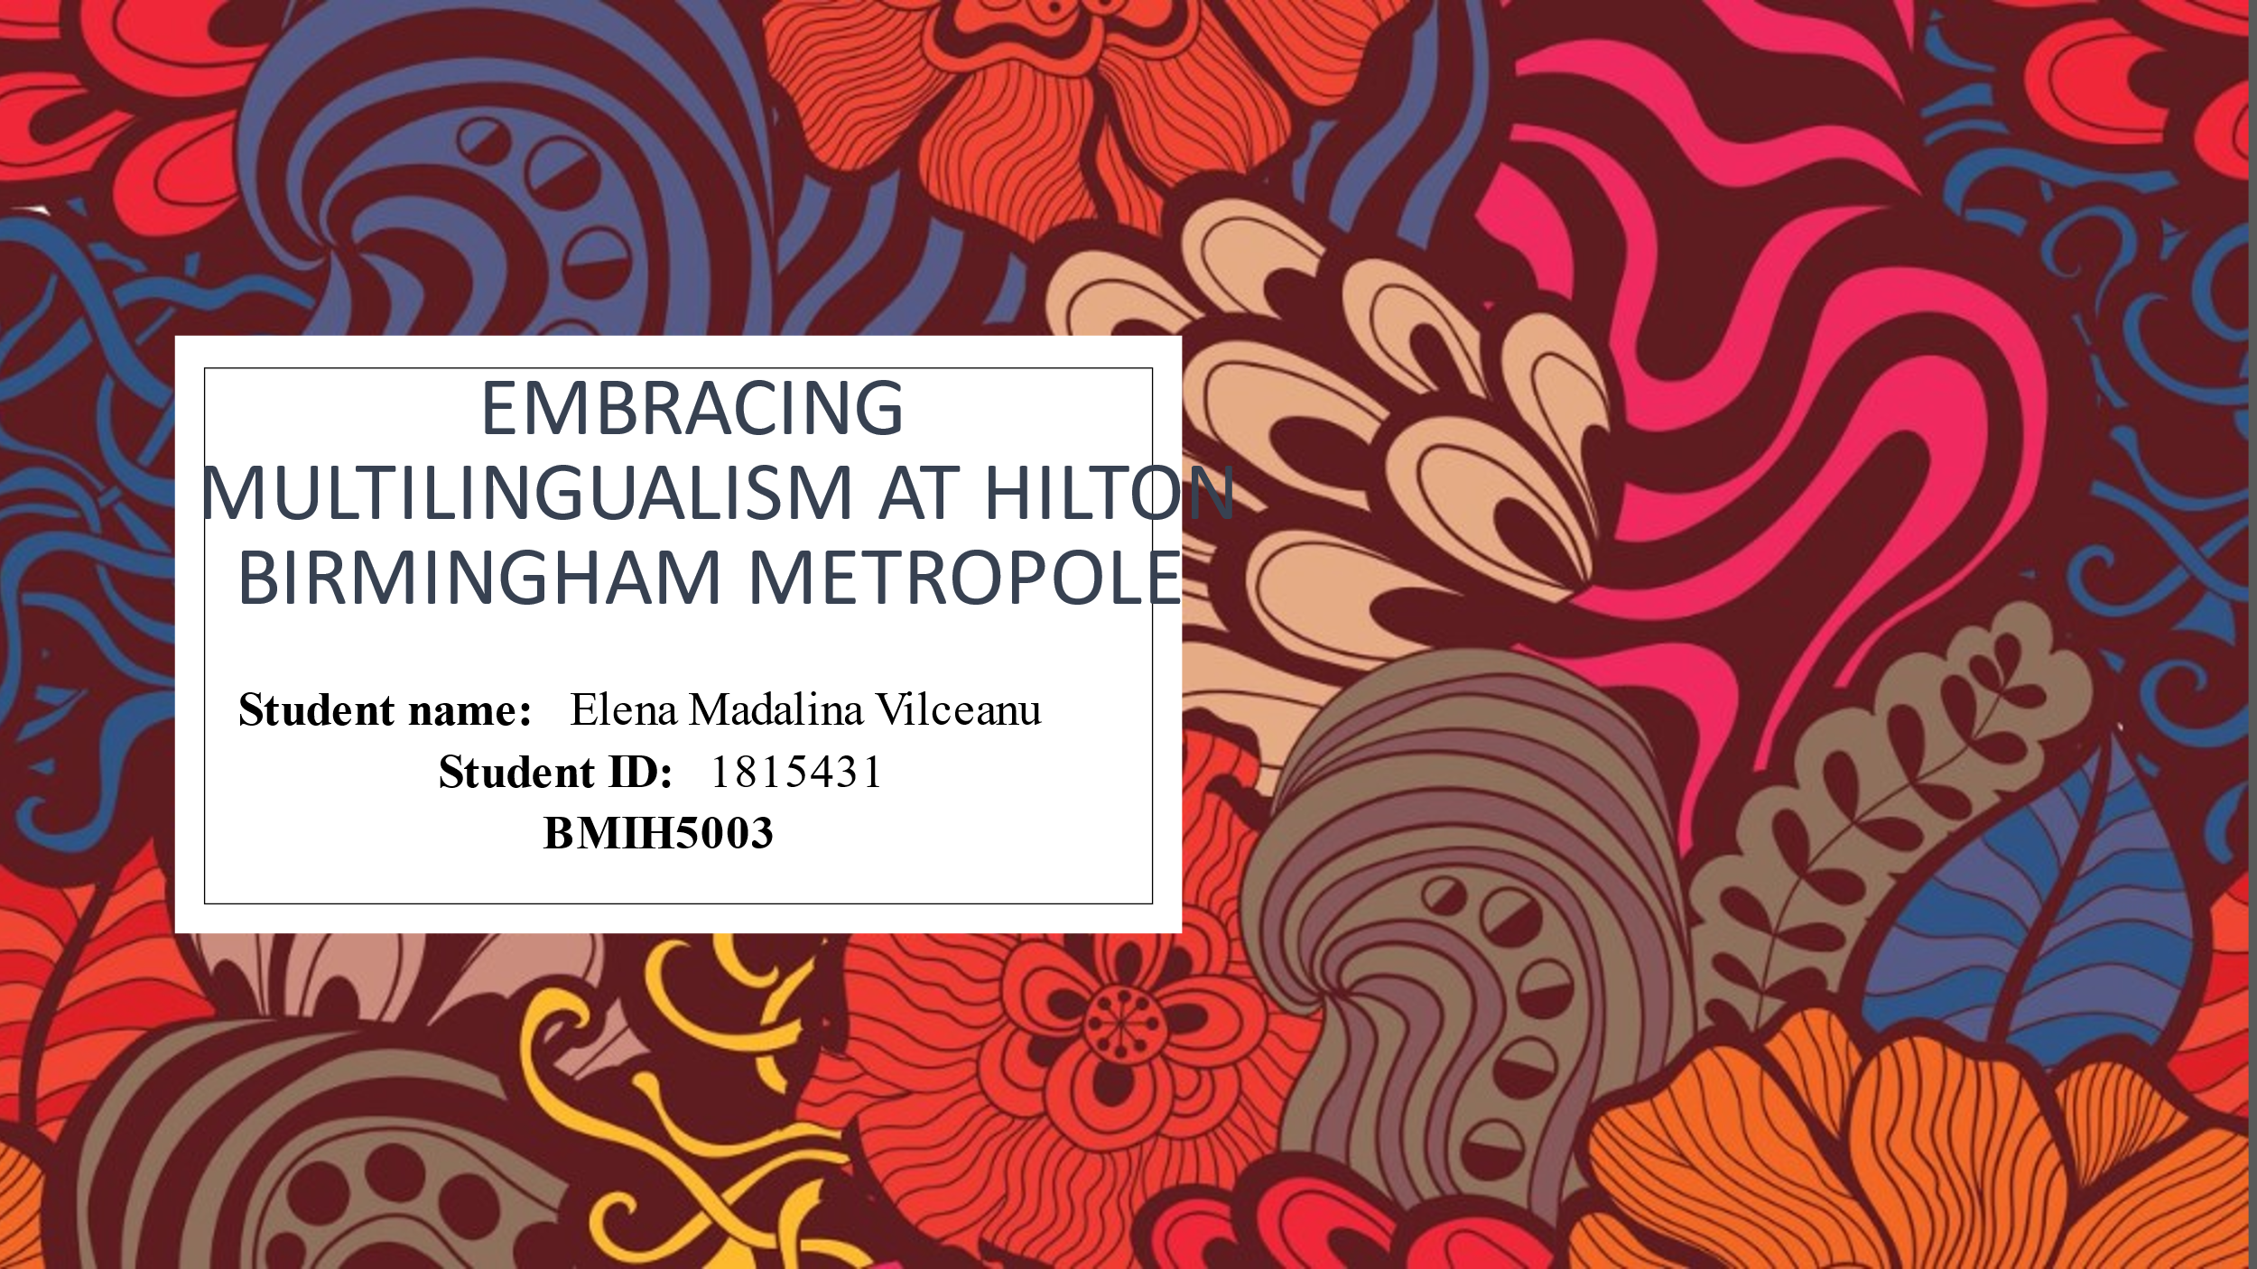
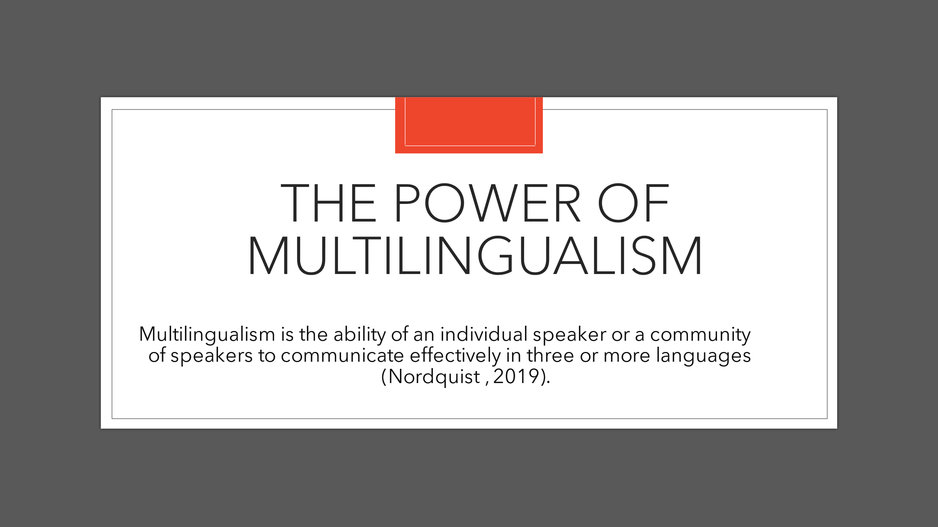
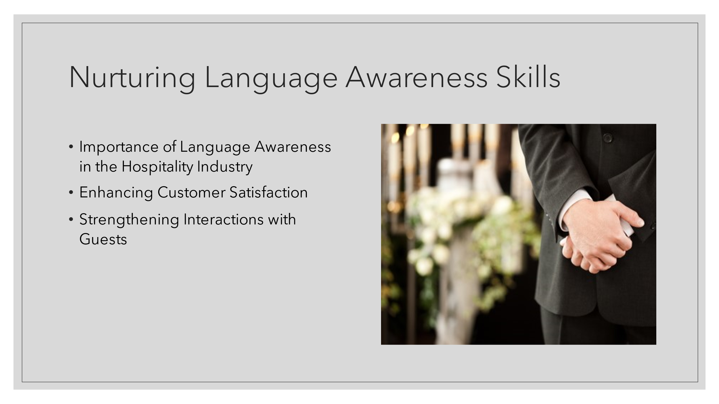
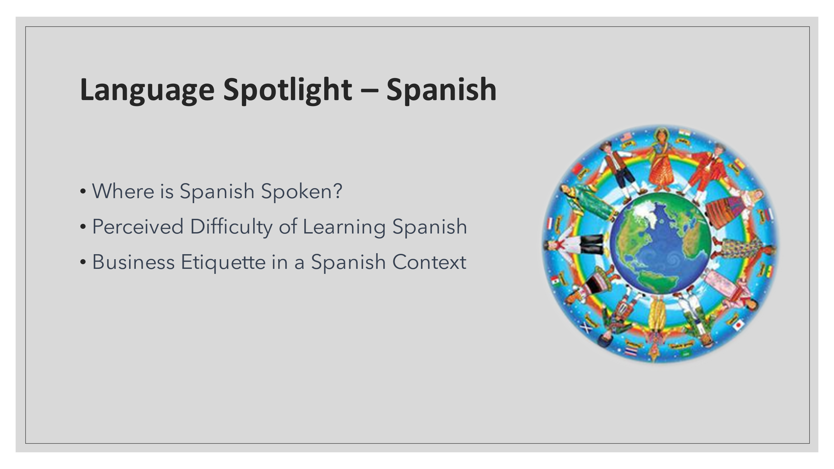
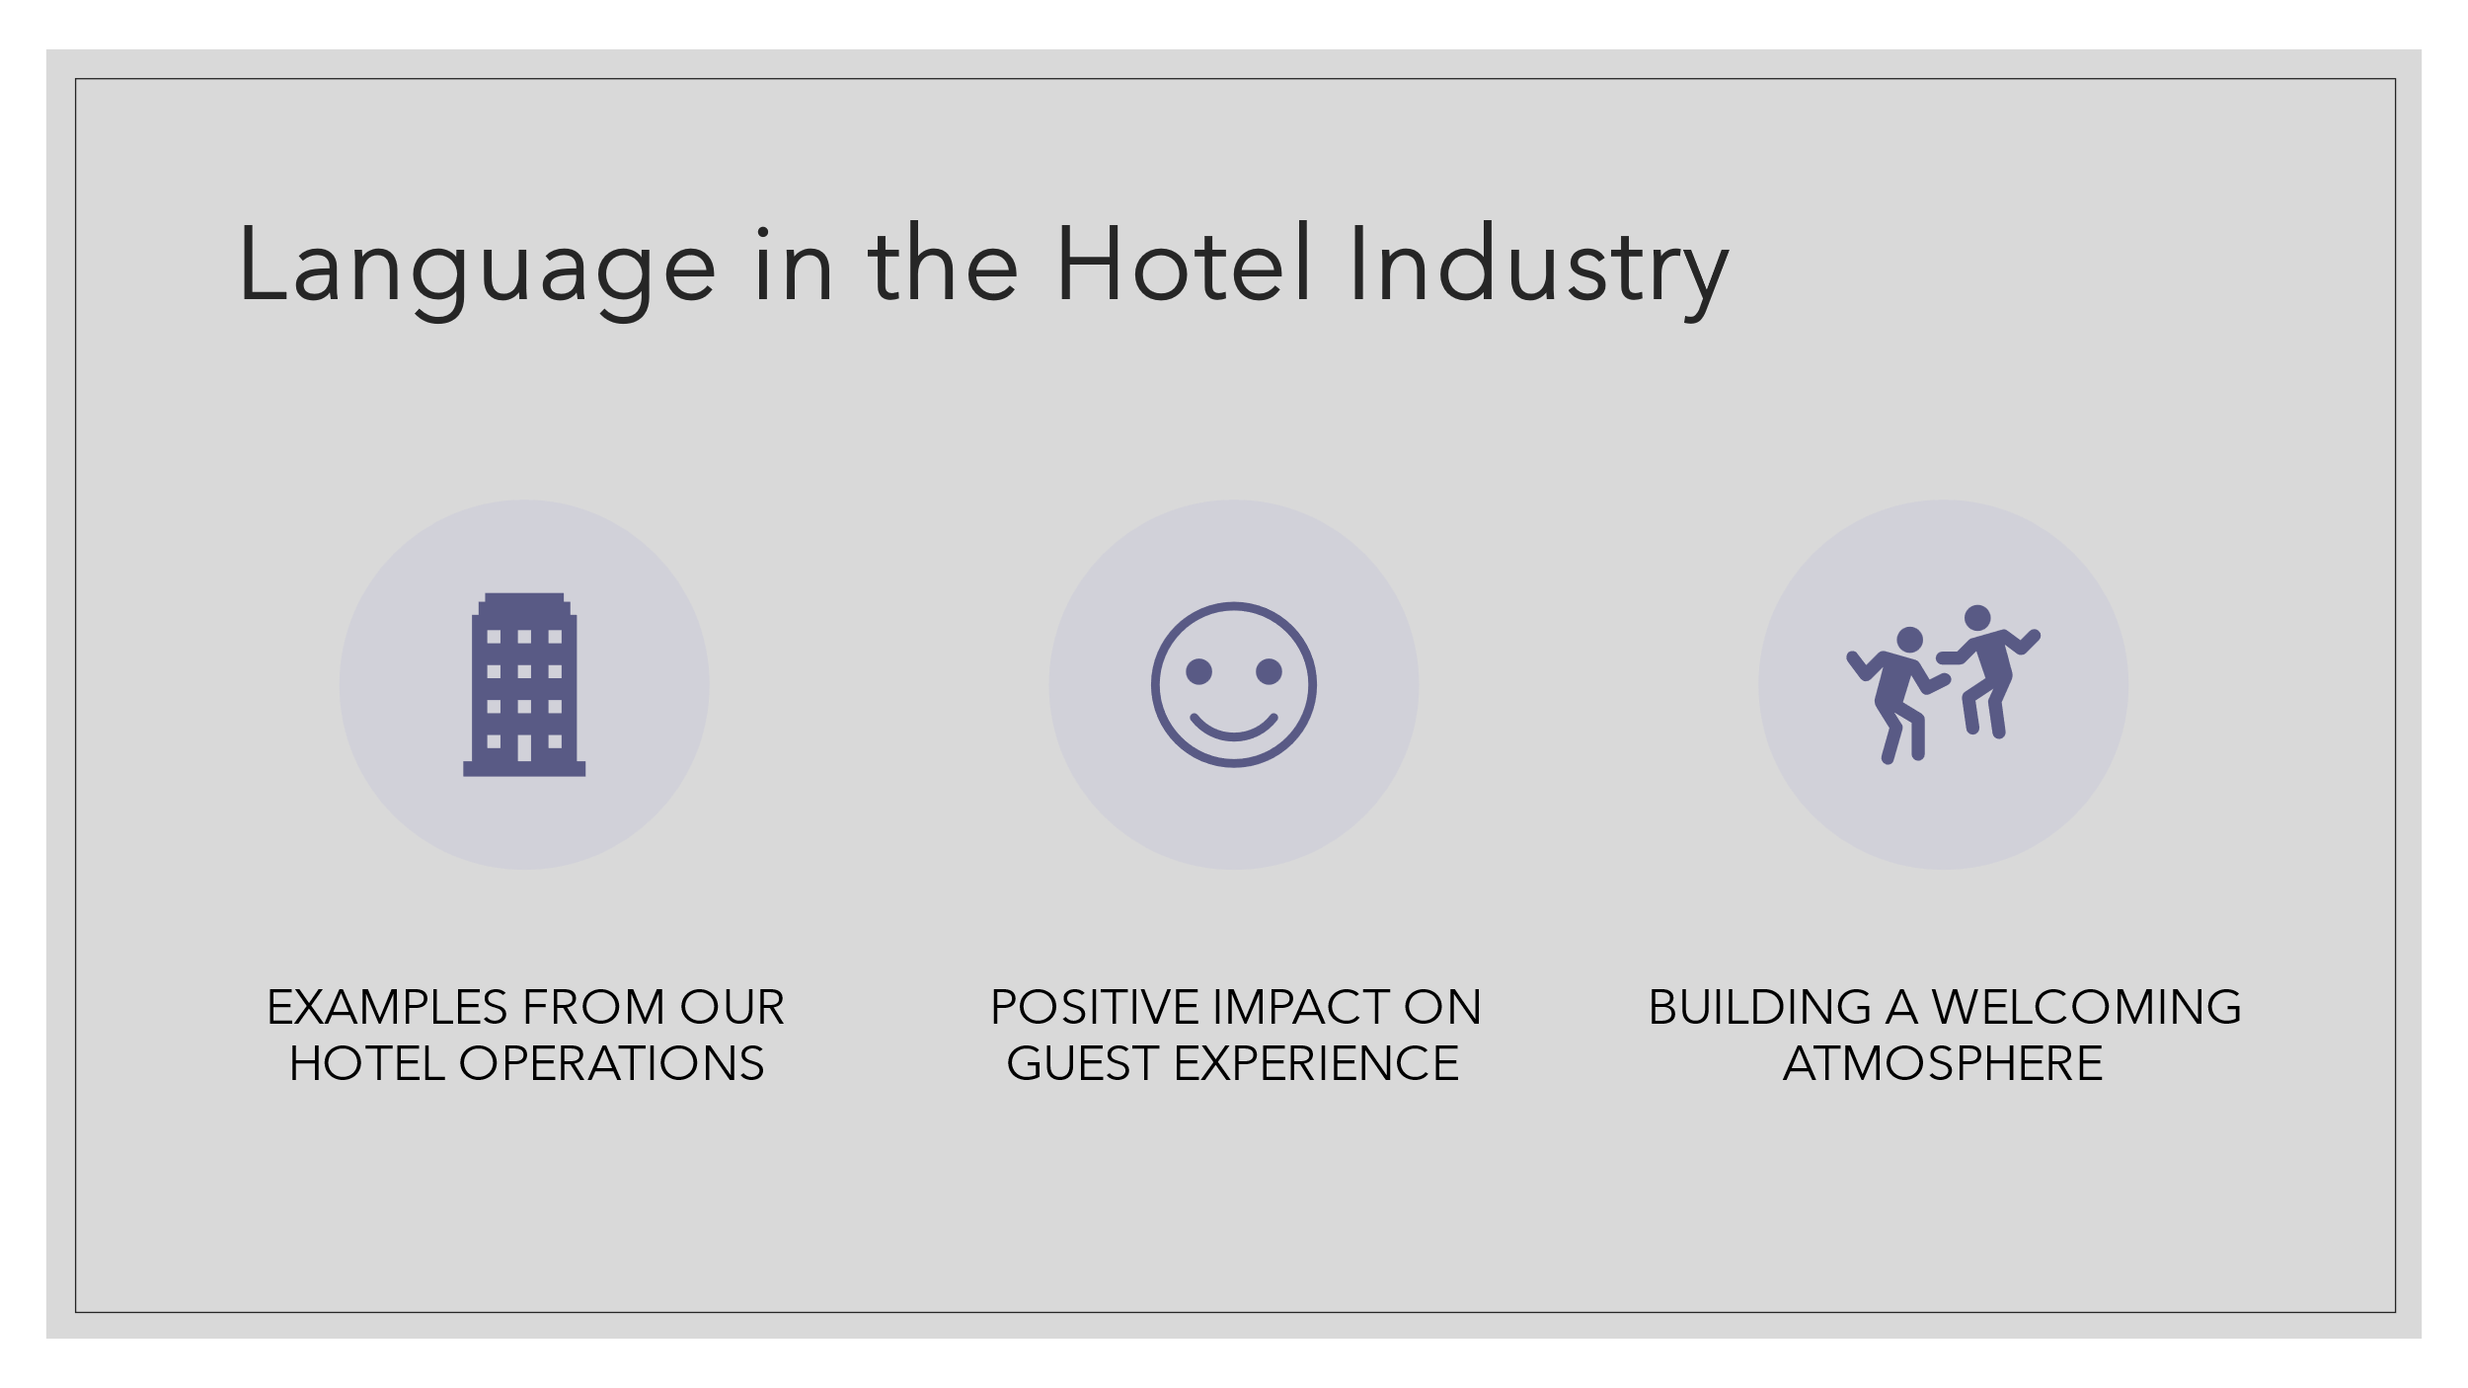
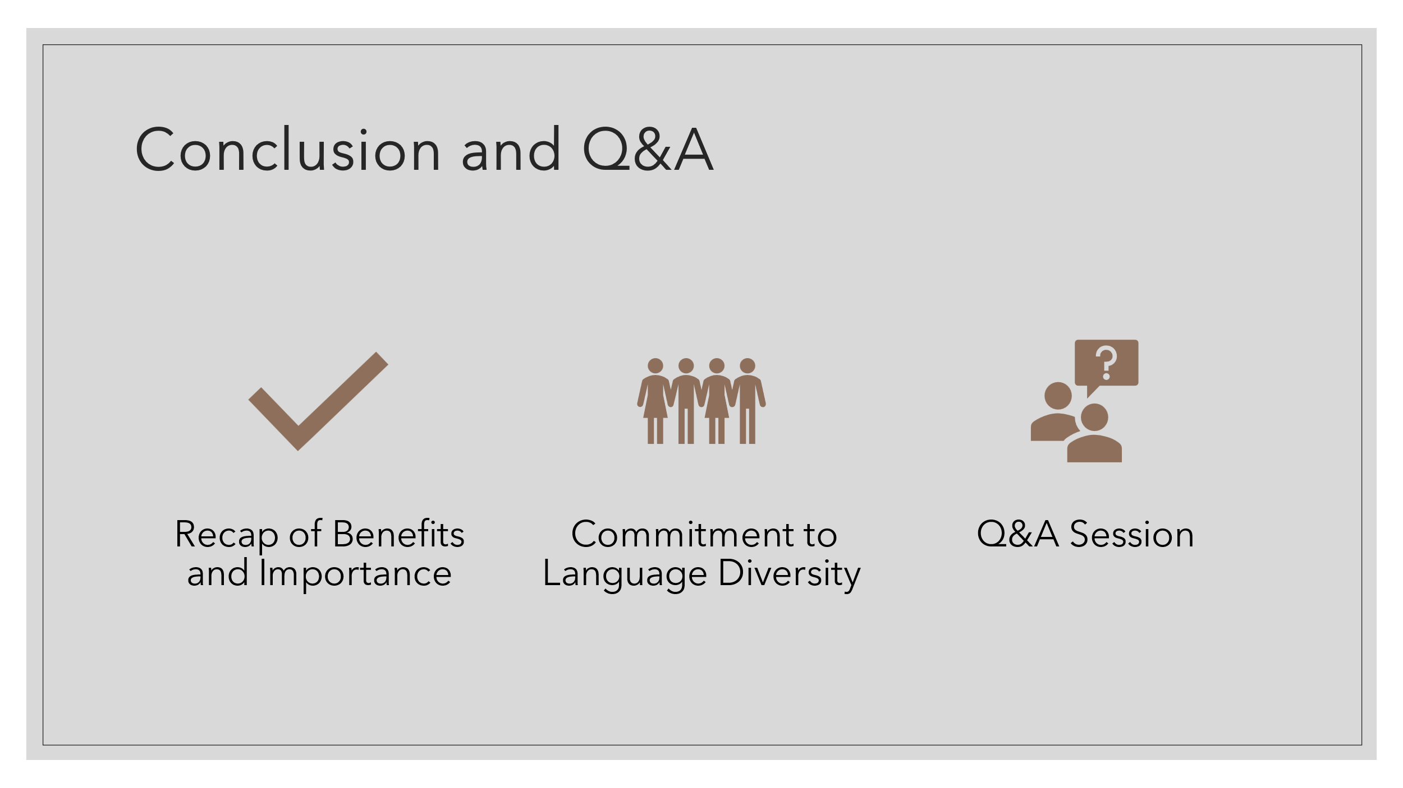
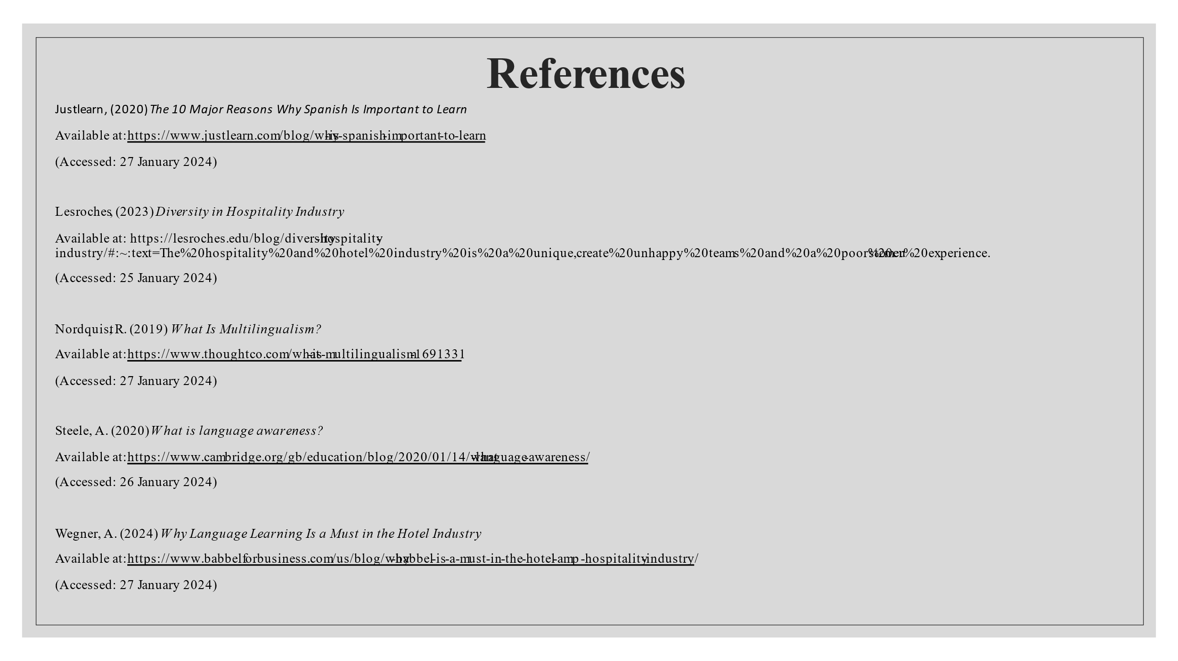
References
Din, M.U., Faraz, A. and Shaheen, M., 2023. Enhancing Cross-Cultural Communication: Managing Food Allergies and Dietary Restrictions in International Hospitality. International Journal of Social Science Archives (IJSSA), 6(2), pp.211-218.
Green, T., Donovan, L., Gu, N., Ma, S. and Currry, D.J., 2023. Exploring Teaching and Research Practices During Cross-Cultural Collaboration: A Self-Study of Two Facilitator’s Involvement in an International Faculty Development Program. Studying Teacher Education, pp.1-22.
Ha, N.H.L., Chua, X.Y., Musimenta, S., Akankwasa, E., Pussayapibul, N., Toh, H.J., Ginting, M.L., Samarasekera, D.D., Tam, W.J., Yap, P.L.K. and Low, J.A.Y.H., 2020. Enablers and barriers of a cross-cultural geriatric education distance training programme: The Singapore-Uganda experience. Geriatrics, 5(4), p.61.
Hong, J.H., 2021. A global strategy of a company that uses culture content as its core business. The Journal of Industrial Distribution & Business, 12(6), pp.37-46.
Jin, Y., 2023. Reflections on Intercultural Communication during Overseas Study by Chinese Students. International Journal of Education and Humanities, 11(3), pp.444-447.
Jung, D., Paek, S., Choe, J.Y. and Kim, J.Y., 2021. Mediating effect of cross-cultural competency on international experiences and self-efficacy among hotel employees. International Journal of Hospitality & Tourism Administration, 22(4), pp.361-382.
Laukka, P. and Elfenbein, H.A., 2021. Cross-cultural emotion recognition and in-group advantage in vocal expression: A meta-analysis. Emotion Review, 13(1), pp.3-11.
Wang, Y., Zhu, J., Wang, X., Li, X. and Zhang, W., 2023. Navigating cross-cultural port tourism: Unleashing the psychological safety valve for risk management. Ocean & Coastal Management, 246, p.106888.

