
database design for dylan’s bookstore
1801285 Gemma Dunlop

May 6, 2019
information engineering
University of Wales Trinity Saint David

Contents
Design 3
Entity Relationship Diagram 3
Normalisation 4
First Normal Form 4
Second Normal Form 4
Third Normal Form 5
Forms 6
Forms menu 7
Reports Menu 8
Queries Menu 9
Author Form 10
New Customer Form 11
Order Details 12
Order Line Form 13
Order Summary Form 14
Stock Order Form 15
Book Details Report 16
Stock Order Report 17
Customer Orders Report 18
Single Table Query 19
Tables 20
Book Details Table 20
Author Table 22
Customer Details Table 24
Order Details Table 26
Order Line 27
Stock Order Details Table 28
Supplier Info Table 29
Relationships 30
Menus 31
Main Menu 31
Forms Menu 32
Reports Menu 33
Queries Form 34
Reports from Macro Query 35
Forms from a Macro Query 39
Author form 41
Book Details Form 42
New Customer Form 43
Order Details Form 44
Order Line Form 45
Order Summary Form 46
Stock Order Form 47
Supplier Info Form 48
Queries 49
Single Table Query Using SQL 49
Multi Table Query 50
Reports 51
Book Details Report 51
Customer Orders report 52
Stock Orders Report 53
User Guide 54
1. Navigating the Author Form to add or delete an author 54
2. Navigating the Book Details Form to add or delete a book 55
3. Searching for an author 56
4. Searching for a book title 57
5. Placing a customer order for a new customer 58
6. Placing a customer order for an existing customer 59
7. Navigating Stock Order Details to place orders with suppliers for new stock items 62
8. Navigating Supplier Details to add a new supplier 63
9. Viewing Book Details report 64
10. Viewing Customer Order Details report 65
11. Viewing Customer Order Details report 66
12. Printing a report 67
13. Viewing book details of all books under £7.99 68
14. Viewing customer orders that are ready for collection 69
15. Searching for a customer order 70

Design

Entity Relationship Diagram
An entity relationship diagram, as shown in figure 1, was designed to plan the tables to be used in the Dylan’s Book Store database. The tables designed are Customer Details, Order Details, Order Line to allow a many to many relationship to be formed on Access, Book Details, Supplier, Stock Order Details.
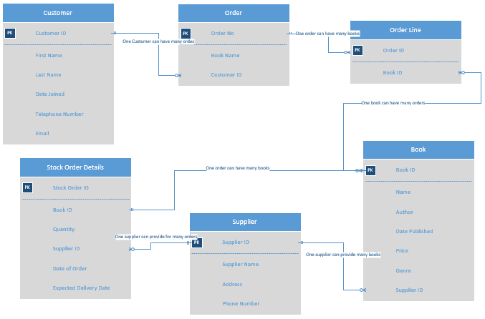
Figure 1 – entity relationship diagram.

Normalisation
A table containing all the records to be used in the database was initially designed in zero normal form.
Figure 2 – database table designed before applying normalisation rules.

First Normal Form
The table was then split into two forms to remove repeated attributes which occur in the logical design.
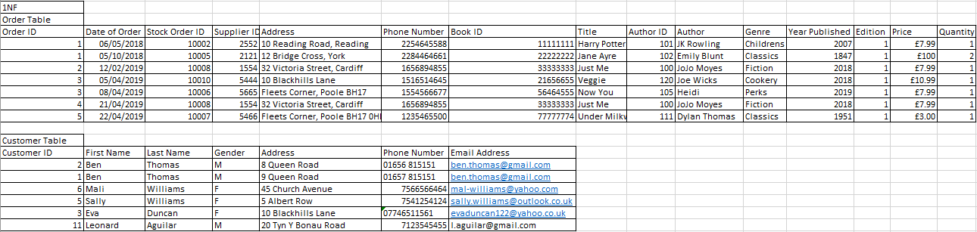
Figure 3 – first normal form of book store database.

Second Normal Form
The customer table is already in 2NF (second normal form) in figure 3, but the order table still had duplicate data. The key attribute in the Order Table is Order ID. Each non-key attribute was checked to see if it was dependent upon Order ID and Book Table and Stock Order Details was created.
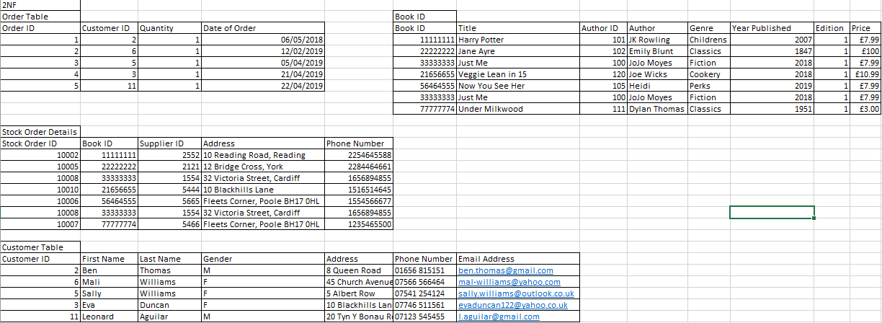
Figure 4 – second normal form of book store database.

Third Normal Form
Tables were then split into third normal form. Redundant data no longer exists in any of the tables.
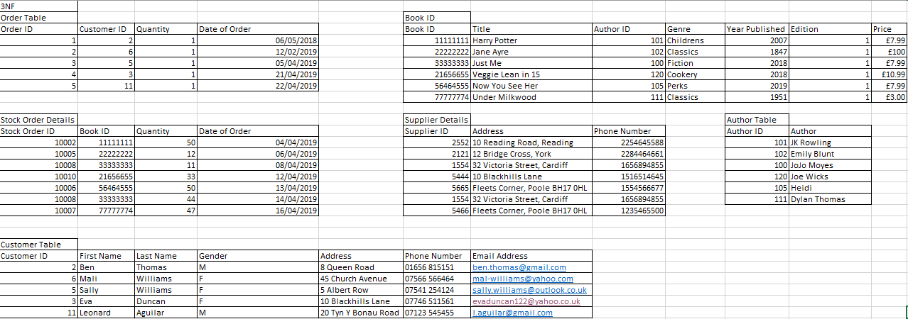
Figure 5 – third normal form of book store database.

Forms
Main Menu Form
A design plan of the main menu form was designed on paper for Dylan’s Book Store. The rectangular boxes represent buttons to be used in the form. The three buttons in the middle of the form link the user to menus shown in figures 7, 8 and 9. The ‘Log Out’ button closes the database.
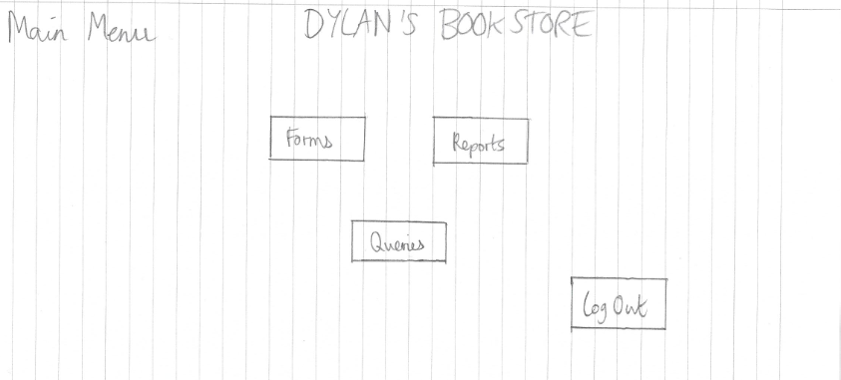
Figure 6 – main menu form plan design.

Forms menu
A Forms menu form was designed on paper, as shown in figure 7, which contains buttons linking the user to six different forms on the Dylan’s Book Store database. The plan includes buttons linking to forms containing Book Details, Customer Order Details and Stock Details.
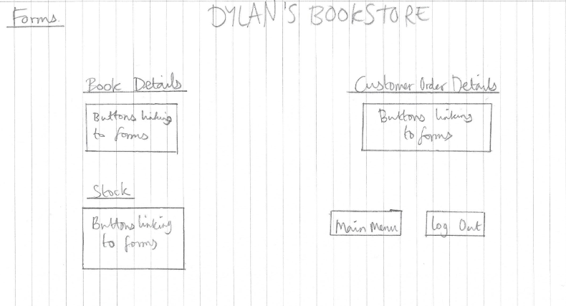
Figure 7 – Forms menu form plan design.

Reports Menu
A Reports menu form was designed on paper, as shown in figure 8, with buttons linking to all the reports (shown in figures 16, 17 and 18) in the database.
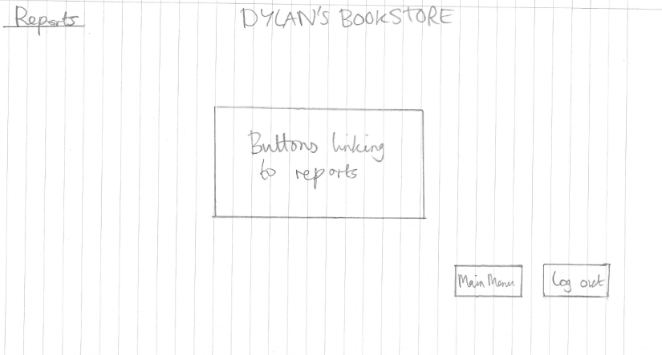
Figure 8 – Reports menu form plan design.

Queries Menu
A queries menu form was designed as shown in figure 9 to display links, in the form of buttons, which link to each query made (shown in figures 61 and 62). Underneath the buttons are search boxes for the user to search for certain criteria. Queries, reports and forms will be generated displaying the results of the search. The search bars will be made using macro queries.
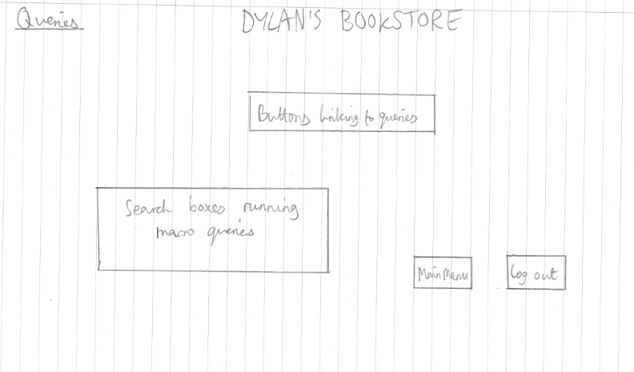
Figure 9 – queries menu form plan design.

Author Form
A form was designed on paper to display author details as shown in figure 10. Five buttons are displayed next to the Author Details records which are used to navigate the Author ID and the author’s First Name and Last Name. The first two buttons with arrow icons navigate the user forwards or backwards through the records, the ‘Add’ button allows the user to create a new Author Details record, the ‘Save’ button allows the user to save new Author Details records created and the ‘Delete’ button allows the user to delete records from the Author Details table.
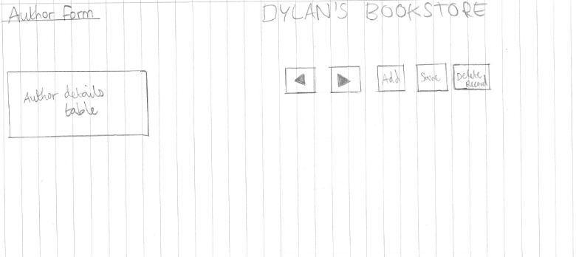
Figure 10 – author form design.

New Customer Form
A form was designed on paper for new customers who would like to place an order as shown on figure 11. The form will contain the customer’s personal details. Five buttons are displayed next to the Customer Details records to navigate the records in the same way as described in the Author Form. This form can be used by staff in the bookstore when a new customer places an order for a book.
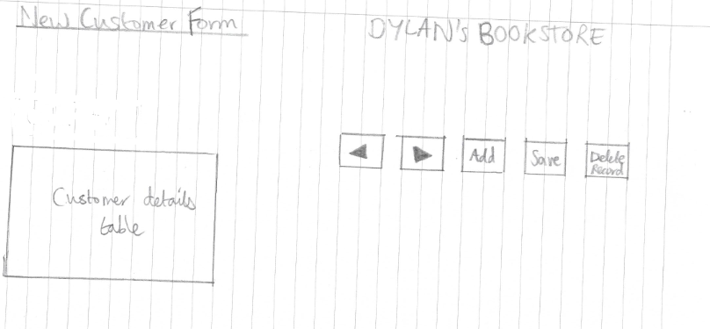
Figure 11 – customer form for when a new customer wants to place an order.

Order Details
An Order Details form was designed on paper, as shown in figure 12 for the details of the book ordered by the customer to be entered into the database. Five buttons are displayed next to the Order Details records to navigate the records in the same way as described in the Author Form.

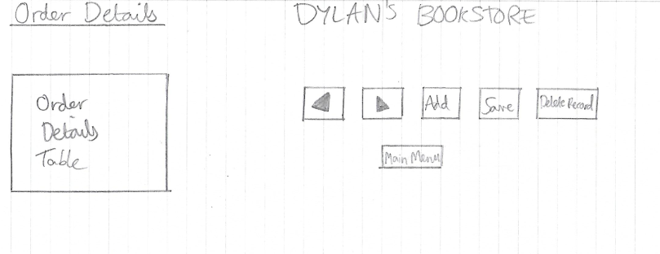
Figure 12 – Order Details Form.

Order Line Form
An Order Line form was designed on paper, as shown in figure 13 to connect the Order ID with the Book ID. Five buttons are displayed next to the Order Line records to navigate the records in the same way as described in the Author Form.

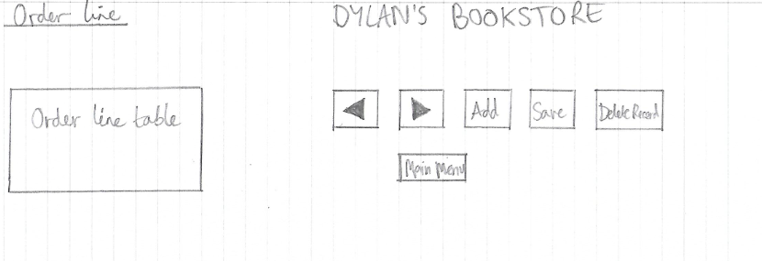
Figure 13 – Order line form.

Order Summary Form
An Order Summary form was designed on paper, as shown in figure 14 to show a final summary of the customer order. It contains a book details subform which displays further details of the book. Five buttons are displayed next to the Order Details Query records to navigate the records in the same way as described in the Author Form.
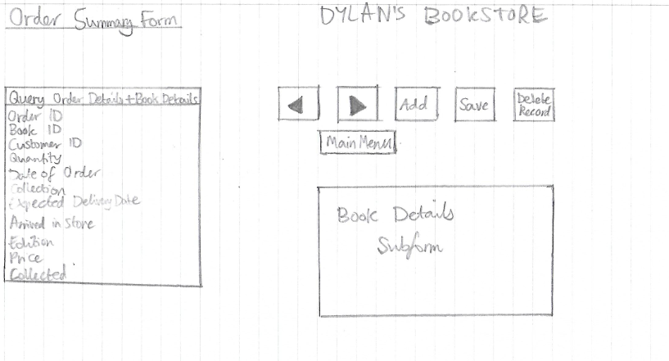
Figure 14 – Order Summary form.

Stock Order Form
A Stock Order form was designed on paper, as shown in figure 15 to display outstanding stock orders. I included a calculation to work out the total value of each order placed with the supplier by multiplying the quantity with the unit price. This enables the company to keep track of the value of books on order and to ensure they have enough money to pay the invoices when received. It displays details of current books Five buttons are displayed next to the Stock Order Details records to navigate the records in the same way as described in the Author Form.

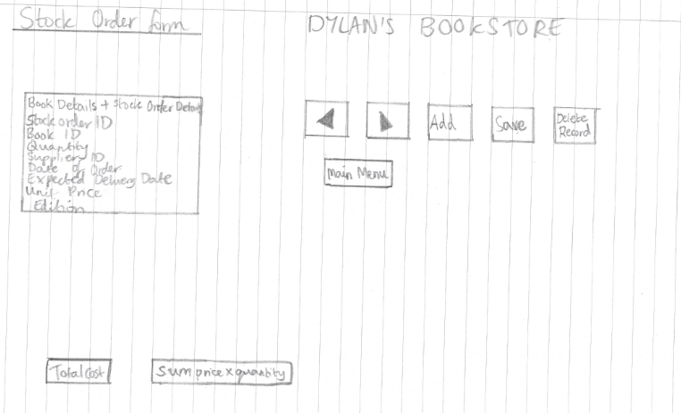
Figure 15 – stock order form.

Book Details Report
A Book Details report was designed on paper, as shown in figure 16 from the Book Details table so the user could see details of stock sorted by genre in an organised manner and calculations can be made to see the total price of stock, the minimum price of stock, the maximum price of stock and the average price of stock.
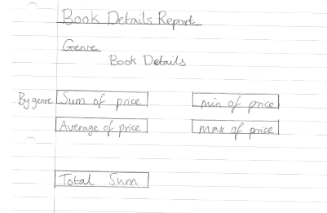
Figure 16 – book details report.

Stock Order Report
A report was designed on paper to show stock order details as shown in figure 17. It shows past and outstanding stock orders. At the bottom of the report is a calculation calculating the total money spent on stock orders to help the company with financial reports.
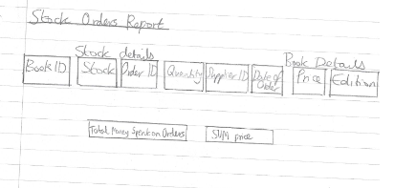
Figure 17 – Stock Order report.

Customer Orders Report
A Customer Orders report was designed on paper showing customer orders, as shown in figure 18. This will sort the orders by genre so the company can see which books and which genres of books are ordered the most. Calculations will be made under each genre for the total price, the average price, the minimum price and the maximum price.
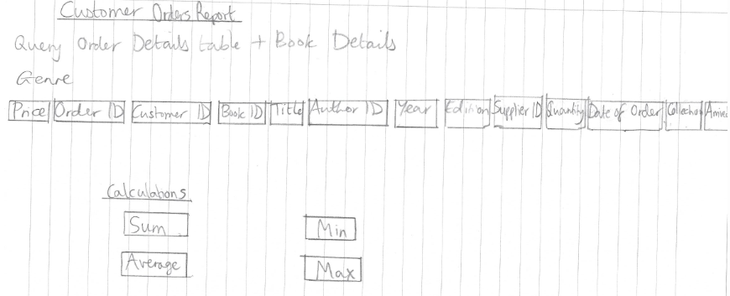
Figure 18 – Customer Orders report.

Single Table Query
A single table query was designed on paper as shown in figure 19 to search for all books in the database which are under £7.99. This can be used to answer customer queries.
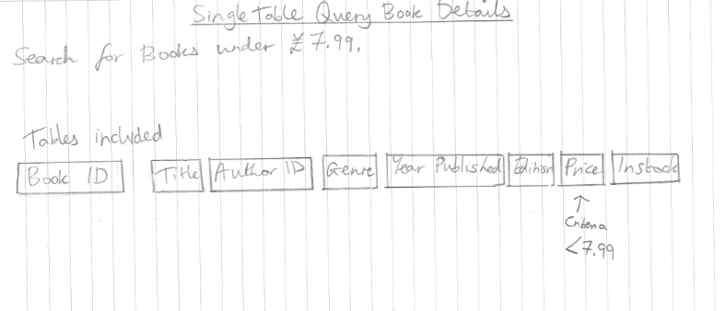
Figure 19 – Single table query for books under £7.99.

Tables

Book Details Table
I created the Book Details table using SQL to store details of each book held in store, as shown in figure 20. Book ID was set as the primary key and Supplier ID as the foreign key.
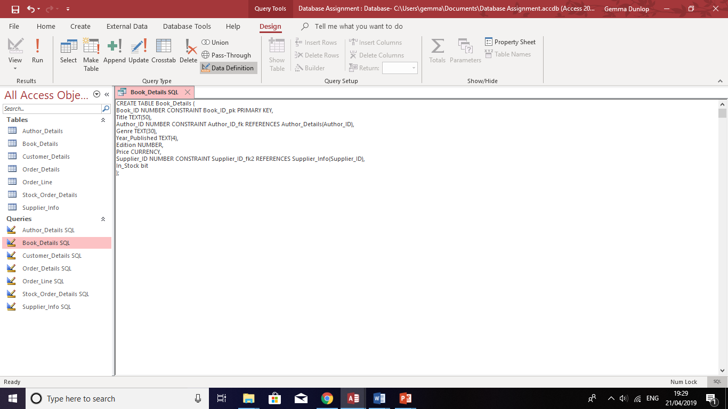
Figure 20 – book details table SQL.

An example of SQL code used to input data into the Book Details table is shown in Figure 21.
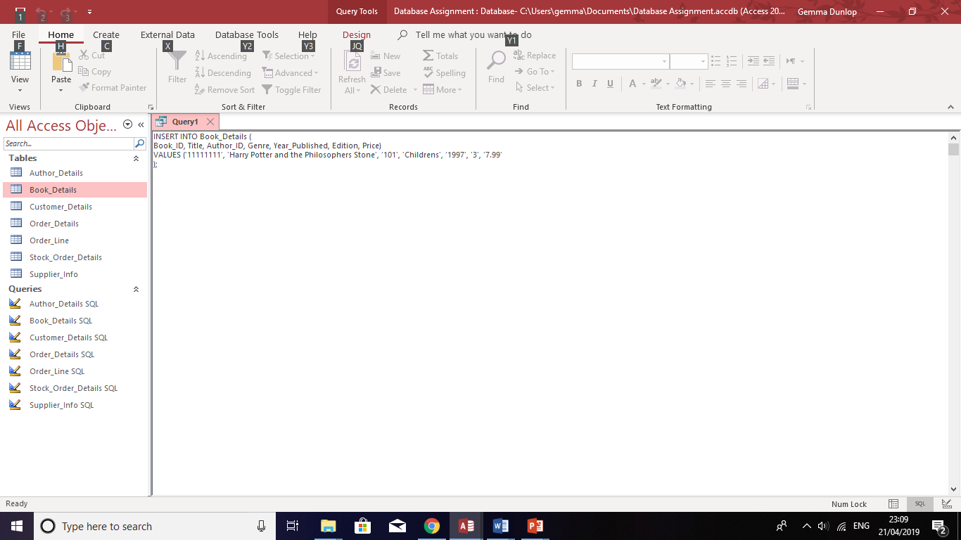
Figure 21 – Book Details data SQL.
The data held in Book Details table is shown in figure 22. The table holds details Book ID, Title, Author ID, Genre, Year Published, Edition, Price, Supplier ID and whether the book is In Stock.
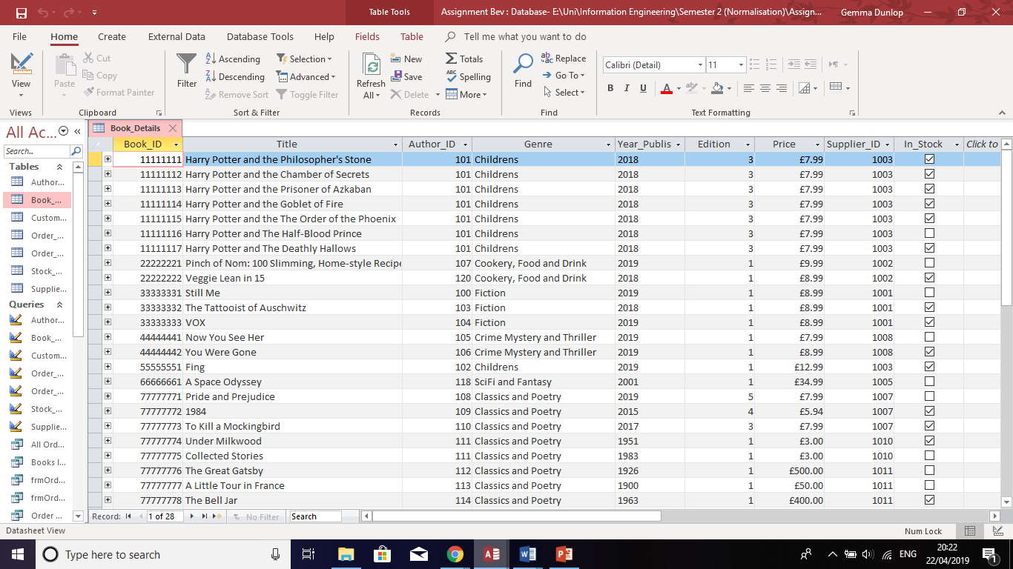
Figure 22 - Book Details data.

Author Table
The SQL code for Author Details table is shown in figure 23. Author ID was set as the primary key.
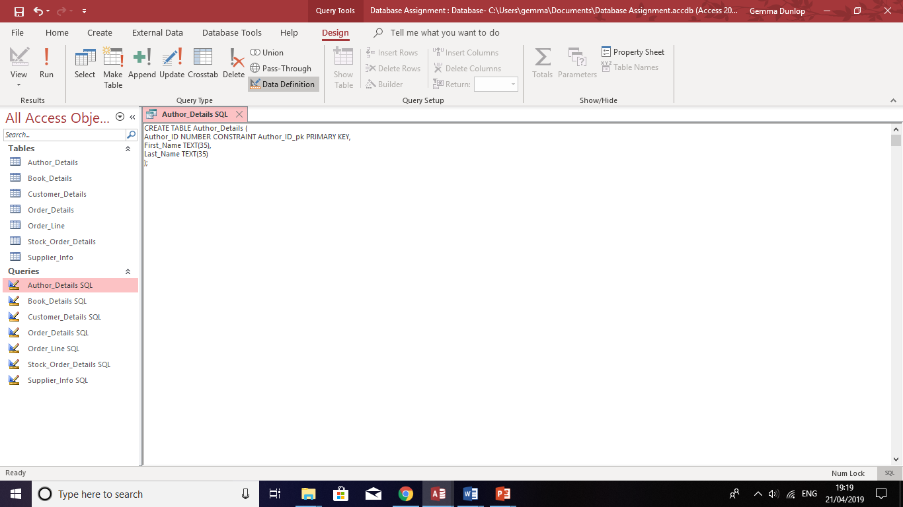
Figure 23 - Author Details SQL.

SQL was used to create data in the Author Details table as shown in figure 24.
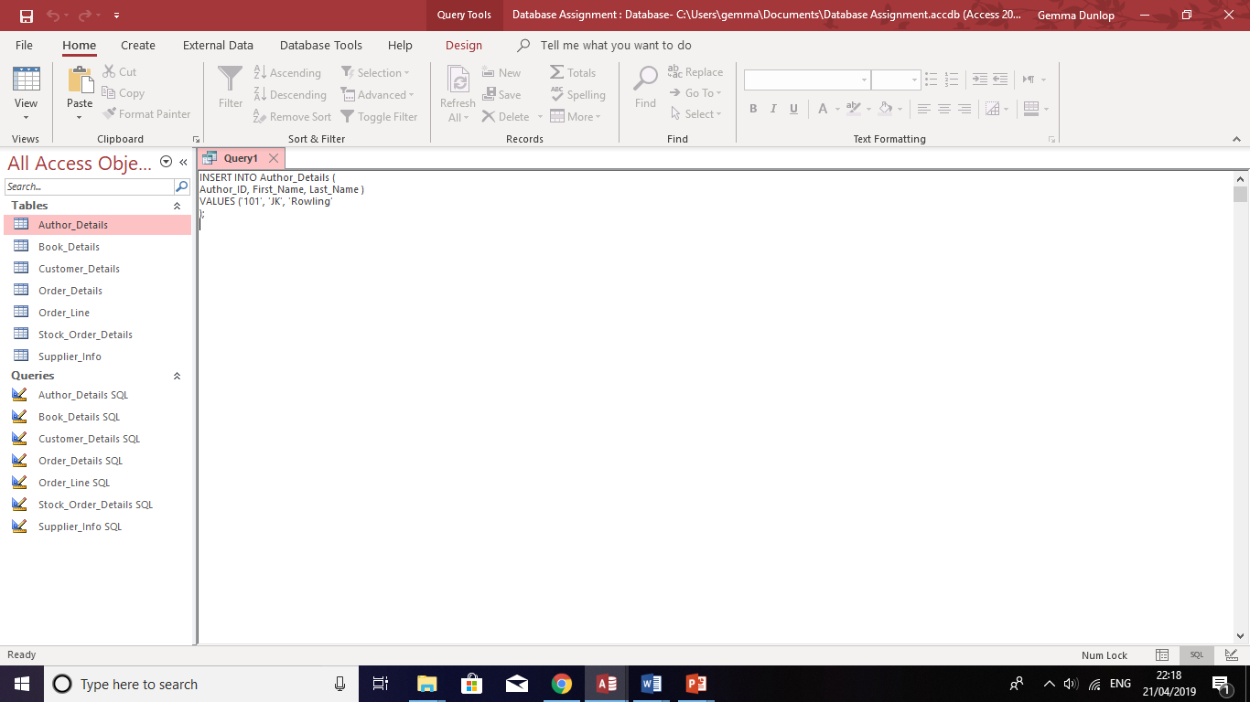
Figure 24 - Author Details data SQL.
The data created using SQL for Author ID, author’s First Name and Last Name is shown in figure 25.
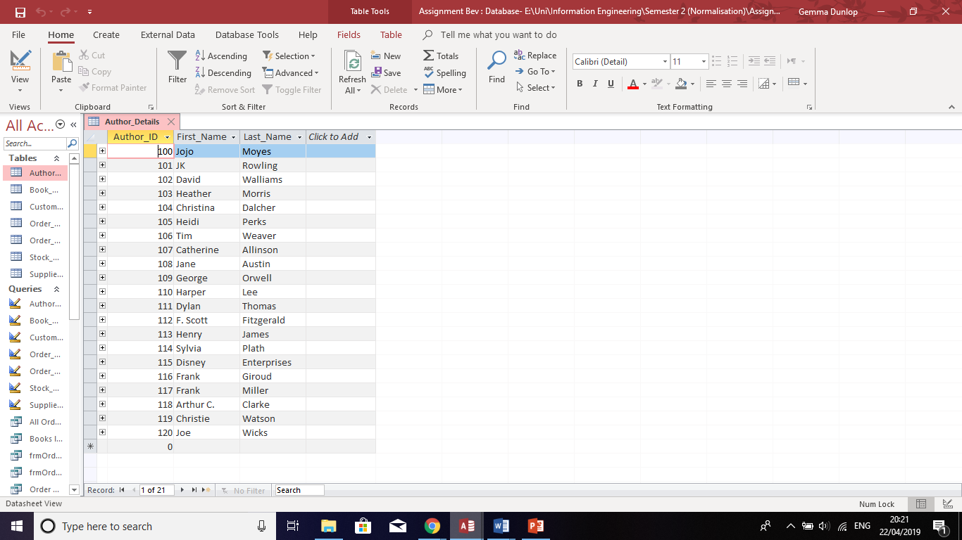
Figure 25 - Author Details data.

Customer Details Table
The SQL code for Customer Details table is shown in figure 26. Customer ID is set as primary key.
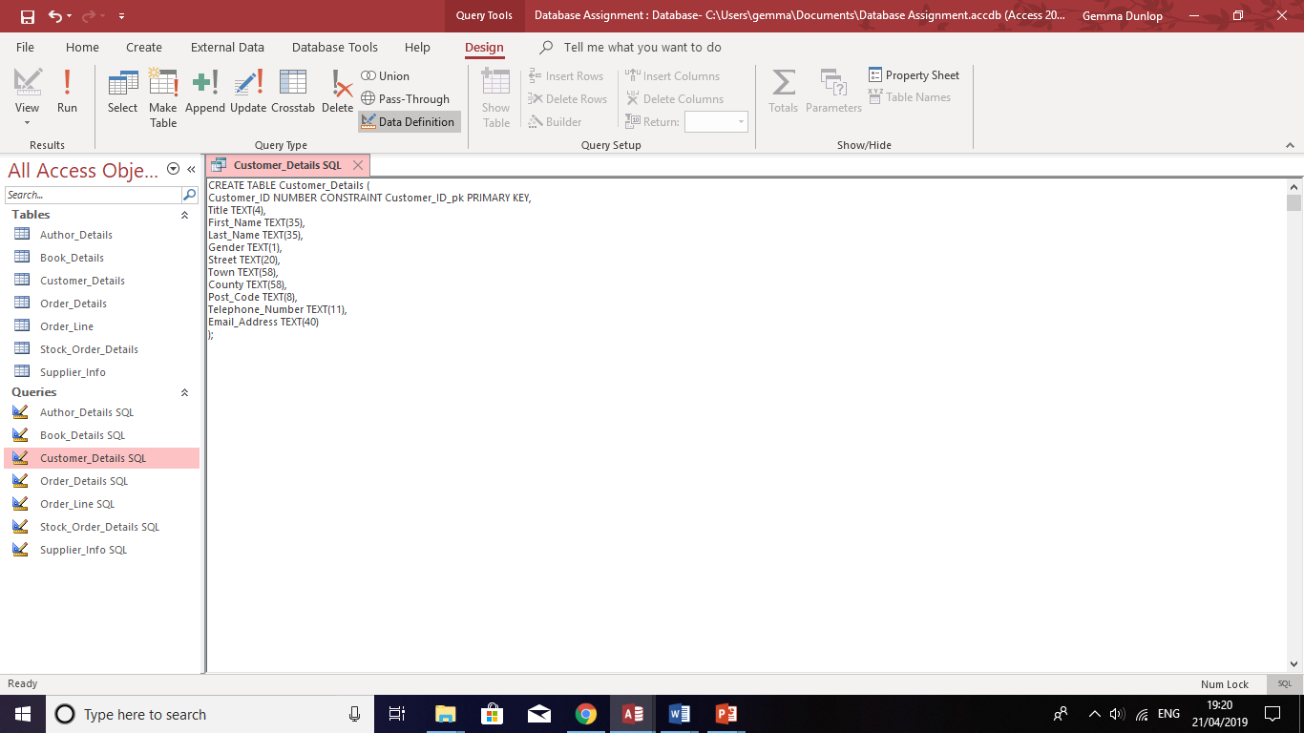
Figure 26 – Customer Details SQL.

The SQL code for inputting data into the Customer Details table is shown in figure 27.
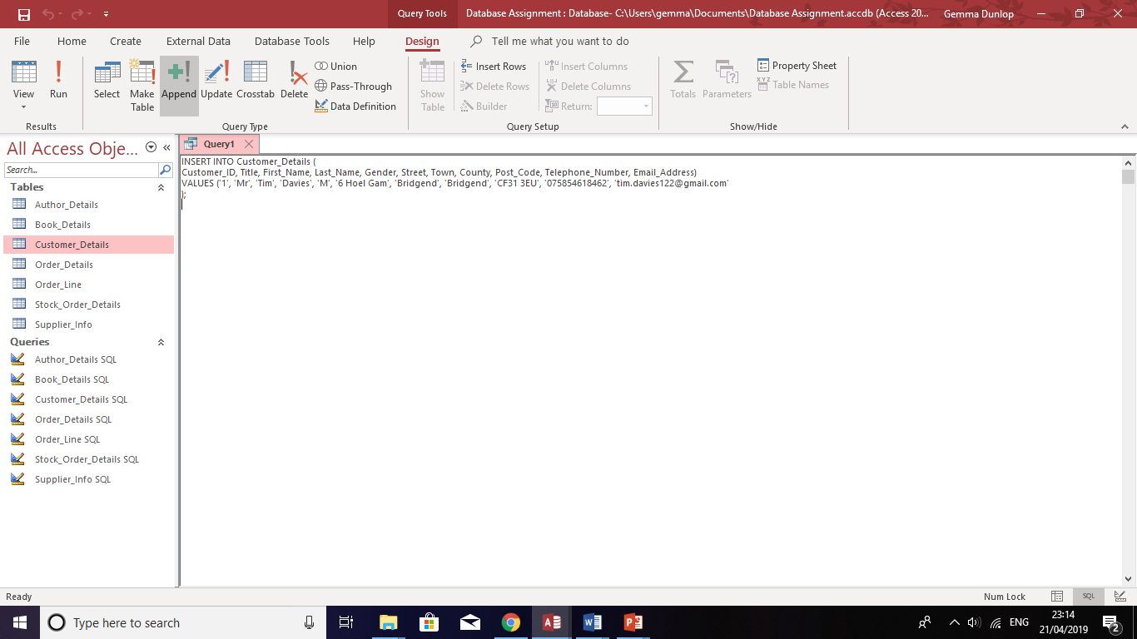
Figure 27 – Customer Details data SQL.
The data held in the Customer Details form for Customer ID, Title, First Name, Last Name, Gender, Street, Town, Country, Post Code, Telephone Number and Email Address is shown in figure 28.
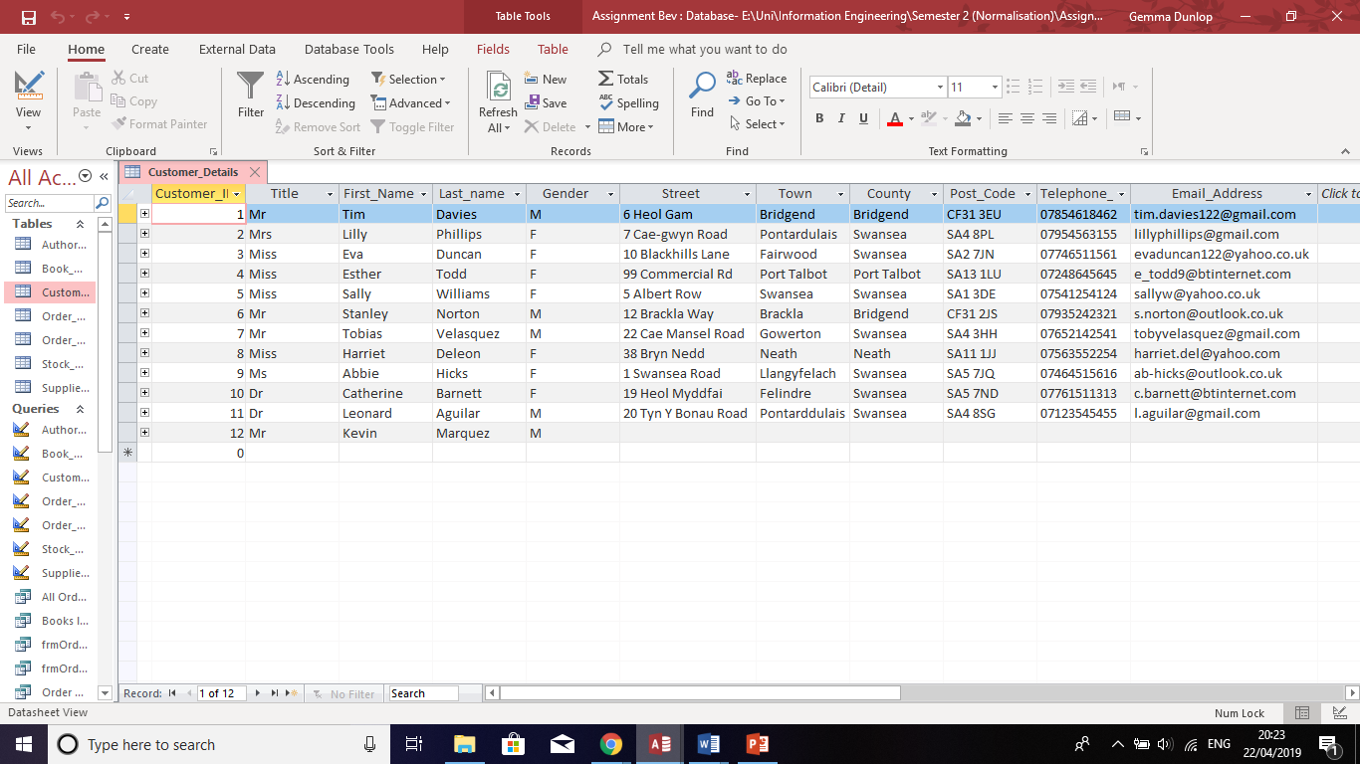
Figure 28 – Customer Details data SQL.

Order Details Table
The SQL code for Order Details table is shown in figure 29. The Order ID is the primary key and the Customer ID is the foreign key.
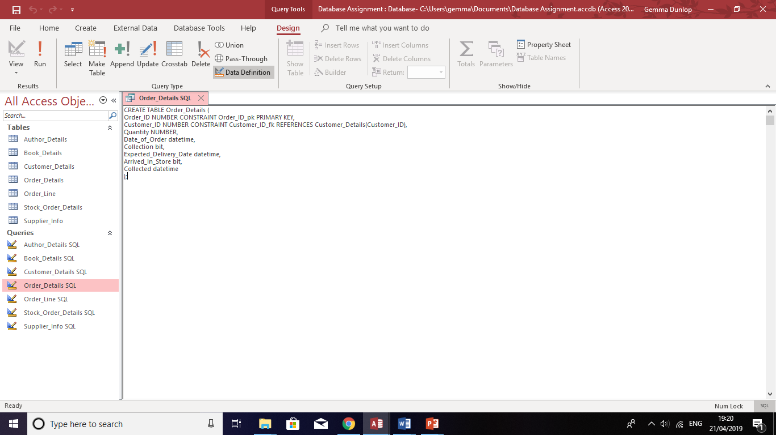
Figure 29 – Order Details SQL.

The data stored for the table Order Details in fields Order ID, Customer ID, Quantity, Date of Order, Collection, Expected Delivery Date, Arrived in Store, and Collected is shown in figure 30.
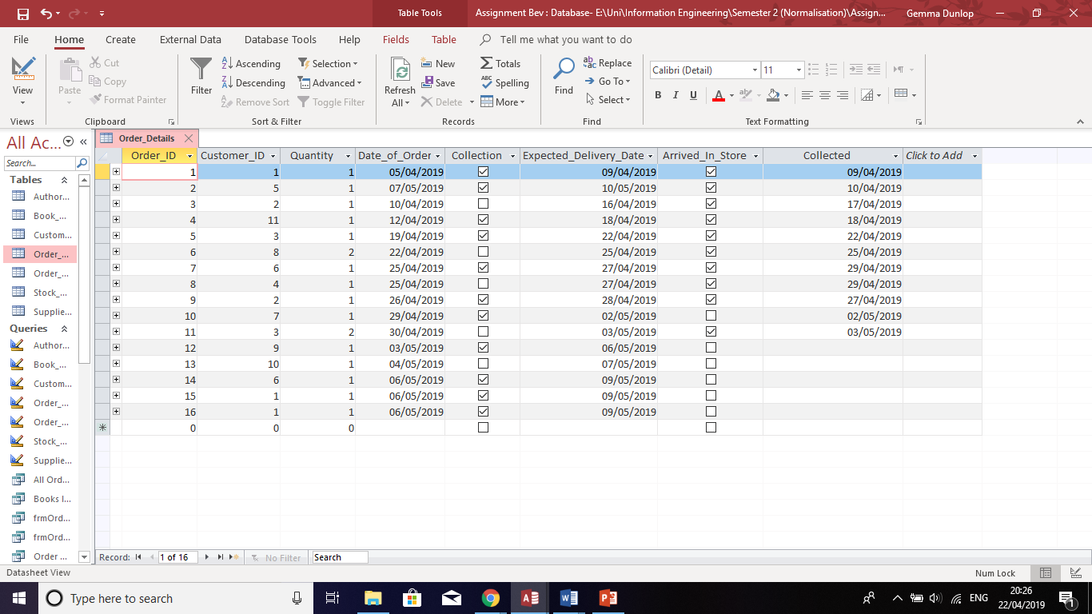
Figure 30 – Order Details data.

Order Line
I researched how to create a table using SQL with more than one primary key. The SQL code used to create the table is shown in figure 31.
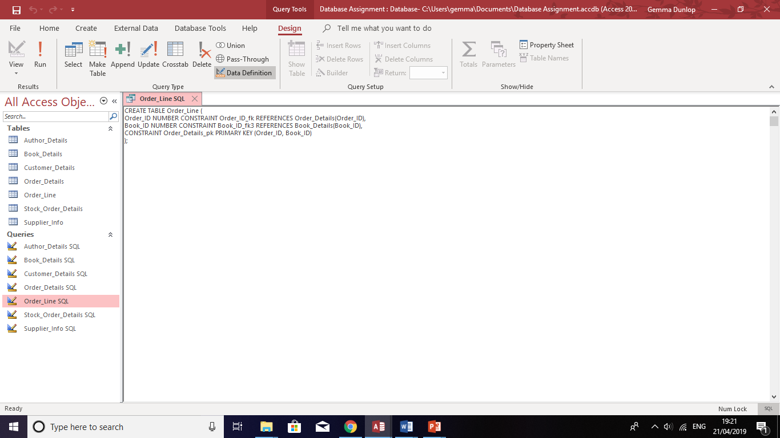
Figure 31 – Order Line SQL.

The data which is stored in the Order Line table is shown in figure 32.
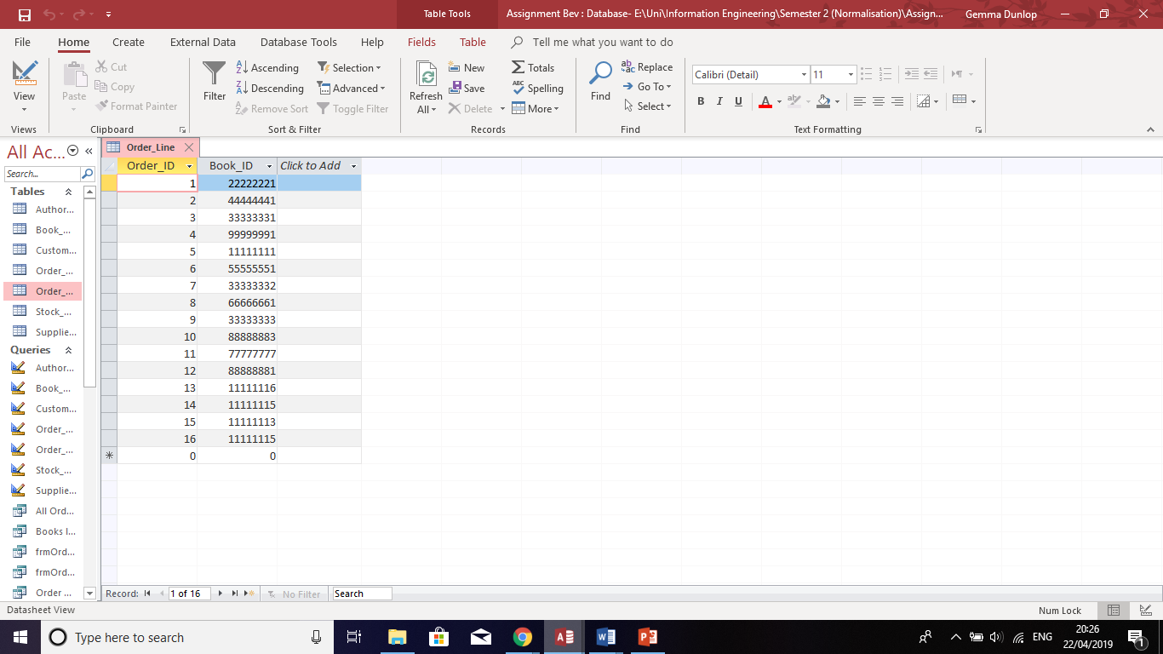
Figure 32 – Order Line data.

Stock Order Details Table
The SQL code for Stock Order Details table. Stock Order ID was set as the primary key, and Book ID and Supplier ID were set as the foreign keys.
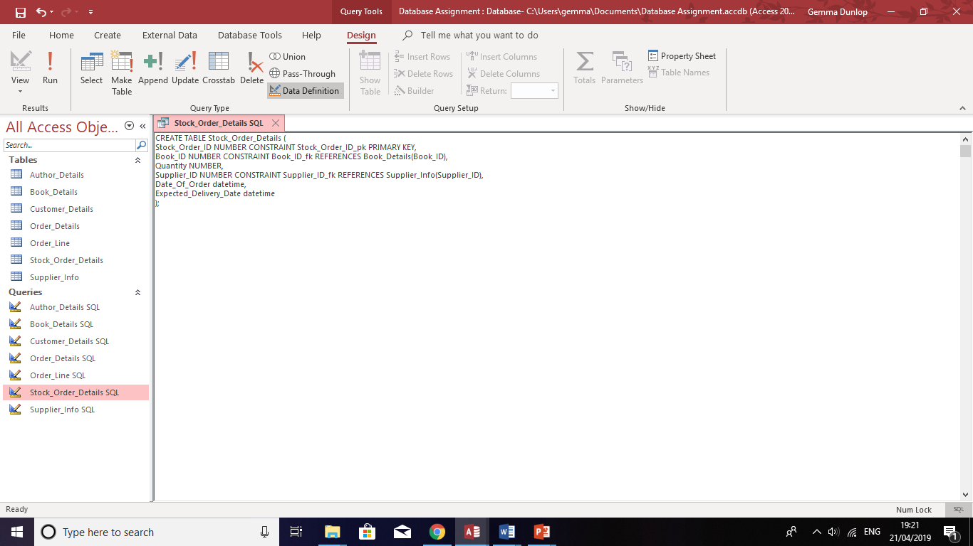
Figure 33 – Stock Order Details SQL.
The data held in the Stock Order Details table for Stock Order ID, Book ID, Quantity, Supplier ID, Date of Order and Expected Delivery is shown in figure 34.
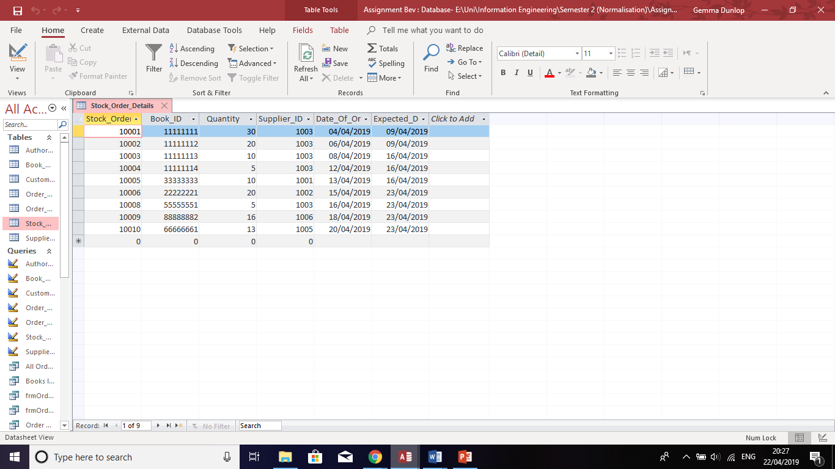
Figure 34 – Stock Order Details table data.

Supplier Info Table
The SQL code used to create the Supplier Info table is shown in figure 35. The Supplier ID is the primary key.
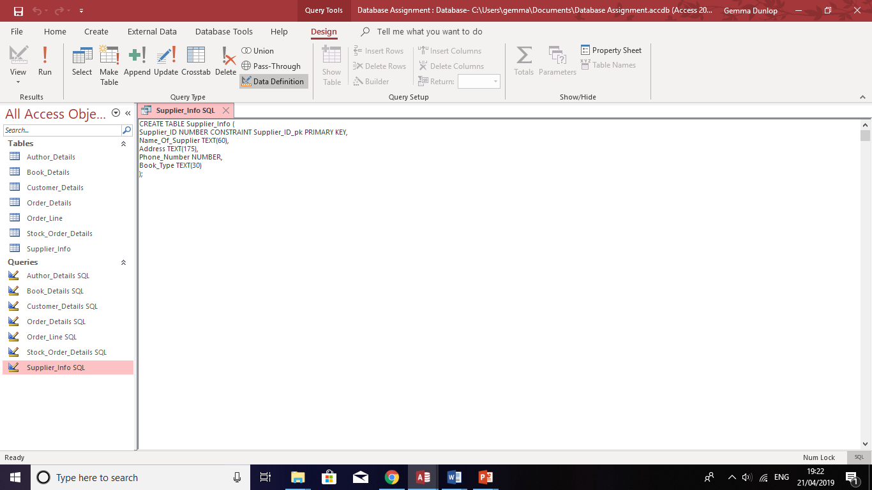
Figure 35 – Supplier Info SQL.

The data held for Supplier ID, Name of Supplier, Address, Phone Number and Book Type in the Supplier Info table is shown in figure 36.
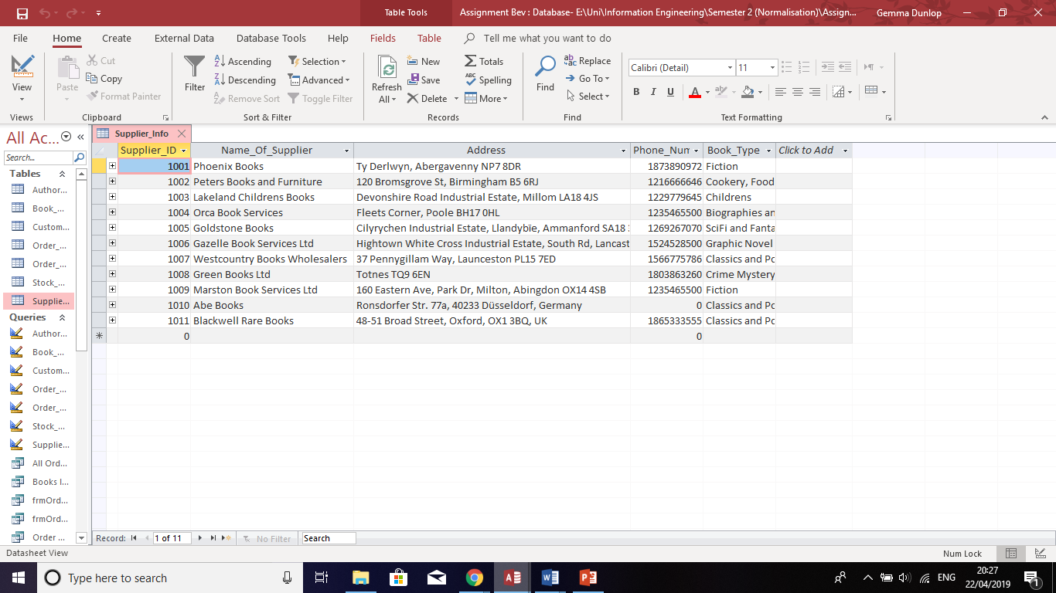
Figure 36 – Supplier Info table data.

Relationships
The relationships on the database were formed from SQL code by establishing primary and foreign keys and is shown in figure 37.
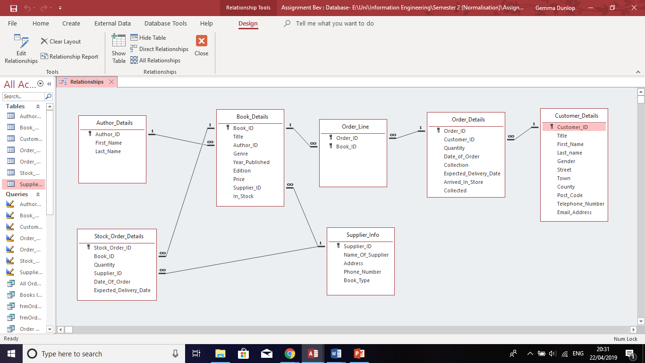
Figure 37 – Relationships for Dylan’s Book Store database.

Menus

Main Menu
The main menu form was created to provide an easy to use interface for staff to use. It contains buttons linking to forms, reports and queries, as shown in figure 38. It also contains a log out button if the user would like to close the database.
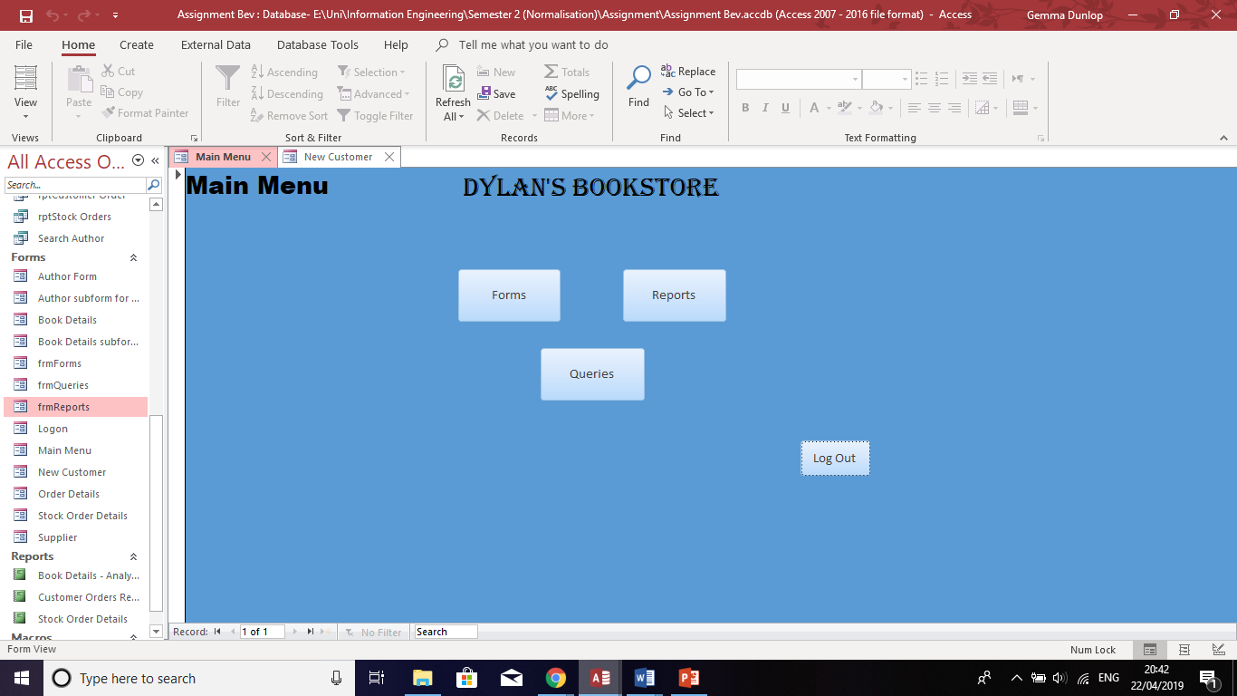
Figure 38 – Main Menu form.

Forms Menu
A Forms Menu was created which contained buttons linking to the Author Details form, Book Details form, New Customer Details form, Order Details form, Order Line form and the Order Summary form as shown in figure 39. This makes navigation easier for the user. The menu also contains two buttons which link the user back to the main menu or exists the user from the database.
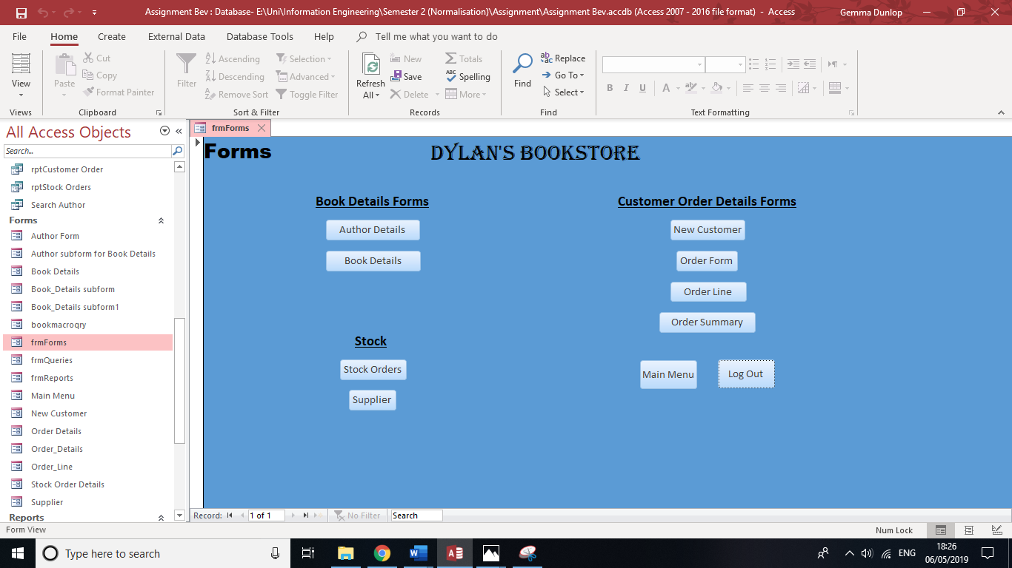
Figure 39 – Forms Menu form.

Reports Menu
A form was created which contained buttons linking to the Book Details report, Customer Orders Report and the Stock Order Details report as shown in figure 40. This makes navigation to each report easier for the user.
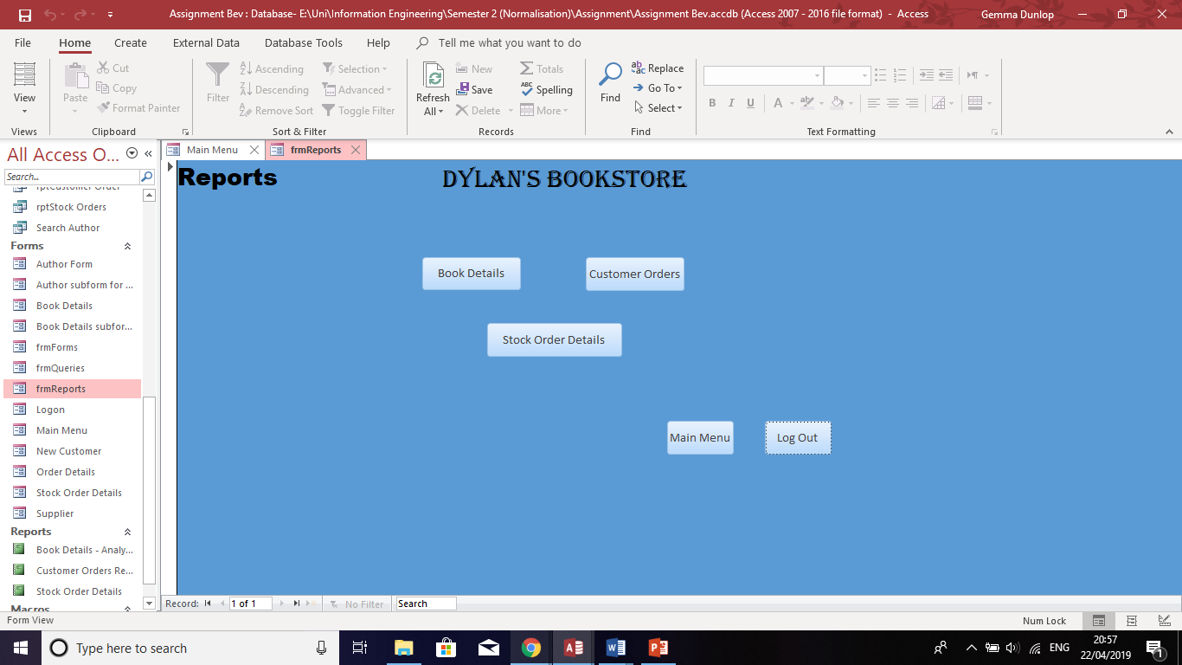
Figure 40 – Reports Menu form.

Queries Form
A form was created containing buttons linking to all the single table query and the multiple table query, as shown in figure 41. There are search bars underneath the search bars so the user can search for certain criteria to answer customer’s queries.
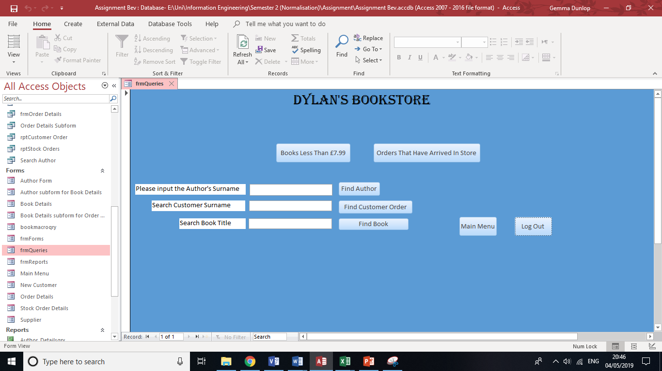
Figure 41 – Queries Menu form.

Reports from Macro Query

Search Author’s Surname
When the user searches for a surname of an author of a book in the search bar, a query and a report which show the results for that author are created as shown in figure 42.
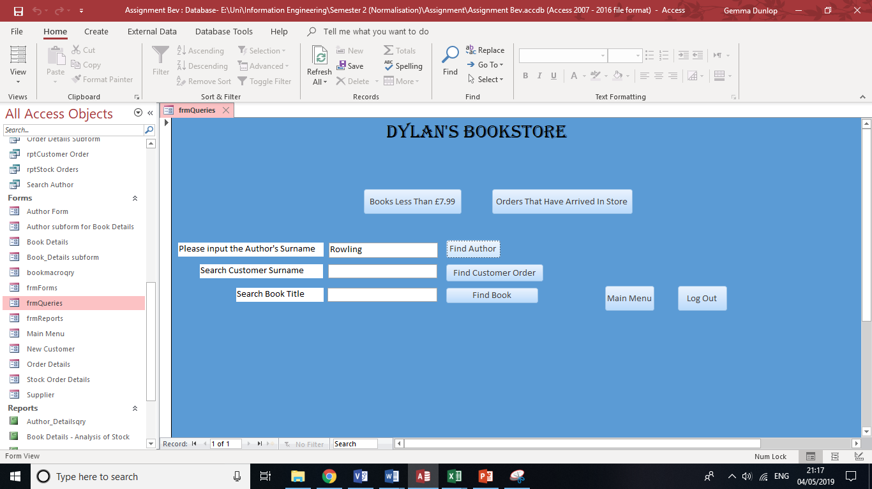
Figure 42 – Author’s surname search bar.

The fields Author ID, First Name, Last Name, Title, Edition and Price were included in the query and the report, as shown in figure 43.
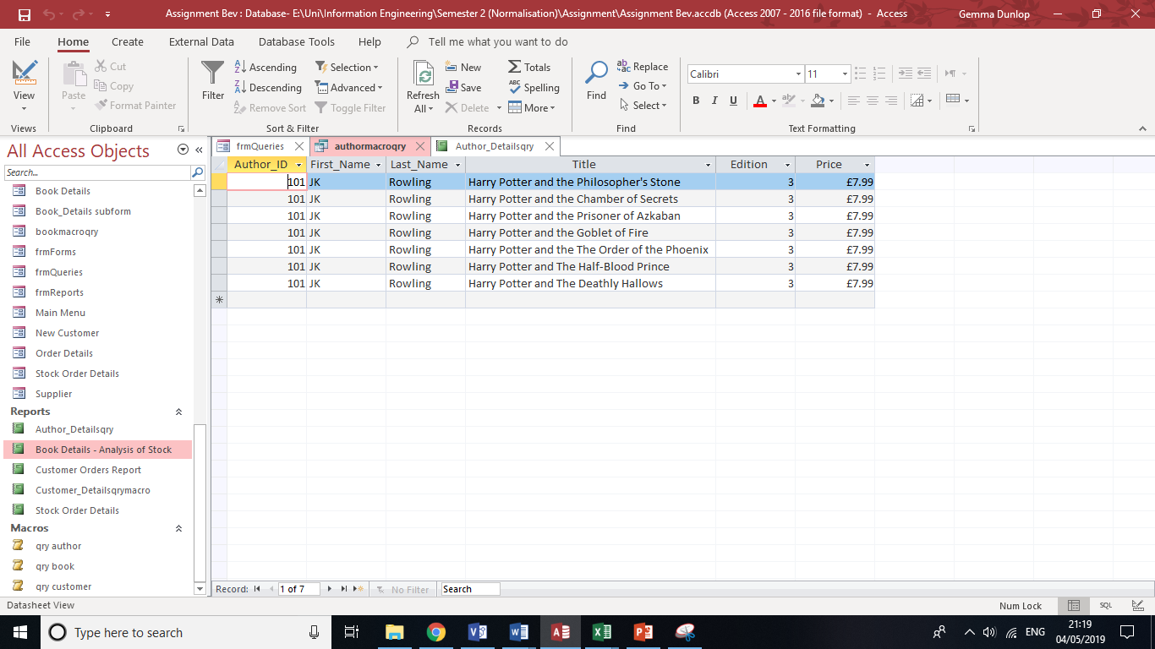
Figure 43 – Author Details macro query.
The report showing the Author Details is displayed in figure 44.
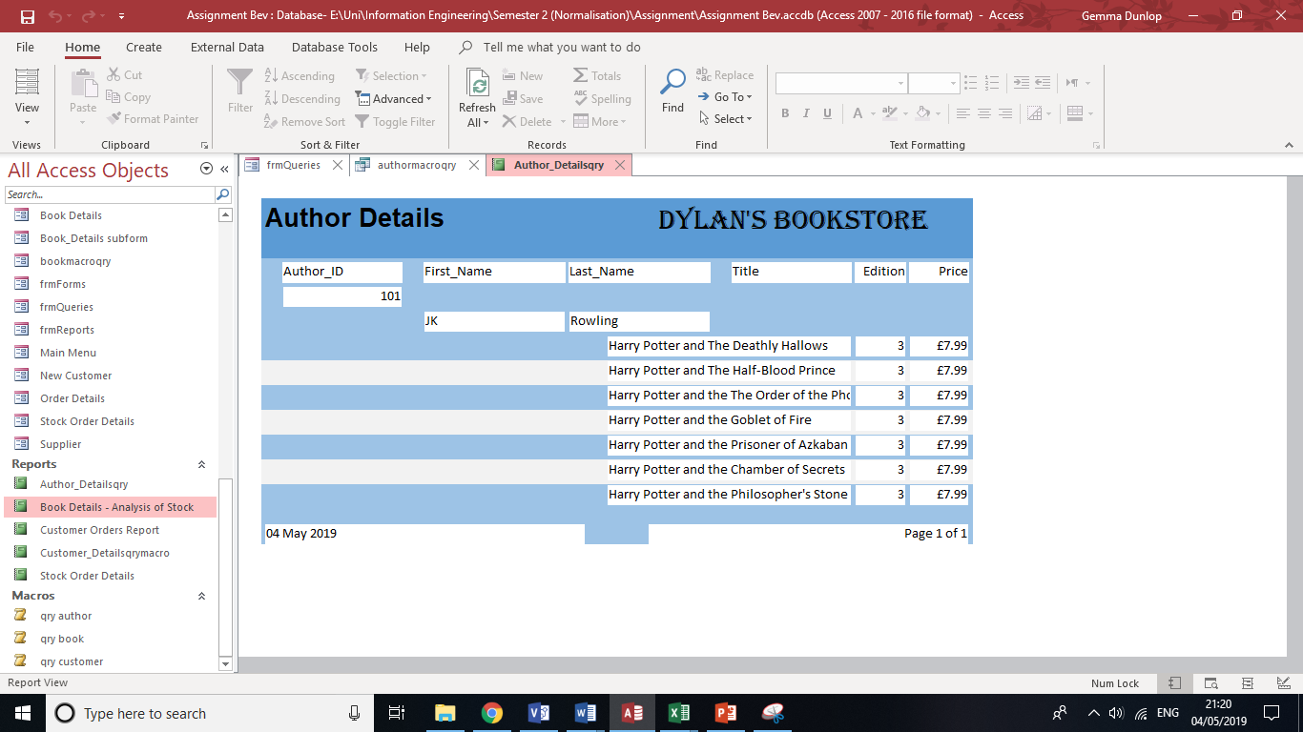
Figure 44 – Author Details macro query report.

The macro query created in order to generate the query and the report for the search criteria is shown in figure 45.
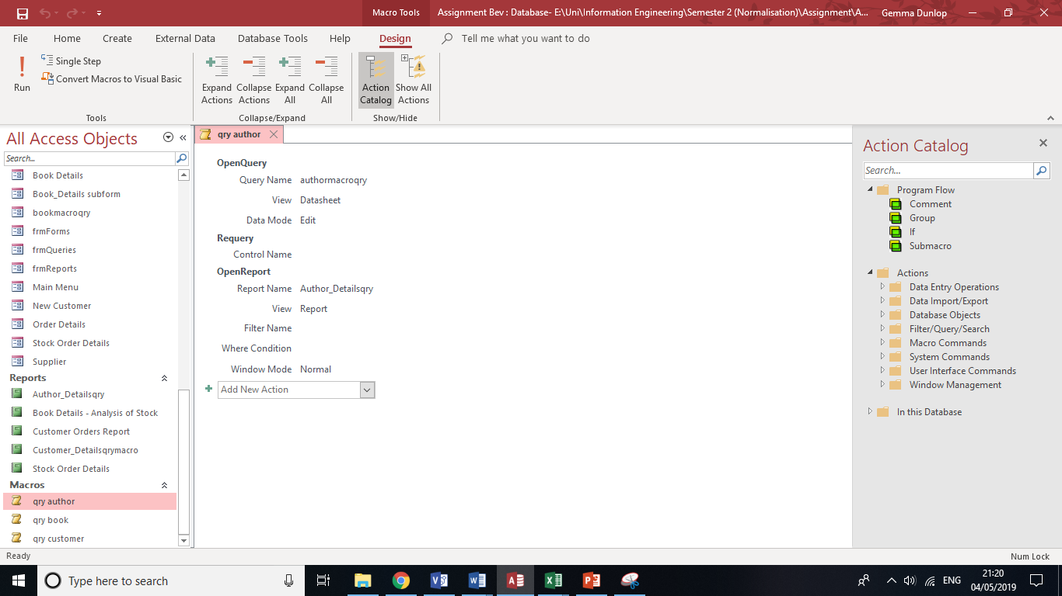
Figure 45 – Author Details query macro.

Search Customer Surname
When the user searches for a surname of a customer in the search bar, a query and a report which show the results for the customer and their order(s) are created as shown in figure 46.
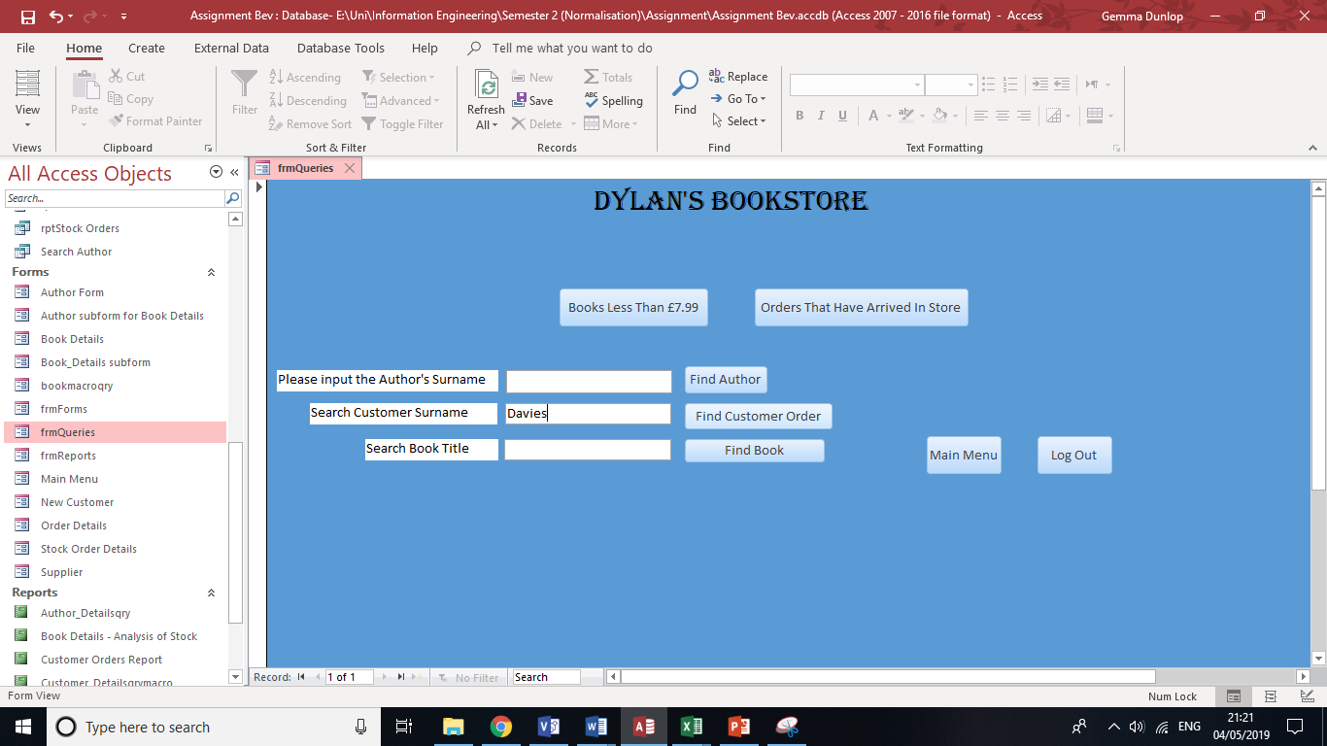
Figure 46 – Customer Surname search bar.

The fields Customer ID, First Name, Last Name, Title, Author ID, Price, Date of Order and Quantity were included in the query and the report is shown in figure 47.
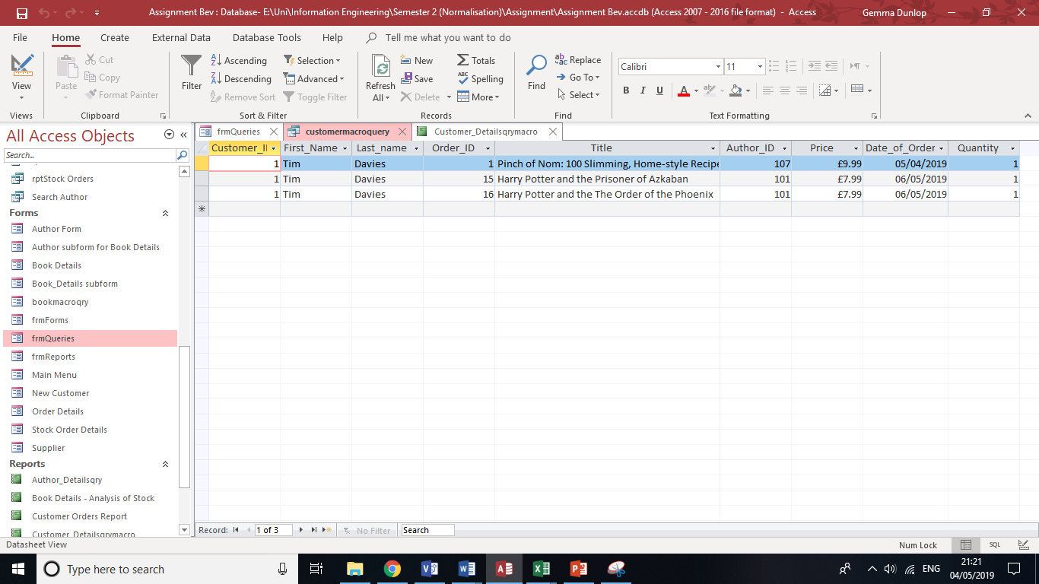
Figure 47 – Customer Details macro query.

The report showing the Author Details is displayed in figure 48. This could be used as a receipt for the customer.
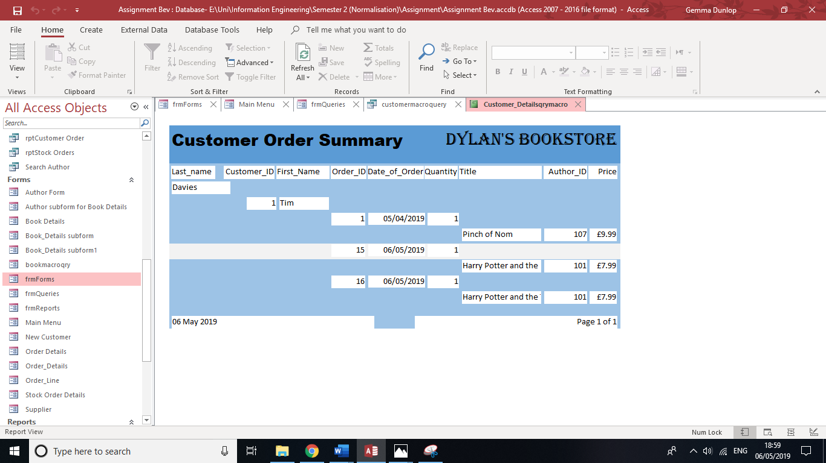
Figure 48 – Customer Details macro query report.

Figure 49 shows the macro query used to generate the query and the report.
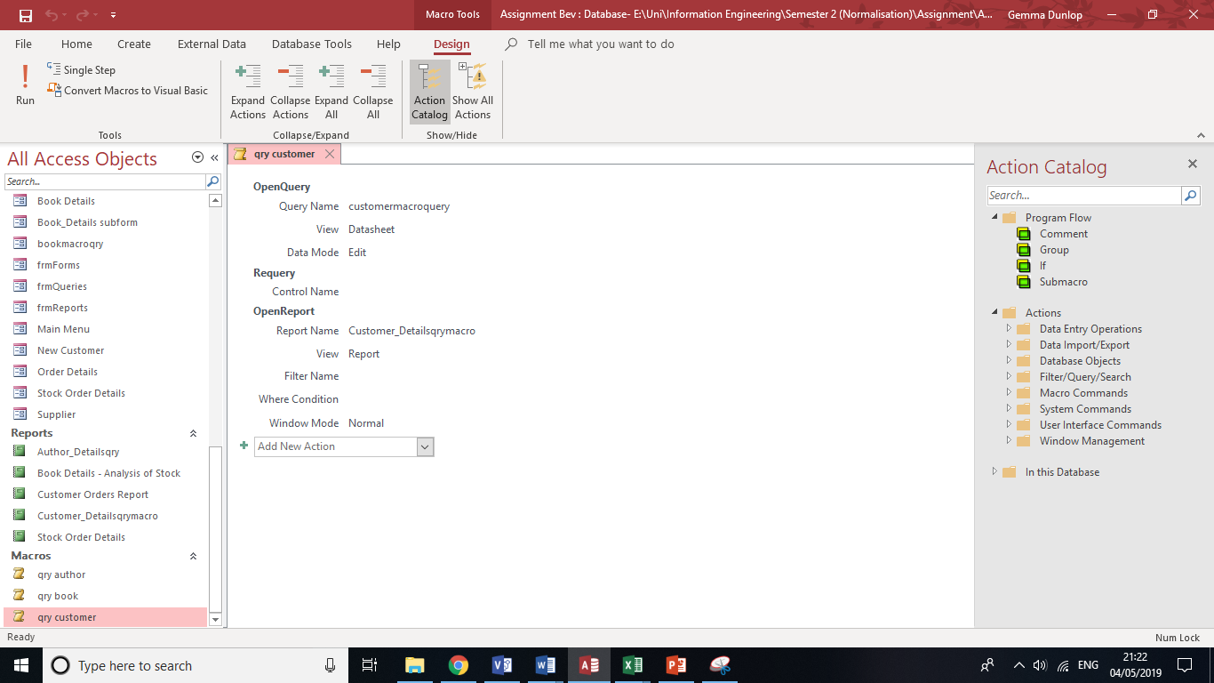
Figure 49 – Customer Details macro query.

Forms from a Macro Query
When the user searches for a book title in the search bar, a query and a form which show the results for the book are created as shown in figure 50.
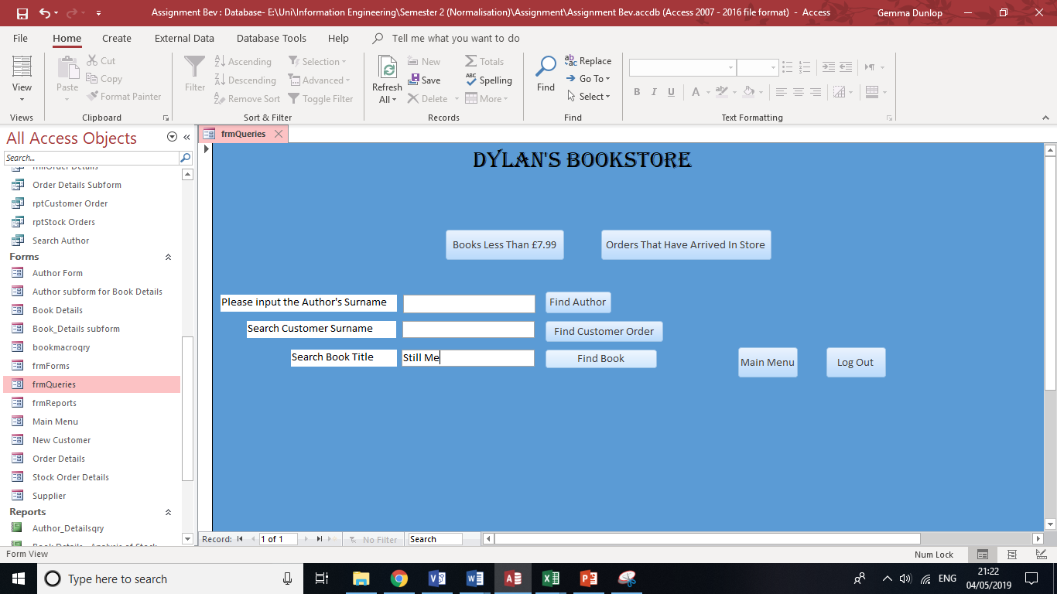
Figure 50 – Book Title search bar.

The fields Book ID, Title, First Name, Last Name, Genre, Year Published, Edition, Price and In Stock were included in the query and the report.
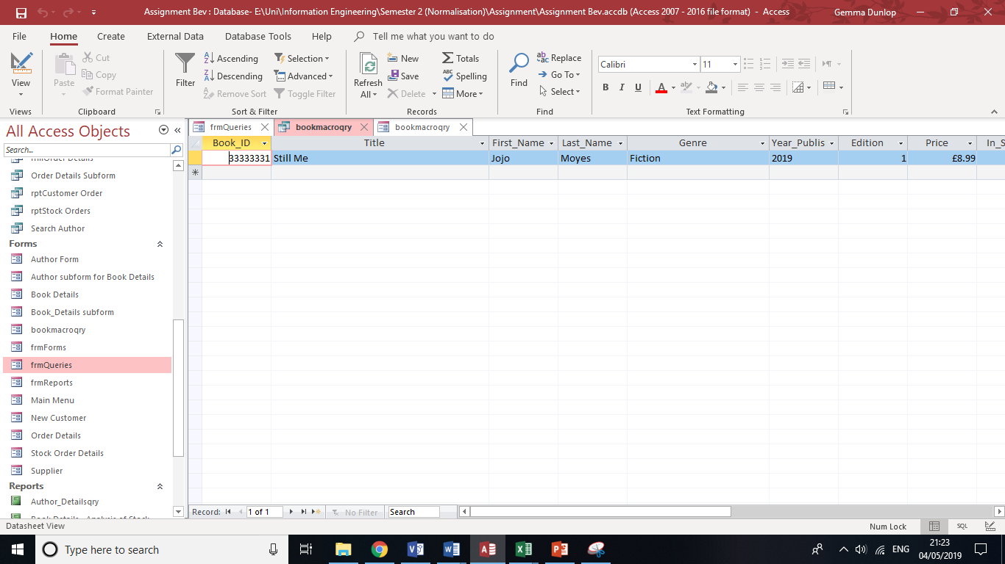
Figure 51 – Book Details query macro query.

The form showing the Author Details is displayed in figure 52.
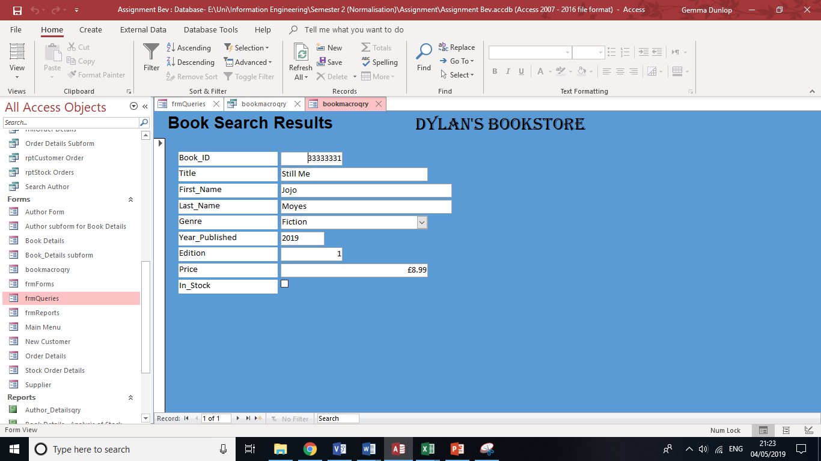
Figure 52 – Book Details macro query form.

The macro query for Book Details is shown in figure 53.
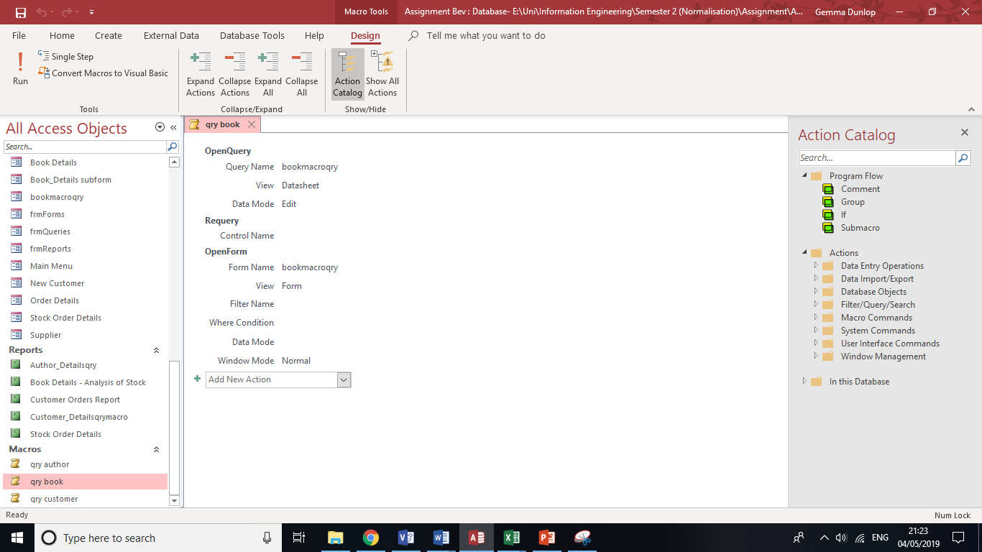
Figure 53 – macro query Book Details.

Author form
A form was created to allow the user to enter details of new authors and view details of currently stored authors.
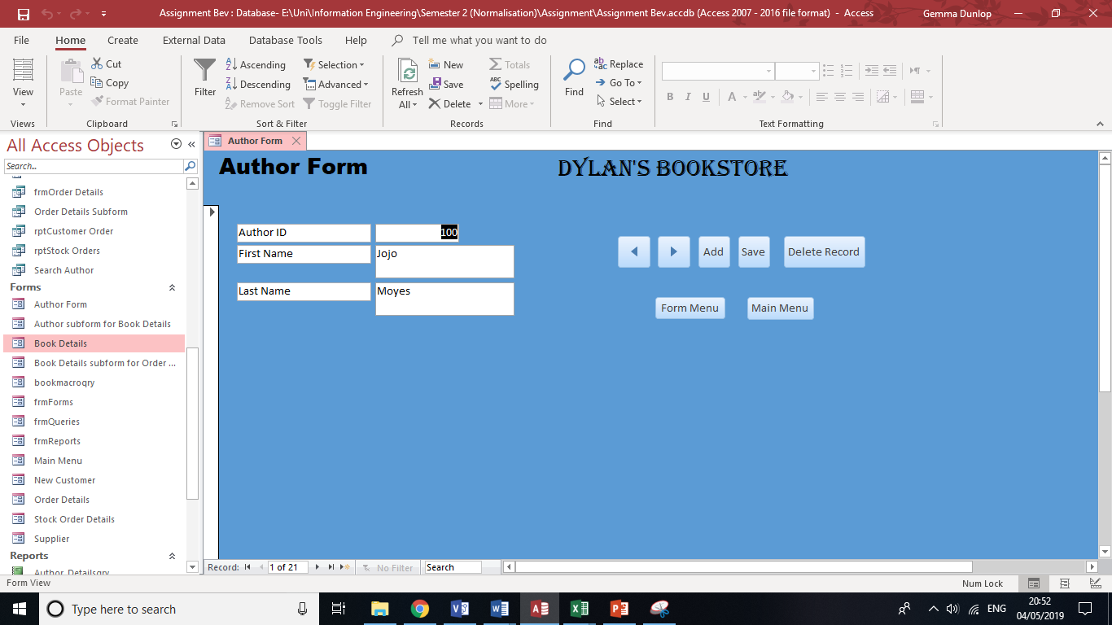
Figure 54 – Author Details form.

Book Details Form
The Book details form allows users to add and delete details of books held in the bookshop. A subform of author details was used as it allowed the user to check if they entered the author ID correctly.
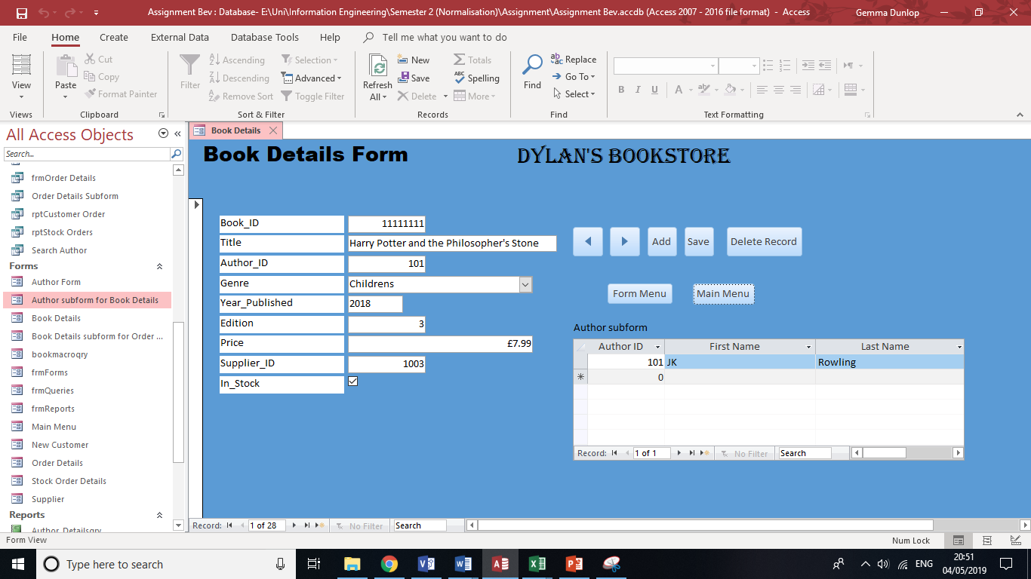
Figure 55 – Book Details Form.

New Customer Form
If a customer has not ordered from the bookstore before and wants to order a book, their personal details can be entered by the user using the New Customer form, as shown in figure 56.
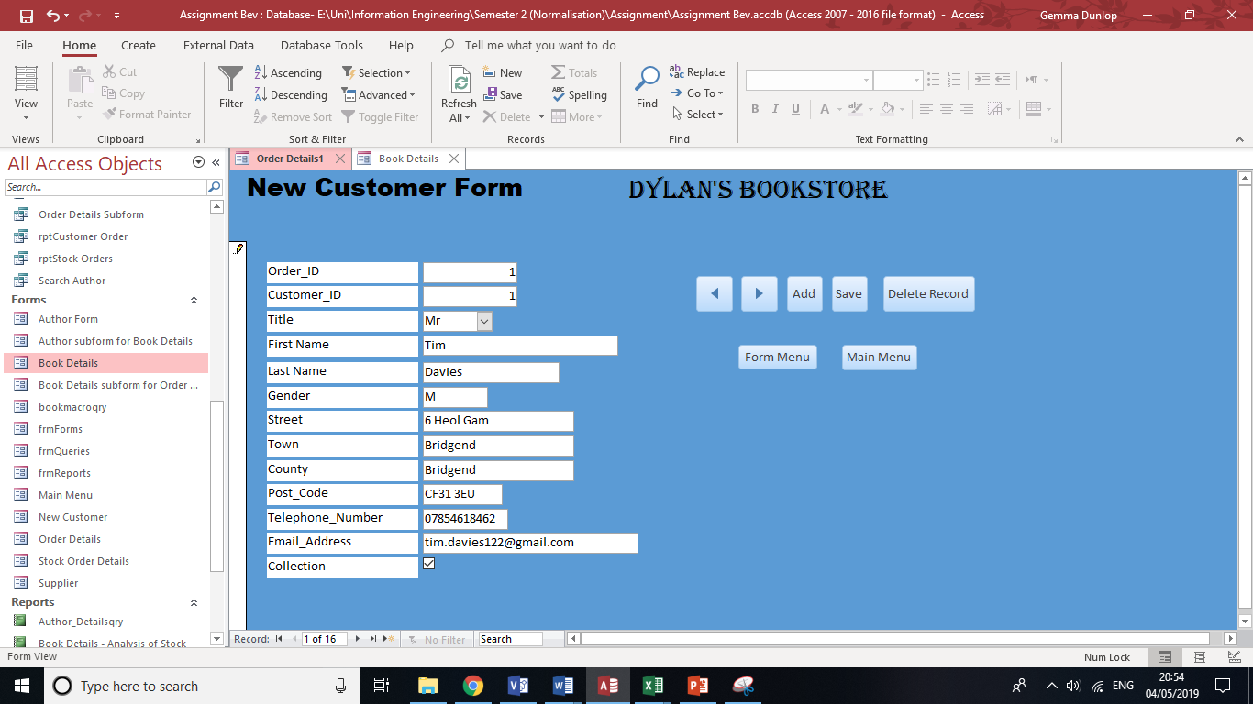
Figure 56 – New Customer Form.

Order Details Form
The Order Details form allows the user to enter Customer Order Details once they have entered the customer’s personal details shown in figure 57 (or using an existing ID if they are a returning customer).
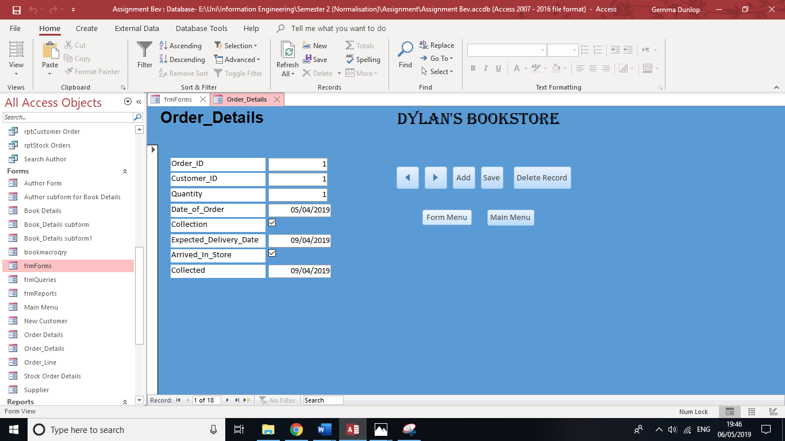
Figure 57 – Order Details Form.

Order Line Form
An Order Line form was created, as shown in figure 58 to connect the Order ID with the Book ID.
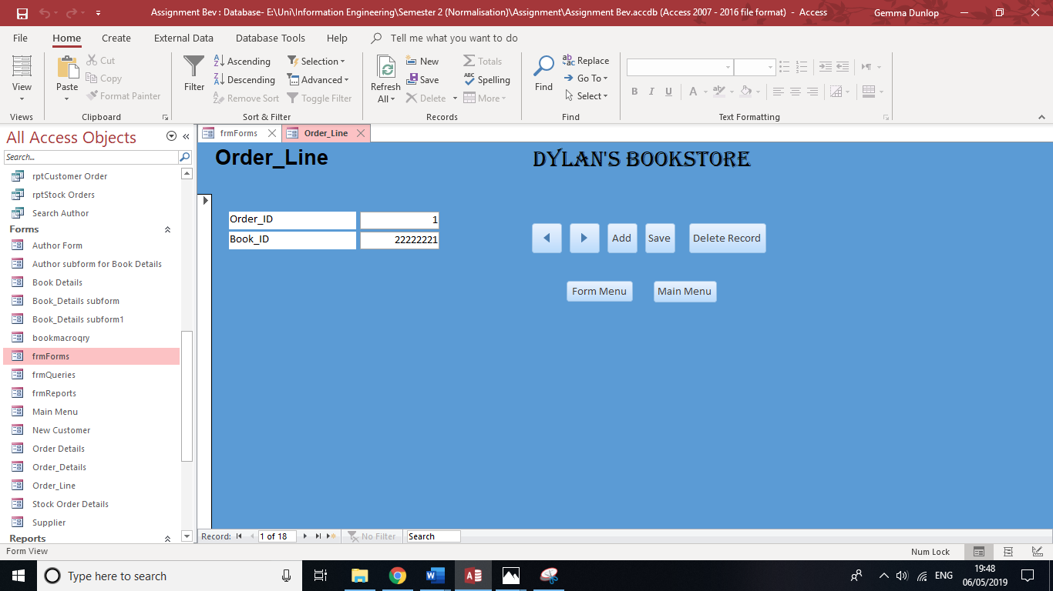
Figure 58 – Order Line Form

Order Summary Form
An Order Summary form was created to give the user a final summary of the customer order they have just placed as shown in figure 59. A Book Details subform was included to check if the user entered the right Book ID and to also show the user additional details of the book the customer has ordered such as the price.
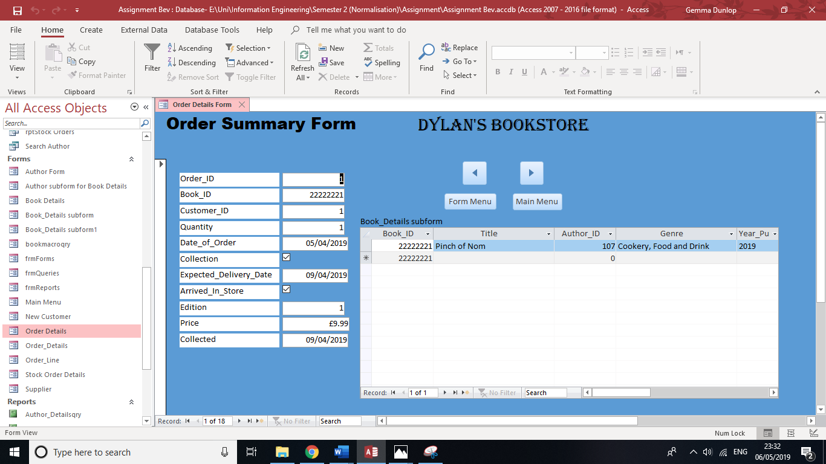
Figure 59 – Order Summary form.

Stock Order Form
A Stock Order form was created to display all the details of previous and outstanding orders, as shown in figure 60.
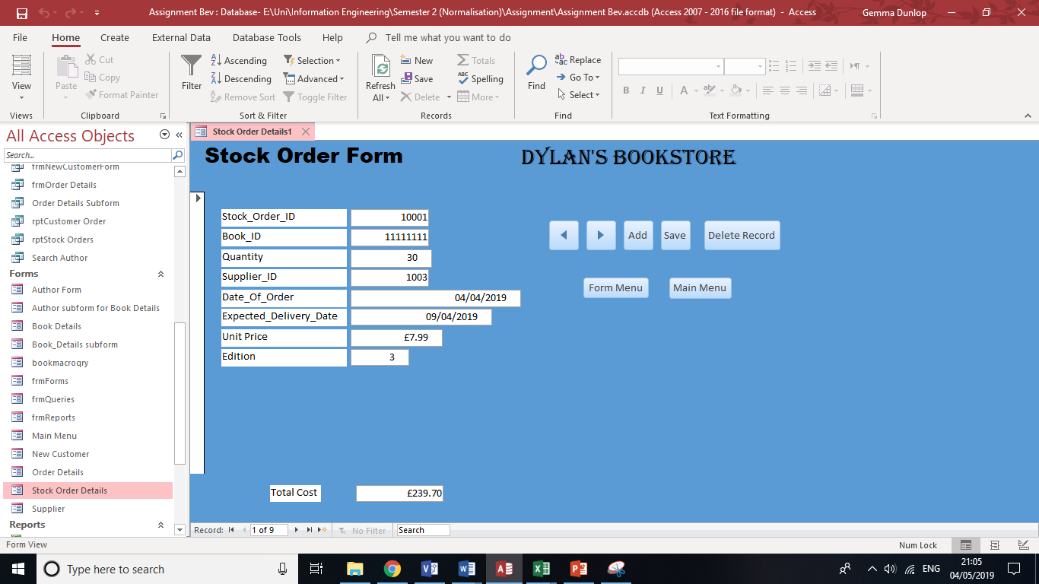
Figure 60 – Stock Order Form.

Supplier Info Form
A Supplier Info form was created to show information of suppliers that the bookstore orders from, as shown in figure 61.
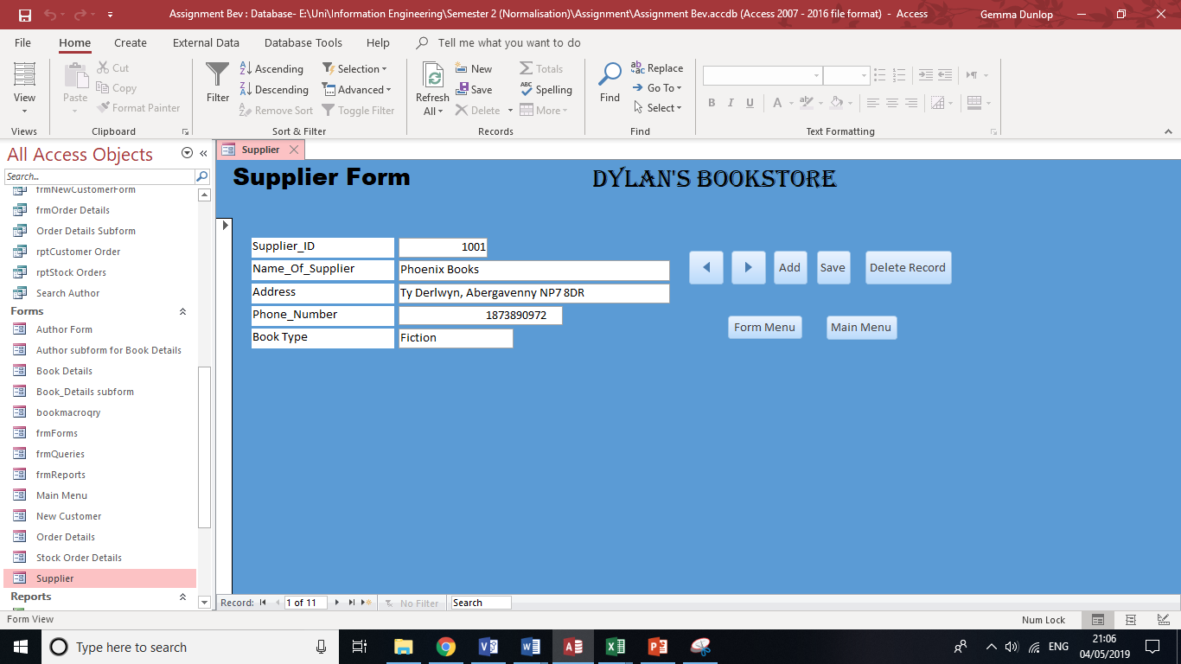
Figure 61 – Supplier Info form.

Queries

Single Table Query Using SQL
The SQL code to create a single table query is shown in figure 62 to search for all books which cost less than £7.99.
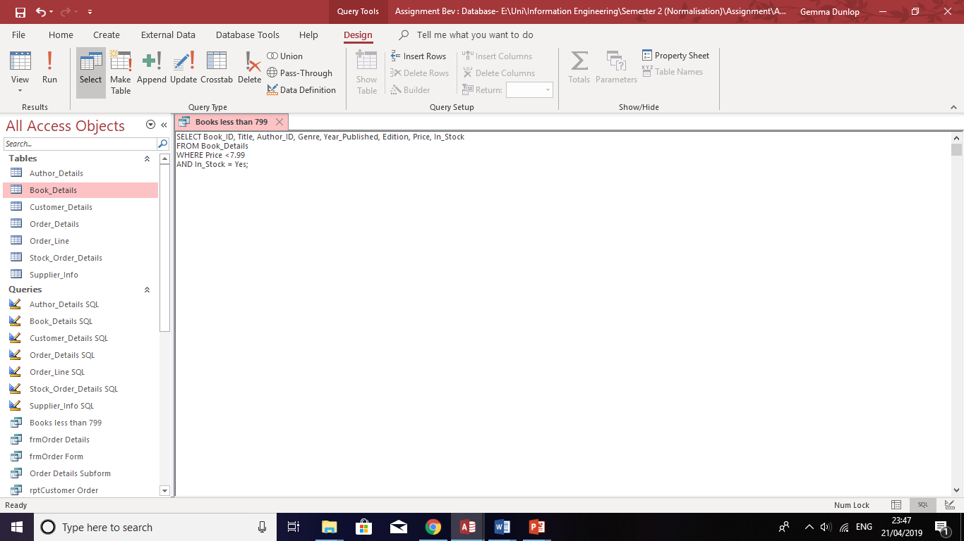
Figure 62 – Single table query for books less than £7.99.

Multi Table Query
A multiple table query was created, shown in figure 63, to display all customer orders which have been delivered to store.
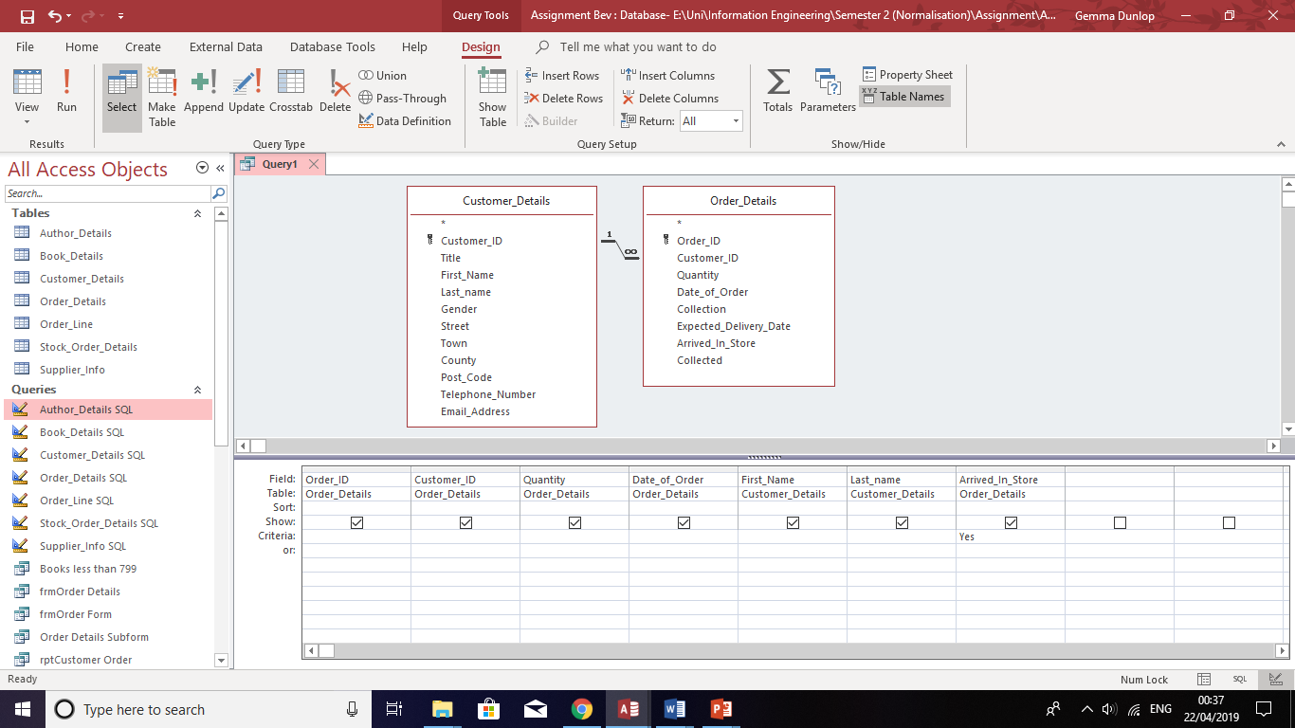
Figure 63 – multiple table query for customer orders which have arrived in store.

Reports

Book Details Report
A report was created which shows details of books in the bookstore, as shown in figure 64. Each book is sorted by genre and below each category contains calculations for the sum, average, minimum and average.
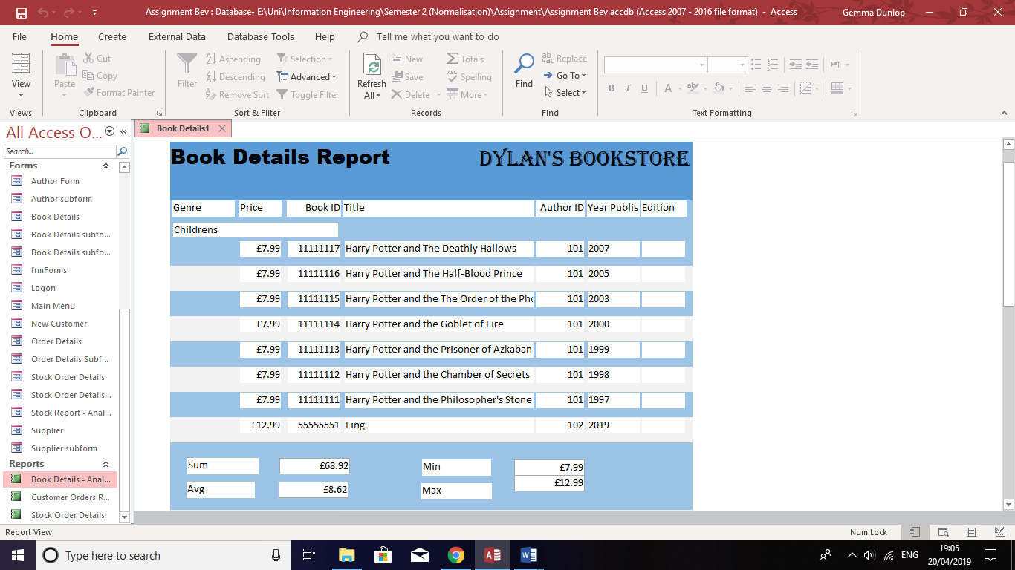
Figure 64 – Book Details report.

Customer Orders report
A report was created which displays customers’ orders, sorted under genre, as shown in figure 65. This allows the bookstore to see a summary of orders made by customers each year and spot trends, e.g. if a certain book was ordered many times.
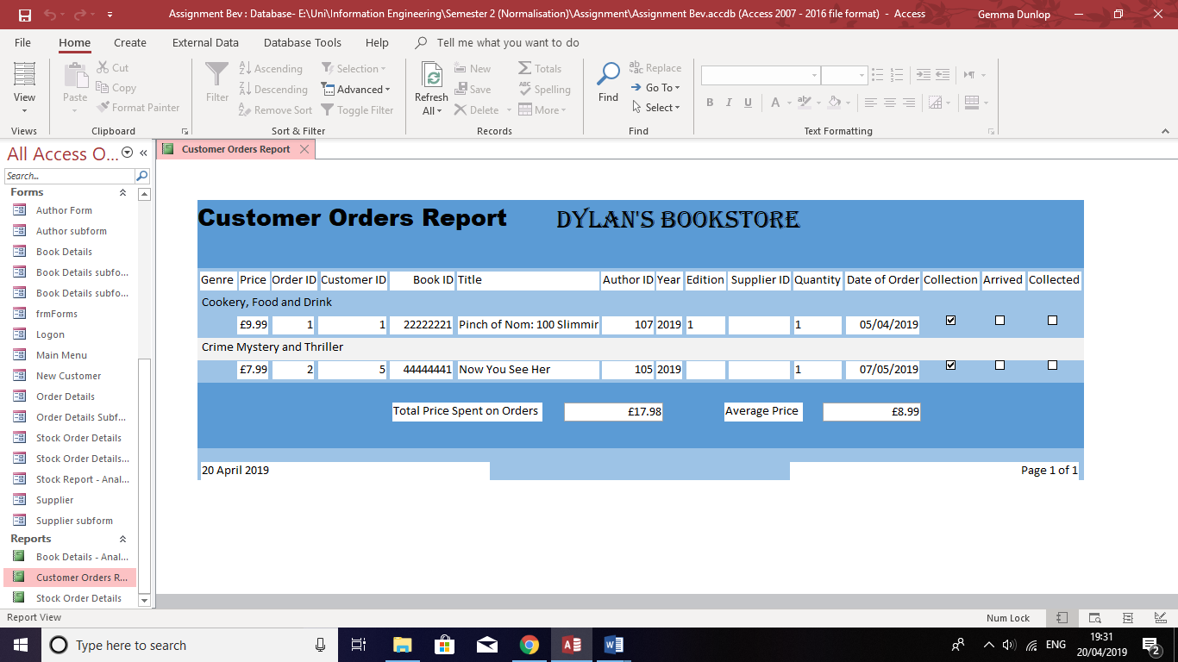
Figure 65 – Customer Details Report.

Stock Orders Report
A report was created which shows orders made by the company to suppliers. A calculation was contained at the bottom of the report which shows how much money the company spent on orders. This can be used annually by the company to calculate how much money the company spent on orders.
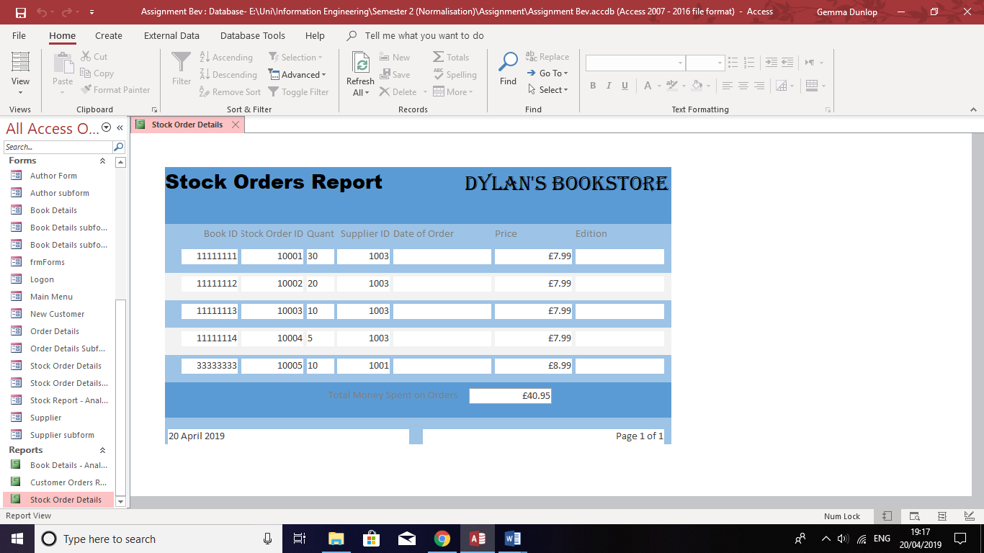
Figure 66 – Stock Order Details Report.

User Guide
Once the database is opened, the main menu appears. Each button on the main menu will link to a different part of the database.

Navigating the Author Form to add or delete an author
Click on the ‘Forms’ button as shown below.
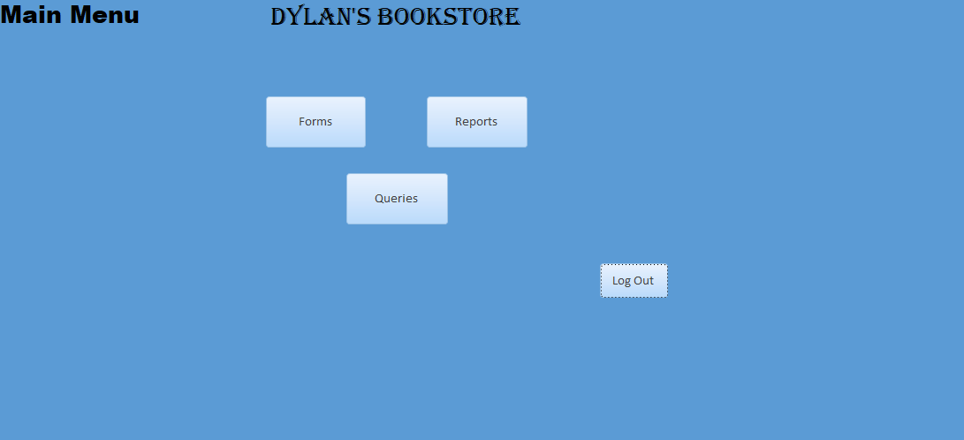
Click the button named ‘Author Details’.
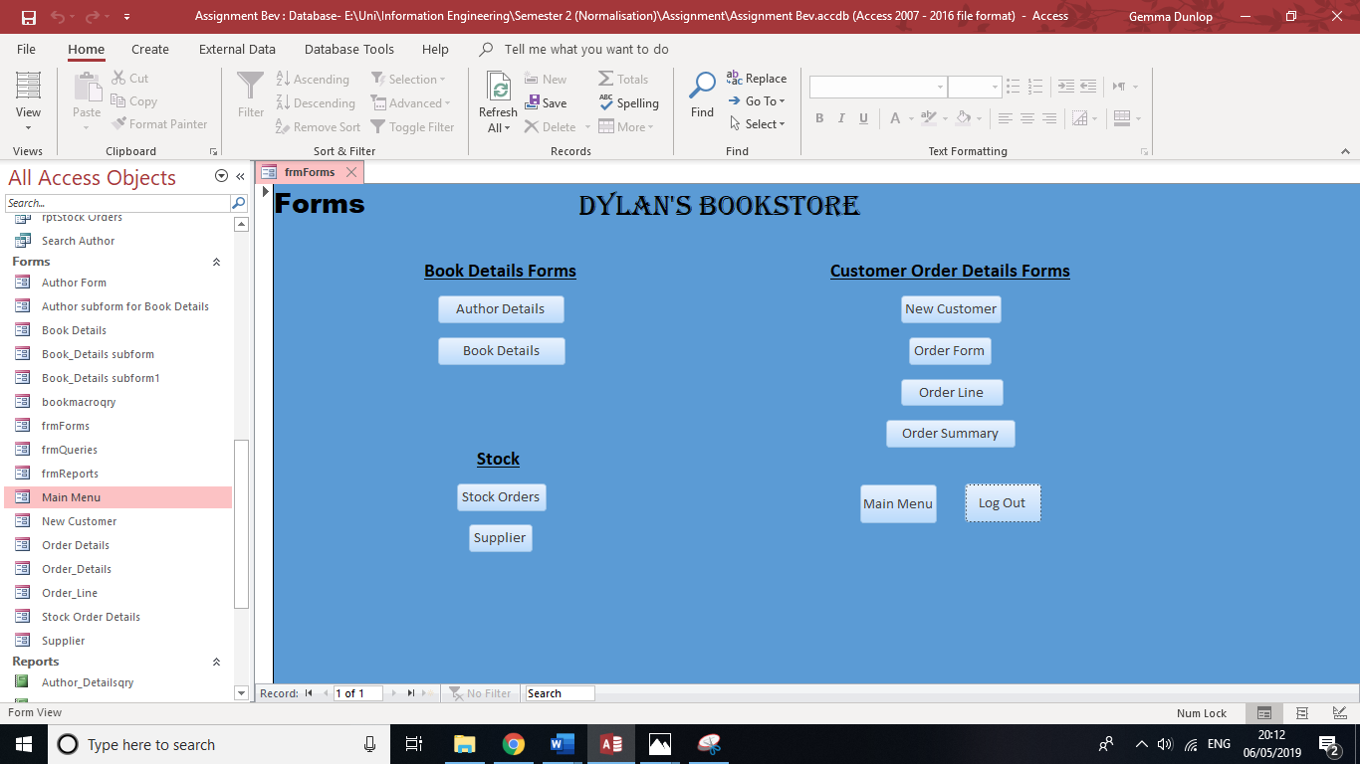
The Author Details form allows you to view author details held in the database. The buttons to the right of the Author Details allow you to navigate through each record.
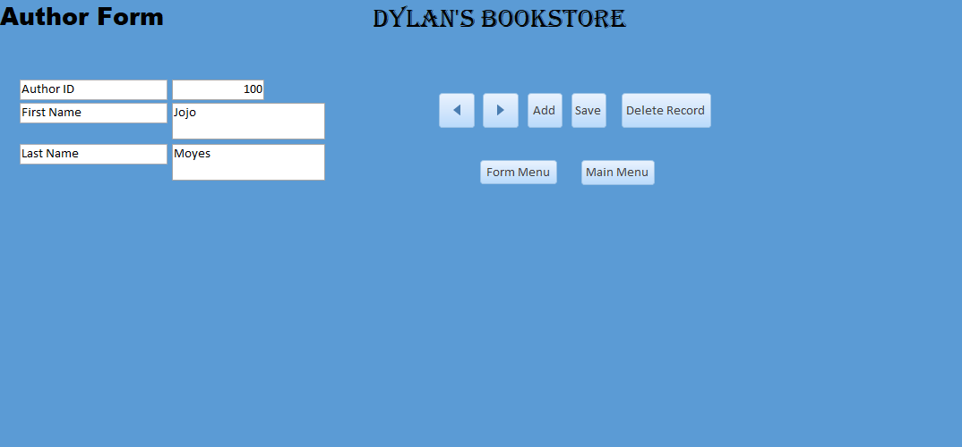

Navigating the Book Details Form to add or delete a book
Click on the ‘Forms’ button, as shown below.
Click the button named ‘Book Details’.
The Book Details form allows you to view details of each book in store.
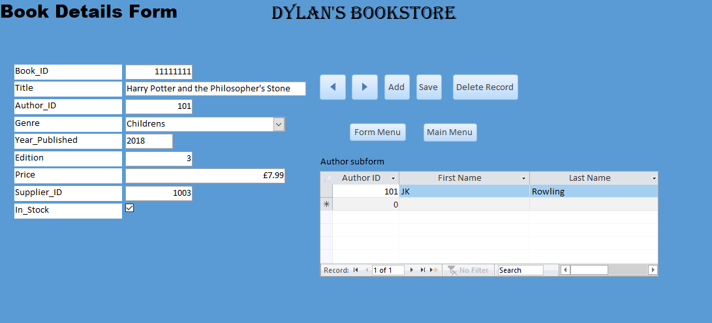

Searching for an author
Click on the ‘Queries’ button, as shown below.
Type the name of the author the customer is querying about and press ‘Find Author’.
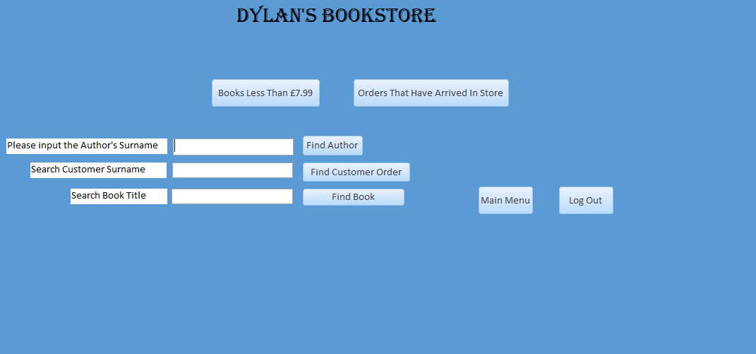
A report and a query will open showing the results of your search.
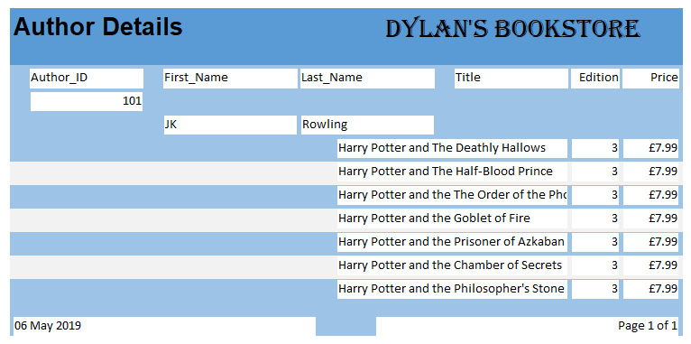
Click on the tabs at the top to view the query.

Searching for a book title
Click on the ‘Queries’ button, as shown below.
Type the name of the book title the customer is querying about and press ‘Find Book’.
A form and a query will open showing the results of your search.
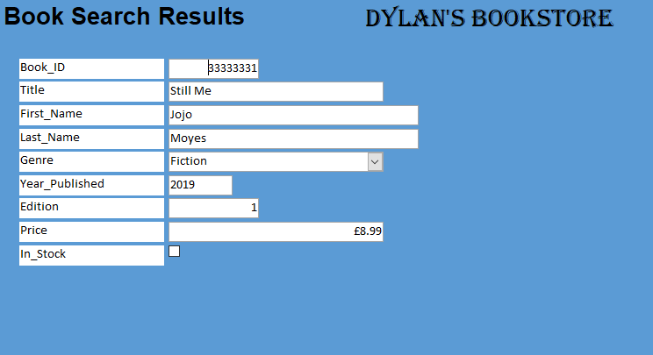
Click on the tabs at the top to view the query.

Placing a customer order for a new customer
Click on the ‘Forms’ button, as shown below.
Click the button named ‘New Customer’.
The New Customer Details form allows you to access customer details. It also allows you to add or delete customer details for new customers who would like to place orders. Click the ‘Forms Menu’ button to return to the Forms Menu. They are now set up as an existing customer, proceed to section 4.
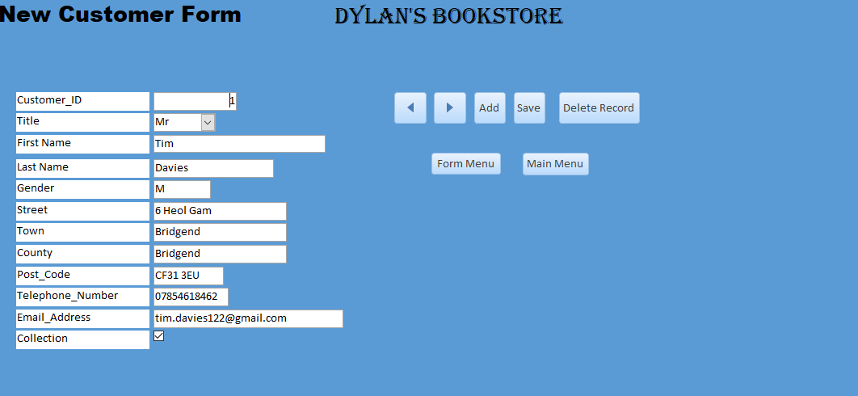

Placing a customer order for an existing customer
Click on the ‘Forms’ button, as shown below.
Click the button named ‘Order Form’.
The Order Details form allows you to enter customer order details when a customer wants to place a new order. Click the ‘Forms Menu’ button to return to the Forms Menu.
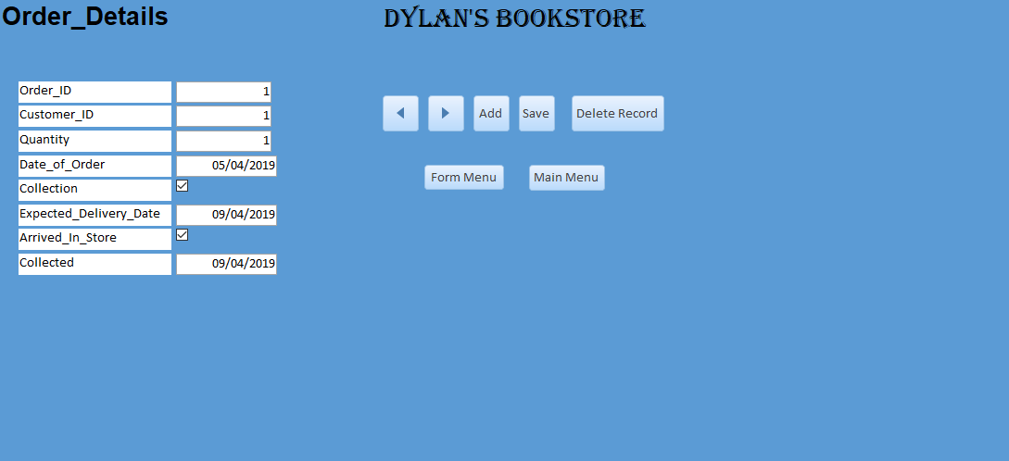

Click the button named ‘Order Line’.
The Order Line form will have to be used when a customer would like to place an order. You have now successfully created a customer order. Click the ‘Forms Menu’ button to return to the Forms Menu.
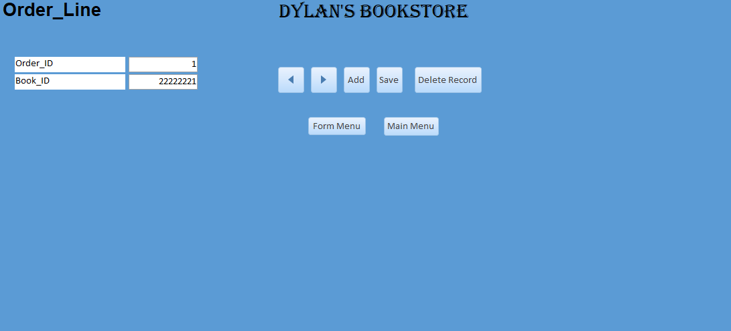

Click the button named ‘Order Summary’ to view the customer’s order details and to check the order details are correct.
The Order Summary form shows a summary of the details of the customer’s order. The subform shows details of the Book, linking to the Book ID. Move the bar at the bottom to see the rest of the details.
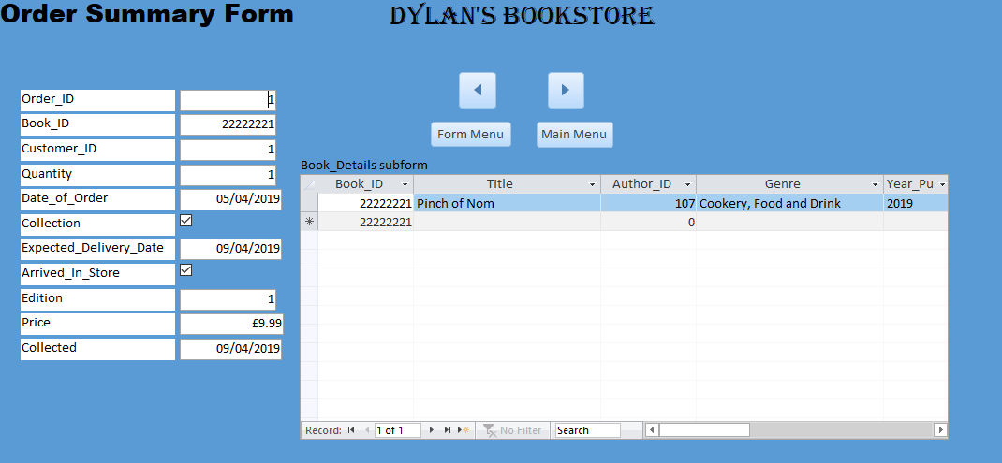

Navigating Stock Order Details to place orders with suppliers for new stock items
Click on the ‘Forms’ button, as shown below.
Click the button named ‘Stock Orders’.
The Stock Order form shows Stock Details held in the database. Press the button ‘Add’ and complete the blank fields for the stock order details.
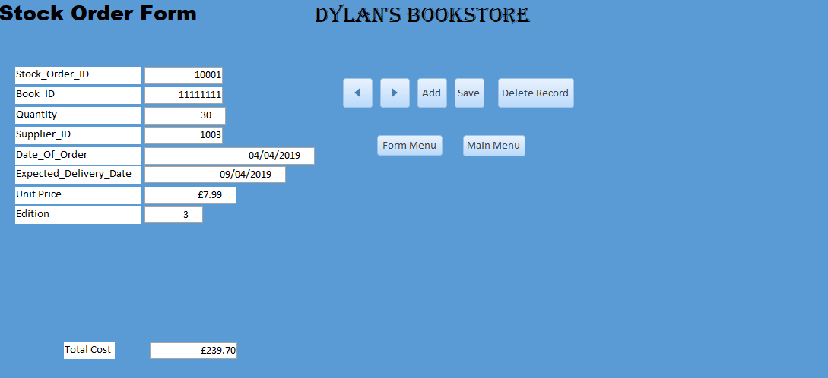

Navigating Supplier Details to add a new supplier
Click on the ‘Forms’ button, as shown below.
Click the button named ‘Stock Orders’.
Press the button ‘Add’ and complete the blank fields for the supplier details.
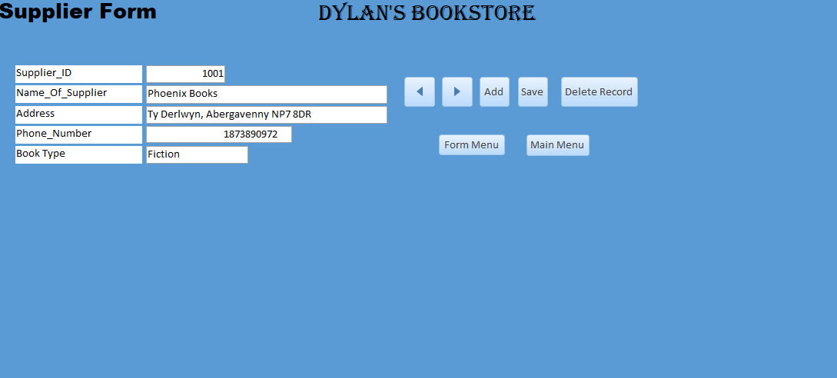

Viewing Book Details report
Click on the ‘Reports’ button, as shown below.
Click the button named ‘Book Details’.
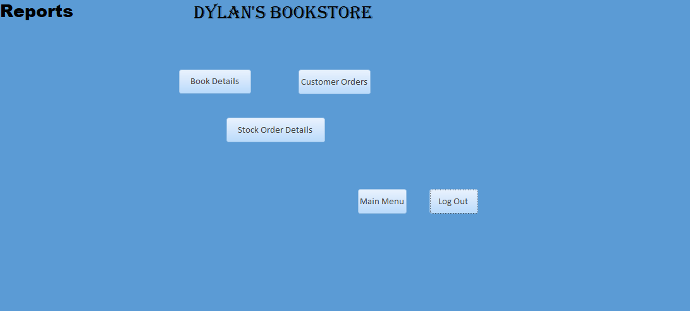
Book details report shows all details of book stored on database, sorted by genre.
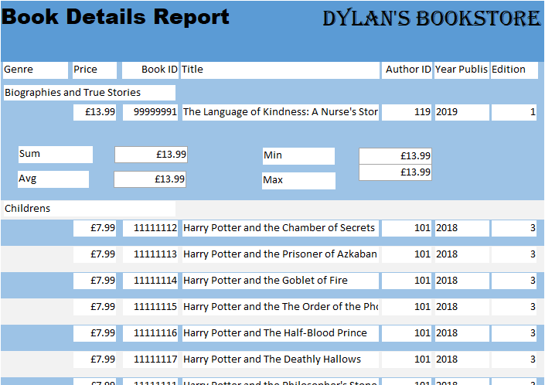
To print the report, see section 10.

Viewing Customer Order Details report
Click on the ‘Reports’ button, as shown below.
Click the button named ‘Customer Orders’.
Customer Orders report shows all details of customer orders stored on database, sorted by genre.
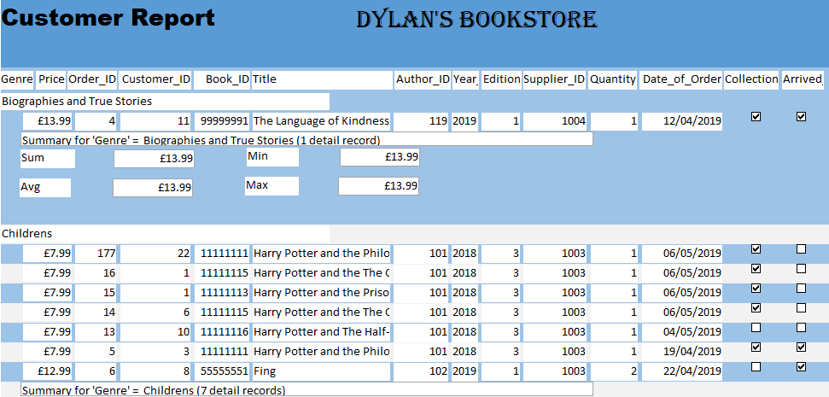
To print the report, see section 10.

Viewing Customer Order Details report
Click on the ‘Reports’ button, as shown below.
Click the button named ‘Stock Order Details’.
Stock Orders report shows all details of stock orders stored on database.
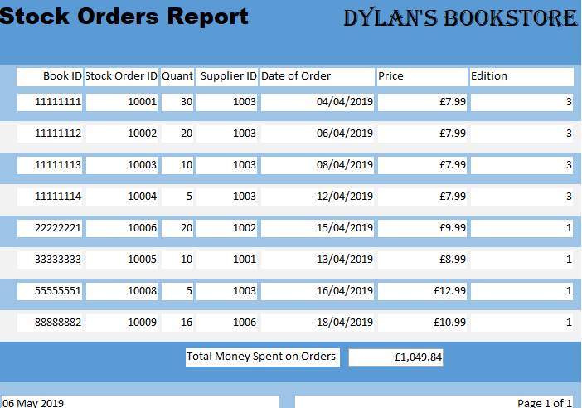
To print the report, see section 10.

Printing a report
Press the view button as shown below and press ‘Print Preview’.
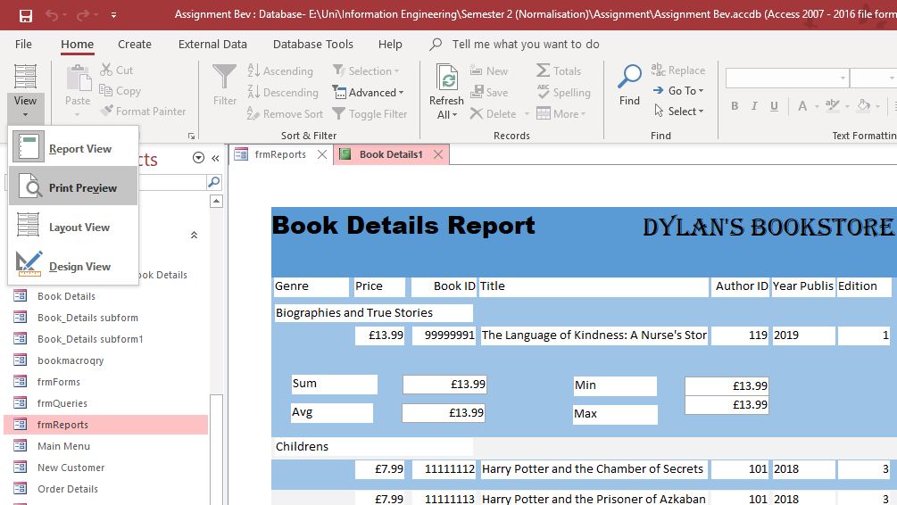
Select Print as shown below.
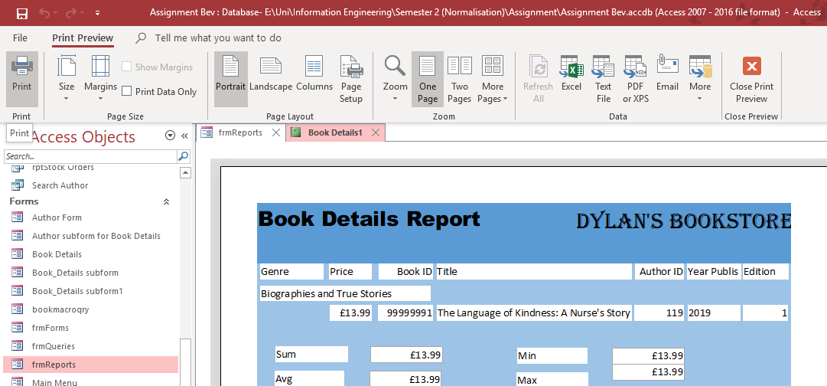

Viewing book details of all books under £7.99
Click on the ‘Queries’ button, as shown below.
Click the button named ‘Books Less Than £7.99’.
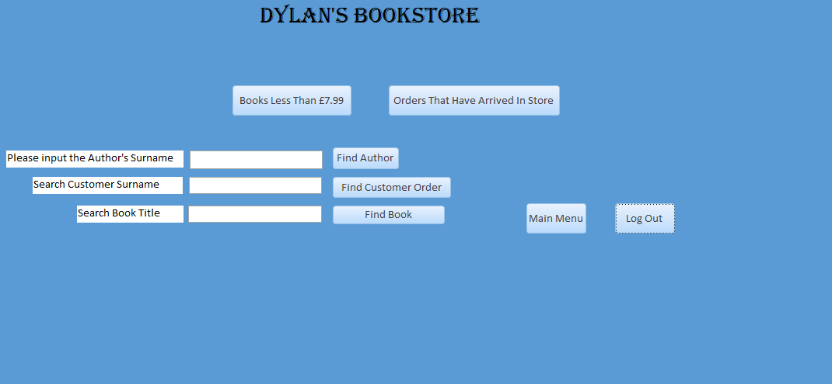
Click the ‘x’ to exit the query and return to the Query Menu.
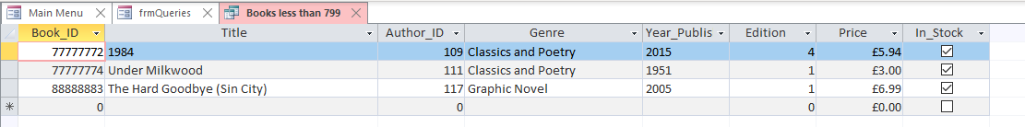

Viewing customer orders that are ready for collection
Click on the ‘Queries’ button, as shown below.
Click the button named ‘Orders That Have Arrived In Store’.

Click the ‘x’ to exit the query and return to the Query Menu.
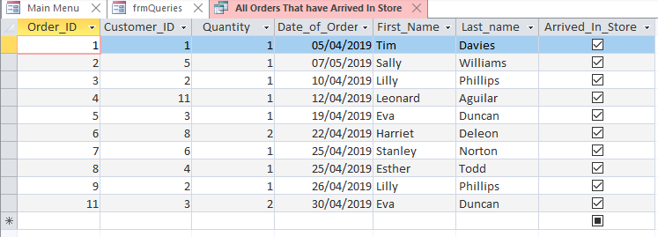

Searching for a customer order
Click on the ‘Queries’ button, as shown below.
Type the customer’s surname and press ‘Find Customer Order.
A report and a query will open showing the results of your search.
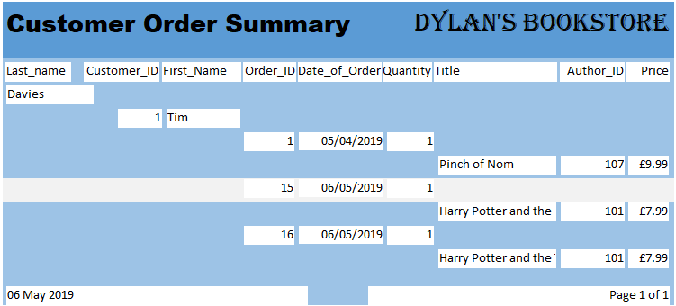
Click on the tabs at the top to view the query.

