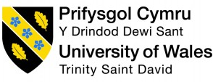

Marketing Report to promote Iceland as a destination at the World Travel Market

Niche Marketing and Social Media
(BMTP4014)
Susie-May James
2404489
Deborah Jenkins
Word Count: 1323

Executive Summary
Iceland; often referred to as the “land of fire and ice”, known for its plethora of glaciers and volcanoes, is located in Northern Europe (Tómas, 2024).
It attracted 2.21 million international tourists in 2023, which exceeded the previous year's figures by 31% (See Appendix A) (Road Genius, 2023).
This report will delve into the growing trends, target markets and future developments of the destination.
A number of different frameworks will be used throughout in order to support this marketing plan of promoting Iceland as a destination in the World Travel Market event.

Table of Contents:
Introduction 2
Situation Analysis 2
Objectives 5
Strategy 5
Tactics 7
Action 7
Control 8
Conclusion 8
Reference List 8
Appendix A 12
Appendix B – SWOT Analysis 12
Appendix C – PESTLE Analysis 14
Appendix D – Ansoff's Matrix 15
Appendix E – Marketing Mix (4P’s) 15

Introduction
The aim of this marketing plan is to promote Iceland as a destination and enhance its presence within the current travel market. This comprehensive plan is designed for business professionals attending the World Travel Market.
A framework that will guide this plan is SOSTAC; an acronym that stands for situational analysis, objectives, strategy, tactics, action and control, all of which are the fundamentals needed to create an effective marketing plan (Chaffey, 2023).
Additional frameworks and theorists that will be featured throughout, include the 4P’s, the 5C’s, PESTLE analysis, SWOT analysis, Ansoff’s Matrix and RACE framework.
In order to develop a successful strategic marketing plan, its essential to focus on market segmentation and niche market planning to reach the target audience, differentiate from competitors and promote itself as a unique and sustainable destination.

Situation Analysis
The following section will be supported by the 5C’s; a model that offers a deeper insight into the internal and external factors affecting an organisation. It stands for company (or in this case country), customers, competitors, collaborators and climate (Product Folio, 2022).

Country
This SWOT analysis (See Appendix B) explores the strengths, weaknesses, opportunities and threats of Iceland. One factor that stood out was that there’s an opportunity to capitalise on the growth of the eco-tourism market, with Iceland being an ideal destination to do so “The global eco-tourism market was valued at £141.3 billion in 2019 and is projected to reach £260.4 billion by 2027, growing at a CAGR of 14.3% from 2020 to 2027” (Coach Hire Comparison, 2024).

Customers
When looking at the Visit Iceland website on Similar Web the demographics include 25-34 year olds as being the main target audience and 53% being women.
The traffic to the site indicates geographical segmentation of inbound visitors within the US and the UK.
The psychographic profile of customers include having values of being eco conscious and are adventure seekers.

Competitors
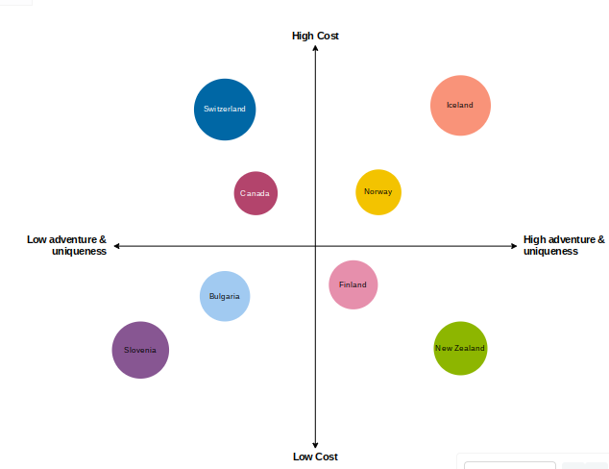
The perceptual positioning map above offers a deeper insight into where Iceland’s competitors stand. It is evident that Norway is its closest competitor, offering similar experiences and landscapes at a more affordable price.
However, Iceland differentiates from its competitors with its USP (unique selling point) of offering a range of natural phenomena's in a close proximity, allowing visitors to easily access and explore, unlike Norway where the attractions are sparsely positioned.

Collaborators
Collaboration is a crucial element when promoting a destination, for example partnering with key businesses to form suitable packages for the customer. This could include Icelandair as an airline, a Guide to Iceland for local experiences and tours, the Blue Lagoon Spa for attraction opportunities and Hilton Reykjavik Nordica for accommodation.
Having an influencer such as Greta Thunburg will benefit Iceland as she is an advocate on sustainability, therefore would help raise the profile and appeal of Iceland to the target market.

Climate
As stated in the PESTLE framework (See Appendix C), the increase in Insta tourism has had a profound impact on Iceland “significance of Instagram in the recent growth in tourist numbers visiting the country” (Stainton, 2019).

Objectives
SMART Objective: To increase bookings to Iceland by 20% by April 2025 through exposure from the World Travel Market, as well as digital campaigns to target both eco conscious and adventure travellers aged 25-45.
Justification: This aligns with the goals by raising the profile of Iceland to attract this target market and meeting the current trends of eco-tourism.

Strategy
Ansoff’s Matrix is a model (See Appendix C) that “helps marketing leaders identify business growth opportunities for their marketing strategies in a challenging market” (Hanlon, 2021).
Having considered the four growth strategies of Ansoff’s Matrix and the specific objective to promote Iceland and increase bookings, it best fits into the market penetration section by appealing to existing markets and products. This involves continuing to market to eco concious and adventure travellers by emphasising Iceland’s sustainability efforts as a destination and unique experiences like the Northern lights display.

The marketing mix; otherwise known as the 4P’s consists of product, price, place and promotion; all of which are essential when marketing a product or service to the public (Twin, 2024).
Product Differentiation: Emphasising on Iceland’s unique offerings including the glaciers, geothermal spas and northern lights will help to set them apart from competitors.
Pricing Strategies: A value based pricing strategy would be most suitable to use in order to “assess customer needs and value perceptions” (Kotler and Armstrong, 2021, p.298).
It would also be necessary to incorporate yield management and adjust prices based on seasonality and demands in order to maximise revenue.
Placement: At Iceland’s stand it would be beneficial to offer a VR experiences for the attendees so that they can immerse themselves in some of the top attractions and sights available, to help them visualise and buy into this.
Similarly, showcasing the tours and experiences through pictures and brochures is essential.
Perhaps offering some Icelandic foods for attendees to taste would be another way to encourage people to the stand.
Packaging: Stating Iceland as “The Land of Fire and Ice” will inquisite people to visit the stand, as well as helping to create a memorable brand for the destination.
Promotional Mix: Digital marketing will be used to capture the audience through influencer campaigns and ensuring that Iceland reaches its full potential through SEO (search engine optimisation).

Tactics
The Race Framework stands for reach, act, convert and engage and is “designed to help brands engage their customers throughout the customer lifecycle” (Chaffey, 2024).
Reach: In order to increase the digital presence of Iceland to reach potential customers, boosting the SEO (search engine optimisation) with websites such as Visit Iceland will help to increase interest. Similarly, collaborating with renowned influencers will help to draw attention to Iceland as a destination and create a demand to visit.
Act: Creating engaging content across social media platforms like Instagram adverts surrounding the reasons to visit Iceland and all it has to offer will capture the attention of the consumer.
Convert: Offering packages and exclusive deals will encourage people to ‘covert’ and buy the product.
Engage: Increasing the post visit interactions from follow up emails will help to keep the customer aware of what’s on offer and engaged in the content being shown.
The communications mix for promoting Iceland at WTM will consist of advertisement through social media, radio and print, events such as the WTM through networking, as well as email and direct marketing to follow up any links generated from the event.

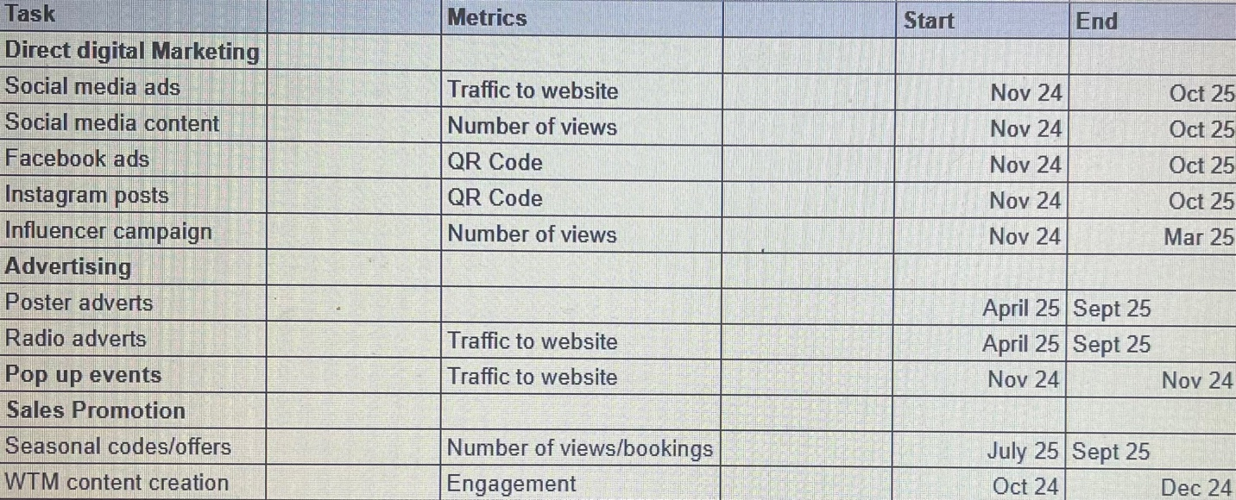
Action

Based on the Gant Chart above, it offers a clear indication of the best marketing channels to appeal to Iceland’s main target market of 25-34 year olds. “The Social Bakers social media trends report shows that Facebook and Instagram, two of the most popular social networks are particularly good for marketing to millennial and Gen Z age groups” (Smart Insights, 2020).
The timings are influenced by a combination of content creation prior to the WTM, alongside the peak periods of activities within the destination (e.g Northern Lights visible between October-March).

Control
The success of this marketing plan can be measured in many different ways. One way is whether the SMART goal previously set is met by the deadline stated. Similarly, KPI’s (key performance indicators) are another way to measure progress through an increase in bookings to Iceland, web searches tracked through google analytics or Similar Web or social media platform engagement. Monitoring this regularly will offer insights into the progress made.
Another indicator will be to measure the overall GDP that tourism generates for Iceland. “Iceland profits greatly from its tourism boom – which accounted for 8.5 percent of its GDP in 2023” (Zimmermann, 2024).

Conclusion
To conclude, Iceland is an ideal destination for both adventure and eco tourists with an abundance of unique natural attractions on offer! To improve, drawing attention to the opportunities including the trends and demands in eco tourism and current sights of volcanic activity will be beneficial for the destinations success and sales.

Reference List

Andrew, H. (2017). UWTSD Logo. Image. Available at: https://www.discoverdylanthomas.com/portfolio-items/dylan-day-poetry-share-uwtsd-carmarthen/print-2 [Accessed 8 Dec. 2024].
BBC (2023). Introduction to the Marketing Mix - the Marketing Mix - Edexcel - GCSE Business Revision - Edexcel. [online] BBC Bitesize. Available at: https://www.bbc.co.uk/bitesize/guides/z4wtmfr/revision/1 [Accessed 8 Dec. 2024].
Chaffey, D. (2023). SOSTAC Marketing Planning Model Guide. [online] Smart Insights. Available at: https://www.smartinsights.com/digital-marketing-strategy/sostac-model/ [Accessed 6 Dec. 2024].
Chaffey, D. (2024). Introducing RACE: a Practical Framework to Improve Your Digital Marketing. [online] Smart Insights. Available at: https://www.smartinsights.com/digital-marketing-strategy/race-a-practical-framework-to-improve-your-digital-marketing/ [Accessed 15 Dec. 2024].
Chomsky, R. (2024). Top 10 Greenest Sustainable Countries in the World. [online] Sustainable Review. Available at: https://sustainablereview.com/top-10-greenest-sustainable-countries-in-the-world/ [Accessed 10 Dec. 2024].
Churm, P.A. (2021). Spectators Flock to See Erupting Icelandic Volcano. [online] Euronews. Available at: https://www.euronews.com/2021/05/09/an-erupting-volcano-in-iceland-is-drawing-tourists-from-around-the-world [Accessed 7 Dec. 2024].
Coach Hire Comparison (2024). 46 Shocking Sustainable Tourism Statistics - Ecotourism Stats 2024. [online] Coach Hire Comparison. Available at: https://www.coachhirecomparison.co.uk/blog/sustainable-tourism-statistics [Accessed 7 Dec. 2024].
Contreras-Langlois, C. (2024). When’s the Best Time for You to Visit Iceland? [online] www.nordicvisitor.com. Available at: https://www.nordicvisitor.com/blog/best-time-visit-iceland-guide/ [Accessed 7 Dec. 2024].
DeGeorge, K. (2018). Northern Lights Tourism Remains Extremely Popular in Iceland. [online] ArcticToday. Available at: https://www.arctictoday.com/northern-lights-tourism-remains-extremely-popular-iceland/ [Accessed 11 Dec. 2024].
Hanlon, A. (2021). The Ansoff Model. [online] Smart Insights. Available at: https://www.smartinsights.com/marketing-planning/create-a-marketing-plan/ansoff-model/ [Accessed 8 Dec. 2024].
Hughes, R.A. (2024). Iceland Volcano eruption: Travel Advice and Blue Lagoon Update. [online] Euronews. Available at: https://www.euronews.com/travel/2024/11/21/iceland-volcano-2023-how-likely-is-an-eruption-and-how-will-it-affect-travel [Accessed 7 Dec. 2024].
Iceland Monitor (2024). Icelandic Nature the Biggest Draw. [online] Icelandmonitor.mbl.is. Available at: https://icelandmonitor.mbl.is/news/news/2024/04/19/icelandic_nature_the_biggest_draw/ [Accessed 10 Dec. 2024].
Kotler, P. and Armstrong, G. (2021). Principles of Marketing. 18th ed. Harlow: Pearson, p.298.
Product Folio (2022). 5 C’s Framework. [online] Productfolio. Available at: https://productfolio.com/5cs-framework/ [Accessed 7 Dec. 2024].
Road Genius (2023). Iceland Tourism Statistics - How Many Tourists Visit? (2023). [online] Road Genius. Available at: https://roadgenius.com/statistics/tourism/iceland/ [Accessed 15 Dec. 2024].
Shahin, I. (2017). How Expensive Is Iceland? | Guide to Iceland. [online] Guide to Iceland. Available at: https://guidetoiceland.is/travel-info/how-expensive-is-iceland [Accessed 7 Dec. 2024].
Smart Insights (2020). 7 Ways to Reach Millennials through Social Media Marketing | Smart Insights. [online] Smart Insights. Available at: https://www.smartinsights.com/social-media-marketing/social-media-strategy/7-ways-to-reach-millennials-through-social-media-marketing/ [Accessed 15 Dec. 2024].
Smart Traveller (2024). Iceland. [online] Smartraveller.gov.au. Available at: https://www.smartraveller.gov.au/destinations/europe/iceland [Accessed 7 Dec. 2024].
Stainton, H. (2019). Insta Tourism explained: What, Why and Where. [online] Tourism Teacher. Available at: https://tourismteacher.com/insta-tourism/ [Accessed 15 Dec. 2024].
Tómas, A. (2024). Where Is Iceland? [online] Guide to Iceland. Available at: https://guidetoiceland.is/best-of-iceland/where-is-iceland [Accessed 10 Dec. 2024].
Twin, A. (2024). The 4 Ps of Marketing and How to Use Them in Your Strategy. [online] Investopedia. Available at: https://www.investopedia.com/terms/f/four-ps.asp.
Zimmermann, A. (2024). I Went to Iceland for a Road trip. I Left with Climate anxiety. [online] Politico. Available at: https://www.politico.eu/article/iceland-climate-change-jokulsarlon-atlantic-ocean/ [Accessed 7 Dec. 2024].

Appendix A
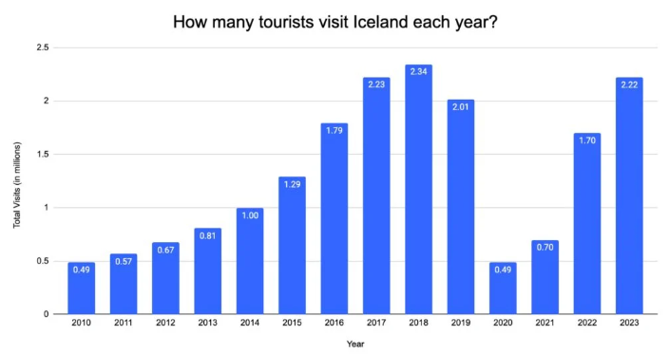

Appendix B – SWOT Analysis
SWOT Analysis on Iceland as a destination
Strengths:  - “More than 40 percent of tourists to Iceland in the winter season go hunting for the Northern lights” (DeGeorge, 2018). This demonstrates that the Northern Lights are the biggest draw to Iceland and therefore is the destinations USP.  - Iceland is a versatile destination that can be visited all year round and is personal to when you wish to visit (Contreras-Langlois, 2024). i.e. some prefer to experience the winter months with the northern lights, while others may even return to see the country’s landscape completely change during the spring and summer months.  - “Iceland also strongly emphasises sustainable tourism, ensuring its natural landscapes are protected for future generations. With its focus on renewable energy and sustainable practices, Iceland stands out as one of the greenest countries in the world” (Chomsky, 2024). This supports the target market of eco conscious travellers in which this marketing plan is aimed towards. | Weaknesses:  - “Iceland is currently one of the most expensive countries in the world” (Shahin, 2017). This shows that it is very expensive for travellers to visit, meaning it could deter people from visiting or even perhaps only target a certain demographic who can afford this.  - “60% of Icelandic tourism industry stakeholders rated infrastructure at tourist sites as bad”, showing the need for infrastructure improvement, especially after this campaign with the influx of tourists visiting (OECD, 2014).
Opportunities:  - “The global ecotourism market was valued at £141.3 billion in 2019 and is projected to reach £260.4 billion by 2027, growing at a CAGR of 14.3% from 2020 to 2027” (Coach Hire Comparison, 2024). This highlights the growing trend of eco tourism, making it favourable for Iceland.  - “A volcano in Iceland that has not erupted in 6,000 years has been drawing huge crowds” (Churm, 2021). It is evident that this current volcanic activity is a unique draw to Iceland.  - “97% of respondents in the Icelandic Tourist Board survey said nature had a major or partial influence on their decision to travel to Iceland” (Iceland Monitor, 2024).  This shows that nature is the main draw for people to visit Iceland, therefore should be the focal marketing point of the destination. | Threats:  - Climate change will bring more erratic and frequent weather issues to Iceland posing a threat to tourism (Zimmermann, 2024).  - The volcano eruptions have caused major travel disruptions in Iceland, with “Visitors evacuated from from the Blue Lagoon thermal spa, one of Iceland’s top tourist attractions” (Hughes, 2024).  - Competition - Find similarweb stat to show icelands biggest competitor and explain that its a threat as they offer similar things – therefore marketing the USP is crucial to stand out..

Appendix C – PESTLE Analysis

Political | Iceland is a politically stable country, which is important for tourism as visitors feel safe when visiting.
Economic | The currency exchange rate can affect whether people visit a destination (e.g whether the £ is strong or weak).  The state of the global economy can have an effect (e.g recession, cost of living crisis).
Social | Social trends such as a rise in eco and sustainable tourism creates a demand to visit destinations like Iceland.
Technological | Technological advancements like digital marketing and social media (insta tourism – bucket list experiences)
Legal | Consumer protection policies in place (e.g if the volcanic eruption occured then compensation would be in place if couldn’t visit the destination.
Environmental | The impacts of climate change such as unpredictable weather patterns can effect tourism in a destination like Iceland.

Appendix D – Ansoff's Matrix
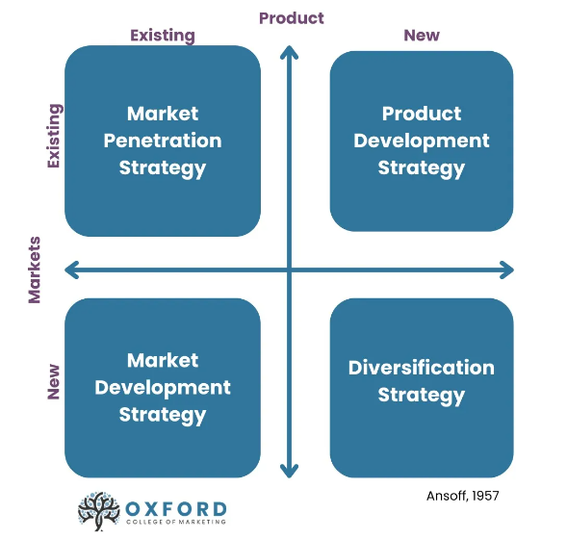
https://blog.oxfordcollegeofmarketing.com/2016/08/01/using-ansoff-matrix-develop-marketing-strategy/

Appendix E – Marketing Mix (4P’s)
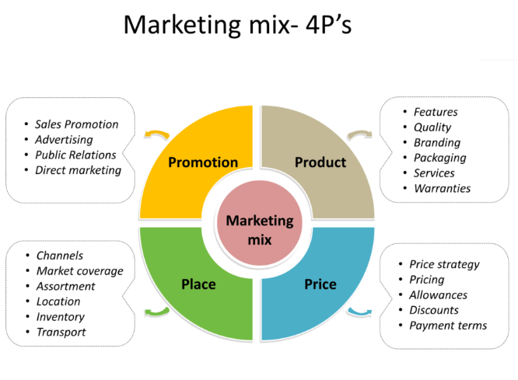

https://gaillereports.com/benefits-of-marketing-mix/

