Gwyndaf Charles Rees

HND Computing

Web Development

Lecturer: Jim Kirkpatrick

Student P Number: P1603201

Word Count: 1349(without references or appendix)
Contents
Introduction 2
Implementation 2
Evaluation 2
Testing 2
Evaluation 3
Reflection 4
Bibliography 5
Reference List 6
Appendix 7

Introduction
This report details the requirements for the implementation of a music lesson management web application as well as the process involved in implementing. It also evaluates the result of that process with regards to design, usability and content as well as discussing the validation techniques employed in the system, the methods used to test them and the system as a whole, and the results of those tests.

Implementation
The ‘MusicTeacher’ web application allows students to register, book and manage music lessons, and add and edit student details; and allows teachers to receive lesson bookings, book exams for their students, and manage their students, lessons and bookings. The target audience is, therefore, people looking to learn to play an instrument and teachers that want more students.
The ‘MusicTeacher’ system must:
- Allow students to register
- Allow students to book a lesson for an instrument
- Allow teachers to book an exam
- Allow teachers to accept or decline lesson bookings
The system should:
- Allow teachers to enter a result for exams
- Provide a calendar of lesson and exam bookings for both teachers and students
- Give a measure of student instrument proficiency
The system could:
- Allow students to edit their information
- Allow students to reset their passwords
- Allow teachers to create student accounts for their students
- Offer a list of available instruments separate from lesson booking
The system won’t:
- Allow teachers to register
- Offer data formats other than tabular
All ‘MoSCoW’ must, should and could requirements have been implemented, however the won’t requirement was not. Screenshots of the implementation can be found in appendices 1-31.

Evaluation

Testing and Validation
The links to each page have been tested as users of both student and teacher roles to ensure the correct path and parameters have been specified. Controller actions that return a view model have been tested multiple times through unit tests to ensure that they do return a model as expected. Unit testing is used as it “provides a much greater reliability improvement for resources expended than system level testing and tends to reveal bugs which are otherwise insidious and are often catastrophic”. The system passes all unit tests created as is evidenced in appendix 33.
The validation for the system’s forms is primarily client side, as this is “more user-friendly than server-side validation, giving and instant response”. Required form inputs were tested by submitting the form without entering values for these fields. Form inputs that require specific data types use the HTML5 input ‘type’ attribute to prevent incorrect value input except date fields, which have text input disabled and then use the ‘flatpickr’ JQuery plugin that creates a date picker for input in these fields. The postcode field on the edit form for student details is also an exception as this field isn’t required but, when entered, mustn’t exceed eight characters as a postcode, with a space in the middle, is a maximum of seven letters or numbers and the space.
The project contains some instances of data annotations being used for validation such as the instrument creation view which simply uses the ‘required’ annotation to ensure a name is entered for the new instrument. This method is particularly effective for simple validation like this. These could have been utilised more for ease of development, however the addition of more data annotations would not improve the system at this stage as other required validation has already been implemented using ‘JavaScript’.
Some fields, such as the grade field on the instrument proficiency edit page (appendix 18), use other HTML5 form validation attributes to act like input masks. In the case of the grade field, the ‘min’ and ‘max’ attributes are used to ensure a number between 1 and 8 is entered.
Because ‘Individual User Accounts’ was selected on creation of the project, the built-in MVC log in system was used which comes with validation to stop the creation of conflicting users and ensuring that data input is correct.
Examples of validation messages can be found in appendix 32.

Evaluation
The database first approach was chosen for this project as the separation between the database and the solution, arguably, improves the ease of development once the database is set up, however this is simply personal preference.
The system uses the ‘ModularAdmin’ Bootstrap template for its basic design and its classes have been implemented on all table views and to implement styled cards for detail views. As a result of using bootstrap and implementing its grid system which allows for the “responsive manipulation of elements”, a better user experience is created for mobile users. The aesthetic of the design is well suited for the system’s content and maintains its usability due to the simplicity of the layout. It was for this reason that an admin template was chosen as these lend themselves to an action-oriented system as opposed to one that is largely founded on aesthetics.
The home page (Appendices 3-5) is laid out such that the primary features of the system are obvious and easy to access both when signed in as either role or when logged out. The table views, such as the lesson bookings page (Appendices 6-7), are obvious in their design and function and the lesson bookings page, in particular, uses colour coding for accepted, declined or pending lesson bookings which improves this further. The button for adding a lesson booking or exam booking is obvious on their respective pages and uses the colour green as well as explicit text to make obvious its use. Many views that incorporate tabular data have small ‘Font Awesome’ icons with links to appropriate actions such as edit or delete. The action that each of these performs is made obvious due to their skeuomorphic design and, by using these instead of text-based buttons, the presentation of potentially saturated tables can be improved.
The student detail page (appendix 14-15) is an effective output of all data relevant to the student, however the use of tables on this view isn’t aesthetically pleasing and perhaps the use of a colour coded card per lesson and exam booking with all the relevant information contained within it would be a more user-friendly implementation, however this raises the concern of card overuse as these have been used for the basic details, address and instrument proficiency on the student detail view already.
The calendar view (appendix 30-31) consists of a table that combines all the exam and lesson bookings for a single user. Although this is an effective method of displaying the data, it’s not user-friendly and the name misleads the user into expecting a calendar as opposed to a table.

Reflection
The overall implementation is well done, however the ability for a teacher to sign up is the primary feature that the system requires in further development. Another improvement that could be made would be a custom error page for 500 errors as these errors can occur if the user attempts to navigate to a page that requires an ID parameter without specifying the parameter. Exploration into finding an effective alternative to the table views on the student detail page is also a potential improvement. The calendar view is an opportunity for improvement too as this is titled calendar but simply displays all lesson and exam bookings in tables with no filters instead of as a calendar that can be filtered by month. To improve this, a simple JQuery calendar plugin such as ‘Full Calendar’ could be implemented and dynamically populated with razor, similarly to how the tables are currently populated.
The system serves its purpose, functions correctly and offers an enjoyable user experience overall. Despite room for improvement in both functionality and design, the system’s implementation has been successful and is sufficiently complete for a first launch.

Bibliography
- Mozilla. Form Data Validation. https://developer.mozilla.org/en-US/docs/Learn/HTML/Forms/Form_validation. [Accessed: 05/05/2018]
- Parking, R. Software Unit Testing. http://condor.depaul.edu/sjost/hci430/documents/testing/UnitTesting.pdf. IV&V Australia. [Accessed 07/05/2018]
- Jakobus B. Marah J. Mastering Bootstrap 4. UK: Packt Publishing Ltd. 1st ed. 2016.

Reference List

Appendix
1 – Register:
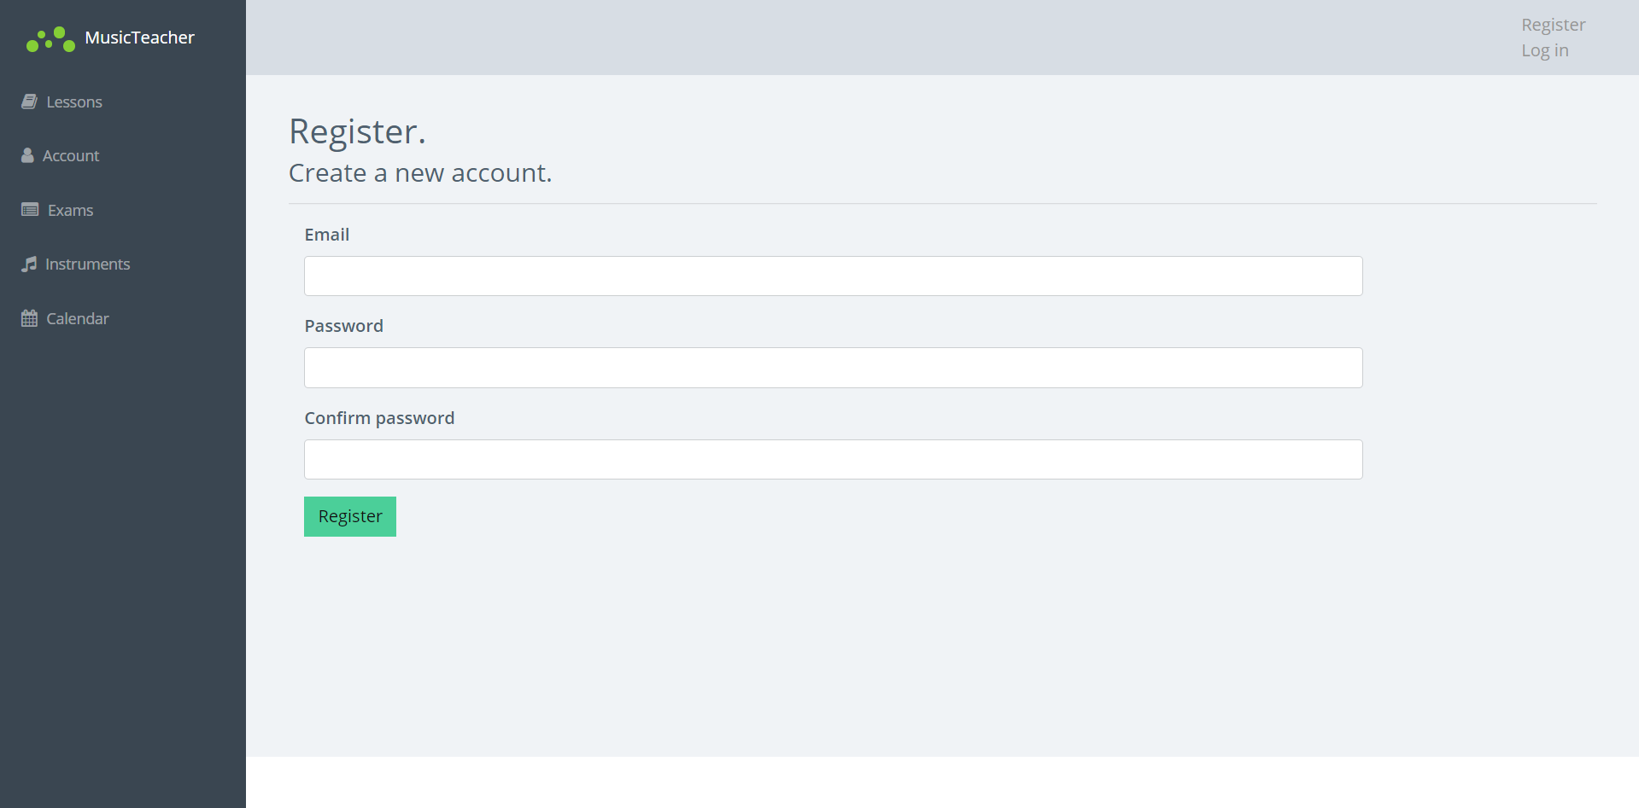
2 – Log In:
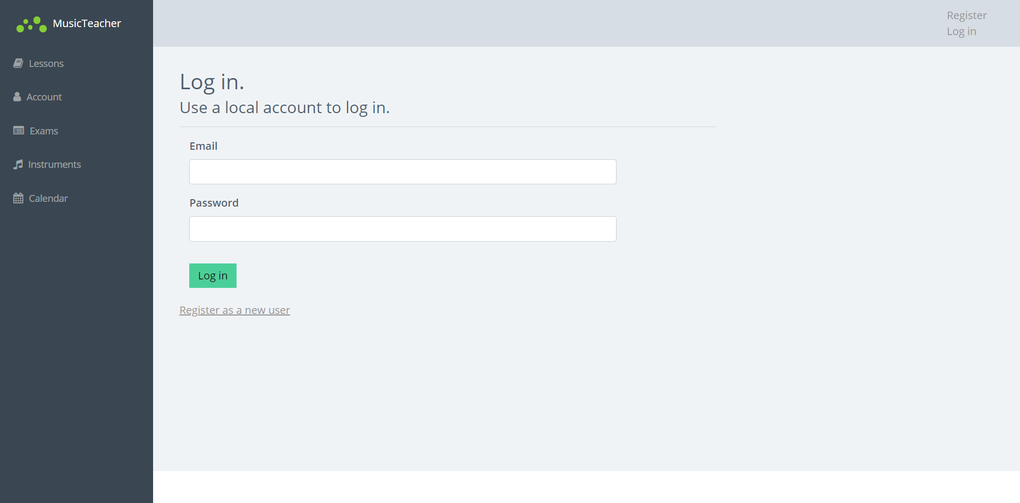

3 – Home Logged Out:
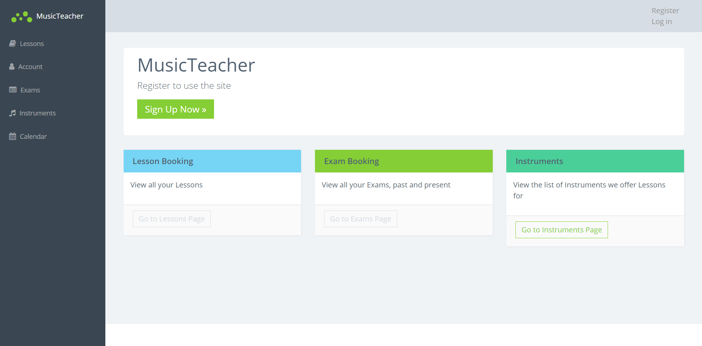
4 – Home Logged in as Student:
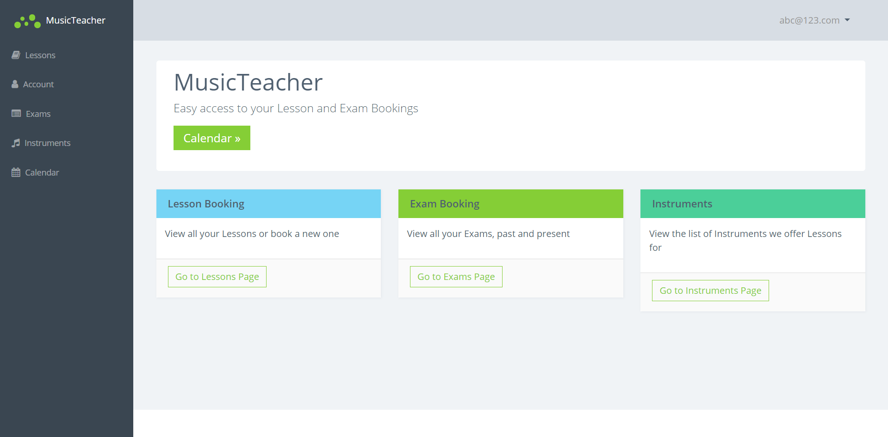

5 – Home Logged in as Teacher:
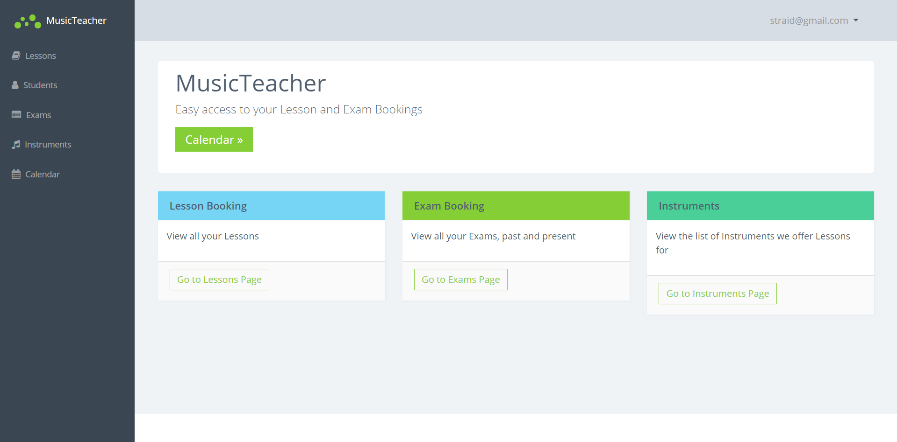
6 – Lesson Booking as Student:
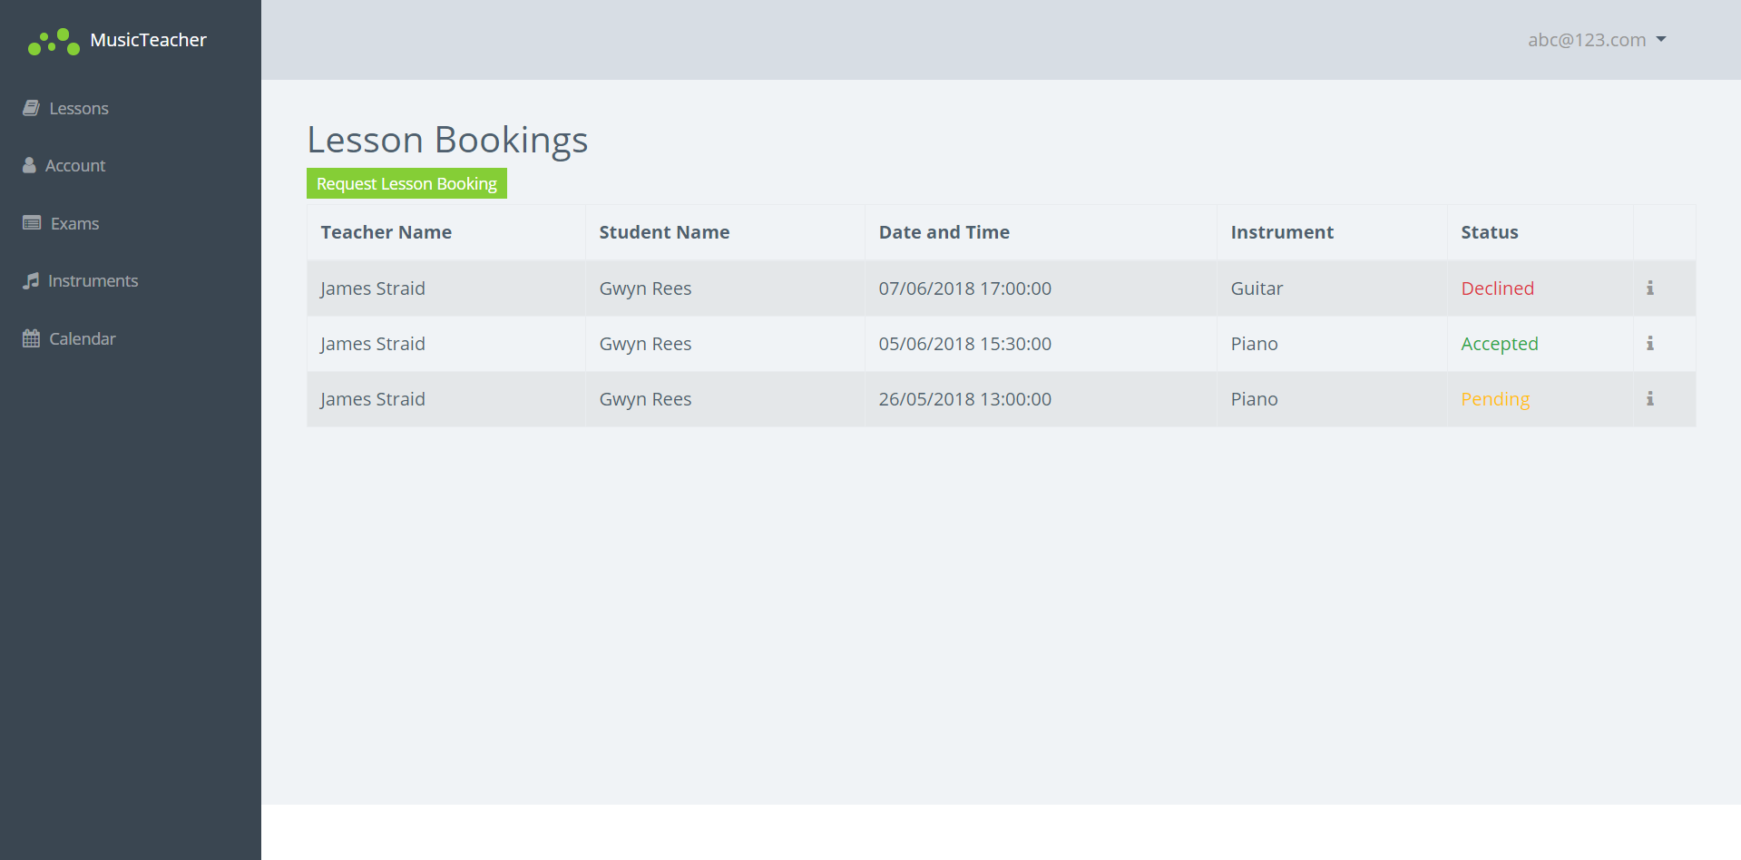

7 – Lesson Booking as Teacher:
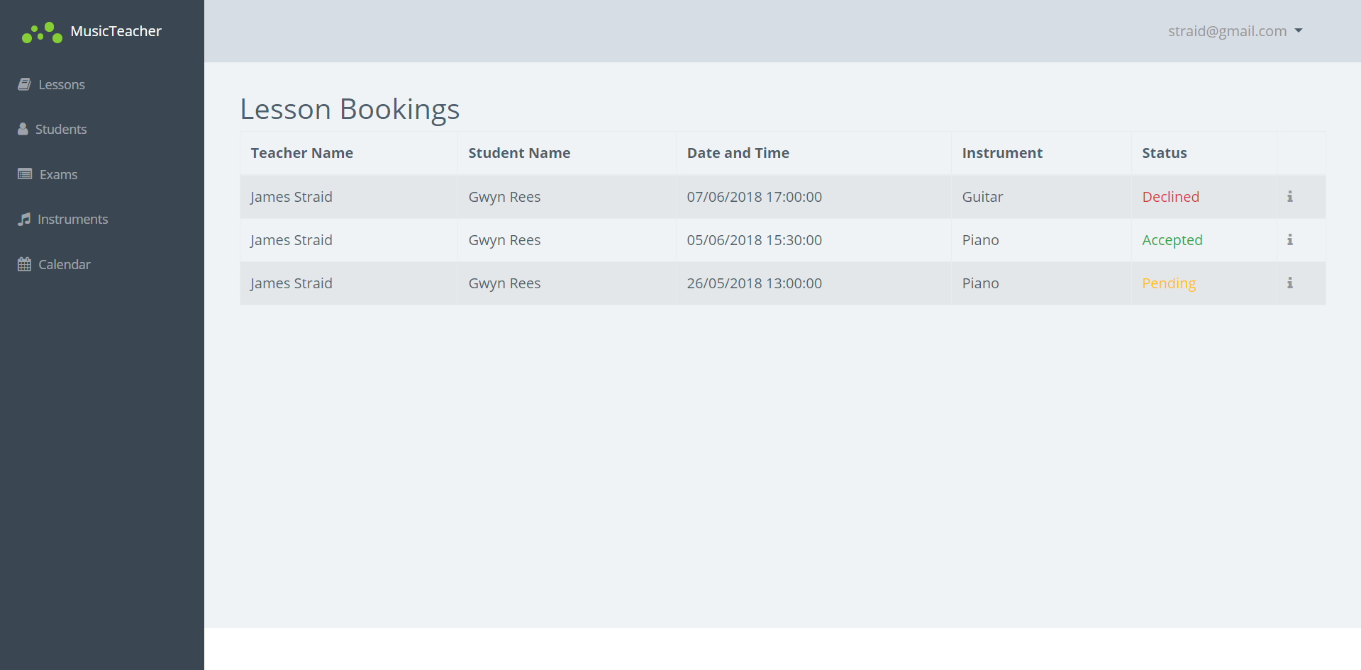
8 – Create Lesson Booking as Student:
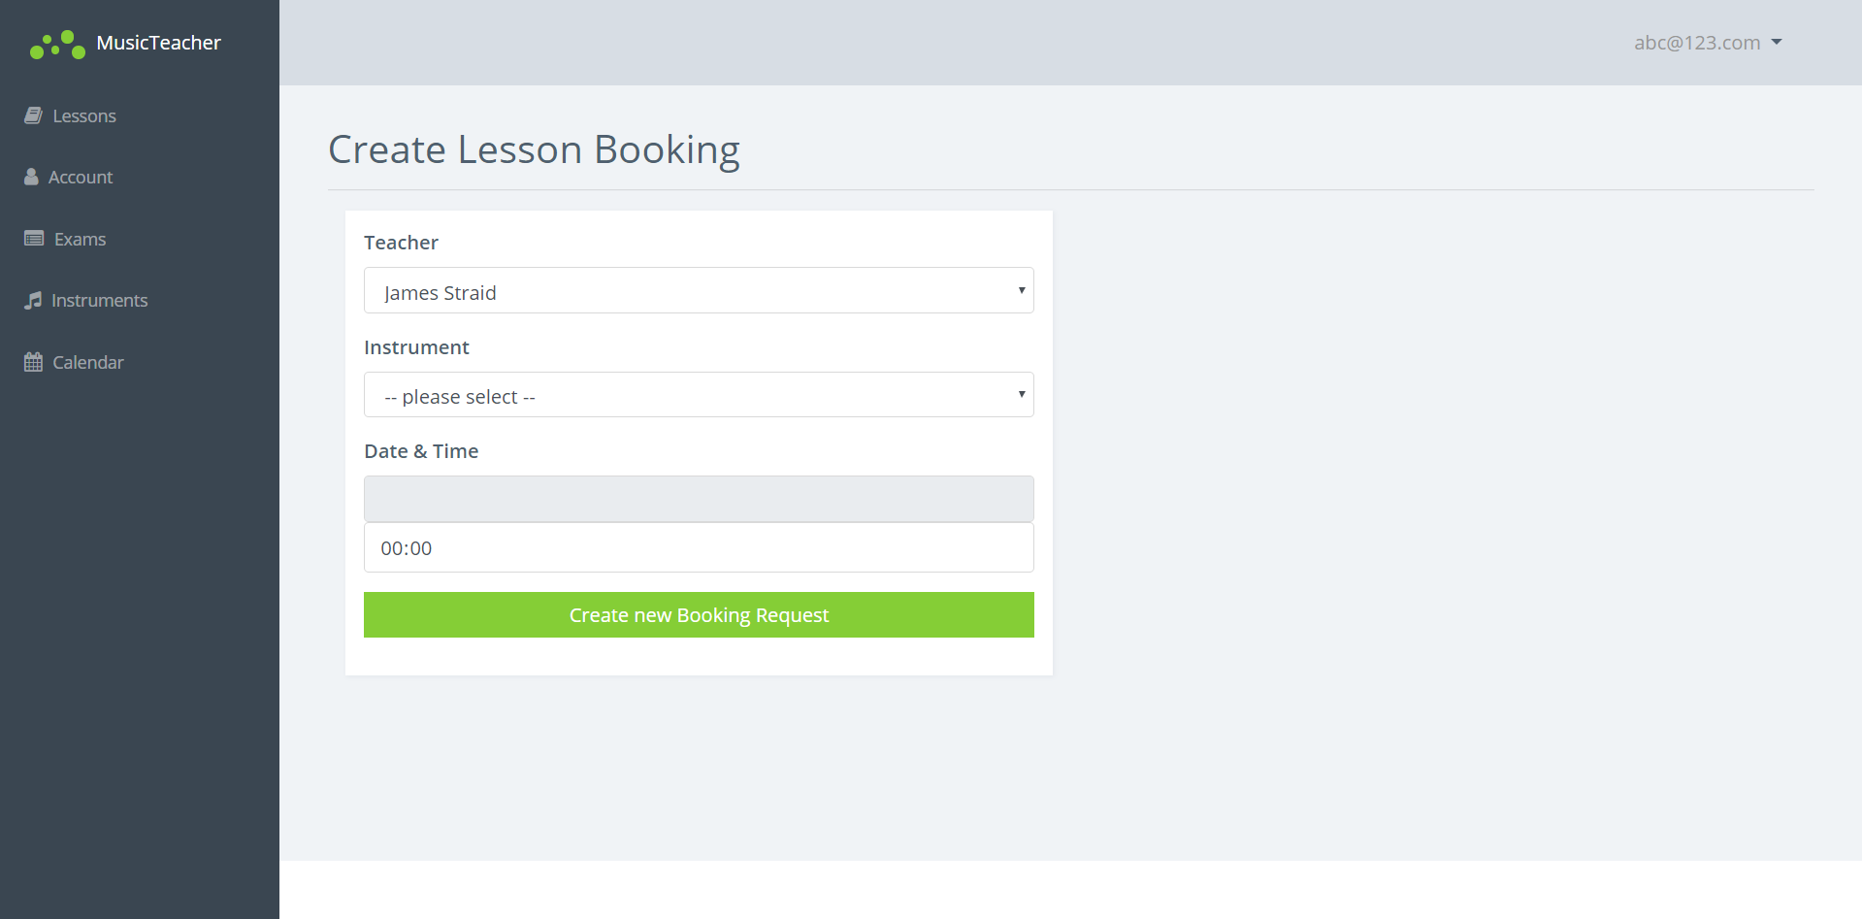

9 – Lesson Booking Detail Pending as Student:
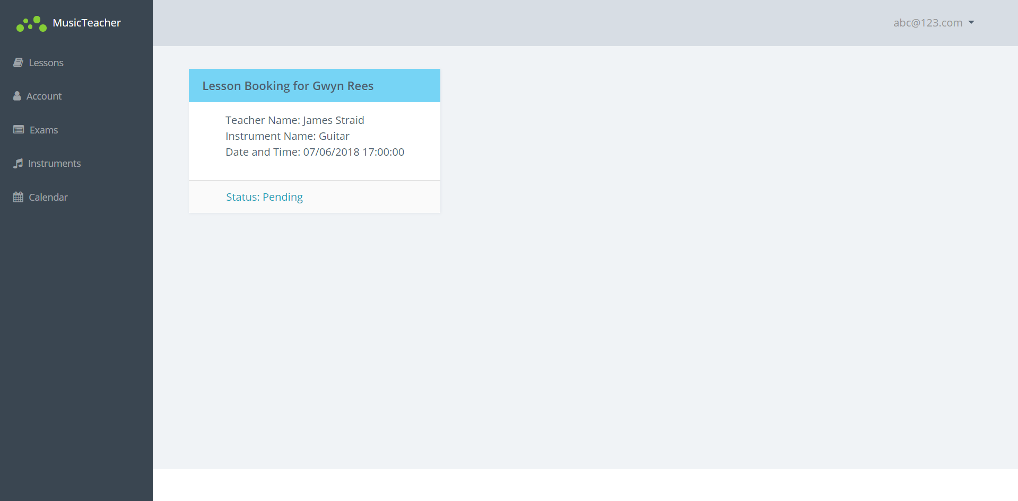
10 – Lesson Booking Detail Accepted as Student:
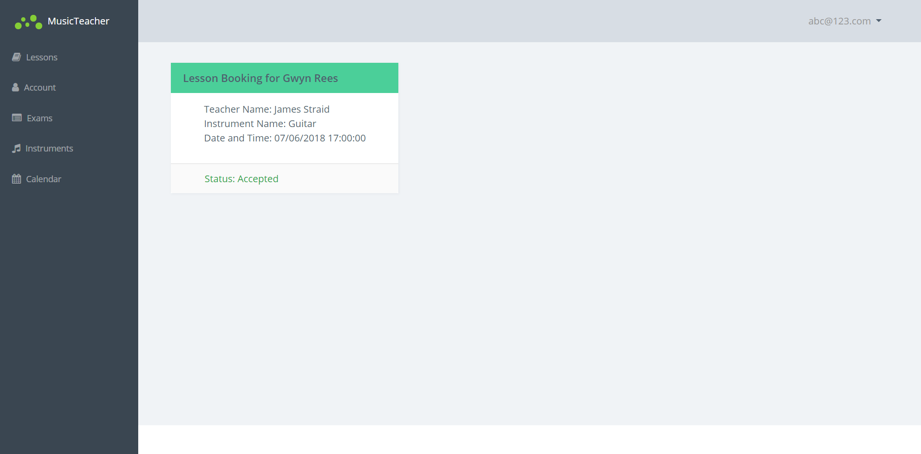
11 – Lesson Booking Detail Declined as Student: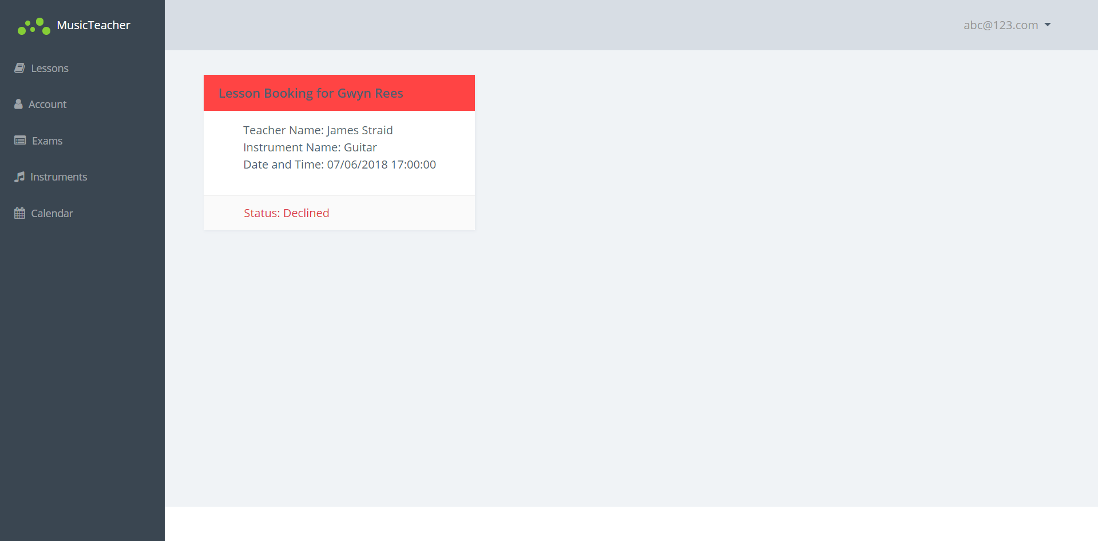
12 – Lesson Booking Detail as Teacher:
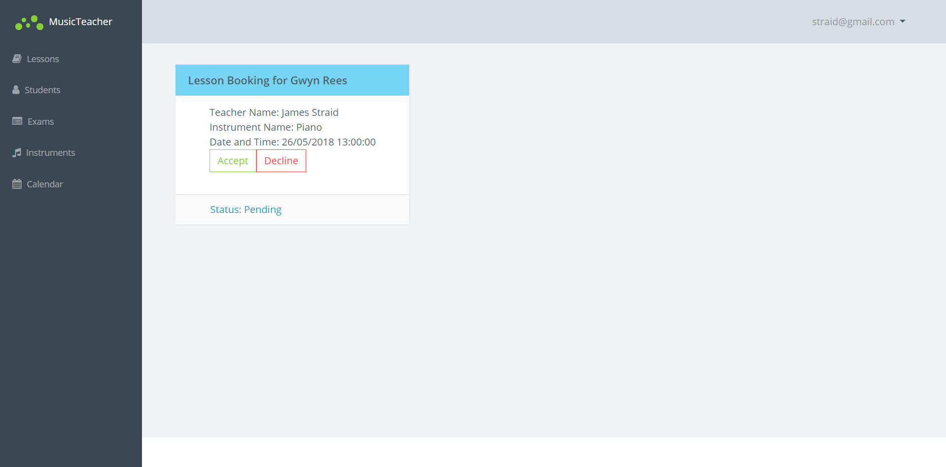

13 – Student List as Teacher:
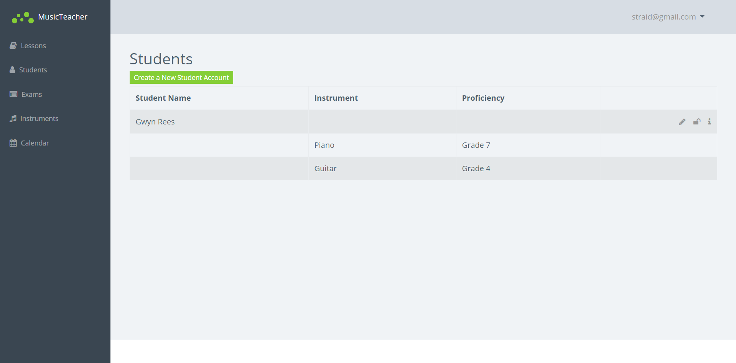

14 – Student Detail as Student:
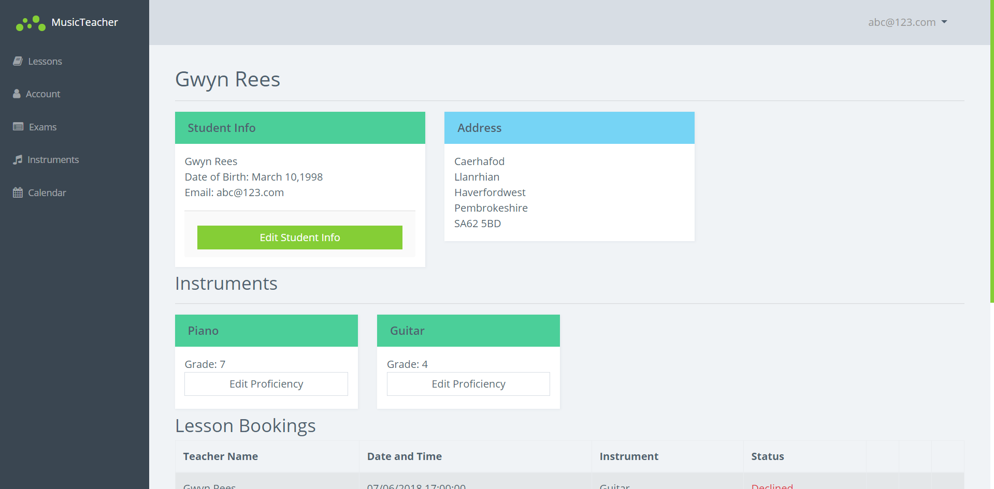
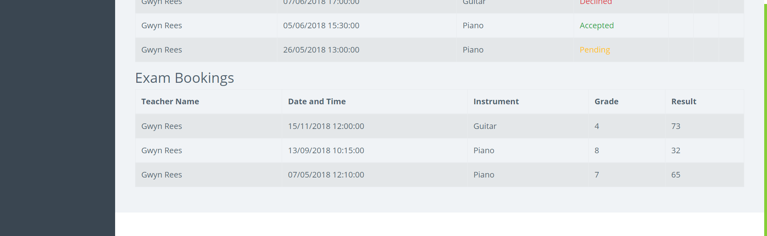
15 – Student Detail as Teacher:
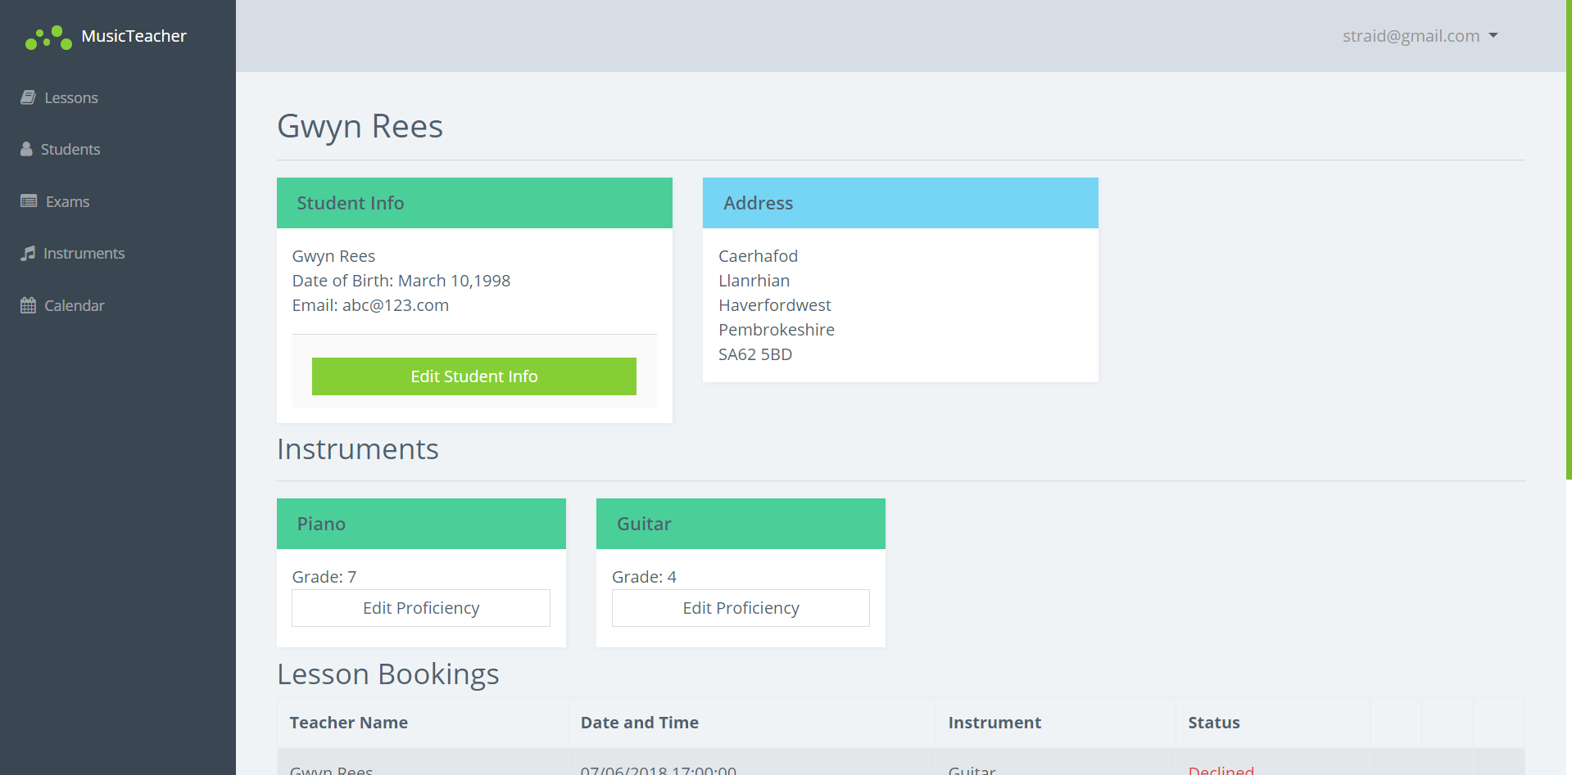
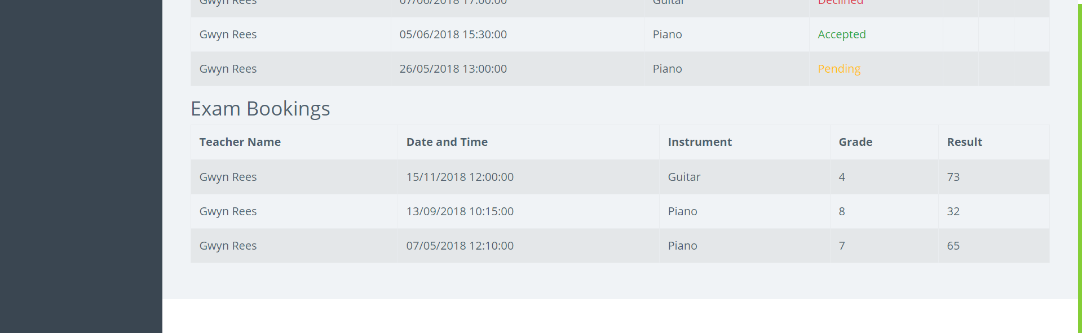
16 – Student Edit:
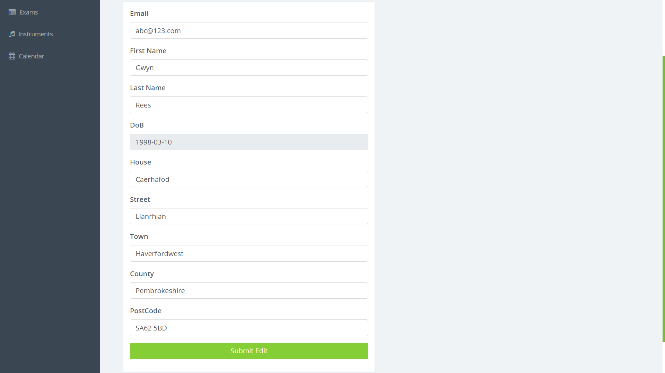
17 – Student Password Reset as Teacher:
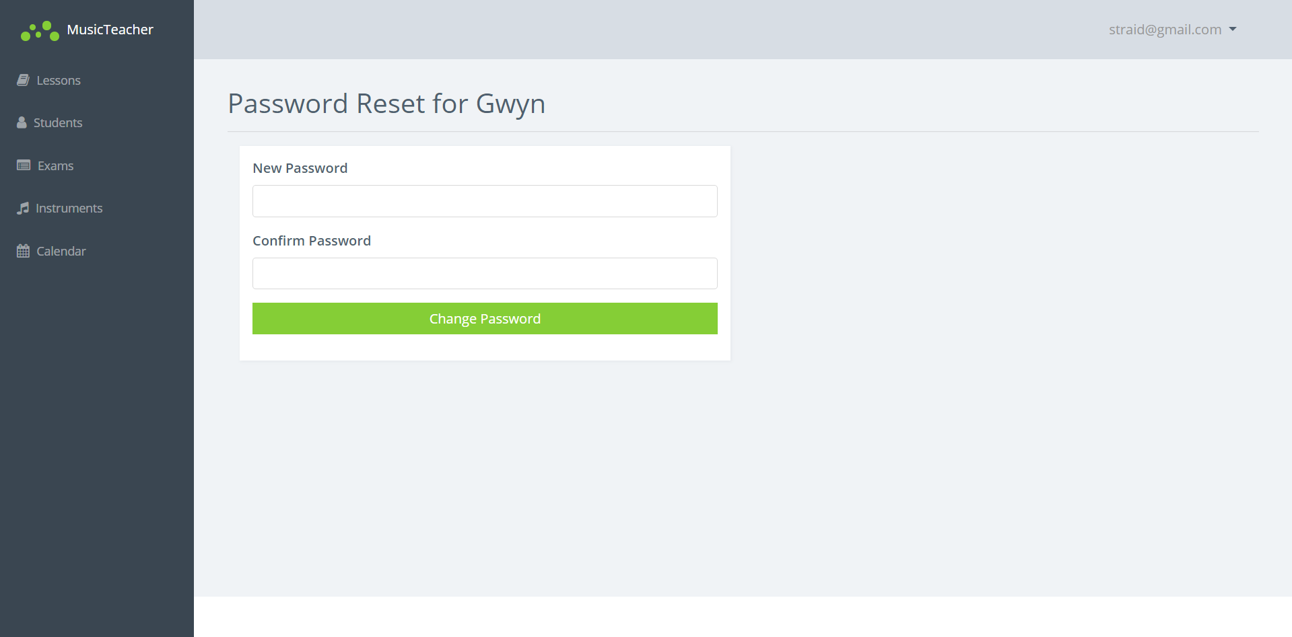
18 – Instrument Proficiency Edit:
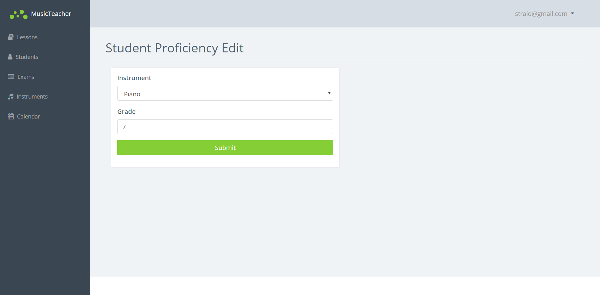

19 – Instruments List as Student:
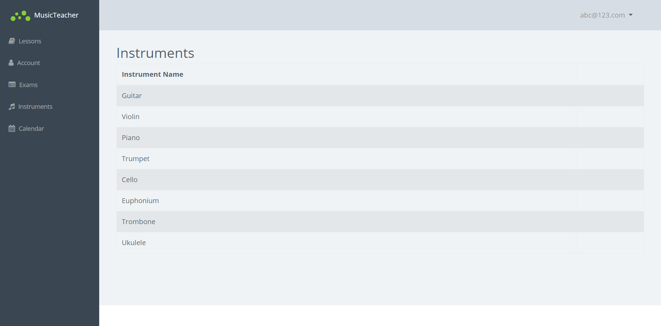

20 – Instruments List as Teacher:
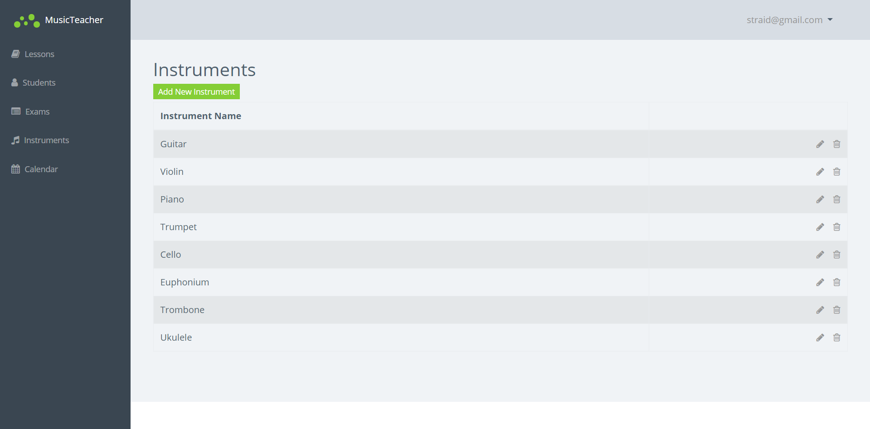
21 – Instruments List Logged Out:
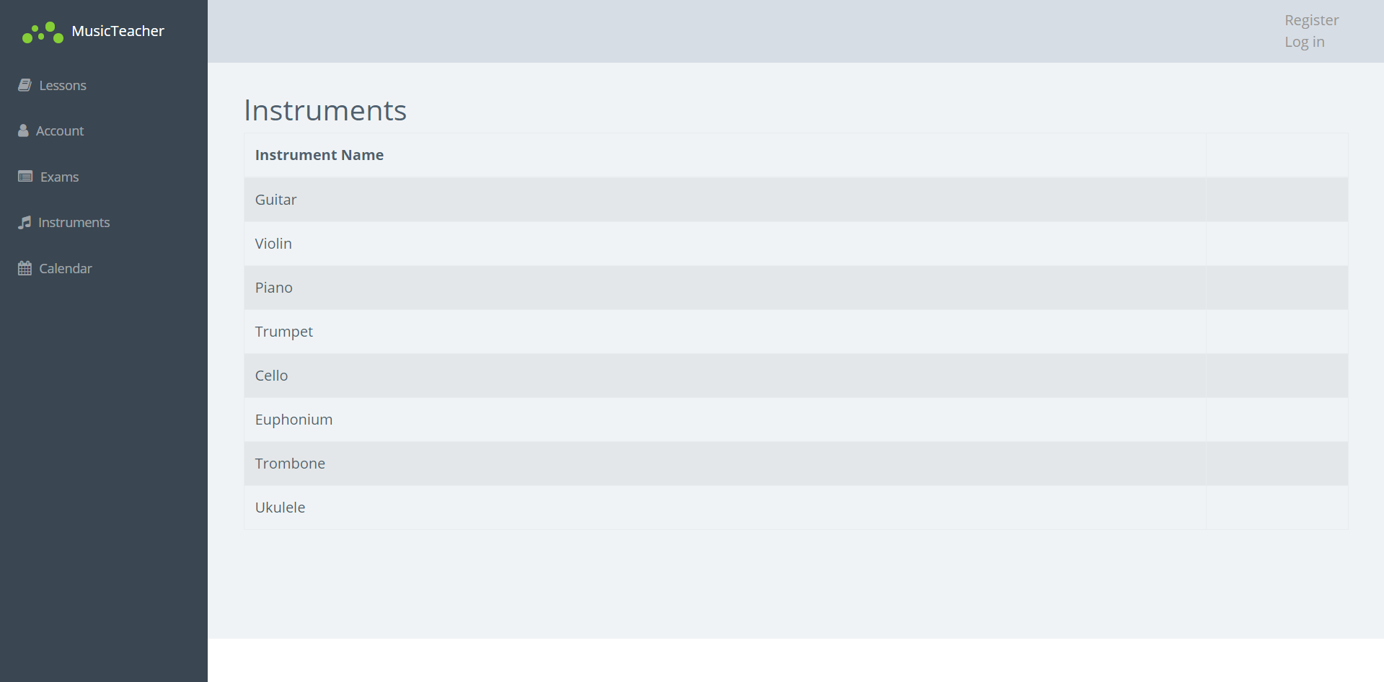

22 – Instrument Create as Teacher:
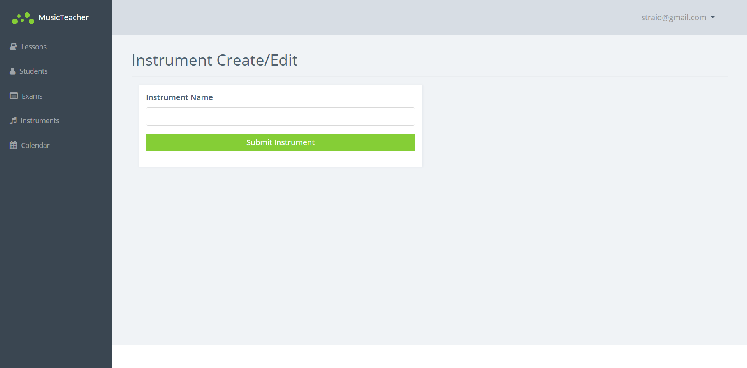
23 – Exam Booking as Student:
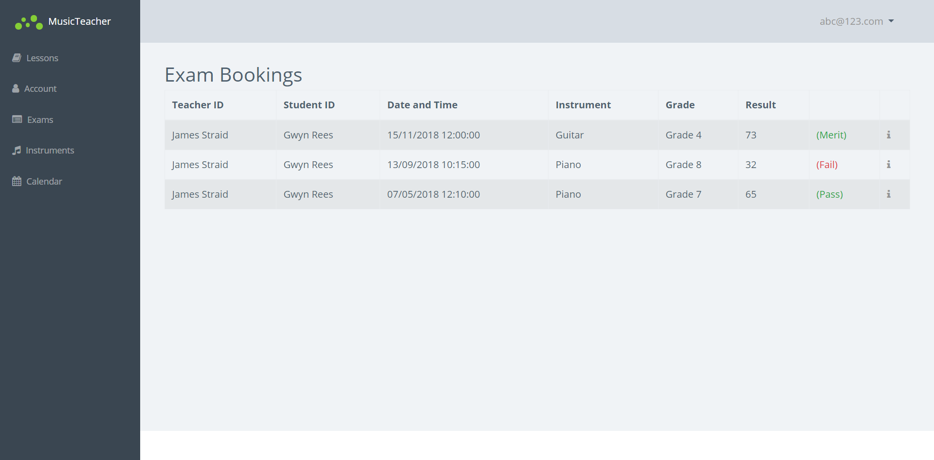

24 – Exam Booking as Teacher:
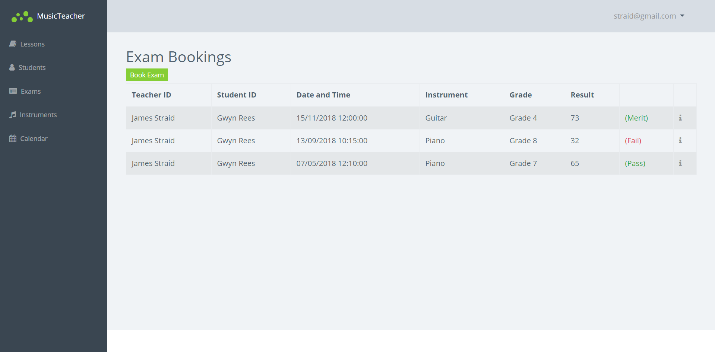
25 – Exam Booking Detail No Result as Teacher:
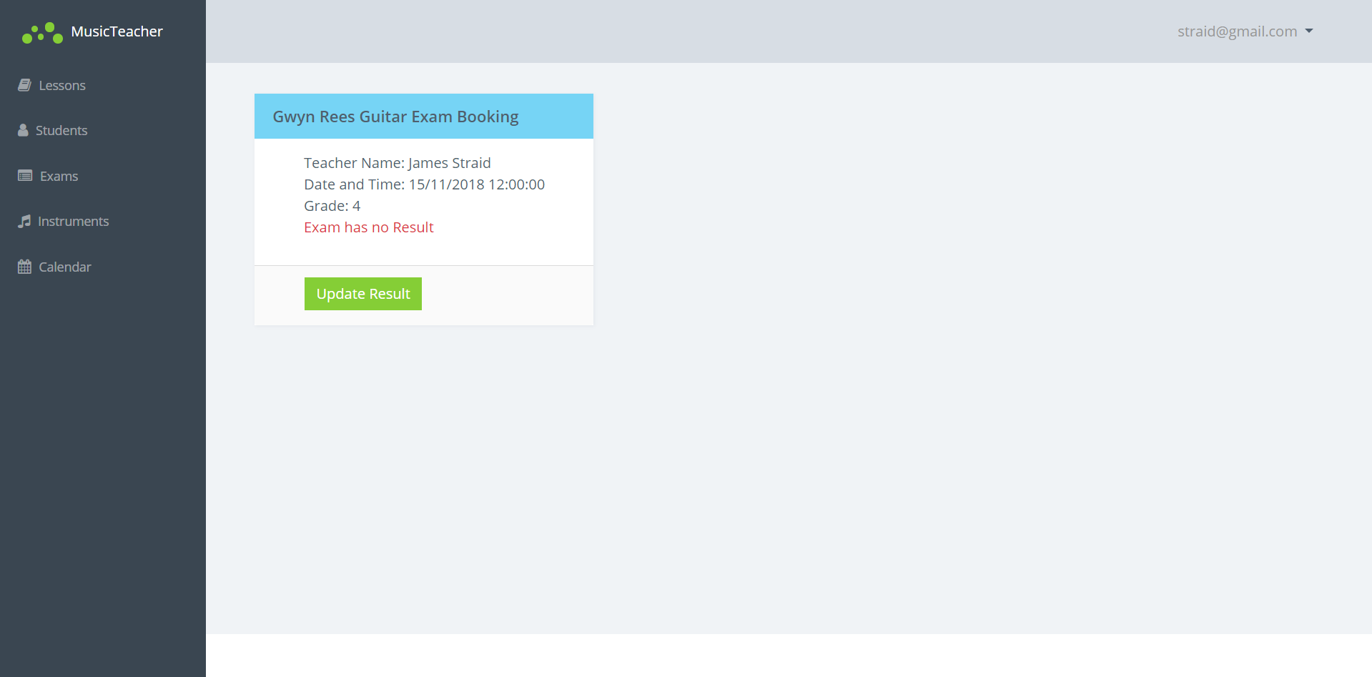

26 – Exam Booking Detail No Result as Student:
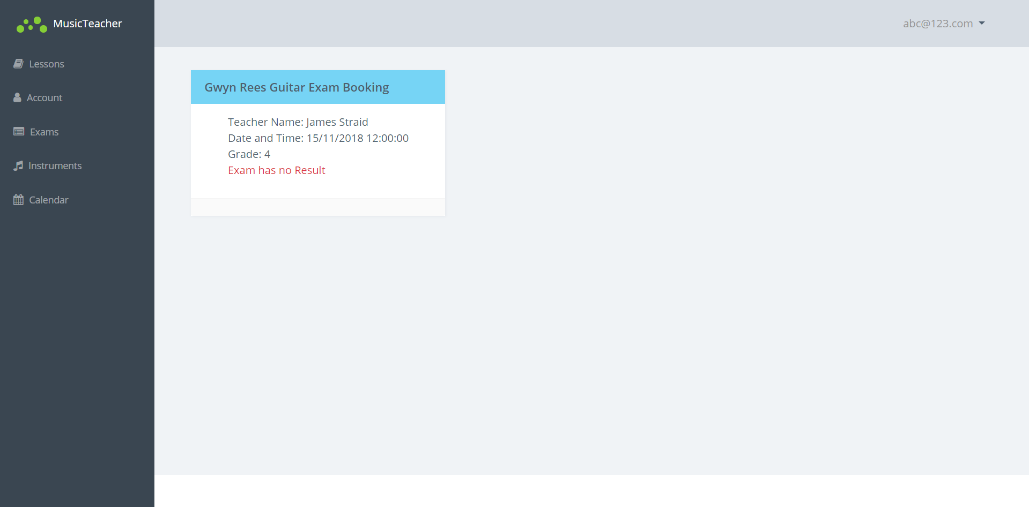
27 – Exam Booking Detail Passed:
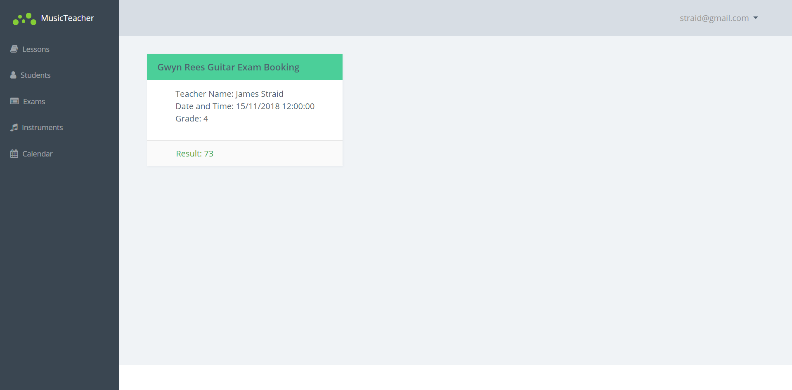

28 – Exam Booking Detail Failed:
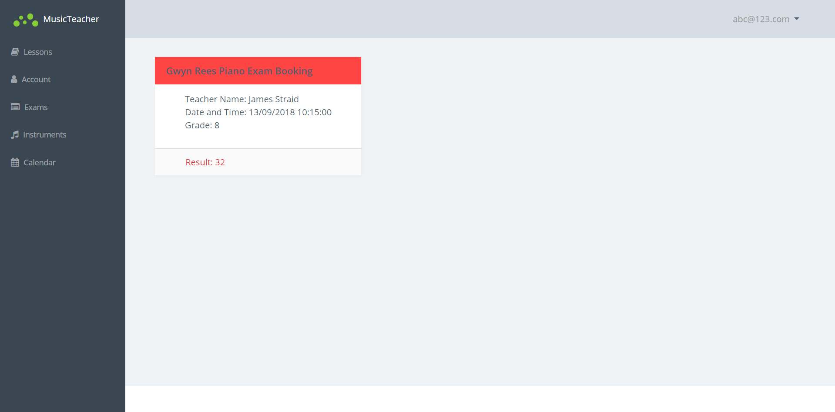
29 – Exam Booking Add Result:
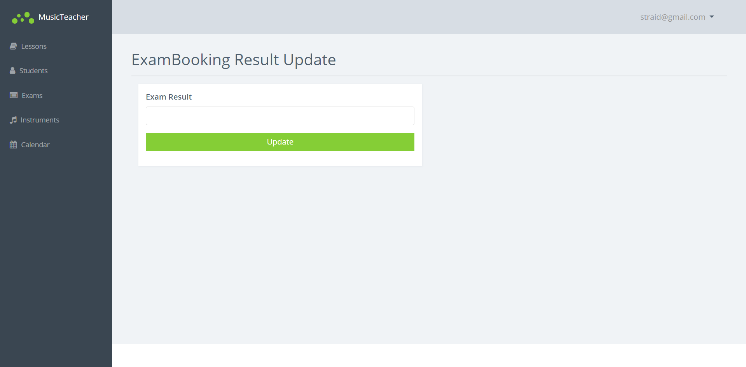

30 – Calendar as Student:
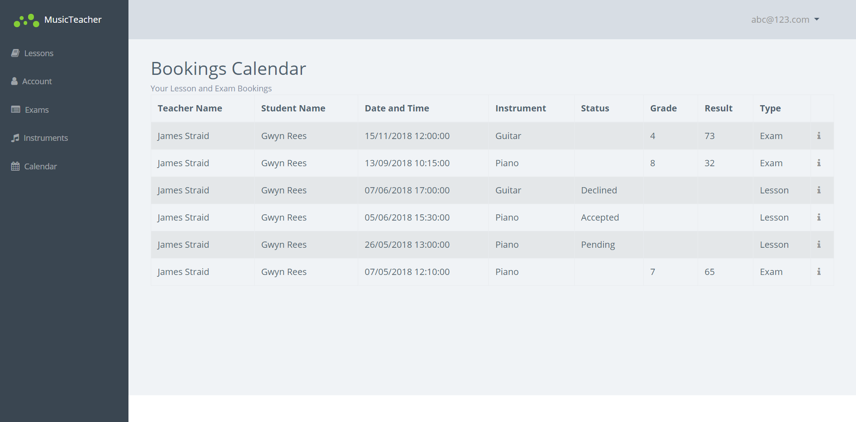
31 – Calendar as Teacher:
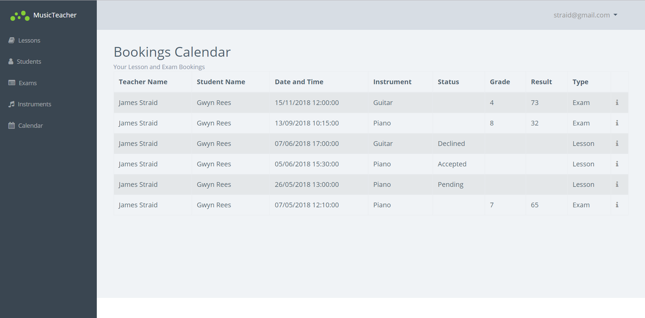

32 – Examples of Form Validation on the System:
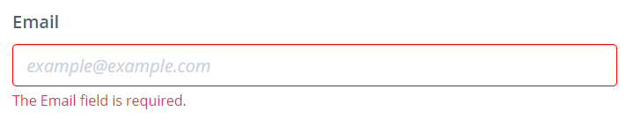
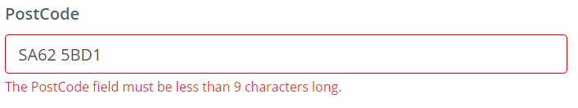
33 – Passed Unit Tests in the Visual Studio Test Explorer:
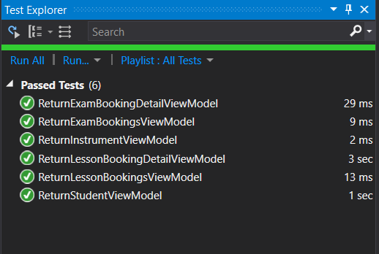

Parking, R. Software Unit Testing. http://condor.depaul.edu/sjost/hci430/documents/testing/UnitTesting.pdf. IV&V Australia. pp. 1. [Accessed: 07/05/2018]
Mozilla. Form Data Validation. https://developer.mozilla.org/en-US/docs/Learn/HTML/Forms/Form_validation. [Accessed: 05/05/2018]
chmln. GitHub – flatpickr. https://github.com/flatpickr/flatpickr. [Accessed: 07/05/2018]
Jakobus B. Marah J. Mastering Bootstrap 4. UK: Packt Publishing Ltd. 1st ed. 2016, Ch. 1. pp. 10.
Fonticons. Font Awesome. https://fontawesome.com/. [Accessed: 07/05/2018]
Ferris, D., Shaw, A. Full Calendar – JavaScript Event Calendar. https://fullcalendar.io/. [Accessed: 08/05/2018]

