Marketing Business Plan school for divers
“Diving Adventures”
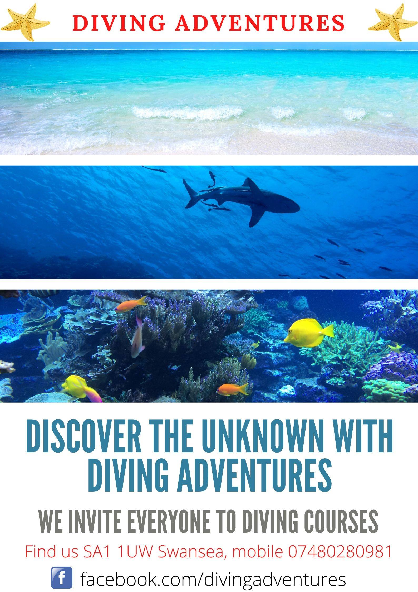

PAWEL CIUBA
1806308

30.06.2020
UNIVERSITY OF WALES TRINITY SAINT DAVID

Table of Contents
Company Description 3
Mission 3
Goal 3
Competences and qualifications 5
Marketing Strategy 6
SWOT Analysis 6
Strengths 6
Weaknesses 6
Opportunities 7
Threats 7
4Ps marketing mix analysis. 9
Product 9
Price 9
Place 10
Promotion 10
Competitor analysis 11
Human resources 11
Financial resources 12
Start-up summary 12
Cash Flow 13
Conclusion 14
References 15

Company Description
The sole owner of Diving Adventures will be me, I will own 100% of the shares.
I decided that it would be a small company to start with, because it will have only one employee who owns the company.
One entrepreneur or sole owner is a company owned and controlled by one person who makes all decisions, responsibilities and profits from his business. Decision making is also fast as it's just the owner who decides where the business is heading and whether or not to undertake any work and where and when they will work. They are generally closer to their customers and offer a more personalised approach and improved customer service as they are the person each customer has contact with.
When you register a sole trader, your business becomes an extension of you — your business and personal finances are considered by HMRC as one. This means that should your business get into debt, you’ll be liable. To dissolve these debts, you may need to rely on your personal savings or assets, including your home. Therefore, it’s important to have your finances and forecasts in order so that you can safeguard against this. Sole traders can also find it more difficult to raise funds for their business. Banks won’t always lend money to sole traders — and when they do, it’s often a much lower amount than what you could receive as a limited company. (Smith, 2018)

Mission
The mission of Diving Adventures is to promote and develop safe diving. Diving is what I love and do with passion. That is why I immerse in every water.
Experts say that a passion for what you do can give you the belief, motivation, and commitment you need to overcome the challenges that self-employment may present. “You must like and be committed to what you're doing,” (Williams, 2018)
The courses we run are not only classes aimed at learning to dive, but also joint adventure, fun and a journey into the unknown. When training divers, I will do my best so that my clients can fully experience safe contact with the underwater world, explore its secrets and become part of it for a moment.

Goal
The goal of Diving adventures is to promote safe and pleasant diving in the waters of the whole world, and to provide professional training in diving at various levels of improvement.
The British are increasingly choosing foreign resorts for vacation, mainly Spain, Egypt and Mexico. These are beautiful countries where many attractions await tourists visiting them. In addition to visiting monuments, riding camels or relaxing on the beach, tourists are increasingly trying their hand at discovering the underwater world. This way of spending free time is becoming more and more popular, which is why a good business idea is to open a diving school where diving courses would be run.
Diving is a sport that involves swimming under the surface of the water. They can be implemented in several ways. The easiest of them is breath-hold diving. You can also use basic, simple ABC equipment such as mask, snorkel and fins for diving. However, then we have no way to get acquainted with all the great things and interesting things that diving gives us using professional equipment. Many people desire to try diving is focused on its more professional form. However, to be able to go underwater in professional equipment, you need to acquire the necessary theoretical and practical knowledge. As a result, natural demand for services in the field of diving courses has been created.
My diving school will offer single dives for beginners and advanced divers, also diving packages, diving course - Scuba Diving for beginners in swimming-like and open waters. Open Water Diver course with international diving qualifications up to a depth of 18 meters. Also the Advanced Open Water Diver course with international diving qualifications up to a depth of 30 meters. Also the right to dive 40 meters deep after completing the Deep Diver diving course.

After the course, the client will be able to:
- plan and carry out dives
- prepare your equipment
- prevent problems and solve them
- control your buoyancy
- dive in a safe and pleasant way

To start diving training you must be at least 10 years old and you cannot have medical contraindications.

The diving school must be properly equipped. It must be assumed that a beginner diver will not have his equipment or even an outfit. Therefore, you need a rental shop with a good range (including foams, jackets, weight belts with weights, breathing automats, cylinders). In addition, it is also good to offer a decent service for divers who would like to repair or inspect the equipment they use. Such a proposal will definitely increase the costs of underwater business, and will certainly be a source of profit over time. It should also be noted that the mere presence of such points will improve the image of my school for divers.

In the diving school, apart from the location, good offer and qualified staff, the price list itself is very important. It should be tailored to the needs of potential customers. It is necessary to describe exactly the costs of each service, both for the rental, service and the school itself. In order to construct a really interesting but also profitable proposal, it's best to compare competitors' price lists. For example: the basic course for beginners is £ 400, the course for advanced divers is from around £ 350-450, the basic course plus dry suit diver £ 530.
Prices depend on the place, size of the group (individual courses can be used) and scope of training.
Diving courses are divided into theoretical and practical parts. At first, my school will use the rented premises for theory classes and a larger pool for practical classes. It is also a good idea to organize away courses abroad or in the country. Then you can use open waters and a swimming pool offered by another company, e.g. a hotel, a guest house, a sports center.
The client will be trained in the principles of safe diving, I will teach him how to use diving equipment and signs enabling communication under water. You should think about the possibility of issuing certificates confirming acquired skills giving certain powers to divers, of course after completing the course and passing theoretical tests.

Before the customers start to arrive, they must be encouraged and convinced. There are several simple and proven ways. First of all, you need to be active on the Internet. Nowadays, a professional, well-positioned website and an active account on a social networking site are essential. Participation in numerous forums on diving topics is necessary. What counts is promotion in the region. You can't regret the money on advertising banners, leaflets, business cards, advertising in the media. Promote yourself at various regional celebrations and events. Remember that your school cannot be missing at trade fairs and conventions or large picnics of diving enthusiasts.

Competences and qualifications
After a survey among potential clients, the vast majority replied that the main criterion they use when choosing a diving school is the instructor's qualifications.
Earning more diving certificates I came to the rank of Diving Instructor.
Diving for 10 years I gained valuable experience which is confirmed by nuerous invitations to dives because I am considered a complete diver who maintains peace and observes safety rules.

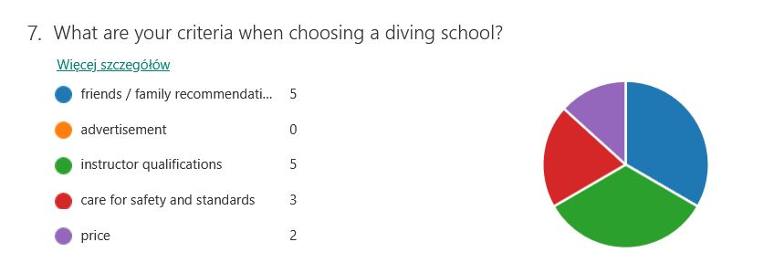

Marketing Strategy
The marketing plan, or ‘marketing strategy,’ consists of identifying the target market and developing the marketing mix.
An effective marketing plan should enhance strengths, help overcome internal weaknesses, take advantage of the opportunities in consideration of the threats, and contribute to goals. (Condon, J.T. and CONDON, J.T. 2010)

SWOT Analysis
Chances and threats, strengths and weaknesses
SWOT analysis is one of the company's analytical methods.
It is characterized by simplicity and speed of application.
Thanks to SWOT analysis, business gains a strategy of operation. Research shows that strategic planning helps organizations to be more productive by better allocating resources to achieving goals.
Strengths are positive internal factors. They constitute the company's internal strength. They should be taken care of in order to keep them also in the future. They can be used for activities related to the company's expansion.

Strengths
Location - Swansea is a very good place to set up a diving school with three swimming pools where you can train.
Only 70 miles to the National Diving & Activity Center (NDAC) in Chepstow where there is one of the best equipped waters for diving training in the UK.
Pembroke Peninsula endowed with lots of diving spots.
Bristol airport from where we can fly to the best dive sites.
Extensive experience in diving and the number of courses carried out.
Good equipment with diving equipment.
Care for safety and procedures for good diving.
Weaknesses
Weaknesses are negative internal factors. The focus should be on eliminating them so that they do not weaken their strengths. They limit the company's efficiency and inhibit its development
Weakness.
A small number of interested clients for diving courses in the winter season.
Financial limits.
Beginners on the diving market in the UK.

Opportunities
Opportunities are positive external phenomena and processes that can be used to develop and expand a company. They can also reduce the company's weaknesses. Focus on making the most of them.
Opportunity.
Although the United Kingdom and Ireland might not immediately spring to mind when thinking of exotic dive destinations, the waters surrounding these ancient nations are something of a revelation. Hundreds of years of merchant seafaring have left a rich wreck heritage, the huge tidal ranges and adrenaline-pumping drift dives have to be seen to be appreciated, and fauna ranging from tiny seahorses to gigantic basking sharks all mean the underwater realm here is rich with surprises. For those properly equipped, however, these waters serve up some truly memorable dives. (Padi Travel).
Increasing the number of inhabitants of the city in which the company operates more potential customers.
Increase in demand for courses offered by the diving school.
The possibility of developing the company by further branches, e.g. tourism.
Canyoning in the rivers.
Sailing on Swansea bay.
Canoeing on the waters of the Pembroke Peninsula.
Organizing trips to the island of Skomer where you can watch puffins, seals and dolphins.

Threats
Threats are negative external phenomena and processes that can block a company's development. Focus on finding remedial measures so that threats do not affect your business.
Price undercutting by competitive diving schools. This is a common practice for profit-oriented instructors who do not pay attention to further cooperation with the client.
Guided by the principle of training and leave.
Diving courses are quite expensive, the need to reach the target customer.
Tax increases or other legal changes.

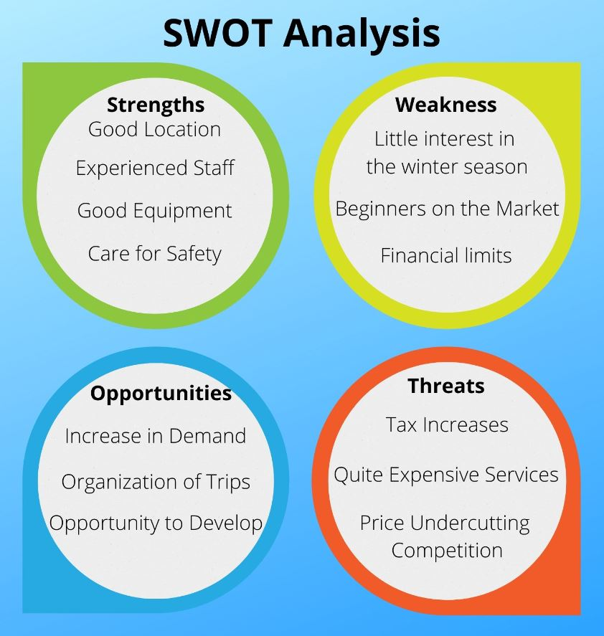

Strategy selection based on SWOT analysis
SWOT analysis identifies four different strategies for an enterprise.
Depending on which pages dominate your SWOT analysis, you have the following strategies to choose from:
Aggressive strategy (strengths and opportunities) - if the factors dominating in the SWOT analysis of a given company are strengths and opportunities, the company should adopt an aggressive strategy consisting in strong expansion. In this situation, focus on the company's strengths to take advantage of opportunities.
Competitive strategy (weaknesses and opportunities) - this is the best choice if weaknesses dominate over strengths, but with external opportunities. In this case, the company should seize the opportunities and focus on eliminating weaknesses.
Conservative strategy (strengths and threats) - the company has great internal potential, but it needs to deal with external threats. She should use her strengths to overcome threats.
Defensive strategy (weaknesses and threats) - the worst possible situation in which external threats are reinforced by internal weaknesses of the enterprise. Focus on company survival. The best solution is to connect to another company.
Disadvantages of SWOT analysis
Subjectivity in determining the significance and number of factors means that the results of SWOT analysis can lead to misinterpretations
contrary to the method's assumptions, not all factors can be easily divided into two categories "positive and negative"
There is no specific method to determine the significance of the factors indicated in the analysis.
The attitude of the person conducting the analysis has an impact on the final result, the optimistic person will write more strengths and opportunities.
The subjectivity of the SWOT analysis results in a focus on current issues of enterprise functioning, lack of long-term thinking.

4Ps marketing mix analysis.
The 4P’s were formalized and developed over the years by experts to ensure the creation and execution of a successful marketing strategy. Through the use of this tool, the attempt is to satisfy both the customer and the seller. When properly understood and utilized, this mix has proven to a key factor in a product’s success. The marketing mix is made up of four unique variables. These four variables are interdependent and need to be planned in conjunction with one another to ensure that the action plans within all four are complimentary and aligned. Through the use of this set of variables, the company can achieve its marketing targets such as sales, profits, and customer retention and satisfaction. (Luenendonk, 2014)

Product
Everything I sell is a product. This does not have to be a physical product. A service like a diving course is also a product.
For the most part, products sold to consumers in the diving industry are:
- Training and training materials.
- Diving, first aid.
- Equipment.
- Outdoor.
- Diving clothing and suits.
- Travel: one-day, fly-away, charter boat trips, etc.
- Equipment rental.
-Sale gas diving: Air, Nitrox, Trimix.
- Repair and maintenance, diving equipment service.

Price
Proper valuation of a service or product can ensure large profits.
Like badly priced services, they can go bankrupt.
Proper pricing depends to a large extent on both internal and external factors.
There is price flexibility for customers continuing subsequent training courses, as well as for customers who once again use mink expeditions.
A regular customer can always count on a price discount.
This is an element of customer retention and regular income.
In other words, the "school" part of the company must be sustainable in itself.

Each of the company's activists that I run at my diving school must be profitable and sustainable. This is the right way to set prices.

Place
The best way to make our products and services best available to consumers is to find the most visited location in our city.
The best places to promote business are places of gatherings of people such as:
The city center, shopping markets, walking places like the marina in Swansea.
Place refers to the spatial location where they are available
my services.
My diving school will be in Swansea Marina. In a rented premises at SA1 1UW.

Promotion
To promote diving among clients and encourage their involvement, it would make sense for training videos and materials to be easily available online, for free.
The profit obtained in this way from the sale of diving courses and the rental of diving equipment can be used to develop the company's business.
Most of the promotional materials of the diving industry are focused on understanding the "current diver". That is, the client who is already on the basic diving course.
However, we most need to reach people who have not had the opportunity to become familiar with the underwater environment.
So people who are not divers who are interested in diving, but have not yet done so and promote diving for them and all related diving services.
The main tool to promote my diving school will be the website and social media like Facebook.
www.divingadventurec.com
I also intend to actively participate in various water sports fairs or picnics.
The promotion will be complemented by advertising banners, leaflets and business cards.
My company logo will be placed on the door of the premises so that customers have no doubts and find me without a problem.
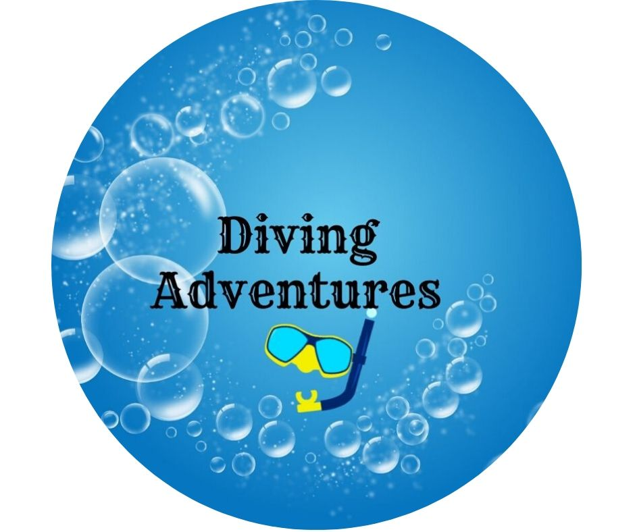

Competitor analysis
There are three diving schools in the vicinity of Swansea.
These schools offer diving courses at various skin organizations.
Before starting to learn, the future diver must decide in which diving school he wants to take the first course. For someone who has no diving experience yet, this choice can be a real problem. Because every school trains in different systems of different organizations. They all teach how to dive.
Licenses issued by all diving organizations are recognized in diving bases around the world.
In addition, choosing the first organization does not attach the customer to it for life. There are no obstacles to taking further courses in another organization or diving school.
It largely depends on the client where he will want to continue the training process and which school he will choose.
Clients by recommendation give an advantage over the competition and on this I will want to build my business.
Being a good instructor, offering the best diving training and working on the best equipment, I am not afraid of competition.
Although you need to consider the element of competitiveness that helps build the best offer.

We need to work together to recruit new divers if UK diving is going to have a bright future. New divers need training and trips, which supports the schools, clubs and tourism. They purchase equipment which supports the retailers and manufactures, and funds the development of new technology and innovation. New divers are the life blood of our industry; (Dennis, 2015)

Human resources
William R. Tracey, in "The Human Resources Glossary," defines Human Resources as: "The people that staff and operate an organization," as contrasted with the financial and material resources of an organization. A human resource is a single person or employee within your organization. Human resources refer to all of the people you employ. Human Resources is also the function in an organization that deals with the people and issues related to people such as compensation and benefits, recruiting and hiring employees, onboarding employees, performance management, training, and organization development and culture. (Heathfield, 2019)

At the beginning, Diving Adventures will be a sole proprietorship. As the business develops, the company will be expanded with a team of new qualified employees.
To meet customer demand and requirements.

Hiring new employees for the company is associated with the need to carry out the recruitment process. Acquiring specialists in the current situation on the labor market is a big challenge for employers. A well-conducted recruitment is the key to attracting the best candidates who will create or join the company's personnel ranks.
Its main goal is to select from among the available candidates for a given position a person who will meet the expectations of the employer to the greatest extent.
Candidates are assessed both in terms of skills, attitude to the company, knowledge, as well as motivation, commitment and expectations.
During the recruitment process I will comply with the principles of protecting personal data of candidates.
Under the General Data Protection Regulation (2016/679 EU) (GDPR), when an employer collects personal data about an applicant during a recruitment process, whether this is directly from the applicant or from a third party such as a recruitment agency, it must provide the applicant with an information notice, also known as a privacy notice or fair processing notice. This notice must set out certain required information, including the purposes for which the data will be processed, the legal bases for processing and the period for which the data will be retained. The employer could provide the information notice on its website, and send a link or copy of the notice in correspondence to individual applicants. Where the employer uses a third-party recruitment portal, it could ensure that the details of the vacancy include a link to the information notice. (XpertHR)

Financial resources

Start-up summary
Start up costs are all the non-recurring costs involved in setting up your business, apart from assets. Sometimes known as sunk costs they’re the costs that, no matter how much of a success or failure your business is, you can’t get back – they’re ‘sunk’ into the business venture. Start up costs cover expenses incurred in getting your business to the point where it’s ready to start selling to customers. (StartUpLoans)
The initial costs that I incur to start my business are presented in the table below.
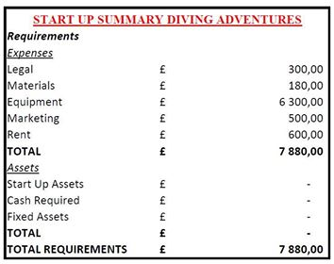
The above costs come from the suppliers with whom I will be sourcing.
Insurance for a diving instructor will be charged once a year.
I will buy them from an insurance company specializing in the sale of insurance for divers, i.e. DAN available online at:
https://www.daneurope.org/sport-member
Equipment is an initial investment necessary to open a business.
The supplier of this equipment will be Simplyscuba available online at: https: //www.simplyscuba.com/
The materials are fixed costs that I will bear every month, including the cost of buying a diving tank with air.
I will use the services of this NDAC provider mainly:
https://www.ndac.co.uk/
Marketing is the cost of buying an advertising banner and business cards that I will order from a company located in Swansea Marneon Signs LTD:
http://www.marneonsigns.com/
I will regularly pay rent for the premises to Dawsons real estate agency:
https://www.dawsonsproperty.co.uk/

Cash Flow
Cash flow is the money that is moving (flowing) in and out of your business in a month. Although it does seem sometimes that cash flow only goes one way - out of the business - it does flow both ways. Cash is coming in from customers or clients who are buying your products or services. Cash is going out of your business in the form of payments for expenses, like rent or a mortgage, in monthly loan payments, and in payments for taxes and other accounts payable. The first six months of a business is a crucial time for cash flow. If you don't have enough cash to carry you through this time, your chances for success aren't good. Suppliers often won't give credit to new businesses, and your customers may want to pay on credit, giving you a "cash crunch" to deal with. (Murray, 2020)

Below I present the Cash flow forecast for Diving Adventures for the next 12 months
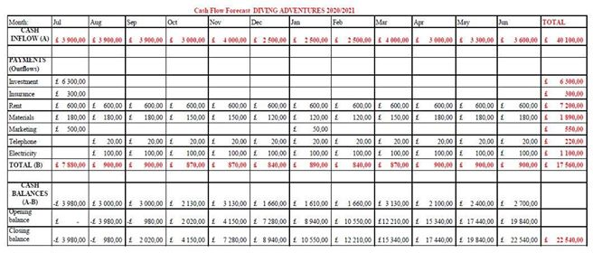

Conclusion
Diving is becoming more and more popular among teenagers and adults who acquire the skills of efficient underwater movement on professional courses organized by diving schools.
The diving school is a year-round business, although of course you can count on the highest turnover from May to September. During this time we are able to train even over 100 people. In the autumn-winter season, it's best to focus on training and trips abroad.
In the diving school, the most important is the instructor and his positive approach to the student. First of all, diving qualifications and experience.
It is worth noting that working in a diving school can be an extra activity for someone, because lessons usually take place in the afternoons, in the early morning or on the weekend.
An interesting offer is a magnet for clients in this business. Therefore, before starting your business, you must have a carefully designed program for various courses. The basic division is training for children and training for older youth and adults - of varying degrees of difficulty from basic recreational to advanced specialist.

References

Smith, R. (2018) Setting up Your Business: The Advantages of Being a Sole Trader [Online] Available at: https://rsaccountancy.co.uk/sole-trader-advantages/
[Accessed: 20.06.2020]

Williams, A.(2018) Self Employment. Teen finance series: Financial independence for teens. [Online]. Detroit: Omnigraphics, Inc. Available at: https://search.credoreference.com/content/entry/ogiiekx/self_employment/0?institutionId=4588 [Accessed: 19.06.2020]

Condon, J.T. and CONDON, J.T. (2010). Strategy marketing planning and the marketing plan. In A. Pizam (Ed.), International encyclopedia of hospitality management. (2nd ed.). [Online]. London: Routledge. Available from: https://search.credoreference.com/content/entry/esthospitality/strategy_marketing_planning_and_the_marketing_plan/0?institutionId=4588 [Accessed 19 June 2020]

Diving in the United Kingdom. [Online] Availble at: https://travel.padi.com/d/united-kingdom/
[Accessed: 20.06.2020]

Heathfield, s.M. (2019) What Is a Human Resource?
Resources Available in the HR Section of TheBalanceCareers [Online] Available at: https://www.thebalancecareers.com/what-is-a-human-resource-1918144 [Accessed: 22.06.2020]

Luenendonk, M. (2014) Understanding the Marketing Mix Concept - 4Ps. [Online] Available at: https://www.cleverism.com/understanding-marketing-mix-concept-4ps/
[Accessed: 20.06.2020]

XpertHR. How does the General Data Protection Regulation (GDPR) affect the processing and retention of recruitment data by employers? [Online] Available at: https://www.xperthr.co.uk/faq/how-does-the-general-data-protection-regulation-gdpr-affect-the-processing-and-retention-of-recruitment-data-by-employers/162308/
[Accessed: 28.06.2020]

Dennis, G. (2015) Simply Scuba. The Future of the Dive Industry For 2015. [Online] Available at: https://www.simplyscuba.com/blogs/blog/the-future-of-the-dive-industry-for-2015
[Accessed: 20.06.2020]

Murray, J. (2020) The balance small business. Cash Flow - How It Works to Keep Your Business Afloat. [Online] Available at: https://www.thebalancesmb.com/cash-flow-how-it-works-to-keep-your-business-afloat-398180 [Accessed: 22.06.2020]

StartUpLoans. How to calculate business start up costs. [Online] Available at: https://www.startuploans.co.uk/business-advice/how-to-calculate-business-start-costs/
[Accessed: 28.06.2020]

