How can the use of regular peer assessment during a lesson influence pupils’ understanding of the learning objective?
The Enquiring Teacher ECPP7001-C

Student Number: My student number is 1400340 on the register; however I am only able to log on to Moodle and my email using the P140122 number from my undergraduate degree. I have spoken to Helen Lewis, the IT department and registry regarding this matter. Initials: NB Group 5 Word Count for the Assignment: 6595

Student Self Evaluation Form

Common Assessment Criteria Applied
Common Assessment Criteria Applied | REFER |  | D |  | C |  | B | A
 | OUTRIGHT FAIL | UNSATISFACTORY | SATISFACTORY | GOOD |  | VERY GOOD |  | EXCELLENT
1. Subject Knowledge and Understanding (which includes using research-informed literature and knowledge and understanding of the subject)
2. Intellectual Skills (Analysis)
3. Pedagogic and Professional Applications (Practical Application and Deployment)
4. Key Transferable Skills
PLEASE COMMENT ON AREAS IN WHICH YOU FEEL THAT YOU HAVE PERFORMED WELL | PLEASE COMMENT ON AREAS you feel that you need TO DEVELOP
In this assignment I have tried to use literature throughout to support my discussions. | To refer to appendices more frequently throughout the assignment, to support my key discussions.
This section repeats in brief the common assessment criteria detailed on previous pages. The extent to which these are demonstrated by you determines your mark. Using these criteria, tick the box that best indicates the level of achievement you feel you have achieved with regard to each of them.

Table of Contents
Aim, focus and purpose of the research 4
Research context 4
Short overview of relevant literature 5
Explanation of the lesson study design 8
Ethical considerations 11
Lesson study 1 and analysis 12
Lesson study 2 and analysis 14
Discussions of the research findings 18
Conclusion 19
Recommendations 20
Reference list 20
Appendices 28
Appendix 1 28
Appendix 2 29
Appendix 3 30
Appendix 4 31
Appendix 5 32
Appendix 6 33
Appendix 7 34
Appendix 8 35

Aim, focus and purpose of the research

The aim of this action research is to understand how the use of regular peer assessment during a lesson can influence pupils’ understanding of the learning objective. This is a small scale close to practice research, which aims to improve my own teaching practice. The regular peer assessment is used as a strategy to influence pupils’ understanding of the learning objective. Judkins et al. (2014) and Scott and McNeish (2013) suggest that research can be used to improve teachers’ subject knowledge and classroom practice. It provides teachers the opportunity to reflect upon their own teaching methods, in order to improve future practice. Reflection can also be used as a tool to inform teachers’ planning. Therefore, the purpose of carrying out this research is to improve pupils’ learning by enhancing my own classroom practice and continuing professional development (CPD). I have chosen to research this key question, as verbal feedback from my first teaching practice has proved this to be an area of development.

Research context

The research was carried out in two primary schools that are a part of the University of Wales Trinity Saint David Yr Athrofa partnership. Primary School A is a large sized school located in Swansea and Primary School B is a medium sized school located in Swansea. Both primary schools cater for pupils aged 3-11. With full attendance permitting, Primary School A has 30 pupils and Primary School B has 29 pupils. The research will take place in Key Stage 2 classes in both primary schools.
Upon discussion with my research partner it was identified that in both primary schools, the pupils are encouraged to use the success criteria as a framework in meeting the learning objective and peer assessment is used to provide and receive feedback. Within the Key Stage 2 class which I worked in during the first teaching practice, the peer assessment was used at the end of lesson, to provide written feedback on a piece of work. However, the issue that interested me was whether providing and receiving regular peer feedback and feed forward at different intervals of a lesson, can influence pupils’ understanding of the learning objective. In this research, the pupils were instructed to use the success criteria as the framework to providing effective verbal and written feedback and feed forward on how to meet the learning objective, in all three peer assessment stops. After each stop, the pupils had the opportunity to act upon the feedback and feed forward which they received and were able to amend their work accordingly. Research from Jones (2005) and the National Foundation for Educational Research (2012) indicate that peer assessment can be used as an effective Assessment for Learning (AfL) strategy to improve pupils’ understanding of the learning objective.

Short overview of relevant literature

The Assessment Reform Group (2002:2) defines AfL as the ‘process of seeking and interpreting evidence for ... learners and ... teachers to decide where the learners are in their learning, where they need to go and how best to get there’. The Department for Children, Education, Lifelong Learning and Skills (DCELLS) (2010) explains that effective teachers embed AfL strategies as part of regular classroom practice and it is implemented throughout the lesson. Hattie (2012) and the DCELLS (2010) suggest that formative assessments should be conducted regularly, but in short cycles throughout the lesson. This is because greater progression is found when AfL is carried out frequently, as opposed to at the end of the lesson. Similarly, the seminal research conducted by Black and William (1998) recommends that formative assessment should be an integral part of the teaching and learning process, as when implemented effectively throughout the lesson, it can double the rate of pupils’ learning. Furthermore, the Organisation for Economic Co-operation and Development (2008) found that formative assessments can improve overall academic achievement. Similarly, research conducted by Hattie (2012) indicates a 70-80% increase in speed of pupils’ learning. However, the Cambridge Assessment International Education (2017) and Jones (2005) say that implementing AfL strategies effectively within the classroom takes time. Additionally, integrating some AfL strategies within the classroom may require additional professional training, such as to improve teachers’ questioning techniques.
As suggested by Hattie (2012) and the DCELLS (2010), AfL aims to support pupils in making progression and improvements with their learning, during the lesson itself. Therefore, feedback should be provided frequently throughout the lesson. According to the DCELLS (2010), in order for feedback to be effective, it is important for it to be provided as soon as possible. This is because Hattie and Timperley (2007), Jones (2005) and the Cambridge Assessment International Education (2017) say that feedback and feed forward has a positive effect on attainment as it informs pupils how to progress in their learning. Additionally, Jones (2005) and the DCELLS (2010) suggest that there should also be planned opportunities for pupils to reflect, and to make the appropriate changes suggested from the feedback. Hodgson (2010) and Jones (2005) state that one method of providing immediate feedback and feed forward is through the use of peer assessment. This is an integral aspect of AfL practice and the process of providing and receiving feedback and feed forward can promote deeper learning.
Research conducted by the University of Exeter (2017), Jones (2005) and the NFER (2012), indicates that peer assessment can be used to improve pupils’ understanding of the learning objective. According to Clarke (2008:92) the ‘Success criteria are the ingredients of the learning objective’ and are regarded as the tools for peer assessment. The Cambridge Assessment International Education (2017) and Chan (2010) suggest that the peer assessment process encourages pupils to apply their understanding of the success criteria in order to make judgements on whether their partner has met the criteria and the learning objective. Pupils are also required to provide feed forward, which could be targets to further develop their partner’s work. One of the reasons why peer assessment can be used to improve pupils’ understanding of the learning objective is that according to Black et al. (2004), it is essential for pupils to have a clear understanding of the success criteria and the learning objective in order to provide effective feedback to their peers. Therefore, the peer assessment process can improve both pupils’ understanding of how to produce a successful piece of work and subsequently their understanding for the learning objective.
Harrison et al. (2001) suggest that when conducting peer assessment it is essential for teachers to share the learning objective and success criteria, as it allows pupils to understand the marking criteria. Leakey (2001) suggests that without a clear understanding the learning objective and the success criteria, pupils are not able to make effective use of the feedback. However, according to Hodgson (2010) and the Department for Education and Skills (2004), sharing the learning objective and the success criteria is already a regular part of classroom practice and the peer assessment can be used as a strategy for further consolidating their understanding of this. Similarly, the NFER (2012) suggests that peer assessment can encourage pupils to think more about the learning objective and success criteria, when giving feedback to their peers. Research by Lindsey and Clark (2001) found that pupils can show their level of understanding of the learning objective through their peer assessment comments. Effective feedback clearly links with the success criteria of the lesson and can therefore indicate whether the pupil has met the learning objective.
Similarly, research conducted by Black and Harrison (2001) found that the peer assessment strategy provided pupils with the opportunity to examine and assess a piece of work critically. Furthermore, researchers such as Hodgson (2010) and Hernandez (2010) found that the peer assessment process can promote self evaluation. This is because as suggested by Hodgson and Pyle (2010), Chan (2010) and Hernandez (2010), using peer assessment strategies within the classroom can encourage pupils to become more independent and autonomous learners by identifying the criteria needed to produce successful work. With practice, pupils will be able to identify their own strengths and develop their own next steps to take their learning forward. This is essential, as such skills are advocated by the upcoming Donaldson (2015) curriculum. As found in the research conducting by Black and Harrison (2001), as although the task involved pupils providing peer feedback, during this process many pupils also evaluated their own work. They set targets based on the criteria to further develop their own academic work. Additionally, research conducted by Black and Harrison (2001), Keogh and Naylor (2007) and Hodgson and Pyle (2010) found that the peer assessment process allows for pupil misconceptions to be identified and addressed. This can therefore allow teachers to put strategies in place to address these barriers towards learning.
Although literature indicates that peer assessment can be used to improve pupils’ understanding of the learning objective, the aim of this action research is to identify how the use of regular peer assessment during a lesson can influence pupils’ understanding of the learning objective. Therefore, as research by Hattie (2012), Jones (2005) and the DCELLS (2010) suggests that effective teachers embed AfL frequently throughout the lesson, the regular peer assessment was decided to be carried out at three intervals of the lesson.

Explanation of the lesson study design

This research used a lesson study approach; this is a form of classroom action research which Dudley (2008) describes as a professional learning process. According to Dudley (2014) and Fernandez and Yoshida (2004), a lesson study is regarded as a model for collaborative learning where teachers identify a particular aspect of classroom practice which they aim to improve and design a specific pedagogical strategy to address this. Collaboratively, the teachers plan, observe, analyse and reflect upon a cycle of lessons and refine the pedagogical strategy to improve the teaching and learning process. A focus group interview then takes place with target children in order to gain their perspectives of the lessons. However as stated by Lim et al. (2018) and Dudley (2013), although teachers have the opportunity to receive feedback in terms of performance management observations or inspections, many teachers do not have the opportunity to provide and receive this form of professional feedback, where the focus is on jointly developing a particular classroom pedagogy. Hargreaves (2012) and Dudley (2014) suggest that in the lesson study approach, the professional learning takes place over a period of time and involves collaborative enquiry. The focus is on joint professional development, as opposed to CPD.
In this research, providing and receiving regular peer assessment was used as the pedagogical strategy to improve pupils’ understanding of the learning objective. In both lessons, the peer assessment was carried out at three different intervals of the lessons. Before each peer assessment stop, the pupils were instructed to use the success criteria to form the basis of their feedback and feed forward. During this process, the pupils swapped their books with an assigned partner and the first step was to read and mark their partner’s work in a different coloured pen. Using the success criteria as a guide, the pupils were required to identify the strengths and areas of development in their partner’s work. The second step was to write these strengths and areas of development on a post-it-note. The final step of this process was to verbally discuss and share the feedback and feed forward with their partner. The aim of this process was for the researcher to identify how providing and receiving regular peer feedback and feed forward may have developed pupils’ learning and understanding of the learning objective.
A preamble was provided for all pupils prior to the start of each lesson. This was used to ensure all pupils understand the aims and objectives of the research. They were explained the research process and reminded of their right to withdraw at any point. Following on from this, a regular classroom practice lesson took place. However the only difference being, the pupils were stopped at three intervals, to carry out the peer assessment process. Each of the three stops took approximately five minutes to complete.
After the lessons were taught, as recommended by Dudley (2014) a focus group interview took place with the four target pupils. The focus group interview was semi-structured in nature with some pre-set questions (see Appendix 1). This is because, as stated by Cohen et al. (2017) and Sharp (2012), given the young age of the pupils, this can be a more appropriate method of interviewing as the nature of the interview is similar to a conversation and therefore, it can be less intimidating. Additionally, it can provide reliable and comparative qualitative data. The interviews took place in an open space, with clear views of the corridors. With consent provided from the schools, the interviews were audio recorded, to help gain a better understanding of the research question. One of the benefits of carrying out a focus group interview was that it provided feedback on how to adapt the first lesson. According to Krueger (2002) and Breen (2006), one of the challenges of conducting focus group interviews is that some participants may overshadow others. Therefore specific measures were put into place, such as asking for each participant’s opinion to allow each voice to be heard. According to Bragg (2007) and Dudley (2014) pupil voice is essential as it can provide researchers with valuable feedback, including recommendations on how to improve the peer assessment process for the following lesson.
A post lesson discussion took place and this provided the opportunity for the researchers to reflect upon the lesson. Although the researcher captured his/her reflections of implementing the regular peer assessment strategy using the Assisted Reflective Conclusions (ARC) model, according to Dudley (2014) and Shúilleabháin (2015), a post lesson discussions is essential as it allows researchers to gain an additional perspective on the effectiveness of the lesson. During this, the researchers can discuss and analyse the feedback which they received from the focus group interview. Then, they can examine the data which the observer had collected to evaluate how each target pupil responded to the strategy and whether the aim of implementing regular peer assessment had been met. Collaboratively, the teachers can then analyse whether the pupils have made progress upon implementing the strategy and what impact this had on their leaning. Finally, the teachers can identify areas of development on how to refine the strategy for the following lesson.
An ARC model was used to capture the reflections of both lessons. As suggested by Sellars (2017), reflections allow teachers to question their teaching methods and strategies. This can provide the opportunity to identify how to improve and refine the methods. The ARC model encourages the researcher to use essential reflective skills as it has been designed by incorporating different reflective models, including Kolb (1984) and Gibbs (1988). This method of reflection allowed the researcher to for example, remember, evaluate, analyse and describe the immediate feelings following the lesson. Additionally, the researcher was able to apply their understanding of literature to suggest an action to improve the following lesson. However, one of the challenges of using the ARC model to reflect is that the questions asked are not specific to the research question; therefore, for the purpose of this research, the questions were modified to reflect upon the regular peer assessment process.
The data was collected using a self created observation schedule to look at specific indicators relating to the research question. The indicators involved looking at whether pupils: provided positive verbal feedback in relation to the success criteria; provided constructive feedback in relation to the success criteria; or provided feedback/reflective comments that discussed something different. This particular observation schedule also incorporated the Leuven Scale to help identify the pupils’ involvement level during the peer assessment process. Therefore, the observation schedule has collected qualitative data and this has been reviewed collectively during the post lesson discussion. This allowed any changes to be made to the methodology and ensured that a shared understanding is established. Therefore, as suggested by Breen (2006) the qualitative data will then be analysed independently by examining key themes emerging from the observation schedules and the focus group interviews.
The research involved using a non-participant observation, as according to Haynes and O’Brien (2000) the qualitative data can be recorded immediately, as the observer is not directly interfering in the lesson. Additionally, Jackson (2010) suggests that more natural behaviour may be displayed. However, as suggested by Cargan (2007), observations are only interpretation of what is happening; therefore this can raise questions of validity. Similarly, according to Sharp (2012), observations can be subjective. Therefore in order to address this issue, this research used an adapted form of the Leuven Scale to ensure that the findings relate to the key research question. Although the adapted Leuven Scale was discussed with the research partner, according to Teijlingen and Hundley (2001), pilot studies can be used to pre-test observation methods and provide feedback on how to make the observations less subjective. Therefore if given the opportunity to conduct similar research in the future, it would be beneficial to conduct a pilot study to ensure a shared understanding of the observation tools is established. This qualitative data, in addition to the pupils’ responses from the focus group interviews has been collected to analyse how regular peer assessment may influence pupils’ understanding of the learning objective.
The focus group pupils were chosen using purposive sampling, as for the purpose of this research the aim was to recruit participants who are more confident and willing to share their opinions, to help gain a better understanding of the research question. The criteria was discussed with the class teachers and their opinions helped to choose these participants. As the nature of this peer assessment process required the pupils to work in pairs, four target children were chosen to be observed and to carry out the focus group interview with. The data collected from the observation schedules and the focus group interviews will be analysed by identifying key themes.

Ethical considerations

When conducting research within a classroom there are potential ethical implications which need to considered; therefore an ethics form has been completed for each of the primary schools. In all aspects of the research, the ethical guidelines outlined by the British Education Research Association (2011), University of Wales Trinity Saint David (2017-2020) and the Education Workforce Council (2017) have been adhered to. Furthermore, the research has been conducted in line with the schools’ existing safeguarding policies and health and safety procedures.
Throughout the research the well-being of the pupils was paramount and involved normal classroom practice. It was under no circumstances different to normal school situations and no pupils were treated differently. The pupils were not pressurised to participate and were informed of their right to withdraw from the research at any point. The focus group interview took place in an accessible setting where pupils felt safe. There were clear views of the corridors and an additional adult was present at all times.
The parents/guardians were provided with a letter to inform them of the research. Should they wish for their child to be observed and be a part of the focus group interview, they signed to provide informed parental consent. All pupils were informed of the nature of the research during the preamble, and a signature was gained from a member of staff of the school to acknowledge that they have witnessed verbal assent to be provided by the pupils.
Throughout the research and within the written assignment, confidentiality and anonymity of the primary schools involved and all participants will be maintained. They will be referred to as pseudonyms such as Pupil A1. All data collected will protect the confidentiality of the participants and permission has been gained for audio recording from the schools involved. The data which has been collected is stored on a password protected electronic file on cloud storage and this follows the schools’ existing policies.

Lesson study 1 and analysis

The learning objective of the lesson was to develop a knowledge and understanding of how to write a narrative text. Overall, it was identified that regular peer assessment had a positive impact on pupils’ understanding of the learning objective (see Appendix 2,3 and 4). As mentioned earlier by Clarke (2008), the success criteria was regarded as the ingredients to meeting the learning objective. During the focus group interview, when asked the question ‘do you think that using regular peer assessment helps you to understand how to meet the learning objective?’ Pupil C1 said ‘to do that thing [meet the learning objective] you have got to include all of the things in the success criteria’. Similarly Pupil B1 said when conducting the regular peer assessment ‘you can remember about the learning objective...if you haven’t done something that’s in the success criteria’. This links back to the suggestions made by Gardner (2014) and Jones (2005) of how the success criteria provides the steps to meet the learning objective successfully.
As suggested by Hodgson and Pyle (2010), Chan (2010) and Hernandez (2010), the peer assessment process can encourage pupils to think about their own work and how they can improve it. Pupil A1 said that during the regular peer assessment process, when ‘looking at the success criteria....you are thinking well have I done that? So you are thinking oh well let’s look at my work because they might put that [feedback] down [for me] as well. So you are just like well we can both improve on it too’. This is essential as according to the NFER (2012) and Pupil C1, having to refer to the success criteria regularly can help you to ‘correct your mistakes and improve it’; therefore, it can improve pupils’ understanding of the learning objective. Additionally, conducting the peer assessment regularly improved the pupils’ learning as Pupil A1 stated that if ‘you are in the middle of (it) [the work] you can quickly change it before it’s the end [of the lesson]. Similarly, Pupil B1 said ‘it’s good doing it a couple of times because you know what to improve on, what you are doing well and [what to] keep on doing.’ Furthermore, Pupil C1 said when you only conduct the peer assessment once, ‘people rush it because they want to go out for break’.
The data from the observation schedules indicates that pupils provided both positive and constructive feedback in relation to the success criteria, in order to meet the learning objective. In terms of how the pupils achieved the lesson goals, overall the data indicates that using regular peer assessment had a positive impact on pupils’ understanding of the learning objective. As suggested by Ferrell and Gray (2016) and Hattie and Timperley (2007), having to provide feedback and feed forward can encourage pupils to refer to the success criteria more. Subsequently, as Jones (2005) and the NFER (2012) say, it can improve both pupils’ understanding of the learning objective. The data from the observation schedules indicates that Pupil A1 identified that their partner’s narrative ‘is scary’, however in terms of feed forward, a target was provided to ‘describe the character more’ in order to meet the success criteria. In the third stop it can be seen that their partner aimed to address this target and received positive feedback in relation to the success criteria, on how they provided a good description of the character’s movements.
However, in the second peer assessment stop it was found that some target pupils showed a decline in the Leuven Scale of involvement. Upon reflection, it was identified that one of the reasons for this could be because, some pupils were unsure of what feedback to provide as they felt that they had already completed the peer assessment process. Usually the peer assessment is only conducted at the end of a lesson, however after explaining the regular peer assessment process to the pupils again, during the third stop, the involvement scale score increased. Therefore in terms of how this lesson could be improved, it was decided to explain the regular peer assessment process in greater depth and to provide further guidance on all three stops.
Furthermore, upon reflection it was decided that in order to improve the second research lesson, pupils will be provided with more initial independent working time before the first peer assessment stop. This is because the pupils did not have enough time to write an opening for their narrative in a great amount of detail. One comment made by Pupil D1 was that ‘you could add a new paragraph [n your work] but we did not have enough time to write another paragraph’. Additionally, when conducting the second research lesson, it was decided to provide more rigid times for the peer assessment process as some stops took longer than others. One of the issues of this was that more time was needed than intended on the peer assessment process and therefore many pupils were not able to complete writing their narrative.

Lesson study 2 and analysis

The learning objective of the lesson was to develop a knowledge and understanding of how to write instructions for a purpose. Overall, similar to the findings of the first lesson, the data indicated that regular peer assessment had a positive impact on pupils’ understanding of the learning objective (see Appendix 5,6 and 7). As the success criteria was regarded as the ingredients of the learning objective (Clarke, 2008), it was found that this process improved pupils’ understanding of this. This is because carrying out the regular peer assessment required the pupils to identify the strengths and areas of development by regularly referring to the success criteria.
Jones (2005) suggests that peer assessment can encourage pupils to use the success criteria effectively; subsequently this can improve their understanding of the learning objective. Pupil D2 said when using regular peer assessment ‘you [can] have a look back at the success criteria [and] you could tell what you are missing and not missing [in your work]. So once you are doing the work and [when] you notice that you are missing it [an aspect of the success criteria] you can just go [and] write [it] back [in your work]’. This therefore shows that conducting regular peer assessment encourages pupils to constantly refer back to the success criteria and learning objective. By doing so, this can improve their understanding of the success criteria and learning objective. Similarly, Hattie and Brown (2011) and Jones (2005) found that peer assessment using the success criteria can be conducted to consolidate and improve pupils’ own understanding of the learning objective, particularly when providing feedback and feed forward. It can also be used as a strategy of checking whether their partner has understood the success criteria and learning objective. Additionally, Pupil C2 ‘loved doing the regular peer assessment because when you do a regular one you can see what your partner has done [what feedback s/he has provided] and...then you tick it off on the post-it note [if you have met that target by the next stop] and it makes it much easier.’ As suggested by Jones (2005), when pupils understand and apply the success criteria to their own work, it was found that academic progress is often maximised.
An example of how providing and receiving regular peer feedback and feed forward can improve pupils’ understanding of the learning objective is provided. During the first peer assessment stop, Pupil C2 identified that in order to write effective instructions and to meet the success criteria, their partner needs ‘to put in a method’ of the steps involved in making a smoothie. During the second stop, Pupil C2 discussed with their partner of how the feedback improved their work as they are beginning to address this aspect of the success criteria. Subsequently in stop three, the researcher observed whilst giving feedback to his/her partner, Pupil C2 identified how his/her partner did ‘very well’ on writing the method. Therefore, this data from the observational schedules indicates that providing and receiving regular feedback and feed forward helped improve both pupils’ understanding of the learning objective. Hattie and Brown (2011), suggest that without having a clear understanding of the learning objective, it is difficult for pupils to deduce what is to be learned during the lesson. Therefore, in this example, the data indicates that the pupils had a good understanding of the learning objective, as they were able to provide and use the feedback and feed forward to meet the success criteria and subsequently the learning objective.
Additionally, when providing feedback of the regular peer assessment process, Pupil C2 said that ‘if you didn’t know what to do [during the lesson] then you can read the learning objective because ...it tells you what to do and I feel like [today’s] learning objective like stands out, I feel like it was part of the work.. like...it was based on [writing instructions of] how to make a smoothie’. Sackstein (2017) and Hattie and Brown (2011) suggest that without a clear understanding of the learning objective and success criteria, it is not possible for pupils to provide effective feedback and feed forward. Alternatively, if pupils are able to generate effective feedback in terms of the success criteria, then it indicates that they have a good understanding of the learning objective.
Furthermore, upon reflection and as suggested by Brookhart (2017), Jones (2005), Gardner (2014) and Frankland (2007), when peer assessment is only conducted at the end of a lesson, pupils may not have the opportunity to act upon the feed forward and this can have an impact on their learning. Therefore when conducting regular peer assessment, the pupils had the opportunity to act upon the targets immediately; therefore, it may have contributed to further developing pupils’ understanding of the learning objective. For example, Pupil C2 said that following from the last stop now ‘I can see good time connectives’. Therefore, the data from the observations indicate that conducting the peer assessment regularly at different intervals provided pupils with the opportunity to improve the quality of their work, in relation to the learning objective and success criteria. Similarly, Jones (2005) found that greater academic progress is shown when pupils have the opportunity to apply the success criteria, when assessing the work produced by their peers.
However, when providing feedback on the peer assessment process, Pupil B2 said ‘I thought that if you piggy bank Pupil A2’s work then they may be sad’. As suggested by the Cambridge Assessment International Education (2017), in order to conduct the peer assessment process more effectively, it is important to promote a supportive and collaborative atmosphere of learning. Furthermore, it is important to ensure that learners understand the importance of peer assessment and the benefits associated with it. Therefore in future practice, I aim to use these strategies to make the peer assessment process more effective. This is essential, as Donaldson (2015) advocates collaborative and shared learning.
After reflecting on the first lesson, more explanation of the peer assessment process was provided in the second lesson, with stricter time limits. During the introduction, the peer assessment process was explained to the pupils in more depth. At each stop, the pupils were instructed to use the success criteria to provide positive feedback on how their partner has met the success criteria and constructive feedback on areas to develop by the following stop. In stop two and stop three, the pupils were instructed to evaluate if their partner has met the target provided from the feedback in the previous stop. Additionally in order to consolidate pupils’ understanding of how to provide effective feedback and feed forward using the success criteria, an example of an instruction text was shown on the board. The task was to identify the strengths and areas of development of the example using the success criteria. As a class, they used the success criteria to collaboratively improve the sentence. This process allowed the pupils to, as suggested by Clarke (2014), Gardner (2014) and Falchikov (2005), identify what a good one looks like. This is a key aspect of AfL as excellence was shared to the class before the pupils began working independently. As suggested by Clarke (2014), this can enhance their chances of success.
The ARC model was used to reflect upon how this lesson could be improved (see Appendix 8). Upon reflection, it was identified from the data recorded on the observation schedules and the focus group interviews, that the time management of the lesson could be improved. The data indicates that Pupil B2 ‘wanted to do more’ work but they needed ‘more time’. Similarly, Pupil A2 said that they would like to carry out the regular peer assessment process again but ‘if we do it again and we have more time to do it we could finish the work’. Therefore if given the opportunity to carry out a similar research in the future, changes will need to be made to account for more time to complete the main activity. This will be explained in more detail in the discussions of the research findings. Additionally, according to Donaldson (2015), it is essential to develop a positive and collaborative learning environment where pupils can share good practice, as some pupils such as Pupil C2, were concerned of providing constructive feedback.
Discussions of the research findings

The results from the data analysis indicate that introducing the regular peer assessment strategy as regular classroom practice would be beneficial for the research class. As overall, it was found that regular peer assessment had a positive impact on pupils’ understanding of the learning objective. As the data from the focus group interviews indicate, overall, the pupils enjoyed conducting the regular per assessment at different intervals and found it to help with their understanding of the learning objective, as they were required to constantly refer back to the success criteria.
Literature from Jones (2005), Hattie (2012) and the DCELLS (2010), suggests that peer assessment can be used as an effective strategy for improving pupils’ understanding of the learning objective. From the post lesson discussions and the ARC reflection, it was found that the regular peer assessment process was fairly lengthy and carrying out this process three times during a one hour lesson took approximately fifteen minutes of the session. Therefore one of the recommendations would be that this process would be better suited for a two hour lesson. The same amount of time would be spent on the regular peer assessment; however there will be more time for the pupils to complete the main activity. However, as it is intended to make the peer assessment a regular part of classroom practice, with practice and training the pupils may become more familiar with the process and therefore in future it may take less time to complete the three stops. Therefore when pupils become more familiar with the process, it may be possible to use the regular peer assessment during a one hour lesson.
Upon reflection it was identified that one of the limitations of the current research is that due to time constraints, the observer was not able to transcribe the entire conversation during the peer assessment process. As the University of Southern Califonia (2018) says, when writing physical notes, key information may be missed due to the nature of the observations and time constraints. As recommended by Gorman and Clayton (2004), if given the opportunity to carry out a similar type of research, it will be beneficial to audio record the conversations; this can then be referred to when analysing the data.
Additionally, after reflecting upon both research lessons, it was identified that the focus group interviews were quite lengthy. It was recommended by Dudley (2014) to keep the interviews short. Therefore in order to address this issue, if given the opportunity to conduct focus group interviews in future, fewer questions will be asked in order to keep the interviews short. As suggested by Breen (2006) if a pilot study was conducted, the researcher could have gained an insight on whether the amount of questions asked need to be revised and it could have provided the opportunity to develop the researcher’s skills as a moderator.
Additionally, the researchers found it difficult to document the conversations of four target pupils; essential information could have been missed when observing one pair. As suggested by Vogt et al. (2014), it can be difficult document observational notes when more than one pair is discussing at one time. Therefore in future practice, it would be beneficial to conduct a pilot study to practise documenting observational notes.
Furthermore, one of the limitations of using a self created observation schedule is that it has not been trialled and tested before; therefore as suggested by Cargan (2007), it can raise questions of reliability and validity. Therefore, although the data which was collected indicated a positive impact of using regular peer assessment to help improve pupils’ understanding of the learning objective, the results cannot be generalised. However, this was a close to practice research, with the primary aim of improving my own CPD and classroom practice.

Conclusion

In conclusion, overall the data indicates that regular peer assessment had a positive impact on pupils’ understanding of the learning objective. Although a positive relationship was identified in both research classes, it does not mean to say that these findings will be found in all other schools. However, as stated earlier, this was a close to practice research aiming to develop my own classroom practice and CPD.
One of the targets from my previous teaching placement was to ensure that pupils have a good understanding of the learning objective. Having undertaken this research, I now have a better understanding of the uses of AfL strategies within the classroom. As recommended by the DCELLS (2010), Black and Harrison (2001), Keogh and Naylor (2007) and Hodgson and Pyle (2010), in terms of my next teaching practice and during my Newly Qualified Teacher year, I will aim to use AfL strategies on a more regular basis, as opposed to only at the start or end of a lesson, as it can allow misconceptions to be highlighted. As the data from the observation schedules and focus group interviews indicated that regular peer assessment can help consolidate and improve pupils’ understanding of the learning objective, I aim to use this strategy regularly in my next placement and try and embed it as part of regular classroom practice during my Newly Qualified Teaching year.

Recommendations

After reflecting upon both research lessons, it can be recommended that regular peer assessment should become an integral part of classroom practice. According to Donaldson (2015:81), within the upcoming curriculum, ‘peer assessment should be developed as [a] way(s) of encouraging children and young people to take greater responsibility for their own learning’. AfL can be used to gain essential feedback on how to improve the teaching and learning process, in order to maximise pupils’ progression in learning. However, as regular peer assessment is a time consuming process, it would be advisable to carry out this form of peer assessment throughout the duration of a two hour lesson, as this would give pupils more time to complete the main activity, as well time to carry out the peer assessment process in depth. Although with practice, the regular peer assessment can become a regular aspect of classroom practice and when the pupils become more familiar with the process, it may be quicker and less time consuming to conduct. Lastly, further training will be needed for the researchers to develop a collaborative learning atmosphere where pupils are encouraged to share good practice.

Reference list

Assessment Reform Group (2002) Assessment for Learning: 10 principles research-based principles to guide classroom practice. London: Assessment Reform Group, Available at: https://www.aaia.org.uk/content/uploads/2010/06/Assessment-for-Learning-10-principles.pdf [Accessed 2 April 2018].
Black, P. and Harrison, C.L. (2001). 'Self- and peer–assessment and taking responsibility: the science student's role in formative assessment', School Science Review, 83, 302, pp.43–49.[Online]. Available at: file:///C:/Users/Shafiul/Downloads/Self-_and_peer-assessment_and_taking_responsibilit.pdf [Accessed 7 April 2018].
Black, P., Harrison, C.L., Marshall, B. and William, D. (2004) ‘Working Inside the Black Box’, Assessment for Learning in the Classroom, 86, 1, pp.8-21. [Online] Available at: http://iteswhite.d20blogs.org/files/2013/06/Assessment-for-Learning-in-the-Classroom.pdf [Accessed 21 March 2018].
Black, P. and William, D. (1998) ‘Inside the Black Box: Raising Standards Through Classroom Assessment’, Phi Delta Kappa, October, pp.1-13. [Online]. Available at: https://www.rdc.udel.edu/wp-content/uploads/2015/04/InsideBlackBox.pdf [Accessed 29 March 2018].
Bragg, S. (2007) ‘‘But I listen to children anyway!’—teacher perspectives on pupil voice’, Educational Action Research, 15,4, pp.505-518 [Online]. Available at: https://servicesforeducation.co.uk/index.php/nov-16-pupil-voice/1501-but-i-listen-to-children-anyway/file.html [Accessed 3 April 2018].
Breen, R.L. (2006) ‘A Practical Guide to Focus-Group Research’, Journal of Geography in Higher Education, 30,3, pp.463-475 [Online]. Available at: https://moodle.uwtsd.ac.uk/pluginfile.php/147133/mod_resource/content/1/A%20Practical%20Guide%20to%20Focus%20Group%20Research.pdf [Accessed 4 April 2018].
British Educational Research Association (2011) ‘Ethical Guidelines for Educational Research’ Available at: https://www.bera.ac.uk/researchers-resources/resources-for-researchers [Accessed 28 March 2018].
Brookhart, S.M. (2017) How to Give Effective Feedback to Your Students. (2nd ed) Alexandria: ASCD.
Cambridge Assessment International Education (2017) ‘Getting started with Assessment for Learning’ Available at: https://cambridge-community.org.uk/professional-development/gswafl/index.html [Accessed 29 March 2018].
Cargan, L. (2007) Doing Social Research. New York: Rowman & Littlefield Publishers INC.
Chan, C. (2010) ‘Self and Peer Assessment’ Available at: http://ar.cetl.hku.hk/self_peer.htm [Accessed 1 April 2018].
Clarke, S. (2008) Active Learning Through Formative Assessment. London: Hodder Education.
Clarke, S. (2014) Outstanding Formative Assessment. London: Hodder Education.
Cohen, L., Manion, L. and Morrison, K. (2017) Research Methods in Education. (8th ed) Oxon: Routledge.
Department for Education and Skills (2004) Excellence and Enjoyment: learning and teaching in the primary years Planning and assessment for learning Designing opportunities for learning. London: Primary National Strategy, Available at: http://webarchive.nationalarchives.gov.uk/20110713133739/https:/www.education.gov.uk/publications/eorderingdownload/designing%20opportunities%20for%20learning.pdf [Accessed 1 April 2018].
Donaldson, G. (2015) Successful Futures Independent Review of Curriculum and Assessment Arrangements in Wales. Cardiff: Welsh Assembly Government, Available at: http://gov.wales/docs/dcells/publications/150225-successful-futures-en.pdf [Accessed 21 March 2018].
Dudley, P. (2008) Improving practice and progression through Lesson Study Handbook for headteachers, leading teachers and subject leaders. London: Department for Children, Schools and Families, Available at: https://moodle.uwtsd.ac.uk/pluginfile.php/133350/mod_resource/content/1/pri_slt_cpd_imp_prac_prog.pdf [Accessed 26 March 2018].
Dudley, P. (2014) ‘Lesson study: a handbook’, Available at: https://moodle.uwtsd.ac.uk/pluginfile.php/133342/mod_resource/content/1/Lesson%20Study%20Handbook.pdf [Accessed 27 March 2018].
Dudley, P. (2013) Lesson Study: professional learning for our time: How and why Lesson Study can help to overcome longstanding and intractable barriers to teacher learning and school to school support. Leicester: University of Leicester, Available at: http://www.aps.sg/files/slss2013/Keynote/Pete_Dudley_Keynote_2_-_060613Singapore_presentation.pdf [Accessed 30 March 2018].
Education Workforce Council (2017) ‘Code of Professional Conduct and Practice for Registrants with the Education Workforce Council’ Available at: https://www.ewc.wales/site/index.php/en/fitness-to-practise/code-of-professional-conduct-and-practice-pdf/file [Accessed 27 March 2018].
Falchikov, N. (2005) Improving Assessment Through Student Involvement: Practical solutions for aiding learning in higher and further education. Oxon: RoutledgeFalmer.
Fernandez, C. and Yoshida, M. (2004) Lesson study: A Japanese approach to improving mathematics teaching and learning. New Jersey: Lawrence Erlbaum Associates, Publishers.
Gardner, J. (2014) AfL: Assessment for Learning: A Practical Guide. Northern Ireland: The Northern Ireland Curriculum, Available at: http://ccea.org.uk/sites/default/files/docs/curriculum/assessment/assessment_for_learning/afl_practical_guide.pdf [Accessed 2 April 2018].
Gibbs, G. (1988) Learning by Doing: A guide to teaching and learning methods. Further Education Unit. Oxford: Oxford Polytechnic.
Gorman, G.E. and Clayton, P. (2004) Qualitative Research for the Information Professional: A Practical Handbook. (2nd ed) London: Facet Publishing.
Hall, K. (2004) making a formative assessment work. Berkshire: Open University Press.
Hargreaves, D. H. (2012) A self improving school system: towards maturity. Nottingham: NCSL, Available at: http://dera.ioe.ac.uk/15804/1/a-self-improving-school-system-towards-maturity.pdf [Accessed 29 March 2018].
Harrison, C., Drozdowskij, J. and Westhead, K. (2001). 'Formative assessment in primary classrooms', Primary Science Review, 68, 19–22. [Online]. Available at: file:///C:/Users/Shafiul/Downloads/PSR68May-Jun2001p19.pdf [Accessed 6 April 2018].
Hattie, J. (2012) Visible Learning for Teachers: Maximizing Impact on Learning. Oxon: Routledge.
Hattie, J. and Brown, G.T.L. ‘Assessment an evaluation’, in M. C. Rubie-Davies (ed), (2011) Educational Psychology: Concepts, Research and Challenges. Oxon: Routledge, pp.102-117.
Hattie, J. and Timperley, H. (2007) ‘The Power of Feedback’, Review of Educational Research, 77, 81, March, pp.1-33, [Online]. Available at: http://education.qld.gov.au/staff/development/performance/resources/readings/power-feedback.pdf (Accessed 29 March 2018).
Haynes, S.N. and O’Brien, W.H. (2000) Principles and Practice of Behavioural Assessment. New York: Kluwer Academic/ Plenum Publishers.
Hernandez, R. (2010) Assessment: Benefits and Challenges of using self and peer assessment. Dublin: University College Dublin, Available at: https://www.ucd.ie/t4cms/UCDTLA0033-1.pdf [Accessed 2 April 2018].
Hodgson, C. (2010) Assessment for learning in primary science: Practices and benefits. Slough: National Foundation for Education Research, Available at: https://www.nfer.ac.uk/publications/AAS02/AAS02.pdf [Accessed 5 April 2018].
Hodgson, C. and Pyle, K. (2010) A literature review of Assessment for Learning in science. Slough: National Foundation for Education Research, Available at: https://www.nfer.ac.uk/publications/AAS01/AAS01.pdf [Accessed 3 April 2018].
Jackson, S.L. (2010) Research Methods: A Modular Approach. (2nd ed) Belmont: Wadsworth Cengage Learning.
Jones, C.A. (2005) assessment for learning: Vocational Learning Support Programme: 16-19. London: Learning and Skills Development Agency, Available at: http://dera.ioe.ac.uk/7800/1/AssessmentforLearning.pdf [Accessed 25 March 2018].
Judkins, M., Stacey, O. , McCrone, T. and Inniss, M. (2014) Teachers’ Use of Research Evidence A case study of United Learning schools. Slough: National Foundation for Educational Research, Available at: https://www.nfer.ac.uk/publications/IMUL01/IMUL01.pdf [Accessed 2 April 2018].
Keogh, B. and Naylor, S. (2007). 'Talking and thinking in science', School Science Review, 88, 324, 85–90.
Kolb, D.A. (1984) Experiential Learning: Experience as the Source of Learning and Development. New Jersey: Prentice Hall Inc.
Krueger, R.A. (2002) Designing and Conducting Focus Group Interviews. Thousand Oaks: Sage, Available at: http://www.eiu.edu/ihec/Krueger-FocusGroupInterviews.pdf [Accessed 2 April 2018].
Leakey, A. (2001) 'Fantastic feedback', Primary Science Review, 68, pp. 22–23.
Lim, C.S., Teh, K.H. and Chiew,C.M. ‘Promoting and Implementing Lesson Study in Malaysia: Issue of Sustainability’, in M. Quaresma, C. Winslow, S. Clivaz, J.P.D. Ponte, A.N. Shúilleabháin and A. Takahashi (eds), (2018) Mathematics Lesson Study Around the World: Theoretical and Methodological Issues. Switzerland: Springer International Publishing, pp.47-64.
Lindsay, C. and Clarke, S. (2001) ‘Enhancing primary science through self- and paired-assessment’, Primary Science Review, 68, pp.15–18.
National Foundation for Education Research (2007) self and peer assessment. Berkshire: National Foundation for Education Research, Available at: https://www.nfer.ac.uk/pdf/getting-to-grips-with-assessment-4.pdf [Accessed 9 April 2018].
Organisation for Economic Co-operation and Development (2008) Assessment for Learning Formative Assessment. Paris: Centre for Educational Research and Innovation, Available at: https://www.oecd.org/site/educeri21st/40600533.pdf [Accessed 29 March 2018].
Sackstein, S. (2017) Peer Feedback in the Classroom: Empowering Students to Be the Experts. Virginia: ASCD.
Scott, S. and McNeish, D. (2013) School leadership evidence review: using research evidence to support school improvement. London: Department for Education, Available at: https://www.dmss.co.uk/pdfs/evidencereview3.pdf [Accessed 22 April 2018].
Sellars, M. (2017) Reflective Practice for Teachers. (2nd ed) London: Sage.
Sharp, J. (2012) Success with you education research project.(2nd ed) London: Sage.
Shúilleabháin, A.N. (2015) Lesson Study as a form of in-School Professional Development: Case studies in two post-primary schools. Dublin: National Council for Curriculum and Assessment, Available at: https://www.ncca.ie/media/2136/lesson-study-pd.pdf [Accessed 29 March 2018].
Teijlingen, E.R.V. and Hundley, V. (2001) ‘The importance of pilot studies’ Available at: http://sru.soc.surrey.ac.uk/SRU35.html [Accessed 30 March 2018].
University of Southern California (2018) ‘Organizing Your Social Sciences Research Paper: Writing Field Notes’ Available at: http://libguides.usc.edu/writingguide/fieldnotes [Accessed 4 April 2018].
University of Exeter (2017) ‘Chapter 10 – Peer and self assessment in student work: principles and criteria’ Available at: https://as.exeter.ac.uk/academic-policy-standards/tqa-manual/lts/peerselfassessment/ [Accessed 29 March 2018].
University of Wales Trinity Saint David (2017-2020) ‘Research Ethics & Integrity Code of Practice’ Available at: http://www.uwtsd.ac.uk/media/uwtsd-website/content-assets/documents/research/research-ethics-integrity-code-practice.pdf [Accessed 18 March 2018].
Vogt, P.W., Vogt, E.R., Gardner, D.C. and Haeffele, L.M. (2014) Selecting the Right Analysis for Your Data: Quantitative, Qualitative and Mixed Methods. New York: The Guildford Press.
Wales: Department for Children, Education, Lifelong Learning and Skills (2010) How to develop thinking and assessment for learning in the classroom. Cardiff: Welsh Assembly Government, Available at: http://learning.gov.wales/docs/learningwales/publications/130429how-to-develop-thinking-en.pdf [Accessed 30 March 2018].

Appendices

Appendix 1
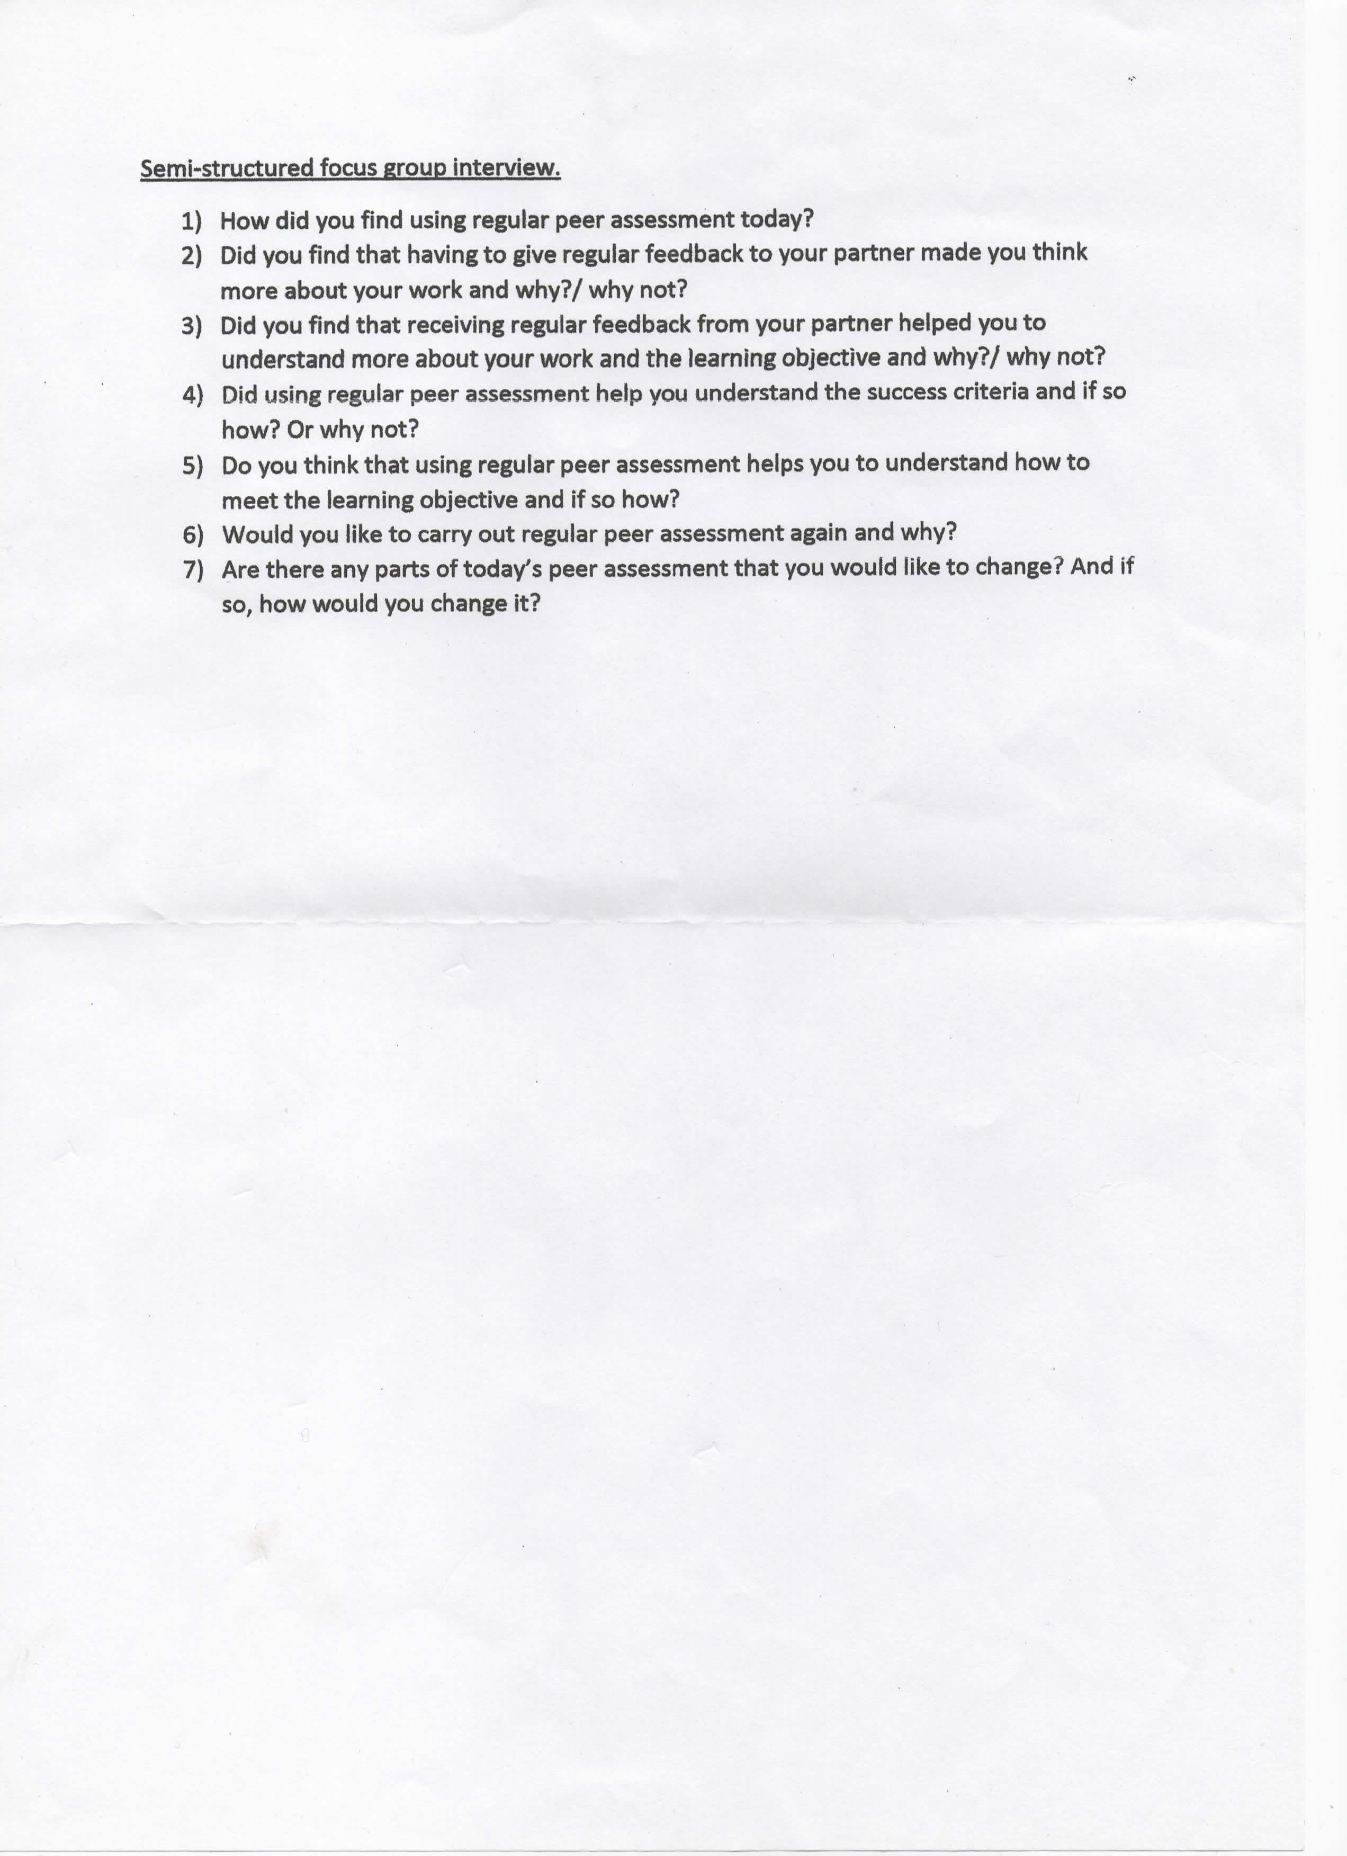

Appendix 2
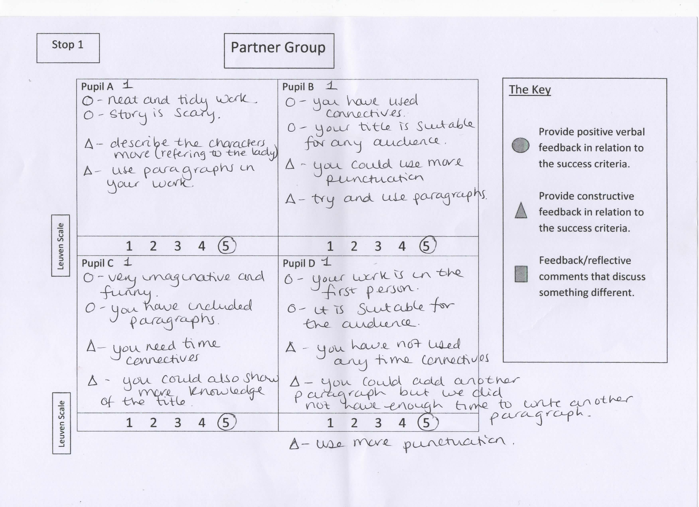

Appendix 3
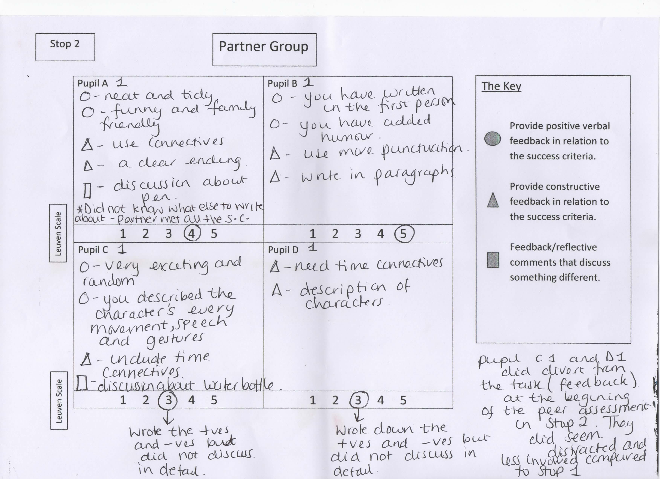

Appendix 4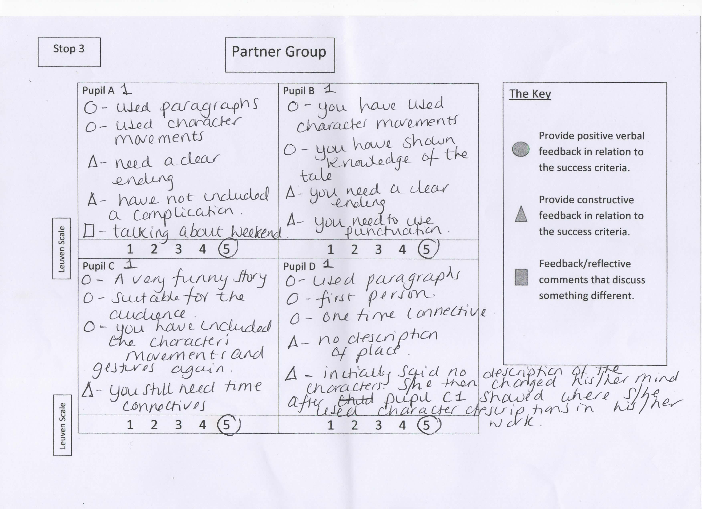

Appendix 5
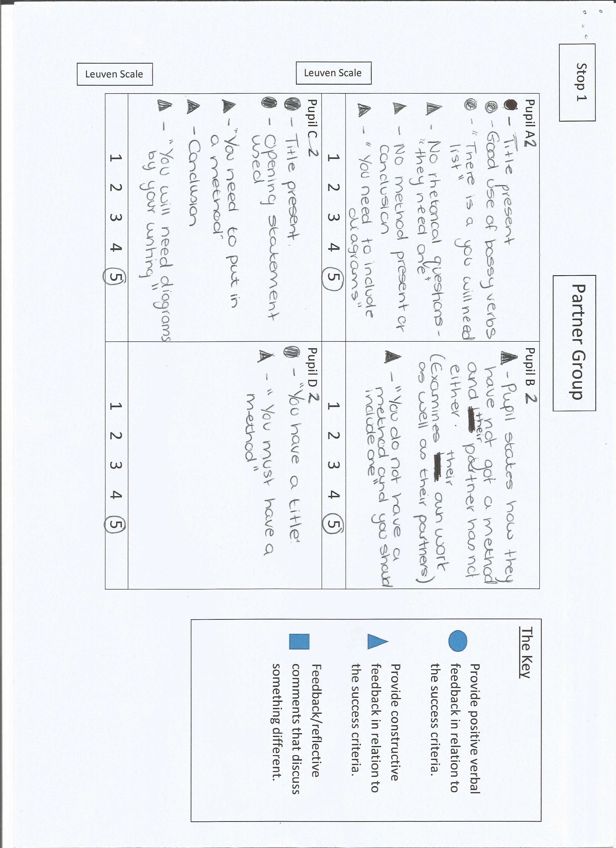

Appendix 6
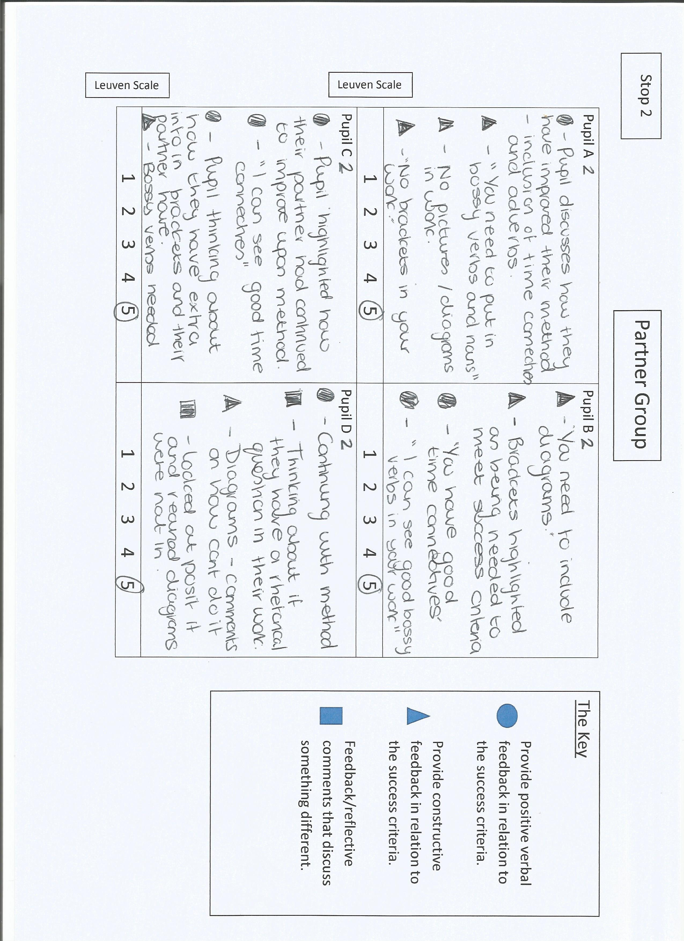

Appendix 7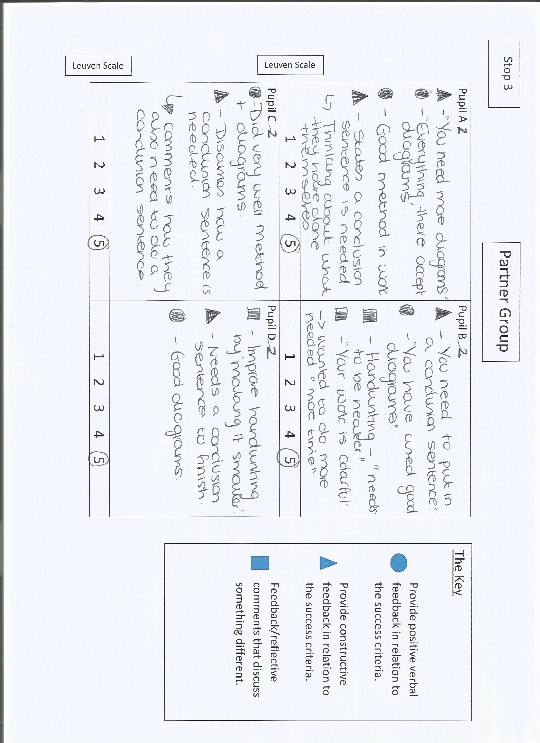

Appendix 8

