

Course: BSc (Hons) Health and Social Care
Module: Health, welling, and Sustainable Development. (BMHP6021_LON)

Student name: Elizabeth Owusu
Student ID: 1917244
Lecturer name: Diola Bijihout
Date

A consultancy report of Lambeth borough local council on health, wellbeing, and sustainable development within the health care sectors in the UK.
Topic
Contents Page………....……………………………………………………………………….1
Introduction…………………………….…………………………………………………………….2
Defining Sustainable Development………………………………………………………………….
Overview of the 17 sustainable development goals…………………………………….…………
A detailed discussion of Goal 3…………………………………………….
A detailed discussion of Goal 4……………………………………………………………….
A detailed discussion of Goal 17…………………………………………
UK policies and initiatives identified to meet the 3 sustainable goals
The Lambeth Borough……………………………………………………………………….
Local policies of Lambeth Borough identified to meet the 3 SDGs………………………3
Reviewing the status of Lambeth borough to meet the 3 sustainable goals…………4

Recommendation……………………………………………….…………………………….7
Conclusion…………………………………………………………………………………7
References……………………………………………………………………………………………

Introduction
Life satisfaction has been found to relate to factors including earnings, employment, health, and individual traits, like age, gender, and personality as well as significant life events. According to Halpern (2010), life happiness has been demonstrated to vary among countries in ways that can be explained by variations in freedom, social capital, and trust.
According to IPCC, 2022, the evolution of humanity has led to an unsustainable planet since it has mostly prioritized economic welfare at the expense of social, environmental, and ecological well-being. At the UN Summit in 2015, the United Nations endorsed the notion of sustainable development objectives, concepts, and models of reforms on how societies might organize in response to the profound need for a sustainable way of life and economic development, institution-building in social and economic life (Argyrou, 22).
UN members have ratified the 17 sustainable goals, which include eradicating poverty and hunger, promoting equality within and between nations, fostering the development of peaceful societies, defending human rights, and preserving the planet long natural resources from climate change (Fong, 2022).
This report will look at the steps taken in the UK health sector to meet the three sustainable development objectives on health and well-being, quality education, and partnership, which are 3, 4, and 17. The report will start with a brief discussion of the sustainable development goals, and a broader discussion on goals 3, 4, and 17. It will further examine UK policies and initiatives identified in these three goals to meet the need of the community to obtain sustainability (GOV., 2022). The paper will examine the development of education, employment, and finances through the three SDGs. The paper will then review the status, the policies needed to meet these goals, how the council is working to achieve them, and finally recommendations and conclusion.

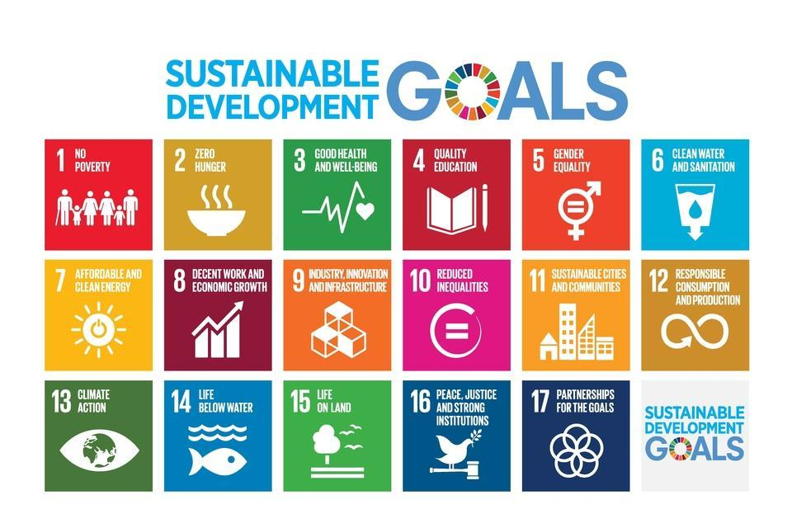
Defining Sustainable Development
Sustainable development is the process of addressing present needs while preserving the capacity of communities. It is the guiding principle behind planning and essential to the nation’s economic, environmental, and social success (Bexell, 2017). The idea acknowledges the significance of making sure that everyone can meet their fundamental needs and leads lives of higher quality, both now and in the future (UK. Gov, 2O19).
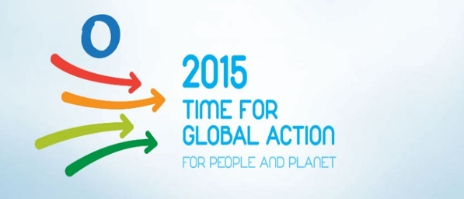

Overview of the Sustainable Development Goals
United Nations’ role in building a sustainable future
Organizations act as crucial linkages between the larger field and local levels in constitutional change (Heinze, 2016).

The Sustainable Development Goals, serve as an ambitious, widely accepted, and shared roadmap for the world we want to see by 2030. The goals are a global set of objectives, and benchmarks, for UN members, and are intended to utilize to guide their political agenda over the next 15 years (Ford, 2015). The SDGs served as a framework for the discussion of various actors, stakeholders, and nations. The United Nations System, international finance, international organizations, parliamentarians, local governments, non-governmental organizations, private sectors, civil society, scientists, academics, women, youth, and all involved. Global online stakeholder consultation has been set up to gather opinions, first-hand knowledge, and suggestions from all parties involved and make them widely available prior to the event (UN, 2022). The 2030 Agenda for Sustainable Development was ratified by 193 nations, at the UN Development Summit 2015. The SDGs apply to all countries, and all industries must contribute to its implementation, The UK oversees achieving the objectives on the home front and aiding in their international achievements (UK. Gov, 2O19).

Sector
SDG 1: No Poverty
SDG 1
Sustainable Development Goal1, aims to eradicate all forms of poverty, enhance social protection, and guarantee that the underprivileged and vulnerable have equal access to economic resources (UN, 2020).
Sector
SDG 2; Zero hunger
Economic; Employment; Educational; Housing, and Health.

The Environment; Land; Food; Sustainability; Safety; Fairness, and Health (Fong, 2021).
The ability to end hunger, ensure food availability, and ensure advanced sustainable agriculture (UN, 2020).
Goal 3, Good health, and well-being
Sector
Economy; Environmental sustainability; Justice; Security; Education; Infrastructure; Housing; Communal food, and health (Fong, 2021).

SDG3; Ensures healthy lives and promotes well-being for all ages. It aims to create a more prosperous and sustainable world (UN, 2020).
SDG 4, Quality education
Sector

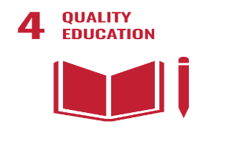
Goal 4, promotes opportunities for everyone to pursue lifelong learning while ensuring inclusive and equitable quality education. SDG4 aims to provide free, egalitarian, and high-quality education, for everyone by 2030 to support the acquisition of knowledge and skill necessary for sustainable development (DID, 2021).
SDG 5; Gender equality
Sector
Early life; Education, and Health
Justice; Security; Health Early life; Education; Employment, and Health (Fong, 2022).
Goal 5; is to eliminate prejudice, achieve gender equality, and provide all women and girls the power they deserve through the activities of the Race Disparity Unit and Government Equalities Office (UN, 2020).
Sector
Health; sustainability; environment; Justice; Housing, and Security
SDG 6; Clean water and sanitation
Goal 6, aspires to ensure that everyone has access to, and can sustainably manage water and sanitation to meet basic requirements (UN, 2021).

SDG 7; Affordable and clean energy

Sector
Sustainability; Infrastructure; Planning; Economy; Housing, and Health.

Goal 7; aims to ensure that everyone has access to modern, affordable, dependable, and sustainable energy. The Clean Growth Strategy is intended to be implemented by empowering industry academia, and civil society (Ford, 2015).
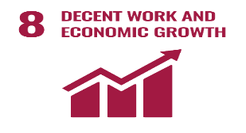
SDG 8; Work and economic growth
Sector
Goal 8, encourage sustained, inclusive, and sustainable economic growth that leads to full and productive employment and decent work for everyone (UN, 2022).
SDG 9; Industry, innovation, and infrastructure

Work and employment; Security; Justice; Housing; and Health.
Sector
The purpose of Goal 9, is to produce a quality, dependable, sustainable, and resilient infrastructure for economic development and social well-being. It also aims to foster innovation (Gov.UK, 2021).
Sector
Affordability; Sustainability; Economics; Environment, and Health.
Finances; Instruction; Employment; Justice; Safety, and Health.
SDS 10; Reduce inequalities
SDG 10; is to reduce inequality both inside and between nations, and that policies must be put in place to enable the social, economic, and political inclusion of everyone.
Sector
SDG 11: Sustainable cities and communities
With aid of effective local government and democratic institutions, Goal 11, strives to establish inclusive, secure, and sustainable cities.
Housing; Community services; Transportation planning; Law and order, and culture; Health.
SDG 12; Responsible consumption anproduction
Sector
Goal 12, attempts to advance the social, economic, environmental, and competitive growth of urban areas that choose sustainable modes of production and consumption patterns (Sachs, 2020).
Agricultural; Environmental; economic, and health factors.

Sector
Environmental responsibility; Planning; Early childhood; Education; Security; Culture; Justice, and Health.
SDG13; Climate Action
SDG 13 concerned the effects of global water, toxic waste, and climate change on world welfare (Tse-Lun, 2020).
Sector
Land; Culture; and planning environment; Food; stable economy; employmental, and health.
SDG14; Life below water
SDG 14 focuses on preventing and reducing all forms of marine pollution.
Sector
SDG 15; Life on land
Goal 15, aims to stop biodiversity loss, manage forests, and contribute to the preservation and restoration of sustainable use of terrestrial ecosystems.
Environment; Agriculture; Food; Sustainability; Planning; Economy; Employment, and health are all related to the land.
SDG 16; Strong Institution; Justice, and Peace
Sector
Economy; Sustainability; Security; Justice, and Health.
Goal 16 strives to advance the peace of societies. It aims to ensure that everyone has access to justice, and to create inclusive, effective institutions at all levels (Fong, 2021).
Sector
SDG 17; Partnership for the goals
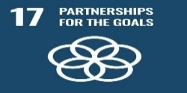
Economy; Sustainability; Justice; Security; Housing; Community services; Education; Infrastructure; Transportation; Early life; Land use; Planning; Agriculture; Food, and Health (Fong, 2021).
Partnerships for Goals (SDG17) are meant to improve domestic tax and other revenue collection, strengthen domestic resource mobilization, advance technological development, boost building capacity, and promote commerce (DID, 2021).

Sustainable Development Goals 3, 4, and 17.

In recent years, there has been a great deal of philosophical and theorical interest in the idea of protecting future generations’ interests, which originates from the definition of sustainable development (Davies, 2016). SDG 3; guarantees a healthy lifestyle and promotes well-being for everyone, regardless of age (UN, 2022). It calls for all nations to work to advance the capabilities of all their citizens, enabling everyone to fulfill their potential regardless of class, or gender. ethnicity religion, or race, and that all nations will track the well-being of their citizenry through improved life satisfaction measurement and reporting, paying particular attention to young children, young adults, and the elderly, addressing the vulnerabilities and needs of each age group (Sachs, 2012), the relationship between health and literacy, and societal well-being (Popoola, 2019). SDG 3 aims to tackle the problem of noncommunicable illnesses and their risk factors (Nabyonga-Orem, 2017) It ensures all people should have access to the healthcare they require, including those for palliative care, rehabilitation, preventive, and health promotion (UN, 2020). To improve work quality while addressing climate change. It also seeks to improve water quality, less waste, healthy vegetation, and both land and aquatic fountains (Sachs, 2012). SDG3; aims to decrease crime, increase equality in the UK, create a local government sector that is resilient and sustainable, deliver priority services, and empower communities. It also aims to end rough sleeping through effective crisis intervention and prevention services, as well as to decrease homelessness in the UK (HSA, 2022) (DID, 2021).
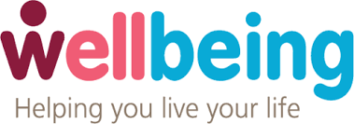
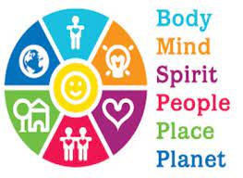
For each individual and the entire country, the social, environmental, and economic aspects of sustainable goals are important. The framework for promoting health and well-being serves as a guide for a more comprehensive application of the SDGs. It ensures that health and well-being are overarching and unifying issues that can strengthen health in all policies approach (Nunes, 2016). SEN’s Capability approach to Well-being. See appendices for Table and comments.

Sustainable Development Goal 4

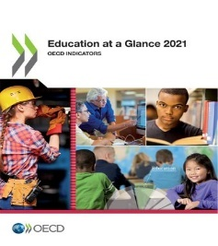
SDG 4, encourages the government of levels to work together to achieve sustainable development globally. These goals call for a dedication to the rules of law, human rights, transparency, participation, inclusion, and good economic institutions that support the public, private, and civil society sectors in the interest of people rather than as a governmental privilege (Sachs, 2012). Goal 4, also promotes opportunities for everyone to pursue lifelong learning and assures inclusive and equitable quality education (UN, 2020). (OECD, 2021). Education promotes socioeconomic mobility and is essential for avoiding poverty (DID, 2021). UNESCO is taking action with a number of initiatives, including collaboration and guaranteeing that education never stops (UN, 2020). SDG 4, which promotes gender equality is crucial for the development of peaceful societies, as well as human potential and sustainability (UN, 2021). SDG 4, strives to advance economic growth by enhancing the pipeline for skills, raising productivity levels, fostering employment, and boosting community and national cohesion. SDG 4 also promotes early education and care of the highest calibre, boosts standards and enables parents to work (DID, 2021).
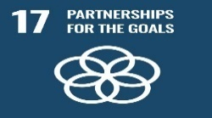
Partnerships for Goals (SDG17) aims to increase domestic tax collection and other forms of income generation, strengthen domestic resource mobilization, advance technological development, boost building capacity, and promote commerce. Through policy coordination and coherence for sustainable development, the partnership for goals aims to improve global macroeconomic stability. By 2020 and 2030, the alliance wants to increase capacity-building assistance for developing nations (UN, 2020). SDG17 aims to safeguard society from harm and extend and amplify the influence of the United Kingdom in the world, especially through the successful application for ASEAN preferred partner status (DID, 2021). According to Santos (2012), sustainable market entrepreneurs directly contribute to the creation of new formal institutions by internalising both the positive and negative externalities problems that have been ignored in the economy and by providing solutions that are bought to the attention of the legislators and policymakers (Argyrou, 22).

The UK policies and initiatives identified to meet the 3 sustainable goals

The UK is doing well, in terms of health-related SDGs (DID, 2021). The national committee’s mandate is to evaluate the extent to which government policies and programs and non-departmental public bodies contribute to environmental preservation and sustainable development, and to evaluate how well they perform in relation to those objectives (Parliament, 2021). 110 million pounds in support by UK aid, for Vaccines Project to keep emerging diseases under control, all in relation to SDGs 3,4, and 17 (Care, 2018). Public Health England and the NHS, (National Health Service), which was created on the 5th of July 1948 has been a key national system for support in terms of health.
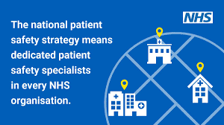

The NHS has set out on a journey to become one of the safest healthcare systems in the world (Care, 2018). The National Patients Safety Strategy and Patients Safety Collaborative are currently implementing a locally owned improvement initiative for all NHS organisations in their region to support development. The NHS assist with the identification and growth of integrated care systems, transformation, and partnerships for sustainability.


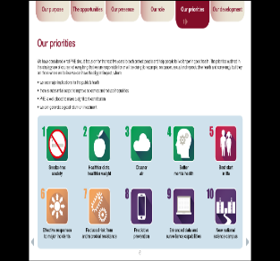
Public Health England is responsible for making the public healthier and reducing health inequalities, protecting the country from public hazards, and promoting healthier lifestyles (Rutter, 2020). Public Health England’s system accomplishes all its objectives (PHE, 2020). It works around the clock’’ to safeguard and enhance the nation’s health and lessen health disparities (PHE, 2020). These are all in relation to SDGs 3 and 4 (UK. Gov, 2O19).
.
.
Public Health Priorities 2020-2025

The Public Health England has been replaced by the UK Health Security Agency (UKHSA), and Office for Health improvement Disparities (OHSC). PHE, was created from ‘’70’’ previous organisations (CQC, 2018). (UKHSA) oversees shielding every citizen from the dangers of infectious diseases, accidents involving chemicals, biological, or nuclear weapons, as well as other health risks, and to ensure the security of the country’s health (HSA, 2022). Five guiding principles for sustainable development were established by the UK government: Preserving the environment’s boundaries, achieving a sustainable economy, ensuring a robust, Health, and just society, and properly using sound science (Holmes, 2011).
The Policy Statement on environmental principles (UK, 2022). Government food policy. Around 75% of what we eat is produced in the UK, and over the past 20 years, that percentage has been largely consistent (UK, 2022). Most UK policies in relation to SDGs 3, 4, and 17, aim to broadly maintain current food production, ensure that by 2030, pay, employment, and productivity have increased in the UK, and increased high-quality skills training, reduction of greenhouse gas emissions by half, promote innovation and halve childhood obesity. This includes the Environmental Act (2021), Fisheries Act (2020), and Agriculture Act (2020) (UK, 2022). In the UK, the Department of Environment, Food, and Rural Affairs funded more resource utilization projects that are predicted to help the industry save up to 23 billion pounds (Tse-Lun, 2020). Three overarching goals for sustainable development are outlined in the national planning policy. Goals 3, 4, and 17; - Financial goal: Entrepreneurship, and environmental (UK. Gov, 2O19). has been a multifaceted phenomenon that has linked social, environmental, and economic aspects of the entrepreneurial process, market transformation, and significant societal growth (Johnson, 2020).

Lambeth Borough Council, London, UK

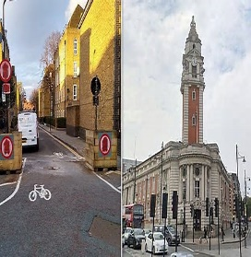

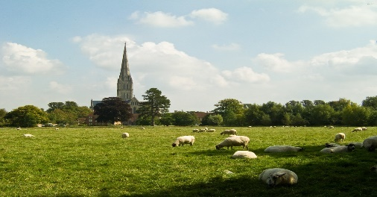
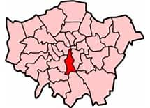
Old Lambehitha
New Lambeth
Borough of Lambeth, London

Coat of arms



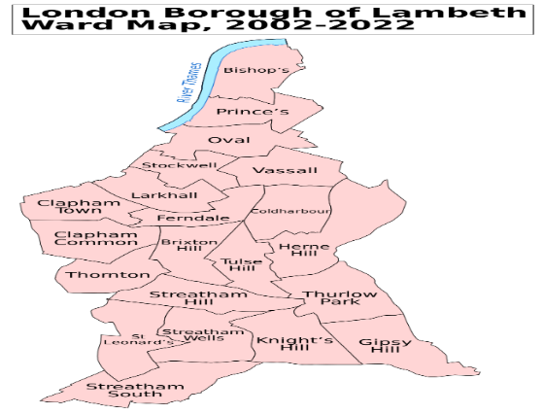

There are 25 wards in Lambeth, 13 of which are represented by 3 councilors and 12 by 2 councilors. In 1964, the council was first put to vote.
Population estimated: - 2020-06-30
Population census: - 2011-03-27
Population census: 2001-04-29
London Borough of Lambeth Ward Map 2002-2022

Borough
321,813
303,086
266,169
0.65%
Annual population change: - 2011-2020

Lambeth, the local government for the London Borough of Lambeth in Greater London, England, is a London borough council, a borough in Greater London, England. It is one of the 32 borough councils of London, the capital of the United Kingdom. The council’s meetings are held at Lambeth Council Town Hall in Brixton, London. 10.36 square miles is the size of Lambeth, in south London, England, which is a part of inner London. Annie Gallop is the current mayor. In 1062, the name was given Lambehitha, ("landing place for lambs") and in 1255, it was given Lambeth in 1255.

Created in April 1965
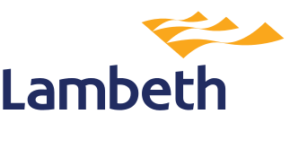
Lambeth Council
With almost 11,300 inhabitants per square kilometer. One of the most densely populous districts in the country is Lambeth.The Borough is expected to have 272,649 households by 2036, up from 143,655 in 2016
Administration Headquarters |   Brixton Hill, Lambeth Town Hall  This Photo by Unknown Author is licensed under CC BY-SA
Government | Density 31,000 square miles
  Types | Lambeth Borough Council.
  Community | Lambeth, Borough of London
  Leaders | Leader and Cabinet.
  Mayor | Annie Gallop (Labour).
  London Assembly | Marina Ahmad (Labour)
  MPs | Florence Elshalomi, Helen Hayes (Labour), Bell Ribeiro- Addy (Labour).
  Council Leader | Clir Claire Holland (Labour).
Area
  Total | 10.36 square (26.82 km2). P. density-11,998/km 2
  Rank | 304th of 309

Lambeth has estimated residents of 321,813 as of June 2022, with a 0.65 percent yearly population change between 2011 and 2020. Lambeth is the 32nd most populous borough in England, with a population density of 31,000 square miles, and its white population is made up of 39% whites, 2.5% white Irish, 0.1% white Gipsy or Irish Travelers, and 15.5% other whites. Indian 1.6 percent, Chinese 1.5 percent, other Asian accounts for 2%, white and black Caribbean 2.7%, white and black African 1.4%, white Asian 1.2%. Pakistan 1%, and Bangladesh 0.7% make up the remaining 2.3% of the population (Lambeth, 2020).( See Appendices for Table and comments). In comparison to the rest of the capital, Lambeth has a population that is more ethnically diverse, and its age distribution is younger than that of both the nation and London (Lambeth, 2020).

The unemployment rate in Lambeth council is 6.2 percent, which is higher than the London average of 4.9 percent. Compared to most other London boroughs, the borough has a greater percentage of working-age residents receiving unemployment benefits (8.4%), compared to London rate of 7.7percent. Among the 136,000 residents of Lambeth, only 15% are employed and live and work in the Borough, making it a low live-and-work ratio. Human health, social work, and administrative and support services are the two industries where employment is most prevalent. The fact that two significant hospitals with a combined employment of 16,000 are situated in Lambeth is related to this. Health and social make up around half of the borough’s employment jobs. According to the SOB, study, 2016 (Lambeth, 2020). The administrative and support services industry employs over two- thirds of its workforce in the fields of security, building. maintenance, landscaping (Lambeth, 2020).
Employment

There are 62 primary schools, 27 secondary schools, and 5 nurseries. 5 colleges and two student referral centres, and five special schools are also present. Between 2009 and 2014, there was a 195 increase in demand for Reception spots in Lambeth schools. In response, Lambeth added over 500 permanent Reception spots as well as over 800 temporary expansion spots into schools (Lambeth, 2020).To accommodate the rapidly expanding resident population as well as the demands of the students and the larger community, Lambeth erected, renovated, and redeveloped schools around the Borough. A total of 2,300 primary spaces with one or five forms of entry, were added throughout that time. Lambeth has witnessed a large increase in secondary provision places in recent years. Between 2012 and 2014, four new academies and free public schools were founded, adding 2,725 secondary school places in grades 7 through 11. Lambeth has created 165 new Special Education Needs and disabilities (SEND) spaces and 450 additional sixth form spots. Most of the community languages spoken at Lambeth schools, in addition to English are Portuguese and Spanish (SOB, 2016). Overall, educational attainment levels in Lambeth schools are rising. There is a currently higher rate of young, education, or training people who are not in employment (NEET), at 6.65 percent compared to 5.3 percent in all of London (Lambeth, 2020).
Education

There are substantial mental health issues and a turnover test in Lambeth. As of right now, Lambeth Primary Care Trust purchases mental health treatments on behalf of the Borough. While the Trust provides community-based -care, it contracts with South London and Maudsley NHS Foundation Trust for the provision of specialized services, a comprehensive plan for commissioning mental health services. The social inclusion agenda has highlighted the significance of having access to regular, mainstream activities and the degree of inequity that those with mental health difficulties encounter (Eric, 2016). Approximately 6,462 persons with learning disabilities are likely to live in the Borough as of 2019, and that figure is expected to rise to 7,016 by 2035 (Lambeth, 2020).
Health and Well- being
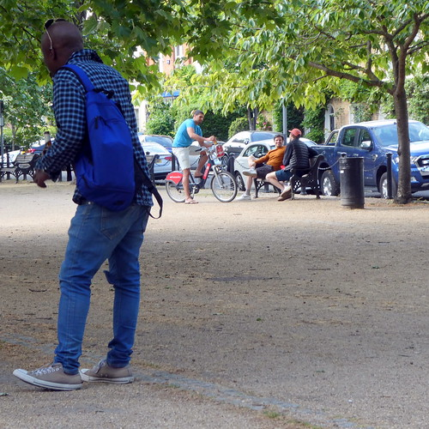
Important places in Lambeth See Table in Appendices

Table 2
Community assets in Lambeth








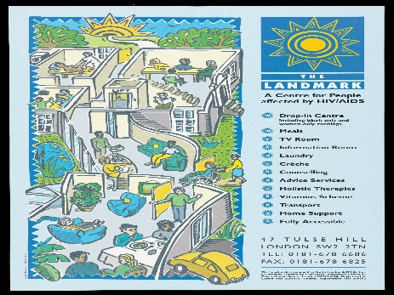

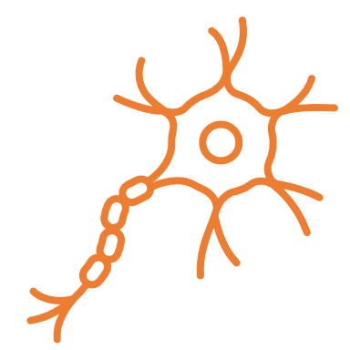










Local policies of Lambeth Borough identified to meet the SDGs 3, 4, and 17

To achieve an economically, socially, and environmentally viable Borough, Lambeth is determined to start its community strategy known as Future Lambeth

The SDG 3 targets relate to human health (Healthy lives for all ages) (Sachs, 2020). Lambeth is dedicated to promoting overall wellbeing, including physical and mental health, as well as raising everyone’s life expectancy (Lambeth, 2020). Lambeth will work, to ensure access to healthcare and quality medical treatment (UN, 2021).
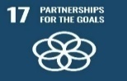
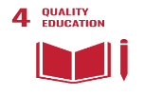
Regardless of age, race, or ethnicity, Lambeth is committed to providing inclusive and equitable education at all levels, including early childhood, primary, secondary, tertiary technical, and summer camp training (UN, 2021). Lambeth also wants to ensure that people with disabilities, children, and youth, as well as those in vulnerable situations, have access to lifelong learning opportunities and can fully participate in society (Lambeth, 2020).
The council will work with relevant partners to deliver affordable housing, including through estate renewal and regeneration strategies, all in relation to the sustainable development of the Borough’s housing requirements of 13,350 homes for the ten-year period 2019/20 to 2028/29 (Lambeth, 2020).
The council work and promote employment and training programs in accordance with London Plan Policy E11, to increase local job possibilities and help solve skill shortages in the community (Lambeth, 2020). The council will work on securing a safe, and safe Borough for everyone through crime prevention and counterterrorism.

Reviewing the status of Lambeth borough to meet the 3 sustainable goals

Lambeth Borough council uses community-centered approaches to mobilize community resources to promote equity and increase people’s control over their health and lives, by actively involving community members in design, and delivery. It attempts to work with individuals who are most at risk for ill health and to give people more control over their health. Three action plans for sustainable goals have been developed by Lambeth Council, environmental, social, and economic objectives in relation to SDG 3, 4, and 17 (Lambeth, 2020).

Health and Inequalities
Health and Wellbeing approach for Lambeth Borough Council

The key component of the local community for increasing health and well-being and decreasing inequalities is involving and empowering the local communities. The Care Act (2014) states that a person’s sense of well-being is tied to their sense of personal dignity, like how they are treated. The socioeconomic determinants of health can be addressed to attain health equity, according to several academics (Macssa, 2021).
Lambeth Local Plan 2020–2035

Lambeth enacted its local plan in September 2015, and in 2016 it began working on a partial revision. A review of some policy concerns has been conducted considering the 2019 Borough Plan update by the council. According to the London Plan 2021, between 2019-20 and 2028-2029, 1,335 net extra houses must be built in Lambeth, encourage financial specialist retail, tourist, information, and cultural uses and activities (Lambeth, 2020). The Index of multiple Deprivation (IMD), 2015, has rank Lambeth as the 22nd most impoverished Borough in England and the eight most deprived Borough in London (Lambeth, 2020).
SDG 17; Partnership for the goals
Lambeth’s economy is a significant component of London, and it has grown more rapidly than the UK. North of Lambeth is a crucial component of London’s central activities zone (CAZ), which is home to important companies and valuable cultural and tourism resources (Lambeth, 2020). A series of significant town centres can be found further south, including Brixton, Clapham, Streatham, and West Norwood/ Tulse Hill. These areas serve as important employment hubs and are home to young people with high skill levels, with over 45 percent of residents having completed a degree, according to statistics (SOB, 2016) report (Lambeth, 2020).
Health and social care: SDG 3; Good health and well-being

Lambeth’s life expectancy has increased over time, although during 2010- 2012, the increase has slowed. In Lambeth, male life expectancy is 4.8 years less than female life expectancy, with male life expectancy being roughly a year less than the national average at 78.7 years and female life expectancy being about 0.4 years higher than the national average at 83.5. The average life expectancy in deprived areas is 5.5 years less for men and 3.7 years for women (Lambeth, 2020).

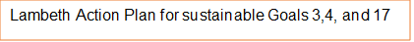
Childcare
Vulnerable groups
Gender Equality
Addressing Caregivers’ exposure to economic collapse.
Taking action to stop gender-based violence, including domestic violence.
Collaboration between all population.

Inclusive Accessible Health Care
Secure quality education
Create a searchable health database to disseminate correct information to everyone.
Reduce the digital divide, make remote learning more accessible, and increase climate education.
Youth forums, commissions and young people’s enthusiasm and energy are all used.
Youth participation

(HSA, 2022). (Lambeth, 2020).

By acting in accordance with the sustainable development philosophy, Lambeth seeks to enhance the economic, social, environmental, and cultural well-being of its residents (Davies, 2016). The councils’ framework makes a commendable attempt to incorporate well-being consideration into decisions and to integrate the efforts across a variety of diverse activities and responsibilities to ensure involvement and accountability (Davies, 2016).
The Environmental Audit Committee is tasked with evaluating how much government agencies, non-departmental public organisations, and policies and programs contribute to environmental protection and sustainable development (Commons, 2012).
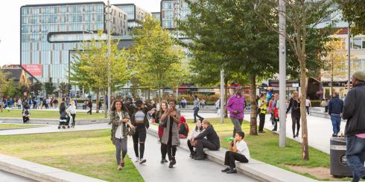
Environmental sustainability
Healthier and safer streets for Lambeth



Public safety and crime reduction are among Lambeth residents’ top priorities (SOB, 2016). In terms of Total Notifiable Offences (TNOs), Lambeth is now rated fifth in London, up from third in 2018. Knife crime offences rose in 2017/18 and fell by 50% by September 2018, but Lambeth gun crime offences rose by 5% between 2017/18 and 2018/19 (Lambeth, 2020).
Social Inequalities

The Care Quality Commission asserts that a change in how the effectiveness of health and social care devices is assessed is necessary to promote collaboration (CQC, 2018). The council is working to promote, and improve working conditions, a more level playing field for all workers, and fairness in the labour market by developing and implementing inclusive policies for everyone, assisting families, and offering housing help. It serves to support the socially underprivileged and promote social mobility, by encouraging people also to advance in their jobs, to create a more prosperous society (Lambeth, 2020).
Lambeth Principles for Achieving its objective goals

We will concentrate on minimizing disparities in terms of social and economic obligations, housing, health, and education (Lambeth, 2020).
Lambeth will collaborate with other organization locally, in London, and national to achieve its goals (Lambeth, 2020).
Lambeth will commission superior services that are efficient and profitable and will take advantage of new technologies (Lambeth, 2020).
The Lambeth Council will help build a resilient society that promotes the general health and well-being of the community (Lambeth, 2020).
The council will pay attention to the opinions and experiences of service users and use these to enhance what we do (Lambeth, 2018).

SDG 3, 4, and 17

(Lambeth, 2018). (Lambeth, 2018). (Lambeth, 2020).
Community-centered approaches to health and wellbeing in Lambeth will focus on empowering local communities, especially underprivileged ones. As a result, we can more effectively combat professional-led services by promoting health and well-being and reducing inequalities (Lambeth, 2020).
The Lambeth council is committed to promoting the good health and well-being of all its members, by-

Improving community members’ abilities, knowledge, social skills, and commitment; friendship; community cohesion; and neighborliness (Lambeth, 2020).

Recommendation
1) Lambeth should strive to further SDGs implementation, financing for local organisations should prioritise community involvement, capacity building, and community support, as well as maintaining and strengthening connections with the health sectors (UN, 2022).
2) Lambeth should work to eliminate unequal social structures through enhancing income redistribution measures and promoting equality of opportunity for everyone, especially the most disadvantaged segments in society (Macassa, 2021).
3) Lambeth council should make changes to the way it commissions and delivers services in collaboration with its partners to provide and foster care and independence (Lambeth, 2020). Partnership forums should also prioritise in health, education, and inclusive participation policies with a focus on young engagement (Lambeth, 2020). Also, policies that drive carbon and air pollution extinction, stabilise climate change below dangerous levels, and minimise ecological disturbance must prioritise health (Sachs, 2020).
4) Lambeth borough must aim to protect residents from abuse and neglect, ensuring control over daily activities, safer streets, comfortable living, and social and economic well-being. Also empowerment of individual’s contribution to society (Lambeth, 2018).

Conclusion
The legacy and education of the SDGs gives us invaluable lessons and experience to start working on new objectives, but the Lambeth council must continue to push for full gender equality, improved health care, and getting every child into secondary education (Ketut, 2020). In terms of health disparities, Lambeth performs significantly worse than the national average, issues with lifestyle contribute to the burden of poor health, which includes diseases and chronic ailments including cancer and heart disease (Lambeth, 2020). Even though health inequalities are being addressed, they still pose a public health risk in some areas of the borough and in society as a whole (PHE, 2020), because of how social economic, and environmental factors are distributed in relation to where people live, learn, work, play, and generally spend their time. (Lambeth, 2020).
The council need official development assistance to promote commerce and growth to revitalize the global partnerships for sustainable development. There is a need for empowerment to increase developmental money (Lambeth, 2020).
In the Appendences are:

ECOSOC Partnership Forum: See Appendices

Tool for measuring well-being: See Appendices
Lambeth council services

Housing Policies: All in relation to SDGs 3, and 4. See also Table in Appendices

In the Appendences are:
See Appendices

References

Popoola B. O. (2019). Involving libraries in improving health literacy to achieve Sustainable Development Goal-3 in developing economies: a literature review. Health information and libraries journal, 36(2), 111–120. https://doi.org/10.1111/hir.12255

Quinlivan, L., Chapman, D. V., & Sullivan, T. (2020). Applying citizen science to monitor for the Sustainable Development Goal Indicator 6.3.2: a review. Environmental monitoring and assessment, 192(4), 218. https://doi.org/10.1007/s10661-020-8193-6.

Roth, G. A., Mensah, G. A., Johnson, C. O., Addolorato, G., Ammirati, E., Baddour, L. M., Barengo, N. C., Beaton, A. Z., Benjamin, E. J., Benziger, C. P., Bonny, A., Brauer, M., Brodmann, M., Cahill, T. J., Carapetis, J., Catapano, A. L., Chugh, S. S., Cooper, L. T., Coresh, J., Criqui, M., … GBD-NHLBI-JACC Global Burden of Cardiovascular Diseases Writing Group (2020). Global Burden of Cardiovascular Diseases and Risk Factors, 1990-2019: Update From the GBD 2019 Study. Journal of the American College of Cardiology, 76(25), 2982–3021. https://doi.org/10.1016/j.jacc.2020.11.010
Copy

GBD 2017 SDG Collaborators (2018). Measuring progress from 1990 to 2017 and projecting attainment to 2030 of the health-related Sustainable Development Goals for 195 countries and territories: a systematic analysis for the Global Burden of Disease Study 2017. Lancet (London, England), 392(10159), 2091–2138. https://doi.org/10.1016/S0140-6736(18)32281-5

Ketut Prasetyo 2021. Measuring the Achievement of the Unemployment and Poverty Target in the Sustainable Development Goals Program in Pandemi Covid-19. The 4th ICSSED, International Conference of Social Science and Education. Sciendo, pp. 304-308. https://doi.org/10.2478/9788366675186-038

Appendix

Tool for measuring Well-being
SWEMWBS

Objective Well-being Measurement

Statement | None of the time | Rarely | Some of the time | Often | All the time
I have been feeling optimistic about the future
I have been feeling useful
I have been feeling relaxed
I have been dealing with problems well
I have been feeling close to other people
I have been thinking clearly
I have been able to make up my mind about things

Your life is worthwhile
ONS
Subjective Wellbeing Measurement
Questions 0 1 | 2 | 3 | 4 | 5 | 6 | 7 | 8 | 9 | 10
Overall, how satisfied are you with your life nowadays?
Overall, how happy did you feel yesterday?
Overall, how anxious did you feel yesterday?
Overall, to what extent do you feel the things you do in your’

Measuring Well-being
Two dimensions are thought to exist for well-being; objective and subjective. A person’s subjective well-being, which is viewed as personal, is measured by directly asking them about their thoughts and feelings about their well-being. This includes questions about things like life satisfaction, positive emotions, and whether their life is meaningful. Objective well-being is based on assumptions about fundamental human rights and needs, such as adequate food, physical health, education, and safety (Commons, 2012).
People’s perception of their own well-being serves as the foundation for one of the ways the United Nations Statistics Office collects data on subjective well-being. In the past, it was assumed that objective factors like people’s health and income might have an impact on each person’s level of well-being. Contrarily, subjective well-being measurements are based on individual preferences and take into consideration what is important to people by letting them determine what is (Commons, 2012).

The 2022 ECOSOC Partnership Forum was conducted in February 2022 with the great goal of furthering the 2030 Agenda’s full implications for sustainable development while helping the world recover from the coronavirus illness or Covid-19. The UN and other international organizations place a high priority on implementing policies related to youth engagement and participation, environmental and climate action, and health and inclusive participation. Other measures include creating a global emergency health fund to help during crises, innovation, research and development, support for small and medium-sized businesses, and more. The development of a workforce that will support local economies, as well as policies on mentorship and coaching, are other policies that have been set into motion (UN, 2021-2022).
The UN has 169 targets that address a broad variety of challenges affecting both developed and developing countries and form the foundation of the sustainable development goals. Poverty, inequality, climate change, inclusive communities, and access to healthcare and education are just a few of the interconnected problems. One of the key commitments is to ‘’leave no one behind’’ and to ensure that development progress reaches the most marginalized and disadvantaged communities. It has urged greater public involvement in scientific research for the benefit of experts, the public, and the environment (Quinlivan, 2020). The mandate of the World Health Organisation in terms of global health is derived from its constitution and is described in its Thirteen General Programme of Work 2019-2023, which focuses on efforts to create a sustainable community to work for the shared future of humanity while enabling everyone to improve their health, address health determinants, and address challenges. Achieving universal health coverage, dealing with health emergencies, and promoting the population goals of the initiative.
The WHO’s global strategy goals for the transitional approach centre on factors such as people living longer, universal health coverage, air pollution, climate change, water sanitation, and hygiene, chemical safety, radiation safety, healthcare settings, workplaces, and national and international contexts.

.
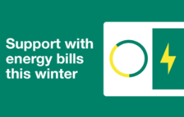
The UK government has finalised the details of Energy Bill Support Scheme for households to receive a four hundred pounds discount on utility bills from October 2022. The Energy Bill Support Scheme provides a discount on the electricity bills to 29 million households across the UK in relation to the SDGs (Zahawi, 2022). The Energy Bill Support Scheme is part of the government’s £37 million costs living package related to SDG 3 and 4 sustainability. £300 one-time living allowance for pensioners covering over 8 million pensioner households, £150 one-time living allowance of approximately six million for food, utensils, and clothing (Zahawi, 2022).
The goal is to protect and improve the built, natural, and historic environments. This includes making efficient use of land, promoting biodiversity, conserving natural resources, reducing waste and pollution, and mitigating and adapting to climate change, including switching to a low-carbon economy.
Social Inequalities
Social inequality is the term used to describe relationship patterns in society that have the potential to injure or lower a group’s social standing, social class, and social network. Social inequality can develop when society understands what the proper gender roles are or when social stereotyping is pervasive. Additionally, discriminatory laws can be used to establish it. The concept of social inequality is a worldwide issue since social inequalities exist between classes, countries, and racial or religious grouping

Three overarching goals for sustainable development are outlined in the national planning policy. Goals 3, 4, and 17; - Financial goal: to ensure that there is enough land of the right kinds accessible at the right time to promote expansion, innovation, and increased productivity as well as by identifying and coordinating the provision of infrastructure. Social objective goal: to promote a safe, well-designed built environment with accessible services and open spaces that reflect current and future needs. Entrepreneurship for sustainable development has been a multifaceted phenomenon that has linked social, environmental, and economic aspects of the entrepreneurial process, market transformation, and significant societal growth (Johnson, 2020)

Lambeth council services
l

Population  (mid-2019 est.)
  Total | 326,034 321,813  2020
  Rank | 32nd of 309
  Density | 31,000 square miles
  Ethnicity
    White British | 39%
    White Irish | 2.5%
    White Gipsy or Irish traveler | 0.01%
    Other mixed | 2.3% | Indian | 1.6%
    Pakistan | 1% | Chinese | 1.5%
    Bangladesh | 0.7% | Other Asian | 2%
    White & Black African | 1.4% | White & Black Caribbean | 2.7%
    Other white | 15.5% | White-Asian | 1.2%
 | With almost 11,300 inhabitants per square kilometer, Lambeth is one of the most densely populated districts in the nation. The Borough is expected to have 272,649 household by 2036, up from 143,655 in 2016
Time Zone | UTC (GMT). Summer: (DST) UTC+ (BST)
Postcodes | Area code(s) | ONS code | GSS code
SE, SW | 020 | 00AY | E09000022

Website
www.lambeth.gov.uk

Police
  Metropolitan police

Lambeth Council Services

Environmental Services | Planning and building control
Housing | Council Tax
Family Services and Information | Benefit and financial support
Adult Social Care and Health | Voting and Elections
Schools and Education | Parks, Sports, and Leisure
Libraries and achieves | One bag a week challenge
Streets, roads, and transport | Parking
Accessibility | Tenants Carter
Register or login into your homeowner account My Lambeth
Children, young people, and families
Business rates, services, and licensing | About the council
Leasehold alteration guidance | Voting and election
Noise, nuisance, anti-social behavior, and safety | Coronavirus Test
Births, deaths, ceremonies, and citizenships | Rubbish and recycling
Coronavirus support for residents | Coronavirus support for business

Housing Policies; All in relation to SDGs 3, and 4. See also Table in Appendices

Homelessness and rough sleeping strategy | 2019
Fire strategy- 2019 | Social Housing Charter
Homelessness Discharge Policy- 2013 | Tenancy Agreement - 2013
Lambeth Housing Standard- 2012 | Tenancy Strategy - 2020
Housing Strategy 2017- 2020 | Tenancy Policy - 2013
Housing Allocation Scheme- 2013 | Housing Placement Policy

Table 2
Community assets in Lambeth

Important places in Lambeth. See Table in Appendices
Table 1
1 | 2 | 3 | 4 | 5 | 6 | 7 | 8 | 9 | 10
Key to some of the Community assets of Lambeth
11 |  | 13
12 |  | 14

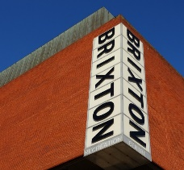
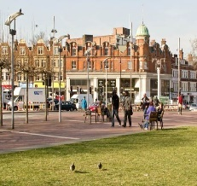

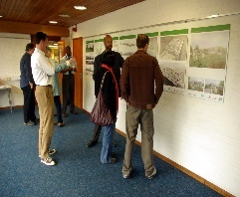

2 3 4 5
This Photo by Unknown Author is licensed under CC BY-SA
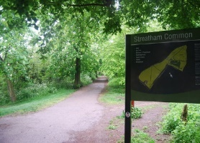
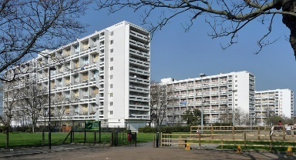




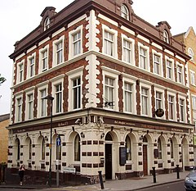
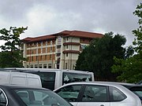

This Photo by Unknown Author is licensed under CC BY-SA
This Photo by Unknown Author is licensed under CC BY-NC

