

Master of Business Administration (MBA)

Module Title: International Business Concepts
Module Code: LCMB7034
Assignment Title:
Benefits and Challenges of International Operations: A Case Study of Tesla, Inc.
Lecturer: Jean Wang
Student Name: Krunal SureshBhai Prajapati
Student ID: 2432481

Table of Contents
1. Introduction 3
2. Why Tesla is an MNC/TNC? 3
3. Benefits and Challenges of International Operations 4
3.1. Research & Development (R&D) 4
3.2. Sourcing and Supply 4
3.3. Production 5
3.4. Sales & Distribution 5
3.5. Financing & After-sales 6
4. Entry Modes into International Markets & Dominant Mode 6
5. Advantages of International Operations of Tesla 7
5.1. Scale and Cost Efficiency 7
5.2. Closeness to Major Growth Markets 7
5.3. Supply-chain Resilience and Vertical Integration 8
5.4. Innovation and Technology Transfer 8
6. Availability of Incentives and Domestic Collaborations 8
7. OLI Factors and Tesla’s Entry Mode in China 9
7.1. Ownership Advantages and Protection of Firm Assets 9
7.2. China’s Location Advantages in the APAC Region 10
7.3. Internalisation Benefits and Wholly-Owned Subsidiary Dominance 11
7.4. Synthesis 12
8. Cultural Differences and Tesla’s Success in China 12
9. SOP Adjustments for Tesla’s Operations in China 17
9.1. Localised people management and workplace culture 18
9.2. Stakeholder, regulatory and crisis communication 18
9.3. Market-facing ecosystem and quality management 19
10. Conclusion 21
References 22

Introduction
Tesla, Inc. is an international leader in electric vehicles, energy storage, and solar technology, which was established in 2003 and is based in Austin, Texas (Shan, Wang and Xu, 2023). Since its initial Roadster, to its mass market Model 3 and Model Ys, Tesla has quickly found its way into various continents, with its manufacturing, sales, and service units in North America, Europe, and Asia (Cai, 2025). Its multinational nature is enhanced by its vertical integration in terms of battery development, vehicle production, and renewable energy systems, and its global supply chain that extends all the way to the sourcing of raw materials and components (The Case Centre, 2024). The multinational presence, especially in China and Germany, and direct consumer markets in more than 35 countries, make the company a transnational one (Shan, Wang and Xu, 2023).
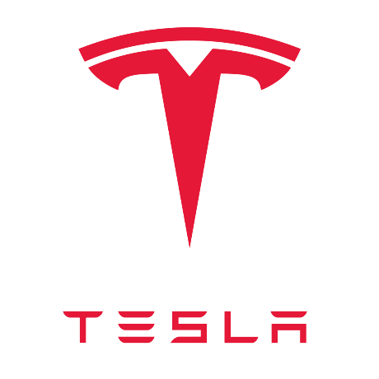
Figure 1: TESLA Logo
The aim to make the world's sustainable energy transition faster and to use the resources available globally makes Tesla a perfect case to study the advantages and drawbacks of international business.

Why Tesla is an MNC/TNC?
Tesla is a Multinational Corporation (MNC) and more specifically a Transnational Corporation (TNC) since it conducts research, sourcing, production, sales, and financing operations in various countries and regions at the same time, which exploits integration globally and responsiveness at local levels (Shan, Wang and Xu, 2023). Indicatively, Tesla does not just design and develop its cars in the United States; it has established manufacturing facilities (giga-factories) in China (Shanghai) and Germany (Berlin-Brandenburg) to cater to local and regional markets (Malik, Masood and Brem, 2023).
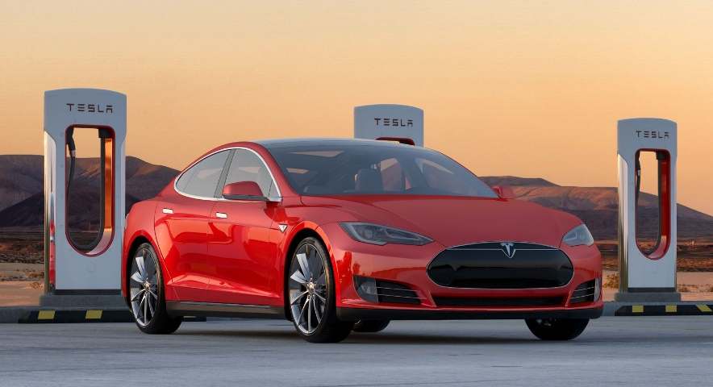
Figure 2: TESLA car model
Source: https://www.britannica.com/money/Tesla-Motors/Tesla-under-Musk-New-models-battery-technology-and-solar-energy
The specificity of Tesla is that the company is vertically integrated, i.e., the battery chemistry and cell manufacturing through the vehicle assembly, and markets its products in dozens of countries, which illustrates the nature of a TNC, i.e., the global business with local customization (Liu, Boothman and Graham, 2025). Its supply chains are continental in both raw material (e.g., lithium, cobalt) and component sourcing, but also leverage its global presence on scale, as well as on proximity to major markets (Malik, Masood and Brem, 2023). Through the localisation of the main aspects of its production and service base, Tesla takes advantage of global economies of scale and scale-related advantages (scale, technology) and local responsiveness (adjustment to local regulatory, consumer, and cost environments).

Benefits and Challenges of International Operations

Research & Development (R&D)
The global value chain of Tesla has started with major investments into research and development in the US and in its plants. These are vehicle design, battery system development, software (Autopilot, firmware updates), and energy products (Powerwall, Solar Roof) (Liu, Boothman and Graham, 2025). The Tesla global R&D allows the company to continue leading in technology, which is subsequently exported.

Sourcing and Supply
Tesla requests raw materials and components all over the world - particularly battery-related raw materials, including lithium and nickel, cobalt, and other rare materials. This global sourcing provides Tesla with resources in various jurisdictions and access to global commodity markets (Kamkoum, 2018). This, however, also presents Tesla to a geopolitical risk and supply-chain vulnerability.

Production
Tesla produces cars and parts in its system of Gigafactories. For example:
- In the US: Fremont Factory (California) and Gigafactory Nevada of battery packs, etc. In China, Gigafactory Shanghai (the first fully localized production facility of the Chinese market) will produce Model 3/Model Y in China (Kamkoum, 2018).
- In Europe, Gigafactory Berlin-Brandenburg (near the largest European EV market) will manufacture the vehicles and battery packs (Gao, 2023).
By placing the production in the vicinity of the major markets, Tesla will be able to minimize the logistics costs and react to the market requirements much faster, and address the problem of control over the regulations and local content.
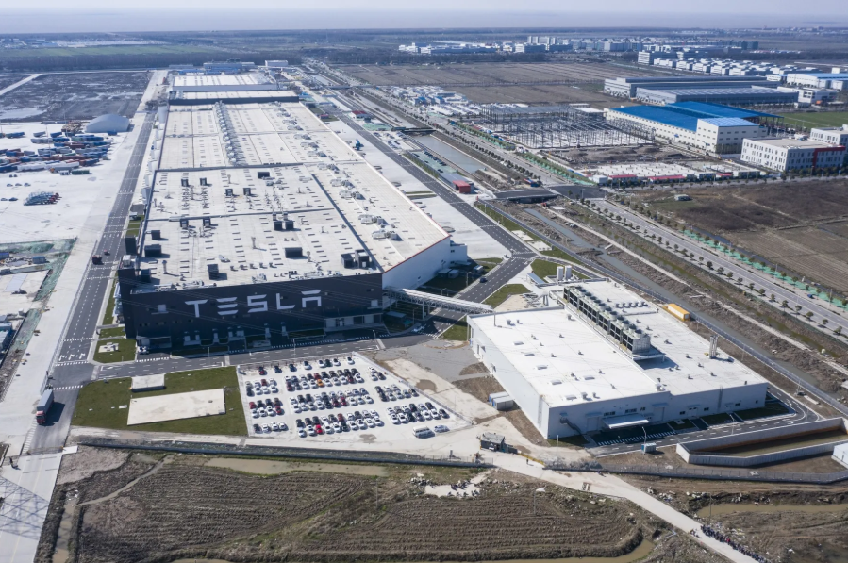
Figure 3: The Tesla Inc. Gigafactory near Shanghai
Source: https://www.chinadailyhk.com/hk/article/142986

Sales & Distribution
The company Tesla operates a direct-to-consumer sales approach (store, online ordering) in numerous markets, avoiding the conventional dealer franchising. Through this international chain of sales, Tesla can have control of its brand, a uniform customer experience, and synchronization of sales and its internet-based ecosystem (Gao, 2023). Tesla has also been developing charging (Supercharger) networks throughout the world, another way that Tesla has expanded its value chain into services, making the company more customer-friendly and creating benefits of being locked into the ecosystem (IMD Business School, 2025).

Financing & After-sales
The global funding of Tesla entails the development of capital in the foreign market (equity, bonds) and running business in various currencies and jurisdictions (Ghar, 2025). After-sales services and distribution of parts are also international: producing products in proximity to the market and controlling service centres across the globe, Tesla contributes to the quality of products, warranty service, and brand integrity at the global level.
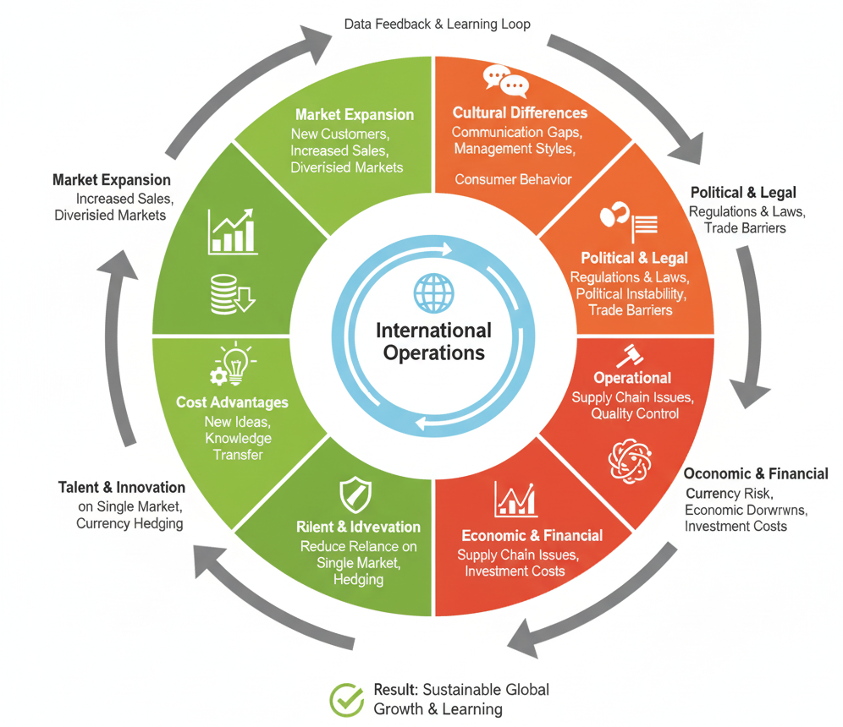
Figure 4: Benefits and Challenges of International Operations (Myself)

Entry Modes into International Markets & Dominant Mode
Some of the modes that Tesla employs to enter global markets are wholly-owned subsidiaries (factories abroad), direct investment, localisation of production, and partnerships/alliances where necessary.
- Tesla set up Giga-factory Shanghai in China as a wholly-owned foreign company, as opposed to the commonplace joint-venture approach by foreign automakers in China (Faraonov and Tarasova, 2025). This direct investment strategy became more controllable and took less time to market.
- Tesla had decided to make a direct investment in Germany and not a joint venture in Europe by setting up the Berlin factory (Ghar, 2025).
- Exports through the existing factories are also used by Tesla to provide the local markets, thereby employing an export mode in certain cases (Faraonov and Tarasova, 2025).
- In the case of sales and service, Tesla often employs company-owned stores and online platforms instead of licensing or franchising. As an illustration, in most markets, its direct-to-consumer sales model bypasses the traditional dealer network (Faraonov and Tarasova, 2025).
- The wholly-owned direct investment is the most common form of investment that Tesla is subject to (setting up its own production and sales units in the international markets) (Liu, Boothman and Graham, 2025). This provides Tesla with complete command of technology, brand, and supply chain integration, enabling it to align with its global standards and strategy.

Advantages of International Operations of Tesla
The international presence of Tesla has several strategic benefits. Below are key benefits:

Scale and Cost Efficiency
Tesla can achieve economies of scale in production and manufacturing of components by manufacturing vehicles and batteries all over the world. Gigafactories allow mass production, which reduces the cost per unit of vehicles and battery packs. An example is that, based on local labour, proximity in the supply chain, and a good policy environment, production can be located in China (Liu, Boothman and Graham, 2025). By sourcing important raw materials all over the world, Tesla can negotiate a better price and supply conditions, and this would lower the input cost and maximize margin.

Closeness to Major Growth Markets
The international expansion of Tesla gets it nearer to the great emerging markets of electric vehicles (EVs). China is the largest motor market in the world, and a rapidly expanding EV market; the availability of a domestic plant (Shanghai) will allow Tesla to cater to local demand within a short period and at a reduced cost (Ghar, 2025). The Berlin factory will enable Tesla to cater to the EU market, enjoy the benefits of the regional incentives, and lower importation tariffs and logistics delays in Europe (Shan, Wang and Xu, 2023).

Supply-chain Resilience and Vertical Integration
The vertical integration (battery cell production, powertrain, vehicle assembly) of Tesla and its international distribution give it operational strength. Indicatively, Tesla's response to the COVID-19 pandemic in its supply chain was more adaptive compared to most competitors based on its global sourcing and in-house capabilities (Shan, Wang and Xu, 2023). It has battery manufacturing and assembly in various geographies will reduce the risks of disruption that may occur in one country, delays in transportation, and even tariffs (Shan, Wang and Xu, 2023).

Innovation and Technology Transfer
The presence in numerous geographies exposes Tesla to various regulatory environments, consumer markets, and innovation platforms. This allows Tesla to iterate, experiment with localisation, and transfer technologies around the world (Ghar, 2025). Indicatively, the cells/pack manufacturing innovations in the US are implemented in China and Europe (IMD Business School, 2025). The international presence enables Tesla to capitalize on R&D opportunities throughout its geographical presence and distribute the development expenses.

Availability of Incentives and Domestic Collaborations
Tesla can also enjoy government subsidies (tax breaks, subsidies) on foreign investment or EV manufacturers by investing in foreign production locations (Aithor, 2024). Localisation of production, as an example, will help Tesla to enjoy the local EV incentives and avoid risks of paying import taxes. Besides, local manufacturing also permits closer associations with neighboring suppliers, labour markets, and regulatory supporters- which could accelerate growth and produce local goodwill (Cai, 2025).
The market diversification of Tesla by operating in several countries helps to reduce its market risk: in case one of the regions decelerates (e.g., the US), Tesla can continue its growth in China, Europe, or some other areas (Malik, Masood and Brem, 2023). This portfolio holds on to sustainable growth. The production capabilities of Tesla do not have regional restrictions since the company can flexibly change the levels of production based on demand, currency fluctuations, and disparities in labour costs.

OLI Factors and Tesla’s Entry Mode in China

Ownership Advantages and Protection of Firm Assets
The ownership dimension of the OLI paradigm explains why Tesla chooses foreign direct investment rather than licensing or joint ventures in China. Tesla possesses a bundle of firm-specific assets that generate above-normal returns: proprietary battery chemistry, integrated powertrain technology, over-the-air software architecture, and the Autopilot/FSD stack, as well as a powerful global brand positioned at the premium end of the battery-electric vehicle (BEV) market. Studies of the Chinese NEV industry show that technology and software capabilities are the main differentiators for foreign entrants, with Tesla repeatedly cited as the benchmark for product quality and digital experience (Zhang and Du, 2024). In Q3 2021, Tesla reported USD 3.11 billion in sales from China, representing 48.5% of its global automotive revenue of USD 6.41 billion, highlighting how strongly these ownership advantages translate into demand in the Chinese APAC market (Xinyi, Chen and Bai, 2022). Figure 1 (Tesla Q3 2021 revenue, China vs rest of the world) visually illustrates how nearly half of Tesla’s automotive revenue already depended on the Chinese market by that time, reinforcing the strategic need to keep control of critical assets. Because advanced battery and software technologies are highly vulnerable to imitation and spillover, the OLI framework predicts that firms with strong proprietary advantages will prefer high-control entry modes to preserve rents and reduce leakage of tacit knowledge (Bai et al., 2020). Tesla’s decision to build and wholly own Gigafactory Shanghai is consistent with this prediction: the company avoids sharing its core technologies and manufacturing know-how with a local joint-venture partner, unlike many traditional automakers in China.
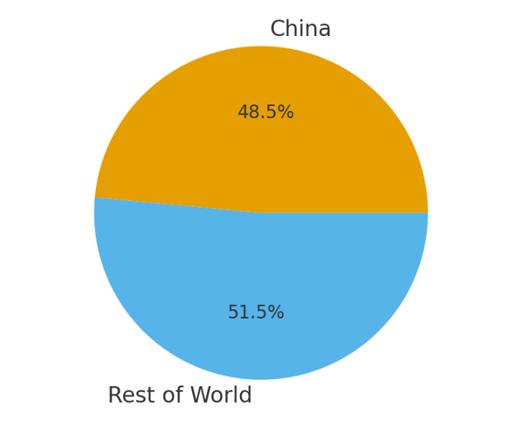
Figure 5: Tesla Automotive Revenue Breakdown (Q3 2021): China vs Rest of World (Myself)

China’s Location Advantages in the APAC Region
Location advantages explain why Tesla selected China as its primary APAC production base instead of relying only on exports from the US or Europe. China has grown into the world’s largest EV market: in 2022, it sold around 6.9 million electric vehicles, more than Europe and North America combined, and BEVs accounted for about 81.8% of Chinese NEV sales in 2021 (Salaberria and Xia, 2023). Demand concentration in one country lowers market risk for a large dedicated plant and facilitates learning from dense clusters of EV users. Provincial-level analyses show that leading Chinese cities repeatedly top national NEV sales rankings and host dense charging networks, which further reinforce local demand spillovers that foreign manufacturers can tap (Shi et al., 2023). At the same time, the Chinese government has used dual-credit policies and NEV subsidies to promote domestic and foreign EV producers, significantly improving the financial performance of listed NEV firms and rewarding high-volume producers such as Tesla (Li et al., 2023).
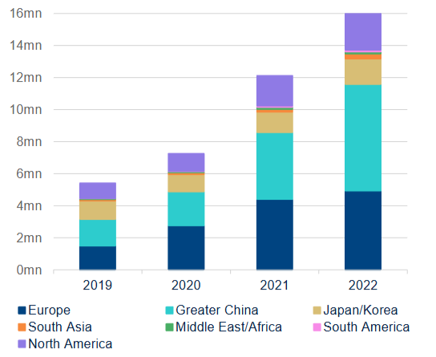
Figure 6: CHINA WAS THE GLOBAL EV TOP SELLER IN 2022 (Ahead Of The Herd, 2023)
Production-wise, China offers Tesla significant location benefits such as availability of lithium in large quantities as battery grade, low labour wages, and a concentration of suppliers into clusters along the coasts. Firm-level studies show that leading Chinese EV manufacturers such as BYD and CATL have created highly efficient battery ecosystems, lowering costs that foreign firms leverage after localising production (Wuttke and Whitfield, 2025). Tesla’s Shanghai Gigafactory reduces shipping costs, avoids import tariffs on US-made vehicles, and serves both China and the broader APAC region, supported by investment plans of up to 1.2 billion yuan and thousands of local jobs (Xinyi, Chen and Bai, 2022). The same study notes that Tesla paid more than 3 billion yuan in taxes within five years, strengthening political support (Chen, 2023). However, strong competition from domestic EV brands pressures Tesla to balance premium pricing with consumer sensitivity. Despite these trade-offs, China remains Tesla’s dominant APAC production base under the OLI logic.

Internalisation Benefits and Wholly-Owned Subsidiary Dominance
Internalisation advantages explain Tesla’s decision to operate wholly within the firm rather than rely on licensing or joint ventures. Before 2018, foreign automakers in China were required to form 50:50 joint ventures to promote technology transfer (Chen, Lawell and Wang, 2020). After policy reforms removed the NEV foreign equity cap, Tesla became the first automaker allowed to build a wholly foreign-owned plant (Fusheng, 2020). This regulatory change meant that, instead of sharing control and sensitive know-how with a local partner, Tesla could own its key Chinese operations and design the governance structure according to its global standards. This enabled Tesla to avoid transaction costs of negotiating, monitoring, and enforcing high-tech manufacturing and software contracts, as well as the coordination problems and opportunism risks that often arise in joint ventures. According to research, domestic Chinese NEV firms react more intensely to performance-related incentives than JVs do, which implies that JVs weaken their focus on strategy (Li et al., 2023). Tesla is therefore strategic since it has internalised production, quality control, and data collection into a single corporate hierarchy that it fully directs. Internalisation also empowers the digital ecosystem of Tesla to support the sale and updates of software, as well as the operation of Superchargers, through consistent rules, data standards, and technical platforms. The usage of local licensees would increase agency risks and weaken brand consistency due to strict safety and data regulations, so keeping these activities inside the firm remains the most coherent option (Chen, 2023).

Synthesis
Taken together, Tesla’s strong ownership advantages in proprietary EV technology and brand equity, China’s exceptional location advantages as the dominant global EV market with dense industrial clusters, and significant internalisation gains from retaining control over technology, quality, and data, create a powerful O+L+I configuration that favours high-commitment, high-control entry. The resulting mode, wholly owned Gigafactory plus direct sales channels differs from the joint-venture pattern that characterised earlier automotive FDI in China, but it fits Dunning’s eclectic paradigm: once the policy environment removed equity caps, a firm with Tesla’s asset profile and strategic ambitions had clear incentives to internalise operations and leverage China as both a mega-market and an export base for the wider APAC region. Expanding production locally also enables Tesla to respond more rapidly to regulatory shifts, supply-chain pressures, and evolving consumer preferences, strengthening its strategic position.

Cultural Differences and Tesla’s Success in China
When the Tesla company begins to introduce its business in China, a critical analysis of the expansion should consider culture as a strategic variable, not the background noise. National culture causes expectations of authority, time, risk, and relationships, resulting in the manner regulatory bodies, employees, and consumers will react to a foreign entrant. The framework by Hofstede and later improvements reflect that the United States is one of the most individualistic cultures in the world, and its power distance is relatively low; and China is a combination of high power distance, collectivism, and a strong long-term orientation. The long-term orientation index in China is documented to be 87, indicating pragmatism of achieving incremental gains and continuity in relationships (Hofstede, 2011). This is opposed to the achievement-oriented US profile that is more of a short-term orientation that informed the Silicon Valley-based Tesla culture. The combination of these differences predetermines the selection by Tesla of the entry mode and the reception of its ethos of fast-moving products in the Chinese APAC market.
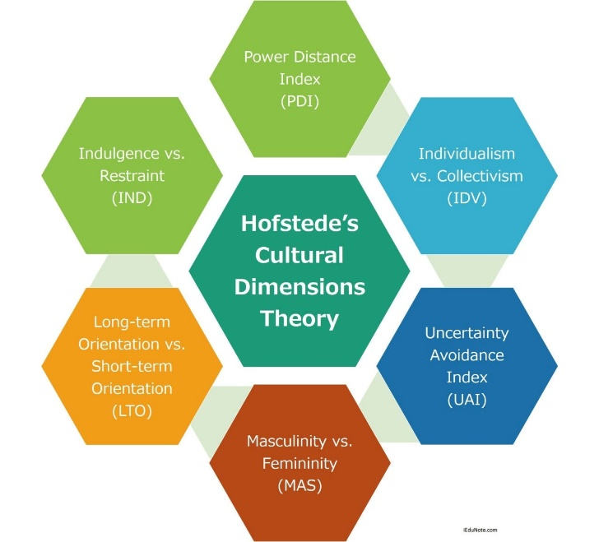
Figure 7: Hofstede’s Framework
Source: https://www.iedunote.com/hofstedes-cultural-dimensions-theory
Figure 5 brings out the magnitude of the US and China cultural concerns. The significantly greater Power Distance of China (80 compared to 40) and Long-Term Orientation (77 vs. 50) indicate top-down decision-making processes and strategy patience, unlike Tesla, an organization with a flat, quick-paced US culture. The US is higher in Individualism (60 vs. 43) and Indulgence (68 vs. 24), which are indicators of autonomy and satisfaction of personal gratification, contrary to the demands of collectivism in China. Such differences are the reasons why the bold and rather data-driven approach adopted by Tesla can be perceived as excessive, since the Chinese authorities and consumers are accustomed to humility and deference.
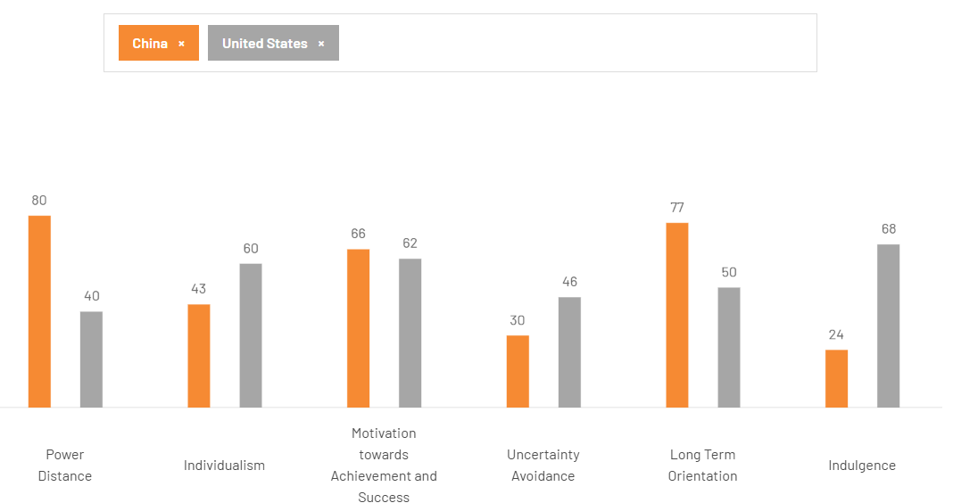
Figure 8: Hofstede’s Cultural Dimension Comparison between China and the United States.
Source: https://www.theculturefactor.com/country-comparison-tool?countries=china%2Cunited+states
To start with, the Cultural distance and the effect it has on the Tesla company relate to institutional factors regarding the choice of market entry. Although studies have confirmed that increasing cultural distance tends to favour joint venturing to share the risk and access the local know-how, recent research on the high-tech sector in China found that companies with high proprietary resources might still decide to adopt wholly owned firms as a means of safeguarding the vital know-how (López-Duarte, 2013). The logic can be seen in the decision by Tesla to construct Gigafactory Shanghai as a wholly foreign-owned company. It also put greater focus on defining and protecting battery, software, and data features as opposed to relational benefits of a local partner, which was an indicator of more pressure (on government relations teams) by the US on collaborative guanxi norms in China.
Second, organisational culture enhances national differences. The Tesla innovation culture is also researched as a very mission-oriented, engineering-focused organisation that values speed and experimentation, and has very flattish hierarchies and strong performance stress (Arreola et al., 2024). In comparison, Chinese corporate environments are usually characterized by status boundaries, respect for seniority, and more emphasis on harmoniousness and face in communication. The confrontational, data-based, Silicon Valley style and the anticipation of respectful, indirect feedback may have an impact on recruitment, retention, and day-to-day coordination in Shanghai. Chinese workers can be impressed with the global brand and technological facilities of Tesla, but they feel more stressed or uncertain about work-personal life and employment. Without a local HR system adjusting reward, appraisal, and communication practices to Chinese norms, turnover and internal conflict will undermine the dynamic capabilities that support the wholly-owned entry mode.
Third, cultural variations determine the success of Tesla's marketing and customer experience principles in China. The consumer culture of the US, and specifically the technology districts, is highly individualist and focused on self-expression and first-mover advantage; the Tesla marketing messages to the home provinces were often focused on joining a disruptive, eco-conscious elite. Chinese purchasers of NEVs, on the other hand, are entrenched in collectivist networks where comparisons of status, family views, as well as group values hold a lot of weight. Rapid growth in China’s NEV market, 6.887 million units sold in 2022 with a 25.6% market share, rising to 9.495 million units and 31.6% share in 2023, reflects not only environmental policy but also a mass aspiration toward technologically advanced, digitally integrated lifestyles (Wang, 2024). Tesla has responded with product and price adaptations, frequent online price cuts, and extensive experiential stores in high-traffic malls, yet studies of its China strategy suggest that local brands better leverage patriotic narratives, social media ecosystems, and super-app integration to embed EVs into everyday collective routines (Zhang, 2023). Cultural misalignment here can limit Tesla’s share growth even when the overall category is booming.
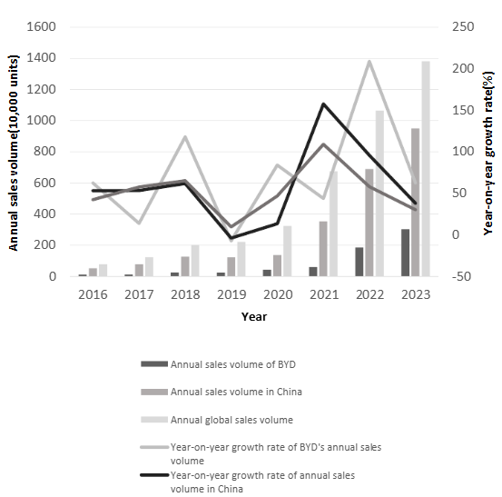
Figure 9: Annual sales volume and growth rates of new energy vehicles (2016-2023) (Zhu, 2025)
Fourth, cultural context is central to crisis communication and regulatory relations. Case studies of Tesla’s 2021 “brake failure” protest at the Shanghai Auto Show show how quickly a technical dispute escalated in a high power-distance, collectivist environment where state media, regulators, and online publics expect visible humility and rapid public contrition from powerful firms (Liu, 2022). Tesla’s initial defensive, evidence-heavy response resembled US crisis playbooks but was read in China as arrogant and disrespectful, triggering state broadcaster criticism and intensified regulatory scrutiny. Only after a more explicit apology and concessions did sentiment partially normalise. This episode illustrates how a US-centric communication style can undermine a constructed market entry position in a context where maintaining face for consumers and officials is as important as technical fault allocation. (Sun et al., 2024)
Cultural differences also create opportunities for Tesla. China’s strong long-term orientation and support for top-down industrial policy align with Tesla’s large-scale projects in charging infrastructure and energy storage, with authorities valuing “lighthouse” firms driving technological upgrading (Sun et al., 2024). Chinese consumers’ comfort with digital platforms complements Tesla’s software-centric model. The key challenge is adapting HR, marketing, and communication to Chinese norms while preserving Tesla’s US-based innovative culture, making cultural differences a strategic terrain shaping long-term APAC success.

SOP Adjustments for Tesla’s Operations in China
Tesla’s OLI-based choice of a wholly owned Gigafactory in Shanghai and a tightly internalised sales and service ecosystem has delivered strong growth, but China’s maturing new energy vehicle (NEV) market and pronounced cultural distance from the United States require formal adjustments to the firm’s Standard Operating Procedures. Recent studies show that China accounted for roughly 63.6% of global NEV sales in 2022, with 6.884 million units sold, and that national NEV stock rose from 13.1 million vehicles in 2022 to 20.4 million in 2023 (Li et al., 2023). Policy-oriented research emphasises that NEVs are a central instrument in China’s carbon peaking and neutrality strategy and have shifted the country from follower to global leader (Li et al., 2023). Forecasts suggest total NEV sales could reach 27.38 million units by 2027, implying a compound annual growth rate of about 14.4% (Ze, 2025). In this hyper-competitive context, where domestic brands increasingly dominate mid-range segments, Tesla must refine its SOPs to turn ownership advantages and location benefits into durable, culturally embedded capabilities.
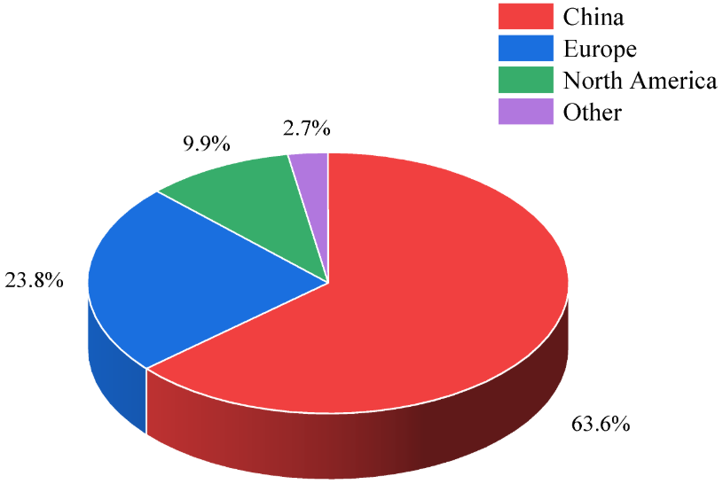
Figure 10: Share of the global NEV market by region in 2022 (Li et al., 2023)

Localised people management and workplace culture
Literature on Tesla’s HR practices highlights an innovation-driven but high-pressure culture, with aggressive targets and frequent restructurings that contribute to elevated turnover and burnout (Khaleque, 2024). At the same time, research on cultural distance shows that employees in high power-distance, collectivist contexts experience more conflict and lower engagement when Western MNCs impose individualistic, low power-distance styles without adaptation (Deng et al., 2024). Chinese HRM studies demonstrate that high-performance work systems deliver stronger trust, job satisfaction, and discretionary effort when integrated with supervisor–subordinate guanxi practices, where managers build personalised, reciprocal ties with staff (Xian, Atkinson and Meng-Lewis, 2017).
Tesla should therefore codify an SOP that localises people management while preserving its ownership advantages in talent and speed. Recruitment and onboarding procedures should emphasise local leadership pipelines and Mandarin-speaking middle managers who can translate Tesla’s mission into culturally resonant terms. Performance management SOPs need to integrate relational metrics, mentoring expectations, and team-based rewards, rather than focusing only on individual output targets. Training modules for expatriate and local managers should explicitly cover guanxi norms, face-saving communication, and indirect feedback techniques, reducing frictions that arise from direct Silicon Valley-style criticism and encouraging trust-based high-performance work systems. Tesla can keep a high-performance work system that meets the expectations of the Chinese by implementing them as formal HR SOPs, and this approach will help in enhancing internalisation advantages by having more devoted and low-turnover local staff and mitigating the risks that cultural distance diminishes productivity.

Stakeholder, regulatory and crisis communication
The 2021 Tesla brake failure protest at the Shanghai Auto Show serves as an example of how inappropriate communication may increase the risk of operations. According to the Situational Crisis Communication Theory of analyzing the case, the immediate data-centered reaction pursued by Tesla as the first line of defense was perceived by Chinese media as an arrogant statement, which prompted more intensive scrutiny, negative reactions on social media, and a drop in stock prices within Chinese borders in the short term (Liu, 2022). Research on foreign companies in China points out that in high PD, collectivist cultures, crisis management that demonstrates humility, responsibility, and readiness to compromise is preferable to technical responses only since it can guard the face of the consumer and the officials (Deng et al., 2024). The studies of guanxi-related stakeholder management also suggest that long-term relational maintenance with regulators and the local community enhances access to information and soft enforcement in the occurrence of controversial situations (Yang, 2011).
Based on these findings, Tesla must instill a Chinese local stakeholder and crisis communication SOP. Such a protocol must mandate that any incident or issue of significance in regards to safety, data, or product quality leads to the creation of the cross-functional China Crisis Cell comprising the local heads of legal, public affairs, and engineering teams and, who have the prerogative of crafting messages to suit the local palpation but may maintain factual accuracy and protection of proprietary information. The draft answers must be checked against standards of face protection, sympathetic recognition of worries of consumers, open reporting of newfound technical results, and active cooperation with government organizations and consumer groups. Assessing social media and statements by the government regularly and prioritizing targets of response time and exercising rehearsal would operationalise the long-term relationship approach suggested in the guanxi literature (Yu, Chang, and Mandizvidza, 2023). Incorporating such SOP strengthens the internalisation benefits of Tesla in a way that the communication is not detached from the technical and legal decision-making, but the cultural and institutional context of the host country must be put into consideration.

Market-facing ecosystem and quality management
The NEV market in China is large, but it is not structurally similar to the home market Tesla has. According to the recent research, NEVs reported approximately 63-64% of the global sales in 2022, and 9.5 million units of Chinese production and sales were recorded in 2023, where domestic brands including BYD, SAIC, and Geely, took up the majority of the incremental volume and the increase in competition in each price bracket (Li et al., 2023). Analysts also record a price war that will squeeze the average industry profit margins to an estimated average of 4.4 by 2024, as compared to over 6% in 2020 (Reuters, 2025). Meanwhile, considering that NEVs have multiple goals related to e-economy and carbon-neutrality, policy studies emphasize that the promotion of NEVs will be tied to the provision of integrated mobility and energy services to consumers instead of separate vehicles (Li et al., 2023).
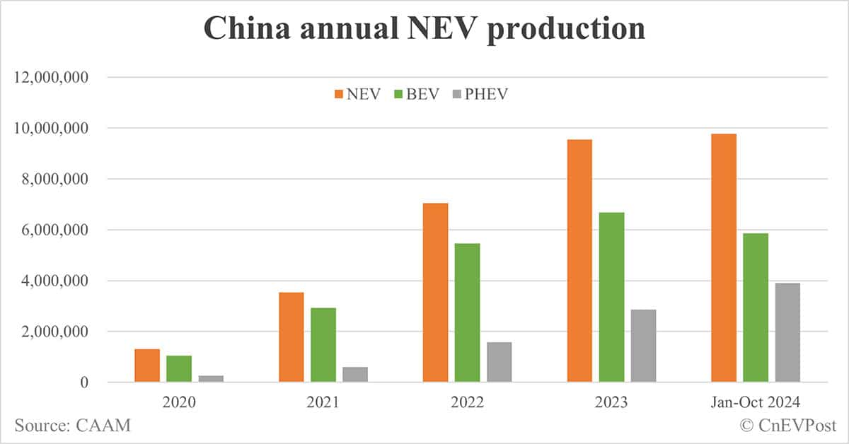
Figure 11: China Annual NEV Production (Zhang, 2025)
In this environment, Tesla’s ownership advantages in software, batteries, and brand must be translated into SOPs that govern pricing, ecosystem integration, and quality transparency in ways that resonate with Chinese consumers and regulators. First, Tesla should formalise a China Ecosystem Localisation SOP linking product updates, pricing decisions, and digital services to market intelligence. Academic work on NEV consumer behaviour in China shows that buyers value seamless integration with super-apps, dense charging networks, and data-rich in-car services at least as much as hardware specifications (Yumeng and Yuan, 2024). SOPs should therefore require early involvement of local software, data, and marketing teams when global over-the-air features, subscription models, or price adjustments are proposed, ensuring that rollouts align with Chinese digital habits, regulatory constraints on data security, and the realities of a price war. Second, Tesla should codify a Quality and Transparency SOP that commits to clearer disclosure of vehicle data in disputes, periodic publication of safety performance indicators for China, and structured joint inspections with regulators. Empirical research on NEV policy effectiveness links transparent performance metrics and government–firm collaboration to higher consumer trust and faster diffusion, especially when local governments view NEV leaders as anchors of green industrial upgrading (Li et al., 2023). These measures would help mitigate the perception, reinforced by past crises, that Tesla is reluctant to share information, while still protecting commercially sensitive algorithms and software architectures.
The three SOP adjustments translate Tesla’s OLI and cultural analysis into actionable routines. Localised people management strengthens internalisation advantages by stabilising high-skill teams and building culturally aligned employee relations. A China-specific stakeholder and crisis communication SOP protects technological ownership advantages while reducing institutional and reputational risks in a high power-distance setting. Market-facing ecosystem and quality SOPs enhance location advantages by aligning Tesla’s software-centric model with China’s NEV ecosystem. Together, these adjustments sustain Tesla’s innovative core while improving competitive legitimacy in the APAC market.

Conclusion
This report has evaluated Tesla’s international expansion through an integrated analysis of its multinational characteristics, OLI determinants, and the cultural dynamics shaping operations in China as a key APAC emerging economy. Tesla’s strong ownership advantages in battery technology, software integration, and brand reputation justify its preference for wholly owned subsidiaries, while China’s extensive NEV ecosystem, large consumer base, and long-term industrial policy provide compelling location advantages. Nevertheless, strong US-China cultural distance affects the managerial expectations, the crisis communication, the interaction with regulatory bodies, and consumer behaviour, and Tesla should find the balance between the culture of Silicon Valley innovation and the norms of hierarchy, relationships, and the decision-making process. These insights can be incorporated into the daily operations of Tesla by the suggested SOP changes, namely localised people management, culturally oriented regulatory and crisis communication, and ecosystem-oriented market approach, which will add to the benefits of internalisation and increase the competitiveness of this firm in the long term. Tesla will be successful to the extent that it can retain its technological competitiveness at the same time as internalizing their practice in the changing institutional and cultural environment of China, where China will continue to form the largest NEV market in the world to date, with sales of 9.5 million units in 2023. Finally, it is the strategic adaptation as opposed to standardisation that will choose to determine whether Tesla will be able to sustain its performance and legitimacy in the APAC region.

References
Ahead Of The Herd (2023) China aiming to tap US$23 trillion energy transition market – Richard Mills. https://aheadoftheherd.com/china-aiming-to-tap-us23-trillion-energy-transition-market-richard-mills/ (Accessed: December 14, 2025).
Aithor (2024) Tesla Globalization: Expansion Strategy. https://aithor.com/essay-examples/tesla-globalization-expansion-strategy.
Arreola, F. et al. (2024) 'Systemic entrepreneurship in the digital era: Tesla’s vision and social transformation,' Journal of Engineering and Technology Management, 74, p. 101844. https://doi.org/10.1016/j.jengtecman.2024.101844.
Bai, J. et al. (2020) Quid Pro Quo, Knowledge Spillover, and Industrial Quality Upgrading: Evidence from the Chinese Auto Industry. https://doi.org/10.3386/w27644.
Cai, B. (2025) 'Impact of internationalization strategies in the electric vehicle industry: a case study of Tesla,' Advances in Economics Management and Political Sciences, 184(1), pp. 174–179. https://doi.org/10.54254/2754-1169/2025.bl23503.
Chen, Y., Lawell, C. -y. C.L. and Wang, Y. (2020) 'The Chinese automobile industry and government policy,' Research in Transportation Economics, 84, p. 100849. https://doi.org/10.1016/j.retrec.2020.100849.
Chen, Z. (2023) 'The impact of China’s introduction of Tesla on itself and the Chinese economy,' Highlights in Business Economics and Management, 23, pp. 299–305. https://doi.org/10.54097/b4jmpc41.
Deng, Y. et al. (2024) 'Does culture matter? Re-examining cultural distance, conflict, and socio-cultural adaptation in MNCs in southwestern China,' International Journal of Intercultural Relations, 103, p. 102077. https://doi.org/10.1016/j.ijintrel.2024.102077.
Faraonov, Y. and Tarasova, K. (2025) 'Global expansion Strategy of Tesla: challenges and opportunities,' International Journal of Psychology and Strategic Communication, p. 348. https://doi.org/10.61030/gajo4415.
Fusheng, L. (2020) Equity cap in commercial vehicle JVs to be removed. https://www.chinadaily.com.cn/a/202006/29/WS5ef949f8a310834817255ba9.html
Gao, Y. (2023) 'A study of Tesla’s international marketing strategy based on the STEPPS model,' Highlights in Business Economics and Management, 23, pp. 971–979. https://doi.org/10.54097/es6rry79.
Ghar, S. (2025) 'Tesla’s international business strategy,' SSRN Electronic Journal [Preprint]. https://doi.org/10.2139/ssrn.5258192.
Hofstede, G. (2011) 'Dimensionalizing Cultures: The Hofstede Model in context,' Online Readings in Psychology and Culture, 2(1). https://doi.org/10.9707/2307-0919.1014.
IMD Business School (2025) Tesla’s global expansion: Where to go next? - IMD business school for management and leadership courses. https://www.imd.org/research-knowledge/strategy/case-studies/tesla-s-global-expansion-where-to-go-next/?
Kamkoum, C. (2018) 'TESLA International Business Strategies,' , ,. https://doi.org/10.13140/rg.2.2.29070.66880.
Khaleque, M.I. (2024) 'A Comprehensive Analysis of Tesla’s HR Strategies in the Global Business Environment: Examining External Influences, Strategic Processes, and HR Functional Alignment with Ulrich’s Vision,' Westengland [Preprint]. https://www.academia.edu/124926109/A_Comprehensive_Analysis_of_Teslas_HR_Strategies_in_the_Global_Business_Environment_Examining_External_Influences_Strategic_Processes_and_HR_Functional_Alignment_with_Ulrich_s_Vision
Li, X. et al. (2023) 'Development of New-Energy Vehicles under the Carbon Peaking and Carbon Neutrality Strategy in China,' Sustainability, 15(9), p. 7725. https://doi.org/10.3390/su15097725.
Li, Y. et al. (2023) 'Can the Dual-Credit Policy Help China’s New Energy Vehicle Industry Achieve Corner Overtaking?,' Sustainability, 15(3), p. 2406. https://doi.org/10.3390/su15032406.
Liu, C., Boothman, S.G. and Graham, J.D. (2025) 'The rise and recent decline of Tesla’s share of the U.S. electric vehicle market,' World Electric Vehicle Journal, 16(2), p. 90. https://doi.org/10.3390/wevj16020090.
Liu, J. (2022) The Tesla brake Failure protestor scandal: A case study of situational crisis communication theory on Chinese media. https://digitalcommons.usf.edu/etd/9396/.
López-Duarte, C.& V.-S.M.M. (2013) 'Cultural distance and the choice between wholly owned subsidiaries and joint ventures,' ideas.repec.org [Preprint]. https://ideas.repec.org/a/eee/jbrese/v66y2013i11p2252-2261.html
Malik, A.A., Masood, T. and Brem, A. (2023) 'Intelligent humanoids in manufacturing to address worker shortage and skill gaps: Case of Tesla Optimus,' arXiv (Cornell University) [Preprint]. https://doi.org/10.48550/arxiv.2304.04949.
Reuters (2025) 'China’s EV exports seen stalling in 2025,' Reuters, 9 January. https://www.reuters.com/business/autos-transportation/chinas-car-sales-extend-gains-dec-2025-01-09
Salaberria, J.L. and Xia, L. (2023) China | The rise of China’s EV sector and its implications for the world. https://www.bbvaresearch.com/en/publicaciones/china-the-rise-of-chinas-ev-sector-and-its-implications-for-the-world/.
Shan, L., Wang, N. and Xu, J. (2023) 'Analysis of Tesla’s business strategy in China,' BCP Business & Management, 38, pp. 2920–2924. https://doi.org/10.54691/bcpbm.v38i.4211.
Shi, L. et al. (2023) 'Exploring the factors that promote sustainable growth in regional sales of new energy vehicles: An Empirical study of China,' Sustainability, 15(8), p. 6748. https://doi.org/10.3390/su15086748.
Sun, R. et al. (2024) 'Spatial-Temporal evolution of sales volume of new energy vehicles in China and analysis of influencing factors,' Sustainability, 16(24), p. 11115. https://doi.org/10.3390/su162411115.
The Case Centre (2024) Tesla’s global expansion: where to go next? - The Case Centre. https://www.thecasecentre.org/products/view?id=183043&.
Wang, Z. (2024) ‘Overview of the development of new energy vehicle market in 2022’, in Annual report on the big data of new energy vehicle in China (2023). Singapore: Springer Singapore, pp. 1–27. doi:10.1007/978-981-97-4840-2_1.
Wuttke, T. and Whitfield, L. (2025) 'China’s technological catch-up and leapfrogging in electric vehicles: A firm-level study of BYD and CATL,' Progress in Economic Geography, p. 100054. https://doi.org/10.1016/j.peg.2025.100054.
Xian, H., Atkinson, C. and Meng-Lewis, Y. (2017) 'Guanxi and high performance work systems in China: evidence from a state-owned enterprise,' The International Journal of Human Resource Management, 30(19), pp. 2685–2704. https://doi.org/10.1080/09585192.2017.1332670.
Xinyi, L., Chen, Z. and Bai, C. (2022) Case study Research in Tesla (China) Marketing Strategy application during COVID-19. https://www.diva-portal.org/smash/record.jsf?pid=diva2%3A1664006&dswid=4202.
Yang, F. (2011) 'The importance of Guanxi to multinational companies in China,' Asian Social Science, 7(7). https://doi.org/10.5539/ass.v7n7p163.
Yu, P., Chang, X. and Mandizvidza, K. (2023) 'Development of new energy vehicles in entrepreneurial ecosystem under the carbon neutrality policy in China,' in Advances in human resources management and organizational development book series, pp. 55–84. https://doi.org/10.4018/978-1-6684-7422-8.ch004.
Yumeng, H. and Yuan, Y. (2024) 'A Cross-Cultural Comparative Study of Electric Vehicle Advertisements from the Perspective of Visual Grammar,' Visions in Leisure and Business, 26(2). https://doi.org/10.25035/visions.26.02.02.
Ze, Q. (2025) 'Analysis of Influencing Factors on China’s New Energy Vehicle Sales and Forecasting with ARIMA Model,' SHS Web of Conferences, 225, p. 03016. https://doi.org/10.1051/shsconf/202522503016.
Zhang, P. (2025) 'China’s year-to-date NEV production surpasses 10 million mark,' CnEVPost, 13 November. https://cnevpost.com/2024/11/14/china-ytd-nev-production-10-million/.
Zhang, S. and Du, Y. (2024) 'A study of customer preference transmission for new energy vehicles based on a signaling game and separating equilibrium,' Sustainability, 16(7), p. 3090. https://doi.org/10.3390/su16073090.
Zhang, Y. (2023) 'The 4P’s of Marketing Mix Analysis: The uniqueness of Tesla’s strategic marketing tactics in China,' in Advances in economics, business and management research/Advances in Economics, Business and Management Research, pp. 233–240. https://doi.org/10.2991/978-94-6463-268-2_28.
Zhu, L. (2025) 'Analysis of technological innovation and competitive advantage in new energy vehicle industry: BYD as an example,' SHS Web of Conferences, 218, p. 01031. https://doi.org/10.1051/shsconf/202521801031.

