Georgica Acsente
2332651
28.05.2024

Professional Career Development

Reflection

University Of Wales Trinity Saint David

Table of Contents
Terms of reference 3
Introduction 3
Main Finding 3
Conclusion 6
PDP – Personal Development Plan 6
References: 7
Appendix: 8
‌1. Learning Style Questionnaire 8
2. SWOT Analysis (Personal) 10
3. Myers Briggs personality profiling test 11
4. Johari Window 12

Terms of reference
This report is a reflection of my experiences and ideas regarding the courses I took at Trinity Saint David University of Wales. I will describe my first feelings, how I moved through the many phases, what I was able to learn, and what aspects of the job I had to accomplish were more challenging using the Gibbs model.
Along with certain materials I gained during my courses, such books, journals, and articles, I'll use a range of web resources at the same time.

Introduction
Professional career development is the process of combining carefully thought-out plans and actions, either done in a group setting or individually, to build a professional career between the employer and the employee. Professional career development also helps the business achieve its main objective of increasing the output of its human resources by ensuring the best possible fit between employees and jobs.
Professional development is important from the employee's point of view since it enables them to achieve objectives and responsibilities that could lead to pay increases or incentives. (Parsons, 2022)
Developing your professional career—also referred to as your own future—is, in my opinion, the main goal in life. Along with teaching you valuable skills like employability, SMART goal setting, SWOT analysis, and personal planning, it may assist you in establishing the profession of your dreams. (Coursera, 2023)
Having a job you love and pursuing your hobbies in work-related activities is a safe path to career success. It is important to give serious thought to your professional development since you will feel less like you are working hard and time will pass more quickly if you are employed in a field you are enthusiastic about.

Main Finding
I succeeded in learning a great deal of vital information, including what employability skills are and how they may support our professional and personal development. I also learnt about SWOT analysis and how to construct SMART goals.
Employability skills refer to the core competencies, personal qualities, and mindsets that enable you to thrive in any type of work environment. These are sometimes known as skills for business, the way to communicate or skills that help in workplace. (Morgan,2023)
This initial lesson made me feel confident about the courses that followed, because it had a lot of logic, and I could find a meaning and a place where I could use all this knowledge in the future.
These days, communication is essential in both private and business settings. Good communication enhances our understanding of other people and situations. It helps us to put aside our differences, promote trust and respect for one another, and create the ideal atmosphere for sharing creative ideas and solving problems. (Stapleton-Charles, 2023)
Even though I believed I had highly developed communication skills, I was able to observe with the aid of these courses that I can occasionally have communication issues when it comes to expressing my personal opinions. But I'm confident that at the end I'll be able to overcome this issue with the support of the UWTSD courses.
However, employability skills encompass much more. For instance, we learnt how to use critical analysis to choose the right source and determine whether a source is relevant.
I had never created a reference in the Harvard style before, but because this isn't my first work that has been turned in, I started to study how to do it properly. (Amberstudent, 2024)
In addition, employability skills provide me with a wealth of additional abilities that will help me address specific difficulties in the future and even boost my motivation, both of which will inadvertently bring me closer to a point where I will be far more productive. (Kelley, 2024)
At the same time, I learnt about SWOT analysis and how it can be used to make critical decisions in both the personal and professional domains.
When I started learning about this SWOT, initially I really liked the idea of ​​finding all the important things to know about a person, business or company. This was one of the most important reasons why I was so open to this new knowledge, the fact that this lesson was very interesting.
Strengths, Weaknesses, Opportunities, and Threats are the four aspects of your business that can be assessed using a SWOT analysis. SWOT analysis is a technique that can help you pinpoint your company's present advantages and draft a successful long-term strategy. (Forsey, 2023)
To begin with, SWOT analysis is a useful tool for determining a company's strengths and weaknesses. It may also help pinpoint the location of major issues. Examples are the rivalry or the neighbourhood where a particular company is situated. (Queensland Government, 2022)
It should be noted that SWOT analysis is a tool that, if we are able to recognise our shortcomings and apply the appropriate knowledge and abilities to address them, can also help us change certain weaknesses into strengths.
In addition, SWOT analysis can assist us in recognising certain chances that present themselves in a given industry, enabling us to expand and advance the firm in the most advantageous and organic manner possible. (Kiely Kuligowski, 2019)
In addition, it assists us in recognising the threats so that we can take preventative measures to shield ourselves from them in the future.
When creating SMART goals, the acronym stands for Specific, Measurable, Achievable, Relevant, and Time-Bound. We may be certain that our goals can be accomplished in a specific length of time by specifying these elements in connection to your objective. (SAMHSA, 2019)
I also learned what a SMART goal is at UWTSD and how it might assist us in setting goals that we hope to achieve in the future. Although I had set goals for myself, I had never known how to begin working towards them in order to achieve them. This was something new for me.
The first stage in creating a smart objective is to be particular. This indicates that the goal needs to be clear and typically provides answers to queries like "what must be achieved" and "what are the steps I must follow." (Gupta, 2022)
The measurable step is the second, and it makes it abundantly evident that both a beginning and an end are necessary in order to facilitate the observation of progress.
The third job is to ensure that the goal is doable. At this point, we must face reality and determine whether the objective we have established is one that we can ultimately achieve.
Being relevant is a further stage that indicates the degree of importance of the objective we have set. (Stibich, 2020)
This stage is critical because it provides us with a comprehensive overview in the conclusion, allowing you to clearly understand all the advantages of achieving this objective.
Last but not least, there is time-bound, where success is quantifiably determined and indicates not just the goal's end point but also its deadline.

Conclusion
In summary, I was able to gain knowledge about employability skills, including what they are, how they may benefit us, and how to use the many other abilities that are included in them, such communication, critical analysis, problem-solving, and time management.
At the same time, with the aid of the Harvard reference, I discovered the true meaning of locating a pertinent source and using it in a paper.
Simultaneously, I discovered the value of learning about a certain business or company and myself, as well as the reasons it's critical to be aware of all its advantages, disadvantages, possibilities, and risks.
Although this SWOT was unfamiliar to me, I was able to understand it easily, which will make it easier for me to apply in the future.
In the end, I learned not only the true meaning of setting a goal but also the actions you must take to guarantee its effective completion—namely, applying the SMART steps.

PDP – Personal Development Plan
Goal: My goal is to be professionally ready but also to develop myself enough in order to be able to get to that confidence level so I can apply for any job that I desire.

What do I need to know? | What will I do to achieve this? | What resources or support will I need? | Target dates for review or completion
I need to know all the information required by different companies in order to be able to be professionally ready. | I need to connect all my university knowledge and skills to the company requirements. | Extra courses and all the help from the teachers or future managers. | 36 months
I need to work for the company and get in touch with these skills and values. | I need to start the work as an entry level with them and also get extra information about the role. | I need to speak with different people that already had experiences within the company. | As soon as possible.
I need to know all the knowledge from university and internal job and get ready with all the skills. | I need to follow my progress and check all the time the status of my studies. | I need to allocate more time to studies and dedicate most of my time to studies. | As soon as possible

References:
Amberstudent (2024). Top 10 Must-Have Employability Skills For Students | Amber. Available at: https://amberstudent.com/blog/post/must-have-employability-skills-for-students#4-critical-thinking [Accessed 9 May 2024].
Coursera. (2023). What Are Professional Development Goals? 10 Examples and How to Set Them. Coursera. Available at: https://www.coursera.org/articles/professional-development-goals [Accessed 3 May 2024].
Forsey, C. (2023). How to Run a SWOT Analysis for Your Business [Template Included]. Hubspot.com. Available at: https://blog.hubspot.com/marketing/swot-analysis [Accessed 11 May 2024].
Gupta, D. (2022). How to Set SMART Goals (+Examples, Template) | Whatfix. The Whatfix Blog | Drive Digital Adoption. Available at: https://whatfix.com/blog/smart-goals/. [Accessed 19 May 2024].

Kelley, K. (2024). Why are Employability Skills Important. Simplilearn.com. Available at: https://www.simplilearn.com/why-are-employability-skills-important-article [Accessed 10 May 2024].
Kiely Kuligowski. (2019). Why You Need a SWOT Analysis for Your Business. Business.com; business.com. Available at: https://www.business.com/articles/swot-analysis-for-small-business-planning/ [Accessed 18 May 2024].
Morgan, A. (2023). Employability Skills: A Guide to Skills Employers Look For. One Education. Available at: https://www.oneeducation.org.uk/employability-skills/. [Accessed 3 May 2024].
Parsons, L. (2022). Why is professional development important? Harvard DCE. Available at: https://professional.dce.harvard.edu/blog/why-is-professional-development-important/. [Accessed 3 May 2024].
Queensland Government. (2022). SWOT analysis. Business Queensland. Available at: https://www.business.qld.gov.au/running-business/planning/swot-analysis [Accessed 12 May 2024].
SAMHSA (2019). Setting goals and developing Specific, Measurable, Achievable, Relevant, and Time-bound objectives. SAMHSA. Available at: https://www.samhsa.gov/sites/default/files/nc-smart-goals-fact-sheet.pdf. [Accessed 17 May 2024].
Stapleton-Charles, N. (2023). Why Is Communication Important in Business? Weave. https://www.getweave.com/why-is-communication-important-in-business/ [Accessed 9 May 2024].
Stibich, M. (2020). How to Make Your Health Goals S.M.A.R.T. Verywell Mind. Available at: https://www.verywellmind.com/smart-goals-for-lifestyle-change-2224097. [Accessed 19 May 2024].
‌

Appendix:

‌1. Learning Style Questionnaire

‌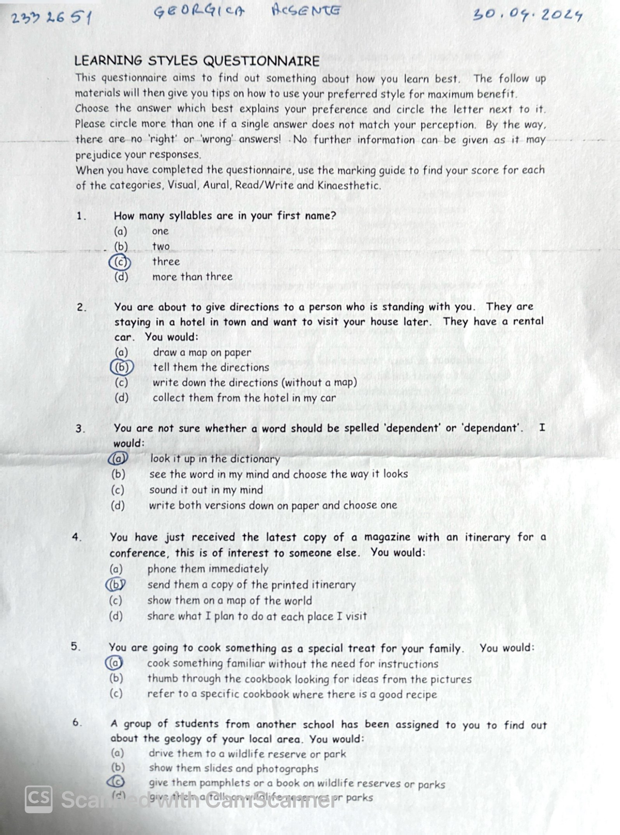
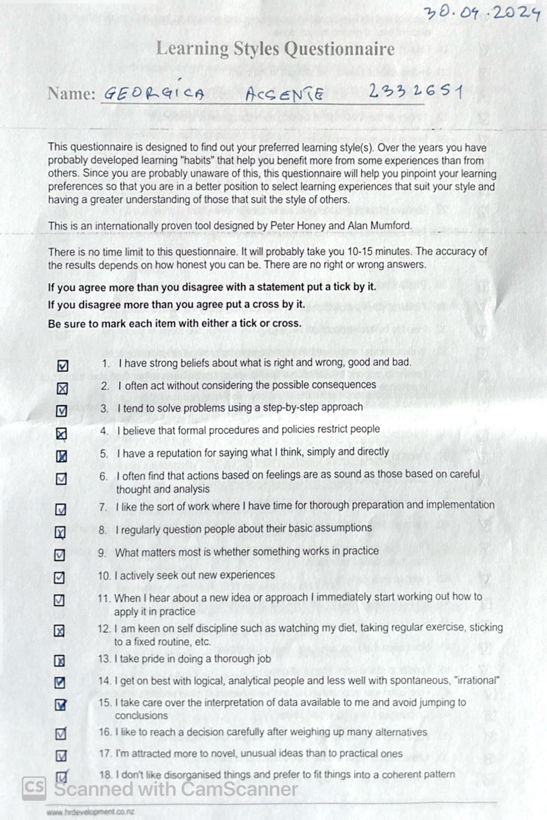

2. SWOT Analysis (Personal)
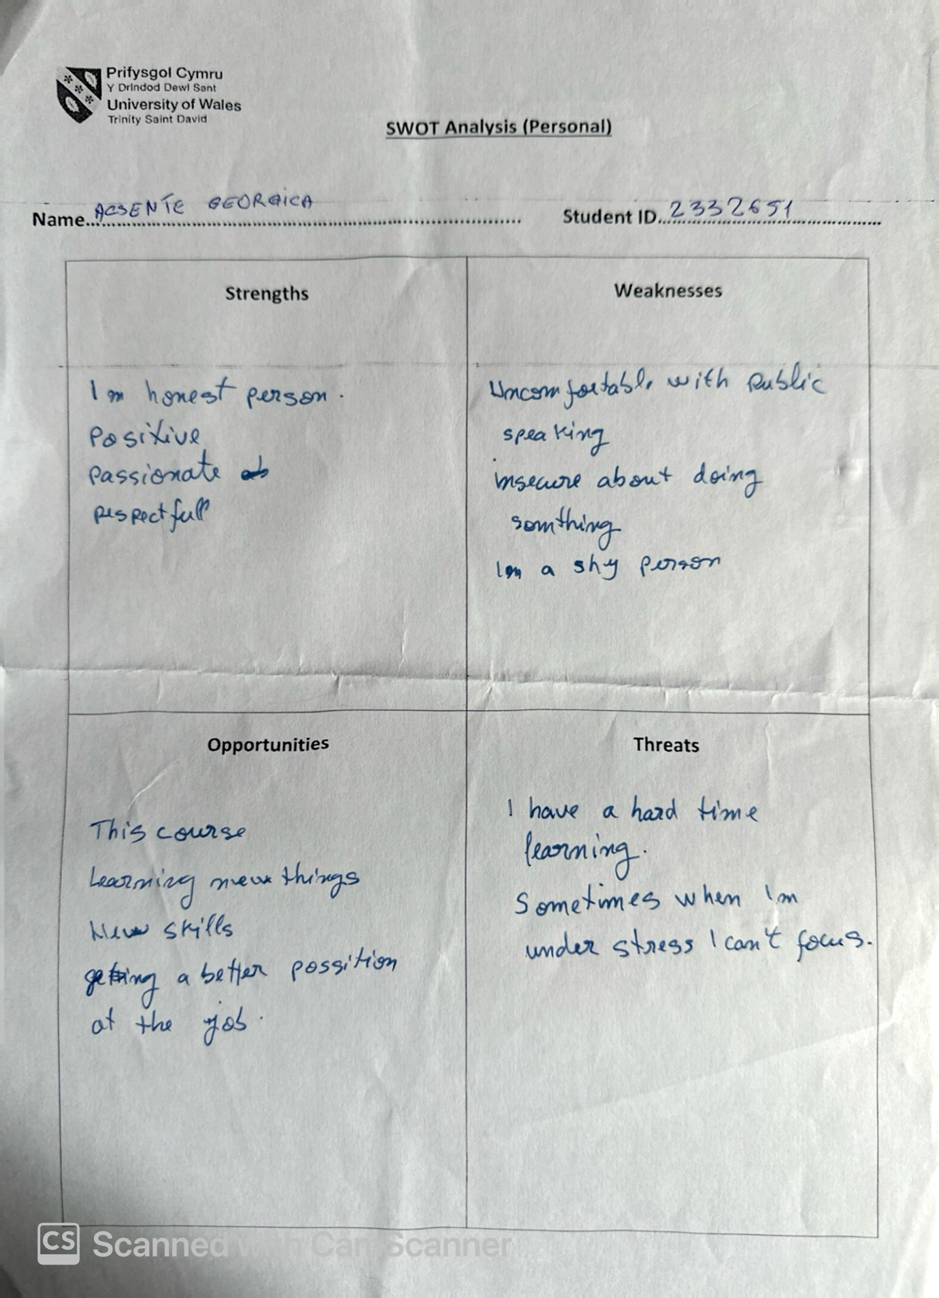

3. Myers Briggs personality profiling test
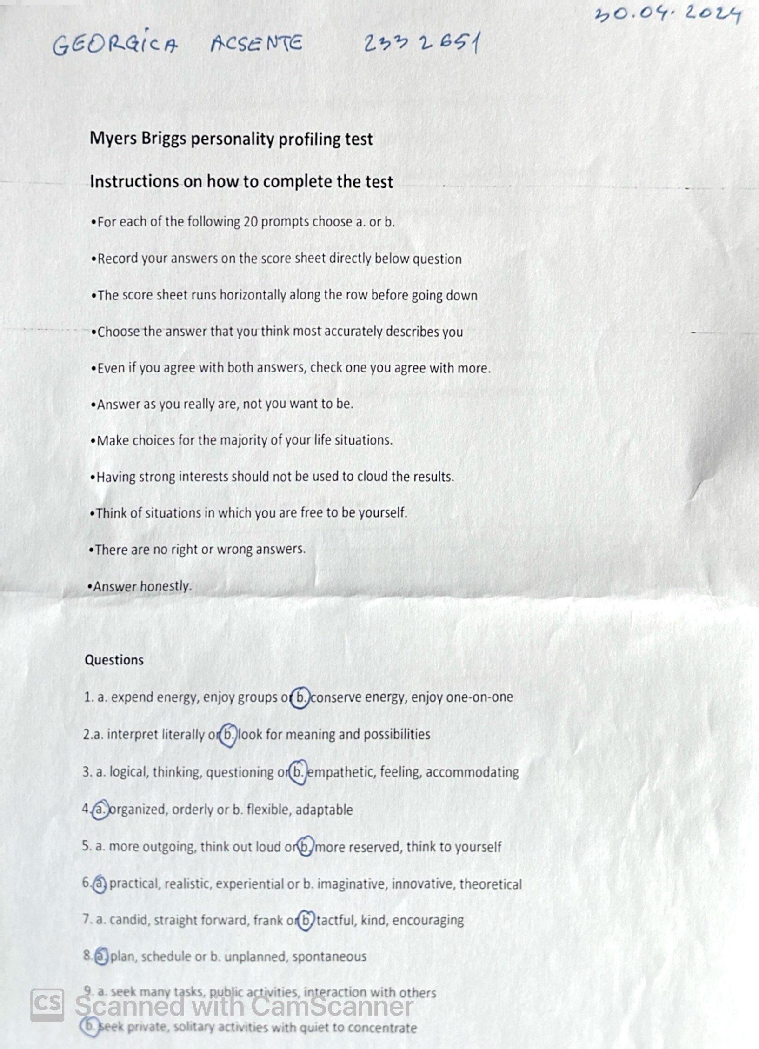

4. Johari Window


