Student name:Sevdalina Velinova
Student number :2017540
Programme: BSc Health and Social Care
Module: Health, Wellbeing and Sustainable Development
Module code: BMHP6021
Lecturer: Chloe Harries
Assignment Title: Written Report
Contents

Introduction……………………………………………………………………………….2
The Key Concepts……………………………………………………………………….3
Health……………………………………………………………………………………….3
Wellbeing……………………………………………………………………………….….3
Sustainable development ………………………………………………………………4
The Sustainable Development Goals…………………………………………………4
Integrating SDGs with Health, Wellbeing, and Sustainable Development….5
Goal 1 - No poverty………………………………………………………………………5
Strategy 1………………………………………………………………………………….6
Strategy 2………………………………………………………………………………….7
Critical Review of the Strategies………………………………………………………7
Evaluation of Progress Made by the UK Government…………………………….8
Challenges in Implementing Goal 1 - No Poverty……………………………….….9
Recommendations for Improvement………………………………………………….9
Goal 3-Good Health and Wellbeing…………………………………………………...10
Strategy 1………………………………………………………………………………….11
Strategy 2………………………………………………………………………………....12
Critical Review of Strategies…………………………………………………………...12
Evaluation of Progress Made by the UK Government……………………….…….13
Challenges in Implementing Goal 3 - Good Health and Wellbeing……………...14
Recommendations for Implementing…………………………………………………14
Conclusion…………………………………………………………………………………15
Reference list……………………….…………………………………………………….17

Introduction

Health care plays a significant role in achieving the Sustainable Development Goals (SDGs) and has a direct impact on numerous goals related to health, wellness, and overall sustainability. They consist of seventeen goals and 169 linked targets that address global concerns in their whole, referring to the financial, social, and environmental aspects of sustainable development in a holistic manner.
The UN 2030 Agenda for Sustainable Development, which was established in 2015, promotes worldwide collective action to end poverty, achieve inclusive sustainable development, protect human rights, and ensure that progress is shared equitably by 2030. We can make major strides toward these widespread objectives by emphasising healthcare. Ultimately this will create a better world that is healthier and more equitable.
The aim of this report is to critically review well-being and sustainable development in the UK's healthcare sectors with a focus on the progress so far in relation to Sustainable Development Goals (SDGs) Goal-1 (No Poverty) and Goal 3. It explains approaches used to realise these objectives, assesses their achievements, examines their impacts, pinpoints difficulties experienced and proffers suggestions for enhancement.

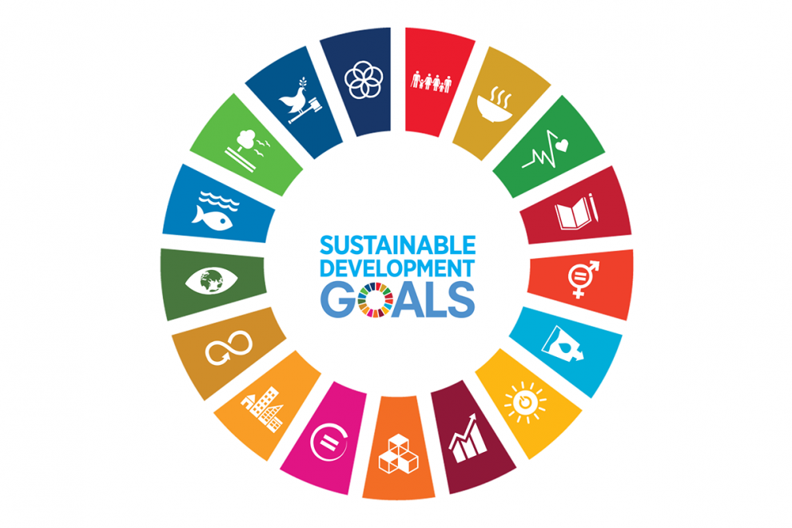

The Key Concepts:
Health
The World Health Organization (WHO) has traditionally described health as a holistic concept encompassing physical, mental, and social well-being, rather than just the lack of disease or illness (World Health Organization,2006). This description emphasises the all-encompassing aspect of health, including different factors that impact a person's overall well-being. Health impacts more than just an individual's well-being, also affecting economic productivity, social stability, and overall quality of life. Having good health improves productivity and economic growth, while also reducing healthcare expenses, ultimately benefiting society (Marmot, 2005).

Wellbeing
A further important aspect to consider is that wellbeing involves far more than physical health, including overall enjoyment of life and the ability to accomplish everyday responsibilities effectively. This notion combines subjective factors like contentment, well-being, and sense of accomplishment with objective indicators like salary, employment status, and education. A strong sense of well-being leads to improved health, social peace, and economic prosperity, allowing people to fulfil their full potential (OECD, 2013).

Overall, health and well-being are intrinsically linked, as a high level of well-being often leads to better health outcomes. To give an illustration of, stress reduction and life satisfaction, key components of wellbeing, are known to lower the risk of chronic diseases. Therefore, promoting well-being is essential for improving overall health, highlighting the importance of policies and practices that focus on both physical health and overall life satisfaction.

Sustainable development
As a result, sustainable development is critical since it fosters the conditions required for improved well-being. Sustainable development addresses the factors influencing well-being by enhancing living conditions and guaranteeing a healthy environment. This comprehensive strategy is critical for improving global quality of life because it ensures that advancement in one area enhances and reinforces progress in others.

The Sustainable Development Goals
The Sustainable Development Goals (SDGs) are the set of 17 connected goals developed by the United Nations in 2015. They address a wide range of global concerns, including health and education, climate action, and economic inequality. These goals provide a universal call to action and a road map for the advancement of sustainability, encouraging collaboration across sectors and states to create a better and more sustainable future for all (United states, 2015).

Integrating SDGs with Health, Wellbeing, and Sustainable Development
Economic productivity and social stability are greatly impacted by health and well-being, which are fundamental to both individual and societal prosperity (Marmot, 2005). As a result, the Sustainable Development Goals (SDGs) pertaining to gender equality, poverty reduction, high quality education, and climate action all support sustainable development, emphasising the connections between these ideas (United Nations, 2015). The fact that the ideas of health, happiness, sustainable development, and the SDGs are intricately entwined and mutually supportive serves as additional evidence of this connection (Sachs, 2015). As an illustration, Goal 3 directly connects health and wellbeing to more general development goals by emphasising the promotion of well-being and ensuring healthy lives for all people at all ages (WHO, 1946). By combining these objectives, we can observe how advancements in one area encourage and support advancements in others, resulting in creating a holistic approach to global development (United Nations, 2015).

The Sustainable Development Goals (SDGs) are vital because they provide a comprehensive and inclusive framework to tackle global issues such as poverty, inequality, health, education, and environmental sustainability. These universally applicable goals promote coordinated action with specific targets and indicators to ensure measurable progress as emphasise equity and inclusion, particularly to the most vulnerable.

On the other hand, they act as a catalyst for policy development, driving political commitment and resource mobilisation. By addressing interconnected global challenges, the SDGs ensure that progress in one area supports advancements in others, enhancing overall well-being and societal prosperity.

Indisputably, the SDGs are crucial for providing a comprehensive, universal, and actionable framework to address pressing global challenges, promoting equity, sustainability, and collaboration for a better future for all.

Goal 1 - No poverty

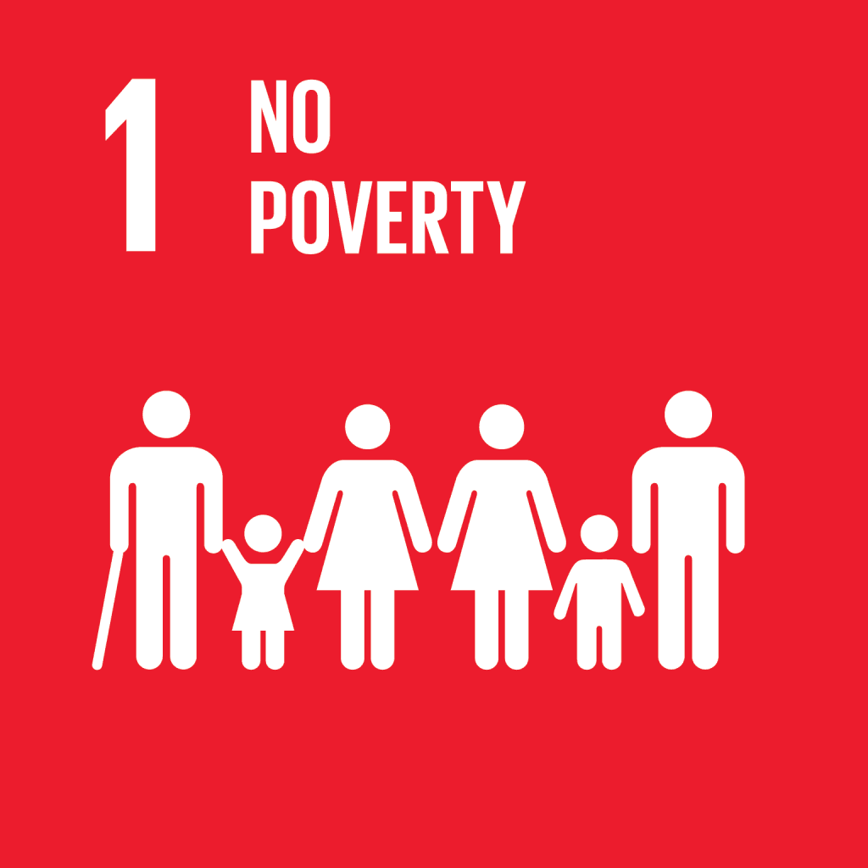

End poverty in all its forms

The main Goal 1 is to eliminate all forms of poverty in the world. Such as, ending extreme poverty by 2030 and ensuring universal access to basic resources and opportunities for economic growth, as ensure that all people, especially the poor and vulnerable, have equal rights to economic resources, access to basic services, ownership, and control over land and other forms of property, inheritance, natural resources, appropriate new technology, and financial services, including microfinance (United Nations, 2015).

To achieve this, it is necessary to comprehensively address poverty by promoting sustainable development, reducing inequalities and promoting inclusive growth (United Nations, 2015).

In the UK, strategies and projects play a fundamental and crucial role in transforming global goals such as Goal 1 - Zero Poverty into concrete actions and results. For example, initiatives such as Universal Credit (Department for Work and Pensions, 2024) and social housing projects (Department for Housing, Communities and Local Government, 2024) are some of the key components of these strategies, which focus on to ensure equitable access of more vulnerable groups to more resources and opportunities.

Such are Universal Credit reforms, which seek to streamline social benefits for greater efficiency, while social housing programs offer affordable housing options. All of these efforts work together to alleviate poverty and promote sustainable development at the local level (Joseph Rountree Foundation, 2018).

Strategy 1:
Universal Credit (UC): UC is a social benefit introduced to replace six other benefits, with the aim of simplifying the benefits system and providing a single payment to individuals or families (Department for Work and Pensions, 2018).

Not only that, but UC also provided a more consistent support system for those transitioning from welfare to work (Department for Work and Pensions, 2020). However, UC has faced criticism for delaying payments, penalties and causing financial hardship for some recipients.

Strategy 2:
Social Housing Programmes: Stable and affordable housing is a critical component in the fight against poverty and initiatives such as the Affordable Housing Program aim to increase the availability of affordable housing by building more social and affordable housing across the UK (Department for Housing, communities and local government, 2018).
The success rate of these programs varies. Although the supply of affordable housing has increased significantly, demand still outstrips supply, resulting in long waiting lists and continued housing insecurity for many low-income families (Shelter, 2019).

Critical Review of the Strategies
Undeniably, Universal Credit has simplified the benefits system, making it easier for recipients to navigate. This consolidation of benefits into a single payment is a significant improvement over the previous system, which was fragmented and complex (House of Commons Work and Pensions Committee, 2019).

Despite its streamlined approach, Universal Credit has faced significant criticism over delays in payments causing financial hardship for many claimants. Reports indicate that some recipients experienced increased stress and hardship due to the initial five-week waiting period for payments (National Audit Office, 2018).

Similarly, the Affordable Homes Program has made progress in increasing the availability of social and affordable housing. However, the pace of new construction is failing to keep up with growing demand, leaving many low-income families on long waiting lists (UK Parliament, 2019).

Although efforts have been made to build more affordable housing, housing insecurity remains a pressing issue. One reason is that high demand and limited supply keep housing unstable for many families, which therefore affects their overall well-being (Shelter, 2019).

Additionally, poverty reduction has direct and indirect positive impacts on health and well-being by improving living conditions, access to nutrition, and reducing stress-related health problems (Joseph Rountree Foundation, 2018).
Overall, it is worth highlighting that the UK has made some progress in reducing poverty through these initiatives. For example, although the problems with the implementation of the Universal credit system still need to be solved, it has helped many families achieve financial stability.

Evaluation of Progress Made by the UK Government
The UK government has implemented significant measures to tackle poverty, as poverty reduction through these strategies has improved living conditions for many, directly impacting health and well-being (Public Health England, 2019). One such measure is Universal Credit as a major reform aimed at making the benefits system more efficient and supportive. However, problems with its implementation prevented its full effectiveness.
Social housing initiatives have also made progress, but demand for affordable housing continues to outstrip supply, also indicating a need for further action and investment (National Audit Office, 2018).

The fact that better housing and financial stability contribute to lower levels of stress and better overall health outcomes needs to be re-emphasized (Food Foundation, 2019), as financial stability through benefits such as Universal Credit allows for better access to nutritious food, which is essential for maintaining good health. In summary, to address poverty, these initiatives significantly help reduce health disparities (Marmot et al., 2020) by providing more equitable access to health services and better health outcomes among different socioeconomic groups.

Challenges in Implementing Goal 1 - No Poverty
In summary, on the one hand, delays and bureaucratic hurdles in the Universal Credit system have led to financial difficulties for some claimants, with the initial waiting period and complex application process representing significant barriers (House of Commons Work and Pensions Committee, 2019). On the other hand, demand for affordable housing continues to exceed supply, leading to housing insecurity as the pace of construction does not keep pace with demand despite increased investment in social housing (Shelter, 2019). These are the main challenges facing for implementing goal 1 No poverty.

Recommendations for Improvement

- Address Delays: To reduce delays in payment processing and streamline the application process, it is crucial to ensure timely financial support for claimants. Additionally, providing better support and guidance for claimants, including financial advice and assistance in navigating the system, can enhance overall satisfaction and efficiency in accessing benefits (Department for Work and Pensions, 2024).

- Increase Affordable Housing Supply: It is recommended to increase investment in social housing projects to meet the growing demand and reduce waiting lists (Ministry of Housing, Communities and Local Government, 2024). Exploring innovative housing solutions, such as modular homes, can quickly increase the availability of affordable housing, addressing critical housing shortages and promoting sustainable urban development.

- Improve Community Support Services: Integrating mental health, job training, and education programs is crucial for overcoming poverty. Fostering collaboration among government, non-profits, and the private sector to build comprehensive support networks can improve effectiveness and sustainability (Smith, 2023).

- Effective poverty reduction programs require continuous monitoring and evaluation to identify areas for improvement and impact on health and wellbeing (World Bank, 2021).

It must be acknowledged that the UK has made commendable progress in addressing poverty and improving health and wellbeing through these and more strategies and programs. However, challenges remain in fully achieving these goals. By addressing implementation issues, increasing housing supply, strengthening community support services, and ensuring continuous monitoring and evaluation, the UK can further enhance health, wellbeing, and sustainable development within its healthcare sectors.

Goal 3-Good Health and Wellbeing

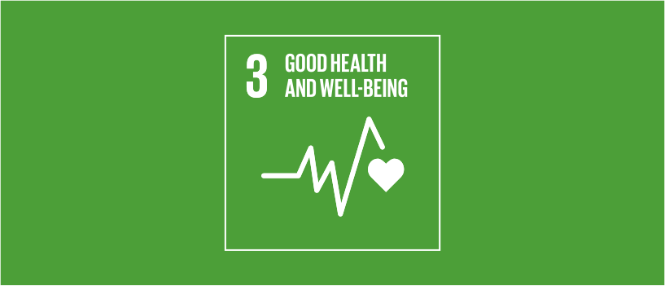

Ensure healthy lives and promote well-being for all at all ages.

Sustainable Development Goal 3 (SDG 3) aims to ensure healthy lives and promote well-being for all at all ages. This goal includes targets such as reducing maternal mortality, ending epidemics of communicable diseases, and reducing deaths and illnesses from hazardous chemicals and pollution (United Nations, 2015).

Strategy 1:
One of the primary UK strategies to implement SDG 3 (Good Health and Wellbeing) is the National Health Service (NHS) Long Term Plan. The NHS Long Term Plan, introduced in 2019, aims to improve the quality of patient care and health outcomes. It focuses on prevention, reducing health inequalities, and integrating care systems (NHS England, 2019).

Strategy 2:
Another important UK strategy for implementing SDG 3 (Good health and well-being) is the Public Health Outcomes Framework (PHOF), which provides a structured and coherent approach to improving public health and reducing health inequalities in England (Public Health England, 2020). It sets indicators and targets to measure progress in key areas such as life expectancy, healthy life expectancy and preventable mortality.

Public Health England's health protection strategy, on the other hand, aims to protect and improve the nation's health and wellbeing by addressing potential threats to public health, including infectious diseases, environmental hazards and chemical exposures (Public Health England, 2020).

Critical Review of Strategies
NHS Long Term Plan
The purpose of this critical review is to assess the implementation in practice of the Plan, whose focus is on prevention and the reduction of inequalities in health care. improve which will reflect positively on patient outcomes (King's Fund, 2019).
However, implementation challenges and resource issues, such as financial constraints and workforce shortages, can hinder the plan's effectiveness, and integrating care systems requires significant coordination and collaboration across sectors (Nuffield Trust, 2020).
It addresses these issues and to improve the Plan's effectiveness, increased funding and resources, along with improved coordination and cooperation between sectors, are critical.

Public Health England's Health Protection Strategy
The strategy targets critical threats to public health, including infectious diseases and environmental hazards. The strategy aims to improve preparedness and the ability to respond quickly and adequately (Public Health England, 2020).
In addition, Public Health England's strategy emphasizes prevention and early intervention by focusing on key areas such as promoting healthy lifestyles and reducing health inequalities. Such initiatives target smoking cessation, empowered healthy eating, physical activity, mental health support health and early disease detection to improve overall health outcomes, thereby reducing long-term health costs and reduce the burden on NHS (Public Health England, 2019).

Furthermore, the strategy highlights the great potential of new technologies in health prevention and intervention. For example, using digital health tools such as mobile health apps to monitor their health status can enable people to manage their health more effectively and provide health professionals with real-time data to tailor interventions accordingly.

However, its effectiveness may be limited by funding cuts and resource constraints (BMJ, 2020).

Evaluation of Progress Made by the UK Government

The UK Government has made significant progress in improving health and wellbeing through initiatives in both the NHS Long Term Plan and Public Health England's Health Protection Strategy. These joint efforts have led to improved health outcomes, better management of public health threats, and a focus on preventive care. However, challenges such as financial constraints and workforce shortages need to be addressed to sustain progress (ONS, 2023).

Overall, SDG 3 initiatives contributed to better health outcomes by targeting key determinants of health and focusing on preventive care (Marmot et al., 2020). As a result, these efforts to reduce health inequalities have led to fairer access to health services, improving overall wellbeing (NHS England, 2019).
In addition, addressing environmental hazards and chemical exposures has reduced pollution-related deaths and illnesses, contributing to a healthier population (Public Health England, 2020).
For example, the Organization for Economic Co-operation and Development (OECD) provides policy recommendations for integrating economic, social, environmental and governance dimensions for sustainable development, while the United Nations and UNICEF play a critical role in promoting global health and well-being (OECD, 2020; UNICEF, 2020).

Challenges in Implementing SD Goal 3-Good Health and Wellbeing

Limited funding can hinder the implementation of health and wellbeing initiatives, affecting their reach and effectiveness (King's Fund, 2019). This issue is compounded by shortages in healthcare professionals, which can limit the capacity to deliver quality care and implement health programmes effectively (Nuffield Trust, 2020).
Furthermore, integrating care systems and coordinating efforts across different sectors and agencies require significant resources and collaboration, posing additional challenges (BMJ, 2020). Addressing complex environmental and chemical threats also demands coordinated efforts and sufficient resources, making effective management difficult (Public Health England, 2020).

Recommendations for Achieving SDG 3

- Increasing Funding for Health Initiatives: Adequate funding is essential to implement and sustain health and wellbeing programmes effectively. Research indicates that increased investment in health services improves health outcomes and reduces disparities (King's Fund, 2019).

- Realising the capabilities of emerging digital technology can also significantly enhance health initiatives. For example, telemedicine platforms enable remote consultations, making healthcare more accessible, particularly for individuals in rural or underserved areas, and ensuring timely medical intervention and continuous care (NHS England, 2020).

- Strengthening Workforce Capacity: Addressing workforce shortages is crucial for delivering quality care and implementing health programmes. Investing in healthcare education and training can help build a robust healthcare workforce, thereby improving service delivery (Nuffield Trust, 2020).

- Enhancing Coordination and Integration: Improved coordination and integration of care systems can enhance the effectiveness of health programmes. Successful integration of care systems has demonstrated improvements in patient outcomes and more efficient resource utilisation (King's Fund, 2019).

- Addressing environmental health risks, such as hazardous chemicals and pollution, remains pivotal for achieving both SDGs (WHO, 2020). Robust strategies integrating environmental considerations into health policies are imperative to mitigate these risks and promote sustainable development effectively (Public Health England, 2020).

In addition, reducing exposure to environmental hazards and chemical contaminants is essential to protect health and well-being. The implementation of pollution reduction policies has been effective in reducing associated deaths and illnesses, highlighting the importance of environmental health initiatives (Public Health England, 2020).

As well as promoting international collaboration between the OECD, the UN and UNICEF, efforts and outcomes to achieve SDG 3 are enhanced. Leveraging these partnerships enhances the UK's ability to address multifaceted challenges and implement best practice globally (Sachs, 2015).

Conclusion
In conclusion, Sustainable Development Goals (SDGs) 1 and 3, focusing on No Poverty and Health and Wellbeing respectively, are fundamentally interconnected in fostering a fairer and healthier society. Poverty reduction is pivotal for improving health outcomes, as disparities in socio-economic status deeply impact access to healthcare, nutrition, and overall living conditions. Conversely, improvements in health and wellbeing play a crucial role in breaking the cycle of poverty, illustrating the symbiotic relationship between these goals.

The UK has made significant strides in implementing strategies and programmes to achieve these SDGs. Initiatives like Universal Credit and social housing programmes under Goal 1 have been instrumental in alleviating poverty and enhancing living standards for vulnerable groups. Despite these efforts, challenges such as implementation delays and inadequate housing supply persist, necessitating ongoing evaluation and enhancement.

In conclusion, it is clear that Goal 3, the NHS Long Term Plan and Public Health England's Health Protection Strategy exemplify the UK's commitment to improving health and reducing inequalities. Progress towards these targets is evident, with tangible improvements in health outcomes and reductions in poverty across the UK. These frameworks prioritize preventive care, disease management, and protection against public health threats.

However, challenges, including financial constraints, labour shortages, and the complexity of health systems integration, pose significant obstacles to their full effectiveness.

Nevertheless, continued efforts are needed to address challenges such as funding constraints and resource inconsistencies. Improving coordination between sectors and strengthening international partnerships will be complementary but also critical to advancing these initiatives and ensuring their sustainability.

In summary, improving SDGs 1 and 3 has a profound impact on healthcare in the UK. By not only improving individual health outcomes, but also supporting the resilience of the health system. By tackling poverty and improving health and well-being the UK can achieve a fairer and more efficient healthcare system

Reference list:

BMJ (2020). Public health threats in the UK. BMJ, 369. doi:10.1136/bmj.m2084.
Department for Work and Pensions (2018). Universal Credit: Welfare that Works. [online] Available at: https://www.gov.uk/government/publications/universal-credit-welfare-that-works [Accessed 3 July. 2024].
Department for Work and Pensions (2020). Universal Credit: Evaluation. [online] Available at: https://www.gov.uk/government/publications/universal-credit-evaluation [Accessed 3 July. 2024].
Department for Work and Pensions (2024). Universal Credit: Future Directions. [online] Available at: https://www.gov.uk/government/publications/universal-credit-future-directions [Accessed 3 July. 2024].
Food Foundation (2019). The Broken Plate. [online] Available at: https://foodfoundation.org.uk/publication/broken-plate-2019 [Accessed 3 July. 2024].
House of Commons Work and Pensions Committee (2019). Universal Credit: the wait for a first payment. [online] Available at: https://publications.parliament.uk/pa/cm201919/cmselect/cmworpen/121/121.pdf [Accessed 3 July. 2024].
Joseph Rowntree Foundation (2018). UK Poverty 2018. [online] Available at: https://www.jrf.org.uk/report/uk-poverty-2018 [Accessed 3 July. 2024].
King's Fund (2019). The NHS Long Term Plan explained. [online] Available at: https://www.kingsfund.org.uk/publications/nhs-long-term-plan-explained [Accessed 3 July. 2024].
Marmot, M. (2005). The Status Syndrome: How Social Standing Affects Our Health and Longevity. Bloomsbury Publishing.
Marmot, M., Allen, J., Boyce, T., Goldblatt, P., & Morrison, J. (2020). Health Equity in England: The Marmot Review 10 Years On. [online] Available at: https://www.health.org.uk/publications/reports/the-marmot-review-10-years-on [Accessed 3 July 2024].
Ministry of Housing, Communities & Local Government (2018). Affordable Homes Programme. [online] Available at: https://www.gov.uk/government/collections/affordable-homes-programme [Accessed 3 July. 2024].
Ministry of Housing, Communities & Local Government (2024). Affordable Homes Programme. [online] Available at: https://www.gov.uk/government/collections/affordable-homes-programme [Accessed 3 July. 2024].
National Audit Office (2018). Rolling out Universal Credit. [online] Available at: https://www.nao.org.uk/report/rolling-out-universal-credit/ [Accessed 3 July. 2024].
NHS England (2019). The NHS Long Term Plan. [online] Available at: https://www.longtermplan.nhs.uk/ [Accessed 3 July. 2024].
Nuffield Trust (2020). The NHS workforce in numbers. [online] Available at: https://www.nuffieldtrust.org.uk/resource/the-nhs-workforce-in-numbers [Accessed 3 July. 2024].
OECD (2013). OECD Guidelines for Multinational Enterprises. [online] Available at: https://www.oecd.org/daf/inv/mne/48004323.pdf [Accessed 3 Jul. 2024].
OECD (2020). Policy Coherence for Sustainable Development (PCSD). [online] Available at: https://www.oecd.org/governance/pcsd/ [Accessed 3 July. 2024].
ONS (Office for National Statistics) (2023). UK Health Statistics. [online] Available at: https://www.ons.gov.uk/peoplepopulationandcommunity/healthandsocialcare [Accessed 3 July 2024].
Public Health England (2019). Health Profile for England. [online] Available at: https://www.gov.uk/government/publications/health-profile-for-england-2019 [Accessed 3 July. 2024].
Public Health England (2020). Health Protection Strategy. [online] Available at: https://www.gov.uk/government/publications/health-protection-strategy [Accessed 3 July. 2024].
Sachs, J. D. (2015). The Age of Sustainable Development. Columbia University Press.
Shelter (2019). Social Housing: How many people are on the waiting list in your area? [online] Available at: https://england.shelter.org.uk/professional_resources/policy_and_research/social_housing [Accessed 3 July. 2024].
UK Parliament (2019). Universal Credit: the wait for a first payment. [online] Available at: https://publications.parliament.uk/pa/cm201919/cmselect/cmworpen/121/121.pdf [Accessed 3 Jul. 2024].
United Nations (2015). Transforming our world: the 2030 Agenda for Sustainable Development. [online] Available at: https://www.un.org/sustainabledevelopment/development-agenda/ [Accessed 3 July. 2024].
United Nations. (2015). Transforming our world: the 2030 Agenda for Sustainable Development. Available at. https://sustainabledevelopment.un.org/post2015/transformingourworld.
UNICEF (2020). Child Protection. [online] Available at: https://www.unicef.org/protection [Accessed 3 July. 2024].
WHO (2020). Protecting Consumers’ Health - Ensuring the Safety of Food. [online] Available at: https://www.who.int/activities/protecting-consumers-health-ensuring-the-safety-of-food [Accessed 3 July. 2024].
World Bank, 2021. The World Bank Annual Report 2021 [Rapport Annuel 2021]. The World Bank Group, number 36067, December.
World Health Organization. (1946). Preamble to the Constitution of the World Health Organization.] Available at: https://www.who.int/about/governance/constitution.
World Health Organization (2020). Protecting Consumers’ Health - Ensuring the Safety of Food. [online] Available at: https://www.who.int/activities/protecting-consumers-health-ensuring-the-safety-of-food [Accessed 3 July. 2024].

