Student Name: Niamh O’Dobhain
Number: 1904839
Programme of Study: BA Fine Art – Studio, Site and Context
Module: ADAD4018 Ways of Thinking
Lecturer’s Name: Alex Duncan

Tasks in the order I received them:
Task 1: Manifesto Writing = words
Task 2: Practice-based Writing =
Task 3: Observational Writing =
Task 1: Manifesto Writing
My own Manifesto
- Create female portraits exploring the ideas of beauty and the ‘grotesque’
- Influenced by the Aesthetic Movement and Feminist values
- Reflect on society and its pressures on women past and present and how it affects their mental health
- Exploit the irony and the contradiction of female stereotypes
- Analyse the perception of age and beauty
- Inspired by the lives of women
- Empower women to create their own version of ‘beauty’
- Celebrate the beauty of individuality
- Curate and present works in innovative ways

TITLE????? – the Pre- Raphaelites and Manifestos?????
When reviewing the National Gallery’s Artemisia exhibition Jackie Wullschläger wrote
“It’s impossible to stand before them without wondering: if art history had been different, if more female artists had painted and had depicted women, could women’s position in history itself have been different?” (2020)
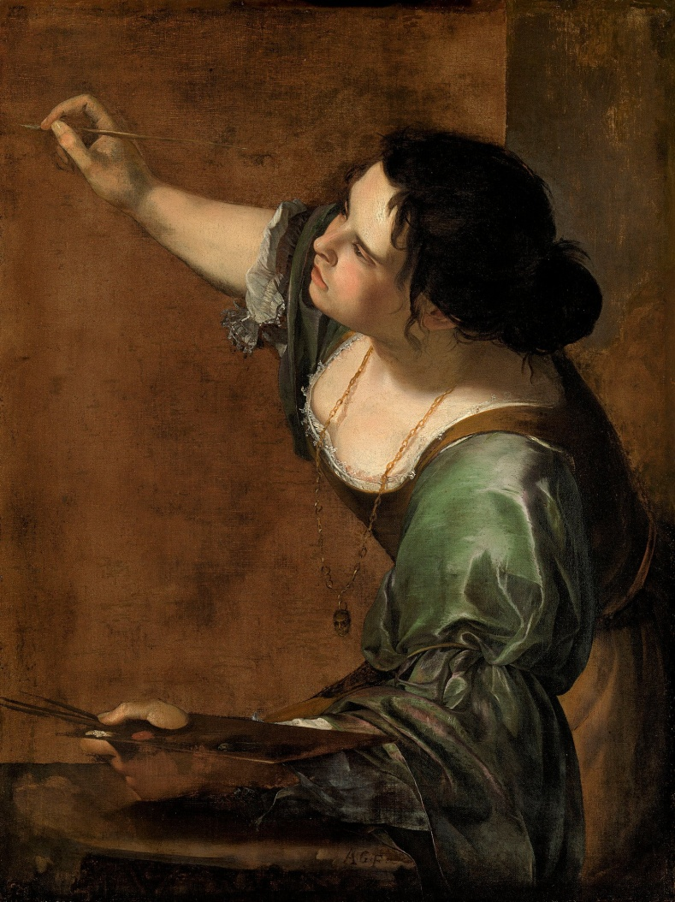
Figure 1: Artemisia Gentileschi, 1639, Self-Portrait as the Allegory of Painting.
Allowing women to represent themselves is fundamentally my aim. I am drawn to researching and telling women’s stories, in a time where we’re fighting to acknowledge people whose representation has been controlled by mostly white, heterosexual, cisgendered men throughout history, it’s crucial to let people tell their own stories and share their perspective.
Since the Feminist Art Movement in the 1960’s, although it is still not equal, more women are being featured in galleries, as well as newly rediscovered female artists who are finally getting the recognition they deserve. The Pre Raphaelite Sisters exhibition in October 2019 – January 2020 showed the works of twelve women whose works were overshadowed by their male contemporaries, with some who were cast aside as muses and not artists in their own right; most notably Elizabeth Siddal. (National Portrait Gallery, 2019) Pre Raphaelitism allowed “a style of painting that encouraged imagination and expression rather than erecting criteria of correctness” (Taylor, 2011), which gave artists freedom especially for women to pave their own way in the art world.
The Pre Raphaelites have been described as “Victorian Avant-Garde” (Poe, 2012) and set up ideas that lead to modernism. The Brotherhood’s idea of a manifesto later became a “hallmark of modernism” (Tate, 2020c) and it tore apart ideals created by the academy. There shouldn’t be rules imposed on artists as to how and what they create. Art needs to expand and grow with the artist. The Pre-Raphaelites even grew away from their manifesto to follow their own individual paths. Artists should strive for individuality to present their own interpretation as well as other’s that might not be heard. Manifestos are becoming less useful to their creators often holding them back and not encouraging individuality.
The Pre Raphaelites initially concentrated on displaying a narrative and looked for more of a ‘realistic’ approach as they ‘returned to nature’ inspired by the teachings of John Ruskin. (Tate, 2020b) However many notable Pre-Raphaelite artists such as Dante Gabriel Rossetti and William Morris later leaned into aestheticism. Pre-Raphaelitism initially
“scorned the advice of Sir Joshua Reynolds, […] rejecting his recommendations […] that artists improve upon what was imperfect or irregular in nature and create an “Ideal Beauty” instead” (Casteras, 1992)
which they did as their muses were not the idealised Victorian women, but through the adoption of aestheticism they were no longer presenting realism either and ultimately created a new idealised beauty. Female Pre-Raphaelite artist “Evelyn De Morgan […] depicted a more authentic version of [Jane] Morris’ feminine beauty by showing her […] hair turning grey with age.” (Katzman and Daher, 2020)
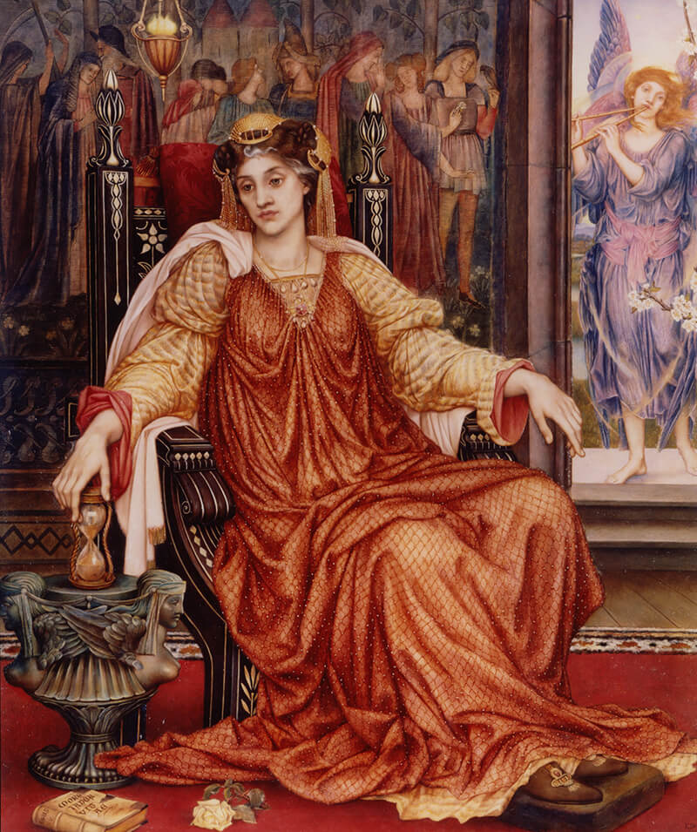
Figure 2: Evelyn De Morgan, 1905, The Hourglass.

Female Pre Raphaelite artists depicted muses they worked with in a different way, often mixing the reality with the aesthetics of the movement. This combination presents an interesting contradiction and most importantly provides women portraying women which should be celebrated and encouraged to allow women to gain control over their own narrative.

Bibliography

Casteras, S.P. (1992) Pre-Raphaelite Challenges to Victorian Canons of Beauty. The Huntington Library quarterly, Vol . 55(1), pp.13–35 Available at: https://www.jstor.org/stable/3817653 (Accessed: 17 November 2020)

Frey, A. (2020) The Women of Pre-Raphaelite Art. Available at: https://www.artandobject.com/articles/women-pre-raphaelite-art (Accessed: 18 November 2020)

Hughes, K. (2019) More than tragic muses: female Pre-Raphaelite artists take flight. Available at:
https://www.theguardian.com/artanddesign/2019/oct/12/more-than-tragic-muses-female-pre-raphaelite-artists-finally-take-flight (Accessed: 18 November 2020)

Jeffrey-Easby, R. (2020) A Beginner’s Guide to the Pre-Raphaelites. Available at: https://www.khanacademy.org/humanities/becoming-modern/victorian-art-architecture/pre-raphaelites/a/a-beginners-guide-to-the-pre-raphaelites (Accessed: 17 November 2020)

Jeffrey-Easby, R. (2020) The Aesthetic Movement. Available at: https://www.khanacademy.org/humanities/becoming-modern/victorian-art-architecture/pre-raphaelites/a/the-aesthetic-movement (Accessed: 17 November 2020)

Katzman. L. and Daher, N. (2020) THE WOMAN BEHIND THE PRE-RAPHAELITE BROTHERHOOD. Available at: https://www.smithsonianmag.com/smart-news/revisiting-women-behind-pre-raphaelite-band-brothers-180974035 (Accessed: 18 November 2020)

National Portrait Gallery. (2019) Pre-Raphaelite Sisters. Available at: https://www.npg.org.uk/whatson/pre-raphaelite-sisters/exhibition/ (Accessed: 18 November 2020)

Orlando, E. J. (2009) “That I May not Faint, or Die, or Swoon”: Reviving Pre-Raphaelite Women. Women's Studies, Vol. 38(6), pp.611–647. DOI: 10.1080/00497870903021505

Poe, S. (2012) Pre-Raphaelites: Victorian Avant-Garde. The British art journal, Vol. 13(3), p.116. https://web.a.ebscohost.com/ehost/pdfviewer/pdfviewer?vid=1&sid=a0606ba8-23fe-49d9-81a2-10a5f3c75e60%40sdc-v-sessmgr03 (Accessed: 18 November 2020)

Roe, D. (2019) Naturally Artificial: The Pre-Raphaelite Garden Enclosed, Victorian Poetry; Morgantown, Vol. 57, Issue. 1, pp. 131-153. DOI:10.1353/vp.2019.0002

Sebag-Montefiore, C. (2018) Sensuality, lust and passion: how the Pre-Raphaelites changed the way the world sees women. Available at: http://preraphaelitesisterhood.com/what-is-the-pre-raphaelite-woman/ (Accessed: 17 November 2020)

Tate. (2020a) POSTMODERNISM. Available at: https://www.tate.org.uk/art/art-terms/p/postmodernism (Accessed: 28 November 2020)

Tate. (2020b) PRE-RAPHAELITE. Available at: https://www.tate.org.uk/art/art-terms/p/pre-raphaelite (Accessed: 17 November 2020)

Tate. (2012a) Pre-Raphaelites: Victorian Avant Garde: Room 1. Available at:
https://www.tate.org.uk/whats-on/tate-britain/exhibition/pre-raphaelites-victorian-avant-garde/pre-raphaelites-victorian/pre (Accessed: 17 November 2020)
Tate. (2012b) Pre-Raphaelites: Victorian Avant Garde: Room 5. Available at: https://www.tate.org.uk/whats-on/tate-britain/exhibition/pre-raphaelites-victorian-avant-garde/pre-raphaelites-victorian-3 (Accessed: 17 November 2020)

Tate. (2020c) Were the Pre-Raphaelites Britain’s first modern artists? Available at: https://www.tate.org.uk/art/art-terms/p/pre-raphaelite/were-pre-raphaelites-britains-first-modern-artists (Accessed: 17 November 2020)

Taylor, H.N. (2011) 'Too individual an artist to be a mere echo': Female Pre-Raphaelite artists as independent professionals. The British art journal, Vol. 12(3), pp.52–59. Available at: http://www.jstor.org/stable/41615243 (Accessed: 17 November 2020)

Weston, N. (2013) PRE-RAPHAELITES: VICTORIAN AVANT GARDE. Craft Arts International, Issue. 87, pp.100–104. Available at: https://web.a.ebscohost.com/ehost/detail/detail?vid=0&sid=7814fe77-307a-4bbc-a920-643cd45edefb%40sdc-v-sessmgr03&bdata

Wullschläger, J. (2020) Female painter who seized the story: Artemisia Gentileschi. Available at: https://www.ft.com/content/682daa89-3812-48a5-af3c-627563174246 (Accessed: 10 December 2020)

List of Figures

Figure 1: Gentileschi, A. (1639) Self-Portrait as the Allegory of Painting. Available at: https://www.rct.uk/collection/405551/self-portrait-as-the-allegory-of-painting-la-pittura (Accessed 27 December 2020)

Figure 2: De Morgan, E. (1905) The Hourglass. Available at: https://www.demorgan.org.uk/jane-morris-by-evelyn-de-morgan/ (Accessed: 27 December 2020)

Task 2: Practice-based Writing
TITIE ????? Semiotics and Hag Horror
As we grow we learn to recognise meanings within imagery through how we view signs. We instinctively use semiotic analysis to figure out the denotations of what is literally there in an image. This then helps us indentify connotations – the meaning of the image. Denotations are factual but connotations are more subjective, due to each of our cultural upbringing and how we view the world; with affecting factors including gender, age, religion, ethnicity and wealth.
Theorist Charles. S Pierce broken down different types of signs and created his three categories; iconic, indexical and symbolic: The iconic is what you can see in an image literally; the indexical is what you can figure out through experience, and the symbol is something that you have learned through convention/ culture which is far more flexible and can be manipulated over time.
John Berger notes in his book Ways of Seeing (1972) that “The way we see things is affected by what we know or what we believe.” How we determine the meaning of an image comes down to the kind of culture around us. Intertextuality refers to something’s meaning being shaped by another thing that already exists; therefore the viewer’s opinions are shaped by another similar thing’s meaning. Theorists Julia Kristeva and Mikhail Bakhtin concluded that everything we see and process “cannot be detached from the social or cultural textuality which is the back drop in which a text [or anything] is created.” (Raj, 2015) These preconceived ideas can be dangerous and it can take a long time to break the cycle.
Here I will analyse a film still from Whatever Happened to Baby Jane (1962) showing how two female middle-aged characters were presented on screen.

During the 1960s a new subgenre of horror was created known as ‘hag-horror’ or ‘psycho-biddy’, ‘hagsploitation’ and more professionally ‘Grande Dame Guignol’. Erin Harrington in her book Women, Monstrosity and Horror Film: Gynaehorror, describes these films as
“featur[ing] older female actors playing mentally unstable or psychotic villains, vulnerable ‘women in peril’, and – in some cases – a slippery combination of the two.” (2016)
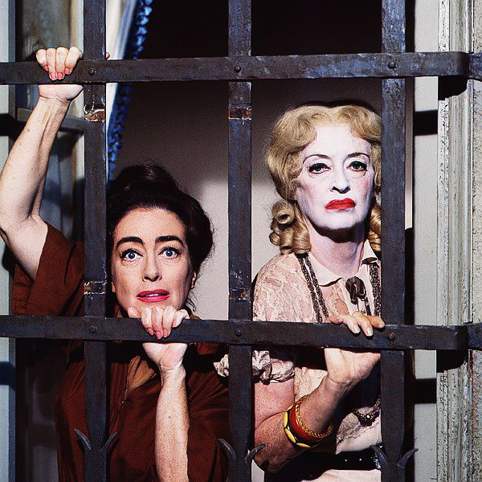
Figure 1: What Ever Happened to Baby Jane?, 1962 [promotional photo]

These films feed into stereotypes of older women that have been around for centuries with the word ‘hag’ which describes an ugly old woman, originated from the word ‘witch’ – “a spiteful, mischievous […] being” (Mayhew, A.L, 1884) and is still used today to degrade women.
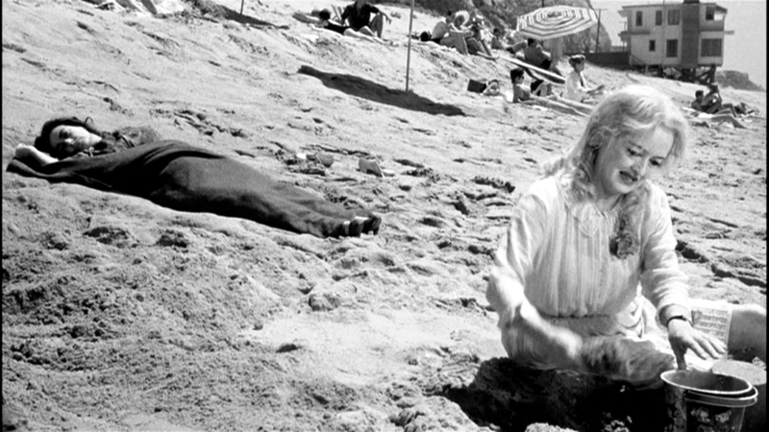
Figure 2: What Ever Happened to Baby Jane?, 1962 (2:04:56)

This film presents the character, Jane as being stuck in the past, tormenting with her overdone heavy makeup suggests lost glamour and reminiscent of a faded film star. Her doll-like hair as well as her pictured building a sandcastle signifies a child-like innocence as her sister; Blanche is dying in the background. This also shows some kind of mental illness as Tomasz Fisiak wrote specifically about leading female characters’ mental health in Hag Horror as Narrative Trauma, stating she
“usually deals with various kinds of traumatic experiences: loss of a child, domestic violence, childhood abuse, family conflicts or sudden end of career in the fickle artistic industry, etc.” (2019)
The representations of these lead female characters propel a certain stereotype of aging women and distort the truths of traumas and use it as entertainment. There is an important story behind the façade that should be told respectfully and honestly. It’s shown subtlety though Jane’s lighter coloured clothes compared to Blanche’s dark, that Jane is actually a victim.

Bibliography

Alfaro, M. (1996) ‘INTERTEXTUALITY: ORIGINS AND DEVELOPMENT OF THE CONCEPT’, Atlantis, Vol. 18, pp. 268-285.

Atkin, A. (2013) Peirce’s Theory of Signs, The Stanford Encyclopaedia of Philosophy, Zalta, E (ed.) Available at: https://plato.stanford.edu/entries/peirce-semiotics/ (Accessed: 10 December 2020)

Be Kind Rewind (2020) The Feud of Bette Davis and Joan Crawford 1963: Pt.2. [video] Available at: https://www.youtube.com/watch?v=lWYISEEl2dI (Accessed: 13 December 2020)

Berger, A. A. (2005) Semiotic Analysis, Media Analysis Techniques, 3rd ed, pp. 3-37, California: Sage

Berger, J. (1972) Ways of Seeing. London, Penguin.

Farber, S and McClellan (2020) Cinema ’62. Chicago: Rutgers University Press

Fisiak, T. (2019) What Ever Happened to My Peace of Mind? Hag Horror as Narrative of Trauma. Text Matters, 9(9), pp.316–328.

Harrington, E. (2016) Women, Monstrosity and Horror Film: Gynaehorror. London: Routledge

Mayhew, A.L. (1884) THE WORD "HAG." The Academy, 1869-1902, (632), p.424.

Raj, P. E. (2015) Interrogating Julia Kristeva’s Concept of Intertextuality. Vol. 3, pp. 77-80 Available at: https://www.researchgate.net/publication/273771676_TextTexts_Julia_Kristeva's_Concept_of_Intertextuality

Shelley, P. (2009) Grande Dame Guignol Cinema. London: McFarland

What Ever Happened to Baby Jane? (1962) Directed by Robert Aldrich [film]. United States: Warner Bros. Pictures

Wullschläger, J. (2015) ‘Portraits: John Berger on Artists’, by John Berger. Available at: https://www.ft.com/content/76a0f4f8-6068-11e5-9846-de406ccb37f2?FTCamp=engage/CAPI/website/Channel_muckrack//B2B (Accessed: 8 December 2020)

List of Figures

Figure 1: What Ever Happened to Baby Jane? (1962) Directed by Robert Aldrich [film - 2:04:56]. United States: Warner Bros. Pictures

Figure 2: What Ever Happened to Baby Jane? (1962) [promotional photo] Available at: https://www.freefilmfestivals.org/event/whatever-happened-to-baby-jane/022-what-ever-happened-to-baby-jane-theredlist/ (Accessed: 7 December 2020)

Task 3: Observational Writing
‘Artemisia’: Curator-led exhibition film by the National Gallery
The National Gallery released a 30 minute curator-led film of the Artemisia exhibition available online ahead of the physical exhibition in December 2020. Due to Covid-19, galleries have been exploring the idea of exhibiting online. There is no doubt that online exhibitions in any format are a different experience to viewing artwork in a physical gallery space: for me it’s no less of an experience, just a very different one.
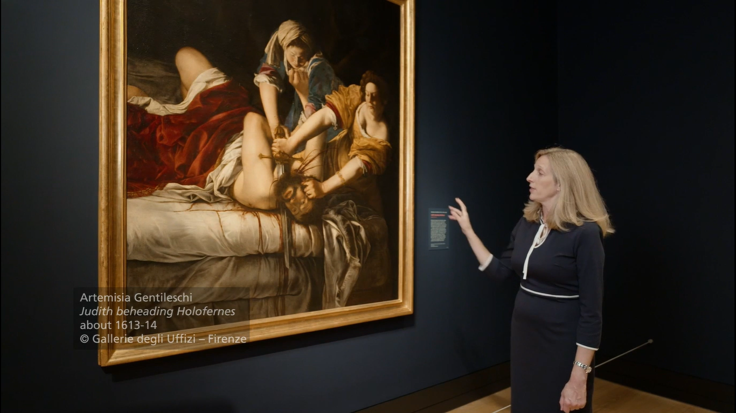
The most notable difference that struck me viewing the Artemisia film was that I had a fixed experience as the curator was fully in control with no interaction available to the viewer. Curator-led exhibition films are “a way of archiving or providing supplementary material” (Quaintance, 2020). I found got a more comprehensive understanding of the artist through an in depth narration from the curator, Letizia Treves than I would get from the captions in a physical exhibition. I found this digital format well suited to the Artemisia exhibition due to seeing some images of her paintings and built up my own opinions and feelings beforehand. However for the pieces that I was seeing for the first time I was forming my opinions through the information presented, therefore missing out on creating my pure own opinions of the work.

Figure 1: Artemisia: Curator-led exhibition film, 2020 (23:16)
The exhibition although on a screen was still powerful and at times my emotional responses were heightened due to Artemisia’s life story being told to me as I view her work. As a woman seeing images of her work, some for the first time it was quite emotional, as I connected to the subject of the female characters painted who felt more real and complete, which I haven’t felt with any of her male contemporaries’ depictions of women. The film presents the artwork in the exhibition space and how someone could move through it with each room acting like chapters in her life, which linked with the chronological narrative of Artemisia Gentileschi’s life being told throughout. This connected to the narrative in Artemisia’s storytelling alongside her own story which became poignant all being told by a female curator.
The whole film shows the importance and relevance of sharing female stories and presenting women fully through paint or exhibiting those works, with the curator Letizia Treves quoted as saying:
“The episode of her rape […] shaped the way in which we speak about Artemisia but I really want visitors to look at her life experiences as a whole and, most importantly, to focus on her artistic achievements.” (2020)
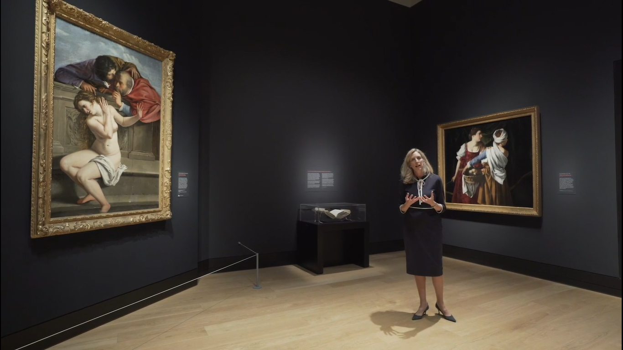
Figure 2: Artemisia: Curator-led exhibition film, 2020 (3:55)
By featuring letters written by Artemisia it allows her to speak for herself and show “the complexities of her personality” (Treves, 2020) not just for what she is generally known for - “revenge in paint” (Souter, 2020). Through the film the dark blue and grey wall colours reflected Artemisia’s sadness and struggles throughout her life, with a large nearly black blank wall looming over the records of her rape trial I found the most impactful. However the purple painted room with the largest paintings commissioned for royalty shows her success with the gold frames around her work throughout I got the sense that I was looking at something very important in history.
“No male artist could have created such potent paintings of female fury, fear, ecstasy, pride, bewilderment and cunning.” (Wullschläger, 2020)

Bibliography

Artemisia: Curator-led exhibition film. (2020) The National Gallery. [video] Available at: https://www.nationalgallery.org.uk/whats-on/artemisia-curator-led-exhibition-film (Viewed: 24 November 2020)

Cumming, L. (2020) Artemisia review – overwhelming present. Available at: https://www.theguardian.com/artanddesign/2020/oct/04/artemisia-review-overwhelmingly-present (Accessed: 2 December 2020)

Figes, L. (2020) Artemisia: an interview with curator Letizia Treves. Available at: https://artuk.org/discover/stories/artemisia-an-interview-with-curator-letizia-treves (Accessed: 1 December 2020).

Gompertz, W. (2020) Artemisia Gentileschi: Will Gompertz reviews her show at the National Gallery. Available at: https://www.bbc.co.uk/news/entertainment-arts-54334727 (Accessed: 2 December 2020)

Gompertz, W. (2018) Review: Artemisia Gentileschi – forgotten portrait of artist who endured rape trial. Available at: https://www.bbc.co.uk/news/entertainment-arts-46626762 (Accessed: 2 December 2020)

Ince, C. (2018) Charles and Ray Eameses’ museums without walls: Films as exhibition and exhibitions as film. Film, Fashion & Consumption, Vol. 7 (1), pp.19–38.

Jones, J. (2020) ‘A blood-splattered thrill ride into vengeance’ – Artemisia review. Available at: https://www.theguardian.com/artanddesign/2020/sep/29/artemisia-gentileschi-review-national-gallery-london (Accessed: 2 December 2020)

Mctighe, S. (2020) Review: Artemisia at the National Gallery in London. Available at: https://www.theartnewspaper.com/review/the-big-review-artemisia (Accessed 1 December 2020)

Quaintance, Morgan. (2020) Remote Viewing. Art Monthly, (437), pp.6–10.

Souter, A. (2020) ‘Artemisia at The National Gallery’. Review of Artemisia [exhibition] by The National Gallery. Available at: https://www.theupcoming.co.uk/2020/10/02/artemisia-at-the-national-gallery-exhibition-review/ (Accessed: 1 December 2020).

The National Gallery. (2019) Art Restoration of Artemisia Gentileschi’s ‘Self Portrait’ [video playlist] Available at: https://www.youtube.com/watch?v=zt7d5Nb5GdE&list=PLvb2y26xK6Y6F2GH6yosrsgGcCmgaNNjp (Accessed: 23 November 2020)

The National Gallery (2019) Artemisia Gentileschi: “The Spirit of Caesar in the soul of a woman!” [video] Available at: https://www.youtube.com/watch?v=08KDcjbBqgE (Accessed: 23 November 2020)

The National Gallery. (2020) Artemisia Gentileschi in 8 paintings. [video] Available at: https://www.youtube.com/watch?v=cNsg6RnlJtI&t=71s (Accessed: 23 November 2020)

The National Gallery (2019) Artemisia Visits [video playlist] Available at: https://www.youtube.com/watch?v=gDVTw6RcHgM&list=PLvb2y26xK6Y5HyMau08vl_nxsliIy0rBi (Accessed: 23 November 2020)

The National Gallery (2020) Judith beheading Holofernes. [video] Available at: https://www.youtube.com/watch?v=-wTXWA0KvgY (Accessed: 24 November 2020)

Wilbourne, E. (2016) A Question of Character: Artemisia Gentileschi and Virginia Ramponi Andreini. Italian studies, pp.335–355

Wullschläger, J. (2020) Female painter who seized the story: Artemisia Gentileschi. Available at: https://www.ft.com/content/682daa89-3812-48a5-af3c-627563174246 (Accessed: 10 December 2020)

List of Figures
Figures 1 & 2: Artemisia: Curator-led exhibition film. (2020) The National Gallery. [video - 23:16 & 3:55] Available at: https://www.nationalgallery.org.uk/whats-on/artemisia-curator-led-exhibition-film (Viewed: 24 November 2020)

