Marcus Taylor
UWTSD MSc Policing (Operational and Strategic Leadership)
Strategic Management in Policing

Table of Contents
Executive Summary. 2
Introduction. 3
Main Findings. 7
Developing a strategic plan. 7
Strategy Statement. 8
Mission Statement, Vision / Objective. 8
The Scope. 10
Environmental Analysis. 11
Resource and Capabilities Analysis. 12
Stakeholders, Culture and Change. 14
Business models. 17
Value creation 17
Value Configuration 17
Value Capture 17
Strategic Options/Theories. 18
VRIO Analysis. 18
SWOT Analysis. 18
Porters five forces. 18
The Harvard Policy Model / The Prescriptive Model. 19
The Learning School Model / Emergent Strategies. 20
Conclusion. 21
Recommendations. 23
References. 24
Appendices. 27
Appendix 1 27
Appendix 2. 28
Appendix 3. 29
Appendix 4. 30

Executive Summary.
Through understanding the term ‘strategy’ and incorporating academic theory, police strategic planning will become more professional. By exploring the current police practices and their performance to achieve, the report will look at how police goals and outcomes can be improved by utilising analysis and theory.
Mission, Vision Statements and planning strategy.
The report looks at how development of plans take place and it explores the terminology found in Mission, Vision statements and how these form part of the planning focus within strategy.
Scope, capacity, capability and environmental factors.
The report examines the scope of the police organisation as a whole and looks at capacity within current processes and seeks to offer recommendations around improvements. Taking into account environmental factors it reports how the use of analysis aids in strategic planning, highlighting strengths, weaknesses and shows potential threats, offering the organisation early protection to enable them the ability to mitigate risk.
Strategic management theory and academic insight.
The report will explore strategic management processes and academic theory and give insight into models of learning and their developers and strategists. Some of the theory explored;
- Building Block View
- Three Horizons framework
- PESTLE
- SWOT
- The value chain
- Porter’s five forces

Theories and strategies will be discussed throughout the report and look at how different strategy schools of thought within academia have emerged to offer support to organisations.
Conclusion and Recommendations.
Conclusions will be given around analysis and recommendations made to achieve better standards within the police organisation, and assist the strategic planning processes.

Introduction.
The term ‘Strategy’ has existed for a number of years but has become very prominent over the last few decades. There are many theorists around strategic management and Mintzberg (1987) is one of the most respected of all strategic minds and introduced one of his most famous strategic models, the ‘Five P’s for Strategy’. This defines strategy as a Plan, a Pattern, a Position, a Perspective and a Ploy and has been widely adopted around strategic thinking and management.
Strategy Is a regular term used in many a boardroom or senior managerial office and is one of the core managerial functions to shape an organisation, but what does it mean? An organisations structures must be fluid and work well to enable functionality, all of its component parts must try and work in tandem to achieve the goals set by its leaders (Whittington, et al., 2019). This report will explore Police Strategic Planning, its processes and the setting out of the plan for that organisation. Organisations can be described as containing five basic parts that evolve and form a structure. These include the ‘Operating Core’, where the workers perform the basic function of the organisation in this report this would mean the response officers. The ‘Middle Line’ which consist of managers who supervise such as Sergeants or first, second line managers and then the ‘Strategic Apex’, the senior leaders of an organisation such as the police chief officer. The final two parts, the ‘Techno Structures’ including your analysts, IT support and then the ‘Supporting Staff’. In the case of policing could include manager’s and leaders in specialist roles and functions assisting the strategic plan, like financial departments for example. All essential cogs in the plan to succeed (Mintzberg, 1979).
A key decision for police senior leaders is the Strategic Plan, how the organisation will look and function for a specified time. With key objectives, visions for its services and functionality to achieve goals and outcomes set out. Strategic planning is described as being a deliberative and disciplined effort to get fundamental decisions right when shaping the direction of the organisation, answering the what and why questions of those stated objectives and goals found within it (Bryson, 2011). The report will examine the police organisations processes, concepts, and theories of setting out and developing a strategic plan. Reviewing academic theories to evaluate if it affects the business positively or negatively in strategy processes.
it is important to explore the term and definitions of Strategy in isolation. So, what is a strategy? There are various views and opinions on this. Magretta (2011) talks about good strategy as being any plan and program that has superior results, enabling better economic performance. Porter (1996) explores how it is not always the case that operational effectiveness is strategy. He discusses how operational effectiveness is not sufficient and that you must preserve and outperform rivals to establish differences over a period, you must have longevity in your aims. All important and positive views on what is strategy, however Phillips (2011) has a different point of view and argues that strategy is that airy fairy stuff that senior managers and company executives do once a year, formulating a document with words and statements of grander that have little to no impact.
Linking these statements to policing it could be argued that there are similarities to Phillips thought processes of using words with no meaning or understanding. Police services in Wales have set out strategic plans and visions, setting goals for the future of their own organisations and communities. Welsh Police services using wording such as safeguarding communities together, and connecting with those communities (Dyfed Powys Police and Crime Commissioner, 2017), and other crime plans headlining with the statement ‘Everything is connected to everything else’ (South Wales Police and Crime Commissioner, 2021). You could argue and ask the question what do both statements actually mean, and do they really know themselves as an organisation at the lower tiers, as these are the staff who are trying to achieve and deliver the aims and goals set out. To deliver a suggested service and vision to the community. Mintzberg (1981) has actually put forward the argument that managers don’t actually know what the word ‘planning’ means as the term is too vast to understand its full meaning, and they merely work out broad things that need to get done and accomplish them.
To simplify the term ‘strategy’ it is explained as the long term goals and direction of any organisation (Whittington, et al., 2019). Strategy is normally defined over a long period of time and sometimes this can be years rather than months and for some organisations this can be over a decade. Long term strategy can be defined and emphasised by the three horizons framework (Whittington, et al., 2021). Horizon 1 showing the here and now, the current core and activities being met. Horizon 2 explores the plan and goals set out, where the organisation looks at future trends, highlighting issues and solutions to potential problems. A form of succession planning within a policing organisation. Horizon 3 concentrates more on the long term, distant future where nothing is certain. This is the riskier of the three horizons, but potentially may have the greater reward or outcome, and could simply be the use of greener technology in policing within 10 years, electric cars as a fleet for example. (Appendix 1).
Organisations are complex in nature and policing within the public sector is no different. When setting out the strategic plan for a police organisation there are complex relationships to consider both internally and externally consisting of partners and stakeholders such as the public, IT companies for example. With the inception of the Police and Crime Commissioner in 2016 now working alongside Chief officers in achieving set goals, scrutiny on strategic plans and performance is greater (Home Office, 2011).
When asking the question of ‘What is Strategy for’ the answer can vary. Within policing, strategy is ultimately to provide a guide and route to stakeholders of where the organisation is going, its purpose and what it’s objectives, goals are within a strategic plan. Stakeholders in turn are those who depend on the organisation to fulfil its own goals and in turn the organisation depends on. Collins & Ruckstad (2008) state that organisations and their managers should be able to summarise their strategy in 35 words or less and if this is the case then so should their staff if it’s to be a successful message. They state if executives and senior managers are truthful with themselves then this is highly unlikely as strategy and its setting is never quite that simple.

Main Findings.

Developing a strategic plan.
When developing a policing strategic plan there are a number of key elements found within it that must be considered by senior managers and chief officers and these elements will be explored further during this report. This is reinforced by theory and can be adopted in early planning phases. There are some public service scholars who are sceptical on the effectiveness of strategic planning in benefitting performance (Mintzberg & Waters, 1985).
The A, B, C’s model of strategic planning concentrates on three questions for the organisation, firstly the A as ‘where you are’, the B as ‘where you want to be’ and C as ‘how to get there’. This is illustrated in (Appendix 2) and presents the strategy formulation in a circular shape, with key areas such as mission, vision managed in a clockwise or counter clock wise motion to work (Bryson & Alston, 2011).
Illustrated below (Diagram 1) is the Building Block View. A structured model normally working from bottom to top to be effective, but it does lend itself to allow flexibility for sections/phases to be managed at differing times such as Phase 1 could be progressing whilst phase 2 is also being created.
Diagram 1 – Building Block View
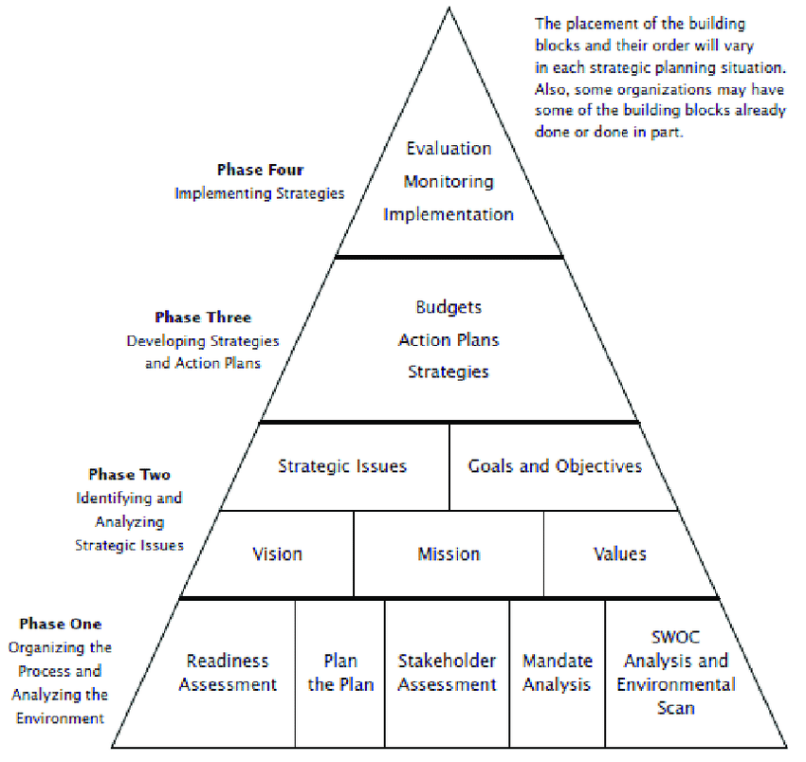 (Bryson & Alston, 2011)

Strategy Statement.
In policing the chief officers and managers should be able to define and summarise their own strategies with a strategy statement. These statements usually contain three main themes, namely the fundamental goals or the Mission Statement and Vision, objectives that the organisation is looking to set. Secondly the scope of its activities and thirdly the capability to achieve this task (Johnson, et al., 2013).

Mission Statement, Vision / Objective.
A mission statement is described as the overriding purpose of an organisation, posing the question of ‘what business are we in’. In policing a well written mission statement will assist in guiding employees, stakeholders in the direction of travel, and explain what the organisation does and what would be lost if it wasn’t there (Whittington, et al., 2021).
Collins and Porras (1996) explain that when building a company vison it will rely heavily on ideology and core values in order to succeed. They describe how the leagacy that computing icon David Packard of Hewlett and Packard or HP left on his death was simply known as the HP Way, a code of ethics or working practice. This was described as his greatest accomplishment and due to its success this code and ways of working continues to drive the companies vision and core Ideology, being described as the glue holding it all together.
It could be argued that policing relies on similar ideologies with police in England and Wales adhering to a Code of Ethics set out by the college of policing (COP). A vision, statement and guidance document for all to work towards. Its messages relayed to all who follow, describing prescriptive behaviours to achive highest standards. It gives direction, statements around honesty, integrity and equality. Utilising statements such as ‘Doing the right thing in the right way’ in its communication strategy (College of Policing, 2014). But are these just words on a page or are they actually followed by employees, and do they align with their own personal values. Do police officers see the value within the code, and were they consulted or do they just follow it due to a fear of reprisal and consequence. Is the messaging strategy working and do the public more importantly see professional improvements and a better organisation. Figures show and it could be argued that the code of ethics set out by COP isnt working as well as they hoped as highlighted by statistics found in the Independent Office for Police Conduct (IOPC) report, who had recieved over 67,000 complaints around the conduct of police officers in England and Wales for 2020/21 (Appendix 4), with delivery of duties and service being one of the highest areas complained around (Independant Office for Police Conduct, 2021).
The policing vision report produced by the National police Chief’s Council shows a 10 year vision for policing and how it will look in the future, tailored towards the complexities of society and its diverse needs. But how was this document put together and what collaborative work went into it to achieve the proposed success and its vision of the future (National Police chiefs council, 2019). Is it just pipe dreams, big phrases being orited by senior leaders, words and sentences like Enshrined and working collaboratetively in the public interest and advancement in public accountability (National Police Chief's Council, 2016). What is the objective of such phrasing and what does this actually mean to the public, do they understand it? Do the police organisations and its staff agree with it, or is it only senior manager’s opinions? In a recent research report compiled on the public’s perception of policing in England and Wales for Her Majesty’s Inspectorate of Constabulary, it is clearly shown that the mission statements and visions of police forces in these areas are not matching the public’s needs. These statements speak of working closely with the public to achieve goals but figures show that over 60% of the public feel that they are not well informed on what local police are doing (BMG Research, 2019).

The Scope.
Organisational theory around Scope asks itself two main questions. Firstly, how and who makes decisions? In police terms are they made at central headquarters or more locally by divisional commanders. The second question addresses motivation of staff to achieve goals and high performance. If looking at the headquarters being the hub and central decision making location of most police organisations, there is the benefit of reduction in costs and most senior decision makers are present. However, there is also the argument around bureaucracy as most top management state that this is always an issue in getting the correct staff in place for example. Too much red tape and hoops to jump through by incorporating HR and other decision makers (Mcafee, 2002). When setting the strategic plan, police managers would be considering what is actually required throughout the organisation. Questions around finance and staffing are considered and if current structures and ways of operating are achieving best value or could changes be made, including departments being added or some not so successful being dismantled or even outsourced. An example of this was when welsh police firearms units were centralised in 2013 and a joint unit established. A change in culture with staff and management evolving to differing ways of working, coming together to achieve a common goal. Cost reductions as less structures and one centralised location has offered better training, requiring less staff to manage it, and has created a more professional practices (Gwent Police and Crime Commissioner, 2013).
Another example of scope and cost reducing in strategic planning is decisions taken around what is run internally by police officers for example and what could be externalised by sub-contracting and outsourcing. The police eating facilities within policing estates are good examples of a change culture, professionalising by getting external stakeholders to manage (Collins & Rukstad, 2008).

Environmental Analysis.
It is important to understand your environment when developing a strategic plan. The benefits to managers from environmental analysis is a greater understanding of what the external environmental issues, influences are and any potential threats could be mitigated sooner. A disadvantage within the model is that you do need to allow it the necessary time and duration to get accurate results (Ginter & Duncan, 1990). Analysis of environmental issues must be considered when planning, a model to utilise for this is PESTLE. Conducting analysis which is political, economic, social, technological, legal factors and ecological (Whittington, et al., 2019). This fits in well with modern policing where services are bound by all areas of the acronym especially political judgements, as regularly placed on the organisation with changes in policies and legislation passed on by government. This can subsequently have that knock on effect in communities resulting in social and economic impacts as a result. One such example was the revision of stop search and its impacts (Home Office , 2015). PESTLE analysis has two main functions. Firstly, to identify the environment it is operating in and secondly to provide information and data to predict future trends, situations and issues that they may encounter on the horizon (Dockalikova & Klozikova, 2014).
Performing a successful PESTLE analysis is concerned with identifying and understanding the influences and factors affecting your organisation and evaluating the impact of the factors highlighted. The visual illustration below (Diagram 2) shows how PESTLE analysis is utilised by senior managers within the NHS around strategic planning around Covid–19 (Bennett, 2021) Similar in policing terms with political and social factors being high on their agenda.

Diagram 2 – PESTLE Analysis
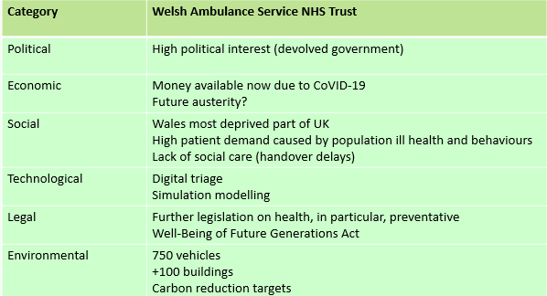 (Bennett, 2021)

Resource and Capabilities Analysis.
For any strategic plan to be successful in the public sector, resourcing and capabilities are key factors. In policing the officers at all levels are needed to implement the plan and with that the capability must be there within an organisation’s structures to enable them to achieve this goal. This has been difficult recently with cuts to finance, resulting in less resources within policing as a result of austerity (Boulton, et al., 2017).
When explaining the word resource, simply put as ‘what we have’, and the term capability as ‘what we do’ with them. Some strategic theorists explain that to gain a competitive advantage and outperform your competitors, a resource based theory or view (RBV) could be utilised. In summary, looking at how their resources and capability will differ from another organisation and how difficult these would be to be imitated. To explain this in a policing sense you have a chief officer within one force who is performing and providing high quality work, when its closest competing police force isn’t providing the same from its senior officer. This is known as a distinctive competency and can be the difference between one organisations success and a similar organisations poor performance (Barney & Clark, 2007).
When considering the strategic plan, three functions are concerned with resource and capability. These are listed below (Diagram 3) as physical, financial and human and are essential resource considerations and must be factored into planning and strategic thinking. This is relevant in determining if you have the correct capacity and capability to manage your business, for example buildings or IT systems from the physical heading, or the organisations employees and managers in the human heading (Whittington, et al., 2021).
Diagram 3
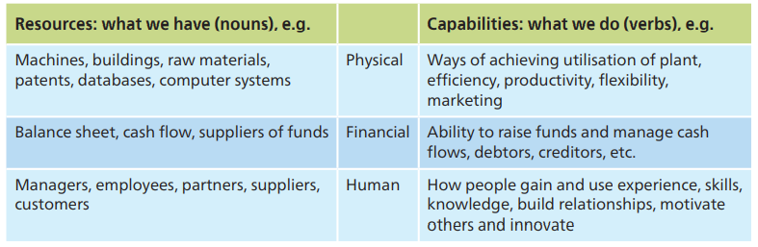

By identifying and evaluating your businesses strengths and weaknesses it allows the organisation to grow.
The value chain is another framework considering resourcing systems that can give a company competitive advantage. In order for an organisation to gain here it requires its resources and systems to be well managed and structured to offer the best value to the business (Porter, 1985). Porters theory below (Diagram 4) shows the primary activities are directly concerned with the organisation and the supportive activities assist with and improve the primary activities services and delivery.
Diagram 4 - The Value Chain
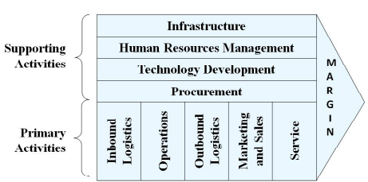 (Porter, 1985)

Stakeholders, Culture and Change.
When defining stakeholders, they include all individuals with interest in the organisation. In relation to strategic planning within policing this includes internal and external bodies such as officers and civilian staff, public, unions, government, other emergency services, suppliers (Diagram 5). They influence the organisation and act in their best interests however their own specific interest is taken into account also (Capon, 2004).
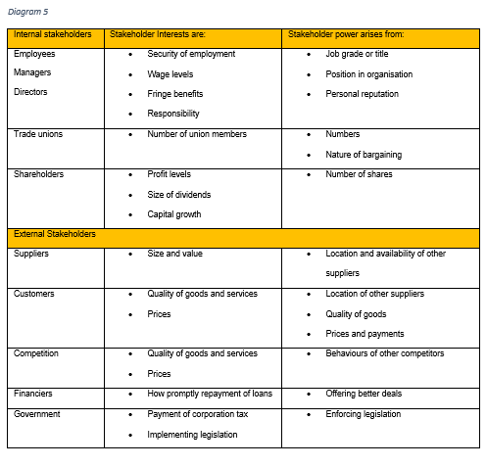 (Capon, 2004)
Partnerships are key to policing as they have seen devolved management structures within organisations recently, placing more focus on new ways of achieving goals and objectives, commonly referred to as new public management (Elliott, et al., 2020). Stakeholders are now paramount to strategic thinking in policing and management is now very much multi-faceted and includes a number of differing key organisations. Stakeholder mapping is a tool that can assist to plot functions and external roles using its power predictability and interest matrix’s which predicts where the power lies, their interest in the project and any problems that are foreseen (Newcombe, 2003).
Organisational culture defines what type of workplace is provided for everyone. It can be argued that good culture can offer a competitive advantage over an organisation with culture issues. In order to succeed three key areas need to be adopted, namely it must be a valuable culture, rare and one that is imperfectly imitable (Martin, et al., 1983). Culture is defined by how efficient its cultural web is (Johnson, et al., 2005). Each of the elements of the web drawn together, entities that form the organisation, all adding to the value of it if success (Diagram 6).

Diagram 6 – The Cultural Web
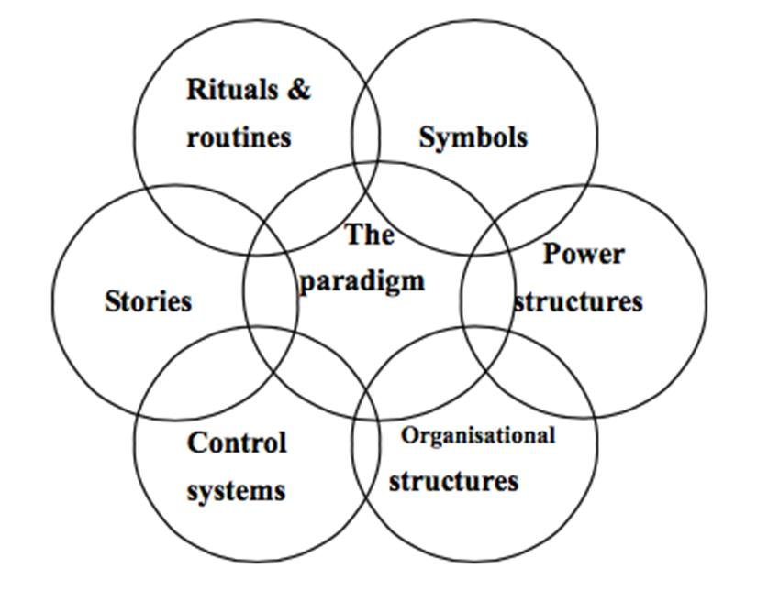 (Johnson, et al., 2005)

It has been argued that changes to the cultural web of an organisation is required in certain circumstances. An example could consist of the organisational structures changing from functional to more divisional ones which will change where the power may sit in the police organisation. Normally a centralised view would be decentralised to divisional commanders with middle managers given far more responsibility of the control and running of their division (Deal & Kennedy, 1983).

Business models.
As part of the strategic plan a key part is the business model and this is split into three sub headings.
Value creation – this describes how the value is created for all parties involved including customers as in the public, staff and partners. The key is how to satisfy their needs and solve any problems that are arising.
Value Configuration – A configuration of independent resourcing and activity, for example all the police IT systems, any facilities within the estate. These form part of a value chain and managers must decide how they are linked within the organisation.
Value Capture - State costing structures for all resources and activities and any revenue for stakeholders and customers. Shows how the value is shared through the organisation and subsequent stakeholders involved within it. It also outlines any profits made.
It’s important to emphasise that the business model is sometimes neglected and is never really questioned and critiqued. Business models must not become institutionalised and part of organisational practices. It can be good practice to share your business model with other similar organisations but it is usual that the business strategy differs (Teece, 2009).

Strategic Options/Theories.
The early stages of strategic planning require key strategic considerations. We will discuss here relevant academic and business theory to support senior decision making in addition to practices explored in the report.

VRIO Analysis.
When discussing gaining a competitive advantage, the mnemonic VRIO could be considered in policing when formulating the strategic plan. Standing for Value, and do the resources exist that are valued by the customer. Rarity is explained as the resources that exist that others do no possess and an example could be as simple as a fleet of electric cars your competitors don’t, or staff members with specific skills offering value to the organisation. Inimitability is defined as resources that are difficult and too costly for rivals to obtain and imitate for their own business. This could come down to location, one rural setting against one urban setting, both individual and unable to be imitated. Lastly organisational support talks about the organisations ability to exploit the resourcing and capabilities set out in an appropriate manner (Fisher, et al., 2020).

SWOT Analysis.
When proposing a strategic plan, analysis of Strengths, Weakness, Opportunities and Threats is beneficial and known as SWOT. The aim to identify the strengths and weaknesses within the organisation, examining what opportunities are available to managers already within the organisation, and highlighting potential threats to the business. This enables better foresight and enables succession planning (Hill & Westbrook, 1997).

Porters five forces.
One of the most recognised strategic theories in management, Porters ‘five forces’ (Porter, 1989). Namely, Threats of new entrants, Threats of differing products, Bargaining power of customers and suppliers and all jockeying for that position within the industry (Appendix 3). Initially a private sector theory, it can also adapt for the public sector and in terms of police strategic planning, profit could be looked at as customer satisfaction. Taking this into account forces within the model would be considered on how they impacted product and service delivery to police customers, enabling managers to concentrate their focus on local key issues and emerging threats. For example, in policing it may look at changing the focus of the service from a key area of business with saturated numbers of stakeholders such as a social service incident which already has large multi organisational inputs to resolve problems. It may now allow senior manager to be more specific, setting objectives within the strategic plan that concentrate on less saturated areas of business with a smaller pool of stakeholders to achieve goals set, a bigger risk as a result to the organisation, however the greater focus allows for better results, more reward and helps to highlight the critical strength and weakness of the organisation (Whittington, et al., 2021).
By modifying the 5 forces to include a political influence, sponsors as well as consumers and by exploring the differences and understanding how both the private and public sector goals around finance and profit differ, Vining (2011) has made a relevant model for policing organisations. It is argued that public organisations and its management should follow the private sector and become more business-like, shifting focus and changing structural and management procedures with the term ‘new public management’ being sponsored (Ferlie, et al., 1996).

The Harvard Policy Model / The Prescriptive Model.
Described by Ferlie and Ongaro (2015) as an essential for the toolbox of any organisations strategic planning. Originally created by Chandler (1963), this particular model is widely thought of as the most used planning process within public sectors. By measuring its strengths and weaknesses, the threats and oppourtunities and values of mangers and what obligations they have to public and stakeholders. This would incorporate a senior management team and is widely seen today in modern day policing with strategy implementation, keeping things simple and relies heavily on the previous SWOT and PESTLE analysis models to function well (Bryson & George, 2020).

The Learning School Model / Emergent Strategies.
With his theory around strategy formation and it being able to be categorised into differing schools of thought, Mintzberg, et al. (1998) suggests ten differing perspectives, schools around strategy and implementation. The Learning school incorporates formation of strategy as an emergent process, an idea of learning over time. In summary the strategy evolves and changes as people learn and adapt. This theory discusses how it’s very much descriptive rather than prescriptive and how strategies actually form in the organisation and not how they are formulated. When analysing this school of thought, deliberate strategy is defined as being realised in action and emergent strategy prioritising learning as the focus. Deliberate strategy as a school of thought has been realised to have very little elements of learning within it. Explicit intentions or implementation of plans for example and never seemingly adapting those intentions to formulate new understandings which the emergent theory introduces. Mintzberg explains that the concept of emergent strategy allows strategic learning as it will acknowledge an organisations taking risks and learning from experimenting. When taking these actions, receiving feedback and evaluating is key, and as this practice continues as a working strategy this pattern will eventually form and become new strategy. In essence each action influences the next and so on. An intended plan or strategy can emerge with new emergent ones to become something different (diagram 7). The below, shows how the emergent strategy intercepts the deliberate strategy.
Diagram 7 - Emergent Strategy
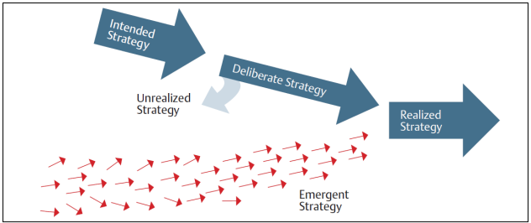
Brews & Purohit (2007) argue from previous planning research that there is a direct link between proper controls, better planning giving better performance relationships and outcomes to the organisation. However, there is a differing that argues there is no direct link to effective planning and greater financial reward (Falshaw, et al., 2006). This is also argued by O'Regan & Ghobadian (2007), who claim no direct link, but claim there could be a link between a serious approach to planning by mangers that could result in positive relationships in police organisational performance if done correctly.

Conclusion.
In conclusion it is clear from analysis and the report findings that there is a vast amount of strategic management theory with academic and professional views around its planning. The business sector has utilised this theory in action for a number of years in managing reward for their respective companies. The report has shown that this is slowly changing as public sector leaders realise their own business can improve by being more professional around strategy although no financial rewards are sought there is the recognition of being the best police force it can be, and with slight changes and utilising strategic theory when making police plans, their own strategy will improve for staff and public alike. Doing capability analysis has shown that it can significantly help the organisation financially and produce better value for money by changing the way business is done, with consideration to smaller estates and more technology used. By utilising analysis when completing strategic plans this has shown to benefit police organisations, PESTLE and SWOT have shown to assist in productivity and achieving set objectives when evaluating. The paper has shown when formulating plans there is no perfect strategy, therefore perfectly emergent, prescriptive and descriptive strategies will be difficult to achieve in isolation so flexibility is required here and a consideration of using elements of all when setting out your strategic plan would appear to be the most beneficial, giving flexibility around emergent issues and trends.
Threats and risk to police businesses can be mitigated with joint working principles and stakeholders mapping is key to this. More consultation is needed with the lower tier workforce and response as the report shows senior managers are still making strategies for organisations in isolation with little consultation around objectives with the workforce. If delivery of strategic aims and objectives are to improve all staff must have a role in its inception, and performance, results will improve for the public. New public management and modern ways of working seem to be assisting the service and by continuing to make use of analysis and theory, evaluate correctly and take action to change where necessary, the benefits to the organisation both financially and professionally will be greater.

Recommendations.
One of the main recommendation from the report is early consultation with all workforce and stakeholders to achieve a more rounded and holistic view of the needs and goals that should be set rather than one individual realising their own values. Officers at all levels are asked to deliver on plans and goals, but have little consultation and no buy in, so motivation to achieving set goals can be effected. Communication strategies must improve to be more relevant to all staff and stakeholders. Messaging must be clear and concise and resonate with the whole organisation, stakeholders, and can be improved by regular meetings and early engagement when considering goals and objective within the strategic plan. This increases their organisational value, and enables all staff to feel part of the overall vision.

References.
Barney, J. B. & Clark, D. N., 2007. Resource Based theory: Creating and Sustaining Competitive Advantage. 1st ed. New York: Oxford University Press.
Bennett, H., 2021. Planning & Performance - A Practitioner's Experience, London: Welsh Ambulance Service NHS Trust .
Bennett, H., 2021. Planning & Performance- A Practitioner’s Experience, London: NHS.
BMG Research, 2019. Public Perceptions of Policing in England and Wales 2018, Birmingham: BMG Research.
Boulton, L., McManus, M., Metcalfe, L. & Brian, D., 2017. Calls for police service:Understanding the demand profile and the UK police response. The Police Journal, 90(1), pp. 70-85.
Brews, P. & Purohit, D., 2007. Strategic Planning in Unstable Environments. Long range Planning, Volume 40, pp. 64-83.
Bryson, J. & George, B., 2020. Strategic Management in Public Administration. Oxford research Encyclopedia, pp. 1-26.
Bryson, J. M., 2011. Strategic Planning for Public and Nonprofit Organizations: A Guide to Strengthening and Sustaining Organizational Achievement, London: John Wiley and Sons.
Bryson, J. M. & Alston, F. K., 2011. Creating Your Strategic Plan. 3 ed. San Francisco: Jossey Bass.
Capon, C., 2004. Understanding Organisational Context. Harlow: Financial Times.
Chandler, A. D., 1963. Strategy and Structure Chapters in History of the Industrial Enterprise. 2 ed. Cambridge, Massachusetts: The M.I.T Press.
College of Policing, 2014. Code of ethics, Coventry: College of Policing.
Collins, D. J. & Rukstad, M. G., 2008. Can You Say what Your Strategy Is?. HArvard Business Review, 86(4), pp. 82-90.
Collins, J. C. & Porras, J. I., 1996. Building Your Company’s Vision. Harvard Business Review On Point, pp. 66-78.
Deal, T. E. & Kennedy, A. A., 1983. Culture: A New Look Through Old Lenses. The Journal Of Applied Behavioral Science, 19(4), pp. 498-505.
Dockalikova, I. & Klozikova, J., 2014. MCDM Methods in Practice: Determining the Significance of PESTEL Analysis Criteria. Kidmore End, Academic Conferences International Limited.
Dyfed Powys Police and Crime Commissioner, 2017. POLICE AND CRIME PLAN 2017-2021, Carmarthen: Dyfed Powys Police and Crime Commissioner.
Elliott, G., Day, M. & Lichtenstein, S., 2020. Strategic planning activity, middle manager divergent thinking, external stakeholder salience, and organizational performance: a study of English and welsh police forces. Public Management Review, 22(11), pp. 1581-1602.
Falshaw, R. J., Glaister, K. W. & Tatoglu, E., 2006. Evidence of formal strategic planning and company performance. Management decisions, 44(1), pp. 9-30.
Ferlie, E., Ashburner, L., Fitzgerald, L. & Pettigrew, A., 1996. The New Public Management in Action. 1 ed. New York: Oxford University Press.
Ferlie, E. & Ongaro, E., 2015. The structuring of organizations Concepts, schools, and contemporary issues. New York: Routledge.
Fisher, G., Wisneski, J. E. & Bakker, R. M., 2020. Strategy in 3D: Essential Tools to Diagnose, Decide, and Deliver. New York: Oxford University press.
Ginter, P. M. & Duncan, J. W., 1990. Macroenvironmental analysis for strategic management. Long Range Planning, 23(6), pp. 91-100.
Gwent Police and Crime Commissioner, 2013. Collaboration. [Online]
Available at: https://www.gwent.pcc.police.uk/en/about-us/working-together/collaboration/#:~:text=The%20Joint%20Firearms%20Unit%20has%20been%20established%20to,but%20also%20generates%20savings%20in%20procurement%20and%20training.
[Accessed 9 January 2022].
Hill, T. & Westbrook, R., 1997. SWOT Analysis: It's Time for a Product Recall. Long Range Planning, 30(1), pp. 46-52.
Home Office , 2015. Revised PACE Code A (Stop and Search), London: Home Office.
Home Office, 2011. Police Reform And Social responsibility Act 2011, London : TSO.
Independant Office for Police Conduct, 2021. Police Complaints Statistics for England and Wales 2020/21, London: Independent Office for Police Conduct.
Johnson, G., Scholes, K. & Whittington, R., 2005. Exploring corporate Strategy. 7th ed. Harlow : Prentice Hall.
Johnson, G. et al., 2013. Exploring Strategy Text and Cases. 10 ed. Harlow: Pearson Education.
Magretta, J., 2011. Understanding Michael Porter : The Essential Guide to Competition and Strategy. Boston: Harvard Business Review.
Martin, j., Feldman, M. S., Hatch, M. J. & Sitkin, S. B., 1983. the Uniqueness Paradox in organizational Stories. Administrative Science Quarterly, Volume 28, pp. 339-358.
Mcafee, P. R., 2002. Competitive Solutions: The Strategist's Toolkit. Oxford: Princeton University Press.
Mintzberg, H., 1979. The Structuring of Organizations. 1 ed. London: Pearson.
Mintzberg, H., 1981. What is Planning Anyway?. Strategic Management Journal, Volume 2, pp. 319-324.
Mintzberg, H., 1987. The Strategy Concept I: Five Ps For Strategy. California Management Review, pp. 11-21.
Mintzberg, H., Ahlstrand, B. & Lampel, j., 1998. Strategy Safari A Guided Tour Through The Wilds Of Strategic Management. New York: The Free Press.
Mintzberg, H. & Waters, J. A., 1985. Of Strategies, Deliberate and Emergent. Strategic Management Journal, 6(3), pp. 257-272.
National Police Chief's Council, 2016. Poliicng Vision 2025, London: National Police Chief's Council.
National Police chiefs council, 2019. The Policing Vision 2025, London: NPCC.
Newcombe, R., 2003. From client to project stakeholders: a stakeholder mapping approach. Construction Management and Economics, Volume 21, pp. 841-848.
O'Regan, N. & Ghobadian, A., 2007. Formal strategic planning: annual raindance or wheel of success?. Strategic Change, Volume 16, pp. 11-22.
Phillips, L. D., 2011. What is Strategy?. Journal of the Operational Research Society, 62(5), pp. 926-929.
Porter, M., 1985. Competitive Advantage. New York: The Free Press.
Porter, M., 1996. What is Strategy?. Harvard Business Review, 74(6), pp. 61-78.
Porter, M. E., 1989. How Competitive Forces Shape Strategy. In: D. Asch & C. Bowman, eds. Readings In Strategic Management. London: Palgrave, pp. 133-143.
Porter, M. E., 2008. The Five Competitive Forces That Shape Strategy. Harvard Business Review, 86(1), pp. 78-93.
South Wales Police and Crime Commissioner, 2021. SOUTH WALES POLICE AND CRIME PLAN 2021-2025, Bridgend: South Wales Police.
Teece, D. J., 2009. Business Models, Business Strategy and Innovation. Long Range Planning, Volume 43, pp. 172-194.
Vining, A. R., 2011. Public Agency External Analysis Using a Modified 'Five Forces' Framework. International Public Management Journal, 14(1), pp. 63-105.
Whittington, R. et al., 2019. Exploring Strategy. 12 ed. Harlow: Pearson.
Whittington, R. et al., 2021. Fundamentals of Strategy. 5 ed. Harlow: Pearson Education Ltd.

Appendices.

Appendix 1
The Three Horizons for Strategy Illustration
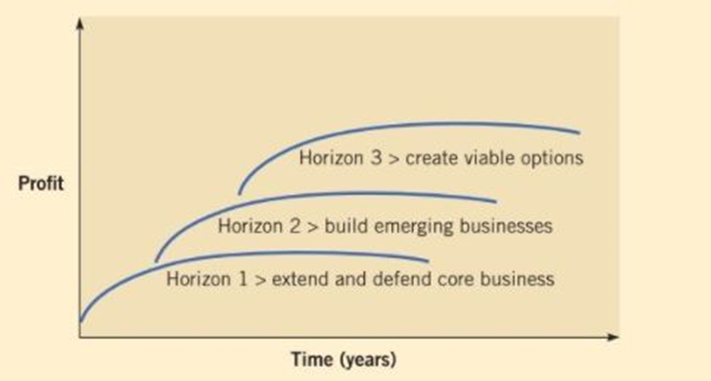 (Whittington, et al., 2021)

Appendix 2.

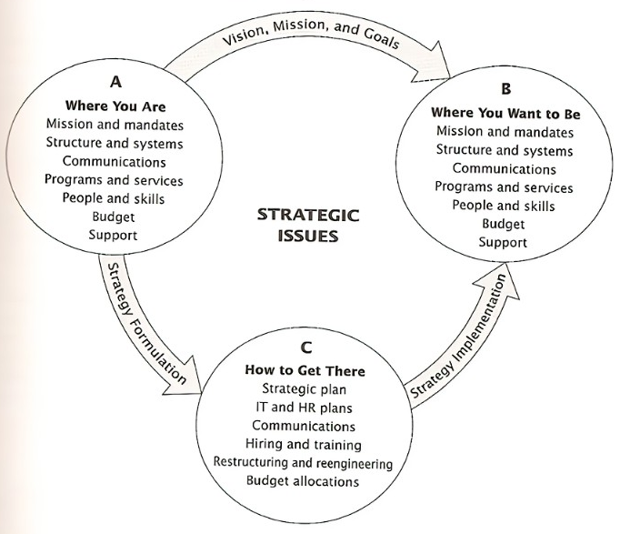
(Bryson & Alston, 2011)

Appendix 3.
Porters Five Forces.
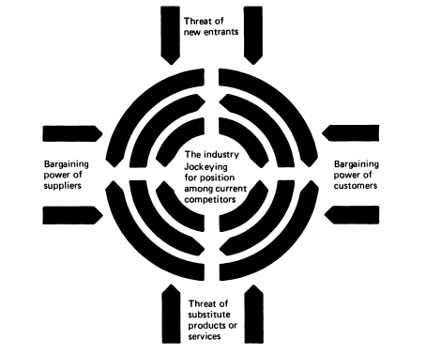
(Porter, 1989)

Appendix 4.

IOPC Findings Table
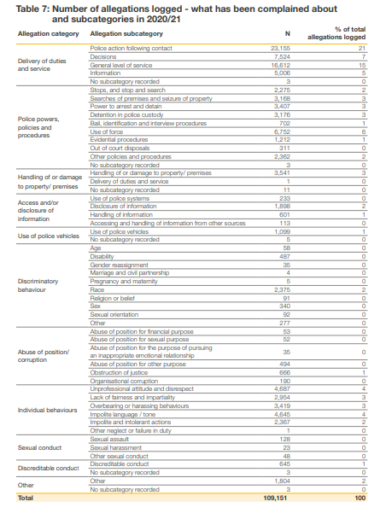
(Independant Office for Police Conduct, 2021)

