

Strategic Management (LCMB7003)

Strategic Analysis of Dell Technologies
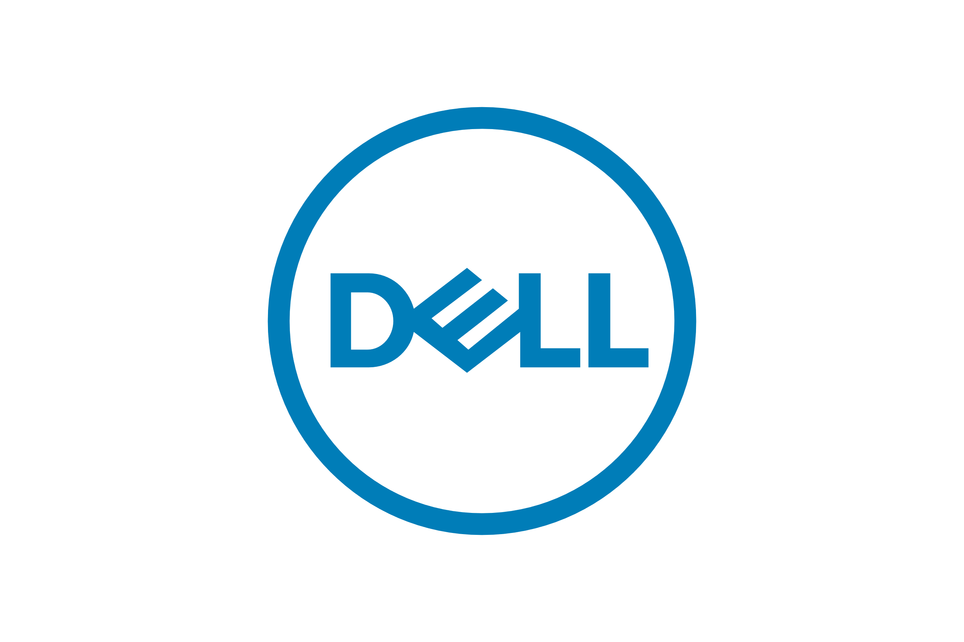

Student name : PARMOD KUMAR
Student Number : 2229251
Lecturer : Dr Hossein Shokri
Word count : 5000
Submission Date : 01 sept 2023

Table of Contents
Introduction 3
Background 3
Mission and objectives 3
Macro-environment analysis 4
Pestle analysis 4
Micro-environment analysis 6
Industry life cycle 6
Porter's industry five forces analysis 7
Internal analysis 8
Strategic resources and capabilities 8
Value chain analysis 9
VRIO analysis of distinctive resources and capabilities 11
SWOT analysis 13
Strategies to sustain competitive advantage 15
Porter's generic strategy 15
Growth strategies 16
Ansoff matrix 16
Green strategy and CSR 17
Conclusion 19
Recommendations 19
References 21
Appendix 1 25
Appendix 2 25

Introduction
Strategic management plays a significant role in managing organisations. Organisations may obtain a competitive advantage using strategic management by achieving long term goals and wise decisions (Whittington, et al., 2020). The report to be written will be focusing on Dell, an international technological company and by considering the company, discussion on the various strategies that are adhered by the company will be evaluated with the help of various frameworks and models. Dell is an efficient technological sphere, providing its services to a vast amount of customers, in a wider scale. The report will consider information on the strategic behaviour, being judged based on the pestle analysis, followed by swot and porter's generic strategy, summing up to presenting vivid information on the typical way the company performs.

Background
Dell Technologies Inc is one of the largest technologies in the world with more than 133000 employees and operating in approximate 180 countries across the globe. Dell, mainly known as “PC's Limited'', was established in 1984 by “American entrepreneur Michael Dell” who was enrolled as a student at the University of Texas in Austin and at present the company revenue stands at $102,3B (Dell Technologies Inc, 2023a). Since then, Dell technology has undergone a remarkable evolution, by continually developing and broadening its product and service to meet the needs of a wide variety of industries and customers. In 2016, Dell technologies acquired EMC Corporation which made Dell a key player in the technology industry (Dell Technologies, 2016). In recent years, Dell has strategically restructured its business operations through a notable statement made in July 2020. Dell declared an in depth review of options to sell its all majority shareholding in “Vmware '' a highly priced “cloud computing business' ' as its latest business strategy. The company's primary objective is to create independent spinoff enterprises, further highlighting its dedication to portfolio optimisation and strategic strategie (Dell Technologies, 2021b).

Mission and objectives
Dell Technologies is committed to providing high-quality products by incorporating the latest technology in the market. However, unlike other competitors in the market, Dell’s vision emphasizes the availability of such advanced services at an affordable rate (Dell technologies, 2023f). Finally, the company wants to maintain a healthy balance sheet, allowing it to deliver on its promises and invest in new technologies for its stakeholders and customers.
According to recent data, Dell’s objective is aimed at setting the bar high when it comes to environmental sustainability. By 2030, the company aims to reduce “GHG emissions” by 50% from Scopes 1 & 2. Dell also plans to generate 75% of its electricity from renewable energy sources by 2030 and 100% by 2040. By taking these initiatives Dell’s mission is to contribute to a more sustainable future and reduce its environmental impact. (Dell Technologies, 2023b).

Macro-environment analysis

Pestle analysis
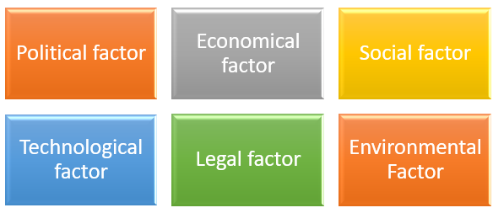
Figure 1: PESTLE analysis

Political Analysis
Dell operates in multiple countries including Europe and China which are the two most important geographical locations. Political relationships determine the ease of import and export of products. The rates differ due to political differences. The former US President Trump had a major conflict with the Chinese Government, which led to increased taxes in import and export of finished products, leading to price shoot up of Dell products in the US. (Farooq, et al., 2023), argues political stability among the countries is essential for the growth of business. During the Presidency of Joe Bidan, the political differences between China and the US came to an end leading to peaceful business.

Economic Analysis
The three main economic factors affecting the operational activities of Dell technologies are the “volatile exchange rates of different currencies”, the “price of supplies” and the “overall economic health of the nation” in which the company operates. (Baur & Dimpfl, 2021) mentioned that, in order to improve operational efficiency, Dell adopted bitcoins in February 2015. Currency exchange rates have a substantial impact on the worldwide performance of Dell. Dell’s revenue was adversely affected by the negative influence on the global expansion of the PC market, brought on by the 2007-2009 worldwide financial and economic crisis. Dell Technologies Inc was able to recover from this setback by cutting back on technological expenses and by increasing efficiency and productivity in their execution sector.
Social Analysis
Nowadays laptops are not limited for office work, the usage growth has increased among all age groups. The company offers various types of computers and laptop products for different customers such as kids, business professionals, tech savvy, gamers. Major competitors of Dell are “Asus”, “HP”, “Lenovo” and “Apple” as they offer the same products (Cheng, 2022a). Customers around the globe utilize various products of the respective organization such as “laptops or desktops for education, business, and entertainment.”
Technological Analysis
Technology-based company Dell is affected by modifications in its primary product, computers. With a concentration on big screens and rapid processor upgrades, the company has transitioned from mouse-operated computers to touchscreen monitors (Yellin, 2018). In the process of remaining competitive in the business market, the respective technological organization “Dell” requires to enhance its “Cloud-based technologies” for better optimization of data and system upgradation.
Legal Analysis
Due to its global operations, Dell is subject to the regulations in each region. Different countries may have different labour laws governing minimum salaries, equitable working conditions, and the well-being of the workers. Furthermore, the organization requires to employ necessary management to adhere to the tax systems and regulations in order to enhance organizational recognition.
Environmental Analysis
Ganda (2019) said that tech companies are under government investigation for manufacturing practices that have large carbon emissions and cause harm to the environment. There are serious hazards to the environment associated with non-biodegradable electronic waste. Dell’s R&D team puts its focus on recyclable items (Dell Technologies, 2023d). Substantially, the requirement of raw materials that are significant for the production has chances to be reduced, which would, on one hand, offer the organization a distinctive advantage over the rivals in terms of cost production.

Micro-environment analysis

Industry life cycle
Industry life cycle is used to determine the lifetime position of an industry based on the fluctuating performance level. The significance of using the “Industry Life Cycle” is to determine the competitive advantage with new entrants and substitutes. Several issues that are adamant to the “Industry cycle” are launch, growth, shake-out, maturity, and decline. This determines the level of productivity in an organization. Dell Technologies is currently in the growth stage and is accompanied by various innovations and business models.
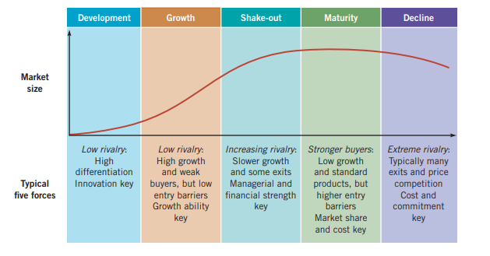
Figure 2: Industry Life Cycle Model
Source: (Whittington, et al., 2020)
The dilemma between the adoption of R&D and marketing sales is prevalent in the growth stage, as observed in the case of the company. Dell created a monopoly of large data storage simultaneously with fast data access that lead to its growth among the future core processors in sub-phases. Dell technology eases up the rebooting of the operating system for the users, during the battery takes off but the system does not go to hibernate mode (Dell technologies, 2023e). Industries concentration takes a toll as in some regions or some sub-part industries the revenue curve flattens out demanding more massive innovation. Dell EMC power store gains an enormous growth rate bringing 20% new customers (Prnewswire.com, 2020).

Porter's industry five forces analysis
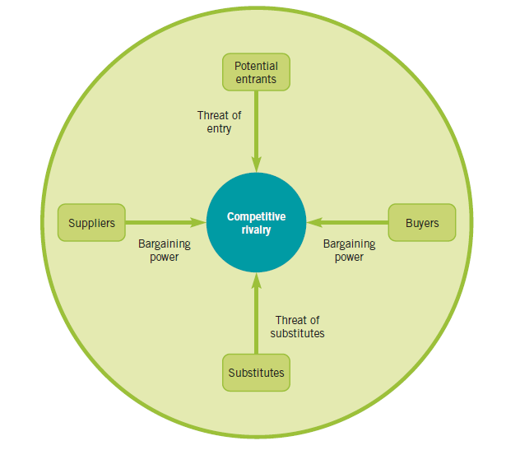
Figure 3: Porter’s Five Forces Analysis
Source: (Whittington, et al., 2020)
Competitive rivalry
Dell faces tough competition from HP, Lenovo and Google Cloud with the growing conscience of IT services. However, Dell Technologies gave major competition to Compaq at the growth stage but due to rapid S4 hybrid rebooting, Dell Technologies prevailed in the market.
Threats of New Entrants
Fewer investments and prevailing competition with the innovation of the same form create the entrants of new rivalries. Dell Technologies pursued Cloud computing, resulting in Google Cloud gathering its dominance without any forbearing investments being an already established IT company (Dell Technologies, n.d.).
Suppliers Power
Suppliers are the main factors for driving up the cost of the inputs. Dell Technologies follows a horizontal integration in controlling all the basic operations of the company (dell.com, 2023). However, Dell Technologies distributed its Edge Computing to Google, creating a dependency on an in-site data storage system to decrease the operational cost. Much increase in the bargaining power of suppliers led to the gradual shift of Dell Technologies to AMD chip provider in 2006.
Buyer Power
Maintenance of a small yet powerful consumer base increases the bargaining power of the buyer. Dell Technologies offers great discounts on the exchange products such that the buyer gets to bargain more on the discounts to obtain a valuable Dell product at a lesser price (United states securites and exchange commission, 2023). However, Dell failed to make innovations in the public clouds system such that the already-existing cloud innovation become subject to consumer bargaining power.
Substitutes Threats
Dell technology manufacturers mainly smartphones and laptops are almost every IT service associated with. The replacement of the company with Lenovo and HP is widely observable. However, Dell Technologies is competing in providing computers to filmmakers and musicians as the computers that are used cannot be replaced by other companies and the price offered by dell is almost similar to other companies but dell provides a wide range of price segment to its customers depending upon the needs of customers.

Internal analysis

Strategic resources and capabilities
Requirements of resources and capabilities are prioritized in every organization including Dell. The assessment of the assets that Dell possess is proficiently maintained which showcases the performance of Dell efficiently.
Resources | Strength | Capabilities | Strength
R1: Product and Service Diversity (Tangible) | 8 | C1: Customer Feedback System.  (Tangible) | 7
R2: Brand Equity and Awareness (Intangible) | 7 | C2: Expansion of business domain at new markets (Intangible) | 7
R3: Distribution Logistics and Supply Chain Management  (Intangible) | 6 | C3: Fast product and service delivery.  (Intangible) | 6
R4: Mergers and Acquisitions  (Intangible) | 7 | C4: Capitalizing technological innovations  (Intangible) | 8
Table 1: Resources and Capabilities (on a scale of 1 to 10)
The “diversity in the product and service” reach of Dell is viable from its cloud computing services and foundational hardware subsidiaries applaud the decisiveness of Dell to expand into edge computing. The respective technology brand’s image is unique and contains “high brand integrity” that has been developed over the years of consistent performance and high-quality service on the global front. It is an exemplary operational strategy that Dell has been able to incorporate into its “supply chain and logistics” through technological integration and advancement. The reagent and dealer-based distribution channel has made it easier for the respective organisation to reach such a large customer base in a significantly shorter duration of time. The corporate leadership and vision were accomplished by the “acquisition” of “VMware” and benefited Dell’s cloud and edge strategies. “Client Solutions Group (CSG)” has strengthened Dell’s cloud service (Marketline, 2020). Dell’s digital transformation powerhouse is the byproduct of “Infrastructure Solutions Group (ISG)”.

Value chain analysis
Value-chain analysis is a methodical framework that aids in locating business operations that might add value and give the company an edge over competitors (Lynch, 2018). It was clear that Dell has a successful value chain management strategy, many other businesses, even those that do not belong to the consumer technology sector, have adopted it. [Referred to Appendix 1]
Primary activities:
Manufacturing and marketing the product to specifically selected clients is the primary value chain operations for Dell. Dell’s efficiency can be enhanced by evaluating the following value chain operations.

Inbound Logistics
As stated by (Sjodin, 2020), owing to the assistance of the suppliers in receiving, storing and distributing products, suppliers are crucial for the success of any business. So, a company must secure its relationship with the suppliers. When developing a product, Dell may run into a number of problems if the in-bound logistics are not well inspected.
Operations
Operational practices such as processing, packaging, assembling and testing are undergone when raw materials are delivered, and Dell is prepared to transform them into finished products and introduce them in the market. For Dell to succeed in the competitive market, productivity must be increased, efficiency must be maximised, and operational activity analysis must be done.
Outbound Logistics
Outbound Logistics refers to the last steps Dell takes to complete the process of manufacturing, some of which includes documentation, product sorting according to destination, shipment. These processes then lead to the delivery of the products to the respective customers. As claimed by (Kusumaputri, 2021), due to the benefits of part modularity, supplier-driven inventory programs, demand scheduling and bulk customisation taken together, Dell typically completes client shipments on time and adheres to its pledge of product customisation.
Marketing and sales
Ding Dang (2021) claimed that to convince clients Dell emphasises on the benefits, advantages and distinctive selling factors of the items it is delivering is a superior option to those of its competitors such as Lenovo or IBM. Dell’s marketing and sales strategy includes advertising, promotions, price strategies, picking up relevant channels and fostering a healthy relationship with channel members.
Services
Customer services before and after the sale and 24*7 service can be cited as one of the enduring foundations of Dell’s market position (Dell Technologies, 2021a). Dell’s staff receive numerous phone calls from customers every day and record and organise their feedback and pass it along to managers.

Secondary activities
Integrating and enabling the primary value chain operations is greatly aided by the support or secondary activities.
Infrastructure
To improve the company’s position in the competitive market, Dell can manage the infrastructural operations within the firm (dell technologies, n.d.), or what are typically referred to as “overhead expenditures”. This process is observed to help the company in increasing the total valuation of the firm and hence help in increasing the competitive edge of the company.

Human Resource Management (HRM)
Monitoring various HRM factors such as hiring, selecting, educating, rewarding, managing performance of the workforce, Dell is able to assess HRM and this would help Dell to hire telent, run training programes and keeping record of performance. The company is observed to take active steps in integrating the cost-effective strategies and hence based on that adopt cost minimisation strategies, that in turn help the company to successfully increase the successive optimisation of relation of the employees and the company. Dell is always concerned towards its employees and provide a no of rights to them for the efficient management of people working over there. Dell is strictly again child labour, slavery, human trafficking, discrimination and harassment (Dell, 2021).

Technology
(Li, 2022), proclaimed that the goal of Dell’s research and development division is to incorporate technology into the operations of manufacturing, marketing, distribution and human resources. The company is observed to have a well-integrated framework of production and distribution process that help the company to properly maintain its automation software and allow the company to properly maintain its research on product design.

Procurement
Dell must take into account its procurement activities, which is the buying of various resources for the production purpose, in order to maximise its inbound, operational and outbound activities. Dell, under procurement, needs to emphasise more on its activities for procurement as this will help the company to bring in the needed optimisation in terms of outbound and operational value chain system. The direct selling of products reduces the complexity of chain management which reduces the supply chain cost (Parvez, et al., 2018).

VRIO analysis of distinctive resources and capabilities
The “VRIO” analysis has proved to be highly efficient in outlining the strategic advantage and competitiveness of Dell in the market. The cognizance of this framework has highly comprehended the respective organization in identifying a long-term competitive advantage for the company by analysing its “resources and capabilities” and discerning its core competencies to develop a sustainable competitive advantage.
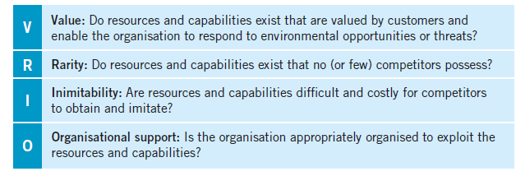
Figure 4: VRIO Framework
Source: (Whittington, et al., 2020)
Resources | Valuable | Rare | Inimitable | Organized | Competitive Implications
Product and Service Diversity | Yes | Yes | Yes | No | Temporary CA
Brand Equity and Awareness | Yes | Yes | No | Yes | Permanent CA
Distribution Logistics and Supply Chain Management | Yes | Yes | No | Yes | Temporary CA
Merger and Acquisitions | Yes | No | No | Yes | Temporary CA
Brand Value | Yes | Yes | Yes | Yes | Permanent CA
Financial Capabilities | Yes | No | No | Yes | Temporary CA

Table 2: VRIO Analysis
Dell a multinational technology company based in America has been able to occupy a prime position in the technology market by selling personal computers, data storage devices, software and even media players. The product and service diversity of Dell brings “value” to the organisation and enjoys a “rare” privilege with its “inimitable” nature. According to (Jiang, et al., 2022)The “Direct Sales Model” has been highly “valuable” in cutting dealer or retailer costs and in establishing a brand value with high integrity. Dell Technologies Inc has a defined corporate social responsibility function that has contributed to high brand recognition unique to this technological magnate. The supply chain management of Dell is expensive to “imitate” and is a “rare” asset of the company as it will require a complete reorganisation of the inner framework of an organisational setup. The propensity to introduce innovation and raise capital has permitted the organization to engage in mergers and acquisitions, which in turn has inculcated a sustained competitive advantage for Dell over other business competitors.
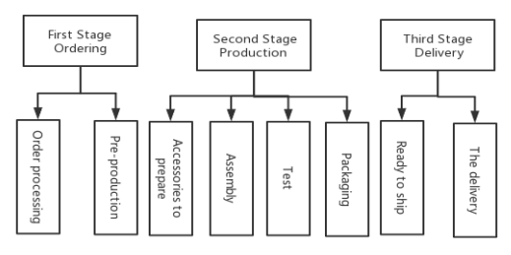
Dell Direct Selling Model
(Jiang, et al., 2022)

SWOT analysis
SWOT analysis is a tool used by organisations for strategic planning and management. Building organisational and competitive strategies with it is effective (Gurel & Tat, 2017). SWOT analysis enables the internal assets, flaws to address, areas for development and progress, and external threats of success of the organisation.
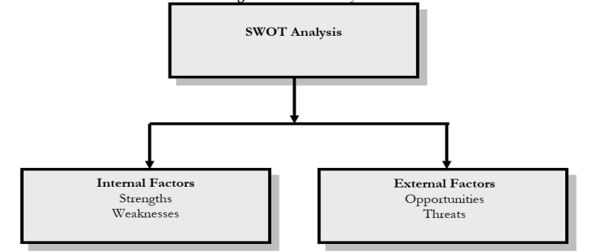
Figure 6: SWOT analysis
Source: (Gurel & Tat, 2017)

Strengths
Dell has established itself as a renowned brand known for its exceptional quality products.The company’s brand value, which has earned a good reputation in the market, is estimated to be “$39.89 billion” (companiesmarketcap, 2023). Dell's unique and highly respected product customisation service is what makes Dell stand out from other major computer brands. Unlike “Sony”, “Toshiba”, and others, Dell allows its users to personalise their laptop to fit necessary needs and preferences. Dell’s commitment to environmental sustainability has been evidenced by its active involvement in several green initiatives and its status as an “eco-friendly company”. Dell is investing heavily in new business start-ups and mergers, strengthening Dell’s business with assets, skills, and talent. (technologies, 2022)
Weaknesses
Dell's inability to invest more in research and development (R&D) has made it difficult for Dell to stand out in the fast-growing market of smartphones and tablets. The Company provides less services to customers. Dell’s customer relations took a nosedive after it outsourced its contact centres to third countries. While Dell has invested heavily to address the issue, the company has yet to fully regain its reputation for excellent customer service. A major weakness of a Dell is a small number of retail locations. While online product sales offer economies of scale and options for customisation, their lack of presence restricts product visibility and lowers customer trust as there is no physical access to view the products before the customers making a purchase.
Opportunities
Dell’s most profitable business divisions are Enterprise Solutions like, Dell Servers, Dell networking, Dell Storage and Service offerings like, Dell Cloud, Dell Security, Dell Infrastructure. Dell focused on growing these business divisions, which offer exciting opportunities and higher profit margins. Dell’s growth opportunities stem from the increasing need for cloud computing and storage (Dell technologies inc, 2023b). The company is well-positioned to provide end-to-end solutions to data centres as well as cloud service providers by leveraging its expertise in storage servers and networking. Increasing communication and technology integrations create best opportunities for Dell to take advantage.
Threats
Due to the closing price gap between brands, Dell is facing some serious external threat. It has intense competition that means the technology industry is saturated with established players such as “HP”, “Lenovo”, and “Apple”, as well as emerging participants who are constantly introducing and innovating new products. This competition generates price war that means a competitive exchange between rival companies who lower the price points on their product and services. “Economic fluctuations” pose a threat to Dell's business. The global economic climate has a significant impact on Dell’s business. During economic downturns, consumer and business spending on technology products and services decreases, resulting in lower demand for Dell’s offerings, which could decrease revenue and profitability also Changes in exchange rates of foreign currencies when they are transferred to the United States dollar, as well as exchanges for U.S. dollars, could have an impact on a company's total revenue (Dell technologies inc, 2023c)

Strategies to sustain competitive advantage

Porter's generic strategy
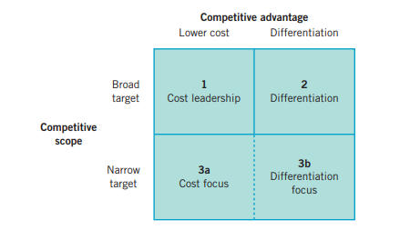
Figure 7: Porter’s Generic Strategy
source: (Whittington, et al., 2020)
The four fundamental generic strategies are cost leadership, differentiation, cost focus, and differentiation focus. Cost Leadership Strategy aims at the lowest-cost producer in the market while maintaining narrow profit margins to achieve a competitive advantage (Whittington, 2020). The key goal is attracting price sensitive customers and gaining market shares based on this cost advantage. Differentiation Strategy mainly focuses on creating or developing unique products or services that are perceived by superior consumers. This strategy allows companies to charge premium amounts and build customer loyalty based on asked value. Cost Focus Strategy concentrates on serving target customers groups or specific market areas effectively. As mentioned by (Whittington, 2020), with this narrow market focus the company understands better the requirements of target customers and enables the company to gain competitive advantage within that particular segment. Differentiation Focus focuses on niche market segments in order to differentiate their product and service and meet unique needs of the specific segment. This helps the company to capture loyal customers of a target market segment even if they charge a premium price.

Dell primarily adapts Cost Leadership Strategy and focuses on cost reduction and operational efficiencies. By implementing various measures the company finally could minimise cost through supply chain and manufacturing processes. The key strategy followed by the company is the “direct to customer” business model where the direct sale is to customers without any intermediaries like retailers (Mark Haranas, 2021). Except “Apple”, the whole customer base is price sensitive, the major competitors also follow cost leadership strategy as “HP” and “Lenovo”. But the fact that makes Dell different is that the company aims “best value for best price”.

Growth strategies

Ansoff matrix
The “Ansoff Matrix”, also known as the “Product/Market Expansion Grid” has held a pivotal position in helping business magnates analyse the risks and consequently building framework for growth, presenting to stakeholders and collaborating about direction (Lynch, 2018). Dell’s global domination can be credited to “Market Development”, “Market Penetration”, “Product Development” and “Diversification”.[Referred to Appendix 2]

Market Penetration
Market penetration means expanding the current product line's share of the market (Johnson, et al., 2016). Increased production capacity has allowed Dell to reach more customers in the existing market with enhanced efficiency in controlling overhead costs. The competitive pricing of Dell has appealed to its client base and has increased sales and consumption leading to higher market penetration (Tracey & Wiersema, n.d.). The decisiveness of Dell to increase investment in marketing and designing communication content apt for the market is highly commendable.

Market Development
Market development strategy means entering into new markets with already existing products to grasp more target customers and expand the geographical location (Johnson, et al., 2016). Dell has a strong pre-existing client base which makes the company transition to edge computing. Dell can choose emerging in untapped customer segments by customising or developing their existing products according to customers preferences to meet specific market needs of those markets. Dell needs to strengthen its online presence and direct to the customer channel in order to reach a wider customer base.

Product Development
Product development strategy includes entering a new market with the existing products and hence updating or introducing new products according to segmented customer base (Johnson, et al., 2016). Introducing newer computer models, expanding product range or exploring new technologies of virtual reality or (IOT) Internet of things devices. Which involves creating products that connect and interact with various other devices, smart home automation and industrial automation. In order to drive a successful product development Dell must invest in research and development and closely monitor industry trends and collaborate with technological vendors.

Diversification
Diversification strategy includes getting into new markets with new products in order to capture a strong client base in the target market (Morden, 2007). Getting involved in the public cloud market and providing consumer-level cloud access to customers can let Dell beat the tech giants like Amazon, Apple, Google and Microsoft (comparably, 2023). As Microsoft has removed the flagship Office suite with cloud-based subscription which updates automatically. Dell needs to provide public cloud service to individuals along with private cloud infrastructure which already is excelling in IT sectors.

Green strategy and CSR
The term "green strategy" refers to an organization's efforts to protect the environment and create the business opportunities that will result from these additional efforts (Lynch, 2018).
Dell is always concerned about the environment and by 2050 dells plans for zero greenhouse gas emission (Dell technologies, 2023a).
Philanthropic Responsibilities
Dell has been a recognized organization in the technologies and electronics industry. Hence, Dell has maintained multiple philanthropic and charitable initiatives to represent the company's business and social responsibilities. Dell has established digital education in Ethiopia, Africa to spread technological reach. Alongside this, Dell is in partnership with United Nations Children’s fund(UNICEF) from October 2022 so that every school can be connected to internet so that every person can reach to internet and get information and dell team members also worked for 920000 hours for community under the community engagement project and Pro Bone program (Dell Technologies, 2023d).
Ethical Responsibilities
Various ethical CSRs have been adopted by Dell as well. Dell has established sustainably aware multinational frameworks that operate within the company and set certain initiatives for Dell to adhere to. Dell has set goals for 2030 that include growing in a more culturally inclusive manner for the workforce as well as shifting to a circular economy. For the prior decade, Dell had made goals of reducing electronic waste and reusing at least 100 million pounds of recycled plastic.
Legal Responsibilities
All CSR practices conducted by Dell operate within legal frameworks and in compliance with various lawful regulations. One government regulation enables commercial and collaborative partnerships between varying firms. Dell utilises this to partner itself with Microsoft. Despite being key competitors, the two companies offer sustainable products for tech and electronic consumers, such as the Dell EMC Tactical Microsoft Azure Stack and the VMare (Dell technologies, n.d.).
Economic Responsibilities
In line with being economically responsible, Dell has two primary economic CSR objectives. Firstly, Dell seeks to adapt a circular economy framework that will reduce waste and lessen the company’s carbon footprint while adapting a closed-loop system to increase productivity and efficiency. A new efficient initiative taken by the company is that of Concept Luna (Robson , 2021).

Benefits of CSR
Corporate Social Responsibility is receiving a lot of attention of all companies because these leave a positive impact on company. Some companies are afraid of the cost of managing CSR, time and effort of implementation but most are on the way to manage CSR.
The main benefits of CSR include the company's reputation, profitability, competitive advantage, and there are a variety of other factors also (Carroll & Shabana, 2010).

Conclusion
In order to sum up, it can be said that the aforementioned study is based on Dell’s strategic management. The study took out the company’s history as well as its aim and objectives. Several models and frameworks, such as the PESTLE analysis model, the life cycle model, the Porter’s five forces analysis framework and the value chain analysis model have been used to conduct an evaluation based on the company’s internal and external aspects. The study demonstrates Dell’s competitiveness with the aid of the VRIO analysis. This report also made efficient use of SWOT analysis, the Ansoff Matrix model and CSR model to carry out the specified study.

Recommendations
One of Dell’s key driving attributes is the maintenance of Dell’s cloud services. Cloud Computing in the modern age is a pivotal service for the IT market, and as per (Mishra, et al., 2022), cloud computing is a sustainable new service utilised by digital users. Therefore, Dell may be able to utilise more revenue into developing Dell Cloud even further to overtake other data cloud services. With the growth of dependence in self-sufficient digital media in line of research as well as education, the development of cloud infrastructure can pose advantageous for Dell.
Coupled with this is edge computing capabilities. Edge computing refers to data assimilation and storage as well as digital processing. While Dell has struggled to keep pace with other edge computing services, the usage of machine learning and artificial intelligence tools to evolve network intrusion detection systems are also considered, while reading varying analytics.
In line with development, a key recommendation is for Dell to initiate further partnerships and establishments that utilise tools that encourage transformative development in the digital scape. While Dell has utilised the aid of cybersecurity firms for Dell Cloud, Dell can collaborate with establishments that are adept with AI or machine learning (technologies, 2018). Dell can also benefit from the development of newer products to create a broader scope of consumers. Other industry competitors have benefitted from widening the products produced and sold. Similarly, the expansion of Dell’s catalogue can pose beneficial to the company’s economic growth.

References
Anon., n.d. [Online].
Baur, D. G. & Dimpfl, T., 2021. The volatility of Bitcoin and its role as a medium of exchange and a store of value. Empirical Economics, Volume 61, p. pages2663–2683.
Boris Miethlich, A. G. O., 2019. The Employment of Persons with Disabilities as a Strategic Asset: A Resource-Based-View using the Value-Rarity-Imitability-Organization (VRIO) Framework. Journal of Eastern Europe Research in Business and Economics.
Carroll, A. B. & Shabana, K. M., 2010. The Business Case for Corporate Social Responsibility: A Review of Concepts, Research and Practice. basedInternational Journal of Management Reviews, pp. 85-105.
Cheng, J., 2022a. Sustainable Competitive Advantage Analysis and Recommendations for Dell Company to Achieve Success. Open Journal of Social Sciences, 10(12), pp. 486-497.
Cheng, J., 2022. Sustainable Competitive Advantage Analysis and Recommendations for Dell Company to Achieve Success. Open Journal of Social Sciences, 10(12), pp. 486-497.
Collins, C. J., 2020. Expanding the resource based view model of strategic human resource management. The International Journal of Human Resource Management, 32(2), pp. 331-358.
companiesmarketcap, 2023. companiesmarketcap. [Online]
Available at: https://companiesmarketcap.com/dell/marketcap/
[Accessed 11 08 2023].
comparably, 2023. comparably. [Online]
Available at: https://www.comparably.com/companies/dell-technologies/competitors
[Accessed 10 08 2023].
Dell Technologies Inc, 2023a. Dell Technologies Inc.- Financial and Strategic Analysis Review, s.l.: marketline.
Dell technologies inc, 2023b. Dell Technologies Inc. - SWOT Analysis, s.l.: marketline.
Dell technologies inc, 2023c. Dell Technologies Inc. - SWOT Analysis, s.l.: Marketline.
Dell Technologies, 2016. Historic Dell and EMC Merger Complete Forms World s Largest Privately Controlled Tech Company. [Online]
Available at: https://www.dell.com/en-us/dt/corporate/newsroom/announcements/2016/09/20160907-01.htm
[Accessed 27 07 2023].
Dell Technologies, 2021a. Dell ProSupport for Client Products, s.l.: Dell Technologies.
Dell Technologies, 2021b. Dell Technologies Announces Planned VMware Spin-Off, Texas: Dell Technologies.
Dell technologies, 2023a. Environmental, Social and Governance, s.l.: Dell technologies.
Dell technologies, 2023a. FY23 Environmental, Social and Governance Report, s.l.: Dell Technologies.
Dell Technologies, 2023b. FY23 Environmental, Social and Governance Report, s.l.: Dell Technologies.
Dell Technologies, 2023d. FY23 Environmental, Social and Governance Report, s.l.: Dell Technologies.
Dell technologies, 2023e. Why Is My Dell System Not Going to Sleep Mode. [Online]
Available at: https://www.dell.com/support/kbdoc/en-uk/000149580/why-is-my-system-not-going-to-sleep-mode
[Accessed 12 08 2023].
Dell technologies, 2023f. who we are. [Online]
Available at: https://www.dell.com/en-uk/dt/corporate/about-us/who-we-are.htm
[Accessed 01 08 2023].
Dell Technologies, 2023. Who we are. [Online]
Available at: https://www.dell.com/en-uk/dt/corporate/about-us/who-we-are.htm
[Accessed 01 08 2023].
Dell technologies, n.d. Code of conduct for partners. [Online]
Available at: https://corporate.delltechnologies.com/content/dam/delltechnologies/assets/whoweare/resources/Dell-Technologies-Partner-Code-of-Conduct-English.pdf
[Accessed 25 08 2023].
Dell Technologies, n.d. Dell Apex. [Online]
Available at: https://www.dell.com/en-us/dt/apex/index.htm#tab0=0&tab1=0
[Accessed 12 08 2023].
dell technologies, n.d. Infrastructure-as-a-Service. [Online]
Available at: https://www.dell.com/en-uk/dt/learn/cloud/infrastructure-as-a-service.htm
[Accessed 17 08 2023].
Dell, 2021. Dell Human Rights Policy, s.l.: Dell.
Ding Ding, X. L. H. X., 2021. Sustainable Competitive Advantage: Case Studies of Dell, Ikea and Byte Dance. Proceedings of the 2021 6th International Conference on Modern Management and Education Technology（MMET 2021, Volume 582, pp. 674-679.
Donna, J. D. et al., 2023. ssrn. [Online]
Available at: https://papers.ssrn.com/sol3/papers.cfm?abstract_id=3779962
[Accessed 01 08 2023].
Farooq, U., Gillani, S., Subhani, B. H. & Shafq, M. N., 2023. Economic policy uncertainty and environmental degradation: the moderating role of political stability. Environmental Science and Pollution Research, 30(7), pp. 18785-18797.
Ganda, F., 2019. The impact of innovation and technology investments on carbon emissions in selected organisation for economic Co-operation and development countries. Journal of Cleaner Production, Volume 217, pp. 469-483.
Gupta, S., Drave, V. A., Dwivedi, Y. K. & Ismagilova, E., 2019. Achieving Superior Organizational Performance via Big Data Predictive Analytics: A Dynamic Capability View. Industrial Marketing Management, 90(3), pp. 581-592.
Gurel, E. & Tat, M., 2017. SWOT ANALYSIS: A THEORETICAL REVIEW. The Journal of International Social Research, 10(51).
Jayasooriya, S. D., 2021. Virtual Value Chain and Physical Value Chain Integration to Get the Competitive Advantage in the Sri Lankan E-Commerce Market. Global Scientific journels, 9(2).
Jiang, Z., Lin, H., Jiang, M. & Ling, W., 2022. Analysis of Dell’s Marketing Strategy. Paradigm Academic Press Law and Economy, 1(1), pp. 29-37.
Johnson, G. et al., 2016. Exploring Strategy: Text and Cases. 11 ed. s.l.:Pearson Education.
Johnson, G. et al., 2016. Exploring Strategy: Text and Cases. 11 ed. s.l.:Pearson Education.
Kabeyi, M. J. B., 2019. Organizational strategic planning, implementation and evaluation with analysis of challenges and benefits for profit and nonprofit organizations. International Journal of Applied Research, 5(6), pp. 27-32.
Kenton, W., 2023. Price War: Meaning and Special Considerations. [Online]
Available at: https://www.investopedia.com/terms/p/price-war.asp
[Accessed 19 07 2023].
Kusumaputri, R., 2021. Dell Corporation Strategy in Supply Chain Management in order to Avoid Bullwhip Effect. International Journal of Business and Technology Management, 3(1), pp. 21-29.
Li, Y., 2022. A Case Study on Dell Technologies and its CEO, Michael Dell. Frontiers in Business, Economics and Management, 3(3), pp. 128-131.
Lynch, R., 2018. Strategic Management. 8 ed. Harlow: Pearson Education, Limited.
Mark Haranas, S. B., 2021. Dell Direct Sales In Conflict With Channel Partners. [Online]
Available at: https://www.crn.com/news/mobility/dell-direct-sales-in-conflict-with-channel-partners
[Accessed 07 19 2023].
Marketline, 2020. Dell Technologies: Company set to become a leader in cloud and edge computing , s.l.: Marketline.
Mishra, P., Pilli, E. S. & Joshi, R. C., 2022. Cloud Security Attacks, Techniques, Tools, and Challenges, Oxon: Crc press.
Morden, T., 2007. TitlePrinciples of strategic management. 3 ed. Hampshier: Ashgate.
Parvez, M., Ullah, N., Sabuj, M. A. & Islam, S., 2018. Profit Maximization of DELL Inc. through Build-to-Order Supply Chain for Laptop Manufacturing. American Journal of Industrial and Business Management, Volume 8, pp. 1657-1671.
Prnewswire.com, 2020. Ten Ways Dell Technologies' Innovation Engine is Modernizing IT. [Online]
Available at: https://www.prnewswire.com/news-releases/ten-ways-dell-technologies-innovation-engine-is-modernizing-it-301157099.html
[Accessed 14 07 2023].
Robson , G., 2021. SOCIAL IMPACT Sustainable PC Design: Concept Luna. [Online]
Available at: https://www.dell.com/en-us/blog/pushing-the-boundaries-of-sustainable-pc-design-concept-luna/
[Accessed 22 08 2023].
Santos, B. D. M. O. G. a. C.-S. F., 2023. Resources and capabilities for Industry 4.0 implementation: evidence from proactive Portuguese SMEs. Journal of Manufacturing Technology Management, 34(1), pp. 25-43.
Shunzhi, L. & Jiabao, L., 2023. How organizations leverage digital technology to develop customization and enhance customer relationship performance: An empirical investigation. Technological Forecasting and Social Change, Volume 188.
Sinnaiah, T., Adam, S. & Mahadi, B., 2023. A strategic management process: the role of decision-making style and organisational performance. Journal of Work-Applied Management, 15(1), pp. 37-50.
Sjodin, D., 2020. Value Creation and Value Capture Alignment in Business Model Innovation: A Process View on Outcome-Based Business Models. Journal of product innovation management, 37(2), pp. 158-183.
technologies, D., 2018. Dell technologies. [Online]
Available at: https://www.dell.com/en-in/dt/corporate/newsroom/dell-technologies-makes-artificial-intelligence-and-machine-learning-real.htm
[Accessed 08 16 2023].
technologies, D., 2022. Dell APEX High Performance Computing, s.l.: Dell Technologies.
Tracey, M. & Wiersema, F., n.d. Customer Intimacy and Other Value Disciplines, s.l.: Havard Business Review.
United states securites and exchange commission, 2023. Annual Reports. [Online]
Available at: https://www.annualreports.com/HostedData/AnnualReports/PDF/NYSE_DELL_2022.pdf
[Accessed 11 08 2023].
Whittington, R., 2020. Exploring strategy : text and cases. 12 ed. Harlow: Pearson.
Whittington, R. et al., 2020. Exploring strategy : text and cases. 12 ed. Harlow: Pearson.
Yellin, B., 2018. HUMAN-COMPUTER INTERACTION AND THE USER INTERFACE, s.l.: Dell emc.

Appendix 1
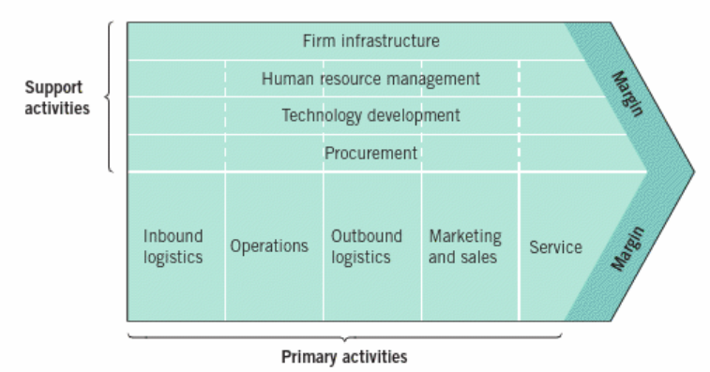
(Whittington, et al., 2020)

Appendix 2

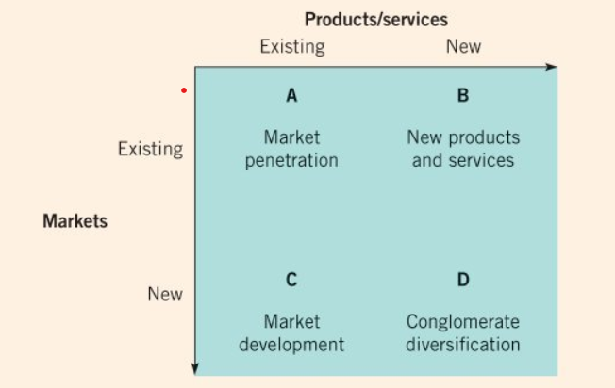
(Johnson, et al., 2016)

