ACADEMIC
AND
EMPLYOYABILITY SKILLS

Table of Contents
Introduction 3
Research-informed Literature 4
Knowledge and understanding of subject 4
Analysis 6
Practical applications and deployment 7
Skills for professional practice 8
Conclusion 10
References 11

Introduction
The present report study is going to focus on the effect of branding on the customers behaviour. The reputation of a brand in the market of business plays a crucial role in deciding the profit of that particular brand. This is because the customer tends to develop their buying behaviour on the effectiveness of the promotion for the brand. Through the completion of the report the researcher will be able to analyse the literature related to the specified topic. Further analysis will be provided along with evaluation of the topic objective. The practical application of such theories will be elaborated in accordance to the skills for the professional practice for gaining the branding effectiveness on the consumer behaviour.

Research-informed Literature
Source 1> Journal
The study of this paper is going with the analysis of the effect and strongest of brand name, store name on customer motivation of purchasing. Mainly this journal has described the theme of customer purchasing decision in the background of brand value. According to Dhruv Grewal (1998), it is a general fact that the purchasing decision depends on the price discount, similarly, customer buying decision also depends on the brand name. Going with the theme of this literature, it can be said that, as soon of viewing a product of a branded company, the customers automatically, started to consider the brand name tagged items, is more dualistically upgraded than the non-branded one. From customer perspective, it can be said that, the brand value carries an inborn tag of good quality and a merchandising tag. According to the literature, branding creates a perceived value about the store and in that way branding positively influences the customer purchasing motivation.
Source 2> Journal
This paper is a research thesis of a controlled experiment to determine the influence of brand name on customer purchasing behaviour. The authenticity of the journal can be proved only then when, it is found that the research study is consists of the design of two different products; in which one is tagged with brand name and is of low quality, while the other, has no popular brand name but dualistically downgraded. Despite of price and quality differentials preference for brand awareness is in overwhelming condition (Häubl and Trifts, 2000). From the survey analysis of this research work, a U shaped pattern of the customer buying behaviour has developed. The U shaped pattern determines the intention of the customer to return back to the branded products. Sometime the branded products selling continue with no advertisement or extra brand awareness program. The research study has ended with the theme that, differential awareness is too much successful for creating a powerful positive influence on the customer buying behaviour. It just works as a powerful permanent magnet for customer attracting the customer.

Knowledge and understanding of subject
A good brand can pursue customer interest to a great extent. People always see a good brand as a sign of high taste. Consumers easily recognize a branded item as compared to a non-branded one. If any company can establish its brand in the market, customer reach is guaranteed. One can say that branding has a positive effect on the consumers. Branding should be done carefully. The company should keep in mind the prospect of branding.
- There are positives and negatives of branding a certain item. Many times it is believed that even if the company is permanently closed, the brand lives in the mind of the people. The closure of any company will not mark the end of a good brand. Suppose two items are on display, one is branded and another one is non-branded (Schivinskiand Dabrowski, 2016). What will be the outcome when a customer visits the store? According to a study, it is believed that more than 80% of the customers look for the branded one first.
- When a customer sees branded clothes, they immediately think that they can rely on the product. This is where branding is superior to a local non-branded product. Before launching a brand or a product, the company does a thorough survey. They take a lot of factors into consideration before launching a brand. Launching a product and creating a brand out of it are two different tasks. Anyone can launch a product any day.
- However, developing a brand needs time and money. The company has to maintain its goodwill in the market to increase their brand value. Once a brand is created in the market, the company should put all their efforts to increase its value. This can only happen if they can promise consumers a good quality product at an affordable rate.
It is a fact that, for research work in the given topic, the researcher has to well acquaint with the proper research technique that will help in real time completion of research work. Additionally at the writing of the research paper, the author would feel a requirement to in text the writing or there will appear the requirement of citation. At this factor the academic referencing technique is too much important for continuing and summarizing a research work. At the same time I think that, it would be better to well acquainted with the academic writing skill, because for as per the topic taken, for exploring it we have to go through the some online or published book or journal. At this time if we go with this journal, we can make easy our understanding if we are acquainted with the academic referencing technique.
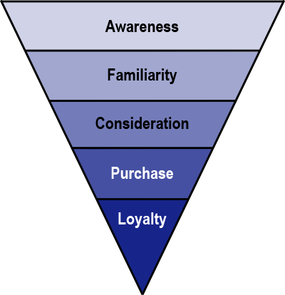
Figure 1: Consumer choice over brand
(Source: Schivinskiand Dabrowski, 2016)

Analysis
Creating a brand is a very difficult task. A brand is the face of your company. Let’s take an example; Apple’s brand value is more than any of its competitor in the technology market. This doesn’t mean that Apple’s iPhone has more features than its competitors. But why do people prefer iPhone over the others? The answer is simple. Apple has created a very good brand value over the years and kept its image intact. A half-eaten apple is now one of the most popular brands in the world. Branding should be done taking consumers’ choices into consideration (Keller, 2016). People tend to relate themselves to a brand which they rely on. Therefore a good brand has a lot of loyal customers.
Most of the consumers tend to ignore better options available and stick to their own brands. This creates a relationship between the consumer and the brand. For example, if any company wants to launch a mobile in the market, they need to identify their potential customers. After identifying them, the company should carry out a survey and understand their way of thinking. If the products are designed keeping in mind of the customer demands, it will be a hit and will draw customer attention towards it. Developing a cheap mobile isn’t the solution. Making a brand of a newly launched mobile will take a certain amount of time in the market (Huang and Sarigöllü, 2014). If there is a combination of good feature and reasonable price in the mobile, it will grab customer interests. Once the customers use it and feel the mobile is worth every penny, it can establish as a brand. The key to increasing the brand value is getting into the mind of the potential consumers and understanding their requirements. Once this is achieved, branding a product becomes easy for the company.

Practical applications and deployment
A brand can never remain as consumers’ top choice forever. Getting on top is easy but remaining on the top is difficult. When a company creates a brand out of its product, the hard task just begins. There is a good example of how a great brand can fail. Nokia was the topmost brand in the mobile phone industry at the beginning of the twenty-first century. At that time there were only a few competitors in the market making Nokia the best of them. As time progressed, many companies started their business. Technology progressed but Nokia didn’t understand their consumer requirements (Sasmitaand MohdSuki, 2015). Every chose Android except Apple and Nokia created their own platform.
This decision was a disaster and led to their decline. Once a robust and most popular brand vanished from the market within a span of few years and it is regarded as the heart-breaking incident in the technology world. This example shows that if any company doesn’t understand their consumers very well, the decline is on the cards.
- The only solution to stay on top is to conduct surveys at a regular interval to understand customers’ requirements. The image of the brand should never be compromised at any cost. Marketing is a good option to maintain the brand value. Nowadays social media plays a key role in uplifting a brand value. All types of marketing techniques should be used to promote the products. According to a survey, 59% people tend to buy products which are from their familiar brand. Most of them don’t want to get out of their comfort zone. Another way to create a good market value of your product is to promote it with a higher emotional intensity.
- The company should thrive to gain their customers’ trust and never compromise with the product’s quality. While collecting the data of the consumers’, a company should follow certain method. Primary data is collected by interviewing people which sometimes can be time-consuming. Secondary data can be gained easily by studying research works, statistics from different sources (Amaldossand Jain, 2015). There will be a limitation of this research to an extent. But this is a popular method to understand what customer requires.
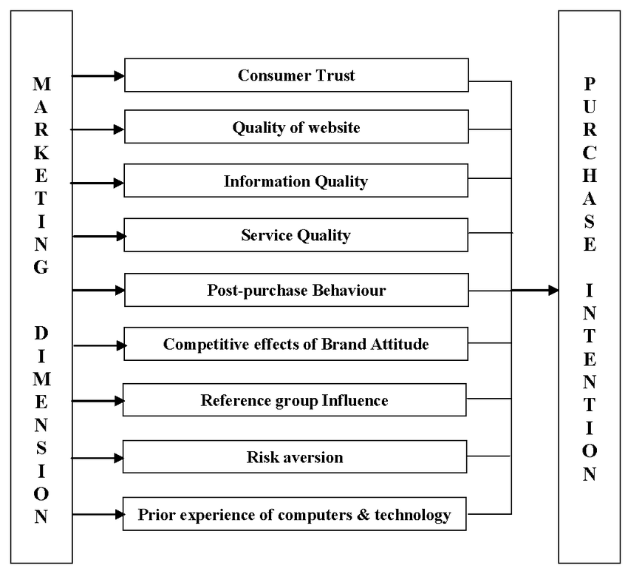
Figure 2: Theoretical model of purchase intention
(Source: Amaldossand Jain, 2015)

Skills for professional practice
There are several ways to approach a research work. A company needs to hire professional to start the survey process. The aim of the survey will be to evaluate customer interest and if the brand has any impact on the market. The secondary target of the survey will be to create awareness of the brand among their potential customers. The company needs to sort out the age of their potential customer and interview them separately (Karimiet al. 2015). A survey should be unbiased and honest. Feedbacks from the customers should be taken separately and the company needs to work on the suggestions of their consumers.
There are several examples when a company has revived only by following suggestions from the customers. The survey should be created in a tabular form and presented to the company’s production team. Immediate actions should be taken to bring changes. The more a company understands the market and their customers’ need easier it will be for them to design their product accordingly (Randhawaet al. 2015). There is no denying the fact that customers’ decision-making process is influenced by their brand choice. Therefore creating a brand is a long-term process where the company has to be patient. A product which is launched should be reliable and worth the money. Every company needs to market their product in a positive way and concentrate on the quality of the product. Once all these criteria are fulfilled, the company can expect their products to become a brand in the market.
Mainly at any project work, the three predetermined skills are required. It is too helpful that, the topic taken for exploration can be only performing research method. At these them I can say that, after profound investigation of those turning out put those which are close are chosen for the place of the exposition in the last research work accommodation. So from this I can comprehend the significance of the execution of those examination work the models, which come after the comprehension and investigation periods of research (Dallas et al. 2017).

Conclusion
From the present study it can be concluded that the branding does play a major role in deciding the buying behaviour of the customer. This was effectively found out from the thorough research from every aspect of the literature. It is quite evident that marketing has been a good option to maintain the brand value and promote the value in the market to gain competitive advantages. However, developing a brand needs time and money, which is quite an essential aspect for starting up the business. Further analysis has been provided along with evaluation of the topic objective. The practical application of such theories is elaborated in accordance to the skills for the professional practice for gaining the branding effectiveness on the consumer behaviour.

References
- Amaldoss, W. and Jain, S., 2015. Branding conspicuous goods: An analysis of the effects of social influence and competition. Management Science, 61(9), pp.2064-2079.
- Balabanis, G. and Siamagka, N.T., 2017. Inconsistencies in the behavioural effects of consumer ethnocentrism: The role of brand, product category and country of origin. International Marketing Review, 34(2), pp.166-182.
- Häubl, G. and Trifts, V., 2000. Consumer decision making in online shopping environments: The effects of interactive decision aids. Marketing science, 19(1), pp.4-21.
- Huang, R. and Sarigöllü, E., 2014. How brand awareness relates to market outcome, brand equity, and the marketing mix. In Fashion Branding and Consumer Behaviors (pp. 113-132). Springer, New York, NY.
- Kang, J., Tang, L. and Fiore, A.M., 2014. Enhancing consumer–brand relationships on restaurant Facebook fan pages: Maximizing consumer benefits and increasing active participation. International Journal of Hospitality Management, 36, pp.145-155.
- Karimi, S., Papamichail, K.N. and Holland, C.P., 2015. The effect of prior knowledge and decision-making style on the online purchase decision-making process: A typology of consumer shopping behaviour. Decision Support Systems, 77, pp.137-147.
- Keller, K.L., 2016. Reflections on customer-based brand equity: perspectives, progress, and priorities. AMS review, 6(1-2), pp.1-16.
- Macdonald, E.K. and Sharp, B.M., 2000. Brand awareness effects on consumer decision making for a common, repeat purchase product:: A replication. Journal of business research, 48(1), pp.5-15.
- Randhawa, P., Calantone, R.J. and Voorhees, C.M., 2015. The pursuit of counterfeited luxury: An examination of the negative side effects of close consumer–brand connections. Journal of Business Research, 68(11), pp.2395-2403.
- Sasmita, J. and MohdSuki, N., 2015. Young consumers’ insights on brand equity: Effects of brand association, brand loyalty, brand awareness, and brand image. International Journal of Retail & Distribution Management, 43(3), pp.276-292.
- Schivinski, B. and Dabrowski, D., 2016. The effect of social media communication on consumer perceptions of brands. Journal of Marketing Communications, 22(2), pp.189-214

