
LDE Assignment 1
Module Code: ACCA 4025
Student Name: Maryam Ali Zoda
Student ID:2531289
Group:1

E-portfolio: Link
Module Code: ACCA 4025
Student Name: Maryam Ali Zoda
Student ID: 2531289

Koushik Modak
London Campus

Table of Contents
Introduction 2
Task 1 Essential academic and employment skills for the future path 2
Task 1 (b): Evaluation of Task 1 (a) based on the Similarity report 3
Task 2: Collaborative Mind Map and Individual Poster 3
Mind Map (Collaborative) 3
Poster (Individual) 3
Task 3: Virtual Collaboration and RefWorks 3
Report on Virtual Collaboration 3
Step-by-step process of using RefWorks with visuals 4
Task 4: E-Portfolio Creation and Evaluation 4
Task 4 (a): E-Portfolio Creation 4
Task 4 (b): Illustrative Review of E-Portfolio Tool Selection 4
Conclusion 4
References 4
Task 1 References: 4
Task 3 References: 5

Introduction
This assignment aimed to highlight skills such as critical thinking, literacy, communication, and adaptability. Critical thinking skills enable an individual to analyse information and make informed decisions when solving a problem. Literacy skills help an individual understand and effectively communicate written information. The combination of literacy and communication skills enables an individual to effectively communicate ideas and work as part of a team. Adaptability skills are equally significant, as they can't, as they assist an individual in responding positively to change and new challenges. The development of these skills is significant for enhancing both academic and professional success. To highlight some of the most significant academic and professional skills that are required for success in academic and professional fields.

Task 1: Essential academic and employment skills for the future path
Task 1 (a): Report on Essential Academic and Employment Skills
Academic skills are essential for students to succeed in their future careers, especially in this dynamic environment. One essential academic skill is critical thinking, which enables students to analyse data critically, ask relevant questions, and make appropriate decisions rather than accepting data without proper evaluation. According to research, students who can think critically can enhance their academic performance and address complex problems in the future [1].
Another skill students need to develop is communication. This entails the student’s ability to express themselves in both oral and written forms. Communication skills play a critical role in helping students complete their tasks successfully. Research has shown that effective communication skills help students achieve better teamwork and academic success [2].
Personal effectiveness skills, such as emotional intelligence, self-motivation, perseverance, and discipline, help you manage your life and behaviour in a way that is goal-oriented, efficient, and effective. Personal effectiveness skills, such as emotional intelligence, self-motivation, perseverance, and discipline, help you manage your life and behaviour in a way that is goal-oriented, efficient, and effective. In the academic environment, personal effectiveness skills help you meet your deadlines, actively participate in class, and learn from your experiences. Personal effectiveness skills, such as emotional intelligence, self-motivation, perseverance, and discipline, help you manage your life and behaviour in a way that is goal-oriented, efficient, and effective. Personal effectiveness skills, such as emotional intelligence, self-motivation, perseverance, and discipline, help you manage your life and behaviour in a way that is goal-oriented, efficient, and effective. Personal effectiveness skills, such as emotional
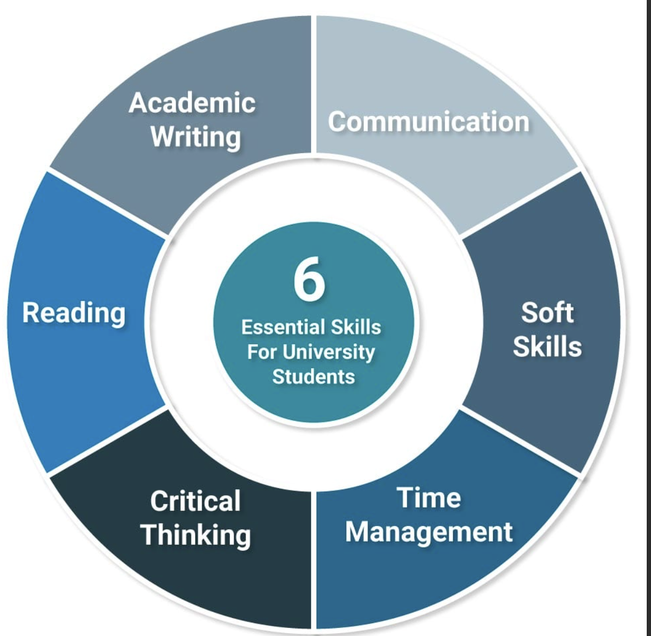
Figure 1: Communication Skills for the Workplace [3].
One of the most important skills in the digital age is information literacy. Students are exposed to vast amounts of information in the digital age, but not all of it is reliable. Students must learn to use the information they find ethically, thereby promoting academic integrity and lifelong learning.

Finally, digital literacy and adaptability are key skills for the future. This is because
technology continues to evolve; therefore, the student needs to know how to effectively utilise digital tools and be able to adapt to new learning environments. Digital competence enables the student to succeed academically and prepares them for the career world, which is dominated by technology [4]
Essential academic and employment skills have a vital role in helping individuals prepare for their future career paths. Academic skills include research, reading, and analytical skills, which assist students in their ability to understand and apply knowledge. Employment skills include leadership, communication, and teamwork skills, which are highly valued in the workplace. Adaptability to change is also necessary in today’s rapidly changing world. Problem-solving and creativity will also help to bring innovation and increase efficiency in the workplace. Self-discipline and accountability will also ensure that all tasks are completed in a timely fashion [5].

Task 1 (b): Evaluation of Task 1 (a) based on the Similarity report

- 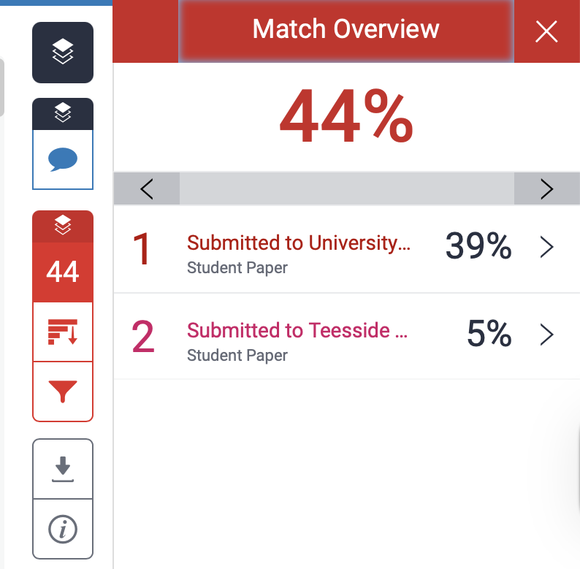

My similarity score for this assignment is 46%. However, everything seems to be okay on my end. My template had a 44% similarity score, and I also scored a 5% similarity score on my reference. Prior to writing this assignment, I have read books on essential skills required in academia and at work according to Google Scholar, as well as a number of reports on this topic.
Regarding the marking, I believe I deserve a mark of 60%. I have carried out thorough research on the topic. I provided a brief introduction about my topic, as well as the skills required for success in academic as well as car paths. I then went on to discuss them one by one, using multiple sources as references. I discussed critical thinking using the book Critical Thinking Skills: Effective Analysis, Argument, and Reflection, researched ability using a report published by MDPI, and problem-solving using a title from the University of Leicester in 2025, Employability skills: Problem-solving in academic work. I then went on to communication skills, writing, and using the book Communication Skills-Core of Employability Skills: Issues & Concerns. I then discussed digital literacy, drawing on the book Digital Literacy and Vocational Education, which provided me with essential information on the topic. I used a relevant picture about this topic.

Task 2: Collaborative Mind Map and Individual Poster

Mind Map Link:
https://mm.tt/map/3952545948?t=q4PFcBkcCh
- 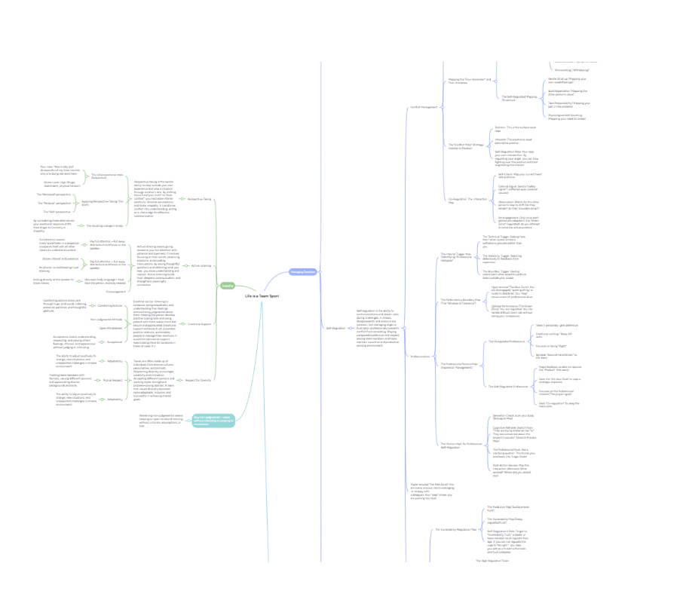

Postal Link: https://canva.link/6b0cdoq7o0mhkzs

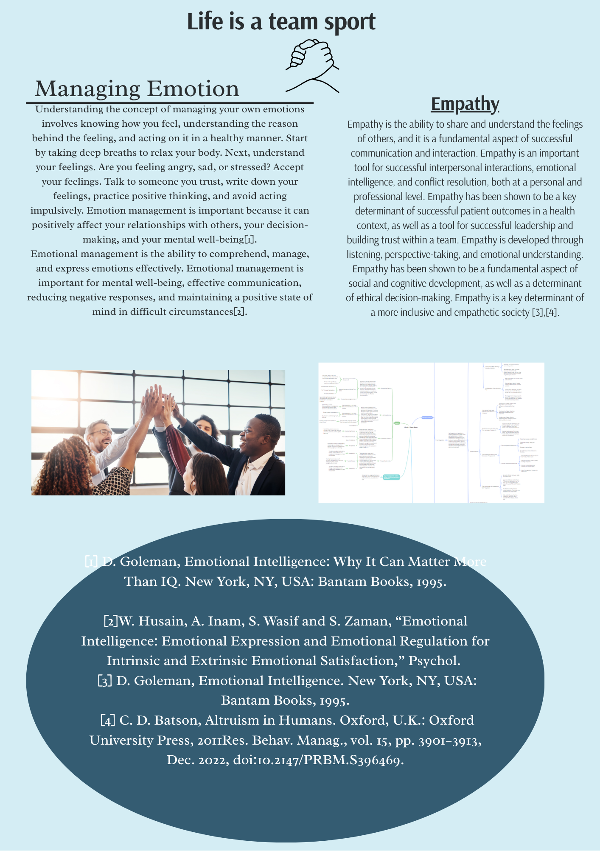

Task 3: Virtual Collaboration and RefWorks

Report on Virtual Collaboration
Topic 1: Forming a team
Virtual collaboration is an integral part of team development in today’s academic and professional environments. With the introduction of technology, people can now work in teams regardless of their geographical locations, thus creating diverse teams. However, this can only happen by considering basic elements such as trust, conflict, commitment, accountability, achievement, and results[1]
Trust is the fundamental team's face when facing the challenge of limited opportunities for interaction, which makes it difficult to develop relationships. Therefore, team members can rely only on communication, transparency, and reliability to build trust. The use of collaboration tools like Microsoft t Teams or Zoom can facilitate communication among the team members. A mental element for the success of any virtual team[2].
Conflict is an inevitable part of any team, but in a virtual setting, it can sometimes arise from miscommunication or a lack of nonverbal cues. To manage conflict, one must promote open communication, establish communication norms, and resolve any miscommunications. Constructive conflict can lead to increased creativity and decision-making capabilities, as diverse opinions can be expressed [3].
For a virtual team to be successful, commitment is crucial. This is because, in most cases, members of a virtual team work individually, making commitment challenging. Goals, roles, and objectives are important in fostering commitment among members of a virtual team. The team leaders or coordinators should ensure that team members know their roles and contributions to the overall project.

Accountability will ensure that every team member assumes responsibility for their roles. In virtual teams, this can be achieved using tools such as shared documents, task management platforms, and activity trackers like Trello or Asana. Check-ins and updates can also promote accountability, ensuring timely delivery of deadlines and the execution of roles [4].

Achievement of virtual teams is highly correlated with collaboration quality and performance. The presence of trust, commitment, and accountability in a team will help them achieve their objectives efficiently. Celebrating small achievements may help motivate the members of the teams to maintain momentum through the project lifecycle
Lastly, results are the ultimate measure of the team’s success. The virtual team has to ensure that it delivers results of high quality and, at the same time, remains efficient in its delivery. It is essential to assess the team's process and final output, as this helps in identifying areas of improvement for the next team collaboration. Reflection and feedback sessions may be conducted to improve team performance.
In conclusion, it is evident that a successful virtual team is not only about technology but also involves effective interpersonal and organisational skills. This includes the use of trust, effective management of conflicts, commitment, accountability, and achievement. Virtual teams, therefore, not only break the barriers of geography but also enhance innovation and productivity.

Step-by-step process of using RefWorks with visuals

First, I go to Google and search for RefWorks of the University of Wales Trinity Saint David and see the RefWorks there. I click on it, and it will open.

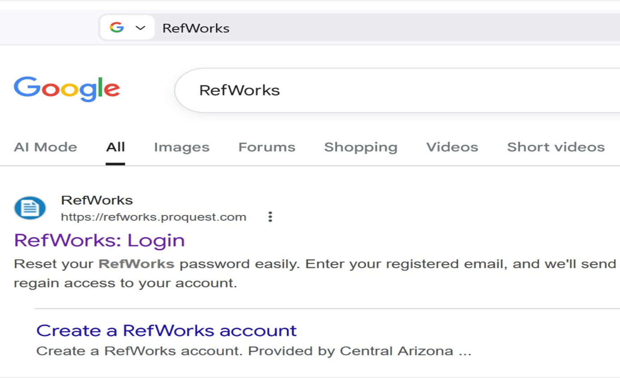
After that, we will create an account by clicking the blue button we can see.

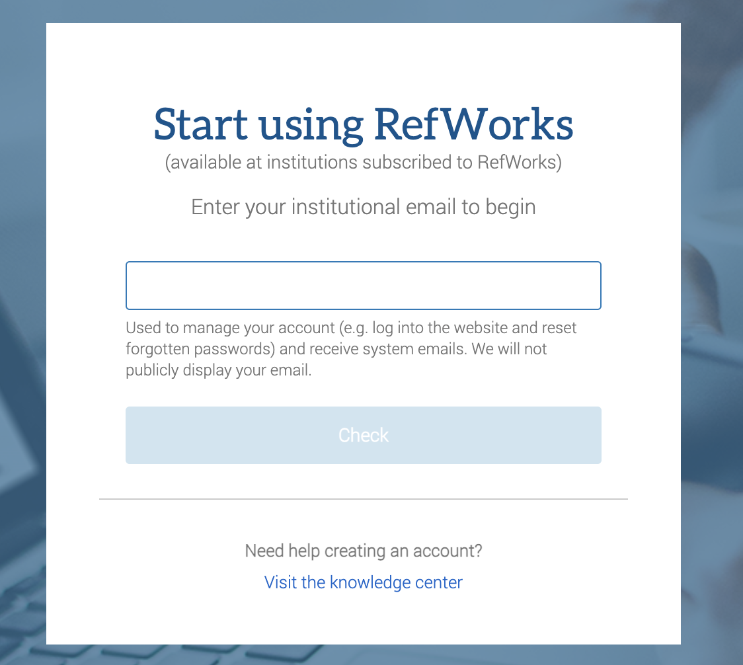Write your email there.
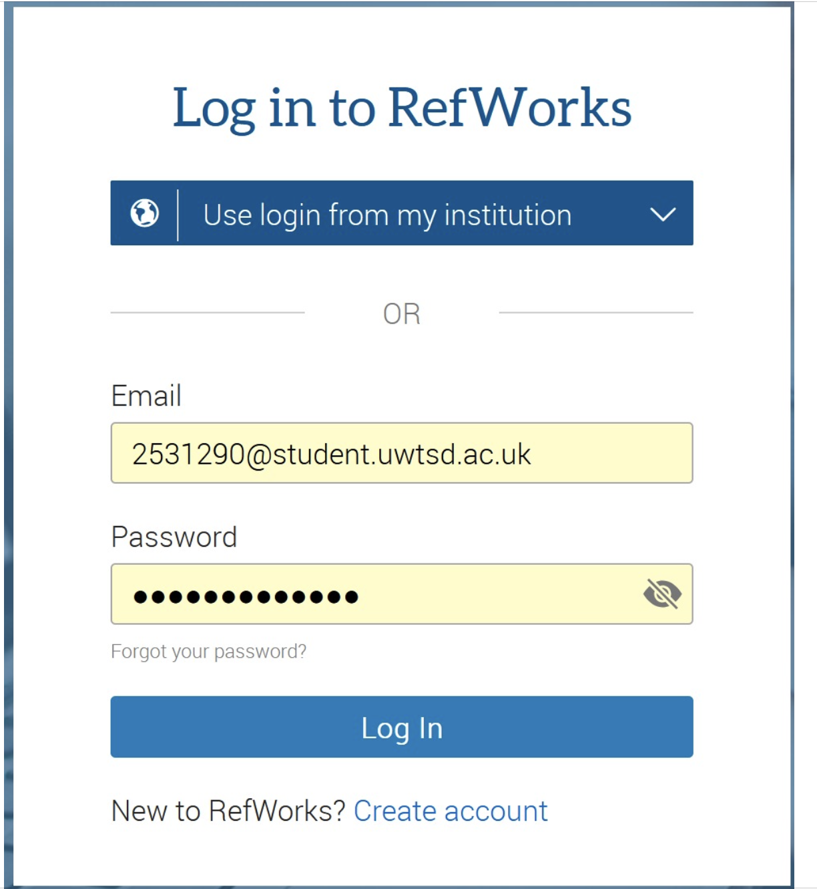
Or if you have an account, just click on sign in and sign in to your account.
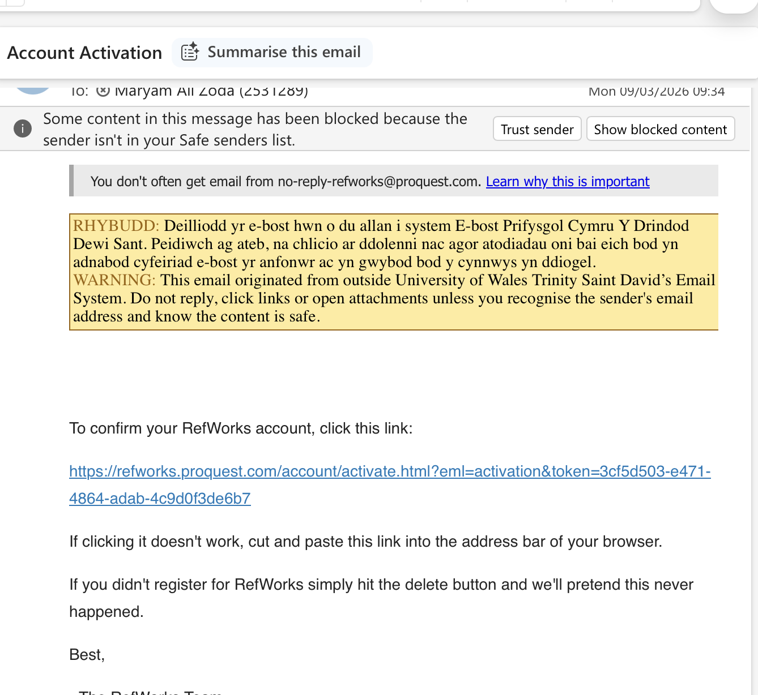

After we create an account, we will receive a confirmation email
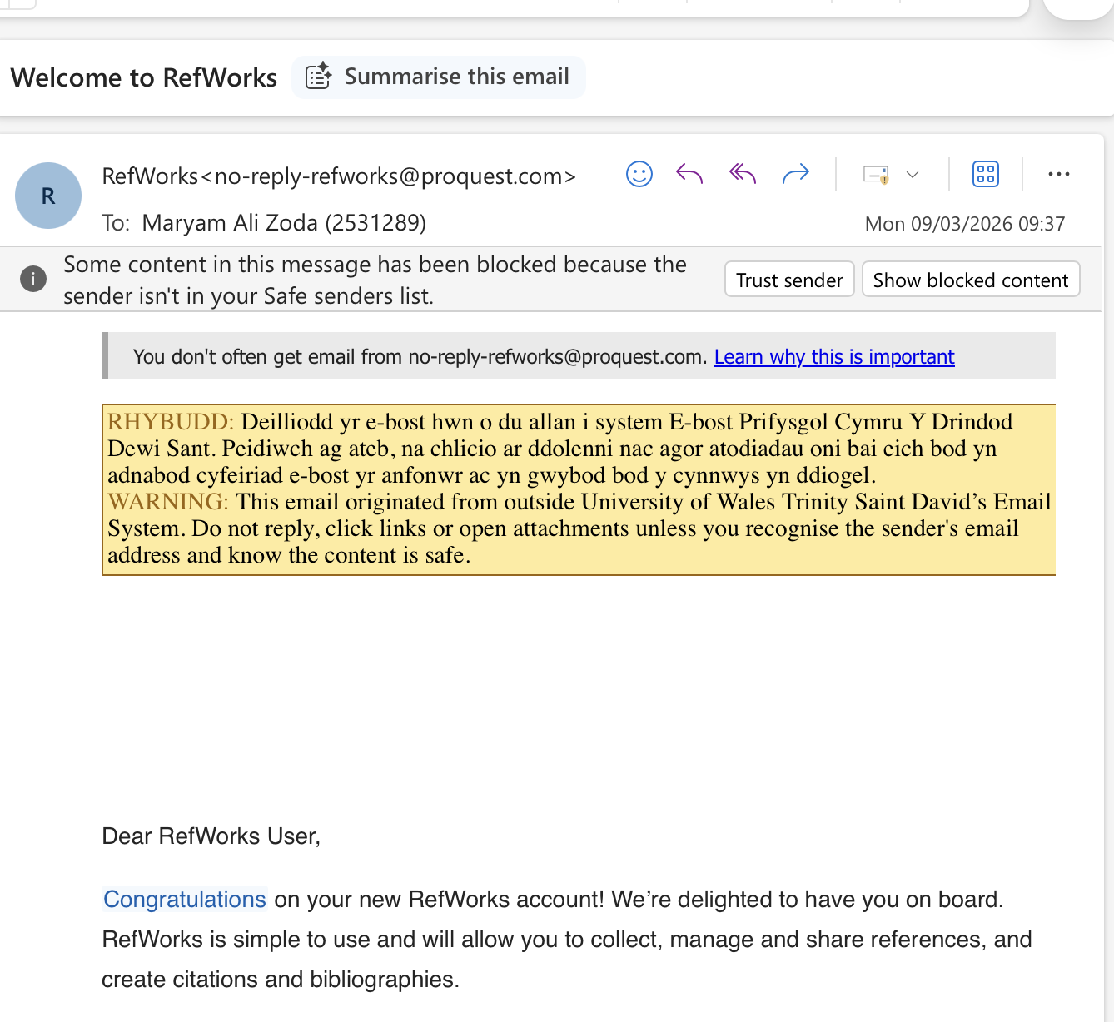
After we confirm the email, we will receive another email so we can use the RefWorks.

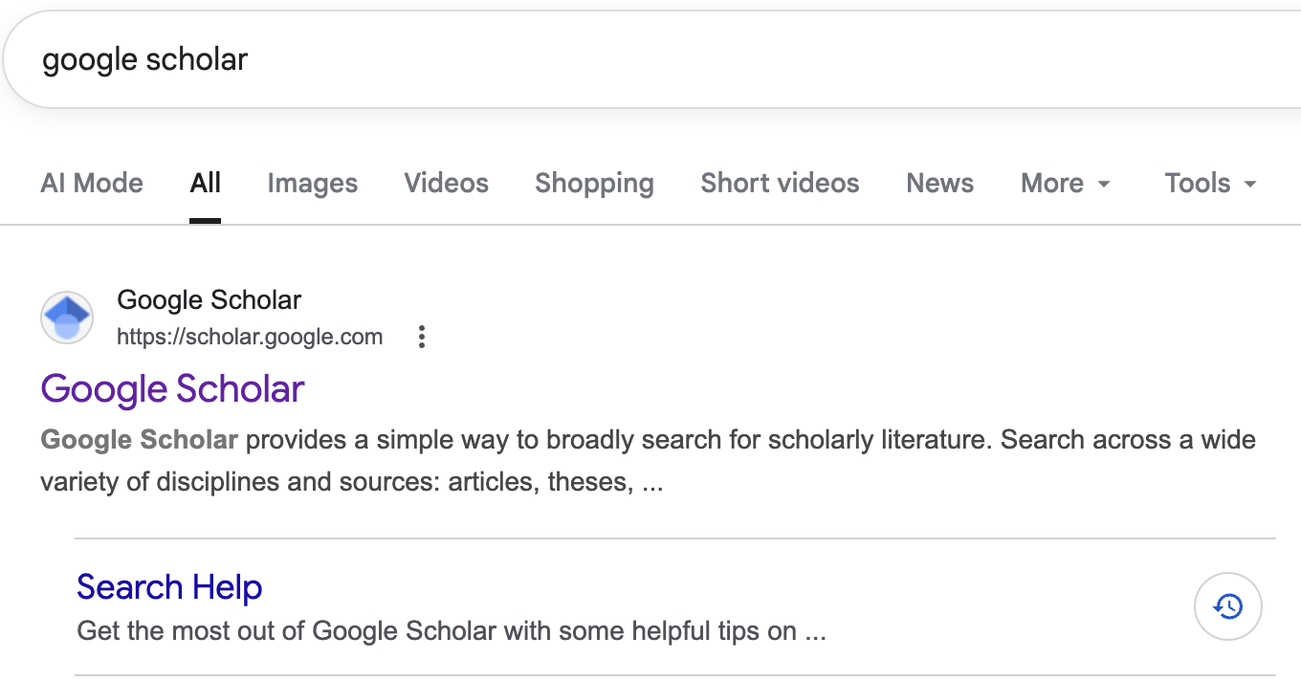
We must open Google Scholar to find the reference citations.
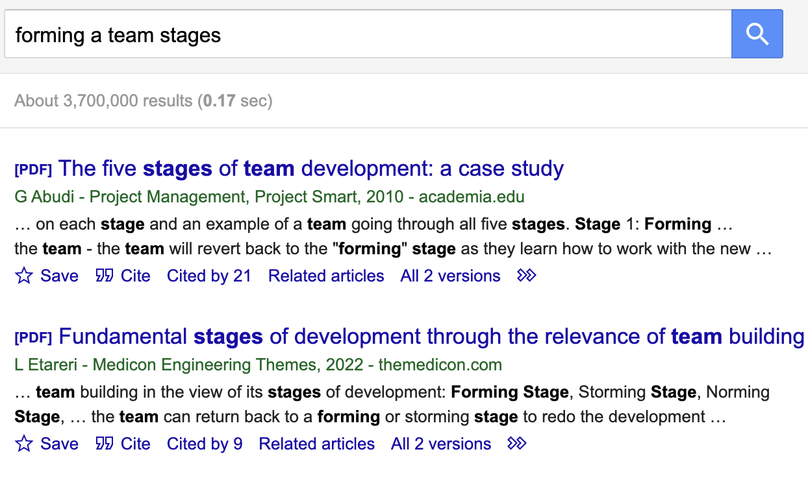
After that, we type a topic to find a reference.

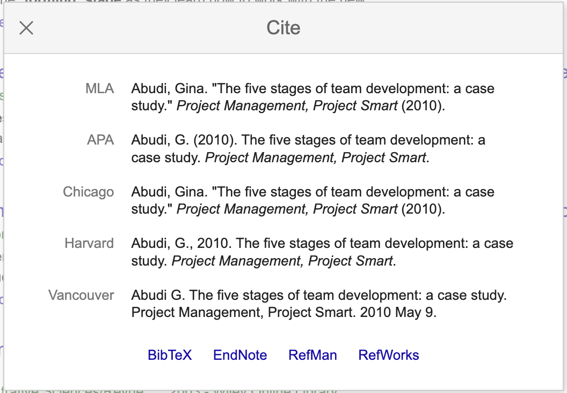

After that, we must click cite and choose a RefWorks
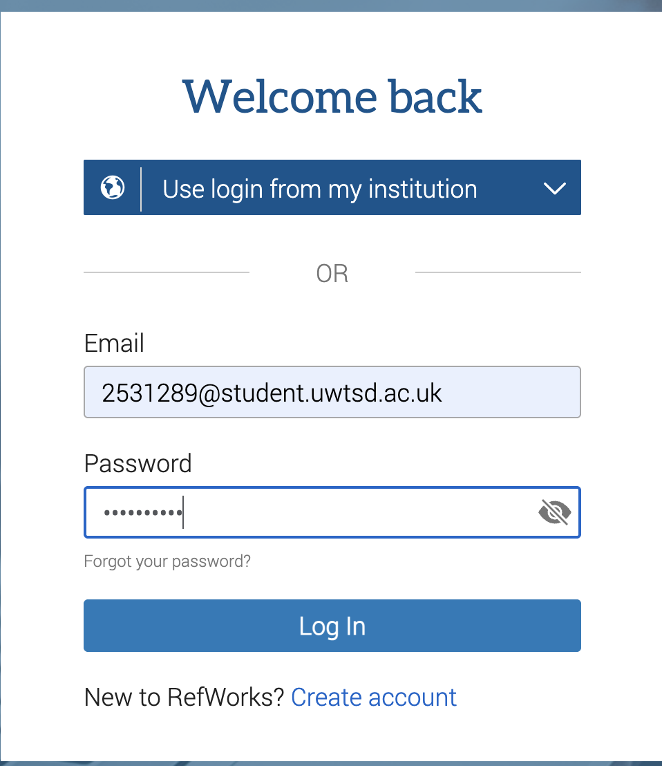
After that, open RefWorks, enter your email and password, and click Log In.
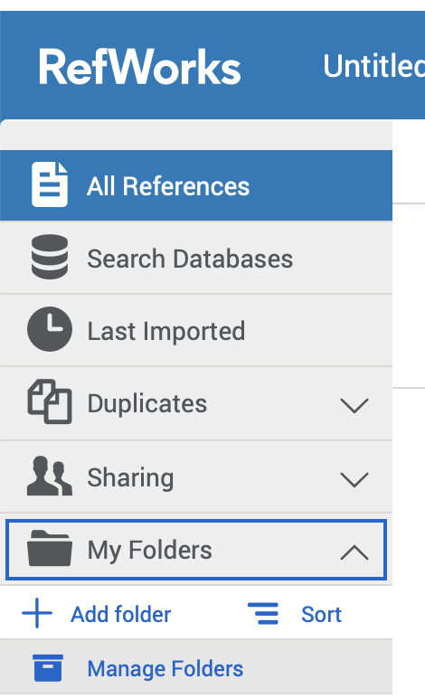
After we must click on a folder to make a new one folder.

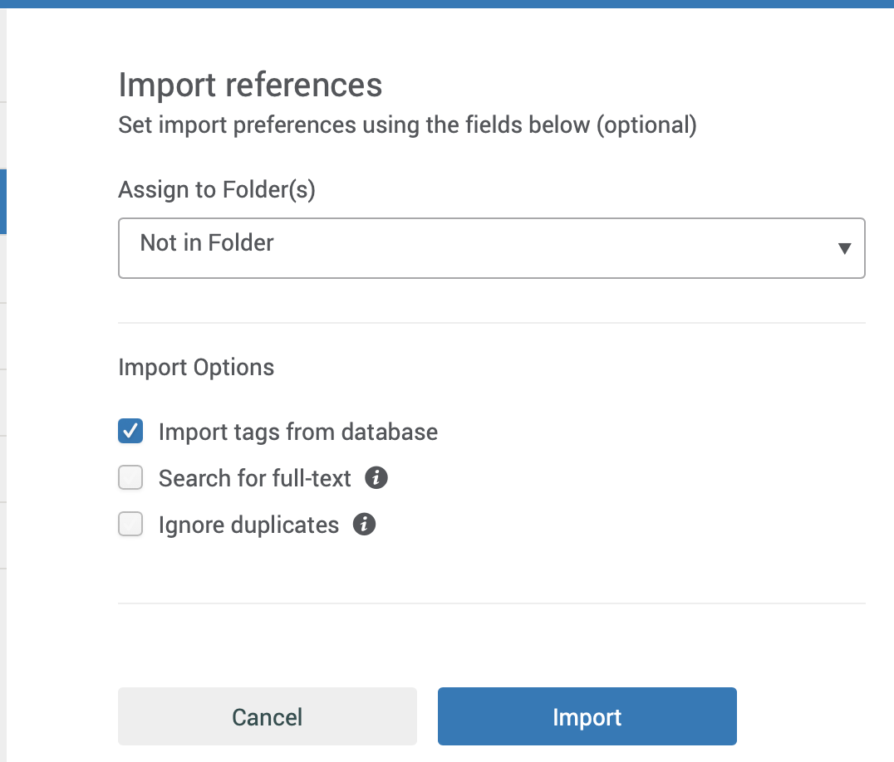
We click the cite and choose the RefWorks, then this page will come up

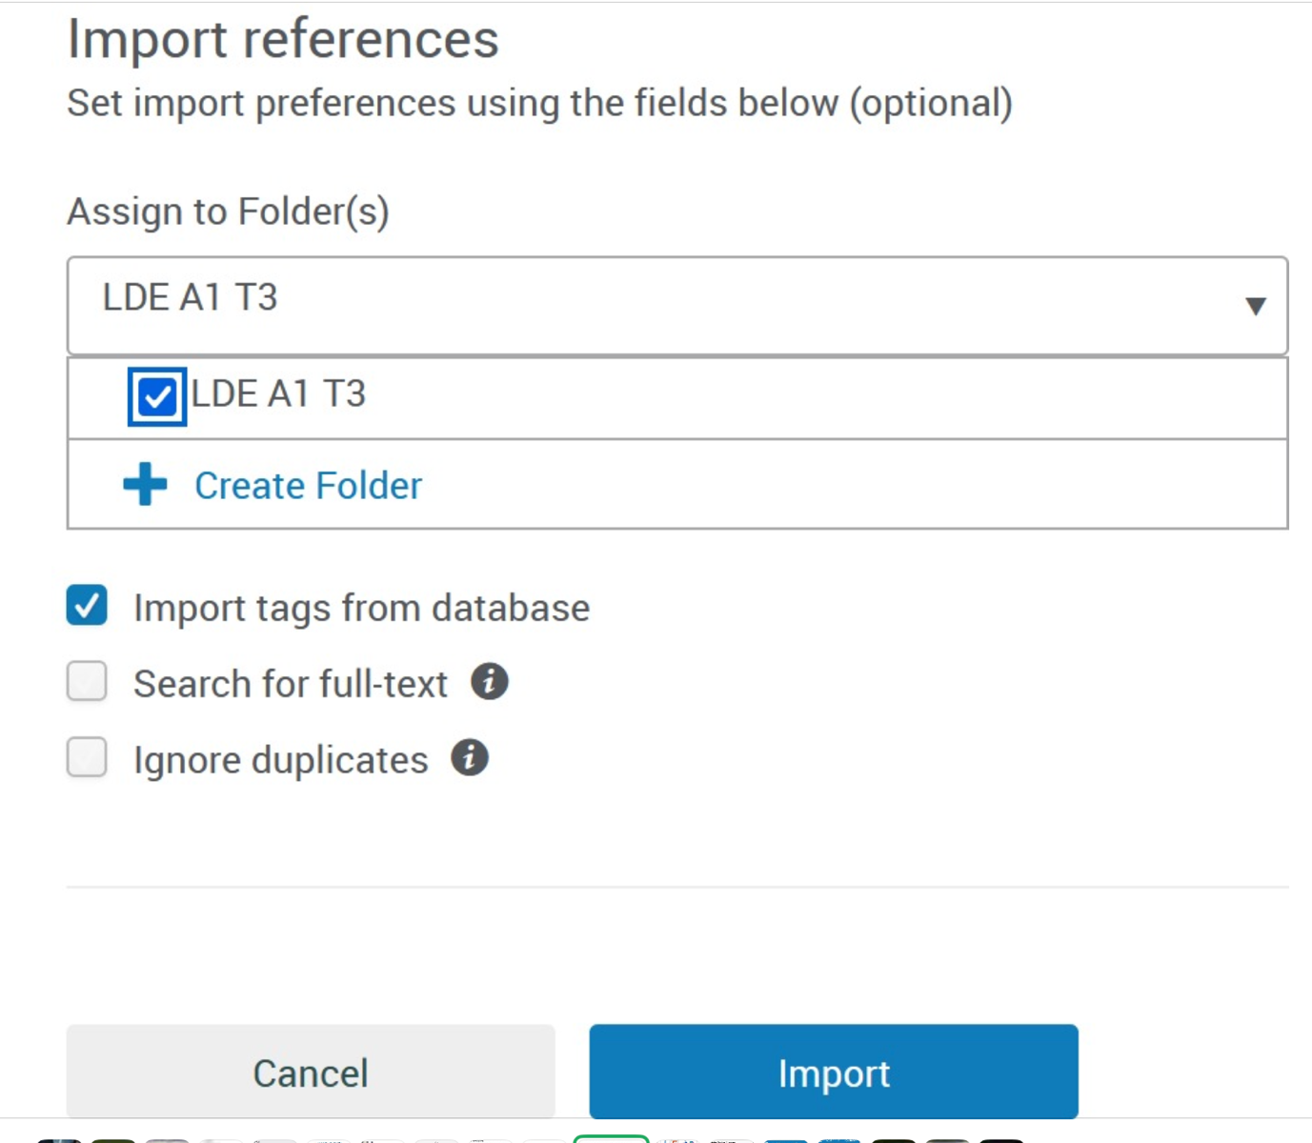
Then we click the folder which we made, and then click import
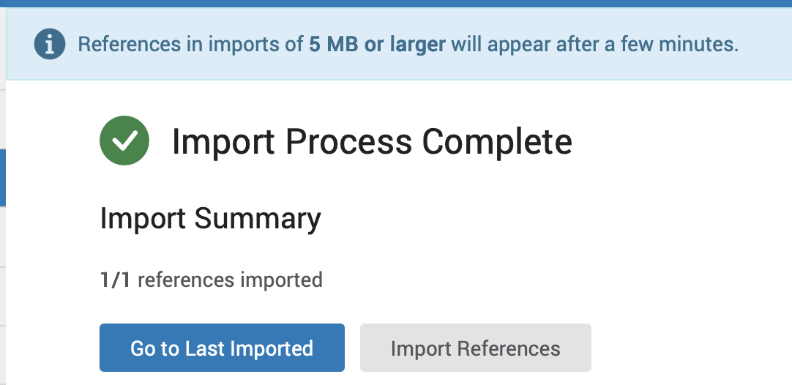
The import process is complete.
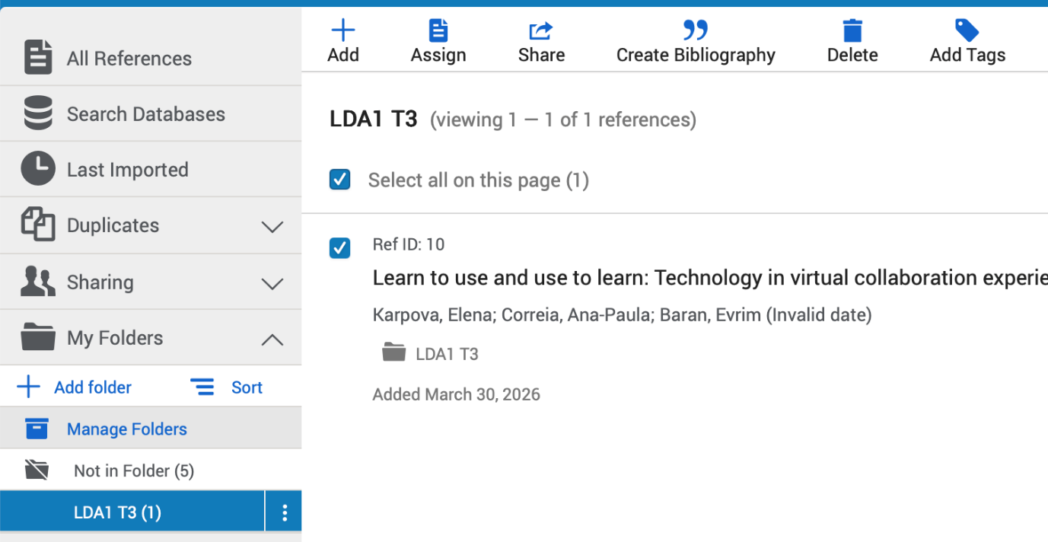
Then we open the folder and must make sure the reference that we import is in there.

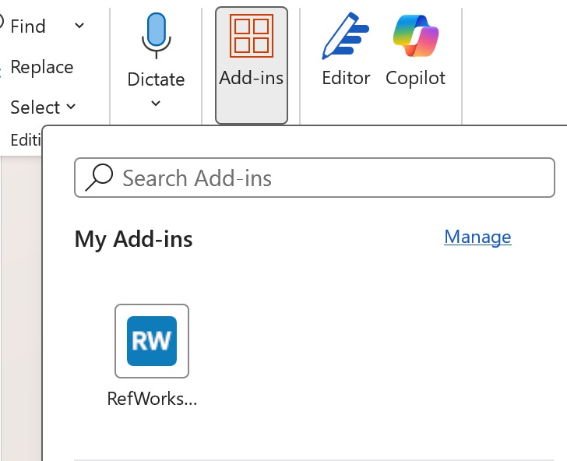Then go to Word and Add-ins; you will see RefWorks. Choose it and add your references.

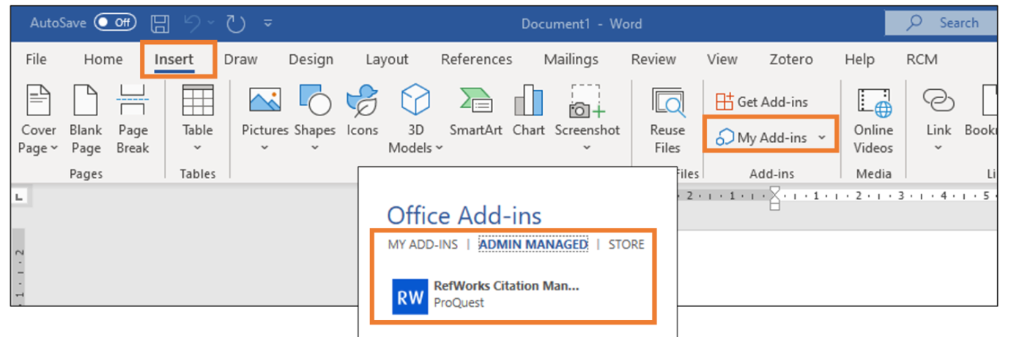

In Open MS Word, click Insert > My Add-ins
Under ADMIN MANAGED, select RefWorks Citation Manager and Add

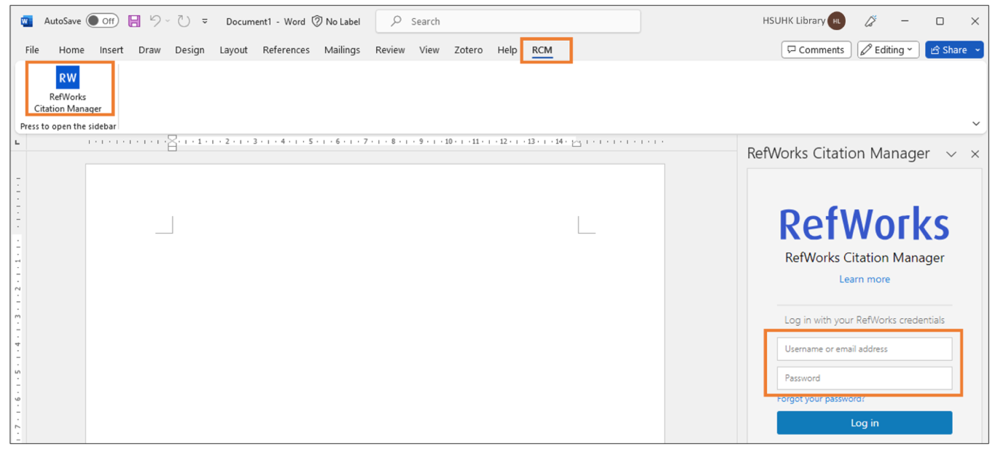
a) click RCM
b) RefWorks Citation Manager button
c) Sign in with your RefWorks account

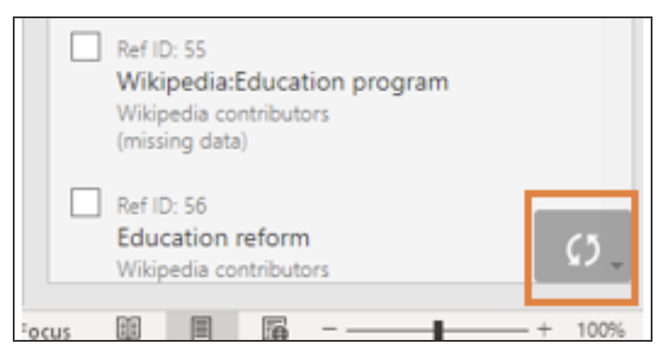
Click the Refresh Reference List button to refresh any updates

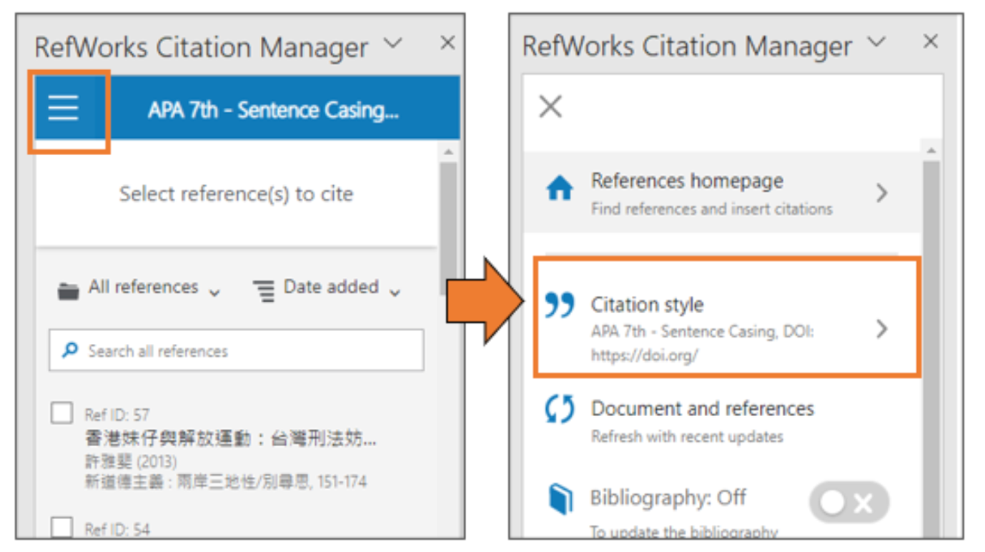
Click the options button > Citation style and select the preferred citation style.

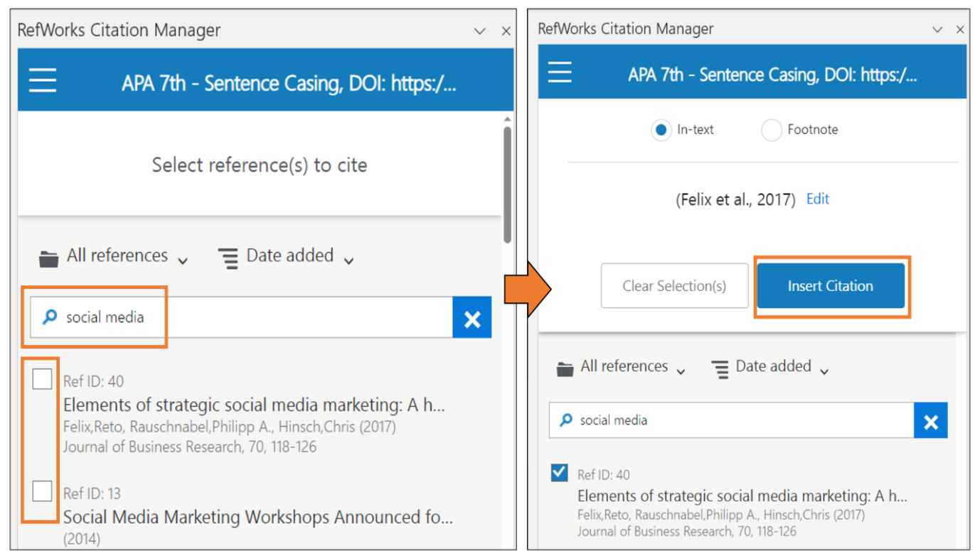
Search and select the reference from the RCM sidebar, and click Insert Citation

Task 4 (a): E-Portfolio Creation
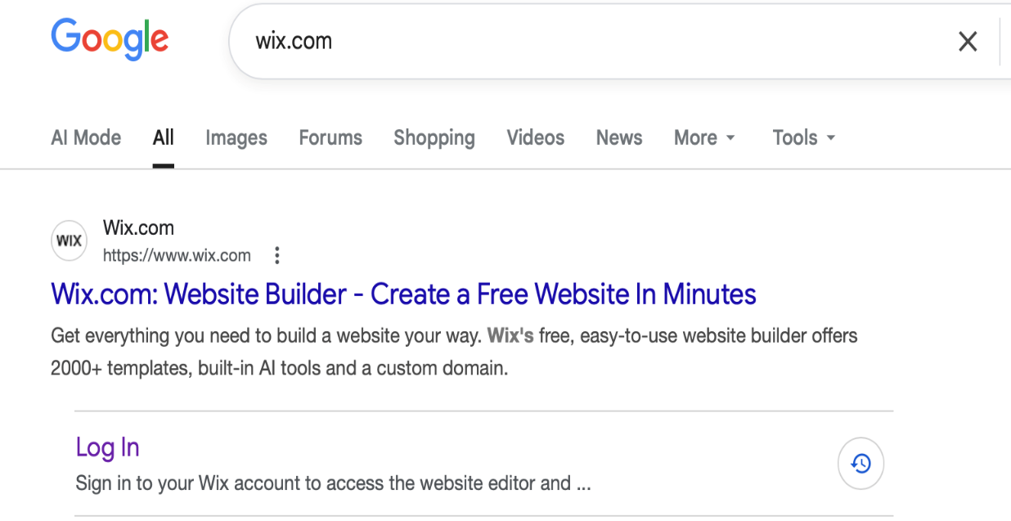
1: Search on Google for Wix.com.


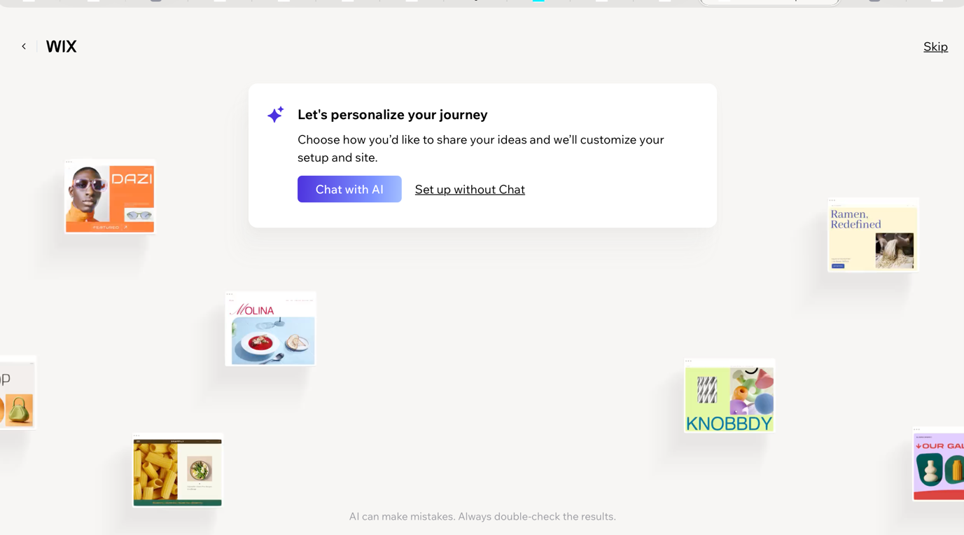
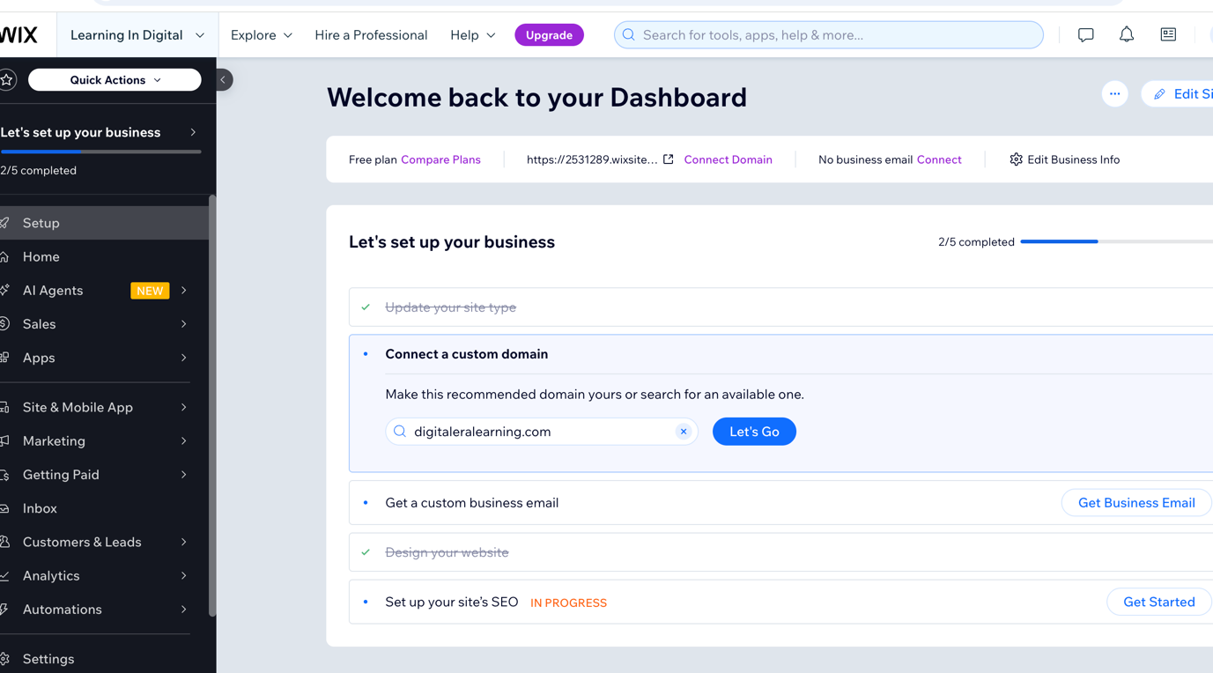

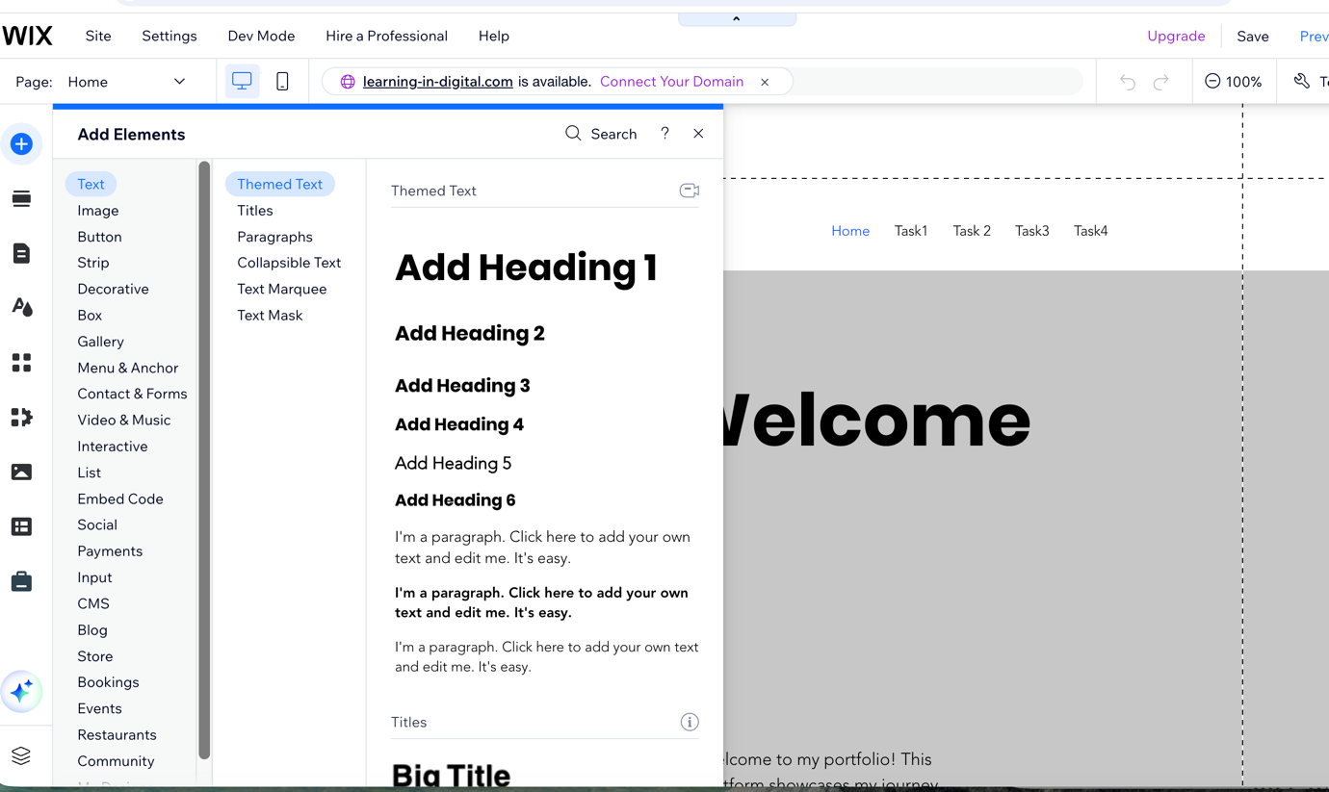
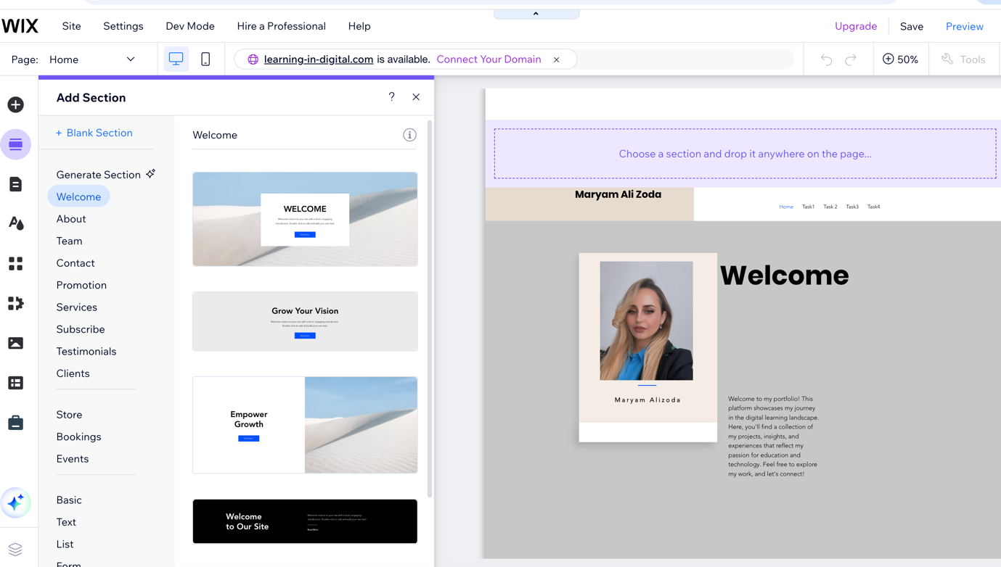
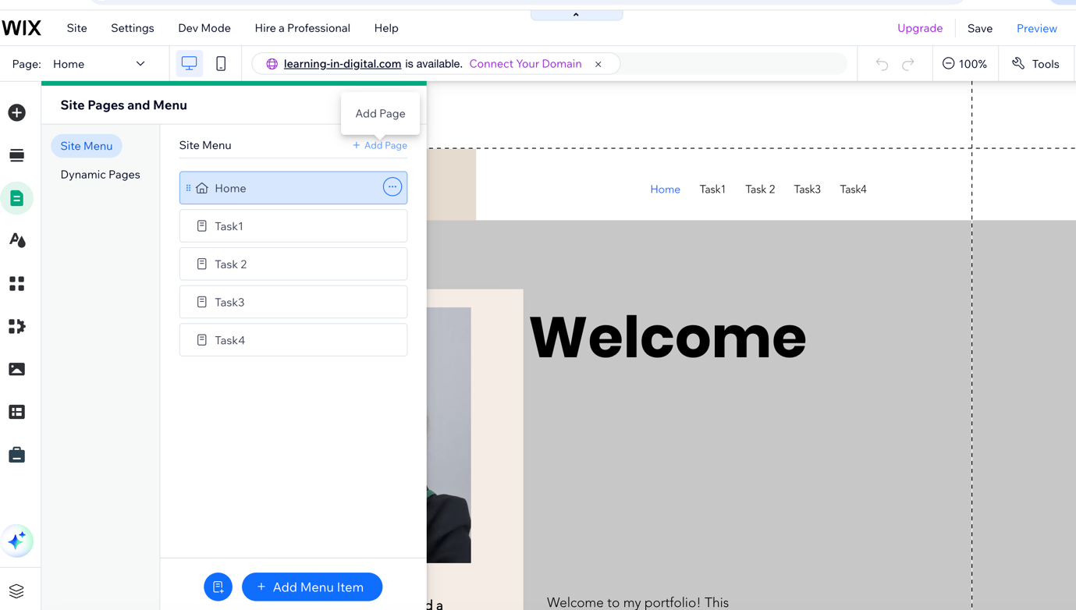

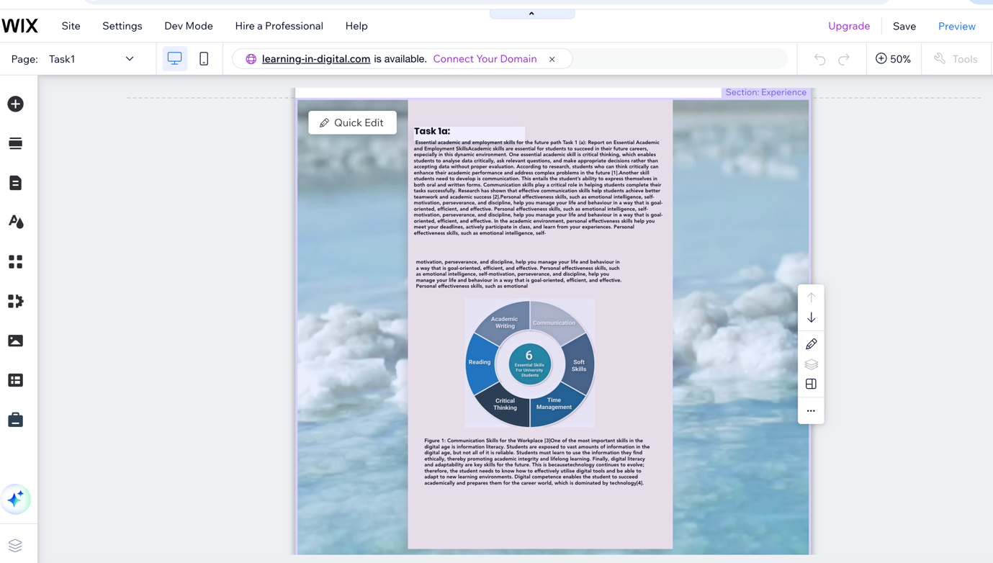
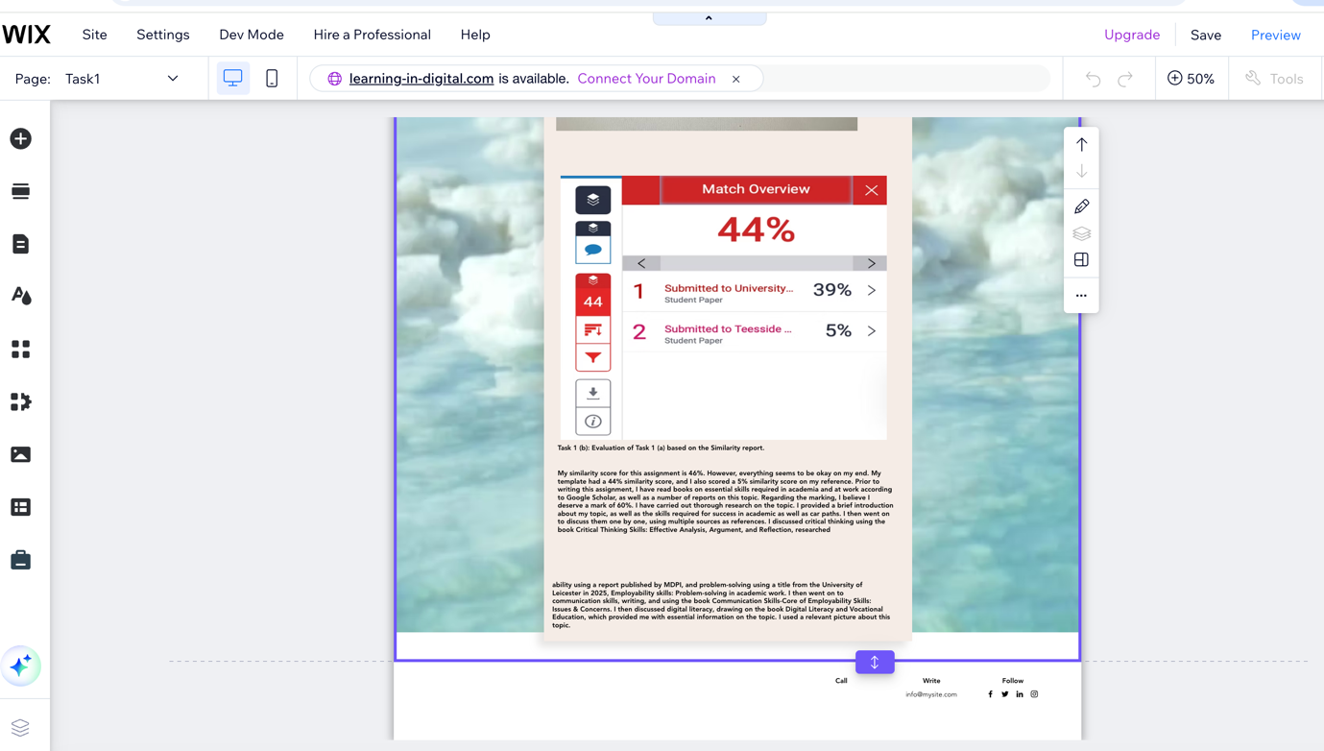
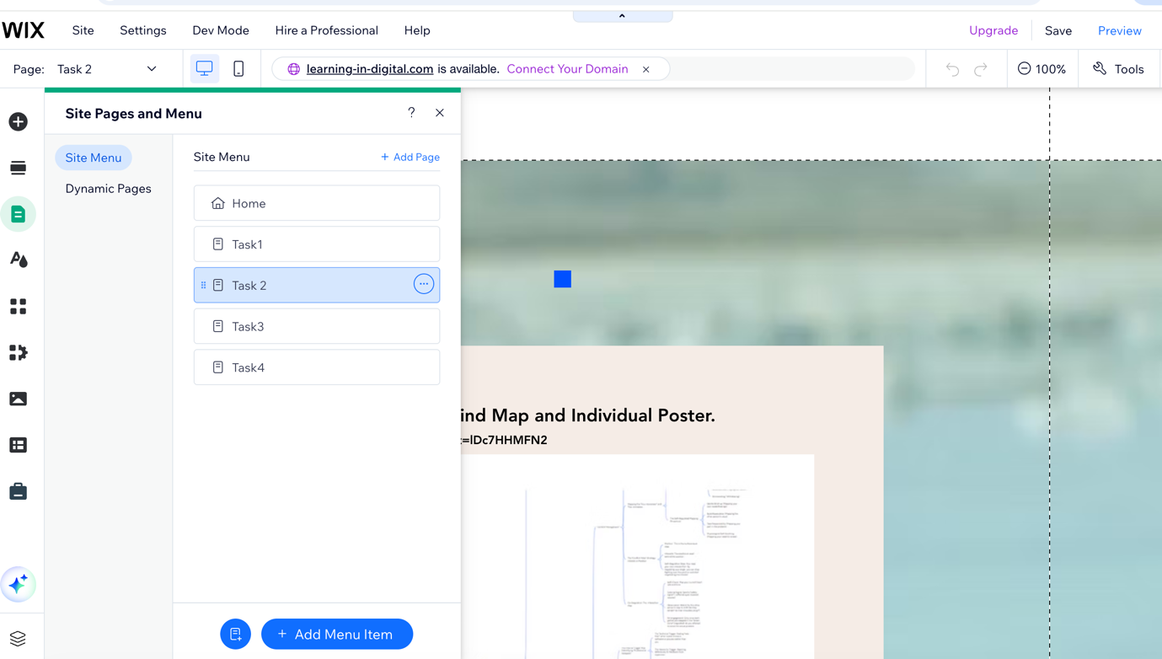
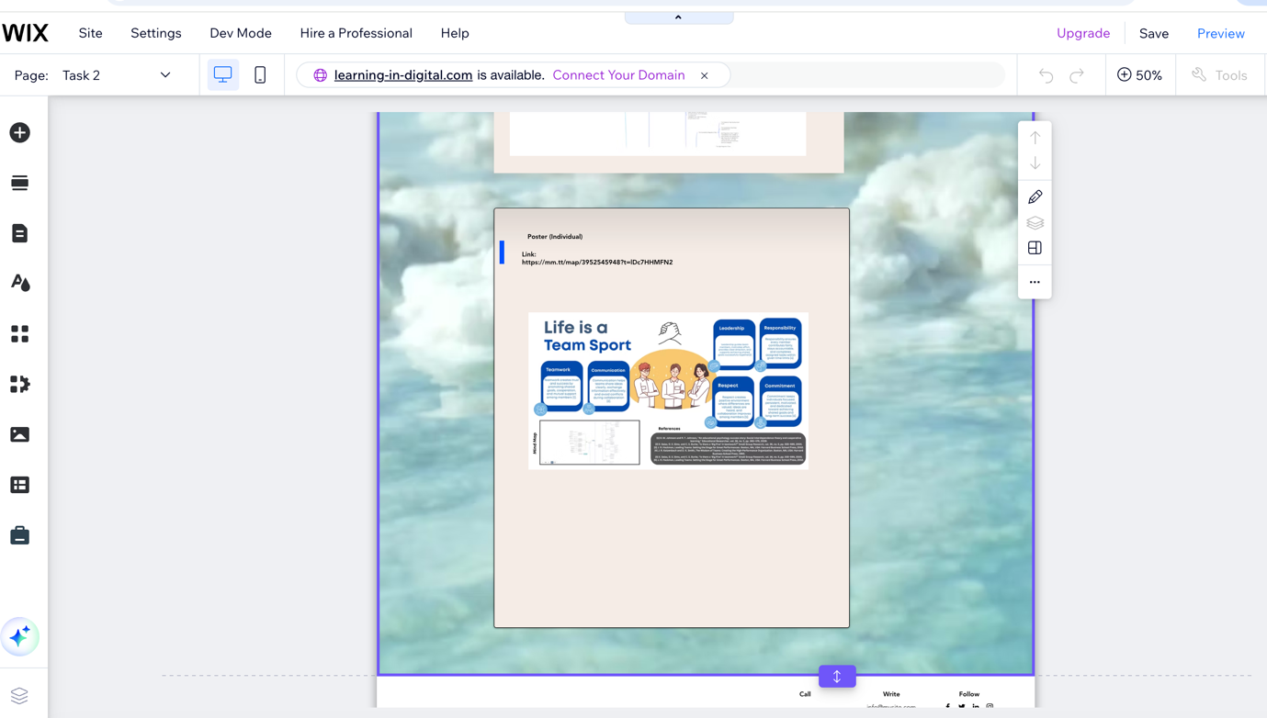

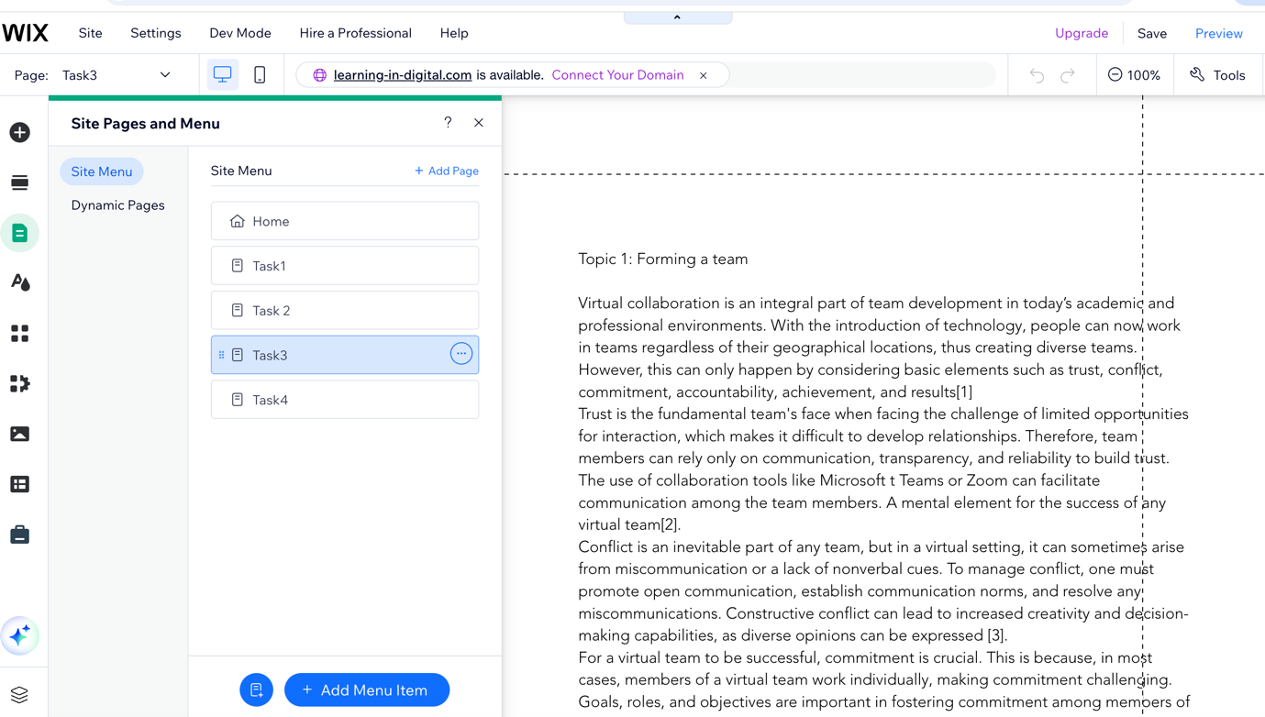

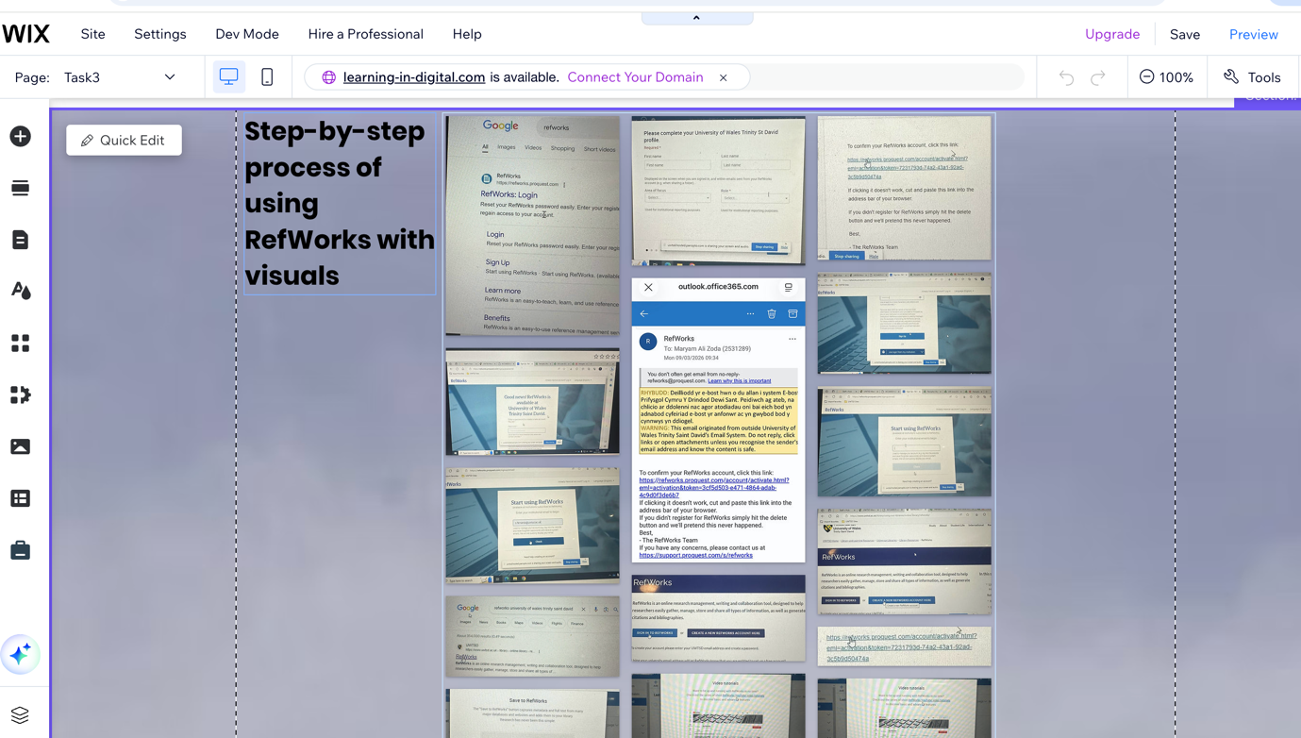

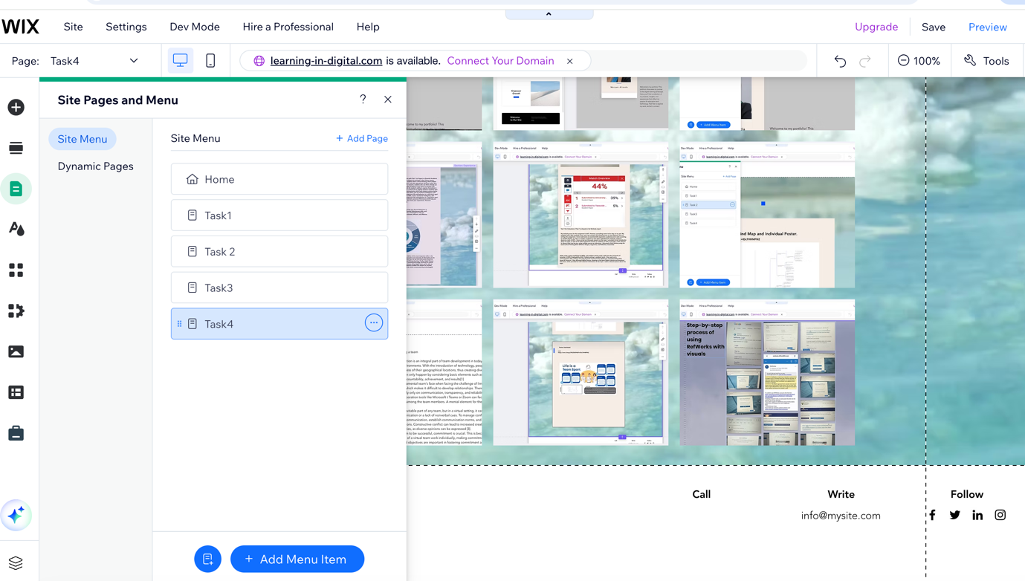

Task 4 (b): Illustrative Review of E-Portfolio Tool Selection
Creating a website with Wix is a simple, versatile process that lets me build a professional site without any coding knowledge. I will begin by selecting a template that fits my needs and editing it to meet my requirements by dragging and dropping the website components into place. I will also have the option to explore other features, such as contact forms and galleries, to enhance the website’s functionality and aesthetic appeal.

I have selected Wix for this project due to its simplicity and suitability for a beginner. The platform is very user-friendly and offers a wide array of options and tools that will help me save time and effort compared to developing a website from scratch. Wix also provides robust hosting and support options that will make the process even easier for me. Therefore, Wix is the best tool for me because it can quickly deliver a functional, visually appealing website.

Conclusion
This assignment has helped me gain a better understanding of the skills needed for both academic success and future employment. I developed important abilities, including critical thinking, research, communication, problem-solving, and digital skills, that are useful in many situations. Working on the mind map improved my ability to work with others, while creating the poster helped me become more creative and independent. I also improved my technical and research skills by using tools like RefWorks and online collaboration platforms. Building an e-portfolio with WordPress was especially helpful because it allowed me to organise and present my work professionally. Overall, this experience has increased my knowledge, strengthened my skills, and boosted my confidence for future studies and career opportunities.

Task 1 References:

Bibliography

[1] | M. Öze, Digital Literacy as a Catalyst for Critical Thinking: From Media to Artificial Intelligence City, Cham , Switzerland: Springeer, 2025.
[2] | S. Cottrell, The study Skills Handbook, London,Uk: Macmillan, 2024-2025.
[3] | “India Entrepreneur,” [Online]. Available: http://www.entrepreneur.com.
[4] | G. Merchant, Rethinking Digital Litteracy, Cheltenham,UK: Edward Elgar Publishing, 2025.
[5] | U. C. f. E. a. S. (UKCES), “Reports on employability and skills gaps,” UK goverment, London UK, 2020.

Task 3 References:
References
[1] S. R. Roy, "Virtual collaboration: The skills needed to collaborate in a virtual environment," vol. 2012, pp.1, 2012,
[2] P. Swanson, et al., "Trust Your Team," vol. 46, no. 4, pp.67–91, 2019,
[3] C. Başoğul, "Conflict management and teamwork in workplace from the perspective of nurses," Perspect.Psychiatr.Care. vol. 57, no. 2, pp.610–619, 2021,
[4] V. R. Stewart, D. G. Snyder and C. Kou, "We hold ourselves accountable: A relational view of team accountability," J.Bus.Ethics. vol. 183, no. 3, pp.691–712, 2023,

