Managing Enterprise in 21st Century Term 2 BMSK4006_LON
A reflective report on my business plan presentation and my studies in Term 1 at Trinity Saint David University of Wales BMSK4006_LON
Lecturer: Dr Gregory Cowan

Table of Contents

Introduction……………………………………….page 2
Description……………………………………………page 2
Things I have learnt page 2-4
Things to improve on and how to do it page 4
Conclusion page 5
Focus of report page 5
References ………………………………….page 6

Introduction.
I will reflect in this report, the various skills I have acquired whilst studying module BMSK4006_LON Managing Enterprise in the 21st century. It will also contain the skill gaps I have recognised whilst on the course and ultimately what plan of action I will take to improve on them.

Description.

I have been on a study course at the London university of Wales trinity saint David, since October 2018. I was very pleased to be accepted as it was an opportunity given to me which neither I nor my family were able to afford previously due to financial difficulties. So one of the modules I am studying is Managing Enterprise in the 21st century, in which in term 1 required me to work with three other students from my class and between us put together a business plan which was presented using power point slides as a group to our Lecturer. We all had to produce our individual slides for the fields we were allocated to cover. The business was named Motorgroom, a car cleaning centre. I will reflect on my studies learnt and events leading up to final presentation, in which I will discuss the business plan structure style, what type of business was chosen, the location of the business ,the products and services of the business amongst other things. I will also identify any skill gaps I have and how to improve on them.

Things I have learnt.

I have learnt how to structure a business plan. The plan needs to include all the important topics in relation to the business and needs to read well so the banker or investor is in no doubt a lot of research and knowledge has been considered putting plan together. The plan should contain the following pages: - contents, introduction, location, the service, product, marketing, competitors, staffing and finance. For example the tasks I undertook were:-Introduction- the explanation of how the business name Motorgroom was formed and the industry it falls in. Location – ensuring geographical location right for business and is easily accessible for driving customers Products and services – products relating to chemicals and polishes used, services relating to different packages of washes from £8 outside only wash to £90 full valet. This has been helpful because I now know how important it is to structure my business plan and give relevant information.

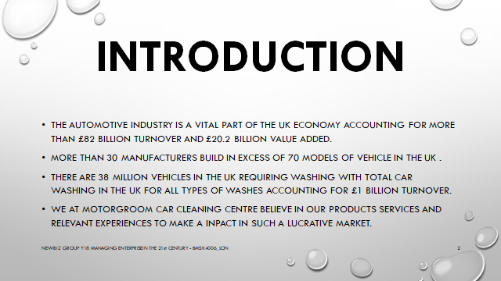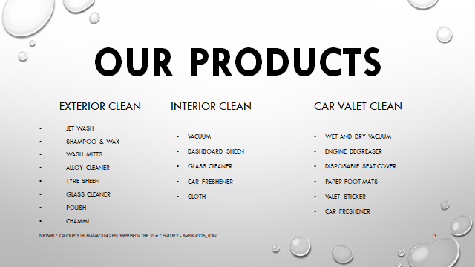
Above: Visual of my slide presentation.

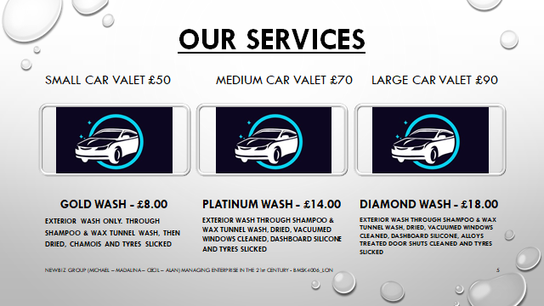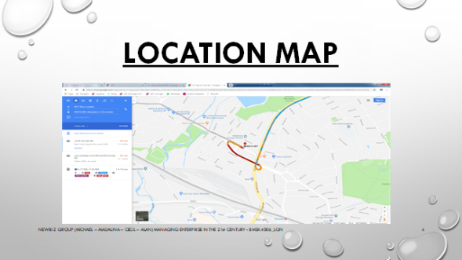
Above: Visual of my slide presentation.

I have also learnt about a various amount of different company set up types, namely private limited company, public limited company, sole traders, franchises, partnerships and Limited company. The two types of P.L.C companies differ because the private company is owned by investors only and the public company is owned by any public citizen who can afford to do so as anyone can buy a share and become a shareholder within that company. A franchise is buying into a business that has already been built or formed, so example being if Motorgroom business grew and was recognised as a reputable car cleaning centre I could sell the model and set up of the business to potential people who’d like to run a business. Sole traders and partnerships businesses are quite easy to start up providing you have a service or product to offer but you the owner will be liable for everything to do with the business. The Motorgroom business plan was developed in mind of it being a limited company as private assets are not part of the business and only products connected to motorgroom can be accessed. This is knowledge is important to me because I now know how to differentiate between company types and am aware of liabilities.

I have developed my skills in different leadership styles. Autocratic leadership style is a style where the leader tells the team what to do, how to do it, not letting the team think for themselves, so a telling you what to do style. A free range leadership style or a “Laissez faire” French translation for “let do” where the leader gives the team direction and objectives and the team do whatever is appropriate to get task done. A participative or democratic leadership style which works with team, example as I was elected team leader for the Motorgroom business plan my leadership style was democratic I would communicate my vision, liaise with team via social media group chat, schedule deadlines for slides to be completed and make the point that everyone is responsible and accountable for their contribution, arrange meetings to put everyone’s work in PowerPoint format for presentation. Having applied this leadership style last term my understanding of this style has improved.

For me the most significant issues I learnt about SWOT and PESTLE analysis when setting up any business, were where I had to identify the strengths, weaknesses, opportunities and threats of the business in the plan. In regards to Motorgroom business plan the strengths were that as a car wash it was in a very good location accessible from north circular road and many other A roads. Weaknesses were not many car owners wash their cars when it is raining and it rains at least for two to three months of the year. Opportunities are contracts from maybe taxi firms, lorry depots and bus depots to clean their vehicles. Threats will be the competition from other car wash companies within radius. The pestle analysis covering the political, environmental, social, legal and economic areas is a more widened analytical look at the business as it ensures the business can function in appropriate fashion regulated by law. Having improved my knowledge this skill will be useful to me as it is my intention is to have my own business one day.

I have begun to build upon my presentation skills and body language skills when doing a presentation. Instead of having a massive amount of literature poured on to slides and just reading from them, it is important to try and remember some of the main talking points of the slide so it shows you have revised your research and remembered it without looking behind you on the screen so often. When presenting a power point presentation, it is important to ensure you engage your audience quickly, this can be done using the six lines per slide, six word per slide rule. Another PowerPoint rule which is helpful is the 10/20/30 rule basically meaning no more than 10 slides, talk no longer than 20 minutes and use no smaller font than 30. Body language and posture is also important when presenting, I have learnt that standing tall, keeping calm, a smart appearance, making eye contact with the member audience and not looking afraid shows confidence in my statue when doing a presentation and encourages audiences engage with me. This skill is important and will be essential to me throughout my university learning journey and also in my employment.
What I have learnt about marketing is that the business being advertised needs to be appealing and effective to attract your customers and for this to happen your presence needs to be seen in the public domain where the public are seeing the business advertised in community papers, on posters, in social media, heard on the radio and such platforms like these. For example having a logo or a branding was essential for the business plan Motorgroom car cleaning company. A back drop of bubbles in the air with car driving through a hoop gives the impression of a car going through a car wash which worked very well as logo. Building an online business presence on social media is a good marketing tool also as there is plenty opportunity for networking. This knowledge of marketing is important to me because I will need to know various marketing strategies for any business ventures I have for the future.

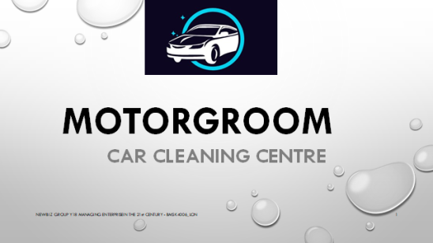
Above: visual of logo

What I have also learnt is that entrepreneurs can be classed as anyone with a plan to create a business whether it is product being made or a service being offered and is willing to take risk is an entrepreneur. Entrepreneurs play a key role in any economy. These are the people who have the skills and initiative necessary to anticipate current and future needs and bring good new ideas to market. Entrepreneurs who prove to be successful in taking on the risks of a new business are rewarded with fame, profits and continued growth opportunities. The Motorgroom business plan shows entrepreneurship it has been well planned and thought through yet takes a risk, although there are numerous car washes in operation, Motorgroom’s unique selling point (professionally trained staff with proven car cleaning track record) to create employment for the economy. Having learned this I now know how important entrepreneurs are to our economy.

Things to improve on and how I’ll do it.
Initially I thought that if I became a business owner I would employ someone like an accountant to go through all my finances and paper work because I am not yet confident about that side of the business, as I am a more practical on the floor hands on kind of person as opposed to being someone sitting in an office working with figures. I realised very early on that whilst preparing for the Motorgroom presentation stronger awareness about cash flow forecast was shown by a team member whom already has a business, so finances for motorgroom were allocated to that person. I will now need to improve on my skills on detailed cash flow forecast charts to help me determine how much available cash I will have in any given month in my business. I will also need to improve on producing a forecast chart showing me when the business is making profit and losing money so I am able to plan for the future. I will do this by looking back over lectures covering these points and doing research outside of the scheduled lectures, to improve my knowledge on subject matter. This is very important and will also save me from hiring extra staff which will allow for that money to go back into the business.

Conclusion.
This reflection report on my Motorgroom presentation and learning skills in Managing enterprise in 21st century, has helped me to reflect and realise any missing contributions from myself in term 1, I have demonstrated my articulate skills in preparing this report, I have also demonstrated my understanding of various topics and commented on them, this will help me evaluate for future forthcoming academic courses and terms. I have as well commented that the skill gaps I need to fill will be worked on as everything is a journey and I will only learn and grow from it. I am

Focus of report.
This report has highlighted my understanding of this module. I have taken time to get to grips with university culture and learning styles. I feel with more dedication and strict schedule to my learning outside the university I will achieve my aim. The focus does show my knowledge has improved from term 1 and also shows I still have skills to improve on.

References
Reference used were
- Power point slides lecturer used in class - Moodule.
- I went to a car wash in Wembley five star car wash, point place, ha96df.
- There was reference to entrepreneur

01:38
01:38

