Cristina-Andreea Grasu (1814440) 03-07-2020

PROBLEMS AT TESCO Do they still understand and engage with their customers?

Executive Summary
The report was written with the purpose to analyze if there are any problems regarding Tesco strategies that the company use to engage with its customers. In the same time the report will include discusses regarding the ethics, sustainability and quality policies in correspondence with the CRM system of Tesco. To discuss the Tesco policies and CRM system a no. of Journals, Books , Articles and Websites will be used by the author.

Contents

Contents
Executive Summary 1
Contents 2
1.0 Introduction 3
2.0 Findings ………………………………………………………………………………………………4
2.1 Development of Tesco and CRM System 4
2.1 Ethics and Sustainability 6
2.2 Quality 10
3.0 Conclusion 13
4.0 Recommendation 14
5.0 Appendices 15
6.0 Acknowledgements 16
7.0 Reference List 17

Introduction
The report was requested by Maria Heffernan on 15 of June 2020 with the purpose to identify if Tesco has any problems in understanding and engaging with its customers. The aim of this report is to underline the Customer Relationship of Tesco and the strategies that the organization use to satisfy and motivate its customer to choose their brand over and over. Further the author will discuss the ethics and sustainability policies that Tesco use and how its strategies engage with the CRM system of Tesco. The author will deeply and critically discuss the values an beliefs that Tesco has regarding its customer, suppliers, employees and stakeholders and based on studies and researches the writer will highlight the advantages and disadvantages that Tesco has experimented in the recent years. Further on the report the writer by using different sources based on Journals , Books and websites , will give the definition of what means the Customers Relationship Management and the important of it to Tesco , the means of Ethics and Sustainability and how Tesco is using the TQM – Total Quality Management to ensure customers that its products mean the highest percentage on quality and hygiene. As a overview of the report the writher will give a conclusion at the end of the report about what exactly matters to Tesco. The report was requested with the submission date on July 3, 2020

Findings
2.1 Development of Tesco and CRM System
Tesco development
According to Tesco history, in 1919, in the East End London, a man named Jack Cohen that recently returned from the war decided to open a market stall by selling surplus groceries. That was the first sign of the biggest retailer today named Tesco, name born from the Te Stockwell a partner of his first product, and Co from Jack’s surname. The first Tesco store took life in 1929 in East End London and because of the rapid success that Tesco faced, Jack Cohen realized that customers are the only source that can ensure business profit and growth. In fact, in 1934 Cohen decided to open a headquarters and a warehouse which soon proved to be the most modern food warehouse in the whole country. Because of a good administration of the stock control which brings saving for the customers, Jack expanded Tesco store all around the London area. During that time, the founder of Tesco try to get all the good deal for his business and in fact after he visited the US, introduce in 1948 in St, Albans, the first self-service which was a discuss for his customers, but soon they start to appreciate all the services that Tesco put in place for them. In fact, Cohen realized that customers are the key to a retail business and start to value their needs. The 1960s and 1980s there have been years in which Tesco has been very dedicated to solutions that could satisfy customers and motivate them to choose Tesco every time. Tesco introduces the Green Shield Stamps, first Petrol station, and start to introduce promotions buy cutting their product prices, making the supermarket more attractive for their customers. The company always focused on the customer relationship and tried to manage it in such a way to can satisfy customer needs. Soon Tesco to introduce their own values ​​“Every little helps matter” and in 1995 introduce the Tesco Clubcard member allowing his customer to save as they shop because of every pound spend in the store, customer get 1point that can be covert into the vouchers, used as a discount in their further shops. Thank you to the growth that Tesco registered in the followed years, launched his online web store focusing even more into the values of customers. Furthermore, Tesco start to values their customers and clients more and start to focus on what can motivate them to choose Tesco but also,
always tried to get involved in helping people in need, which today has brought him a famous name in several countries. (Tesco Plc,2020)
The importance of CRM system
According to the author for every businesses where customers are at the based of their profit , it is important to have an excellent management of the customers relationship as they are the principles source from where the growth and the success come. Definition of CRM: According to Buttle F. “CRM is a business strategy that maximizes profitability, revenue and customer satisfaction by organizing around customer, segments, fostering and behavior, that satisfies customers and implementing customer-centric processes” (Buttle, 2009) According to the author important part of the CRM is to identify the types of customers that the company has an trying to develop strategies that can interact with their needs and satisfy their expectations. Another part that play and important role into developing and excellent CRM is the communication and the analysis of the database that can identify exactly the lifetime values that their customers has in this way the company will know exactly the type of products that his clients is looking for and so will be able to please and motivate customer to became loyal to that brand. (Kumar and Reinartz, 2012) In fact, Tesco is using different techniques to record the database of their loyal customer. One of the approaches that Tesco use to improve the loyalty of their customer is the Clubcard member. Adopted for the first time in 1995 the Clubcard member is a card specially build for the loyal customer that Tesco want to reward for choosing their brands over and over. In fact, the Clubcard is an important piece of the CRM software because thank you to this system Tesco can identify through online surveys the type of products that their clients are looking for and so can make it available in stores. (McElhatton, 2009) Also Tesco is using the McKinsey 7s model to set up the exactly objective that the company needs to achieve. On the other hand, Tesco is using the segmentation, targeting and positioning to identify the requested and expectation that most of customers have. Tesco is using all these methods to classify people into groups with the same needs and to know accurately what are the requirements that the business must focus on. (Dudovsky ,2016) According to Foster L ,customer insight and strategy direct , Tesco core purpose is to do what matters better together and to focus on what its most important to people and try to listen to what they want to communicate through monthly surveys by asking them about their problems or the improvements that they may want to see in store . On the other side, Towle K., manager director in Central Europe and Turkey says that is important to understand what matter to customer and try to find affordable solution that can match with every customer value. In fact , Bush C, UK Manager Director says that values for the customer is not only about prices but is “about quality , products , range ,service” and it always been part of Tesco objective to understand customers and what are their expectation and try to manage a structure that can help the business to engage with customer beliefs and values better than any other business. (Tesco News, 2013) According to the author, to have a constant progress there are steps to follow to can reach the perfect development. One of the models that a company can use to follow is the seven factors of McKinsey’ model, a model that most of the time is viewed as a strategy with seven steps to follow that are essential for the business growth. (K. and F. Lovingsson, 2005) As Tesco is one of the biggest store retails in UK the business has establish objectives and strategies to follow to achieve business plans. In fact , the author based on his researches has identify that according to Witcher and Chau , Tesco organization values are based on what matters to the customer by trying to build up a system that can bring advantages to the company as their success depend on the people. In fact, Tesco to achieve its objectives, which are based totally on organization main values, is trying to use a strategy by aligning the employee’s principles with the company standards because if the employees are feeling appreciate and motivate will try to deliver ” every little help” for the company customers and following this system will ensure business accomplishment. (Witcher B and Chau S ,2008)

Ethics and Sustainability

Mean of Ethics
The word “Ethics” which has his origin from Latin word “ethics” and Greek work “ethikos” relates to the characters of an individual. Ethics are moral principles that influence people to take a decision based on their values about what is wrong or right , true and false , fair or unfair , now a days the wrong behavior is called unethical and the right behavior is named as an ethical behavior. (Paliwal, 2006) Based on the researches made by the author, the concepts of ethics is not a recent discovery but has been derived from religions, philosophies and cultures and is covering a set of principles that businesses, societies , communities , have to follow because is founded on the values of a good life . rights and responsibilities between people and countries, the difference between right and wrong and moral decisions. (BBC,2014)
According to the author, today the ethics principles in a business are important procedures to follow as is essential for trades to respect the nine clauses based on what an organization need to respect regarding the labour practices.
Nine clauses of the ETI base code: (Ethicaltradeorg ,2016)
- “Employment is freely chosen”
- “Freedom of association and the right to collective bargaining are respected”
- “Working conditions are safe and hygienic”
- “Child labour shall not be used”
- “Living wages are paid”
- “Working hours are not excessive”
According to the author, Tesco being one of the biggest retailer company in the UK has to follow this clauses and be sure that they release the safeness of respecting the ETI base code to their customers. According to the Ethical Trading Approach of Tesco, the organization has since 1998 try to follow and to respect all this values. In fact because Tesco’s customer want to be sure that everything they buy is produced under decent conditions the company ethical approach is based on four pillars : values – they want to ensure customer that supplier values are align with the company values; motoring – which is a process that allow Tesco to find the truth regarding the conditions for workers in their supply chains ; improvement – helping their supplier to improve and to offer a best quality service and in the end the transparency – which is about the honesty and the being open when working with others. However , according to the author is really hard to keep an eye on every single supplier from different country that they work with. (Our Tesco, 2020) According to different studies in September 2019 Tesco has register the Ethical Consumer’s best rating for its supply chain management but in the same it has been discovered that one of its supplier was using slave labor following a three-year police investigation where some of its victims where paid with 50p a day to work on farms , recycling centers and poultry factories. In the meantime same issue has been register with different retails stores as Asda , Waitrose, Marks & Spencer, Sainsbury’s. According to the author Tesco despite its four pillars has register during the years several ethics issue in different sectors. Recent studies shows that in the same year,2019, Tesco gets the “ worst rating from Ethical Consumer for its policy on the use of toxic chemicals in its electronic products – as they did not have a publicly facing policy”, following , on January 2020 Ethical Consumer came across a June 2018 statement stating that Tesco F&F clothing was “committed to enforcing existing bans on… Phthalates – used in many plastics as plasticisers and flame retardants” , products that are not allowed to use and Tesco did not mention the use of it. (Ethical Consumer, 2020) According to Jennings B. the principles set of ethics values come along with the sustainability as virtue ,consequence and context are all ethically important in navigating sustainability.(Jennings B ,2010)
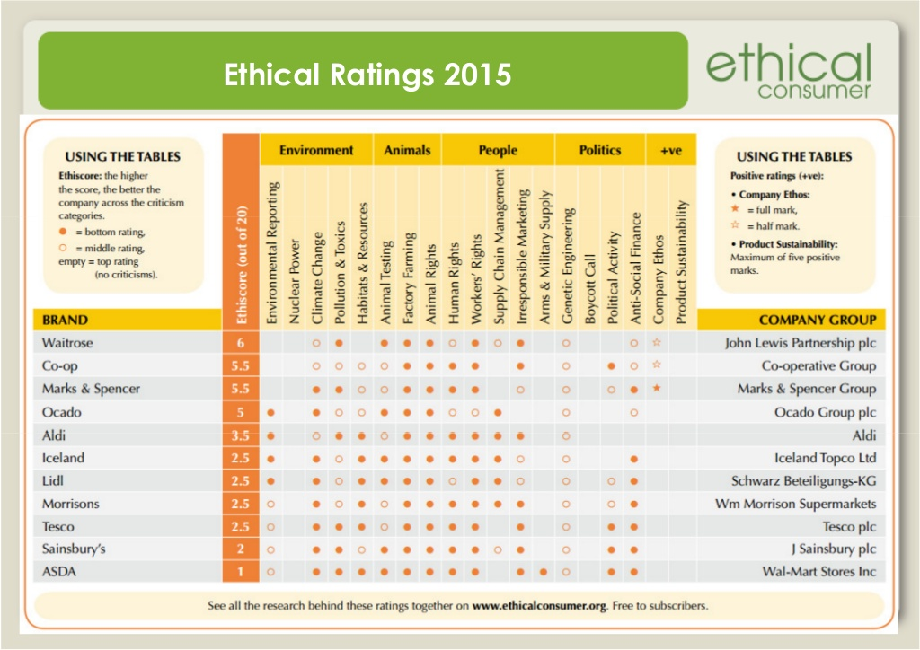
Definition of Sustainability- According to Grant M. sustainability is focused on respecting the needs of the present without putting in danger the future of coming generations. The concept of sustainability is based on the economic, environmental, and social factors. (Grant M. ,2020) According to the author the terms sustainability is something that inspire business to make environmentally friendly decisions. To encourage and motivate customers , Tesco has join the World Wide Life for Nature which is and organization where people are the center of everything they do but also they get involved into help the local communities to conserve the natural resources and change markets and policies on the road to sustainability (WWF, 2020). According to Steele T., WWF chief executive, the CEO of Tesco, Dave Lewis, has made a huge impact on Tesco with his plan on reducing Tesco environmental impact and improve sustainability. (Holder, 2020) In fact, Tesco objectives regarding the sustainability are to “make affordable, healthy and sustainable food available to everyone” . This plan has as principles, “to help customers to eat more sustainably” ,”restoring nature in food producing and eliminate waste”. According to the author all this principle that Tesco has set up together with WWF is to make customer feel more comfortable in to choose their brand as they show interest into social, economic and environmental sectors and its plans are based on what really motivate customers. According to the author this initiative of Tesco has a huge impact into the CRM system as the organization is trying always to find best projects through which its show its interest regarding the values and beliefs of their customers , suppliers , shareholders , colleagues and stakeholders.
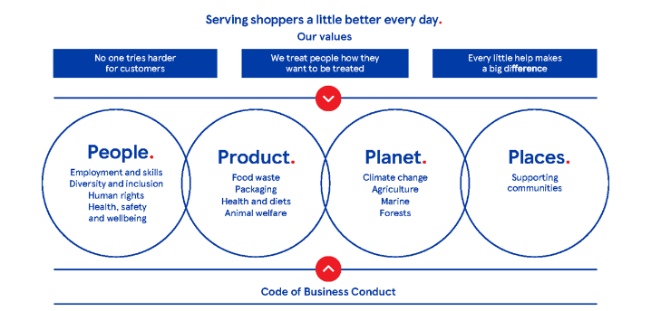
Tesco Plan
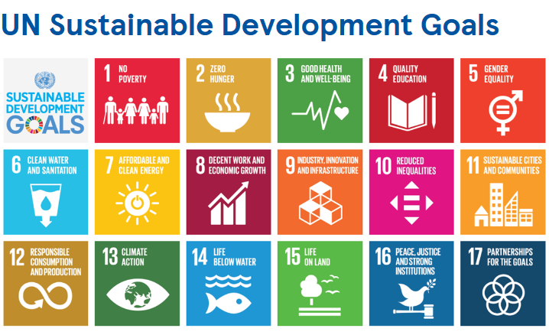
Tesco Sustainability Goals
As sustainability is one of the objectives through which want to motivate their customers ,Tesco has promised by the end of 2020 to remove one billion pieces of plastic from their products , to reduce the environmental impact and to change consumer demand for less waste. According to Weston P., in 2018 Tesco produced 18 million pieces of plastic but company objectives are to remove the plastic and to replace them with the paper bags that contaminate less the ecological environmental. According to the author as plastic pollution is on of the crisis that affect the planet, most of the supermarkets work on their strategies to ensure that their policies help with environmental sustainability. (Weston, 2019)

Quality

According to the author, for businesses also is important the quality of the service they have to offer but, quality is not just about the product or service is also about the reputation that an organization gain through want they offer to their customers. The author based on his researches identify that for customers is important to receive good quality products because if the organization maintain a the quality of the products they have to offer the risk and cost of replacing faulty goods has a small percentage. (Quain, 2019) According to Tesco plc its customer expects the company to sell products with high quality and in the same time they have to ensure the customer that their products are made in a safe and respect all the applicable laws and regulations. Based on the researches, Tesco to guaranty the highest quality to its customers, the organization has around the globe a skilled team and colleagues that dedicate their time to ensure that every product meet the standard quality requested by the law. In fact Tesco together with their suppliers and development team what to ensure that their own brand products are of great quality and meet legal and safety requirements, in the same time before the production began all the general merchandise and seasonal ranges are tested through a combination of customer panel. An example of what really Tesco is trying to do is it Nutrition Team which support the food business. According to Tesco plc , the Nutrition team of Tesco works together with “Diabetes UK, British Heart Foundation, Cancer Research, Anaphylaxis UK, Coeliac UK and government (Public Health England and Department of Health) to make sure that the product they offer to their customer meets the needs of every different customer that cross its stores. Another important process that Tesco follow to ensure the customer of the quality of their products is the labelling and packing of their items in fact the objective of the organization is to communicate all the necessary information but the primary focus is the declaration of ingredients. (Tesco Quality, 2020) According to the author even if Tesco meets all this standards and what to ensure their customer about the good quality that they had to offer, in the recent year the company had a scandal regarding the label on their products by not telling the truth about the real product inside of it , in fact Tesco has seen the accusation of selling horse meat and one of its chicken suppliers was implicated in a scandal regarding the hygiene standards.
According to the author, another strategy that Tesco use is TQM – Total quality management is a process that businesses need to follow to prevent any errors or mistakes and to create customers satisfaction on a high standard. According to the author the quality is seen as a weapon used by the other supermarkets to compete on the market. Based in the research, Tesco since it opens his first store has focus on new products and services to satisfy the needs of its clients. In fact, now a days the company has different deals with manufacture and sales of food items, groceries, clothes, electronics, houses, internet services, financial and insurance services. The main objective of Tesco is the reach the quality performance and to be above of all other business strategies. Based on the research, to achieve its goals of quality the company use different strategies : (Jyoti, 2013)
Human Resource- the company is trying to maintain only the people with the right skills for the service of quality delivered to its customers;
Policies – Tesco has standards that needs to be align with the quality assurance
Speed performance – the preparation of the food has to follow the hygiene standards;
Cost performance- Tesco also is taking in consideration the quality management system that it suppliers as before making a contract with them. (Jyoti, 2013)
According to the author Tesco strategy is based on a “steering wheel” which in another organization is called us the BSC- Balanced Scorecard , the organization to simplify their work build the balanced scorecard based on the sectors that the company work with and in this why Tesco can analyze better the changes and the issues that a sector needs. (Savkin, 2020)
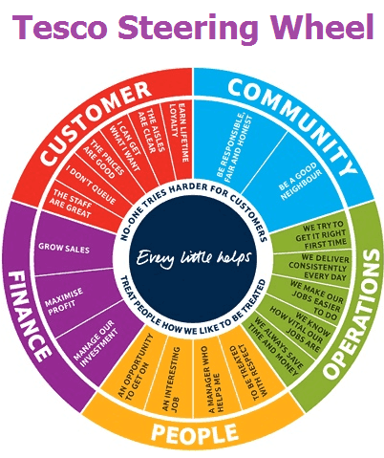
The steering wheel of Tesco provide a clear direction to the employees what are the objectives and identify exactly whether the company was on track to achieve its goals or not. Based on the researches the author identify that other major objectives of Tesco regarding his Balance scorecard are based on: (Marr ,2020)
- Sales;
- Profit;
- Cash flow;
- Customer feedback;
- Colleagues feedback;

Conclusion
According to the author the biggest retail store in the UK to certify the growth of its business and to ensure that customers are satisfied when they shop in its stores, it is focusing the attention on the values and beliefs that the company has as a core purpose. Based on the information given under the Findings session, the author identifies that Tesco main objectives are built around the strategies to meet the customers need. In fact, the organization try to offer to its customer the best deals in the supermarket and to simplify customers life from the innovation based on the new technology as well as the services and the rewards for the loyal customers. Based on the researches an important improvement and change that Tesco has done was to introduce the Clubcard member which Today, thank to this strategy Today is one of “Europe’s fastest-growing financial services company”. According to the author to improve its CRM system Tesco introduce a lots of services to can support the loyal customer, benefits as Tesco Personal Finance , Tesco.com, self-services, Tesco mobile and many other facilities that in the same time help it with the evolution on a variety of different products based on the preferences that customers has offer through surveys of by the compilation of the Clubcard member form. (Humby, Hunt and Phillips, 2003)

Recommendation

Regarding the CRM system the author recommend Tesco to give the same importance to the other sectors such as community , people , finance and operations as the organization give to the Clubcard member and instead of focusing all of it strategies around the loyalty customers the company should make equal strategies for even for the other people that are not member of the Clubcard. Based on ethics and sustainability the author advice Tesco to check more often the way it supplier apply the law and to be sure that supplier policies mention the right law to follow for the production of it products. Furth more the author advice Tesco, regarding the “steering wheel” to have specific strategies which should include everyone who contributes to the company’s success.

Appendices

Acknowledgements

Reference List
1. Tesco PLC. 2020. Our History. [online] Available at: <https://www.tescoplc.com/about/our-history/> [Accessed 28 June 2020].
2. Buttle, F., 2009. Customer Relationship Management. 1st ed. Oxford: Elsevier/Butterworth-Heinemann, p.4.
3. Kumar, V. and Reinartz, W., 2012. Customer Relationship Management. Berlin: Springer Berlin, pp.3,4,5.
4. McElhatton, N., 2009. Tesco Adopts CRM Software To Improve Customer Handling In Call Centres. [online] Campaignlive.co.uk. Available at: <https://www.campaignlive.co.uk/article/tesco-adopts-crm-software-improve-customer-handling-call-centres/896708> [Accessed 28 June 2020].
5. Dudovskiy, J., 2016. Tesco Segmentation, Targeting And Positioning - Research-Methodology. [online] Research-Methodology. Available at: <https://research-methodology.net/tesco-segmentation-targeting-and-positioning-2/> [Accessed 28 June 2020].
6. TescoNews ., 2013. Understanding Our Customers Around The World [Annual Report 2012/13]. [online] Youtube. Available at: <https://www.youtube.com/watch?v=BetSHjvJkMo> [Accessed 28 June 2020].
7. Lovingsson, B and F., 2005. The A-Z Of Management Concepts And Models. London: Thorogood Publishing, p.209
8. Witcher B. J. and Chau S. V.,2008. “Contrasting used of balanced scorecards: case studies at two UK companies” , Strategic Change , vol.17 ,issue 3-4 ,pp 107-110
9. Bbc.co.uk. 2014. BBC - Ethics - Introduction To Ethics: Ethics: A General Introduction. [online] Available at: <http://www.bbc.co.uk/ethics/introduction/intro_1.shtml> [Accessed 30 June 2020].
10. Paliwal, M., 2006. Business Ethics. New Delhi: New Age International, pp.3,4,5.
11. Ethicaltrade.org. 2016. The ETI Base Code | Ethical Trading Initiative. [online] Available at: <https://www.ethicaltrade.org/resources/eti-base-code> [Accessed 30 June 2020].
12. Ethical Consumer. 2020. How Ethical Is Tesco Plc? | Ethical Consumer. [online] Available at: <https://www.ethicalconsumer.org/company-profile/tesco-plc> [Accessed 30 June 2020].
13. Our Tesco. 2020. Ethical Trading - Our Tesco. [online] Available at: <https://www.ourtesco.ie/working-at-tesco/people-policies/legal-policies/code-of-business-conduct/trading-fairly/ethical-trading/> [Accessed 30 June 2020].
14.Jennings B. ,2010. “Ethical Aspect of Sustainability” , Minding Nature Journal , Vol 3. N. 1
15. Grant, M., 2020. Sustainability. [online] Investopedia. Available at: <https://www.investopedia.com/terms/s/sustainability.asp> [Accessed 30 June 2020].
16. World Wildlife Fund. 2020. History | WWF. [online] Available at: <https://www.worldwildlife.org/about/history> [Accessed 30 June 2020].
17. Holder, M., 2020. Outgoing Tesco CEO Dave Lewis To Join Environmental Charity WWF As Chair. [online] Available at: <https://www.businessgreen.com/news/4014974/outgoing-tesco-ceo-dave-lewis-join-environmental-charity-wwf-chair> [Accessed 30 June 2020].
18. Quain, S., 2019. Why Is Quality Important For A Business?. [online] Small Business - Chron.com. Available at: <https://smallbusiness.chron.com/quality-important-business-57470.html> [Accessed 1 July 2020].
19. Tesco PLC. 2020. Product Safety & Quality. [online] Available at: <https://www.tescoplc.com/sustainability/publications/policies/downloads/product-safety-quality/> [Accessed 1 July 2020].
20. Jyoti, B., 2013. [online] Bhaskar81809.wixsite.com. Available at: <https://bhaskar81809.wixsite.com/supplychain/single-post/2015/04/03/Total-Quality-Management-%E2%80%93-How-Tesco-is-benefited> [Accessed 1 July 2020].
21. Savkin, A., 2020. Learning from Tesco Strategy Map and Scorecard. [online] BSC Designer - Strategy Execution Software. Available at: <https://bscdesigner.com/tesco-balanced-scorecard.htm> [Accessed 1 July 2020].
22. Bernard Marr. 2020. Six Kpis For An Entire Organisation? How Tesco Overhauled Its Performance Management Framework. [online] Available at: <https://www.bernardmarr.com/default.asp?contentID=1522> [Accessed 1 July 2020].
23. Weston, P., 2019. Tesco Vows To Remove One Billion Pieces Of Plastic Packaging By End Of 2020. [online] The Independent. Available at: <https://www.independent.co.uk/environment/tesco-plastic-packaging-waste-bags-environment-trays-lids-a9180691.html> [Accessed 1 July 2020].
24. Humby, C., Hunt, T. and Phillips, T., 2003. Scoring Points: How Tesco Is Winning Customer Loyalty. London: Kohan Page, pp.1-5.

