Leading in Action

Reflective Diary

2017/18

Name: Rebecca Sandford
Student number: 1703022

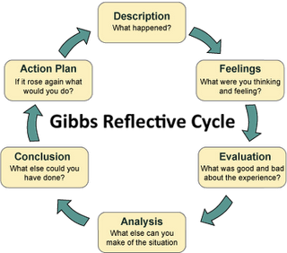

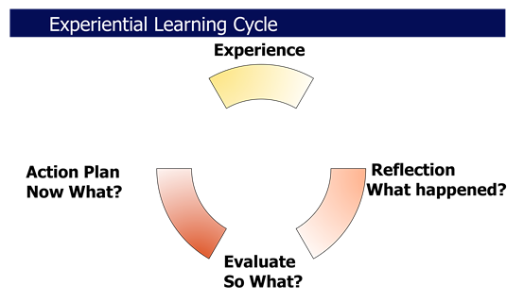

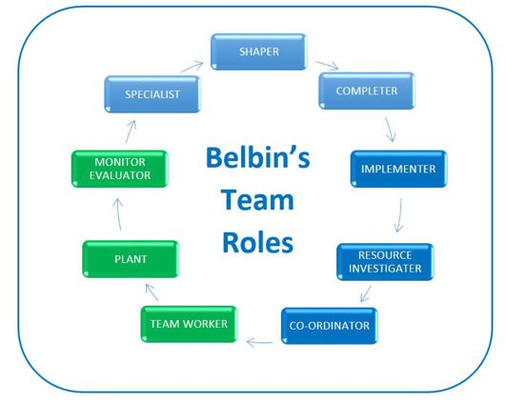

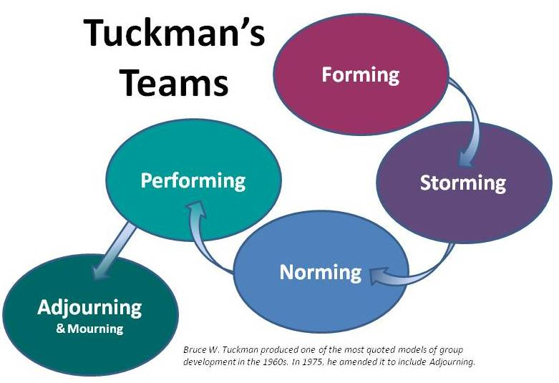
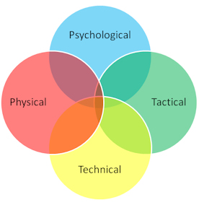

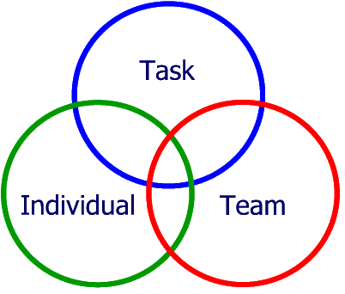John Adair

Tasks:
Task One:
Using the reflective models and models of teamwork you need to reflect on how the activities undertaken, critically evaluate your role in that activity, how well you worked as a team and your leadership skills.

You need to apply the theories discussed and any other theories you wish to use. Make sure you Harvard reference.

Use this electronic version of the diary to submit your reflective writing.

Task Two:
You need to keep a reflective diary of your fitness. There are 20 fitness sessions per semester, 50% of the mark is attendance for all of those sessions. The diary is a record and evidence that you attended these sessions.
In the diary you will need to reflect on your performance, what level you started at, how has your fitness changed and developed during the year.
You will need to show the use of reflective theory in your answers.

Record all your entries in this electronic diary and submit through turnitin by 4th May 2018.

Outdoor Session One:
Activity: Mountain biking
Performance Evaluation:
On Monday 13th November, I took part in mountain biking. We started off with the basics of how to stop the bike and making sure we were using our breaks right. When we were going through the basic skills I felt like I gave all my effort to make sure that they knew I was listening and that I understood what the leader was saying.
Once we went through all the basics and done a few activities we all cycled off as a group to pump tack. Once we arrived there we walked through the tack to find out what we needed to do at certain points of the tack to make sure we didn’t injure ourselves. Once we walked it, we all had a go at going around the track as many times as we wanted. When it was my turn I was finding that I wasn’t using the right breaks at the right point and wasn’t angling my bike at the right position when going around a curve. We then got into pairs and each partner would go and you would evaluate there performance and say what they would need to work on next time they went and they would do the same when it was your turn.
Once we finished at the pump tack as one of the tasks was for the boys were given orders from the style of autocratic leadership, where they were told to direct us to a set location. When we set off they made sure everyone was ready to leave, but as we started to cycle all of the boys were at the front of the ride and wasn’t making sure that everyone in the group could keep up or if they were safe.
we also cycled up a mud cycle track and went up to another pump tack where I found that I had more confidence and went around the track. I learnt from the previous pump tack the does and don’t and found that it flowed more then last time. After we had a play around on the tracks we made our way back down to where we started. As we were high up on the track down there was a lot of hills where I didn’t feel confident to cycle down so I walked them. If I was to do it again I would make myself cycle down them and push myself more
Actions for next time:
The actions that I am going to take on board for next time is to be more confident when going on the bike tracks and not let myself give up so easily. This happened when we got to the cycle tracks and there were lots of hills I bottled it and ended up walking down them. For next time I am going to cycle the entire cycle path and push myself.
Another action that I would take for the when I do the activity again is if I was in charge of directing the group to a certain location. The things that I would do differently is made sure that the people who are directing the group are split up so one being at the front another in the middle and the final person at the back. This then gives you the opportunity to make sure that everyone keeps up and they also know where they are going.

Outdoor Session Two:
Activity: Rock climbing
Performance Evaluation:
On 13th March 2018 I took part in a rock climbing activity where we walked from the car park down to the cliff edge. Where we all put on our harnesses and were double-checked by the staff on the activity, we dumped our bags down there as well.
We then walked further down some rocks to where the three ropes were set up. There was an easy rope which wasn’t too high a medium level which was higher and the third rope which was higher again and a more difficult to reach the top. As I didn’t have much confidence on climbing up the rocks I only stuck to the first rope which was the easiest to climb and I went up there a few times gradually getting higher until I eventually reached the top.
Actions for next time:
My actions for next time would be to have more confidence to push myself to climb the higher ropes and also to believe that I can climb to the top and not give up half way climbing the rocks, as I am in a controlled environment where they will look after our safety. Also next time we go I will make sure that I wear my different trainers that have more grip and support that will help me climb the ricks easier and my foot wont slip from underneath as much. Also another action for next time would be to have the confidence to push myself to climb the higher and harder ropes.

Outdoor Session Three:
Activity: Surfing
Performance Evaluation:
On the 13th March 2018 I look part in surfing down Rhosilli bay, where we walked down to the beach and set up a semi circle with our surfboards. And was taught the right technique on how to stand up on the board and if the instructor showed certain signals we were to get out of the water straight away, this was taught to us for our safety and also for us to communicate if the group needed any help.
When in the water we all worked well as a team making sure that there was enough space between us all as the water was very choppy and that no one got injured. This was good for improving our communication skills as it made us communicate with everyone to make sure that we all stayed safe in the water.
Actions for next time:
The actions I am going to take for next time is that I am going to master trying to stand up on the board and catch at least one wave into the shore. As when I walked down to the beach and what my parents have told me previously made surfing sounds like it was easy to master. But when you are actually in the water and the sea is choppy it is very challenging to try and stand up and catch the wave in at the right point of time.
Fitness Diary:
Date: Monday 2nd October 2017
Activity: 40-minute intense cardio (HIIT)
Performance Evaluation:

For our first session of the year, we did a 40minute intense cardio session also known as (HIIT) class. as this was the first class of the year I found this class intense and hard as we did a continuous minute with a 30 second break and done reps of 3 of each activity. I feel like I found this activity hard as haven’t done HIIT training before. I feel that the more HIIT sessions that I take part in and the more I keep pushing myself my HIIT fitness and performance shall improve.
Each activity that we had to do in this session is 5 reps of each activity.
- Star jumps
- Sit ups
- Push ups
- Plank
- Russian twists
- Reverse lunges
- Squat jumps
Actions for next time:
As this was my first session my actions for next time would be to put more effort into the session. Also other ways I could help keep up my levels of fitness is by going for a run or joining a local fitness class or even join a spots team.
Fitness Diary:
Date: 09th October
Activity: 40- minute intense cardio (HIIT)
Performance Evaluation:
This was my second session of doing a HIIT class and from the last session of HIIT to this one I could see a slight improvement. But was still finding that t5he session was very intense and that I wasn’t able to keep up the whole time of the session without having a break. But found that I lasted longer then the session before, so my levels of fitness are improving.
Each activity that we had to do in this session is 5 reps of each activity.
- Star jumps
- Sit ups
- Push ups
- Plank
- Russian twists
- Reverse lunges
- Squat jumps
Actions for next time:
As this was my first session my actions for next time would be to put more effort into the session. Also other ways that I am going to help improve my levels of fitness is by I have joined the local gym and have started going for a run once or twice a week also along with this I have joined the local hockey team.
Fitness Diary:
Date: 30th October
Activity: Team building activities
Performance Evaluation:
At the beginning of the session we were all standing in a circle holding hands with one person on the outside, where their aim was to reach the person in the circle who had the foam roll. But the circle wasn’t allowed to break. Each time they reached the person on the inside they would swap roles.
We also played netball with the class being split into two teams and everyone in the team had to have possession of the ball before it would be classed as a point, but if the ball was dropped or intercepted it would automatically go to the other team.
The next activity that our group took part in was called cones and mountains the aim of this activity was for one team to turn the cones into mountains (turning them upside down) and the other team would be turning them back into cones. At the end of this activity the team with either the most cones or mountains wins.
We finally finished off the session with doing a few interval races and being split into teams of 4/5. In our groups one of the races was a 30meter sprint test from one cone back to the other and then the next team member would go. The next race was the shuttle run. We ended the session by everyone doing a wall squat and seeing how long you can last.
Actions for next time:
Actions for next time would be to make sure that I know everyone’s name and make everyone is involved in each activity. Another action for next time is to also improve on my speed and time in the interval races.

Fitness Diary:
Date: 06th November
Activity: 40 Minute intense cardio (HIIT) with a partner.
Performance Evaluation:
In this session we started off the session warming up by doing;
- Star jumps
- Squats
Once we warmed up we going into partners and we were doing activities together using weights
- Sit ups using a 5kg weight- this involved when coming up from the sit up passing the weight to your partner.
- Russian twists using a 5kg weight, and when crossing over the one side you would pass it to your partner.
- We also did a minute plank
- Push ups
- We also done a minute of raising our legs six inches off the ground and holding that position working on the core body.
Actions for next time:
Actions for next time will be to work more on my core body strength as I found that I struggled when doing the sit ups and also when doing the leg raises and holding it. How I’m going to improve this is by carry on practicing this when I’m at home so the next time I do it I wont be struggling as much.

Fitness Diary:
Fitness Diary: Zumba
Date: 13th November
Performance Evaluation:
In this session we did an hours workout of dance working on all aspects of the body. In this session I was able to keep up and found that I didn’t feel like I was struggling at all throughout the whole session. This shows me that me fitness levels are improving. This session involved being constantly on the move and not stopping, but was enjoyable as Zumba involves dancing to the music.

Actions for next time:
My actions for next time will be to make sure that I participate for the whole of the session and not stop half way through to have a break, and also to put more effort in so I feel the burn more and actually feel the burn. When we first started the session I didn’t think that doing Zumba would be as intense and as hard as it sounds, I found it challenging as it constant and none stop. Next time I take part in this activity I will make sure that I participate for the whole hour.

Fitness Diary:
Date: 20th November
Performance Evaluation:
Activity: Dodgeball
In this session we played dodgeball, we were set into two teams’ boys against girl’s team. In the session we had a leader of the team who told the rest of the team what to do and what position to be in. but this didn’t really go to plan as people were doing their own thing.
Other things that didn’t go to well in the session was that it was boys against girls if this activity was to be done again things that I would change would be to mix the teams up and split the girls and boys up.
Actions for next time:
Actions for next time would be to practice on my throwing technique. Ways in which I am going to improve my throwing technique is by working on the way I throw a ball. Another action for next time will be to make sure that there is communicating between the teams so that people know what they are doing.

Fitness Diary:
Date: 27th November
Activity: Zumba
Performance Evaluation:
In this session we did an hours workout of dance working on all aspects of the body. In this session I found it really enjoyable and was motivated throughout the whole session as its something different. In this session I found it reasonably easy and didn’t find that I was struggling compared to the last time that I took part in the Zumba activity. I felt like I pushed myself to make sure that I completed the whole hour and didn’t stop.
Actions for next time:
My actions for next time will be to make sure that I put more effort in so I feel the burn more and actually feel the burn. In the second session I session found that Zumba was still intense and as hard as it sounds, I found it challenging as it constant and none stop. Next time I take part in this activity I will make sure that I participate for the whole hour.

Fitness Diary:
Date: 12th February
Activity: interval training
Performance Evaluation:
We started off the session by doing a 20 minute warm up where if number one was called we had to do a pike jump, if number two was called we had do to a tuck jump, three was a burpee jump, four was lay on your back and raise your legs six inches from the ground and five we had to sprint as fast as we could around a square that was set out.
we then went on to play British bulldog where we had to run from one end of the set out area to the other without being touched by the person on it with the ball. We played that activity for about 10 minutes then we went into races where we were in 4 or 5 teams. We were then put into 4 teams of 4 in a square set out, each team had a foam ball between them and when certain number were called out some members of the team would have to change to a different cone, or change direction you threw the ball, or a member of the team would move to a new team. If you failed at doing one of these commands the whole class would have to do a forfeit this could include; plank for 1minute, 20 crunches, 20 press ups or leg raises 6inch off the ground for 1minute.
We ended the session with a few races One of the races was the wheelbarrow where you had to take one of your team members up holding their feet while they walked on the hands, once you got up to the top you swapped and the roles were reversed. then we done sprints where you had 3 cones in your line where you would run to the first cone then back to the wall, then to the second and back to the fall, then finally to the 3rd cone and back then the next person would go.
Overall in this training session I feel like gave 100% effort and put everything I could into making sure that I perform to my best ability. I managed to complete every activity that was set out in that session. One thing that I personally left like I struggled on was doing press ups, I made it easier for myself and done box press ups.
Actions for next time:
My actions for next time would be to train to work my way up to doing the full press ups instead of doing box press ups. The way in which I would do this is
least 5 real press ups instead of doing box press up. And each time when coming to do this type of training is to add another press up, until it gets to the point where I don’t need to do box press ups.

Fitness Diary:
Date: Monday 22nd February
Activity: workout with weights
Performance Evaluation:
- Weight of the pole 6kg
- Dumb bells 6kg
In this session we did a 40minute workout using weights, this session worked on the upper body strength and also the legs. This was my first session with using weights in the workout and I found that I struggled with certain aspects of the session when using the weight for some of the upper body. My upper body strength isn’t brilliant so when taking part in certain activities. Other then those issues I managed to keep up with the class doing all the other activities. This tells that from attending the fitness sessions weekly and also keeping up the fitness out of university that my fitness levels have improved.

Actions for next time:
My actions for next time will be to keep to the same weight of the bar and the dumb bells but to slowly increase the weight of the bar and also the weight of the dumb bells, this overtime will help me with my future jobs e.g. for police riot training. Other things I would do is also do workouts which help improve the upper body strength.

Final Evaluation on fitness.
In 500 words give an evaluation of how you feel that your fitness has changed and developed over the last year.

Over the past year I feel that my fitness have improved hugely from the start of term to the end of term. This is due to doing fitness twice a week and from playing hockey for the university which I do twice a week training on Monday and game days on a Wednesday, as well as this I started going to the gym in my spare time in order to also keep up with the levels of fitness. If I didn’t have fitness twice a week it wouldn’t of motivated me to carry on being active and going to the gym and playing extra sports.
I have noticed from the beginning of the year to now that I am able to push myself more to achieve better goals and making new personal bests. At the beginning of term I struggled with lasting the full 40 minutes of the session now I am able last longer when doing the 40-minute sessions. I feel at the start at some of the sessions I wouldn’t put as much effort in as I knew I could of. But as the weeks went on I upped my game and started to put more effort in.
From these fitness sessions I am now also able to adapt the session’s work into my everyday routine as I found out that you don’t need equipment in order to train and I now know how to perform certain exercises that I maybe wasn’t doing properly in the first place. I have also found that from the start of the year to now I enjoy fitness that what I did at the start of the year, I find I am now motivated to keep in shape and stay the same way and I now feel more confident in myself then I did at the beginning of the year, this is all because of how much my fitness has improved and now my positive outlook on exercise from what I used to have.
Also when we first went to Rhosilli for the day of activities I wasn’t very confident in myself when doing the activity. But when I went back on the 13th March and I felt that my fitness and confidence had increased which made me want to participate and interact more in the activities. From taking part in meant that you would be working on different aspects of the body, which kept me interested but also made me see a difference in my fitness levels, and they were continuing to improve.
Overall I feel mentally and physically fitter in myself then I did at the start of the year and I’m now going to make sure I maintain this level of fitness and also to improve it to the next level in order for me doing into my third year I am going to carry on going to the gym on a regularly basis and now being the hockey captain carry on playing hockey for the university and also from a home side.

