

University of Wales Trinity of St David:
Ordnance Munitions and Explosives

Academic Year 2024 - 2025

Lewis Gray (2224230)

Systems Engineering
Supervisor: Dave Holly

June 2025

Academic Integrity Declaration
I declare that:
- the thesis submitted has been written by me alone.
- the thesis submitted has not been previously submitted to this university or any other.
- that all content, including primary and/or secondary data, is true to the best of my knowledge.
- that all quotations and references have been duly acknowledged according to the requirements of academic research.
I understand that to knowingly submit work in violation of the above statement will be considered by examiners as academic misconduct.

Abstract
Being tasked with developing a munition to eliminate an IT suite in an unspecified tower block, the toolset associated with the systems engineering methodology of designing a complex system was used to achieve a final concept. The requirements of a diverse range of stakeholders, from the end-user to regulators and financiers were taken into consideration at every stage of the project, which resulted in a final concept munition that met the customer’s requirements.

Table of Contents
Academic Integrity Declaration 2
Abstract 3
Table of Figures 5
I - Introduction 6
II - Key Customer Requirements 6
III – System and Critical System Functionality 7
IV - Design Choices 9
V – Conclusion 11
VI – References 12
VII – Appendices 13

Table of Figures
Figure 1: Stakeholder Relationship Map 7
Figure 2: System Process Flow Diagram 8
Figure 3: Pugh Matrix Results 9
Figure 4: Realised Munition Design 10
Figure 5: Breakdown of Missile Components 10

I - Introduction
Following a set of requirements set by the customer, which was to produce ‘An explosive device capable of neutralising a hostile communications centre, housed in a room within the second floor of an office block building. The design should be capable of accurate delivery into the room from a distance of at least 100m and the effect event should be such that collateral damage to the adjacent rooms is minimised.’, the systems tools following the development pathway of Systems Engineering were used to derive a solution through the design process.

The principals of Systems Thinking were used to negotiate, develop, and make sense of the complexity of the larger system and the relationship each component part has with the rest of the system and the adjacent subsystems. Rather than breaking the system down, Systems Thinking takes a holistic approach to defining and developing a reliable system which meets the criteria as laid out by the customer and achieves the requirements set by the shareholders [1].

As the munition advanced in development, focus was placed on the high-level system requirements which deliberate with regard to what exactly is needed to be achieved as opposed to in what manner and what capacity the requirement will be achieved through. The high-level requirements were followed through the entire Systems Engineering design tools and with regard to the requirements of the individual departments, including safety, manufacture, test and evaluation, and breakdown and disposal, in order to identify any points of failure and any additional requirements through the development of the system.

II - Key Customer Requirements
For a system as complex as a munition designed to eliminate an IT suite, a diverse and expansive set of requirements is required to ensure reliability, safety and operability of the system. The product will require hardware, software, user input and facilities to take it through the CADMID cycle (Concept, Assessment, Demonstration, Manufacture, In-service, and Disposal) and each of these will require their own set of requirements to operate effectively as part of the system as a whole. Failure to properly engage with the requirements and collect a level of requirements that encompasses all aspects of the system can potentially lead to expensive redesigns due to poor system performance and/or an unacceptable level of safety being achieved.

These requirements were derived from the various stakeholders involved in the munition project, where a stakeholder is an entity with a level of influence over the project [2]. This influence could emanate from the stakeholder providing finances for the project, being the end-user, or being affected in some capacity by the programme and/or system. With regard to the concept munition, stakeholders included were regulators, financiers, the end user, manufacturers, disposal personnel. These requirements were collated into a stakeholder relationship map which shows the relationship and interaction between the individual stakeholders.
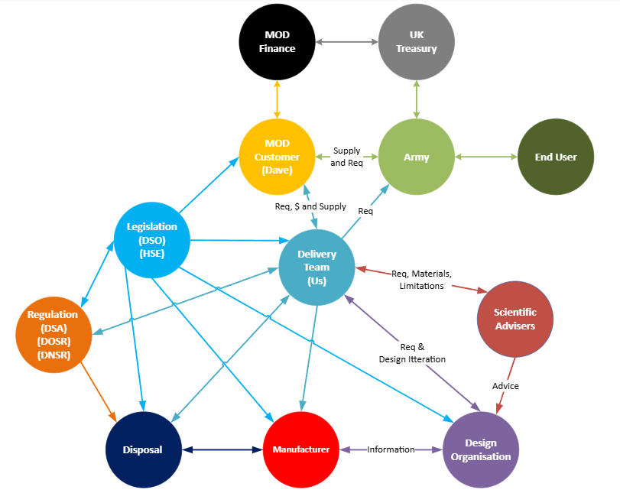
Figure 1: Stakeholder Relationship Map

Operational requirements were then laid out by stakeholder regarding what each stakeholder whished to get out of the munition. These requirements ranged from the customer’s requirement to neutralise the target, to the user’s requirements to be safe and ergonomic. A Pairwise Comparison was then used to determine which of the requirements is preferred when being applied to the munition and its task of eliminating the IT suite [3]. These requirements were then refined via the use of a second pairwise comparison to obtain the final, most important set of requirements for the munition.

Once the System requirements had been collated and refined to derive the final set of requirements, development could start working out the system functionality requirements.

III – System and Critical System Functionality
The high-level functions of any system are the result of a combined effort through the interactions of all the sub-systems, and the hardware associated with them, that make up the whole [4]. As per the customer requirements and after examining the results from the system functions analysis, it was determined that the munition system must neutralise the target after being fired from a range of at least 100m and cause minimal damage to the adjacent rooms, limiting collateral damage. However, the system should also be accurate, reliable, and ergonomic.

When determining the functionalities the system would need to effectively fulfil the functional requirements derived from the stakeholders, in-service and legacy munitions systems were examined and evaluated to determine how they deployed and executed their task. Previous experience was also drawn on, as various members of the team either worked closely with such systems as a user on the ground, or as part of regulatory bodies helping to design such systems. It was found that these systems shared common features and functionalities that contributed to the objective being carried out successfully. A Process Flow Diagram was developed to illustrate the key steps and functions of the system from the beginning to the end of its deployment and how they relate to one another.

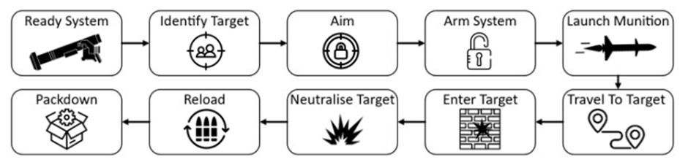
Figure 2: System Process Flow Diagram

Through the utilisation of the of the System Process Flow Diagram, a System Function Means Analysis (SFMA) was put together, through which various propositions were put forward as mediums via which the respective function would be carried out. These propositions were further refined after evaluation through a System Functional Failure Modes Effect Analysis (SFFMEA).

The SFFMEA was used to identify and belabour various function failure modes of the system, and account for the various impacts these would have on the system as a whole. This helped to bring forward the various sectors of the system which could result in a failure, as well as the individual consequences of each failure on the system. The SFFMEA was therefore used to identify and mitigate, or design out, potential sources of failure within the system.

This process generated the need for additional functional requirements such as the requirement to aim and fire the munition, in addition to the manner in which the munition would enter and neutralise the target. This also led to an increase in the number of safety requirements as the presence of explosive hazards such as backblast and a volatile solid fuel rocket motor were now present and posed significant harm to the user and those around them. This created safety implications for the design and disposal team who then had to develop concepts round these hazards which then had to be considered by the design team in order to facilitate these concepts.

As the design progressed and gradually became more complicated in scope, the number of individual systems with their own respective subsystems were needed to successfully realise in ultimate objective of the munition. Various systems like guidance units, the Command Launch Unit (CLU), and targeting systems would all have to communicate with each other in order to get the munition from its launch tube to the objective and successfully neutralise it. To augment design and identify sources of unwanted ‘noise’ a P-diagram was utilised. ‘Noise’ in systems engineering refers to variables that can cause unwanted fluctuation in end results. The source of noise is typically beyond the control of the designer, but the effects of noise can be mitigated through robust system planning. The use of a P-diagram identified the source of this noise, and the design team used this information to design out as much noise as was reasonably practicable to achieve a successful result.

Out of the gathered requirements, it was determined that the critical system functions were to launch the munition, deliver its payload, and neutralise the IT suite. This in turn would require a safe launch that would pose minimal risk to the operators and those around them, while utilising an effective arming system that reliably engages to deliver the payload at the correct instance.

To ensure a reliable and safe arming and detonation, the Explosive Bridge Wire (EBW) within the Safety and Arming Unit (SAU) was identified as the critical safety component. The SAU contained within it the initiation mechanism for the primary and secondary explosive and was given the most attention when safety was considered. The SAU would be given the highest level of quality control and process control procedures in order to ensure the component had the highest levels of reliability in order to make the system as safe as reasonably practicable.

IV - Design Choices
After input from stakeholders and different sections of the project team, as well as influence from the various requirements gathered up until this point, a modular design was adopted. This allowed the system to be more convenient to manufacture and assemble, as well as breakdown and dispose of at the other end of the munition’s lifecycle.

A total of three designs that satisfied the customer requirements were put forward by the design team and were evaluated against each other and an in-service, off the shelf equivalent using a Pugh Matrix. The systems were evaluated against the set of functional requirements and the most effective and achievable at attaining the requirements was selected to be brough forward.
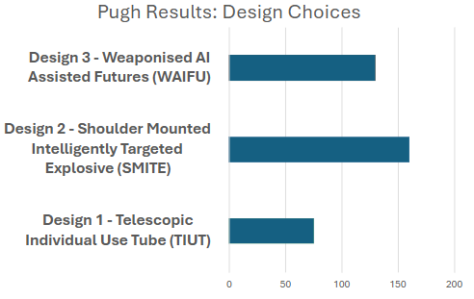
Figure 3: Pugh Matrix Results
The ultimate system design consisted of a telescopic tube assembly which contained within it the missile unit, which is assembled as one unit, with the missile already loaded into the disposable launch tube assembly, and the CLU which serves to aim, provide a targeting solution, and fire the missile. This design and configuration were best suited to achieving the proscribed requirements while maintaining the highest levels of safety and ergonomics.

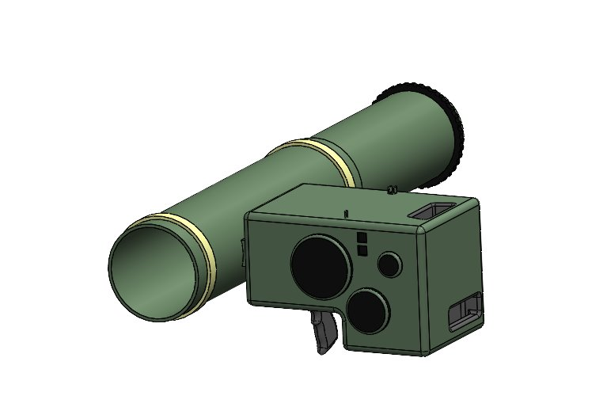
Figure 4: Realised Munition Design

A key design feature identified through the design process was the method with which the Telescopic Missile Tube (TMT) would be secured to the CLU. In the end, a repeating dove tail mount assembly was deemed to be the most suitable solution to interface the two components as it was inexpensive, simple, and ergonomic.

The CLU was designed to be the master control unit over the telemetry of the missile. The CLU programs the missile’s guidance system the target data which generates a firing solution to reach the specified target using fire-and-forget guidance principals. The CLU, with its three sets of high-powered optics, including thermal lenses, would also be used to get positive identification on the target before firing, thus reducing the potential for unintended casualties such as in blue-on-blue incidents.

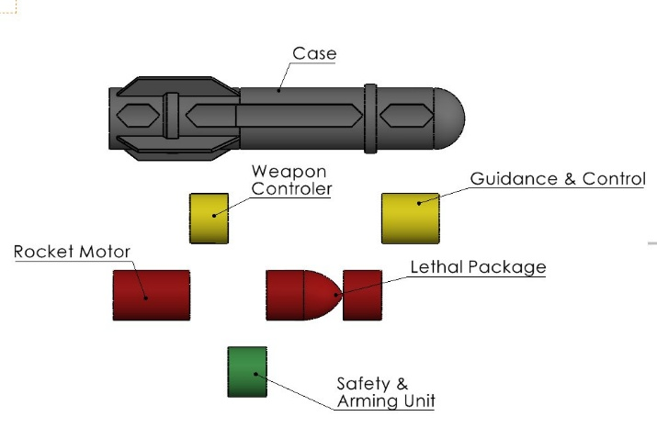
Figure 5: Breakdown of Missile Components
The benefits of the modular design apply to a wide range of shareholders. By manufacturing and assembling each part of the missile separately, the risk of unintended detonation is dramatically reduced as without the presence of the SAU, there is no mode available to initiate the lethal package. The safety protocols in place during manufacturing would prevent any incidental initiations due to factors such as Electro-Static Discharge (ESD) and kinetic factors like spigots or temperature.

A big benefit of the modular design lies at the end of the munition’s lifecycle when it is due to be broken down and disposed of. The ability to separate inert components from energetic ones would facilitate the economic and environmentally friendly requirement of the disposal team as materials like plastics and composites could be shredded and recycled instead of being burned, putting toxic particulates into the atmosphere, generating air pollution.

V – Conclusion
In conclusion, in order to create such a complex system-of-systems, the systems engineering tools such as Pugh Matrices, SFFMEAs and P-diagrams were employed in order to identify potential points of failure, develop and assess redesigns, and conceptualise potential solutions to design problems; all to satisfy as best as practicable the requirements laid out by the stakeholders.

In the end, the modular system adopted proved the best method to sate the diverse requirements laid out by each department involved in the project in addition to the stakeholders from the users on the ground, to the disposal companies who will breakdown the munition at the end of its life. The safety benefits also worked in the modular design’s favour, especially with regards to the manufacture and disposal phases of the CADMID lifecycle.

In totality, using the systems engineering method and its respective tools and matrices to develop a solution to the customer’s requirements resulted in an extensive and robust product. Tools such as P-Diagrams helped design out noise and SFFMEAs allowed the design team to identify points of failure and develop solutions to them while expanding the scope of the project and keeping safety in mind.

VI – References

[1] | University of Sheffiled, “Systems engineer role and hy study systems engineering,” University of Sheffield, 13 September 2021. [Online]. Available: https://usic.sheffield.ac.uk/blog/why-study-systems-engineering. [Accessed June 2025].
[2] | Reqi Systems Engineering Articles, “Defining Scope and Stakeholder Needs in Systems Engineering,” Reqi Systems Engineering Articles, 9th November 2023. [Online]. Available: https://reqi.io/articles/defining-scope-and-stakeholder-needs. [Accessed June 2025].
[3] | D. Kyne, “Pairwise Comparison (Definition, Methods, Examples, Tools),” OpinionX, 17 May 2025. [Online]. Available: https://www.opinionx.co/blog/pairwise-comparison. [Accessed June 2025].
[4] | J. Krupczak, “Using Functional Analysis As A Framework For Understanding Technology,” 2010. [Online]. Available: https://www.academia.edu/68356339/Using_Functional_Analysis_As_A_Framework_For_Understanding_Technology. [Accessed June 2025].

VII – Appendices
Appendix I: System Requirements
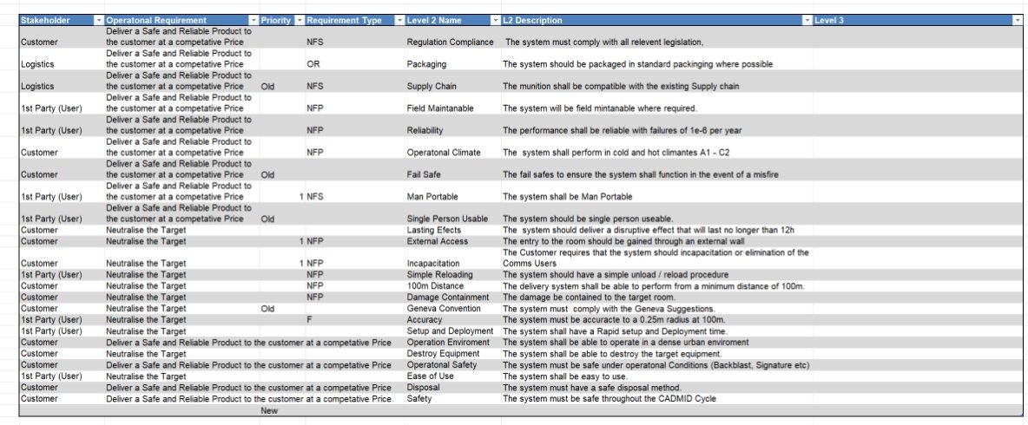

Appendix II: System Function Means Analysis (SFMA)
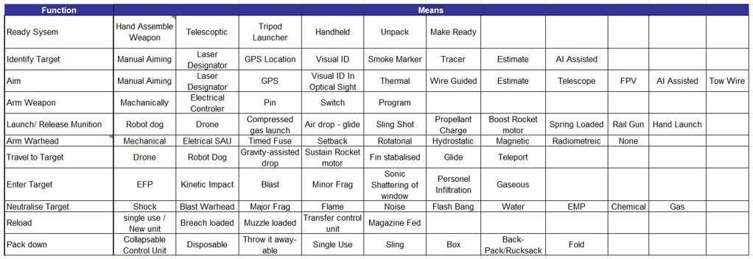

Appendix III: System Functional Failure Modes Effect Analysis (SFFMEA).
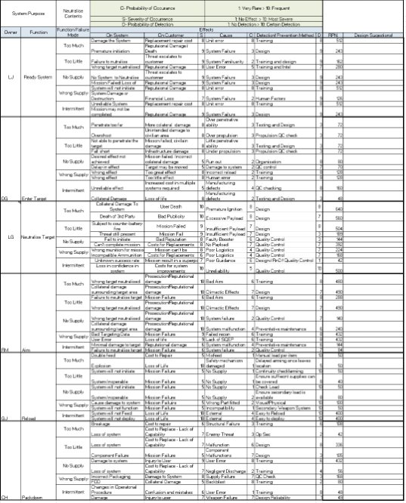

Appendix IV: Requirement Pairwise Comparrison


