DIGITAL SKILLS AND RESEARCH METHODS

THE IMPACT OF Virtual Learning Environment

Student Name: Diego Torres
Student number: 2133739
August 17, 2022
University of wales trinity saint david
[Company address]
Lecturer: Fernando Suneth

INDEX

- INTRODUCTION pg.2
- BACKGROUND pg.3
3.0 AIMS AND OBJECTIVES OF THIS RESEARCH pg.4
  - OBJECTIVES pg.4
3.2 ANALYSIS pg.4
4.0 METHOD pg.5
5.0 RESULTS pg.6
6.0 DISCUSION pg.12
7.0 CONCLUSION pg.13 8.0 REFERENCE pg.13
8.0 APPENDIX pg.14/ 17

- INTRODUCTION
The report would begin with a presentation cover, then its index with the following points;
- INTRODUCTION pg.2
- BACKGROUND pg.3
- AIMS AND OBJECTIVES OF THIS RESEARCH pg.4
3.1OBJECTIVES pg.4
3.2ANALYSIS pg.4
- METHOD pg.5
- RESULTS pg.6
- DISCUSION pg.11
- CONCLUSION pg.13 REFERENCE pg.12
- APPENDIX pg.14/ 16

VLE is a platform that offers students and professors digital solutions the increase the learning experience. Take advantage of the benefits of this technology to complement an in-class experience, with computers in university help the use of the platform. Before era of the technology, teachers and institutions began sending students lessons by post as early as 1840. In 1989Tim-Berners Lee, a young British engineer proposed a system he called the World Wide Web. During that decade "Learning Management Systems " By 2010, nearly all large institutions had adopted e-learning courseware. As social networking sites developed, virtual learning environments became more interactive, cooperative and conversational. It is important to investigate this topic because we are in the era of technology and help us to know the use of students as well as the value of the VLE.

- BACKGROUND

The types of VLE services are: Turnitin Email Links, Teaching, Learning Resources, IT Support, Assignment Upload, Assignment Correction and Grading, Tutor Feedback on your work. Type of Student benefits; easy access, cost savings, 'instant' feedback on assignments, print reduction, one-stop source for college information, quick communication with your teachers, blogs and discussion forums, control over learning and independence, the 'watch and learn' section (for students with learning difficulties and/or disabilities). Teaching; Submit assignments and other assignments, grade, track student performance, provide feedback, plan and manage lessons and other activities, increased flexibility and flexibility, to help plan lessons, manage administrative work, and the University; in the pandemic it was an excellent benefit, in meetings and exams to enter the university it is more effective.
Types of challenges faced by: Students: change in Routine, distractions During Virtual Learning, avoid Temptation, building Trust and Confidence, difficulties Asking Impromptu Questions, lack of Social Interaction, difficulty Getting Immediate Feedback. Teaching staff: frozen screens and tech problems galore, muting and unmuting, some students are dominating the conversation, others are MIA, do you require video or not? dealing with the unexpected Admin: communication with direct reports, communicating feedback. VLE requires the technology of computers, Distance Learning Degree, Program, Professional Certification Courses, instructional videos or audio, lectures, books, articles, and other writings, podcasts, webinars, High School or University.
Types risks associated with VLE are; the quality of the internet can make learning difficult. A person who is not disciplined with the study will be a risk for her career studying with this technology. Legislation of VLE is direct and maintained by a commercial company and administered centrally by the education team in the youth department. All the clubs have access to it and to their own data and the shared resources. Opportunities to have resources that would not be in the classroom and the opportunity to understand the issues better.

- AIMS AND OBJECTIVES OF THIS RESEARCH
Impact positive; students used a software collaboration tool that enables students and teachers to communicate online to develop their understanding and analytical skills. Students performed significantly better and encourage progressive thought, and independent thinking. Impact negative; Students in an online learning environment lack the opportunity and benefits of structured dialogue and the sense of community created in a traditional on-site classroom environment, cram learning into one session or one week.
The ways we should improve VLE be to introduce mechanisms identifying issues in the learning system early during the semester, move beyond outdated eLearning & LMS approaches, achieve high levels of learning content engagement across students, utilise a multi-channel approach to learning delivery, create a self-learning culture create a successful experience. To acquire that knowledge is gained in this research about the benefits of students with learning, teachers and admin. Moodle was known, the virtual learning platform that helps the student and the teacher to be in active communication about any doubt of the module. I learned to do the quiz on the platform survey.

3.1 Objectives
The aim of this research is to examine activity logs obtained by students’ while they are logged into the virtual learning environment in order to detect frequencies and priorities of students’ choice of activities in a VLE. The activity logs are used to measure students’ effectiveness of learning to determine whether students’ activity logs, within courses supported by a virtual learning environment as part of a blended learning approach, correlate with their final marks and the students’ perceptions of using the virtual learning environment. The VLE also helps and supports teaching by engaging and enthusing students with resources that would not normally be available in a formal classroom, encouraging discussion and debate.

3.2 Analyse.
This research is based on individual learning using the Virtual Learning Environment where it is necessary to generate a bi-mediated didactic communication between the teacher and the student. The research looks at the cognitive development of students at Saint Davy's University of Wales through the use of VLE.

4.0 METHOD
I used the methods following; Descriptive In this case, the facts to be described must be selected according to very defined criteria that allow demonstrating relationships of interest. Explanatory; I used this approach to investigate the relationships between the origin, cause and effect of a particular situation. Remediation; in this case, the objective is to correct or improve some condition of the object of study, so the possible causes and effects are analysed. Historical; the researcher explaining the origin and trajectory of the object of study. During my research, secondary research approach was I used and applied to collect quantitative and qualitative data as it helps to understand the services available in VLE, technologies required, benefits, drawbacks and the challenges faced by university students, teachers and admin.
In this case different types of books, journals, magazines and articles were referred and used to collect quantitative and qualitative. University Moodle was accessed and other sources available from the internet was used to collect relevant details. People were postgraduate of fourth year students, all of whom had just started using VLE. All students who completed the questionnaire online. The questionnaire was completed by 21 students out of 36. All students had a computer and Internet access. Thereupon, primary research approach was conduct to collected quantitative and qualitative data related VLE. Therefore, online software tool was used to create a survey which includes 10 questions related to VLE and then it was sent by e-mail among colleagues to get their feedback.

5.0 RESULTS

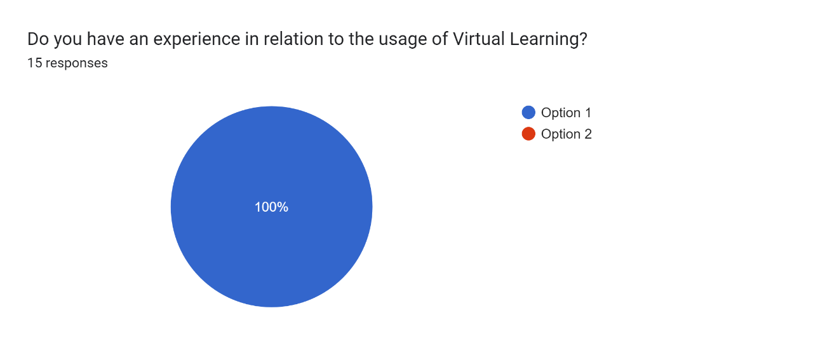

The graph represents one hundred percent blue colour is fifteen people who responded that they have experience in the use of virtual learning.

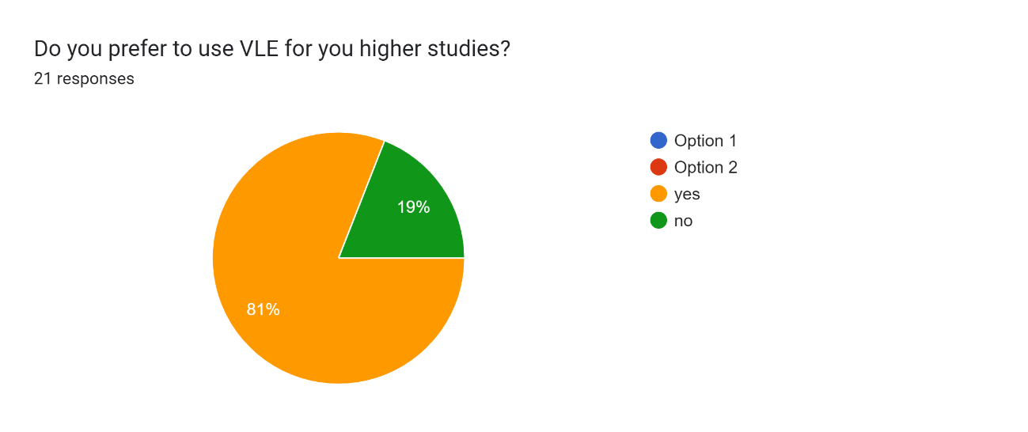

The graph represents in colours if the students prefer to use VLE for higher studies, eighty one percent is orange the option 2 “yes” and nineteen percent is green the option 1 “no”.

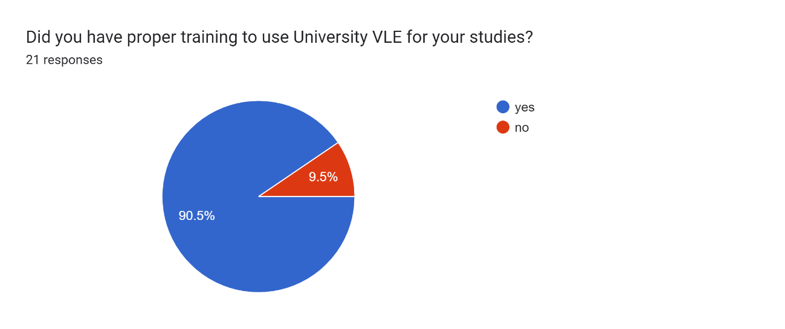

The graph represents 21 student responses that 90.5% of students have proper VLE training to use at the University for their studies and 9.5% do not have proper training.
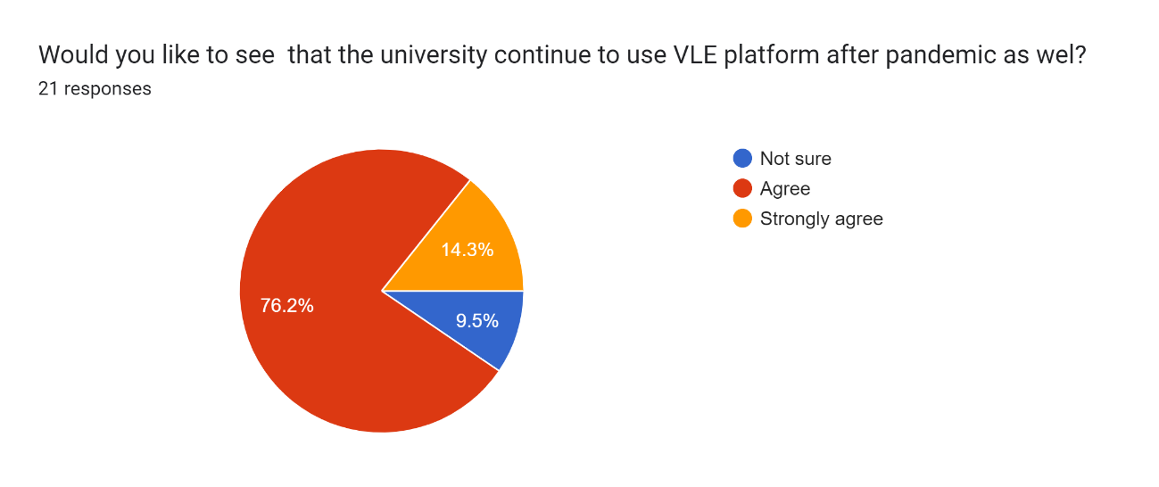

The graph represents 21 student responses that 76.2% agree of students that the university continue to use VLE platform after pandemic as well, 14.3% is strongly agree and 9.5% not sure.

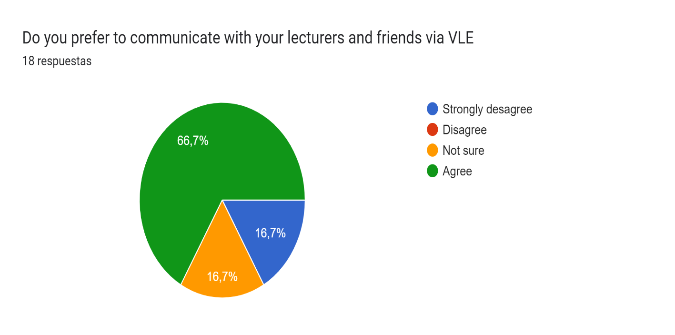

The graph represents 18 student responses that 66,7% agree with prefer to communicate with your lecturers and friends via VLE, 16,7% strongly desagree and 16,7% not sure.

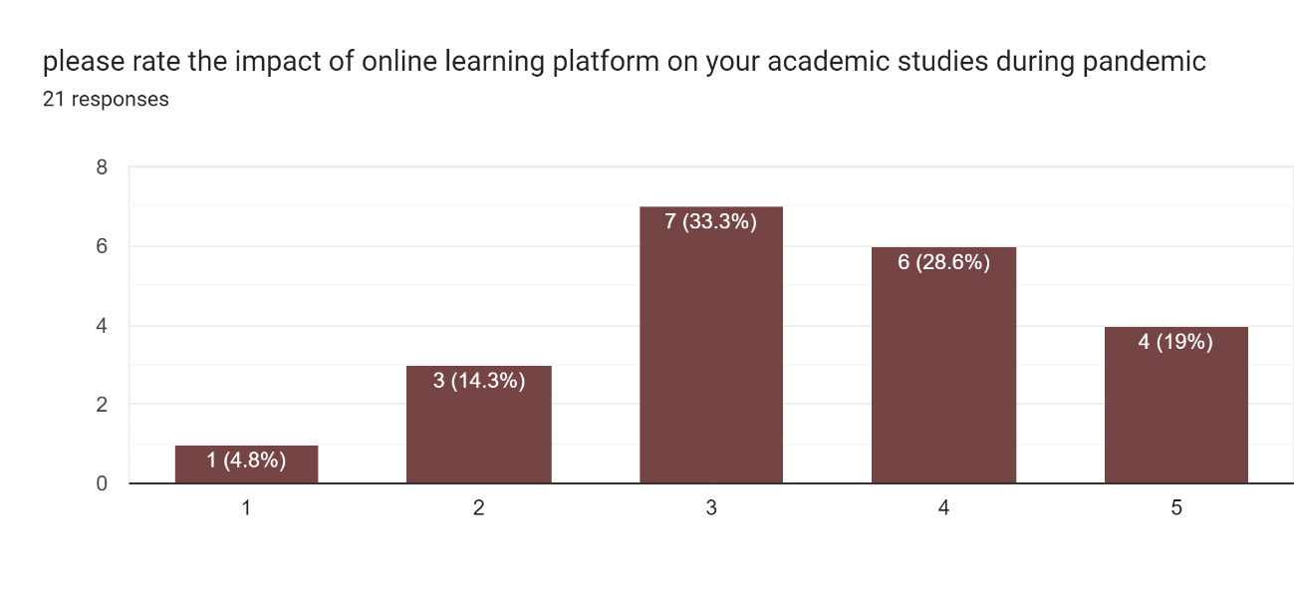
The graph represents 21 student responses that 4.8% extremely is the impact of online learning platform on academic studies during pandemic, 14.3% dissastified, 33.3% not sure, 28.6% satified, 19% extremely satified.

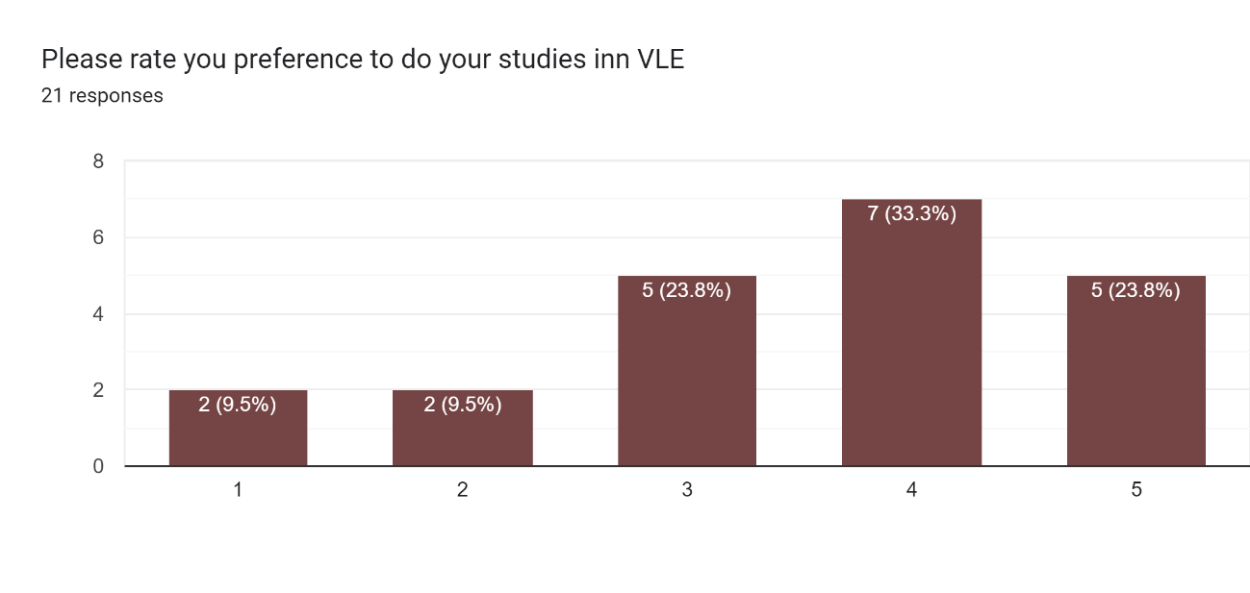

The graph represents 21 student responses that 9.5% extremely is the preference to do studies in VLE, 9.5% dissastified, 23.8% not sure, 33.3% satified, 23.8% extremely satified.

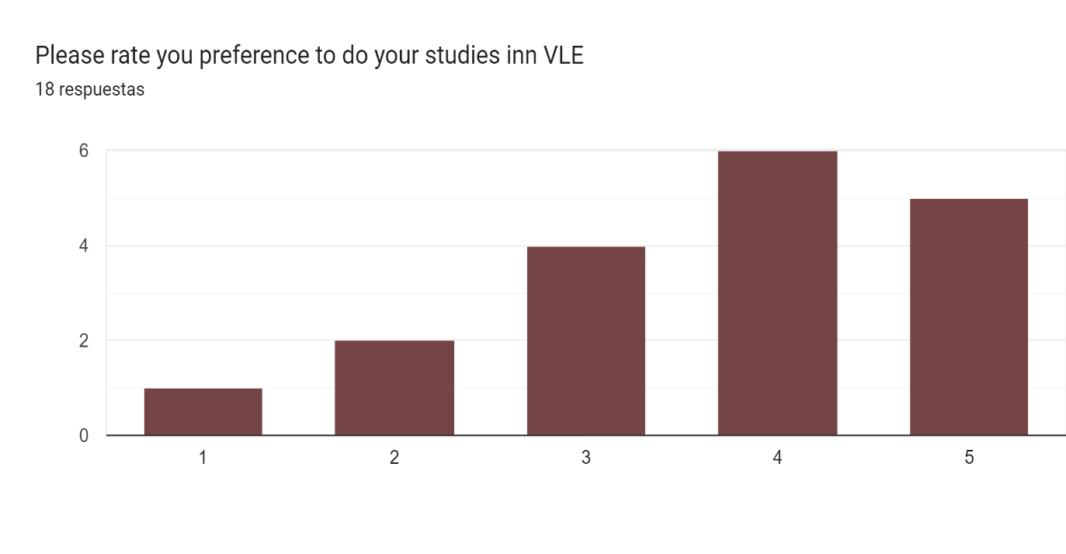
The graph represents 21 student responses that 4.8% extremely is the preference to do studies in VLE, 9.5% dissastified, 19% not sure, 28.6% satified, 23.8% extremely satified.

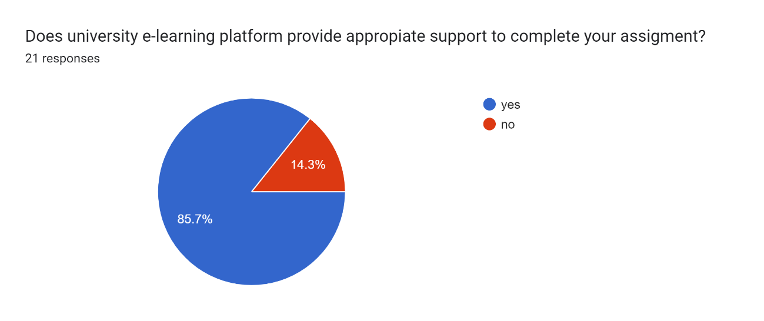

The graph represents 85.7% of 21 students reponses that the university e-learning platform provide appropiate support to complete your assigment and 14.3% that no provide adequate.

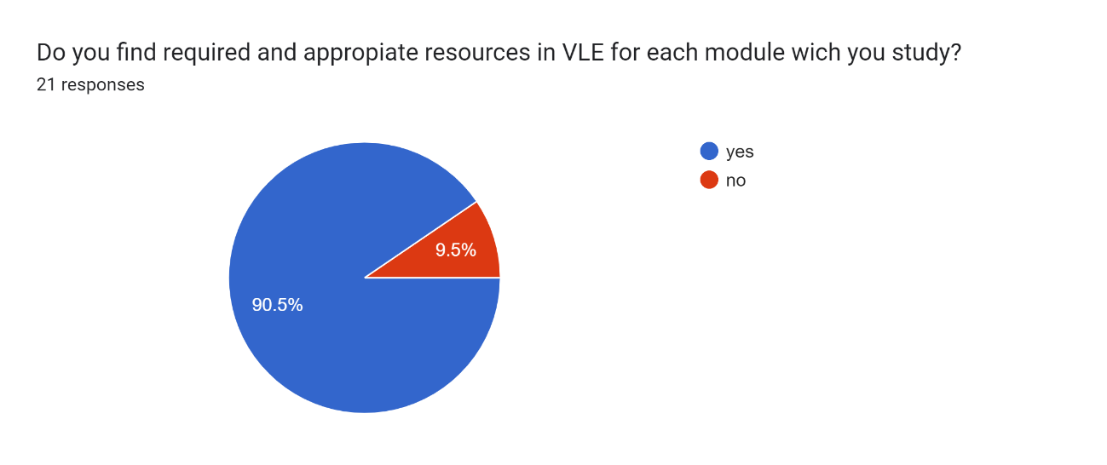

The graphs represents 90.5% thah of 21 reponses the students find required and appropiate resources in VLE each module wich your study and 9.5% that of students that “no” find required and appropiate resources.

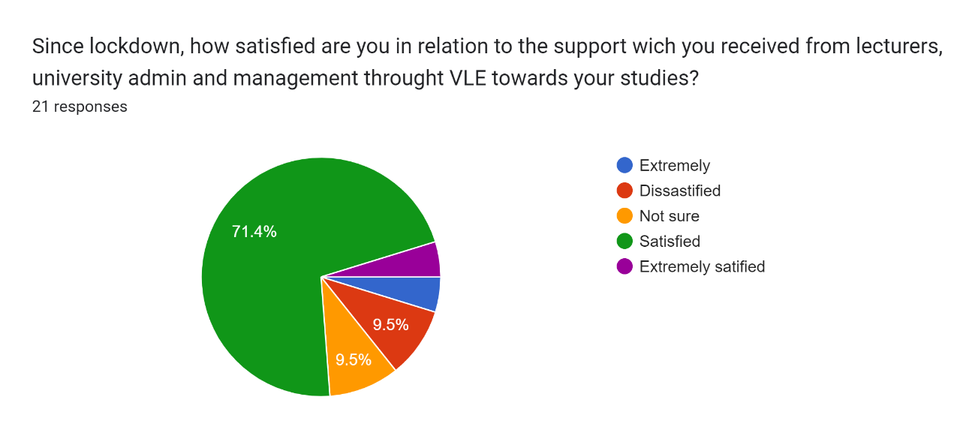

Since lokcdown, The graph represents that 71.4% the 21 reponses are students satisfied to the support wich you received from lecturers, university admin and management throught VLE towards your studies, 9.5% of students dissastified to the support, 4.9% extremely and 4.8% of sudents extremely satisfied.

6.0 DISCUSION
VLE is a platform that offers students and professors digital solutions the increase the learning experience. Types of services: Turnitin links by email, teaching, learning resources, IT support, assignment upload, etc. Impact positive; students used a software collaboration tool that enables students and teachers to communicate online to develop their understanding and analytical skills. Students performed significantly better and encourage progressive thought, and independent thinking. Impact negative; students in an online learning environment lack the opportunity and benefits of structured dialogue and the sense of community created in a traditional on-site classroom environment, focus. The methods are; descriptive, explanatory, remediation, historical.
The most students preferred Virtual Learning Environment. At the beginning of the course, it was the first time I used the Virtual Learning environment, everything was new, it was difficult but as time went by and with daily practice. I was taking advantage of the Moodle platform. I like to learn in this new way so I can work and study at the same time. Any doubt or review of any task is much easier because it can be sent to the teacher by the student's email, I save on transportation and travel time. The biggest challenge I had was getting back on the computer and that includes all the programs we used at the university. I choose Virtual learning environment because it is the most productive way I know to learn with productivity and I recommend to improve feedback: to make it part of the online course, to give incentives, simplify the questions.
To access third party sources; Go to the Security section of your Google Account, under “Third-party apps with account access,” select Manage third-party access. Select the app or service you want to review. The use online software tool to create surveys formatting, send frequent surveys, be brief in your questions, enlist the help of others, stick to specifics, clarify in your survey question answers, keep questions relevant, go easy on yes/no questions, know when to use matrix questions, rely on survey templates and the Question Bank. The use MS-Excel to create charts and graphs numerical data, data headings, data in proper order, first, we must place the cursor in the empty cell and click on the “Insert chart. After we click on the “Insert Chart,” we can see a blank chart, right-click on the chart and choose the “Select Data” option. In the below window, click on “Add.” In the below window, under “Series name,” select the heading of the data series, and under the “Series values,” select data series values. Now, the default chart is ready.

7.0 CONCLUSION
TVL/TEL the content should be more complete for mobile platforms. VLE is a platform that helps us increase learning and teaching by replacing formal learning with virtual learning, making it more effective for students and teachers satisfactorily.

8.0 REFERENCES

Puzhevich, V (2022) The Use of Virtual Learning Environment in Educational The Use Of Virtual Learning Environment In Education | SCAND Blog [Date last view: 9th August, 2022]
Mathers, C (2021) 7 Benefits of a Virtual Learning 7 Benefits of a Virtual Learning Environment (developgoodhabits.com)[Date last view: 14th August, 2022)
Fogden, T (2020) Common Challenges and Opportunities Faced by Students During Virtual Learning Common Challenges and Opportunities Faced by Students During Virtual Learning (twollow.com)[Date last view: 5th August, 2022]
Ofsted, (2013)Virtual learning environment Virtual learning environments (publishing.service.gov.uk)[Date last view: 14th August, 2022]
Kennedy, Mark ; Dunn, Thomas J (2018) Improving the Use of Technology Enhanced Learning Environments in Higher Education in the UK: A Qualitative Visualization of Students’ Views Improving the Use of Technology Enhanced Learning Environments in Higher Education in the UK: A Qualitative Visualization of Students’ Views - University of Wales Trinity Saint David (uwtsd.ac.uk)[Date last view: 14th August, 2022]
McAvinia, C (2016) Virtual Learning Environment Virtual Learning Environment - an overview | ScienceDirect Topics [Date last view: 14th August, 2022]
Fraser, H (2022) Learning as a Service Learning as a Service | Hemsley Fraser
Enfoque de la investigación: tipos y características (lifeder.com) [Date last view: 16th August, 2022]

9.0 APPENDIX



