Cover page:


UWTSD BIRMINGHAM CAMPUS
Knowledge and Information Management Skills for the Workplace
BMSW5106
M I Malik
1810158
Lecturer name: Buddhi Pathak

Table of content page:


Cover page: 1
Table of content page: 2
Introduction: 3
Assignment questions: 3
1: Why are information systems essential for the case study Zopa: 3
2: What information systems are implemented by Zopa describe the input, processing and output of any one of such systems: 4
3: Explain why Zopa has structure composed of different functions and levels. How computer based information system can support managers at each level and functions of Zopa operations: 5
4: Discuss Zopa’s potential knowledge management challenges and offer recommendations to strengthen their knowledge management practices from the knowledge acquistionretention transfer prespectives: 5
5: Discuss how overall approach adopted by Zopa incorporates porter’s generic competitive strategy and in what ways use of IS/IT has enabled Zopa to achieve a competitive advantage: 7
6: How does the knowledge management practice of the case company will benefit from progress in information technology: 9
7: How would the case organisation implement enterprise resource planning (ERP) systems, explain both advantages and challenges of having ERP systems with example: 11
Conclusion: 12
References: 12


Introduction
Knowledge 1and 1information 1management 1lets 1employees 1and 1individuals 1to 1make changes, solve 1big 1problems 1and 1communicate 1vital 1data 1to 1raise 1efficiency 1within 1a 1corporate 1or association, 1it 1enable 1employees 1or 1individuals 1to 1find 1the 1essential 1information 1they require 1quicker 1and 1this 1also 1helps 1to 1increases 1competence 1and 1Improve 1quality 1as 1by knowing 1these 1skills 1and 1sharing 1it 1correctly 1throughout 1your 1organisation 1can 1make 1a 1big difference 1in 1your 1company 1progress.
In this assignment I will be considering company called Zopa and will explain why knowledge and information management skills are important to gain progress in any organisation.
Zopa 1is 1a 1UK 1based 1company 1which 1was 1established 1in 12005, 1this 1was 1the 1first 1peer 1to peer 1leading 1company 1which 1was 1offering 1loans 1and 1other 1financial 1and 1credit 1offers 1to customers 1on 1a 1better 1rate 1compare 1to 1other 1companies, 1in 12020 1they 1established 1zopa bank 1which 1Is 1the 1greatest 1opportunity 1 1for 1new 1and 1old 1customers 1to 1manage 1their money more 1easily 1and 1another 1main 1reason 1to 1open 1this 1bank 1was 1to 1understand 1their 1customer needs 1more 1accurately 1by 1using 1their 1knowledge 1and 1information 1skills 1as 1to 1become successful 1in 1any 1business 1you 1have 1to 1understand 1the 1customer 1satisfaction 1criteria (Allen D. 12004).
Another 1important 1objective 1of 1this 1company 1is 1to 1keep 1their 1customers 1happy 1all 1the 1time as 1customers 1are 1the 1main 1key 1to 1success 1for 1any 1organisation, 1it 1takes 1years 1of 1hard working 1and 1effort 1to 1build 1your 1reputation 1in 1the 1competitive 1market 1and 1also 1to 1make good 1relationship 1with 1your 1customers 1but 1it 1only 1takes 1on 1wrong 1move 1to 1finish 1all 1that reputation 1and 1relationship 1as 1if 1you 1ignore 1your 1customer 1needs 1 1then 1it’s 1not 1possible for your 1business 1to 1be 1successful 1so 1it 1is 1very 1important 1to 1understand 1the 1mean 1of 1when you 1say 1customer 1is 1always 1right 1(Kerzner 1H. 12001) 1so 1near 1to 1Zopa 1no 1matter 1if 1are 1new customer 1or 1old 1customer 1they 1treat 1all 1their 1customers 1fairly 1which 1means 1no 1catches such 1as 1offers 1are 1for 1new 1customs 1only. 1
Assignment questions:
1: Why are information systems essential for the case study Zopa:

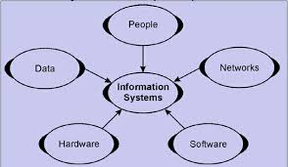
Information 1systems 1are 1the 1information 1and 1communication 1technologies 1used 1by organizations 1and 1the 1way 1people 1interact 1with 1that 1technology 1to 1support 1business processes, 1Information 1systems 1also 1perform 1specific 1functions 1to 1support 1operations, including 1payroll, 1employee 1record 1storage, 1preparation 1and 1storage 1of 1company documents, 1and 1credit 1card 1processing. 1In 1support 1operations, 1the 1information 1system 1can increase 1efficiency 1and 1increase 1employee 1productivity.
In other words the information system is the most important function in any business which can 1help 1them 1analyse 1and 1organize 1important 1data. 1The 1main 1purpose 1of 1this 1function 1is to 1convert 1raw 1data 1into 1useful 1information 1which 1can 1be 1stored 1and 1used 1in 1any 1business in 1the 1future 1to 1make 1important 1decisions.
According 1to 1Zopa 1research 1more 1data 1has 1been 1created 1and 1stored 1in 1the 1past 1few years compare 1to 1whole 1previous 1history 1of 1human 1race 1(Tony, 12019), 1In 1old 1times 1people 1use to store 1data 1manually 1in 1books 1but 1now 1a 1days 1latest 1technology 1has 1arrived 1and 1now everybody 1use 1latest 1available 1technology 1to 1store 1such 1information 1so 1like 1all 1other modern 1companies 1to 1make 1their 1life 1easier 1Zopa 1also 1use 1latest 1technology 1such 1as Hadoop 1and 1Spark 1allowed 1companies 1to 1gather 1and 1organize 1as 1much 1data 1as 1they wanted.

2: What information systems are implemented by Zopa and describe the input, processing and output of any one of such systems:
According 1to 1(Poynter, 12010) 1technology 1has 1become 1so 1advanced 1that 1instead 1of 1phone call 1people 1are 1using 1most 1latest 1technologies 1to 1communicate 1with 1each 1other 1which 1are like 1emails, 1WhatsApp, 1Facebook, 1Skype, 1Viber 1and 1many 1more, 1Zopa 1has 1a 1lot 1of different 1information 1system 1available 1to 1take 1store 1and 1use 1customer’s 1data, 1Zopa 1has joined 1with 1paylink 1solution 1and 1introduced 1a 1new 1cloud 1based 1digital 1income 1and expenditure 1product 1called 1Embark.
By using Embark technology Zopa 1support 1customers 1who 1are 1experiencing 1financial difficulties 1as 1It 1works 1by 1capturing 1information 1about 1the 1consumer's 1overall 1financial situation 1and 1this 1can 1be 1done 1manually 1by 1taking 1information 1from 1customer 1or 1by 1using open 1bank 1to 1access 1their 1current 1account 1information, 1Zopa 1also 1use 1this 1technology 1to understand 1the 1affordability 1of 1loan 1customers 1who 1have 1undergone 1environmental changes 1and 1therefore 1require 1payment 1plans, 1these 1customers 1can 1also 1access 1Embark via 1self-service 1portal 1or 1they 1can 1be 1connected 1to 1customer 1service 1agents 1to 1discuss further 1regarding 1their 1 1payment 1plans.
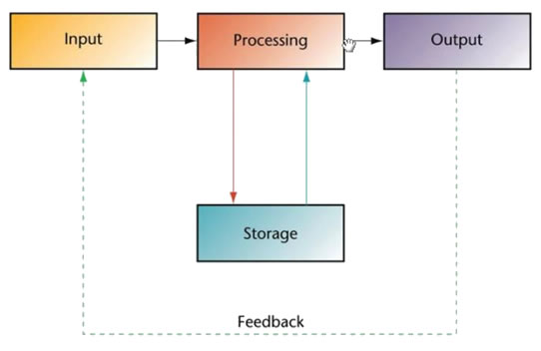
This 1tool 1has 1made 1life 1very 1easy 1as 1by 1using 1this 1tool 1customers 1can 1directly 1access debit 1advice 1with 1PayPlan 1and 1check 1what 1offers 1are 1available 1to 1them 1and 1as 1a 1matter 1of fact 1just 1by 1entering 1their 1information 1to 1the 1system 1they 1can 1be 1informed 1if 1they 1will 1be able 1to 1get 1the 1loan 1or 1selected 1product 1or 1not 1and 1if 1they 1have 1trouble 1understanding then by 1just 1one 1click 1they 1can 1be 1connected 1to 1highly 1trained 1customer 1service 1advisers 1who can 1give 1them 1best 1advice 1on 1what 1product 1to 1choose 1as 1now 1a 1days 1everybody 1like 1self service 1more 1so 1it 1is 1very 1important 1for 1companies 1to 1improve 1and 1bring 1new 1and 1latest technology 1where 1customers 1feel 1more 1happy 1and 1comfortable 1to 1access 1and 1use 1this service 1with 1confidence 1as 1customer 1satisfaction 1is 1the 1main 1key 1hidden 1behind 1success of any 1business. 1(Marcoulides, 1G, 11998).

3: Explain why Zopa has structure composed of different functions and levels. How computer based information system can support managers at each level and functions of Zopa operations:
Information 1system 1is 1the 1collection, 1storage 1and 1processing 1of 1data. 1The 1data 1can 1be used 1at 1any 1time 1when 1necessary. 1Computer-based 1information 1systems 1use 1computers to collect, 1store 1and 1process 1digital 1data
A computer based information system consists of five main components, 1hardware, software, 1data, 1personnel, 1and 1processes, 1these 1five 1components 1are 1connected 1but 1I personally 1think 1from 1all 1above 1elements 1data 1is 1the 1most 1important 1element 1it 1works 1like fuel 1in 1vehicles 1as 1nothing 1is 1possible 1without 1data.
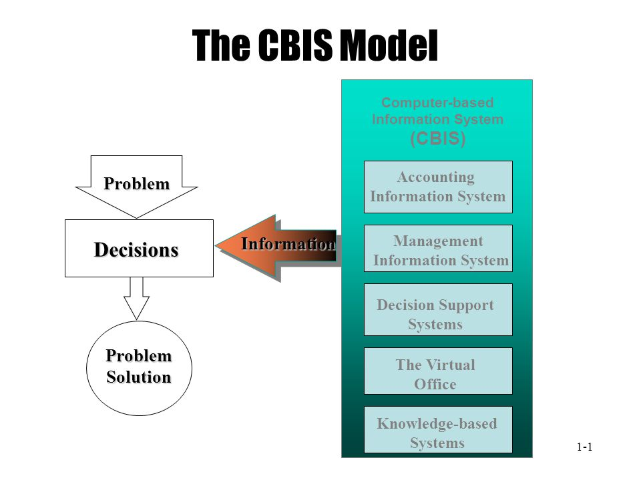
At 1Zopa 1managers 1receive 1decision 1making 1information 1in 1various 1forms, 1the 1most 1formal information 1channel 1is 1the 1company's 1computer 1based 1information 1system 1CBIS 1which uses 1electronic 1computing 1technology 1to 1create 1an 1information 1system, 1the 1latest computers 1systems 1plays 1important 1role 1to 1solve 1organizations 1big 1problems, 1although computers 1have 1traditionally 1been 1used 1for 1transaction 1processing 1functions 1but 1now 1a days 1recent 1technological 1advances 1have 1allowed 1managers 1to 1directly 1access 1computer support 1systems 1to 1make 1important 1decisions 1so 1by 1using 1this 1technology 1it 1is 1important to make 1a 1decision 1which 1will 1put 1positive 1effects 1on 1your 1organisation, 1(Cottrell 12008).

4: Discuss Zopa’s potential knowledge management challenges and offer recommendations to strengthen their knowledge management practices from the knowledge acquistionretention transfer prespectives.
Knowledge 1management 1is 1a 1conscious 1process 1of 1defining, 1organizing, 1retaining 1and sharing 1the 1knowledge 1and 1experience 1of 1employees 1in 1the 1organization 1by 1using 1different tools 1such 1as 1emails, 1phone 1calls, 1video 1chats, 1face 1to 1face 1communication 1etc. communication 1is 1very 1important 1to 1achieve 1success 1in 1any 1business 1as 1without 1this progress 1not 1possible 1(Tuckman 1B 1W 12012).The 1main 1goal 1of 1knowledge 1management 1is to 1improve 1the 1efficiency 1of 1the 1organization, 1preserve 1knowledge 1within 1the 1company, and it 1can 1also 1improve 1the 1efficiency 1of 1organizational 1decision-making 1capabilities.
Considering Zopa there are several knowledge management challenges they have to deal with, 1this 1process 1is 1more 1than 1just 1knowing 1everything 1the 1organization 1has 1learned 1and devised 1in 1the 1past 1and 1putting 1everything 1in 1one 1place, 1now 1I 1am 1going 1to 1talk 1about 1the most 1common 1challenges 1this 1company 1may 1come 1across, 1and 1how 1to 1overcome 1them.
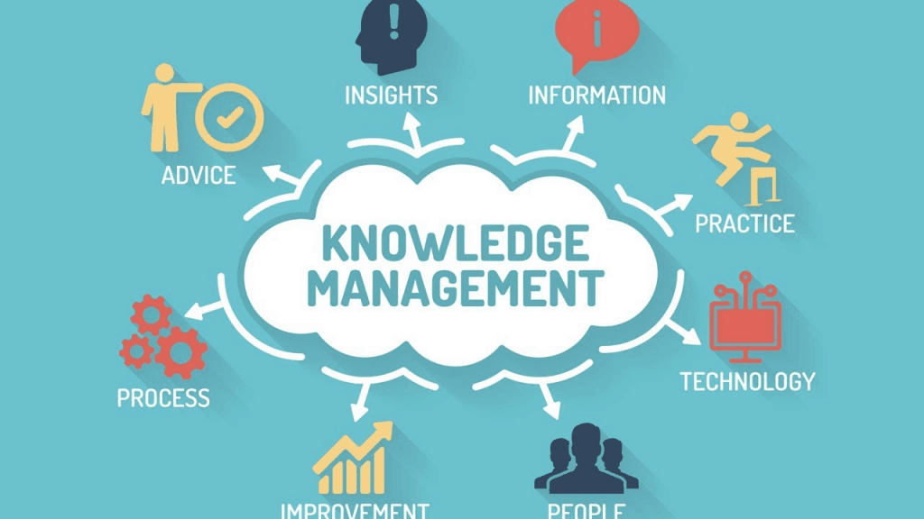
Making 1it 1easy 1for 1people 1to 1find 1what 1they 1are 1looking 1for:
No 1one 1likes 1to 1look 1for 1what 1they 1need 1for 1long 1periods 1of 1time, 1so 1as 1employees responsible 1for 1knowledge 1sharing, 1you 1need 1to 1make 1sure 1that 1all 1information 1is 1in 1one place 1and 1that 1it 1is 1easily 1accessible, 1in 1this 1way 1you 1can 1help 1users 1find 1what 1they 1need immediately, 1his 1can 1save 1a 1lot 1of 1time, 1which 1can 1eventually 1be 1used 1to 1complete 1other 1tasks.
Managing 1community 1engagement:
Even 1in 1Big 1companies 1like 1Zopa 1with 1an 1internal 1knowledge 1sharing 1platform 1problems doesn’t 1get 1sorted 1itself 1as 1a 1responsible 1person 1you 1have 1to 1talk 1to 1your 1team 1by answering 1questions 1and 1recognizing 1the 1people 1who 1have 1played 1an 1important 1role 1in 1the development 1of 1the 1platform 1as 1they 1are 1the 1people 1who 1add 1value 1to 1the 1community.
Encouraging 1people 1to 1share 1their 1knowledge:
At 1Zopa 1all 1management 1and 1employees 1like 1to 1help 1each 1other 1so 1they 1also 1like 1the 1idea of 1​​sharing 1knowledge 1and 1valuable 1information 1as 1almost 1every 1employee 1of 1the 1company have 1access 1in 1the 1knowledge 1management 1platform 1and 1benefit 1from 1it, 1to 1keep 1an 1eye on 1employee 1engagement 1the 1process 1of 1gamification 1is 1important 1as 1by 1using 1this process 1you 1can 1observe 1engagement 1of 1employees 1so 1this 1is 1also 1a 1great 1way 1to 1focus on 1your 1most 1valuable 1team 1members, 1another 1great 1way 1is 1company 1internal 1email system 1where 1all 1management 1and 1employees 1can 1share 1information 1(Adair,J, 1E 1, 12009).

Facilitating 1collaboration 1among 1team 1members 1and 1different 1teams:
One 1of 1the 1knowledge 1management 1challenges 1at 1Zopa 1is 1to 1facilitate 1the 1collaboration 1of team 1members, 1good 1example 1of 1solving 1this 1problem 1is 1to 1customize 1the 1ideation process by 1identifying 1and 1clearly 1outlining 1its 1different 1stages, 1no 1matter 1which 1team 1the 1member belongs 1to, 1this 1will 1keep 1the 1member 1up 1to 1date 1and 1participate.
Measuring 1knowledge 1contribution 1and 1rewarding 1active 1users:
In 1this 1challenge 1Zopa 1need 1to 1reward 1most 1active 1employees 1of 1the 1company 1so 1other inactive 1employees 1will 1be 1motivated 1to 1put 1more 1effort 1in 1their 1work 1to 1achieve 1same target 1as 1their 1other 1work 1members, 1 1company 1needs 1to 1observe 1who 1meet 1their 1targets on 1time 1and 1make 1sure 1to 1reward 1them 1as 1they 1deserve. 1This 1will 1encourage 1more 1and more 1company 1members 1to 1start 1contributing.

5: Discuss how overall approach adopted by Zopa incorporates porter’s generic competitive strategy and in what ways use of IS/IT has enabled Zopa to achieve a competitive advantage:
Porter 5 Forces was proposed by Michael E. Porter in 1979, 1it 1is 1simple 1but 1powerful 1tool for understanding 1the 1competitiveness 1of 1your 1business 1environment 1and 1for 1identifying 1your strategy's 1potential 1profitability, 1(Marc, 1Warda, 12019). 1Zopa 1and 1a 1lot 1of 1other 1companies use 1the 1Porter 15 1forces 1tool 1to 1determine 1whether 1it 1is 1profitable 1to 1enter 1a 1particular trade.

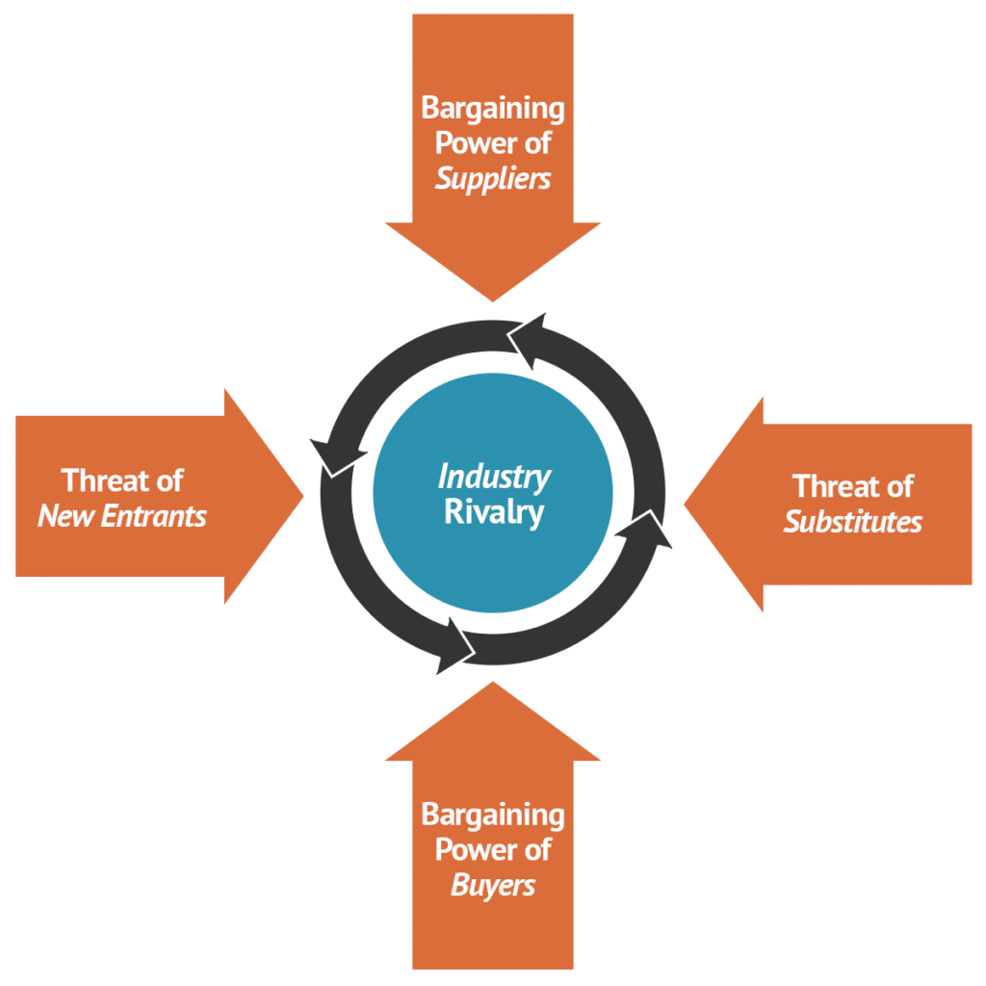

Porter 15 1Forces 1Analysis:
This 1model 1can 1help 1Zopa 1determine 1the 1attractiveness 1of 1the 1industry 1and 1understand 1its competitive 1position 1in 1the 1market. 1This 1analysis 1can 1also 1be 1used 1to 1make 1strategically wise 1decisions 1that 1can 1improve 1the 1performance 1of 1Zopa.
Threats 1of 1new 1entrants:
Threat 1of 1new 1entrants 1reflects 1how 1new 1market 1players 1impose 1threats 1to 1the 1existing market 1players. 1If 1the 1industry 1will 1be 1profitable 1and 1barriers 1to 1enter 1the 1industry 1will 1be low, 1it 1will 1attract 1more 1players 1and 1hence, 1the 1threat 1of 1new 1entrants 1will 1be 1high.
In 1regards 1to 1tackle 1these 1threats 1Zopa 1develop 1brand 1loyalty 1by 1working 1on 1customer relationship 1management.
Zopa 1has 1a 1large 1number 1of 1valuable 1customers 1they 1introduce 1their 1products 1and services 1to 1those 1customers 1on 1reasonable 1and 1affordable 1rates.
Threat 1of 1Substitute 1Products 1or 1services:
High 1substitution 1threats 1indicate 1that 1customers 1can 1use 1alternative 1products/services from 1other 1industries 1to 1meet 1their 1needs.
Zopa 1can 1reduce 1this 1by 1making 1their 1product 1better 1than 1others.
It 1should 1also 1provide 1customers 1with 1compelling 1reasons 1by 1providing 1a 1better 1experience and 1cost-effectiveness.
Rivalry 1among 1existing 1firms:
The 1Rivalry 1among 1existing 1firms 1shows 1the 1number 1of 1competitors 1that 1give 1threatening competition 1and 1pressure 1to 1ZOPA.
To 1overcome 1this 1Zopa 1invest 1in 1research 1and 1development 1activities 1to 1identify 1new customer 1groups, 1in 1some 1cases 1cooperation 1with 1competitors 1can 1be 1mutually 1beneficial.
Bargaining 1Power 1of 1Suppliers:
When 1the 1supplier 1has 1strong 1bargaining 1power, 1it 1will 1make 1the 1buyer 1pay, 1In 1addition high 1supplier 1bargaining 1power 1will 1increase 1industry 1competition, 1and 1similarly 1due 1to high profitability 1and 1growth 1potential 1weak 1supplier 1capabilities 1will 1make 1the 1industry 1more attractive.
To 1sort 1out 1this 1issue 1Zopa 1needs 1to 1work 1on 1their 1supply 1chains 1that 1they 1need 1more suppliers 1as 1if 1one 1supplier 1is 1increasing 1their 1brand 1prices 1Zopa 1should 1choose 1different supplier.
Bargaining 1Power 1of 1Buyers:
If 1buyers 1has 1strong 1bargaining 1power 1it 1makes 1the 1industry 1less 1competitive 1and 1increase the 1profitability 1and 1growth 1opportunities.
Zopa 1manages 1buyers 1bargaining 1power 1by 1increasing 1their 1customers, 1introducing 1new products, 1targeting 1new 1market 1sectors 1and 1adopting 1product 1modification 1strategies.
Porter's 1generic 1strategy 1is 1also 1a 1useful 1framework 1for 1organizations 1and 1by 1using 1this framework 1they 1can 1gain 1a 1competitive 1advantage 1in 1any 1industry, 1they 1are 1four strategies.
Cost 1Leadership 1Strategy:
Cost 1leadership 1strategy 1is 1where 1companies 1focus 1on 1reducing 1the 1cost 1of 1delivering products 1or 1services 1to 1customers

Differentiation 1Strategy:
The 1differentiation 1strategy 1is 1where 1a 1company 1focuses 1on 1distinguishing 1its 1products 1or services 1from 1competitors.
Cost 1Focus 1Strategy:
Cost 1focus 1strategy 1is 1the 1evolution 1of 1cost 1leadership 1strategy 1where 1Focus 1refers 1to when 1a 1company 1focuses 1on 1a 1niche 1market 1and 1Cost 1refers 1to 1the 1company 1producing the 1product 1or 1service 1for 1an 1aggressive 1cost 1to 1them.
Differentiation 1Focus 1Strategy:
There 1are 1two 1aspects 1on 1this 1strategy, 1one 1focuses 1on 1the 1differentiation 1aspect 1of strategy, 1and 1the 1other 1focuses 1on 1the 1fact 1that 1companies 1are 1entering 1a 1niche 1market.
In 1regards 1to 1IS/IT 1at 1Zopa 1data 1is 1everything 1they 1use 1open 1source 1tools 1such 1as particularly 1the 1PyData 1stack, 1which 1includes 1tools 1like 1jupyter, 1Pandas 1and 1scikit-learn.
Zopa 1is 1built 1on 1top 1class 1technology 1and 1data 1analysis, 1so 1open 1source 1is 1very 1important to 1them 1as 1it 1helps 1them 1deliver 1their 1product 1or 1service 1to 1customers 1very 1quickly, 1it 1also allows 1them 1to 1be 1more 1innovative 1with 1the 1community 1on 1a 1day-to-day 1basis, 1In 1fact 1it would 1be 1impossible 1for 1them 1to 1do 1their 1jobs 1without 1the 1tools 1such 1as 1Stackoverflow, Github, 1pyGMO, 1Kafka, 1Kubernetes 1and 1Ruby, 1Zopa 1consider 1the 1use 1of 1Open 1Source 1as part 1of 1their 1competitive 1advantage, 1because 1it 1enables 1them 1to 1deliver 1new 1software, software 1updates 1and 1data 1insights 1faster 1than 1any 1other 1company 1can 1provide.

6: How does the knowledge management practice of the case company will benefit from progress in information technology:
Information 1technology 1plays 1a 1vital 1role 1in 1knowledge 1management 1as 1by 1using 1IT 1you can 1do 1many 1tasks 1such 1as 1manage 1documents, 1data 1storage, 1information 1access, exchange 1and 1sharing 1of 1ideas. 1IT 1provides 1solutions 1knowledge 1management 1and 1it 1is also 1a 1tool 1for 1improving 1the 1efficiency 1and 1functions 1of 1knowledge 1management, 1most managers 1at 1companies 1like 1Zopa 1belive 1that 1information 1technology 1can 1provide 1an 1edge in 1harvesting 1knowledge 1from 1piles 1of 1old 1buried 1data 1repositories 1(Bhatt, 12001).
Information technology is considered to be one of the most important types of technology and plays an important role in knowledge management, 1the 1name 1information 1technology can 1clearly 1see 1the 1relationship 1between 1IT 1and 1knowledge 1management, 1the development of 1information 1technology 1in 1recent 1decades 1has 1greatly 1promoted 1the 1effectiveness 1of knowledge 1management 1and 1its 1various 1applications.
Knowledge 1is 1based 1on 1data 1and 1information, 1where 1data 1is 1considered 1as 1raw 1facts, information 1is 1regarded 1as 1an 1organised 1data 1and 1knowledge 1is 1perceived 1as 1meaningful information 1so 1knowledge 1can 1be 1viewed 1both 1as 1a 1something 1to 1be 1stored 1and manipulated 1and 1as 1process 1of 1simultaneously 1knowing 1and 1applying 1expertise (Zack,1999).
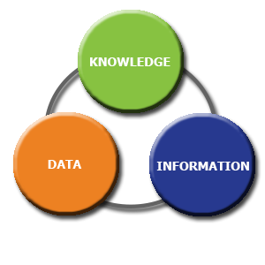
Considering 1Zopa 1Information 1technology 1has 1played 1an 1important 1role 1in 1to 1improve 1their knowledge 1managing 1activities 1such 1as 1collecting 1data, 1online 1application 1process, applications, 1data 1storage, 1fast 1process, 1information 1distribution, 1this 1also 1enables 1Zopa 1to operate 1more 1effectively 1and 1by 1using 1latest 1information 1technology 1they 1can 1add 1value, improve 1quality 1and 1increase 1productivity 1by 1using 1their 1knowledge 1management 1skills.

The 1technological 1revolution 1has 1improved 1the 1business 1of 1this 1century 1in 1five 1main 1areas:
Solve 1complex 1problems.
As 1a 1technology 1company 1Zopa 1consider 1Open 1Source 1and 1use 1a 1lot 1of 1different 1tools 1to solve 1complex 1problems 1and 1it 1also 1enables 1them 1to 1deliver 1new 1software, 1software updates 1and 1data 1insights 1faster.
Make 1better 1decisions.
Good 1business 1decisions 1are 1based 1on 1solid 1market 1research, 1this 1can 1be 1achieved 1by interacting 1with 1the 1team 1through 1video 1conferences, 1reviewing 1public 1sentiment 1on 1social media 1and 1industry 1forums 1and 1using 1online 1surveys 1to 1obtain 1customer 1feedback, 1to achieve 1this 1target 1Zola 1use 1tools, 1such 1as 1Microsoft 1CRM 1Dynamics 1and 1Google Analytics.
Improved 1marketing:
These 1days 1social 1networks 1are 1the 1best 1source 1to 1advertise 1your 1products 1e.g. 1 Facebook or 1LinkedIn 1just 1by 1searching 1you 1will 1see 1what 1you 1need 1(Nye. 1D.E, 12006). 1Zopa 1use online 1marketing 1using 1online 1advertising 1methods 1such 1as 1SEO, 1PPC, 1and 1Facebook ads, this 1is 1much 1better 1way 1to 1advertise 1your 1product 1rather 1than 1using 1old 1tradition 1way where you 1have 1to 1convince 1customer 1to 1buy 1your 1product.
Improved 1customer 1support:
Zopa 1support 1customers 1through 1multiple 1channels 1like 1phone 1calls, 1emails, 1social 1media platforms, 1webinars, 1etc. 1In 1addition, 1customer 1relationship 1management 1systems 1can 1help companies 1understand 1customer 1behaviour.
Improved 1resource 1management.
Zopa 1employees 1use 1cloud 1computing 1which 1allows 1them 1to 1use 1any 1device 1anywhere 1in the 1world 1to 1get 1access 1into 1their 1company 1work.

7: How would the case organisation implement enterprise resource planning (ERP) systems, explain both advantages and challenges of having ERP systems with example:
Enterprise 1Resource 1Planning 1is 1an 1important 1enterprise 1application 1that 1integrates 1all 1the individual 1department 1functions 1into 1a 1single 1software 1application, 1Zopa 1is 1well 1organised and 1highly 1professional 1organisation, 1Zopa 1clearly 1understand 1the 1need 1and 1benefits 1of professional 1ERP 1system 1requirement 1as 1Zopa 1ERP 1tools 1share 1a 1common 1process 1and data 1model 1covering 1a 1wide 1range 1of 1end 1to 1end 1operational 1processes 1such 1as 1finance, human 1resources, 1distribution, 1manufacturing, 1service, 1and 1supply 1chain.
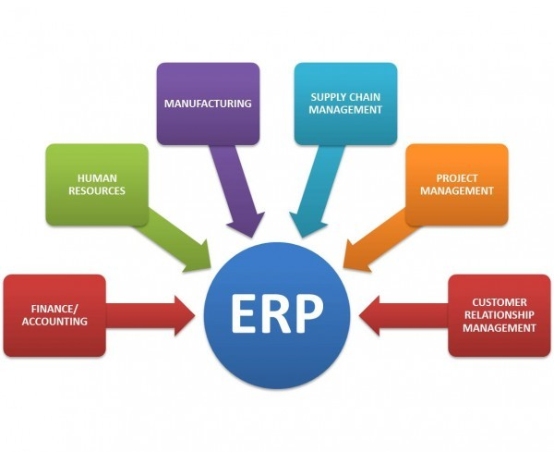
There 1are 1many 1benefits 1to 1having 1an 1ERP 1system 1within 1an 1organization 1For 1example, 1it can 1create 1an 1information 1repository, 1reduce 1operating 1costs, 1and 1pave 1the 1way 1for 1accurate 1reporting, 1because 1it 1provides 1a 1standardized 1way 1of 1operation, 1it 1can 1also 1help 1simplify 1business 1processes 1where 1just 1single 1tick 1can 1bring 1you 1all 1the 1information 1you 1need 1(Mackenzie, 12005).
Advantages:
Improved 1communication.
Better 1Financial 1Planning.
Data 1redundancy 1is 1reduced 1to 1a 1minimum.
Deeper 1understanding 1of 1the 1overall 1business 1situation.
Improved 1Data 1Security 1and 1Accessibility
If 1the 1company 1is 1small 1size 1business 1for 1example 1takeaway 1or 1news 1agent 1shop 1then they 1really 1don’t 1need 1ERP 1system 1as 1it 1will 1probably 1cost 1more 1to 1install 1this 1system 1and their 1profit 1margin 1will 1not 1allow 1them 1for 1this 1extra 1expense 1and 1due 1to 1the 1company 1size it 1will 1be 1easy 1for 1them 1to 1do 1all 1their 1tasks 1manually. 1
Disadvantages:
Challenges.
Slow 1software.
Cost 1of 1ERP.
Slow 1data 1migration & too 1complex.
Conclusion:


In 1any 1organisation 1knowledge 1and 1information 1management 1skills 1plays 1an 1important 1role as 1without 1the 1correct 1knowledge 1of 1these 1skills 1success 1is 1not 1possible, 1these 1skills 1can increases 1the 1efficiency 1of 1an 1organization's 1different 1activities, 1like 1all 1other 1companies Zopa 1try 1to 1give 1best 1customer 1support 1to 1their 1customers 1by 1using 1their 1knowledge 1and information 1skills 1as 1company 1believe 1that 1customers 1are 1the 1main 1source 1of 1success 1in any 1organisation 1so 1their 1first 1priority 1is 1to 1give 1good 1customer 1support, 1company 1has 1the best 1tools 1available 1to 1all 1staff 1members 1where 1they 1can 1learn 1to 1improve 1their 1knowledge and 1information 1skills, 1company 1use 1different 1methods 1to 1keep 1all 1staff 1updated.
Company 1strongly 1believes 1that 1internal 1communication 1and 1teamwork 1is 1also 1important 1to gain 1success 1as 1excellent 1teamwork 1can 1bring 1a 1noble 1fortune 1for 1the 1company 1(Maund, 2017) 1another 1main 1reason 1for 1this 1company 1to 1be 1very 1successful 1in 1the 1present 1market is 1that 1they 1offer 1their 1products 1and 1services 1to 1customers 1at 1very 1reasonable 1interest 1rate compare 1to 1other 1competitive 1market 1lenders, 1company 1process 1is 1very 1simple 1and straight forward 1as 1when 1customer 1apply 1for 1credit 1card 1or 1loan 1company 1use 1their 1best 1available sources, 1software 1and 1credit 1agencies 1to 1take 1decision 1within 1few 1hours 1and 1money 1can be 1transferred 1into 1customer’s 1account 1on 1the 1same 1day.
So 1finally 1I 1would 1consider 1this 1company 1has 1made 1a 1strong 1place 1in 1the 1market 1as 1they are 1very 1well 1know 1without 1the 1correct 1skills 1of 1knowledge 1and 1information 1they 1can’t 1be successful.

References:

Allen, 1D. 1(2004). 1Customer 1satisfaction 1research 1management. 1Milwaukee: 1ASQ 1Quality Press.
Adair, 1J, 1E, 1(2009) 1Effective 1Teambuilding: 1How 1to 1make 1a 1winning 1team. 1London: 1Pan Books
Argyres, 1N., 1& 1McGahan, 1A. 1M. 1(2002). 1An 1interview 1with 1Michael 1Porter. 1Academy 1of Management 1Perspectives, 116(2), 143-52.
Bartusková, 1T., 1& 1Kresta, 1A. 1(2015). 1Application 1of 1AHP 1method 1in 1external 1strategic analysis 1of 1the 1selected 1organisation. 1Procedia 1Economics 1and 1Finance, 130, 1146-154.
Bhatt, 1G., 12001, 1Knowledge 1Management 1in 1Organisations: 1Examining 1the 1Integration between 1Technologies, 1Techniques, 1and 1People, 1Journal 1of 1Knowledge 1Management Volume 15 1no 11 1pp. 168-75
Cottrell, 1S. 1(2008) 1The 1Study 1Skills 1Handbook 13rd 1edition. 1Hampshire: 1Palgrave 1MacMillan
Kerzner, 1H. 1(2001). 1Project 1management. 1New 1York: 1John 1Wiley.
Marcoulides, 1G. 1(1998). 1Modern 1methods 1for 1business 1research. 1Mahwah, 1N.J. 1Lawrence Erlbaum.
Mackenzie, 1A, 1(2005). 1Problematizing 1the 1mechanical: 1The 1protest 1as 1occasion? 1Social Epistemology, 119, 1381, 199.
Maund, 1A. 1Schriek, 1M. 1and 1Tinkler, 1P. 1(2017). 1Certificate 1in 1Higher 1Education: 1Skills 1for the Workplace 1Student 1Yearbook. 1Sage 1Publications
Marc 1Helmold, 1Warda 1Samara 1(2019) 1Progress 1in 1Performance 1Management: 1Industry Insights 1and 1Case 1Studies 1on 1Principles, 1Application 1Tools, 1and 1Practice,: 1Springer.
Nye. 1D.E,(2006). 1Innovation 1matters: 1Inquiries 1to 1live 1with. 1Cambridge, 1Mama: 1The 1MIT Press.
Poynter, 1R, 1(2010) 1The 1handbook 1of 1on 1the 1web 1and 1online 1networking 1research: Apparatuses 1and 1strategies 1for 1economic 1specialists. 1Joined 1Kingdom: 1Wiley
Tuckman, 1B.W. 1and 1Harper, 1B.E. 1(2012) 1Conducting 1educational 1research. 16th 1edn. United States: 1Rowman 1& 1Littlefield 1Publishers.
Tony, 1Gudia 1(2019). 1Big 1Data 1and 1Machine 1Learning 1in 1Quantitative 1Investment, 1: 1John Wiley 1& 1Sons.
Zack, 1M., 11999, 1Managing 1Codified 1Knowledge, 1Sloan 1Management 1Review, 1Vol. 140 1No. 4, 1pp. 145-58

