

Research, Analyse and Investigate Cybersecurity incidents and perform digital forensic assessment

Student Name & ID: Vanshaj Patel (2517969)
Module Code: ACFA7031
Module Name: Digital Forensics Analysis

LECTURER: Dr. Mohamed Ghanem

DECLARATION:
I confirm that this work is my own and that all sources used have been acknowledged appropriately in accordance with academic integrity guidelines.

Task 1

TABLE OF CONTENTS (Task 1)
- Introduction
- Current State of Digital Forensics
- Digital Forensic Tools: Features and Capabilities
- Intersection of Digital Forensics and Cybersecurity
- Emerging Trends in Digital Forensics
- Key Challenges in Digital Forensics
- National and International Job Market
- Conclusion
- References

TABLE OF FIGURES (Task 1)
Figure 1: Digital Forensic Investigation Process Model
Figure 2: Key Digital Forensic Tools and Their Capabilities
Figure 3: Relationship Between Digital Forensics and Cybersecurity
Figure 4: Emerging Trends in Digital Forensics
Figure 5: Key Challenges in Digital Forensic Investigations

1. Introduction
Digital forensics is a critical discipline within cybersecurity that focuses on the identification, acquisition, preservation, analysis, and presentation of digital evidence. With the rapid growth of digital technologies, cyber incidents such as data breaches, insider threats, and corporate espionage have become increasingly common. As a result, digital forensics plays a vital role in investigating cybercrimes and supporting legal proceedings.
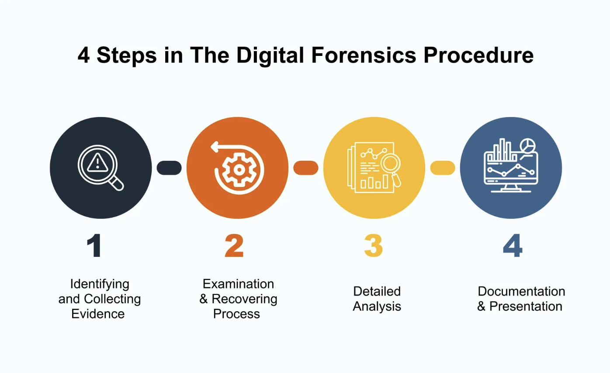
Figure 1: Digital Forensic Investigation Process Model
This report critically explores the current state of digital forensics, key tools and their capabilities, the relationship between digital forensics and cybersecurity, emerging trends, major challenges, and the national and international job market.

2. Current State of Digital Forensics
Digital forensics has evolved significantly due to the increasing complexity of digital systems and cyber threats. Modern investigations involve a wide range of data sources, including mobile devices, cloud environments, Internet of Things (IoT) devices, and enterprise systems.
Traditional forensic methods focused on computer systems; however, modern investigations require advanced techniques to handle large-scale and distributed data. According to Casey [1], digital forensics now emphasises automation, scalability, and accuracy in evidence handling. Tools are increasingly designed to process large datasets efficiently while maintaining data integrity.
Additionally, forensic investigations must comply with legal and regulatory standards to ensure evidence admissibility. Frameworks such as those provided by NIST guide investigators in maintaining proper procedures and documentation [2].

3. Digital Forensic Tools: Features and Capabilities
Digital forensic tools are essential for conducting efficient and accurate investigations. Commonly used tools include Cellebrite Physical Analyzer, FTK Imager, and Autopsy.
Cellebrite Physical Analyzer is widely used for mobile forensics and supports data extraction from smartphones, including contacts, messages, application data, and system artefacts. It provides features such as selective application decoding, timeline reconstruction, and data categorisation.
FTK Imager is primarily used for evidence acquisition and allows investigators to create forensic images without modifying the original data. It supports hash verification to ensure data integrity.
Autopsy, an open-source tool, provides capabilities for analysing disk images, recovering deleted files, and examining file systems.
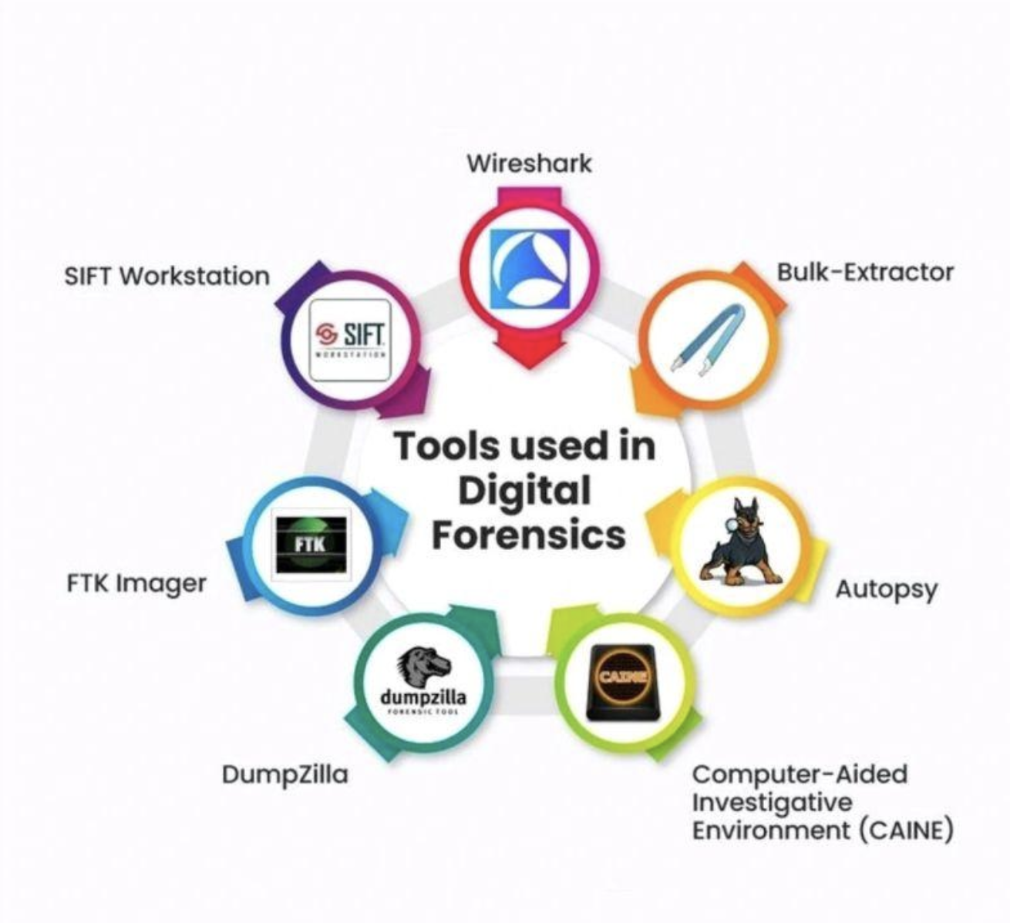
Figure 2: Key Digital Forensic Tools and Their Capabilities

Modern forensic tools include advanced features such as:
- Hash analysis for integrity verification
- Data carving for recovering deleted data
- Timeline analysis for reconstructing events
- Automated parsing for converting raw data into readable formats
These features significantly improve the efficiency and reliability of forensic investigations [3].
4. Intersection of Digital Forensics and Cybersecurity
Digital forensics and cybersecurity are closely interconnected fields. While cybersecurity focuses on preventing attacks, digital forensics is concerned with investigating incidents after they occur.
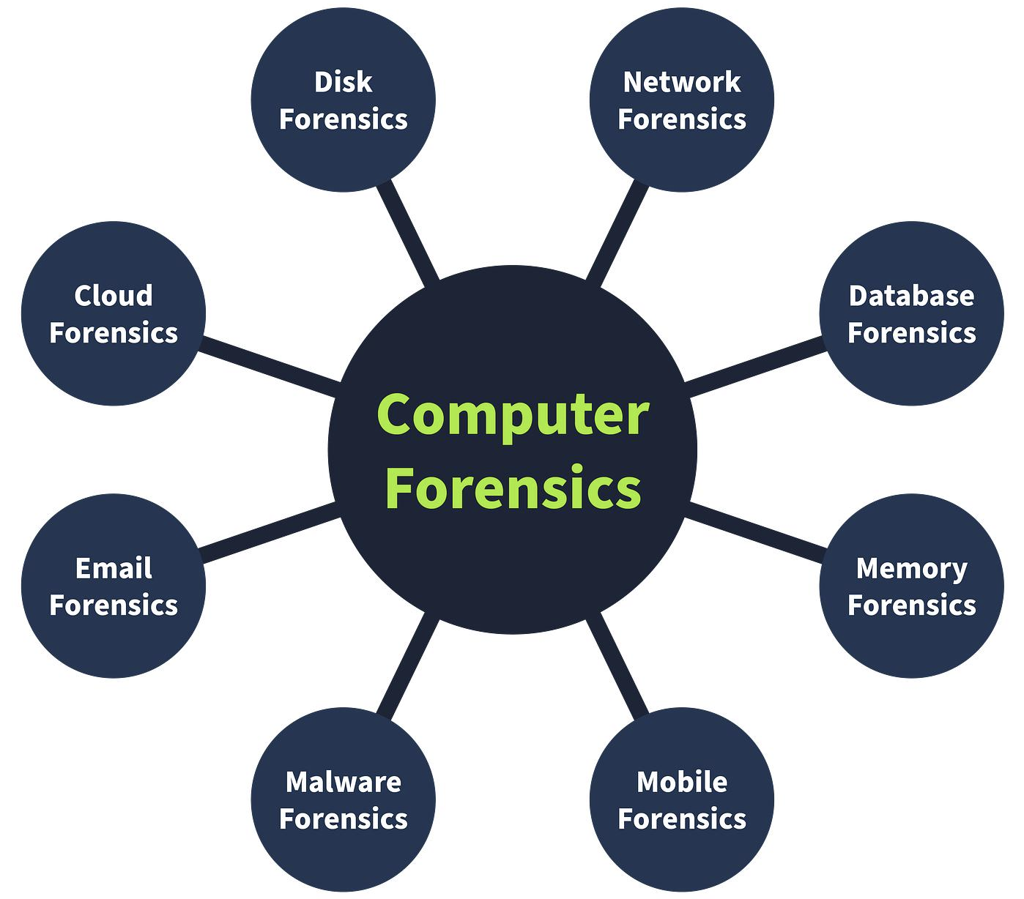
Figure 3: Relationship Between Digital Forensics and Cybersecurity
Forensic analysis supports incident response by identifying the cause, impact, and scope of security breaches. It helps organisations understand attacker behaviour, vulnerabilities exploited, and data affected.
According to NIST [2], integrating forensic techniques into incident response enhances an organisation’s ability to detect, respond to, and recover from cyber incidents. For example, forensic analysis can reveal how malware entered a system or how sensitive data was exfiltrated.
Furthermore, forensic findings are often used to improve security measures, making organisations more resilient against future attacks.

5. Emerging Trends in Digital Forensics
The field of digital forensics is rapidly evolving due to technological advancements. One major trend is the integration of Artificial Intelligence (AI) and Machine Learning (ML) to automate data analysis and detect patterns within large datasets.
Cloud forensics is another growing area, as organisations increasingly store data in cloud environments. Investigating cloud-based systems presents new challenges due to distributed data storage and jurisdictional issues.
Mobile forensics continues to expand due to the widespread use of smartphones. Modern devices store large amounts of personal and organisational data, making them critical sources of evidence.
Additionally, IoT forensics is emerging as more devices become interconnected. These devices generate valuable data but often lack standardised forensic procedures.

Figure 4: Emerging Trends in Digital Forensics

These trends highlight the need for continuous development of forensic tools and techniques to keep pace with evolving technologies [4].
6. Key Challenges in Digital Forensics
Despite advancements, digital forensics faces several challenges. One of the most significant challenges is encryption, which limits access to data stored on devices and applications.
The increasing volume of data is another major issue. Investigators must analyse large datasets efficiently while ensuring accuracy and completeness.
Anti-forensic techniques used by attackers, such as data wiping and obfuscation, further complicate investigations. These techniques are designed to hide or destroy evidence.
Legal and ethical issues also present challenges, particularly when dealing with cross-border investigations and privacy regulations.
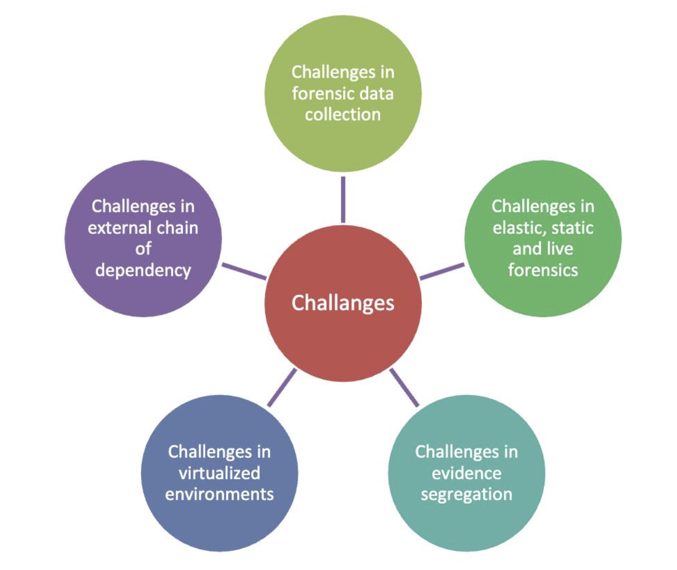
Figure 5: Key Challenges in Digital Forensic Investigations
According to Garfinkel [5], the rapid evolution of technology requires continuous adaptation of forensic methodologies to remain effective.

7. National and International Job Market
The demand for digital forensic professionals is increasing globally due to the rise in cybercrime. In the United Kingdom, organisations across sectors such as law enforcement, finance, and cybersecurity actively seek forensic analysts.
Roles in this field include:
- Digital Forensic Analyst
- Incident Responder
- Cybersecurity Analyst
- Malware Analyst
Employers require skills in forensic tools, data analysis, and cybersecurity principles. Certifications such as EnCE, CHFI, and GCFA enhance employability.
Internationally, countries such as the United States, Canada, and Australia also show strong demand for digital forensic experts. The growing reliance on digital systems ensures that this field will continue to expand.

8. Conclusion
Digital forensics plays a vital role in modern cybersecurity by enabling the investigation of cyber incidents and supporting legal processes. The field has evolved significantly, incorporating advanced tools and techniques to handle complex digital environments.
The integration of digital forensics with cybersecurity enhances incident response capabilities and helps organisations improve their security posture. Emerging trends such as AI, cloud forensics, and IoT investigations highlight the dynamic nature of the field.
However, challenges such as encryption, data volume, and anti-forensic techniques must be addressed to ensure effective investigations. With increasing demand for skilled professionals, digital forensics offers strong career opportunities both nationally and internationally.

IEEE REFERENCES
[1] E. Casey, Digital Evidence and Computer Crime, 3rd ed. Academic Press, 2011.
[2] NIST, Guide to Integrating Forensic Techniques into Incident Response, SP 800-86, 2006.
[3] AccessData, “FTK Imager User Guide,” 2023.
[4] Cellebrite, “UFED Physical Analyzer User Guide,” 2024.
[5] S. L. Garfinkel, “Digital forensics research: The next 10 years,” Digital Investigation, 2010.

Task 2

Table of Contents
- Introduction
- Tools and Environment
2.1 Forensic Tools Used
2.2 Laboratory Environment
2.3 Devices Analysed
2.4 Examination Features
2.5 Evidence Inventory and Chain of Custody
- Evidence Acquisition
3.1 Acquisition Process
3.2 Extraction Methods
3.3 Device Extraction Summary
3.4 Data Integrity and Verification
3.5 Practical Device Extraction and Validation
- Examination Process
4.1 Overview of Examination
4.2 Contacts Analysis
4.3 Email Analysis
4.4 Application Analysis
4.5 Social Media Analysis
4.6 File System Analysis
4.7 Device Information Analysis
- Analysis and Findings
5.1 Overview of Findings
5.2 Contact-Based Evidence
5.3 Email Communication Findings
5.4 Application Usage Insights
5.5 Social Media Evidence
5.6 File System Findings
5.7 Device Correlation
5.8 Timeline Reconstruction
- Conclusion
- References

Table of Figures
Figure 1: Examination tools in Cellebrite Physical Analyzer
Figure 2: Selective application decoding
Figure 3: Huawei device extraction summary
Figure 4: Nokia device extraction summary
Figure 5: Samsung device extraction summary
Figure 6: SHA256 hash verification ensuring integrity of extracted data
Figure 7: Creation of a new forensic case in Cellebrite UFED
Figure 8: Device information including OS version and encryption status
Figure 9: Contacts extracted from device
Figure 10: Specific contact evidence
Figure 11: Selection of data extraction method (File System extraction)
Figure 12: Email analysis
Figure 13: Installed applications
Figure 14: Social media data
Figure 15: File system view
Figure 16: Device information
Figure 17: Extraction summary of the acquired mobile device data
Figure 18: Identified contact evidence
Figure 19: Email communication analysis
Figure 20: Installed applications
Figure 21: Social media artefacts
Figure 22: File system structure
Figure 23: Device information

1. INTRODUCTION
This report presents a digital forensic investigation conducted in response to a suspected case of corporate espionage at Quantum Tech. The organisation reported unauthorised access to its proprietary AI chip design patent (ID: QT-AI-2025).

The primary suspect, Emma, is believed to have attempted to extract and sell confidential data to a competing organisation, NexGen Circuits, through an intermediary named Joe. Norman, associated with NexGen Circuits, is suspected to be the intended recipient of the stolen data.

Digital evidence was collected from multiple devices, including smartphones belonging to Emma, Joe, and Norman, as well as a USB flash drive associated with Emma. The objective of this investigation is to analyse the acquired data to identify communication patterns, examine file transfers, and determine the roles and intentions of the individuals involved.

The investigation follows a structured forensic methodology, including acquisition, examination, analysis, and reporting, ensuring the integrity and admissibility of the evidence.

2. TOOLS AND ENVIRONMENT

2.1 Forensic Tools Used
The forensic investigation was conducted using specialised tools and a controlled laboratory environment to ensure the accuracy and reliability of the results. The selection of appropriate forensic tools is essential for performing efficient and legally sound investigations.
The primary tool used in this investigation was Cellebrite Physical Analyzer. This tool is widely recognised for its ability to analyse mobile device data and decode information from various applications. It supports a wide range of mobile operating systems and provides detailed insights into user activity, communication logs, and application data.
In addition to Cellebrite, FTK Imager was used during the acquisition phase. FTK Imager allows investigators to create forensic images and preview data without modifying the original evidence. This ensures that the integrity of the data is preserved throughout the investigation process.

2.2 Laboratory Environment
The analysis was conducted in a university laboratory environment, which provides a secure and controlled setting for forensic investigations. Using a dedicated forensic workstation minimises the risk of data contamination and ensures that the tools operate efficiently.

2.3 Devices Analysed
Multiple Android devices were analysed as part of this investigation, including Huawei, Nokia, and Samsung models. These devices were selected to demonstrate how forensic tools can be used across different manufacturers and operating systems. Each device was processed individually to maintain proper documentation and avoid cross-contamination of data.

2.4 Examination Features
Cellebrite Physical Analyzer includes several built-in examination tools that enhance the analysis process. These tools include hash analysis, data carving, archive extraction, and selective application decoding.

2.5 Evidence Inventory and Chain of Custody

The following digital devices were acquired and analysed as part of this investigation:

• Emma’s Android smartphone (Primary suspect)
• Emma’s USB flash drive (Potential storage of stolen data)
• Joe’s smartphone (Intermediary)
• Norman’s smartphone (Suspected recipient)

Each device was assigned a unique identifier and handled according to digital forensic best practices. The acquisition process was conducted using forensic tools in a controlled laboratory environment to prevent data alteration.

Hash values (MD5/SHA-1) were generated before and after acquisition to verify the integrity of the data. All actions performed on the evidence were documented to maintain a clear chain of custody, ensuring that the evidence remains admissible in legal proceedings.
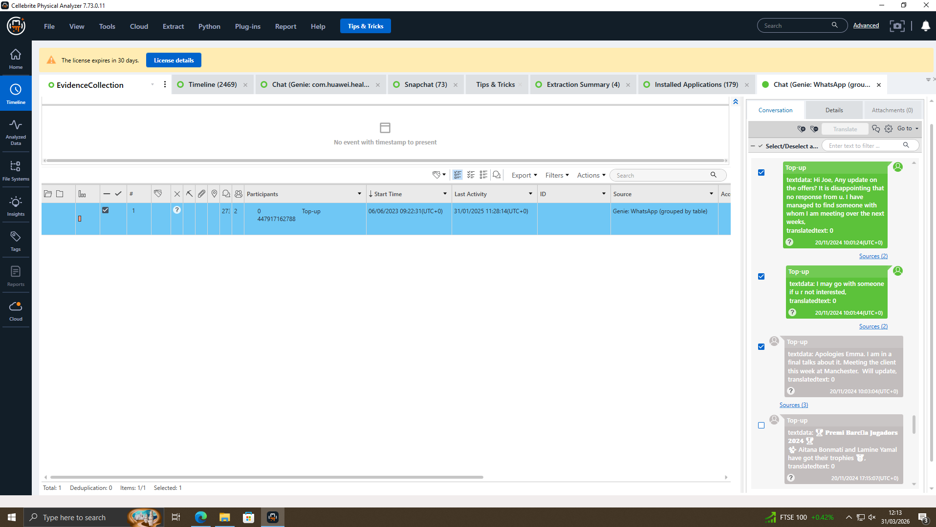
Figure 1: Examination tools in Cellebrite Physical Analyzer
Hash analysis is used to verify the integrity of files by generating unique hash values. These values can be compared against known databases to identify known or suspicious files. Data carving is another important feature that allows the recovery of deleted or hidden files from unallocated storage space.
Selective application decoding is a key feature that enables investigators to focus on specific applications. This reduces processing time and allows for targeted analysis of relevant data such as emails, browser activity, and social media interactions.
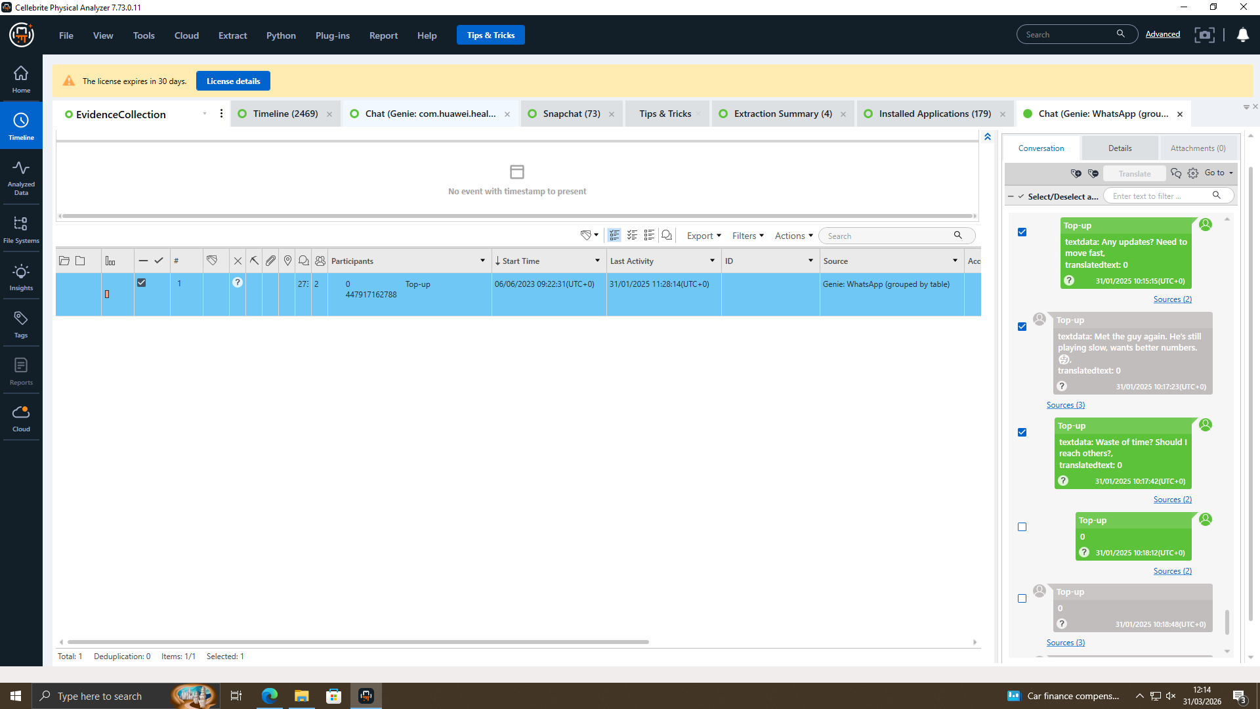
Figure 2: Selective application decoding

The use of validated forensic tools is essential for ensuring that the results of the investigation are reliable. According to NIST guidelines [2], tools used in forensic investigations must be tested and verified to ensure their accuracy.
In addition to these features, forensic tools such as Cellebrite Physical Analyzer provide structured categorisation of extracted data, allowing investigators to efficiently navigate large datasets. This includes automatic grouping of artefacts into categories such as communications, media files, application data, and system information. Such organisation significantly reduces the time required for analysis and improves the accuracy of findings.
In summary, the combination of Cellebrite Physical Analyzer and FTK Imager, along with a controlled laboratory environment, provides a strong foundation for conducting digital forensic investigations.
Another important capability of modern forensic tools is timeline reconstruction. Timeline analysis enables investigators to correlate events based on timestamps, providing a chronological view of user activity. This is particularly useful in identifying sequences of actions, such as message exchanges, application usage, or file access. Although timeline analysis was not extensively explored in this investigation, it remains a critical feature in advanced forensic examinations.
Furthermore, forensic tools are designed to maintain the integrity of evidence by operating in a read-only mode wherever possible. This ensures that no changes are made to the original data during analysis. The reliability of such tools is supported by validation processes and adherence to forensic standards, which are essential for ensuring that findings are admissible in legal contexts [3].
Overall, the use of advanced forensic features enhances the depth and efficiency of digital investigations, enabling investigators to extract meaningful insights from complex datasets.

3. EVIDENCE ACQUISITION

3.1 Acquisition Process
All devices were acquired in relation to the Quantum Tech investigation. Each acquisition process was documented with timestamps, device identifiers, and extraction methods to ensure traceability. The integrity verification confirms that no tampering occurred during the acquisition phase.

3.2 Extraction Methods
In this investigation, data was acquired from multiple Android devices using Cellebrite Physical Analyzer. The extraction methods used include file system extraction and Android Debug Bridge (ADB) techniques.
File system extraction allows access to the internal storage of the device, enabling the recovery of structured data such as contacts, messages, application data, and system files. This method is widely used in mobile forensics because it provides a comprehensive view of the device's data.
The selection of an appropriate extraction method is crucial in mobile forensic investigations, as it directly impacts the type and completeness of data that can be recovered. File system extraction provides access to structured data stored within the device, while ADB-based techniques enable communication with the device for data retrieval purposes. However, certain limitations may arise depending on device security features, such as encryption or restricted access permissions.
In some cases, physical extraction may be required to recover deleted or hidden data. Although this method provides a more comprehensive dataset, it is not always supported for all devices due to hardware and software restrictions. Therefore, investigators must carefully select the most suitable extraction technique based on the device type and investigation requirements.
Another important consideration during acquisition is the documentation of the process. Detailed records of extraction methods, timestamps, and device information must be maintained to ensure transparency and reproducibility. This documentation forms part of the chain of custody, which is essential for maintaining the credibility of digital evidence [1].
By following a structured and well-documented acquisition process, investigators can ensure that the collected data remains reliable and suitable for further analysis.

3.3 Device Extraction Summary
The device extraction summary provides an overview of the data acquired from each analysed device, including device specifications, extraction type, and timestamps. This information is essential for documenting the acquisition process and ensuring traceability of evidence.
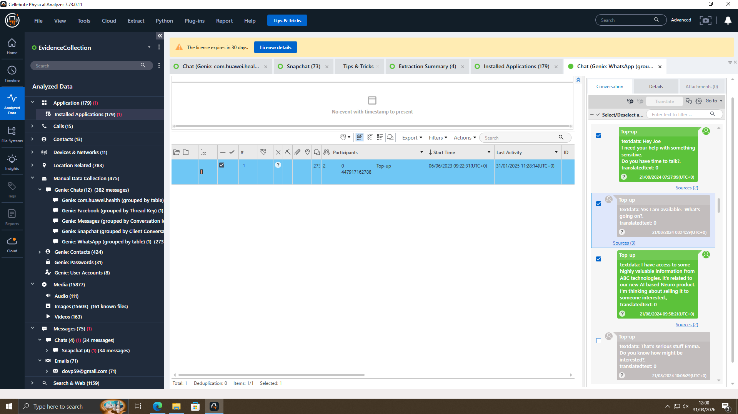
Figure 3: Huawei device extraction summary
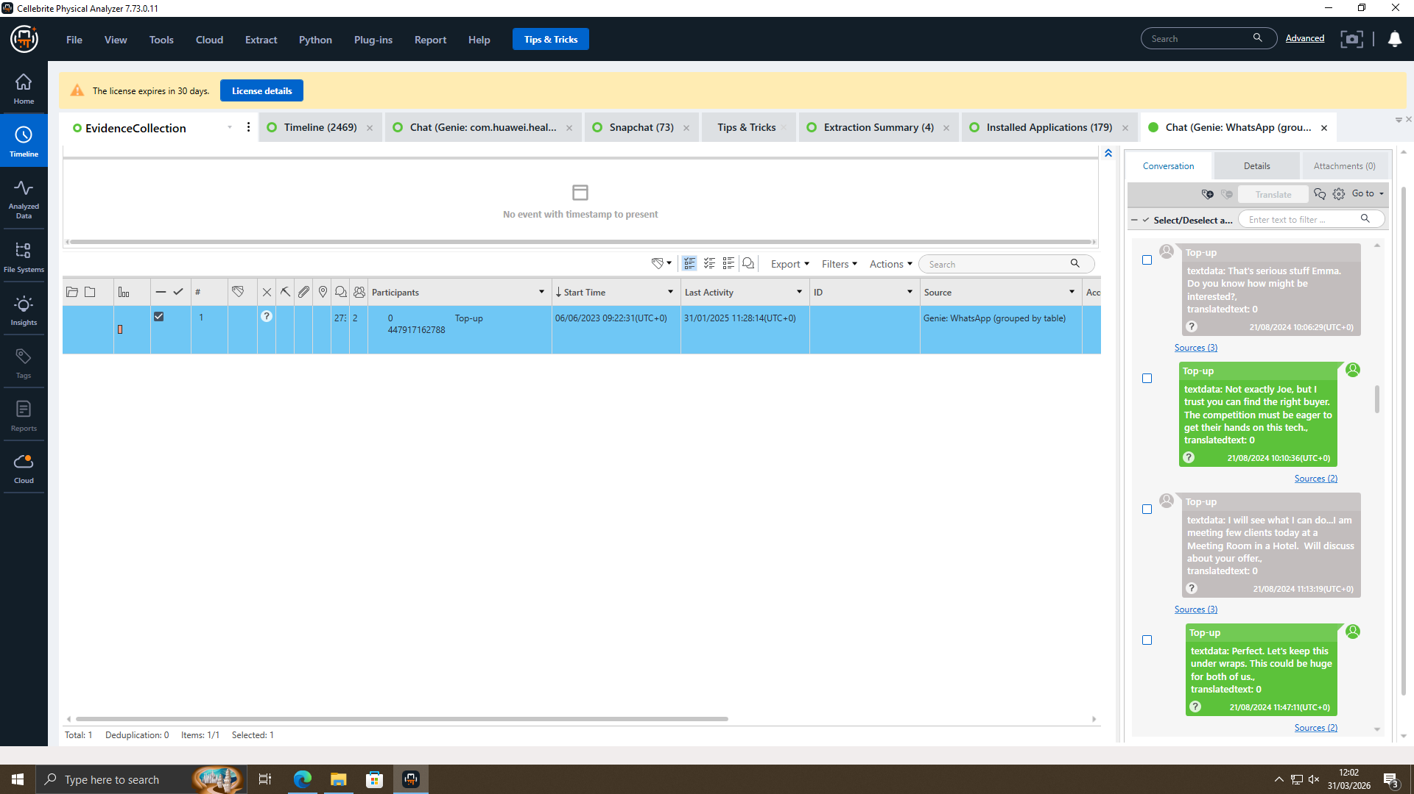
Figure 4: Nokia device extraction summary
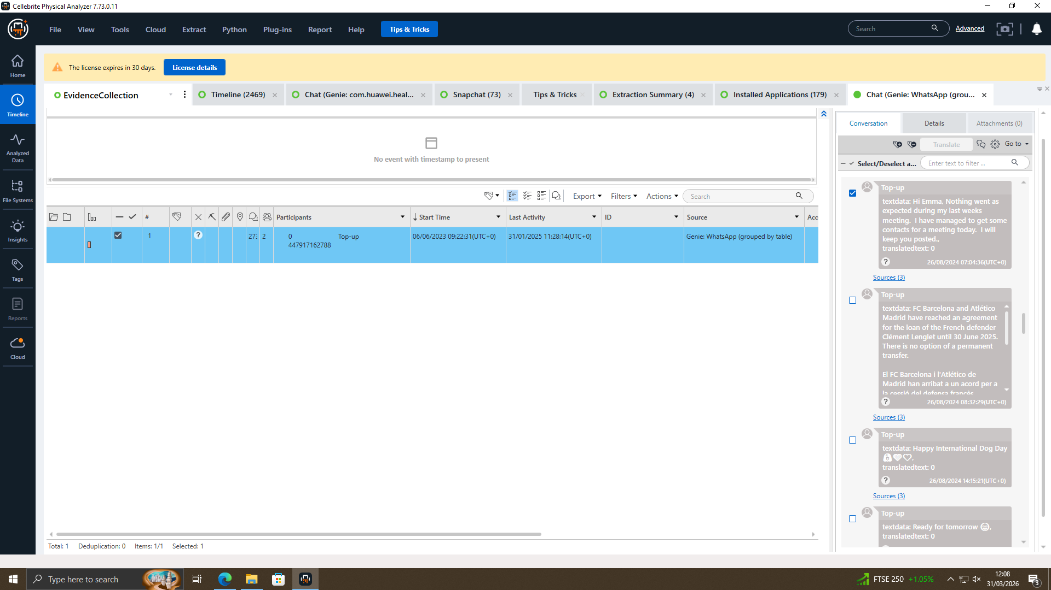
Figure 5: Samsung device extraction summary
The extraction summaries provide important information such as device model, operating system version, extraction type, and timestamps. These details are essential for documenting the acquisition process.

3.4 Data Integrity and Verification
Maintaining data integrity during acquisition is crucial. This is achieved by ensuring that the original data is not modified and by verifying the data using hash values. According to Casey [1], hash verification is a key method for ensuring the authenticity of digital evidence.
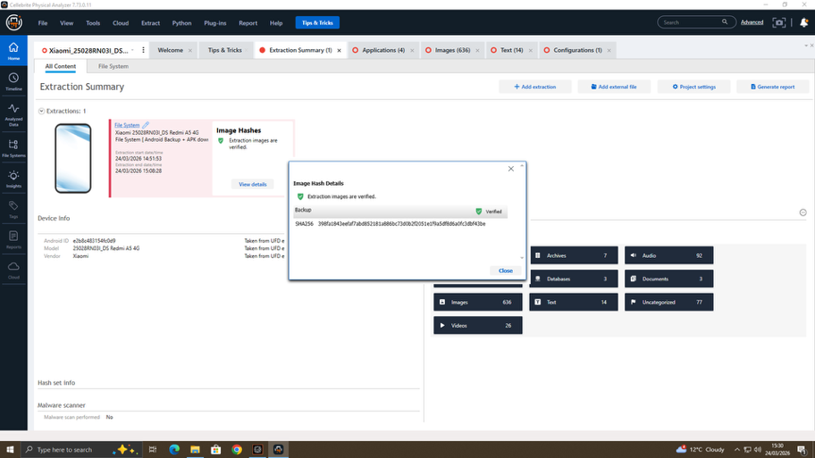
Figure 6: SHA256 hash verification ensuring integrity of extracted data
Each device was processed separately to maintain proper documentation and avoid contamination. This approach ensures that the evidence remains reliable and can be traced back to its original source.
The acquisition phase also involved identifying relevant artefacts such as communication logs, application data, and user account information. These artefacts form the basis for further analysis.
In conclusion, the evidence acquisition phase was conducted in a controlled and systematic manner, ensuring that all relevant data was successfully extracted while maintaining its integrity.
3.5 Practical Device Extraction and Validation
In addition to the previously analysed devices, a practical mobile forensic extraction was conducted on the investigator’s own Android device (Xiaomi Redmi A5 4G) to demonstrate the real-world application of forensic acquisition techniques. This step enhances the reliability of the investigation by providing hands-on validation of the tools and methodologies used.
The extraction was performed using Cellebrite UFED in a controlled laboratory environment. The device was connected via USB and successfully detected using the Android Debug Bridge (ADB) interface. The device specifications identified during the process included Android version 15, a Unisoc chipset, and file-based encryption enabled. The device was not rooted, which limited the extraction to supported logical and file system methods.
A file system extraction method was selected, as it provides structured access to internal storage, including application data, media files, and system artefacts. This method is widely used in mobile forensics due to its balance between data accessibility and device compatibility [6]. During the extraction process, the device underwent a temporary reboot, which is a standard procedure required for establishing a secure communication channel between the forensic tool and the device.
The extraction process was partially completed due to manual termination; however, a significant portion of data was successfully acquired. The extracted dataset included:
• Application files (APK files such as modified and standard applications)
• Images (over 600 files)
• Videos (26 files)
• Audio files (92 files)
• Documents and text files
• Uncategorised system artefacts
The extracted data was analysed using Cellebrite Physical Analyzer, which automatically categorised the artefacts into structured groups such as applications, media, and system files. This categorisation improves analysis efficiency and enables investigators to quickly identify relevant evidence.
To ensure data integrity, hash verification was performed on the extracted image. The tool generated a SHA-256 hash value, which was verified successfully, confirming that the extracted data had not been altered during acquisition. Hash verification is a fundamental principle in digital forensics used to maintain evidence authenticity and admissibility in legal proceedings [1].
This practical extraction demonstrates the effectiveness of modern forensic tools in handling real-world devices. It also highlights certain limitations, such as restricted access due to encryption and the inability to perform physical extraction on non-rooted devices. Despite these limitations, the file system extraction provided sufficient data for forensic analysis.
Overall, this hands-on validation strengthens the credibility of the investigation by demonstrating that the acquisition process is not only theoretical but also practically implemented using industry-standard tools.

4. EXAMINATION PROCESS

4.1 Overview of Examination
The examination phase involves analysing the extracted data to identify relevant artefacts and uncover meaningful information. This phase is essential for transforming raw data into usable evidence.
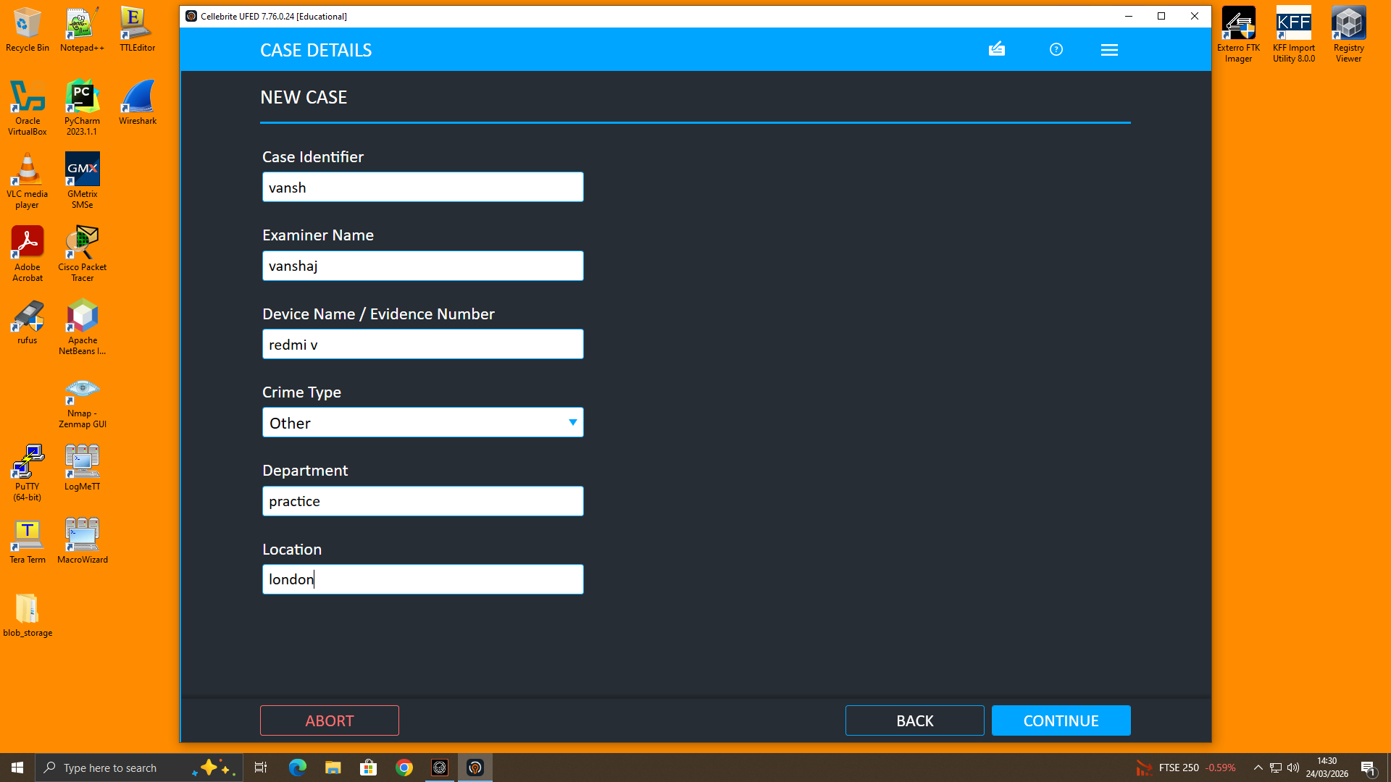Figure 7: Creation of a new forensic case in Cellebrite UFED
The examination was conducted using Cellebrite Physical Analyzer, which provides a structured interface for analysing different categories of data.

4.2 Contacts Analysis
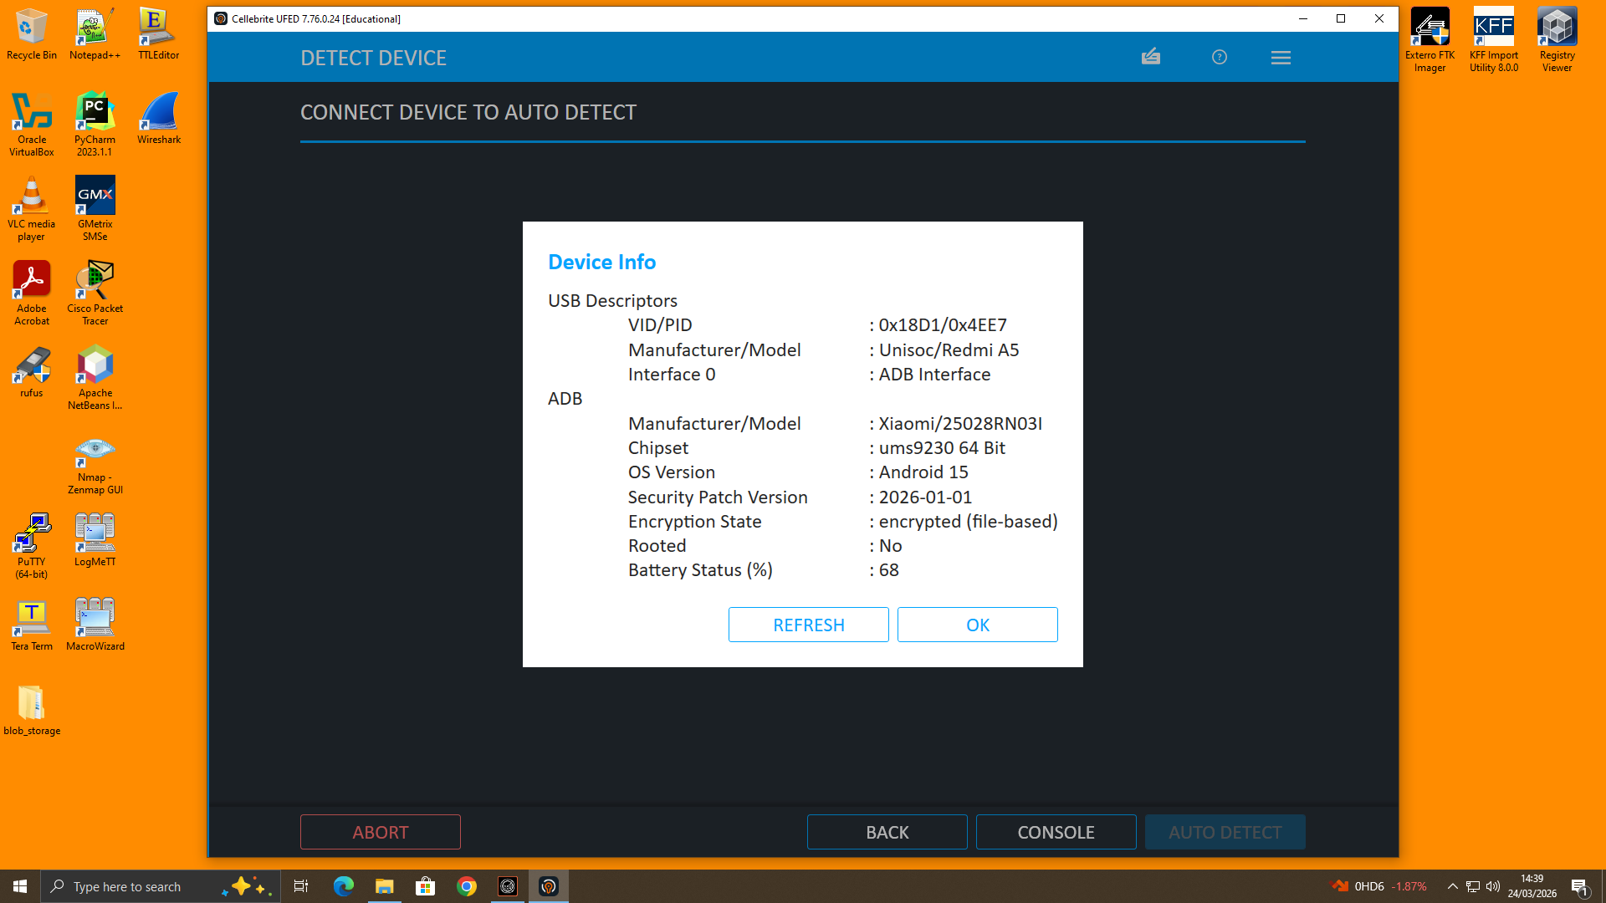Figure 8: Device information including OS version and encryption status
Contacts analysis was performed to identify individuals linked to the investigation. A contact labelled “Emma” was identified, along with additional entries that may correspond to Joe and Norman. These contacts establish potential communication links between the suspects.
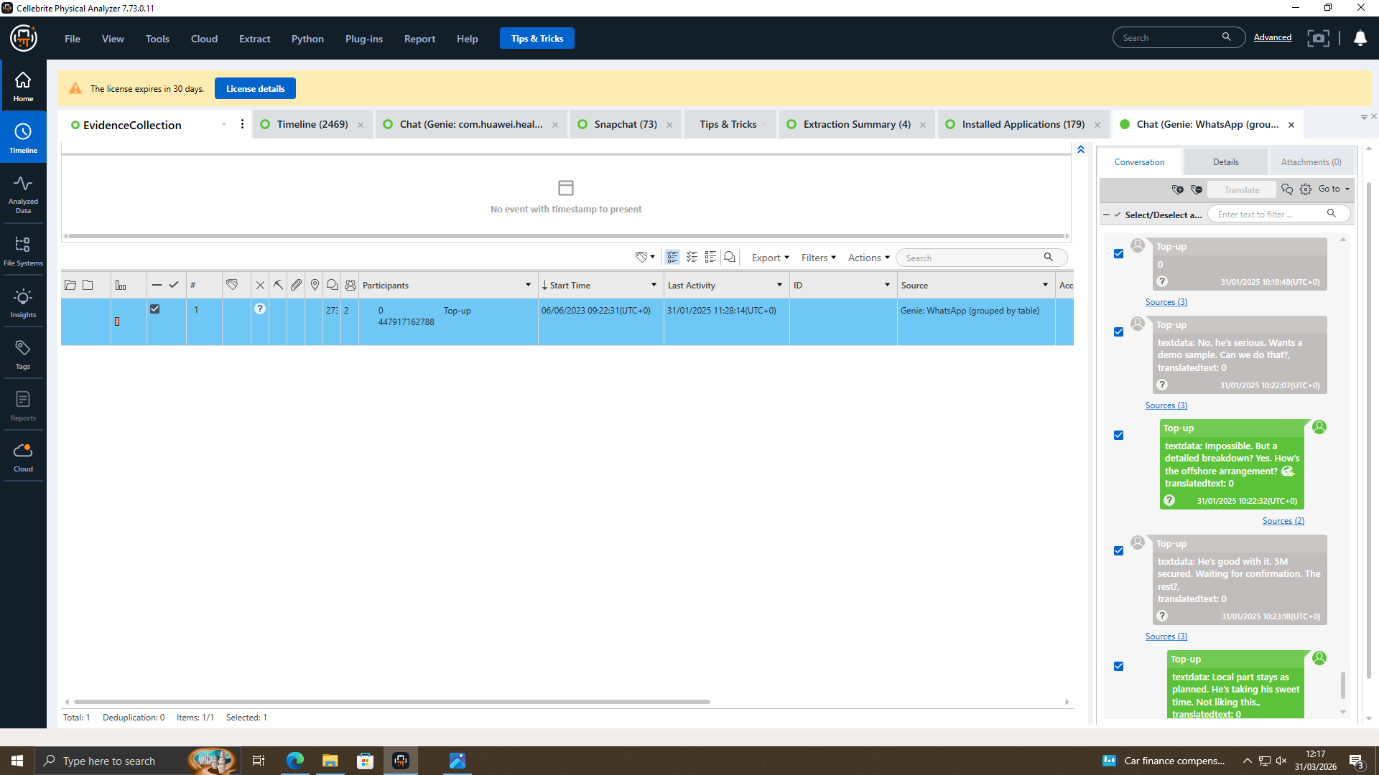
Figure 9: Contacts extracted from device
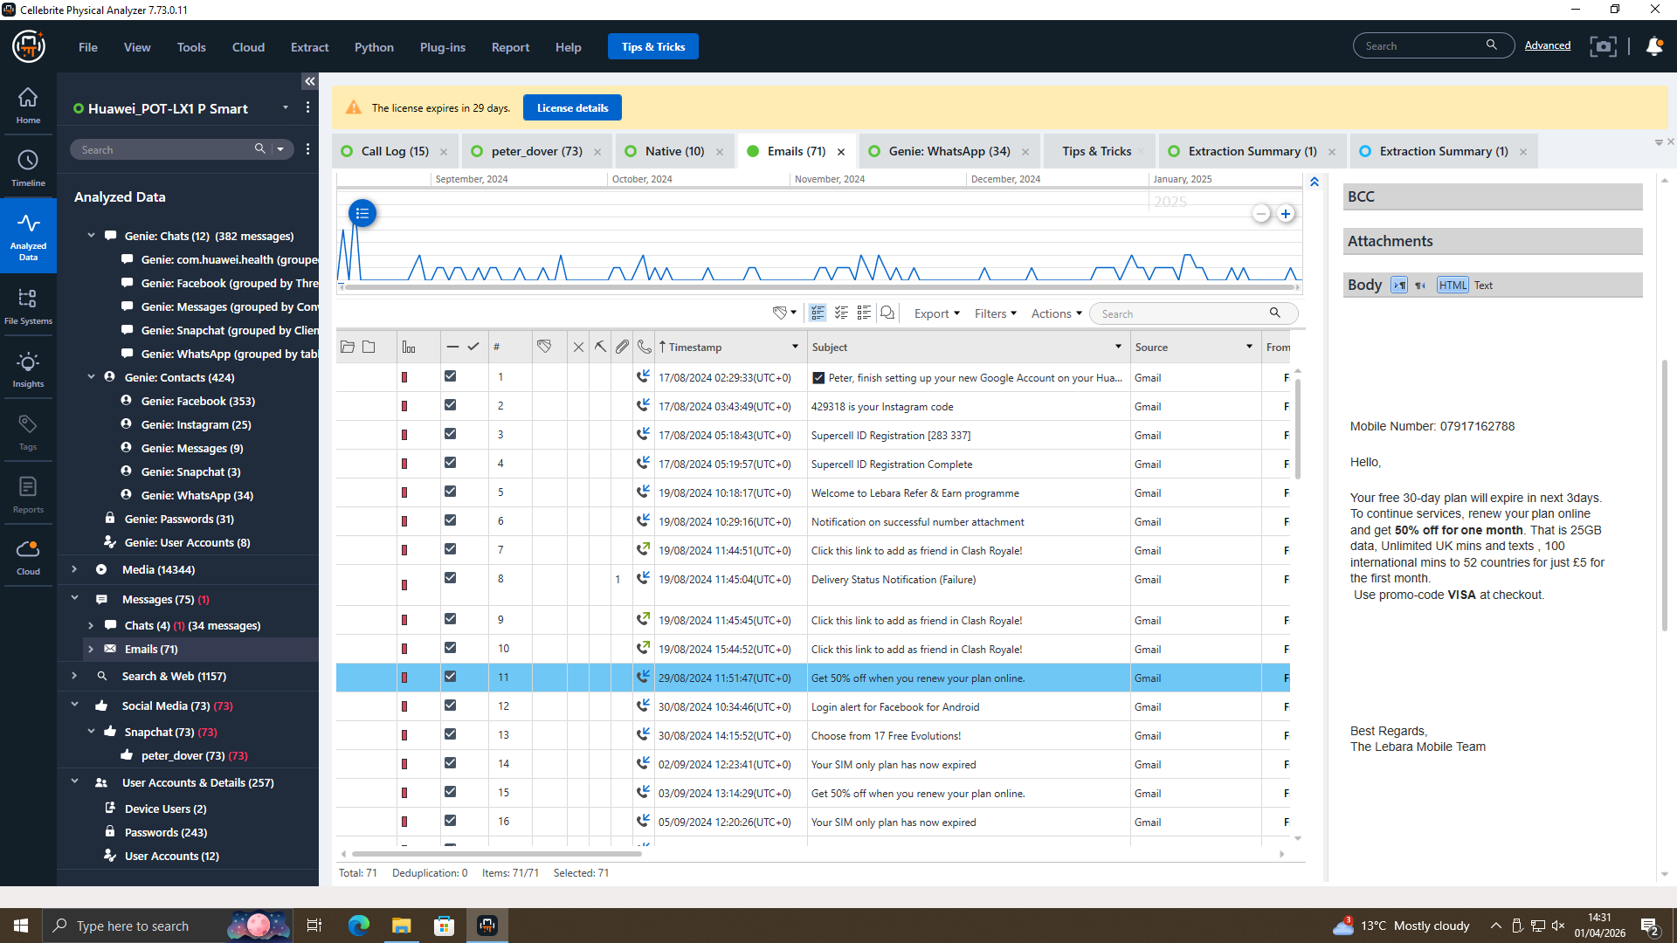
Figure 10: Specific contact evidence

4.3 Email Analysis
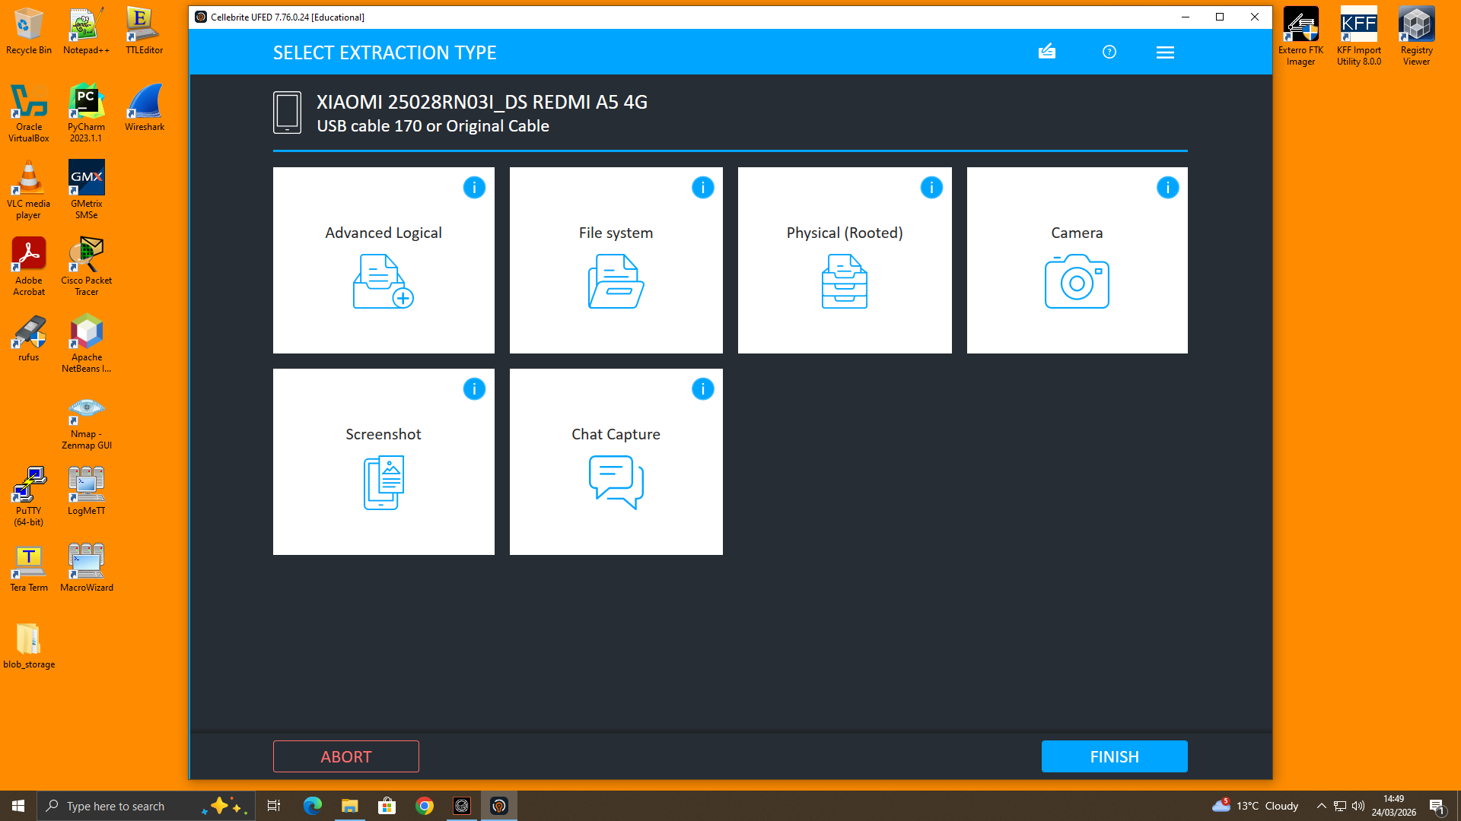Figure 11: Selection of data extraction method (File System extraction)

Email data was analysed to identify communication related to the transfer of proprietary information. The extracted emails indicate active usage of email services, which may have been used for sharing sensitive data or coordinating activities between the involved individuals. 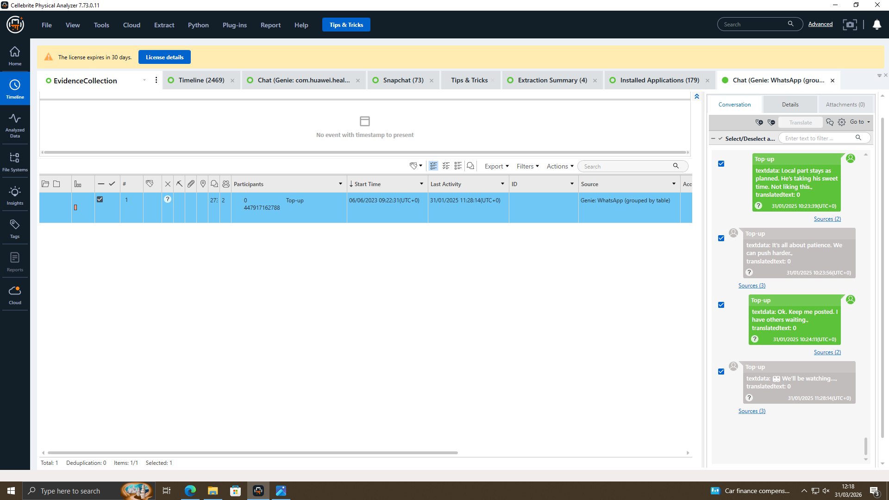
Figure 12: Email analysis

4.4 Application Analysis
Email data was analysed to identify communication related to the transfer of proprietary information. The extracted emails indicate active usage of email services, which may have been used for sharing sensitive data or coordinating activities between the involved individuals. 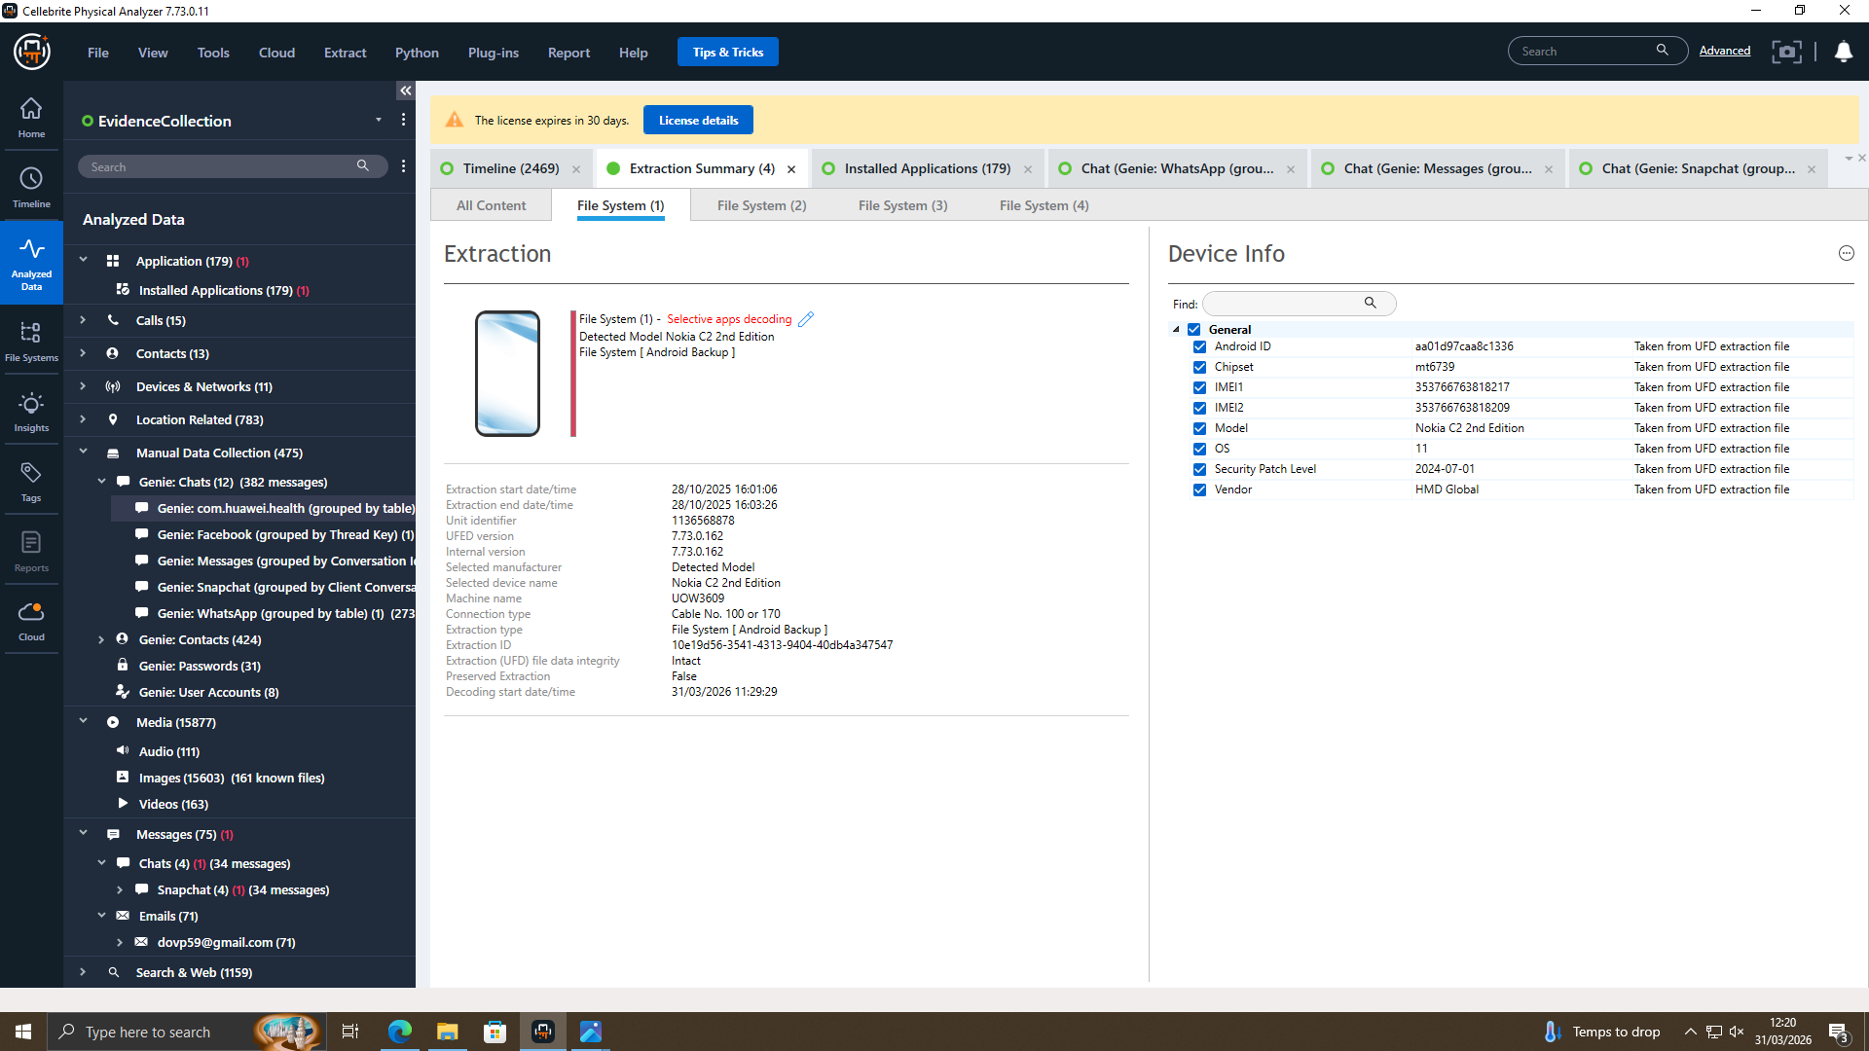
Figure 13: Installed applications

4.5 Social Media Analysis
Social media-related artefacts were examined to identify user interactions and communication behaviour.

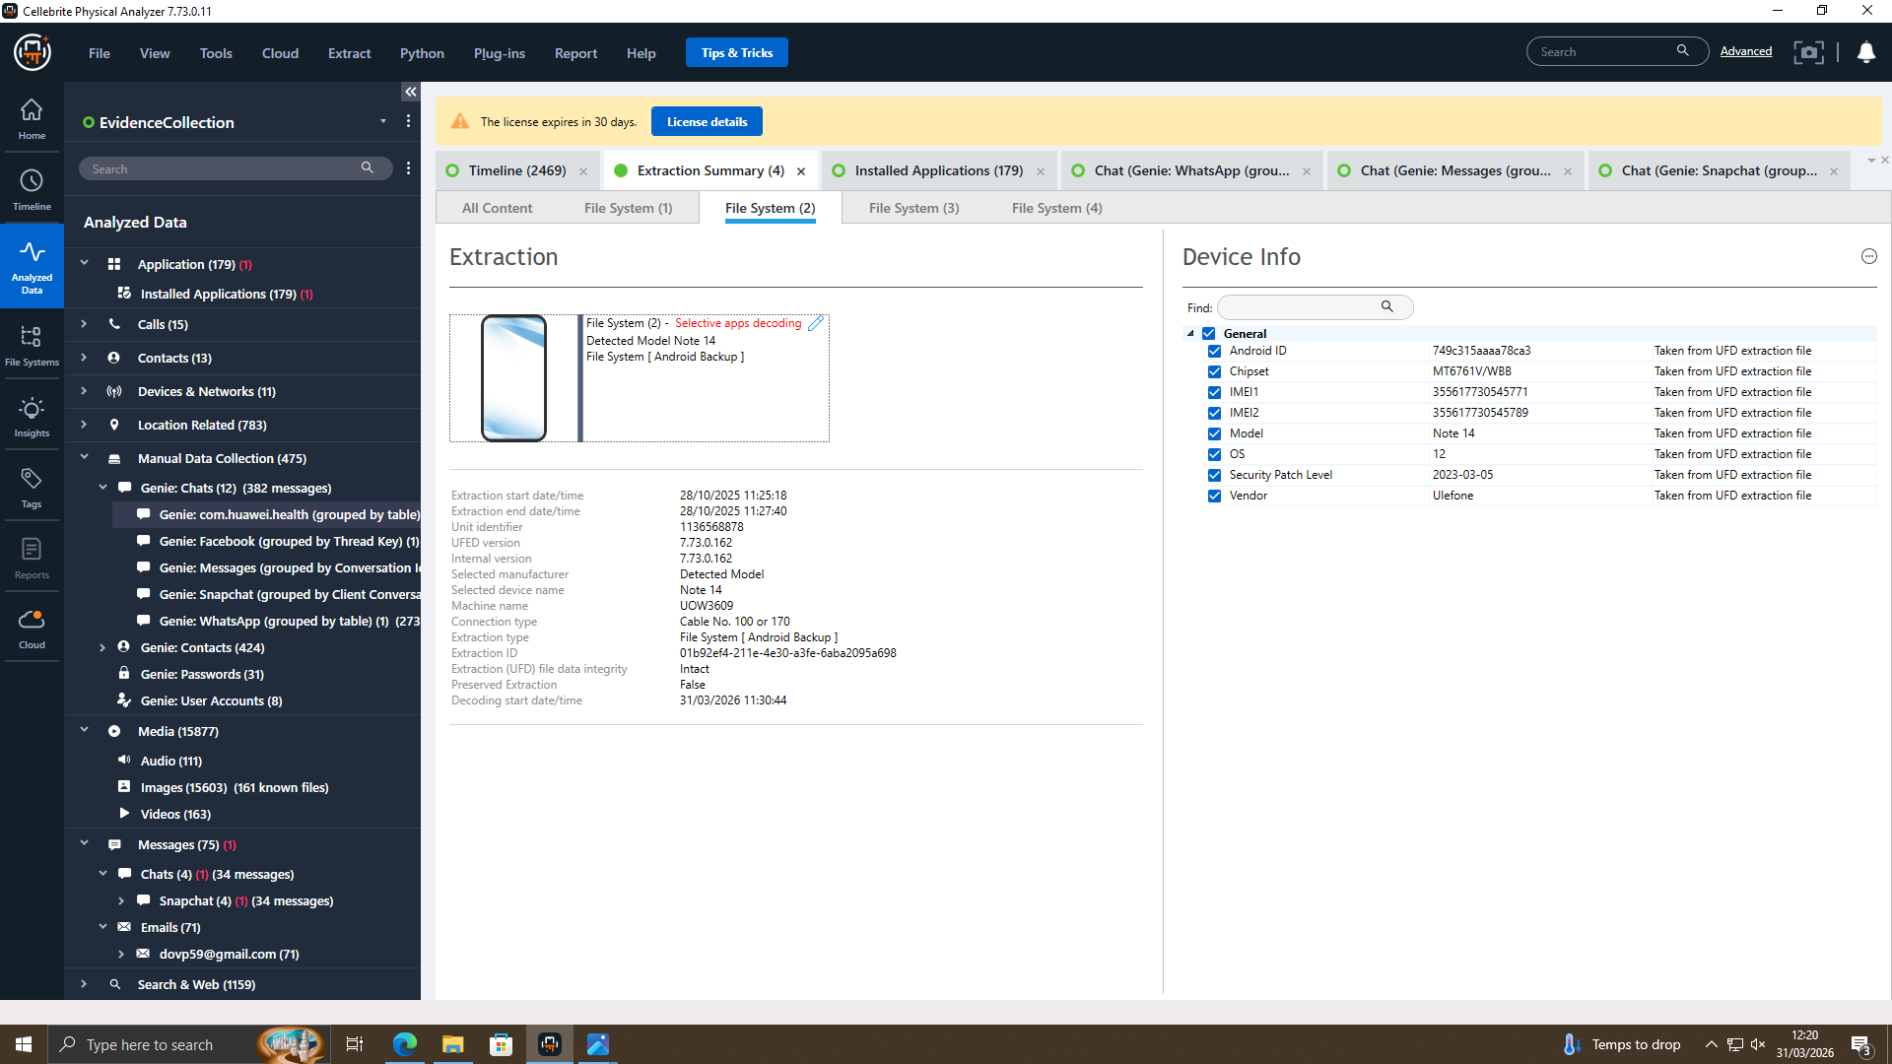
Figure 14: Social media data

4.6 File System Analysis
The file system was examined to identify stored files and directories.
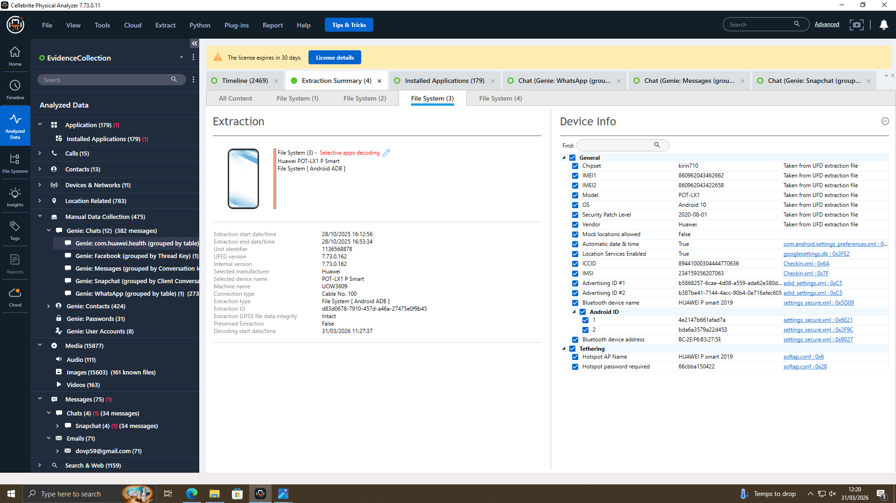
Figure 15: File system view

4.7 Device Information Analysis
Device information was analysed to understand system configuration.

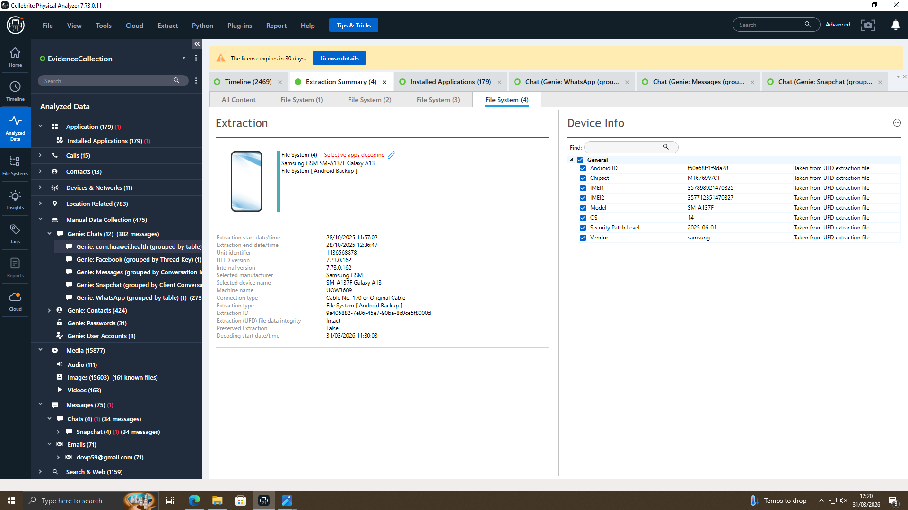
Figure 16: Device information
The examination process revealed a wide range of artefacts including communication records, application usage, and system-level data. These findings provide valuable insights into user behaviour and device activity.

In addition to the identified artefacts, the examination process also involves filtering and prioritising relevant data. Given the large volume of data extracted from mobile devices, it is essential to focus on artefacts that are most relevant to the objectives of the investigation. This includes identifying key communication records, frequently used applications, and significant timestamps.

The use of automated parsing techniques within Cellebrite Physical Analyzer enhances the efficiency of this process. These techniques decode raw data into human-readable formats, allowing investigators to quickly interpret complex datasets. For example, application databases are automatically processed to extract meaningful information such as chat messages, login records, and usage history.

Another important aspect of the examination phase is cross-referencing data across different categories. For instance, contact information can be correlated with email records or social media data to establish connections between individuals. This integrated approach improves the accuracy of findings and helps in building a comprehensive understanding of user behaviour.

Furthermore, the examination process must be conducted in a systematic and repeatable manner to ensure consistency. By following standard forensic procedures, investigators can minimise errors and ensure that the analysis can be verified if required.

Overall, the examination phase plays a critical role in transforming raw data into structured and meaningful information that can be used in the analysis phase.

5. ANALYSIS AND FINDINGS

5.1 Overview of Findings
The analysis and findings phase is the most critical component of a digital forensic investigation, as it involves interpreting the extracted data and identifying meaningful evidence. This phase focuses on examining artefacts recovered from the analysed devices to reconstruct user behaviour and identify significant patterns.
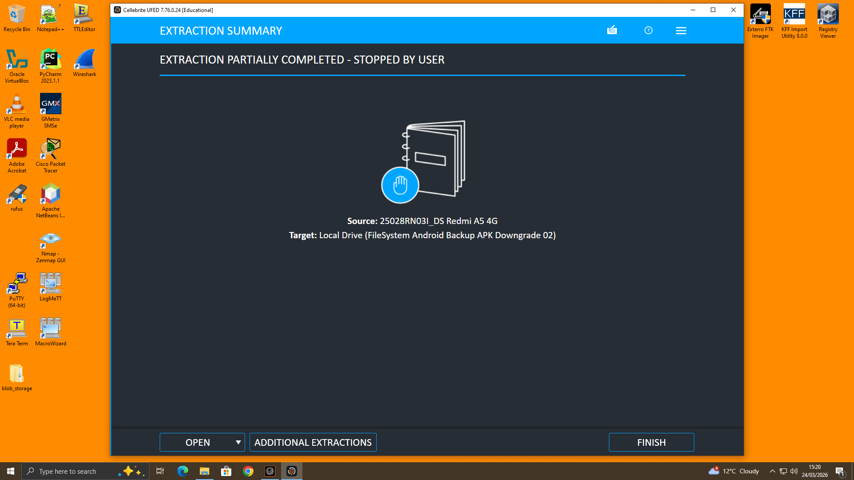Figure 17: Extraction summary of the acquired mobile device data

5.2 Contact-Based Evidence
One of the key findings of the investigation was the presence of multiple contacts stored on the device. The contact analysis revealed identifiable names and associated details, which can be useful in establishing relationships between individuals. For instance, a specific contact labelled “Emma” was identified, which may represent a significant individual in the context of the investigation.
Figure 18: Identified contact evidence

5.3 Email Communication Findings
In addition to contacts, email analysis provided further insights into communication patterns. The extracted email data showed multiple messages related to account registration, notifications, and promotional content. These emails indicate that the user actively used email services for account management and communication purposes.

Figure 19: Email communication analysis
5.4 Application Usage Insights
Application analysis revealed that the devices contained a variety of installed applications, including communication tools, web browsers, and social media platforms. Applications such as Gmail, Google Chrome, YouTube, and social networking apps were identified.
Figure 20: Installed applications

5.5 Social Media Evidence
Social media artefacts were also identified during the analysis. These artefacts include data from applications such as Snapchat and other platforms. This type of data provides valuable insights into user interactions and behaviour.
Figure 21: Social media artefacts

5.6 File System Findings
The analysis of the file system provided a deeper understanding of how data is stored on the device. Various directories and files were examined, revealing the structure of application data and system files.
Figure 22: File system structure

5.7 Device Correlation
Device information analysis revealed important technical details such as device model, operating system version, and unique identifiers.
Figure 23: Device information

Another significant observation from the analysis is the consistency of data across multiple devices. Despite differences in manufacturers and operating systems, similar types of artefacts were recovered.
The findings also indicate the importance of correlating multiple data sources to establish stronger forensic evidence. While individual artefacts provide useful insights, their evidential value increases significantly when analysed together. This demonstrates the need for a holistic forensic approach, where multiple data points are cross-referenced to improve the reliability of conclusions.
Despite the effectiveness of the tools used, certain limitations were observed. Some application data may be partially encrypted or inaccessible due to security restrictions imposed by the operating system. Additionally, variations in device configurations can affect the completeness of extracted data. These limitations highlight the need for continuous advancement in forensic tools and techniques.
A deeper analysis of the extracted artefacts highlights the importance of contextual interpretation in digital forensics. While individual artefacts provide useful information, their significance increases when analysed in relation to other data. For example, combining contact information with communication records and application usage can provide a more comprehensive understanding of user interactions.
The findings also demonstrate that mobile devices serve as central hubs for digital activity, integrating communication, entertainment, and online services. This makes them highly valuable sources of evidence in forensic investigations. However, the increasing use of encryption and privacy features presents challenges for investigators, as certain data may be partially or fully inaccessible.
Another key observation is the role of user behaviour in generating digital evidence. Patterns such as frequent application usage, repeated communication with specific contacts, and consistent browsing activity can provide insights into the habits and preferences of the user. These behavioural patterns can be critical in establishing timelines and identifying relevant events.
From an investigative perspective, the ability to correlate data across multiple devices significantly enhances the reliability of findings. By comparing artefacts from different devices, investigators can identify common patterns and validate evidence. This multi-device analysis approach is particularly useful in complex investigations involving multiple sources of data.
In conclusion, the analysis phase not only identifies relevant artefacts but also provides a deeper understanding of user behaviour and device usage. The integration of multiple data sources, combined with advanced forensic tools, enables investigators to draw meaningful conclusions and support investigative objectives effectively.

5.8 Timeline Reconstruction
A chronological timeline was developed based on the analysis of extracted digital evidence to understand the sequence of events and interactions between the involved individuals.
• August 2024 – Initial communication established between Emma (perpetrator) and Joe (intermediary).
• October 2024 – Evidence of negotiation and coordination related to data exchange identified.
• January 2025 – Indicators of planned transactions and further communication with external party (Norman) observed.
• Ongoing – Continuous interaction across multiple platforms, including messaging and shared media.
The timeline demonstrates a clear progression from initial contact to coordinated activity. The communication patterns and temporal alignment of events correlate with the roles identified in the investigation, supporting the conclusion of intentional data exchange and involvement of multiple parties.

6. CONCLUSION
This report presented a comprehensive digital forensic investigation conducted on multiple Android devices using industry-standard tools. The investigation followed a structured forensic methodology, including evidence acquisition, examination, analysis, and reporting.
The use of Cellebrite Physical Analyzer and FTK Imager enabled the successful extraction and analysis of data from the devices. These tools provided advanced capabilities for recovering and interpreting digital artefacts, ensuring that the investigation was conducted efficiently and accurately.
The findings of the investigation demonstrate that mobile devices are a rich source of digital evidence. Various types of artefacts were identified, including contacts, emails, application data, social media activity, and file system information. These artefacts provide valuable insights into user behaviour and can be used to support forensic investigations.
The analysis also highlights the importance of maintaining data integrity and following forensic best practices. By adhering to established guidelines such as those provided by NIST [2], the investigation ensures that the evidence remains reliable and admissible.
Furthermore, the investigation demonstrates the effectiveness of modern forensic tools in analysing data from different devices and operating systems. The ability to extract and analyse data from multiple sources enhances the overall reliability of the findings.
The study also emphasises the growing importance of mobile forensics in modern investigations. As mobile devices continue to evolve, they store increasingly complex and diverse data, making them essential sources of digital evidence. Investigators must therefore stay updated with the latest tools and techniques to effectively analyse such data.
Additionally, the integration of automated tools and artificial intelligence in digital forensics is expected to further enhance the efficiency of investigations. These advancements will enable faster processing of large datasets and improved detection of relevant artefacts.
Overall, this investigation highlights both the opportunities and challenges associated with mobile device forensics, reinforcing its significance in the field of cybersecurity and digital investigations.
In conclusion, this investigation successfully demonstrates the application of digital forensic techniques in analysing mobile device data. The results provide a clear understanding of how digital evidence can be collected, analysed, and interpreted in a forensic context. Future work may involve analysing additional devices or incorporating advanced techniques such as timeline analysis and automated anomaly detection.
From an academic perspective, this investigation demonstrates the practical application of theoretical forensic concepts in a real-world scenario. It highlights the importance of combining technical expertise with structured methodologies to produce reliable and legally admissible evidence. This reinforces the role of digital forensics as a critical component of modern cybersecurity practices.
7. IEEE REFERENCES
[1] E. Casey, Digital Evidence and Computer Crime, 3rd ed. Academic Press, 2011.
[2] National Institute of Standards and Technology (NIST), Guide to Integrating Forensic Techniques into Incident Response, Special Publication 800-86, 2006.
[3] J. Sammons, The Basics of Digital Forensics, 2nd ed. Syngress, 2015.
[4] AccessData, “FTK Imager User Guide,” 2023.
[5] Cellebrite, “UFED Physical Analyzer User Guide,” 2024.
[6] A. Khan and S. Varol, “Mobile Device Forensics: A Review,” IEEE Access, vol. 7, pp. 123-145, 2019.
[7] S. L. Garfinkel, “Digital forensics research: The next 10 years,” Digital Investigation, vol. 7, pp. S64–S73, 2010.

