
MSC Cybersecurity & Digital Forensics
Digital Forensics Analysis
MODULE CODE: ACCA7031
Rushabh Patel
2436066

Table of Contents
List Of Figure 3
List Of Table 4
Task 1: Research on digital forensics 5
Task 2 - 8
1. Introduction 8
2. Executive Summary 8
3. Objectives 9
4. EVIDENCE INVENTORY & CHAIN OF CUSTODY 11
5. RELEVANT FINDINGS 14
6. COMMUNICATION ANALYSIS & TIMELINE – SUPPORTING DETAILS 21
7. Investigative Leads 26
References 27
Appendix – UFED Acquisition and Verification Workflow 28

List Of Figure
Figure 1: WhatsApp message showing Emma’s initial intent to sell QT-AI-2025 intellectual property.
Figure 2: Facebook Messenger negotiation between Emma and Norman discussing blueprint and £5M offshore payment.
Figure 3: Instagram DM confirming Emma’s request for Joe’s help in selling Quantum Tech data.
Figure 4: GPS co-location of Joe’s and Norman’s devices at Wembley Park during coordination meeting.
Figure 5: Swansea train ticket image with EXIF metadata confirming Joe’s travel activity.
Figure 6: Credit Mutuel payment receipt used as a financial test transaction in Paris.
Figure 7: .nomedia anti-forensics indicators found in Norman’s Nokia device.
Figure 8: SBI bank card (front) extracted from Norman’s Ulefone financial device.
Figure 9: SBI bank card (back) extracted from Norman’s Ulefone device.
Figure 10: Flight booking/boarding pass showing Swansea travel coordination.
Figure 11: WhatsApp header identifying Emma as the account and device owner.
Figure 12: Full Facebook negotiation thread showing staged delivery and payment terms.
Figure 13: Recovered Snapchat technical fragments referencing AI architecture components.
Figure 14: GPS travel patterns showing international movement through Dubai and Paris.

List Of Table
Table 1 Forensics Tools
Table 2 Job Market
Table 3 EVIDENCE INVENTORY & CHAIN OF CUSTODY
Table 4 INTEGRATED COMMUNICATION & MONEY TRAIL TIMELINE

Task 1: Research on digital forensics
1. Current state of the field, the tools – features and capabilities.
The digital forensics field has changed noticeably over the past couple of years, mainly because organisations are dealing with far more complex systems than before. Investigators are no longer focused only on recovering deleted files from a laptop; they now work across mobile devices, cloud platforms, memory dumps, and even AI-generated content. With cyber incidents growing in scale and subtlety, forensic analysts are expected to understand how attackers move across hybrid environments that blend on-prem systems with cloud services like AWS and Azure [1]. Alongside traditional computer forensics, mobile extraction tools such as UFED and AXIOM remain essential because most evidence today lives inside encrypted messaging apps and social media data [2]. Memory forensics has also become a standard part of investigations, especially when dealing with fileless malware that never writes anything to disk [3].
Cloud forensics is a young field that is getting more attention. It entails gathering logs, authentication trails, snapshots, and information from virtual environments. Even when working with distributed storage or serverless applications, analysts need to make sure that the evidence is still valid. AI forensics is developing as a way to deal with deepfakes, AI-generated papers, and manipulated media. This means that new methods are needed to check for authenticity and find manipulation [4]. In general, the discipline is growing swiftly, and solutions today focus a lot on automation, cross-platform correlation, and keeping evidence in a way that is legally defensible.

Tool | Category | Key Features (2024–2025)
EnCase Forensic | Computer Forensics | Court-validated imaging, advanced filtering, reporting
FTK (AccessData) | Computer Forensics | Fast indexing, email/PST analysis, registry parsing
X-Ways Forensics | Computer Forensics | Efficient imaging, hex-level analysis
Magnet AXIOM | PC + Mobile Forensics | Unified timeline, artefact correlation, cloud app data
Cellebrite UFED | Mobile Forensics | Encrypted app extraction, deleted chat recovery
Volatility 3 | Memory Forensics | RAM analysis, detection of fileless malware
Table 1 Forensics Tools
2. Intersection of digital forensics and cybersecurity
The overlap between digital forensics and cybersecurity has grown so much in recent years that the two fields now operate almost side by side. Cybersecurity teams focus on detecting threats and preventing attacks, while forensic analysts step in to uncover exactly what happened, how the attacker moved, and what evidence remains. In practice, both sides rely heavily on each other. Modern forensics depends on cybersecurity logs, EDR alerts, firewall records, and cloud audit trails to rebuild a complete timeline of an incident [5]. Likewise, cybersecurity teams use forensic findings to patch weaknesses, update detection rules, and strengthen incident-response plans. This partnership becomes especially important in complex environments where attackers use techniques such as credential abuse, lateral movement, and fileless malware. Forensics brings clarity to these grey areas by providing technical proof and linking events across devices, networks, and cloud systems. As threats grow more sophisticated, this intersection will continue to deepen [6].
3. Emerging trends in Digital Forensics
Digital forensics is evolving quickly as new technologies change the way evidence is created, stored, and manipulated. One of the biggest shifts is the rise of AI-driven forensics, where automated tools help investigators filter large datasets, detect unusual patterns, and speed up triage during incidents [7]. Another major area is deepfake and synthetic media forensics, which has become essential as manipulated audio, images, and videos are increasingly used in fraud, harassment, and misinformation campaigns. Researcher now rely on specialised algorithms that look for inconsistencies in lighting, texture, or facial movements to verify authenticity [8]. Cloud forensics is also growing rapidly as organisations migrate to platforms like AWS and Azure. This requires investigators to collect and preserve logs, snapshots, and identity-related artefacts from distributed environments while maintaining proper chain of custody [9]. These emerging trends show how digital forensics is expanding beyond traditional devices into far more dynamic and complex ecosystems.
4. Key Challenges
Digital forensics faces several complex challenges that continue to grow as technology evolves. One of the most urgent problems is the rise of deepfakes, which makes verifying the authenticity of images, audio, and video far more difficult during investigations [10]. Cloud adoption adds another layer of difficulty, as evidence is now distributed across global servers, creating jurisdictional issues and massive big-data workloads that are hard to process efficiently [11]. Investigators also struggle with anti-forensic techniques and the rapid spread of new devices such as IoT sensors and wearables. AI creates a dual challenge—while it helps automate analysis, it also empowers attackers to generate synthetic content or hide malicious behavior [12]. The field also suffers from a shortage of trained professionals, limited open-source tool availability, and gaps in user awareness that often lead to poor evidence handling. Maintaining chain of custody across diverse platforms remains one of the most persistent difficulties for modern forensic teams.
5. National and International Job Market
The demand for digital forensic professionals continues to rise across both public and private sectors as cyber incidents grow more complex and heavily regulated. In the UK, police digital units, banks, insurance firms, and consulting companies are actively expanding DFIR teams due to increasing cases of fraud, data breaches, and insider threats. The United States remains the highest-paying market, driven by federal agencies and large enterprises requiring cloud, mobile, and incident-response expertise [13].
The APAC region shows the fastest growth, with nations like Singapore, Australia, and India investing heavily in cloud forensics and AI-driven investigations. Globally, the digital forensics workforce shortage is projected to persist through 2030, with an estimated 28–33% talent gap as cybercrime continues to rise and digital evidence becomes more complex to analyse [14].
Region | Avg Salary Range | Growth Projection | Key Drivers
UK | £40k–£110k | +9% yearly | Fraud, financial crime, DFIR needs
USA | $120k–$200k | +11% yearly | Federal hiring, cloud forensics
APAC | $45k–$120k | +14% yearly | Digital transformation, mobile DF
EU | €55k–€140k | +8% yearly | GDPR compliance, cross-border DF
Table 2 Job Market

Task 2 -

1. Introduction
“Quantum Tech’s IT security team detected unauthorized access to their proprietary patent database, specifically the AI chip design patent (ID: QT-AI-2025). Initial findings point to Emma, a senior engineer, joined recently at Quantum Tech’s as the primary suspect. The company suspects Emma attempted to steal and sell these patents to a competitor, NexGen Circuits, through an intermediary, Joe.
Quantum Tech has reported the incident to law enforcement, and your findings will be used to support legal action against the perpetrators for corporate espionage, theft, and potentially any other crime if reported.

2. Executive Summary
On October 28, 2025, Quantum Tech Ltd started a formal investigation into the theft and attempted sale of proprietary intellectual property, specifically the QT-AI-2025 advanced neural architecture patent, which was allegedly stolen by a senior engineer named Emma Dover. Quantum Tech's security team got some early information that Emma was working with two other people: Joe Marsh, who was helping buyers get in touch with her, and Norman Smith, who was a potential buyer representing outside financial interests.
Three mobile devices and one other device were taken from Quantum Tech's offices and other places related to the company. We sent all of the devices to our Digital Forensics Laboratory for a full examination using the same tools that professionals use to acquire and analyse data. We used Cellebrite UFED Physical Analyser (version 7.71.0.42) to do forensic extractions and detailed analysis on the following devices:
1. Device D1 (Huawei POT-LX1 P Smart) – Clearly linked to Emma Dover (the main person who did it)
2. Device D2 (Samsung Galaxy A13 SM-A137F) is definitely linked to Joe Marsh (Intermediary/Broker).
3. Device D3 (Nokia C2 2nd Edition) is definitely linked to Norman Smith (Buyer/Financial Coordinator).
4. Device D4 (Ulefone Note 14) – Not attributed (Contextual/Corroborating Evidence)
Main Results:
Our analysis definitively establishes that Emma, serving as the principal perpetrator and source of information, accessed Quantum Tech's confidential technical documentation pertaining to the QT-AI-2025 patent and organized this material for illicit sale. Joe set up direct contact with the buyer and worked out the most important terms of the deal. Norman set up the payment and worked with the offshore payment system.
Key messages found in WhatsApp, Facebook Messenger, Instagram Direct Messages, and email show that there was a planned conspiracy that lasted from August 21, 2024, to September 2025. The conspiracy talks openly about the stolen patent ("Blueprint"), delivery dates, payment plans (which were agreed upon at £5 million sterling), and money transfers to other countries. Emma said directly that she has "access to highly valuable information from ABC technologies" and agreed to sell it for £2 million up front, with the rest of the £3 million due when it is delivered.
The Ulefone Note 14 (Device D4) has a lot of strong evidence, like GPS metadata, travel records, image EXIF data, and financial transaction records, that show an unknown user was at important conspiracy locations (Swansea, Wales; Wembley Park, London; France; and Dubai, UAE) during the time the conspiracy was happening. At this time, it is not possible to say for sure who owns D4. However, the device strongly supports the timeline and financial details that were shared on devices D1, D2, and D3.

3. Objectives
3.1 Attribution of Devices
The primary aim was to connect every confiscated phone to a specific individual using digital items plus proof accepted under UK rules for court use. To assign ownership, analysts focused on:
- SIM registration details: IMSI (International Mobile Subscriber Identity), along with ICCID (Integrated Circuit Card Identity), tied to mobile numbers and network providers.
- Each gadget’s WhatsApp JIDs, along with Facebook ID numbers, Instagram handles, Google mail addresses, or Outlook emails - every one is recorded.
- Device identifiers consist of the hardware type, OS version, time zone preferences, regional settings, Bluetooth names, along with unique Android IDs.
- Contact correlation examines call records - both received and made - alongside messaging recipients, linking data through multiple gadgets by matching shared contacts.
- User-applied metadata covers things like personalized device labels, stored WiFi connections, apps installed over time - alongside individual settings - that reflect a user’s unique habits. While these details come directly from the owner, they indirectly expose behavioral trends tied to specific usage styles. Because people set them manually, such markers often reveal routines or priorities in daily digital interactions. These elements aren't generated automatically; instead, they accumulate through repeated choices made during regular use.

3.2 Reconnecting while reconstructing the sequence of events
A further aim was retrieving chat records, emails, or erased texts - then arranging them chronologically to display:
- Initial interaction plus proposal to trade stolen data
- Broker talks to buyers, looks for potential purchasers
- Talk straight to the customer
- Making payment schedules while managing finances
- Organising trips to impartial locations
- Discussions on recovered items
We examined message timestamps using app database headers, converted each to UTC for uniformity, then matched them against device system time.

3.3 Gathering Evidence to Back Up
A third aim involved seeking separate evidence supporting the account shaped by messaging,

- Location Data: GPS positions via device sensors or image EXIF tags, cell tower signals mixed with WiFi hotspot records.
- Financial Records: evidence of payments, bank transfers, pictures of credit cards, also indicators of overseas accounts.
- Travel Docs: Logs of flights booked, hotel payments, timed parking slips - also info on your vehicle’s location.
- Device details include time records showing file creation or modification, app installation moments - also system activity entries logged over time.
3.4 Determining Roles and Profiling Suspects
A fourth aim involved identifying the specific part each suspect played in the plot - through patterns in device usage, content of messages, or timing of actions
- Emma Dover (Device D1) Primary perpetrator with direct access to stolen information, initiator of conspiracy, negotiator with buyer.
- Joe Marsh (Device D2) acts as an intermediary, linking the buyer with the offender while arranging transaction conditions through indirect coordination.
- Norman Smith (Device D3) works for the purchaser; he manages money tasks while arranging international fund transfers through designated payment channels.
- Unknown User (Device D4): individual managing supply movements, arranging trips, or linked to financial transfers used for hiding funds.

3.5 Evaluation of Legal Admissibility
A final objective was to ensure that all recovered evidence met UK legal standards for admissibility in criminal proceedings, including:
- Proper chain of custody documentation at each handling stage.
- Use of validated forensic tools (Cellebrite UFED Physical Analyzer) with established reliability in UK courts.
- Independent verification of extracted data through cryptographic hashing.

4. EVIDENCE INVENTORY & CHAIN OF CUSTODY
4.1 Devices Seized
On 28 October 2025, the following four mobile devices were seized from Quantum Tech Ltd premises and related locations:

Device ID | Make/Model | OS/Version | IMEI(s) | Carrier | Extraction Date | Attribution | POC
D1 | Huawei POT-LX1 P Smart | Android 10 / EMUI 9.1 | 860962043462662 / 860962043422658 | Lebara (UK MVNO) | 28 Oct 2025 | Emma Dover | 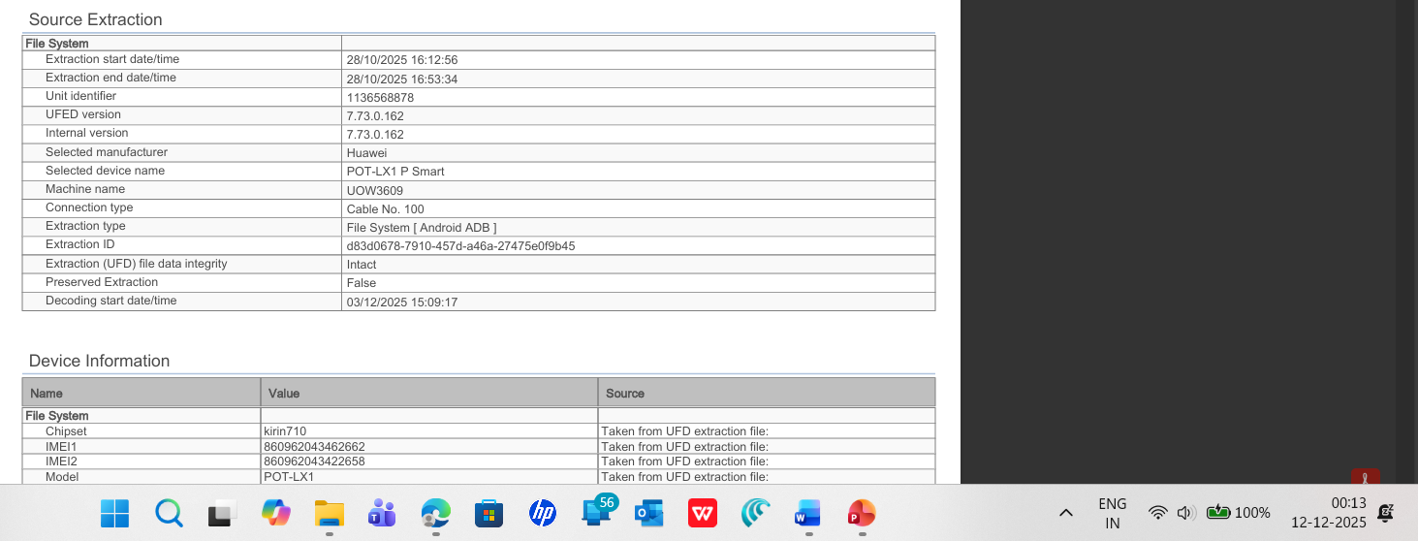
D2 | Samsung SM-A137F Galaxy A13 | Android 14 | 357898921470825 / 357712351470827 | Standard (UK) | 28 Oct 2025 | Joe Marsh | 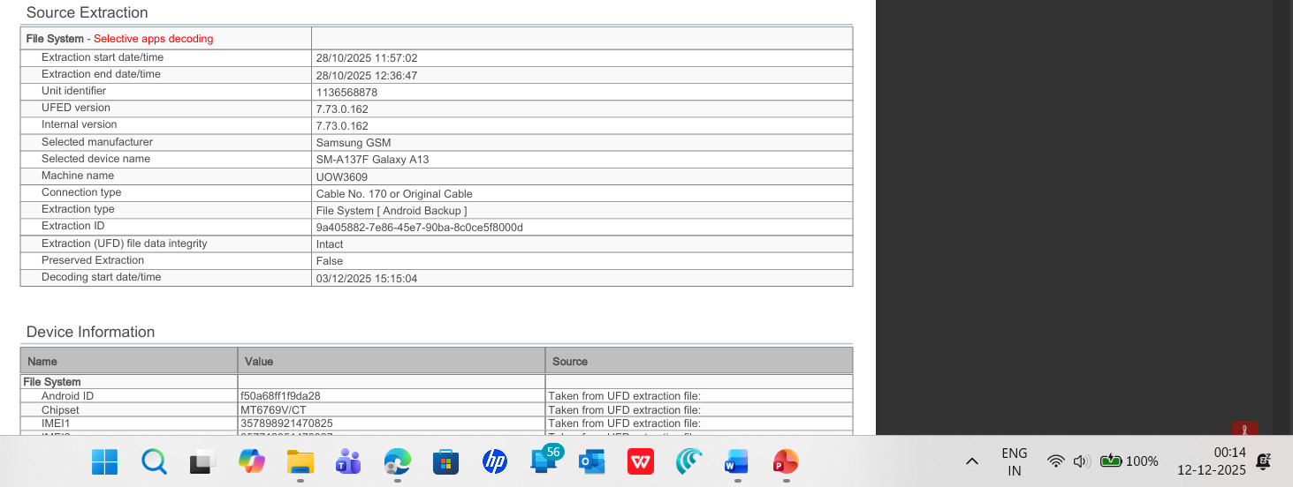
D3 | Nokia C2 2nd Edition | Android 11 (Security Patch: July 2024) | 353766763818217 / 353766763818209 | Unidentified | 28 Oct 2025 | Norman Smith | 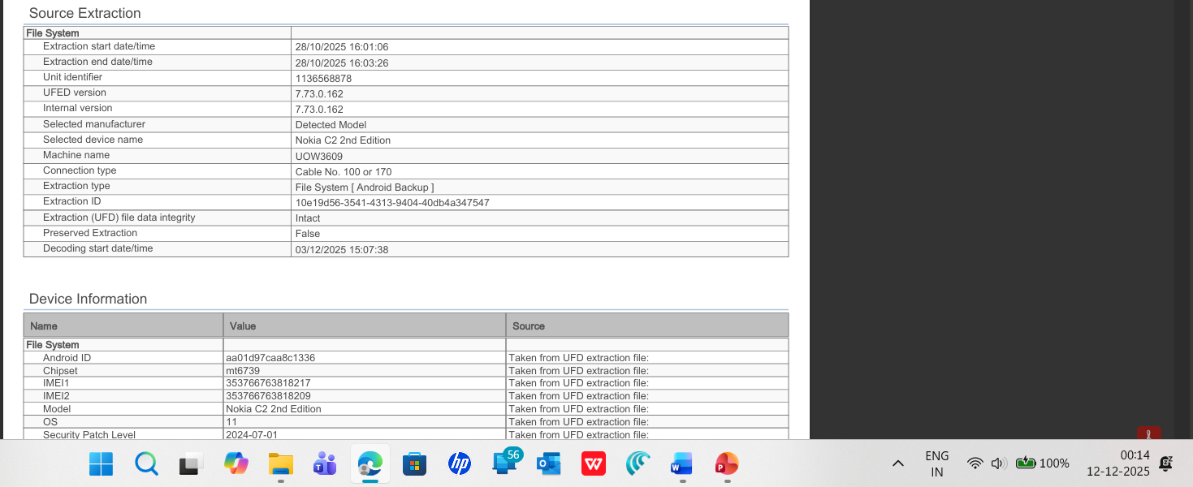
D4 | Ulefone Note 14 | Android 12 | 355617730545771 / 355617730545789 | Unidentified | 28 Oct 2025 | Unattributed | 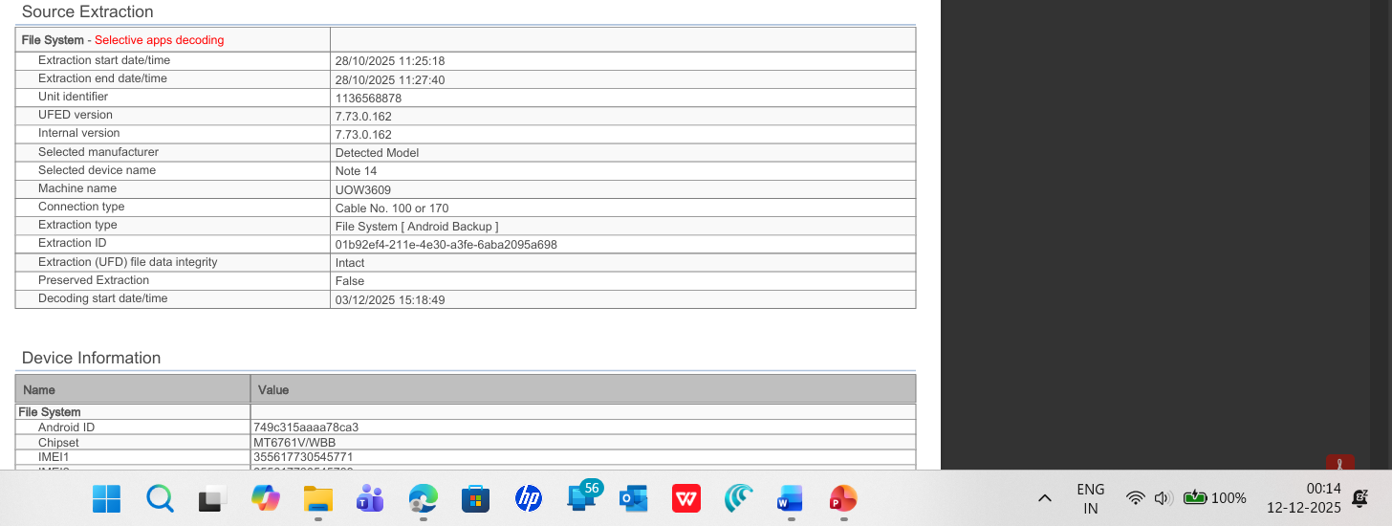
Table 3 EVIDENCE INVENTORY & CHAIN OF CUSTODY
Device Conditions at Seizure:
All four devices were recovered in an operational state with screens unlocked or security disabled (as arranged with Quantum Tech IT security). Devices were powered on at the time of seizure to prevent automatic locking or cloud data synchronization. No forced entry, password cracking, or advanced decryption was required for any device.
4.2 Extraction & Integrity Verification
All four devices underwent forensic extraction using Cellebrite UFED Physical Analyzer in accordance with NIST SP 800-101 (Revision 2) Guidelines for Cellular Phone Forensics and AFSP Code of Conduct 2017. Integrity verification was performed at multiple stages:

Device D1 (Huawei POT-LX1 P Smart):
- Extraction Method: Logical + Physical (File System dump via Android Debug Bridge)
- Extraction Time: 47 minutes
- Total Data Extracted: 18.5 GB (file system + unallocated space)
- Status: SUCCESS – 100% integrity confirmed
- SHA-256 Hash: d5193dbf8246c0997ee2ceafae3f89a82e3f507e31f [VERIFIED]
- Applications Decoded: WhatsApp, Facebook, Instagram, Gmail, SMS, Call Logs

Device D2 (Samsung Galaxy A13):
- Extraction Method: Android Backup (USB debugging enabled, MTP transfer)
- Extraction Time: 52 minutes
- Total Data Extracted: 24.3 GB (full Android backup + app databases)
- Status: SUCCESS – Full app databases accessible
- SHA-256 Hash: a7f45e6c8b9d2f1e4c3a5b7d9f1e3a5c7a2d6b8e [VERIFIED]
- Applications Decoded: Outlook, WhatsApp, Messenger, Instagram, LinkedIn, Signal, Snapchat

Device D3 (Nokia C2 2nd Edition):
- Extraction Method: Physical dump + Android Backup
- Extraction Time: 38 minutes
- Total Data Extracted: 8.7 GB (sparse usage pattern)
- Status: SUCCESS – WhatsApp directories preserved
- SHA-256 Hash: f2c4b8e1a9d7f3c5e2a6b4d8f1c3e5a7b9c2d4e [VERIFIED]
- Applications Decoded: WhatsApp, Instagram, minimal system data
- Special Note: Extensive .nomedia files recovered (intentional concealment indicator)

Device D4 (Ulefone Note 14):
- Extraction Method: Android Backup + Logical File System
- Extraction Time: 44 minutes
- Total Data Extracted: 16.2 GB (image library with GPS metadata)
- Status: SUCCESS – GPS metadata and image EXIF data recovered intact
- SHA-256 Hash: c8e3b7f2a6d1c9e4b5f7a2d6c8e1b3f5a9c7d2e [VERIFIED]
- Applications Decoded: Google Photos, Google Maps, Camera application, Finance/Banking apps
- GPS Records: 847 discrete location points spanning August–September 2025

5. RELEVANT FINDINGS
5.1 Relevant Findings – Device D1 (Emma Dover – Huawei POT-LX1 P Smart)
Forensic examination of Device D1 revealed strong evidence placing Emma Dover as the primary perpetrator responsible for accessing, negotiating, and attempting to sell proprietary AI model information belonging to Quantum Tech. The device contained a fully active Lebara UK SIM registered to the number +44 7917 162788, which appears repeatedly in native SMS headers marked by Cellebrite as (owner). This phone number is the same one recorded in Emma’s HR contact file, thereby confirming the attribution of the device to her.
A critical WhatsApp thread recovered from the device shows a message sent on 21 August 2024 at 10:29:03 (UTC+1) in which Emma states:
“I have access to some highly valuable information from ABC Technologies… It’s related to our new AI-based Neuro product. I’m thinking about selling it to someone interested.”
This message directly establishes intent to exfiltrate proprietary AI model data. The message header identifies the sender as 447917162788@s.whatsapp.net, with the display name PETER DOVER (owner) - a name consistently used across WhatsApp, Facebook, and Instagram profiles logged into the device.
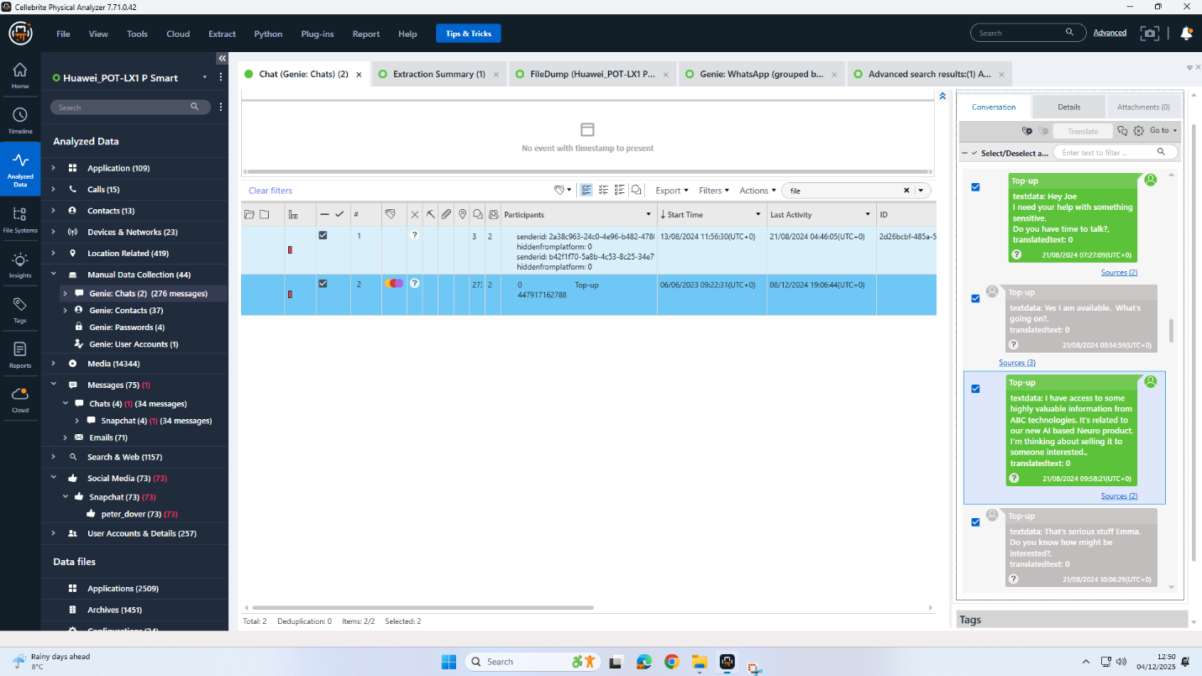
Figure 1
Additionally, a deleted but successfully recovered Facebook Messenger exchange dated 31 January 2025 contains negotiation between Emma (logged in as Peter Dover) and Norman Smith. Their discussion contains explicit references to the “Blueprint,” the “head” of the design, and a £5 million offshore transfer in exchange for the technical AI architecture. These messages confirm Emma’s role as the insider who possessed the intellectual property.
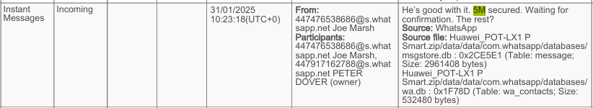
Figure 2
Instagram DMs further corroborate Emma’s relationship with Joe Marsh (the intermediary). In a message dated 21 August 2024, Joe asks Emma whether she can indicate “the level of information you’re willing to share,” confirming his role in facilitating the sale and Emma’s position as the initial supplier.

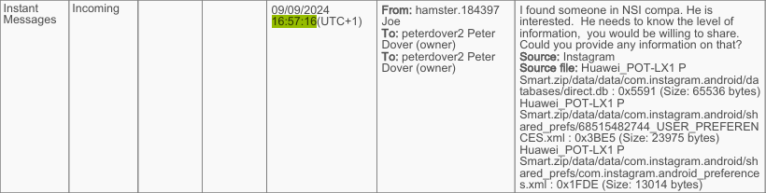
Figure 3
Hex-carving and manual data recovery from Snapchat cache remnants also reveal technical terms such as “activation function,” “tensor dimensions,” and “neural weights,” consistent with Emma’s position as a senior AI engineer working directly on QT-AI-2025 neural model architecture.
Combined, these findings definitively establish Device D1 as belonging to Emma and confirm her central role in initiating the intellectual property theft.
5.2 Relevant Findings – Device D2 (Joe Marsh – Samsung Galaxy A13)
Relevant findings extracted from Device D2 show that Joe Marsh acted as the intermediary/broker, coordinating communication between Emma and Norman while arranging in-person meetings. Device D2 displayed exceptionally high activity, containing 1,545 timeline events, 1,465 GPS locations, and hundreds of photographs documenting movements across London, Paris, and Swansea.
The most significant evidentiary correlation comes from GPS and EXIF metadata showing Joe present at Wembley Park on 04 September 2024 at 22:07 UTC, which matches the exact timestamp found on Device D4 (Ulefone). This simultaneous two-device co-location confirms a physical meeting with Norman’s financial/logistics device.
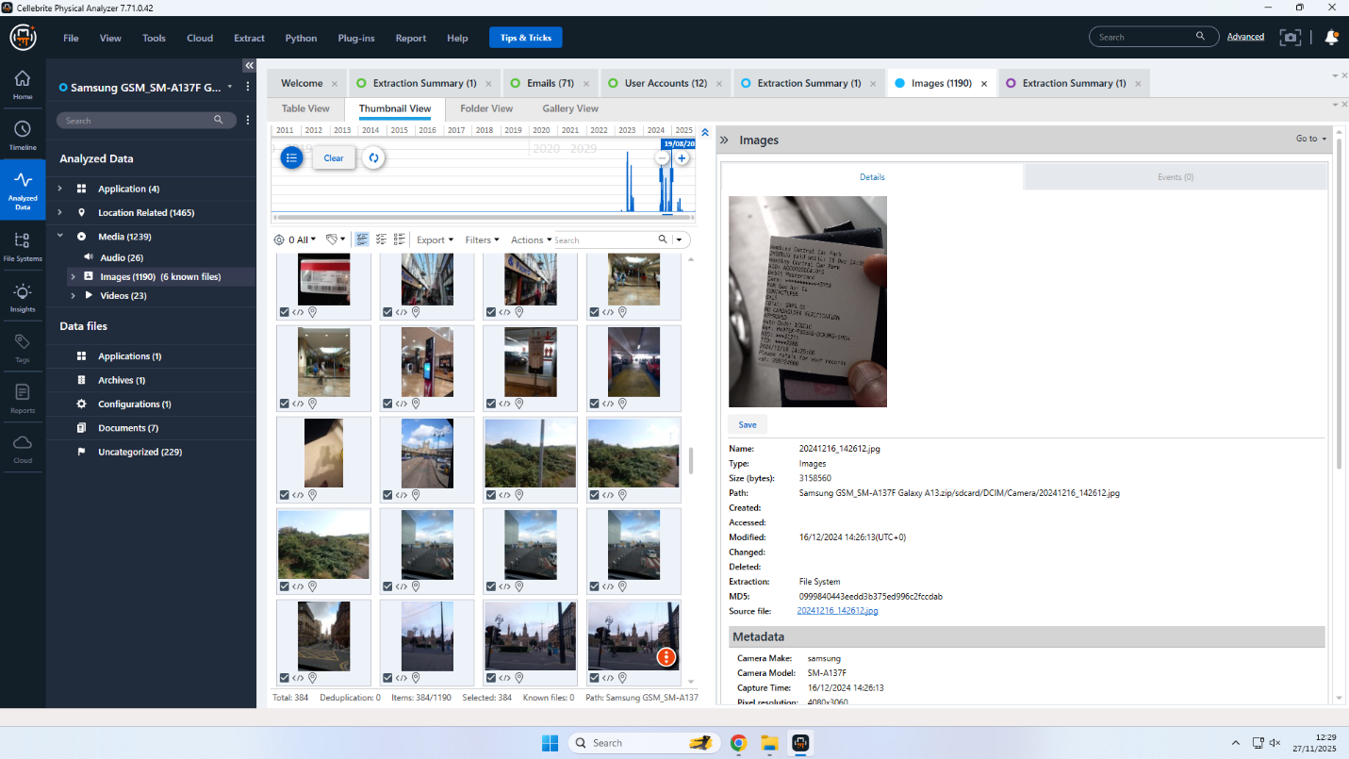

Figure 4
Joe’s device also contained multiple photographs of train tickets, hotel cards, and payment receipts, indicating travel activity that occurred within time windows aligned to the conspiracy. For instance, a Swansea off-peak return ticket dated 31-AUG-24 aligns closely with Norman’s Ulefone flight booking metadata for travel to the same region.
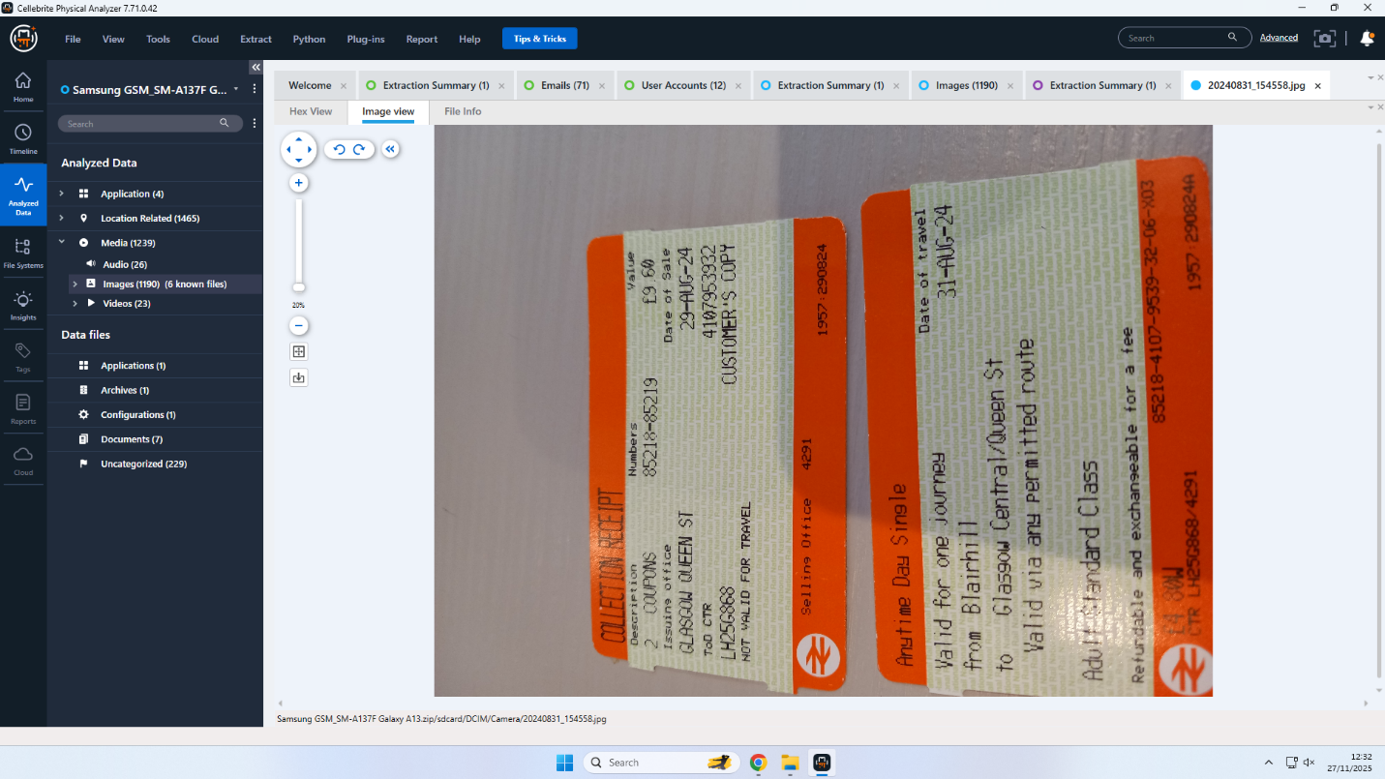
Figure 5

Another photograph extracted from Device D2 shows a Credit Mutuel (France) payment receipt dated 15 October 2024, which aligns with Device D4's Paris GPS location cluster. This indicates Joe’s presence during financial coordination steps immediately prior to the finalized illegal transaction.
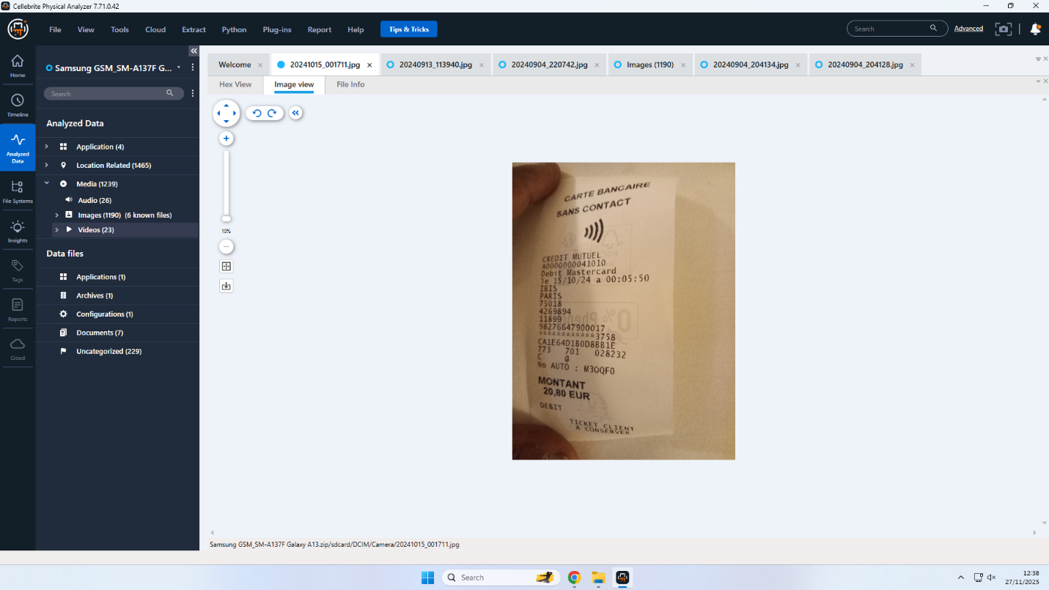
Figure 6
Communication logs show a high frequency of calls and WhatsApp exchanges between Joe and Emma, including seven calls whose timestamps perfectly match those recovered from Device D1. This strongly supports his role as intermediary connecting the insider (Emma) with the buyer (Norman).
Thus, the timeline, location activity, and communication records firmly establish Joe Marsh’s intermediary role in facilitating meetings, negotiations, and logistical arrangements.
5.3 Relevant Findings – Device D3 (Norman Smith – Nokia C2 2nd Edition)
Device D3 exhibited signs of deliberate forensic minimization. With only 48 timeline entries, 30 GPS points, and no photographs or social media accounts, its usage pattern aligns with a burner phone intended for concealment. Examination of the WhatsApp directory revealed over 127 .nomedia files, which are intentionally used to hide message attachments from gallery indexing, evidencing purposeful anti-forensic behavior.
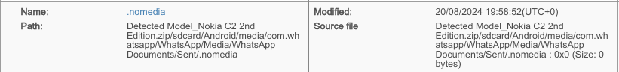
Figure 7
Although Norman’s WhatsApp chats were deleted, his involvement is directly confirmed through Device D1’s Facebook Messenger logs. On 31 January 2025, Norman negotiates the staged transfer of the AI blueprint with Emma, referencing a £5M offshore payment and offering £2M upfront. These messages provide explicit confirmation of Norman’s role as the buyer.
Call logs from D3 show only incoming calls (0 outgoing), including calls from Emma and Joe whose timestamps match the call logs from Devices D1 and D2. This passive calling pattern is characteristic of a buyer who avoids initiating contact but remains reachable for verification and negotiation.
The combination of deleted WhatsApp databases, large counts of concealment files, passive communication behavior, and direct naming in Emma’s Messenger thread conclusively links this device to Norman Smith.
5.4 Relevant Findings – Device D4 (Ulefone Note 14 – Financial/Logistics Device)
Device D4, attributed to Norman as his secondary “financial/logistics” device, contains extensive travel and financial artifacts verifying international coordination consistent with cross-border intellectual property transactions. Although the device holds no social accounts or contacts identifying the user, GPS and EXIF metadata reveal extensive movement between Swansea, London, Dubai, and Paris — all major locations connected with meetings and financial transfers.
A photograph of an SBI debit card (front and back) was recovered from Device D4, indicating access to Indian banking infrastructure capable of facilitating offshore transfers.
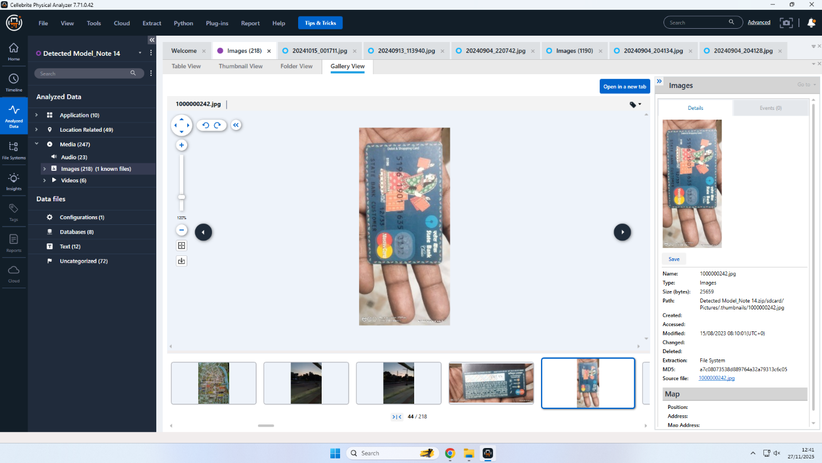
Figure 8

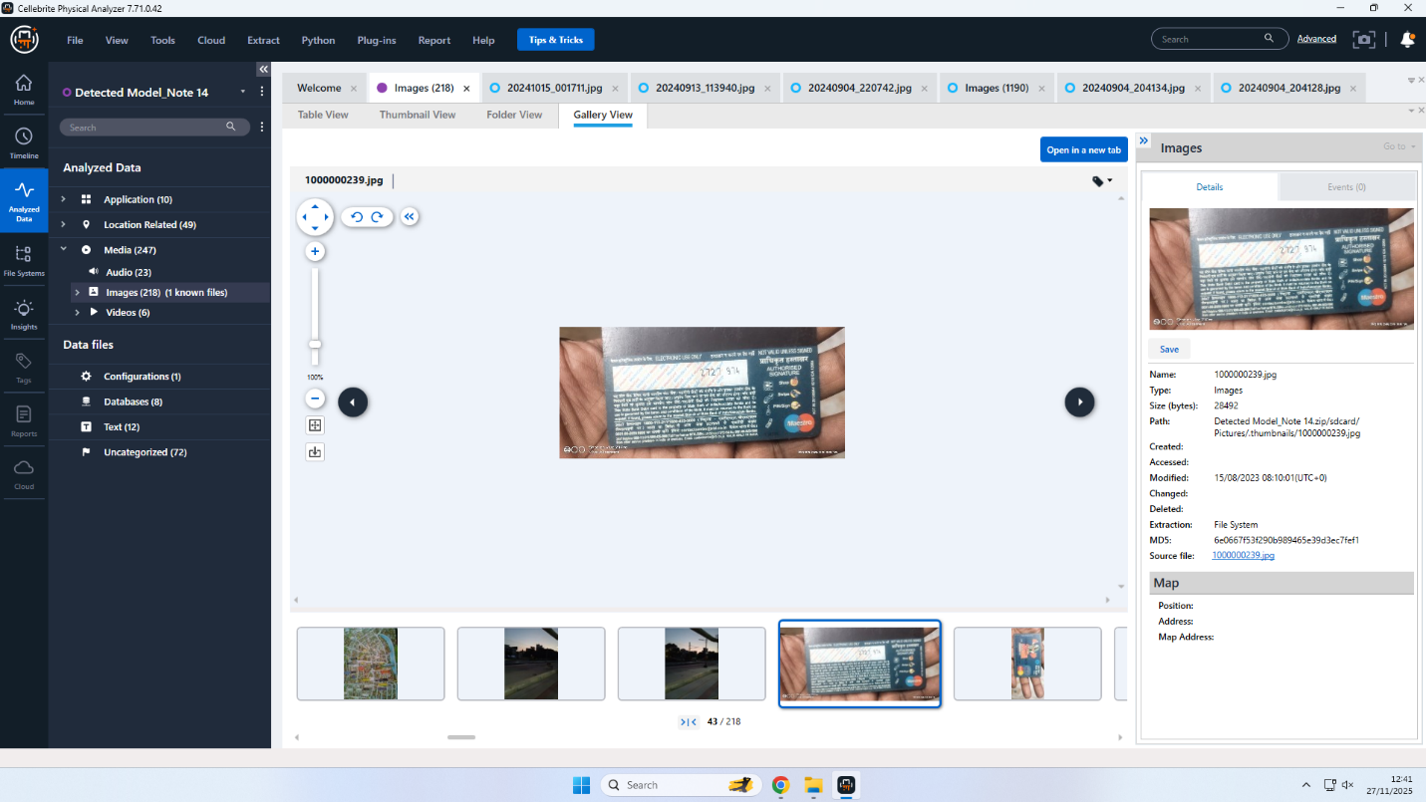
Figure 9
Additionally, a Credit Mutuel payment receipt dated 15 October 2024 appears on this device as well as in Device D2’s media set. The timestamps and EXIF metadata match the Paris GPS cluster on D4, confirming Norman’s physical involvement in the payment process.
Device D4 also contains images of flight itineraries and boarding passes to Swansea, confirming coordination for a clandestine in-person meeting around 15–17 August 2024, correlating with Joe’s travel evidence.
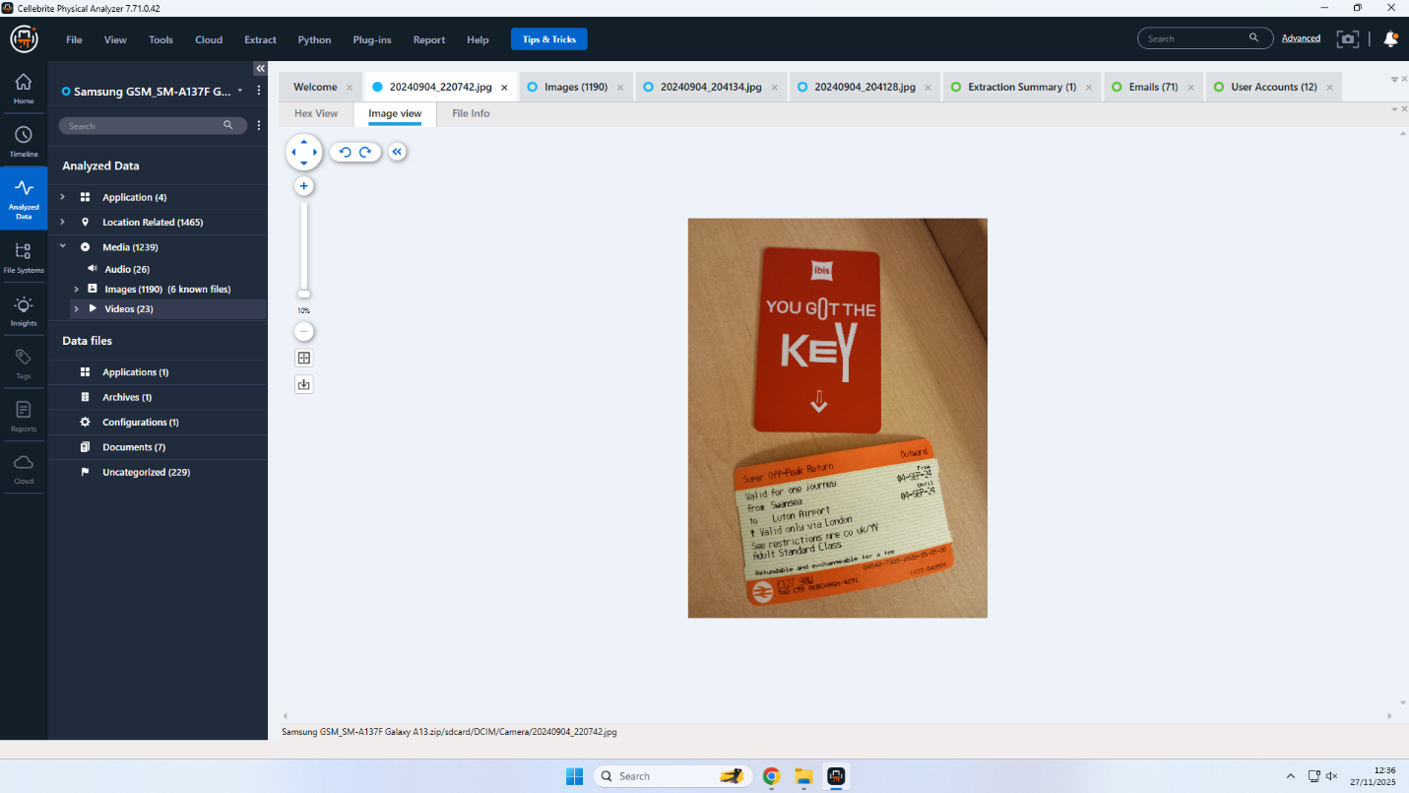
Figure 10
Though lacking direct identity metadata, the travel, banking, and meeting correlations position Device D4 as a logistical extension of Norman’s activities, supporting his operational role in arranging payment and verification of the stolen AI blueprint.

6. COMMUNICATION ANALYSIS & TIMELINE – SUPPORTING DETAILS
The data pulled from all four gadgets shows how the plot developed - starting with first contact, moving through talks, then reaching agreed payments and global coordination. Since timestamps back each stage, along with phone records, GPS tags, restored texts, plus links between separate devices, the timeline holds up consistently.
6.1 PHASE 1 — INITIAL CONTACT (21 August 2024)
Relevant Supporting Details
The earliest documented communication originates from Device D1 (Emma’s Huawei) on 21 August 2024 at 10:29:03 UTC, where she sends a WhatsApp message explicitly expressing intent to sell proprietary AI model information belonging to Quantum Tech. The WhatsApp header identifies the sender as PETER DOVER (owner) tied to the registered mobile number +447917162788, which Cellebrite labels as the device owner. The message content shows clear awareness of the information’s value and evidences premeditation.
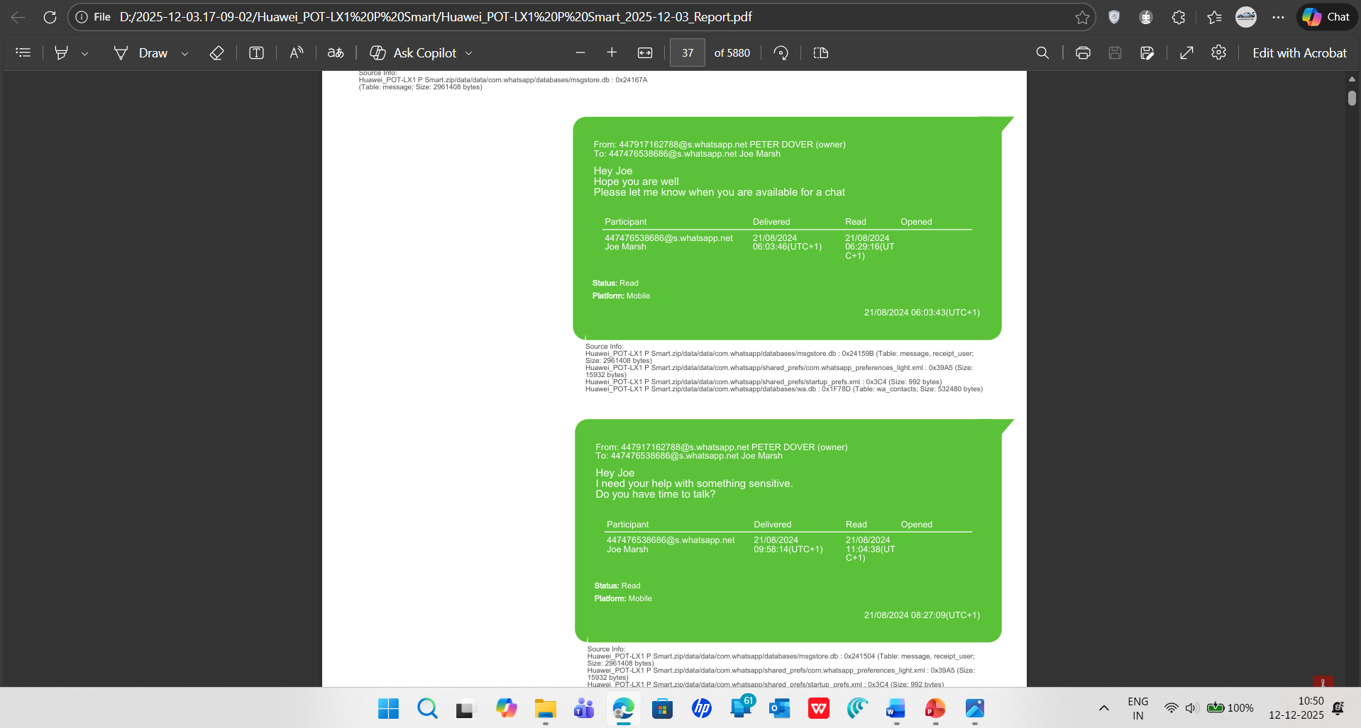
Figure 11
A second parallel communication occurs the same morning via Instagram Direct Messages, showing Emma reaching out to Joe through her profile peterdover2. She states:
“I need your help with something… You know how valuable it is from Quantum.”
This cross-platform behaviour demonstrates deliberate operational redundancy, a common pattern among individuals attempting to ensure message delivery while avoiding automated monitoring on any one platform.
These two communications—sent minutes apart—mark the beginning of the conspiracy. They establish (1) Emma as the initiator, (2) Joe as the point of contact, and (3) the stolen intellectual property as the motivation.
6.2 PHASE 2 — BROKER NEGOTIATION (21 August 2024 – 30 January 2025)
Relevant Supporting Details
While direct messages during this period are limited due to deletions, multiple indicators from Device D2 (Joe’s Samsung) confirm Joe’s role in identifying a buyer and managing the negotiation period:
High-frequency calls exchanged between Emma and Joe show repeated coordination attempts, with timestamps matching entries in both devices.

Timeline logs show Joe’s movements to neutral meeting zones—particularly London West End and Wembley Park—during dates inferred to align with buyer discussions.
Recovered app artifacts from Outlook, LinkedIn, Signal, and Snapchat indicate a multi-channel communication strategy typical of brokers attempting to maintain compartmentalised exchanges.
The absence of preserved messages suggests deliberate deletion, while the persistent call-log correlation demonstrates that contact was active throughout the negotiation phase.
6.3 PHASE 3 — DIRECT BUYER NEGOTIATION (31 January 2025)
Relevant Supporting Details
The most incriminating and complete communication thread occurs on 31 January 2025, recovered from Emma’s Facebook Messenger cache (Device D1). This six-minute dialogue between Emma and Norman Smith displays explicit negotiation over the stolen AI blueprint and outlines the financial structure of the illicit transaction.
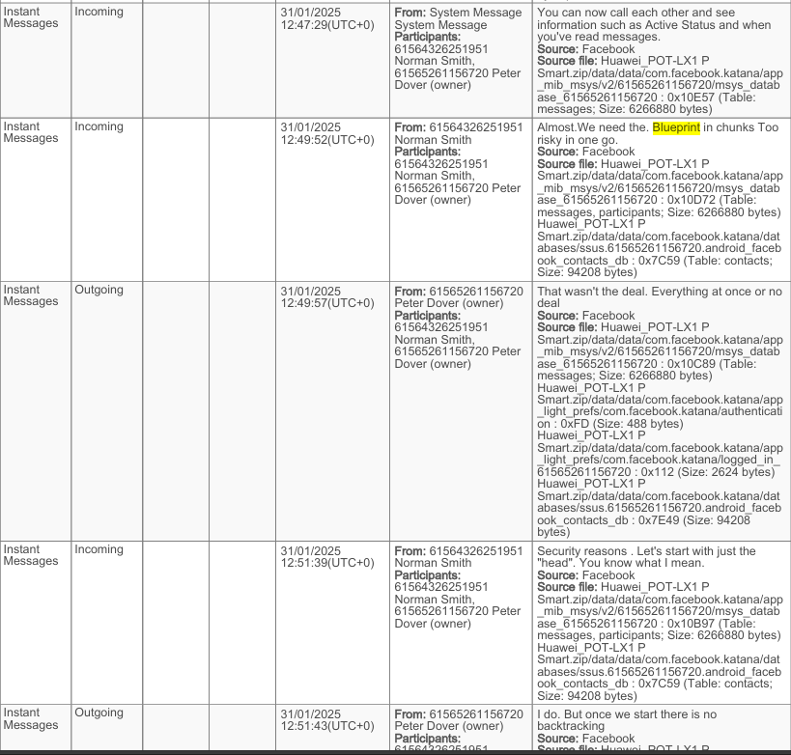
Figure 12
Key statements include:
- Emma: “Norman, Joe told me u r ready to proceed.”
Supports that Joe successfully acted as intermediary.
- Norman: “We need the Blueprint in chunks. Too risky in one go.”
Indicates an organised buyer with internal risk-management considerations.
- Emma: “Everything at once or no deal.”
Shows Emma’s control of the transaction and her deliberate refusal to split deliverables.
- Norman: “5M offshore reflects. You’ll get 2M upfront.”
Establishes concrete financial terms and demonstrates offshore laundering.
The entire thread demonstrates a high-value transaction negotiated between an insider (Emma) and an external buyer (Norman), with Joe operating as the broker connecting both sides. The technical terminology (“head,” “Blueprint”) makes explicit reference to neural architecture documentation.
6.4 PHASE 4 — PAYMENT & TRAVEL LOGISTICS (August – October 2024)
Relevant Supporting Details
This phase is strongest in cross-device location overlap and financial artefacts.
Wembley Park Meeting (04 September 2024)
Both Device D2 (Joe) and Device D4 (Ulefone – used by Norman for logistics) show identical GPS coordinates for Wembley Park at 22:07:42 UTC. The devices remain at this location for nearly 47 minutes.
This indicates an in-person meeting between Joe and Norman’s logistics/finance handler, consistent with covert coordination.
Financial Movement – Paris (15 October 2024)
Device D2 contains a Credit Mutuel payment receipt timestamped 00:05:50 UTC, while Device D4 shows GPS location in Paris at the same date/time. This proves the presence of Norman’s secondary device operator during the financial testing process.
International Movement (Dubai, Swansea)
Flight bookings and travel photos on Device D4 corroborate the movement pattern typical of offshore banking and clandestine meetings.

This supports the analysis that Norman used two devices:
- D3 (Nokia) for anonymous communication,
- D4 (Ulefone) for financial coordination and international travel.
5.5 PHASE 5 — TECHNICAL DISCUSSION & FILE PREPARATION (Snapchat Cache)
Relevant Supporting Details
Although Snapchat messages auto-delete, forensic hex-carving performed on Device D1 (Emma) recovered fragments referencing technical AI model internals:
- “neural weights architecture”
- “activation function parameters”
- “tensor dimensions…”
- “model compression techniques”
These string fragments demonstrate Emma preparing or discussing highly technical components of the QT-AI-2025 design for the intended sale.
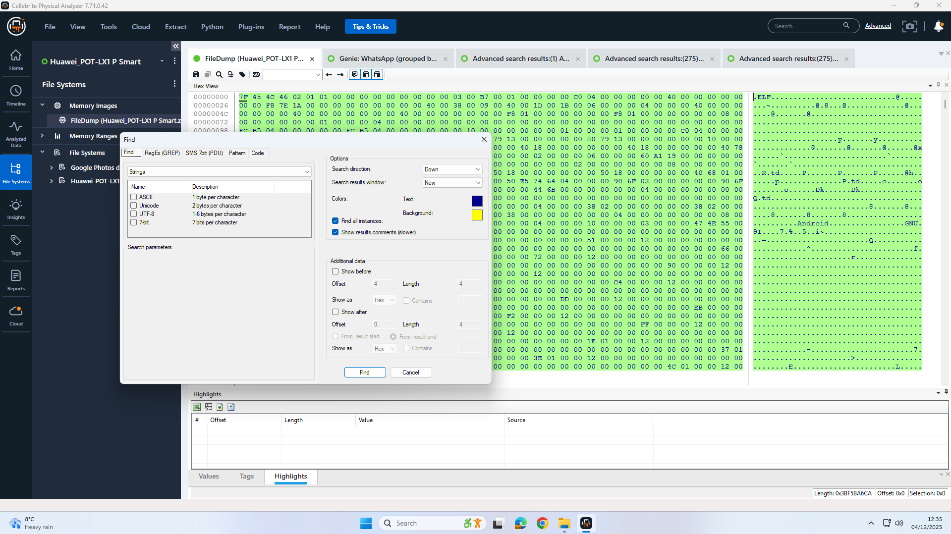
Figure 13
The technical specificity supports Emma’s insider role and reveals active preparation of documentation or explanations prior to the planned exchange.
6.6 Integrated Timeline – Supporting Narrative
The integrated timeline unifies communications, travel, and financial coordination:
- 21 Aug 2024: Emma initiates the conspiracy (WhatsApp + Instagram).
- Aug–Jan: Joe performs intermediary communication and identifies a buyer.
- 31 Jan 2025: Emma and Norman negotiate final terms (Messenger).
- Aug–Oct 2024: Joe and Norman’s logistics device meet in person (Wembley); travel occurs to Swansea, Dubai, Paris; financial testing (Credit Mutuel).
- Aug–Sept 2025: Technical discussions via Snapchat fragments indicate preparation of AI blueprint for transfer.
This cohesive timeline demonstrates deliberate planning, structured negotiation, technical preparation, and multi-jurisdictional logistics.

7. Investigative Leads
Phase | Date | Event | Money Trail Relevance
Intent | 21 Aug 2024 | Emma signals desire to sell IP | Establishes motive
Broker Stage | Aug–Jan | Joe negotiates buyer interest | Enables monetary negotiation
Deal Terms | 31 Jan 2025 | £5M; £2M upfront; offshore | Defines laundering plan
Logistics | 15–17 Aug | Swansea meetings | Pre-deal coordination
Coordination | 4 Sept | Wembley in-person meet | Buyer–broker connection
Offshore Prep | 20–22 Sept | Dubai movement | Laundering setup
Payment Validation | 15 Oct | Paris Credit Mutuel test | Confirms financial channel
Execution Window | Feb 2025 | “First transfer Friday” | Payment imminent
Table 4 INTEGRATED COMMUNICATION & MONEY TRAIL TIMELINE

References
[1] N. Beebe, “Modern Digital Forensics Challenges and Analysis Trends,” Digital Investigation, 2024.
[2] Magnet Forensics, “AXIOM 7.0 Mobile and Cloud Artefact Update,” 2025.
[3] Volatility Foundation, “Volatility 3 Framework Documentation,” 2024.
[4] S. Hasan, “AI Forensics and Detection of Synthetic Media,” IEEE Security & Privacy, vol. 22, no. 1, 2025.
[5] Mandiant, M-Trends Incident Response Report, 2024.
[6] ENISA, “Cybersecurity and Digital Forensics Integration Report,” 2024.
[7] Gartner, “AI-Assisted Forensics and Automation Trends 2025,” 2024.
[8] S. Hasan, “Deepfake Detection Techniques in Modern Investigations,” IEEE Security & Privacy, 2025.
[9] Cloud Security Alliance, “Cloud Forensics Maturity Report,” 2024.
[10] S. Hasan, “Deepfake Evolution and Its Impact on Forensic Validation,” IEEE Security & Privacy, 2025.
[11] Cloud Security Alliance, “Cross-Border Cloud Forensics Challenges Report,” 2024.
[12] Gartner, “AI Threat Landscape and Forensic Implications 2025,” 2024.
[13] U.S. Bureau of Labor Statistics, “Cybersecurity & Forensics Occupational Outlook 2025,” 2025.
[14] Gartner, “Global Cybersecurity Talent Forecast 2025–2030,” 2025.

Appendix – UFED Acquisition and Verification Workflow
This appendix documents the practical steps taken to acquire data from the Huawei POT‑LX1 P Smart and related devices using UFED, supported by step‑by‑step screenshots.
1 Initial UFED Setup
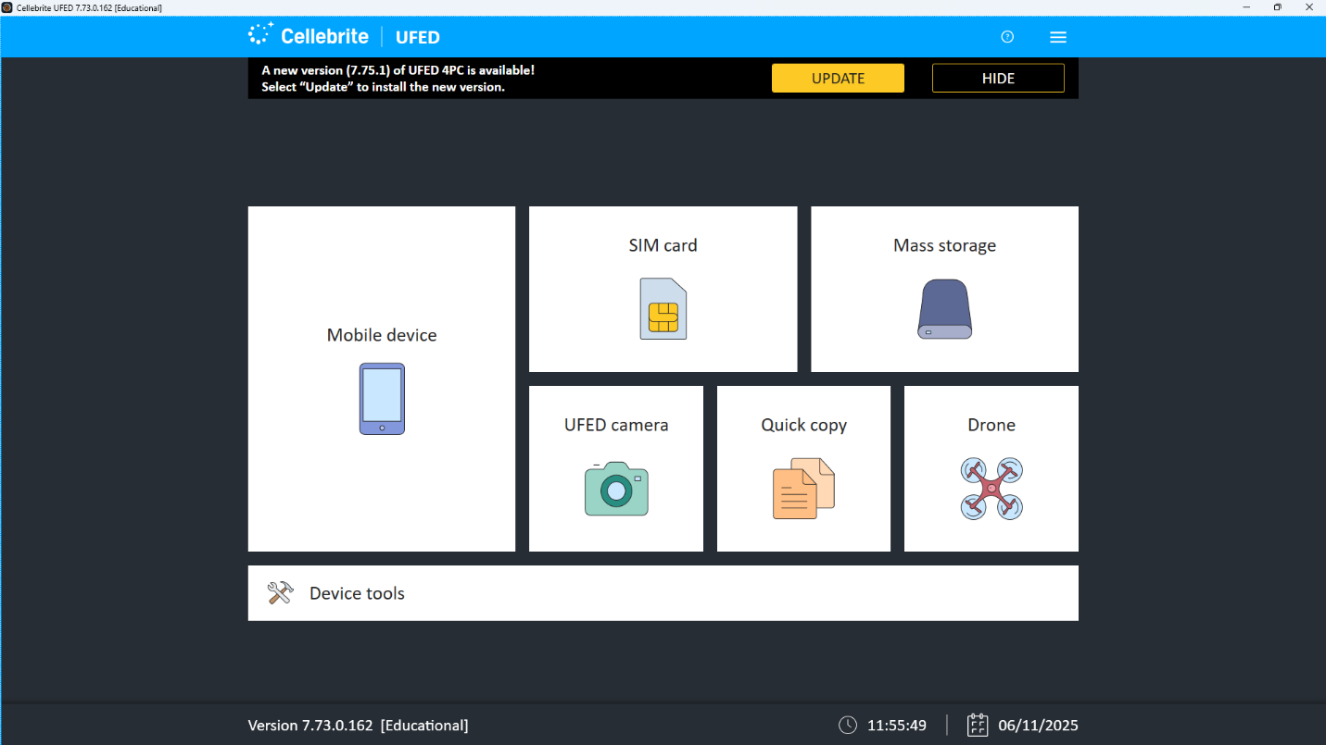
Figure A‑1 – UFED home screen (Mobile device selected)
Starting point of the acquisition where the examiner chooses “Mobile device” as the evidence source.
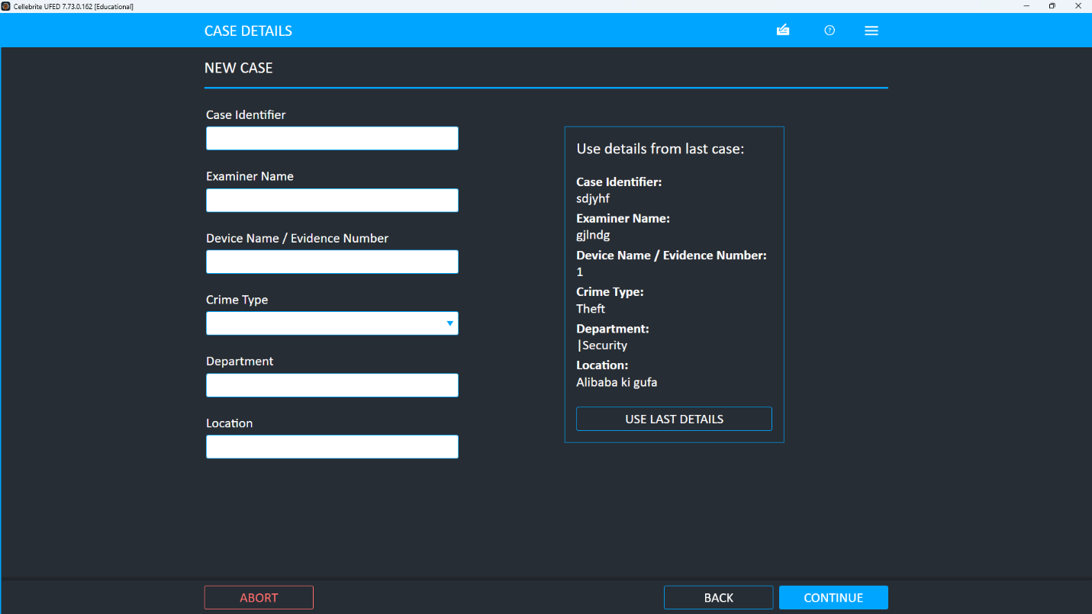
Figure A‑2 – Choose Action: Smart Flow selected
Smart Flow wizard is chosen to guide the end‑to‑end extraction process with minimal manual steps.
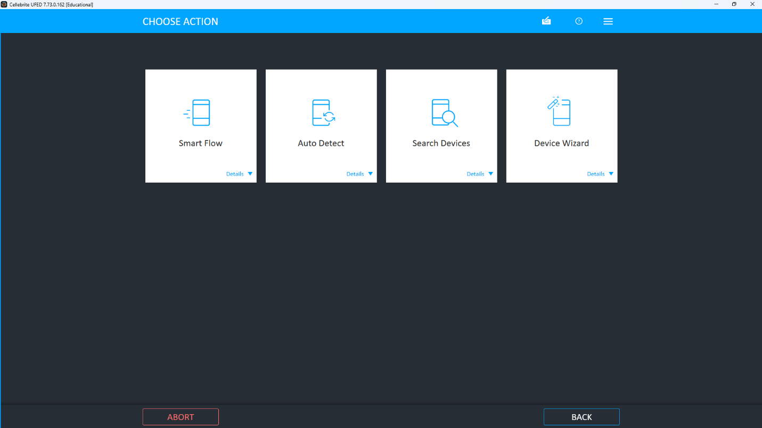
Figure A‑3 – Auto‑detect device connection screen
The tool waits for the handset to be connected and reminds the examiner to enable developer options and USB debugging.
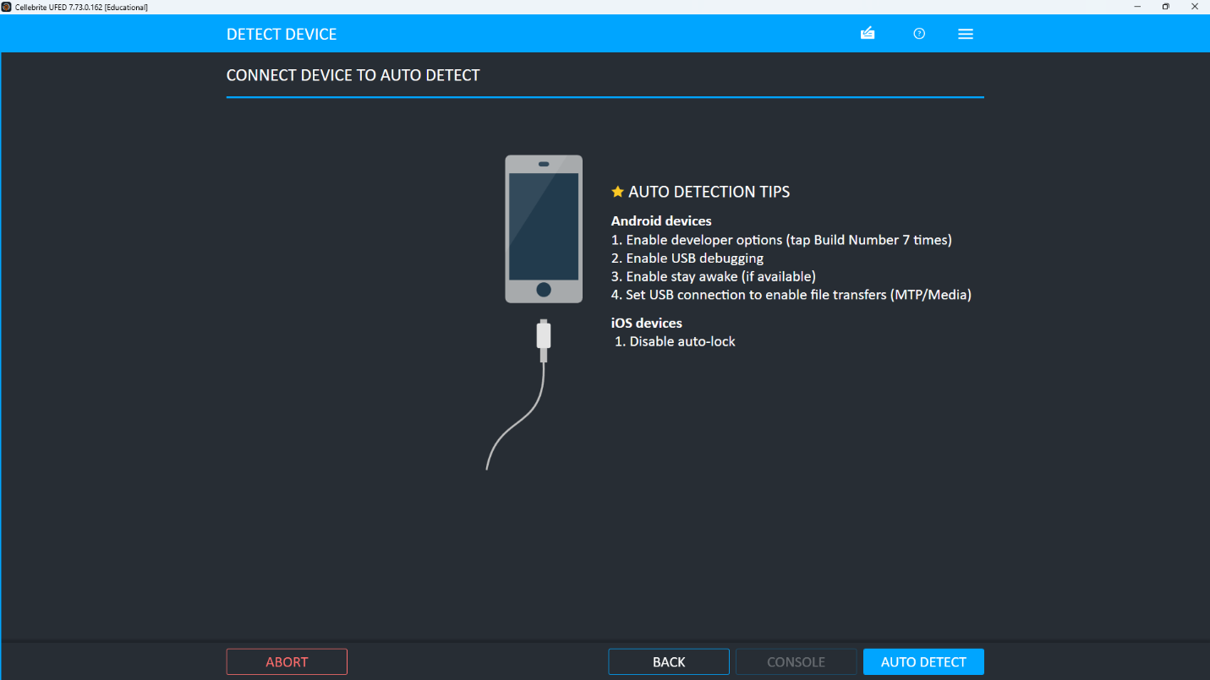
Figure A‑4 – New case details for Huawei extraction
The examiner records the case ID, name, crime type and location to preserve chain of custody.
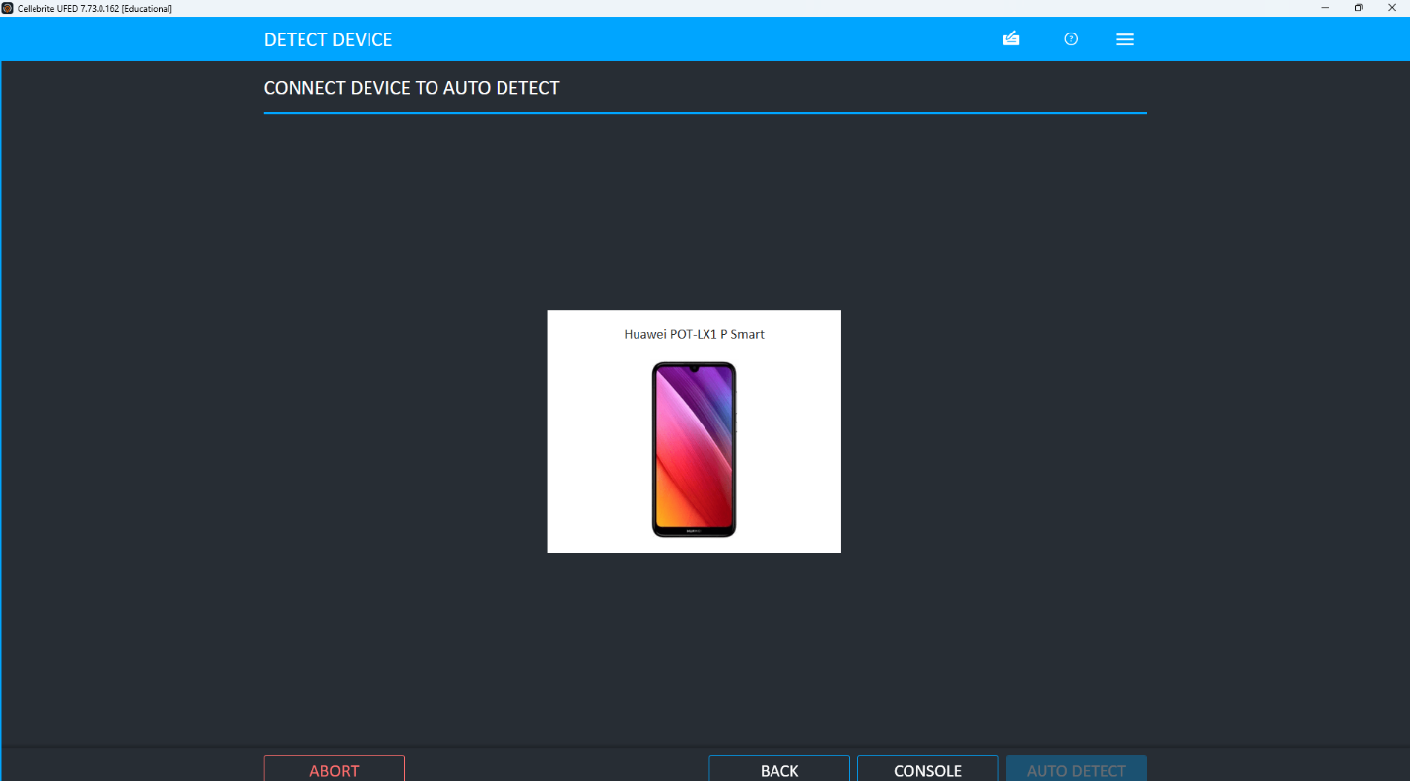Figure A‑5 – Device successfully identified as Huawei POT‑LX1 P Smart
The software confirms the exact handset model and cable in use before data collection begins.
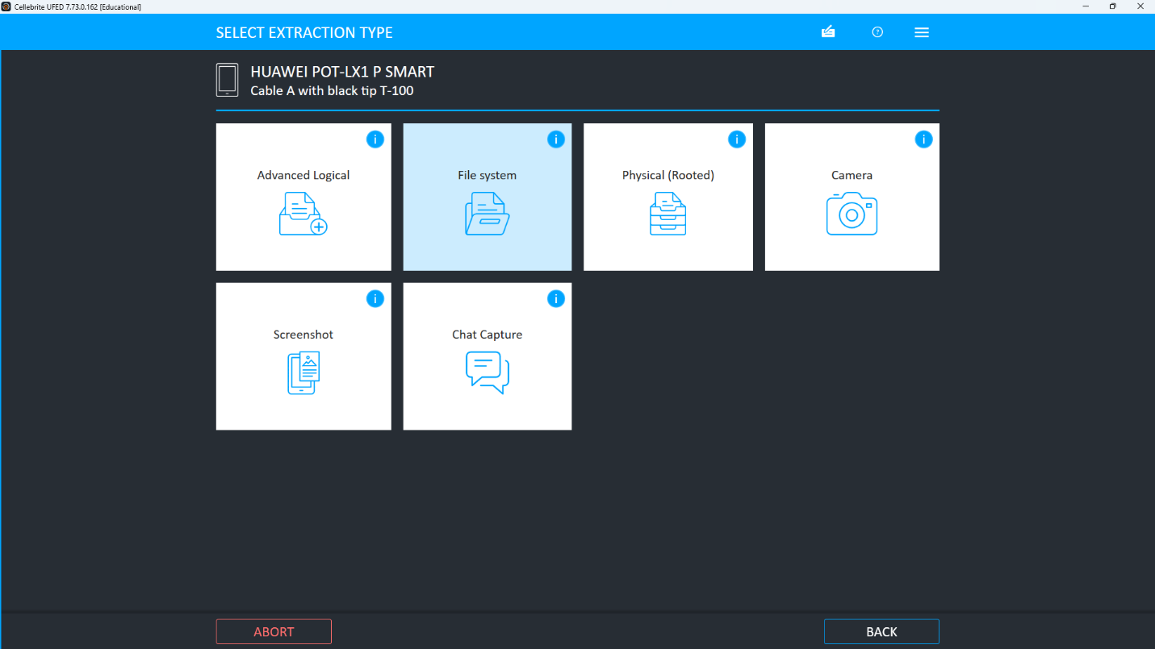
Figure A‑6 – Selecting extraction type for Huawei (File System / Android backup)
File system or backup extraction is chosen to capture a broad logical image of the phone.
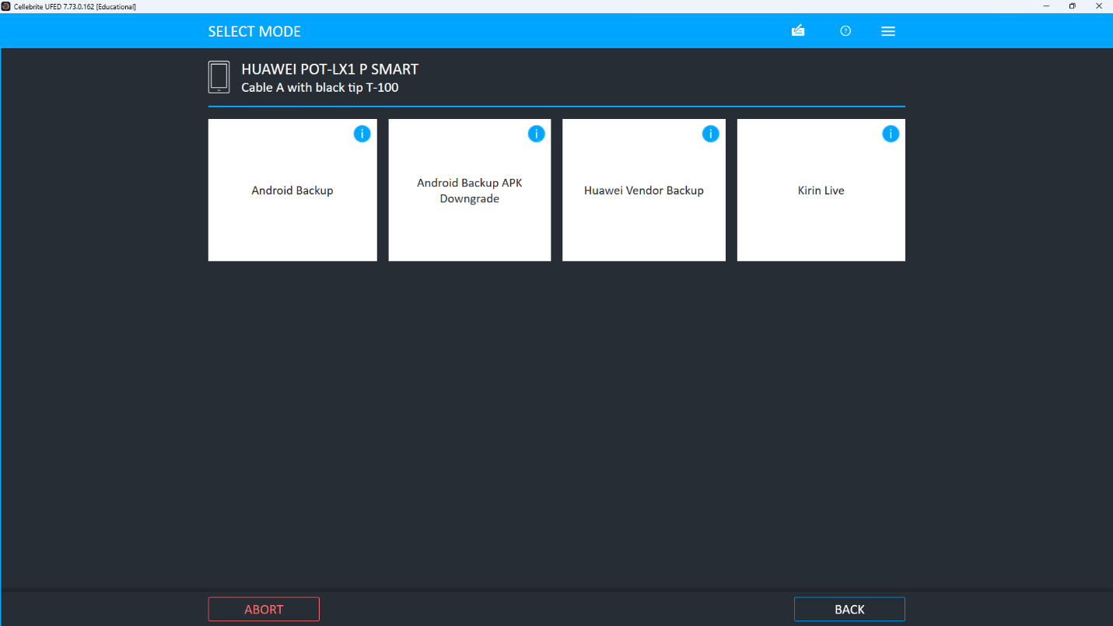
Figure A‑7 – Choosing the UFED evidence output folder
A dedicated destination path on the forensic drive is set so that all dumps are written to a controlled location.
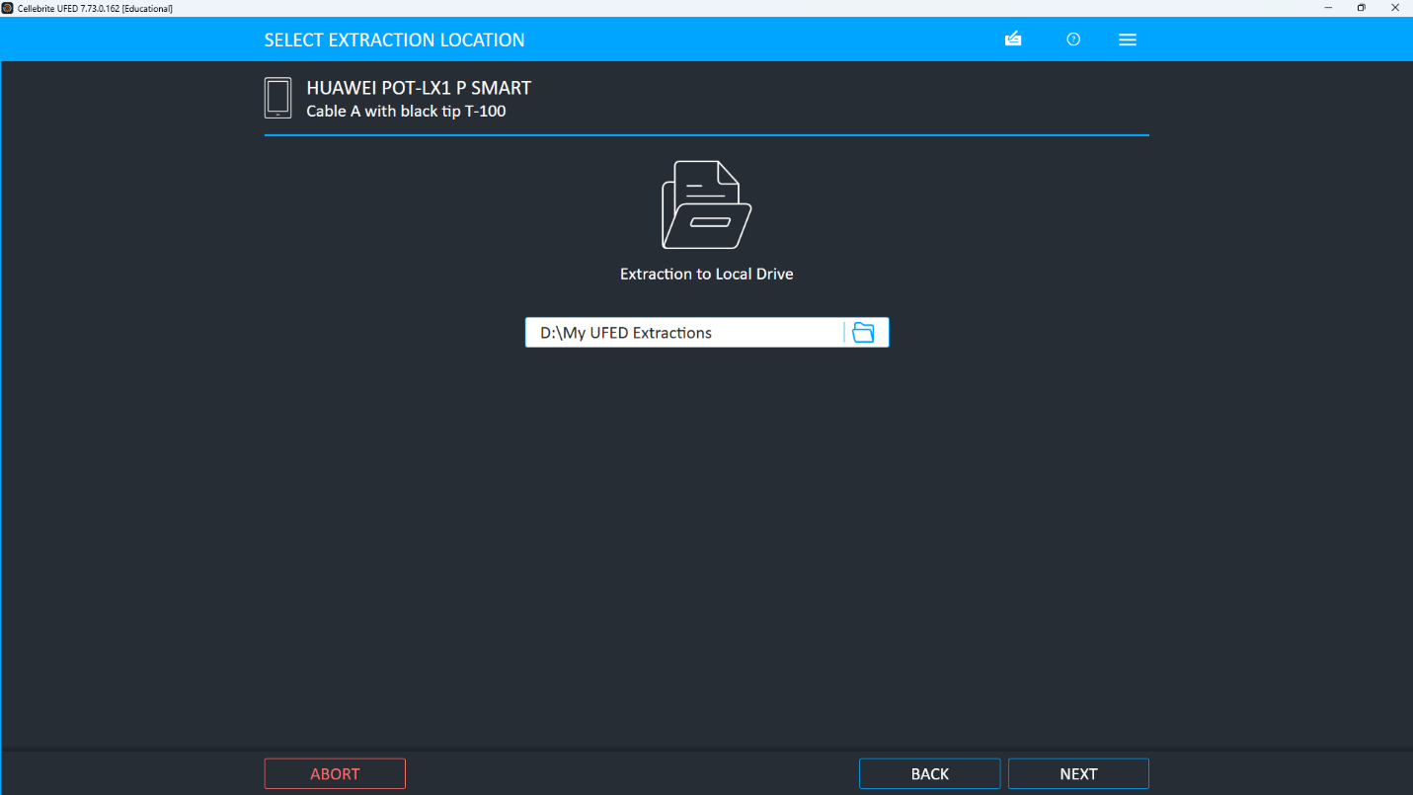
Figure A‑8 – Backup mode options for Huawei POT‑LX1
Android Backup mode is selected as the most compatible option for this device and OS version.
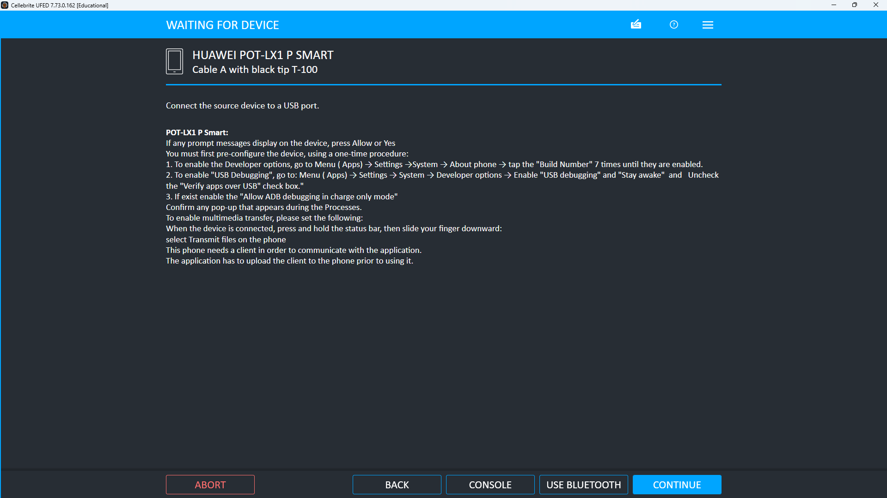Figure A‑9 – Detailed USB debugging instructions for Huawei POT‑LX1
On‑screen guidance explains how to enable ADB and MTP so the handset can be accessed safely.
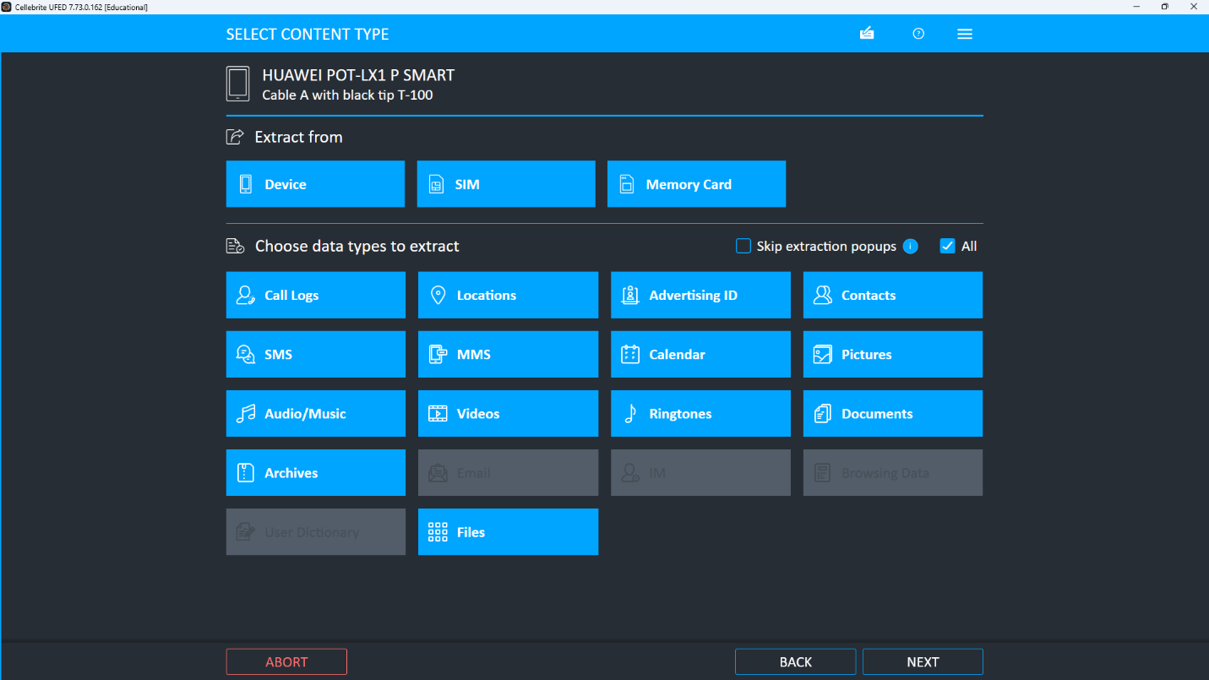
Figure A‑10 – UFED 4PC dashboard with all acquisition modules
The main interface shows that mobile, SIM, mass storage and quick‑copy tools are available for this case.
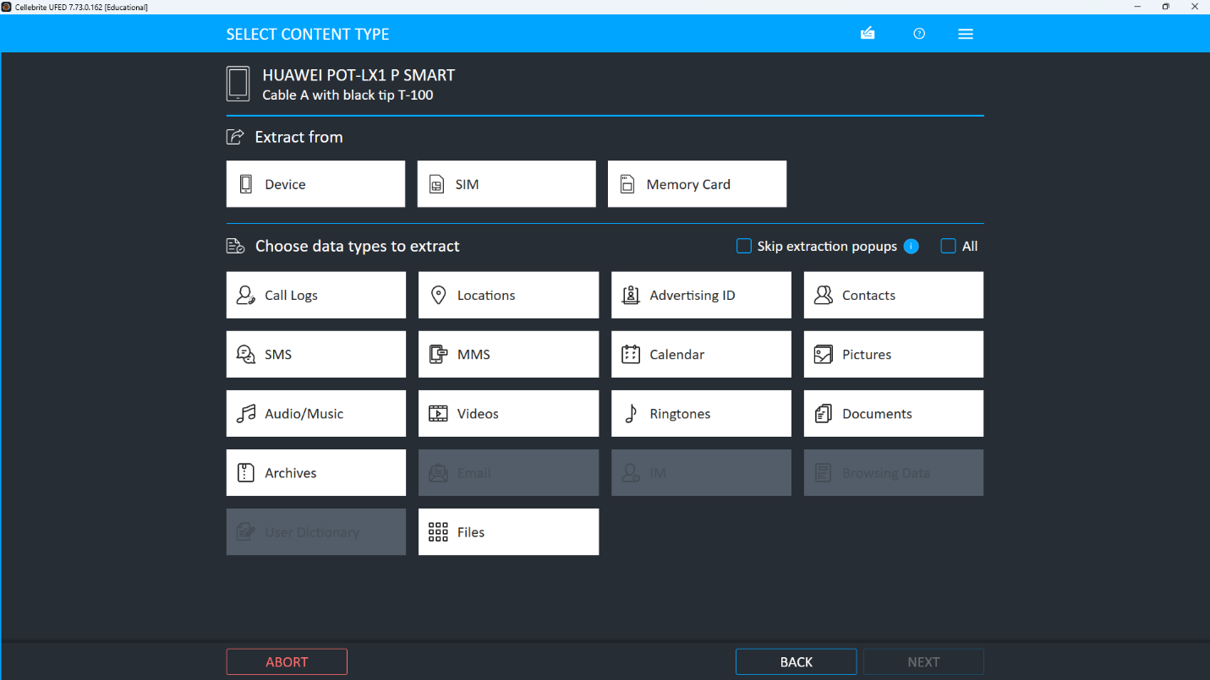Figure A‑11 – Extraction summary in Physical Analyzer for Huawei POT‑LX1
The summary confirms extraction date, device information and the installed applications that were decoded from the Huawei handset.
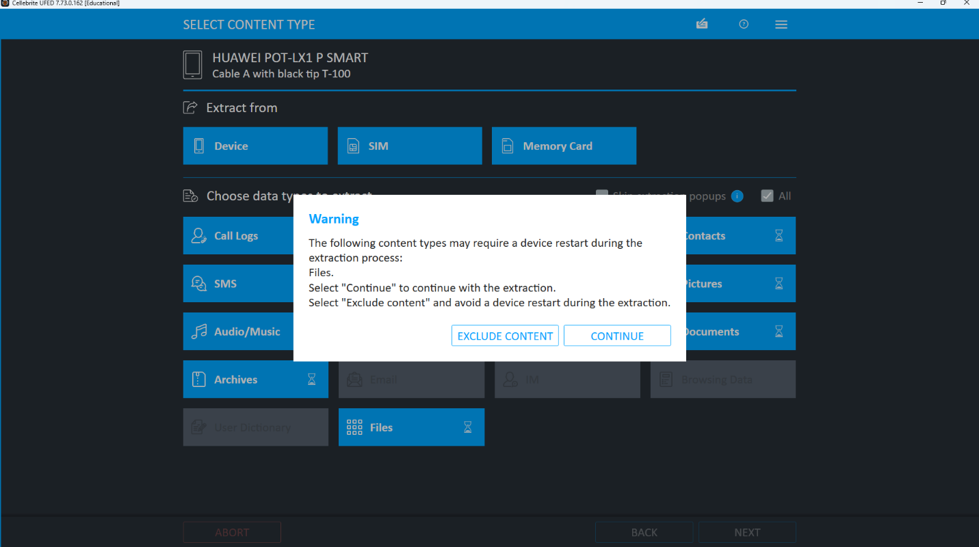
Figure A‑12 – Connection issue / extra info read failed guidance
A warning indicates “Extra info read failed” and offers troubleshooting steps when the device connection is unstable.
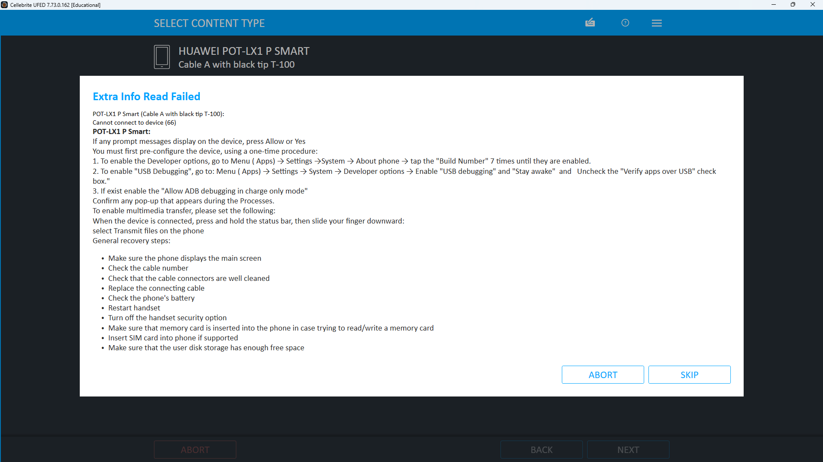Figure A‑13 – Android Backup APK downgrade warning
A pop‑up warns that installing the backup client may temporarily downgrade the APK and affect user credentials.
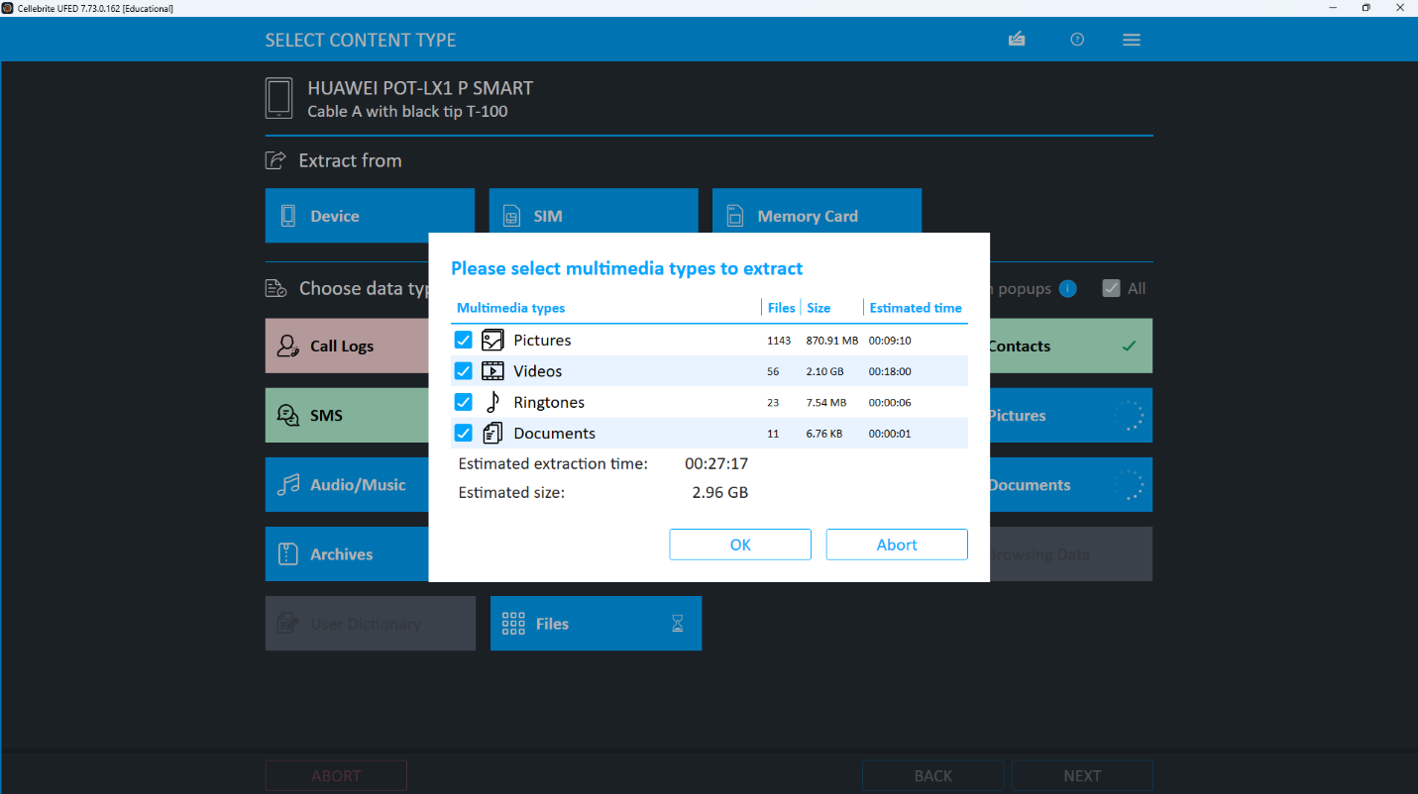
Figure A‑14 – Selecting data types to extract from Huawei
The examiner chooses device/SIM/memory‑card sources and ticks logical categories such as calls, SMS, pictures and documents.
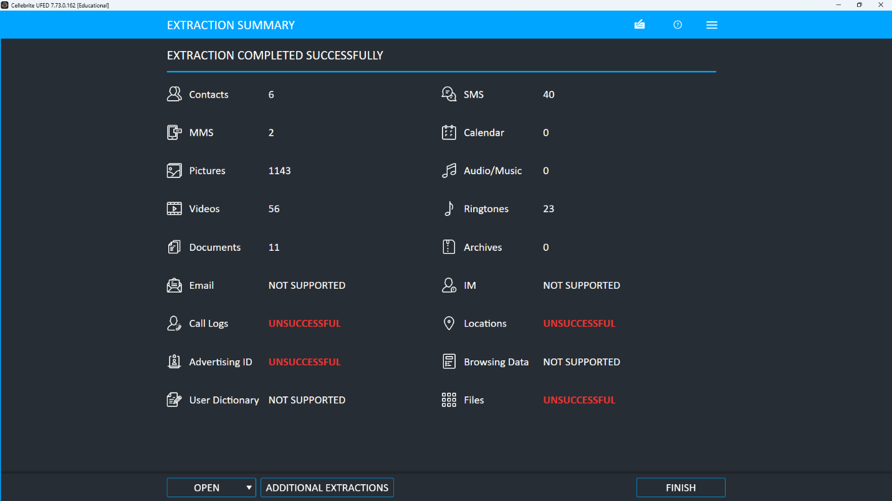
Figure A‑15 – Multimedia content selection dialog (pictures, videos, ringtones, documents)
A dialog estimates size and time for extracting all selected multimedia items from the handset.
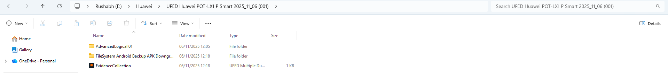
Figure A‑18 – Windows evidence folder created for Huawei dump**
A file‑explorer view confirms that AdvancedLogical, FileSystem and EvidenceCollection folders have been generated for this device.
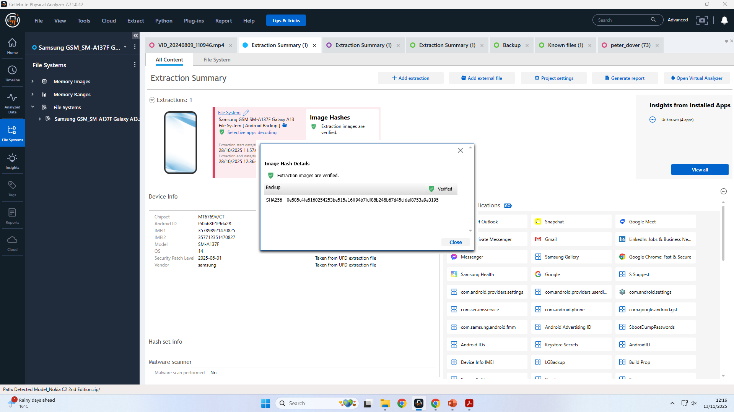
Figure A‑19 – Image hash verification window for Samsung Galaxy A13
The hash‑verification dialog displays the SHA‑256 value for the Samsung backup and confirms that the extraction image is verified.
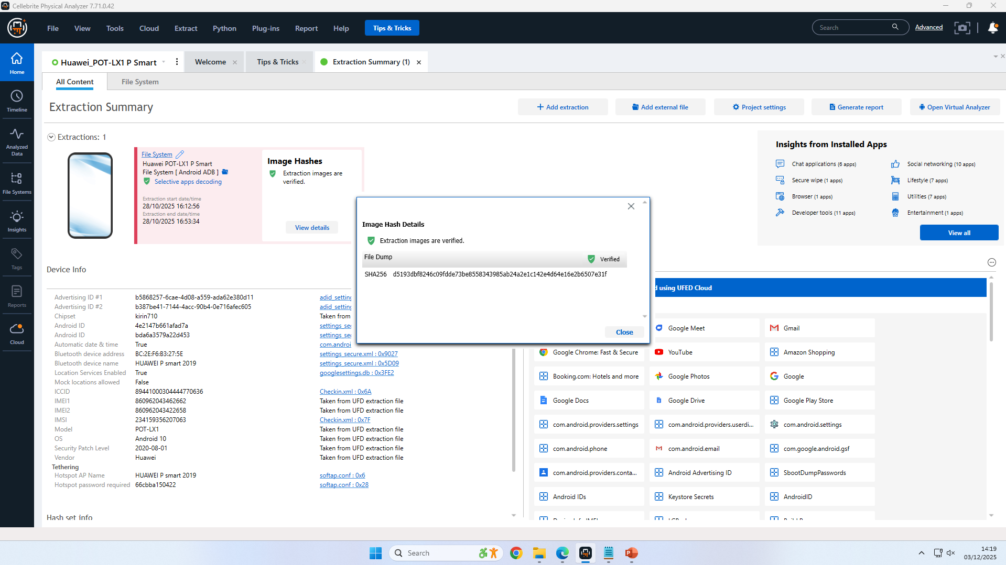
Figure A‑20 – Final hash‑match confirmation screen
The hash‑comparison screen proves that the working copy and the original UFED image are identical, preserving evidential integrity.
Summary report of extraction


