DIGITAL SKILLS AND RESEARCH METHODS

Student name | Miloud Dguigou
Student no | 1814060
Module title | Digital skills and Research Methods
Module code | BMSK4003
Lecturer Name | Balendran Kandasamy

ISLAMOPHOBIA IN THE UK

Table of Contents

Introduction 3
Aim and Objectives 3
Literature Review 4
Primary Research 6
Methodology 6
Ethical considerations 7
Limitations of the study 7
Results 7
Conclusion 8
Abstract……………………………………………………………………………………………. 10

References 12
Appendices 13

Introduction
Islamophobia is thriving in the UK since 9/11 and has been noticeably increased since 2008 with the recession. With the existence of the anti-Muslim sentiments particularly, in the aftermath of any terrorist attacks from London to Manchester to Birmingham, the threats has been increasing since. Some part of the British people ,however, have contributed to the non-acceptance of the Islam as religion in the country. There has been a few inflow of the population to the acceptance of the Muslim religion. With time the acceptance and reaction to the Islamic practices have only worsened in the UK. The study is a modest attempt with the aim at evaluating the effects of Islamophobia in the UK.

Aim and Objectives
Aim
The study aims to evaluate the effect of the Islamophobia on the people and the nation of the UK.
Objectives
- To analyze the effect of Islamophobia in the UK
- To evaluate the reaction of people towards the incidents
- To mitigate the situation occurring since the past years

Research questions
- What are the effects of Islamophobia in the UK?
- How people have been affected with the terrorist incidents in the UK?
- How can be the effects of Islamophobia occurring in the UK mitigated?

Scope of the research
The consultative processes which are adopted by the UK government were to increase anti-terrorist measures in one hand and to spread message of tolerance on the other hand.
However, the failure has been noticed in the Government's own motive which created somewhat of a blind spot for the country. The country has been affected with communal distress. There have been repeated terrorist attacks in different part of the country from London to Manchester. This modest study, despite its limitations, is a small contribution to the development of the ideas of this subject. It also helps in analyzing the effects of the Islamophobia among the people of UK (Hopkins, 2019). With the study the development of the mitigation theory for reducing the threat of terrorist attacks.

Literature Review
Concept of Islamophobia
Islamophobia is highly loaded term which has been used for certain specific agendas, which have a somewhat sectional agenda as well. Abbas and Awan (2015) have said within the span of two years only 4 % of the UK population have adapted themselves to the acceptance of the Islamic people within their territory. There are unease feelings regarding the existence of Muslim dominated population in cities like Birmingham and over the Muslim representation in the British government, in the Parliament and in other public organizations.

Advent of the Islamophobia
As a term Islamophobia has been coined by the Runnymede Trusts as per the Muslim domination context in the UK province. Islamophobia has generated with the examination of the historical impact of religion on the different regions of the world. As per Richards and Brown (2017), the Islamophobia has been predominantly developed to put a stress on the expansion of the Christianity. The advent and attack of the Islamophobia has become more widespread through the language, beliefs and cultural contrasts. Cohen and Tail (2017) have addressed huge differences of the beliefs, values, as well as ideology regarding politics.

Fear of Islamophobia
The Eurocentric and Oriented Global Power structure has been mostly threatened by the advent of Islamophobia. With the aim of resolving the disparities existing between the economic, political as well as social aspects even the cultural activities the Muslims have imposed threats on the people who do not belong to their community. Gawlewicz and Narkowicz (2015) have coined that violence is the only tool they have been opting for years to rehab the civilizations especially in their target area. However, Abbas (2019) has said that the community is primarily concerned with the spread of Islamophobia and secondarily their religion. The most notable impacts of Islamophobia have been characterized by messages of hate and sometimes by direct physical violence such as the killings in New Zealand’s mosque by non-Muslims extremists.

Reaction to Islamophobia
In recent years, tensions are spreading across different regions of the World. A series of terror activities by Muslims and Christians extremists have been increased from New Zealand to America. Allen (2016) has informed huge number of life losses in all the terror activities which have put a threat not only to the other religions but also to the Muslims who are residing in these countries. The people in such areas are asking for more security in the common places. Incidents, which are occurring in the other countries, are imposing an increasing threats of reprisals from different communities throughout the world. As per Najib and Hopkins (2019), the people have been threatened to join the religious activities. Parents are scared to send their children to the schools or any children fairs. All the people are demanding for security of life under each and every circumstance. All possible premises are servile with the CCTV and armed security forces for the whole day.
The rate of verbal abuses has increased a lot along with the instances of physical violence. Awan (2016) has stated that Islamophobia has a trend of in human practices rather than any digital means. The target areas tend to get more and more criminal offences from the communal distress rather than mere criminal activities.

Primary Research

Methodology
The primary research for the progress of this study can be completed by surveying people who may have been influenced by Islamophobia. In the current study the primary research has been carried out with surveying people who may have strong feelings about islamophobia in general, and on Muslims in particular. Primary research is very important for the current research because with this the current scenario can be modesty analyzed .With survey the current situation, the interview can only be evaluated with the close ended questions.

Sampling method
The analysis of the study can be continued through circulating questionnaire among 55 peoples who are living nearby schools or are regular visitors to the places of public gathering mostly above the age of 20.

Ethical considerations
The analysis needs to keep in consideration the ethical aspects which are as follows:
- The respect of Freedom of Speech and Freedom of Thoughts.
- The respect of confidentiality.
- The Data Protection Act should be considered to protect the data collected from the individuals.
- The collection of information can only be carried on with the full consent of the participants.

Limitations of the study
The study has limitations with respect to the time assigned to the research. Moreover, it is quite impossible to collect the data from all the people all over the country. The persons who were interviewed were not ready to provide detailed information regarding their adoption technologies.
Results
Quantitative data analysis (Refer to Appendix 1)
The survey questions for the individuals are as follows:
Q1) What is your Gender?
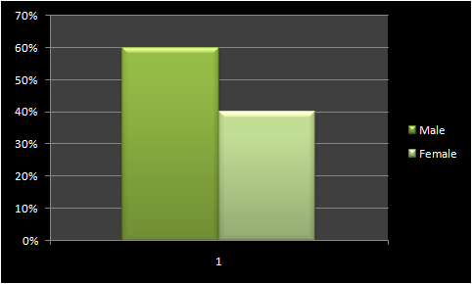

Figure 2: Question 1
(Source: Created by author)

Q2) Are you afraid of Islamophobia?

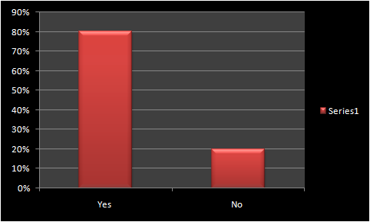

Figure 3: Question 2
(Source: Created by author)
Q3) Are you scared of going to school areas?

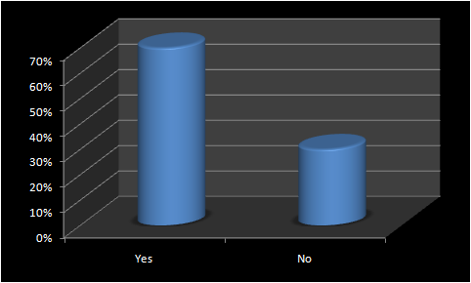

Figure 4: Question 3
(Source: Created by author)
Q4) Is there any security forces around the premises of the housing?
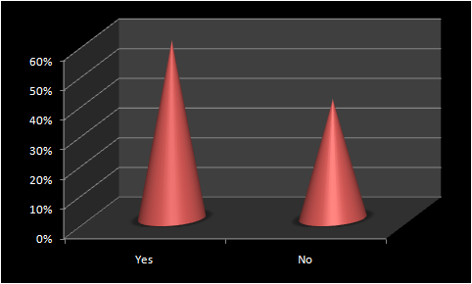

Figure 5: Question 4
(Source: Created by author)
Q5) Do you feel protected in public gatherings?

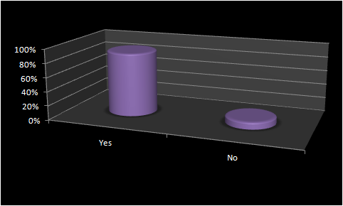

Figure 6: Question 5
(Source: Created by author)
There are about 60% male and the rest are female in the targeted sample. The scare of Islamophobia lies within 80% of the people which means that the area is subjected to threats and instances of the phobia. Mostly the people who are regular visitors to schools are scared of any terrorist attacks. There are many people who have started avoiding the areas other than emergency situations. Public gatherings are also avoided by the people because the gatherings become primary target of the terror activists so that they can attack a huge number of people at the same time. Along with the churches, mosques or shopping centers, security has increase and a large funds has been allocated by the public services authorities.

Qualitative Data analysis (Refer to Appendix 2)
1. What are the security measures undertaken?
The Security services
The security services has undertaken a series of anti-terrorist measures and developed planning to control and diffuse anti-terrorist attacks. They, however, trying to focus also on the public collaboration and vigilance in the public areas. They are trying to keep the public vigilant but not alarmed.
From Airports to public gathering, security is getting tight. At the airports for example, all passengers are subject to very strict and tight search before boarding their planes. The monitoring the of public gathering like schools, shopping malls, clubs, mosques, churches, and Synagogues are noticeably getting stronger. It is obvious that some measures are obvious to the public particularly, in the most famous touristic attractions which gives them some sense of security.

Conclusion
In the UK the impact of Islamophobia has a negative effect on Muslims and on the image of Islam as religion of peace for a long period of time to come. Sentiments are high and the impacts is clear especially, on the aftermath of any terrorist attacks, on Muslims and non-Muslim population alike. It has been found that the effects of Islamophobia is increasing day by day particularly, in social media platforms such as Twitter and Facebook and in some national newspaper from the Right and far Right political movements.
Some of these incidents are going unnoticed by the authorities and the perpetrators could not been brought to justice. The survey which has been conducted has provided evidences of huge percentage people being worried from such activities. They are trying to avoid public gatherings and are demanding more security in places of worship such as Mosques, Churches and Synagogues. The mitigations are planned with the activities of the security services to minimize the risks of terrorist attacks.

Abstract
There have been a series of measures which can be adopted by the UK government as well as the local authorities to protect all people what so ever their ethnicity, faith or sex orientation. It is, however, widely admitted that not all Muslims are terrorists and all British people are not islamophobic. Therefore, there is a need of urgent open dialogue and understanding between all communities and faiths in the UK and beyond.
In fact, British Muslim are more integrated and contribute positively to the wider economy than in any other European countries.

References
aljazeera.com, (2019). UK media's portrayal of Muslims 'misleading and negative'. Available at: https://www.aljazeera.com/news/2019/07/uk-media-portrayal-muslims-misleading-negative-study-190708104550539.html. [Accessed on: 18/08/2019].
Abbas, T. and Awan, I., (2015). Limits of UK counterterrorism policy and its implications for Islamophobia and far right extremism. International Journal for Crime, Justice and Social Democracy, 4(3), pp.16-29.
Laverick, W. and Joyce, P., (2019). Islamophobia and the Social Cohesion Agenda. In Racial and Religious Hate Crime (pp. 177-246). Palgrave Macmillan, Cham.
Awan, I., (2016). Islamophobia on Social Media: A Qualitative Analysis of the Facebook's Walls of Hate. International Journal of Cyber Criminology, 10(1).
Gawlewicz, A. and Narkowicz, K., (2015). Islamophobia on the move: Circulation of anti-Muslim prejudice between Poland and the UK.
Najib, K. and Hopkins, P., (2019). Where does Islamophobia take place and who is involved? Reflections from London and Paris. Social and Cultural Geography.

Appendices
Appendix 1: Survey Questionnaire
Q1) What is your Gender?
Answers | Number of respondents | Percentage of respondents
Male | 33 | 60%
Female | 22 | 40%

Q2) Are you afraid of Islamophobia?
Answers | Number of respondents | Percentage of respondents
Yes | 44 | 80%
No | 11 | 20%

Q3) Are you scared of going to school areas?
Answers | Number of respondents | Percentage of respondents
Yes | 39 | 70%
No | 16 | 30%

Q4) Is there any security forces around the premises of the housing?
Answers | Number of respondents | Percentage of respondents
Yes | 33 | 60%
No | 22 | 40%

Q5) Do you feel protected in public gatherings?
Answers | Number of respondents | Percentage of respondents
Yes | 49 | 90%
No | 6 | 10%

