Programme: BA (Hons) Business Management
Module: Entrepreneurship
Module code: LCBB5001
Assignment Title: Component 1: Written Report (Business Plan)
Lecturer: Masud Ibrahim
Student name: Mirela Oprea
Student ID: 2107120

Table of Contents
Introduction 3
Overview of the business idea and products 3
Legal format of the startup company 5
Management of the company 6
Evaluation of the business idea by using the SWOT analysis model 7
Apply the 4Ps of marketing to your business idea 9
A cash flow forecast for the first 12 months 11
Conclusion 11
References 12

Introduction
Business management and entrepreneurship are essential disciplines to cater to growth and sustain a successful new business for a long time. Business management focuses on planning, leading, organizing and controlling the resources (Ramirez, 2024). Entrepreneurial ideas rely on seizing bigger opportunities and innovation to create new ventures and attract customers which includes creativity, risk-taking and flexibility in dynamic market conditions. The report is going to deal with a new business idea for a sustainable drinkware company, EcoSip Hydration focuses on plastic reduction with an innovative spirit and detailed legal format, management procedure and analysis followed by a cash flow forecast.

Overview of the business idea and products
EcoSip Hydration is a sustainable drinkware that leverages forward-thinking and is dedicated to reducing single-plastic consumption by offering reusable and eco-friendly alternatives. Growing environmental concerns advocate for reducing plastic waste by offering durable, stylish and biodegradable products (Vadakkepatt et al., 2021).
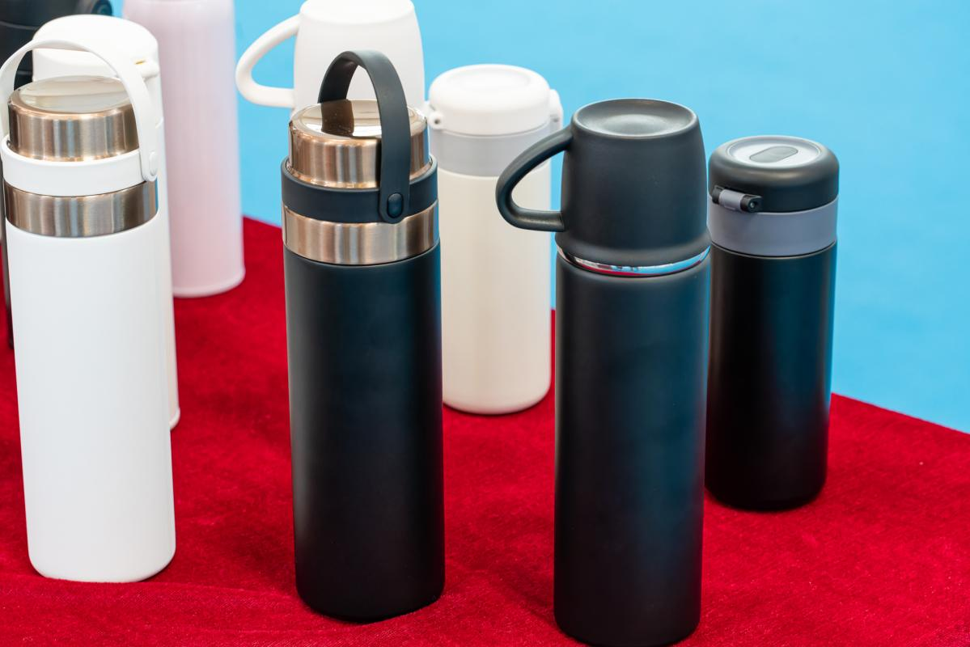
Figure: Reusable and sustainable drinkware options
(Source: LinkedIn, 2024)
Reusable and Bio-degradable straws and bottles- The core products of the company offer reusable water bottles and biodegradable straws. The bottles are made from stainless steel and sustainable bamboo which makes them lightweight and durable. The variety of products with customization cater to diverse customers and the multifunctional and leak-proof feature accompanied with insulated interiors keep the beverages hot or cold for an extended period. The bottles are specially crafted to become long-lasting reducing early replacements. The straws are also made from plant-based materials and bamboo which are durable enough for daily use and break down naturally. Bio-degradable straws and bottles are significant to reduce the use of single-use plastic that causes ocean pollution (Raghunathan et al., 2022). The straws come with a reusable carrying case which is more convenient.
Customization and partnership with environmental organization -The customization opinion in the drinkware industry is unique as the customers will be able to customise the designs, patterns and products willingly which is more functional and carries a fashion statement as well. The service appeals to eco-conscious individuals and corporate clients as well who prefer sustainable products and look for eco-friendly options. Commitment to the environmental cause and partnering with environment-friendly organizations help a new business gather a loyal customer base (Alam and Islam, 2021). These are mainly focused on plastic waste reduction and ocean cleanups where a portion of the profit will be donated to reinforce the mission of the company to enhance positive impacts on the environment.
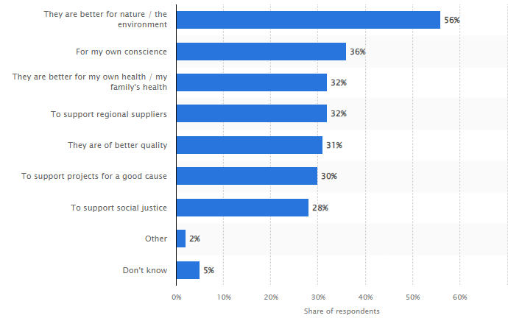
Figure: Reasons for sustainable food or drink product purchase in the UK
(Source: Statista, 2023)

Legal format of the startup company
An entrepreneurial company must adhere to the legal format in the UK to define the liability, business structure, tax obligations and regulatory requirements. EcoSip Hydration would be a private Limited Company (Ltd.) that will offer limited liability, flexibility and growth potential for an ideal sustainable business. The company will use the personal assets of the shareholders which are protected. For entrepreneurial business ideas, the protection of personal assets is essential for the founders to minimize financial risks (Amit et al., 2022). The company will be owned by the shareholders and management by the CEO and other directors as well. The directors including the founders in the early stage keep control over the strategic decisions of the business. The investors will gain shares as partners and it will raise the capital of the business. EcoSip Hydration will be subject to the UK Corporation tax on profits which is currently set at 25% for most of the business in 2024. Directors will receive salaries and shareholders will receive dividends by proper planning to gain tax benefits. The business profits of an entrepreneurial business can retain future expansion by benefiting from lower tax rates compared to the sole traders (Gordon, 2018). The company will also adhere to the legal obligations including filing accounts with Companies House, VAT registration and complying with UK employment laws as well. The company will also adhere to the UK Environmental Management System (EMS) standards like ISO 14001 which will help the company to implement sustainable practices by reducing environmental impact further.

Management of the company
A focus on sustainability and efficient management is highly needed to align business practices with eco-friendly goals that ensure market competitiveness and profitability.
Owners and leadership
The company will be led by the founder initially and as the primary owner and he as a CEO will include other directors to consider sound decision-making, market expansion, product development and marketing initiatives as well. The founder and owner of the company prioritizes sustainable business practices and product designs to set the values and vision of the company and ensure sustainability which is embedded in the business (Bocken and Geradts, 2020). The key roles include chief Executive Officer (CEO) or managing director, Chief Operating Officer (COO), Chief Marketing Officer (CMO) and Chief Financial Officer (CFO) who will showcase their leadership traits.
Employees
For a small business startup like EcoSip Hydration, the company will start with a lean team and the initial staff will include full-time employees and freelancers to support diverse core functions. The product designers will design eco-friendly hydration options to align with the sustainability goals of the company. Their expertise will ensure the aesthetic appeal and functionality of the company. The marketing and sales executives play major roles in introducing a newly launched company product to drive sales through online and offline channels (Lapoule and Colla, 2016). The operations and Logistics team will ensure green supply chains, lean inventory management and sustainable practices for manufacturing and delivery to ensure all the processes adhere to sustainable practices. High-quality customer interaction and post-purchase support are offered by the customer service representatives to maintain loyalty and customer satisfaction.
External professional services/experts
The company will require external expertise also for critical situations such as legal experts to maintain the environmental laws with proper legal consultation and navigate further compliances with relevant certifications and guidance as well. Sustainability consultants are also necessary to ensure a sound business process including sourcing, manufacturing and packaging adhere to best sustainable practices (Alayón et al., 2017). It will support the company to achieve better transparency. The company will also need financial audit experts for pepper planning that seeks investments. E-commerce specialists and It specialists will also assist with managing and developing offline stores and ensure digital transactions, cybersecurity with sound data privacy. External digital marketing agencies will be hired further to promote the brand through online campaigns, SEO and influencer collaborations.

Evaluation of the business idea by using the SWOT analysis model
A SWOT analysis model offers a strategic evaluation of the new business idea along with identifying the strengths, weaknesses, opportunities and threats as well. This framework will significantly help to assess and evaluate the business idea of EcoSip Hydration concerning the viability and future potential of the company in the competitive eco-friendly market of the UK.
Strengths  - Focus on sustainability  - Growing market trends  - Customization options  - Positive brand image | Weaknesses  - Higher initial costs  - Limited market penetration  - Challenges to maintain green supply chain
Opportunities  - Expansion of the existing product lines  - Profitable corporate partnerships  - E-commerce growth | Threats  - Higher market competition  - Changing regulations in the UK  - Economic downturns and market volatility

(Created by the Learner)
The strengths of the company highlight its central focus on eco-friendly and biodegradable products which appeal strongly to environmentally conscious customers. The use of biodegradable materials and reusable designs helps to meet the evolving consumers' demands for sustainable and responsible choices (Moshood et al., 2022). Options for customization of bottles and straws improve the hydration of corporate clients and individual consumers along with enhancing awareness by reducing single-use plastic that harms the planet. These products can profit the ocean cleanups that can maintain the ethical image of the company along with fostering consumer trust. Besides the strengths, the business ideas also include some weaknesses including high initial costs for manufacturing and sourcing sustainable products, and eco-friendly materials that are higher in price than the conventional alternatives. This affects the profit margins at the initial stages. As a new business, the company can face challenges in facilitating customers and grabbing recognition while competing with the existing brands. Sourcing sustainable products and materials can offer logistic challenges that potentially affect the costs and production (Hsu et al., 2016).
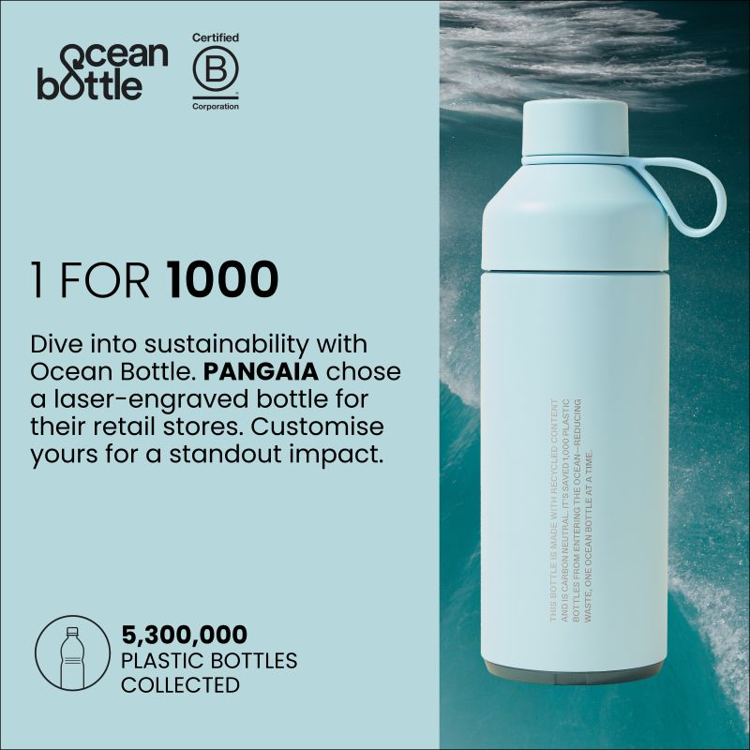
Figure: Pangaia’a ocean bottle available in the UK store
(Source: LinkedIn, 2023)
The opportunities include expansion of the existing products such as eco-friendly lifestyle products, and compostable packaging that can enhance market reach. It has further options to collaborate with eco-friendly organizations to boost sales and brand exposure. The rise of e-commerce also offers the opportunity for the company to reach global audiences in online markets and digital marketing. In addition to this, the threats include intense market competition, new entrant issues, changing regulations and policies and economic hardships that demand low-cost alternatives.

Apply the 4Ps of marketing to your business idea
- Product- EcoSip Hydration will offer eco-friendly drinkware options such as bamboo and stainless steel reusable bottles and biodegradable bamboo and plant-based materials made stars. The core products are extremely functional, well-designed, and well-crafted to meet the contemporary needs of society along with meeting the needs of the broad customer base. These products can replace single-use plastic and offer customization options to the customers to retain a loyal customer base.
- Price- Value-based Pricing strategy is significant for an entrepreneurial business that deals with eco-friendly alternatives (Ottman, 2017). The company will opt for this pricing strategy to position it as one of the premium drinking options in the UK. this will reflect the values of the products according to the costs and the features like leakage-proof, highly durable and customization will raise the price points along with maintaining the pace of competitiveness in the sustainable product markets in the UK to attract wonder customers.
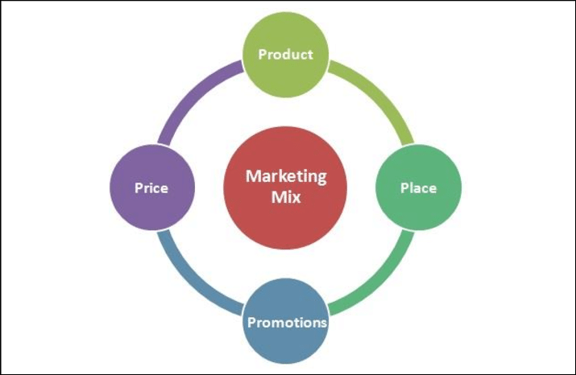
Figure: 4P’s Marketing Mix
(Source: Surtawijaya and Soegoto, 2020)
- Place- The company will leverage multi-channel distribution strategies through websites, social media platforms and e-commerce platforms like Amazon to reach broader audiences. Facilitating retail partnerships with eco-friendly retailers and healthy food stores can also help the sustainable drinkware company (Doherty et al., 2020). It will target businesses and corporate events across the UK by offering custom-branded products for better promotion.
- Promotion- The company will further focus on digital marketing, social media marketing, influencer collaborations, environmental partnerships and content marketing by leveraging Instagram, Facebook, eco-lifestyle space along co-branded campaigns along with reducing single-use plastics.

A cash flow forecast for the first 12 months
The company will start with initial funding of € 25000 for several expenses in product development, website building, e-commerce setup, legal and registration fees, packaging and shipping materials and miscellaneous as well. Gradually the company will improve investments such as and at the end of the year the investments will be more than € 42000. The sales figure will also vary from 2000 to 3000 in individual months as well which will reflect the overall growth possibilities along with the total cash flow which will hit to € 29000 in December. The raw material charges will be the same approximately throughout the year as expected. Similarly, the operational costs for the other operations will also remain the same throughout the year as expected. The outflow of cash for buying new machinery and other accessories is significant in the first two months and the line of credit interest will be same every month as assumed. Finally, the net cash flow in the last months will reach to more than € 68000.

Conclusion
Thus, it can be included that it is significant for entrepreneurship to achieve success and meet organisational goals along with facilitating business management including the development of tailored strategy, adequate marketing, financial management, operation and human resource management as well. The management structure of EcoSip Hydration is crucial to ensure smooth operations and growth as well. The 4P’s Marketing include Product, Price, Place and Promotion which are major elements while crafting the use of marketing strategies to effectively reach the target market for the company. EcoSip Hydration aims to target health and eco-conscious consumers who prioritize sustainability without sacrificing designs and multi-functionality along with maintaining legal format, steady structure and tailored marketing strategies.

References
Alam, S.S. and Islam, K.Z., 2021. Examining the role of environmental corporate social responsibility in building green corporate image and green competitive advantage. International Journal of Corporate Social Responsibility, 6(1), p.8.
Alayón, C., Säfsten, K. and Johansson, G., 2017. Conceptual sustainable production principles in practice: do they reflect what companies do?. Journal of cleaner production, 141, pp.693-701.\
Amit, R., Glosten, L. and Muller, E., 2022. Entrepreneurial ability, venture investments, and risk sharing. In Venture Capital (pp. 135-148). Routledge.
Bocken, N.M. and Geradts, T.H., 2020. Barriers and drivers to sustainable business model innovation: Organization design and dynamic capabilities. Long range planning, 53(4), p.101950.
Doherty, B., Haugh, H., Sahan, E., Wills, T. and Croft, S., 2020. Creating the New Economy: Business models that put people and planet first.
Gordon, R., 2018. How should taxes be designed to encourage entrepreneurship?. Journal of Public Economics, 166, pp.1-11.
Hsu, C.C., Tan, K.C. and Mohamad Zailani, S.H., 2016. Strategic orientations, sustainable supply chain initiatives, and reverse logistics: Empirical evidence from an emerging market. International journal of operations & production management, 36(1), pp.86-110.
Lapoule, P. and Colla, E.B., 2016. The multi-channel impact on the sales forces management. International Journal of Retail & Distribution Management, 44(3).
LinkedIn (2023) Ocean Bottle on LinkedIn: The World’s Most Needed Reusable Water Bottle. Available at: https://www.linkedin.com/posts/the-ocean-bottle_the-worlds-most-needed-reusable-water-bottle-activity-7135960896165548032-5SNn (Accessed: 15 October 2024).
LinkedIn (2024) Ellen Gracia on LinkedIn: Too much of a good thing? The environmental downside of the ‘Stanley cup’... Available at: https://www.linkedin.com/posts/egracia_too-much-of-a-good-thing-the-environmental-activity-7208534672320905216-ilkf (Accessed: 15 October 2024).
Moshood, T.D., Nawanir, G., Mahmud, F., Mohamad, F., Ahmad, M.H. and AbdulGhani, A., 2022. Biodegradable plastic applications towards sustainability: A recent innovations in the green product. Cleaner Engineering and Technology, 6, p.100404.
Ottman, J., 2017. The new rules of green marketing: Strategies, tools, and inspiration for sustainable branding. Routledge.
Raghunathan, R., Nelluri, P., Rajendran, D., Pandiselvam, R., Thulasiraman, V., Sahoo, S.K., Pillai, S. and Jerome, R.E., 2022. Biodegradable Products from renewable sources: Impact on Replacing Single Use Plastic for Protecting the Environment.
Ramirez, J.G.C., 2024. The power of planning: how business plans drive effective management strategies. Integrated Journal of Science and Technology, 1(3).
Statista (2023) Drivers of sustainable food/beverage purchases in the UK 2021, Statista. Available at: https://www.statista.com/forecasts/1241126/drivers-of-sustainable-food-beverage-purchases-in-the-uk (Accessed: 15 October 2024).
Surtawijaya, A.A.A. and Soegoto, D.S., 2020, January. Developing Strategic Marketing Plan for Artificial Flower Bouquet Business in Bandung. In International Conference on Business, Economic, Social Science, and Humanities–Economics, Business and Management Track (ICOBEST-EBM 2019) (pp. 29-31). Atlantis Press.
Vadakkepatt, G.G., Winterich, K.P., Mittal, V., Zinn, W., Beitelspacher, L., Aloysius, J., Ginger, J. and Reilman, J., 2021. Sustainable retailing. Journal of Retailing, 97(1), pp.62-80.

 | Jan | Feb | Mar | April | May | June | July | Aug | Sep | Oct | Nov | Dec | Total
Balance in the beginning of the year | 25000 | 28000 | 29000 | 30000 | 25000 | 31000 | 33546 | 35876 | 37987 | 38765 | 40987 | 42345
Cash Inflows
Sales | 2000 | 2000 | 2344 | 3455 | 2398 | 2423 | 2456 | 2342 | 2675 | 2765 | 2987 | 2987 | 30832
Debtors collection | 0 | 0 | 0 | 0 | 0 | 0 | 0 | 0 | 0 | 1000 | 1000 | 1000 | 3000
Total cash inflows in the business | 5000 | 4000 | 6000 | 7000 | 7000 | 8000 | 9000 | 12000 | 15000 | 18000 | 22000 | 25000 | 29000
Cash Outflows
Cash outflow through operating activities
Cost to buy raw materials | 1000 | 1000 | 1000 | 1000 | 1000 | 1000 | 1000 | 1000 | 1000 | 1000 | 1000 | 1000 | 12000
Cost for other activities for operations | 500 | 500 | 500 | 500 | 500 | 500 | 500 | 500 | 500 | 500 | 500 | 500 | 6000
Cash outflow for investing activities
Outflow of cash for buying new machineries | 3000 | 5000 | 0 | 0 | 0 | 0 | 0 | 0 | 0 | 0 | 0 | 0 | 8000
Cash outflow for buying new production accessories | 2000 | 2000 | 0 | 0 | 0 | 0 | 0 | 0 | 0 | 0 | 0 | 0 | 4000
Cash outflow due to financing activities
Interest payment | 0 | 0 | 0 | 0 | 0 | 0 | 0 | 0 | 0 | 0 | 200 | 200 | 400
The line of Credit Interest | 200 | 200 | 200 | 200 | 200 | 200 | 200 | 200 | 200 | 200 | 200 | 200 | 2400
Total outflow of cash | 700 | 800 | 700 | 900 | 700 | 800 | 700 | 700 | 700 | 700 | 800 | 800 | 9000
Net Cash Flows | 1900 | 2000 | 3100 | 4500 | 4700 | 4900 | 5145 | 5398 | 7876 | 9823 | 9598 | 9923 | 68863

