14th April 2022
Network Configuration and Administration
Introduction to Computer Systems
Barry Bradshaw
1909431
Contents
Figure List 3
Introduction 4
Virtual Machines 5
Adding Clients onto the server 9
Cloning clients 10
IP addresses 11
IP address testing 13
Connecting to Domain 14
Downloading applications 16
Running Utility applications 17
Conclusion 18
References 19
Bibliography 20

Figure List
Figure 1 - Completed Server (before Windows server or clients have been added) 5
Figure 2 - Creating a new Server on VirtualBox 5
Figure 3 - Partitioning the Hard Drive to allocate 20GB 6
Figure 4 – The file to download Windows Server onto Server. 6
Figure 5 - Installation of Windows Server onto Server 6
Figure 6 - Selection of features required on the server. 6
Figure 7 - Fully Completed server, ready for installation of clients. 6
Figure 8 - Warnings given before installing domain to server. 7
Figure 9 - Adding features required for Active Directory Domain Services. 7
Figure 10 - Verifying NetBIOS name assigned to domain. 7
Figure 11 - Setting a new forest for server domain. 7
Figure 12 - Setting domain password. 7
Figure 13 - Automatically logging out after domain settings had been applied. 7
Figure 14 - Adding admin settings to server 8
Figure 15 - New admin user has been added. 8
Figure 16 - New admin user Barry Bradshaw being added to server 8
Figure 17 - Admin Status confirmed. 8
Figure 18 - Windows 10 file ready to be downloaded onto the client. 9
Figure 19 - Installation of client 1 onto the server. 9
Figure 20 - Windows 10 installing onto client. 9
Figure 21 - Inserting Windows Key 9
Figure 22 - Final steps of Windows 10 installation. 9
Figure 23 - Cloning client one to create more clients. 10
Figure 24 - Setting DNS client IP address the same as on the server 11
Figure 25 - Setting up Static IP on server 1 11
Figure 26 - Setting up the DHCP's IP addresses 12
Figure 27 - Setting the range of the DHCP server. 12
Figure 28 - DHCP Scope setup and that the IP's are configured ready for client connection. 12
Figure 29 - Setting how long the IP address can be used by the client. 12
Figure 30 - Client is connected to DHCP server and IP address has been assigned. 12
Figure 31 - Using the ipconfig/all command to show the IP addresses 13
Figure 32 - Testing if the assigned IP address had worked. 13
Figure 33 - Testing cloned server had the correct IP addresses. 13
Figure 34 - Connecting client to server. 14
Figure 35 - Setting remote connections to allow on servers and clients 14
Figure 36 - The connection of the client to the server’s domain 14
Figure 37 - Client is connected to the local server (@bazz.local) 15
Figure 38 - Confirmation of client connection to local server (@bazz.local). 15
Figure 39 - Installation of Google Chrome 16
Figure 40 - Installation of Spotify 16
Figure 41 - Installation of CPU-z 16
Figure 42 - Running the resource monitor utility application 17
Figure 43 - Running the CPU-Z utility application 17

Introduction
The aim of this assignment is demonstrating the ability to install and manage a networked computer, utilising the software provided to create several virtual machines in order to show understanding of how a variety of network configurations work.
Firstly, several virtual computers (each referred to as a client) will be created using the program VirtualBox, which will have an operating system installed upon them which should run automatically when the virtual computer is powered on. These clients will be added to a server also created on VirtualBox.
Each computer in the network will have a static IP address, configured using the network set up pages, which will then be verified using the command line function and associated networking commands such as ipconfig, ipconfig/all and ping.
There will then be a demonstration of the usage of Utility Software, and that basic applications can be installed onto and be used on the virtual computers. A couple of different applications will be installed on the systems, as they will have different requirements of the virtual computer to prove that set-up has been successful.
Next, one of the servers will be made the Primary Domain Controller and DNS (Domain Name System), where a client will then be used to join the domain that was created.
Finally, a DHCP (Dynamic Host Configuration Protocol) server will be created, and the virtual computer will be reconfigured to automatically acquire an IP address from the DHCP server.

Virtual Machines
A virtual machine is a program that acts like a computer, complete with a CPU (Central Processing Unit) and memory, with the biggest difference being that it only exists within a program within your computer. It has no physical properties and is “often thought of as virtual computers or software-defined computers within physical servers, existing only as code” (Microsoft, n.d).
Virtual machines behave like a physical computer and are often utilised to operate a different operating system than that of the physical computer and run separate from the physical computer, the partition meaning that the software used on the virtual machine cannot interfere with the physical computers operating system. This means that Virtual Machines can be very useful for accessing data that is infected with a virus to protect all of the other data in your computer. As different operating systems can be used on a virtual machine, it means that programs and software that were not made for the physical computer’s operating system can be downloaded and used.
The program utilised to create virtual machines for this assignment was VirtualBox. Overall, this program was simple to use with plenty of support available online when problems were encountered. VirtualBox was easy to install, and the booting time of the virtual machine was fast compared to other options to like VMware which seems a lot slower. Using VirtualBox did not significantly slow down the host computer when running, indicating that it only uses a small amount of resources (compared to alternative software that allows virtual machines to be created).
Figure 1 shows a screenshot of the first server being created, using the program VirtualBox, where the Virtual Machines will be entered onto.
Figure 2 shows a screenshot of the completed server, before Windows server and any clients have been added.
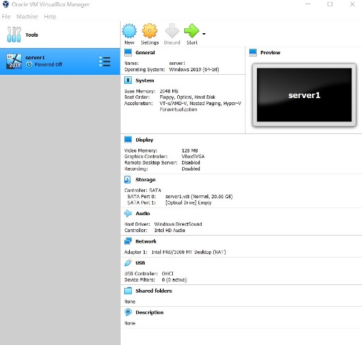
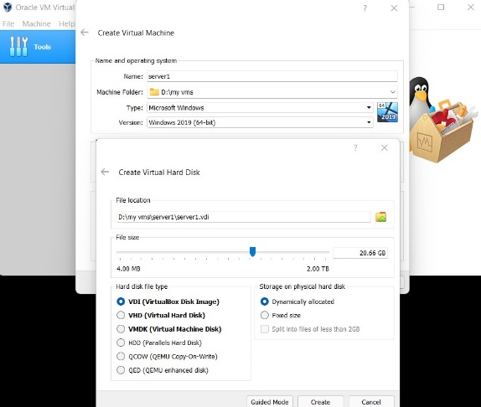
Figure 1 - Completed Server (before Windows server or clients have been added)
Figure 2 - Creating a new Server on VirtualBox

Figure 4 shows a screenshot of the files to download Windows Server onto the Server.
Figure 3 shows a screenshot of the process of partitioning the host computer’s hard drive, to allocate 20GB of storage.
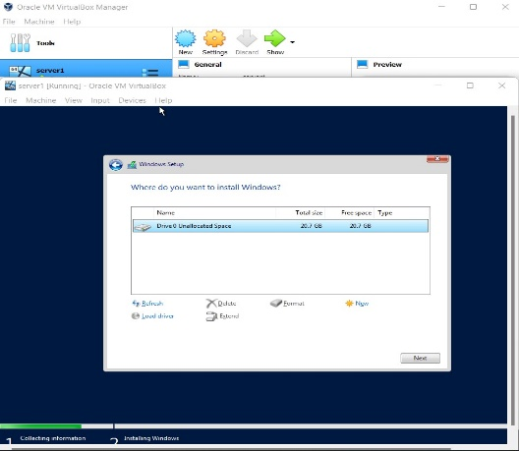
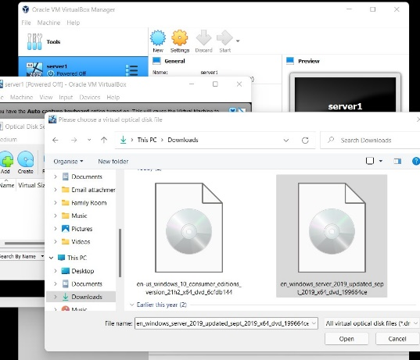
Figure 3 - Partitioning the Hard Drive to allocate 20GB
Figure 4 – The file to download Windows Server onto Server.

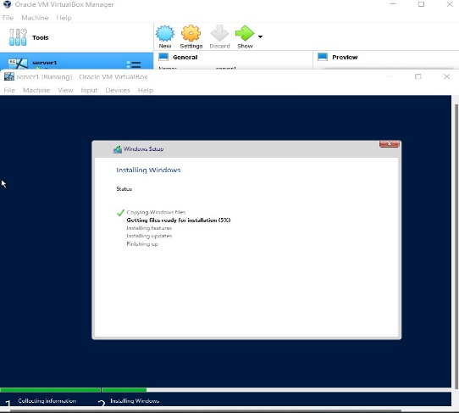
Figure 5 shows the installation of the Windows Server onto the Server
Figure 5 - Installation of Windows Server onto Server

Figure 6 shows a screenshot of the fully completed server, ready for installation of clients.
Figure 7 shows a screenshot of the selection of the features required on the server.
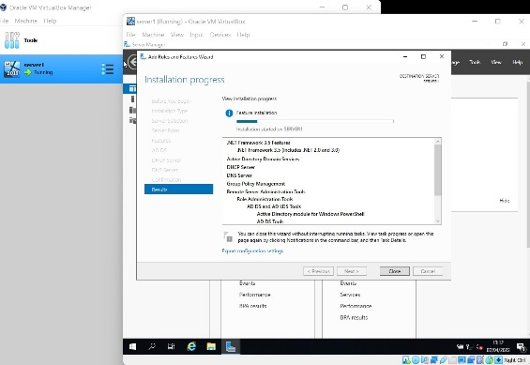
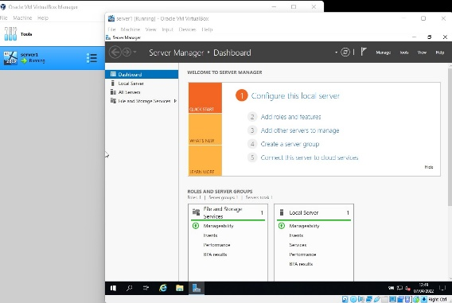
Figure 6 - Selection of features required on the server.
Figure 7 - Fully Completed server, ready for installation of clients.

Figure 8 shows a screenshot of adding features that are required for the Active Directory Domain Services.
Figure 9 shows a screenshot of the warnings given before installing domain to server.
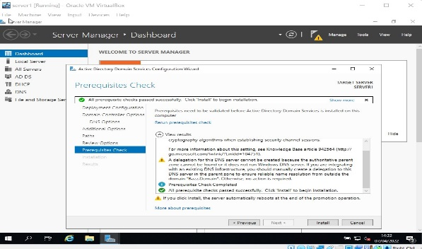
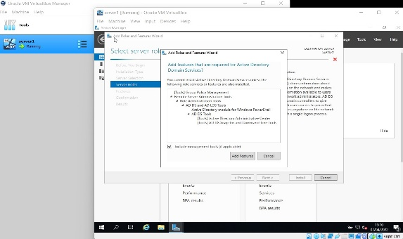
Figure 8 - Warnings given before installing domain to server.
Figure 9 - Adding features required for Active Directory Domain Services.

Figure 10 shows a screenshot of setting a new forest for server domain.
Figure 11 shows a screenshot of verifying NetBIOS name assigned to domain.
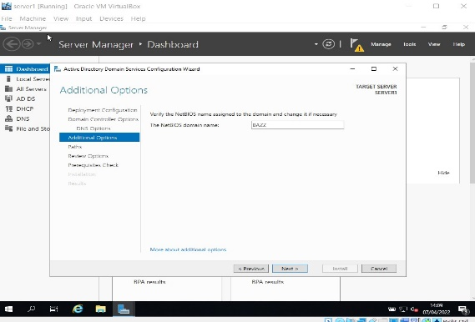
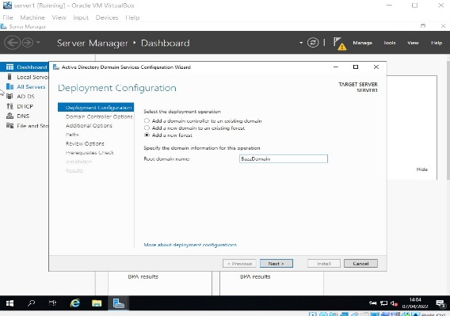
Figure 10 - Verifying NetBIOS name assigned to domain.
Figure 11 - Setting a new forest for server domain.

Figure 12 shows a screenshot of the logging out of the server once the domain settings had been applied.
Figure 13 shows the setting of the domain password.
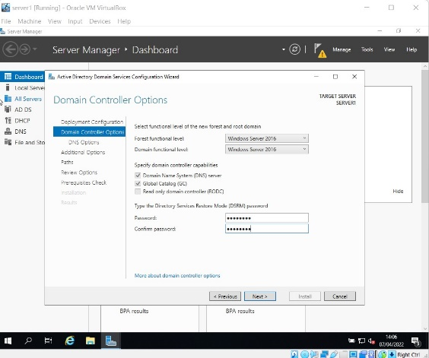
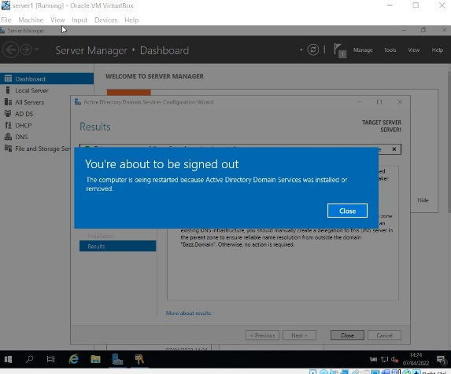
Figure 12 - Setting domain password.
Figure 13 - Automatically logging out after domain settings had been applied.
Figure 14 shows a screenshot of adding admin settings onto the server for use later when adding clients.
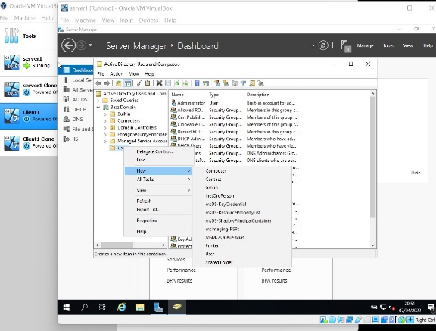
Figure 14 - Adding admin settings to server

Figure 16 shows a screenshot of adding a new admin user.
Figure 15 shows a screenshot that the new admin user has been created.
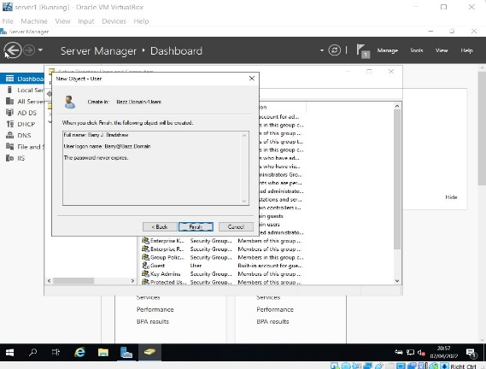
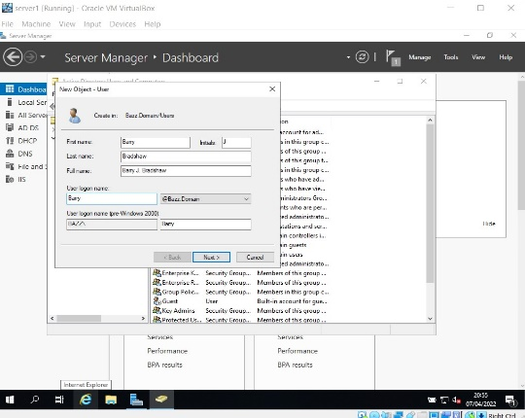
Figure 15 - New admin user has been added.
Figure 16 - New admin user Barry Bradshaw being added to server

Figure 17 shows a screenshot that the admin user has been confirmed.
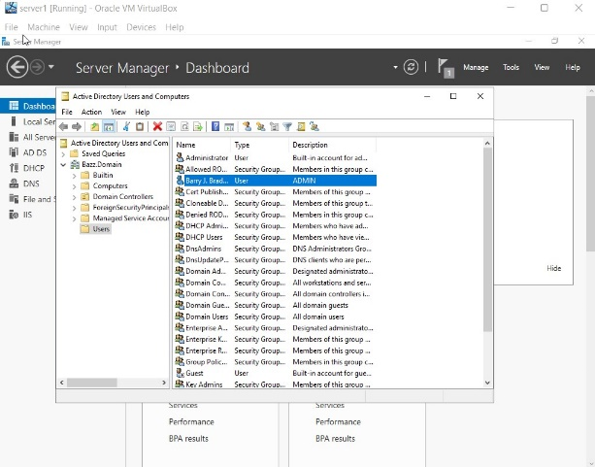
Figure 17 - Admin Status confirmed.

Adding Clients onto the server
Figure 18 shows a screenshot of the installation of a client onto the server.
Figure 19 shows the Windows 10 file ready to be downloaded onto client 1.
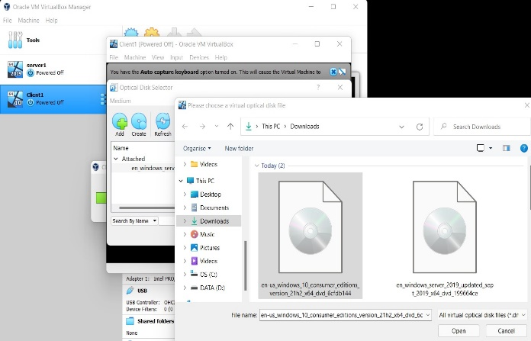
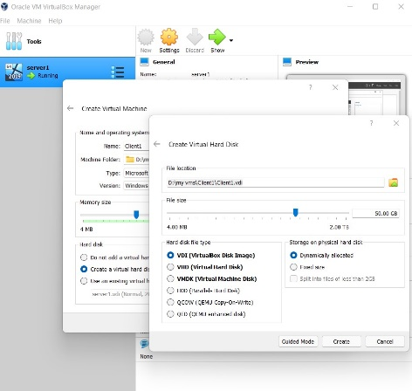
Figure 18 - Windows 10 file ready to be downloaded onto the client.
Figure 19 - Installation of client 1 onto the server.

Figure 20 shows Windows 10 installing onto client.
Figure 21 shows the screen where the Windows key was inserted.
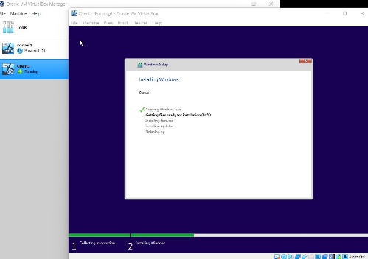
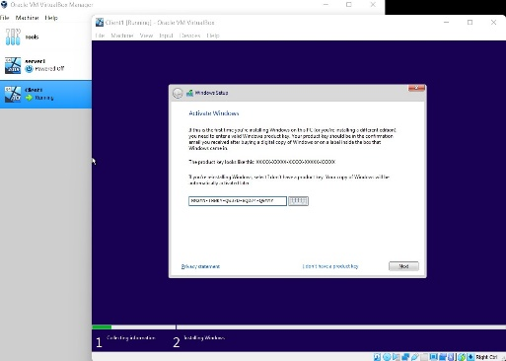
Figure 20 - Windows 10 installing onto client.
Figure 21 - Inserting Windows Key

Figure 22 shows the final steps of the Windows 10 installation.
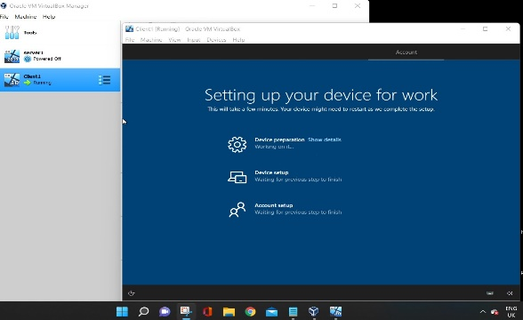
Figure 22 - Final steps of Windows 10 installation.

Cloning clients
Rather than installing windows onto each client individually, it was decided to clone the clients after the windows 10 operating system had already been installed.
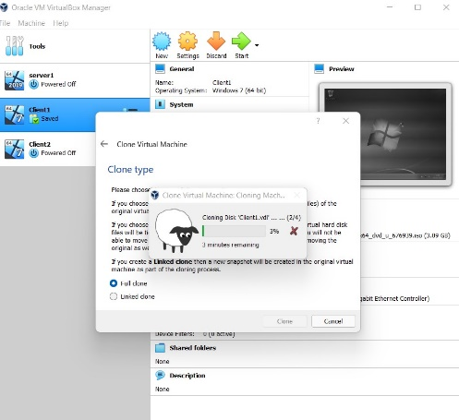
Figure 23 - Cloning client one to create more clients.

IP addresses
An IP (Internet Protocol) address is a unique code given to a device which can connect to the internet or a local network. The internet Protocol is a set of rules regarding the formatting of data which is sent via the internet or between devices on a local network. IP addresses act as an identity for the device, which the internet needs in order to show where to send the requested information. Websites also have IP addresses so when a data request is sent between a device and a website the internet knows where the information is being gathered from and where it’s going.
The internet is essentially a mailman – without addresses on the letters nothing is going to get to the right place.
IP addresses are made up of a string of four numbers, each between 0 and 255 separated by periods. An example of an IP address might look like this: 200.150.15.2. However, IP addresses are not randomly assigned – they are produced using an algorism “and allocated by the Internet Assigned Numbers Authority (IANA), a division of the Internet Corporation for Assigned Names and Numbers (ICANN)” (Kaspersky.com, n.d.). Once a domain has been bought, they go through a domain registrar and pay a fee to the ICANN who registers the domain and assigns the IP address to the domain name (although there is a few free ways to do this).
For a home computer, it is the job of the Internet Service Provider (Virgin Media, BT, TalkTalk, Sky, etc) to provide your devices with an IP address, as it is their job to provide the device with an internet connection. However, for a company device, many larger companies prefer to automatically assign IP addresses via a Dynamic Host Control Protocol (DHCP). A DHCP is a “client/server protocol that automatically provides an Internet Protocol (IP) host with its IP address and other related configuration information such as the subnet mask and default gateway” (Gerend et al, 2021).
IP addresses can also change (unless a static IP has been set to the device) if the device moves location and connects to another Internet Service Provider, such as connecting to a hotel’s WIFI – where a temporary IP address will be assigned to your device.
Figure 24 shows the setting up of a static IP address on server one.
Figure 25 shows that the DNS IP address is the same on the client as the server.
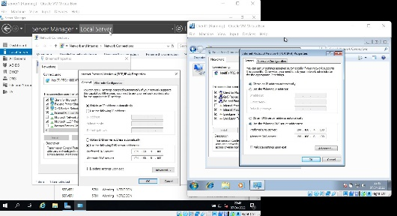
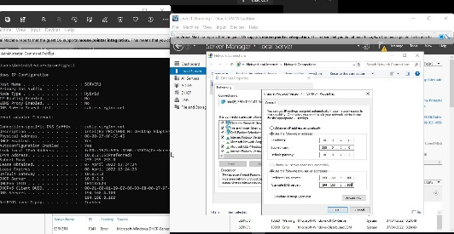
Figure 24 - Setting DNS client IP address the same as on the server
Figure 25 - Setting up Static IP on server 1

Figure 26 shows the setting up of the DHCP’s IP addresses.
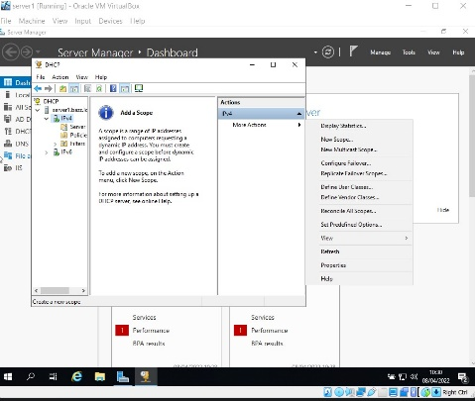
Figure 27 shows the setting of the range on the DHCP server.
Figure 26 - Setting up the DHCP's IP addresses
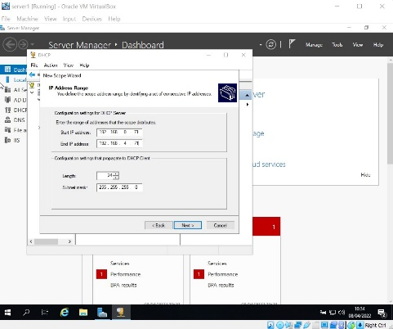
Figure 27 - Setting the range of the DHCP server.

Figure 28 shows the setting of how long each IP address can be used by the client.
Figure 29 shows the DHCP Scope setup, and that the IP's are configured ready for client connection.
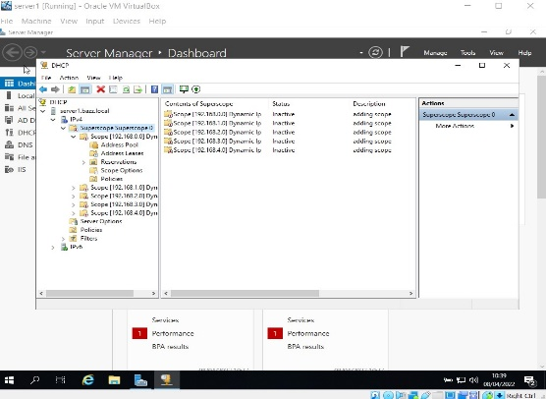
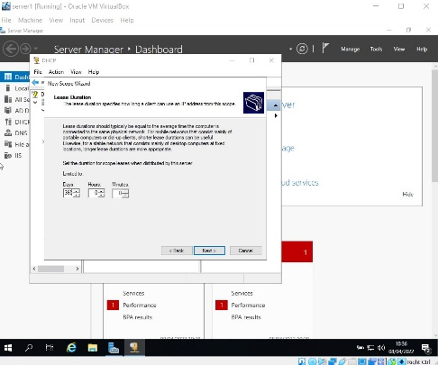
Figure 28 - DHCP Scope setup and that the IP's are configured ready for client connection.
Figure 29 - Setting how long the IP address can be used by the client.

Figure 30 shows that the client connected to the DHCP server, and a new IP address given.
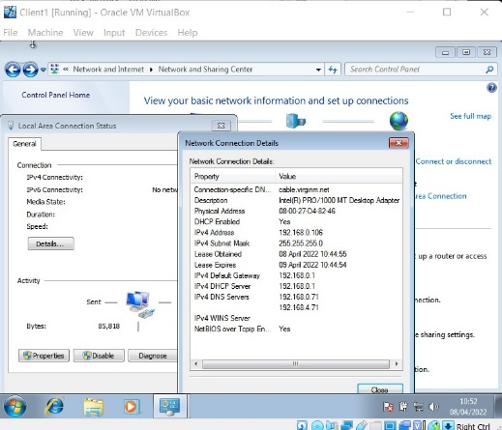
Figure 30 - Client is connected to DHCP server and IP address has been assigned.

IP address testing

Figure 31 shows that ipconfig was utilised to show the server and DNS IP addresses. The command ipconfig/all was used to show all the information at the same time.
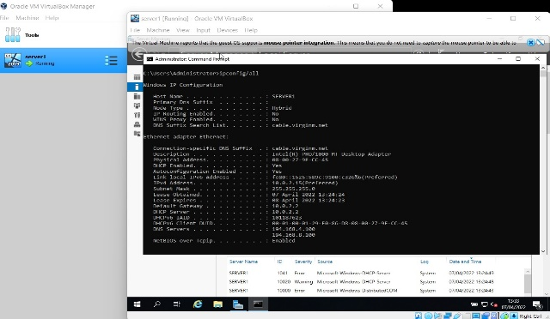
Figure 31 - Using the ipconfig/all command to show the IP addresses

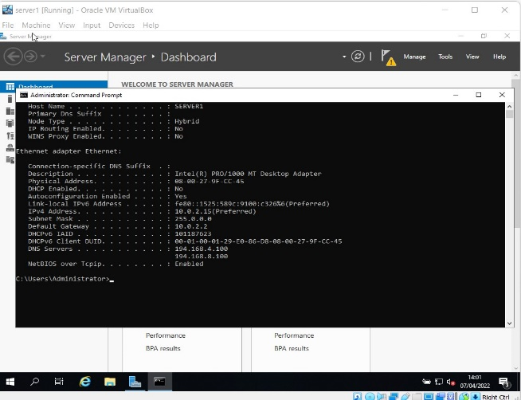
Figure 32 shows the testing to see if the IP address that had been assigned to the server had worked.
Figure 32 - Testing if the assigned IP address had worked.

Figure 33 shows the testing of the cloned server, checking the to see if the static IP addresses had been carried over correctly.
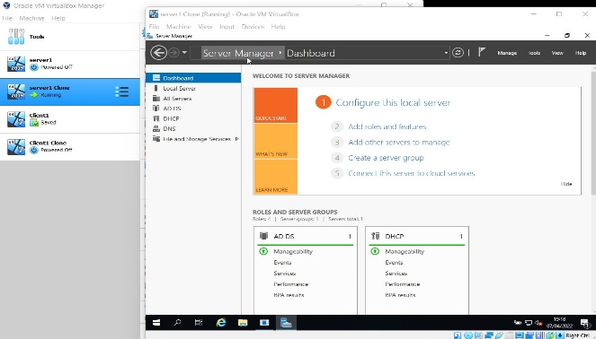
Figure 33 - Testing cloned server had the correct IP addresses.

Connecting to Domain

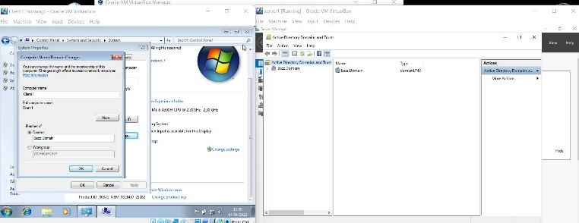
Figure 34 shows the connection of the client to the server.
Figure 34 - Connecting client to server.

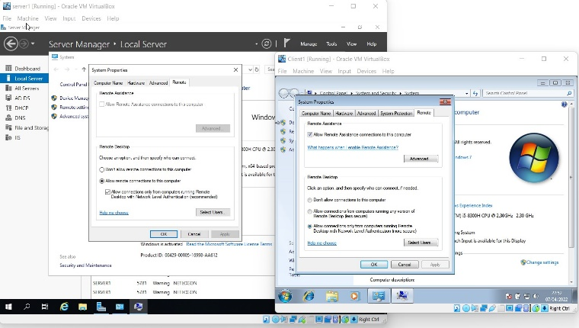
Figure 35 shows the setting of remote connections to allow on servers and clients.
Figure 35 - Setting remote connections to allow on servers and clients

Figure 36 shows the connection of the client to the server’s domain (@bazz.local) and the entering of the user account details.
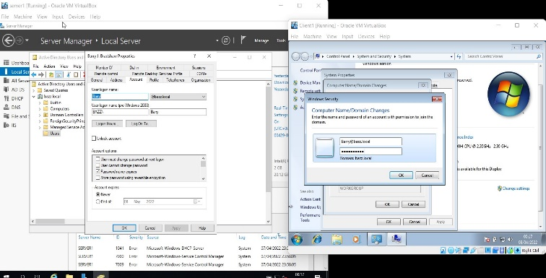
Figure 36 - The connection of the client to the server’s domain

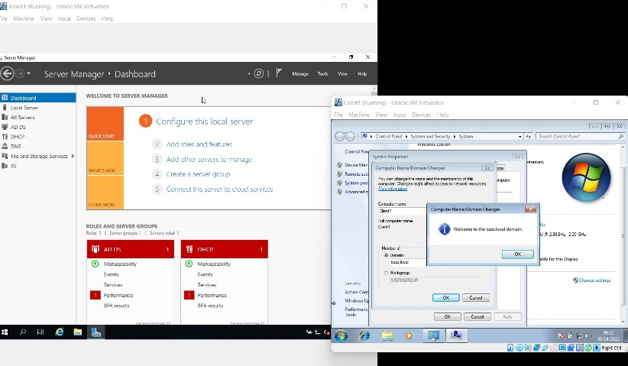
Figure 37 shows that the client is connected to the local server.
Figure 37 - Client is connected to the local server (@bazz.local)

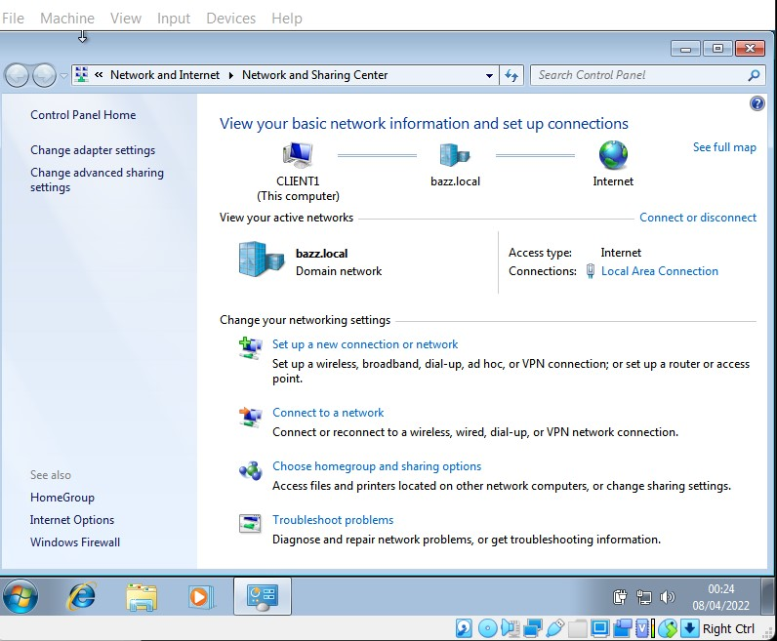
Figure 38 shows the confirmation of the client connection to the local server (@bazz.local).
Figure 38 - Confirmation of client connection to local server (@bazz.local).

Downloading applications

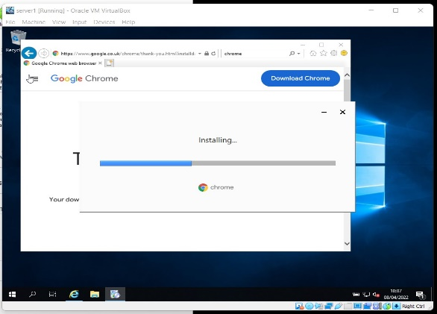
Figure 39 shows the installation of the Google Chrome application onto the server.
Figure 39 - Installation of Google Chrome

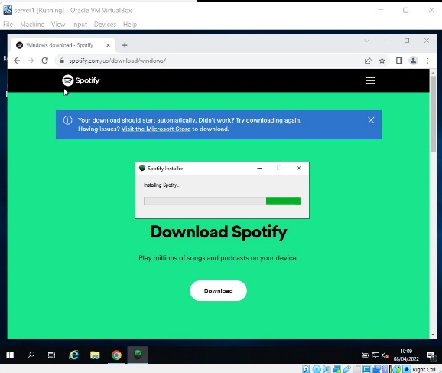
Figure 40 shows the installation of the Spotify application onto the server.
Figure 40 - Installation of Spotify

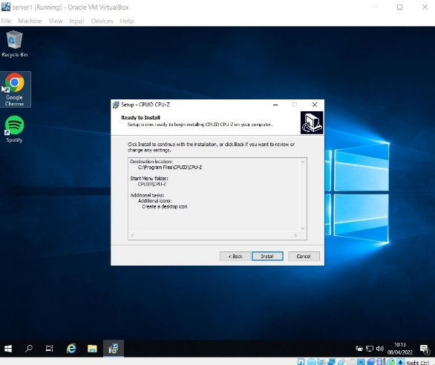
Figure 41 shows the installation of CPU-z utility application onto the server.
Figure 41 - Installation of CPU-z

Running Utility applications

Figure 42 shows the resource monitor running, which is a utility application which checks how much of the computer’s resources (CPU, Hard drive etc) are being used by an application.
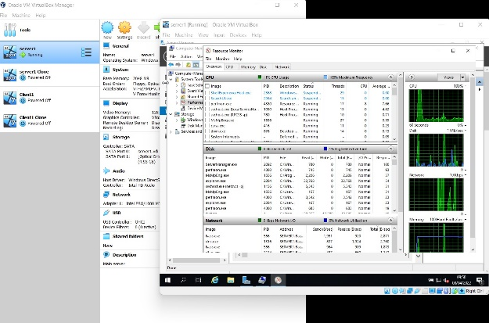
Figure 42 - Running the resource monitor utility application

Figure 43 shows the CPU-Z application running, which is a utility application which shows a range of data about the computer it is downloaded on, such as what Processor is used and what Memory the system has.
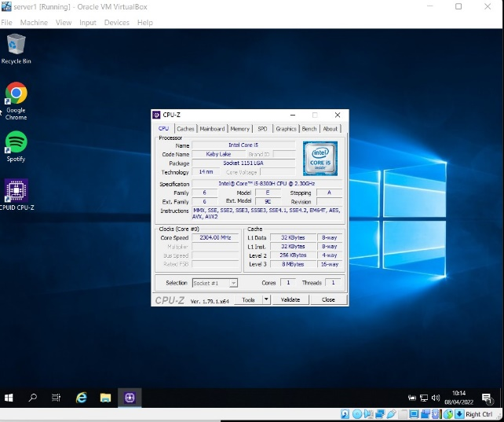
Figure 43 - Running the CPU-Z utility application

Conclusion
The goal of this assignment was to demonstrate the ability to set up and manage a small computer network. This was done by creating a server and then some client computers as virtual machines, utilising the VirtualBox program throughout which allowed for the completion of this work. Windows server 2019 was installed onto the server, and Windows 10 was installed onto the client as an operating system.
Once the servers and clients had been created, they were cloned to increase the number of machines in the network.
Following this the IP addresses were configured so that they were static and added features to the servers such as DHCP and DNS. These were all tested to ensure that the servers and clients were connected to the local network that was created (named @bazz.local).
Finally, several applications were downloaded and installed (such as Google Chrome and Spotify), and utility programs were run to show that they could work on the systems.

References

[1] (n.d.). Virtual machines: virtual computers within computers. Available: https://azure.microsoft.com/en-gb/overview/what-is-a-virtual-machine/#overview [Accessed 07 Apr 2022].
[2] (n.d.). What is an IP Address – Definition and Explanation. Available: https://www.kaspersky.com/resource-center/definitions/what-is-an-ip-address [Accessed 09 April 2022].
[3] (29 July). Dynamic Host Configuration Protocol (DHCP). Available: https://docs.microsoft.com/en-us/windows-server/networking/technologies/dhcp/dhcp-top#:~:text=Dynamic%20Host%20Configuration%20Protocol%20(DHCP)%20is%20a%20client%2Fserver,subnet%20mask%20and%20default%20gateway. [Accessed 10 April 2022].

Bibliography

[1] (n.d.). What is DNS?. Available: https://www.cloudflare.com/en-gb/learning/dns/what-is-dns/ [Accessed 07 Apr 2022].
[2] (n.d.). Virtual machines: virtual computers within computers. Available: https://azure.microsoft.com/en-gb/overview/what-is-a-virtual-machine/#overview [Accessed 07 Apr 2022].
[3] (12 May). Advantages and disadvantages of VirtualBox over VMWare. Available: https://www.geekboots.com/story/advantages-and-disadvantages-of-virtualbox-over-vmware [Accessed 08 April 2022].
[4] (n.d.). What is an IP Address – Definition and Explanation. Available: https://www.kaspersky.com/resource-center/definitions/what-is-an-ip-address [Accessed 09 April 2022].
[5] (07 July). How to Set Local IP Addresses. Available: https://smallbusiness.chron.com/set-local-ip-addresses-50561.html [Accessed 10 April 2022].
[6] (10 Feb). Home Network Addressing. Available: https://stevessmarthomeguide.com/home-network-addressing/ [Accessed 09 April 2022].
[7] (14 Oct). How to Set Up a Static IP Address. Available: https://uk.pcmag.com/networking/124250/how-to-set-up-a-static-ip-address [Accessed 10 April 2022].
[8] (n.d.). Data networks and IP addresses. Available: https://www.open.edu/openlearncreate/mod/oucontent/view.php?id=129584&printable=1 [Accessed 10 April 2022].
[9] (29 July). Dynamic Host Configuration Protocol (DHCP). Available: https://docs.microsoft.com/en-us/windows-server/networking/technologies/dhcp/dhcp-top#:~:text=Dynamic%20Host%20Configuration%20Protocol%20(DHCP)%20is%20a%20client%2Fserver,subnet%20mask%20and%20default%20gateway. [Accessed 10 April 2022].

