Assignment 1

Feasibility Plan for an International Meeting
Individual Presentations

SANTA’S WINTER EXPO

- Name: MARIANA MURESAN
- Student ID:2210334
- Module Title: INTERNATIONAL MEETINGS MANAGEMENT FOR THE HOTEL INDUSTRY
- Module code: BMIH6007
- Modulel lead: KATHRYN FLYNN

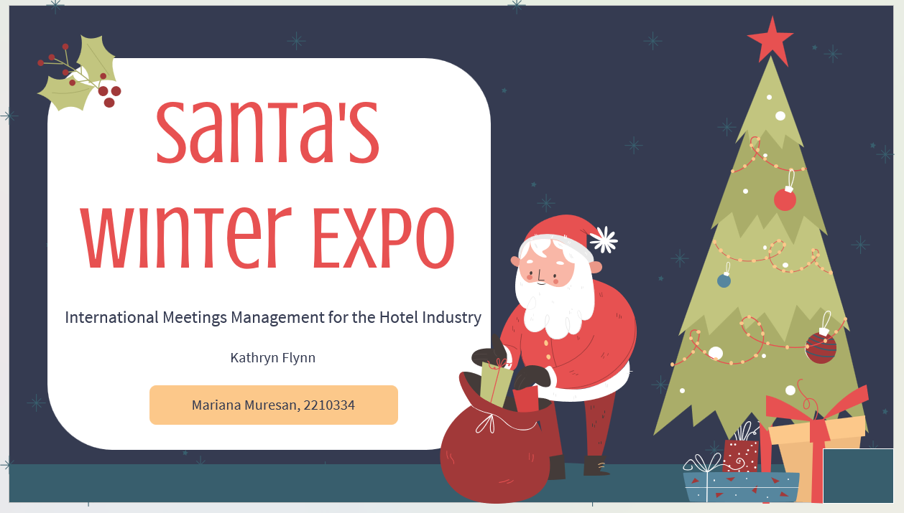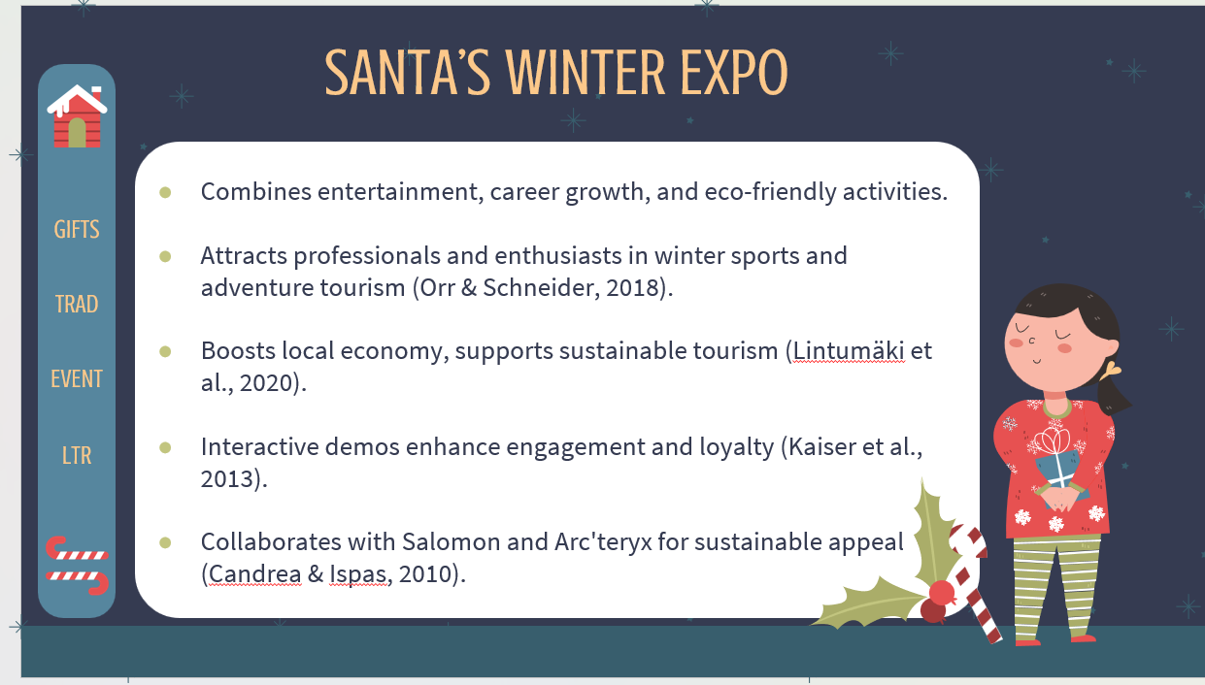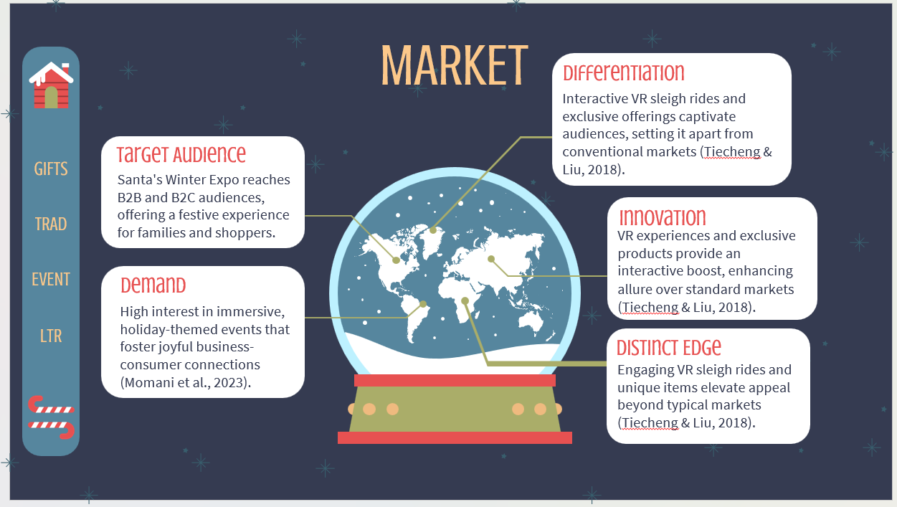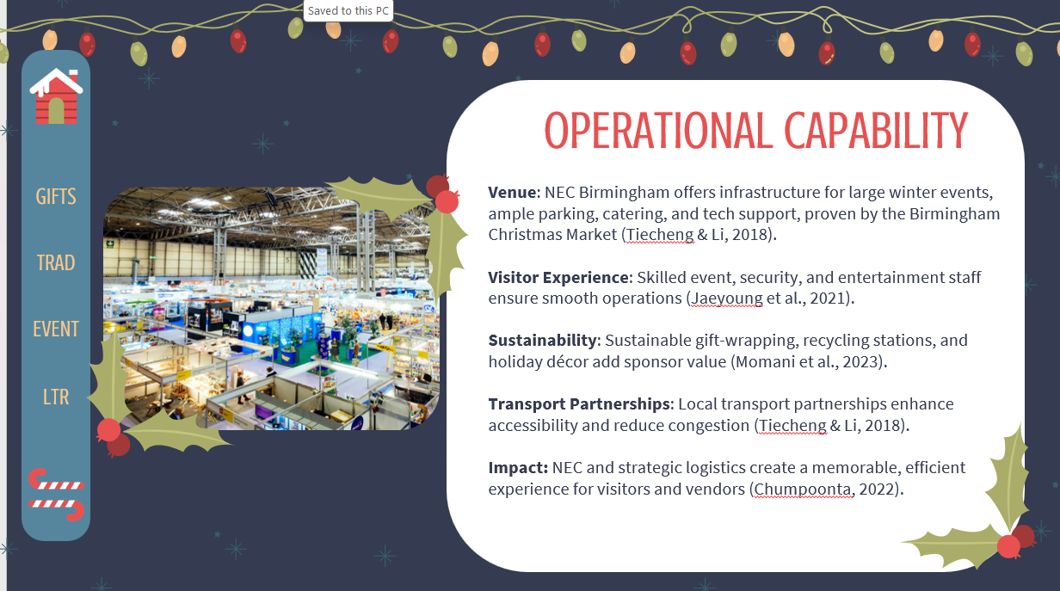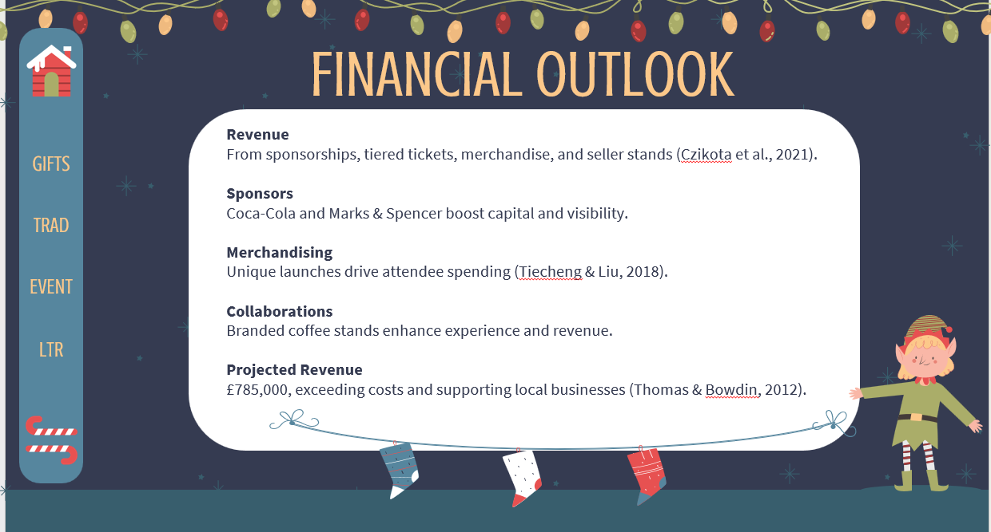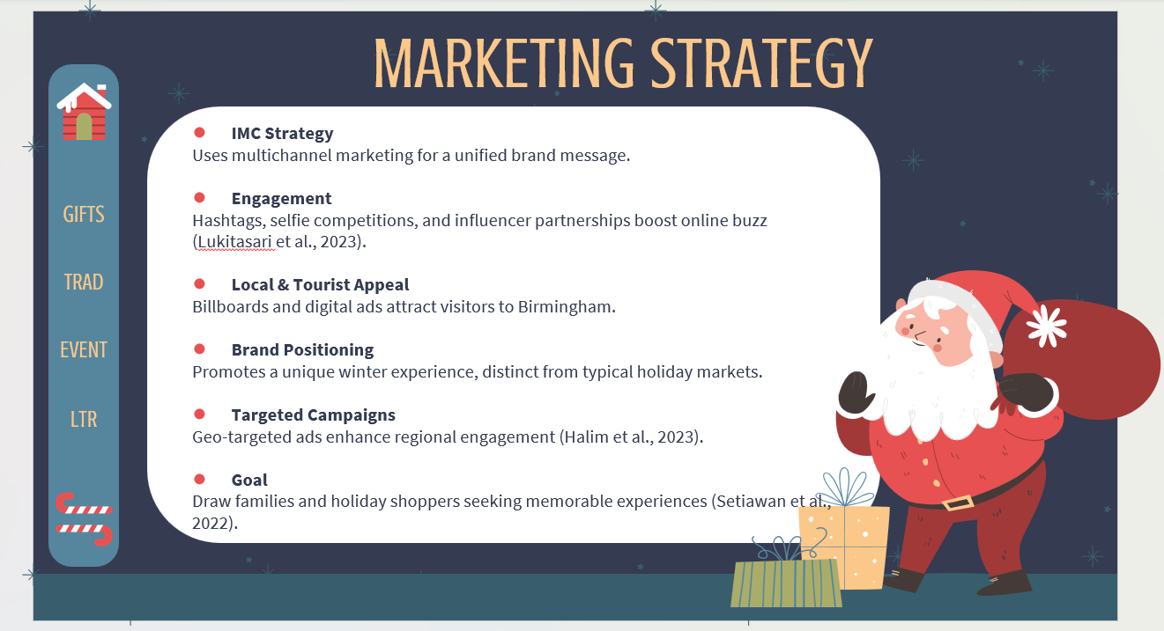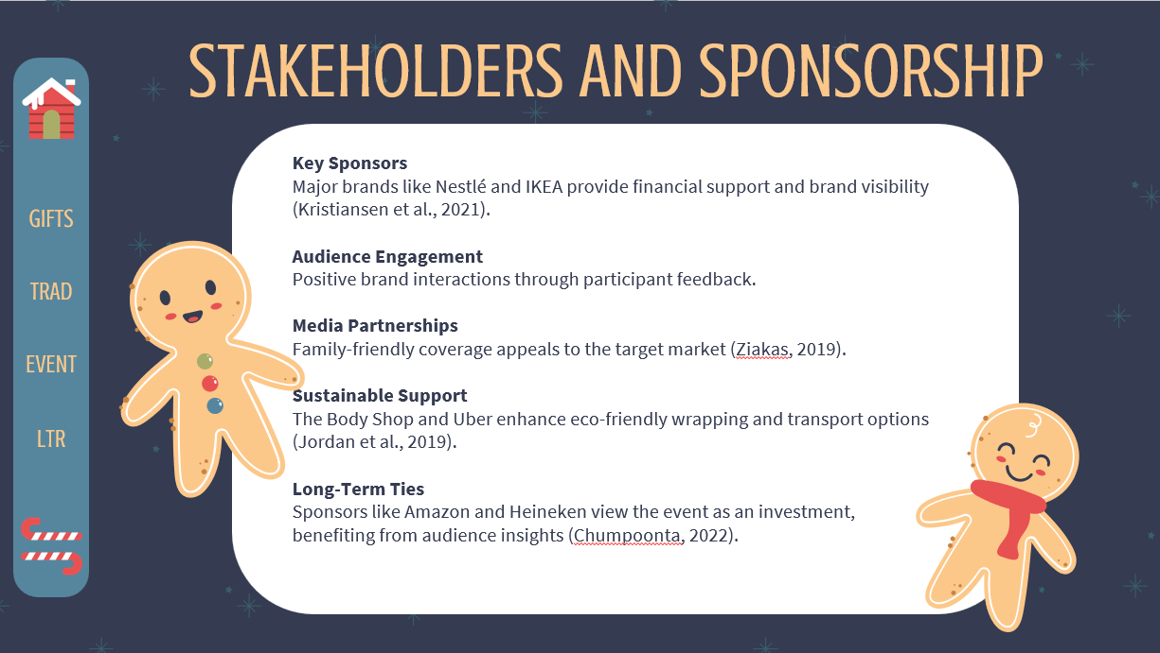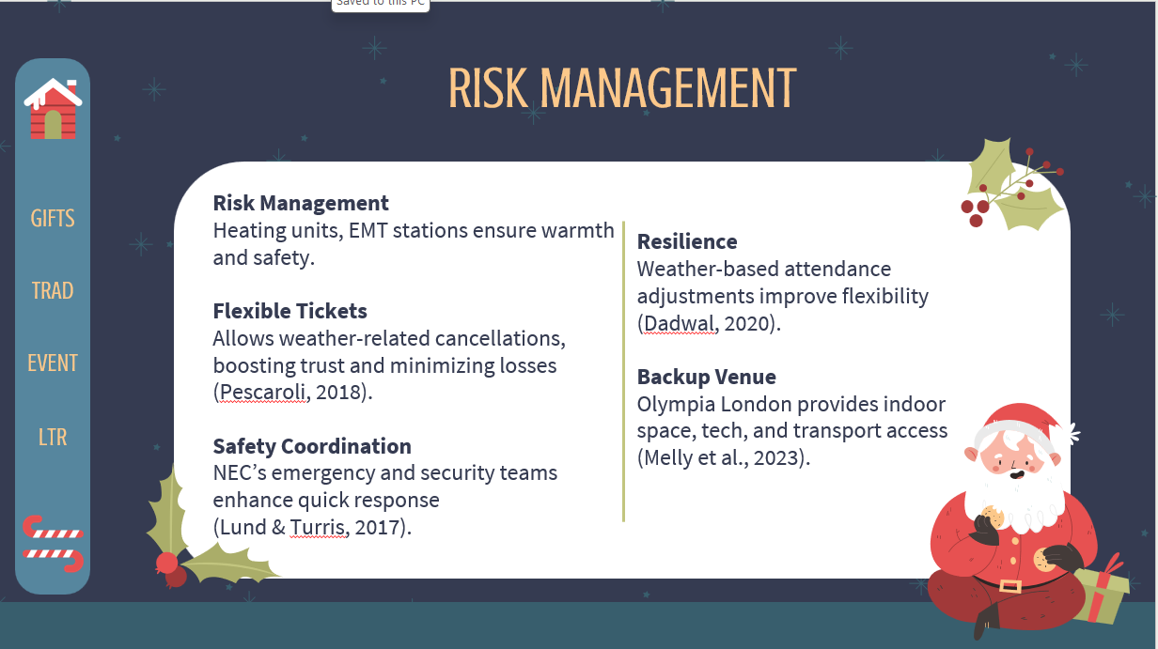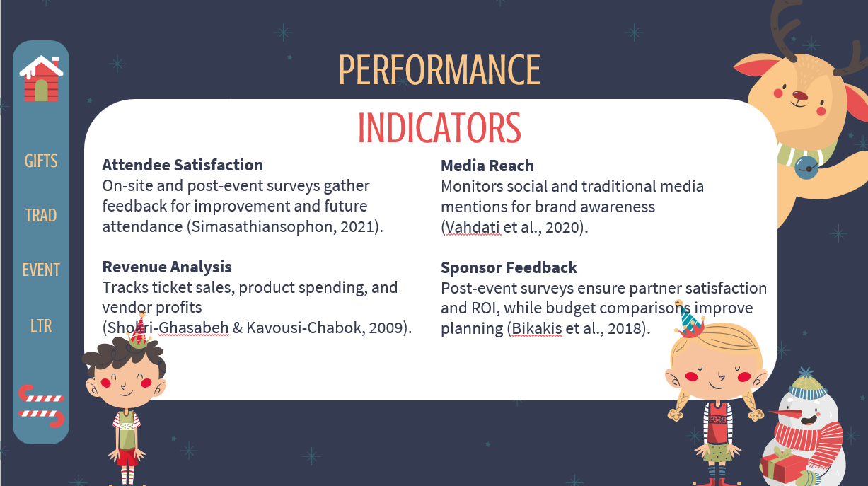

References
- An, J., Kim, H., & Hur, D., 2021. Keeping the Competitive Edge of a Convention and Exhibition Center in MICE Environment: Identification of Event Attributes for Long-Run Success. Sustainability, 13, pp. 5030. https://doi.org/10.3390/SU13095030.
- Bikakis, N., Kalogeraki, V., & Gunopulos, D., 2018. Attendance Maximization for Successful Social Event Planning. , pp. 121-132. https://doi.org/10.5441/002/edbt.2019.12.
- Chumpoonta, P., 2022. Digital Transformation in the MICE Industry (Powered by Zoho Backstage). The Eurasia Proceedings of Educational and Social Sciences. https://doi.org/10.55549/epess.1221504.
- Czinkota, M.R., Kotabe, M., Vrontis, D., Shams, S.R., Czinkota, M.R., Kotabe, M., Vrontis, D. and Shams, S.R., 2021. Designing effective promotion and advertising strategies. Marketing Management: Past, Present and Future, pp.553-606. https://www.researchgate.net/profile/Demetris-Vrontis/publication/354106239_Designing_Effective_Promotion_and_Advertising_Strategies/links/6283aa7717ae76609bfd306a/Designing-Effective-Promotion-and-Advertising-Strategies.pdf
- Dadwal, S.S. and Dadwal, D., 2020. Management of Health and Safety Risks at Large Events: Process, Procedures, and Factors. In Legal, Safety, and Environmental Challenges for Event Management: Emerging Research and Opportunities (pp. 21-41). IGI Global. https://openresearch.lsbu.ac.uk/download/e7aec906542f47834d7bfb05e17aaedb84814c973a83bbeca46ab1483e4a13da/533344/Management-of-Health-and-Safety-Risks-at-Large-Events_-Process-Procedures-and-Factors.pdf
- Halim, D., Pramesti, D., & Ratnasari, H., 2023. Analysis Marketing Strategy Of Phenom Event Indonesia During The Covid-19 Pandemic. Journey : Journal of Tourismpreneurship, Culinary, Hospitality, Convention and Event Management. https://doi.org/10.46837/journey.v6i1.163.
- Halpenny, E.A. and Vaugeois, N., 2018. Edmonton's WinterCity Strategy-enhancing winter living through innovative leisure practice in a northern Canadian city. https://www.researchgate.net/profile/Nicole-Vaugeois/publication/324213586_Innovative_Leisure_Practices_CASES_AS_CONDUITS_BETWEEN_THEORY_AND_PRACTICE_EDITED_BY_TOM_DELAMERE/links/5ac515dba6fdcc051daf15a2/Innovative-Leisure-Practices-CASES-AS-CONDUITS-BETWEEN-THEORY-AND-PRACTICE-EDITED-BY-TOM-DELAMERE.pdf#page=86
- Hu, B., & Yan, B., 2022. Analysis System of MICE Tourism Economic Development Strategy Based on Machine Learning Algorithm. Mobile Information Systems. https://doi.org/10.1155/2022/1283040.
- Jordan, T., Gibson, F., Stinnett, B. and Howard, D., 2019. Stakeholder Engagement in Event Planning: A Case Study of One Rural Community's Process. Event Management, 23(1), p.61. https://search.proquest.com/openview/3398e857ba635db24446bd333c43f53b/1?pq-origsite=gscholar&cbl=6339620
- Kantari, L., Pujawan, I., Arvitrida, N., & Hilletofth, P., 2020. Investigating the mix of contract-based and on-demand sourcing for transportation services under fluctuate and seasonal demand. International Journal of Logistics Research and Applications, 24, pp. 280 - 302. https://doi.org/10.1080/13675567.2020.1751807.
- Kim, K., & Ko, D., 2020. How to Build a Sustainable MICE Environment Based on Social Identity Theory. Sustainability. https://doi.org/10.3390/su12177166.
- Kristiansen, E., Solem, B.A., Dille, T. and Houlihan, B., 2021. Stakeholder Management of Temporary Sport Event Organizations. Event Management, 25(6), p.619. https://search.proquest.com/openview/4bd564c005b74433dab75ea527a2425d/1?pq-origsite=gscholar&cbl=6339620
- Lekgau, R., & Tichaawa, T., 2022. COVID-19 AND MICE EVENTS: UNPACKING THE FACTORS MEDIATING THE RETURN OF IN-PERSON EVENTS IN SOUTH AFRICA. Analele Universităţii din Oradea, Seria Geografie. https://doi.org/10.30892/auog.322103-888.
- Lim, C., & Zhu, L., 2018. Examining the link between meetings, incentive, exhibitions, and conventions (MICE) and tourism demand using generalized methods of moments (GMM): the case of Singapore. Journal of Travel & Tourism Marketing, 35, pp. 846 - 855. https://doi.org/10.1080/10548408.2018.1435334.
- Lukitasari, R., Dewi, N., & Lumanauw, N., 2023. Event Marketing Strategy During The Pandemic Crisis: Case Study Of The Westin Resort And Spa Ubud-Bali. Journey : Journal of Tourismpreneurship, Culinary, Hospitality, Convention and Event Management. https://doi.org/10.46837/journey.v6i2.119.
- Lund, Adam & Turris, Sheila. (2017). The Event Chain of Survival in the Context of Music Festivals: A Framework for Improving Outcomes at Major Planned Events. Prehospital and Disaster Medicine. https://www.researchgate.net/publication/315465966_The_Event_Chain_of_Survival_in_the_Context_of_Music_Festivals_A_Framework_for_Improving_Outcomes_at_Major_Planned_Events
- Melly, D., McLoughlin, E. and Maguire, K., 2023. Emerging venue considerations for event management: The case of Ireland. Tourism and Hospitality, 4(1), pp.187-201. Available at: https://doi.org/10.3390/tourhosp4010011
- Momani, H., Som, A., Qassem, A., Salim, M., & Eppang, B., 2023. THE EFFECTS OF SEASONALITY ON MICE TOURISM DEMAND IN JORDAN. PLANNING MALAYSIA. https://doi.org/10.21837/pm.v21i30.1412.
- Pescaroli, G., 2018. Perceptions of cascading risk and interconNational Exhibition Centreted failures in emergency planning: Implications for operational resilience and policy making. International Journal of Disaster Risk Reduction. https://doi.org/10.1016/J.IJDRR.2018.01.019.
- Setiawan, R., Wibisono, D., & Purwanegara, M., 2022. Defining Event Marketing as Engagement-Driven Marketing Communication. Gadjah Mada International Journal of Business. https://doi.org/10.22146/gamaijb.63788.
- Shokri-Ghasabeh, M. and Kavousi-Chabok, K., 2009. Generic project success and project management success criteria and factors: Literature review and survey. https://www.researchgate.net/profile/Morteza-Shokri-Ghasabeh/publication/228353003_Generic_project_success_and_project_management_success_criteria_and_factors_Literature_review_and_survey/links/5691ba3e08aee91f69a52031/Generic-project-success-and-project-management-success-criteria-and-factors-Literature-review-and-survey.pdf
- Simasathiansophon, N., 2021. Running event quality: conceptualization and measurement scale. E3S Web of Conferences. https://doi.org/10.1051/E3SCONF/202124411017.
- Thomas, R. and Bowdin, G., 2012. Events management research: State of the art. Event Management, 16(2), p.103. https://search.proquest.com/openview/0062e332bfb12e7bd9b72201bd25baf5/1?pq-origsite=gscholar&cbl=6339620
- Tiecheng, L., & Li, L., 2018. An empirical study of the economic impact of the MICE industry in China using interregional input-output models (IRIO).. Tourism Tribune, 29, pp. 34-45. https://doi.org/10.11648/J.AJMSE.20180305.12.
- Vahdati, S., Fathalla, S., Lange, C., Behrend, A., Say, A., Say, Z., & Auer, S., 2020. A comprehensive quality assessment framework for scientific events. Scientometrics, 126, pp. 641 - 682. https://doi.org/10.1007/s11192-020-03758-1.
- Ziakas, V., 2019. Issues, patterns and strategies in the development of event portfolios: configuring models, design and policy. Journal of Policy Research in Tourism, Leisure and Events, 11(1), pp.121-158. https://doi.org/10.1080/19407963.2018.1471481

