Thomas Luke Smith (1900652)

E-Portfolio


E-Portfolio
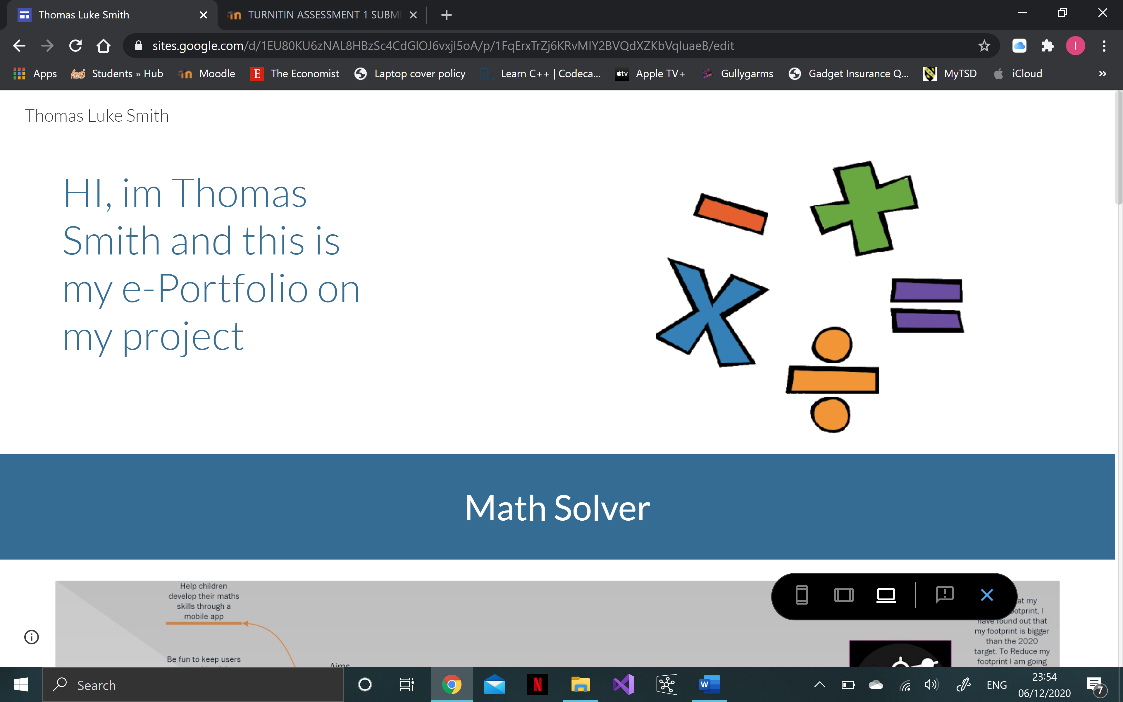
https://sites.google.com/view/thomas-luke-smith/home

Unit 1 – Mind Map
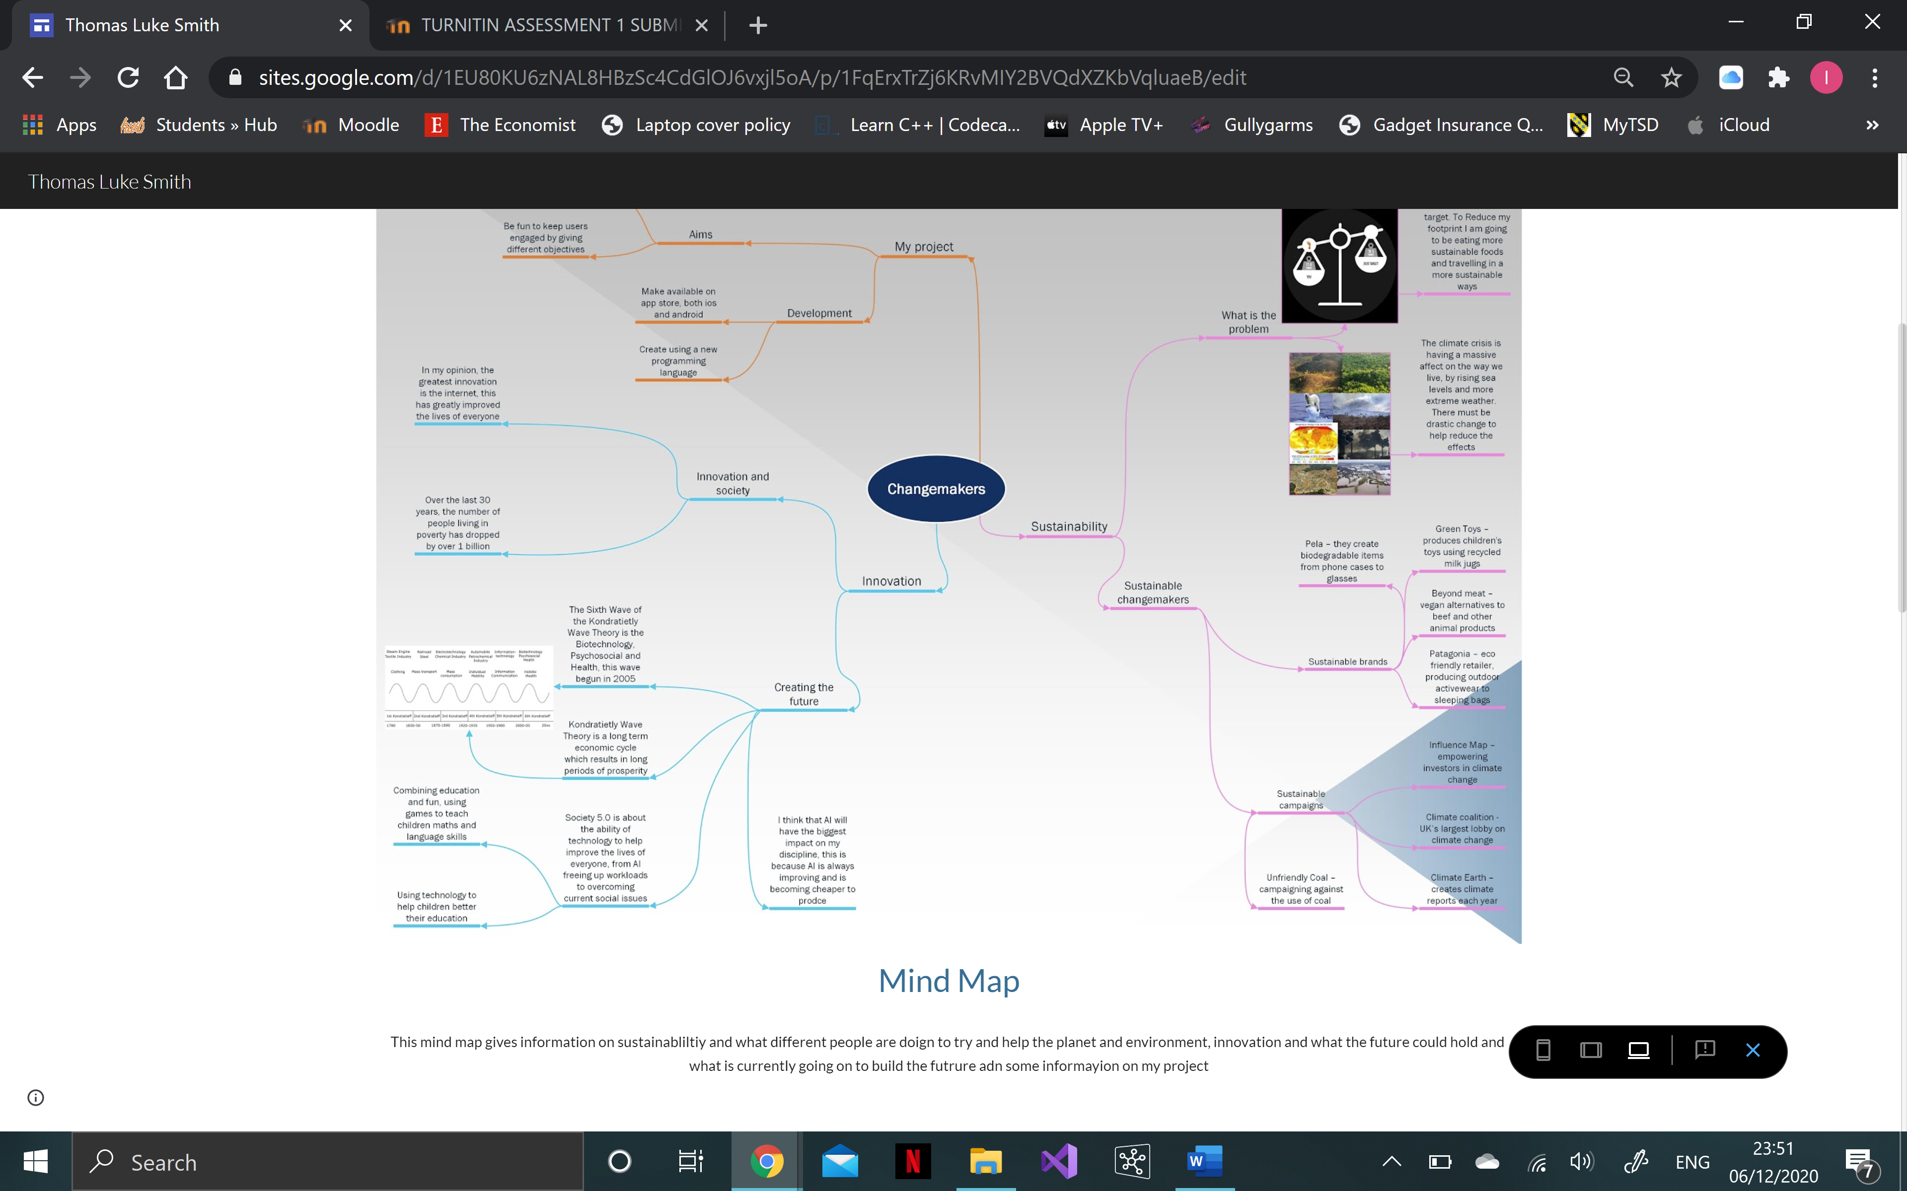
https://sites.google.com/view/thomas-luke-smith/home

Unit 2 -Image Based Video Application
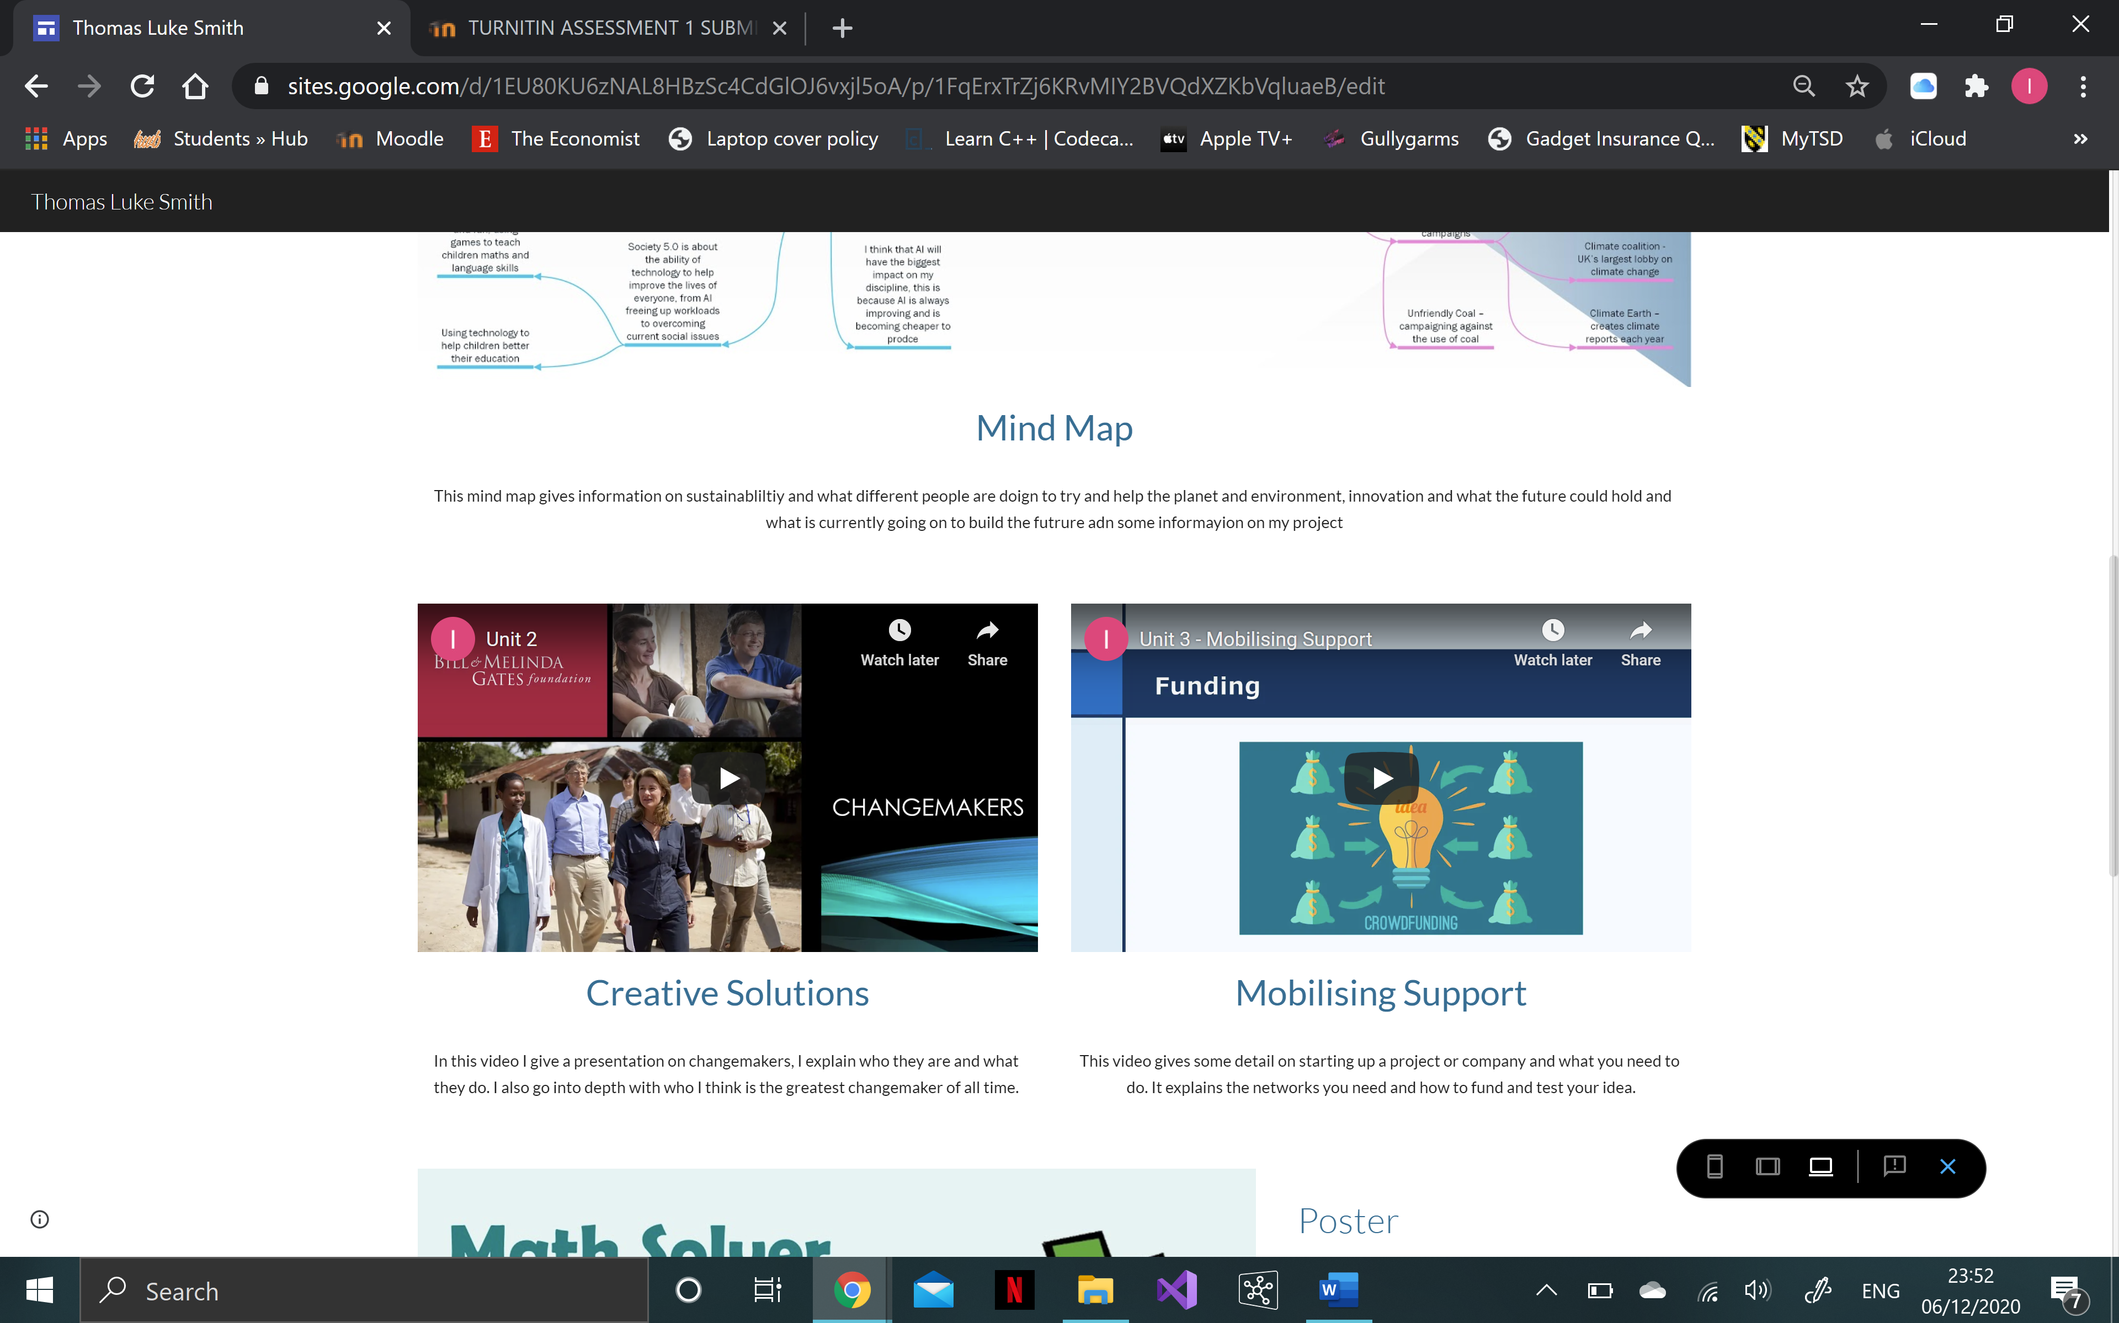
https://sites.google.com/view/thomas-luke-smith/home

Unit 3 – Video Presentation
https://sites.google.com/view/thomas-luke-smith/home

Unit 4 – Academic Poster
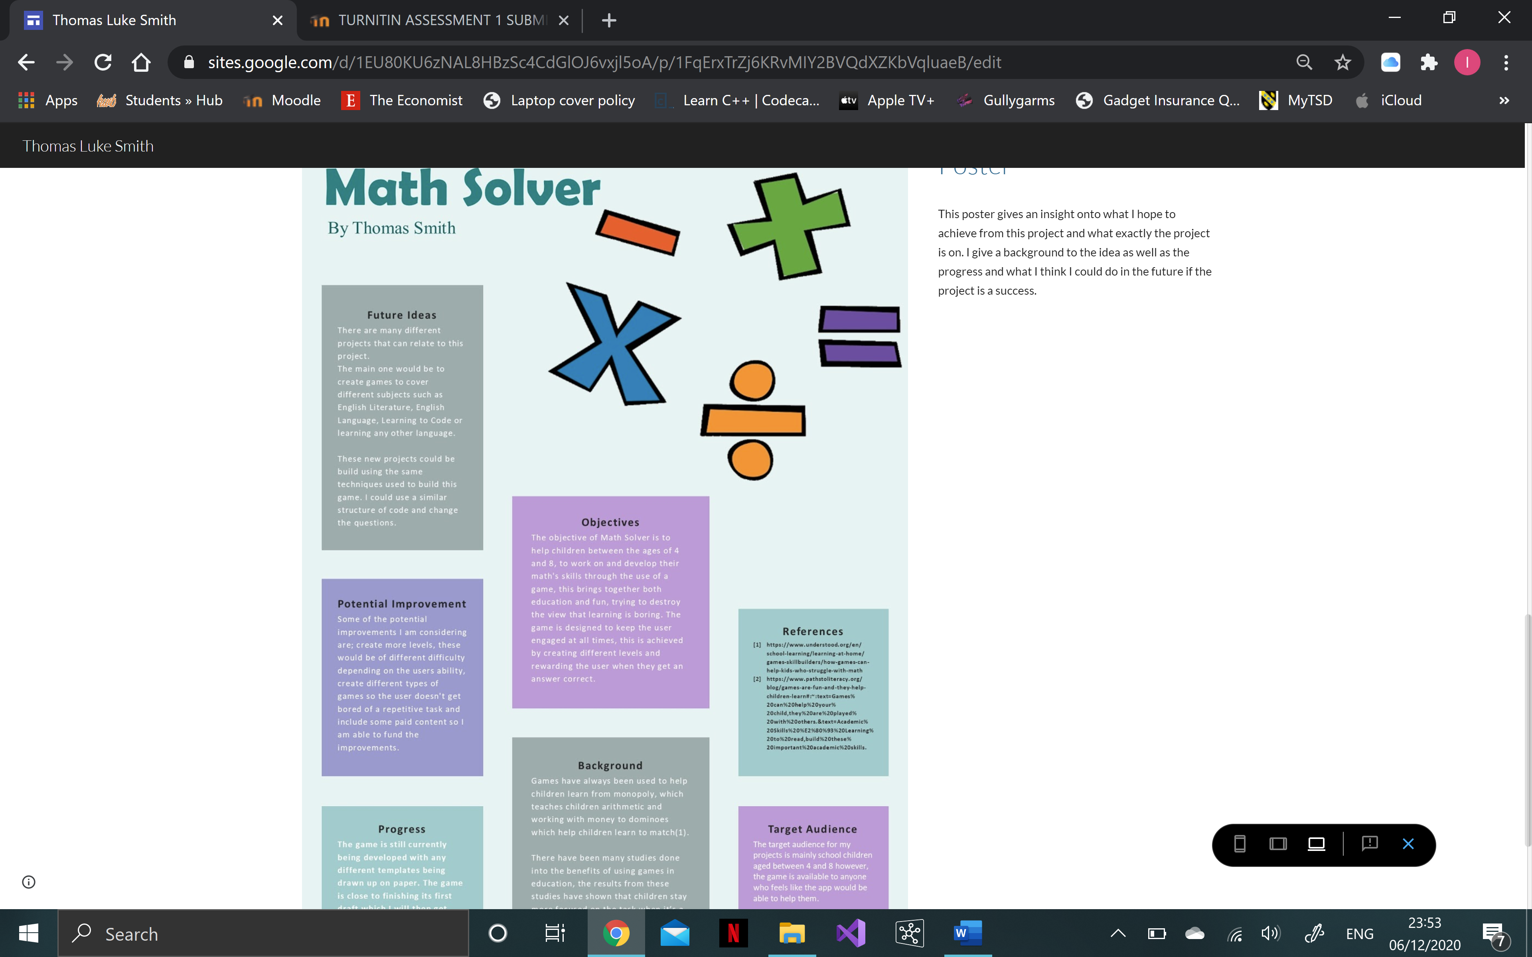
https://sites.google.com/view/thomas-luke-smith/home

