Essential skills for study and employment and their development supporting in future career after graduation.

- Essential skills in study.
Based on the research that proves it, I can say that strong study skills and consistent study habits are two of the most important components of any person's general academic success. These skills and habits can facilitate your stay competitive with people that could appear “smarter” than you. Here are some of them:

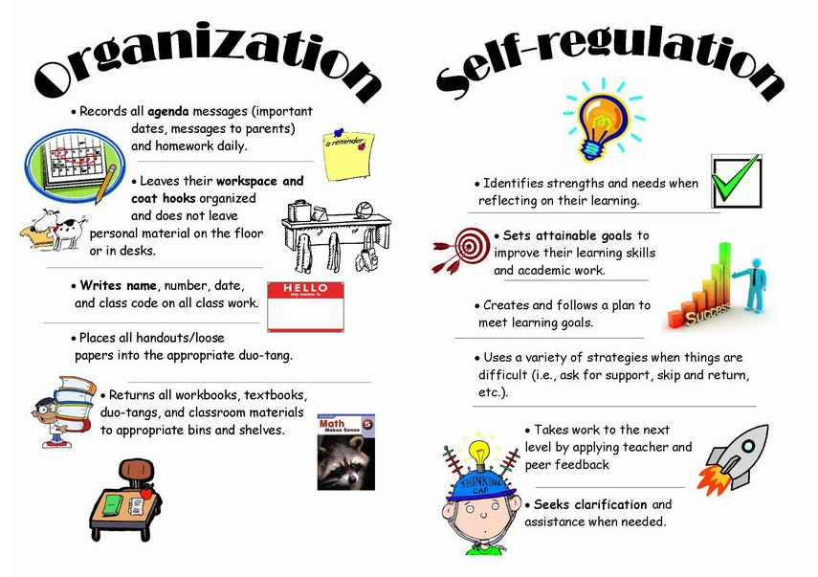

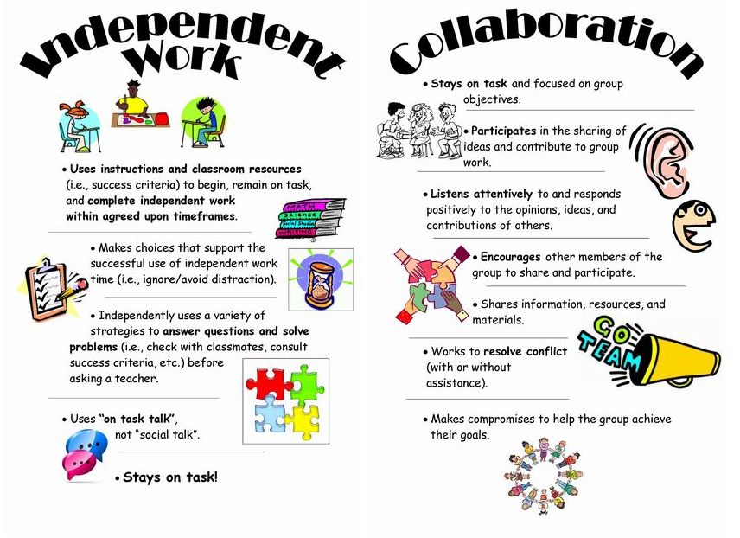
- Essential skills in employment
While you must sustain, you are specializing in earning industry-recognized certificates or upskilling to learning new technologies to remain employable, also consider developing and improving your soft skills. Today, your education and knowledge may only be enough to qualify for employment but, to achieve success in most roles within the field of emerging technologies, you will need soft skills like communication, team-work, and problem-solving. Here are some employability skills employers are trying to find within the employment:
- Communication and interpersonal
- Problem-solving
- Self-motivation
- Working under pressure
- Organizational skills
- Team spirit
- Learning skills
- Number and data skills
- Value diversity
- Negotiation skills

- Development of the skills supporting in future career.
This involves making sure that you have the skills needed to take advantage of opportunities when they arise. That is why it is important to take a systematic approach to developing your skills, so they are ready when you need them. Creating a Personal Development Plan is the starting point for this.

References
Bibliography
[1]J. B., “Welcome to Signet Education,” Signet Education, Apr. 22, 2013. https://signeteducation.com/ (accessed Apr. 22, 2021).
[2]M. Koprowski, Essential Skills in Studies. 2014. Available: https://koprowski.weebly.com/ (accessed Apr. 22, 2021)
[3]Simlilearn, “Employability Skills,” Employability Skills, vol. 0, no. 1, Mar. 2021, Accessed: Summer 04, 2021. [Online]. Available: https://www.simplilearn.com/.
[4]Personal Development Plan. Mind tools LTD, Apr. 2007-2014. Available: https://www.mindtools.com/courses/lnV924x0/PersonalDevelopmentPlanning.pdf (accessed Apr. 22, 2021)

