BA DEGREE ASSIGNMENT SPECIFICATION
SCHOOL OF TOURISM & HOSPITALITY
Student name: | Shariful Islam | Student number: | 2013505
Programmes: | BA International Hotel Management
Module: | Managing Food and Beverage Operations | Module Level (4, 5, 6): | 6
Module code: | BMIH6002 | Contribution to Overall Module Assessment (%): | 50%
Lecturer: | Christopher Wilkin  Rodrigo Fernandes Aguilera | Internal Verifier: | Lola Villard
Assignment Title: | Student Learning Log (1250 Words +/-10%) | Assignment No: | 1 of 2
Hand Out Date: | w/c 24th of April 2023  Wednesday 2nd of June 2023 by 23h59 | Submission deadlines: | Monday 12th of
 | w/c 24th of April 2023  Wednesday 2nd of June 2023 by 23h59 |  | June 2023 by
Draft Deadline: | w/c 24th of April 2023  Wednesday 2nd of June 2023 by 23h59 | The return date of provisional | 23h59
 | w/c 24th of April 2023  Wednesday 2nd of June 2023 by 23h59 | marks & written feedback: | 10th of July 2023 by
 | w/c 24th of April 2023  Wednesday 2nd of June 2023 by 23h59 |  | 23h59

Table of Contents
Introduction 3
Vocational development 4
Self-development 5
Academic development 6
Conclusion 8
Reference 9

List of Figures
Figure 1: Dewey's Experiential Learning Theory 5
Figure 2: Kolb's Learning Cycle 6

Introduction
This work is based on my work experience at the Gourmet Haven Hotel and attempts to offer a thorough perspective on my overall growth and learning. It's broken down into three primary sections: academic growth, self-improvement, and career development. With an emphasis on achieving goals and learning outcomes, I will talk about my experiences and accomplishments in the vocational development sector overseeing food and beverage operations (Suriani & Ariani, 2020). With an emphasis on problem-solving and communication, the self-development section will emphasise the abilities and talents I have acquired. Finally, the part on academic progress will look at how theoretical understanding was put to use and incorporated into real-world circumstances.

Vocational development
I had the chance to develop essential knowledge in the area of Food and Beverage Operations while working my internship at Gourmet Haven Hotel. This succinct evaluation seeks to evaluate my overall placement encounter in terms of the placement objectives and my education outcomes while commenting on my personal, professional, and academic growth. The goals of the placement were very obvious from the beginning, to provide me with the information and understanding required to manage Food and Beverage Operations inside the hotel and to hone a variety of management skills I had learned during my academic career. My core service abilities and essential skills, such as task management, self-management, problem-solving, and communication, were also a goal of the placement.
I worked hard to accomplish the goals listed in my action plan and learning agreement during my whole stay at Gourmet Haven Hotel. I took an active role in watching and learning from seasoned professionals as I shadowed supervisory roles. As a result, I had a profound understanding of the significance of work-based core abilities and their use in actual situations (Allais & Schoer, 2021). The opportunity to practise food production and service methods firsthand was one of the most rewarding aspects of my professional development. This hands-on training solidified my interest in the sector and gave me a good basis for comprehending the complexities of food and beverage operations.
When I think back on my professional development, I must admit that there were "lost" possibilities among the many wonderful experiences I had. Looking back, I see that I should have been more aggressive in asking mentors and supervisors for advice and input. This lost chance showed me the value of grabbing any opportunity for development and aggressively seeking guidance. My internship at the Gourmet Haven Hotel was a worthwhile experience. In addition to helping me meet the placement objectives, it also aided in my academic, professional, and personal growth. I am appreciative of the information, abilities, and insights I have learned over the past several months, as they will surely influence my future job in the food and beverage sector.

Self-development
During my internship at the Gourmet Haven Hotel, I ran across a management problem with client services. Throughout my time working in the food and beverage division, I saw a reoccurring issue where customers frequently expressed dissatisfaction with the promptness of their orders and the quality of the overall service. I attempted to comprehend the issue from several viewpoints and create workable answers by using Dewey's Experiential Learning Theory for my self-development.
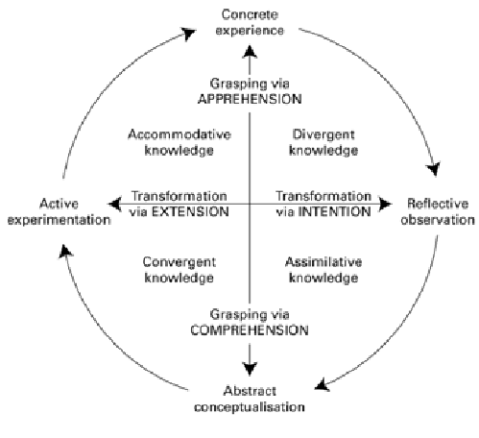
Figure 1: Dewey's Experiential Learning Theory
Source: (Seaman, 2019)
I used reflective thinking to handle the management issue by looking at it as a whole. First, I looked at the underlying factors that contributed to the delayed service, such as poor coordination between kitchen staff and service employees, a shortage of manpower during busy times, and unclear communication lines. I actively explored different answers, drawing on Dewey's philosophy. To enhance coordination and communication among the kitchen and service employees, I suggested putting in place a thorough training program. Opportunities for cross-training would be provided in this program to promote empathy and understanding among teams (Harris, 2018). In addition, I recommended changing the shift plan to guarantee enough personnel levels during peak hours and cut down on visitor wait times.
To emphasize the significance of timely and effective service, I included theories in my suggested solutions and cited service delivery models like the RATER model (Reliability, Assurance, Tangibles, Empathy, Responsiveness). The hotel might raise customer happiness, improve the whole dining experience, and increase its reputation by putting these principles into practice. As an outcome of this analytical process, I also realized the value of strong cooperation and communication when dealing with management difficulties. My observations and suggested solutions were shared with coworkers and managers via my active participation in team meetings.

Academic development
To actively engage in academic growth throughout my time working at Gourmet Haven Hotel, I applied and developed the following important skills: self-management and development, task management, applying initiative to workplace issues, communication, and application of information. To advance my academic development and close the gap between theoretical understanding and real-world application, I used Kolb's experiential learning cycle.
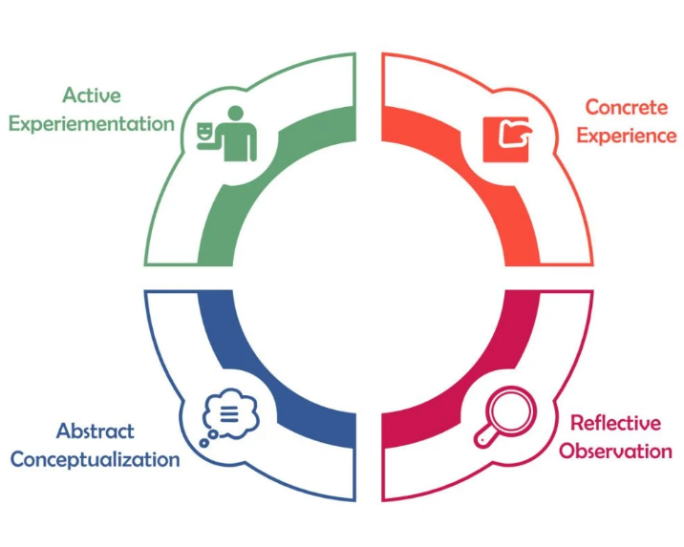
Figure 2: Kolb's Learning Cycle
Source: (Pelkey & Noyes, 2019)
Kolb's learning cycle starts with experience. I faced a variety of difficulties and chances as I absorbed myself in the hotel environment, which gave me the chance to hone my task- and self-management abilities. I developed my ability to prioritise jobs by juggling a variety of obligations and due dates, guaranteeing smooth workflow and achieving organizational objectives. I learned from this experience how crucial time management and flexibility are in the fast-paced hospitality industry. I proceeded to the reflection stage in Kolb's learning cycle after building on the experience. I regularly assessed my experiences, critically analysed issues at work, and actively looked for answers. I improved my problem-solving abilities by introspection, taking into account many viewpoints and utilizing my knowledge and experiences to suggest useful and doable solutions.
Contextualization, the third level, included establishing links between my academic knowledge and the job. At the Gourmet Haven Hotel, I used theoretical ideas from my studies in practical settings. For instance, I applied communication theories to enhance relationships with visitors and coworkers, providing effective channels of communication. The fourth step, experimenting, allowed me to test and hone my abilities on the job. I aggressively sought feedback from my bosses and coworkers to evaluate the efficacy of my strategies and make the required modifications. I was able to improve my task management techniques, my communication abilities, and my ability to apply information in real-world settings because of this iterative approach.

Conclusion
During my time working at Gourmet Haven Hotel, I had the opportunity to improve professionally, personally, and academically. I learned a lot about the management concerns and difficulties the food and beverage business faces via reflective practice. I actively used theoretical information from Dewey's Experiential Learning Theory and Kolb's Experiential Learning Cycle to develop my problem-solving, time-management, self-management, task-management, communication, and knowledge application abilities (Röhrer & Fuchs, 2021). This voyage of self-reflection has not only deepened my awareness but also given me the skills I need to succeed in my future professional endeavours. This will be very beneficial for the future of my career in the field.

Reference
Allais, S. and Schoer, V. (2021) 'Rethinking "supply and demand" of technical and Vocational Education and Training: Insights from a company survey in three manufacturing sectors in South Africa', Journal of Education and Work, 34(5–6), pp. 649–662. doi:10.1080/13639080.2021.1967302.
Harris, J. (2018) ‘Prior learning assessment: Does Dewey’s theory offer insight?’, New Directions for Adult and Continuing Education, 2018(158), pp. 77–86. doi:10.1002/ace.20281.
Pelkey, J. and Noyes, C. (2019) ‘Using Kolb’s learning cycle to improve student sustainability knowledge’, Sustainability, 11(17), p. 4602. doi:10.3390/su11174602.
Röhrer, N. and Fuchs, M. (2021) ‘The region matters—for whom? the regional actor network for vocational education and training in tourism of Cancún (Mexico)’, International Journal of Training and Development, 25(3), pp. 244–258. doi:10.1111/ijtd.12217.
Seaman, J. (2019) ‘Restoring culture and history in Outdoor Education Research: Dewey’s theory of experience as a methodology’, Journal of Outdoor Recreation, Education, and Leadership, 11(4), pp. 335–351. doi:10.18666/jorel-2019-v11-i4-9582.
Suriani, N.M. and Ariani, R.P. (2020) ‘Balinese fusion food as local culinary tourism products’, Proceedings of the 2nd International Conference on Social, Applied Science, and Technology in Home Economics (ICONHOMECS 2019) [Preprint]. doi:10.2991/assehr.k.200218.036.

