School Development Plans outline the school's vision, goals and strategies to improve themselves (Welsh Government, 2014). The school's leadership team writes a School Development Plan with the school's employees, governors and stakeholders. The School Development Plan reflects the aspirations of the school. It outlines the goals the school want to achieve, often over a period of 3 to 5 years. The plan should be reviewed in regulation to see if the school are making progress towards the goals. A School Development Plan is significant for improving the school and making sure that the school as a whole, including the stakeholders, work together to support the school, the local community and the learners (Government of Wales, 2014).

This essay examines the School Development Plan of a school in Swansea. It is worth noting that the school holds 435 learners and provides free food to 29% of learners. This essay will focus on priority 1 of the School Development Plan; 'To continue our recovery, post-pandemic, focusing on attendance, parental engagement and whole school family well-being' (SDP). This priority has come from the response to Covid, as due to the pandemic the attendance of learners has decreased significantly. According to the Welsh Government, attendance has decreased across the whole of Wales, with absence being five points higher than before Covid (Senedd Cymru, 2023).

Literature Review

The Development Plan process is a cycle of planning, implementing and evaluating strategies to improve the education of learners. According to Fullan (2005), the vision of the Development Plan should be shared among all the school's stakeholders. Fullan says that the Development Plan is built on data, with a focus on analysing the academic progress of the learners in order to make an improvement. In order to be successful in creating a Development Plan, the school needs to be critical of themselves in order to understand their strengths and the means to improve. This could happen with the assessment of the learners' achievement, attendance and behaviour (Fullan, 2005).

The Handbook for Principals on School Improvement (Ontario Ministry of Education, 2015) agrees with the suggestion from Fullan (2005) that planning a school's growth effectively requires a thorough, collaborative process that includes all stakeholders. The significance of bringing together parents/carers, students, teachers, and the larger community in the preparation and implementation of the plan is also emphasised in the School Planning and Reporting Handbook (Manitoba Education and Advanced Learning, 2015). This cooperative approach can help to create a sense of ownership and involvement in the plan's success by ensuring that the objectives and methods of the plan represent the needs and priorities of all stakeholders. The requirement for continuous monitoring and evaluation of the plan's progress is also highlighted by the Ontario Ministry of Education (2018). They suggest that regular data analysis and updates on progress help to identify areas for improvement, track the success of the methods used, and make any necessary changes to the planning. Schools should make sure that their development plans are successful and responsive to the changing needs of their students by involving all stakeholders and keeping an emphasis on continual evaluation.

Although the sources provided are not directly about education in Wales, they give insightful advice that may be used in educational settings all around the world. In addition, the new Curriculum for Wales (2022) places emphasis on a learner-centred, more comprehensive approach that is similar to educational frameworks in other nations, such as Canada. For example, developing skills, critical thinking, and experimental learning are all prioritised in the Curriculum for Wales, as they are in the Canadian educational system (OECD, 2020). In order to create a more student-centred and efficient educational system in Wales, Canadian sources can provide insightful viewpoints and best practices.

The Covid pandemic has had a significant impact on schools across Wales and the world as a whole. Schools have created a new way of learning and teaching in order to adapt to the new situation. As schools begin to recover, it is essential to focus on attendance, parental engagement and well-being to ensure that the learners are able to succeed in this new environment. Improving attendance is one of the school's aims to be successful within priority 1 of their School Development Plan. According to NAESP, attendance is significant in determining the success of the learners. They suggest that learners who attend school regularly are more likely to succeed in their studies (NAESP, 2020).

Another aspect of the priority is parental engagement. A review by the National Education Association (2018) says that parental engagement has a powerful effect on the child. Children with parents and carers who contact the school are more likely to attend school and be motivated to do work. In order to engage parents and carers, a school can implement strategies, including communication with the parents and carers and creating a positive partnership between parents/carers and teachers (Epstein, 2018).

The well-being of the whole school is one of the school's main priorities (Headteacher of the schooll, 2023). The welfare of the whole school is in relation to all stakeholders, including the learners, the parents/carers, the school community and employees. According to the World Health Organization, well-being can improve academic success and mental health for learners and workers (WHO, 2015).

According to Jennings and Greenberg (2009) to improve well-being in schools, schools can try a variety of strategies including creating positive publicity for learners, their parents and employees.

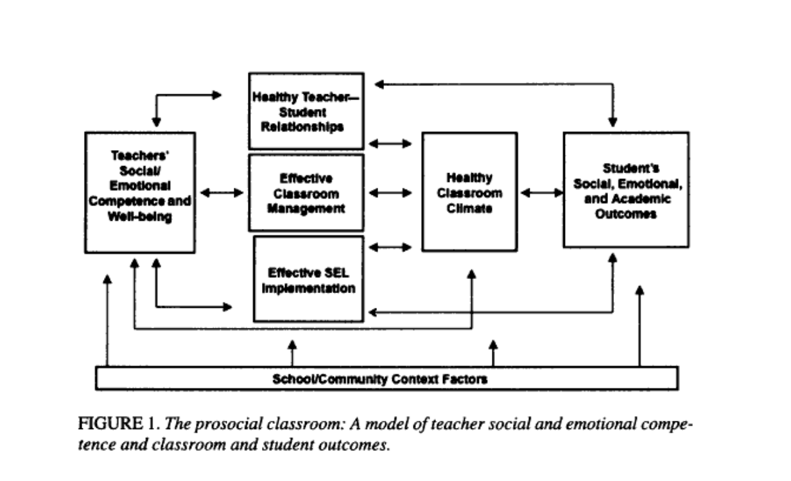

This figure shows how a positive environment can impact learner outcomes. This figure suggests that the social and emotional competence of teachers is influenced by the environment, therefore having an impact on the learner, their work and their well-being (Jennings and Greenberg, 2009).

Developing an Action Plan

Through its Self Evaluation Report (SMLT,2023), the school evaluates its success and areas that require improvement. The research helped the school to pinpoint numerous areas that needed improvement.

As previously mentioned, one of the areas that the school are trying to improve is attendance. The school are taking many actions to try and achieve this, including trying to improve their communication with the learners’ parents/carers. To do this the school has sent out regular letters to the parents/carers and communicates with them through ClassDojo. ClassDojo (n.d) is a website that helps in ‘keeping teachers, families and kids connected’. The platform offers a number of tools that make it easier for parents and carers to keep informed about their children's education and connect with teachers (Wagner & Ballou, 2017). These features include instant messaging, scheduling parent-teacher conferences, and tracking student achievement. Additionally, it has been demonstrated that ClassDojo and comparable platforms increase parental involvement and boost student learning outcomes (Patel & Ganatra, 2018). These platforms have the ability to improve the educational experience for kids and encourage more parental involvement in their children's education by facilitating improved communication and collaboration between schools and parents/caregivers.

In recent years, the use of data analysis in education has grown in significance. Schools can identify their strengths and weaknesses and create improvement plans by gathering and analysing data on student performance. Data analysis can be applied to the school development plan to help with goal and target setting, progress monitoring, and intervention effectiveness evaluation (Fullan, 2005). In the subject school, they use RAG (red, amber, green) rating to track their learners' progress and their attendance (SDP). This enables them to monitor the learners' academic journey and identify any areas for improvement and identify any learners who are not attending on a regular basis.

Another main aspect of this school’s priority is increasing wellbeing among staff, students and families. The school has put many new ideas in place in order to achieve this. For example, the school have completed a self-evaluation for the whole school's wellbeing using the Public Health Wales guidance (Public Health Wales, n.d). The school have completed the SHRN (School Health Research Network) survey in order to provide data for their self-evaluation. Promoting wellbeing within the school community can be significantly helped by putting into practice the advice offered by Public Health Wales on whole school wellbeing and using tools like the SHRN questionnaire. Public Health Wales's recommendations place a strong emphasis on an integrated approach of wellbeing that takes into account a person's physical, mental, and emotional well-being (Public Health Wales, 2020). This advice can help the school develop a setting that encourages students and employees to have positive mental health, resilience, and social connectivity. A validated method for evaluating many aspects of student wellbeing, such as emotional health, relationships, and school involvement, is the SHRN questionnaire (Murphy et al., 2019). The school can gain important insights into specific areas of wellbeing that may need attention by distributing the SHRN questionnaire and can then create specific efforts to address them. This proactive approach to well-being promotion can help create a welcoming and positive school atmosphere, which will ultimately improve students' general wellbeing and academic success, along with the wellbeing of staff.

