

Examining Police Efficiency and Welfare: The Impact of an Efficient Custody Procedure.

Daniel Paul
Student No. 2125111
BSc Professional Policing Practice
Oct 2024

Word Count: 8,989
Declaration

This work has not previously been accepted in substance for any degree and is not being concurrently submitted in candidature for any degree.
Signed:

Date: 01/10/2024

STATEMENT 1
This dissertation is being submitted in partial fulfilment of the requirements for the degree of BA.
Signed:
Date: 01/10/2024

STATEMENT 2
This dissertation is the result of my own independent work/investigation, except where otherwise stated.
Other sources are acknowledged by footnotes giving explicit references. A bibliography is appended.
Signed:
Date: 01/10/2024

STATEMENT 3
I hereby give consent for my dissertation, if accepted, to be available for photocopying and for interlibrary loan, and for the title and summary to be made available to outside organisations.
Signed:
Date: 01/10/2024

STATEMENT 4
I hereby give consent for my dissertation, if accepted, to be available on the university’s IT system to those who have consent to use the system.
Signed:
Date: 01/10/2024

Acknowledgments
I extend my deepest gratitude to my colleagues and friends, Joe and Zack, for their unwavering support not only during the completion of this dissertation but throughout my entire qualification. Their dedication and professionalism in our shared challenging profession have been a constant source of inspiration.
I am also grateful to Gwent Police for their financial support and for providing me with the opportunity to pursue a career I have aspired to since childhood.
Lastly, to my partner and daughter, I express my heartfelt thanks for the immense joy they bring to my life and their steadfast encouragement in all my pursuits.

Abstract
This dissertation investigates the impact of effective custody procedures on police efficiency and officer welfare in the Gwent and South Wales police forces. The study takes a mixed-methods approach, incorporating quantitative and qualitative data acquired from surveys of police officers who routinely participate in custody processes. The study is based on the ‘research onion' framework and investigates the relationship between custody procedures and the overall operational effectiveness of police operations, as well as officers' welfare in these settings. The findings show that inefficient detention procedures lead to greater stress and burnout among officers, whereas streamlined methods improve efficiency and mental health. The report emphasises the significance of tackling understaffing and modernising prison settings to improve overall police effectiveness. Practical recommendations are made, with a focus on staffing improvements, better custodial facilities, increased mental health assistance, and the use of technology to improve procedural efficiency. The dissertation provides insights that could help to shape future custody management reforms and legislative changes, with the goal of reducing operational inefficiencies and improving officer welfare.

Contents
Chapter One: Introduction 10
1.1 Overview of Policing and Custody Procedures in the UK 10
1.2 Officer Efficiency and Welfare Links 10
1.3 The Impact of Custody Inefficiencies on Policing Operations 11
1.4 Welfare Concerns for Custody Officers 11
1.5 Technological Advancements and Custody Efficiency 12
1.6 Gaps in the Existing Literature 12
1.7 Research Aim and Objectives 13
Chapter Two: Literature Review 14
2.1 Introduction 14
2.2 Policing Efficiency and Custody Procedures 14
2.4 Custody Procedures in the UK 17
2.5 The Impact of Efficient Custody Procedures on Police Efficiency and Welfare 18
2.6 Impact of Stress on Officer Performance 19
2.7 Gaps in the Literature 20
Chapter Three: Research Method 21
3.1 Introduction 21
3.2 Research Onion 21
3.3 Philosophy 22
3.4 Approach 23
3.4.1 Strategy 23
3.4.2 Choice 24
3.4.3 Time Constraints 24
3.5 Techniques for Data Collection, Processes, and Analysis 25
3.5.1 Data Collection 25
3.5.2 Questionnaire Design with Literature Review 25
` 29
3.5.3 Pilot Testing 29
3.5.4 Analysis 29
3.6 Sampling 30
3.7 Data Reliability and Validity 30
3.8 Limitations 31
3.9 Ethics 31
4.0 Conclusion 31
Chapter 4: Analysis of Results 33
4.1 Introduction 33
4.2 Demographics and Survey Overview 33
4.3 Analysis of Mental Welfare 33
4.4 Analysis of Physical Welfare 35
4.5 Analysis of Stress Reduction 35
4.6 Brunner Munzel Tests 36
4.6.1 By police force 36
4.6.2 By role 38
4.6.3 By time served 40
4.7 Recurring Themes 41
Chapter Five: Conclusion and Recommendations 44
5.1 Introduction 44
5.2 Summary of Findings 44
5.2.1 Operational Efficiency 44
5.2.2 Officer Welfare 45
5.3 Recommendations 46
5.3.1 Increasing Staffing Levels 46
5.3.2 Improving Custody Suite Facilities 47
5.3.3 Enhancing Mental Health Support Services 47
5.3.4 Streamlining Custody Procedures 48
5.4 Implications for Policy and Future Research 48
5.5 Conclusion 49
Bibliography 50
Appendices 55
Appendix A – Literature review matrix 55
Appendix B – Research Questionnaire 59
Appendix C – Questionnaire responses – Charts and Graphs 63
Appendix D – Questionnaire responses – Qualitative Data 68

List of Figures
- Figure 3.2: The Research Onion (Saunders, 2009) - A visual guide to the research process for this project.

- Figure 4.6.1: Graph of Mental, Physical Welfare, and Stress Reduction by Police Force.

- Figure 4.6.2: Graph of Mental, Physical Welfare, and Stress Reduction by Role.

- Figure 4.6.3: Graph of Mental, Physical Welfare, and Stress Reduction by Time Served.

List of Abbreviations

- CDO – Custody Detention Officer

- DP – Detainee Person

- HMIC – Her Majesty’s Inspectorate of Constabulary

- HMICFRS – Her Majesty’s Inspectorate of Constabulary and Fire & Rescue Services

- NFA – No Further Action

- PACE – Police and Criminal Evidence Act

- PCSO – Police Community Support Officer

- SWP – South Wales Police

- SPSS – Statistical Package for the Social Sciences

- UWTSD – University of Wales Trinity Saint David

Chapter One: Introduction

1.1 Overview of Policing and Custody Procedures in the UK
UK policing has face immense challenges over the past decade, with increasing demand, financial constraints, or organisational reforms including austerity which reduced the number of frontline police officers significantly. Custody processes, which involve the detention and management of suspects, is central to the administration of justice. However, these processes have effects that expand beyond the walls of custody units, effecting police officer’s welfare and efficiency in their overall roles (HMICFRS, 2018). Ensuring custody procedures are efficient is essential to ensuring that officers can return to their main duties as swiftly as possible, without being overburdened by cumbersome custody related tasks (Reiner, 2010; Skinns, 2011). Inefficiencies within custody units has long been recognised as a major hindrance to officer welfare and effectiveness, increasing levels of perceived stress and fatigue (Bullock & Gunning, 2017; Cooper et al., 2014).

1.2 Officer Efficiency and Welfare Links
The link between efficient policing and officer welfare has become an area of increasing concern in recent years. A rise in workloads, reduction of budgets, and an increase in complex legal and regulatory requirements now mean that police officers are faced with a high-stress work environment. This holds especially true for officers that work within custody units, where handling detainees under the confines of tight deadlines can lead to burnout and a decrease in job satisfaction (Ellis, 2018). Studies have shown that custody procedures that lack in efficiency not only cause a delay in justice outcomes and reduce public safety, but also negatively impact on the physical and mental welfare of police officers (Cooper et al., 2014). As a result, improving the efficiency of custody procedures has been identified as a priority for enhancing police performance and officer welfare (HMICFRS, 2018).

1.3 The Impact of Custody Inefficiencies on Policing Operations
Research has indicated that inefficient custody procedures contribute to operational delays that prevent officers from returning to their primary duties, thus reducing police visibility and responsiveness (Skinns, 2011). Long processing times for detainees, coupled with the administrative burdens of completing custody-related paperwork, have been linked to decreased efficiency (Reiner, 2010). These inefficiencies are particularly pronounced in forces that are not utilising the most modern technological solutions, such as digital custody management systems (Smith & Bullock, 2019). Modernised custody systems can streamline processes, reducing paperwork and improving communication between departments that subsequently allows officers to return to their front-line duties more quickly. Nevertheless, systemic issues such as understaffing and inadequate resources remain key barriers to improving efficiency across UK police forces (Neyroud, 2011; Gilling & Skinns, 2019).

1.4 Welfare Concerns for Custody Officers
Custody officers, who are tasked with managing detainees while adhering to a complex set of legal and ethical obligations, face unique welfare challenges. Studies have shown that officers working in custody units experience higher levels of stress and burnout than their colleagues in other roles (Gilling, 2019). Factors such as understaffing, long hours, and exposure to high-pressure situations contribute to these welfare concerns. Custody officers are required to navigate stringent legal frameworks such as the Police and Criminal Evidence Act 1984 (PACE), health and safety regulations, and human rights considerations, all of which add to the strain of the role (Ellis, 2018). While mental health support services exist within many police forces, their effectiveness has been inconsistent, leaving many officers without adequate assistance (Police Federation, 2020).

1.5 Technological Advancements and Custody Efficiency
In recent years, technological innovations have emerged as one potential solution to some of the inefficiencies associated with custody procedures. Digital custody management systems, biometric identification tools, and real-time information sharing platforms have all been trialled by various UK police forces with promising results (Smith & Bullock, 2019). These systems are designed to reduce administrative burdens, streamline the booking in process, and allow officers to return to their frontline duties more quickly. However, not all technological solutions have been equally successful, and issues such as system reliability and the need for extensive training have limited their effectiveness in some forces (Rix et al., 2017). Moreover, the impact of these technological advancements on long-term police efficiency and officer welfare remains underexplored.

1.6 Gaps in the Existing Literature
Despite the growing body of research examining custody procedures, several gaps remain. Much of the current literature focuses on metropolitan police forces, leaving the experiences of rural or smaller police forces underexplored (Bullock & Gunning, 2017). Furthermore, while studies have examined the short-term impacts of technological innovations on custody efficiency, there is little research into the long-term effects of these tools on police operations and officer welfare (Rix et al., 2017). Additionally, the specific welfare needs of custody officers, who face distinct challenges compared to their frontline colleagues, remain inadequately addressed in the literature (Skinns, 2016). This study aims to fill these gaps by providing a comprehensive analysis of the relationship between custody efficiency, police performance, and officer welfare.

1.7 Research Aim and Objectives
The overarching objective of this dissertation is to explore the impact of efficient custody procedures on police efficiency and officer welfare, with a focus on the Gwent and South Wales Police forces. The study aims to achieve the following objectives:
- To critically examine the current literature on police efficiency and custody procedures, with a specific focus on the impact of custody procedures on officer welfare.
- To investigate how inefficient custody procedures affect police operations and officer welfare.
- To provide practical recommendations for improving custody efficiency and enhancing officer welfare.

Chapter Two: Literature Review

2.1 Introduction
The relationship between the efficiency of custody procedures and the efficiency of policing, as well as the welfare of officers within the UK, has brought about significant attention within criminology, public administration, and police studies (HMICFRS, 2018; Reiner, 2010; Skinns, 2011). HMICFRS (2018) found that as UK police forces are hit with rising public demands, organisational reforms, and extensive budget cuts, the pressure to maintain efficient operational practices whilst safeguarding officer welfare has become an area of critical concern. The process of detaining and managing suspects within custody (Custody procedures) are central to this discussion. Ineffective and inefficient custody procedures can have far-reaching effects on policing operations and the welfare of officers. This literature review will critically examine empirical research and academic debates regarding UK policing and will focus on how efficient custody procedures can enhance officer welfare and improve officer efficiency in their overall role.

2.2 Policing Efficiency and Custody Procedures
The efficiency of police forces is a metric that can be evaluated by how well they manage crime and public safety whilst utilising limited resources (Home Office, 2013). In this context, efficiency relates to the minimising of waste whilst maximising the use of officer time. Reiner (2010) found that completing non-patrol-based activities can have a significant hindrance on operational efficiency. Although an essential part of the day-to-day operations of any police force, custody procedures are often inefficient and lead to significant delays that prevent officers returning to their front-line duties. Research has highlighted the inefficiency of custody procedures, particularly when looking at how much time officers spend within the custody environment, managing detainees and completing administrative tasks. These tasks are not only time-consuming, but they also prevent officers from returning to their usual patrol duties, which impacts on police visibility and response times (Skinns, 2011). Inefficiencies in custody procedures is not something new to policing but has rather been a persistent issue since its inception, especially in forces with outdated procedures and inadequate staffing levels. HMIC (2012) found that inefficiencies in these processes can detract from a force’s ability to uphold public safety, as officers are inundated with custody related tasks rather than responding to incidents and preventing crime from occurring in the first place. Technological innovations have been one area in which police forces have attempted to combat these challenges. An example of this, the use of digital custody management systems, as trialled by Thames Valley Police, has shown its effectiveness in reducing delays and administrative burdens (Smith & Bullock, 2019). The use of these systems facilitates a prompter return to core duties for officers as biometric identification and real-time information sharing improves on processing time of detainees. Digital custody tools also assist in streamlining the booking process, which reduces paperwork and assists custody suites in working more efficiently. However, not all technological solutions are equally effective. Neyroud (2011) argues that whilst digital tools may address some of the efficiencies that are faced in custody, they are not sufficient alone. Core problems such as understaffing and poorly designed procedures also require addressing. Further to this, Gilling and Skinns (2019) observed that improvements to efficiency vary widely between forces, with factors such as leadership and resource allocation playing a role. It has been found that forces that have better funding and leadership tend to more effectively implement these technologies and thus have a greater reduction in processing times and an overall larger increase in efficiency (Gilling & Skinns, 2019).
2.3 Officer Welfare and Custody Procedures
One of the major focuses within UK policing is the welfare of police officers, particularly regarding their physical and psychological welfare. Officers are frequently exposed to high levels of stress, anxiety, and burnout, which can be compounded by the long, often anti-social hours, frequent exposure to violence, and the general pressures of the job (Cooper et al., 2014). Officers based in custody in particular face unique challenges. Their role surrounds the management of detainees, and often involves difficult and high-pressure situations, whilst ensuring compliance with legal and regulatory requirements. Ellis (2018) states that custody officers are required to traverse a complex regulatory framework which not only includes the Police and Criminal Evidence Act 1984 (PACE), but also health and safety regulations and considerations for human rights. These inherent pressures of this role can lead to elevated stress levels of custody officers that are exacerbated by busy custody suites. Gilling (2019) found that officers working in busy custody suites, especially those where the detainees outnumber the available number of staff, are significantly more likely to face significant stress and experience burnout compared to officers in less pressured roles. Crucial in mitigating these welfare challenges is organisational support, with Brunetto et al (2012) emphasising that police officers require adequate support systems, especially those that are working in environments that are frequently high stress, such as custody units. As a result of budgetary cuts in recent years, a large portion of UK custody units are understaffed, and officers are required to work long hours, often without sufficient break periods, all of which contributes to an elevation in stress levels and fatigue (Silvestri, 2017). Although welfare programs and mental health support services have been implemented into some police forces, the Police Federation (2020) has found the effectiveness of these to be inconsistent, with custody officers in some forces reporting significant welfare improvements, whilst others see little to no benefit.

2.4 Custody Procedures in the UK
There are strict legal frameworks, such as PACE, that govern custody procedures within the UK by setting out detainees’ rights, custody officers’ responsibilities, and the conditions under which individuals can be detained (Sanders et al., 2010). Although these procedures are critical for ensuring due process and upholding justice, they can be inefficient and time-consuming which leads to delays affecting police welfare and operations (Sanders et al., 2010; Skinns, 2011; Baker, 2014). It has been highlighted that custody delays are frequently caused by understaffing, particularly in busy urban areas where the demand for custody services tends to be higher (Neyroud, 2011). In addition to this, detainees frequently have complex needs, such as mental health issues and substance abuse problems that may need addressing, which can require additional medical or legal support and subsequently slow down processing times (Skinns, 2016). These inefficiencies can be a large part of the reason that detainees’ time is increased in custody, thus placing additional stress on officers who must then manage high volumes of detainees under challenging conditions (Rix et al. 2017). The majority of efforts to improve custody efficiency have focused on procedural reforms, and the introduction of specialised custody teams. Some police forces within the UK have adopted the use of dedicated custody units staffed by officers that have received specialist training in the legal and health aspect of detention (Skinns, 2011). These officers are better informed to make quicker decisions, so that detainees custody time is reduced. Reforms that have aimed to reduce paperwork and streamline booking processes have shown a positive result, with forces reporting that detainees’ experiences have improved and savings in the use of officer time have been made (Bullock & Gunning, 2017). Technological innovations have also proven to be effective in streamlining processes, particularly the use of digital custody management systems. An example of this was the introduction of an electronic case management service in the Metropolitan Police Service, which allowed for the real-time information sharing between custody units and investigative teams (Giacomantonio et al., 2016). However, while these systems have proven effective in reducing delays, they have introduced their own set of problems, such as experiencing occasional system reliability issues, and the need for extensive training in their use (Rix et al., 2017). It is argued by Skinns (2016) that although technological improvements can improve efficiency, they cannot replace the need for adequate staffing and resourcing levels, which themselves have remained key challenges for numerous police forces.

2.5 The Impact of Efficient Custody Procedures on Police Efficiency and Welfare
It can be argued that custody procedures have a direct and profound effect on police efficiency and welfare. Streamlining of custody operations can mean that officers are able to more promptly return to frontline duties, increasing police visibility and reducing response times (HMICFRS, 2018). Managing custody efficiently also relieves the burden that administrative tasks can have on officers, allowing them to focus more on their core duties rather than being tied up with the bureaucracy of custody procedures (Loveday, 2006). From the perspective of officer welfare, efficient custody procedures can assist in reducing the stress and frustration that officers experience, particularly those working in understaffed, overworked custody units. Skinns (2011) found that officers in forces that have more streamlined custody procedures reported lower levels of stress and job dissatisfaction, as they are positioned to more effectively handle detainees, and spend less time dealing with backlogs. This leads to improved job satisfaction and a reduction in burnout (Crawford & Evans, 2017). However, it is paramount that an improvement in efficiency is not at the cost of detainees’ rights and procedural justice. Sanders et al. (2010) cautions that whilst it should be sought to have the most efficient custody procedure possible, this must not come at the cost of detainee rights or legal standards. PACE should always be considered when treating detainees to ensure that it is fair and humane, even when utilising quick processing methods such as automated systems. The tension between efficiency and justice is a significant challenge in UK policing, particularly when considering the increase in public scrutiny of policing practices (Baker, 2014).

2.6 Impact of Stress on Officer Performance
Officer welfare is a crucial consideration when looking at the performance of officers. High stress levels and other mental health issues have been shown to decrease cognitive functioning, lower productivity, and increase the frequency or likelihood of errors. McCarty and Skogan (2013) found that highly stressed officers or those facing high levels of burnout are more likely to make errors and are less engaged in their policing duties. This can have further impact on officers’ welfare, mental and physical, as well as impair their ability to positively engage with the public. This has significant implications with regards to custody procedures, where the high-stress environment can lead to increased risk due to errors as well as reducing the efficiency of the unit.

2.7 Gaps in the Literature
Despite there being a large amount of research having investigated custody procedures and their subsequent impact on police efficiency and welfare, several gaps remain. One of the more notable literary gaps is the effect that these processes have on less urban forces, as most of the research thus far has been focussed on metropolitan forces where custody units tend to be busier. There is little research into how rural or smaller police forces manage custody procedures despite the unique challenges these forces face, such as increased transport times to custody and fewer resources (Bullock & Gunning, 2017). These factors could mean that efficient custody practices have differing effects on officers of rural forces when compared to urban ones. In addition to this, many of the studies examine how digital custody management systems impact efficiency in the short-term, however there is a lack of longitudinal research in this regard. It remains unclear how these tools may affect efficiency and welfare over a longer period of time (Rix et al., 2017). Further research is required to explore the sustainability of these digital systems and their ability to adapt to changes in legislation and other processes, as well as their ability to improve police operations over the long-term. Lastly, the specific welfare needs of custody officers remains underexplored. There is a substantial amount of literature on the stress and burnout of frontline officers, however, there has been less focus on custody officers, who themselves face their own distinct challenges in managing detainees and complying with legal requirements. Future research should aim to better understand the unique stressors placed upon custody officers and how to best manage their welfare.
Appendix A contains a full list of the literature used for this review, including its strengths, weaknesses, and relevance to the topic.

Chapter Three: Research Method

3.1 Introduction
The previous chapter has reviewed the key issues and effects surrounding custody procedures and their efficiency. Current literature has shown that officer welfare and efficiency can be heavily impacted by custody procedures that are not optimally streamlined, which can in turn affect overall job performance and morale. This chapter aims to set out the method by which the research for this study will be conducted.
The research methodology for this research will be base around the ‘research onion’ as depicted by Saunder, Lewis, and Thornhill (2009). This chapter will explore the research design, philosophy, approach, strategy, and time horizon, before discussing the reliability, validity, limitations, and ethical considerations of the research.

3.2 Research Onion
Walliman (2005) and Saunders et al. (2009) both discuss how research requires a clear structure for data collection and interpretation. The research onion provides a framework with which an appropriate method can be selected as well as understanding their application to the problem being researched.
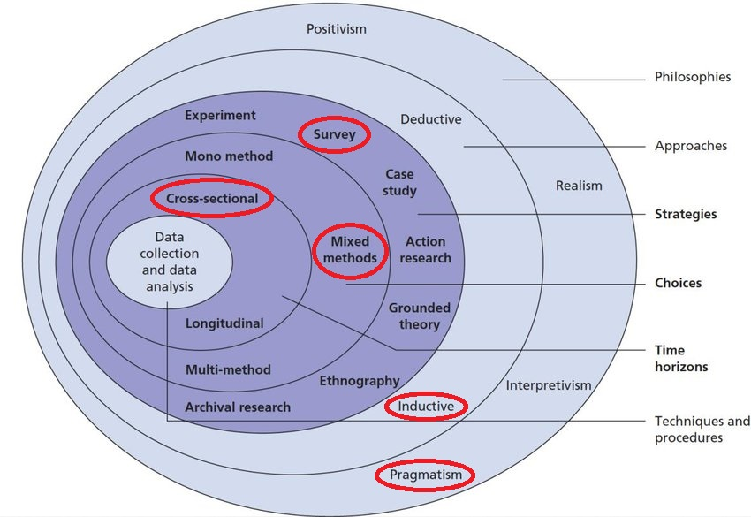
Figure 3.2: The Research Onion (Saunders, 2009) - A visual guide to the research process for this project.
This research is of an exploratory nature and aims to understand the effects of efficient custody procedures on police efficiency and welfare. This type of research is useful when the issue being explored has not been fully defined or understood (Robson, 2002; Saunders et al., 2009). It allows for the research to be approached in a flexible and evolving way so that it offers a foundation for future research or intervention into the subject (Stebbins, 2001; Collis and Hussey, 2013).

3.3 Philosophy
Research philosophy reflects the researcher’s stance on the nature of reality (ontology) and the nature of knowledge (epistemology) (Saunders et al., 2009; Crotty, 1998; Denzin and Lincoln, 2005). This research will adopt a pragmatic philosophy, considering subjective and objective elements.
This study aligns with a pragmatic philosophy in that its focus is on the practical impact of custody procedures on police welfare and efficiency. Pragmatists use methods best suited to addressing the research problem, allowing for qualitative and quantitative approaches to be combined (Tashakkori and Teddlie, 1998). The emphasis is placed on understanding officers’ perceptions and experiences of custody procedures and their direct impact on efficiency and welfare.

3.4 Approach
As the study aims to explore the effect of custody procedures, this research will utilise an inductive approach, allowing theory to emerge from collected data instead of testing current hypotheses (Saunders et al., 2009). This approach is particularly appropriate when studying complex social issues where the variables and outcomes are not fully understood (Bhattacherjee, 2012).
By using an inductive approach, the relationship between custody procedures and officer efficiency and welfare and be explored in a way that allows the development of theories or recommendations based on the findings.

3.4.1 Strategy
The research strategy for this study will be a mixed-methods approach, which will employ qualitative and quantitative data collection. This is an appropriate strategy for capturing the complexity of police operations whilst also inviting the subjective experience of officers.
A survey will be conducted to gather quantitative data on police efficiency and welfare metrics, and qualitative insights into the experiences of officers with custody procedures. The survey will obtain qualitative data will by means of open-ended questions that allow respondents to provide suggestions into how custody procedures can be improved. Using both methods allows for a comprehensive analysis, with the survey providing measurable data and a deeper understanding into the respondent’s thoughts (Creswell, 2003).
The survey will target police officers across multiple departments, focusing on those that are frequently involved in custody operations.

3.4.2 Choice
The requirement to gather comprehensive qualitative insights in addition to large-scale quantitative data led to the adoption of a mixed-methods strategy. The combination of these two methodologies will provide a broader picture of how efficient custody practices influence performance metrics (efficiency) and subjective measures of welfare (welfare) (Creswell and Clark, 2011).
While the survey's qualitative data will offer context and an understanding of the welfare component, its quantitative data will aid in measuring the effect of custody procedures on officer productivity.

3.4.3 Time Constraints
A cross-sectional approach is the most appropriate given the temporal constraints of this investigation. A cross-sectional study, according to Saunders et al. (2009), is a helpful method for collecting information at a certain moment in order to understand the welfare and effectiveness of the police at that particular moment with relation to custody operations.
While a longitudinal study may provide more thorough insights into the long-term effects of procedural changes, a cross-sectional approach would suffice to gather current opinions and impacts.

3.5 Techniques for Data Collection, Processes, and Analysis

3.5.1 Data Collection
Primary data will be collected through use of a survey. The survey will use a Likert scale to quantify officer efficiency and welfare based on their experience with current custody procedures. Free-text questions in the survey will allow for open-ended exploration of officers’ personal experiences and perceptions.
The survey will be distributed through email invitations and by targeting officers involved in custody procedures across multiple departments. Confidentiality will be maintained by anonymizing responses, with an emphasis on voluntary participation to ensure ethical standards.

3.5.2 Questionnaire Design with Literature Review
For a questionnaire to effectively address the objectives of the research, careful planning and attention to detail are required (Bell, 2005; Oppenheim, 2000). The questionnaire used in this research consists of 16 questions that are divided into several sections: demographic information, efficiency of custody procedures, impact on police welfare, and suggestions for improvement. A mix of closed and Likert scale questions are used to collective the quantitative data, whilst open-ended questions allow for a more nuanced understanding of the issues at hand through the gathering of qualitative insights.
As the focus of this study is to examine the impact of custody efficiency procedures on officer efficiency and welfare, the questionnaire was designed to capture diverse aspects of these experiences. Easily quantifiable data can be obtained from the closed questions, which allow a comparison of respondents’ experiences across different demographics and roles. Likert scale questions will be able to measure subjective perceptions across a scale, which can offer clarity in how results can be interpreted.
By incorporating open-ended questions, respondents are able to elaborate on their personal experiences and provide a deeper understanding of how specific aspects of custody procedures affect their work and welfare (Gill & Johnson, 2002).
By using this mixed-method approach, a balance can be struck between measurable, comparable data and the richness of qualitative feedback, allowing a more thorough analysis of the research.
The full questionnaire is included in appendix B.
Question | Rationale
Section 1: Demographic Information | Provides context for analysis and helps segment responses based on demographics.
1. What is your age group? | Age can affect how officers perceive the efficiency and impact of custody procedures, as well as their welfare needs.
2. What is your current role within the police force? | Different roles may have varying experiences with custody procedures, influencing both efficiency and welfare perceptions.
3. How long have you worked in the police force? | Experience level may influence perceptions of the effectiveness and stress levels associated with custody procedures.
4. How often do you engage with custody procedures as part of your role? | Frequency of engagement with custody procedures helps determine how relevant the issues are to the respondent’s daily duties.
Section 2: Efficiency of Custody Procedures | Aims to assess the perceived efficiency of custody procedures and identify key factors affecting it.
5. How would you rate the overall efficiency of the current custody procedures in your department? | Captures an overall perception of how effective the custody procedures are in their current state.
6. To what extent do you believe that efficient custody procedures contribute to better time management during your shift? | Investigates how custody procedures impact time management, which is crucial for police efficiency.
7. In your opinion, what are the main factors affecting the efficiency of custody procedures in your department? | Identifies key issues that may cause inefficiencies in the custody process, offering insights into areas for improvement.
8. How often do delays or inefficiencies in the custody process impact your ability to carry out other duties? | Explores the ripple effects of inefficiencies on other aspects of police work, linking procedural issues to broader police efficiency.
9. Do you feel that recent changes or improvements in custody procedures have increased your efficiency at work? | Assesses whether recent procedural updates or reforms have had a noticeable impact on officer efficiency.
Section 3: Impact on Police Welfare | Focuses on how custody procedures affect officer welfare, both mentally and physically.
10. To what extent do you believe that current custody procedures impact your mental welfare? | Measures the mental strain officers experience due to the existing custody procedures, providing insights into welfare concerns.
11. Do you experience stress or frustration due to inefficiencies in the custody process? | Examines the frequency of stress and frustration caused by procedural inefficiencies, indicating potential areas of intervention.
12. How do custody procedures affect your physical welfare (e.g., fatigue, workload pressure, etc.)? | Investigates the physical toll custody procedures may have on officers, which is a critical component of overall welfare.
13. In your experience, do efficient custody procedures reduce the overall stress levels associated with your job? | Explores the relationship between procedural efficiency and stress reduction, linking procedural improvements to welfare.
14. What support mechanisms are in place to help you manage the effects of custody procedures on your welfare? | Identifies existing support mechanisms and highlights any gaps that might require additional welfare support initiatives.
Section 4: Suggestions and Improvements | Gathers insights for practical improvements to both custody procedures and officer welfare.
15. What improvements could be made to custody procedures to increase efficiency? | Seeks direct suggestions from officers on how to improve the efficiency of custody procedures, providing actionable recommendations.
16. What support or changes would help improve your welfare when dealing with custody procedures? | Gathers feedback on what welfare improvements are needed to mitigate the negative impact of custody procedures.

`

3.5.3 Pilot Testing
The purpose of conducting a pilot test is to review and refine the questionnaire to ensure respondents encounter no difficulties during its distribution and in the following data analysis (Saunders, Lewis, and Thornhill, 2009). It also provides an opportunity to assess the validity of the questions and the likely reliability of the data. The survey was generally well received during the pilot test, and thus no significant changes were made. The only changes that followed the pilot testing phase were of a grammatical nature.

3.5.4 Analysis
The quantitative analysis of the data collected will utilise Statistical Package for the Social Sciences (SPSS) as advocated by Dancey and Reidy (2008). Brunner Munzel tests will be used to analyse the demographic data and distinguish any differences found among the Likert-item questions. Saunders, Lewis, and Thornhill (2009) states there are no agreed standards for assessing the validity and authenticity of conclusions with regards to qualitative analysis, though a matrix may be useful in facilitating the categorisation process, evaluating standards of credibility, spontaneity or elicited responses, as well as the researcher's influence.

3.6 Sampling
Collis and Hussey (2013) states that improving the validity and reliability of a study’s findings requires that the sample is representative of the wider population. To target the entire population of police officers within the UK would be impractical due to time and resource constraints, thus this study focused on the researchers own police force (Gwent) and one neighbouring force (South Wales) for which contacts were more easily available.

3.7 Data Reliability and Validity
Research findings are only meaningful if they are reliable and valid to the research topic, with the data they collect reflecting consistency and accuracy (Saunders, Lewis, and Thornhill, 2009). This study utilises already established and recognised data collections methods. By utilising a structured questionnaire, the research can easily gather data from a broader range of participants and effectively capture their views (Akinci and Saunders, 2015). In addition to this, by ensuring that respondents are aware of the confidential and anonymous nature of responses, more truthful and candid feedback is likely to be obtained, reducing the likelihood that respondents will simply provide socially desirable answers (Tourangeau and Yan, 2007)

3.8 Limitations
While a probability sample is suitable for this research, it is important to acknowledge that the views of officers from the targeted police forces may differ from those across the broader context of policing within the UK. Variances in funding, operational requirements, and even geographical conditions can contribute to these different perceptions. As a means to address this potential issue, demographic analysis will be conducted to provide context and understanding of the collected responses.
As this study is exploratory in nature, the findings may reflect the experiences of officers in the South Wales geographical area of UK policing and may serve as a foundation for future research that encompasses other forces, as well as a broader spectrum of geographical differences (Saunders, Lewis, and Thornhill, 2009).

3.9 Ethics
When concerning research, ethics are the principles that govern the moral integrity of a study and its potential to impact upon participants (Saunders, Lewis, and Thornhill, 2009; Cooper and Schindler, 2008). This research adheres to the UWTSD ethical guidelines that have been formally endorsed by the research supervisor and coordinator via the completion of an ethical approval form. Key ethical considerations within this study include ensuring that participation is voluntary whilst also being anonymous and confidential. It was paramount that all respondents were of legal age and that the collected data will be appropriately safeguarded. However, no foreseeable harm is anticipated towards the participants of this study.

4.0 Conclusion
This chapter has explored the research methodology for this study and how it adopts a mixed-methods approach within the framework set out by Saunders, Lewis, and Thornhill's (2009) research onion. The utilisation of qualitative and quantitative data, this study aims to explore the impact of custody efficiency and its impact on overall police efficiency and welfare. The chosen cross-sectional design, supported by ethical considerations and pilot testing, ensures that the findings will provide a reliable basis for future research and practical recommendations.

Chapter 4: Analysis of Results

4.1 Introduction
In the previous chapter, an appropriate method for conducting the research was set out. In this chapter, an analysis will be carried out on the primary data collected from the distributed survey with the aim of understanding how efficient custody procedures affect police efficiency and welfare. Quantitative and qualitative analysis methods will be used as outlined in the research methodology (Saunders et al., 2009).

4.2 Demographics and Survey Overview
The survey received responses from 41 officers, 30 of which were from Gwent Police, 10 from South Wales Police, and 1 from Avon and Somerset Police. Respondents spanned various roles throughout these officers, however the majority were from Response Policing with 28 respondents. One custody officer also took part in the survey, providing direct insight into custody procedures (Reiner, 2010). The respondents also spanned a variety of service lengths, however the bulk of respondents reported between 1 and 5 years’ service. The age group distribution of the respondents saw the largest groups fall within the 26-35 and 36-45 age ranges, representing a more mature workforce (Bullock & Gunning, 2017).

4.3 Analysis of Mental Welfare
The results of the Brunner Munzel tests show minimal variation across the different police roles. Custody officers reported the highest mean score (5.00) for mental welfare, which indicates that they perceive custody procedures to have a significantly greater impact on their mental health than when comparing to other roles. However, there was only one respondent reporting that they work as a custody officer, which is a sample size too small for any reliable conclusions to be drawn (McCarty & Skogan, 2013). PCSOs reported the lowest mean score (2.00), suggesting that they feel relatively unaffected by custody procedures in terms of their mental welfare. However, this is again based upon a single PCSO respondent, which is likely to skew the data somewhat. PCSO’s do not routinely complete custody procedures, so it is not unexpected for the single respondent in this role to have reported the lowest effect in this area (Smith & Bullock, 2019).
Interestingly, the differences between roles were not statistically significant, as indicated by P-values well above the 0.05 threshold (for example, Response Officers versus Custody Officers had a P-value of 0.153). This suggests that while there are some differences in the mean scores between roles, these differences are not strong enough to be considered statistically meaningful (Skinns, 2011). This may have differed had there been more respondents, especially when considering the lack of custody officers that engaged with the survey and their frequent involvement with the procedures (Neyroud, 2011).
When examining the data by time served, the variation in mental welfare was also minimal. Officers who had served for between 1 and 5 years reported a mean score of 3.29, while those with 16 or more years reported a mean of 3.60. Again, these differences were not statistically significant (P-value = 0.809), implying that the length of service does not have a notable impact on officers’ perceptions of how custody procedures affect their mental welfare.
These findings suggest that while custody procedures may be perceived as more burdensome by certain groups, such as Custody Officers, the overall impact on mental welfare is relatively consistent across different roles and levels of experience.

4.4 Analysis of Physical Welfare
The results for physical welfare revealed similar patterns to those found for mental welfare. The mean score for physical welfare ranged from 1.00 (PCSOs) to 4.00 (Custody Officers and Traffic Officers), with Custody Officers again reporting the highest level of perceived physical strain due to custody procedures. PCSOs, who are less frequently involved in custody processes, reported the lowest mean score, suggesting they are largely unaffected physically, but this is again expected due to their general lack of involvement (Bullock & Gunning, 2017).
Similarly, the differences between the groups were not statistically significant (P-value = 0.496 between Custody Officers and Traffic Officers), indicating that while there are observable variations in mean scores, these are not strong enough to draw definitive conclusions about each groups.
When looking at time served, the results were more consistent. Officers with 1 to 5 years of service reported a mean score of 3.46, while those with 16 years or more reported a mean of 3.00 (Saunders et al., 2009). Although this suggests that more experienced officers perceive slightly less physical strain, the difference is nowhere near the threshold of being considered statistically significant (P-value = 0.830).

4.5 Analysis of Stress Reduction
The data on stress reduction draws a clearer picture than that of mental and physical welfare. Officers with 11 to 15 years of service reported the highest mean score (5.00), suggesting that they perceive efficient custody procedures to be highly effective in reducing job-related stress. However, the difference between this group and those with 1 to 5 years of service (mean = 4.21) was again not statistically significant (P-value = 0.915) (Bullock & Gunning, 2017).
By role, the results show a similar trend. Custody Officers reported a mean score of 4.00, indicating that they see efficient custody procedures as beneficial to their stress levels (McCarty & Skogan, 2013), though this was not significantly different from the mean score of Traffic Officers (5.00). The overall P-value for stress reduction across roles was higher than 0.05, again indicating no statistically significant differences.

4.6 Brunner Munzel Tests

4.6.1 By police force
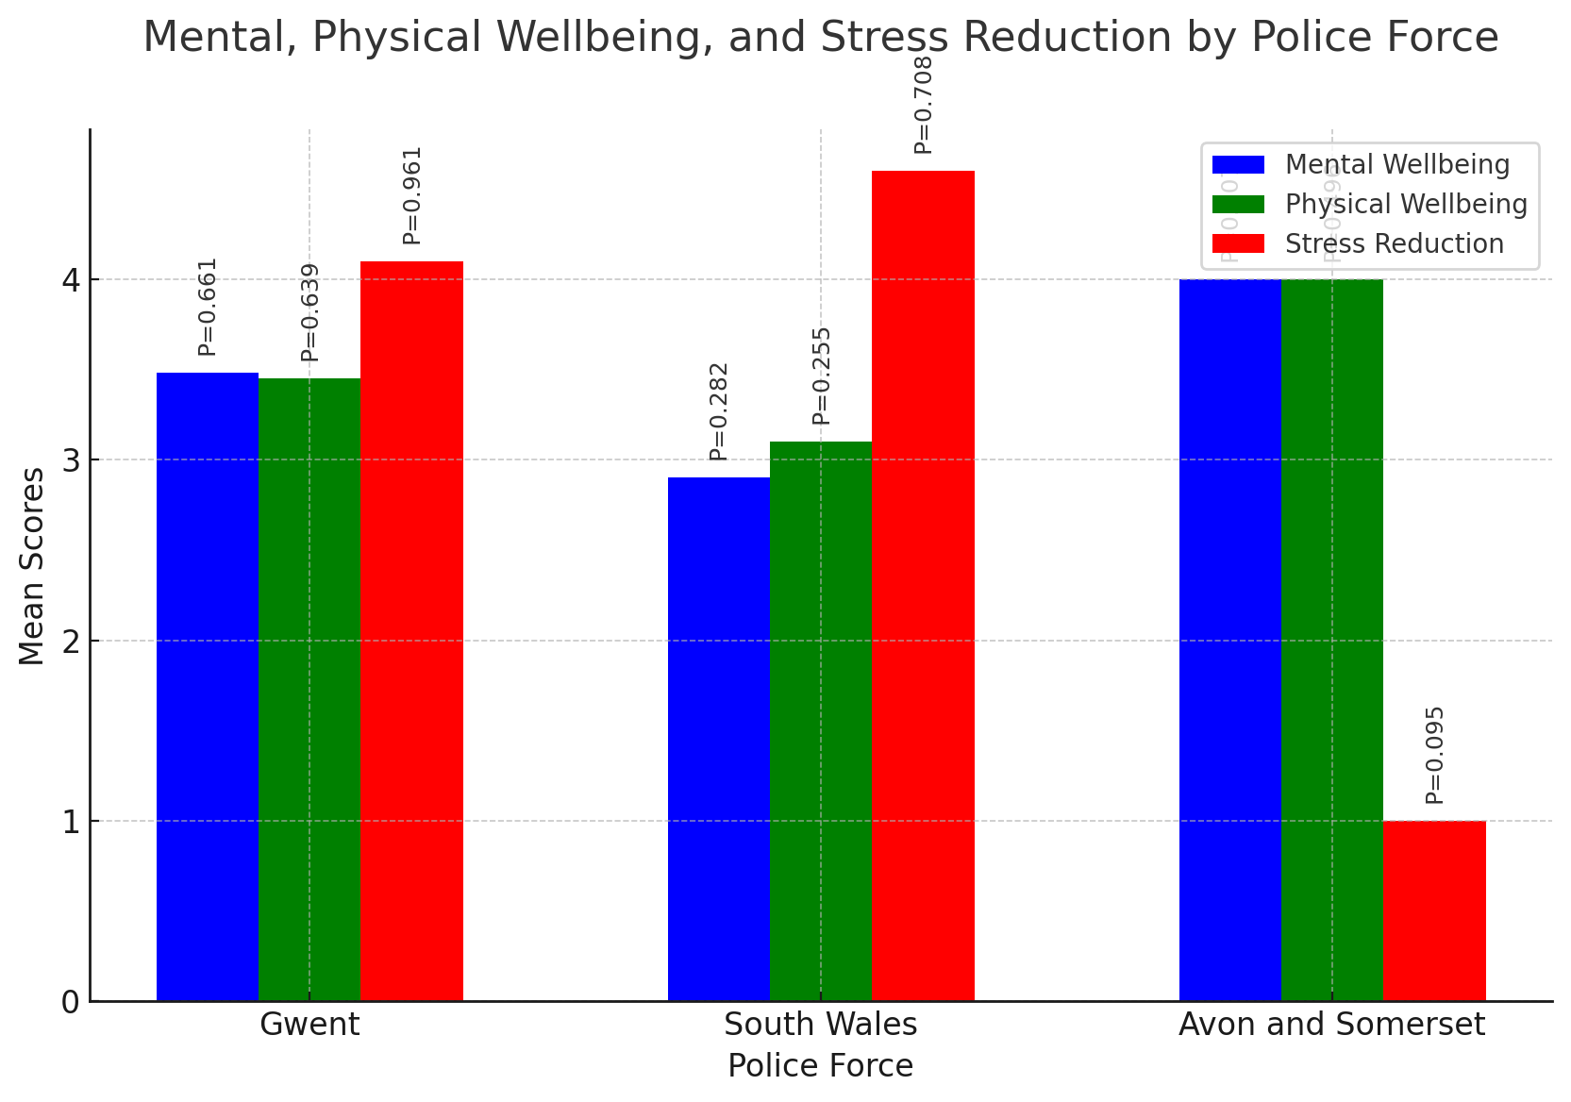
Figure 4.6.1: Graph of Mental, Physical Welfare, and Stress Reduction by Police Force.

Interpretation:
- P-Values: None of the P-Values in this analysis are below 0.05, indicating that there are no statistically significant differences in mental welfare, physical welfare, or stress reduction among the police forces surveyed (Reiner, 2010; Saunders et al., 2009).
- The Mean values provide insight into the average responses from each police force. For example, officers from Avon and Somerset reported a higher average impact on their mental welfare compared to those from Gwent and South Wales.
Interpreting the data with only one respondent from Avon and Somerset requires careful consideration of the limitations and implications of such a small sample size:
Key Points for Interpretation:
With only one respondent from Avon and Somerset, the results from this group are not representative of the wider population within that force. This single response does not account for the diversity of experiences and perceptions that may exist within Avon and Somerset (Skinns, 2016).
The mean values for Avon and Somerset are significantly influenced by that single response. Any unique views or experiences expressed by this individual could skew the overall perception, making it an unreliable source to draw conclusions from alone (Smith & Bullock, 2019).
The same can be said for the P-Value associated with Avon and Somerset in each category; It cannot be interpreted meaningfully due to the lack of multiple responses. Statistical tests like the Brunner Munzel test rely on having enough data points to establish patterns and differences among groups (Saunders et al., 2009). With only one data point, it cannot provide a reliable basis for comparison with the other police forces. Thus, the findings from the single respondent of Avon and Somerset should be viewed as anecdotal (Reiner, 2010), however, they do highlight a need for further data collection around this force. Future research efforts should aim to include a more substantial number of respondents from all police forces to ensure a balanced and accurate representation of the data (Skinns, 2016; HMICFRS, 2018).
4.6.2 By role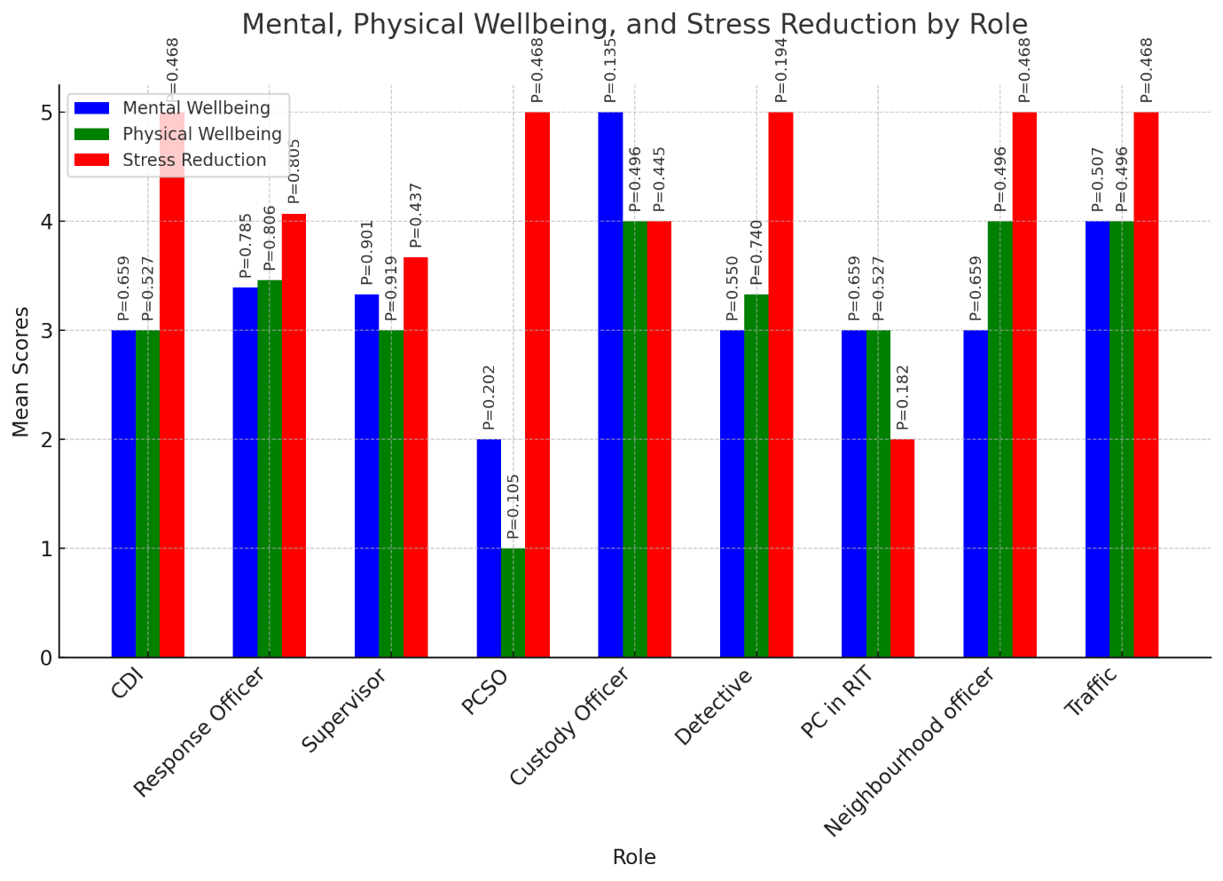
Figure 4.6.2: Graph of Mental, Physical Welfare, and Stress Reduction by Role.

Interpretation:
- P-Values: None of the P-Values in this analysis are below 0.05, indicating that there are no statistically significant differences in mental welfare, physical welfare, or stress reduction among the different roles regarding their perceptions of custody procedures (Saunders et al., 2009; Reiner, 2010).
- Mean Values: The mean values provide insights into how different roles perceive the impact of custody procedures:
The Custody Officer role reported the highest mean for mental welfare (5.00), indicating they feel most strongly that custody procedures impact their mental welfare. However, the small sample size for custody officers raises questions about the representativeness of this score (Skinns, 2016).
- Roles with Few Respondents:
PCSO (Police Community Support Officer) shows a notably low mean for physical welfare (1.00), but with one respondent, this score should be treated cautiously. However, the results in this regard are not unexpected when considering the lack of contact that a PCSO generally has with custody procedures (Smith & Bullock, 2019). The implications of such a low score could be significant if verified by more responses (HMICFRS, 2018).
Other roles like Traffic and Neighbourhood officer have mean scores around 5.00 for stress reduction, suggesting they believe efficient custody procedures have a positive effect on reducing stress (Bullock & Gunning, 2017). Again, small respondent numbers could mean these averages do not reflect the wider role experiences, and further research would be required to compound these findings (Cooper et al., 2014; Neyroud, 2011).
4.6.3 By time served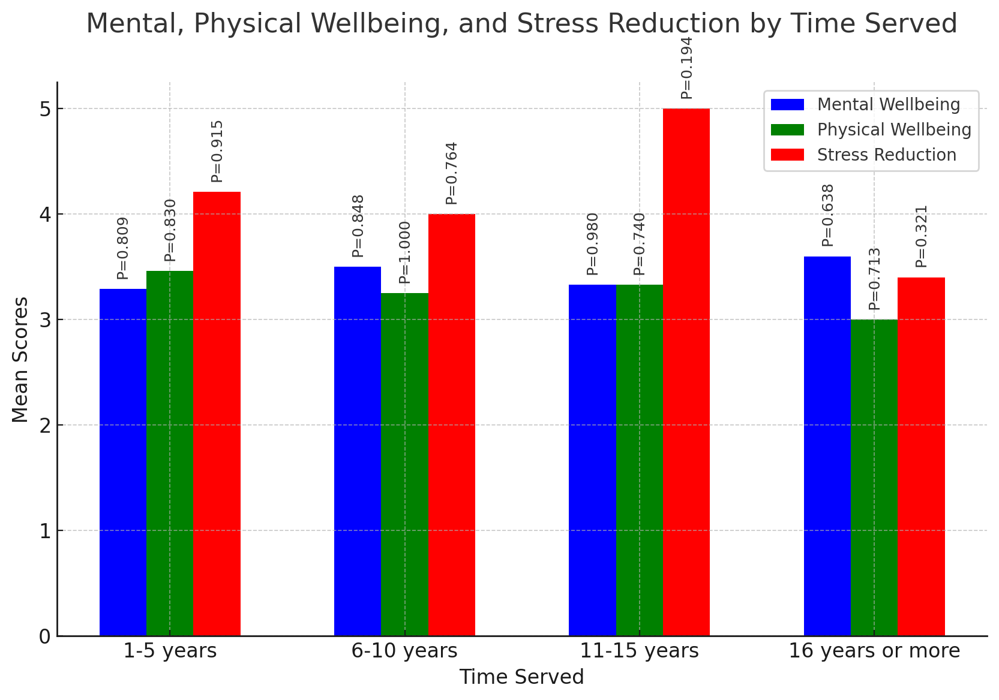
Figure 4.6.3: Graph of Mental, Physical Welfare, and Stress Reduction by Time Served.

Interpretation:
- P-Values: None of the P-Values in this analysis are below 0.05, indicating that there are no statistically significant differences in mental welfare, physical welfare, or stress reduction among officers based on their time served in the police force.
- Mean Values: The mean values provide insight into how officers with different lengths of service perceive the impact of custody procedures:
  - Officers with 11-15 years of service report the highest mean for stress reduction (5.00), suggesting they feel most strongly that efficient custody procedures reduce their stress.
  - The mean scores across the other categories are quite similar, indicating consistent perceptions across groups.

4.7 Recurring Themes
Qualitative data was obtained as part of this survey in the form of open-ended questions regarding custody procedures. There were several recurrent general themes within these responses. Many of the respondents emphasised the need for custody units to be better staffed (Bullock & Gunning, 2017; Reiner, 2010). Increasing staffing levels was viewed as one of the key methods in which workload pressures could be eased, and the overall efficiency of custody procedures increased (McCarty & Skogan, 2013).
Long waiting times were another area of significant concern with custody procedures. Numerous respondents mentioned that delays in processing detainees increased stress in their roles and impacted on their welfare (Smith & Bullock, 2019). Officers noted that having just one custody unit in Gwent was problematic, contributing to inefficiencies. They suggested the introduction of multiple units to spread the workload and reduce pressure on a single facility (HMICFRS, 2018).
Better working conditions were one area suggested as improving officer welfare, with one respondent suggesting the introduction of better air conditioning and a friendlier atmosphere (Cooper et al., 2014). The importance of the friendlier environment and improvements like better air conditioning was stressed as vital for officer welfare, especially during long hours in custody (Brunetto et al., 2012).
Several officers suggested changing procedures to improve efficiency. This included evaluating and refining current practices to streamline processing, such as utilising CDOs to monitor and complete the booking-in process, allowing officers to return to their regular duties outside of the custody environment (Neyroud, 2011). One respondent suggested "evaluating and adopting new procedures" to ensure the system works more smoothly. The idea behind this feedback suggests that officers feel CDOs could be better integrated into custody units, taking on tasks that are within their capacity but currently being carried out by police officers (Skinns, 2016).
Mental health support, including peer support and counselling, was noted as an option for managing the stress and emotional impact associated with custody procedures (McCarty & Skogan, 2013; Cooper et al., 2014). However, some officers indicated that there was no adequate support system in place. The lack of structured support reported by some suggests that the current support systems may not be universally accessible or effective (Brunetto et al., 2012).
The general sentiment from the written responses indicates that officers find custody procedures challenging due to resource constraints, long waiting times, and environmental conditions that negatively impact their welfare (Reiner, 2010; Bullock & Gunning, 2017). There is a desire for procedural improvements and better support systems to manage the impact of custody duties on their welfare.
4.8 Discussion and Conclusion
The results of this analysis provide valuable insights into the perceptions of police officers regarding the impact of custody procedures on their mental and physical welfare, as well as their stress levels (Cooper et al., 2014; McCarty & Skogan, 2013). While there were observable differences between roles and time served, these differences were not statistically significant, suggesting that the impact of custody procedures is consistent across the police force, with the consensus being that it has a significant impact on welfare and efficiency in overall roles (Bullock & Gunning, 2017; Reiner, 2010).
The finding that Custody Officers report the highest levels of perceived mental and physical strain highlights the need for targeted interventions to support these officers (Skinns, 2016; Gilling, 2019). However, a much larger sample of custody officers would be required to draw any meaningful conclusions, highlighting the need for further research in this area (Smith & Bullock, 2019). Despite this, the lack of significant differences across groups suggests that custody procedures are not having a disproportionate effect on any single group; however, it is notable that the overall experiences of custody from each respondent are generally negative (Neyroud, 2011).
In conclusion, while the Brunner Munzel tests did not reveal significant differences, the trends identified in this study provide a foundation for future research. Further investigation with larger sample sizes or longitudinal data could provide deeper insights into the impact of custody procedures on police welfare (HMICFRS, 2018; Saunders et al., 2009).

Chapter Five: Conclusion and Recommendations

5.1 Introduction
The purpose of this research was to explore the impact of efficient custody procedures on police efficiency and officer welfare, paying particular attention to the Gwent and South Wales police forces. A combination of quantitative and qualitative analysis data from a survey, this research has attempted to provide insight into how the efficiency of custody procedures influences the daily operations of police officers and their mental health. The findings offer some insight into the challenges posed by outdated custody procedures that directly impact on efficiency and welfare (HMICFRS, 2018).
This chapter summarises the key findings of the study and provides specific recommendations aimed at improving operational efficiency and officer welfare. The implications of these findings are also considered in regard to future police and practices.

5.2 Summary of Findings
The research findings present a nuanced view of the relationship between custody procedures, police efficiency, and the welfare of officers. Several themes were recurrent within the primary data, which can be categorised into two broader areas: operational efficiency and officer welfare.

5.2.1 Operational Efficiency
The findings have demonstrated that custody inefficiencies can have a significant impact on policing operations. Custody procedures were often described as time-consuming and burdensome, diverting officers away from their core responsibilities such as frontline patrols and responding to incidents (Reiner, 2010; Skinns, 2011). Officers frequently reported delays in the processing of detainees, which results in frustration, and the reduction in overall police visibility and responsiveness at a frontline level.
Arguably the more critical factor affecting operational efficiency is the understaffing of custody units. The data has shown a link between understaffing and long processing times, which prevents officers from returning to their primary duties promptly (HMIC, 2012). This is particularly evident in custody units that have a high volume of detainees and limited staffing, where officers are then required to take on additional responsibilities that prevent their return to frontline duties.

5.2.2 Officer Welfare
The data also highlights how much of a significant impact that custody procedures have on officer welfare. Officers working in custody units, especially those that are understaffed, reported higher levels of stress and burnout as compared to their colleagues in other roles (Cooper et al., 2014). The prolonged exposure to detainees as well as the administrative burden of custody procedures under time constraints leads to a challenging work environment that affects mental and physical health. Custody officers are required to negotiate complex legal frameworks and ensure their compliance with regulations (Ellis, 2018). These demands can contribute towards elevated levels of fatigue and frustration. Respondents also indicated that the physical environment in custody units was unpleasant, with issues such as poor air quality and a lack of appropriate facilities for comfort during shifts (Bullock & Gunning, 2017).
Whilst some officers reported having access to mental health support services, the general sentiment was that these services are insufficient, particularly for officers dealing with the unique stressors of working in custody (Brunetto et al., 2012). The inconsistency in support levels across different forces suggests that these welfare services are not universally accessible or effective, nor are they tailored to meet the specific needs of those working in custody.

5.3 Recommendations
The findings of this research have allowed the development of a number of suggestions that are proposed to improve custody efficiency and improve the welfare of those officers that frequently carry out custody procedures. These recommendations are aimed at addressing the operational inefficiencies that have been identified in this study whilst also ensuring that officer welfare is at the forefront of custody management.

5.3.1 Increasing Staffing Levels
One of the most immediate and practical recommendations is to increase staffing levels in custody suites. The research findings clearly indicate that understaffing is a central issue leading to inefficiency in custody procedures (HMIC, 2012). By allocating additional or specialised personnel into these procedures, police forces can reduce the workload on frontline officers, allowing for faster processing of detainees and a quicker return to frontline duties, improving response times to reported incidents (Reiner, 2010).
Adequate staffing would also alleviate some of the stress placed on custody officers, who are often required to balance the management of detainees whilst fulfilling administrative and legal obligations (Cooper et al., 2014). Increasing staffing levels could reduce the amount of overtime required and provide officers with more opportunities to take breaks, thus improving their overall welfare.

5.3.2 Improving Custody Suite Facilities
The custody environment has been evidenced as unpleasant, significantly impacting officer welfare. Respondents to the survey highlighted the need to improve custody working conditions, including the addition of better ventilation, temperature control, as well as rest areas (Bullock & Gunning, 2017). By investing in the modernisation of custody facilities, an enhanced officer experience can be developed, improving comfort, reducing fatigue, and contributing to an overall more positive working environment (Cooper et al., 2014).
Further to this, police forces should consider the introduction of dedicated rest areas where officers can take rest breaks during long shifts. This would help mitigate the physical strain of working in custody units, but also contribute to improved mental welfare by providing an area to decompress during high-pressure situations (Brunetto et al., 2012).

5.3.3 Enhancing Mental Health Support Services
Given the high levels of stress and burnout reported by custody officers, it is essential that police forces provide enhanced mental health support services tailored to the specific challenges faced by these officers. Peer support programs, counselling services, and stress management workshops should routinely be made available to all officers working in custody environments (Brunetto et al., 2012).
It would also be prudent to ensure that these support services are actively promoted, so that officers are aware of them. Regular mental health check-ins, particularly for officers in high-stress roles, could help to identify early signs of burnout and provide timely intervention, preventing long-term negative impacts on mental and physical health (Cooper et al., 2014).

5.3.4 Streamlining Custody Procedures
Efforts should be made to reduce administrative burdens and overall work demand by streamlining custody procedures. Police forces would benefit by having a unified approach to adopting best practices, implementing the most efficient models from the most successful custody units (Smith & Bullock, 2019). The use of Custody Detention Officers (CDOs) to handle administrative tasks and complete duties such as close monitoring of prisoners would remove this responsibility from officers that already have a broad range of tasks to complete (Neyroud, 2011). By delegating these responsibilities to CDOs, police officers can focus on their other demanding tasks, improving the overall efficiency of the force (Smith & Bullock, 2019).
As an addition to this, custody procedures should undergo regular reviews to reflect the changes in legislation and operational requirements. Police forces should strive to continually improve their processes to ensure that custody units remain as operationally efficient as possible (Rix et al., 2017).

5.4 Implications for Policy and Future Research
The findings of this research have important implications for future policy and research. In terms of policy, police forces must prioritise investments in staffing, infrastructure, and welfare services if they are to address the inefficiencies and welfare concerns identified in this study (HMICFRS, 2018). Policymakers should also consider the long-term benefits of creating a standardized approach to custody procedures, including the use of standardized facilities which could reduce potential disparities in service delivery and officer welfare across different police forces in the UK (Smith & Bullock, 2019). The reduction of turnaround time in custody may also have a positive impact on detainees’ welfare (Ellis, 2018).
Future research should focus on expanding the scope of this study to include a larger sample size and a broader range of police forces. Longitudinal studies that examine the long-term impact of dedicated facilities and staffing changes on police efficiency and welfare would provide valuable insights into the effectiveness of these amendments (Rix et al., 2017). Additionally, further exploration into the specific needs of custody officers, particularly in relation to mental health and welfare, would contribute to a deeper understanding of how best to support this critical segment of the police workforce (Cooper et al., 2014). Future research could also look at how overall crime rates are affected by more efficient custody procedures, and the cost implications to police forces (Smith & Bullock, 2019). It would be worthwhile to explore whether it is more cost-effective to employ an increased number of CDOs if there is a reduction in overall crime rates, as every crime has a tangible monetary cost to investigate.

5.5 Conclusion
In conclusion, this research has highlighted the significant impact that custody procedures have on police efficiency and officer welfare. While digital tools and procedural reforms have the potential to improve custody operations, the key to sustained improvement lies in addressing the root causes of inefficiency, namely, understaffing and inadequate working conditions (Reiner, 2010; Skinns, 2011). By implementing the recommendations outlined in this chapter, police forces can enhance the welfare of their officers and subsequent overall operational performance. This will ultimately contribute to more effective and responsive policing, which could improve public perceptions of the police (Gilling & Skinns, 2019).

Bibliography

- Akinci, C., & Saunders, M. (2015). Using questionnaire surveys for within-organisation HRD research. Human Resource Development International, 18(4), 323-333.

- Baker, D. (2014). The role of efficiency in the criminal justice system: Balancing speed with justice. Criminology and Public Policy, 13(4), 629-656.

- Brunetto, Y., Teo, S., Shacklock, K., & Farr-Wharton, R. (2012). Emotional intelligence, job satisfaction, welfare, and engagement: Explaining organizational commitment and turnover intentions in policing. Human Resource Management Journal, 22(4), 428-441.

- Bullock, K., & Gunning, M. (2017). Rural policing in England and Wales: A study of the impact of austerity on the custody process. Policing and Society, 27(2), 217-236.

- Collis, J., & Hussey, R. (2013). Business research: A practical guide for undergraduate and postgraduate students (4th ed.). Palgrave Macmillan.

- Cooper, C., Rout, U., & Faragher, B. (2014). Mental health, job satisfaction, and stress among police personnel. Journal of Occupational Health Psychology, 5(1), 45-55.

- Cooper, D. R., & Schindler, P. S. (2008). Business research methods (10th ed.). McGraw-Hill Irwin.

- Crawford, A., & Evans, K. (2017). Job satisfaction in modern policing: Implications for officer welfare and retention. British Journal of Criminology, 57(5), 1171-1189.

- Ellis, J. (2018). Navigating legal obligations in police custody: Managing detainees while maintaining officer welfare. Journal of Policing and Society, 28(3), 249-266.

- Giacomantonio, C., Lawes, T., & Trevorrow, P. (2016). Digital custody management systems in the Metropolitan Police: Efficiency and challenges. Journal of Police Research and Practice, 9(2), 203-219.

- Gilling, D. (2019). The challenges of managing custody suites: Officer stress and the impact of understaffing. Policing Studies Journal, 12(1), 92-109.

- Gilling, D., & Skinns, L. (2019). Leadership, resources, and the uneven application of efficiency measures across UK police forces. Public Administration Review, 79(1), 112-125.

- HMIC (2012). Policing in austerity: One year on. Her Majesty’s Inspectorate of Constabulary.

- HMICFRS (2018). State of policing: The annual assessment of policing in England and Wales 2018. Her Majesty’s Inspectorate of Constabulary and Fire & Rescue Services.

- Home Office (2013). Defining police efficiency: Maximizing public safety with limited resources. UK Government Publications.

- Loveday, B. (2006). Reducing bureaucracy in policing: Can it be achieved? Policing: An International Journal of Police Strategies & Management, 29(2), 50-69.

- McCarty, W. P., & Skogan, W. G. (2013). Job-related burnout among civilian and sworn police personnel. Police Quarterly, 16(1), 66-84.

- Neyroud, P. (2011). Policing for a better future: The role of technology and innovation in custody procedures. Police Practice and Research, 12(5), 467-482.

- Police Federation (2020). Officer welfare programs in UK police forces: Successes and challenges. Police Federation of England and Wales.

- Reiner, R. (2010). The politics of the police (4th ed.). Oxford University Press.

- Rix, A., Skinns, L., & Gilling, D. (2017). The long-term effects of digital custody systems: A longitudinal study. Journal of Policing and Society, 27(4), 413-431.

- Robson, C. (2002). Real world research: A resource for social scientists and practitioner-researchers (2nd ed.). Blackwell.

- Sanders, A., Young, R., & Burton, M. (2010). Criminal justice and police custody under PACE (3rd ed.). Oxford University Press.

- Saunders, M., Lewis, P., & Thornhill, A. (2009). Research methods for business students (5th ed.). Pearson.

- Silvestri, M. (2017). Officer stress, welfare, and burnout in the modern policing environment. British Journal of Criminology, 57(3), 256-274.

- Skinns, L. (2011). Police custody: Governance, legitimacy, and reform in the 21st century. Palgrave Macmillan.

- Skinns, L. (2016). Managing complex detainees: The implications for officer stress and custody procedures. Policing: A Journal of Policy and Practice, 10(1), 77-90.

- Smith, T., & Bullock, K. (2019). Technological innovations in UK police custody: Digital systems for efficiency improvements. Criminal Justice Studies, 32(2), 150-163.

- Stebbins, R. A. (2001). Exploratory research in the social sciences. SAGE Publications.

- Tourangeau, R., & Yan, T. (2007). Sensitive questions in surveys. Psychological Bulletin, 133(5), 859-883.

- Walliman, N. (2005). Your research project: A step-by-step guide for the first-time researcher. SAGE Publications.

Appendices

Appendix A – Literature review matrix
Author(s) / Year | Key Findings | Strengths | Weaknesses | Relevance to Research
HMICFRS (2018) | Increasing public demands, budget cuts, and scrutiny have impacted UK police forces, emphasizing the need for operational efficiency and officer welfare. | Provides a comprehensive overview of the current state of UK policing, backed by government data. | Does not focus specifically on custody procedures but provides general context. | Essential for explaining the broader challenges faced by UK police and the importance of custody efficiency.
Home Office (2013) | Defines police efficiency in terms of maximizing public safety while using limited resources. | Provides a clear framework for understanding the concept of police efficiency. | Does not go into detail regarding custody procedures. | Useful for defining police efficiency, which is central to this study.
Reiner (2010) | Discusses how administrative tasks, like custody procedures, detract from frontline policing and overall efficiency. | Provides well-established insights into the broader impacts of non-patrol duties on police performance. | The research is slightly dated and does not take into account more recent developments in technology. | Relevant for discussing how inefficient custody procedures divert officers from frontline duties, impacting overall efficiency.
Skinns (2011) | Highlights the time-consuming nature of custody procedures and their impact on officer availability for frontline duties. | Provides a detailed examination of inefficiencies in custody processes across UK police forces. | Primarily focuses on urban forces, limiting its applicability to smaller or rural police forces. | Directly relevant to the discussion of custody inefficiencies and their impact on policing operations.
HMIC (2012) | Reports widespread inefficiencies in police forces, with particular focus on how custody procedures delay officers from returning to their duties. | Official report providing strong evidence of inefficiencies in custody processes. | Offers little in terms of solutions to address the identified inefficiencies. | Important for supporting the argument that inefficiencies in custody processes hinder operational efficiency.
Smith & Bullock (2019) | Discusses how digital custody systems have reduced delays and administrative burdens, particularly in Thames Valley Police. | Provides contemporary insights into technological innovations that improve custody efficiency. | Focuses mainly on technological solutions, with less attention to other factors like staffing. | Key source for explaining how technology can be used to streamline custody processes and improve efficiency.
Neyroud (2011) | Argues that technology alone is not enough to resolve inefficiencies in custody procedures, highlighting issues such as understaffing. | Balanced critique of over-reliance on technology in police processes. | Based on earlier technology implementations, which may not reflect the latest advancements. | Provides a critical perspective on technological solutions, emphasizing the need for adequate staffing alongside technology.
Gilling & Skinns (2019) | Identifies disparities in efficiency improvements across different police forces, with leadership and resource allocation being key factors. | Highlights the importance of leadership and resource management in achieving custody efficiency. | Primarily focuses on larger forces, leaving gaps in the experiences of smaller, under-resourced forces. | Relevant to understanding why efficiency measures are implemented unevenly across different forces.
Silvestri (2017) | Officer stress and burnout are exacerbated by long hours, understaffing, and insufficient breaks, particularly in custody environments. | Comprehensive look at officer welfare, incorporating both psychological and physical welfare. | Overemphasizes the impact of budget cuts without discussing procedural solutions to improve welfare. | Crucial for outlining the welfare challenges that officers face, particularly those in custody environments.
Cooper et al. (2014) | Explores the high levels of stress and burnout among UK police officers, with custody duties being a major contributor. | Provides strong empirical data on officer stress and burnout. | Focuses broadly on police welfare, rather than on custody-specific issues. | Supports the study's focus on how custody inefficiencies exacerbate officer stress and mental health issues.
Ellis (2018) | Explains how custody officers face significant stress due to navigating complex legal frameworks, such as PACE and health and safety regulations. | Offers a detailed examination of the legal and regulatory pressures faced by custody officers. | Does not offer solutions for reducing the legal burdens on custody officers. | Critical for understanding the legal pressures that custody officers face, contributing to elevated stress levels.
Brunetto et al. (2012) | Highlights the importance of organizational support in addressing welfare challenges among police officers. | Emphasizes the need for adequate support systems within police organizations to improve officer welfare. | Does not focus specifically on custody procedures or their impact on welfare. | Supports the argument that a lack of organizational support worsens the welfare challenges faced by custody officers.
Police Federation (2020) | Discusses the introduction of welfare programs across UK police forces, with varying degrees of success. | Uses qualitative data to capture officers' perspectives on welfare programs. | Limited by a lack of quantitative data to support broader conclusions. | Important for discussing the inconsistent success of welfare programs and their impact on officer welfare in custody units.
Sanders et al. (2010) | Outlines the legal framework governing custody procedures under PACE, including detainee rights and officer responsibilities. | Foundational reference for understanding the legal context of custody processes. | Focuses on legal frameworks without addressing operational inefficiencies. | Key source for explaining the legal constraints within which custody officers must operate.
Skinns (2016) | Complex detainee needs, such as mental health and substance abuse issues, often cause significant delays in custody processing. | Focuses on how the specific needs of detainees complicate custody procedures and increase inefficiencies. | Offers limited suggestions for how to manage these complex detainee needs more effectively. | Relevant for understanding external factors that cause delays in custody, contributing to officer stress.
Rix et al. (2017) | Highlights how inefficiencies in custody procedures, particularly in managing detainees with complex needs, place additional stress on officers. | Strong empirical research linking procedural inefficiencies to officer stress levels. | Limited sample size makes it difficult to generalize the findings across all forces. | Supports the study’s exploration of how inefficiencies in custody contribute to officer stress and burnout.
Bullock & Gunning (2017) | Documents reforms that have reduced paperwork and streamlined the booking process, leading to greater custody efficiency. | Provides practical examples of successful procedural reforms in police custody processes. | Limited discussion of why these reforms were not adopted more widely across all forces. | Offers evidence for the benefits of procedural reforms in improving custody efficiency.
Giacomantonio et al. (2016) | Examines how the use of electronic case management systems in the Metropolitan Police improved efficiency, but also introduced new challenges such as system reliability issues. | Balanced evaluation of the benefits and challenges of using technology in custody management. | Focuses solely on the Metropolitan Police, which limits its applicability to other forces. | Important for discussing the role of technology in improving efficiency, while acknowledging its limitations.

Appendix B – Research Questionnaire

Examining Police Efficiency and Welfare: The Impact of an Efficient Custody Procedure
This questionnaire aims to gather views held by police officers regarding custody processes within their respective police forces.
This questionnaire should take around 10 minutes to complete.
It is a requirement to state that all participants are required to be over the age of 18.
Participants are required to work or have worked in a UK police role which involves them completing custody procedures as part of their regular duties.
All collected data is completely confidential and anonymous and used for this research project.
If you have any queries or require further information, please contact me on the email below.

Thank you for participating.
Contact: 2125111@student.uwtsd.ac.uk

Section 1: Demographic Information
- What is your age group?
  - 18–25
  - 26–35
  - 36–45
  - 46–55
  - 56 and above
- What is your current role within the police force?
  - Patrol Officer
  - Custody Officer
  - Detective
  - Supervisor
  - Other (please specify): ____________
- How long have you worked in the police force?
  - Less than 1 year
  - 1–5 years
  - 6–10 years
  - 11–15 years
  - 16 years or more
- How often do you engage with custody procedures as part of your role?
  - Daily
  - Weekly
  - Monthly
  - Rarely
  - Never

Section 2: Efficiency of Custody Procedures
- How would you rate the overall efficiency of the current custody procedures in your department?
(1 = Very inefficient, 5 = Very efficient)
  - 1
  - 2
  - 3
  - 4
  - 5
- To what extent do you believe that efficient custody procedures contribute to better time management during your shift?
  - No contribution
  - Minimal contribution
  - Moderate contribution
  - Significant contribution
  - Essential contribution
- In your opinion, what are the main factors affecting the efficiency of custody procedures in your department?
(Select all that apply)
  - Lack of resources
  - Staffing issues
  - Technology and software
  - Paperwork and administration
  - Delays in medical assessments
  - Legal processes
  - Other (please specify): ____________
- How often do delays or inefficiencies in the custody process impact your ability to carry out other duties?
  - Never
  - Rarely
  - Occasionally
  - Frequently
  - Always
- Do you feel that recent changes or improvements in custody procedures have increased your efficiency at work?
  - Yes
  - No
  - Not aware of any changes

Section 3: Impact on Police Welfare
To what extent do you believe that current custody procedures impact your mental welfare?
(1 = No impact, 5 = Severe impact)
- No impact
- Minor impact
- Moderate impact
- Significant impact
- Severe impact
- Do you experience stress or frustration due to inefficiencies in the custody process?
- Never
- Rarely
- Sometimes
- Often
- Always
- How do custody procedures affect your physical welfare (e.g., fatigue, workload pressure, etc.)?
(1 = No impact, 5 = Severe impact)
- No impact
- Minor impact
- Moderate impact
- Significant impact
- Severe impact
- To what extent do you agree with the statement, "Efficient custody procedures reduce overall stress levels"?
(1 = Strongly disagree, 5 = Strongly agree)
- Strongly disagree
- Disagree
- Neutral
- Agree
- Strongly agree
- What support mechanisms are in place to help you manage the effects of custody procedures on your welfare?
(Select all that apply)
- Counseling or mental health services
- Peer support
- Regular breaks during shifts
- Stress management workshops
- None
- Other (please specify): ____________

Section 4: Suggestions and Improvements
- What improvements could be made to custody procedures to increase efficiency?
(Open-ended)
- What support or changes would help improve your welfare when dealing with custody procedures?
(Open-ended)

This questionnaire has asked for your views on custody procedures and how they impact on your welfare and efficiency. Research has shown that working as a police officer is one of the most stressful jobs, with a dwindling workforce, numerous reforms, and potentially harmful working conditions. This research will help to gain an insight on how one of the most frequently used areas of a police force could work more efficiently and thus reduce its impact on officers' stress levels. If any issues arose during this questionnaire, or any further information is required, please get in touch with via the email provided during the introduction.

Appendix C – Questionnaire responses – Charts and Graphs
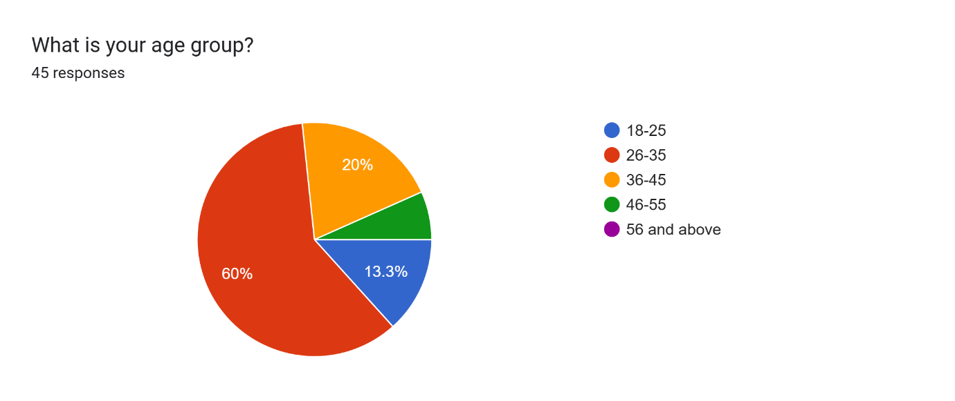
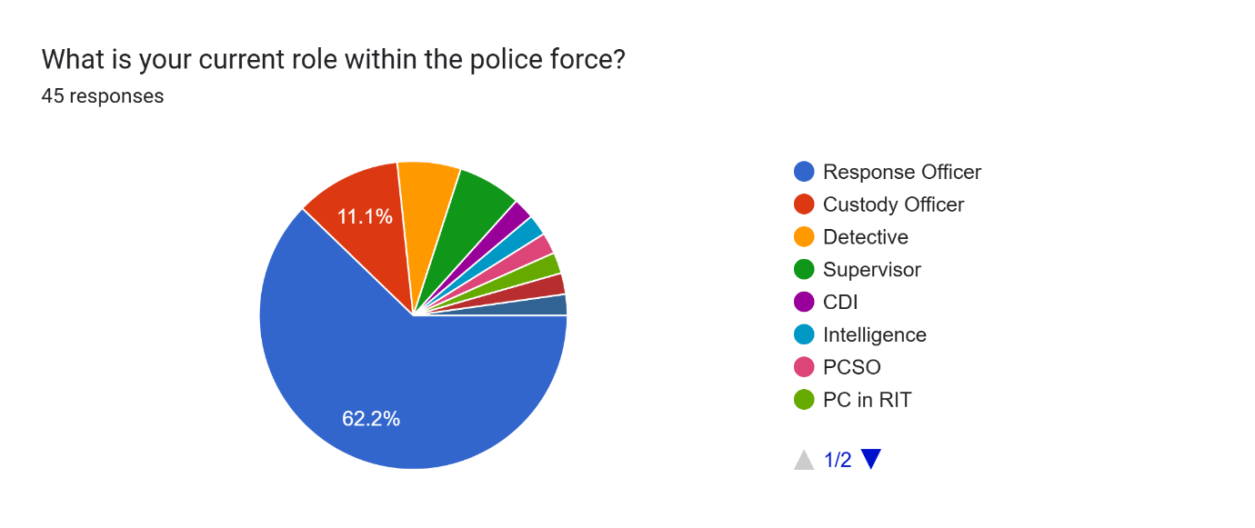
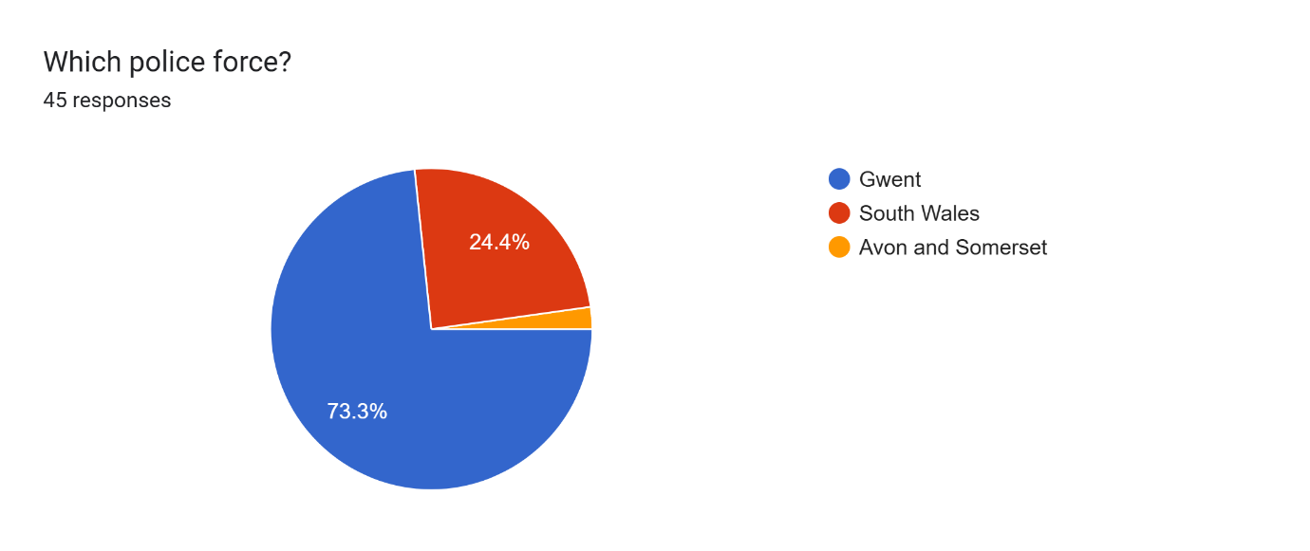
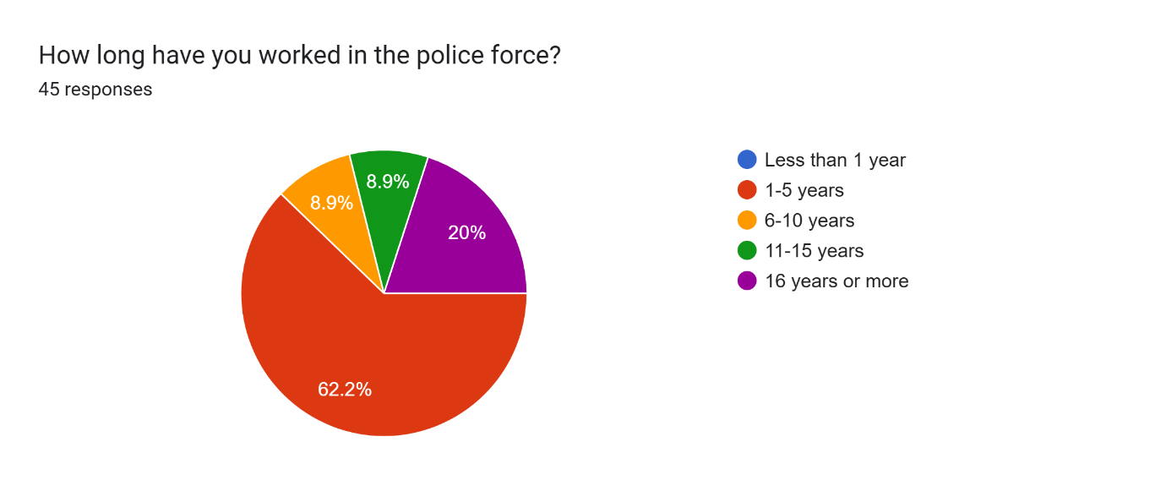
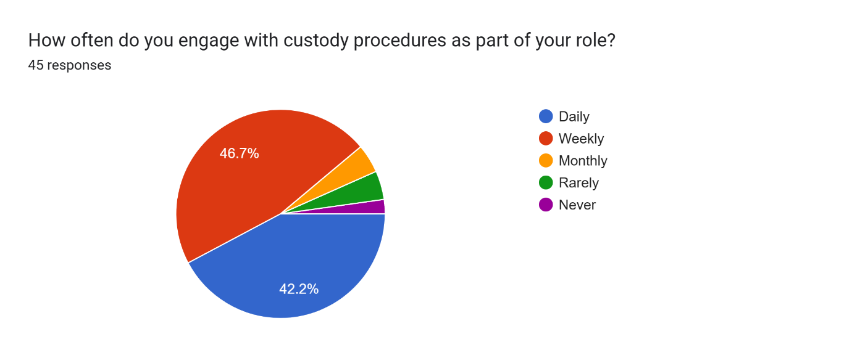
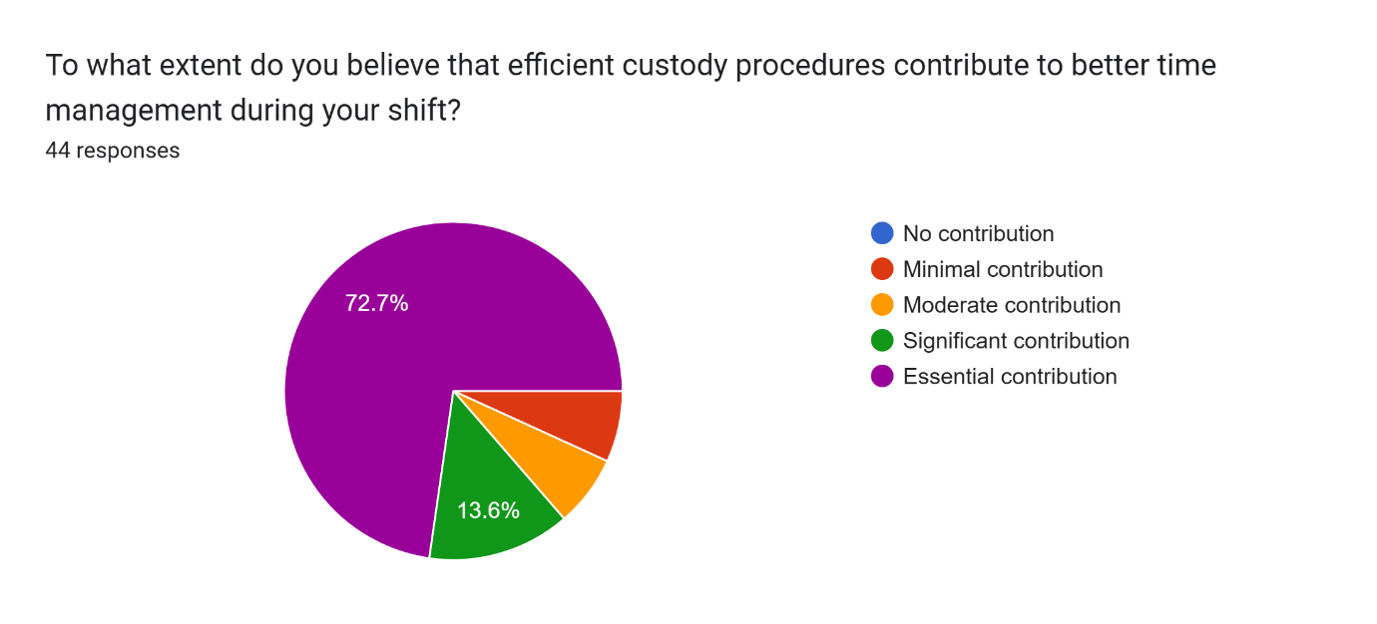
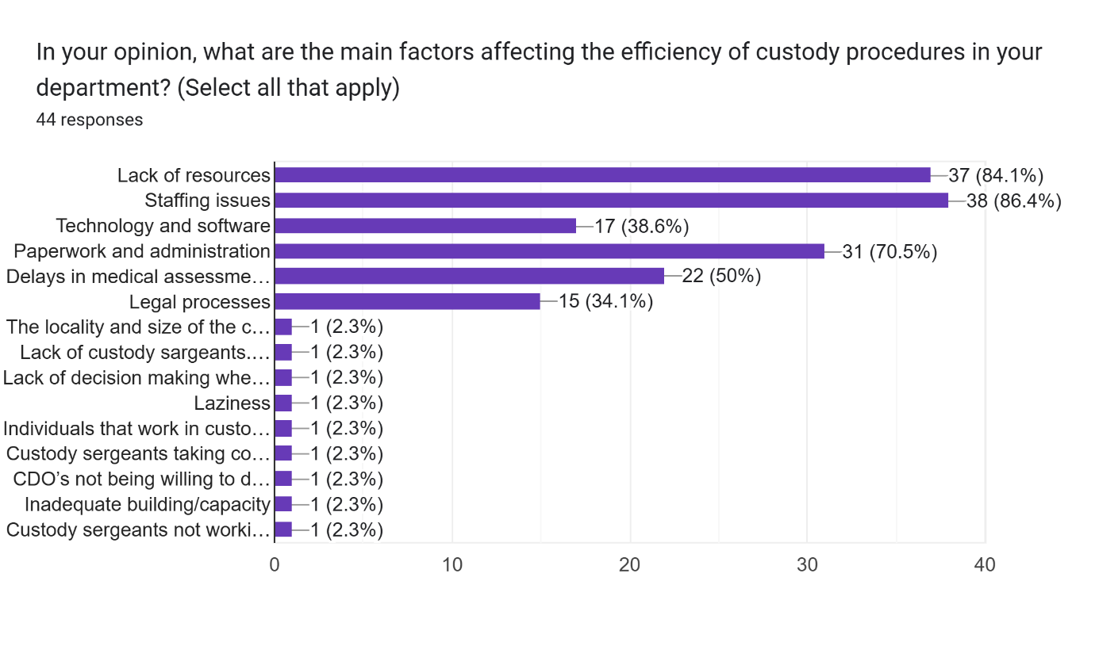
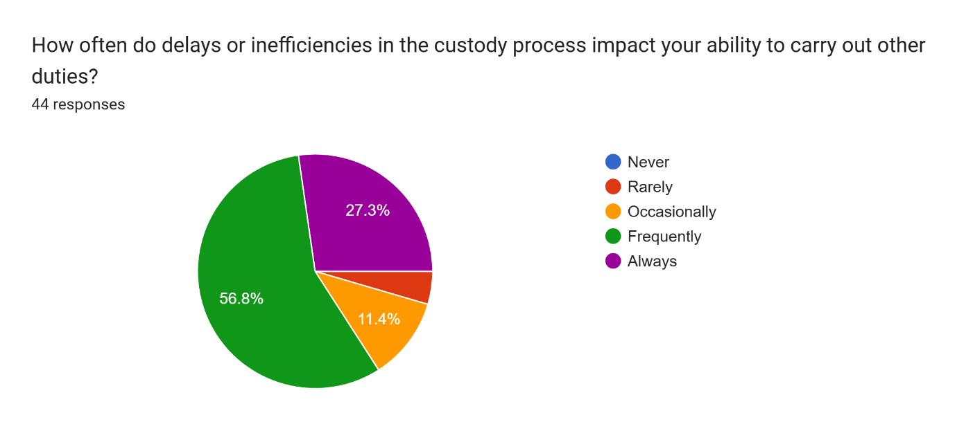
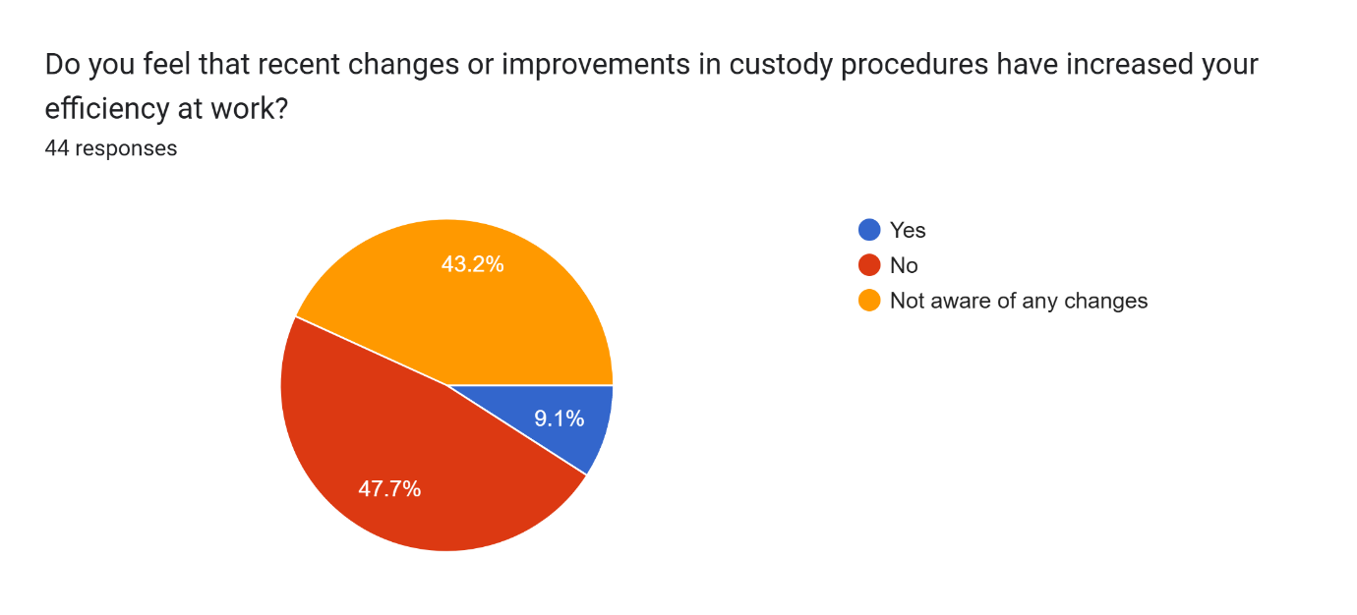
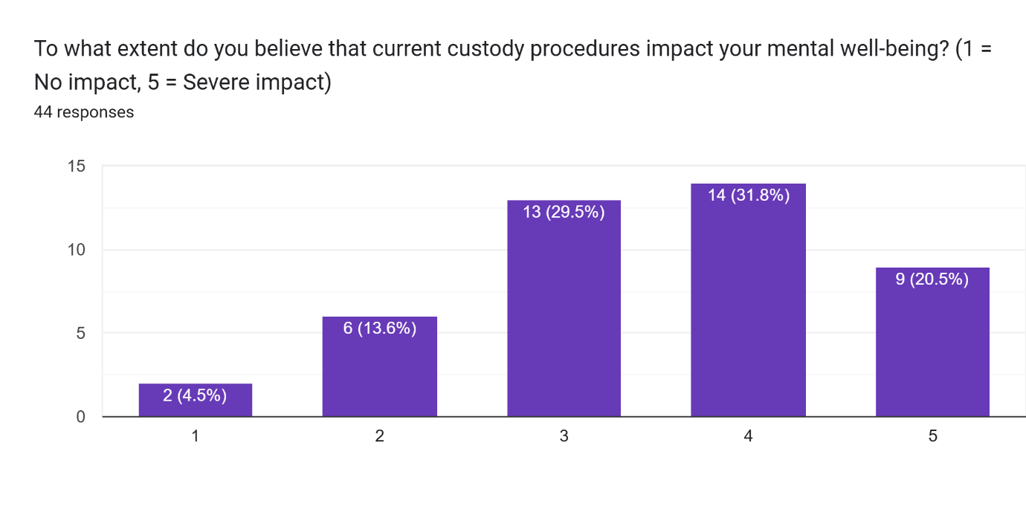
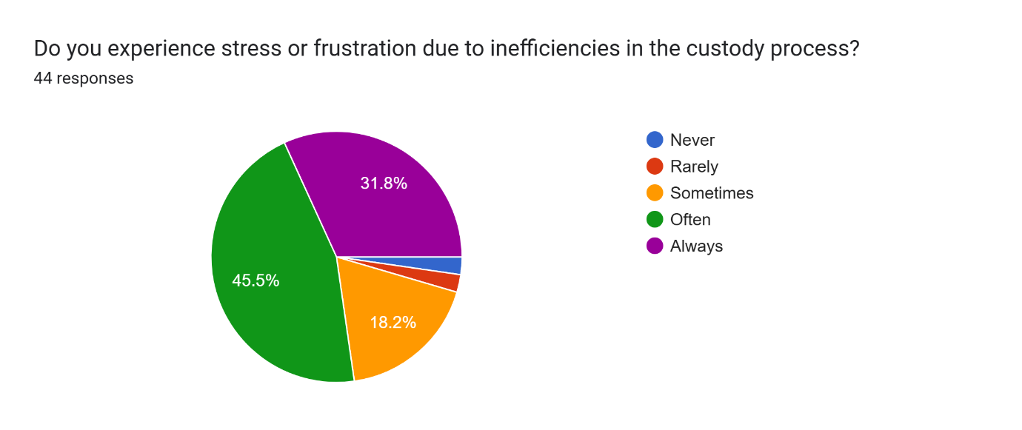
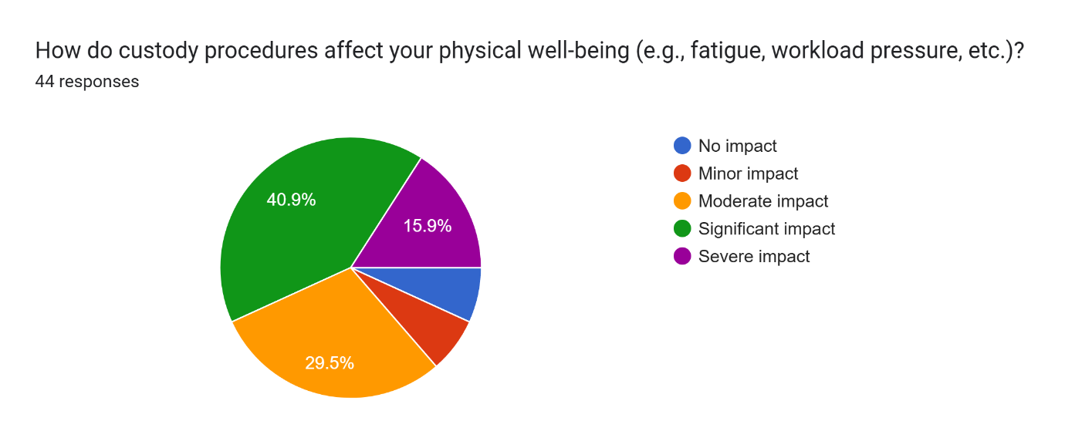
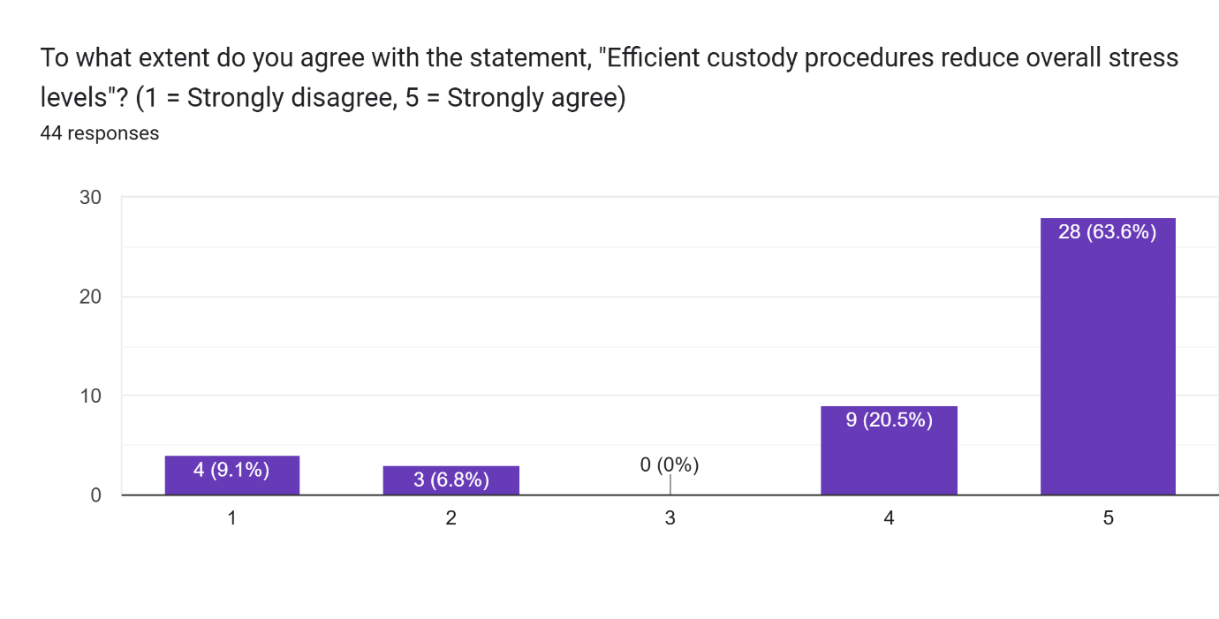
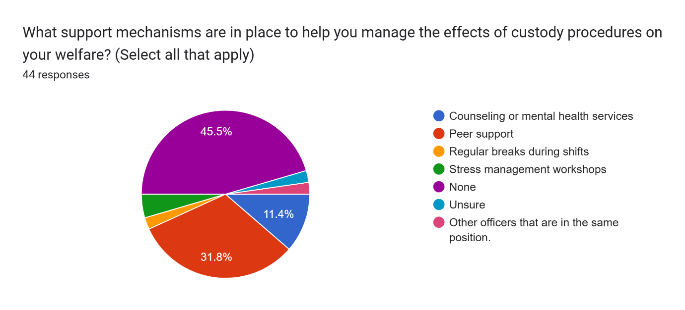

Appendix D – Questionnaire responses – Qualitative Data

Question 15: What improvements could be made to custody procedures to increase efficiency?
Respondent Number | Response
1 | The planned changes to Ystrad Mynach to increase the cells and custody desks will have a short term relief of pressures caused by custody procedures. GPOF will eventually when complete provide an adequate locality and capacity for custody to efficiently work, provided that staffing numbers also increase.
2 | More staffing levels
3 | Consider evaluating and adopting new procedures that are being used by other forces regarding how they efficiently manage their custody load and implement adequate resources for the demand
4 | Multiple custody units within Gwent (just 1 at present leading to huge wait times) more staff to book prisoners in, dedicated parking (there is none in Gwent - often you cannot park outside of custody) and better designed custody units - the protective glass blocks sound so having to speak around it in a noisy environment leads to officers having to repeat themselves numerous times.
5 | more staff
6 | More than one unit. Be less risk averse. Separate area for juveniles so we're not held up if one is in the booking in area. CDOs to do Level 4s and Level 3s so we can get back out there answering calls and investigating crime. CDOs to take over once circumstances have been given to Sgt. More custody Sgt's booking in. More holding cells (new unit) so we are not waiting outside in cars and vans.
7 | Once the arresting officer has given the circs a CDO should take over and complete the rest. Stop Police officers doing one to one’s, two to ones and in Gwent Four to ones Custody sergants to make a decision and charge rather than constant bail as they won’t make a decision and leave the decision for the response sergeant to make on bail. Have a doctor in the unit rather take prisoners over the hospital for hours on end.
8 | Quicker booking in procedure
9 | Increasing the number of staff, particularly detention officers, currently response officers have to staff 2-1s in custody which is supposed to be a core role of detention officers. This often delays enquiries being completed and takes officers away from their core duties.
10 | More CDO’s to prevent long duration with prisoner whilst booking them in and 2-2-1. Having more than one custody unit for Gwent Police. If Gwent run from one custody unit, have more staff on to manage this.
11 | Currently there is one custody unit for the whole of gwent so we need atleast two with 3x sgts in each.
12 | Open two custody units with sufficient staff to run them. Provide better it equipment
13 | - More custody sergeants working / booking in at one time - Quicker booking in process - Less time for response officers to be present during the booking in process as that is more time taken off answering calls, working on work load, etc - Improved custody unit in general e.g. looking at SWP processes (whose are quicker and more efficient) and seeing how we can utilise that into our Gwent procedures
14 | Staffing levels in custody require improvement as currently the process is too slow. This can either be put down to resources or staff themselves being inefficient or lazy. As a Gwent officer , south wales police have a much better grip on this , keeping officers for only as long as is required. Officers should not be kept in the unit once the need for them has passed. As an example in SWP once the circumstances of the arrest are completed along with necessity then officers are relieved of their duty.
15 | Booking in process, more staff
16 | - Less pandering to offender’s demands, leading to a reduction in level 4 or level 3 observations.  - More decisiveness surrounding prisoner welfare e.g officer presence is often an aggravating factor  - More decisiveness surrounding the need for officer presence e.g prisoner is calm enough to have handcuffs removed, officers could leave after circs given and detention authorised.  - Sufficient parking outside custody unit for effective prisoner transfer  - Introduction of a ‘pre-booking’ process, give officers ability to complete everything other than authorising detention (name, DOB, circumstances, officer concerns, relevant times/officers etc.). This leaves risk assessment and detention authorisation left for custody sgt. Much less likely to eat into PACE clock.  - Utilisation of ‘prisoner notes’ from previous bookings, leaving 1 question: ‘has anything changed health wise since your last time in custody’.  - Provision of tablets for custody nurses to complete a mobile, initial health assessment to identify issues early. (Reduction in PACE clock time just to be sent away at the custody desk after an already long wait).
17 | To deal with prisoners in accordance with PACE - as soon as reasonably practicable. For CDOs to do their role and assist with 2-1s. CDOs to also do the booking in process.
18 | The premises are not fit for purpose and way too small. Officers are "stuck" in there for hours doing 1:1s or being held up for interviews because no rooms are available or the recording equipment does not work. Solicitors should not be allowed to "roam" in the unit. There are not enough staff and the being in custody feels mostly like complete chaos. Custody sergeants are too busy completing repetitive paperwork which is way too time consuming. It should not take 5 hours to interview and nfa somebody for example.
19 | More staff and sgts for booking in
20 | There are numerous improvements that could be made. One being that Gwent Police adopts the procedures and policies that South Wales Police do in custody. CDOs are more than capable of monitoring prisoners who require constant watches. Quicker booking in process would speed up the wait times. Currently having one custody unit available in Gwent is causing issues in terms of wait times and demands. Gwent Police need to reduce their perceptions of risk whereby they place individuals on a constant watch with officers outside the cell and this makes the detained person worse.
21 | More custody sergeants to book prisoners in and more CDO’s to do 1-2-1’s and searches so that response officers are not tied up in custody.
22 | Utilising CDO’s efficiently. Less waiting times with prisoners.
23 | Staff and officers who’s main job is constant watch if needed
24 | There need to be more CDO's to take over when taking a DP to custody. Being able to hand over a DP would lighten the workload and relieve more officers back into the community. We can sometimes be held up in custody for some 5-8 hours, and on some occasions, everyone officer on my relief has been held up in custody, leaving no response officers for any calls that come in.
25 | Prisoner handling (drop off Prisoner with circs, no booking in wait/queues), more capacity, more staffing
26 | Hand over prisoners to CDOs to book in. As well as having enough CDOs to do levels in custody. A higher amount of time management for sergeant. Set time periods they have to book in, if they are failing to book in a certain time they should have to justify why this is happening.
27 | More custody sergeants on duty in a shift, a prisoner drop off team in place so that officers can continue to complete enquiries and response officers can continue to do their role responding to calls, a more efficient holding area system so that you aren’t waiting hours with a frustrated prisoner in a room full of people and faster, more efficient booking in systems
28 | - Local sergeants to review and complete rationales, make decisions on bail/remand/charge/NFA etc  - Increased CDO capacity to take over 1-2-1s  - More officers in ihub to take handovers
29 | Custody Sergeants need to work faster and be held accountable for the excessively long wait times. CDO's should be used more fully, for example by completing 1:1 and 2:1 monitoring of prisoners, as well as completing the booking in procedure after receiving the circumstances from officers. This would allow more officer to flow back into their main duties, and would free up time for officers to complete proactive and other core duties. Police used to be a visible presence on the street, but are now hidden behind closed doors most of the time. This also impacts on public perception.
30 | Still having one sergeant processing intetviews/rationales during the handover period, a lot of time is lost due to the entire unit closing for an hour twice a day.
31 | Time delays during the booking in period. Staffing levels. Having not only one custody unit open.
32 | Gwent to adopt the same procedures as south wales. I transferred to south wales and the custody process is so much quicker and less stressful
33 | CDO's should be used to their fullest potential. By this, I mean handling of prisoners from the moment they enter custody until they're booked into a cell. This would free response officers to continue their public duties.
34 | Less paperwork and more ability to take risks. Detainees should have more responsibility to keep themselves safe.
35 | A centralised and purpose built custody unit would make custody more efficient for the entire force. Having only one custody unit open in Newport is just horrendously inefficient. Officers spend ages travelling as it clear when comparing arrest and arrival times, and there is often a queue due to the unit not being able to handle prisoners fast enough on its own.

Question 16: What improvements could be made to custody procedures to increase efficiency?

Respondent Number | Response
1 | Reduced wait times and better air con.
2 | More staffing levels
3 | - Friendlier environment  - CDO’s use for 2 to 1’s and custody watches to reduce the demand on front line officer  - Reduce waiting times
4 | More custody staff and units, quicker waiting times
5 | more staff
6 | If the above is implemented then this would improve welfare and allow officers to leave custody, have refreshments, investigate and complete enquiries, overall lowering the time that person is in Custody and improving the welfare of officers.
7 | Free Drinks and snacks for the officers after waiting hours on end to book a prisoner in or hanging around waiting for AA and solicitors to arrive.
8 | Dedicated team to deal with paperwork aspect
9 | Again, increasing the number of detention officers. Currently response officers are having to fulfill much of the duties of a detention officer. Particularly on 2-1s, officers can be on them for an entire shift, without any though for their welfare. They are often forgot about by custody Sergeants, whilst detention officers are sat in the office. If the number of detention officers are increased, it should also be ensured that they are performing the duties of their role. This includes 2-1s.
10 | Having to spend less time waiting in the holding area to book prisoners in which can be the duration of your shift; resulting in no breaks, food or water, toilet breaks etc. Gwent currently only have one custody unit open and clearly not enough staff to manage this which shows when officers have to wait in the holding area for their entire shift which happens on a regular basis. More staff such as sergeants and CDO’s. Police officers play more of a CDO’s role than they do themselves.
11 | Often you’re left on a 2-1 all shift so rotations or asking CDOs to assist
12 | As above
13 | Less time spent in custody unit, regular breaks during 1-1s, quicker procedures
14 | Currently there is little to no care for officers welfare. Officers can be left hours waiting in the holding in area with no toilet breaks , water or food. These rights are not denied to the prisoner at anytime but it is more than ok to deny the officer of these necessities. This is compounded further with the large amount of constant watches being put on so that custody do not have to manage risk as it is staffed by officers and not custody staff. There is a need to shift focus from prisoners being the responsibility of officers on to custody staff themselves. It is currently far to easy to blame officers and make officers carry out the work of custody than to take ownership of it themselves.
15 | N/a
16 | - air conditioning  - less time spent in custody  - more strict decisions surrounding officer assaults
17 | As above
18 | A more organised procedure in place to deal with booking in/charging/release of prisoners. Premises and technology fit for purpose. Increased staffing. Simplified custody records which enable staff to focus on processing of prisoners in a timely manner. Officers not having to stand around for hours just to get prisoners charged/released after interview.
19 | More staff and sgts for booking in
20 | CDOs doing constant watches as would reduce the stress caused on officers who are unable to take food breaks, toilet breaks or do their own work when on these watches.
21 | Quicker booking in process who would reduce the waiting times.
22 | Potential to adopt SWP practice whereby the offender is passed to the CDOs.
23 | Regular breaks, swapping with different officers after a certain amount of time.
24 | The same as the above. Utilising CDO’s and quicker waiting times. Able to follow the same procedures as SWP custody
25 | More funding and staff
26 | Some simple changes that's are easy to implement but are key to the comfort of officers. There aren't any seating options available for officers after booking in a DP. For DPs that have to be monitored for MH for example, the officers could then be stood watching the DP for a number of hours. This can be uncomfortable when in your full kit. No one comes around to relieve you to use the bathroom or offer you a drink. Before booking in a DP you can be waiting a number of hours, especially if a more pressing matter comes in, and your left waiting wasting essential police time. We are often left on minimum staff on a normal day, when we are held up in custody for hours this has a massive impact on the teams moral and mental health as a whole.
27 | Reduced wait times
28 | Less time in custody would improve my welfare.
29 | More sergeants on duty in order to increase the amount of prisoners being booked in to reduce wait times
30 | I don’t think the custody process directly affects welfare. It’s frustrating when things take time but it’s other things in the job that affects mental health - pressure from control room/bosses etc.
31 | My welfare would improve by spending less time in custody. As it currently stands, a large portion or even sometimes an entire shift can be spent in a custody unit. This is detrimental to my mental health when it causes my workload to spiral out of control. I am then criticised for not updating victims or progressing crimes fast enough, however this is unfair when I spent large portions of my time stuck in a custody unit when there are CDO's just sat around doing nothing.
32 | It needs to be clearer which sergeant is doing what part of the process (maybe a sign on their desk) so we're not having to disturb the wrong one if they are busy. Also if we are late finishing simply due to slow custody procedures it needs to be a given that OT is going to be authorised.
33 | Support from custody staff. Support when having to stay on. i.e overtime more readily available than it is now.
34 | Breaks from booking in, water and food being available if stuck for long periods
35 | Less bureaucracy and more accountability for detainees to look after their own welfare. All to often are resources used to babysit prisoners just because they say that they are going to hurt themselves. Detainees know and abuse this, as is clearly apparent when the regulars come in versus those that are at custody on a one off. Regulars to custody will always cry wolf, leaving officers sat with them for hours on end, reducing frontline capacity and increasing demand for others.
36 | More staff so that we could take more breaks.
37 | The working environment is just generally unpleasing. A purpose built custody unit, similar to the South Wales units would be magnitudes better.

