Name of the report: BMIH6005 Organisational Consultancy
My name: Shakera Begum (2012517)|
Name of the company: Premier Inn
Report delivery date: 21/11/2021

Executive Summary
The problem or issue at stake
The Premier Inn is a venerable name in the hospitality industry considering its enormous market share and number of hotels. the internal organizational challenges regarding management and innovation will be found while delineating the organization’s attempts to deal with the situation. The Premier has different management problems like skill-shortage of employees, market growth problems, supply chain problems, and service variety inadequacy. How the company has dealt with the issue and what steps have been taken are discussed in this consulting report.
Findings of the report
Many employees of the Premier Inn are not as adept as expected which made the service of the hotel slow and low-quality. In a survey of 6373 customers of the Premier Inn, it was noticed that 62% of them were dissatisfied due to the slow service in the hotel (Hicks, 2022). Again, Premier Inn noticed a high customer turnover and the key cause behind this problem was the lack of miscellaneous services. Premier Inn noticed a high customer turnover in 2020 and the reason behind this issue was the lack of diverse services. The Premier Inn found from its research that 34% of the customer turnover happened due to a lack of diverse services in the hotel (Noordzy & Whitfield, 2014). Another problem was regarding the supply chain management of the hotel. Given that Brexit has made importing and exporting difficult, Premier Inn cannot import its raw materials sufficiently. Also, Also, poor communication between logistics and information systems has increased waste and deteriorated the problem further. 73% of the customer of the Premier Inn were displeased due to the supply chain management issue (Withvector.com, 2022). Lastly, the Premier Inn has faced a market growth problem since 42% of the hotel and tourism industries in the UK are experiencing a growth hold-up as a result of Brexit.
Analysis of the findings
All of the management issues in the Premier Inn have been deteriorating for the company. They have made the company suffer in its employee pool, revenue, market share, costs, and so on. The hotel has taken some effective steps to solve the problems (Peterson, 2022). To illustrate, the Premier Inn Hotel installed robotics technology in the workplace and trained employees through on-the-job training methods to accelerate service delivery to its customers and improve the skill shortage problem. These management techniques were effective since customer service at the Premier Inn by 25% within 6 months of the change (Johnson & Whittington, 2020). On the other hand, the Premier Inn started two new services: spa services and gymnasium to increase the service variety and solve the issue related to the fact. The Premier Inn was able to boost its customer pool by 25% in 2021 while getting a 2% larger market share that year due to the boon of service variety (Hoerl & Snee, 2022).

Table of Contents
Introduction 1
Scope and analysis 2
Overview of the Premier Inn 2
External environmental analysis 3
Internal environmental analysis 5
Main body 6
Findings and results 13
Action Plan 16
Recommendations 18
Conclusion 19
References 21

Introduction
Organizational consultancy refers to the identification of developmental solutions and performance gaps in a company by a professional consultant through the evaluation of organizational data (Johnson, 2021). Consultancy is integral to discerning some basic business factors such as leadership and management given that what kind of leadership and management will suit a company is decided through the consultancy report. The purpose of this report is to develop an organizational consultancy report for the Premier Inn, a multinational hotel chain business (Burnett, 2022). Through the consultancy report, the internal organizational challenges regarding management and innovation will be found while delineating the organization’s attempts to deal with the situation. Problems such as organizational technological transformation, employee training, employee conflicts, customer service, social distance maintenance, service variety inadequacy, supply chain problem, and so on will be addressed in this consultancy report (Traynor, 2022). For this identification, the internal and external environments of the Premier Inn will be analysed at the beginning. Given that analysis of SWOT and PESTEL models of the business environment will be effective to find out the external and internal business environment’s impact on the hotel, these models will be used here (Matthias & Campbell, 2019). After analysing the business environment, the areas of improvement for the Premier Inn will be depicted. How the company is embracing change, what problems they are facing, and how they are dealing with that will be addressed by using different change management theories and models like Kurt Lewin’s change management model. The findings of the analysis will be presented afterwards and will be linked to the environmental analysis of the Premier Inn. Finally, some recommendations will be presented for the business on the shortcomings that will have been identified in the previous discussions.

Scope and analysis

Overview of the Premier Inn
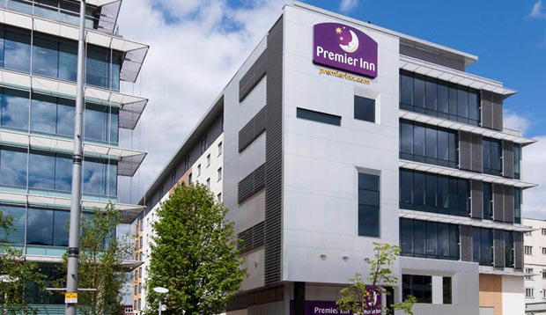
Figure 1: The Premier Inn.
Source: (O’Meara, 2021).
British people have always preferred travelling as their recreational activity as travelling is connected to their culture. For fulfilling their travel thirst, many hotel chain businesses have been developed for this purpose and the Premier Inn is one of them (Fernando, 2019). The Premier Inn, which is currently the largest hotel chain in the UK, was established first by Whitbread Plc, the mother company of the hotel. The hotel was named Travel Inn when it was first established in 1987, denoting that the age of the hotel is 35 years now. The hotel was one of the most modern hotels at that time and it was founded by its owner to compete with Travelodge, the leading hotel chain at that time (Wood, 2022). Later, in 2004, Whitbread Plc purchased the full share of Premier Lodge and merged the hotel with Travel Inn to strengthen its overall business activities and customer service while naming the venture the Premier Travel Inn. However, the name was shortened to the Premier Inn in 2007 (Jones, 2021). The Premier Inn is a gigantic hotel chain business with approximately 800 hotels comprising 72,000 rooms. Headquartered in Dunstable, the UK, the Premier Inn operates in 4 countries now in more than 800 locations. The Premier Inn made a total of £520 million as of 2021 as revenue while its profit stood at £197 million. The hotel chain accounts for 70% of the total earnings of Whitbread Plc. The Premier Inn hotel has 112,822 employees currently who try their best to serve the customers splendidly. In 2022, a survey of 3738 customers of the Premier showed that 72% of the customers are satisfied with the service of the hotel (Gorman, 2020). This also justifies the gigantic market share of the company since the Premier Inn has a 34% market share in the hospitality industry. The goal of the company is to gain a 50% market share within the next 5 years and that is why it has incorporated some technological transformations to improve its service further (Proctor, 2020). Moreover, the company has a scintillating brand image as it is well-known as an aristocratic wedding destination since it has some mega wedding venues in the hotels. Its diverse services are a boon to its positive reputation as well. However, its failure to maintain social distancing during the COVID-19 pandemic has also been criticised and put some negative impacts on the hotel’s brand image (Vidal, 2022).

External environmental analysis
The outside influences and factors that have a significant impact on the business performance and growth are called collectively the external environment of a business (Matthias & Campbell, 2019). Here, the external environment of the Premier Inn is dissected through the delineation of the PESTEL analysis.
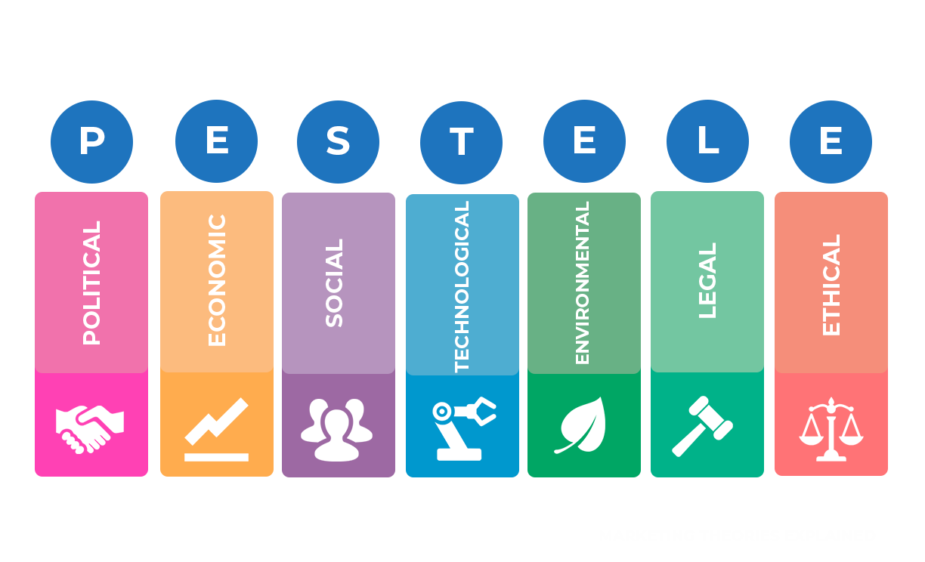
Figure 2: PESTEL analysis.
Source: (Mehmood, 2020).
Political: The UK government conducts an open market policy for the businesses that operate in the country, denoting that the Premier Inn gets some benefits in opening new hotels as well as in exporting and importing. Moreover, the UK is a partner of the EU trade bloc, which shows that the Premier Inn can attract human resources and purchase raw materials from the partner nations of the trade bloc (O'Neill, 2022). This is exquisitely effective for the sustainable business growth of the hotel since both its service quality and customer pool increase in this way. However, the tax rate of the country is quite high thanks to the high-profit margin, therefore, it puts a negative impact on the operating cost of the Premier Inn as well as its business growth (Smith, 2019).
Economic: As of 2021, GDP per capita in the UK is $31,708- a sign of the high purchasing power of the denizens there. This is beneficial for the sales of the Premier Inn given that people tend to travel and spend on recreation when they have enough money in hand. Again, the corporate interest rate is also quite affordable in the UK: 2.25% only as of 2022, indicating that it impacts the fund collection of the Premier Inn positively and ensures sustainable business growth for the company (Proctor, 2020). However, the latest economic report has stated that the inflation rate in the UK has soared up to 10.1% as of September 2022, which affects both the sales and operating costs of the Premier Inn negatively.
Social: The UK inhabitants have a propensity towards travelling, meaning their purchasing habit impacts the sales of the Premier Inn splendidly. Furthermore, employee commitment is top-notch in the country, which also affects the employee turnover rate auspiciously, denoting that the Premier Inn can develop a dedicated and large workforce easily. However, the population of the UK is quite small: 68.7 million only, therefore, this impacts customer attraction to the hotel negatively (Traynor, 2022).
Technological: The Premier Inn is quite enriched technologically since it uses the latest technologies such as robotics, Artificial Intelligence, 5G, and so on, having a great impact on customer service and sustainable business growth (Burnett, 2022). However, the cyber security of the hotel is not robust, therefore, it sometimes faces a low customer satisfaction rate.
Environmental: Given that Premier Inn is a service-based company, it does not emit carbon or other toxic gases, therefore, it is known as an environment-friendly company and its brand image is increased as a repercussion (Wood, 2022). However, the hotel neither practices waste management nor uses renewable energy, denoting a high operating cost.
Legal: The Premier Inn is a company that cares for its employees because it practices the Employment Act 1996, the Health and Safety Act 2010, and the Equal Remuneration Act 1976 in the workplace. This practice helps the company run the business legally and get a competitive advantage (Matthias & Campbell, 2019). However, the hotel has not been very successful in maintaining social distancing during the pandemic time, which makes it face customer lawsuits, and other legal issues and impedes its sustainable business growth as well.

Internal environmental analysis
The factors that are directly connected with a business and impact that significantly are called collectively the internal business environment. The internal business environment of Premier Inn is analyzed here through a SWOT analysis.
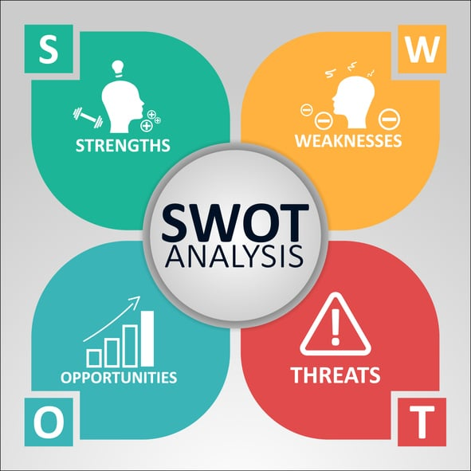
Figure 3: SWOT analysis.
Source: (Szende, 2021).
Strengths | Weaknesses
- The Premier Inn has a gigantic brand value since it is the largest hotel chain in the UK (Saunders, 2020).  - The hotel has a huge workforce with 112,822 employees (Capocchi, 2019).  - It has a substantial number of investors which means its funds are enough to operate the business well. | - The services of the Premier Inn are quite expensive, owing to the high quality of the services (Warner, 2020).  - The food variety in the restaurant section of the hotel is not satisfactory.  - The hotel’s marketing policies are not top-notch, which makes them lose customers sometimes.
Opportunities | Threats
- The corporate interest rate in the UK has been reduced during the pandemic to bolster the businesses there, which is an opportunity for the company to raise funds easily.  - The UK has joined the EU trade bloc recently, an opportunity for the hotel to export, import, and attract human resources from partner countries (Warner, 2020). | - The high inflation rate in the UK has made the price of raw materials in the hospitality industry skyrocket, a threat to the operating cost of the Premier Inn (Athiyaman, 2022).  - The population of the UK is quite small, which is a threat to the sales and customer attraction of the hotel.
Table 1: SWOT analysis.
Source: Own.
Being the largest hotel chain in the UK, the Premier Inn has a massive brand value. The huge customer pool and the diverse number of locations justify the strength. Also, to serve the customers well and to operate the enormous business, Premier has sufficient employees and investors who work diligently for the sustainable business growth of the company (Kefalas, 2021). Although the quality is top-notch, the services of the Premier Inn are quite expensive. The use of premium materials and skilled employees in the service justifies the price though. Moreover, the food variety of the hotel is also low since it prepares only American, British, Spanish, and Italian dishes, missing Asian items entirely (Warner, 2020). Also, its marketing strategies can also be said to be quite outdated due to the less use of technology. To depict the opportunities, the low-interest rate and the UK’s inclusion in the EU trade bloc are auspicious for the company since it can raise funds sufficiently, purchase raw materials easily, and attract human resources adequately. However, there are threats for the Premier Inn regarding high inflation and a small population as they increase the cost and reduce the sales of the hotel significantly (Athiyaman, 2022).

Main body
Premier Inn Hotel, as the leading name in the hospitality industry, has many shortcomings in its operations and management (Burnes, 2014). The company has resolved some of them recently with adept management techniques while some of the inadequacies are yet to be dealt with. The following is the delineation of those areas of improvement through the application of different models and theories.
Employees’ skill shortage
Although Premier Inn has a huge workforce, many of its employees are not skilled enough. This skill shortage impeded customer service significantly. Therefore, the Premier Inn used an innovation management technique to resolve the problem. The following is the delineation of the management technique through the application of Kurt Lewin's change management model.
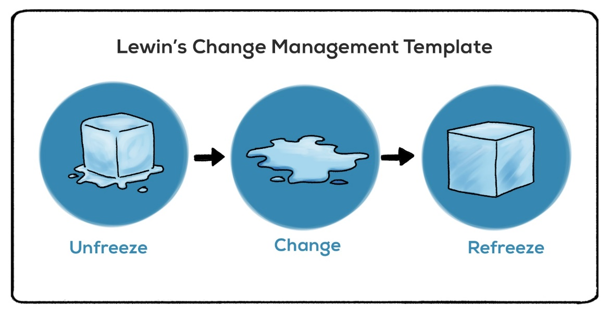
Figure 4: Kurt Lewin's change management model.
Source: (Muldoon, 2020).
Unfreeze: Due to the ineptness of some employees, the Premier Inn was facing some extreme setbacks regarding customer service since service became slow and customer dissatisfaction was noticed. To illustrate, Hicks (2022) conducted a survey of 6373 customers of the Premier Inn and noticed that 62% of them were displeased due to the slow service in the hotel. Therefore, the management of the hotel planned to change its management technique to resolve the problem. It also arranged a meeting with employees and suppliers for preparing them for the change (Slack, 2019).
Change: In order to change the process, the Premier Inn adopted the transformation management technique. To accelerate customer service, the Premier Inn planned to install some technologies in the workplace given that technologies can serve faster than their human counterparts. The hotel management installed the robotics technology in the workplace in 2020 and recorded a 20% faster service delivery to its customers (Willamson, 2022). On the other hand, to develop employee skills, the hotel management changed the training technique. From the traditional training, the Premier Inn resorted to on-the-job training to improve employees effectively. Given that no time was wasted during the training process and employees could learn practically, this method was highly effective. An interview with 60 employees of the Premier Inn showed that 5/6th of the participants thought that on-the-job training helped them to grow their skills significantly (Godsiff, 2021).
Refreeze: However, it is always difficult to implement a change perfectly, and that is why the hotel management needed to adjust some management techniques. The Premier Inn trained its employees on the use of the new technology. The hotel management also motivated its employees to learn from on-the-job training well while delineating its future impact for sustaining the change. Slack (2019) found from his research that these management changes improved the customer service of the Premier Inn by 25% within 6 months of the change. The more satisfied customer base visited the hotel more often, denoting that the sales of the hotel took a jump by 10% and that is why the Premier Inn got a competitive advantage over its competitors (Noordzy & Whitfield, 2014).
Supply chain management problem
The term "supply chain" describes the organized network of businesses that provides the corporation with the products and resources it needs. Supply chain management is the process of overseeing this system of the supply chain. In essence, it is a centralized system that controls the movement of goods and resources. According to Burnes (2021), efficient supply chain management may cut the extra cost of supplies by 26%. The major goal of the supply chain is to prevent any product or resource shortages that could hurt the operations of the business. Premier Inn, however, is currently having issues with its supply chain. Premier Inn, one of the biggest hotel brands in the UK, uses a lot of supplies on a daily basis (Johnson & Whittington, 2020). Mineral water and water for mattresses, showers, bed linens, food and drinks, and pillows, as well as transportation, tissues, furniture, and other items, are the key supplies needed by Premier Inn. However, a lot of customers seem to believe that the company's supply chain is having issues. The government's policy on Brexit was the primary cause of the supply chain issue for Premier Inn. 55% of the hotel’s supply chain has been impacted by Brexit, claims Buttrick (2009). Previously, the business could efficiently get the goods and supplies it needed from other European Union countries. However, sourcing materials from outside the UK is particularly difficult and time-consuming now that the UK has left the EU. Furthermore, it becomes challenging to sustain supply flow when the majority of Premier Inn's suppliers are located outside of the UK. Customer unhappiness is the result of this interruption in the supply chain, which has a negative impact on the company's reputation. A survey of 9483 customers of the hotel showed that 73% of them were dissatisfied due to the delayed and low-quality service of the company, thanks to the supply chain problem (Noordzy & Whitfield, 2014).
Although this has a detrimental effect on Premier Inn, it also gives the business the chance to choose a UK-based supplier for its products. By doing this, the business will increase productivity and shorten the wait time for obtaining goods. The chance to develop a solid and sustainable supply chain will be supported as Premier Inn enters into contracts with domestic suppliers.
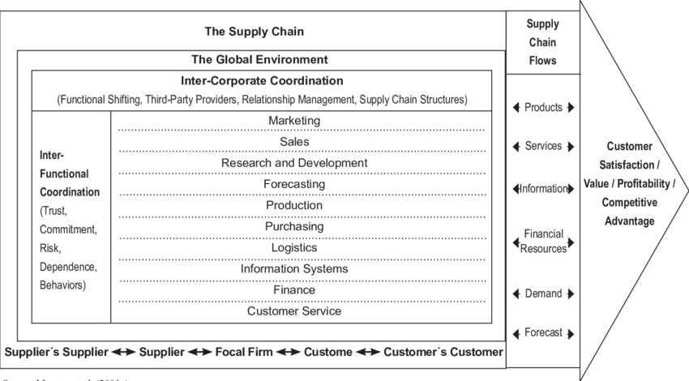
Figure 5: A model of Supply Chain Management.
Source: (Sari and Suslu, 2020).
The issue with Premier Inn's supply chain management can be found using the supply chain management model. The model concentrates on both internal and external elements. According to the model, there should be a cross-functional collaboration between Premier Inn's many departments. In this, there should be great coordination between the sales, marketing, logistics, forecasting, finance, production, purchasing, information system, and client service functions (Karatepe, 2019). However, there is a lack of cooperation between Premier Inn's information system and its logistical department. It has been discovered that the information management in some Premier Inn locations does not maintain an accurate record of the necessary supplies. Because of this, the logics department is unaware of which sections need supplies and how much is needed. Additionally, because the branches improperly disclose information regarding consumer demand and needed resources in the information system, demand forecasting is also harmed. The Premier Inn supply chain was impeded by the worldwide environment in addition to these internally uncoordinated functions. The Premier Inn's supply chain has been disrupted by the UK government's Brexit policies (Chen, 2019). Other country suppliers are now requiring a longer lead time before delivering the supplies. The Premier Inn supply chain is also hampered by this.
Service variety shortage
In 2020, the Premier Inn noticed a customer turnover and the reason for the issue was found that customers were looking for diverse services, which the hotel lacked (Sari and Suslu, 2020). In response to this issue, the Premier Inn brought some management changes which impacted the company positively. The change in management is delineated below through the use of the PDCA model.
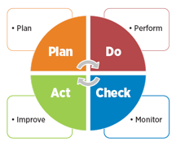
Figure 6: PDCA model.
Source: (Quartapelle, 2020).
Plan: Given that Premier Inn noticed the need for luxurious service in the hotel, it planned the inclusion of two new services: gymnasium and spa service. The Premier Inn found from its research that 34% of the customer turnover happened due to a lack of these services in the hotel (Sibanda and Pooe, 2022). Therefore, the installation of these services was planned.
Do: In this stage, the hotel management examined the change with some loyal customers to identify the accurate management technique. For instance, the Premier Inn arranged a small outdoor and indoor gym to check customer preferences. Moreover, it examined the spa categories as well with its customers to initiate that service effectively.
Check: The Premier Inn reviewed the effectiveness of its small examination in this stage. To illustrate, the hotel checks if the management technique was effective or if it is needed to be changed. Moreover, the company records customer opinions for better results. From the review, the Premier Inn found that 84% of the participants favored an outdoor gym while 3/4th of them suggested for professional spa service provider for a decent service (Karatepe, 2019).
Act: Suggestions are taken from the previous stage and the plan is implemented after amending accordingly in this stage. As per the recommendations got from customers, the Premier Inn developed a gym on the ground floor of each hotel in 2021. It kept easy access for the customers of the hotel. Moreover, it initiated the spa service in the second half of the same year and recruited some professional and experienced personnel for this service. Given the increase in service variety, Premier Inn was able to boost its customer pool by 25% in 2021, which was a huge advancement in the context of competitive advancement (Chen, 2019). Increased services were also effective to attract new customers from the rivals of the hotel which increased its market share by 2% and gave a competitive advantage.
Market growth problem
Since the Brexit happened, Premier Inn has faced some problems regarding market growth. The BCG matrix is applied here to identify the hotel’s problems in market share and growth.
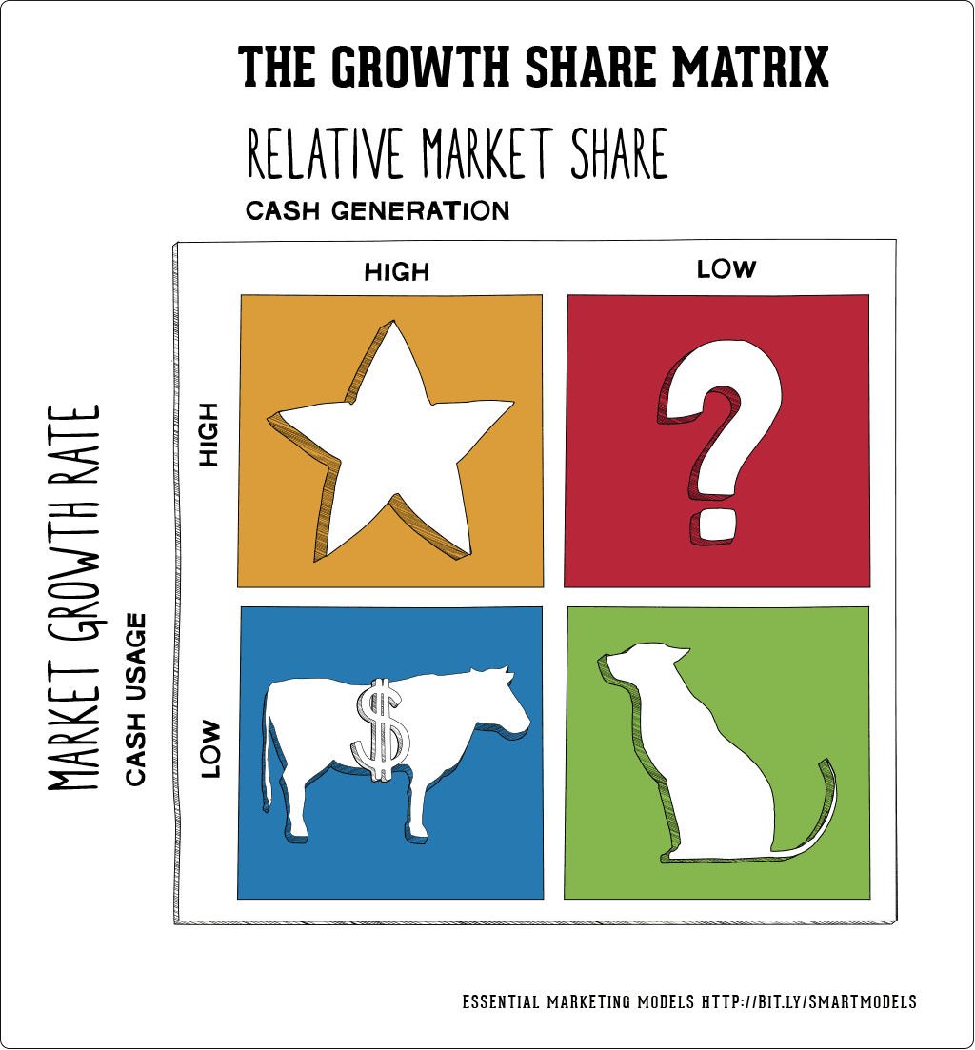
Figure 7: BCG matrix.
Source: (Jaya, Silva and Athauda, 2018).
Based on market share and opportunities for market expansion, the BCG matrix comprises four stages. Dogs, stars, question marks, and cash cows are in these stages.
Dogs: The term "dog" describes a company with a relatively small market share and no potential for future growth. These firms don't have promising prospects for the now or the future.
Stars: Firms with a substantial market share and promising futures are referred to as stars (Atanga, 2021). Companies in this region make high profits and have room for growth.
Question mark: This stage is used to symbolize businesses with significant room for market expansion but little market share at the moment. Companies should concentrate on current development at this point.
Cash cow: This is a situation in which a business has a substantial market share but experiences a decline in sales revenue (Tiawon and Supartha, 2021). The does not, however, have promising futures in terms of market expansion opportunities.
There are currently few prospects for Premier Inn to grow its market share in the UK. However, Premier Inn is experiencing strong domestic market sales. The business engages in a number of promotional activities, including promotional codes, off-season specials, price reductions, and more. According to Chakravarti (2017)'s survey, domestic hotels have expanded their use of sales marketing by 16% in order to enhance their market share. Despite the fact that these promotional operations are costing the company money, the company does not see any room for additional market expansion. Due to the government's Brexit decision, Premier Inn is also restricted from opening its outlets in other European nations. In his analysis, Hadi and Wood) (2019) stated that 42% of the hotel and tourism industries in the UK are experiencing a growth hold-up as a result of Brexit. Therefore, Premier Inn is in the Cash cow phase of the BCG matrix due to its substantial revenue, significant market share, and minimal prospects for market expansion in the UK.

Findings and results
The following is the delineation of the findings and results got from the discussion above.
Issues identified (Developmental areas) | Results | The model used in the finding | Resources used in the identification
Skill shortage | Some skill shortage was identified for the employees of the Premier Inn. 62% of customers in the hotel were displeased by the slow service of the company (Chakravarti, 2017). Installation of robotics technology and providing on-the-job training to the employees facilitated the hotel to recover the problem. | To identify the skill shortage and analyze the change process, Kurt Lewin’s change management model has been used. | Some technological resources such as computers, smartphones and data analysis tools such as Sisense, Tableau, MS Excel, and so on have been used.
Supply chain problem | Premier Inn has faced some issues with its supply chain recently. 55% of the hotel’s supply chain has been impacted by Brexit as export-import has become a little tougher due to this policy (Basana et al., 2022). Sourcing materials from outside the UK is particularly difficult and time-consuming which delays the service delivery as well as its quality. Moreover, the lack of communication between the information system and logistics department has exacerbated the issue. 73% of the customer the Premier Inn have been found to be dissatisfied due to the delayed and low-quality service of the company, thanks to the supply chain problem. | The Supply Chain management model has been used to identify the issue properly. | Different data analysis tools such as RapidMiner and KNIME have been used while collecting data from business journals and relevant websites.
Service variety shortage | The lack of services like a gymnasium and spa was responsible for 34% of customer turnover in the Premier Inn (Hadi and Wood, 2019). The hotel incorporated these in 2021 and was able to increase its customer base by 25% in the same year (Kumar, 2020). | The PDCA model was used in this identification to find out Premier Inn’s process of applying innovation and change. | Collaboration tools like Wrike and Zoom have been used to gather data and reach a conclusion about the identification.
Market growth problem | 42% of British companies are facing market growth barriers due to Brexit and the Premier Inn is no different (Chakravarti, 2017). The company cannot open outlets in European countries anymore which creates the issue of market growth. | The BCG model has been used for identifying the market growth problem. | Business journals, books, websites, and data analysis tools like Talend have been used in this section.
Table 2: Findings and results.
Source: Own.
Despite having a huge workforce, many of the employees of the Premier Inn are not skilled enough. This ineptness caused customer service to get slow and raised customer resentment to some extent. In a survey of 6373 customers of the Premier Inn, it was noticed that 62% of them were dissatisfied due to the slow service in the hotel (Hicks, 2022). Premier Inn planned to install some technologies in the workplace and enhance employee training to resolve the issue. The hotel management installed the robotics technology in the workplace in 2020 and recorded a 20% faster service delivery to its customers. Moreover, the hotel management changed the training technique from traditional training to on-the-job training to fill up the skill shortage effectively (Kumar, 2020). These management techniques were effective since customer service at the Premier Inn by 25% within 6 months of the change. Premier Inn noticed a high customer turnover in 2020 and the reason behind this issue was the lack of diverse services. Premier Inn noticed the need for luxurious service in the hotel and that is why planned the inclusion of gymnasium and spa services. Given that 34% of the customer turnover happened due to a lack of these services, the installation was effective (Cunill and Forteza, 2021). After rigorous examination, the Premier Inn installed the services in 2021. The Premier Inn was able to boost its customer pool by 25% in 2021 while getting a 2% larger market share that year due to the boon of service variety. Given that Brexit has made importing and exporting difficult, Premier Inn cannot import its raw materials such as Mineral water and water for mattresses, showers, bed linens, food and drinks, and pillows, as well as transportation, tissues, furniture, and other items easily. The hotel was dependent on 55% of its materials (Baron & Armstrong, 2007). Purchasing these from outside the United Kindom is time-consuming and hazardous. Often the quality cannot be scrutinized properly. Also, poor communication between internal departments like logistics and information systems has deteriorated the issue further. Therefore, the supply chain management issue has engendered dissatisfaction in 73% of the customer of the Premier Inn (Brierley, 2006). Due to the government's Brexit decision, Premier Inn is restricted from opening its outlets in other European nations. Research showed that 42% of the hotel and tourism industries in the UK are experiencing a growth hold-up as a result of Brexit (Fisman & Sullivan, 2014). Moreover, it has little space in the UK to open a new hotel and grow its market share. This creates a market growth barrier for the Premier Inn and puts it in the cash cow stage.

Action Plan
The following is an action plan for the aforementioned problems.
Number | Problem | Solution | Desired outcome | Time scale | Completion Date | Planned Budget
1 | Supply chain problem | The solution to this issue is creating alternative channels for procuring raw materials. The Premier Inn can procure tangible resources from the partner countries in the EU trade bloc since the UK is a member of the trade bloc (Cunill and Forteza, 2021). The Premier Inn can also work on solving employee conflicts to increase the communication between its internal departments for solving the issue. | The Premier will be able to collect raw materials easily and fast, which will result in fast service delivery and increased customer satisfaction. | 4 months | 15.01.2023 | £30,000
2 | Market growth problem | Premier Inn should look for Asian countries with rich economies. Given that not many Asian countries have luxurious hotels, although demand is high, Premier Inn can choose those places for growing its market share (Puspita and Yuliawan, 2019). | The market share of the Premier Inn Hotel will increase obviously. Also, the hotel will face low competition in the new market considering the low competition there. Therefore, the revenue and sales of the company will be top-notch. | 6 months | 15.04.2023 | £70,000
Table 3: Action Plan.
Source: Own.

Recommendations
- The Premier Inn should contact the partner countries in the EU trade bloc for procuring tangible resources since the UK is a member of the trade bloc. This will open the hotel to a fast and easy process of collecting raw materials, and at a cheap price as well (Brierley, 2006). Moreover, procuring materials from those countries will not create any legal issues as well.
- The Premier Inn needs to work on solving employee conflicts to increase the communication between its internal departments like Logistics and Information systems for solving the issue of the supply chain. The increased interaction will help any kind of waste in the Supply Chain department and thus the issue regarding it will be solved effectively.
- The hotel ought to look beyond the European countries for increasing its market share. Many countries in Asia have a high demand for lavish hotels and the Premier Inn should grab that opportunity for enhancing its market share (Baron & Armstrong, 2007). It can venture to Japan, Korea, Singapore, and other economically strong countries to fulfil its goal.
Premier Inn needs to increase promotion through the use of digital media like social media platforms to advertise its services all over the world. This will create new opportunities for increasing the market share of the company.
For the problems regarding supply chain and market growth, Premier Inn needs to take some effective actions. The company needs to contact the partner nations in the EU trade bloc for acquiring resources and materials because the UK is an associate member of this trade bloc. Also, the Premier Inn should solve employee conflicts and enhance the communication between Logistics and Information systems for solving the issue of the supply chain. Moreover, the hotel should penetrate Asian countries for increasing its market share and solve the growth-related issue.

Conclusion
Premier Inn, a multinational hotel chain business, has faced some management issues recently, mostly regarding changes and innovation. The issues have been regarding skill-shortage of employees, market growth problems, supply chain problems, and service variety inadequacy. From the external environmental analysis of the Premier Inn, it has been noticed that the hotel has both positive and negative impacts from the factors of the PESTEL model. To illustrate, the open market policy and the low-interest rate are beneficial for sales and fundraising. However, the tax rate and the high inflation rate are portentous for the operating cost of the company. Again, The Premier Inn has a gigantic brand value since it is the largest hotel chain in the UK while It has a substantial number of employees and investors. On the other hand, the services of the Premier Inn are quite expensive and the food variety in the restaurant section of the hotel is not satisfactory either. To state the management issues, due to the ineptness of some employees, the Premier Inn was facing some extreme setbacks regarding customer service since service became slow and customer dissatisfaction was noticed. The hotel planned to install robotics technology in the workplace and train employees to fasten service delivery to its customers and improve the skill shortage problem. The company also faced a service variety problem, which it solved by including a gymnasium and spa services in its service list. However, there are two problems that the company has yet to solve. These are market growth and supply chain-related problems. The Premier Inn should contact countries in the EU trade bloc and venture to Asian countries for solving these problems. To conclude, I thank the management of Premier Inn hotel for choosing me as a consultant. I have tried my best to deliver top-notch service to the client. I have collected all the crucial data and analyzed them critically to reach the final decision. Moreover, I have consulted the best possible solutions for the company to help it overcome the existing issues. Therefore, I hope and suggest that the hotel will employ me as a consultant in the future if it requires such services.
Being a large and multinational hotel chain, the Premier Inn faces various management problems. Let it be product variety, employee skills, supply chain, or market growth, the company has some shortcomings or opportunities for further development. The company has installed technologies and increased training to solve the issue while starting new services as well. However, there are chances like Asian market penetration and purchasing resources from partner countries which can aid the goal of the company more effectively.

References
Arifin, M., Ibrahim, A. and Nur, M. (2019). Integration of supply chain management and tourism: An empirical study from the hotel industry of Indonesia. Management Science Letters, 1(1), pp.261–270. doi:10.5267/j.msl.2018.11.013.
Atanga, R.A. (2021). THE EFFECT OF SUPPLY CHAIN MANAGEMENT SYSTEMS (SCMS) ON CUSTOMER SATISFACTION IN THE HOTEL INDUSTRY IN GHANA: THE CASE OF SELECTED HOTELS IN THE UK. RA Journal Of Applied Research, 04(11). doi:10.31142/rajar/v4i11.01.
Athiyaman, A. (2022) “Strategic choices in the International Hospitality Industry,” International Hospitality Industry, pp. 142–160. Available at: https://doi.org/10.1016/b978-0-7506-5295-7.50012-4.
Baron, A. and Armstrong, M. (2007) Human Capital Management. Tokyo.
Basana, S.R., Suprapto, W., Andreani, F. and Tarigan, Z.J.H. (2022). The impact of supply chain practice on green hotel performance through internal, upstream, and downstream integration. Uncertain Supply Chain Management, 10(1), pp.169–180. doi:10.5267/j.uscm.2021.9.010.
Brierley, E. (2006) Talent on tap getting the best from freelancers, interims and consultants. London: Chartered Institute of Personnel and Development.
Burnes, B. (2014) Managing change. Harlow, England: Pearson.
Burnes, B. (2021) “Kurt Lewin and the planned approach to change: A re-appraisal,” Journal of Management Studies, 41(6), pp. 977–1002. Available at: https://doi.org/10.1111/j.1467-6486.2004.00463.x.
Burnett, L. (2022) Premier Inn has a room for everyone in latest 'Rest easy' spot, LBBOnline. Little Black Book. Available at: https://www.lbbonline.com/news/premier-inn-has-a-room-for-everyone-in-latest-rest-easy-spot (Accessed: November 6, 2022).
Buttrick, R. (2009) The project workout. Harlow: Financial Times Prentice Hall.
Campos, D.F. and Marodin, T.G. (2019). PERCEPTIONS OF QUALITY AND EXPECTATIONS OF HOTEL SERVICES. Journal of Operations and Supply Chain Management, 5(1), p.82. doi:10.12660/joscmv5n1p82-99.
Capocchi, A. (2019) “Revenue management from a business-economics perspective,” Economic Value and Revenue Management Systems, pp. 101–119. Available at: https://doi.org/10.1007/978-3-030-02417-8_6.
Chakravarti, B.K. (2017). Hotel management. New Delhi: A.P.H. Pub. Corp.
Chen, M.-H. (2019). A quantile regression analysis of tourism market growth effect on the hotel industry. International Journal of Hospitality Management, [online] 52(1), pp.117–120. doi:10.1016/j.ijhm.2015.10.001.
Cunill, O.M. and Forteza, C.M. (2021). The Franchise Contract in Hotel Chains: A Study of Hotel Chain Growth and Market Concentrations. Tourism Economics, 16(3), pp.493–515. doi:10.5367/000000010792278446.
Fallon, M.J. and Rutherford, D.G. (2017). Hotel management and operations. Hoboken, N.J.: Wiley.
Fernando, A.C. (2019) Business environment. Chennai, India: Pearson.
Fisman, R. and Sullivan, T. (2014) The org: How the office really works. London: John Murray.
Godsiff, P. (2021) “Service systems and requisite variety,” Service Science, 2(1-2), pp. 92–101. Available at: https://doi.org/10.1287/serv.2.1_2.92.
Gorman, G. (2020) “The external environment of business,” Business Studies A Level, pp. 208–224. Available at: https://doi.org/10.1007/978-1-349-13846-3_13.
Hadi, S. and Wood, L.C. (2019). Improving Hotel Performance Through Active Supply Chain Risk Management: A Preliminary Model. SSRN Electronic Journal, 1(1). doi:10.2139/ssrn.2544537.
Hicks, K. (2022) Top 8 change management models: A comparison guide, Zendesk. Available at: https://www.zendesk.com/blog/change-management-models/ (Accessed: November 6, 2022).
Hoerl, R.W. and Snee, R.D. (2022) Statistical thinking: Improving business performance. Pacific Grove, CA: Duxbury-Thomson Learning.
Hood, A. (2018) “The role of Pestel analysis,” Sustainable Management of Coal Preparation, pp. 415–419. Available at: https://doi.org/10.1016/b978-0-12-812632-5.00034-3.
Ivanova, M.G. (2021). Issues and challenges within Hotel Supply Chain. SSRN Electronic Journal, 1(1). doi:10.2139/ssrn.2931128.
Jaya, A.A.K.K., Silva, S.D. and Athauda, A.M.T.P. (2018). Business strategy, market orientation and sales growth in hotel industry. Tropical Agricultural Research, 24(3), p.228. doi:10.4038/tar.v24i3.8008.
Johnson, A. (2021) “Alternative consultancy processes,” Business Research Projects, pp. 239–248. Available at: https://doi.org/10.4324/9780080459691-22.
Johnson, G. and Whittington, R. (2020) Exploring strategy: Text and cases. Harlow, England: Pearson.
Jones, S. (2021) “SWOT analysis,” Dictionary of Marketing Communications [Preprint]. Available at: https://doi.org/10.4135/9781452229669.n3585.
Karatepe, O.M. (2019). Perceptions of organizational politics and hotel employee outcomes. International Journal of Contemporary Hospitality Management, 25(1), pp.82–104. doi:10.1108/09596111311290237.
Karatepe, O.M. (2020). High-performance work practices and hotel employee performance: The mediation of work engagement. International Journal of Hospitality Management, 32(1), pp.132–140. doi:10.1016/j.ijhm.2012.05.003.
Kefalas, A.G. (2021) “Toward a sustainable growth strategy,” Business Horizons, 22(2), pp. 34–40. Available at: https://doi.org/10.1016/0007-6813(79)90049-1.
Kerdpitak, C. (2020). EFFECT OF DRIVERS PRESSURES ON SUPPLY CHAIN MANAGEMENT PERFORMANCE WITHIN THE HOTEL INDUSTRY. Polish Journal of Management Studies, 20(2), pp.290–299. doi:10.17512/pjms.2019.20.2.24.
Kumar, T. (2020). Every Moment Matters: Study of Employee Engagement at Radisson Hotel Group, Nagpur. HELIX, 8(6), pp.4206–4209. doi:10.29042/2018-4206-4209.
Le, S., Wu, J. and Zhong, J. (2020). Supply chain quality performance: The effect of supply chain integration in hotel industry. Computational Intelligence, 1(1). doi:10.1111/coin.12379.
Matthias, O. and Campbell, J. (2019) “Consultancy in management education,” Management Consultancy Insights and Real Consultancy Projects, pp. 108–116. Available at: https://doi.org/10.4324/9781315593425-10.
McFarlane, J. and Curran, R. (2021) “Business organizations the internal environment,” Enterprise and its Business Environment [Preprint]. Available at: https://doi.org/10.23912/978-1-910158-78-4-2923.
Mehmood, M. (2020) “Finance in the hospitality industry,” Contemporary Management Approaches to the Global Hospitality and Tourism Industry, pp. 185–212. Available at: https://doi.org/10.4018/978-1-7998-2204-2.ch011.
Morana, J. (2021) “Sustainable Supply Chain Management Balanced Scorecard,” Sustainable Supply Chain Management, pp. 139–165. Available at: https://doi.org/10.1002/9781118604069.ch4.
Muldoon, J. (2020) “Kurt Lewin: Organizational change,” The Palgrave Handbook of Management History, pp. 615–632. Available at: https://doi.org/10.1007/978-3-319-62114-2_32.
Noordzy, G. and Whitfield, R. (2014) “Project Management of New Hotel openings,” Educational Strategies for the Next Generation Leaders in Hotel Management, pp. 140–163. Available at: https://doi.org/10.4018/978-1-4666-8565-9.ch006.
O’Meara, P. (2021) “Pestel and the Northern Society,” The Decembrist Pavel Pestel, pp. 114–123. Available at: https://doi.org/10.1057/9780230504608_8.
O'Neill, S. (2022) Premier inn sees upsides for itself with economic headwinds, Skift. Available at: https://skift.com/2022/10/25/premier-inn-sees-upsides-for-itself-with-economic-headwinds/ (Accessed: November 6, 2022).
Peterson, D. (2022) “Skills shortage ‘will worsen,’” Education + Training, 43(2). Available at: https://doi.org/10.1108/et.2001.00443bab.003.
Proctor, A. (2020) “Internal Business Environment,” Encyclopedia of the UN Sustainable Development Goals, pp. 408–408. Available at: https://doi.org/10.1007/978-3-319-95726-5_300081.
Pugh, D.S. and Mayle, D. (2019) Change management. Los Angeles: SAGE.
Puspita, N.M.D. and Yuliawan, A.K. (2019). ROLE OF EMPLOYEE ENGAGEMENT ON WORK SATISFACTION REGARDING EMPLOYEE SERVICES QUALITY AT THE GRAND SANTHI HOTEL DENPASAR. Review of Management and Entrepreneurship, 2(1), pp.1–16. doi:10.37715/rme.v2i1.954.
Quartapelle, A. (2020) Customer satisfaction. Milano: McGraw-Hill.
Sari, K. and Suslu, M. (2020). A modeling approach for evaluating green performance of a hotel supply chain. Technological Forecasting and Social Change, 137(1), pp.53–60. doi:10.1016/j.techfore.2018.06.041.
Saunders, K.T. (2020) “The interest rate swap: Theory and evidence,” Journal of Corporate Finance, 5(1), pp. 55–78. Available at: https://doi.org/10.1016/s0929-1199(98)00017-0.
Sibanda, P. and Pooe, R.I.D. (2022). Enhancing supply chain performance through supply chain practices. Journal of Transport and Supply Chain Management, 12(1). doi:10.4102/jtscm.v12i0.400.
Slack, N. (2019) “PDCA cycle,” Wiley Encyclopedia of Management, pp. 1–1. Available at: https://doi.org/10.1002/9781118785317.weom100162.
Smith, W. (2019) “Business and the external environment,” Financial Services Management, pp. 130–145. Available at: https://doi.org/10.4324/9780203515532-10.
Szende, P. (2021) Hospitality Revenue Management: Concepts and Practices. Palm Bay, FL, USA ;: Apple Academic Press.
Tiawon, H. and Supartha, I.W.G. (2021). Implementing a business strategy with supply chain management in a management system and management control to improve the performance of the hotel business. Uncertain Supply Chain Management, 9(3), pp.687–695. doi:10.5267/j.uscm.2021.4.010.
Traynor, S. (2022) Edinburgh Premier Inn evacuated as fire crews race to City Centre Hotel, edinburghlive. Available at: https://www.edinburghlive.co.uk/news/edinburgh-news/edinburgh-premier-inn-evacuated-fire-25372547 (Accessed: November 6, 2022).
Vidal, M. (2022) “The management contradiction,” Management Divided, pp. 235–272. Available at: https://doi.org/10.1093/oso/9780198795278.003.0008.
Warner, S. (2020) “EU trade policy in practice,” Handbook on the EU and International Trade, pp. 169–170. Available at: https://doi.org/10.4337/9781785367472.00017.
Whittington, R. and Molloy E. (2005) HR’s role in organisation: shaping change. Research report. London: Chartered Institute of Personnel and Development.
Willamson, D. (2022) “Cytokine production in primary BCG lesions,” Pathogenesis of Human Pulmonary Tuberculosis, pp. 299–311. Available at: https://doi.org/10.1128/9781555815684.ch19.
Withvector.com (2022) Types of supply chain management: 6 models to know, With Vector. Available at: https://www.withvector.com/types-of-supply-chain-management-6-models-to-know/ (Accessed: November 6, 2022).
Wood, Z. (2022) Premier Inn took £226 from me even though there was no booking, The Guardian. Guardian News and Media. Available at: https://www.theguardian.com/money/2022/oct/25/premier-inn-took-226-from-me-even-though-there-was-no-booking (Accessed: November 6, 2022).

