

Task 1 – Reading Task Template
Upload your photo of your A3 in-class notes here:
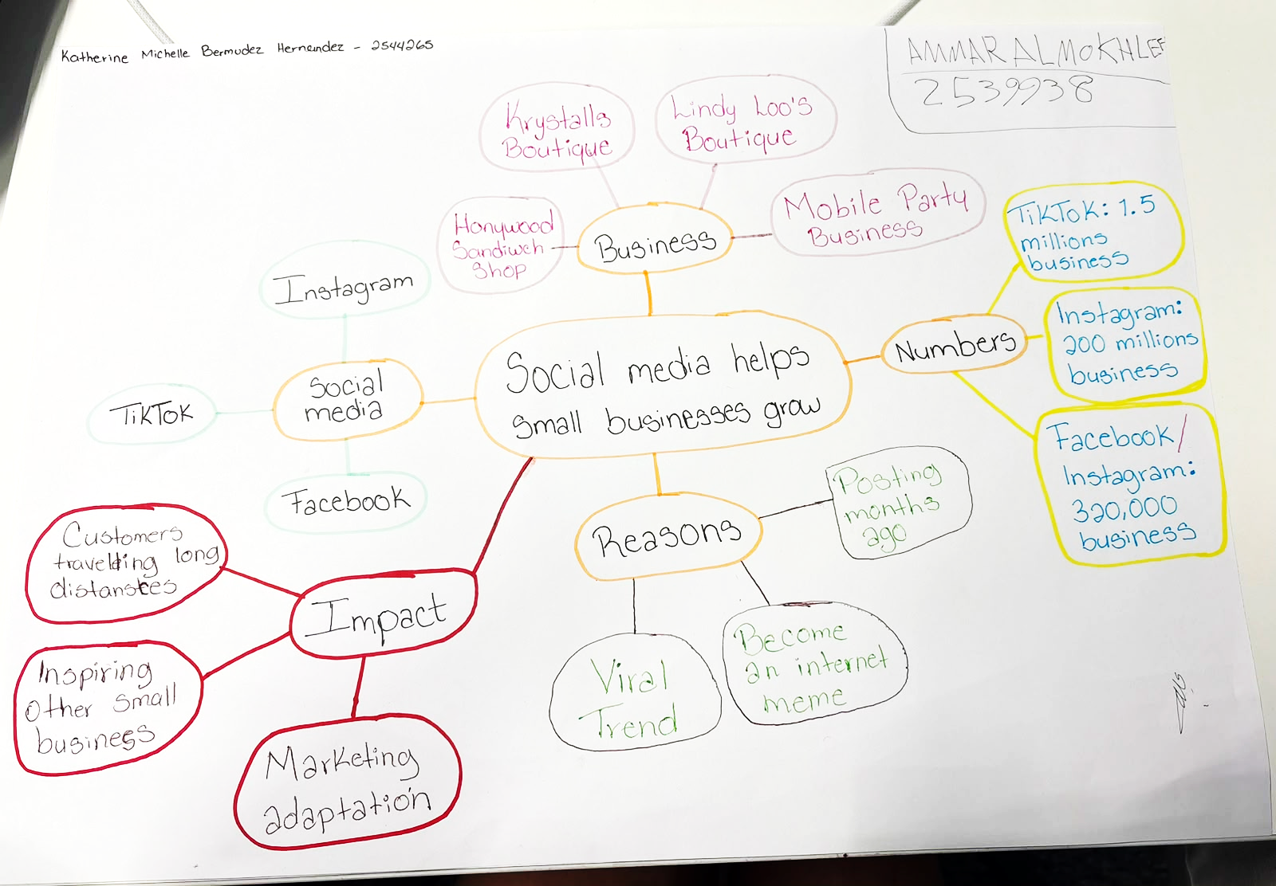

1. Answer these questions using the sentence starters below
a. What is the main idea of the text?
The main idea is social media can help small businesses go viral and attract many new customers.

b. What are two key points?
- One key point is people travelling long distances to visit businesses they find viral on social media.
- Another key point is going popular in internet attract more customers and higher sales.

c. What part of the text did you find most important? Why?
The most important part is the impact of the social media because the impact is so big in scales like made people travel long distances and how the business increase by a post that change the direction of the business.

d. Was anything unclear or difficult to understand?
I was not sure about if the formula of the marketing can be apply for multiples business and if all would have the same success or not if at the final always depents no only in the social media but also need to be by the hand of a good group of marketing.

e. How did your group help you understand the text better?
My group helped me by see more details were you can think there can be nothing of important information.

3. One sentence reflection
Question: What did you find challenging about this task?
The hardest part was identify the keys ideas because the text included so many examples and details that made it harder to decide which ones are the most important keys points.

