Fundamentals of construction technology
ACBA4001
Site investigation case study

- Student name-Jean-Paul Marshall

- Student id number-2023697

- Lecturer’s name-Allan Nantel

- Submission deadline-6th January 2022

- Word count-2500

Contents page

List of illustration – page 2

Executive summary – page 3

Introduction – page3

Site details – page3

Geological appraisal – page5

Environmental appraisal – page6

Archaeology appraisal – page8

Conceptual ground model – page8

Recommendations for the site investigation – page9

Suitable foundation – p10

Reference list – page11

List of illustration
1) Site lay out
2) Site lay out
3) Old site lay out and building information
4) core hole sample
5) core hole sample
6) Swansea bomb storage
7) Swansea docks being bombed
8) Radon gas map
9) Sketch of proposed foundation

Executive summary

To summarise, the proposed build is for a 300 square meter building with two storeys to house a restaurant, café bar, ice cream parlour, kitchen food stores and a self-contained apartment. The plot is currently used for two car parks and is owned partly by Swansea civic centre and the Marriott hotel. It was previously used for manufacture and storage and road and rail access; this was all demolished over time. The proposed site has a high possibility of contaminants from its heavy involvement in the import export and industrial era of the docks mainly coal and metals. The desk top study shows the core hole shows the ground is made up and what it made up from, up to a depth of thirty meters. 0 to 2.10 is made ground, 2.10 to 7.30 is coarse sand, gravel, and large boulders, 7.30 to 7.75 is peat, 7.75 to 24.00 is very coarse sand, gravel, and large boulders, 24.00 to 25.50 is laminated silty clay, 25.50 to 26.75 very large boulders, 26.75 to 27.5 is moderately to highly weathered grey mud, 27 to 28.50 is large boulders and gravel and 28.5 to 30.00 moderately to highly weathered grey mudstone. The core hole shows that a pile foundation is best suited for this site as shear failure of the foundation is a high risk. The next step would be to have a geotechnical surveyor to survey the site, so that a more accurate assessment can be made.

Introduction

The purpose of this preliminary desk top study is to identify all the potential risks, history of area and best methods of approach, to see if this site is suitable to build a commercial building including foundation recommendation. I will highlight what is most important for the geotechnical contractor to look at in more detail.

Site details
Location – The site post code is SA1 1PG and the grid reference is latitude 51.613233 Longitude -3.9453430. (Google maps,2022). (Illustration 1). The site is made up of two car parks separated by an area of landscaped land (illustration 2)

Access – The site can be accessed by car or on foot, from the Marriott hotel car park or the civic centre car park as illustrated on Oystermouth Rd - Google Maps (2021). (Illustration 1).
present/proposed land use -The plot is currently being used, as car parks by the civic centre and the Marriott hotel, as well as access from Dunvant place to the cycle path on the shoreline as shown on google maps Oystermouth Rd - Google Maps(2021). (Illustration 1) The proposed land use is to build an ice cream shop, restaurant, and accommodation quarters for the managers. Land ownership – Swansea council own the civic centre. (Wikipedia,2021), Bill Marriott Jr owns the marriott hotel (ironset,2022)
Past uses – There where road and rail networks in the area that are no longer there, namely Paxton Street and Paxton terrace (illustration 3) there was a timber yard, paint factory, canister works, wagon repair services and several buildings for storage. These buildings compromised of one and two storey buildings as described in (Illustration 3) Compare maps (georeferencer.com). (Insurer information from 1929 Insurance Plan of Swansea: sheet 9-2 (georeferencer.com)
Boundaries – The boundaries are clearly indicated in (illustration 1&2)

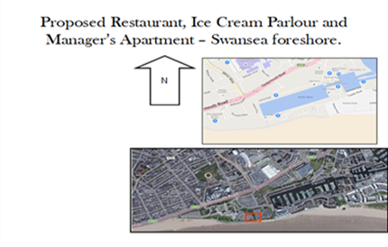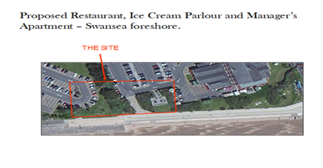
Illustration 1 (supplied with brief) illustration 2 (supplied with brief)
Old lay out of site and past uses 1929
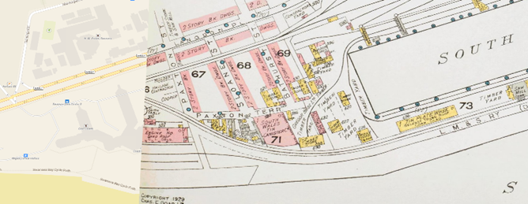
Illustration 3 (British Library,1929)

Brief history of the Swansea area
Swansea or “sweins island” as it was first known, was identified in 1000ad as a small fort, rumoured to be used by a Norseman to raid the Welsh coast.
12th Century - The Normans conquered the area and Swansea was founded,
13th Century - The town had 1000 people living there and a local market, it was also towards the end of the century Swansea was hit by black death which killed around half the population.
14th Century - Swansea was run by the official named Portreeve and his 12 aldermen. The main industries currently where leather, wool, and ship building.
15th to 18th Century - At this time Swansea would grow quickly from 1000 residents to 3000, due to ship building, wool manufacturing, glove making and the coal mining boom, increasing amounts of coal and later iron, copper, lead, zinc, pottery was exported from Swansea. This made the Swansea docks very busy as well as this, the local markets got busier. The boom in industry caused more people to move here and the side effect of this was new infrastructure such as a grammar school, its first bank and first theatre all by 1785. It was in 1791 that a group of men were put in charge of the harbour they were called the harbour commissioners. It was then that the north dock was built in 1852, the south dock in 1859 and the prince of Wales dock in 1881. There was also a negative affect The boom of industry raised the population to 100000 causing issues with overcrowding and sanitary leading to cholera out breaks. To combat this parliament formed the paving commission to be responsible for the paving, cleaning, and lighting of the streets, the street lighting came in the form of gas in 1821.
19TH Century - The boom was to continue in Swansea, as it was to become the centre of the metal working industry. It made huge amounts of zinc, tin plate and copper that were shipped through the docks as well as oil imported in and refined in Swansea then exported, and this was driven by access to the canal which carried the heavy raw materials quicky to and from the port. In 1906 the first council houses were built in Swansea. More were built in the 1920s, 1930s and many more after 1945 as well as private houses. The king’s dock was built in 1909 followed by the queen’s dock in 1920 Swansea was affected by the war, the bombing runs killed 387 people and destroyed the city centre. It was rebuilt in the 1960s. During the war the economy was booming, but after the war the metal working industry slowed down rapidly, and coal mining stopped by the end of the century. As the need for the port decreased, the council closed the south dock in 1969 and it was opened as a marina in 1982 and the north dock is now known as parc Tawe, as it had a shopping centre built there in the 80s.
Lambert (2021) was the main source of information.

Geological appraisal
The geological appraisal is based on my research of bore hole records from GeoIndex - British Geological Survey (bgs.ac.uk)

Description of strata, based on core hole samples
The core hole shows the ground is made up and what it made up from, up to a depth of thirty meters. 0 to 2.10 is made ground, 2.10 to 7.30 is coarse sand, gravel, and large boulders, 7.30 to 7.75 is peat, 7.75 to 24.00 is very coarse sand, gravel, and large boulders, 24.00 to 25.50 is laminated silty clay, 25.50 to 26.75 very large boulders, 26.75 to 27.5 is moderately to highly weathered grey mud, 27 to 28.50 is large boulders and gravel and 28.5 to 30.00 moderately to highly weathered grey mudstone.

Bore hole logs (Illustration 4 and 5)
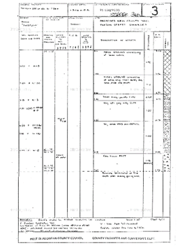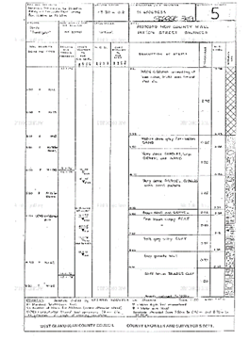
(British geological survey,1976)

The geomorphology of the site is made up from Superficial strata, it is made up artificial strata as indicated in the bore hole samples, with no risk of subsidence as its on a level plane. It is how ever open to erosion due to the shales and mud stone. The bed rock is made of limestone. There is a coal seam at west cross running east-west and one from Oystermouth road southwards to mumbles. The Geological Society (geolsoc.org.uk) there is mining all over Swansea some of which are pen-filia 51°38'47.9"N 3°56'45.6"W - Google Maps and Moriston https://goo.gl/maps/exZHmjxye1VxAzMh6

Environmental appraisal
Potential contaminations from past uses – The potential contaminants for this site would be items used, in the process the previous businesses would have used in their production, storage and transport of there products. A train track ran through this area that serviced the docks for the transport of varies items such as timber, metals, coal, and quarry products and could have spilled cargo (BBC,2021). There used to be two roads on the site that are no longer there Paxton Street and Paxton terrace as well as a rail network so these could be backfilled to save money.

Potential contaminations from the new build – The potential contaminants from the new build would be minimum if any at all if procedures were made and followed. It is worth mentioning human error, based on human error there is potential contamination as mistakes can be made i.e., spillage of chemicals and fuels, materials blown into the sea etc.

Pollution history – The pollution in Swansea and the surrounding area was made up from industry pollution, such as copper, lead, tin, silver, zinc smelting, coal mining as well as others. The result of the smelting process was devastating on Swansea as the pollution caused long term contamination, giving Swansea the title of the most polluted place in the world and the title “Copperopolis”. The pollutants in the air and landscape compromised of sulphur dioxide, hydrogen fluoride, sulphurous acid, sulfuric acid, and hydrofluoric acid known as acid rain. This contaminated the ground with particles of copper, sulphur, arsenic, lead, antimony, silver, and other pollutants found in the process (jstor,1997)

Hydrogeology – Based on the core hole samples of this area and information from the British geological survey the ground is made up of a superficial alluvial sand deposits (sand and gravel) with a limestone, and mudstone interbedded bedrock (British geological survey,2022). To understand this Darcy’s law has to be looked at to determine the flow of water correctly with in soil water dynamics (science direct,2022)
Flora and fauna risks – The main risks to flora and fauna in this area would be, if the contaminants where disturbed and spread around the environment as the contaminants mentioned are heavy metal particles from industry such as lead, copper, silver etc they have the potential to cause severe consequences to humans, wildlife, and plant life (pmc, 2012).

Weather and effects on site – The highest wind speeds are in December 18mph, the wettest days are in November 125 mm of rain, the hottest days are in July 17 degrees, the coldest days 6 degrees are in February and the annual rain fall is 995 mm. All measurements are an average (Time and date,2022). The effects of this weather on the building would be minimum but you would need to look at up lift and racking caused by wind, also the choice of foundations could be affected due to the ground make up and rain fall and wind causing expansion and shrinkage (allura,2022).
I would also look at the effect of the sea air and water containing salt, this will affect the steel in the building if exposed (tss,2021)

Wildlife – Striped Millipedes, Harlequin ladybirds, isopods, Gulls in the UK gulls, are protected by the Wildlife and Countryside Act (1981). Anyone killing, injuring, or taking a bird, damaging, or destroying its nest or taking or destroying its eggs without a licence from NRW is guilty of an offence and risks prison and a hefty fine (Swansea university,2020)

Archaeology appraisal
With Swansea dating back to the 12 century there is a possibility of finding items from history, some items and buildings already found are
- A roman fort. Roman coins and roman pottery
- A fort built in 1860 with guns to defend against France, but in 1909 they through the guns in the sea to save money on disposing of them
- The mumbles railway was the first passenger, horse drawn train in the world (Mumbles and Gower Tourist Information Centre (2021)

What is most likely to be found
In my opinion the most likely items to be found on the site location would be
- infrastructure materials
- building materials from demolition
- Waste items from the businesses

Unlikely to be found
In my opinion there is a small chance of finding unexploded ordnance from the war, since Swansea dock area stored, loaded ships with bombs and ammunition and was bombed in the war (Swansea docks commission,2021)

Swansea bomb, storage, and transport The aftermath of a bomb on the harbour
(Illustration 6) (Illustration 7)
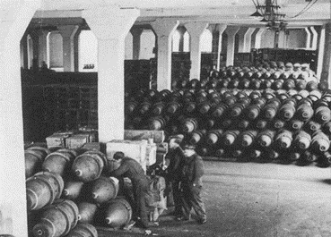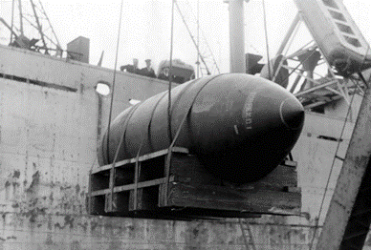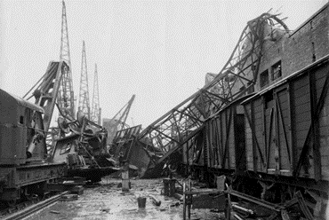
(Swansea docks commission,2021)

Conceptual ground model
Potential ground related hazards – Building materials, chemicals, paints, old services, old, demolished structures, previous services, uxos, and radon gas. These contaminants would have come from previous use of the area by industry and commercial use. The pathways these contaminants would take would be leaching into the ground and water table as well as being a hazard if disturbed. The risk to human health is great if digested, inhaled or pass through the skin. And in some cases, are carcinogenic as well as causing all sorts of health problems (Gard,2019). The metals in the ground also affect the vegetation causing stunting in growth and deformation as well as stopping vegetation from growing at all (Environmental pollution,2020). Radon gas Is present in this area as stated by UK health security agency (UK health security agency,2019). Radon gas is a colourless, odorous gas that causes cancer if inhaled, its formed from the break down of rocks and soils (gov.uk,2014)
Radon gas map (Illustration 8)
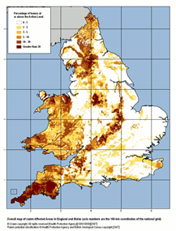
Illustration 4 (UK health security agency,2019)

Recommendations for the site building regulation/codes of practice and local authority involvement.

I recommend the geotechnical surveyor look at the hazards I have outlined before he cores any part of the site. The main concerns are unregistered mine shafts/voids, old services, buried gas canisters, diesel tanks, uxos, built up gases. Its important to check the stability of the ground and its make up across the site to see if it changes at all, meaning a different foundation can be used. I think its important to take several samples across the site and take them to a lab to check their toxicity. It would be beneficial to check the drainage capacity of the soil to see if its worth replacing with engineered back fill to increase drainage. If a detailed survey including all the above is done it will show what we are facing on excavation and pilling the foundations, it will also give data on the cost this will let us know the potential costs.

My recommendations are from Building regs, and codes of practice as listed below
Pile design to bs en1997-1:2004(ec7)
Ground testing to bs5930
Methods of Test for Soils BS 1377
desk study and site reconnaissance UK practice of BS EN 1997-1 and BS EN 1997-2
The Building Act 1984
The Building Regulations 2010
Flood and water management act 2010
National strategy for flood and coastal erosion risk management in Wales.
Wildlife and countryside act 1981

Suitable foundation – In my opinion the foundation most suited to this site with this environment and ground conditions would be a pile foundation. I have come to this decision based on the findings out lined in the report. To clarify the site has a non-bearing artificial ground, the need for a 30-meter pile is necessary to gain the correct bearing and eradicate shear force as explained in (Structural guide,2022). Under the man-made layer is also non-bearing and will shrink and expand with water content causing instability and erosion so using a pile will eliminate this as well as causing the settlement to be the same across the foundations (The constructor,2019)

This is a sketch of what I would set it out like, so the piles can reach the high-density bedrock. – (Illustration 9)
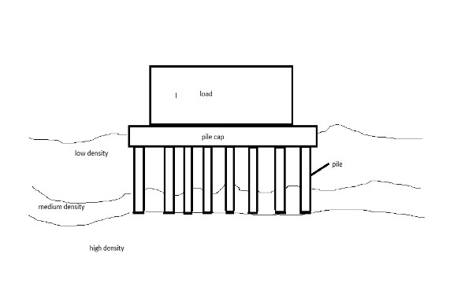
Sketch done by Jean-paul Marshall on paint

Reference list
Allura (2022) How extreme weather conditions affect home building. Available at: How Extreme Weather Conditions Effect Home Building | Allura USA (Accessed: 04 January 2022).
BBC(2021) the mumbles railway. Available at: BBC - Wales History: The Mumbles Railway(Accessed: 18 November 2021).
British geological survey (2021) geology of Britain viewer. Available at: Geology of Britain viewer | British Geological Survey (BGS) (Accessed:01 January 2022).
British library (1929). Insurance plan of Swansea. Available at: Insurance Plan of Swansea: sheet 9-2 (georeferencer.com) (Accessed 24 December 2021).
British geological survey(1976) bore hole samples. Available at: Page 1 | Borehole SS69SE311 | Borehole Logs (bgs.ac.uk) (Accessed: 01 January 2020).
Environmental pollution (2020) toxic effects of heavy metals on human health and plants. Available at: Toxic Effects of Heavy Metals on Human Health and Plants | Industries (environmentalpollution.in) (Accessed 04 January 2022).
Gard (2019) Heavy metal poisoning. Available at: Heavy metal poisoning | Genetic and Rare Diseases Information Center (GARD) – an NCATS Program (nih.gov) (Accessed: 02 January 2022).
Oystermouth Rd - Google Maps
Google maps(2021) satellite view. Available at Oystermouth Rd - Google Maps (Accessed: 20 October 2021).
Gov.uk (2014) Radon. Available at: Radon - GOV.UK (www.gov.uk) (Accessed 27 December 2021).
Ironset(2021) who owns the Marriott chains of hotels. Available at: Who owns the Marriott chain of hotels? – IronSet (iron-set.com) (Accessed: 04 January 2022).
Jstor(2009) Atmospheric pollution and the British copper industry 1690-1920. Available at: Atmospheric Pollution and the British Copper Industry, 1690-1920 on JSTOR (accessed: 04 January 2020).
Lambert.t(2021) A History of Swansea. Available at A HISTORY OF SWANSEA - Local Histories/(Accessed: 20 October 2021).
Mumbles and Gower Tourist Information Centre (2021).Historic mumbles. Available at: Historic Mumbles | (visitmumblesandgower.co.uk) (Accessed 26 December 2021).
Old-maps.co.uk(2021) Available at Old-Maps - the online repository of historic maps - Map 265116 192382 12 100954
Pmc(2012) Heavy metals toxicity and the environment. Available at: Heavy Metals Toxicity and the Environment (nih.gov) (Accessed: 04 January 2022).
Science direct (2021) Darcy’s law. Available at: Darcy's Law - an overview | ScienceDirect Topics (Accessed: 25 December 2021).
Structural guide(2022). Shallow foundations. Available at: Shallow Foundation Failure - Structural Guide (Accessed 01 January 2022).
Swansea university (2020) Our natural environment. Available at: Our Natural Environment - Swansea University (Accessed 24 December 2021).
Swansea docks commission (2021). World war one. Available at: Swansea Docks-Docks at War (accessed 26 December 2021).
Time and date (2022) Annual weather averages near Swansea. Available at: Climate & Weather Averages in Swansea, Wales, United Kingdom (timeanddate.com)(Accessed: 04 January 2020).
Tss (2021) how the sea breeze can affect your stainless steel. Available at: How the Sea Breeze Can Affect Your Stainless Steel | Tampa Steel (Accessed:04 January).
The constructor (2019) What are the needs and functions of a pile foundation?. Available at: What are the Needs and Functions of Pile Foundation? - The Constructor. (Accessed:04 January 2022).
UK Health Security Agency(2019) UK radon map. Available at: UKradon - UK maps of radon (Accessed: 25 December 2021).
Wikipedia (2021) Swansea civic centre. Available at: Swansea Civic Centre - Wikipedia (Accessed: 04 January 2022).

