DIGITAL SKILLS FOR PERSONAL GROWTH
BMSW4008
KEMETIA JAMES
STUDENT: 2308793


Overview summary
Task :1................................................................................................3
Tasks:2 5-minute video ....................................................................4
Task: 3. survey ....................................................................................5
Task:4 .................................................................................................6
References...........................................................................................7

My report is to demonstrate the Brand Water Lilly Bar and Grill and how it came into existence. Come and explore our diverse menu offering authentic Caribbean cuisine, live music events, and catering services.

Authentic Caribbean Cuisine
Our Authentic Caribbean Cuisine transports you straight to the islands with every bite. We use traditional recipes and fresh ingredients to create dishes bursting with flavour. Started from jerk chicken and curried goat to plantains and callaloo, our menu offers a variety of options that cater to all tastes. Our chefs are passionate about bringing the true essence of the Caribbean to Cardiff, making sure each dish is a delightful experience. Whether it is a hearty meal or a light snack, we have something for everyone.

Our Authentic Caribbean Cuisine is made using traditional recipes and the freshest ingredients. This ensures each dish is not only delicious but also true to its roots. Our chefs are dedicated to delivering an exceptional dining experience, making sure every meal is memorable. If you love Caribbean food or want to try something new, our menu is sure to impress.

- Traditional recipes
- Fresh ingredients
- Variety of options

Jamaican National dish Ackee and saltfish served with boiled bananas and yam and fried dumpling
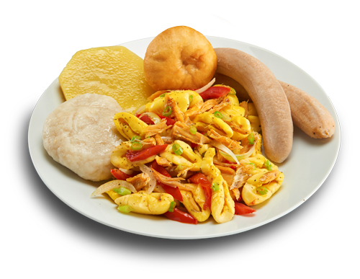
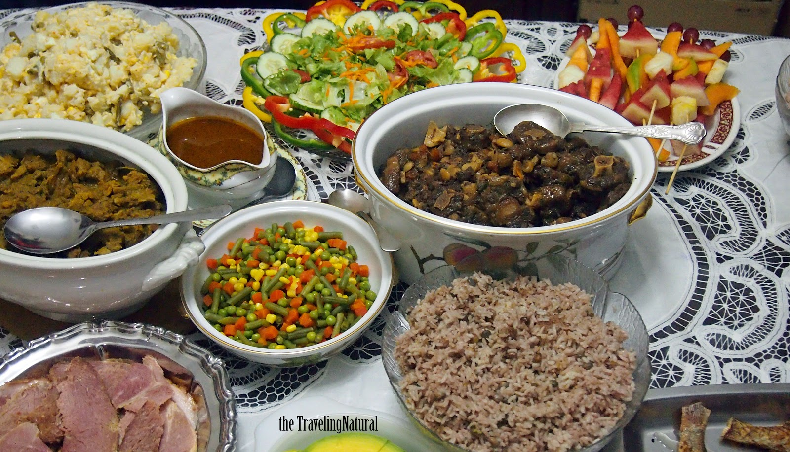

Live Music Events

Our Live Music Events create a vibrant and enjoyable atmosphere at Water Lilly Caribbean Bar and Grill. We host talented local and Caribbean musicians who perform a mix of genres, from reggae and calypso to Soca and dancehall. These events are perfect for relaxing with friends, enjoying a delicious meal, and soaking up the lively Caribbean vibes. Our schedule features regular performances that keep our patrons entertained and looking forward to their next visit. Join us for an unforgettable night of music and fun.

Live Music Events at Water Lilly Caribbean Bar and Grill are designed to offer an entertaining and enjoyable experience. We collaborate with talented local and Caribbean musicians to provide high-quality performances. The vibrant atmosphere created by our live music nights makes it a perfect venue for socialising and having fun. Don't miss out on these lively events.
- Talented musicians
- Vibrant atmosphere
- Regular performances

Private Parties & Catering

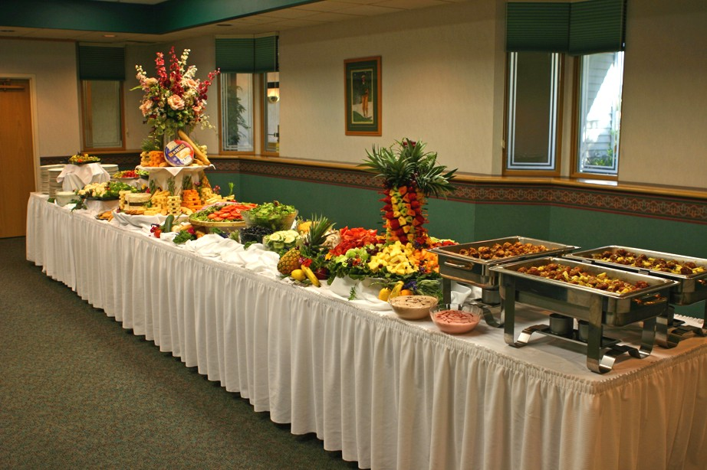
Our Private Parties & Catering services are crafted to make your special occasions unforgettable. We offer bespoke packages to meet your needs and create a personalised experience. With our delicious Caribbean cuisine and attentive service, your guests will be impressed. Whether it is a small gathering or a large celebration, we ensure a seamless and enjoyable event.

- Tailored packages
- Customised menu
- Professional service

For those special occasions, our Private Parties & Catering services ensure your event is a memorable one. We offer tailored packages to suit any celebration, from birthdays and anniversaries to corporate gatherings. Our team works closely with you to create a customised menu featuring our authentic Caribbean dishes, and we provide professional service to match. Whether hosting your event at our venue or a location of your choice, we promise an exceptional experience that your guests will love.

The Water Lilly Brand mission is to bring warm and happiness to anyone who visits to have their meal and to enjoy the taste of the Caribbean without going to the Caribbean.
Certainly! Water Lilly Bar and Grill Jamaican Cuisine is a delightful restaurant that fuses mouth-watering Caribbean Flavors with exciting tropical cocktails and craft beer. The Restuarant specialties include Jerk chicken, Oxtail, Brown Stew Chicken, Curry Goat and Jerk Pork. If you are ever in the mood for authentic Jamaican cuisine, this place is a must-try 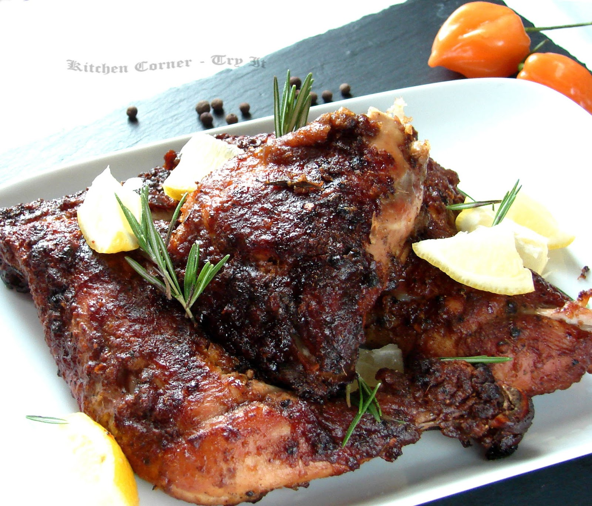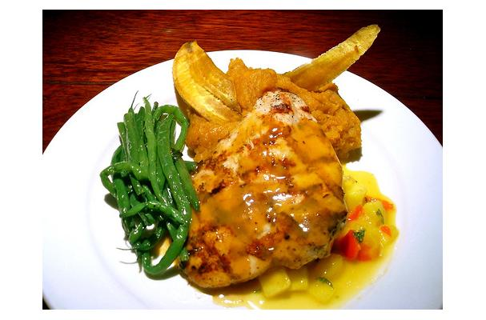
They also have an event space that can accommodate 20-200 people, making it an excellent choice for hosting gatherings. Live music, including reggae and DJ performances, adds to the vibrant atmosphere. You can find them on Canton High Street in Cardiff, come on in and explore the bold and vibrant Flavors of the region.
The restaurant was established by Kemetia James, her passion for architecture and business development played a key role in designing the unique and one-of-a-kind venue. Kemetia is originally from Jamaica and bring the love for cooking to the UK and would like to share it with the world. Water Lilly Bar and Grill also offers event space and catering, making it an excellent choice for hosting gatherings. Live music, including reggae and local talent, adds to the vibrant atmosphere.
The Water Lilly Bar and Grill opening times to accommodate all when needed.
- Sunday: 10 AM - 9 PM
- Monday to Thursday: 8AM - 10 PM
- Friday: 8 AM - 11 PM
- Saturday: 10 AM - 11 PM (kitchen closes at 10 PM) each night.

Top dishes

Oxtail (GF)
A delicacy! Tender pieces of braised meat falling off the bone, seasoned with a variety of island spices and cooked down in brown gravy sauce with butter beans.
£40.00 +

Ackee & Saltfish (GF)
Jamaican national dish. Sauteed in onions, green pepper, bell pepper, thyme, scotch bonnet pepper and salted codfish.
£28.00 +

Ackee & Saltfish with Fried Dumpling
Jamaican national dish. Sauteed in onions, green pepper, bell pepper, thyme, scotch bonnet pepper and salted codfish.
£28.00

Barbeque Jerk chicken dinner (GF)
Bone-in chicken, dry rubbed with jerk seasoning then charcoal grilled then marinated in a honey BBQ sauce. Served with 3 sides. £20.00 +

Brown Stew Chicken Dinner (GF)
Tender pieces of bone-in chicken seasoned with island spices, thyme, and scallion. Cooked down in a brown gravy sauce.
£20.00

Jamaican cuisine is a mixture of cooking techniques, flavours and spices influenced by Amerindian, West African, Irish, English, French, Portuguese, Spanish, Indian, Chinese, and Middle Eastern people who have inhabited the island.

According to (The Best of Jamaican Food | 25 Must-Try Jamaican Dishes and Drinks
By: AuthorAshaki Dixon
Posted on Last updated: July 20, 2023

It is also influenced by the crops they introduced into the Island from tropical Southeast Asia, many of which are now grown locally. The Jamaican uses all these different culture ways in preparing food and the use of spices in their own way to make a unique taste for themselves. When you eat a Jamaican born person meal you can know the difference straight way.

“Water Lilly Caribbean Bar and Grill provided an amazing experience. The food was delicious, and the live music made our night truly special.”
Kemetia James
© 2024 water Lilly Caribbean bar and grill
Powered by Webador

References

The Best Of Jamaican Food | 21 Must-Try Jamaican Dishes (foodieflashpacker.com)

Jamaican Food: 7 Must-Try Traditional Dishes of Jamaica | Travel Food Atlas

20+ Traditional Jamaican Recipes - The Kitchen Community

Jamaican Food - 15 Traditional dishes to eat in Jamaica (with photos) (swedishnomad.com)

Good To Go Jamaican Cuisine - Updated 2024, Jamaican Restaurant in Chicago, IL (opentable.com)

Jamaican flavours - BBC Food

Order Online (toasttab.com)

Jamaican Food - 20 Traditional Dishes You Have to Try | The Planet D
30 Best Traditional Jamaican Food And Cuisine To Try (nomadsunveiled.com)

20+ Traditional Jamaican Recipes - The Kitchen Community

Traditional Jamaican Food Guide – What To Eat In Jamaica (fooddrinkdestinations.com)

London’s 6 Best BBQ Joints, According to Award-Winning Food Writer Melissa Thompson (timeout.com

Task 2

Task 3-

Restaurant Customer Satisfaction Survey

Rating Scale:
1- Strongly agree, 2 – Agree, 3 – Neutral, 4 – Disagree 5 – Strongly Disagree

Food Quality
1. The food was fresh, prepared well, and arrived hot
2. The food was valued the price.

Service Quality
3. Was the wait time reasonable.
4. Was the waiter/waitress and was the staff friendly, attentive, and knowledgeable.

Ambiance
5. How was the cleanliness of the restaurant
6. The lighting and music are enjoyable and adjusted to appropriate level.
7. Food presented beautifully

Background Questions
8. How often would you dine with us
9. How likely are you to recommend us to a friend or colleague
10. Please rate your overall Dining experience

This survey was created to give an insight into how my restaurant is growing with the responses I can analyze and understand where I need to improve the business. Based on the response I have received I understand i need to focus on the wait time and quality of service provided. By analyzing their response, i can analyze common pain points, areas of improvement, and potential barriers for conversion.

By categorizing and segmenting responses, I can uncover valuable insights about my target audience's preferences, motivations and buying behaviors that are tailored to my marketing strategies ultimately driving higher conversion rates.

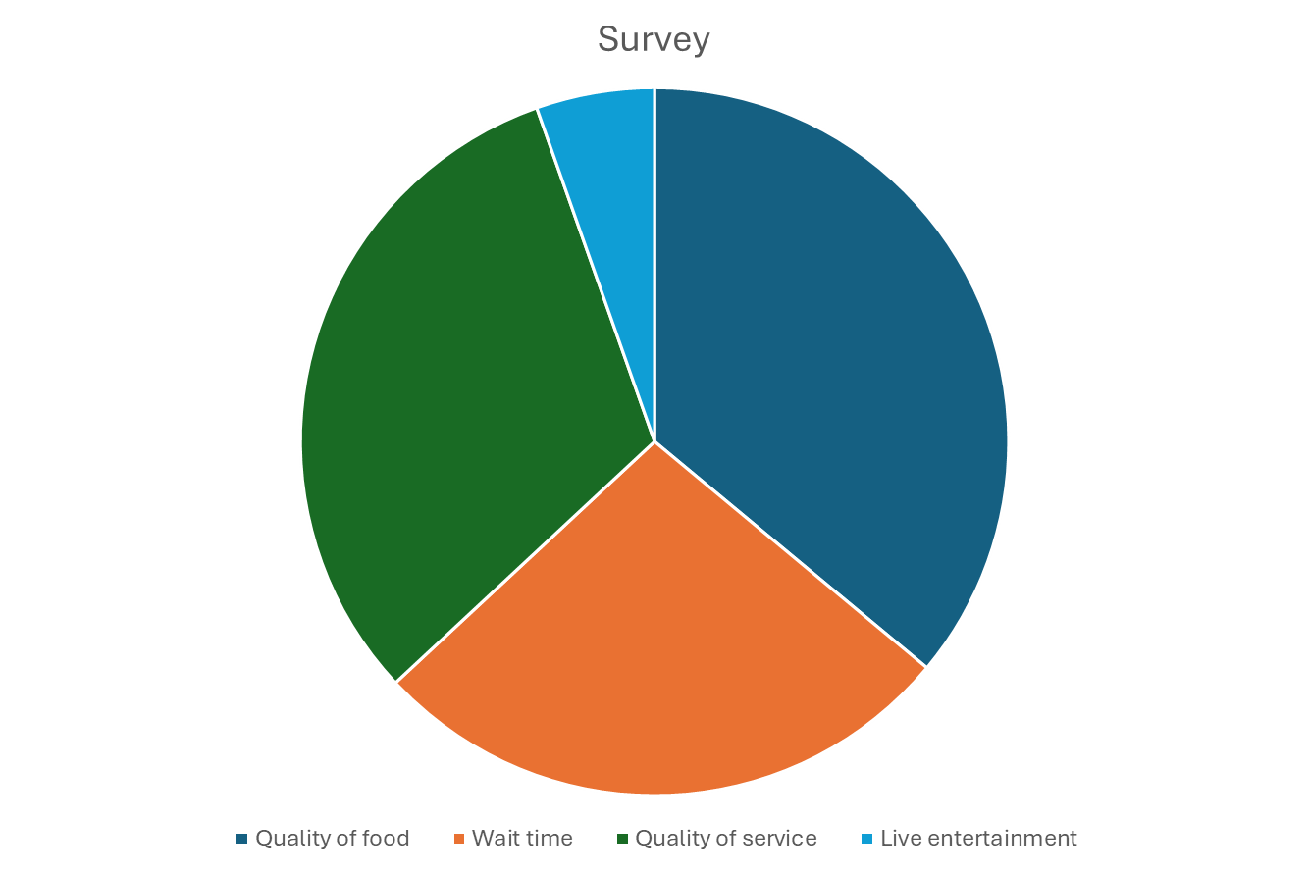

After analyzing the survey i can gain valuable insights on customers satisfaction and how to improve product and service and focus on ways to decrease wait time on orders.
From the pie chart above, most participants enjoyed the quality of the food they ordered. A third of participants did not enjoy the live music as much. 30% of participants enjoyed the quality of service provided and 20% were ok with the wait time for their orders.

In the survey graph conclusions, the food quality is the most favored along with service quality. Many participants enjoyed the overall quality and service provided and did not really enjoy the live music as much. In the future we can expect to reduce the live music as to the customers' preferred choice as our main goal is to provide an environment where customers can feel at home and enjoy the feel of being in the Caribbean without being in the Caribbean.

As the graph shows customers' preferences, with food quality being at its best, we can bring different quality food with wide ranges of assorted flavors that are homemade.

In conclusion to my findings and understanding of starting my own business. I now understand and know the different steps and strategies I would have to focus on in order for my business to grow. My target audience are important as focusing on their needs and wants as customers can influence the decisions of other prospective customers by using word of mouth and internet reviews. Customers can once again provide valuable feedback to other business and this can help improve product and services by telling us what they like and dislike and what they need and don’t want. With my findings I know understand how to generate cash flow and different ways to keep up with trend and bring in new customers through advertising and using website that way I can manage reviews and focus on ways to improve the quality of service.

Website Task 4
Home - Editor - Webador

In addition to the website, it is created to make it easy for customers to view, navigate, look at the different options available and make bookings online. The website is filled with lots of information about the food, the service, the quality and the attention to detail to attract customers.
The waterlily Caribbean bar and grill website is easy to navigate. It gives you options to book online, browse the menu in the meantime, book for special occasions/parties, you also have the option to leave request and comments as you like. The main purpose of our website is awareness as well as sales and conversions. For my business to grow its customer base and generate traffic as mentioned before easy navigation and it is the best way for customer to locate waterlily Caribbean bar and Grill and for us to understand our target audience.

- Our Menu

Tasks 3
Tasks 4

