
[Date]

(ACCA4023_LON)
Module name: Introduction to Web and Database

CertHE Computing Skills for Workplace

Student Name : Biniam Aregawi Abraha
Student Number : 2532266
Group : 01
Date : 20 July 2026
Lecturer : Suresh Shanmugasundaram

Contents
Introduction 2
Task 1: Implementation Guide: 3
Entity-Relationship Diagram (ERD) Create a well-labelled ERD showing entities, primary and foreign keys, and the relationships (with appropriate cardinality) between them. 5
Normalization Compliance The data model should be normalized to Third Normal Form (3NF) to minimize redundancy and dependency issues. 8
Sample Data Population Populate the system with atleast 5 rows of sample data that reflects realistic use cases (e.g., a list of riders, bike records, rentals, maintenance logs). 10
Query Development Design and run a series of practical queries to demonstrate how the system can be used. Example queries might include bikes currently out on rental, bikes due for service, most frequently used bikes or rentals by a particular rider The choice of relevant queries is left to your discretion, but some examples could be like reviewing bike availability, service needs, and user activity patterns 12
. Validation and Testing Evaluate your system against the functional requirements to confirm that it meets user needs. Document your testing process and outcomes. 18
Scenario Description 19
Validation and Testing 20
Reflection 21
Conclusion 21

3. Introduction

AutoPark Management System is a city-based company with parking sites across the area. It is the intention of this proposal to set up an Access database at the head office of AutoPark Management System to manage information on customers, vehicles, parking locations, parking spaces, bookings and payments made by customers for use by staff of AutoPark Management System. Manual record keeping currently used by AutoPark Management System for customers details, vehicle details, parking sites, parking spaces, bookings and payments made by customers for use by staff at the head office of AutoPark Management System suffers from errors and loss of data. In addition, management of parking spaces are currently ineffectual[1]. An Access database will hold up-to-date and accurate information of customers, vehicles, parking locations, parking spaces, bookings and payments made by customers for use by staff at the head office of AutoPark Management System. It will eliminate duplication of information and provide rapid information by use of queries, forms and reports. It will enable management of all parking sites on a day to day basis. It will enable monitoring of parking spaces for occupancy and revenue generated. It will aid management of AutoPark Management System to make decisions for future of company. It will provide efficient management of all parking activities at all sites[2].

4- In this work a system for managing pharmacy has been developed. Entities for storing information about medicines, suppliers, customers, prescriptions and sales transactions have been implemented.

The Medicines entity contains data on all of the medicines that are for sale in the pharmacy. Each medicine is stored with details on the medi-id, med- name, medicine’s price and quantity of that medicin available in store.

Suppliers Entity - the Suppliers table stores information about the suppliers that provide medicines to the pharmacy. Each supplier is identified by a supplier ID, supplier name, and supplier address.
.

All individuals visiting pharmacy are stored in the Customers entity. For each customer-id, fullname, email and location are stored.

Medication Orders: This treatment Records contains all the information related to the prescriptions that have been obtained by the customers of the pharmacy. This entity has fields for the medication orders- id, customer- id, customers name or date of issue of the prescription.

Sales Transactions for Medicines
PK | Transa_id
 | Custo_id
 | Medi_id
 | Quan

Medicines
PK | Medi_ID
 | Medi_Name
 | pri
 | Quan

For this table columns will be the medi_id, the medi-name, the price for that medicines, and the amount of that medicine inside stores. The primary key for this table will the Medi_id.
Suppliers
PK | Supp_ID
 | Supp_Name
 | adres

will create a table for suppliers , the table will contain supplier id , name and address , the primary key for this table will be supplier id .
Customers

PK | Custo_ID
 | Custo_Name
 | email
 | Addres

And for the customer , the primary key will be customer id, and the rest of attributes for that table will be name, email, and address.

Prescriptions
PK | Prescri_ID
 | Custo_ID
 | Custo_Name
 | Date Issued

In this table first key field Prescription ID (primary key). It will also include Customer ID (foreign key linked to customer ID in the Customers table) and Date Issued.
Sales
PK Sale_ID - Primary key for sales table. - To relate customer table and sales table, customer id will be a foreign key. - To relate medicine table and sales table, medicine id will be a foreign key.
PK | Sale_ID
 | Custo_ID
 | Medi_ID
 | Quan

One Supplier can provide many different Medicines for the pharmacy, so the Supplier–Medicine relationship is one-to-many. Also, one Customer can create or receive many Prescriptions, making the Customer–Prescription relationship one-to-many.
A single Customer may have several sales transactions in the pharmacy system, but each transaction belongs to a specific Customer. Therefore, the Customer–Sales relationship is a one-to-many relationship.
One medicine supplied to many times by one Supplier. The relation between Supplier and pharmacy (or between pharmacy and Customer) will be many to many. The relationship can be defined in the database table as shown below

5_ Entity-Relationship Diagram (ERD) Create a well-labelled ERD showing entities, primary and foreign keys, and the relationships (with appropriate cardinality) between them.
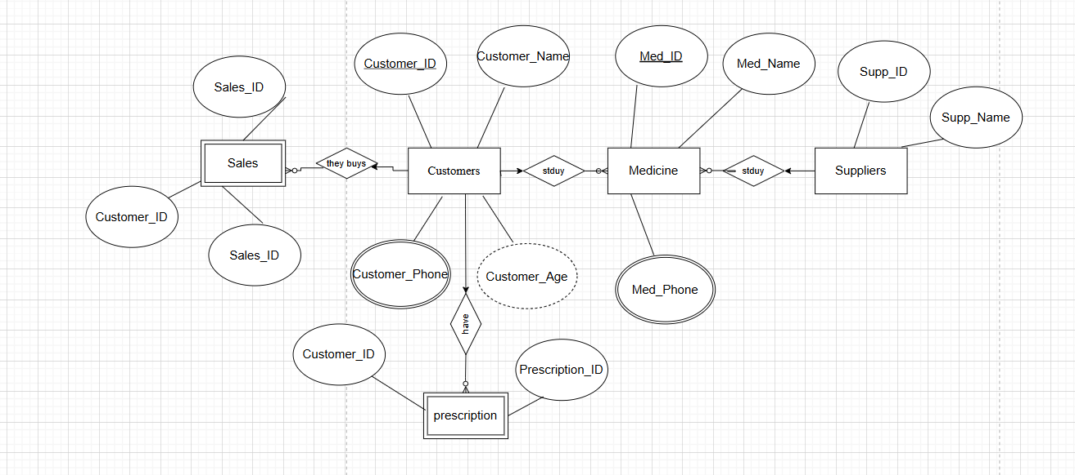
A single rectangle indicates independent entities and double rectangle indicates dependent entities. The diamonds in between entities indicate relation. The relation can be one-to-one, many-to-one or many-to-many[3].
Next, each attribute is represented as an oval, where the primary key of each entity is written underlined and separated by commas (e.g. custo- id, medi-id, Supp- id ,sale- id,). Derived attributes drawn as dashed oval shapes (e.g. custo_age) and multi-valued attributes drawn as double oval shapes (e.g. custo- phone, medi- phone, Email address).

6 - Data structure Development Using your ER model, construct the design by defining each entity and establishing relationships with appropriate constraints to ensure data integrity.
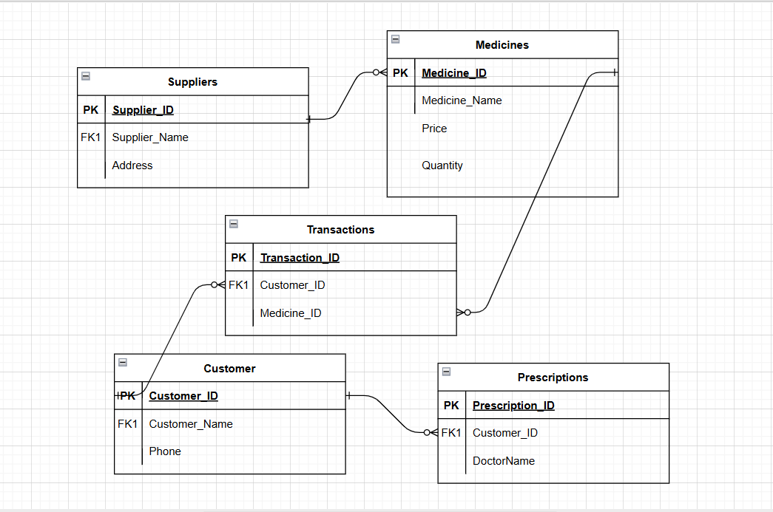

To aid reader in understanding the MediLink Pharmacy information entities and their inter-relationships, an Entity Relationship Diagram (ERD) has been created and depicted in Figure 1 below. The five information entities considered are Supplier, Medicine, Customer , sales and Prescription with each information entity described by set of attributes, and the inter-relationships a mong the entitiy described with cardinality constraints to ensure the data integrity and confidentiality[4].

The customer
Attributes: Custo_ID , (Primary_Key), Custo_Name, Phone_Number, Address, Date_Of_Birth
Description: Stores and manages information about the pharmacy's customers.
Customer
Description: Represents the pharmacy’s customer database and stores information about customers.
Relationships: a customer has many prescriptions and many sales.

Medicine
Attributes:MedicineID (Primary Key), MedicineName, ExpiryDate, Price, SupplierID (Foreign Key).
Medicine: This table contains the pharmacy stock of medicines and their relations to other tables, such that each medicine can appear in many Prescriptions, in many Sales transactions and be from only one Supplier.

Supplier
Attributes: SupplierID (Primary Key), SupplierName, ContactNumber, Address.
Supplier: The Supplier entity holds the details of all suppliers who supply medicines to the pharmacy. A supplier can supply many medicines.

Prescription
Attributes: PrescriptionID (PK), CustomerID (FK), MedicineID (FK), PrescriptionDate, Dosage.
Description: A Prescription is an issued prescription for a customer that contains a list of medicines prescribed to the customer. Each customer can have many Prescriptions and each Prescription can have many Medicines (to represent the amount of each Medicine prescribed).
Relationships:A prescription is related to 1 customer (N:1) and 1 medication (N:1).

Sales Transaction

Description:Stores all pharmacy sales transactions.

Relationships:A Sales Transaction is for One Customer (N:1) and for One Medication (N:1).

General Notes on the Diagram

Primary keys are underlined.
Foreign keys establish relationships between entities.
Cardinality to indicate relationship type (one-to-many or many-to-one).
The database is designed to minimize data redundancy.
The database supports efficient reporting and query processing.

7_ Normalization Compliance The data model should be normalized to Third Normal Form (3NF) to minimize redundancy and dependency issues.

This lecture In Normalization a database goes through different steps such as 1NF, 2NF and 3NF. For demonstration lets assume we have a table as follows:

Sale_id | Custo_name | Medi_name | Suppl_name | quan | pri
S01 | Biniam | Amoxicillin | Maruf | 3 | 17
S02 | Biruk | Metformin | Jossy | 7 | 11

There are two values of the field Quantity for the Customer Biniam. As mentioned above for the other Customers there are also two values for the field Quantity for each record. Thus the field Quantity must be changed to a single value for each record and therefore the 1NF is to be implemented for this table. The table below shows the Normalized data for the table above.
Table
Custo_id | Custo_name
01 | Biniam
02 | Biruk

Sale_id | Custo_id | Medi_name | Suppl_name | quan | pri
S01 | 01 | Amoxicillin | Maruf | 3 | 17
S02 | 01 | Amoxicillin | Yared | 5 | 17
S03 | 02 | Metformin | Jossy | 7 | 11

Next step to remove the repeating field and to make 1NF[5].

4. 4. 5. Next we apply 2NF using removing Partial FD, so that non-key attributes are determined by the key attribute using creating 3 tables.
Customer_tables
Custo_Id | Custo_Name
Cu0 | Biniam
Cu1 | Biruk

Because Custo_name

Medicines table
Medi_id | Medi_Name | Suppl_Id | pri
Me0 | Amoxicillin | Su0 | 17
Me1 | Metformin | Su1 | 11

Sales table
Sale_Id | Custo_Id | Medi_Id | quan
Sal0 | Cu0 | Me0 | 7
Sal1 | Cu1 | Me1 | 5

Third Normal Form (3NF): After having eliminated all transitive dependencies in the previous step, Dependent attributes are moved to separate tables and corresponding Determinant attributes are assigned as Primary Keys for these new tables. The tables which have been created in this way are then Normalized to the Minimum possible extent, i.e. every non-Key attribute is dependent on the Primary Key of that table. The following Normalized tables are created from the start from the Customer Table.
Custo_id | Custo_name
C0 | Biniam
C1 | Biruk

For this resource the main entity is the drug and not the key.
Supplyer_table
Suppl_id | Suppl_name
Su0 | Maruf
Su1 | Jossy

Medicines table
Medi_Id | Medi_Name | Suppl_Id | pri
Me0 | Amoxicillin | Su0 | 17
Me1 | Metformin | Su1 | 11

Sales Table
Sale_Id | Custo_Id | Medi_Id | quan
Sal0 | Cu0 | Me0 | 7
Sal1 | Cu1 | Me1 | 5

All determinant has been used as a primary key for these tables.

8- Sample Data Population Populate the system with atleast 5 rows of sample data that reflects realistic use cases (e.g., a list of riders, bike records, rentals, maintenance logs).

Riders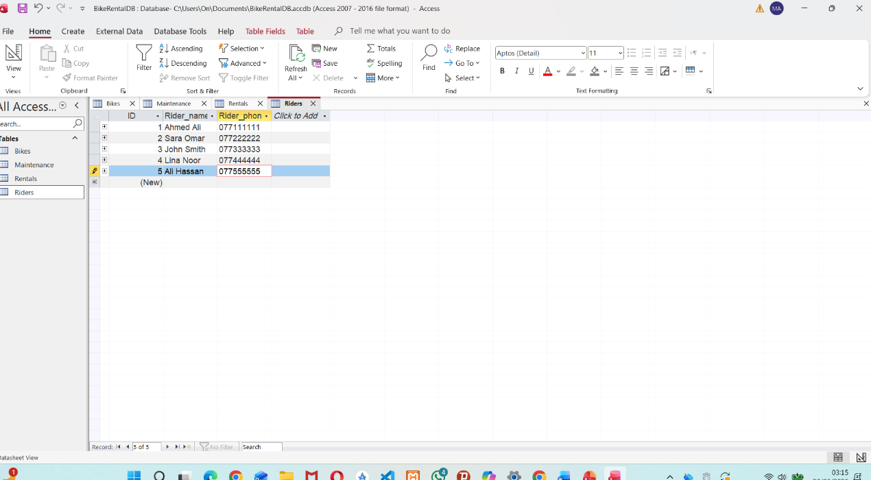
Riders Table
The attributes of this table consist of Rider_ID, Rider_Name, and Rider_Phone, as above
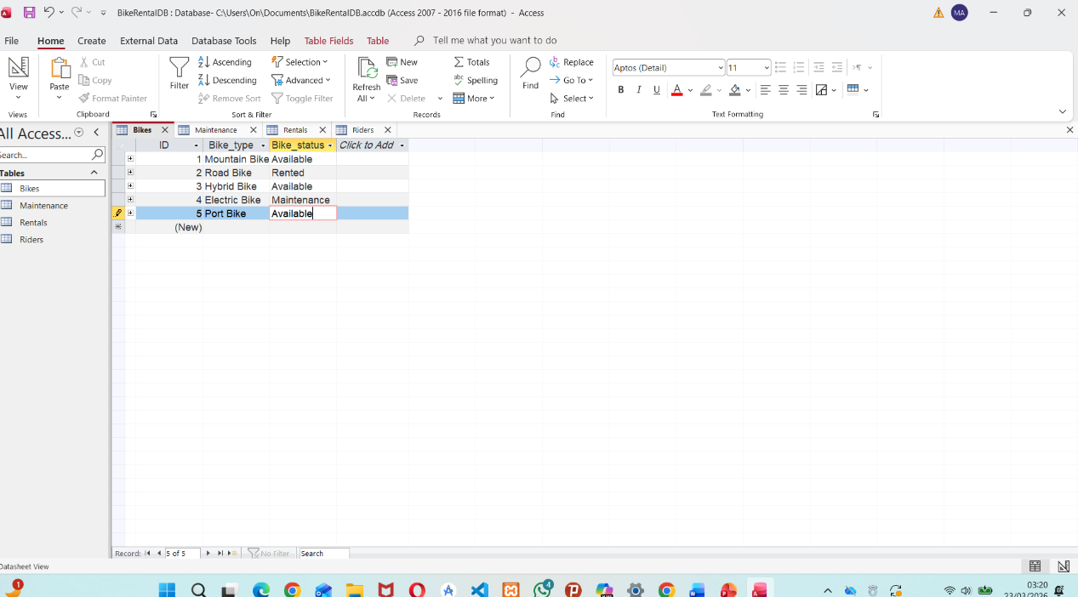
Bikes Table
This table contains Bike_ID, Bike_Type, and Bike_Status. It includes 5 types of the bikes, with status recorded as rented, available, or under maintenance.

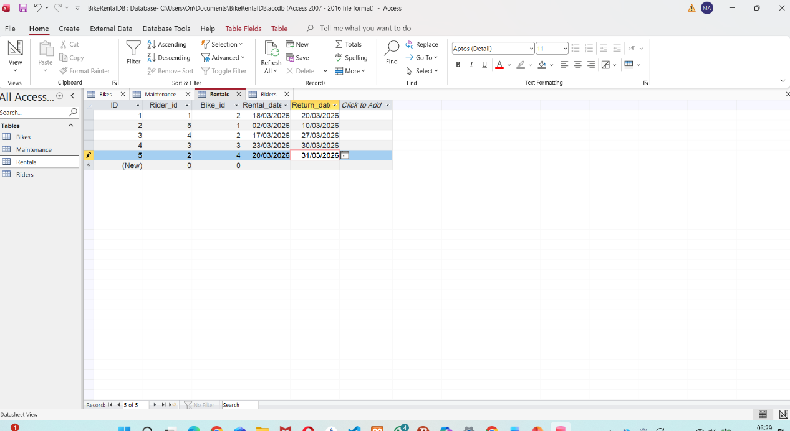
Rentals Table
This table contains Rental_ID, Rental_Date, and Return_Date. It is connect to the Riders Table and Bikes Table using their Primary Key as foreign Keys, as shown.
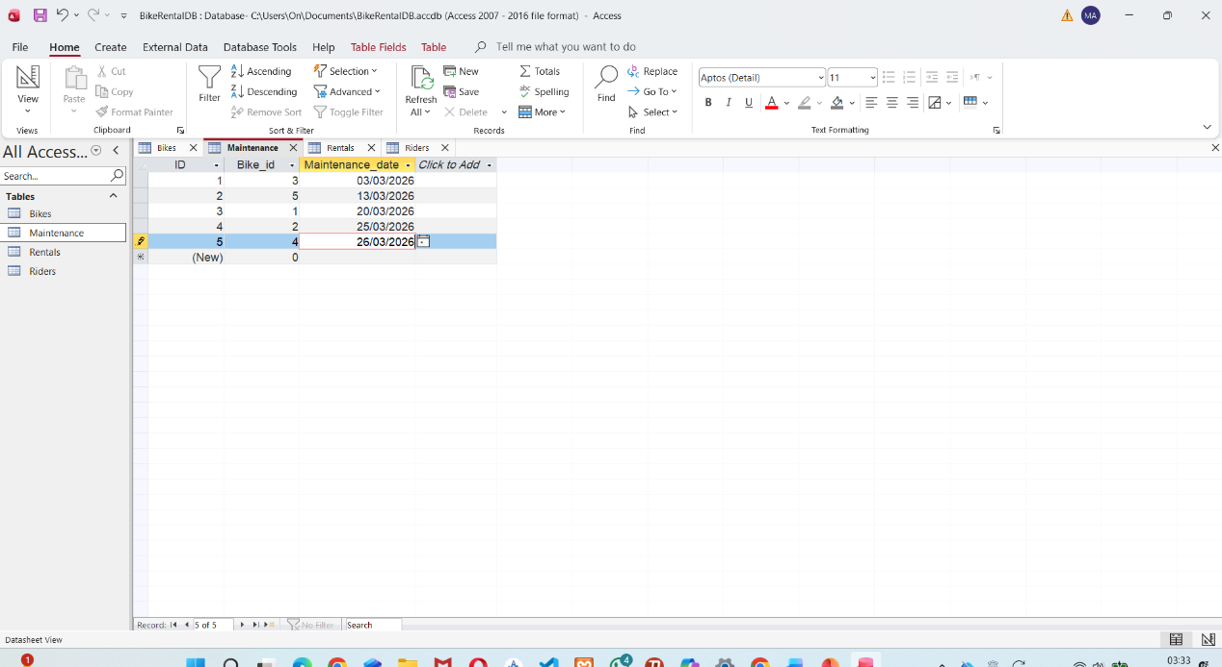
Maintenance Table
This table contains Maintenance_ID and Maintenance_Date. It is linked to the Bike Table using Bike_ID a foreign Key.

9_ Query Development Design and run a series of practical queries to demonstrate how the system can be used. Example queries might include bikes currently out on rental, bikes due for service, most frequently used bikes or rentals by a particular rider The choice of relevant queries is left to your discretion, but some examples could be like reviewing bike availability, service needs, and user activity patterns

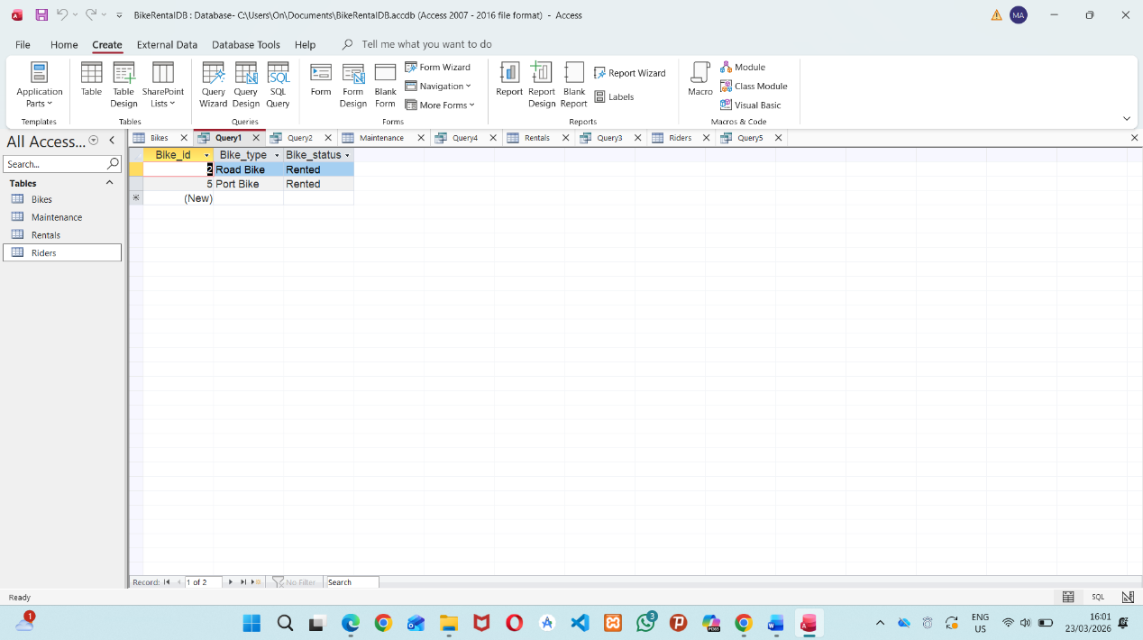

As shown here, only the rental bikes are displayed.
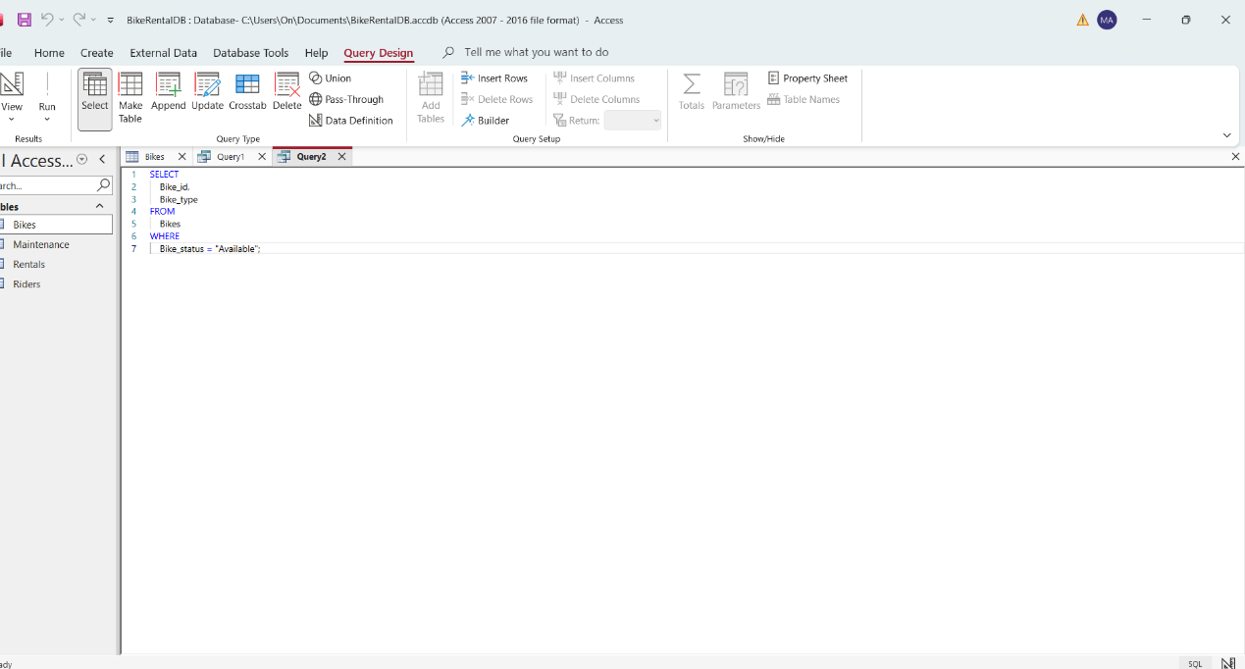

Return all the rented bikes to monitor for the new rentals. The query will return all records for all bikes with a Bike Status of ‘Rented’. The following fields will be returned.Bike_ID, Bike_Type and Bike_Status.

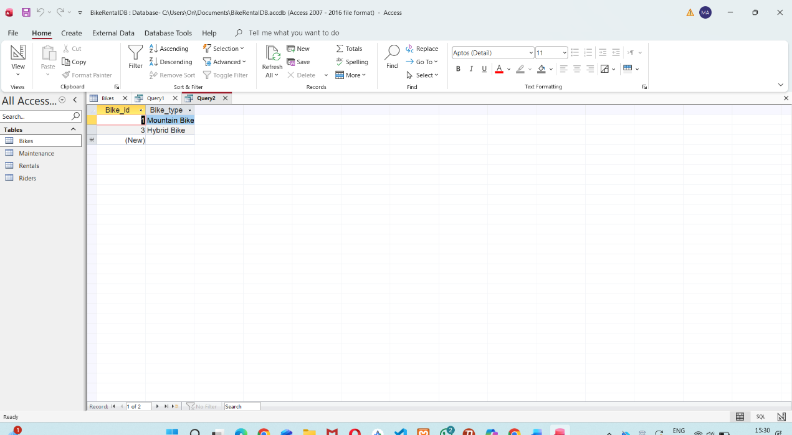

As shown above, two bikes are currently available for customers to rent, as their status is marked as "Available".
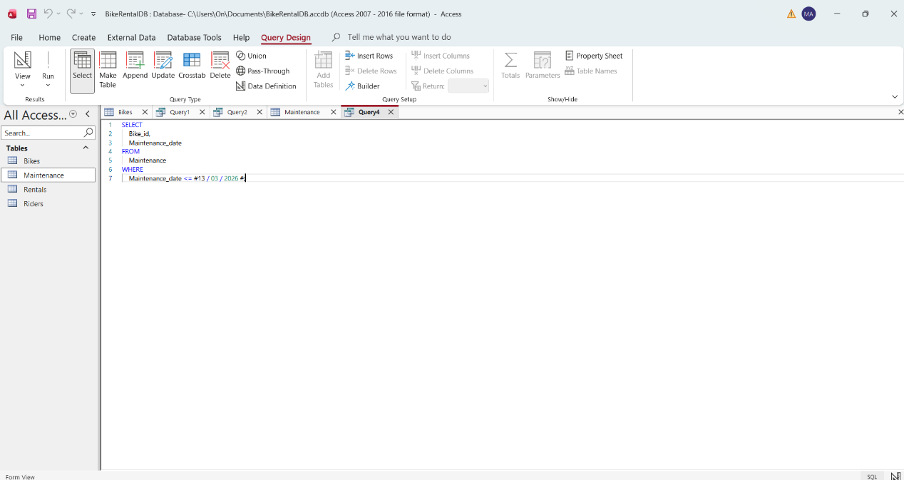
SELECT Bike_Id, Maintenance_Date
FROM Maintenance
WHERE Maintenance_Date = 03-03-2026
This Query shows All the bikes that it needs Maintenance today or have passed their scheduled maintenance date. It helps the maintenance team monitor service schedules and ensure that bikes receive the required maintenance on time.

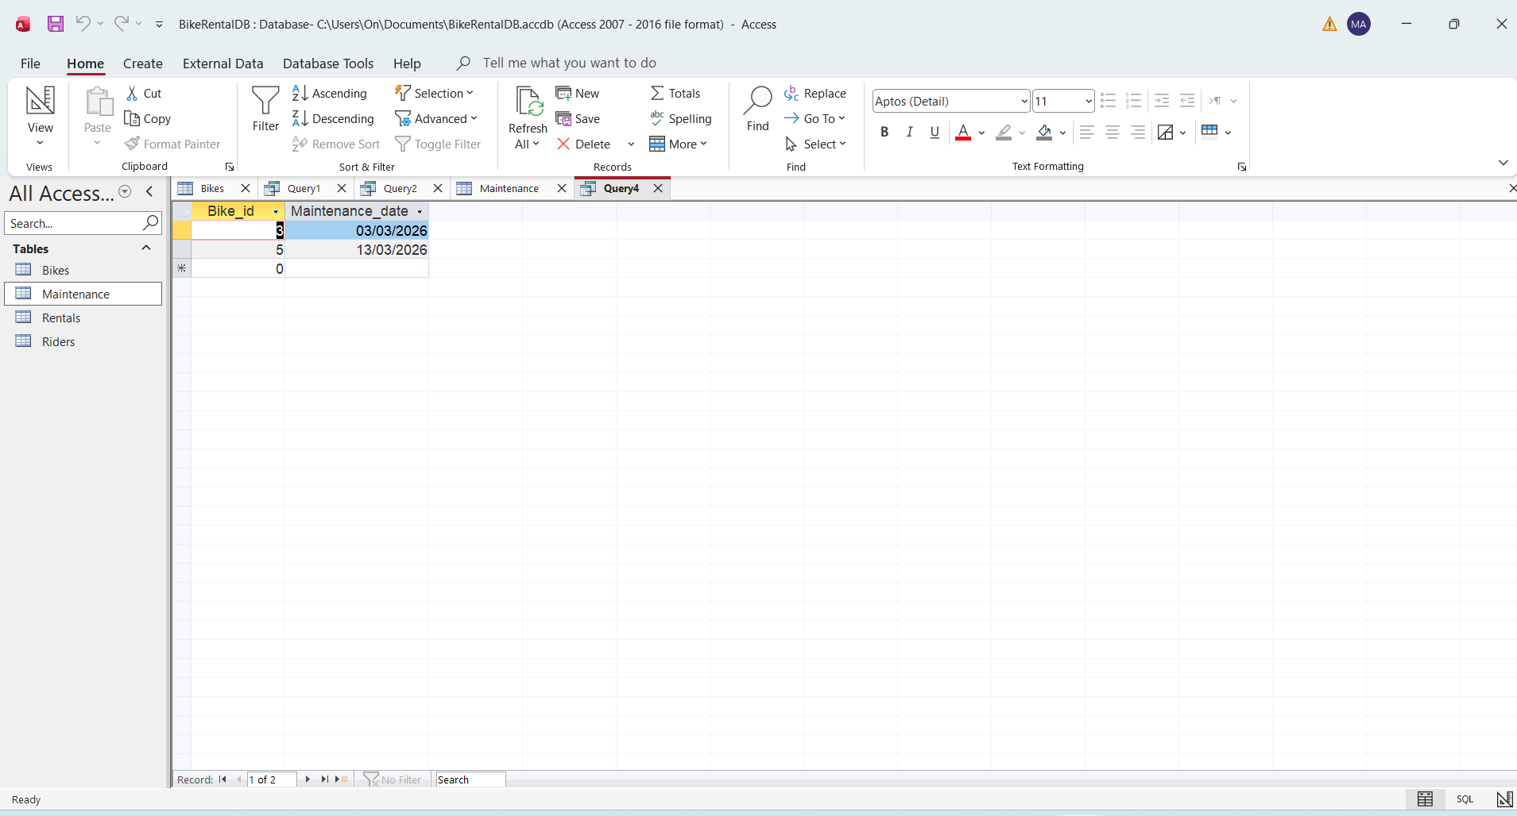

As shown above, we have two bikes that require maintenance today or have passed their scheduled maintenance date.
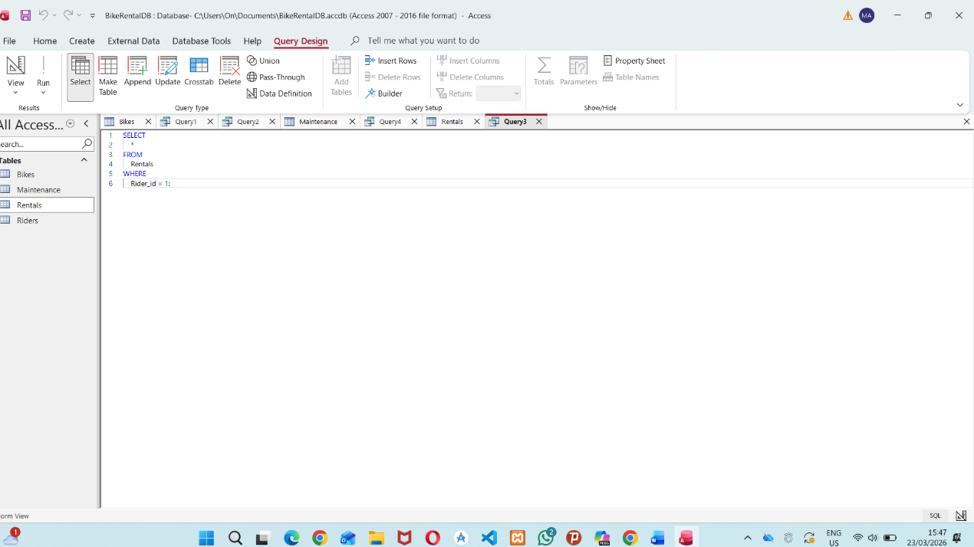

SELECT *
FROM
Rentals
WHERE
Rider_Id = 1;
This query displays all rental records for a specific rider by filtering the Rider_ID. It helps track the rider’s rental history and monitor their activity within the system.

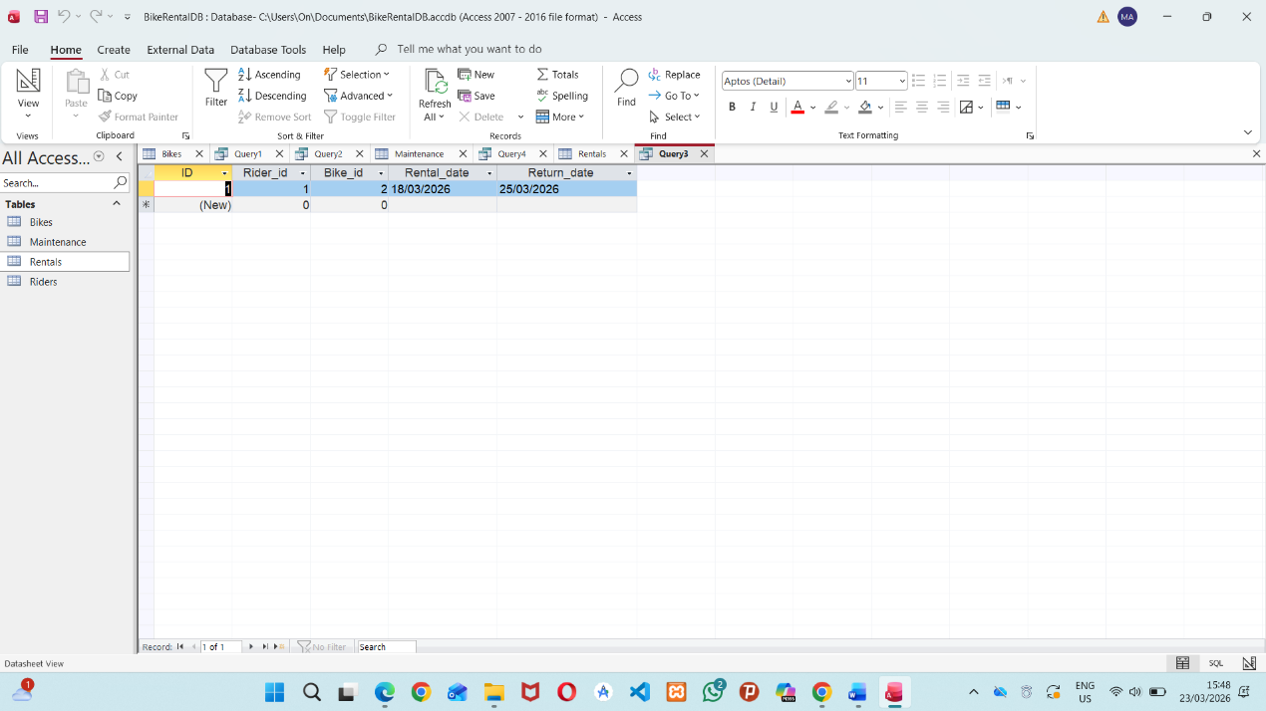

Shown above , the rider with Rider_ID = 1 has All their rental data displayed, including their rental records and activity details.

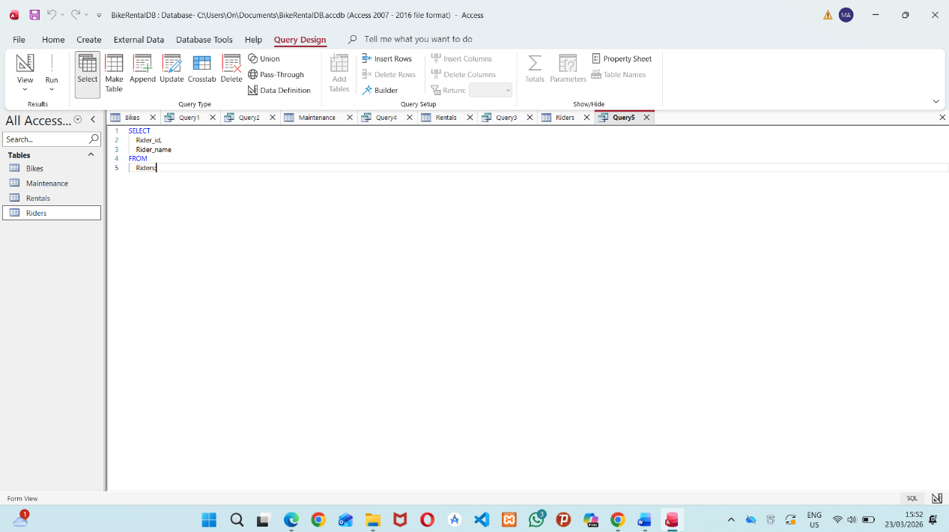
SELECT Rider_ID, Rider_Name
FROM
Riders;
This query retrieves all riders stored in the system along with their IDs. It helps display rider information and provides an overview of the registered users in the system.

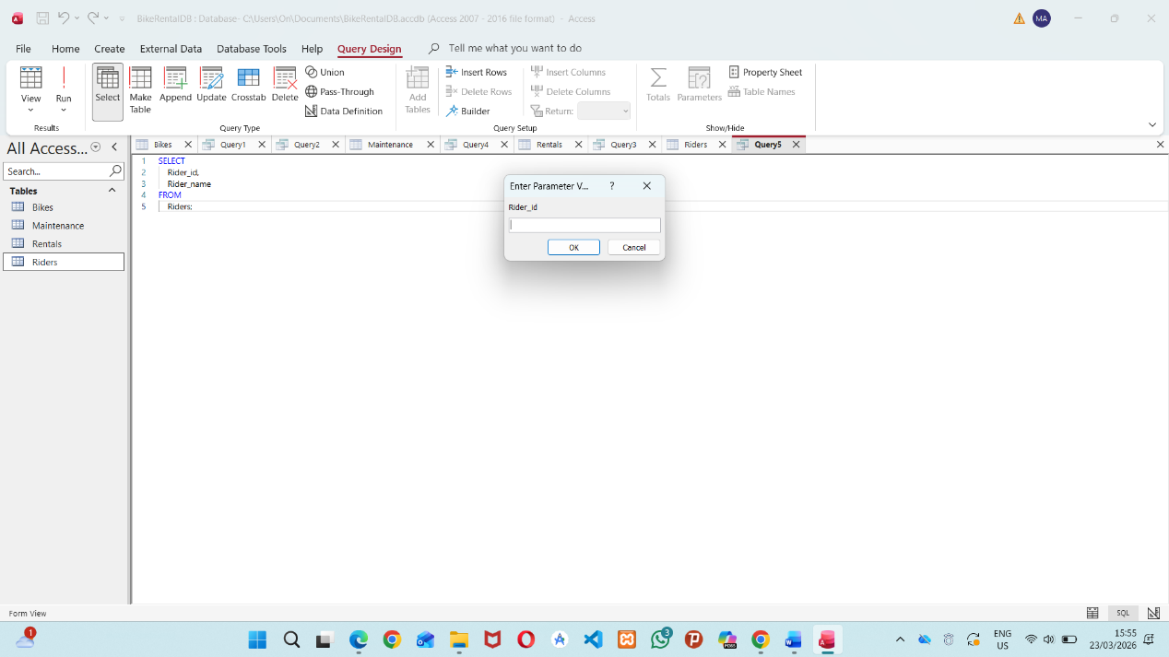
Here, we need to enter the Rider ID and press OK to display the related information.

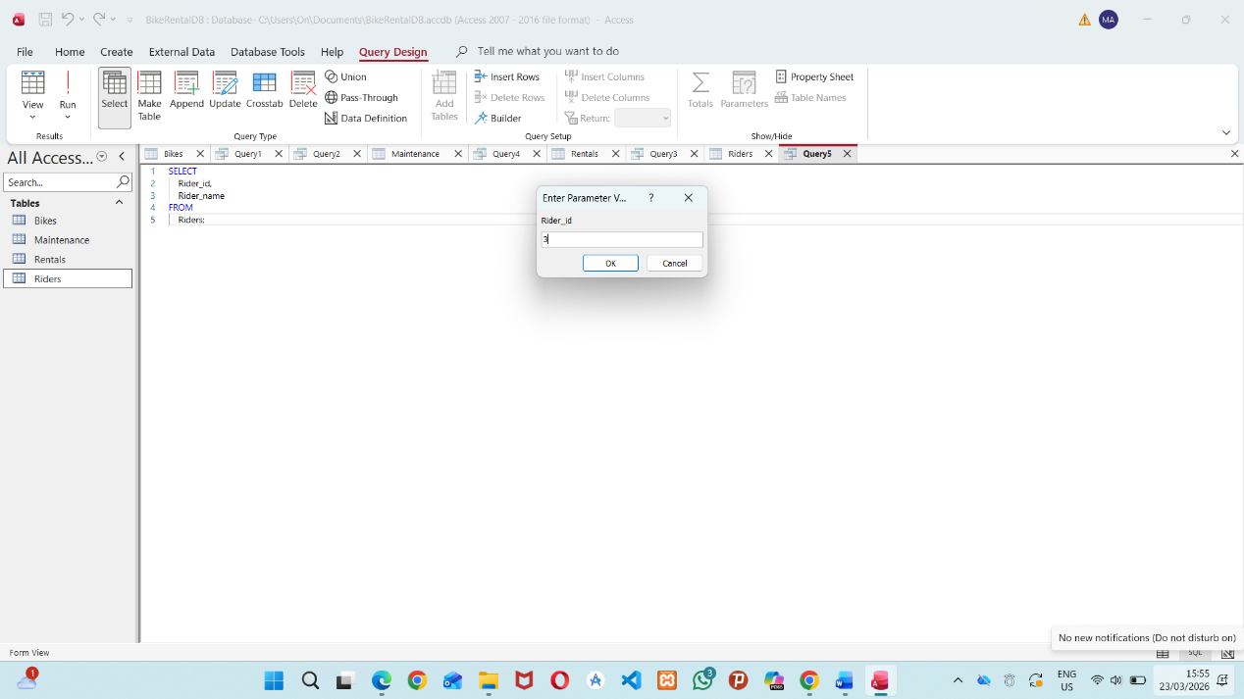
shown , we insert Rider_Id = 3

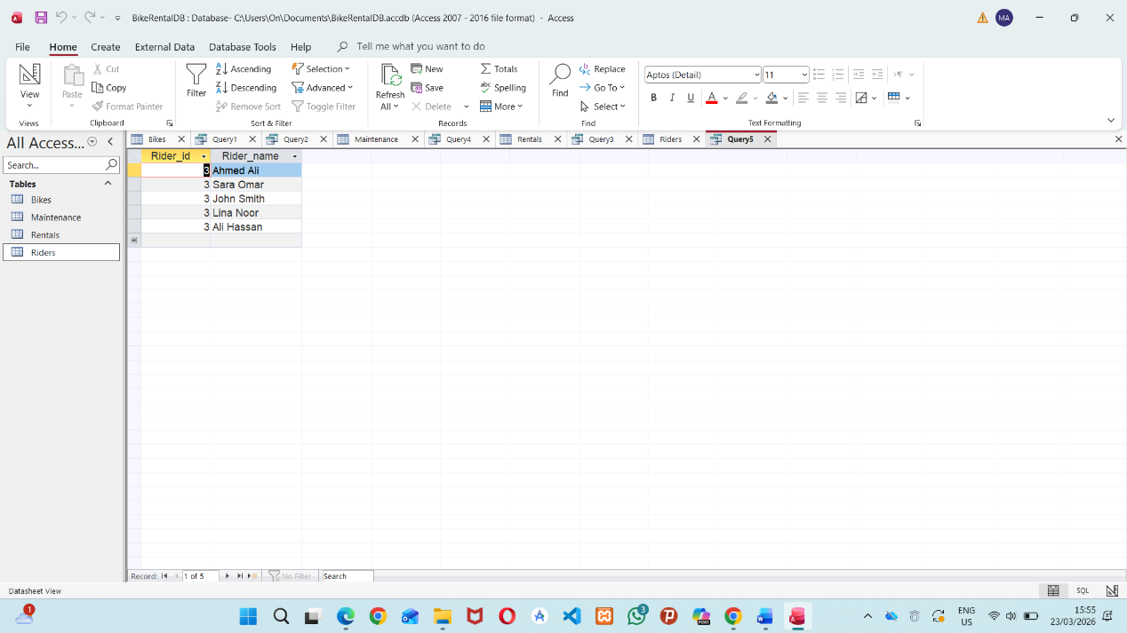
shown, riders saved in the system_IDs = 3

9- Validation and Testing Evaluate your system against the functional requirements to confirm that it meets user needs. Document your testing process and outcomes.

Scenario Description
MediLink PharmacyMediLink is managing stock of medicines, keeping track of given prescriptions for customers, suppliers and sales transactions. It stores data of medicines, suppliers and customers. It also generates reports about stock of medicines, sales and possibly other legal issues that are subject to legal requirements.

- Efficient management of medication records and inventory levels.
- Maintaining and monitoring customer prescription details.
- Tracking supplier information and recording sales transactions.
This will also provide a means of reporting stock levels, sales transactions and compliance with all relevant laws.
Bicycle Rental System
This system is designed to manage information related to:
- Bicycles.
- Riders
- Maintenance activities.
- Rental records.
It also tracks the status of each bicycle, whether it is available, currently rented, or under maintenance.
and also it will analyze the all activity done by all the riders and also it will show which bikes are used most.

Tables
MediLink Pharmacy Tables
Table Name | Fields | Description
Medicines | Medicine-ID (PK), Name , Supplier-ID, Quantity, Price | Medicine information
Suppliers | Supplier-ID (PK), Name, Phone, Address | Supplier information
Customers | Customer-ID (PK), Name, Phone, Address | Customer information
Prescriptions | Prescription-ID (PK), Customer-ID, Medicine-ID, Date, Dosage | Details of the prescription

,

given to the Sales
Table Name | Fields | Description
sales | Sale-ID (PK), Customer-ID, Medicine-ID, Date, Quantity, Total-Price | Sales transactions

Bike Rental Tables
Table Name | Fields | Description
Riders | Rider-ID (PK), Rider-Name, Phone | Rider information
Bikes | Bike-ID (PK), Bike-Model, Status | Bike information
Rentals | Rental-ID (PK), Rider-ID, Bike-ID, Rent-Date, Return-Date | Rental transactions
Maintenance | Maintenance-ID (PK), Bike-ID, Service-Date, Next-Service-Date | Maintenance records

Rental Tables Fields Description for fields above. All rental transactions are stored in this table.

10- Validation and Testing
For the verification of the functional requirements of the system in use it was checked if the system fulfills the needs of men and women in the concrete application accordingly. For the test runs some practical cases were realized. These cases for example are the registration of new data for the schedules of the riders, of the bikes, for the registrrations of rentals as well as for the registrrations of the maintenance. Furthermore the retrieval of data by means of queries for bikes which are available, which are rented as well as which are already serviced. Moreover the change as well as the deletion of the existing data were checked.

The system tests all worked well. This includes adding a new rider and a new bike to their respective lists. Saving a new rental as a new record worked well. The queries for available, for rented, for serviced bikes all worked well and retrieved the expected results.

System functions for storage of data as well as for data retrieval have been tested. The system handles user’s inquiries in an up-to-date and correct way. All test cases have been executed successfully. The system fulfills all specified functional requirements in a correct, safe and stable way to manage a bicycle rental service.

11- Reflection
A couple of things went wrong while building this system. For me the most important point was the design of the tables to keep redundancy as low as possible and to make access to information easy. The design of queries in a simple way so that it is possible to perform analysis with the least amount of tables for relations between them, was another thing. Sometimes it was also problematic to validate the queries with the given experimental data (which is limited).

There are some additional functionality that can be included to this system. A user friendly interface, data backup (it could be automatic) and automated reports for monitoring of rentals and of maintenance for the different facilities. In this way all the activities of the passengers could be logged and afterwards associated to the corresponding rental records. In this way, the people in charge of managing these facilities will have much more information in order to take the corresponding decisions.

12- Conclusion
Pharmacy and bicycle rental management systems are for managing data. Information is stored in an organized manner, and information is quickly retrieved and analyzed to help make a decision. The system can be made more efficient as the system is put into real life use, more productive, and it will prevent errors.

References
[1] C. Chullabodhi, S. Chalermpong and A. Ratanawaraha, "Examining the root causes of on-street parking mismanagement in Central Bangkok," vol. 21, no. 1, pp.207, 2022,
[2] T. Litman, Parking management, Victoria Transport Policy Institute Victoria, Canada, 2016.
[3] C. J. Date and H. Darwen, "All for One, One for All," 2006,
[4] D. B. A. De Vries, "No title," 2006,
[5] S. Patro and K. K. Sahu, "Normalization: A preprocessing stage," 2015,

