Connor Daniel (1909665)
1909665@student.uwtsd.ac.uk

Electronics two
ASSIGNMENT 1

Contents
Introduction 3
Background research 3
Multipliers 3
VHDL 3
FPGA 3
Methodologies 3
Braun’s multiplier 3
Wallace tree 4
Applications and Advantages of Multipliers 5
A flowchart/pseudocode showing the system operation. 6
Braun’s multiplier 6
Wallace tree 6
VHDL Codes 6
Braun’s multiplier 6
Wallace tree 20
Simulation Results 29
Braun’s multiplier 30
Wallace tree 30
Synthesis 31
Braun’s multiplier 31
Wallace tree 32
Schematic diagrams 33
Braun’s multiplier schematic 33
Wallace tree schematic 33
Implementation 33
Design timing summary 34
Braun’s multiplier 34
Wallace tree 34
Critical path delay 34
Braun’s multiplier 35
Wallace tree 36
Details of testing and results 36
Braun’s multiplier 37
Project summary 37
Power 37
RTL schematic 38
Wallace tree 38
Project summary 38
Power 39
RTL schematic 39
Critical path 39
Braun’s multiplier 39
Wallace tree 40
Conclusion 41
Bibliography 42

Introduction
This report will look into binary multipliers and their importance in various electronic applications, for this assignment mainly looking into Braun’s multiplier and Wallace tree. These two multipliers will be created using a VHDL software to compare, synthesize and evaluate both multipliers. The software will allow a look into the schematic and circuit design of both multipliers before testing the multipliers. After testing a comparison and evaluation on the performance of the two multipliers will be completed, outlining what steps were taken to overcome any problems. The evaluations will also include considerations and recommendations that could be implemented if the task were to be completed again in the future.

Background research

Multipliers
A binary multiplier is a logic circuit that performs the multiplication of binary numbers, these binary numbers are called multiplicand and multiplier. The aim of this multiplication is to reduce the time taken to make calculations and lower power usage in electronic systems. The first step of the binary multiplication process is to create the partial product terms via bit-by-bit multiplication. The next stage is the reduction of these partial product terms before the final addition step to produce a final binary output. [3]
Multipliers play an essential role in electronics as they are crucial as they are responsible for a large number of the calculations made in various computer and signal processing applications. The increase in demand for these multipliers has come from the expansion of the computer and signal processing industries. Therefore, increasing the need for a high speed and low power binary multipliers. [4]

VHDL
Very high-speed integrated circuit hardware description language (VHDL) serves as a description language for hardware. It is used in the design of electronics to explain mixed signal and digital systems. These systems include integrated circuits (ICs) and field programmable gate arrays (FPGA). VHDL is also used as a parallel programming language. The advantage of using VHDL when designing a system is that it allows us to verify and model the behaviour of the system before it is translated into hardware.[6]

FPGA
Field programmable gate arrays (FPGA) are a form of integrated circuit, that contain configurable logic blocks (CLB) connected by programmable interconnects. This means they allow the hardware to be re-configured how they are desired after manufacturing due to this they are extremely versatile allowing developers to complete simple and complex functions. [7]

Methodologies

Braun’s multiplier
A Braun’s multiplier is a parallel array multiplier due to its structure it is very commonly used. This structure allows the need for no special logic to shift partial product therefore making the layout of the multiplier very efficient. A Braun’s multiplier is a combination of AND gates, full adders, and half adders. The Braun’s multiplier is a form of ‘non-addictive’ multiplier due to this arrangement of the AND gates and adders. This means it can complete multiplication without relying heavily on repeated additions like traditional addictive methods. The first step of the Braun’s multiplier is to generate the partial products, this is done by multiplying a single bit with the multiplicand. These partial products are then shifted depending on their bit sequences before being added. The sum can then be calculated via the use of a carry propagation adder, at this stage N-1 adders are needed where N is the length of the multiplier. [1] [5]

Wallace tree
The Wallace tree is another form of parallel multiplier which consists of full and half adders to go through a reduction process. In the traditional Wallace tree, there is three steps to the multiplication process. The first step being to generate a partial products consisting of N squared bits, these bits then get separated in to three adjacent rows each. In the next stage full adders and half adders are then used to reduce these rows of three. Full adders are used where there are 3 bits and half adders are used where there are 2 bits. The outcome for each of these three rows is a set of two rows. The bits are passed down the columns of the Wallace tree without processing. This reduction process is repeated until the final two rows. At this stage the rows are added together via a carry propagating adder.[2]
There has however been research into methods on how to improve the Wallace tree. One of these methods is the reduced complexity Wallace reduction approach. It has a modification to the second phase reduction of the process that decreases the number of half adders compared to the traditional Wallace tree. When the partial products are formed, they are converted to an inverted pyramid array. An inverted pyramid array is created by shifting the bits in the left half of the partial product array are shifted in the upward direction. When the second phase begins the modified array gets split into groups of three rows each using full adders in each column. The use of half adders is only necessary when the number of reduction stages is greater than the traditional Wallace tree. When comparing the modified and traditional Wallace tree both perform equally in terms of delay and have the same amount of reduction stages however, the modified Wallace multiplier is an improvement as it has far fewer half adders therefore reducing the complexity of the design. [2]
Another design that was created that was an improvement on the traditional Wallace where multi bit compressor adders and Sklansky adders were implemented. In the novel low power high speed Wallace multiplier 4:2 and 5:2 compressors are in place for the partial product reduction in the second stage. In the final stage Sklansky adders are used in the second stage for addition. When you compare both multiplier the modified Wallace multiplier has reduced latency and reduced power.[2]
Below you can see the dot diagram for a Wallace tree. The red ovals show the half adders and the green ovals show the full adders.

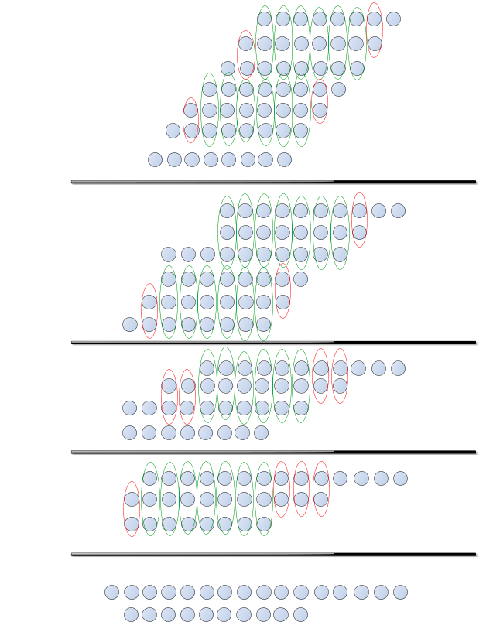

Applications and Advantages of Multipliers
The advantage of using these multipliers is down to how easy it can generate product terms or partial product terms. This reduces the time it takes to process signals therefore, increasing the speed and efficiency. The use of multipliers can also reduce the complexity of a circuit due to its design. The binary multiplier is simple when you compare it with circuits containing binary adders and subtractors, this also helps lower the cost. Another advantage of these multipliers is the fact that they are available in small IC’s meaning they can be used for a variety of different electronic applications. The binary multiplier also can help reduce the power consumption as its ability to perform multiplication at a fast rate therefore increases the efficiency of a system.[3]
There is a wide variety of uses for the binary multiplier these include arithmetic logic units in processors, digital signal processing applications, graphics processing units, communication systems, error correcting codes, and cryptographic algorithms. The multipliers would be used in digital processing for tasks such as audio processing, image processing, and telecommunication as the high-speed calculations are essential for processing various signals. The binary multipliers would be used in GPUs as they can complete complex calculations at high speeds which improves rendering, shading and image processing. Binary multipliers are also used in microprocessors and microcontrollers through arithmetic logic units (ALU’s). The binary multiplier is used to carry out multiplication instructions and to increase the processing capabilities of the CPU. Another use for the binary multiplier is for communication and cryptographic algorithms. They provide a safe method of communication and encryption. [3]

A flowchart/pseudocode showing the system operation.

Braun’s multiplier
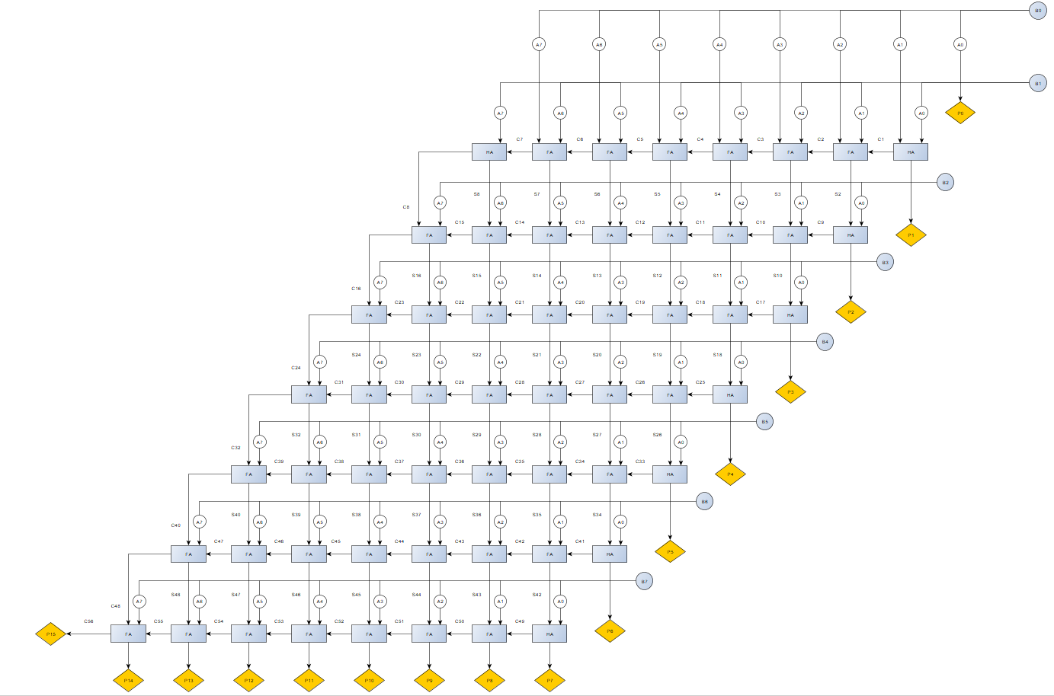

Wallace tree
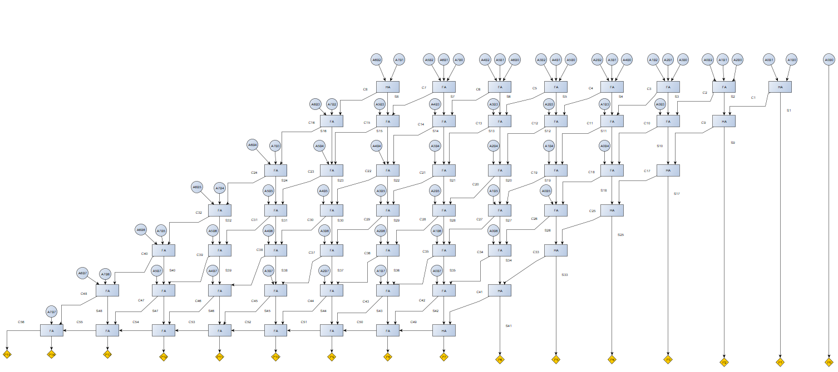

VHDL Codes

Braun’s multiplier
----------------------------------------------------------------------------------
-- Company:
-- Engineer:
--
-- Create Date: 30.11.2023 12:54:04
-- Design Name:
-- Module Name: BraunsMultiplier - Behavioral
-- Project Name:
-- Target Devices:
-- Tool Versions:
-- Description:
--
-- Dependencies:
--
-- Revision:
-- Revision 0.01 - File Created
-- Additional Comments:
--
----------------------------------------------------------------------------------

library IEEE;
use IEEE.STD_LOGIC_1164.ALL;

-- Uncomment the following library declaration if using
-- arithmetic functions with Signed or Unsigned values
--use IEEE.NUMERIC_STD.ALL;

-- Uncomment the following library declaration if instantiating
-- any Xilinx leaf cells in this code.
--library UNISIM;
--use UNISIM.VComponents.all;

entity BraunsMultiplier is
Port ( A : in std_logic_vector (7 downto 0);
B : in std_logic_vector (7 downto 0);
P : out std_logic_vector (15 downto 0));

end BraunsMultiplier;

architecture Behavioral of BraunsMultiplier is
signal A1B0 : std_logic;
signal A0B1 : std_logic;
signal A2B0 : std_logic;
signal A1B1 : std_logic;
signal A0B2 : std_logic;
signal A3B0 : std_logic;
signal A2B1 : std_logic;
signal A1B2 : std_logic;
signal A0B3 : std_logic;
signal A4B0 : std_logic;
signal A3B1 : std_logic;
signal A2B2 : std_logic;
signal A1B3 : std_logic;
signal A0B4 : std_logic;
signal A5B0 : std_logic;
signal A4B1 : std_logic;
signal A3B2 : std_logic;
signal A2B3 : std_logic;
signal A1B4 : std_logic;
signal A0B5 : std_logic;
signal A6B0 : std_logic;
signal A5B1 : std_logic;
signal A4B2 : std_logic;
signal A3B3 : std_logic;
signal A2B4 : std_logic;
signal A1B5 : std_logic;
signal A0B6 : std_logic;
signal A7B0 : std_logic;
signal A6B1 : std_logic;
signal A5B2 : std_logic;
signal A4B3 : std_logic;
signal A3B4 : std_logic;
signal A2B5 : std_logic;
signal A1B6 : std_logic;
signal A0B7 : std_logic;
signal A7B1 : std_logic;
signal A6B2 : std_logic;
signal A5B3 : std_logic;
signal A4B4 : std_logic;
signal A3B5 : std_logic;
signal A2B6 : std_logic;
signal A1B7 : std_logic;
signal A7B2 : std_logic;
signal A6B3 : std_logic;
signal A5B4 : std_logic;
signal A4B5 : std_logic;
signal A3B6 : std_logic;
signal A2B7 : std_logic;
signal A7B3 : std_logic;
signal A6B4 : std_logic;
signal A5B5 : std_logic;
signal A4B6 : std_logic;
signal A3B7 : std_logic;
signal A7B4 : std_logic;
signal A6B5 : std_logic;
signal A5B6 : std_logic;
signal A4B7 : std_logic;
signal A7B5 : std_logic;
signal A6B6 : std_logic;
signal A5B7 : std_logic;
signal A7B6 : std_logic;
signal A6B7 : std_logic;
signal A7B7 : std_logic;

--P2
signal C1 : std_logic;
signal S2 : std_logic;

--P3
signal C2 : std_logic;
signal S3 : std_logic;
signal C9 : std_logic;
signal S10 : std_logic;

--P4
signal C3 : std_logic;
signal S4 : std_logic;
signal C10 : std_logic;
signal S11 : std_logic;
signal C17 : std_logic;
signal S18 : std_logic;

--P5
signal C4 : std_logic;
signal S5 : std_logic;
signal C11 : std_logic;
signal S12 : std_logic;
signal C18 : std_logic;
signal S19 : std_logic;
signal C25 : std_logic;
signal S26 : std_logic;

--P6
signal C5 : std_logic;
signal S6 : std_logic;
signal C12 : std_logic;
signal S13 : std_logic;
signal C19 : std_logic;
signal S20 : std_logic;
signal C26 : std_logic;
signal S27 : std_logic;
signal C33 : std_logic;
signal S34 : std_logic;

--P7
signal C6 : std_logic;
signal S7 : std_logic;
signal C13 : std_logic;
signal S14 : std_logic;
signal C20 : std_logic;
signal S21 : std_logic;
signal C27 : std_logic;
signal S28 : std_logic;
signal C34 : std_logic;
signal S35 : std_logic;
signal C41 : std_logic;
signal S42 : std_logic;

--P8
signal C7 : std_logic;
signal S8 : std_logic;
signal C14 : std_logic;
signal S15 : std_logic;
signal C21 : std_logic;
signal S22 : std_logic;
signal C28 : std_logic;
signal S29 : std_logic;
signal C35 : std_logic;
signal S36 : std_logic;
signal C42 : std_logic;
signal S43 : std_logic;
signal C49 : std_logic;

--P9
signal C8 : std_logic;
signal C15 : std_logic;
signal S16 : std_logic;
signal C22 : std_logic;
signal S23 : std_logic;
signal C29 : std_logic;
signal S30 : std_logic;
signal C36 : std_logic;
signal S37 : std_logic;
signal C43 : std_logic;
signal S44 : std_logic;
signal C50 : std_logic;

--P10
signal C16 : std_logic;
signal C23 : std_logic;
signal S24 : std_logic;
signal C30 : std_logic;
signal S31 : std_logic;
signal C37 : std_logic;
signal S38 : std_logic;
signal C44 : std_logic;
signal S45 : std_logic;
signal C51 : std_logic;

--P11
signal C24 : std_logic;
signal C31 : std_logic;
signal S32 : std_logic;
signal C38 : std_logic;
signal S39 : std_logic;
signal C45 : std_logic;
signal S46 : std_logic;
signal C52 : std_logic;

--P12
signal C32 : std_logic;
signal C39 : std_logic;
signal S40 : std_logic;
signal C46 : std_logic;
signal S47 : std_logic;
signal C53 : std_logic;

--P13
signal C40 : std_logic;
signal C47 : std_logic;
signal S48 : std_logic;
signal C54 : std_logic;

--P14
signal C48 : std_logic;
signal C55 : std_logic;

--p15
signal C56 : std_logic;

component fulladder
Port ( A : in STD_LOGIC;
B : in STD_LOGIC;
Cin : in STD_LOGIC;
Sum : out STD_LOGIC;
COut : out STD_LOGIC);
end component;

component Halfadder
Port ( A : in STD_LOGIC;
B : in STD_LOGIC;
Sum : out STD_LOGIC;
COut : out STD_LOGIC);
end component;

begin
A1B0 <= A(1) and B(0);
A0B1 <= A(0) and B(1);

A2B0 <= A(2) and B(0);
A1B1 <= A(1) and B(1);
A0B2 <= A(0) and B(2);

A3B0 <= A(3) and B(0);
A2B1 <= A(2) and B(1);
A1B2 <= A(1) and B(2);
A0B3 <= A(0) and B(3);

A4B0 <= A(4) and B(0);
A3B1 <= A(3) and B(1);
A2B2 <= A(2) and B(2);
A1B3 <= A(1) and B(3);
A0B4 <= A(0) and B(4);

A5B0 <= A(5) and B(0);
A4B1 <= A(4) and B(1);
A3B2 <= A(3) and B(2);
A2B3 <= A(2) and B(3);
A2B1 <= A(2) and B(1);
A1B4 <= A(1) and B(4);
A0B5 <= A(0) and B(5);

A6B0 <= A(6) and B(0);
A5B1 <= A(5) and B(1);
A4B2 <= A(4) and B(2);
A3B3 <= A(3) and B(3);
A2B4 <= A(2) and B(4);
A1B5 <= A(1) and B(5);
A0B6 <= A(0) and B(6);

A7B0 <= A(7) and B(0);
A6B1 <= A(6) and B(1);
A5B2 <= A(5) and B(2);
A4B3 <= A(4) and B(3);
A3B4 <= A(3) and B(4);
A2B5 <= A(2) and B(5);
A1B6 <= A(1) and B(6);
A0B7 <= A(0) and B(7);

A7B1 <= A(7) and B(1);
A6B2 <= A(6) and B(2);
A5B3 <= A(5) and B(3);
A4B4 <= A(4) and B(4);
A3B5 <= A(3) and B(5);
A2B6 <= A(2) and B(6);
A1B7 <= A(1) and B(7);

A7B2 <= A(7) and B(2);
A6B3 <= A(6) and B(3);
A5B4 <= A(5) and B(4);
A4B5 <= A(4) and B(5);
A3B6 <= A(3) and B(6);
A2B7 <= A(2) and B(7);

A7B3 <= A(7) and B(3);
A6B4 <= A(6) and B(4);
A5B5 <= A(5) and B(5);
A4B6 <= A(4) and B(6);
A3B7 <= A(3) and B(7);

A7B4 <= A(7) and B(4);
A6B5 <= A(6) and B(5);
A5B6 <= A(5) and B(6);
A4B7 <= A(4) and B(7);

A7B5 <= A(7) and B(5);
A6B6 <= A(6) and B(6);
A5B7 <= A(5) and B(7);

A7B6 <= A(7) and B(6);
A6B7 <= A(6) and B(7);

A7B7 <= A(7) and B(7);

--P0
P0 : P(0) <= A(0) and B(0);

--P1
P1 : Halfadder port map (A1B0 , A0B1 , P(1) , C1);

--P2
S2_1 : fulladder port map (A2B0 , A1B1 , C1, S2 , C2);
P2: Halfadder port map (A0B2 , S2 , P(2) , C9);

--P3
S3_1 : fulladder port map (A3B0 , A2B1 , C2 , S3 , C3);
S10_1 : fulladder port map (A1B2 , S3 , C9 , S10 , C10);
P3 : Halfadder port map (A0B3 , S10 , P(3) , C17);

--P4
S4_1 : fulladder port map (A4B0 , A3B1 , C3 , S4 , C4);
S11_1 : fulladder port map (A2B2 , S4 , C10 , S11 , C11);
S18_1 : fulladder port map (A1B3 , S11 , C17 , S18 , C18);
P4 : Halfadder port map (A0B4 , S18 , P(4) , C25);

--P5
S5_1 : fulladder port map (A5B0 , A4B1 , C4 , S5 , C5);
S12_1 : fulladder port map (A3B2 , S5 , C11 , S12 , C12);
S19_1 : fulladder port map (A2B3 , S12 , C18 , S19 , C19);
S26_1 : fulladder port map (A1B4 , S19 , C25 , S26 , C26);
P5 : Halfadder port map (A0B5 , S26 , P(5) , C33);

--P6
S6_1 : fulladder port map (A6B0 , A5B1 , C5 , S6 , C6);
S13_1 : fulladder port map (A4B2 , S6 , C12 , S13 , C13);
S20_1 : fulladder port map (A3B3 , S13 , C19 , S20 , C20);
S27_1 : fulladder port map (A2B4 , S20 , C26 , S27 , C27);
S34_1 : fulladder port map (A1B5 , S27 , C33 , S34 , C34);
P6 : Halfadder port map (A0B6 , S34 , P(6) , C41);

--P7
S7_1 : fulladder port map (A7B0 , A6B1 , C6 , S7 , C7);
S14_1 : fulladder port map (A5B2, S7 , C13 , S14 , C14);
S21_1 : fulladder port map (A4B3 , S14 , C20 , S21 , C21);
S28_1 : fulladder port map (A3B4 , S21 , C27 , S28 , C28);
S35_1 : fulladder port map (A2B5 , S28 , C34 , S35 , C35);
S42_1 : fulladder port map (A1B6 , S35 , C41 , S42 , C42);
P7 : Halfadder port map (A0B7 , S42 , P(7) , C49);

--P8
S8_1 : Halfadder port map (A7B1 , C7 , S8 , C8);
S15_1 : fulladder port map (A6B2 , S8 , C14 , S15 , C15);
S22_1 : fulladder port map (A5B3 , S15 , C21 , S22 , C22);
S29_1 : fulladder port map (A4B4 , S22 , C28 , S29 , C29);
S36_1 : fulladder port map (A3B5 , S29 , C35 , S36 , C36);
S43_1 : fulladder port map (A2B6 , S36 , C42 , S43 , C43);
P8 : fulladder port map (A1B7 , S43 , C49 , P(8) , C50);

--P9
S16_1 : fulladder port map (A7B2 , C8 , C15 , S16 , C16);
S23_1 : fulladder port map (A6B3 , S16 , C22 , S23 , C23);
S30_1 : fulladder port map (A5B4 , S23 , C29 , S30 , C30);
S37_1 : fulladder port map (A4B5 , S30 , C36 , S37 , C37);
S44_1 : fulladder port map (A3B6 , S37 , C43 , S44 , C44);
P9 : fulladder port map (A2B7 , S44 , C50 , P(9) , C51);

--P10
S24_1 : fulladder port map (A7B3 , C16 , C23 , S24 , C24);
S31_1 : fulladder port map (A6B4 , S24 , C30 , S31 , C31);
S38_1 : fulladder port map (A5B5 , S31 , C37 , S38 , C38);
S45_1 : fulladder port map (A4B6 , S38 , C44 , S45 , C45);
P10 : fulladder port map (A3B7 , S45 , C51 , P(10) , C52);

--P11
S32_1 : fulladder port map (A7B4 , C24 , C31 , S32 , C32);
S39_1 : fulladder port map (A6B5 , S32 , C38 , S39 , C39);
S46_1 : fulladder port map (A5B6 , S39 , C45 , S46 , C46);
P11 : fulladder port map (A4B7 , S46 , C52 , P(11) , C53);

--P12
S40_1 : fulladder port map (A7B5 , C32 , C39 , S40 , C40);
S47_1 : fulladder port map (A6B6 , S40 , C46 , S47 , C47);
P12 : fulladder port map (A5B7 , S47 , C53 , P(12) , C54);

--P13
S48_1 : fulladder port map (A7B6 , C40 , C47 , S48 , C48);
P13 : fulladder port map (A6B7 , S48 , C54 , P(13) , C55);

--P14
P14 : fulladder port map (A7B7 , C48 , C55 , P(14) , C56);

--P15
P15 : P(15) <= C56;

end Behavioral;

Wallace tree
----------------------------------------------------------------------------------
-- Company:
-- Engineer:
--
-- Create Date: 07.12.2023 09:45:19
-- Design Name:
-- Module Name: Wallace - Behavioral
-- Project Name:
-- Target Devices:
-- Tool Versions:
-- Description:
--
-- Dependencies:
--
-- Revision:
-- Revision 0.01 - File Created
-- Additional Comments:
--
----------------------------------------------------------------------------------

library IEEE;
use IEEE.STD_LOGIC_1164.ALL;

-- Uncomment the following library declaration if using
-- arithmetic functions with Signed or Unsigned values
--use IEEE.NUMERIC_STD.ALL;

-- Uncomment the following library declaration if instantiating
-- any Xilinx leaf cells in this code.
--library UNISIM;
--use UNISIM.VComponents.all;

entity Wallace is
Port ( A : in std_logic_vector (7 downto 0);
B : in std_logic_vector (7 downto 0);
P : out std_logic_vector (15 downto 0));
end Wallace;

architecture Behavioral of Wallace is

component fulladder is
Port ( A : in std_logic;
B : in std_logic;
Cin : in std_logic;
Sum : out std_logic;
COut: out std_logic);
end component;

component Halfadder is
Port ( A : in std_logic;
B : in std_logic;
Sum : out std_logic;
COut : out std_logic);
end component;

signal S2,S3,S4,S5,S6,S7,S8,S10,S11,S12,S13,S14,S15,S16,S18,S19,S20,S21,S22,S23,S24,S26,S27,S28,S29,S30,S31,S32,S34,S35,S36,S37,S38,S39,S40,S42,S43,S44,S45,S46,S47,S48: std_logic;

signal C1,C2,C3,C4,C5,C6,C7,C8,C9,C10,C11,C12,C13,C14,C15,C16,C17,C18,C19,C20,C21,C22,C23,C24,C25,C26,C27,C28,C29,C30,C31,C32,C33,C34,C35,C36,C37,C38,C39,C40,C41,C42,C43,C44,C45,C46,C47,C48,C49,C50,C51,C52,C53,C54,C55 : std_logic;

signal A1B0 : std_logic;
signal A2B0 : std_logic;
signal A3B0 : std_logic;
signal A4B0 : std_logic;
signal A5B0 : std_logic;
signal A6B0 : std_logic;
signal A7B0 : std_logic;

signal A0B1 : std_logic;
signal A1B1 : std_logic;
signal A2B1 : std_logic;
signal A3B1 : std_logic;
signal A4B1 : std_logic;
signal A5B1 : std_logic;
signal A6B1 : std_logic;
signal A7B1 : std_logic;

signal A0B2 : std_logic;
signal A1B2 : std_logic;
signal A2B2 : std_logic;
signal A3B2 : std_logic;
signal A4B2 : std_logic;
signal A5B2 : std_logic;
signal A6B2 : std_logic;
signal A7B2 : std_logic;

signal A0B3 : std_logic;
signal A1B3 : std_logic;
signal A2B3 : std_logic;
signal A3B3 : std_logic;
signal A4B3 : std_logic;
signal A5B3 : std_logic;
signal A6B3 : std_logic;
signal A7B3 : std_logic;

signal A0B4 : std_logic;
signal A1B4 : std_logic;
signal A2B4 : std_logic;
signal A3B4 : std_logic;
signal A4B4 : std_logic;
signal A5B4 : std_logic;
signal A6B4 : std_logic;
signal A7B4 : std_logic;

signal A0B5 : std_logic;
signal A1B5 : std_logic;
signal A2B5 : std_logic;
signal A3B5 : std_logic;
signal A4B5 : std_logic;
signal A5B5 : std_logic;
signal A6B5 : std_logic;
signal A7B5 : std_logic;

signal A0B6 : std_logic;
signal A1B6 : std_logic;
signal A2B6 : std_logic;
signal A3B6 : std_logic;
signal A4B6 : std_logic;
signal A5B6 : std_logic;
signal A6B6 : std_logic;
signal A7B6 : std_logic;

signal A0B7 : std_logic;
signal A1B7 : std_logic;
signal A2B7 : std_logic;
signal A3B7 : std_logic;
signal A4B7 : std_logic;
signal A5B7 : std_logic;
signal A6B7 : std_logic;
signal A7B7 : std_logic;

begin

A1B0 <= A(1) and B(0);
A2B0 <= A(2) and B(0);
A3B0 <= A(3) and B(0);
A4B0 <= A(4) and B(0);
A5B0 <= A(5) and B(0);
A6B0 <= A(6) and B(0);
A7B0 <= A(7) and B(0);

A0B1 <= A(0) and B(1);
A1B1 <= A(1) and B(1);
A2B1 <= A(2) and B(1);
A3B1 <= A(3) and B(1);
A4B1 <= A(4) and B(1);
A5B1 <= A(5) and B(1);
A6B1 <= A(6) and B(1);
A7B1 <= A(7) and B(1);

A0B2 <= A(0) and B(2);
A1B2 <= A(1) and B(2);
A2B2 <= A(2) and B(2);
A3B2 <= A(3) and B(2);
A4B2 <= A(4) and B(2);
A5B2 <= A(5) and B(2);
A6B2 <= A(6) and B(2);
A7B2 <= A(7) and B(2);

A0B3 <= A(0) and B(3);
A1B3 <= A(1) and B(3);
A2B3 <= A(2) and B(3);
A3B3 <= A(3) and B(3);
A4B3 <= A(4) and B(3);
A5B3 <= A(5) and B(3);
A6B3 <= A(6) and B(3);
A7B3 <= A(7) and B(3);

A0B4 <= A(0) and B(4);
A1B4 <= A(1) and B(4);
A2B4 <= A(2) and B(4);
A3B4 <= A(3) and B(4);
A4B4 <= A(4) and B(4);
A5B4 <= A(5) and B(4);
A6B4 <= A(6) and B(4);
A7B4 <= A(7) and B(4);

A0B5 <= A(0) and B(5);
A1B5 <= A(1) and B(5);
A2B5 <= A(2) and B(5);
A3B5 <= A(3) and B(5);
A4B5 <= A(4) and B(5);
A5B5 <= A(5) and B(5);
A6B5 <= A(6) and B(5);
A7B5 <= A(7) and B(5);

A0B6 <= A(0) and B(6);
A1B6 <= A(1) and B(6);
A2B6 <= A(2) and B(6);
A3B6 <= A(3) and B(6);
A4B6 <= A(4) and B(6);
A5B6 <= A(5) and B(6);
A6B6 <= A(6) and B(6);
A7B6 <= A(7) and B(6);

A0B7 <= A(0) and B(7);
A1B7 <= A(1) and B(7);
A2B7 <= A(2) and B(7);
A3B7 <= A(3) and B(7);
A4B7 <= A(4) and B(7);
A5B7 <= A(5) and B(7);
A6B7 <= A(6) and B(7);
A7B7 <= A(7) and B(7);

--first stage

P0 : P(0) <= A(0) and B(0);

ha11 : Halfadder port map (A1B0,A0B1,P(1),C1);
fa12 : fulladder port map (A2B0,A1B1,A0B2,S2,C2);
fa13 : fulladder port map (A3B0,A2B1,A1B2,S3,C3);
fa14 : fulladder port map (A4B0,A3B1,A2B2,S4,C4);
fa15 : fulladder port map (A5B0,A4B1,A3B2,S5,C5);
fa16 : fulladder port map (A6B0,A5B1,A4B2,S6,C6);
fa17 : fulladder port map (A7B0,A6B1,A5B2,S7,C7);
ha18 : Halfadder port map (A6B2,A7B1,S8,C8);

--second stage
ha21 : Halfadder port map (S2,C1,P(2),C9);
fa22 : fulladder port map (A0B3,S3,C2,S10,C10);
fa23 : fulladder port map (A1B3,S4,C3,S11,C11);
fa24 : fulladder port map (A2B3,S5,C4,S12,C12);
fa25 : fulladder port map (A3B3,S6,C5,S13,C13);
fa26 : fulladder port map (A4B3,S7,C6,S14,C14);
fa27 : fulladder port map (A5B3,S8,C7,S15,C15);
fa28 : fulladder port map (A6B3,A7B2,C8,S16,C16);

--third stage
ha31 : Halfadder port map (S10,C9,P(3),C17);
fa32 : fulladder port map (A0B4,S11,C10,S18,C18);
fa33 : fulladder port map (A1B4,S12,C11,S19,C19);
fa34 : fulladder port map (A2B4,S13,C12,S20,C20);
fa35 : fulladder port map (A3B4,S14,C13,S21,C21);
fa36 : fulladder port map (A4B4,S15,C14,S22,C22);
fa37 : fulladder port map (A5B4,S16,C15,S23,C23);
fa38 : fulladder port map (A6B4,A7B3,C16,S24,C24);

--fourth stage
ha41 : Halfadder port map (S18,C17,P(4),C25);
fa42 : fulladder port map (A0B5,S19,C18,S26,C26);
fa43 : fulladder port map (A1B5,S20,C19,S27,C27);
fa44 : fulladder port map (A2B5,S21,C20,S28,C28);
fa45 : fulladder port map (A3B5,S22,C21,S29,C29);
fa46 : fulladder port map (A4B5,S23,C22,S30,C30);
fa47 : fulladder port map (A5B5,S24,C23,S31,C31);
fa48 : fulladder port map (A6B5,A7B4,C24,S32,C32);

--fifth stage
ha51 : Halfadder port map (S26,C25,P(5),C33);
fa52 : fulladder port map (A0B6,S27,C26,S34,C34);
fa53 : fulladder port map (A1B6,S28,C27,S35,C35);
fa54 : fulladder port map (A2B6,S29,C28,S36,C36);
fa55 : fulladder port map (A3B6,S30,C29,S37,C37);
fa56 : fulladder port map (A4B6,S31,C30,S38,C38);
fa57 : fulladder port map (A5B6,S32,C31,S39,C39);
fa58 : fulladder port map (A6B6,A7B5,C32,S40,C40);

--sixth stage
ha61 : Halfadder port map (S34,C33,P(6),C41);
fa62 : fulladder port map (A0B7,S35,C34,S42,C42);
fa63 : fulladder port map (A1B7,S36,C35,S43,C43);
fa64 : fulladder port map (A2B7,S37,C36,S44,C44);
fa65 : fulladder port map (A3B7,S38,C37,S45,C45);
fa66 : fulladder port map (A4B7,S39,C38,S46,C46);
fa67 : fulladder port map (A5B7,S40,C39,S47,C47);
fa68 : fulladder port map (A6B7,A7B6,C40,S48,C48);

--seventh stage
ha71 : Halfadder port map (S42,C41,P(7),C49);
fa72 : fulladder port map (S43,C42,C49,P(8),C50);
fa73 : fulladder port map (S44,C43,C50,P(9),C51);
fa74 : fulladder port map (S45,C44,C51,P(10),C52);
fa75 : fulladder port map (S46,C45,C52,P(11),C53);
fa76 : fulladder port map (S47,C46,C53,P(12),C54);
fa77 : fulladder port map (S48,C47,C54,P(13),C55);
fa78 : fulladder port map (A7B7,C48,C55,P(14),P(15));

end Behavioral;

Simulation Results
For the simulation of both multipliers the clock was forced for A with a leading-edge value of 1 and a trailing edge value of 0. This process was repeated for B. The next step was to force the constant for A, which was given a value of 9, this was then repeated for B and B was given a value of 8. The output number came to 48 on both multipliers which is correct as the value radix was hexadecimal.

Braun’s multiplier
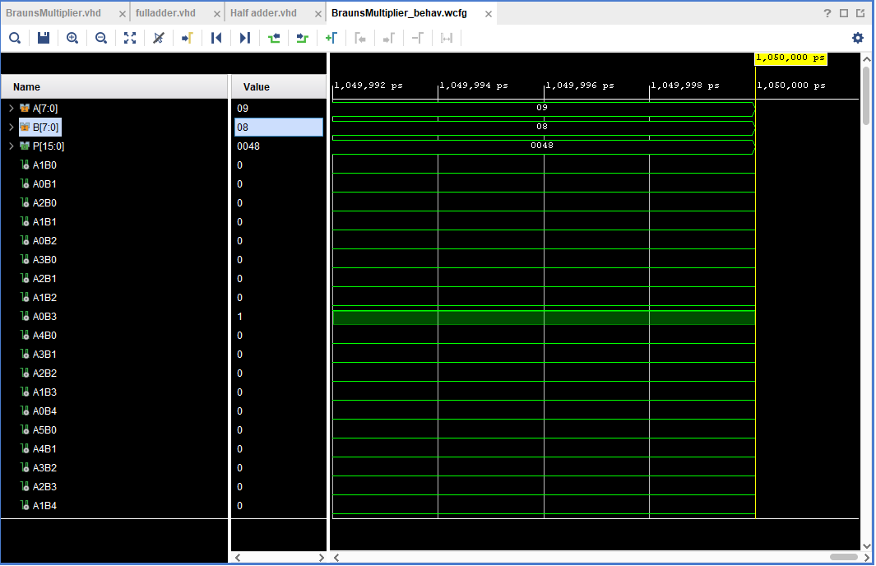

Wallace tree
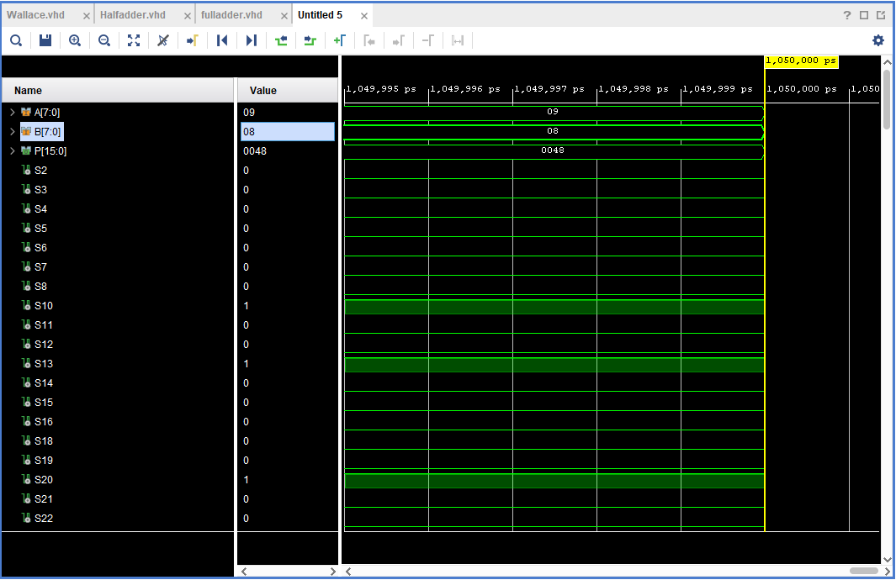

Synthesis

Braun’s multiplier
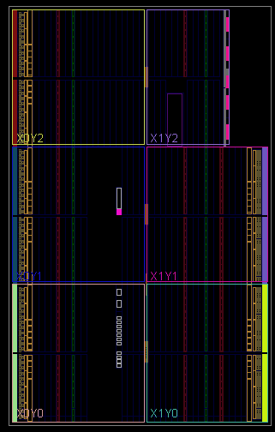
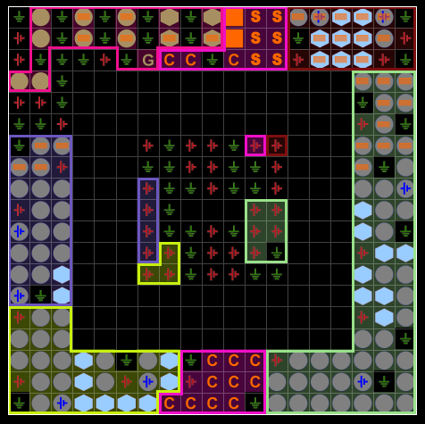

Wallace tree
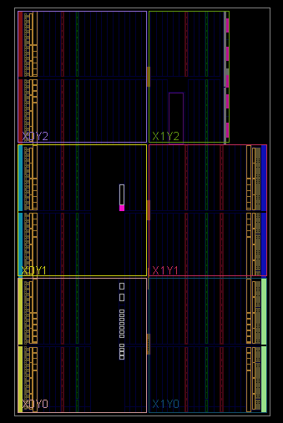
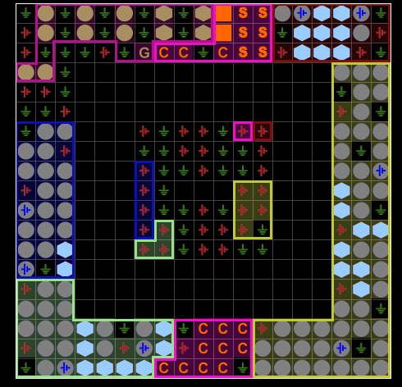

Schematic diagrams
After the synthesis had been run a schematic was created, these schematics can be seen below. Once the schematic was open the I/O pins could be assigned a package. After the pins had been assigned it was possible to move on to the next stage which was to run implementation.

Braun’s multiplier schematic
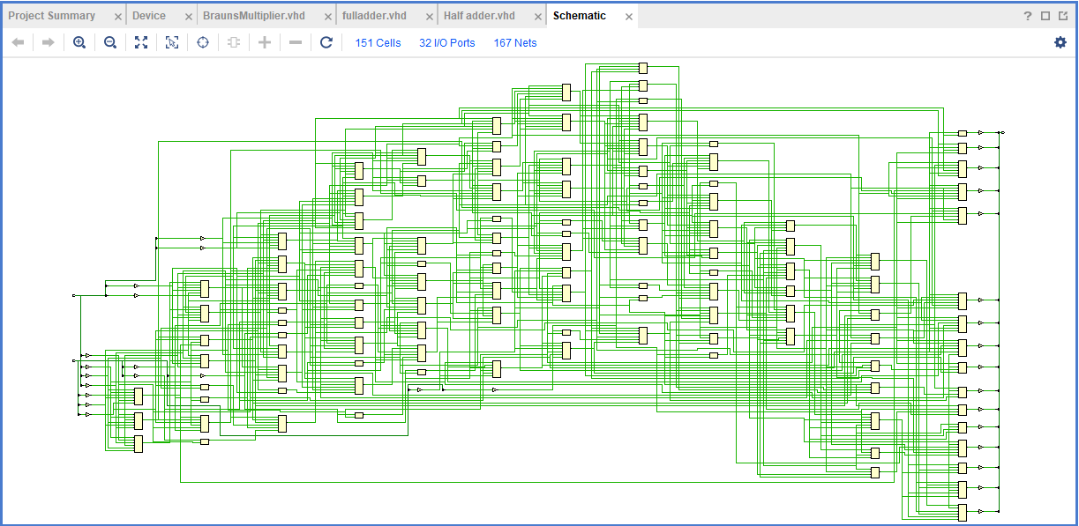

Wallace tree schematic
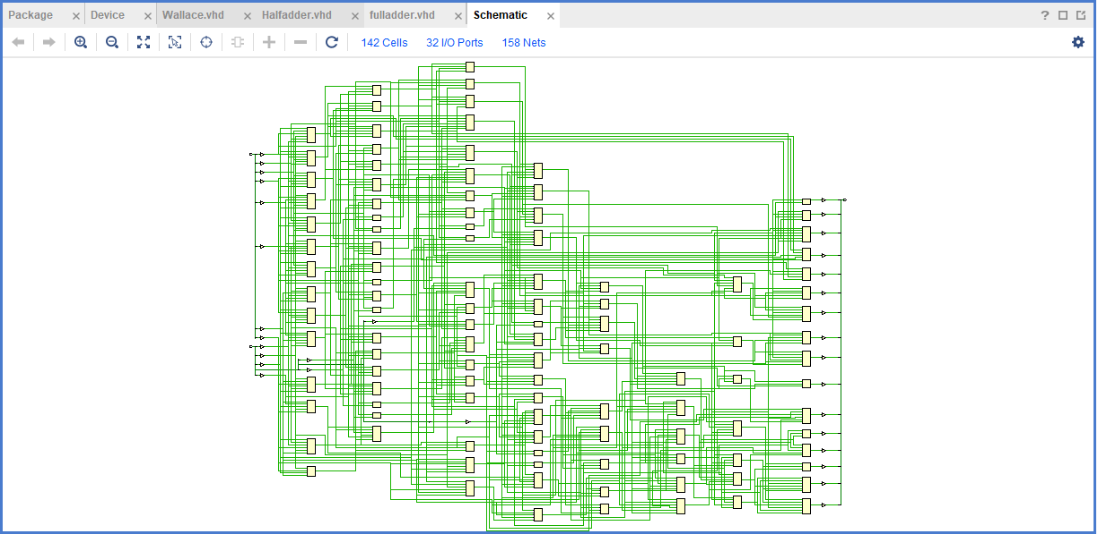

Implementation
Once the implementation was run, a timing summary report was given along with a datasheet. This allowed a look into the design timing summary which is shown below. The design timing summary give us information on the worst negative slack (WNS) which tells us if a signal is on time, arriving early or arriving late. If the WNS is equal to 0ns the signal is arriving on time, if the signal is arriving early or late the wns will be positive or negative respectively. It also shows the total negative slack (TNS), this is the sum of the negative slack values in the design.

Design timing summary

Braun’s multiplier

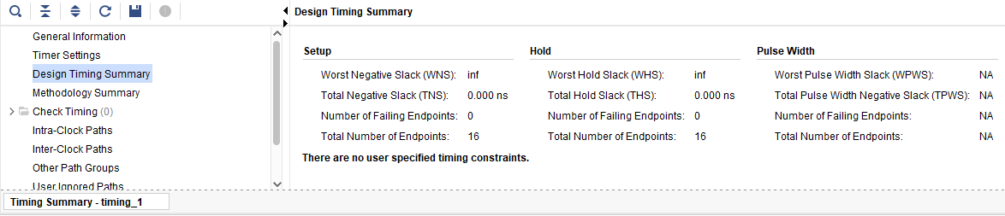
Wallace tree
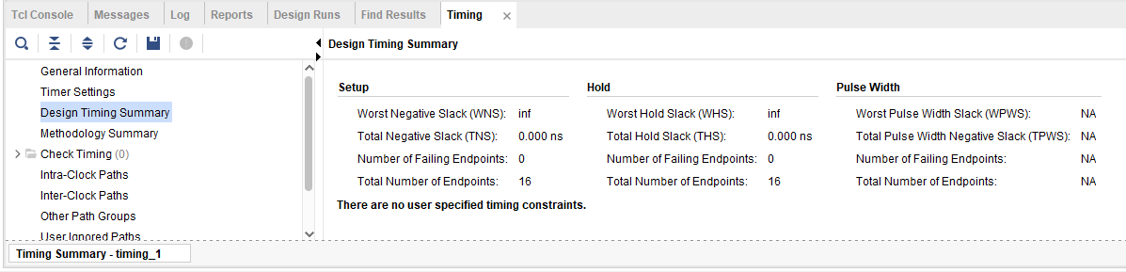

Critical path delay
From the data sheet provided in the timing summary the combinational delays can be viewed. The max delay for both was noted. From this a clock was created to improve the worst negative slack on both multipliers. The clock for the Braun’s multiplier was created for a time of 13.872 and the Wallace tree clock was created for a time of 4.607. As shown in the updated design timing summary this allowed both multipliers design to have a worst negative slack of 0.00 ns meaning all the signals were arriving on time.

Braun’s multiplier
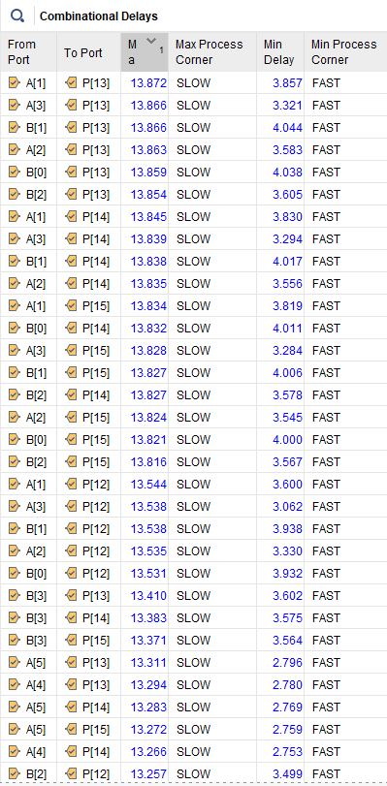
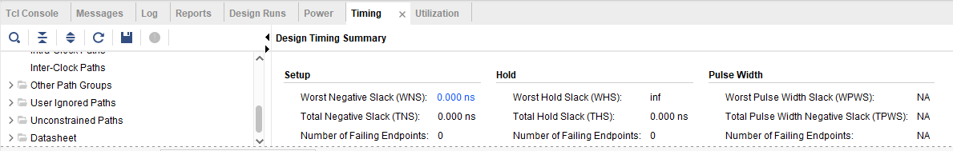

Wallace tree
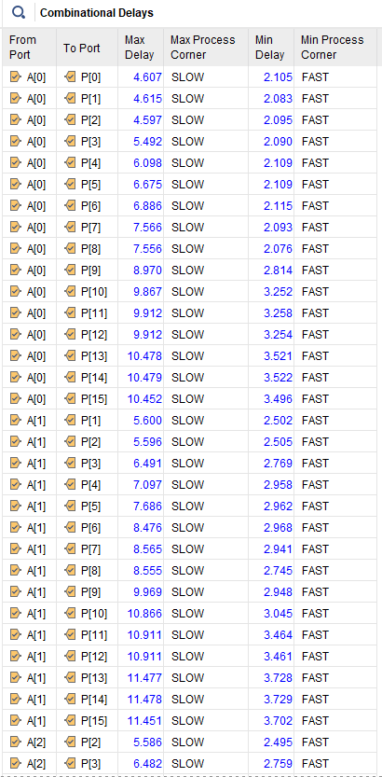
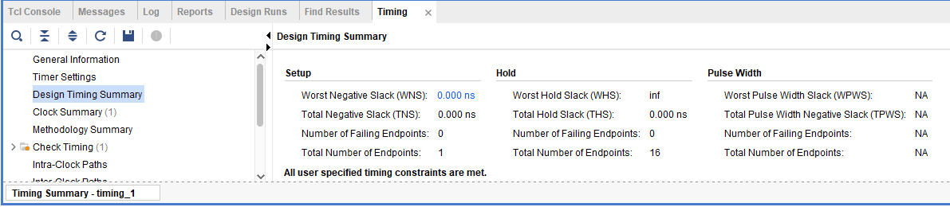

Details of testing and results
Below you can see the project summary and power results of both the Braun’s multiplier and the Wallace tree. The RTL schematics for both multipliers are also shown below.

Braun’s multiplier

Project summary
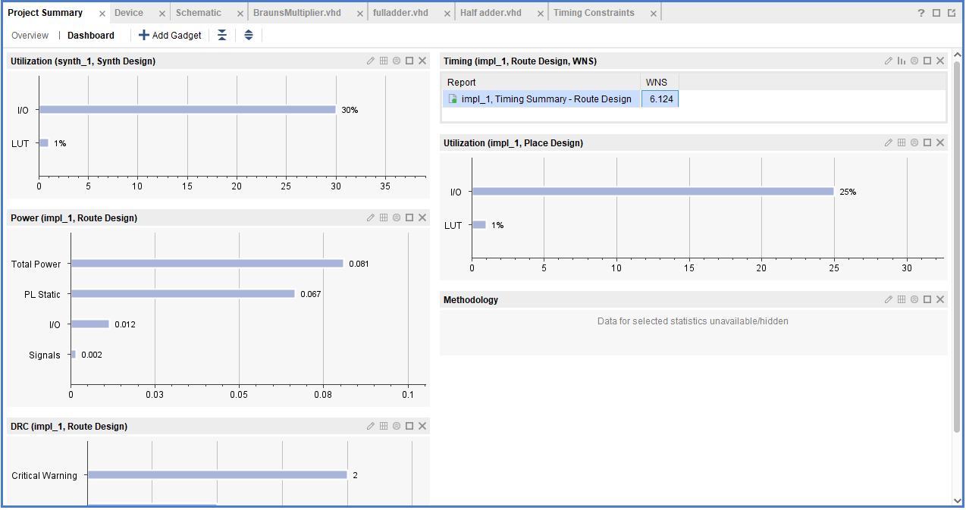

Power
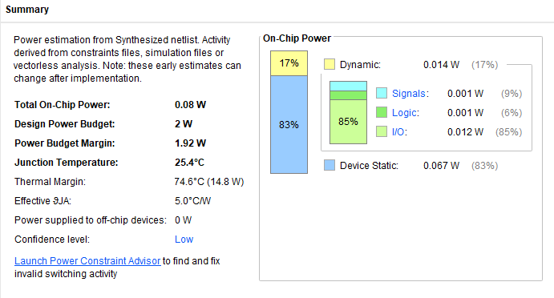

RTL schematic
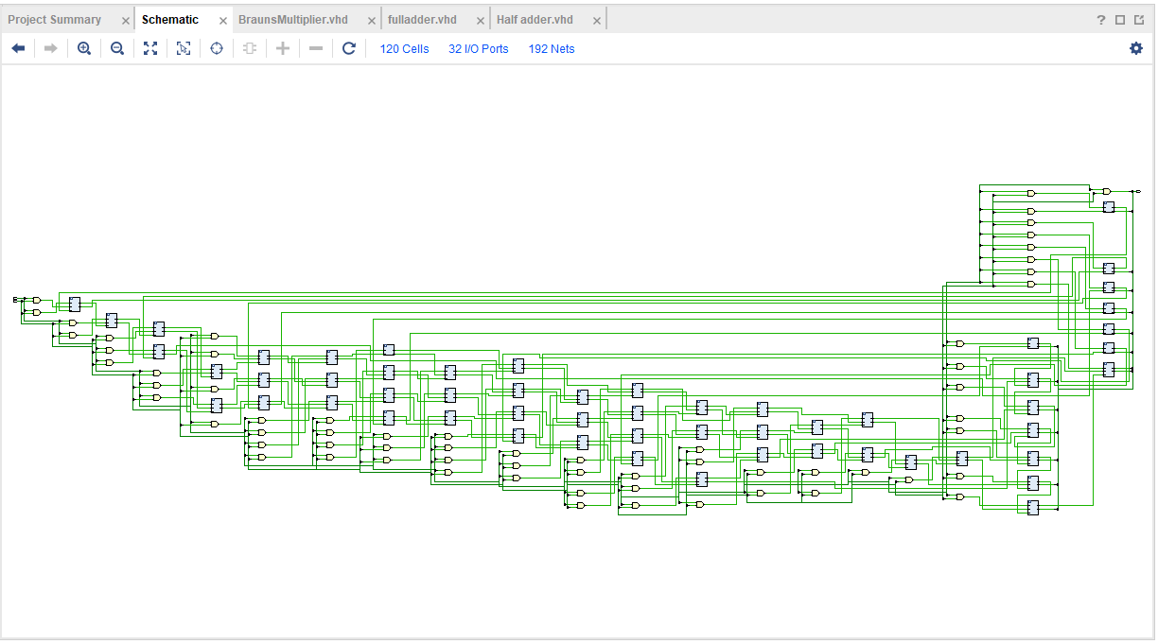

Wallace tree

Project summary
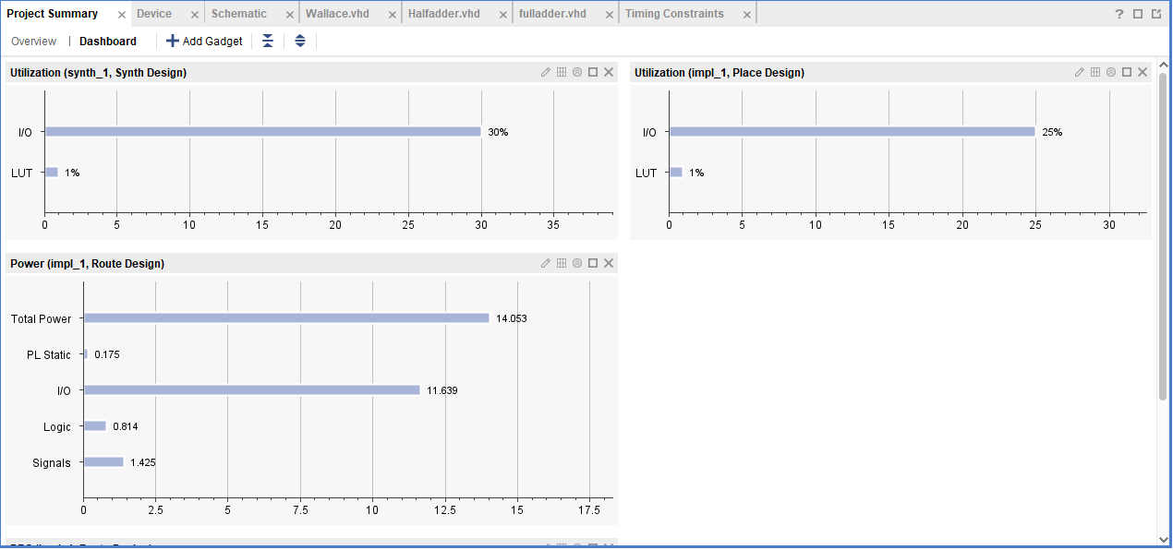

Power
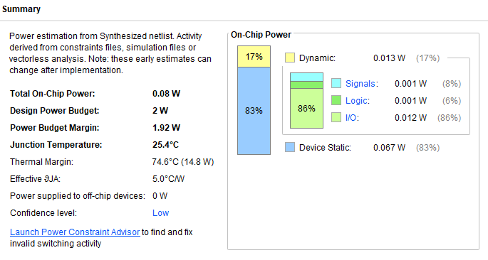

RTL schematic
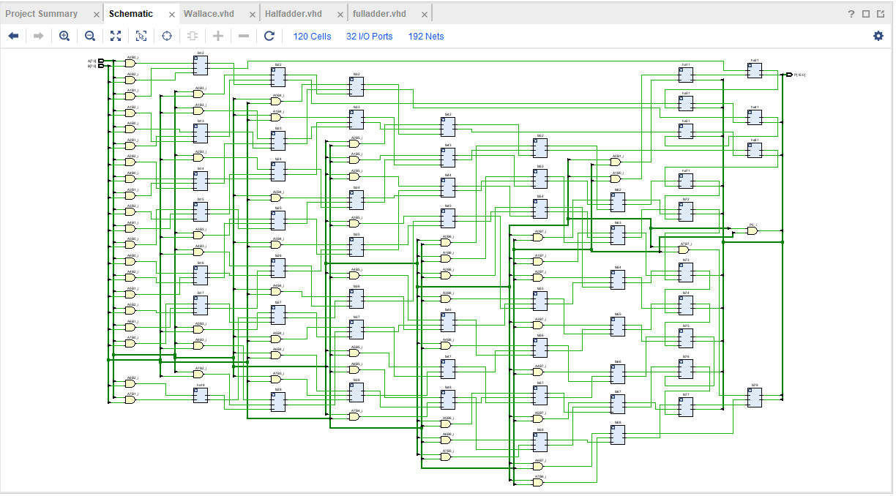

Critical path

Braun’s multiplier
The red line below shows the critical path.
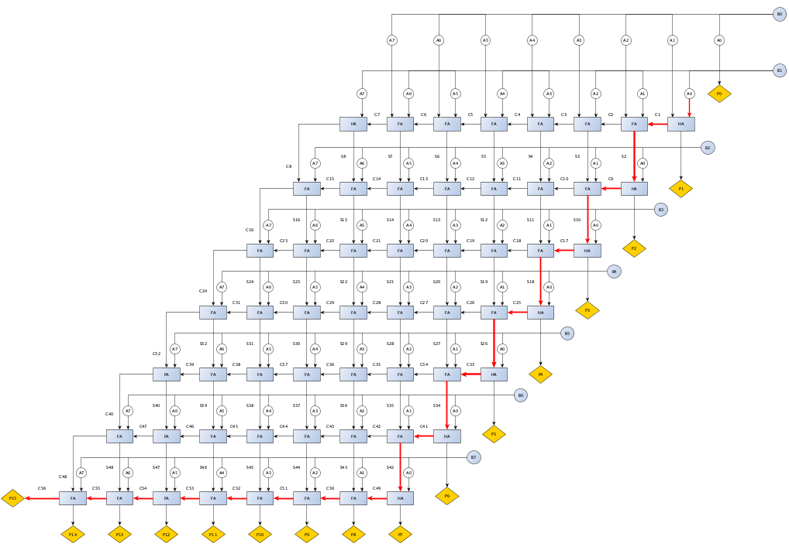
$$Longest delay=1ns+\left(7x2ns\right)+\left(13x2ns\right)$$
$$Longest delay=1ns+14ns+26ns$$
$$Longest delay=41ns$$

Wallace tree
The red line below shows the critical path.
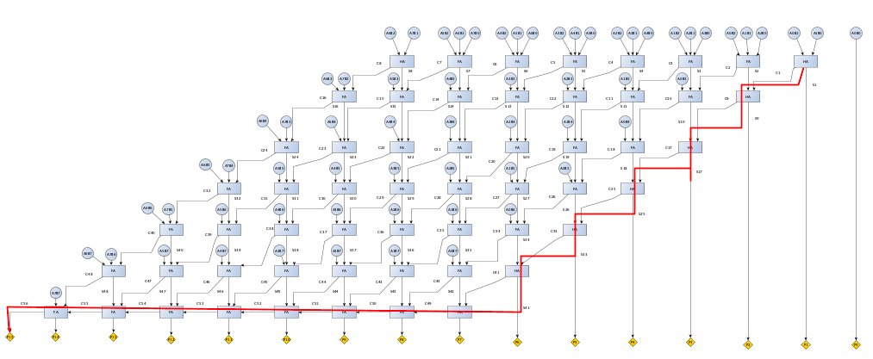
$$Longest delay=1ns+\left(7x2ns\right)+\left(7x2ns\right)$$
$$Longest delay=1ns+14ns+14ns$$
$$Longest delay=29ns$$

Conclusion
In conclusion this report investigates binary multipliers, their advantages and their applications. This report specifically looks into the Braun’s multiplier and Wallace tree. The two multipliers were created using a VHDL software which facilitated the synthesis, comparison and evaluation of the two multipliers. This allowed an insight into both multipliers circuit design, schematic and performance factors such as power. The research conducted in this report highlights the importance of the use of binary multipliers in modern technology in fields such as digital signal processing and computing due to their reduced complexity, high speed and low power ability to make complex calculations.

Bibliography
[1] Prof. J. A. Ms. Madhu Thakur, “Design of braun multiplier,” Design of Braun Multiplier with Kogge Stone Adder & It’s Implementation on FPGA, https://www.ijser.org/paper/Design-of-Braun-Multiplier-with-Kogge-Stone-Adder-Its-Implementation-on-FPGA.html (accessed Jan. 13, 2024).
[2] H. Bansa, K. G. Sharma, and T. Sharma, Wallace tree multiplier designs: A performance comparison review , https://core.ac.uk/download/pdf/234643291.pdf (accessed Jan. 13, 2024).
[3] T. Agarwal, “Binary multiplier : Types, block diagram, working and its applications,” ElProCus, https://www.elprocus.com/binary-multiplier/ (accessed Jan. 13, 2024).
[4] Soniya and S. Kumar, “A Review of Different Type of Multipliers and Multiplier-Accumulator Unit.,” InternationalJournalofEmergingTrends& TechnologyinComputerScience(IJETTCS), https://d1wqtxts1xzle7.cloudfront.net/49611461/multiplier1-libre.pdf?1476511564=&response-content-disposition=inline%3B+filename%3DMultiplier.pdf&Expires=1705241248&Signature=I5htEGJcMNlGuRU~aGtLKmxlKUIOv~JlPQUlogu5sc5uSdVtL9vkxpgznQzadSV~wTYUUGaFk6zz1e2vcFzGBLnHQVSpG3zXfXLwyzotosDmD3TCiG4Ytt9eaQE48B84IPGK42kxnMrPHVrGvb5wGqmUtRYpa6itRo58nE53SJglMRodn5bv~U5Va89dr-I~~jZG8J3-6E6hAFRM0OiArG2cnCFvgGK7mafqCzaT6tfmOzTSHQ70v~Czp56yLBC5LhuLsX~XnxOmOwY7N5naLrTqeZ9KhlHgRUBwt8jbNQBRvqjombVuBF-qrBCaDIU6Xi-kNdYVoZtwhYwfvGkHDA__&Key-Pair-Id=APKAJLOHF5GGSLRBV4ZA (accessed Jan. 14, 2024).
[5] M. V. S. ASISH , P. S. SINDHU, K. KALKI, and D. N. V. BHARATHI, A report on multiplier and its types - ijvdcs.org, http://www.ijvdcs.org/uploads/536241IJVDCS14380-70.pdf (accessed Jan. 14, 2024).
[6] Cadence PCB Solutions et al., “Hardware description languages: VHDL vs Verilog, and their functional uses,” Hardware Description Languages: VHDL vs Verilog, and Their Functional Uses, https://resources.pcb.cadence.com/blog/2020-hardware-description-languages-vhdl-vs-verilog-and-their-functional-uses#:~:text=What%20Is%20VHDL%3F,field%2Dprogrammable%20gate%20arrays). (accessed Jan. 14, 2024).
[7] “What is an FPGA? field programmable gate array,” AMD, https://www.xilinx.com/products/silicon-devices/fpga/what-is-an-fpga.html (accessed Jan. 14, 2024).

