University of Wales Trinity Saint David

Wales Institute of Science & Art

Suspension Kinematics and performance Analysis.
Vehicle/Motorsport Technology
ACHA4004/ACHA4012

Dylan Joseph Arthur
2004556
November 2021
Contents
1.0 Introduction 3
2.0 Laboratory Research 4
2.1 Equipment 4
2.2 Methodology. 5
2.2.1 Wheel Position Methodology. 5
2.2.2 Tyre Vertical Stiffness Methodology. 5
2.2.3 Spring Stiffness Methodology. 5
2.2.4 Unsprung mass test 5
2.3 Results. 6
2.3.1 Raw Data 6
2.3.2 Visualized Results 7
3.0 Wingeo Kinematic Simulation 10
3.1 Methodology 10
3.1.1 Wingeo Ride Investigation. 10
3.1.2 Wingeo Roll Investigation. 11
3.2 Wingeo Kinematics Results. 12
3.2.1 Visualized Wingeo Kinematics Results. 13
3.2 Roll Centre Migration 14
4.0 Suspension Calculations. 16
4.1 Calculations. 16
4.2 Discussion. 16
5.0 Validation. 17
6.0 Conclusion. 18
References. 19

1.0 Introduction
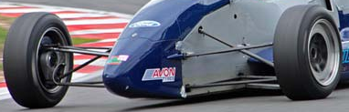
This report will investigate the front suspension of a Van Diemen single seater race car as used in the Formula Ford series, it utilises a double wishbone and pushrod system which can be seen below.
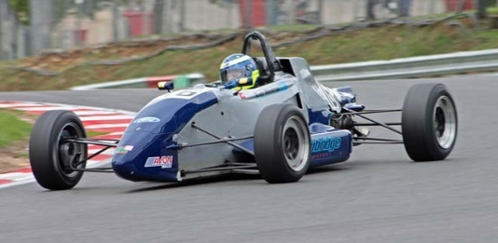
Lucy Wardrop’s Formula Ford Zetec nicknamed “Silver” (Chris Snowdon Racing, n.d.)

The aims of this report are to explore the variables of the suspension system, analysing how changes to the ride height and roll affect the geometry using both measured data and data gathered using a virtual model of the front suspension using Wingeo. These two data sets will then be compared to assess the accuracy and locate any discrepancies between them.

2.0 Laboratory Research
The first research completed was completing four tests in the Laboratory. These consisted of a Wheel Position Tests, Tyre Vertical Stiffness Test, Spring Stiffness Test, and an Unsprung Mass test.

2.1 Equipment
The equipment used is listed below:
Wheel Position Tests – Suspension rig, Two DTI (Digital test Indicator) gauges mounted to toe gauge, Digital camber gauge, Digital height gauge, vernier calliper.
Tyre Vertical Stiffness Test – wheel and tyre, Hydraulic press tyre stiffness rig, corner weight scale, DTI gauge, tyre pressure gauge, tyre inflator.
Spring Stiffness test – Electronic digital spring tester with scale, coil spring, DTI gauge with magnetic mount.
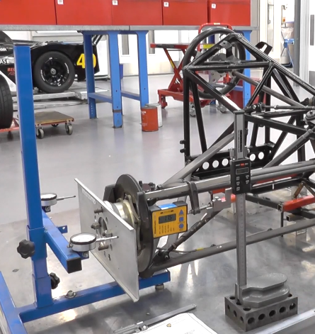
Unsprung Mass test – Unsprung mass rig, corner weight scale, Allen keys.
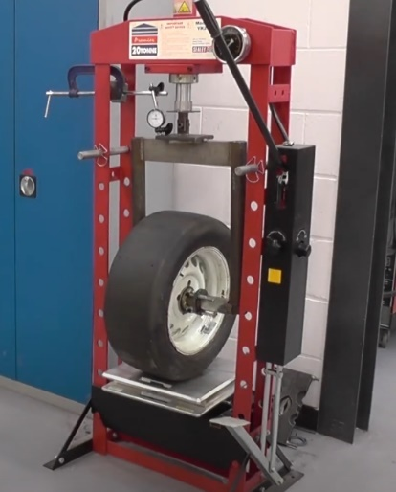
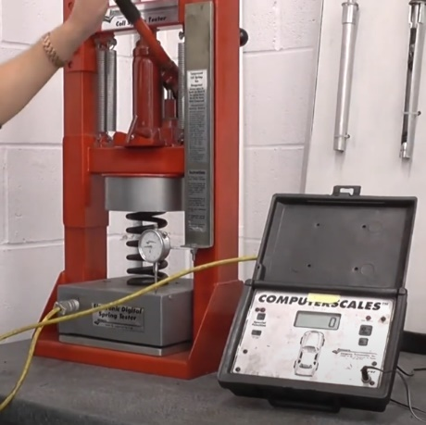

Coil Spring Test Setup.
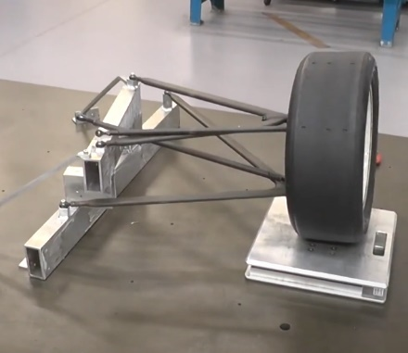
Tyre Stiffness Test Setup.
Wheel Suspension test setup
Test setups shown above, Image credit to Tudor. T and Davies. P 2020.

Unsprung Mass test setup.

2.2 Methodology.

2.2.1 Wheel Position Methodology.
The camber gauge was attached to the bump steer plate on the wheel hub, the toe gauge with the DTI gauges was then positioned with both spindles in contact with the plate. The DTI gauges were approximately 50% along the spindle so they can move freely in or out, the DTIs were then zeroed. Next the height gauge was positioned with the contact point on the top of the bump steer plate and zeroed, finally the starting length of the thread on the mock damper was measured using the vernier calliper and noted. The first reading was measured without adjusting the mock damper and involved just measuring the camber. Next the push rod (mock damper) was rotated two revolutions and the thread length measured with the vernier calliper. The values on the camber gauge, both DTI gauges and height gauge were noted. This process was repeated a further 7 times until all values from -20mm to 20mm approx ride height had been recorded.

2.2.2 Tyre Vertical Stiffness Methodology.
The wheel and tyre were placed on the testing rig with the corner-weight scale beneath the tyre, using the hydraulic press a small load was placed on the tyre. Next the tyre pressure was checked and adjusted to 10psi using the tyre pressure gauge and air compressor, after this the DTI was zeroed. Next the handle on the hydraulic press was pumped until the DTI read 2mm and the reading on the corner weight scale was noted, this was repeated 6 further times in 2mm increments until readings from 0-14mm had been gathered.

2.2.3 Spring Stiffness Methodology.
A coil spring from the formula ford was placed into an electronic digital spring tester, where it is not under any load and still free to move. The DTI was then positioned on the rig, in contact with the baseplate and was then zeroed. The handle was then pumped until the DTI completed a full rotation meaning it has moved 0.1 inches and the reading on the display was noted. This was repeated a further 9 times so that readings from 0-1 inch have been gathered in 0.1-inch increments.

2.2.4 Unsprung mass test
To test for the Unsprung mass on the car a corner weight scale was zeroed then placed under the wheel on the Unsprung mass rig. This reading was noted, and then the bolts attaching the wishbones to the rig were removed so the wheel and wishbone assembly could be removed. This was then weighed separately, and the mass recorded.

2.3 Results.

2.3.1 Raw Data
The raw data alongside the calculated values from the laboratory can be seen below.

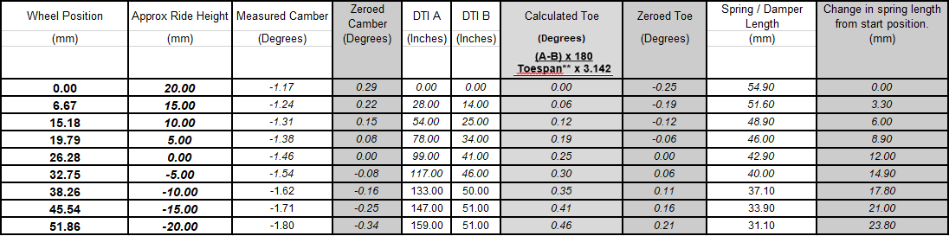
Wheel position Tests:

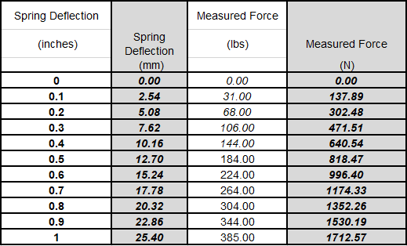
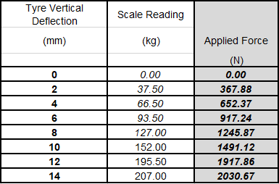
Tyre Vertical Stiffness Test: Spring Stiffness Test:

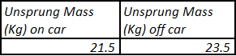
Unsprung Mass Test:

2.3.2 Visualized Results
Fig. 1 – Camber Change Vs Ride Height.
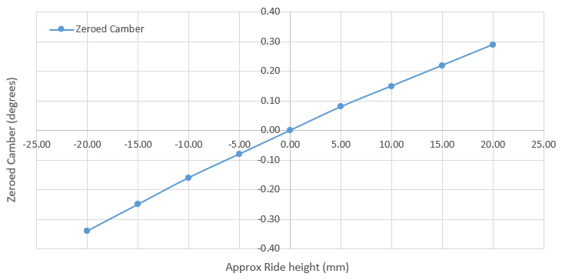

Fig. 2 – Toe Change Vs Ride Height.
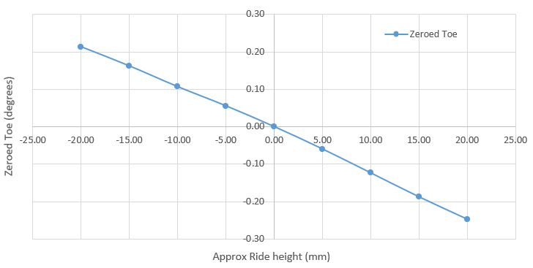

In Fig. 1 a linear relationship is seen where the Camber tends towards positive with the increases in ride height, this will result in a larger positive camber value on the front wheels in instances such as rear pitch on the transverse axis under heavy acceleration, as well as on the inside wheels when cornering because of the chassis rolling due to the transfer of weight laterally. (Krönke. M, 2017)
In Fig. 2 a linear relationship is seen where the Toe tends towards negative (toe out) with the increase in ride height, this causes a higher toe out value on the front wheels under heavy acceleration and on the inside wheel when cornering. Toe out on the front wheels is common in race cars to improve turn in response and also help reduce understeer to improve handling particularly on more technical circuits (Woodwiss. S, 2020).

Fig. 3 – Change in spring length vs wheel position.
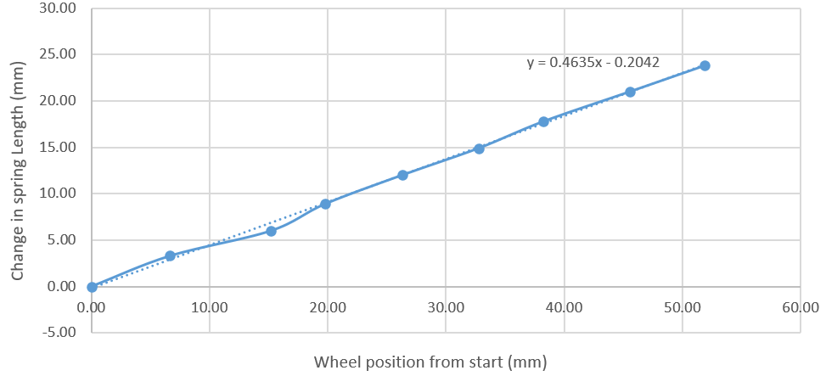

Fig. 3 shows a linear relationship between the change in spring length and wheel position as the spring length is changed. The gradient shows the motion ratio of the suspension setup, this was calculated to be 0.4635.

Fig. 4 – Tyre Deflection Vs Applied Force.
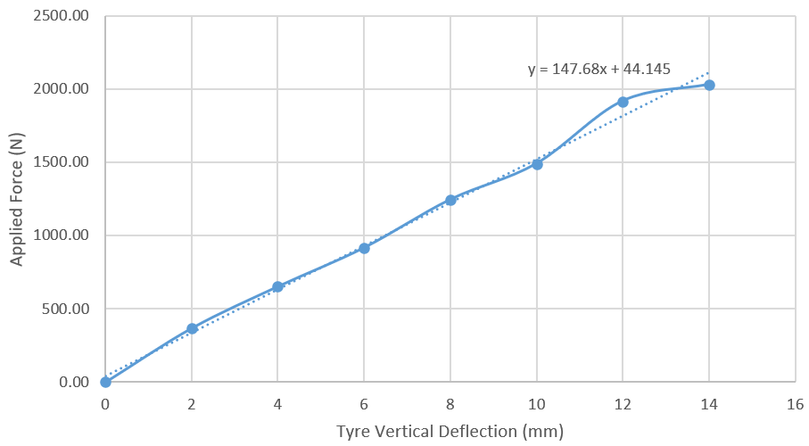

Fig. 4 shows the tyre deflection depending on the force applied with a pressure of 10psi. The rate of deflection is shown to be linear, from this graph the gradient can be calculated and shows the Tyre stiffness when placed into SI units, and when calculated was 147680N/m.
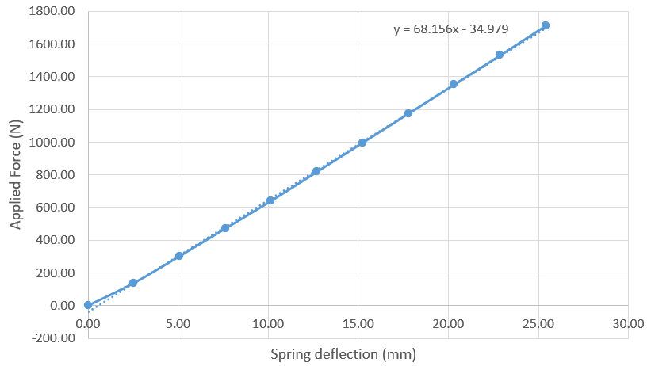
Fig. 5 – Spring Deflection Vs Applied Force.

Fig. 5 shows the amount of force required to compress the coil spring by a given distance. The gradient once calculated shows the spring rate of the coil spring. For this spring it was calculated to be 68.156N/mm.

3.0 Wingeo Kinematic Simulation
The second set of tests completed were using a modelled front suspension on Wingeo.

3.1 Methodology

3.1.1 Wingeo Ride Investigation.
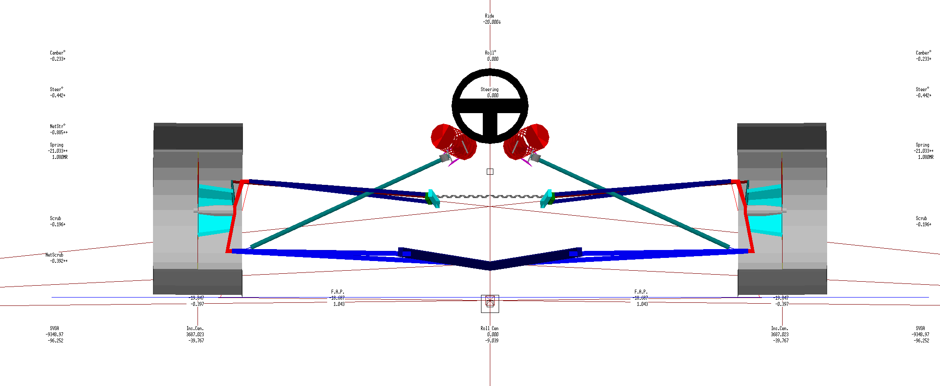
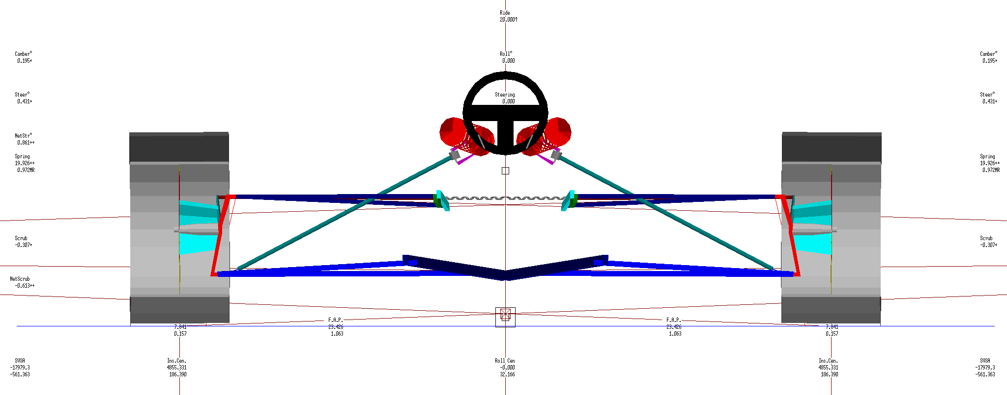
The first test involved changing the Ride height from -20mm to 20mm in 5mm increments and seeing its effects on Camber, Toe and Motion Ratio. The minimum and maximum values can be seen below.
Fig. 7 – Wingeo Model at +20mm Ride height.
Fig. 6 – Wingeo Model at -20mm Ride height.

3.1.2 Wingeo Roll Investigation.
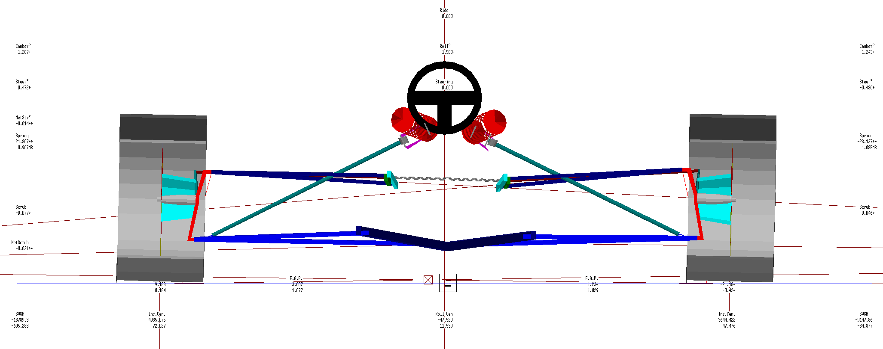
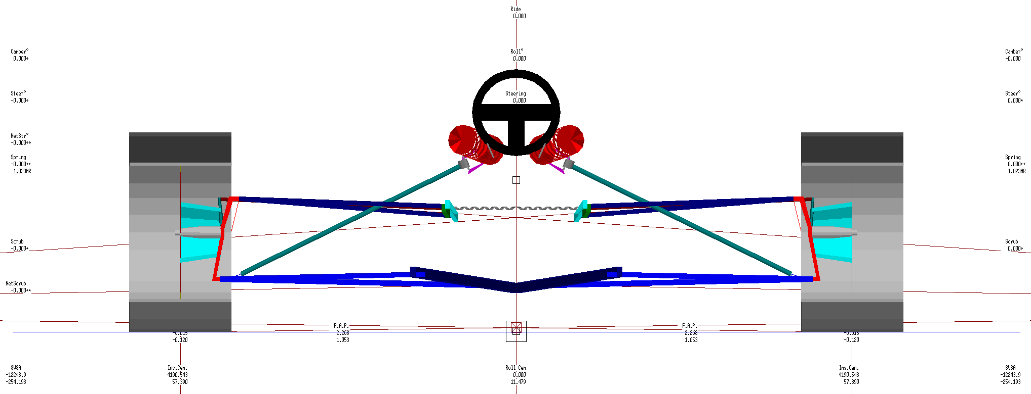
The second test involved changing the Roll of the model from 0 to 1.5 degrees and seeing its effects on the Camber, Toe and Motion ratio. The minimum and maximum values can be seen below.
Fig. 9 – Wingeo Model at 1.5 degrees Roll.
Fig. 8 – Wingeo Model at 0 degrees Roll.

3.2 Wingeo Kinematics Results.
Wingeo Ride Height Investigation Results.
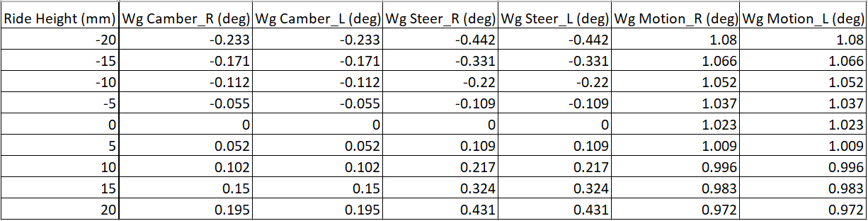
Wingeo Roll Investigation Results.
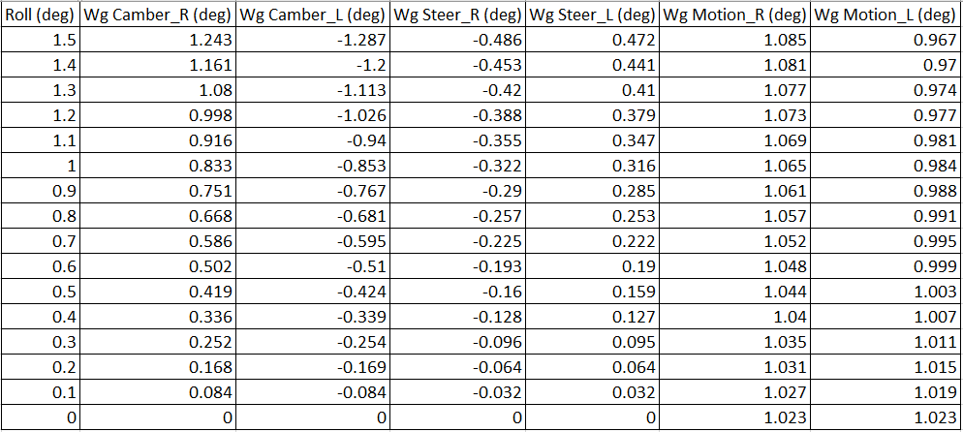

3.2.1 Visualized Wingeo Kinematics Results.
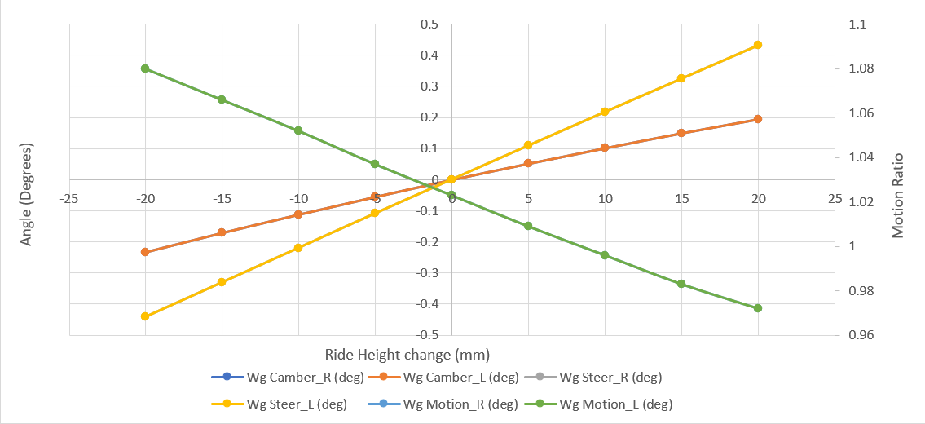
Fig. 10 – Combined Wingeo Ride Height Results.

Fig. 10 shows the changes to Camber, Toe, and motion Ratio when the ride height is adjusted. Only the Left wheel values are visible due to the values of each variable being identical on both wheels when ride height is changed. A linear increase can be seen with both camber and toe values and a linear decrease can be seen with motion ratio, with the increase in ride height.
Fig. 11 – Combined Wingeo Roll Results.
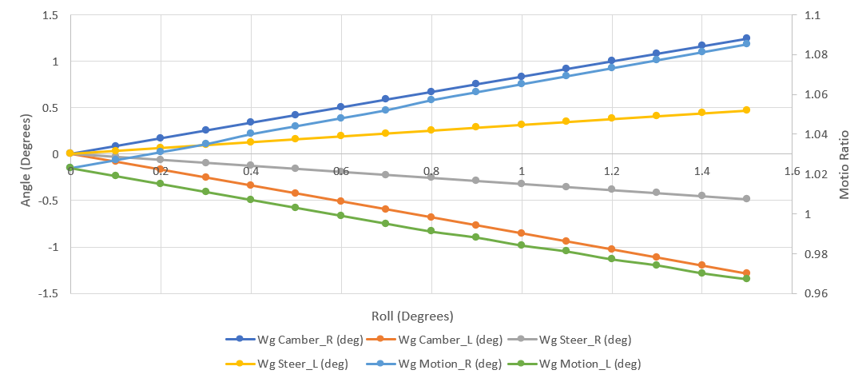

Fig 11. Shows The effects of roll on the camber, toe, and motion ratio on each of the front wheels, the roll is positive which in Wingeo shows a roll to the right side, signifying the car full cornering to the left. The outside (front right) wheel shows the camber to be tending towards positive and toe tending towards negative (toe out). The motion ratio also tends towards positive. The inside (front left) wheel shows the opposite pattern.

3.2 Roll Centre Migration
The roll centre is the point at which the car “rolls” around and can be located as seen below by drawing lines from the tyre contact points to the instant centres of each side of the suspension, where those lines cross is the roll centre.
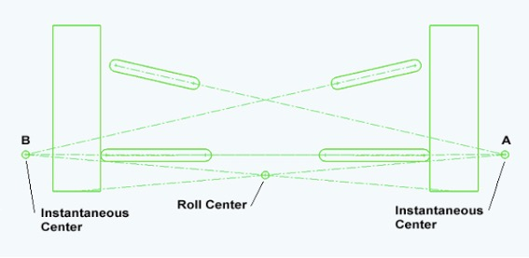

Roll centre Diagram Vogel, J n.d.

The roll centre is very important as it has huge effects on the way the car handles and behaves. The roll centre height, and distance to centre of gravity are crucial and have large effect on the handling characteristics (J. Vogel, n.d.). The higher the roll centre, and closer to the centre of gravity, the less roll the system will experience, and if the roll centre is the same as the centre of gravity no roll will be experienced. (thef1clan, 2020)

Below is a diagram showing the roll centre migration Through the following manoeuvre:
1-Full Braking: Bump = -20mm, Roll = 0 degrees
2-Half Braking, Half Cornering: Bump = -10mm, Roll = 0.75 degrees
3-Full Cornering Bump = 0mm, Roll = 1.5 degrees
4-Half Accelerating, Half Cornering Bump = +10mm, Roll = 0.75 degrees
5-Full Accelerating: Bump = +20mm, Roll = 0 degrees
Fig. 12 – Roll centre migration test in Wingeo.
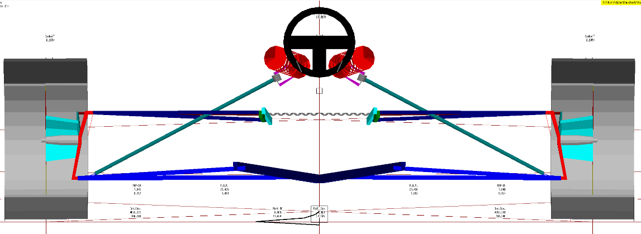

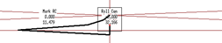

The roll centre can be seen moving quite significantly in this test, mainly horizontally under cornering and vertically under acceleration and braking. Under braking it drops, this results in the front becoming more susceptible to roll due to the roll centre being further from the centre of gravity, widening the instant centres will also reduce the negative camber gain with bump (Racing Aspirations, 2017)

4.0 Suspension Calculations.

4.1 Calculations.
Using the data gathered from the laboratory research many calculations were made to find suspension characteristics, for these equations Kt = Tyre stiffness (calculated 147680N/m), Ks = spring rate (calculated 68.156N/mm), MR = motion ratio (calculated 0.4635), Ms = sprung mass (assumed 115kg), Mus = Unsprung mass (calculated 21.5kg on car, 23.5 kg off car).
-Wheel Rate (Kw) was found using the equation: Kw = Ks * MR² This was found to be 14642.1N/m.
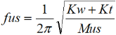
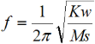
-Ride frequency also known as the natural frequency of the sprung mass was found using the following equation: this was found to be 1.80Hz.
-the Front Unsprung mass natural frequency was found using the equation This was calculated to be 13.83Hz.

4.2 Discussion.
The Ride frequency of a car says a lot about a vehicles handling characteristics, with the two extremes being passenger cars around 0.5-1.0Hz and racecars with over 50% of their weight in downforce being 3.5-5.0Hz, the 1.80Hz calculated places it in the 1.5-2.5Hz bracket of low aero racecars and moderate aero Formula cars (Rajeev. N, 2019). The lower the Ride frequency the softer the suspension will be and the slower it will respond, whereas a higher ride frequency give less suspension travel allowing for lower ride heights, and lower centre of gravity. (Rajeev. N, 2019)

5.0 Validation.
Fig. 11 – Measured Camber Vs Wingeo Camber.
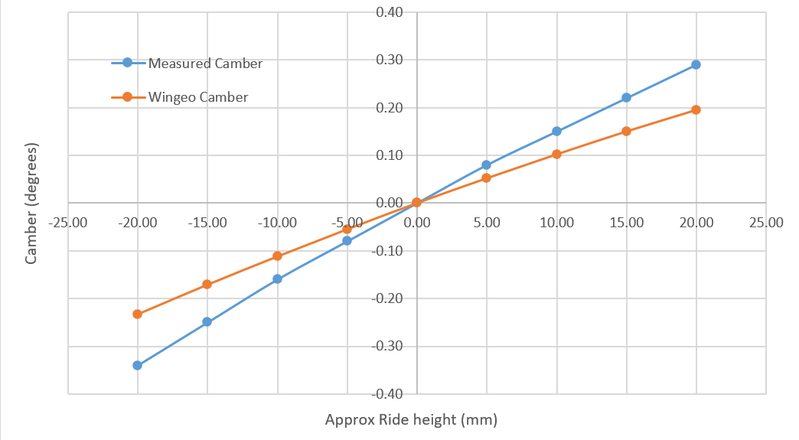

Looking at Fig.11 both the measured and Wingeo camber values showed a similar relationship with the increase in ride height, with the only difference being the Measured values increasing at a faster rate. This could be down to multiple reasons, including inaccurate measurements, the Wingeo model being slightly incorrect, but is most likely due to the measuring method for the real values, as the ride height was an approximate value therefore measuring the ride height directly would give more accurate data.
Fig. 12 – Measured Toe Vs Wingeo Toe.
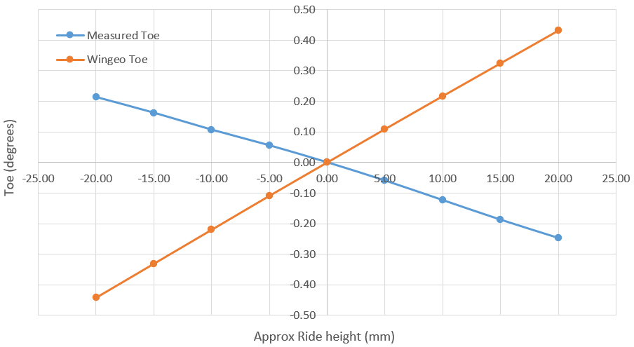

Looking at Fig.12 with the raw data from both tests an opposite relationship can be seen, this is strange as a much closer relationship is expected such as that in Fig. 11. This could be due to reading the DTI gauges in the incorrect order or an issue with the Wingeo model and to validate this reading the test could be completed again paying close attention to the DTI toe gauges.

6.0 Conclusion.
To conclude there were many interesting findings both from the laboratory testing and Wingeo testing, which gives a great insight into the suspension used in the Van-Diemen. In particular the camber results, seeing a relationship which can lead onto many improvements such as a larger negative camber value resulting in reduced positive camber on the outside wheel when cornering and accelerating hard which will improve stability. Also Finding the ride frequency will be very useful if changing any of the aerodynamic components on the car, as higher downforce will require a higher ride frequency. If the experiments were to be completed again a more thorough measuring system would be employed allowing for more accuracy within the wheel position tests and more reliable results.

References.
- Chris Snowden Racing, Formula Ford – Van Diemen RF01. https://cs-racing.co.uk/csr-formula-ford.html (Accessed 10/11/21)
- Tim Tudor and Paul Davies, Laboratory equipment setup videos.
- Martin Krönke, 5.6 Camber & Toe - https://virtualracingschool.com/academy/iracing-career-guide/setups/camber-toe/ (accessed 14/11/21)
- Scott Woodwiss, suspension secrets – how to tune toe settings. https://brscc.co.uk/suspension-secrets-how-to-tune-toe-settings/ (accessed 13/11/21)
- Jonathan Vogel, Tech explained – roll centre. https://www.racecar-engineering.com/tech-explained/tech-explained-roll-centre/ (accessed 20/11/21)
- TheF1Clan, roll centre & roll couple: what are they and what role do they play in racecar design? https://thef1clan.com/2020/06/09/roll-center-roll-couple-what-are-they-and-what-roll-do-they-play-in-racecar-design/ (accessed 22/11/21)
-Racing Aspirations, Roll centre Movement (kinematic). https://www.racingaspirations.com/roll-center-movement-kinematic/ (accessed 20/11/21)
- Nandan Rajeev, Natural Frequency, Ride Frequency, and their Influence in Suspension System Design. https://www.ijera.com/papers/vol9no3/Series-3/K0903036064%20.pdf (accessed 28/11/21)

