Henry Rennison
2218326 Learning in the Digital Era (ACCA4025) Workshop Skills
Workshop Skills/ Log Book

Learning in the Digital Era

Proteus Design

I started by making a basic circuit on proteus using a few basic components: 741, 3 resistors, 3 capacitors, and a 9v power supply. I used one 20k resistors and two 10k resistors. There was also a power supply.
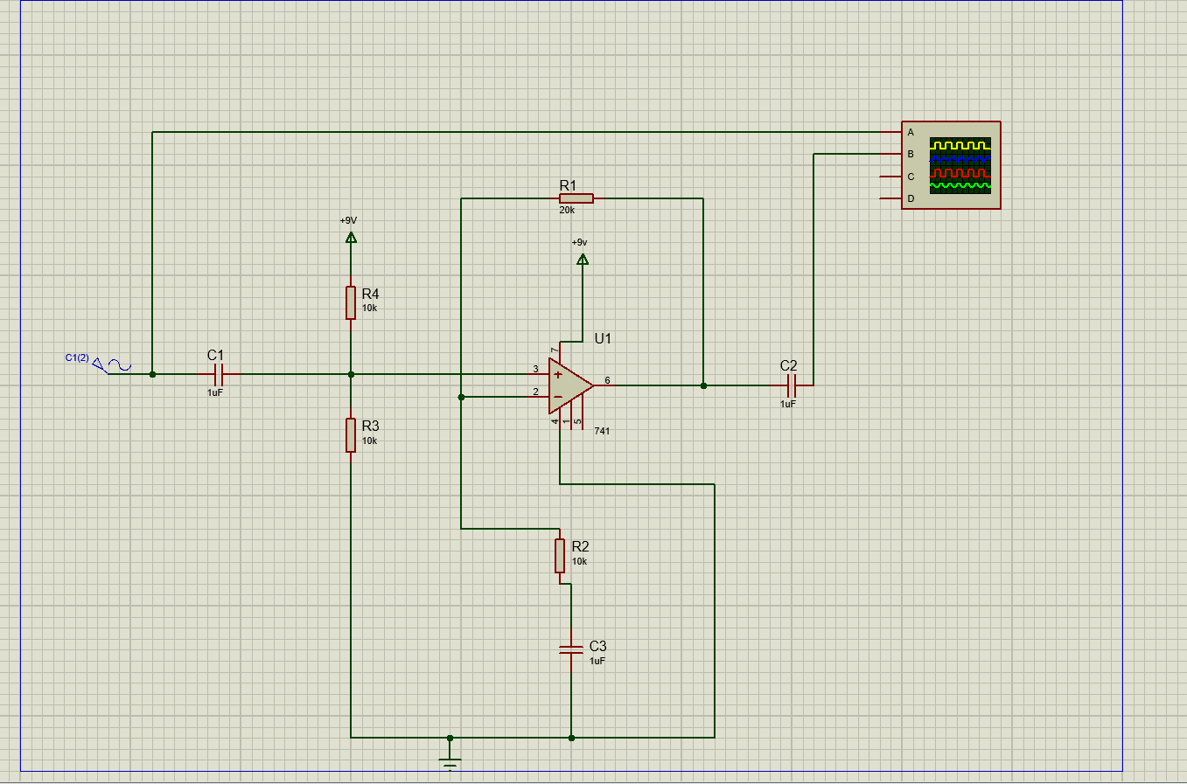

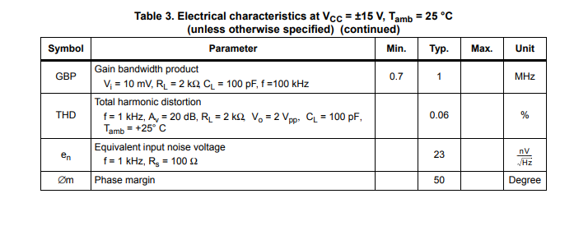
I then ran the proteus simulations at various frequencies to try and see at what point the output would reach its max before dropping off. I was testing to make sure that my circuit design would amplify the input three times.

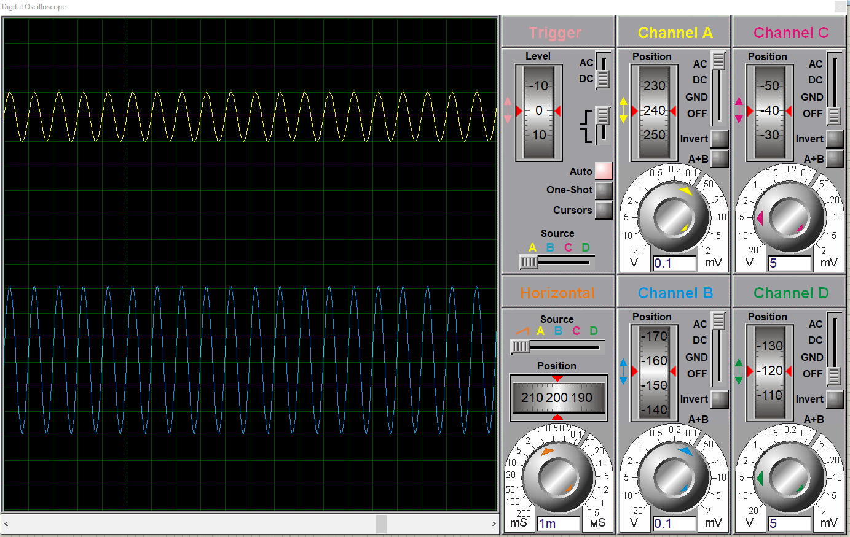
Frequency (kHz) | Output half wave (mV)
0.1 | 282.5
0.2 | 300
0.5 | 300
1 | 300
2 | 300
5 | 300
10 | 300
20 | 300
50 | 290
100 | 287.5
200 | 256
250 | 237.5
300 | 218.75
310 | 215.7
320 | 211.75
330 | 207.5
340 | 205.25
350 | 201.25
400 | 183.75
450 | 171.25
500 | 158.75

I then went through upping the frequency to see what the peak output was. I found peak was 300 mV at 500Hz then gradually went down from between 20-50 kHz and continued to drop. These were the results I was expecting to see.

Easy PC
I then made the following schematic design on easy pc adding all the same components (741, 3 resistors, 3 capacitors, and a 9v power supply) I used in my proteus design. I also put the components in the same places for continuity purposes.
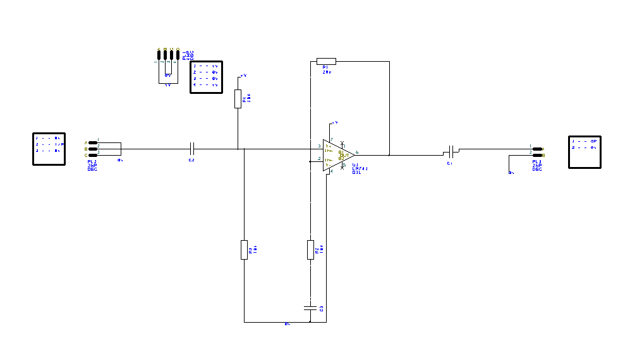
I then added a border by adding component and searching A4, I then named my design and put my name on the border. As you can see in the picture below:

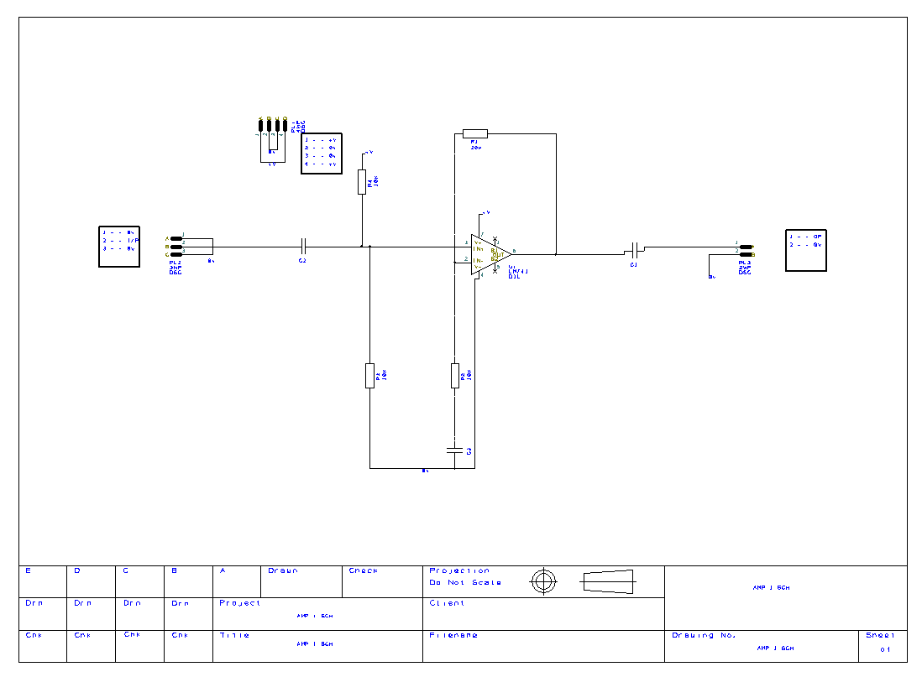

PCB Design
I then converted the design in to a PCB board, this just gives you the list of components used and I then had to put them all in place. I then started to put all my components in place to replicate my initial design. Assuming the design and components are correct it automatically connects to the nearest connection (0v/9v).

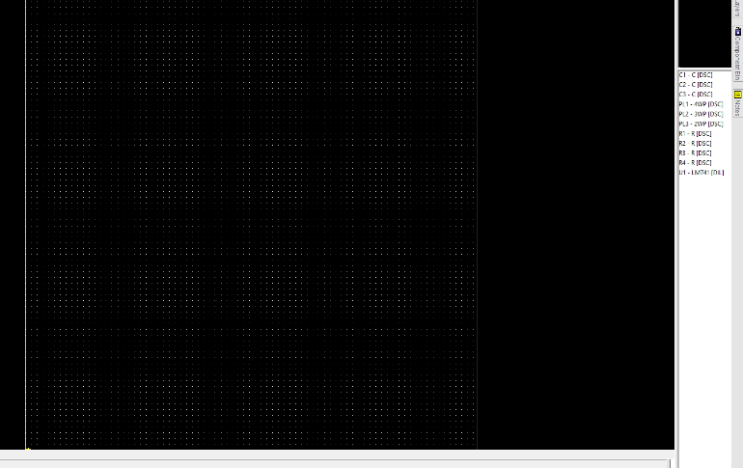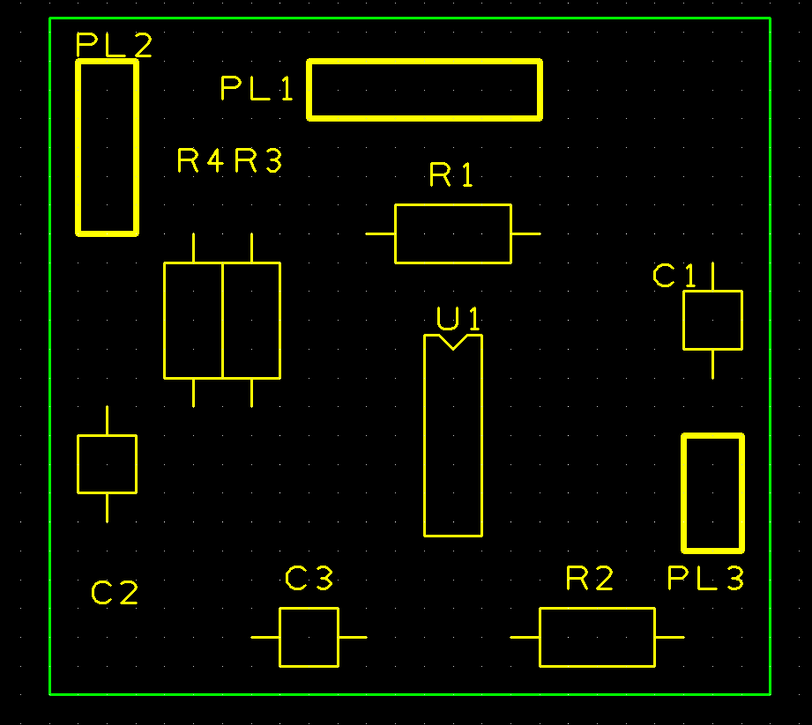

Once I added the components I then made 2 dummy copper layers which remove any links between the 9V and 0V. The dummy layers also provide a dummy version of the copper plates that will form part of the circuit I had to create one dummy layer for 0V and one 9V to then get the following:

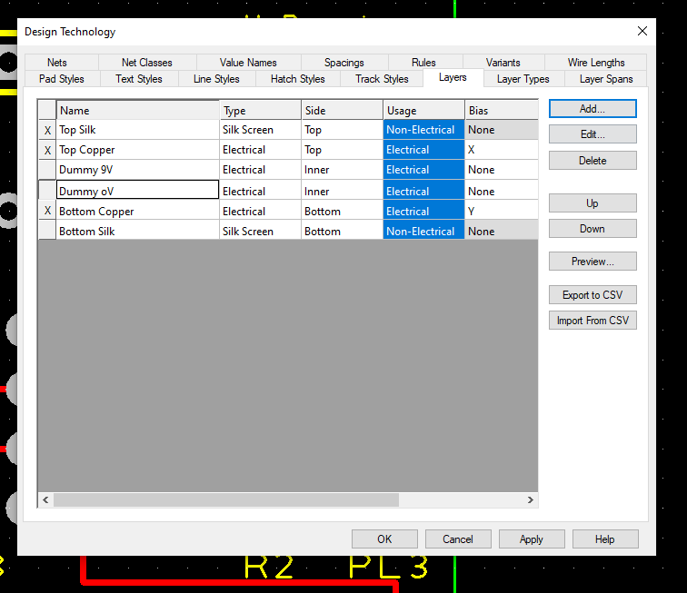
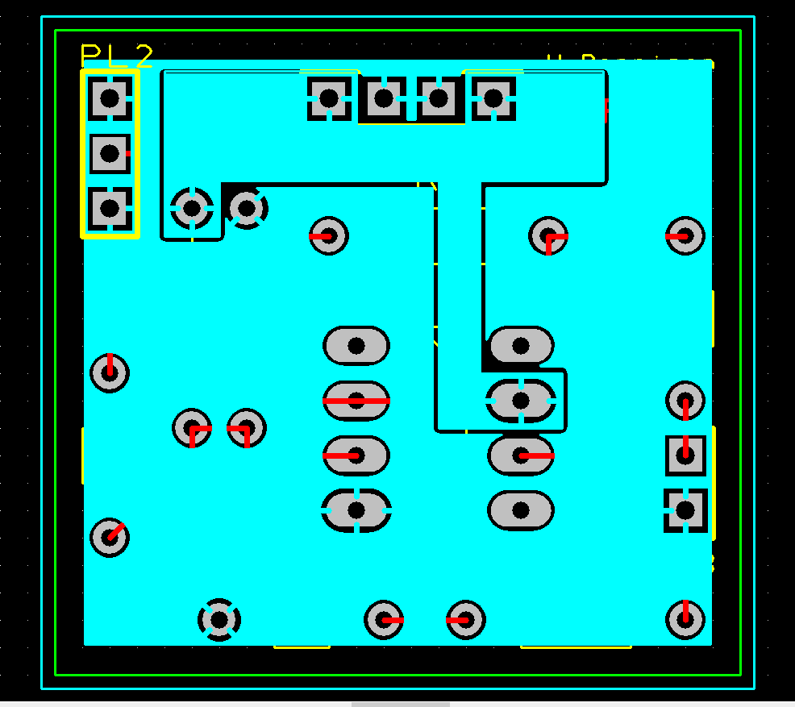

I then drew out a pour area to separate the Ground from the 9v as you will see in the image below there is a pour area separating the pins for 9v and the pins for 0v/ground connections. Copper Pouring for the 0v goes over the whole board. 9v is in the black border going over the 9V connection pins.
I also then added name of the board and my name. I Put the Creator in Top silk and the name of the board in top layer copper.
I then removed all layers to see yellow connections which will need to be done in top layer copper. I then connected all the connectors in top layer copper (red lines).
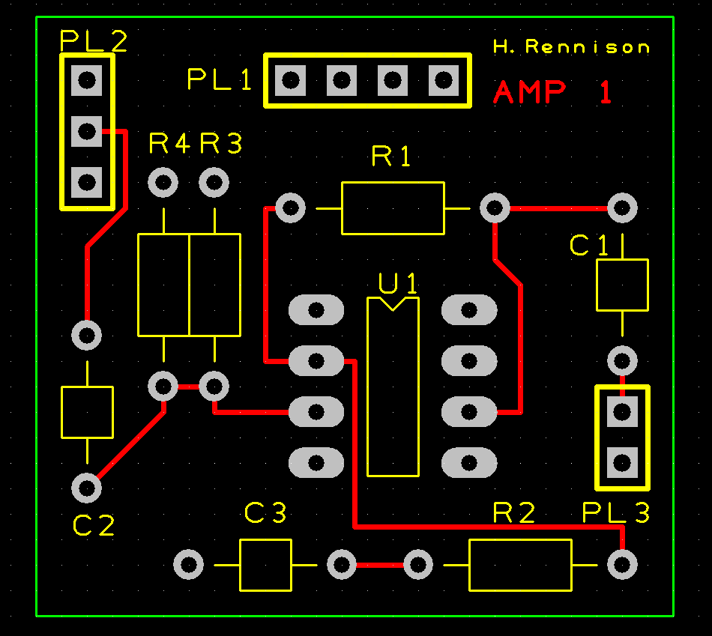
I then ran the tests that are built in to easy PC to make sure there was no obvious design flaws or inaccuracies in my easy PC Design. I did this so that when I send away the design to be manufactured it won’t come back faulty/ not working as I would expect it too.
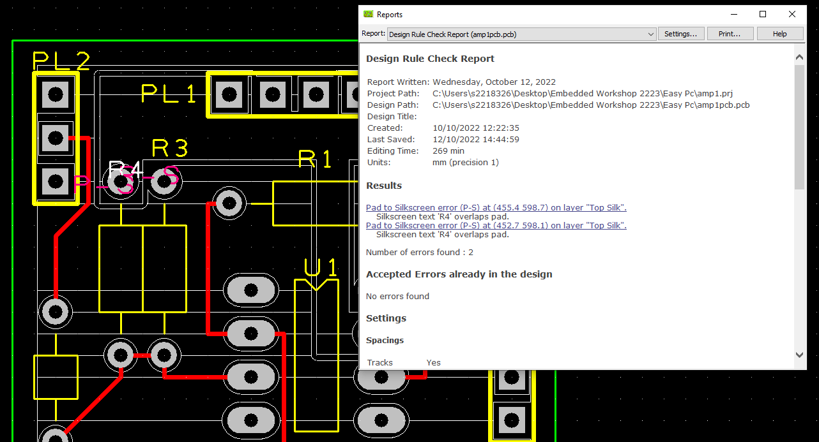
I only had one error and this was a name of a component (pink writing near R3) overlapping slightly with another component which was an easy fix and just involved me moving the name around slightly. These tests would also have highlighted if any other parts or connections were overlapping and could cause issues with the PCB working.

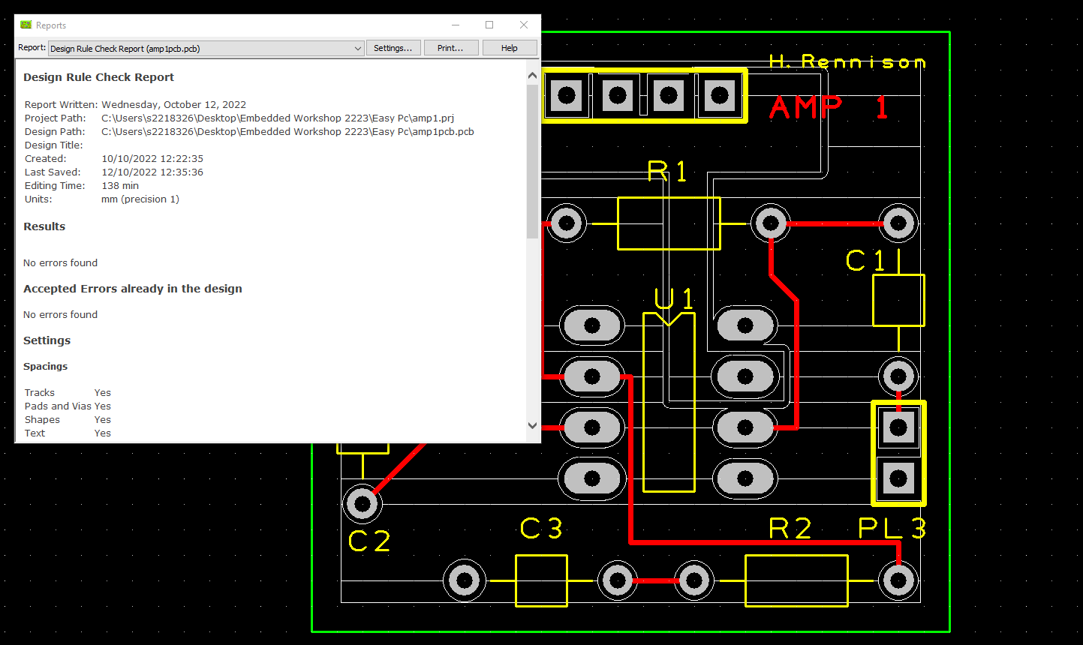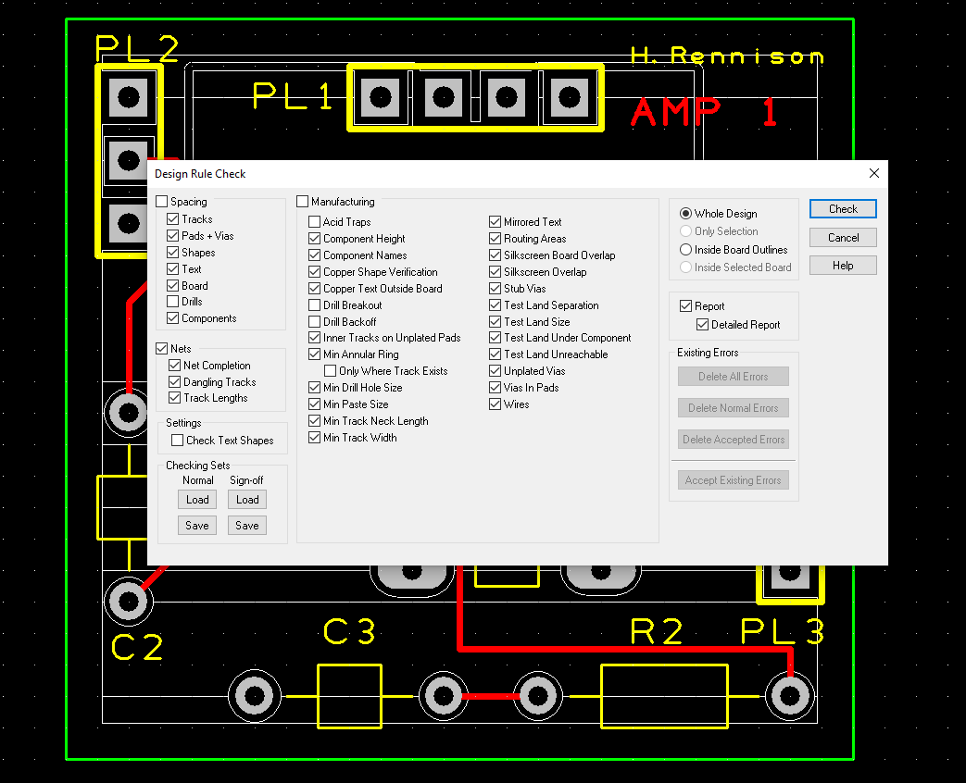

When I did the testing on the board I did it step by step rather than testing for everything in one go as this can come up with multiple errors and it can be very difficult to diagnose them all as some of them will flag up multiple times. The order in which I carried out the tests are:
- Start with spacing and untick drills.
- Then tested Nets
- Then manufacturing; acid traps, drill breakout, drill back off, only where track exists
- I then checked the 3D model of my PCB board to make sure everything looked in order.

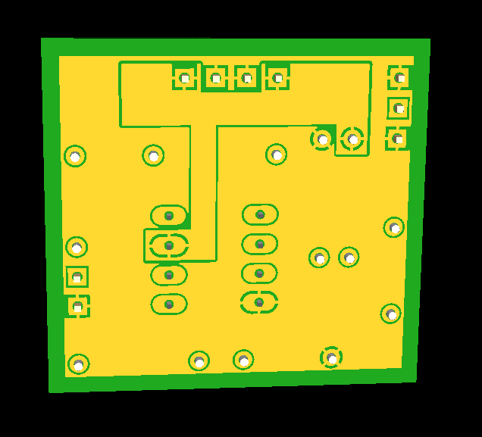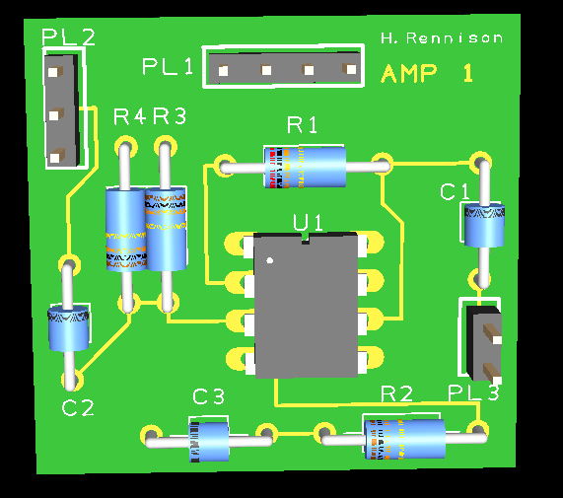

After checking for any errors on Easy PC I then went to JLPCB and uploaded my gerber file and placed the order for my PCB board to be created.

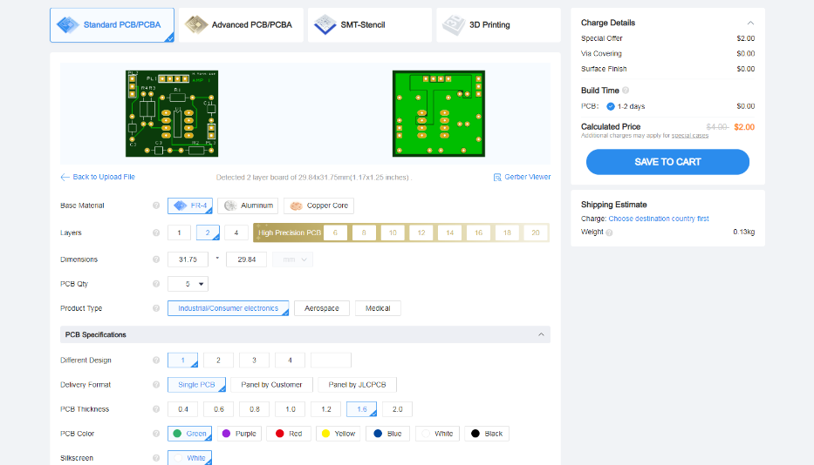

Bread Board Assembly/ Testing

After sending away my gerber file I then moved on to making my design on pebble using all the same components once again. This is just a visual prompt for my reference for putting together my physical breadboard.

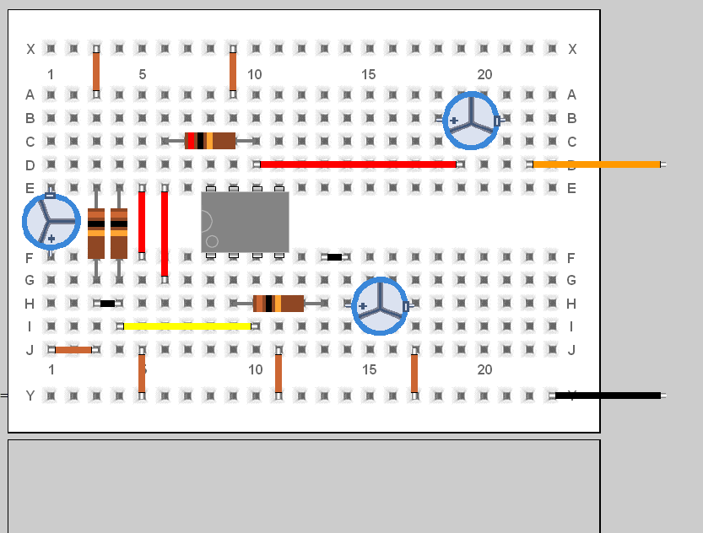
I then collected all the physical components and added them to my breadboard along with single strand copper cables to connect all the components together. It was at this point that I realised that I had the wrong resistors I had actually used 1 x 10k and 3 x 20k. After I had found this out I then corrected the error and swapped them out for the correct resistors.
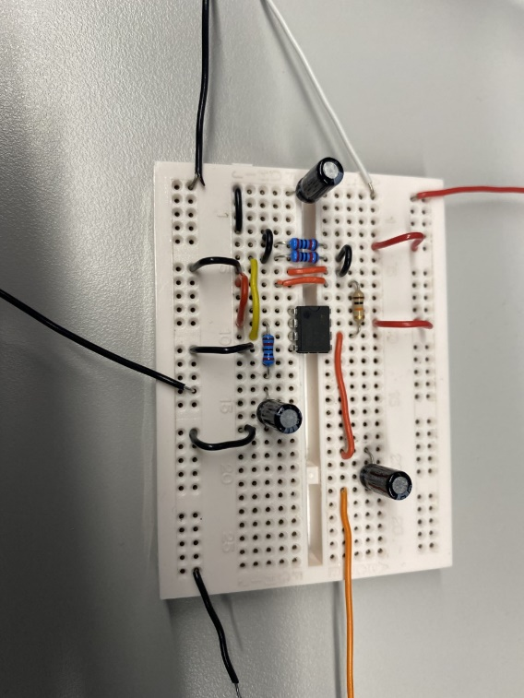
I then connected by breadboard up to the oscilloscope, wave form generator and Power supply using the probes provided set to 1x so they didn’t amplify it further. I tested at gradually increasing frequencies as I did with the proteus simulations to test it and to see what throughput we were getting. And compared them to results I got from proteus.

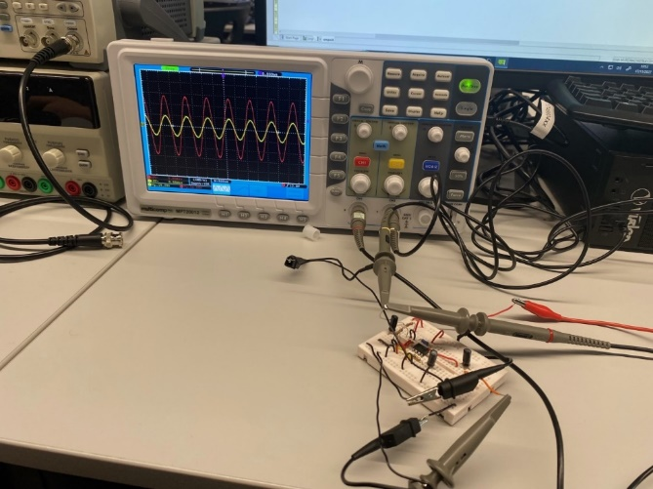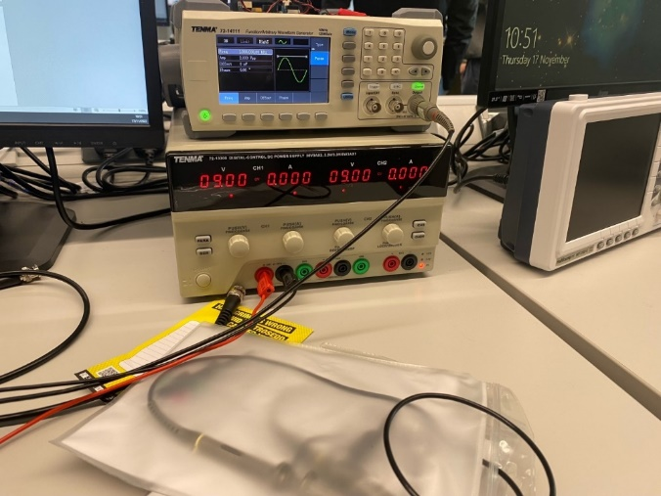

The Breadboard testing also followed the same pattern as the proteus simulations but did drop off a little later at 100 (kHz). The results were as follows:

Frequency (kHz) | Output Peak to Peak (mV) | Half wave (mV)
0.1 | 536 | 268
0.2 | 552 | 276
0.5 | 568 | 284
1 | 568 | 284
2 | 568 | 284
5 | 568 | 284
10 | 568 | 284
20 | 568 | 284
50 | 568 | 284
100 | 568 | 284
200 | 536 | 268
250 | 512 | 256
300 | 480 | 240
310 | 472 | 236
320 | 466 | 233
350 | 456 | 228
400 | 416 | 208
410 | 408 | 204
420 | 408 | 204
425 | 400 | 200
430 | 392 | 196
440 | 392 | 196
450 | 384 | 192
500 | 384 | 192

Once I had finished testing on the breadboard I then started soldering on the components to my PCB Board that had arrived since our last lecture. I started with the smaller components (resistors and 741) so that the bigger components didn’t get damaged or bent while adding the others. Once I had finished soldering the smaller parts I added the capacitors.

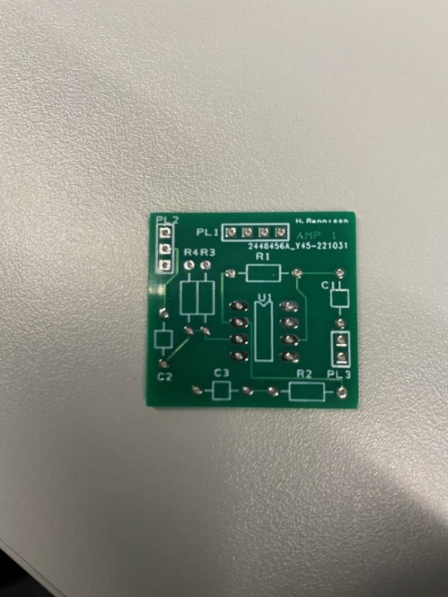
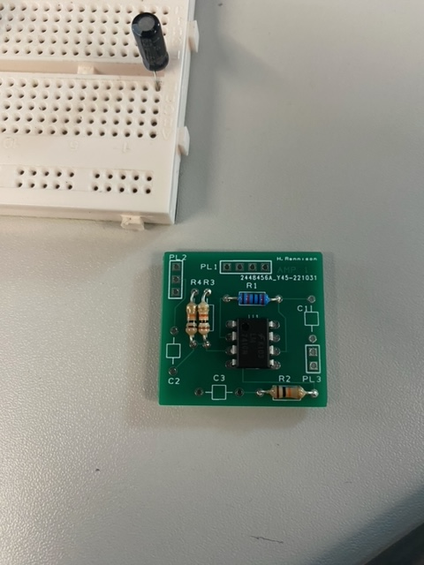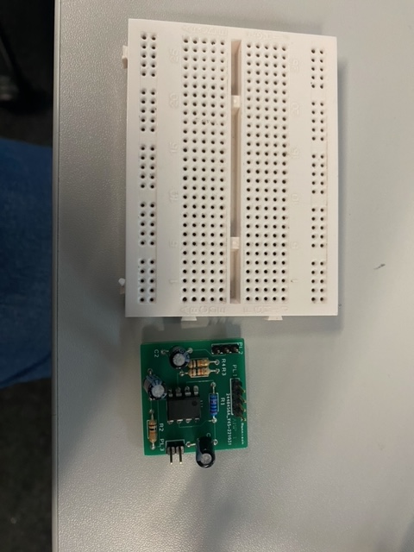
Once I had finished soldering all my components on to my PCB board I then connected it up to the oscilloscope, wave from generator and power supply to test that it was working and amplifying the input.
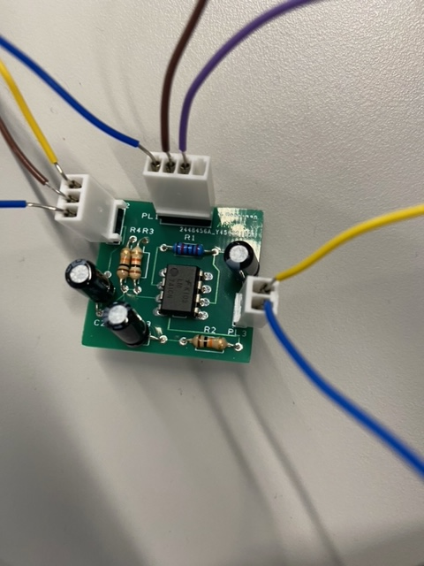
Frequency (kHz) | Output Peak to Peak (mV) | Half wave (mV)
0.1 | 532 | 266
0.2 | 552 | 276
0.5 | 568 | 284
1 | 568 | 284
2 | 568 | 284
5 | 568 | 284
10 | 568 | 284
20 | 568 | 284
50 | 568 | 284
100 | 568 | 284
200 | 528 | 264
250 | 496 | 248
300 | 464 | 232
310 | 456 | 228
320 | 448 | 224
350 | 424 | 212
400 | 392 | 196
410 | 392 | 196
420 | 384 | 192
425 | 376 | 188
430 | 372 | 186
440 | 368 | 184
450 | 360 | 180
500 | 336 | 168

I found that my PCB board despite the numbers not being exactly the same it did follow the same pattern of amplifying the input by 3. This is what the tests on my bread board and proteus also showed. The Oscillator gave me readings of the point to point where as the readings from proteus were half wave readings. Below is the graph with both the point to point and the half wave readings. You can see that they drop off at 250 khz which was very similar to the bread board which started to drop off at between 200/250 khz. Compared to my proteus results which did drop off a little earlier at around 50 khz.
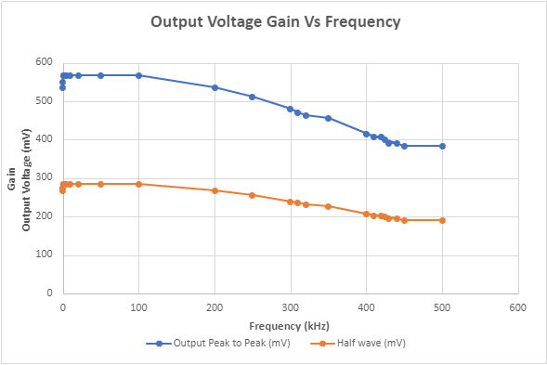

Conclusion

I found that in all my testing on Proteus, my bread board and on my finished PCB they did all show a gain of 3 the differences were with at what point they started to drop off. This can be for a number of reasons but the simulated tests on proteus has no external factors which will impact the results so I would get the same results if I was to run all the tests again. The Breadboard and PCB board were both physical tests that were done on physical bits of equipment so there is a lot more possible interference which can impact the results such as:
- Human Error
- Bad connections
- Poor soldering (PCB)
- General electrical interference.
- Test equipment not being completely accurate.

Possible ways to make the physical testing more accurate could have been to test the breadboard and PCB multiple times on different sets of test equipment. I could have also tested 2 breadboards and 2 PCB boards. This would however involve using 2 sets of all the components which would have been a waste of components. I think that my results where all pretty reliable and all showed the patterns I would have expected without any real issues or need to retest any of the above.

