Jess Eardley (2217994)
Systems engineering UWSTD
Taguchi experiment

Contents
Table of Figures 2
Table of Tables 2
Objective 3
Method and Apparatus 4
Experimental Data 5
Interpretation of Results 5
Conclusion 6
Reflection 6
Works Cited 7

Table of Figures
Figure 1 Catapult System [2]. 4
Figure 2 Front position factor graph 5
Figure 3 Pull back factor graph. 5

Table of Tables
Table 1 Experimental matrix and results. 5

Objective

The objective was finding the optimum setting of a catapult system, using Taguchi’s method to produce a design of experiments that overcomes the drawbacks of one factor at a time by testing every combination of the factors at different levels. Interactions between: ‘Band front position’ and ‘Band anchor’, ‘Band anchor’ and ‘Stop position’ will be identified using the experiments and controls can be put in place to limit these interactions and other noises found during the experiment.

Method and Apparatus

The catapult was first set up onto the table, secured with a G-clamp. The tape measure was drawn from the catapult to the end of the tables, approximately 3m. The ball was then placed into the cup by the operator. Team member 1, the operator set up the catapult system and drew it back to fire, Team member 2 placed themselves next to the tape measure to take the distance travelled by the ball, Team member 3 placed them self at the end of the table to collect the ball and roll back to the operator (A or B) and Team member 4 collected the results and added to the design matrix spreadsheet. To ensure accurate results, each experiment tested 3 times to ensure an average could be calculated.
To ensure safety on the catapult range caution was taken when launching the ball, only when the range was cleared of people. A countdown was called to ensure the team member reading the results was ready as well as alert others to impending firing.
The experiments followed the array laid out in the design matrix, each test was noted into the spreadsheet and an average result was calculated.
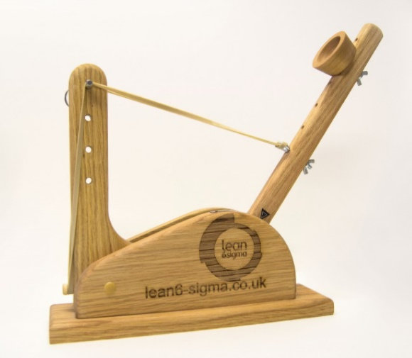
Figure 1 Catapult System [2].
The apparatus for the experiment:
- Catapult System containing
  - Band Front (position 1 & 3)
  - Band Anchor (2 & 4)
  - Stop Position (1 & 3)
  - Pull Back Scale (140 &170)
- Ball
- Tape measure
- G-Clamp

Experimental Data

The data shown in this table is the results of the catapult experiments. Shown in Table 1 in the results section shows that 3 tests were carried out for an accurate result, as the results are added together and divided by 3 to obtain an average result. The tests performed were selected using an array of L₈ which is 7 Factors at 2 levels. L_{n} means n=number of experiments. The 7 factors are shown at the top of Table 1. The factors of each are 2 different positions on the catapult and 2 different operators [1].

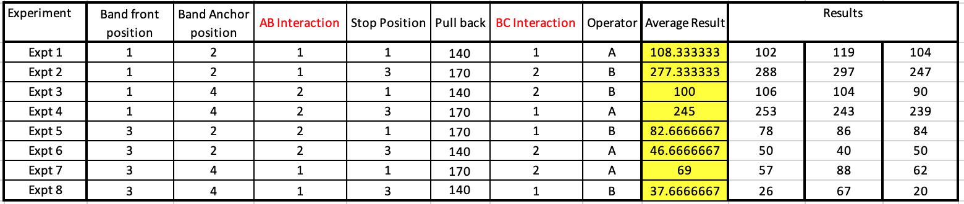
Table 1 Experimental matrix and results.

Interpretation of Results

The results show that the best result was obtained with Experiment 2 as it has the highest resulting distance travelled by the ball launch from the catapult, see Table 1. Therefore, for each of the 7 factors the optimum level was identified, these are shown in the results in Table 1.
The control factors obtained from the results is the ‘front position’ and ‘pull back’ as they have the largest range, this is obtained from the Figures 2 and 3.
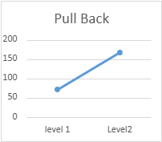
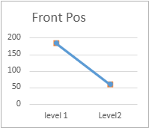

Figure 2 Front position factor graph
Figure 3 Pull back factor graph.

Conclusion

The Taguchi experiment was an efficient tool for analysing a system as only a few experiments were required. Not all possible positions required to be tested reducing time and in a live scenario, cost. The factors and levels were easily obtained from the experimental matrix, the group only having to decide on how many repeats of each experiment should take place.
The results showed a clear optimum level for each of the 7 factors during Experiment 2 as during this experiment the distance travelled was the largest. The interactions between the factors were identified as ‘pull back’ and’ front position’ from the results on the graph as here had the largest range.

Reflection

The experiment went well however the group delve straight into the task without a plan. The experiment could have gone smoother if a plan was made before the task started. The repeating of each experiment was decided after the experiment had begun, which meant going back to the first experiment to carry out further shots.
The reading of the measurement of the distance travelled by the ball wasn’t accurate with more shots being taken when the measurer missed the ball landing. These measurements were therefore not accurate and would require a better measurement method such as recording the flight of the ball and the landing and watching the recording back at a slower speed to ensure accuracy.

Works Cited

[1] | J. Z. M. O. &. B. T. Stephanie Fraley, “14.1: Design of Experiments via Taguchi Methods - Orthogonal Arrays,” Libre Text Engineering, [Online]. Available: https://eng.libretexts.org/Bookshelves/Industrial_and_Systems_Engineering/Chemical_Process_Dynamics_and_Controls_(Woolf)/14%3A_Design_of_Experiments/14.01%3A_Design_of_Experiments_via_Taguchi_Methods_-_Orthogonal_Arrays.
[2] | lean6sigma, “Training Aids,” [Online]. Available: https://www.lean6-sigma.co.uk/training-aids/.

