Dylan Samuel

2119913

Advanced construction technology

Table of Contents

- Executive Summary

- Purpose of the Report

3. Background to the Bryn Bragl Development
3.1 Site Location and Context

4. Construction Materials, Fabric Strategy and Influence of Local Government
4.1 Fabric-First Strategy Shaped by Climate and Technology Needs
4.2 Design Influenced by Solar Gain and PV Integration
4.3 Airtightness and Ventilation Systems Embedded in the Design
4.4 Response to Local Environmental Conditions

5.Building Services: Human Comfort and Energy Efficiency
5.1 Heating and Hot Water Systems
5.2 Mechanical Ventilation with Heat Recovery (MVHR)
5.3 Renewable Energy Generation and Battery Storage
5.4 Controls, Monitoring and User Interaction
5.5 Evaluation of the Building Services Strategy

6. Conclusions on Technologies, Construction Methods and Building Services

7. References

Executive summary

Bryn bragl is a housing development of 14 eco homes, which are designed to use daylight to provide most of their energy. The houses and apartments being developed by Wales & West Housing at Rhiw Cefn Gwlad, Bryn Bragl, Bridgend have been designed to shape the way zero-carbon homes could be built in the future.
They look very much like any other new housing development, except the roofs are made of electricity-generating Photovoltaic (PV) panels and inside there is a Tesla battery to store energy. Instead of gas central heating and radiators, each home is fitted with a state-of-the-art heat pump and ventilation system, which draws in fresh air which is warmed and gently circulated through the house. (Stokes, 2020)

2. Purpose of the Report

The purpose of this report is to evaluate and appraise the sustainable construction methods, technologies, and building services implemented within the Bryn Bragl residential development in Bridgend, South Wales. As the company seeks to shift towards more environmentally responsible and energy-efficient construction practices, this report provides a detailed assessment of how the project’s design, fabric, and services contribute to its status as an energy-positive development.
The report aims to identify the key features that enable the scheme to generate more energy than it consumes, and to assess how these approaches can be applied or adapted for future projects undertaken by the company. Through examining the construction methods, building envelope performance, environmental technologies, and occupant-centred building services, the report will highlight best practice elements and potential implementation challenges.
By reviewing the outcomes from Bryn Bragl and comparing them with other relevant sustainable housing schemes, this report will support informed decision-making on the adoption of low-carbon, high-performance construction techniques. It will also provide practical recommendations that align with the company’s strategic goal of delivering more sustainable, cost-effective, and future-proof developments across South Wales.

3. Background to the Bryn Bragl Development

Bryn Bragl, located in Bridgend, South Wales, is a pioneering residential scheme developed by Wales & West Housing in collaboration with Zenergy Design. Completed in 2020–2021, the project comprises fourteen highly energy-efficient homes, including one-bedroom flats, two-bedroom semi-detached houses, and four-bedroom family dwellings. The development forms part of a wider initiative to trial innovative, low-carbon housing solutions that can reduce energy consumption, lower tenant fuel bills, and contribute to national and regional carbon-reduction targets.

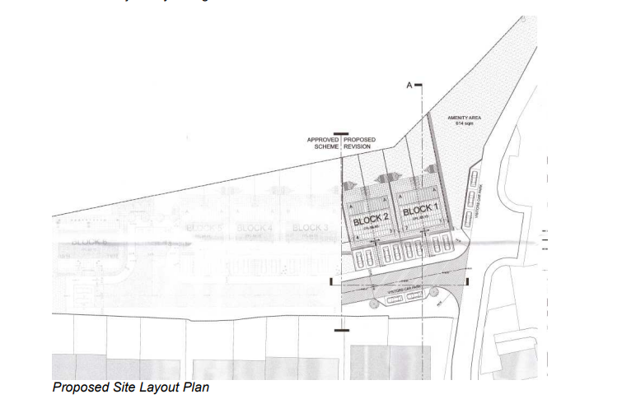

(LOCATION: Land west of Bryn Bragl Brackla CF31 2LP PROPOSAL: Residential development of 4 affordable housing units with car parking and associated works, n.d.)

The scheme is recognised as one of the first energy-positive residential developments in the region, meaning that it is designed to generate more energy than it uses over the course of a typical year. This is achieved through a combination of high-performance building fabric,
integrated renewable energy technologies, and smart, efficient building services. The design draws heavily on the principles demonstrated in the SOLCER House, a research project led by Cardiff University that explored affordable, replicable, low-carbon construction techniques.
Bryn Bragl has gained national attention for its innovative approach and has been awarded the 2024 CIBSE Residential Project of the Year, highlighting its strong performance in real-world operation. The development also aligns with Welsh Government energy and sustainability goals, contributing to the broader ambition to decarbonise the housing stock and promote more resilient, environmentally responsible communities.
Planning approval was granted under references P/17/393/FUL and P/18/410/FUL, with documents available through the Bridgend Planning Portal. These outline the design rationale, environmental considerations, and sustainability objectives embedded into the scheme from an early stage.

3.1 Site Location and Context

The location of the project benefits from good access to local services, including schools, public transport links, retail amenities, and health facilities. This reduces reliance on private car use and supports more sustainable patterns of living. The area’s topography and relatively open surroundings also allowed the design team to maximise natural daylighting and orient the dwellings favourably for solar gain and photovoltaic (PV) generation.
Bridgend’s climate, characterised by mild winters, moderate rainfall, and variable solar exposure typical of South Wales, also influenced the development’s approach to energy use and thermal performance. The site’s exposure to prevailing winds and seasonal weather patterns was considered when designing the building envelope, airtightness strategy, and renewable energy systems, ensuring that the homes maintain comfort, durability, and energy efficiency throughout the year.
Overall, the contextual characteristics of the site — including its geographical location, microclimate, and surrounding infrastructure — played a significant role in shaping the sustainable design and technology choices employed within the Bryn Bragl project.

4. Construction Materials, fabric strategy and how its been influenced by the local government

The design of the Bryn Bragl development has been fundamentally shaped by the technologies required to achieve energy-positive performance and by the environmental conditions specific to South Wales. From the earliest stages of design, renewable energy systems, fabric efficiency, and local climatic factors were treated as central design drivers rather than optional additions. This resulted in an integrated, fabric-first approach that brings together building form, orientation, materials, and services into a cohesive high-performance strategy.
4.1 Fabric-First Strategy Shaped by Climate and Technology Needs
Bryn Bragl’s construction strategy is centred on delivering a high-performance building envelope capable of minimising heat loss, reducing operational energy demand, and providing a stable thermal environment throughout the year. South Wales has a cool, damp climate with moderate wind exposure and variable solar conditions, making heat retention and airtightness essential for achieving low-energy operation.
To meet these demands, the project adopts a fabric-first approach, employing construction materials and detailing methods that offer excellent thermal performance, airtightness, and durability. A key component of this approach is the use of panelised construction systems, including Structural Insulated Panels (SIPs) or similarly high-insulation wall and roof panels. These systems provide low U-values and reduced thermal bridging, helping maintain internal warmth during colder months while reducing reliance on mechanical heating systems. Additionally, the precision of off-site fabrication ensures consistent quality, faster construction, and reduced waste—benefits that align with the project’s sustainability goals.
4.2 Design Influenced by Solar Gain and PV Integration
The local environment and technological requirements heavily influenced the orientation and roof design of the dwellings. Roof structures were specifically engineered to support extensive photovoltaic (PV) arrays, which form a fundamental part of the development’s energy-positive strategy. Rather than being retrofitted, solar technologies were integrated into the core architectural design, influencing roof pitch, structural layout, and façade positioning. This allows the PV systems to capture maximum solar exposure throughout the year, even in South Wales’ variable sunlight conditions.
High-performance triple glazing or low-emissivity double glazing further enhances solar gain while reducing heat loss. Window placement and building orientation were carefully considered to maximise natural daylighting, improve occupant comfort, and reduce the need for artificial lighting and heating.
4.3 Airtightness and Ventilation Systems Embedded in the Design
The requirement for advanced building services, specifically Mechanical Ventilation with Heat Recovery (MVHR) and compact heat pump systems, also shaped the internal layout and detailing of the dwellings. A robust airtightness strategy supports the efficient operation of these systems, with careful attention given to junctions, service penetrations, and ventilation pathways. High airtightness combined with controlled ventilation ensures that internal heat is retained while maintaining healthy indoor air quality. An important consideration in an airtight, energy-efficient home.
Space planning within the homes accommodates service zones for MVHR units, battery storage, and energy monitoring equipment. This reflects both the technological needs of the development and the requirement for simple, accessible systems suitable for social housing tenants.
4.4 Response to Local Environmental Conditions
The South Wales context influenced several aspects of the design. The region’s climate—with cool winters, damp air, and fluctuating sunlight—increased the importance of insulation, airtightness, and dependable renewable systems. Orientation was used to harness available sunlight for PV and to reduce heat gains/losses depending on seasonal changes. The local topography and exposure to prevailing winds also informed the positioning of openings, ventilation intakes, and sheltered elevations, ensuring durability and performance in all weather conditions.
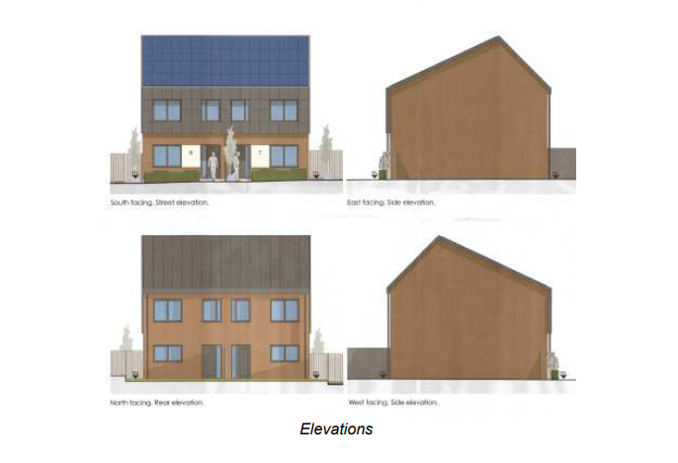

(LOCATION: Land west of Bryn Bragl Brackla CF31 2LP PROPOSAL: Residential development of 4 affordable housing units with car parking and associated works, n.d.)

5. Building Services: Human Comfort and Energy Efficiency

The building services installed at Bryn Bragl play a key role in achieving both occupant comfort and high levels of energy efficiency. Because the homes have been designed with a high-performance building fabric, the building services systems can operate efficiently and at lower energy demand. The services strategy focuses on using low-carbon technologies, maximising renewable energy use, and providing systems that are suitable for long-term use in a social housing setting.

5.1 Heating and Hot Water Systems
Space heating and domestic hot water at Bryn Bragl are primarily provided by air-source heat pumps (ASHPs). Heat pumps were selected because they are significantly more energy efficient than traditional gas boilers and align with UK and Welsh Government decarbonisation targets. ASHPs extract heat from the outside air and upgrade it to a usable temperature for space heating and hot water.
Due to the high levels of insulation and airtightness within the homes, the heating demand is relatively low. This allows the heat pumps to operate at lower flow temperatures, improving their efficiency and reducing running costs. As a result, residents benefit from comfortable internal temperatures while using less energy.
A limitation of air-source heat pumps is that their performance can reduce during very cold weather. However, the mild climate of South Wales and the low heat demand of the buildings help reduce this risk. Correct sizing and commissioning of the heat pumps is essential, as oversized or poorly set systems can lead to inefficiency and higher energy use.

5.2 Mechanical Ventilation with Heat Recovery (MVHR)
Mechanical Ventilation with Heat Recovery (MVHR) systems are used to provide continuous ventilation to each dwelling. In highly airtight homes such as those at Bryn Bragl, natural ventilation alone is not sufficient to maintain indoor air quality. MVHR systems remove stale air from kitchens and bathrooms while supplying fresh air to living spaces and bedrooms.
The key benefit of MVHR is that it recovers heat from the extracted air and transfers it to the incoming fresh air. This reduces heat loss and helps maintain stable internal temperatures, improving both comfort and energy efficiency. MVHR also helps control moisture levels, which is important in the damp climate of South Wales and reduces the risk of condensation and mould.
However, MVHR systems require regular maintenance, such as filter changes, to operate effectively. If residents are not informed about maintenance requirements, system performance and air quality can be negatively affected. This highlights the importance of resident guidance and ongoing support.

5.3 Renewable Energy Generation and Battery Storage
Electricity for the development is generated using roof-mounted photovoltaic (PV) panels. The PV systems are a central part of the development’s energy-positive strategy and were designed to generate more electricity than the homes use over a typical year.
To improve the use of on-site generated electricity, battery storage systems are installed in the dwellings. These batteries store excess electricity generated during the day and allow it to be used during periods of higher demand, such as evenings. This reduces reliance on grid electricity and increases the overall efficiency of the system.
Any surplus electricity that cannot be used or stored is exported back to the national grid. While battery systems improve performance, they increase capital costs and may require replacement over time. This must be considered when assessing long-term value and maintenance requirements.

5.4 Controls, Monitoring and User Interaction
The building services systems at Bryn Bragl are managed through simple control interfaces and energy monitoring displays. These allow residents to control heating, hot water, and ventilation settings, as well as view their energy consumption and generation.
Smart controls are used to prioritise renewable energy use, for example by charging batteries when PV output is high. Post-occupancy monitoring was carried out to assess real-world performance and identify any issues after residents moved in. This process allowed systems to be adjusted and improved, ensuring that the homes performed as intended.
A potential challenge with advanced controls is user understanding. If systems are too complex, residents may not use them correctly, which can reduce efficiency. Clear instructions and ongoing support are therefore essential.

5.5 Evaluation of Building Services Strategy
The building services strategy at Bryn Bragl successfully supports both human comfort and energy efficiency. The combination of heat pumps, MVHR, PV panels, and battery storage allows the homes to operate with low carbon emissions and reduced energy costs for residents.
However, the success of these systems depends on correct design, commissioning, maintenance, and occupant engagement. Without these, there is a risk of underperformance. Overall, the building services at Bryn Bragl demonstrate that low-carbon technologies can be effectively used in social housing when they are supported by a high-performance building fabric and appropriate user support.

6. Conclusions on Technologies, Construction Methods and Building Services

The Bryn Bragl development is a strong example of how sustainable construction methods and low-carbon building services can be successfully applied within a social housing context. In my opinion, the key reason for the project’s success is the fabric-first approach, combined with the early integration of renewable technologies and building services, rather than relying on individual technologies in isolation.
Construction Methods and Building Fabric
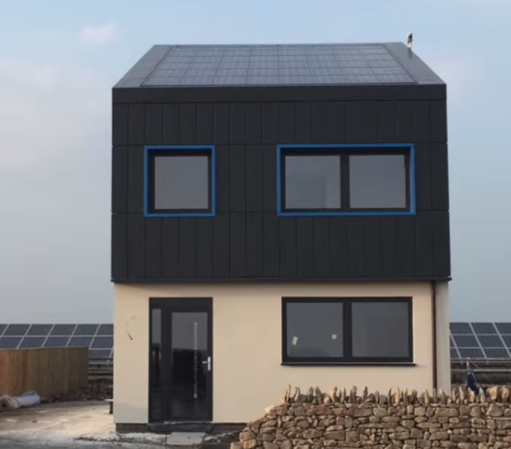
The use of high-performance building fabric, including panelised construction systems such as Structural Insulated Panels (SIPs), has significantly reduced heat loss and improved build quality. Compared to traditional masonry construction, this method delivers better airtightness, faster construction times, and improved energy performance. Similar benefits have been demonstrated in projects such as the SOLCER House in South Wales, which also achieved energy-positive performance using a fabric-first approach.
However, panelised construction requires a high level of workmanship and quality control. Other developments have shown that poor installation can lead to airtightness and moisture issues, highlighting that this method is only successful when properly designed, installed, and supervised.

(Carbon Copy, 2024)

Technologies and Building Services
The combination of air-source heat pumps, MVHR systems, photovoltaic panels, and battery storage is well suited to the low energy demand of the homes. Heat pumps operate efficiently in well-insulated dwellings, while MVHR systems improve indoor air quality and reduce heat loss. Battery storage increases on-site use of renewable electricity and supports energy-positive performance.
In other low-energy housing schemes, similar technologies have underperformed due to poor commissioning or lack of occupant understanding, particularly with MVHR systems..
Overall Conclusion
Overall, the technologies, construction methods, and building services used at Bryn Bragl have proven to be effective and demonstrate best practice for sustainable housing in South Wales. While these approaches involve higher upfront costs and increased complexity, the long-term benefits in energy efficiency, reduced carbon emissions, and occupant comfort outweigh these challenges. For future projects, adopting similar strategies, while ensuring good commissioning, maintenance, and resident support, would support the company’s move towards more sustainable construction.

References

LOCATION: Land west of Bryn Bragl Brackla CF31 2LP PROPOSAL: Residential development of 4 affordable housing units with car parking and associated works. (n.d.). Available at: https://democratic.bridgend.gov.uk/documents/s16931/P%2018%20410%20FUL.pdf [Accessed 5 Dec. 2025]
.LOCATION: Land west of Bryn Bragl Brackla CF31 2LP PROPOSAL: Residential development of 4 affordable housing units with car parking and associated works. (n.d.). Available at: https://democratic.bridgend.gov.uk/documents/s16931/P%2018%20410%20FUL.pdf.Stokes, A. (2020a).
Homes of the future in Bridgend. [online] Wales & West Housing Association. Available at: https://www.wwha.co.uk/en/news/homes-of-the-future-near-completion-in-bridgend/ [Accessed 5 Dec. 2025].Stokes, A. (2020b). Homes of the future in Bridgend. [online] Wales & West Housing Association. Available at: https://www.wwha.co.uk/en/news/homes-of-the-future-near-completion-in-bridgend/.
Carbon Copy. (2024). Solcer House: Affordable Energy Positive Housing. [online] Available at: https://carboncopy.eco/initiatives/solcer-house-affordable-energy-positive-housing.

