UNIVERSITY OF WALES TRINITY SAINT DAVID
LONDON CAMPUS
Assignment 2
Learning in the Digital Era
Video Link: A presentation on Self-Evaluation^J Professional Development Plan and Topic Summary.pdf

Module Name: Learning in the Digital Era
Module Code: ACCA 4025

Student Name: Viacheslav Odrynskyi

Student ID: 2530812

Group: 3

Lecturer’s Name: Suneth Ferdando

Table of Contents
Introduction 2
Main Body 2
Conclusion 9
References 9

Introduction
Today, I will discuss my self-evaluation, my professional development plan, and key ideas from the assigned topic, while reflecting on my strengths, goals, and future career development in the IT industry.

Main Body
This presentation focuses on my self-evaluation, professional development plan, personal strengths, career goals in the IT industry, and the use of Gibbs’ Reflective Cycle for continuous improvement.

Video Link: A presentation on Self-Evaluation^J Professional Development Plan and Topic Summary.pdf

Slide 1 COVER PAGE
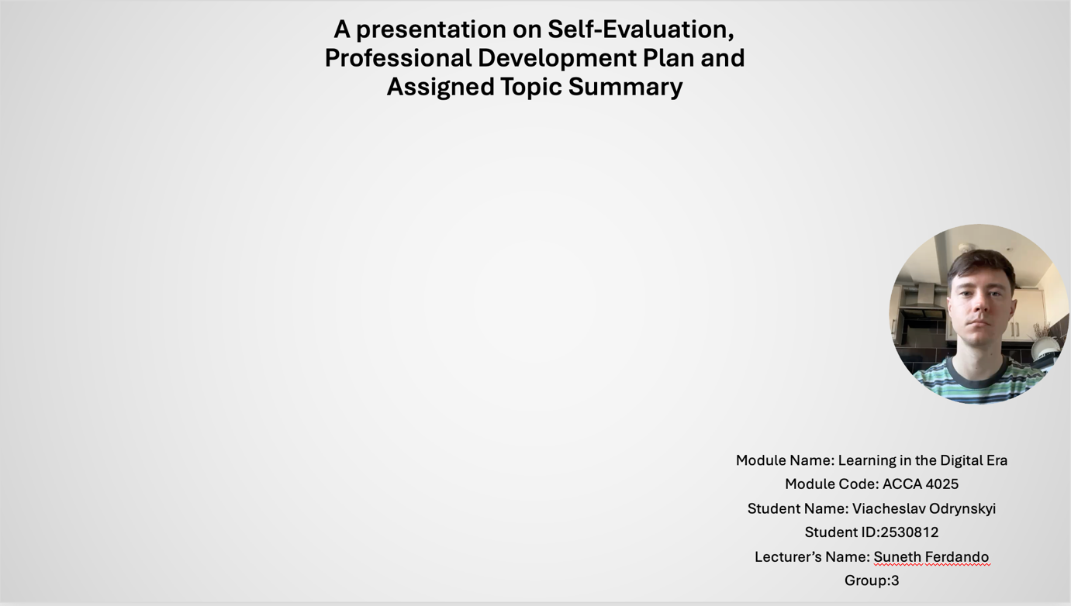

Slide 2 INTRODUCTION
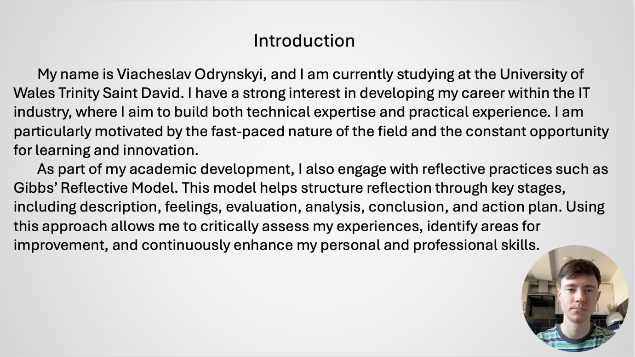

Slide 3 GIBB’s REFLECTIVE MODEL
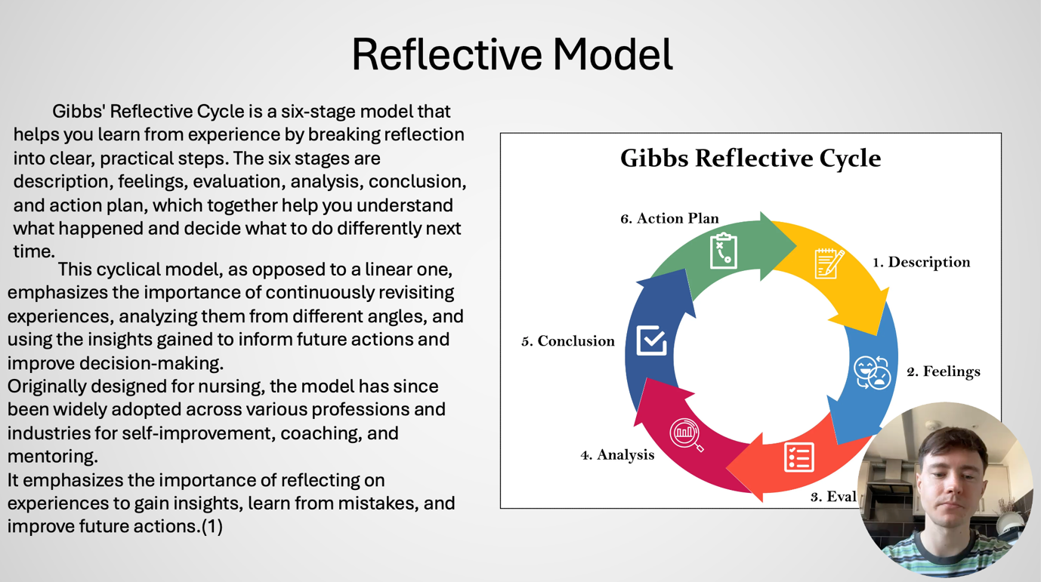

Slide 4 TASK 1: SELF EVALUATION
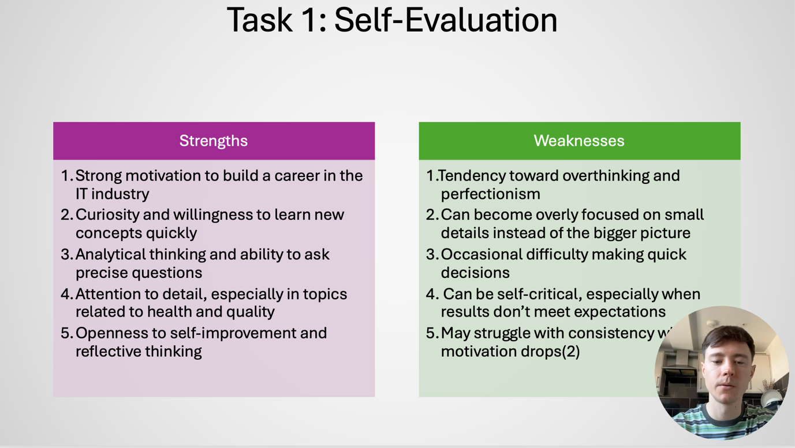

Slide 5 TRAITS GAINED FROM THE SELF EVALUATION
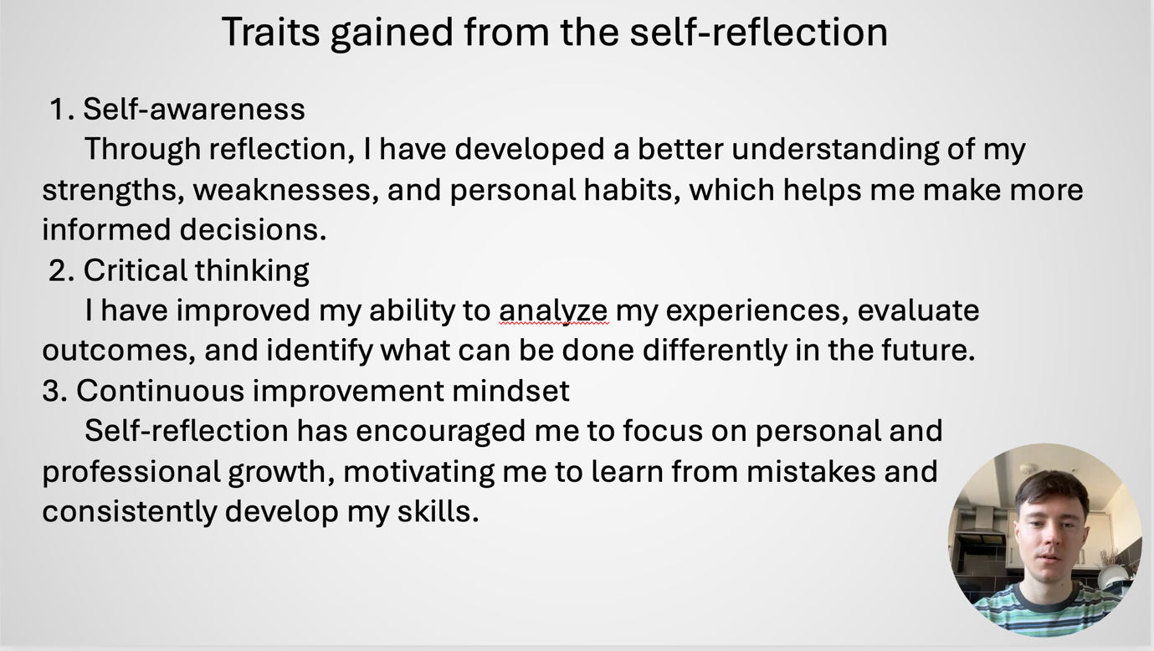

Slide 6 PROFESSIONAL DEVELOPMENT PLAN
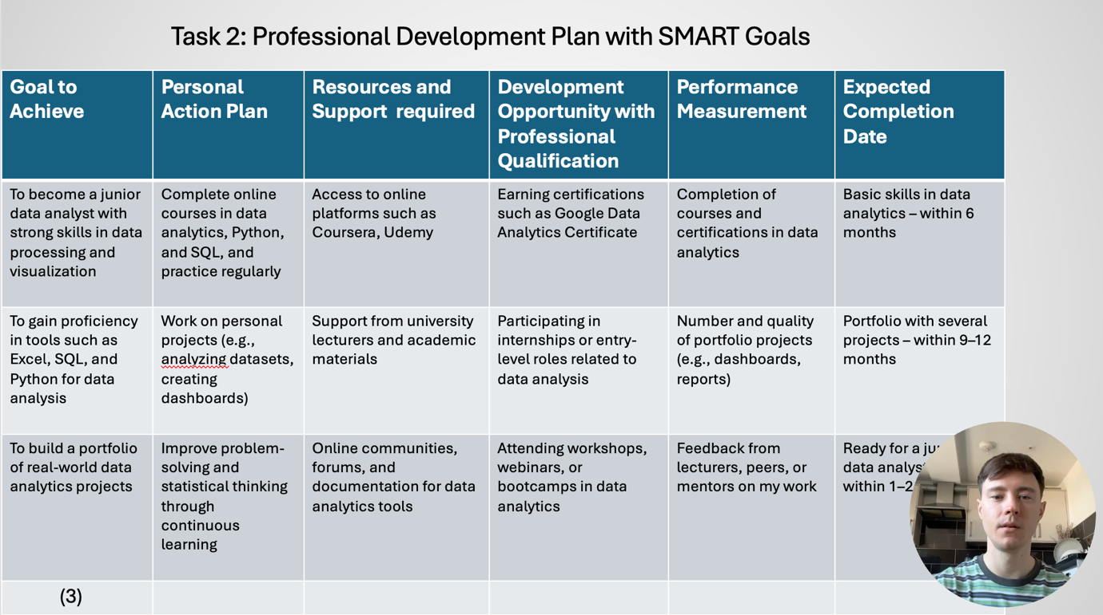

Slide 7 UNIT 4 TOPIC SUMMARY
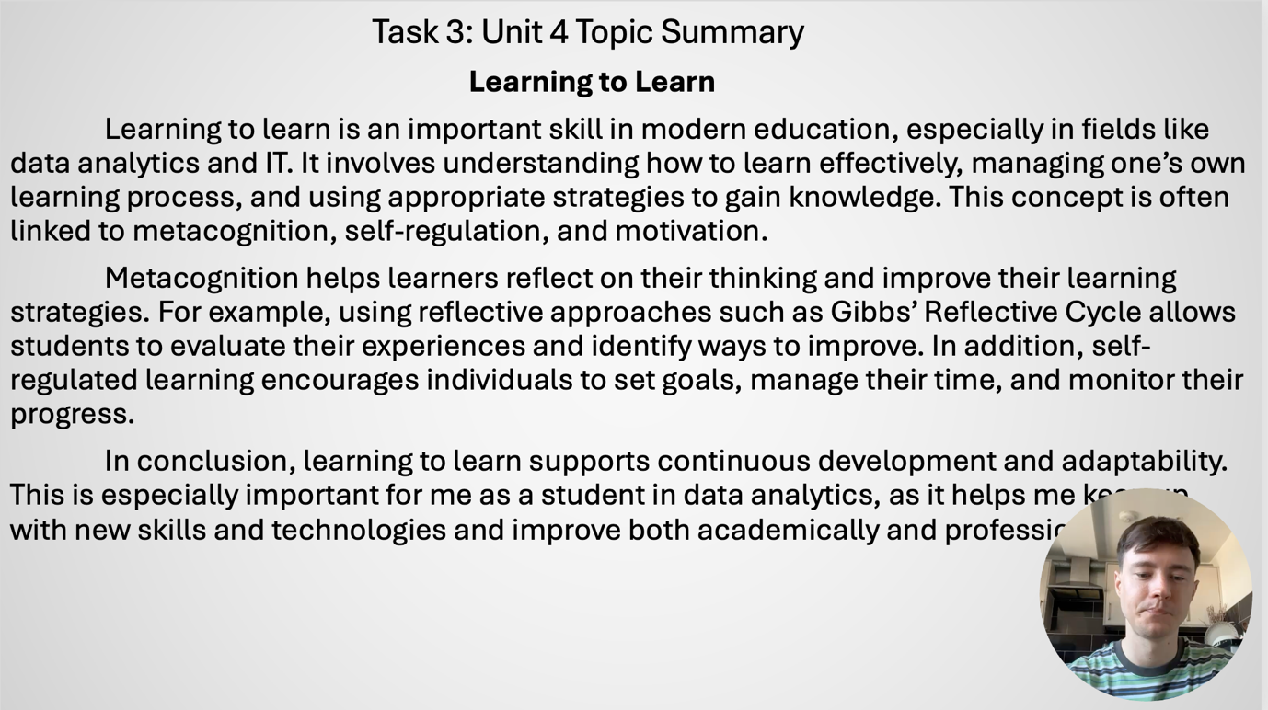

Slide 8 CONCLUSION
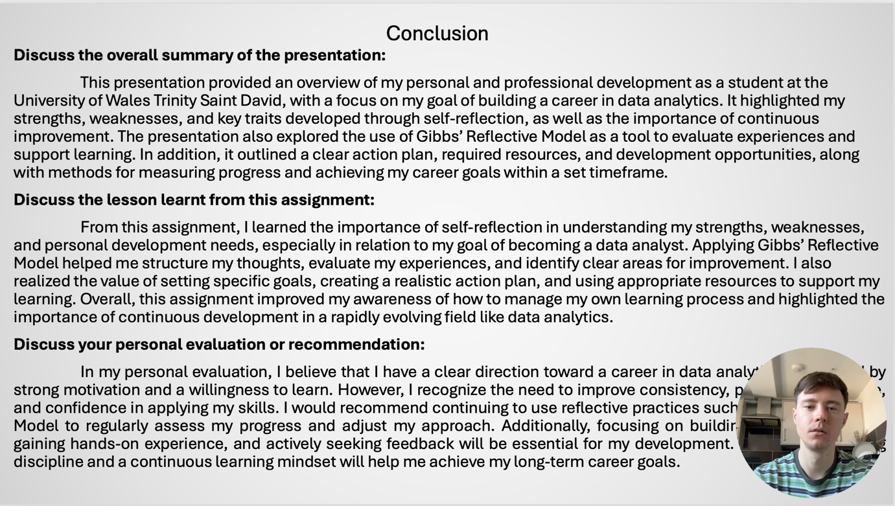

Slide 9 REFERENCES
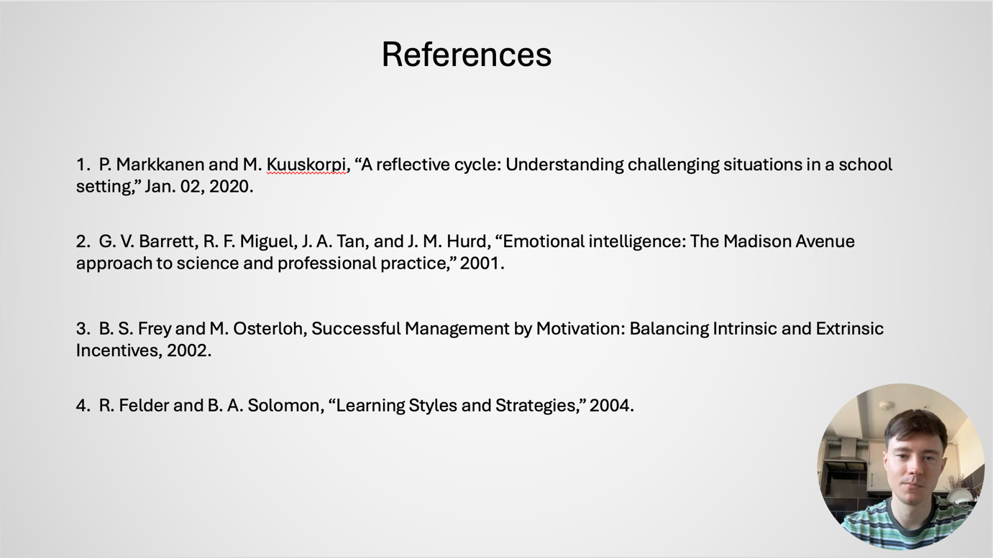

Conclusion
In conclusion, this presentation highlighted the importance of self-evaluation, reflection, and continuous development. It also showed how identifying strengths, setting career goals, and using models such as Gibbs’ Reflective Cycle can support my future growth and success in the IT industry.

References

1. P. Markkanen and M. Kuuskorpi, “A reflective cycle: Understanding challenging situations in a school setting,” Jan. 02, 2020.
2. G. V. Barrett, R. F. Miguel, J. A. Tan, and J. M. Hurd, “Emotional intelligence: The Madison Avenue approach to science and professional practice,” 2001.
3. B. S. Frey and M. Osterloh, Successful Management by Motivation: Balancing Intrinsic and Extrinsic Incentives, 2002.
4. R. Felder and B. A. Solomon, “Learning Styles and Strategies,” 2004.

