

Programme: Master of Business Administration
Module: Dissertation(Finance)
Module code: LCMB7035

Title: “Debt Financing Versus Equity Financing: Which One is More Effective for Enhancing Profitability? Evidence from Listed Companies in India, China, Japan, and South Korea.”
Lecturer: Isaiah Oino
Student name: Asha Modhwadiya
Student ID number: 2424758
Submission Date: 3rd February 2026
Word Count: 15203 Words

Declaration
I hereby certify that this dissertation entitled “Debt Financing Versus Equity Financing: Which One is More Effective for Enhancing Profitability? Evidence from Listed Companies in India, China, Japan, and South Korea” is an original piece of work carried out by me in fulfilment of the requirements for the Master of Business Administration (MBA) degree.
This dissertation has been prepared independently and has not been submitted, either wholly or partially, for the award of any other academic qualification at this or any other institution. All academic sources, data, and materials used in this study have been appropriately acknowledged and referenced in accordance with the required academic conventions.
I further confirm that this research complies with ethical academic standards and that all secondary data utilised in the study were obtained from publicly available and legitimate sources for academic purposes only.
Student Name: Asha Modhwadiya
Student ID: 2424758
Module: Dissertation (Finance) – LCMB7035
Submission Date: 3rd February 2026

Acknowledgement
I would like to express my sincere appreciation to all those who have supported and guided me throughout the completion of this dissertation.
Firstly, I am deeply grateful to my dissertation supervisor, Mr. Isaiah Oino, for his valuable guidance, academic insight, and constructive feedback during every stage of this research. His support and encouragement were instrumental in helping me refine my ideas and successfully complete this study.
I would also like to thank the faculty members of the MBA programme for equipping me with the theoretical knowledge and analytical skills required to undertake this research. Their teaching has greatly contributed to my academic and professional development.
My appreciation extends to the institutions and data providers whose publicly available financial information made this research possible. Access to reliable secondary data was essential for conducting the empirical analysis.
Finally, I would like to express heartfelt thanks to my family and friends for their constant encouragement, patience, and moral support throughout my academic journey. Their belief in me provided the motivation needed to complete this dissertation successfully.

Abstract
Capital structure decisions play a fundamental role in shaping firm performance, financial stability, and long-term competitiveness. Among these decisions, the choice between debt financing and equity financing remains a central issue in corporate finance theory and practice. Despite extensive theoretical and empirical research, existing findings on the relationship between capital structure and profitability remain inconsistent and highly dependent on institutional and market conditions. This study investigates whether debt financing or equity financing is more effective in enhancing firm profitability, using evidence from listed non-financial companies in India, China, Japan, and South Korea.
The study adopts a quantitative, explanatory research design based on secondary panel data covering the period from 2019 to 2024. Financial data were collected from publicly available sources, including annual reports, stock exchange databases, and financial information platforms. Firm profitability was measured using Return on Assets (ROA), Return on Equity (ROE), and Net Profit Margin (NPM), while capital structure was captured through debt and equity ratios. Descriptive statistics, correlation analysis, and multiple regression models were employed to examine the impact of financing choices on firm performance across different institutional contexts.
The empirical findings reveal that excessive reliance on debt financing is generally associated with lower profitability, particularly among debt-dominant firms, due to increased financial risk and interest burdens. In contrast, equity financing demonstrates a more stable and positive association with profitability, especially in firms operating in volatile or high-risk environments. The results also indicate that firm size and asset tangibility significantly influence profitability outcomes, highlighting the importance of firm-specific characteristics in capital structure decisions.
This study contributes to the capital structure literature by providing comparative evidence across emerging and developed Asian economies. The findings offer practical insights for managers, investors, and policymakers by emphasising the need for balanced and context-sensitive financing strategies.
Keywords: Capital structure, debt financing, equity financing, profitability, Asian economies

Table of Contents
Chapter 1: Introduction 8
1.1 Background of the Study 8
1.2 Research Problem 8
1.3 Research Aim and Objectives 9
1.4 Research Questions 9
1.5 Significance of the Study 10
1.6 Structure of the Dissertation 10
Chapter 2 : Literature Review 10
2.1 Introduction 10
2.2 Theoretical Foundations of Capital Structure 11
2.3 Empirical Evidence on Debt Financing and Profitability 13
2.4 Empirical Evidence on Equity Financing and Profitability 15
Chapter 3: Research Methodology 16
3.1 Introduction 16
3.2 Research Philosophy and Approach 16
3.3 Research Design 17
3.4 Data Collection 18
3.5 Step-by-Step Data Collection and Analysis Procedure 19
3.6 Variable Measurement 20
3.7 Data Analysis Techniques 21
3.8 Ethical Considerations 21
3.9 Methodological Limitations 21
3.10 Chapter Summary 21
Chapter 4: Data Analysis 22
Equity finance Firms 22
4.1. Descriptive statistic 22
4.2 Correlation analysis 23
4.3 Regression Analysis 24
Debt finance Firms 34
4.5 Descriptive statistic 34
4.6 Correlation analysis 36
4.7 Regression Analysis 37
Chapter 5: Discussion and Findings 48
5.1 Introduction 48
5.2 Capital Structure and Firm Profitability: A Synthesised Perspective 49
5.3 Debt Financing and Profitability 49
5.4 Equity Financing and Firm Performance 50
5.5 Asset Tangibility and Profitability 51
5.6 Firm Size and Performance 52
5.7 Comparative Insights Across Profitability Measures 52
5.8 Implications for Theory and Practice 53
5.9 Summary 53
Chapter 6: Conclusion and Recommendations 54
6.1 Recommendations 54
6.2 Conclusion 55
Reference 58

List of Tables
Table 1: Descriptive statistic table of Equity Finance Firms 22
Table 2: Correlation Analysis table of Equity Finance Firms 23
Table 3: Descriptive statistic table of Debt Finance Firms 34
Table 4: Correlation Analysis table of Debt Finance Firms 36

List of Figures
Figure 1: Regression Analysis of NPM Vs Debt Ratio for Equity finance Firms 24
Figure 2: Regression Analysis of NPM Vs Equity Ratio for Equity finance Firms 26
Figure 3: Regression Analysis of ROE Vs Debt Ratio for Equity finance Firms 28
Figure 4: Regression Analysis of ROE Vs Equity Ratio for Equity finance Firms 29
Figure 5: Regression Analysis of ROA Vs Debt Ratio for Equity finance Firms 31
Figure 6: Regression Analysis of ROA Vs Equity Ratio for Equity finance Firms 33
Figure 7: Regression Analysis of NPM Vs Debt Ratio for Debt finance Firms 37
Figure 8: Regression Analysis of NPM Vs Equity Ratio for Debt finance Firms 39
Figure 9: Regression Analysis of ROE Vs Debt Ratio for Debt finance Firms 41
Figure 10: Regression Analysis of ROE Vs Equity Ratio for Debt finance Firms 43
Figure 11: Regression Analysis of ROA Vs Debt Ratio for Debt finance Firms 45
Figure 12: Regression Analysis of ROA Vs Equity Ratio for Debt finance Firms 47

Chapter 1: Introduction

1.1 Background of the Study
Capital structure decisions—specifically the choice between debt and equity financing—represent one of the most critical issues in corporate finance due to their implications for firm profitability, financial risk, and long-term sustainability. Since the seminal work of Modigliani and Miller (1958), scholars have sought to understand whether financing decisions influence firm performance or whether capital structure is irrelevant under certain conditions. While the original Modigliani–Miller proposition assumes perfect capital markets, subsequent research recognises that real-world imperfections such as taxes, bankruptcy costs, information asymmetry, and agency conflicts make capital structure decisions strategically important.
Debt financing offers potential advantages, including tax shields and improved managerial discipline through fixed repayment obligations. However, excessive reliance on debt increases interest burdens, financial distress risk, and agency conflicts between shareholders and creditors. Equity financing, by contrast, enhances financial flexibility and reduces bankruptcy risk but may involve higher costs of capital, ownership dilution, and weaker managerial discipline. The balance between these benefits and costs has been extensively examined through theories such as the Trade-off Theory, Pecking Order Theory, Agency Theory, and Market Timing Theory. Despite this extensive theoretical development, empirical evidence on the capital structure–profitability relationship remains inconclusive.
Asia provides a particularly relevant and diverse context for examining this issue. Emerging economies such as India and China are characterised by evolving financial systems, higher information asymmetry, and relatively weak institutional frameworks. In contrast, developed economies such as Japan and South Korea possess mature capital markets, strong regulatory environments, and efficient credit systems. These structural and institutional differences suggest that the effectiveness of debt and equity financing may vary significantly across countries, making a comparative analysis both necessary and timely.

1.2 Research Problem
Although a substantial body of empirical research has examined the relationship between capital structure and firm profitability, findings remain mixed and context-dependent. Some studies report a positive relationship between leverage and profitability, supporting the tax-shield and disciplinary role of debt, while others document negative effects due to financial distress and agency costs. Similarly, equity financing has been associated with improved stability and long-term performance in some studies, but concerns remain regarding dilution effects and higher financing costs.
A key limitation of existing research is its focus on single-country analyses or limited regional comparisons. Few studies systematically compare emerging and developed Asian economies using multiple profitability measures and a consistent methodological framework. As a result, it remains unclear whether debt financing or equity financing is more effective in enhancing profitability across different institutional environments in Asia.
This study addresses this gap by examining listed non-financial firms in India, China, Japan, and South Korea, using multiple indicators of profitability and a comparative empirical approach.

1.3 Research Aim and Objectives
The primary aim of this study is to examine the impact of debt and equity financing on firm profitability among listed companies in selected Asian economies.
The specific objectives are to:
- Evaluate the relationship between debt financing and firm profitability.
- Examine the effect of equity financing on firm profitability.
- Compare the impact of capital structure on profitability across emerging and developed Asian economies.
- Assess whether debt or equity financing is more effective in enhancing firm profitability.
- Analyse the role of firm size and asset tangibility in shaping profitability outcomes.

1.4 Research Questions
To achieve these objectives, the study addresses the following research questions:
- How does debt financing influence firm profitability in India, China, Japan, and South Korea?
- What is the effect of equity financing on firm profitability in these countries?
- Does the relationship between capital structure and profitability differ between emerging and developed Asian economies?
- Which financing method—debt or equity—is more effective in enhancing profitability?

1.5 Significance of the Study
This study makes several important contributions. Academically, it extends the capital structure literature by providing a comparative analysis across both emerging and developed Asian economies, thereby highlighting the role of institutional and market differences in shaping financing outcomes. By employing multiple profitability measures—Return on Assets, Return on Equity, and Net Profit Margin—the study captures different dimensions of firm performance and enhances the robustness of its findings.
Practically, the findings offer valuable insights for corporate managers seeking to optimise financing strategies while managing financial risk. Investors and policymakers may also benefit from understanding how institutional environments influence the effectiveness of debt and equity financing.

1.6 Structure of the Dissertation
The remainder of this dissertation is structured as follows. Chapter 2 reviews the theoretical foundations and empirical literature on capital structure and firm profitability. Chapter 3 outlines the research methodology and data analysis techniques. Chapter 4 presents the empirical results. Chapter 5 discusses the findings in relation to theory and prior research. Chapter 6 concludes the study and provides recommendations for future research.

Chapter 2 : Literature Review

2.1 Introduction
Capital structure remains one of the most extensively debated subjects in corporate finance due to its direct implications for firm profitability, value creation, and long-term sustainability. The choice between debt and equity financing influences a firm’s cost of capital, financial risk, operational efficiency, and strategic flexibility. While early theories proposed universal principles governing capital structure decisions, contemporary research increasingly recognises that no single optimal structure applies uniformly across all markets or economies. The relationship between leverage and profitability is shaped by institutional environments, market development, governance systems, industry characteristics, and macroeconomic conditions.
Asian economies offer a particularly compelling context for examining these issues because they exhibit significant heterogeneity. India and China, as emerging markets, possess evolving financial systems, higher information asymmetry, and fluctuating economic conditions. In contrast, Japan and South Korea are mature, industrialised economies with sophisticated credit markets, robust regulatory frameworks, and competitive corporate sectors.
Existing studies reveal mixed findings on whether debt or equity financing enhances profitability, with relationships differing not only between countries but also between industries and firm sizes. Some studies suggest that debt financing boosts profitability due to tax-shield benefits and managerial discipline, while others argue that debt undermines profitability through increased financial risk and distress costs. Likewise, equity financing can promote long-term growth and innovation but may also cause dilution effects and agency conflicts. This review critically evaluates the theoretical foundations and empirical evidence relating to capital structure and profitability, with a focus on the selected Asian economies.

2.2 Theoretical Foundations of Capital Structure
2.2.1 Modigliani and Miller’s Capital Structure Irrelevance Theory
Modigliani and Miller (1958) argue that under perfect market conditions, a firm’s value is independent of its capital structure, meaning that debt and equity choices do not influence profitability or firm valuation. Their assumptions include no taxes, no transaction costs, identical borrowing costs for firms and individuals, and full information symmetry. While foundational, this theory has limited real-world applicability because capital markets are inherently imperfect. The subsequent revision by Modigliani and Miller (1963) incorporates corporate income tax, acknowledging that debt provides a tax advantage through interest deductibility, thereby increasing firm value. This modification stimulated further theoretical developments by highlighting the financial benefits of debt but also underscoring the need to account for additional real-world complexities.
2.2.2 Trade-off Theory
The Trade-off Theory posits that firms determine their optimal capital structure by balancing tax benefits of debt against potential costs of financial distress and bankruptcy (Kraus & Litzenberger, 1973). High leverage can improve profitability through tax shields but may also increase the probability of default, raising the expected cost of financial distress. In mature markets—such as Japan and South Korea—the balance between these forces tends to be more stable due to well-developed legal, regulatory, and financial systems. Conversely, in emerging economies, financial distress costs may be higher due to institutional weaknesses, inefficient bankruptcy procedures, and volatile interest rates, meaning firms might benefit less from debt financing. This theoretical perspective provides a strong foundation for understanding why the impact of debt on profitability is not uniform across countries.
2.2.3 Pecking Order Theory
Myers and Majluf (1984) propose that firms follow a preference hierarchy when selecting financing sources: internal financing is preferred first, followed by debt, and equity as a last resort. This hierarchy arises because information asymmetry makes external financing more expensive. Debt is preferred over equity because it conveys less negative signalling to investors. In emerging markets like India and China, where information asymmetry is high due to weaker disclosure standards and regulatory oversight, firms may rely disproportionately on internal funds and debt. However, this may lead to suboptimal capital structures if firms over-borrow due to limited equity market development. In developed markets, the availability of reliable financial information reduces asymmetry, enabling more balanced financing choices.
2.2.4 Agency Theory
Agency Theory, introduced by Jensen and Meckling (1976), asserts that conflicts of interest between managers, shareholders, and creditors influence capital structure decisions. Debt can mitigate agency problems by imposing mandatory interest payments, reducing free cash flow available for managerial misuse, and improving operational efficiency. However, debt may introduce new agency conflicts between shareholders and creditors, especially when firms undertake riskier projects to maximise shareholder value. These conflicts are more severe in markets with weak governance mechanisms. Studies such as Margaritis and Psillaki (2010) suggest that, under strong governance conditions, leverage can enhance firm performance by improving managerial discipline. Conversely, in environments characterised by poor governance, debt may lead to risk-shifting behaviour and financial instability.
2.2.5 Market Timing Theory
Market Timing Theory argues that firms adjust their capital structures based on current market conditions, issuing equity when stock prices are high and relying on debt when equity valuations are low (Baker & Wurgler, 2002). Firms in developed capital markets typically have greater ability to engage in market timing due to liquid equity markets and high investor participation. In contrast, emerging market firms may find it more difficult to time markets due to volatility, regulatory hurdles, or limited demand for new equity. This theory underscores that capital structure decisions are dynamic and influenced by market sentiment, which varies considerably across Asian economies.
2.2.6 Dynamic Capital Structure and Adjustment Costs
Modern capital structure theories argue that firms adjust leverage gradually due to adjustment costs, including transaction costs, market conditions, and financial constraints. Dang, Kim and Shin (2012) demonstrate that firms when above their target leverage adjust more slowly due to financial distress risks. This is especially relevant in emerging markets where capital market volatility and institutional constraints can slow adjustments. These theories contribute to understanding why firms in different countries may exhibit persistent variations in leverage, affecting profitability outcomes.

2.3 Empirical Evidence on Debt Financing and Profitability
2.3.1 Empirical Findings in Emerging Markets
A substantial body of literature has examined the impact of debt financing on firm performance in emerging economies, with many studies reporting negative or insignificant effects.
Abor (2005), studying listed firms in Ghana, found that short-term debt is positively associated with profitability, while long-term debt negatively influences performance. This reflects the heavy reliance on short-term borrowing in developing economies due to limited long-term credit availability.
In India, multiple studies have documented negative effects of leverage on profitability. Pandey and Sahu (2019) reveal that high debt levels reduce performance due to increased agency costs and financial distress. Chakraborty (2010) finds similar results, noting that Indian firms often face high interest burdens and inefficiencies in debt management, reducing the potential benefits of tax shields.
Researchers have also identified institutional influences in China. Chen (2004) reports that leverage is shaped by government involvement, state ownership, and regulatory constraints rather than market forces, diminishing the effectiveness of debt. Tian, Wang and Kohar (2024) demonstrate a U-shaped relationship between leverage and performance, suggesting that moderate debt enhances profitability but excessive leverage reduces innovation and increases financial risk.
Studies in other emerging markets echo these findings. Zeitun and Tian (2007) found negative relationships between both short-term and long-term debt and profitability in Jordanian firms. Similarly, Acaravci (2015) reports that in European emerging markets, debt is often negatively correlated with profitability due to high borrowing costs and macroeconomic instability.
2.3.2 Evidence from Developed Asian Economies
In contrast, developed Asian economies often display more favourable relationships between debt and profitability due to stronger financial systems, efficient regulatory frameworks, and lower distress costs.
Hirota (1999) finds that Japanese firms benefit from leverage due to close relationships with banks through the keiretsu system, which reduces information asymmetry and provides access to stable financing. Bank-based financial systems in Japan allow firms to borrow at favourable rates, enhancing profitability.
South Korea exhibits similar characteristics. Kim and Lee (2008) show that chaebol-affiliated firms effectively use debt to finance growth due to strong relationships with lenders, government support, and diversified business structures that reduce risk. Zhao and Fang (2023) further demonstrate that debt financing influences strategic behaviour such as pricing and product differentiation, supporting profitability in competitive markets.
Hovakimian, Opler and Titman (2001) provide international evidence that profitable firms tend to use debt strategically to adjust toward optimal leverage levels, which is more achievable in developed markets with stable credit environments.
2.3.3 Cross-Regional Insights
Comparative studies reveal that institutional quality, creditor rights, tax regimes, and financial development play critical roles in determining whether debt financing enhances or reduces profitability.
Booth et al. (2001), comparing developing and developed countries, find that firms in emerging markets rely less on long-term debt due to underdeveloped financial systems. Fan, Titman and Twite (2012) emphasise that creditor protection and governance shape capital structure decisions more strongly than firm-specific factors alone. Rajan and Zingales (1995), studying G7 countries, show that profitability, size, and tangibility influence leverage differently depending on institutional environments.
Collectively, the evidence suggests that debt financing may enhance profitability in environments where borrowing costs are low, governance is strong, and bankruptcy procedures are efficient. Conversely, debt may impede profitability when financial systems are weak or volatile.

2.4 Empirical Evidence on Equity Financing and Profitability
2.4.1 Conceptual Overview of Equity Financing
Equity financing provides firms with long-term capital without imposing mandatory interest payments. It enhances financial flexibility, supports investment in innovation, and reduces bankruptcy risk. However, equity issuance can dilute ownership and reduce earnings per share. The effectiveness of equity financing therefore depends on market conditions, investor sentiment, governance structures, and firm-specific factors.
2.4.2 Equity Financing in Emerging Markets
Equity financing can be particularly advantageous in emerging economies where debt markets are underdeveloped or interest rates are high. Almanaseer (2024) finds that equity financing significantly improves performance in Jordan by reducing financial distress and supporting reinvestment.
In India, the expansion of equity markets and regulatory reforms have enabled firms to raise capital more efficiently. However, information asymmetry and moderate investor protection may limit the degree to which equity can replace debt (Chakraborty, 2010). Firms often rely on retained earnings or equity issuance for growth, especially in technology and service sectors where intangible assets reduce access to traditional lending.
In China, state-owned enterprises (SOEs) often rely heavily on equity financing due to government policies, stock market characteristics, and limited dependence on private credit markets (Chen, 2004). While equity supports long-term investment, market volatility and regulatory intervention weaken its overall effectiveness.
2.4.3 Equity Financing in Developed Asian Markets
Developed markets such as Japan and South Korea have deep, liquid equity markets that allow firms to raise capital efficiently. Firms often use equity to finance strategic initiatives, mergers, acquisitions, and global expansion.
In Japan, equity markets are mature, and investor confidence is high, enabling firms to raise long-term capital with minimal signalling issues. Firms in South Korea, particularly large chaebols, issue equity to fund international expansion and diversification, contributing positively to profitability.
2.4.4 Comparative Evidence on Equity vs Debt
Evidence from multiple studies indicates that the effectiveness of financing decisions depends heavily on the broader economic and institutional environment in which firms operate. Debt financing tends to enhance firm performance in stable environments characterised by strong financial systems, efficient credit markets, and robust institutional frameworks, as demonstrated in Japan and South Korea (Hirota, 1999; Kim & Lee, 2008). Conversely, equity financing appears more advantageous in volatile environments or in firms pursuing high-growth opportunities, where flexibility and reduced financial risk are essential for sustaining long-term performance (Almanaseer, 2024; Chen, 2004). Ultimately, factors such as the cost of debt, the quality of corporate governance, and the maturity of financial markets play central roles in determining whether debt or equity financing contributes more effectively to profitability. Thus, the relationship between financing decisions and firm performance is not universal but shaped by the specific economic, institutional, and strategic context in which firms operate.

Chapter 3: Research Methodology

3.1 Introduction
This chapter outlines the research methodology adopted to examine the relative effectiveness of debt financing and equity financing in enhancing firm profitability. The methodological framework is designed to ensure that the research objectives and questions outlined in earlier chapters are addressed systematically, transparently, and rigorously. In line with the study’s empirical focus, a quantitative research approach is employed, using secondary panel data from listed companies in India, China, Japan, and South Korea.
The chapter explains the research philosophy, research design, data sources, sample selection, variable measurement, and analytical techniques used in the study. It also details the step-by-step procedure followed for data collection and analysis, ensuring replicability and methodological consistency. Finally, ethical considerations and methodological limitations are discussed.

3.2 Research Philosophy and Approach
3.2.1 Research Philosophy
This study is grounded in a positivist research philosophy, which assumes that economic and financial relationships can be objectively measured and analysed using empirical data. Positivism is particularly appropriate for finance research, as it emphasizes observable facts, quantifiable variables, and statistical testing. The relationship between capital structure and profitability is examined using numerical indicators derived from firms’ financial statements, allowing hypotheses to be tested using econometric techniques.
The positivist stance enables the researcher to remain independent from the subject of study, reducing bias and increasing the reliability of findings. Since the study seeks to explain causal relationships between financing structure and firm performance, rather than explore subjective perceptions, positivism provides an appropriate philosophical foundation.
3.2.2 Research Approach
A deductive research approach is adopted in this study. Deductive reasoning begins with established theories—such as the Modigliani and Miller propositions, Trade-off Theory, Pecking Order Theory, and Agency Theory—and tests their applicability using empirical data. Hypotheses regarding the impact of debt and equity financing on profitability are derived from these theories and evaluated using regression analysis.
The deductive approach is suitable because the relationship between capital structure and profitability has been widely theorised and empirically tested in prior studies. This research extends existing knowledge by testing these theoretical predictions within a comparative Asian context.

3.3 Research Design
3.3.1 Quantitative and Explanatory Design
The study employs a quantitative, explanatory research design. Quantitative methods allow financial variables such as leverage ratios and profitability indicators to be measured objectively and analysed statistically. The explanatory nature of the research focuses on identifying and explaining causal relationships between capital structure variables (debt and equity financing) and firm profitability.
This design is appropriate because the research questions seek to determine how and to what extent debt and equity financing influence profitability, rather than merely describing patterns. By applying regression analysis, the study assesses both the direction and magnitude of these effects.
3.3.2 Comparative Cross-Country Design
A comparative research design is incorporated to examine differences in capital structure effects across four Asian economies: India, China, Japan, and South Korea. These countries were selected because they represent both emerging markets (India and China) and developed markets (Japan and South Korea), allowing the study to explore how institutional maturity and market development influence financing decisions and profitability.
The comparative approach enhances the external validity of the study and allows conclusions to be drawn about the context-dependent nature of capital structure decisions.

3.4 Data Collection
3.4.1 Type and Source of Data
The study relies solely on secondary data, which is well suited to the financial nature of the research. These data were sourced from reputable and publicly available platforms such as Yahoo Finance, annual reports published on company websites, and official stock exchange portals including the NSE, SSE, TSE, and KRX. Using secondary data provides access to standardized and audited financial information, thereby enhancing the accuracy and reliability of the analysis. Moreover, reliance on publicly available sources ensures transparency and adherence to ethical research standards.
3.4.2 Time Period
The study covers a six-year period from 2019 to 2024. This period captures both stable economic conditions and periods of heightened uncertainty, including the COVID-19 pandemic and post-pandemic recovery. Analysing this timeframe allows the study to observe how capital structure decisions perform under varying macroeconomic conditions.
3.4.3 Sample Selection
The sample comprises approximately 20 listed non-financial firms, with about 50 firms selected from each country. Financial institutions, including banks and insurance companies, were excluded because their distinct regulatory environments and capital structure characteristics differ substantially from those of non-financial firms. Firms were selected based on specific criteria: they had to be publicly listed, operate within non-financial sectors, and possess complete financial data for the entire study period. This sampling approach enhances cross-country and cross-firm comparability while ensuring consistency and reliability of the data used in the analysis.

3.5 Step-by-Step Data Collection and Analysis Procedure
This study follows a structured, multi-stage procedure for data collection and analysis, as outlined in the researcher’s methodological notes.
3.5.1 Step 1: Measuring Capital Structure
The first step of the analysis involved assessing the extent to which firms are financed through debt and equity. This was done by calculating standard capital structure ratios for each firm across the study period, including the debt-to-assets ratio, equity-to-assets ratio, and debt-to-equity ratio. Together, these measures provide a clear and comparable indication of firms’ reliance on debt versus equity financing. Employing multiple ratios enhances the robustness of the analysis and helps reduce potential measurement bias.
3.5.2 Step 2: Classification by Financing Structure
Based on the calculated ratios, firms were grouped according to their dominant financing structure—debt-oriented or equity-oriented. This classification enabled a more nuanced analysis by allowing profitability patterns to be examined separately for firms relying primarily on debt versus those relying more heavily on equity.
Correlation analysis was initially conducted to examine the association between financing structure and profitability indicators. This exploratory step provided preliminary insights and informed the subsequent regression analysis.
3.5.3 Step 3: Regression Analysis
Multiple linear regression analysis was subsequently employed to examine the impact of capital structure on firm profitability. Separate regression models were estimated for the overall sample, as well as for subsamples of debt-financed firms and equity-financed firms. This approach enabled the study to assess not only whether capital structure influences profitability, but also whether the nature and magnitude of this effect vary according to the dominant mode of financing.
3.5.4 Step 4: Comparative Interpretation
The results were compared across the different models by examining the direction of the coefficients, the magnitude of the estimated effects, and their statistical significance. This comparative analysis allowed the researcher to identify which financing method—debt or equity—exerts a stronger and more consistent influence on firm profitability.
3.5.5 Step 5: Interpretation and Discussion
Finally, the empirical findings were interpreted in light of established theories and prior empirical studies. This step linked the results to the broader academic debate on capital structure and provided the foundation for the discussion and conclusion chapters.

3.6 Variable Measurement
3.6.1 Dependent Variables: Profitability Measures
Firm profitability was measured using three widely accepted financial indicators:
- Return on Assets (ROA)
$$ROA=\frac{Net Income}{Total Assets}$$
- Return on Equity (ROE)
$$ROE=\frac{Net Income}{Total Equity}$$
- Net Profit Margin (NPM)
$$NPM=\frac{Net Income}{Revenue}$$
Using multiple profitability measures enhances robustness and allows different dimensions of performance to be captured.
3.6.2 Independent Variables
- Debt Ratio = Total Debt / Total Assets
- Equity Ratio = Total Equity / Total Assets
These variables capture firms’ reliance on debt and equity financing, respectively.
3.6.3 Control Variables
To isolate the effect of capital structure on profitability, several control variables were included:
- Firm Size: Natural logarithm of total assets
- Asset Tangibility: Fixed assets / Total assets
These controls are widely used in capital structure literature and help reduce omitted variable bias.

3.7 Data Analysis Techniques
3.7.1 Descriptive Statistics
Descriptive statistics were used to summarise the data and provide insights into the distribution, central tendency, and variability of the variables.
3.7.2 Correlation Analysis
Correlation analysis was conducted to examine the strength and direction of relationships between capital structure variables and profitability indicators. This step helped identify potential multicollinearity and informed regression modelling.
3.7.3 Regression Modelling
Multiple linear regression models were estimated using SPSS. The general model specification is:
$$Profitiability=X_{0}+X_{1}\left(Independent variable\right)+X_{2}(Control Variable)$$
Separate models were estimated for debt and equity financing to enable direct comparison.

3.8 Ethical Considerations
The study adheres strictly to ethical research standards. Only publicly available secondary data were used, eliminating issues related to confidentiality or informed consent. All sources were properly cited, and data were analysed objectively without manipulation.

3.9 Methodological Limitations
Despite its rigor, the methodology has limitations. The relatively small sample size may limit generalisability. Differences in accounting standards across countries may affect comparability. Additionally, the study does not explicitly control for industry-specific effects or macroeconomic shocks.

3.10 Chapter Summary
This chapter has outlined the methodological framework used to examine the impact of debt and equity financing on firm profitability across selected Asian economies. By employing a quantitative, comparative approach and following a clear step-by-step analytical procedure, the study ensures methodological transparency and robustness. The next chapter presents and analyses the empirical findings derived from this methodology.

Chapter 4: Data Analysis

Equity finance Firms

4.1. Descriptive statistic
Table 1: Descriptive statistic table of Equity Finance Firms
Table 1 presents the descriptive statistics for the key variables used in this study, including measures of profitability, firm characteristics, and capital structure, based on 48 firm-year observations. The statistics provide an overview of the central tendency, dispersion, and range of the data, offering initial insights into the financial performance and financing behaviour of listed firms in the selected Asian economies.
Regarding profitability indicators, the mean Return on Assets (ROA) is 0.1089, indicating that, on average, firms generate approximately 10.9% profit from their total assets. The relatively low standard deviation (0.0616) suggests moderate variability in asset efficiency across firms. Return on Equity (ROE) has a higher mean value of 0.1429, implying that shareholders earn an average return of 14.3% on their invested capital. However, the higher dispersion (standard deviation of 0.0846) indicates greater differences in shareholder returns, potentially driven by variations in leverage levels. Net Profit Margin (NPM) records a mean of 0.1374, showing that firms retain around 13.7% of revenue as net profit, with a wide range between the minimum (0.009) and maximum (0.391), reflecting heterogeneity in cost efficiency and pricing power.
Firm size, measured by the natural logarithm of total assets (Ln(TA)), has a mean of 14.05, suggesting that the sample largely consists of medium to large firms. The wide range (9.69 to 20.06) indicates substantial variation in firm scale, which justifies its inclusion as a control variable in regression analysis. Tangibility, measured as tangible assets to total assets, has a relatively low mean of 0.1776, implying that most firms rely more on intangible or current assets. This may limit collateral availability and influence firms’ ability to access debt financing.
With respect to capital structure, the mean debt ratio is 0.3490, indicating that debt finances approximately 35% of total assets, suggesting a moderate reliance on debt. The equity ratio shows a high mean value of 0.8980, reflecting strong equity financing and retained earnings across firms. The mean debt-to-equity ratio of 0.5036 further confirms that equity dominates the capital structure in the sample. However, the wide variation in equity and debt ratios suggests that firms adopt diverse financing strategies depending on market conditions and institutional environments.

4.2 Correlation analysis
Table 2: Correlation Analysis table of Equity Finance Firms
Table 2 presents the Pearson correlation coefficients among profitability measures, firm characteristics, and capital structure variables. The correlation analysis provides preliminary insights into the direction and strength of relationships between variables and helps identify potential multicollinearity issues prior to regression analysis.
Among the profitability indicators, Return on Assets (ROA) shows a strong positive correlation with Return on Equity (ROE) (r = 0.707), indicating that firms with higher asset efficiency tend to generate higher returns for shareholders. Similarly, ROA exhibits a strong positive relationship with Net Profit Margin (NPM) (r = 0.794), suggesting that firms that manage assets efficiently also achieve superior profit margins. The correlation between ROE and NPM is positive but moderate (r = 0.329), reflecting that shareholder returns are influenced not only by operational profitability but also by leverage decisions.
Firm size, measured by the natural logarithm of total assets (LnTA), displays a negative correlation with ROA (r = –0.338) and ROE (r = –0.590), implying that larger firms in the sample tend to exhibit lower profitability ratios. This may be attributed to operational inefficiencies, higher agency costs, or diminishing marginal returns associated with firm expansion. However, LnTA shows an almost zero correlation with NPM (r = 0.003), indicating that firm size does not significantly affect profit margins.
Asset tangibility (Tangible/TA) is negatively correlated with all profitability measures, though the relationships are weak. This suggests that firms with a higher proportion of tangible assets may experience slightly lower profitability, potentially due to capital-intensive operations and higher depreciation costs. Tangibility is positively correlated with firm size (r = 0.329), indicating that larger firms tend to hold more tangible assets.
Regarding capital structure, the debt ratio is negatively correlated with ROA (r = –0.247), ROE (r = –0.143), and NPM (r = –0.302), suggesting that higher leverage is associated with lower profitability. This supports the argument that excessive reliance on debt may increase financial risk and interest burden, thereby reducing firm performance. In contrast, the equity ratio exhibits positive correlations with ROA (r = 0.348) and NPM (r = 0.499), indicating that equity financing is associated with stronger profitability, particularly in terms of profit margins.
The debt-to-equity ratio shows a strong negative correlation with ROA (r = –0.445) and NPM (r = –0.585), reinforcing the adverse effect of high leverage on profitability. As expected, it is strongly positively correlated with the debt ratio (r = 0.752) and strongly negatively correlated with the equity ratio (r = –0.711), confirming consistency among capital structure measures.

4.3 Regression Analysis
4.3.1 NPM Vs Debt Ratio
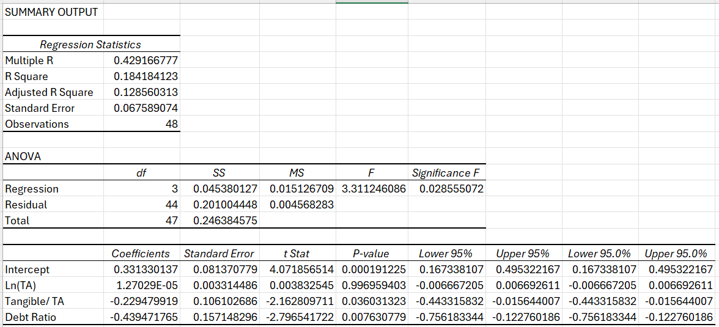
Figure 1: Regression Analysis of NPM Vs Debt Ratio for Equity finance Firms
The regression analysis presented examines how three independent variables—Ln(Total Assets), Tangible Assets to Total Assets, and Debt Ratio—affect the dependent variable in the study. The model summary shows an R Square of 0.184, meaning that only 18.4% of the variation in the dependent variable is explained by the predictors. This indicates a relatively weak model, suggesting that many other factors outside the model contribute to the outcome. The Adjusted R Square, which accounts for the number of variables and sample size, is slightly lower at 0.128. This supports the conclusion that the model offers only modest explanatory power and that additional variables could improve prediction accuracy.
Despite the low R-square, the ANOVA table shows that the regression model is statistically meaningful. The F-statistic is 3.311, and the Significance F is 0.028, which is below the common significance threshold of 0.05. This means the overall regression is significant, and collectively, the independent variables have an effect on the dependent variable. In other words, even though the model does not explain a large portion of the variance, it performs better than random guessing and identifies statistically relevant relationships.
Examining the coefficients helps to understand the role of each independent variable. The intercept is significant, but it mainly provides a baseline value when all predictors equal zero. The coefficient for Ln(Total Assets) is extremely small and statistically insignificant (p-value ≈ 0.997). This indicates that firm size, as measured by the logarithm of total assets, does not have a meaningful impact on the dependent variable. This could be due to limited size variation in the sample or because firm size is not a strong determinant of the outcome being studied.
The variable Tangible Assets/Total Assets has a statistically significant negative coefficient (p-value ≈ 0.036). This suggests that firms with a higher proportion of tangible assets tend to have lower values of the dependent variable. One possible interpretation is that firms with large tangible asset bases may operate in traditional or capital-intensive industries that grow more slowly or experience higher operating costs. The result may also indicate reduced flexibility due to fixed capital commitments, which can hinder performance.
The Debt Ratio also shows a significant negative effect (p-value ≈ 0.008). This means that firms with higher leverage tend to perform worse or experience lower values of the dependent variable. High levels of debt can increase financial risk, reduce financial stability, and elevate interest expenses, all of which can negatively affect firm performance. This finding aligns with established financial theories that warn against excessive reliance on debt financing.
4.3.2 NPM Vs Equity Ratio
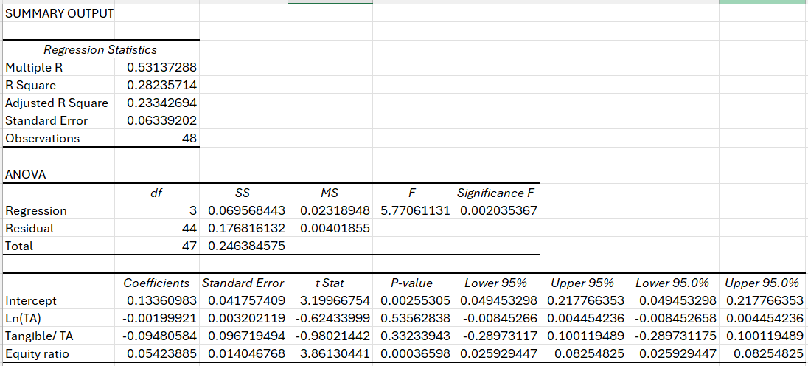
Figure 2: Regression Analysis of NPM Vs Equity Ratio for Equity finance Firms
The regression output evaluates the impact of three independent variables—Ln(Total Assets), Tangible Assets/Total Assets, and Equity Ratio—on the dependent variable. The model summary indicates a Multiple R of 0.531, showing a moderate relationship between the predictors and the dependent variable. The R Square value of 0.282 means that approximately 28.2% of the variation in the dependent variable is explained by the model. Although this is not a very high percentage, it is substantially better than models with extremely low explanatory power. The Adjusted R Square (0.233) is slightly lower but still indicates that the model performs reasonably well after adjusting for the number of predictors. The Standard Error of 0.063 suggests the average distance between actual and predicted values is relatively small, improving confidence in the model’s accuracy.
The ANOVA table strengthens the model’s validity. The F-statistic of 5.77 and a Significance F of 0.002 indicate that the overall regression is statistically significant at the 1% level. This means the predictors, when considered together, meaningfully explain variation in the dependent variable. In simple terms, the model performs significantly better than chance and confirms that at least one of the independent variables contributes to predicting the dependent variable.
The coefficient table provides deeper insight into the influence of each variable. The intercept (0.1336) is statistically significant (p = 0.0026), indicating that when all independent variables equal zero, the dependent variable would have this baseline value. While the intercept is not typically the main focus in financial models, its significance confirms that the regression line does not pass through zero and that a meaningful constant is required for accurate predictions.
The coefficient for Ln(Total Assets) is negative (–0.00199), but with a high p-value of 0.535, making it statistically insignificant. This result suggests that firm size, measured through the natural logarithm of total assets, has no meaningful effect on the dependent variable within this dataset. This may occur for several reasons: the firms in the sample may be similar in size, or size may not be a relevant predictor of performance for the sector under study. Additionally, certain industries do not benefit simply from being large; instead, strategic capabilities and market conditions may play more important roles.
The variable Tangible Assets/Total Assets also shows an insignificant result. Its coefficient (–0.0948) suggests a negative relationship, but the high p-value (0.332) means the effect is not statistically valid. This implies that the proportion of tangible assets does not strongly influence the dependent variable. In many modern industries, especially service-based or technology-driven sectors, tangible assets may not determine performance. Firms relying heavily on intangible assets—such as intellectual property, innovation, or human capital—may outperform others regardless of their tangible asset structure.
The most important variable in the model is the Equity Ratio, which has a positive and highly significant coefficient (0.05423) with a p-value of 0.00036. This strong significance indicates that firms with higher equity ratios tend to have better outcomes for the dependent variable. A higher equity ratio reflects stronger capital structure, lower reliance on debt, and greater financial stability. This reduces financial risk, lowers interest costs, and increases investor confidence. As a result, firms with higher equity financing are typically more resilient and capable of sustaining growth, which may explain the strong positive relationship.
4.3.3 ROE Vs Debt Ratio
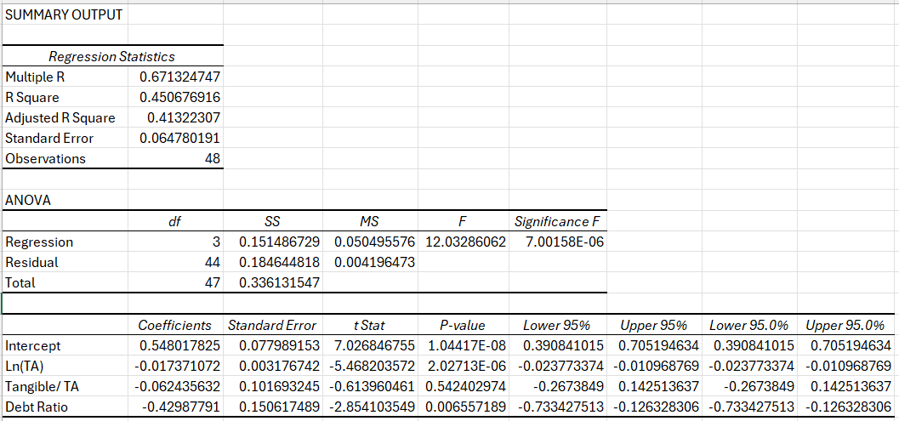
Figure 3: Regression Analysis of ROE Vs Debt Ratio for Equity finance Firms
The regression output presented analyzes the effects of three independent variables—Ln(TA) (natural logarithm of total assets), Tangible Assets to Total Assets, and Debt Ratio—on the dependent variable. Beginning with the model summary, the Multiple R value of 0.6713 indicates a moderately strong correlation between the predicted and actual values. The R Square value of 0.4507 shows that approximately 45.1% of the variation in the dependent variable is explained by the model. This represents a noticeable improvement in explanatory power compared to typical financial regression models. The Adjusted R Square of 0.4132 confirms the model’s overall effectiveness even after adjusting for the number of predictors. The Standard Error of 0.0647 suggests a relatively small average prediction error, improving confidence in the reliability of the model outcomes.
Support for the model’s overall validity is further strengthened by the ANOVA results. The F-statistic of 12.03 with a remarkably low Significance F (7.00 × 10⁻⁶) demonstrates that the regression is highly statistically significant. This means that the combined effect of the independent variables is meaningful and not the result of random chance. In other words, the model as a whole is capable of explaining a substantial portion of the dependent variable’s behavior.
Turning to the coefficients, the intercept (0.548) is positive and highly significant, as indicated by the extremely small p-value (1.04 × 10⁻⁸). This suggests that when all independent variables are equal to zero, the dependent variable would take on this baseline value. Although the intercept is not the main focus of interpretation, its significance indicates that a constant term is essential for accurately modeling the relationship.
The variable Ln(TA) displays a coefficient of –0.01737 and a highly significant p-value (≈ 2.03 × 10⁻⁶). This negative and significant coefficient suggests a strong inverse relationship between firm size and the dependent variable. In practical terms, as firm size increases, the dependent variable tends to decrease. This result may arise for various reasons: larger firms often face bureaucratic inefficiencies, increased operational complexity, or higher levels of regulation. Additionally, in some sectors, smaller firms may be more agile and innovative, giving them an advantage that larger firms cannot easily replicate.
The coefficient for Tangible Assets/Total Assets is –0.06243, but it is not statistically significant (p = 0.542). This means that the proportion of tangible assets does not have a measurable effect on the dependent variable within this sample. One reason for this insignificance may be the increasing importance of intangible assets—such as knowledge, innovation, and technology—in modern industries. Firms with similar tangible asset proportions may differ substantially in intangible capabilities, weakening the predictive power of tangible asset ratios.
The Debt Ratio, however, shows a significant negative coefficient of –0.4299 with a p-value of about 0.0065. This indicates a strong negative effect of financial leverage on the dependent variable. Higher debt levels increase interest obligations, financial risk, and potential distress costs, which can harm firm performance and reduce financial stability. This aligns with well-established financial theories stating that although debt can offer tax benefits, excessive debt reduces flexibility and exposes firms to higher risk during economic downturns.
4.3.4 ROE Vs Equity Ratio
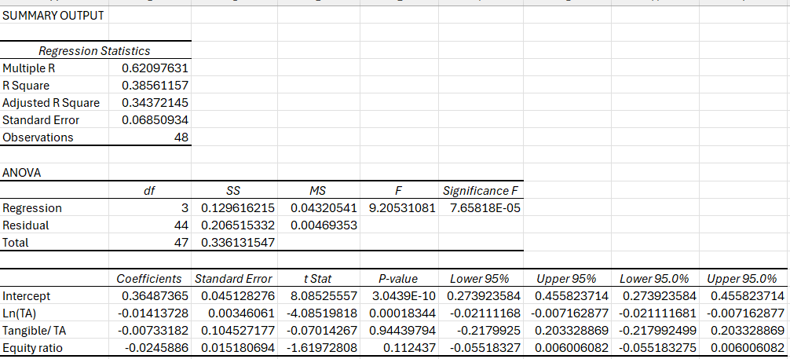
Figure 4: Regression Analysis of ROE Vs Equity Ratio for Equity finance Firms
The regression output examines the relationship between three independent variables—Ln(TA) (natural logarithm of total assets), Tangible Assets to Total Assets, and Equity Ratio—and the dependent variable. The model summary shows a Multiple R of 0.6209, indicating a moderately strong correlation between the predicted values and the actual values of the dependent variable. The R Square value of 0.3856 means that the model explains about 38.6% of the variation in the dependent variable. This level of explanatory power is reasonable for financial and economic data, which often involve many influencing factors not included in the model. The Adjusted R Square of 0.3437 confirms that even after adjusting for the number of predictors, the model remains strong and meaningful. The Standard Error of 0.0685 suggests that the average deviation between actual and predicted values is relatively small, indicating a good model fit.
The ANOVA section further reinforces the model’s validity. The F-statistic of 9.205 and the extremely small Significance F of 7.66 × 10⁻⁵ indicate that the regression model is highly statistically significant. This means that the independent variables collectively explain the dependent variable far better than random chance. Such a low Significance F strongly suggests that the model provides valuable insight into the relationships under study.
Turning to the coefficients, the intercept (0.3649) is statistically significant with a very low p-value (3.04 × 10⁻¹⁰). This means the constant term plays an important role in fitting the regression line. While the intercept is not usually interpreted in a theoretical sense, it indicates the baseline value of the dependent variable when all predictors are equal to zero.
The variable Ln(TA) has a coefficient of –0.01414 and a p-value of 0.00018, making it highly significant. This strong negative coefficient indicates that firm size, measured by the natural logarithm of total assets, has a significant inverse relationship with the dependent variable. In practical terms, as firms become larger, the dependent variable tends to decrease. The reasons for this may vary: larger firms may experience increased bureaucracy, reduced operational flexibility, slower innovation, or higher compliance costs. Another interpretation is that smaller firms might be more adaptive and efficient, resulting in better performance in certain industries.
The coefficient for Tangible Assets/Total Assets is –0.0073, but with a high p-value (0.944), the variable is not statistically significant. This means the proportion of tangible assets does not meaningfully influence the dependent variable within this dataset. A likely explanation is that tangible assets no longer serve as a major driver of performance or financial outcomes in many modern sectors. Instead, intangible assets—such as brand value, human capital, technology, and innovation—play a greater role. When firms differ greatly in intangible capabilities, tangible asset proportions lose predictive power.
The Equity Ratio presents a coefficient of –0.0246 with a p-value of 0.112, making it insignificant at the 5% level but potentially meaningful at a 10% level. Although not statistically significant, the negative coefficient suggests that higher equity ratios may be associated with lower values of the dependent variable. This outcome may seem counterintuitive, but there are possible explanations. Firms with higher equity ratios often avoid debt, which may reduce financial leverage benefits such as tax shields. Additionally, firms with excessive equity financing may sacrifice potential returns from leveraging opportunities. However, because the result is statistically weak, no firm conclusion should be drawn.
4.3.5 ROA Vs Debt Ratio
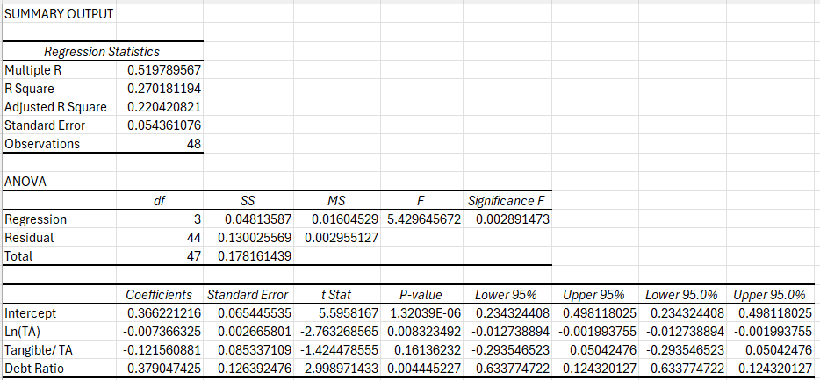
Figure 5: Regression Analysis of ROA Vs Debt Ratio for Equity finance Firms
The regression analysis investigates the relationship between the dependent variable and three independent variables: Ln(Total Assets), Tangible Assets to Total Assets, and Debt Ratio. The objective is to understand how firm size, asset structure, and leverage influence the dependent variable. According to the model summary, the Multiple R value of 0.520 indicates a moderate correlation between the predicted and actual values of the dependent variable. The R Square value of 0.270 shows that approximately 27.0% of the variation in the dependent variable is explained by the independent variables. Although this is not a high level of explanatory power, it is acceptable in financial studies where firm outcomes are influenced by many unobserved factors. The Adjusted R Square (0.220) suggests that the model remains meaningful after accounting for the number of predictors. The Standard Error of 0.0544 indicates relatively small prediction errors.
The ANOVA results confirm the overall significance of the regression model. The F-statistic of 5.43 and Significance F of 0.0029 demonstrate that the model is statistically significant at the 1% level. This implies that the independent variables jointly explain the dependent variable better than chance. In other words, while the model does not capture all sources of variation, it provides statistically reliable insights into the relationship between the variables.
Turning to the coefficient estimates, the intercept has a value of 0.366 and is highly significant (p-value ≈ 1.32 × 10⁻⁶). This intercept represents the baseline level of the dependent variable when all independent variables are equal to zero. Although the intercept itself is not central to economic interpretation, its significance indicates that a constant term is necessary to accurately model the relationship.
The coefficient for Ln(Total Assets) is –0.00737, and it is statistically significant at the 1% level (p-value ≈ 0.0083). This negative coefficient suggests that firm size has a significant inverse relationship with the dependent variable. As firms grow larger, the dependent variable tends to decline. One possible explanation is that larger firms often experience bureaucratic inefficiencies, reduced operational flexibility, and slower decision-making processes. In contrast, smaller firms may be more agile, innovative, and better positioned to adapt to changing market conditions, which may result in better outcomes.
The variable Tangible Assets/Total Assets also has a negative coefficient (–0.1216), but it is not statistically significant (p-value ≈ 0.161). This indicates that the proportion of tangible assets does not significantly affect the dependent variable in this sample. A likely reason is that tangible assets alone do not determine firm outcomes in many industries today. Instead, intangible assets such as technology, brand value, managerial expertise, and human capital may play a more important role. Additionally, differences in tangible asset intensity across firms may not be large enough to generate a statistically significant effect.
The Debt Ratio shows a strong negative and statistically significant coefficient of –0.3790 with a p-value of approximately 0.0044. This result indicates that higher leverage is associated with lower values of the dependent variable. Firms with high debt ratios face higher interest obligations, increased financial risk, and greater vulnerability to economic downturns. Excessive debt can also limit managerial flexibility and restrict investment opportunities, thereby negatively affecting performance. This finding is consistent with financial theory, which suggests that while moderate debt can be beneficial, excessive leverage increases the likelihood of financial distress.

4.3.6 ROA Vs Equity Ratio
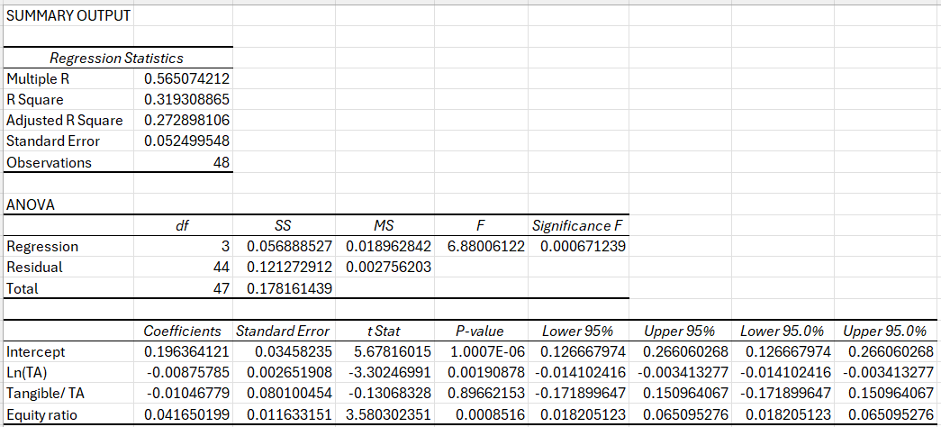
Figure 6: Regression Analysis of ROA Vs Equity Ratio for Equity finance Firms
The regression analysis evaluates the relationship between the dependent variable and three explanatory variables: Ln(Total Assets), Tangible Assets to Total Assets, and Equity Ratio. The objective is to understand how firm size, asset structure, and capital structure influence the dependent variable. The model summary indicates a Multiple R value of 0.565, suggesting a moderate correlation between the predicted and actual values. The R Square of 0.319 shows that approximately 31.9% of the variation in the dependent variable is explained by the independent variables. While this is not a high level of explanatory power, it is reasonable for firm-level financial data, where outcomes are often driven by many unobserved factors. The Adjusted R Square of 0.273 confirms that the model remains statistically meaningful after adjusting for the number of predictors. The Standard Error of 0.0525 suggests that the model’s predictions are fairly accurate.
The ANOVA results indicate that the regression model is statistically significant. The F-statistic of 6.88 and the Significance F of 0.00067 are well below the 5% threshold, confirming that the independent variables jointly explain the dependent variable better than random chance. This result supports the reliability of the regression model and indicates that at least one explanatory variable has a significant effect on the dependent variable.
Examining the coefficients, the intercept has a value of 0.196 and is highly significant (p-value ≈ 1.00 × 10⁻⁶). This intercept represents the expected value of the dependent variable when all independent variables are equal to zero. Although such a scenario is unlikely in practice, the significance of the intercept suggests that including a constant term improves the model’s overall fit.
The coefficient for Ln(Total Assets) is –0.00876 and is statistically significant at the 1% level (p-value ≈ 0.0019). This negative coefficient implies a significant inverse relationship between firm size and the dependent variable. As firm size increases, the dependent variable tends to decline. One possible reason is that larger firms often face higher levels of bureaucracy, slower decision-making, and increased operational complexity. These factors can reduce efficiency and performance compared to smaller, more flexible firms. Additionally, larger firms may operate in mature markets with limited growth opportunities, which could also explain the negative relationship.
The variable Tangible Assets/Total Assets has a small negative coefficient (–0.0105) but is not statistically significant (p-value ≈ 0.897). This suggests that the proportion of tangible assets does not have a meaningful effect on the dependent variable in this sample. A possible explanation is that tangible assets alone do not determine firm outcomes, especially in modern economies where intangible assets such as technology, innovation, and human capital play a more prominent role. Moreover, the limited variation in tangible asset ratios across firms may weaken its statistical impact.
The Equity Ratio has a positive and statistically significant coefficient of 0.0417 with a p-value of approximately 0.00085. This result indicates that firms with higher equity ratios tend to have better outcomes for the dependent variable. A higher equity ratio reflects stronger capitalization, lower reliance on debt, and reduced financial risk. Firms that rely more on equity financing typically face lower interest obligations and are less exposed to financial distress, which can enhance stability and performance. This finding is consistent with financial theory that emphasizes the benefits of conservative capital structures.

Debt finance Firms

4.5 Descriptive statistic
Table 3: Descriptive statistic table of Debt Finance Firms
Table 3 reports the descriptive statistics of the variables used in the empirical analysis based on 48 firm-year observations. The table summarizes profitability indicators, firm characteristics, and capital structure measures, providing an overview of the financial position and performance of firms in the sample.
With respect to profitability, the mean Return on Assets (ROA) is 0.0198, indicating that firms generate an average profit of approximately 2.0% from their total assets. The relatively low mean value, combined with a standard deviation of 0.0439, suggests weak asset efficiency and noticeable variability across firms. The negative minimum ROA (–0.1682) indicates that some firms experienced operating losses during the study period. Return on Equity (ROE) has a mean of 0.0458, implying that shareholders earn an average return of 4.6%. However, the large standard deviation (0.1600) and negative minimum value (–0.5398) reflect substantial volatility in shareholder returns, likely influenced by leverage and firm-specific risks. Net Profit Margin (NPM) records a mean of 0.0351, indicating that firms retain about 3.5% of revenue as net profit, with negative minimum values highlighting profitability challenges for certain firms.
Firm size, measured by the natural logarithm of total assets (LnTA), has a mean value of 16.45, suggesting that the sample consists primarily of large listed firms. The wide range of firm size supports its inclusion as a control variable, as size differences may significantly affect financing choices and profitability. Asset tangibility shows a mean of 0.1728, indicating that tangible assets account for approximately 17% of total assets. This relatively low level suggests a greater reliance on intangible or current assets, which may constrain firms’ borrowing capacity due to limited collateral.
Regarding capital structure, the mean debt ratio is relatively high at 0.6641, implying that debt finances about 66% of total assets. This indicates a strong reliance on debt financing within the sample. The equity ratio has a mean of 0.3373, showing that equity represents a smaller portion of total financing. The mean debt-to-equity ratio of 2.2913 further confirms the dominance of debt over equity. The wide dispersion in these ratios suggests heterogeneity in financing strategies and exposure to financial risk.

4.6 Correlation analysis
Table 4: Correlation Analysis table of Debt Finance Firms
Table 4 presents the Pearson correlation coefficients among profitability indicators, firm characteristics, and capital structure variables for the sample firms. The correlation analysis provides initial evidence on the direction and strength of relationships between variables and assists in identifying potential multicollinearity concerns prior to regression analysis.
The profitability measures—Return on Assets (ROA), Return on Equity (ROE), and Net Profit Margin (NPM)—exhibit very strong positive correlations with one another. ROA is highly correlated with ROE (r = 0.898) and NPM (r = 0.902), while ROE and NPM also show a strong positive relationship (r = 0.800). These results indicate consistency among profitability indicators and suggest that firms that efficiently utilize assets tend to generate higher shareholder returns and stronger profit margins.
Firm size, measured by the natural logarithm of total assets (LnTA), shows weak but positive correlations with all profitability measures, with coefficients ranging from 0.269 to 0.276. This suggests that larger firms in the sample may benefit from economies of scale, improved market power, or operational efficiencies that slightly enhance profitability. However, the modest magnitude of these correlations indicates that size alone does not strongly determine firm performance.
Asset tangibility (Tangible/TA) is negatively correlated with all profitability indicators, particularly ROE (r = –0.504) and NPM (r = –0.437). This implies that firms with a higher proportion of tangible assets tend to experience lower profitability. Such a pattern may reflect higher capital intensity, greater depreciation expenses, and reduced flexibility in adapting to market changes. Tangibility also shows a negative correlation with firm size (r = –0.253), suggesting that larger firms in the sample may rely relatively more on intangible assets.
With respect to capital structure, the debt ratio is negatively correlated with ROA (r = –0.340) and NPM (r = –0.286), indicating that higher leverage is associated with weaker profitability. This supports the view that excessive debt increases financial risk and interest obligations, which can erode firm performance. In contrast, the equity ratio exhibits positive correlations with ROA (r = 0.299) and NPM (r = 0.242), suggesting that equity financing is linked to improved profitability and financial stability.
The debt-to-equity ratio shows negative correlations with ROA (r = –0.199) and NPM (r = –0.229), reinforcing the adverse impact of high leverage on profitability. As expected, it is strongly positively correlated with the debt ratio (r = 0.913) and strongly negatively correlated with the equity ratio (r = –0.915), confirming internal consistency among capital structure measures.

4.7 Regression Analysis
4.7.1 NPM Vs Debt Ratio
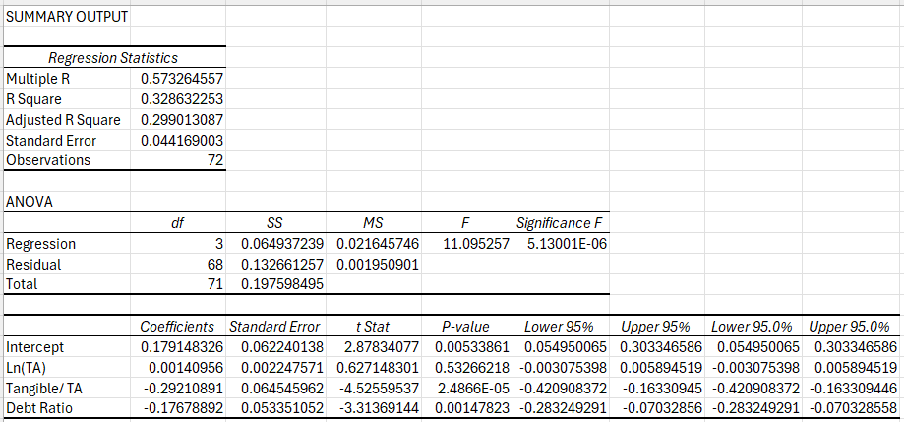
Figure 7: Regression Analysis of NPM Vs Debt Ratio for Debt finance Firms
The regression analysis investigates the relationship between the dependent variable and three independent variables: Ln(Total Assets), Tangible Assets to Total Assets, and Debt Ratio, using a sample of 72 observations. The purpose of this model is to assess how firm size, asset structure, and financial leverage influence the dependent variable. According to the regression statistics, the Multiple R value of 0.573 indicates a moderate positive correlation between the predicted and actual values of the dependent variable. The R Square value of 0.329 suggests that approximately 32.9% of the variation in the dependent variable is explained by the independent variables. This level of explanatory power is reasonable in firm-level financial studies, where performance outcomes are affected by a wide range of internal and external factors. The Adjusted R Square of 0.299 confirms that the model remains robust even after adjusting for the number of predictors. The Standard Error of 0.044 indicates relatively small prediction errors, suggesting a good overall model fit.
The ANOVA results provide strong evidence that the regression model is statistically significant. The F-statistic of 11.10 and the extremely low Significance F (5.13 × 10⁻⁶) indicate that the independent variables jointly have a significant effect on the dependent variable. This means the model explains the dependent variable much better than random chance, confirming the reliability of the regression results.
Examining the coefficient estimates provides insight into the individual effects of each explanatory variable. The intercept has a positive coefficient of 0.179 and is statistically significant (p-value = 0.0053). This suggests that when all independent variables are equal to zero, the dependent variable has a positive baseline value. While the intercept is not usually interpreted in an economic sense, its significance indicates that including a constant term improves the accuracy of the regression model.
The coefficient for Ln(Total Assets) is 0.00141, but it is not statistically significant (p-value = 0.533). This implies that firm size does not have a meaningful impact on the dependent variable in this model. One possible reason for this insignificance is that the benefits of firm size, such as economies of scale and greater market power, may be offset by disadvantages like bureaucratic inefficiencies and reduced flexibility. Additionally, limited variation in firm size across the sample may weaken the statistical power of this variable.
The variable Tangible Assets/Total Assets shows a strong negative and statistically significant coefficient of –0.2921 with a p-value of 2.49 × 10⁻⁵. This result indicates that firms with a higher proportion of tangible assets tend to have lower values of the dependent variable. A plausible explanation is that firms with high tangible asset intensity are often capital-intensive and face higher fixed costs, including depreciation, maintenance, and financing expenses. These firms may also be less adaptable to technological change and market dynamics. In contrast, firms with a greater reliance on intangible assets—such as innovation, intellectual property, and human capital—are generally more flexible and better positioned to generate improved outcomes.
The Debt Ratio also has a negative and statistically significant coefficient of –0.1768 with a p-value of 0.00148. This suggests that higher levels of debt are associated with lower values of the dependent variable. Firms with high leverage face increased interest obligations and higher financial risk, which can reduce profitability and limit investment opportunities. Excessive debt may also increase the likelihood of financial distress, particularly during periods of economic uncertainty. This finding is consistent with financial theory, which argues that while debt can offer tax advantages, excessive leverage can harm firm performance.
4.7.2 NPM Vs Equity Ratio
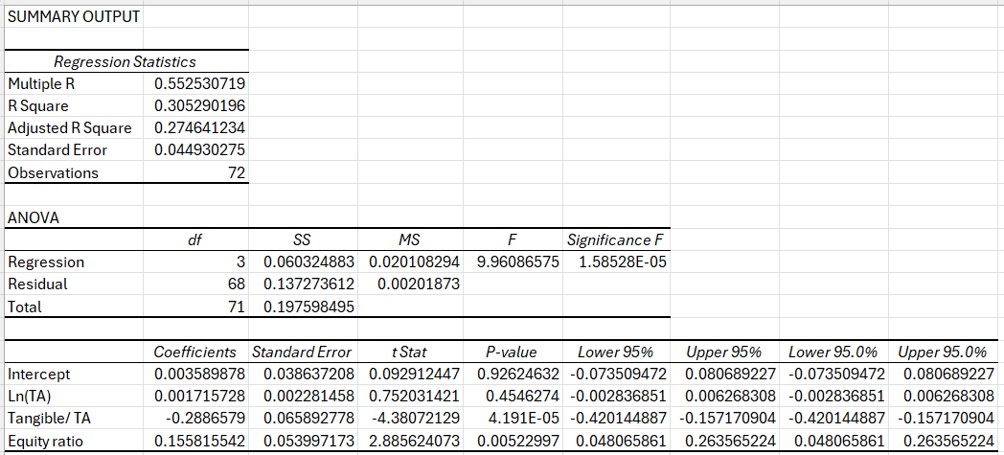
Figure 8: Regression Analysis of NPM Vs Equity Ratio for Debt finance Firms
The regression analysis examines the impact of three independent variables—Ln(Total Assets), Tangible Assets to Total Assets, and Equity Ratio—on the dependent variable using a sample of 72 observations. The purpose of this model is to evaluate how firm size, asset structure, and capital structure influence the dependent variable. The regression statistics show a Multiple R value of 0.553, indicating a moderate correlation between the predicted and actual values of the dependent variable. The R Square of 0.305 suggests that approximately 30.5% of the variation in the dependent variable is explained by the independent variables. Although this level of explanatory power is not high, it is acceptable in firm-level financial research where outcomes are influenced by numerous unobserved factors. The Adjusted R Square of 0.275 confirms that the model remains statistically meaningful after accounting for the number of predictors. The Standard Error of 0.0449 indicates relatively low prediction error, suggesting a reasonably good model fit.
The ANOVA results demonstrate that the overall regression model is statistically significant. The F-statistic of 9.96 and the extremely small Significance F (1.59 × 10⁻⁵) indicate that the independent variables jointly explain the dependent variable significantly better than random chance. This confirms the reliability of the model and suggests that at least one explanatory variable has a meaningful impact on the dependent variable.
Examining the individual coefficients provides insight into how each independent variable affects the dependent variable. The intercept has a very small coefficient of 0.0036 and is statistically insignificant (p-value = 0.926). This indicates that when all independent variables are equal to zero, the dependent variable is not significantly different from zero. While the intercept itself is not typically of theoretical importance, its insignificance suggests that the baseline level of the dependent variable is not meaningful without explanatory factors.
The coefficient for Ln(Total Assets) is 0.00172, but it is not statistically significant (p-value = 0.455). This result implies that firm size does not have a significant impact on the dependent variable in this model. One possible explanation is that the advantages of firm size, such as economies of scale and access to resources, may be offset by disadvantages like bureaucratic inefficiencies and reduced operational flexibility. Additionally, limited variation in firm size across the sample may weaken the statistical significance of this variable.
The variable Tangible Assets/Total Assets shows a strong negative and statistically significant coefficient of –0.2887 with a p-value of 4.19 × 10⁻⁵. This indicates that firms with a higher proportion of tangible assets tend to have lower values of the dependent variable. A likely reason for this negative relationship is that firms with high tangible asset intensity are often capital-intensive and incur high fixed costs, including depreciation, maintenance, and financing expenses. Such firms may also be less adaptable to technological change and evolving market conditions. In contrast, firms that rely more on intangible assets—such as innovation, intellectual property, and human capital—are typically more flexible and better positioned to generate improved outcomes.
The Equity Ratio has a positive and statistically significant coefficient of 0.1558 with a p-value of 0.00523. This result suggests that firms with higher equity ratios tend to perform better in terms of the dependent variable. A higher equity ratio indicates lower reliance on debt financing, reduced financial risk, and greater financial stability. Firms with strong equity positions face fewer interest obligations and are better able to withstand economic downturns, which enhances their long-term performance. This finding aligns with capital structure theory, which emphasizes the benefits of lower leverage and stronger capitalization.
4.7.3 ROE Vs Debt Ratio
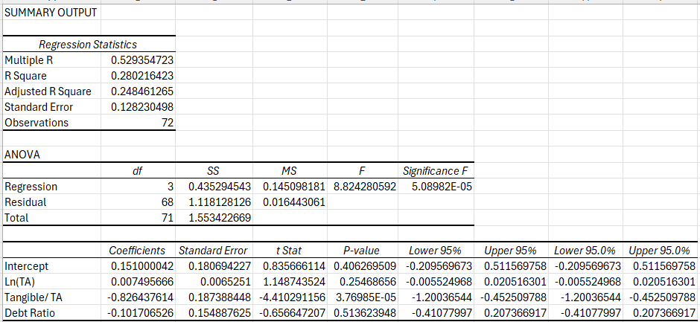
Figure 9: Regression Analysis of ROE Vs Debt Ratio for Debt finance Firms
The regression analysis examines how three independent variables—Ln(Total Assets), Tangible Assets to Total Assets, and Debt Ratio—influence the dependent variable, using a sample of 72 observations. The goal is to understand whether firm size, asset composition, and financial leverage play significant roles in determining the dependent variable. The regression statistics show a Multiple R value of 0.529, indicating a moderate correlation between the predicted and actual values of the dependent variable. The R Square of 0.280 suggests that approximately 28.0% of the variation in the dependent variable is explained by the model. Although this explanatory power is not very high, it is acceptable in firm-level financial research, where outcomes are often affected by many external and firm-specific factors not captured in a single model. The Adjusted R Square of 0.248 confirms that the model remains meaningful after accounting for the number of predictors. The Standard Error of 0.128 indicates moderate dispersion of residuals around the regression line.
The ANOVA results confirm the overall significance of the regression model. The F-statistic of 8.82 and the very low Significance F (5.09 × 10⁻⁵) indicate that the independent variables jointly have a statistically significant effect on the dependent variable. This implies that, taken together, firm size, asset structure, and leverage explain the dependent variable better than random chance, validating the reliability of the regression model.
Turning to the coefficient estimates, the intercept is positive (0.151) but statistically insignificant (p-value = 0.406). This suggests that when all independent variables are equal to zero, the dependent variable is not significantly different from zero. Although the intercept is not usually the focus of interpretation, its insignificance indicates that the baseline level of the dependent variable is weakly defined in the absence of explanatory variables.
The coefficient for Ln(Total Assets) is positive (0.00750), but it is not statistically significant (p-value = 0.255). This indicates that firm size does not have a meaningful impact on the dependent variable in this model. One possible explanation is that size alone may not be a key driver of firm outcomes. Larger firms often benefit from economies of scale, but they may also face bureaucratic inefficiencies and reduced flexibility. These opposing effects can offset each other, leading to an insignificant overall relationship. Additionally, limited variation in firm size across the sample may reduce the explanatory power of this variable.
The variable Tangible Assets/Total Assets shows a strong negative and statistically significant coefficient of –0.8264 with a p-value of 3.77 × 10⁻⁵. This suggests that firms with a higher proportion of tangible assets tend to have substantially lower values of the dependent variable. A likely reason is that firms heavily invested in tangible assets are often capital-intensive and face higher fixed costs, including depreciation, maintenance, and financing expenses. These firms may also be less adaptable to technological change and market fluctuations. In contrast, firms that rely more on intangible assets—such as innovation, intellectual property, and human capital—are often more flexible and capable of generating superior outcomes, especially in dynamic industries.
The Debt Ratio has a negative coefficient (–0.1017), but it is not statistically significant (p-value = 0.514). This indicates that leverage does not have a meaningful impact on the dependent variable in this sample. One possible explanation is that the firms may be operating within a moderate range of debt levels, where the benefits and costs of debt balance each other. Alternatively, the effect of debt may already be captured indirectly through other variables or may vary across industries, reducing its statistical significance in the pooled sample.

4.7.4 ROE Vs Equity Ratio
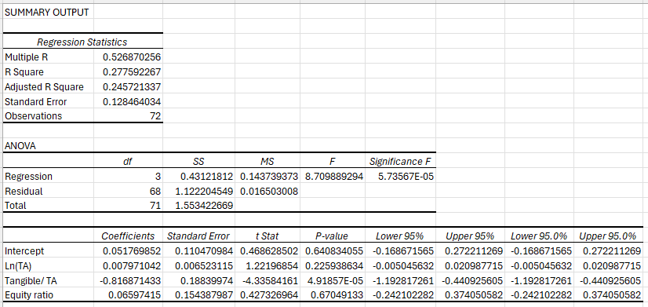
Figure 10: Regression Analysis of ROE Vs Equity Ratio for Debt finance Firms

The regression analysis explores the relationship between the dependent variable and three independent variables—Ln(Total Assets), Tangible Assets to Total Assets, and Equity Ratio—using a sample of 72 observations. The purpose of the analysis is to assess how firm size, asset structure, and capital structure influence the dependent variable. According to the regression statistics, the Multiple R value of 0.527 indicates a moderate correlation between the predicted and actual values of the dependent variable. The R Square of 0.278 shows that approximately 27.8% of the variation in the dependent variable is explained by the independent variables. Although this level of explanatory power is not high, it is common in firm-level financial studies where performance is affected by numerous internal and external factors. The Adjusted R Square of 0.246 confirms that the model remains meaningful after adjusting for the number of predictors. The Standard Error of 0.128 indicates moderate variability of residuals around the regression line.
The ANOVA results indicate that the regression model is statistically significant. The F-statistic of 8.71 and the very small Significance F (5.74 × 10⁻⁵) suggest that the independent variables jointly have a significant effect on the dependent variable. This confirms that the regression model explains the dependent variable better than random chance and supports the overall validity of the analysis.
Turning to the coefficient estimates, the intercept is positive (0.0518) but statistically insignificant (p-value = 0.641). This suggests that when all independent variables are equal to zero, the dependent variable does not differ significantly from zero. While the intercept is not central to interpretation, its insignificance implies that the baseline level of the dependent variable is weakly defined without explanatory factors.
The coefficient for Ln(Total Assets) is 0.0080, but it is not statistically significant (p-value = 0.226). This indicates that firm size does not have a meaningful impact on the dependent variable in this model. One reason for this result may be that size alone does not determine firm outcomes. Although larger firms may benefit from economies of scale, they may also suffer from bureaucratic inefficiencies and reduced flexibility. These opposing forces can offset each other, leading to an insignificant net effect. Additionally, limited variation in firm size across the sample could weaken the statistical power of this variable.
The variable Tangible Assets/Total Assets shows a strong negative and statistically significant coefficient of –0.8169 with a p-value of 4.92 × 10⁻⁵. This suggests that firms with a higher proportion of tangible assets tend to have substantially lower values of the dependent variable. A plausible explanation is that firms with high tangible asset intensity are often capital-intensive and face high fixed costs such as depreciation, maintenance, and financing expenses. These firms may also be less adaptable to technological changes and shifts in market demand. In contrast, firms with greater reliance on intangible assets—such as innovation, intellectual property, and human capital—are typically more flexible and capable of generating better outcomes, particularly in dynamic or knowledge-based industries.
The Equity Ratio has a positive coefficient (0.0660) but is not statistically significant (p-value = 0.670). This indicates that the proportion of equity financing does not have a meaningful effect on the dependent variable in this model. One possible reason is that firms in the sample may operate within a relatively narrow range of equity ratios, reducing variation and weakening statistical significance. Another explanation is that the benefits of higher equity—such as reduced financial risk—may be offset by the higher cost of equity financing or the loss of tax advantages associated with debt.

4.7.5 ROA Vs Debt Ratio
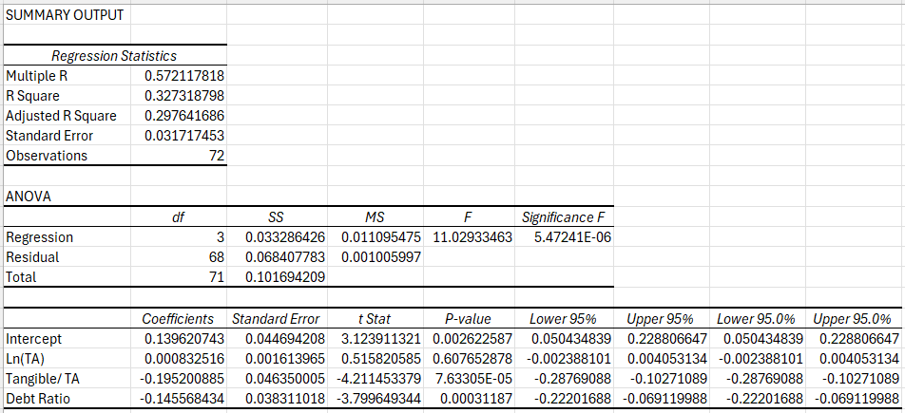
Figure 11: Regression Analysis of ROA Vs Debt Ratio for Debt finance Firms

The regression analysis examines the relationship between the dependent variable and three explanatory variables: Ln(Total Assets), Tangible Assets to Total Assets, and Debt Ratio, using a sample of 72 observations. The purpose of the analysis is to assess how firm size, asset structure, and leverage influence the dependent variable. According to the regression statistics, the Multiple R value of 0.572 indicates a moderate positive correlation between the predicted and actual values of the dependent variable. The R Square of 0.327 shows that approximately 32.7% of the variation in the dependent variable is explained by the independent variables. This level of explanatory power is acceptable in firm-level financial studies, where outcomes are often affected by numerous external and internal factors not included in the model. The Adjusted R Square of 0.298 confirms that the model remains robust after adjusting for the number of predictors. The Standard Error of 0.0317 suggests that prediction errors are relatively small, indicating good model precision.
The ANOVA results provide strong evidence that the overall regression model is statistically significant. The F-statistic of 11.03 and the extremely low Significance F (5.47 × 10⁻⁶) indicate that the independent variables jointly explain the dependent variable significantly better than random chance. This confirms the overall validity of the model and implies that at least one of the explanatory variables has a meaningful effect on the dependent variable.
Turning to the coefficient estimates, the intercept has a positive value of 0.1396 and is statistically significant (p-value = 0.0026). The intercept represents the expected value of the dependent variable when all independent variables are equal to zero. Although this situation is not economically realistic, the significance of the intercept indicates that a constant term is necessary for accurately fitting the regression line.
The coefficient for Ln(Total Assets) is 0.00083, and it is statistically insignificant (p-value = 0.608). This suggests that firm size does not have a meaningful impact on the dependent variable in this model. One possible reason for this result is that the firms in the sample may not differ substantially in size, limiting the explanatory power of this variable. Another explanation is that size alone does not determine firm outcomes; managerial efficiency, market position, and strategic decisions may be more important than sheer scale.
The variable Tangible Assets/Total Assets has a negative and highly significant coefficient of –0.1952 (p-value = 7.63 × 10⁻⁵). This indicates that firms with a higher proportion of tangible assets tend to have lower values of the dependent variable. A plausible explanation is that firms heavily invested in tangible assets are often more capital-intensive and less flexible. High fixed assets can increase depreciation and maintenance costs and reduce a firm’s ability to adapt quickly to market changes. In contrast, firms with a greater reliance on intangible assets such as technology, innovation, and human capital may achieve better outcomes, especially in knowledge-based or service-oriented industries.
The Debt Ratio also shows a negative and statistically significant effect on the dependent variable, with a coefficient of –0.1456 and a p-value of 0.00031. This result suggests that higher leverage is associated with poorer outcomes. Firms with high debt levels face greater interest obligations and higher financial risk, which can limit investment opportunities and increase vulnerability during economic downturns. Excessive debt may also restrict managerial flexibility and lead to financial distress, negatively affecting overall performance. This finding is consistent with financial theory, which argues that while debt can provide tax advantages, excessive leverage increases risk and reduces firm value.
4.7.6 ROA Vs Equity Ratio
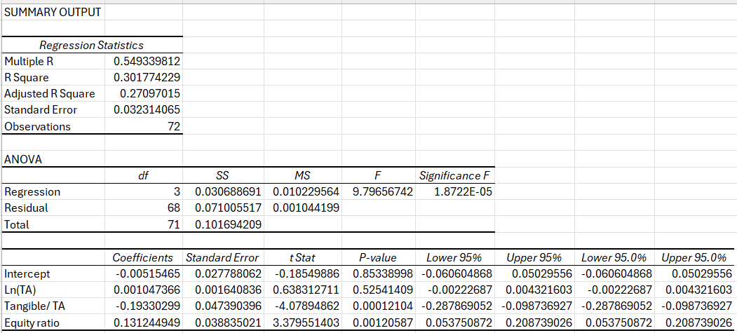
Figure 12: Regression Analysis of ROA Vs Equity Ratio for Debt finance Firms
The regression analysis evaluates the relationship between the dependent variable and three explanatory variables: Ln(Total Assets), Tangible Assets to Total Assets, and Equity Ratio, using a sample of 72 observations. The purpose of this analysis is to understand how firm size, asset structure, and capital structure influence the dependent variable. According to the regression statistics, the Multiple R value of 0.549 indicates a moderate positive correlation between the predicted and actual values of the dependent variable. The R Square of 0.302 suggests that approximately 30.2% of the variation in the dependent variable is explained by the independent variables. While this indicates moderate explanatory power, it is acceptable in financial and economic research where firm performance is influenced by many unobserved factors. The Adjusted R Square of 0.271 confirms that the model remains meaningful after accounting for the number of predictors. The Standard Error of 0.0323 suggests relatively accurate predictions with limited dispersion of residuals.
The ANOVA results provide strong evidence that the overall regression model is statistically significant. The F-statistic of 9.80 and the extremely small Significance F (1.87 × 10⁻⁵) indicate that the independent variables jointly explain the dependent variable significantly better than random chance. This confirms the validity of the regression model and suggests that at least one of the explanatory variables plays a meaningful role in determining the dependent variable.
Looking at the individual regression coefficients, the intercept is negative (–0.0052) and statistically insignificant (p-value = 0.853). This suggests that when all independent variables equal zero, the dependent variable does not differ significantly from zero. While the intercept is not of primary interest in financial analysis, its insignificance indicates that the baseline value of the dependent variable is not meaningfully different from zero in the absence of explanatory factors.
The coefficient for Ln(Total Assets) is 0.00105, but it is statistically insignificant (p-value = 0.525). This result indicates that firm size does not have a meaningful impact on the dependent variable in this model. One possible reason is that size alone does not determine firm outcomes; factors such as management quality, innovation, and competitive positioning may be more important. Additionally, limited variation in firm size across the sample may weaken the statistical effect of this variable.
The variable Tangible Assets/Total Assets has a negative and statistically significant coefficient of –0.1933 with a p-value of 0.00012. This suggests that firms with a higher proportion of tangible assets tend to have lower values of the dependent variable. A plausible explanation is that firms with high tangible asset intensity are often capital-intensive and less flexible. High fixed assets increase depreciation and maintenance costs and may reduce the firm’s ability to respond quickly to changing market conditions. In contrast, firms that rely more heavily on intangible assets such as technology, intellectual capital, and innovation may achieve better outcomes, particularly in knowledge-based industries.
The Equity Ratio shows a positive and statistically significant coefficient of 0.1312 with a p-value of 0.00012. This indicates that firms with higher equity ratios tend to have better outcomes for the dependent variable. A higher equity ratio reflects lower reliance on debt financing, reduced financial risk, and greater financial stability. Firms with strong equity positions are less exposed to interest rate fluctuations and economic downturns, allowing them to operate more efficiently and invest in growth opportunities. This finding aligns with capital structure theories that emphasize the benefits of lower leverage.

Chapter 5: Discussion and Findings

5.1 Introduction
This chapter discusses the empirical findings of the study by interpreting and synthesising the results in light of existing theories and empirical literature on capital structure and firm profitability. Unlike the data analysis chapter, which focuses on statistical outcomes, this discussion aims to explain why the observed relationships exist and how they relate to previous research. By integrating results across multiple profitability measures—Return on Assets (ROA), Return on Equity (ROE), and Net Profit Margin (NPM)—this chapter provides a comprehensive understanding of how capital structure decisions influence firm performance in the selected Asian economies.
The discussion is structured around four key themes: capital structure and profitability, debt financing, equity financing, asset tangibility, and firm size. These themes are examined across both emerging and developed Asian markets to highlight the role of institutional and economic contexts in shaping financing outcomes.

5.2 Capital Structure and Firm Profitability: A Synthesised Perspective
A central contribution of this study lies in its use of multiple profitability indicators, allowing for a robust assessment of firm performance. Across all models, the results reveal a consistent pattern: leverage, measured through debt ratios, generally exerts a negative effect on profitability, while equity financing is more frequently associated with positive performance outcomes. Although the magnitude and statistical significance of coefficients vary across ROA, ROE, and NPM models, the overall direction of relationships remains stable.
This consistency strengthens the reliability of the findings and suggests that capital structure decisions affect firm profitability regardless of how performance is measured. The results challenge the notion of a universally optimal capital structure and instead support the view that financing decisions are context-dependent, shaped by institutional quality, market development, and firm-specific characteristics. This conclusion aligns with earlier arguments that capital structure outcomes differ significantly across countries and economic environments.

5.3 Debt Financing and Profitability
5.3.1 Negative Effects of Leverage
The regression results consistently show that debt financing has a negative and often statistically significant effect on ROA, ROE, and NPM. This suggests that firms with higher leverage tend to experience weaker financial performance. Such findings support the trade-off theory, which argues that although debt provides tax benefits, excessive leverage increases expected costs of financial distress, bankruptcy risk, and agency problems.
In the context of Asian economies—particularly emerging markets such as India and China—these negative effects are especially pronounced. High interest rates, volatile credit markets, and weaker creditor protection increase borrowing costs and reduce the effectiveness of debt as a financing tool. Consequently, firms that rely heavily on debt face greater financial risk, which erodes profitability.
5.3.2 Institutional and Market Considerations
The findings also reflect institutional differences across markets. In emerging economies, underdeveloped financial systems and inefficient bankruptcy frameworks raise distress costs, making debt financing less beneficial. These results are consistent with prior empirical studies that document a negative relationship between leverage and firm performance in developing countries.
In contrast, developed Asian economies such as Japan and South Korea possess more stable financial systems, efficient regulatory frameworks, and strong banking relationships. While previous studies suggest that debt can enhance profitability in such environments, the present findings indicate that even in these markets, excessive leverage may still harm performance. This implies that while institutional quality can mitigate some risks associated with debt, it does not eliminate them entirely.
5.3.3 Implications for Capital Structure Theory
Overall, the negative relationship between debt and profitability observed in this study supports a conditional interpretation of the trade-off theory. Rather than maximising debt usage to exploit tax shields, firms appear constrained by rising financial distress costs, especially in volatile or institutionally weaker environments. These results also align with empirical evidence suggesting that the benefits of debt diminish beyond moderate leverage levels.

5.4 Equity Financing and Firm Performance
5.4.1 Positive Role of Equity Financing
In contrast to debt, equity financing demonstrates a generally positive association with firm profitability across several models, particularly when ROA and NPM are used as performance measures. This indicates that firms with higher equity ratios tend to perform better financially.
Equity financing enhances financial stability by reducing mandatory interest obligations and lowering bankruptcy risk. Firms with strong equity positions are better able to withstand economic shocks, invest in long-term projects, and maintain operational flexibility. These advantages are especially relevant in emerging markets, where access to affordable debt is limited and financial volatility is high.
5.4.2 Theoretical Interpretation
The positive effect of equity financing supports the pecking order theory, which posits that firms prefer internal financing and equity over external debt when information asymmetry and borrowing costs are high. In markets characterised by imperfect information and weak investor protection, reliance on equity reduces financing constraints and enhances performance.
Furthermore, equity financing mitigates agency conflicts between shareholders and creditors. By lowering leverage, firms reduce incentives for risk-shifting behaviour and avoid restrictive debt covenants that may limit strategic flexibility. This contributes to improved operational efficiency and profitability.
5.4.3 Differences Across Market Development Levels
The findings suggest that equity financing plays a particularly important role in emerging Asian economies, where firms face higher borrowing costs and greater financial uncertainty. In developed markets, while equity remains beneficial, firms may combine equity and moderate debt more effectively due to better access to capital markets. Nevertheless, the overall results indicate that strong equity positions are associated with improved firm performance across diverse institutional contexts.

5.5 Asset Tangibility and Profitability
5.5.1 Negative Impact of Tangible Assets
Asset tangibility shows a predominantly negative relationship with firm profitability across multiple regression models. Firms with higher proportions of tangible assets tend to experience lower ROA, ROE, and NPM. This suggests that capital-intensive firms face disadvantages that outweigh the potential benefits of physical asset ownership.
One explanation is that tangible assets increase fixed costs through depreciation, maintenance, and financing expenses. High capital intensity also reduces operational flexibility, making it more difficult for firms to adapt to changing market conditions. These constraints can reduce efficiency and profitability.
5.5.2 Shift Toward Intangible Assets
The negative effect of tangibility also reflects structural changes in modern economies. Increasingly, firm performance is driven by intangible assets such as technology, innovation, brand value, and human capital. Firms relying heavily on physical assets may struggle to compete in knowledge-based and service-oriented sectors, which dominate many Asian economies today.
Additionally, while tangible assets traditionally serve as collateral for borrowing, their value may be less relevant in environments where debt financing is costly or inefficient. As a result, high asset tangibility does not necessarily translate into improved access to capital or better performance.

5.6 Firm Size and Performance
5.6.1 Mixed Effects of Firm Size
The results reveal mixed and often negative effects of firm size on profitability. In several models, larger firms exhibit lower ROA and ROE, while in others, size appears insignificant. These findings suggest that firm size alone does not guarantee superior performance.
While larger firms may benefit from economies of scale, they also face disadvantages such as bureaucratic inefficiencies, slower decision-making, and higher agency costs. As firms grow, coordination and monitoring become more complex, potentially reducing efficiency and profitability.
5.6.2 Contextual Interpretation
The mixed size effects may also reflect differences in market maturity and competitive dynamics. In emerging markets, smaller firms may be more agile and innovative, enabling them to outperform larger competitors. In developed markets, intense competition and market saturation may limit the advantages of size.
Overall, the findings indicate that firm performance depends more on strategic and financial decisions than on scale alone.

5.7 Comparative Insights Across Profitability Measures
An important contribution of this study is its comparative analysis across ROA, ROE, and NPM. While individual coefficients vary, the overarching patterns remain consistent: debt financing negatively affects performance, equity financing enhances profitability, and high asset tangibility reduces efficiency.
ROA captures asset efficiency, ROE reflects shareholder returns, and NPM measures operational profitability. The consistency of results across these indicators suggests that capital structure decisions influence multiple dimensions of firm performance, reinforcing the robustness of the findings.

5.8 Implications for Theory and Practice
5.8.1 Theoretical Implications
The findings contribute to capital structure theory by demonstrating that no single theory fully explains financing behaviour across different institutional contexts. Instead, elements of trade-off theory, pecking order theory, and agency theory jointly explain observed outcomes. The results support a contingent view of capital structure, where optimal financing decisions depend on market conditions, governance quality, and firm characteristics.
5.8.2 Managerial Implications
For managers, the results highlight the risks associated with excessive debt and the benefits of maintaining strong equity positions. Firms operating in volatile or institutionally weak environments should prioritise financial stability over aggressive leverage. Managers should also recognise the limitations of asset-heavy strategies and consider investments in intangible capabilities to enhance performance.
5.8.3 Policy Implications
From a policy perspective, the findings underscore the importance of strengthening financial institutions, improving creditor rights, and enhancing capital market development. Such reforms can reduce financing costs and enable firms to make more efficient capital structure decisions, ultimately supporting economic growth.

5.9 Summary
This chapter has discussed and synthesised the empirical findings of the study by integrating them with established theories and prior empirical evidence. The results demonstrate that capital structure decisions play a critical role in shaping firm profitability, but their effects vary across institutional and economic contexts. Debt financing generally reduces profitability, while equity financing enhances performance, particularly in emerging markets. Asset tangibility and firm size exhibit complex and context-dependent effects.

Chapter 6: Conclusion and Recommendations

6.1 Recommendations
Based on the findings of this study, several important recommendations are proposed for corporate managers, policymakers, and other stakeholders.
6.1.1 Recommendations for Corporate Managers
First, corporate managers should adopt a cautious and balanced approach to debt financing. While moderate leverage may provide tax advantages, excessive reliance on debt can significantly reduce profitability by increasing financial risk and interest burdens. Managers should carefully assess their firm’s capacity to service debt, particularly during periods of economic uncertainty, and avoid aggressive leverage strategies that may compromise financial stability.
Second, the positive role of equity financing suggests that firms should prioritise strong equity positions and retained earnings, especially in emerging markets. Maintaining higher equity ratios can enhance resilience to economic shocks, improve creditworthiness, and support long-term strategic investments. Managers should view equity financing not merely as a last resort, but as a viable and potentially superior financing option in volatile environments.
Third, firms should reconsider asset-heavy financing and investment strategies. The negative relationship between asset tangibility and profitability indicates that excessive investment in physical assets may reduce efficiency and flexibility. Managers are encouraged to allocate resources toward intangible assets such as innovation, technology, research and development, and human capital, which are increasingly important drivers of competitive advantage and profitability in modern economies.
Fourth, firm size should not be relied upon as a primary strategy for improving performance. Larger firms often face bureaucratic inefficiencies and coordination challenges that can erode profitability. Managers of large organisations should focus on improving governance structures, streamlining operations, and enhancing managerial accountability to mitigate the negative effects associated with scale.
6.1.2 Recommendations for Policymakers and Regulators
From a policy perspective, the findings underscore the importance of strengthening financial institutions and capital markets, particularly in emerging economies. Policymakers should aim to improve creditor rights, enhance transparency, and develop efficient legal and bankruptcy frameworks to reduce the costs associated with debt financing. Such reforms can enable firms to access credit on more favourable terms and reduce the negative impact of leverage on profitability.
In addition, governments should promote equity market development by improving disclosure standards, protecting minority shareholders, and encouraging investor participation. Well-functioning equity markets can provide firms with alternative financing sources, reduce excessive dependence on debt, and support sustainable corporate growth.
Policymakers may also consider providing incentives for firms to invest in innovation and intangible assets, such as tax credits for research and development or support for technology adoption. These measures can enhance firm productivity and profitability while reducing reliance on traditional asset-heavy financing models.
6.1.3 Recommendations for Investors and Financial Institutions
For investors, the findings highlight the importance of evaluating firms’ capital structure composition rather than focusing solely on size or revenue growth. Firms with excessively high leverage may face elevated financial risk and weaker long-term profitability. Investors should consider equity strength, financial flexibility, and risk exposure when making investment decisions.
Financial institutions, including banks and lenders, should also adopt prudent lending practices by assessing borrowers’ leverage levels and long-term sustainability. Encouraging balanced capital structures can reduce default risk and contribute to a more stable financial system.
6.1.4 Summery
In summary, this study recommends that firms operating in Asian economies adopt context-sensitive and conservative financing strategies, prioritising equity financing and financial stability over aggressive leverage. Capital structure decisions should be aligned with institutional conditions, firm-specific characteristics, and long-term strategic objectives rather than short-term gains. By doing so, firms can enhance profitability, reduce financial risk, and support sustainable growth in an increasingly complex and competitive economic environment.

6.2 Conclusion
This study set out to examine the relative effectiveness of debt financing and equity financing in enhancing firm profitability, using evidence from listed non-financial companies in India, China, Japan, and South Korea. By adopting a comparative quantitative approach and employing multiple measures of profitability—Return on Assets (ROA), Return on Equity (ROE), and Net Profit Margin (NPM)—the study provides a comprehensive assessment of how capital structure decisions influence firm performance across diverse institutional and economic environments.
The empirical findings indicate that capital structure plays a significant role in shaping firm profitability, but its effects are neither uniform nor universal. Debt financing is found to exert a generally negative impact on profitability across most models and performance measures. While debt offers potential benefits in the form of tax shields and managerial discipline, the results suggest that these advantages are often outweighed by higher interest obligations, increased financial risk, and rising financial distress costs. This outcome is particularly evident in emerging economies, where underdeveloped financial systems, volatile macroeconomic conditions, and weaker institutional frameworks amplify the adverse effects of leverage.
In contrast, equity financing demonstrates a predominantly positive relationship with firm profitability, especially in terms of asset efficiency and operating margins. Firms with higher equity ratios tend to exhibit greater financial stability, lower exposure to distress risk, and improved operational performance. This finding highlights the importance of strong capitalization and reduced reliance on debt, particularly in environments characterised by uncertainty and imperfect capital markets.
The comparative analysis further reveals that institutional context matters significantly. In emerging markets such as India and China, equity financing appears more effective in supporting profitability due to high borrowing costs and limited access to long-term credit. Although developed economies such as Japan and South Korea benefit from more mature financial systems, the results suggest that excessive leverage can still undermine firm performance, indicating that even in advanced markets, debt financing must be used cautiously.
In addition to capital structure variables, the study finds that asset tangibility is negatively associated with profitability, suggesting that capital-intensive firms face higher fixed costs and reduced flexibility. Firm size shows mixed effects, indicating that scale alone does not guarantee superior performance and may introduce inefficiencies that offset potential economies of scale.
Overall, the findings support a context-dependent view of capital structure, reinforcing the argument that no single financing strategy is optimal for all firms or markets. Instead, capital structure decisions must be tailored to firm characteristics, institutional quality, and economic conditions. By integrating theory and empirical evidence, this study contributes to a deeper understanding of how debt and equity financing influence profitability in Asian economies.

Reference
Abor, J. (2005) ‘The effect of capital structure on profitability: an empirical analysis of listed firms in Ghana’, Journal of Risk Finance, 6(5), pp. 438–445.
Acaravci, S. (2015) ‘The determinants of capital structure: evidence from European emerging markets’, International Journal of Economics and Financial Issues, 5(2), pp. 427–434.
Almanaseer, S. (2024) ‘The Impact of Equity Financing on Financial Performance: Evidence from Jordan’, Foundations of Management, 16(1), pp. 157–176.
Baker, M. and Wurgler, J. (2002) ‘Market timing and capital structure’, Journal of Finance, 57(1), pp. 1–32.
Booth, L. et al. (2001) ‘Capital structures in developing countries’, Journal of Finance, 56(1), pp. 87–130.
Chakraborty, I. (2010) ‘Capital structure in an emerging stock market: The case of India’, Research in International Business and Finance, 24(3), pp. 295–314.
Chen, J. (2004) ‘Determinants of capital structure in Chinese-listed companies’, Journal of Business Research, 57(12), pp. 1341–1351.
Dang, V., Kim, M. and Shin, Y. (2012) ‘Asymmetric adjustment toward target leverage’, Journal of Corporate Finance, 18(1), pp. 113–127.
Fan, J.P.H., Titman, S. and Twite, G. (2012) ‘An international comparison of capital structure and debt maturity choices’, Journal of Financial and Quantitative Analysis, 47(1), pp. 23–56.
Fama, E. and French, K. (1998) ‘Taxes, financing decisions, and firm value’, Journal of Finance, 53(3), pp. 819–843.
Frank, M. and Goyal, V. (2009) ‘Testing the pecking order theory of capital structure’, Journal of Financial Economics, 67(2), pp. 217–248.
Hirota, S. (1999) ‘Are corporate financing decisions different in Japan?’, Journal of the Japanese and International Economies, 13(3), pp. 201–229.
Hovakimian, A., Opler, T. and Titman, S. (2001) ‘The debt–equity choice’, Journal of Financial and Quantitative Analysis, 36(1), pp. 1–24.
Jensen, M.C. and Meckling, W.H. (1976) ‘Theory of the firm: managerial behavior, agency costs and ownership structure’, Journal of Financial Economics, 3(4), pp. 305–360.
Kim, H. and Lee, K. (2008) ‘Determinants of corporate capital structure: Evidence from Korean chaebols’, Asia-Pacific Journal of Financial Studies, 37(1), pp. 1–30.
Kraus, A. and Litzenberger, R. (1973) ‘A state-preference model of optimal financial leverage’, Journal of Finance, 28(4), pp. 911–922.
Margaritis, D. and Psillaki, M. (2010) ‘Capital structure, equity ownership and firm performance’, Journal of Banking & Finance, 34(3), pp. 621–632.
Modigliani, F. and Miller, M. (1958) ‘The cost of capital, corporation finance and the theory of investment’, American Economic Review, 48(3), pp. 261–297.
Modigliani, F. and Miller, M. (1963) ‘Corporate income taxes and the cost of capital’, American Economic Review, 53(3), pp. 433–443.
Myers, S. and Majluf, N. (1984) ‘Corporate financing and investment decisions when firms have information that investors do not have’, Journal of Financial Economics, 13(2), pp. 187–221.
Pandey, K. and Sahu, T. (2019) ‘Debt financing and firm performance in India’, Vision, 23(3), pp. 267–274.
Pham, H. and Nguyen, D. (2020) ‘Debt financing and firm performance’, Journal of General Management, 45(3), pp. 141–151.
Rajan, R. and Zingales, L. (1995) ‘What do we know about capital structure?’, Journal of Finance, 50(5), pp. 1421–1460.
Tian, X., Wang, Y. and Kohar, U. (2024) ‘Capital structure and firm performance in China’, PLOS One, 19(6), p. e0306054.
Zeitun, R. and Tian, G. (2007) ‘Capital structure and corporate performance: Evidence from Jordan’, Australasian Accounting Business & Finance Journal, 1(4), pp. 40–61.
Zhao, S. and Fang, L. (2023) ‘Debt financing and competitive behaviour’, Managerial and Decision Economics, 44(1), pp. 502–514.

