Gethin Pritchard
2507657
Placement: Culinary Skills BMGM4002
Jemma Smith

1500 words
15 references

Element 1: Introduction to Culinary Skills

My placement at Altitude 28 under Chef Albert enabled me to build on existing culinary knowledge while refining practical skills essential for professional kitchen work. In the early stages, I was assigned routine preparation tasks such as labelling and cleaning fridges, dating food items, and stock rotation. Although I initially felt this was repetitive, I later recognised their importance in maintaining food safety, hygiene, traceability, and operational discipline, which are fundamental components of professional kitchen management (Chartered Institute of Environmental Health, 2023; Codex Alimentarius Commission, 2023).
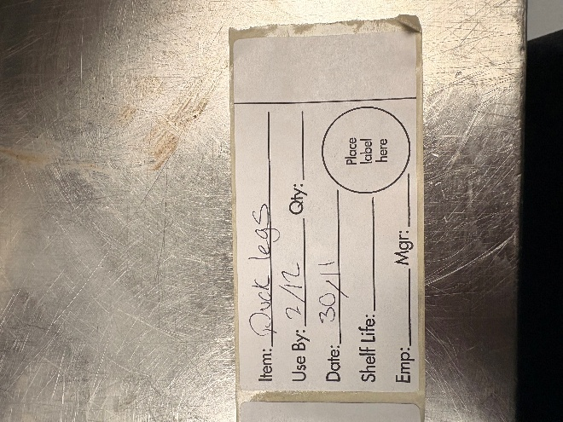
(picture above shows label for duck legs )
During busy service periods, direct instruction was limited, requiring me to rely heavily on observation and replication. Shadowing the pass chef allowed me to develop an understanding of plating techniques, including the use of negative space, balance, and garnish placement. In the prep kitchen I prepared dishes such as duck pâté, babaganoush, and provolone rillettes, each requiring precision in flavour, texture, and consistency for the service kitchen. As my confidence grew, I gained experience with sous vide cooking, searing and resting proteins, and using the Rational oven to finish dishes. A key moment of validation occurred when I successfully recreated Chef Albert’s lobster tortellini, which he praised, reinforcing my developing competence and confidence.
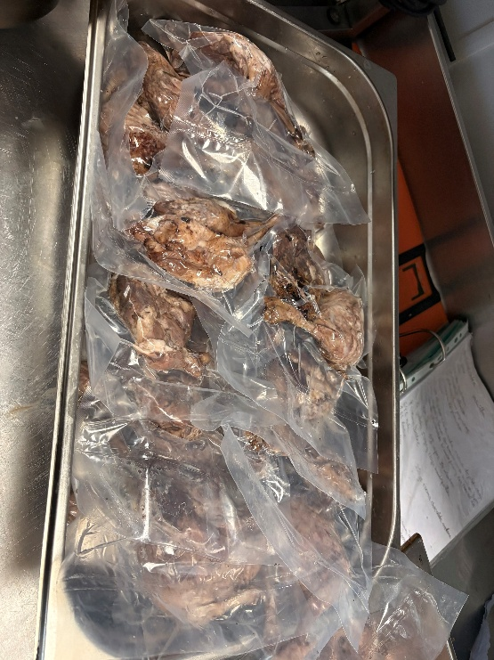
(picture above shows braised duck legs vaccum sealed with vac pack ready for sous vide cooking during service)
My daily responsibilities centred on preparation work essential to the smooth running of the kitchen. This included chopping vegetables, producing purées, and preparing large batch sauces, typically in quantities of five 4-litre containers, with two stored in the fridge and three in the freezer. A daily prep list structured the workflow and ensured mise en place was completed efficiently. I followed established operational systems such as FIFO, comprehensive date labelling, and safe defrosting procedures, all of which align with recommended food safety practices (World Health Organization, 2022; SafeFood, 2023).
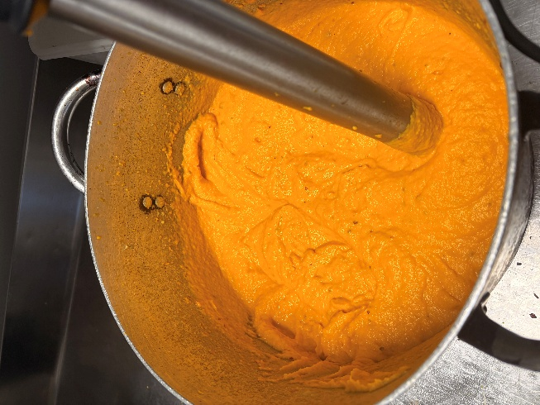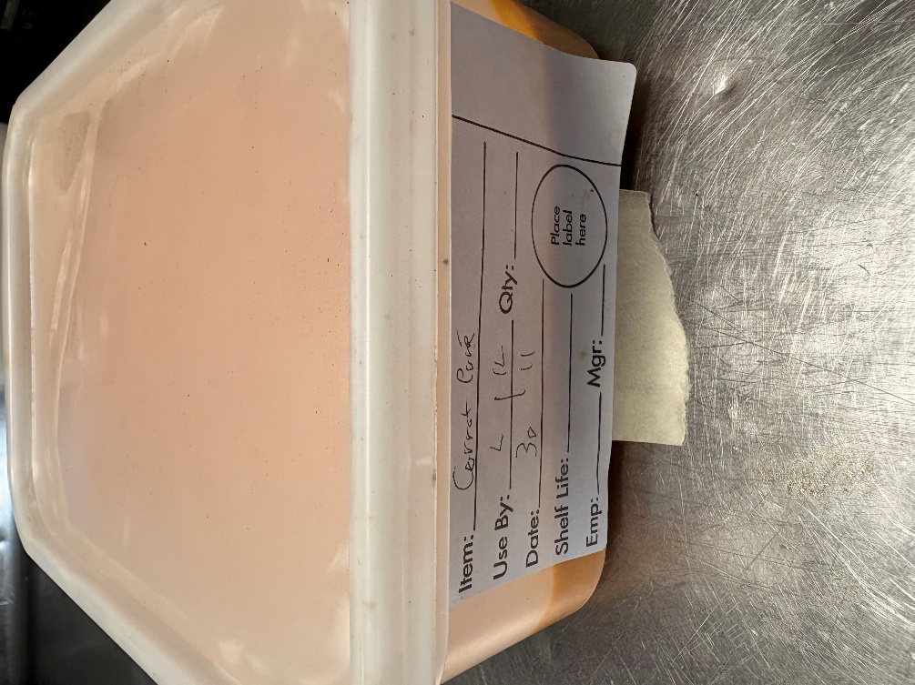
(pictures above show carrot puree made with immersion blender and then labelled in tub ready for service)

Service setup formed another key part of my role, involving the organisation of all components required for service and resetting stations at the end of each shift. With numerous fridges and freezers across the site, organising chilled and frozen storage was a constant task requiring attention to detail. I supported service in a limited capacity by operating the fryers and assisting another chef with starters, which provided insight into the pace and pressure of live service.
Throughout the placement, I used a range of professional equipment, including the Rational oven, Thermomix, Robot Coupe, vac pack machine, and blast chiller. These tools enabled efficient production, consistency, and improved workflow, demonstrating how equipment competency is essential in professional kitchen operations (McGee, 2004; Ferris, 2022).
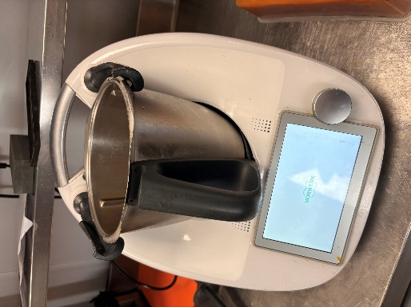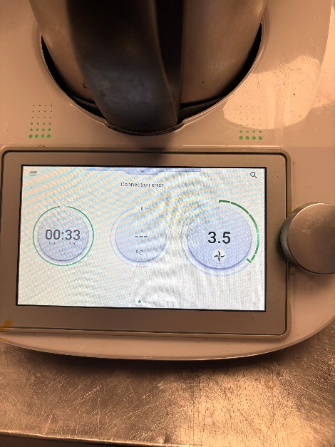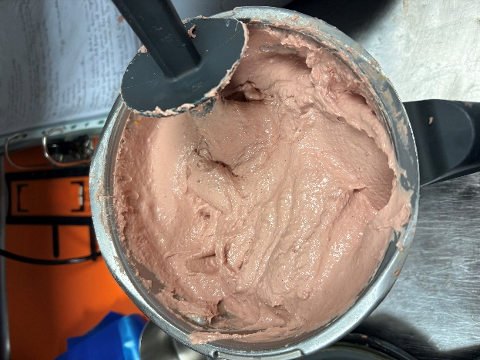
(pictures above show use of thermomixer to create duck pate)
Reflecting on my experience, the greatest challenge I encountered was the combination of limited prior knowledge and minimal instruction during busy periods. This often left me uncertain about expectations and contributed to a sense of being underused, particularly when repetitive tasks dominated the early stages. However, these challenges encouraged me to develop resilience and initiative. I learned to make decisions independently, take responsibility for my actions, and seek information proactively when guidance was not immediately available. This aligns with experiential learning theory, which emphasises learning through action and reflection (Kolb, 1984; Schön, 1992).
If I were to repeat the placement, I would focus on improving communication, expanding my culinary knowledge, asking for more feedback, and increasing my hours beyond my allocated to gain broader exposure. Despite the difficulties, I experienced moments of pride and belonging, particularly when other chefs engaged with me beyond work tasks or when we shared humour during quieter moments. The best part was the head of prep showing me to make honeycomb and warning about adding too much baking soda and subsequently adding too much himself .Successfully operating new equipment also contributed to my sense of progress and reinforced my confidence in adapting to professional kitchen environments.
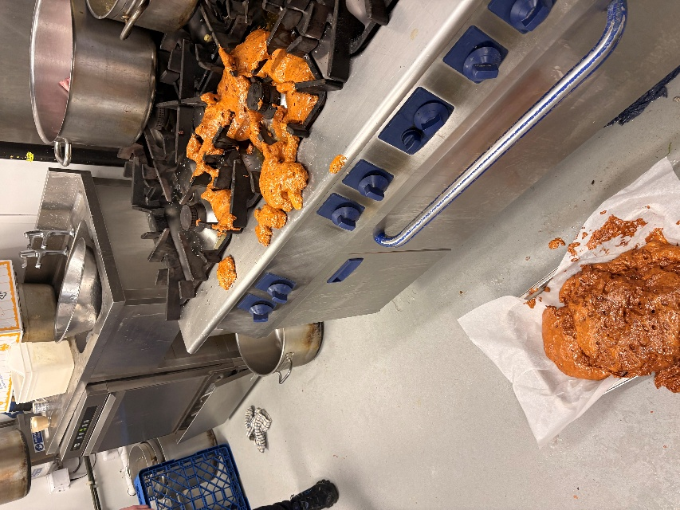
(picture above shows the “honeycomb volcano” which occurred when head of prep added too much baking soda to the mix after warning me about its volatility)

Element 2 – Kitchen Health & Safety
Although no formal HACCP documentation was visible during my placement, some core food safety principles were consistently applied. The kitchen used colour-coded chopping boards and knives to separate raw and cooked foods, and raw meat and fish were stored on the lowest shelves of fridges to prevent drip contamination. These practices reflect the global hygiene expectations outlined in the General Principles of Food Hygiene (Codex Alimentarius Commission, 2023).
I carried out extensive cleaning of equipment after use, particularly high-risk items, and end of shift cleaning routines ensured that work surfaces and storage areas were sanitised daily. Research shows that inadequate cleaning is a major contributor to foodborne illness (Health and Safety Executive, 2023), reinforcing the importance of these routines. Temperature control was managed through built-in gauges on fridges, freezers, and blast chillers. Although calibrated thermometer readings were not taken during my time there, probes were occasionally used to check cooked items. Maintaining correct temperatures is a critical control measure in preventing bacterial growth (World Health Organization, 2022).
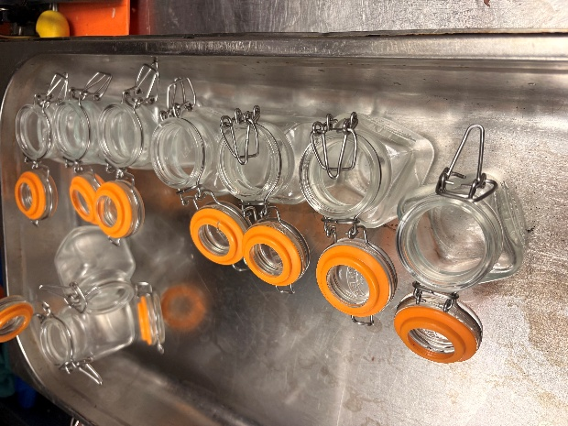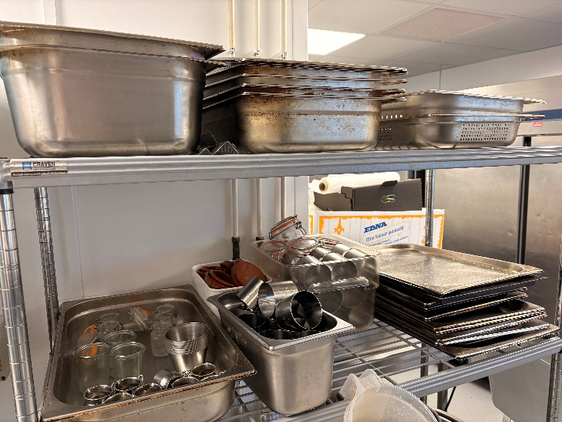
(Pictures above show Duck pate jars cleaned before use , Equipment shelf after being cleaned and organised )
Cross-contamination was further prevented through the use of separate vac-packing machines for raw and cooked products, strict adherence to colour-coded equipment, and cleaning down stations after each task. Raw fish and meat were defrosted safely in perforated trays under cold running water, while thawed items were wrapped and stored in sealed containers. These practices align with HACCP-based approaches to hazard identification and control (SafeFood, 2023).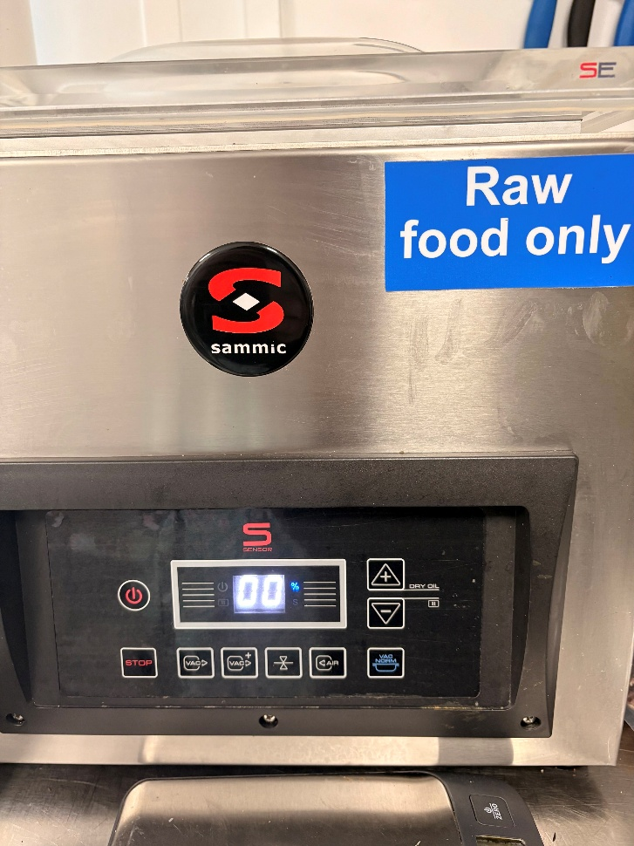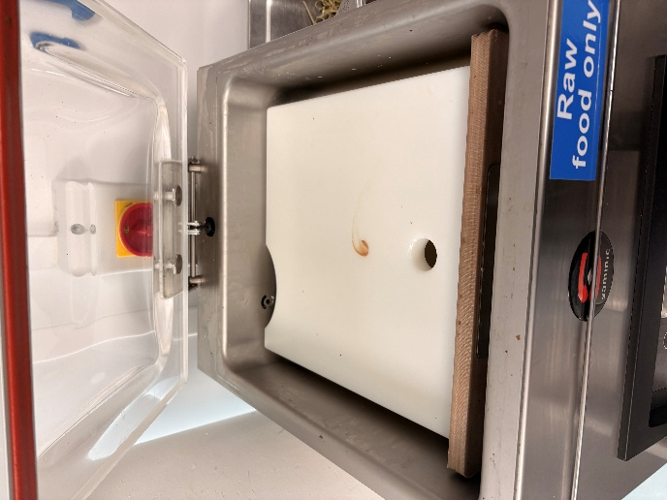
(pictures above show the vac pac machine designated for raw food only )

Allergen information was available on the menu and in the dish book, aligning with the legal requirements of the Food Information for Consumers Regulation (Food Standards Agency, 2022). However, there were no allergen-labelled containers or storage systems in the kitchen, meaning allergen management relied heavily on staff knowledge. This is less robust than the structured allergen control procedures recommended in contemporary research (Allergy UK, 2024).
Reflecting on my experience, I believe I contributed positively to hygiene and safety by consistently cleaning my station, maintaining personal hygiene, avoiding mixing high-risk items, and labelling everything I prepared. These behaviours align with global food safety frameworks (World Health Organization, 2022). However, challenges included language barriers, limited instruction, and gaps in my own knowledge. Research shows that staff competence develops through repeated exposure to real-world tasks and reflective practice (Strohbehn and Sneed, 2020), which mirrors my experience.
Overall, the placement highlighted the importance of food safety in shaping professionalism and guest trust (Allergy UK, 2024).

Element 3 – Organisational Issues
The organisational context of my placement shaped both workflow and expectations. Although the business did not have a formal mission statement, its operational aims were clear: to deliver consistent food quality, maintain efficient service, and uphold a welcoming atmosphere. Mission clarity is essential for aligning staff behaviour and service delivery (Institute of Hospitality, 2021).
Staffing structures were lean, with limited training opportunities. This contrasts with larger operators where structured onboarding and continuous development are standard (People 1st International, 2020). Training in my placement was informal and observational, relying on shadowing rather than documented procedures. While this can build practical competence, it may also create inconsistencies in performance and communication. However, I do understand that the non-managerial staff have no obligation to train me.
The business operated in a competitive local market, with nearby pubs and restaurants offering similar menus. Market positioning in such environments depends heavily on guest experience and perceived value (Morrison, 2018). The kitchen’s focus on efficiency and consistency reflected an understanding that operational reliability is a key differentiator.
Performance expectations were shaped by informal service time targets; however, this depended on how busy the floor and kitchen was. Speed of service is a critical performance indicator influencing guest satisfaction (VisitBritain, 2021). Quality monitoring relied on customer feedback, particularly online reviews. Guest feedback functions as a key performance indicator and provides insight into service consistency (UKHospitality, 2021). Maintaining a positive atmosphere was essential, as the guest experience is shaped by ambience, staff interaction, and service flow (Ladhari, 2009).
The kitchen contributed to this by ensuring dishes were prepared consistently and presented to a high standard. This reflects the SERVQUAL model, which emphasises reliability, responsiveness, and assurance as core dimensions of service quality (Parasuraman, Zeithaml and Berry, 1988).
Reflecting on my experience, I contributed positively to workflow efficiency by completing prep tasks promptly, supporting service, and maintaining communication with front-of-house staff. These behaviours align with hospitality management theory, which highlights teamwork and interdepartmental communication as essential for smooth service (Institute of Hospitality, 2021).
Challenges included the lack of structured training and unclear organisational systems. Adapting to these shortfalls required initiative and resilience. Monitoring customer reviews and observing how the team responded to feedback helped me understand how quality is managed in practice.
Developing organisational awareness improved my teamwork and operational insight. Understanding how my role contributed to the wider service flow helped me anticipate needs and support colleagues more effectively. This aligns with service quality literature, which emphasises that staff alignment with organisational goals directly influences guest satisfaction (Ladhari, 2009).
Overall, I did enjoy my placement and I believe it gave me good insight into the practices of professional kitchens. However, I do think Altitude 28 should have some in-depth training programs in place, even if not for placement staff but also their new hires.

Refrence List

Allergy UK (2024)
Updated Allergen Guidance for Food Businesses. London: Allergy UK.
Available at: https://www.allergyuk.org/news/17778/
(Accessed: 13 January 2026).

Chartered Institute of Environmental Health (2023)
Food safety: hygiene, cleaning and contamination control. Available at: https://www.cieh.org/food-safety/
(Accessed: 01 January 2026).

Codex Alimentarius Commission (2023)
General Principles of Food Hygiene CXC 1-1969. Rome: FAO/WHO.
Available at: https://openknowledge.fao.org/server/api/core/bitstreams/6866dc55-d2c0-48dd-a528-a4d634f1b0b4/content
(Accessed : 02 January 2026)

Ferris, I.M. (2022)
‘Hazard Analysis and Critical Control Points’, in Applied Food Science. Wageningen: Brill.
Available at: https://brill.com/edcollchap-oa/book/9789086869336/BP000011.xml?srsltid=AfmBOop29FrEXlylWH59E4RKxGZ7EQ6NkB7KysP6Qin2JV9ByCNDJygi&body=contentSummary-133844
(Accessed : 06 January 2026)

Health and Safety Executive (2023) Cleaning in food businesses.
Available at: https://www.hse.gov.uk/food/cleaning.htm
(Accessed: 12 January 2026).

Institute of Hospitality (2021)
Operational excellence in hospitality. Available at: https://www.instituteofhospitality.org/knowledge/
(Accessed: 14 January 2026).

Kolb, D. (1984)
Experiential Learning: Experience as the Source of Learning and Development. Englewood Cliffs: Prentice Hall.
Available at: https://www.researchgate.net/publication/235701029_Experiential_Learning_Experience_As_The_Source_Of_Learning_And_Development
(Accessed: 07 January 2026).

Ladhari, R. (2009)
‘Service quality, emotional satisfaction and behavioural intentions’, Managing Service Quality, 19(3), pp. 308–331.
Available at: https://www.emerald.com/jstp/article-abstract/19/3/308/300320/Service-quality-emotional-satisfaction-and?redirectedFrom=fulltext
(Accessed: 05 January 2026).

McGee, H. (2004)
On Food and Cooking: The Science and Lore of the Kitchen. New York: Scribner.
Available at: https://moodle.net/.pkg/@moodlenet/ed-resource/dl/ed-resource/qHhqCmUU/027_On_Food_and_Cooking_The_Science_and_Lore_of_the_Kitchen_PDFDrive_.pdf
(Accessed: 05 January 2026).

Morrison, A. (2018)
Marketing and Managing Tourism Destinations. 2nd edn.
Available at: https://www.taylorfrancis.com/books/mono/10.4324/9781315178929/marketing-managing-tourism-destinations-alastair-morrison
(Accessed: 02 January 2026).

Parasuraman, A., Zeithaml, V. and Berry, L. (1988)
‘SERVQUAL: A multiple item scale for measuring consumer perceptions of service quality’, Journal of Retailing, 64(1), pp. 12–40.
Available at: https://www.researchgate.net/publication/200827786_SERVQUAL_A_Multiple-item_Scale_for_Measuring_Consumer_Perceptions_of_Service_Quality
(Accessed: 06 January 2026)

People 1st International (2020)
Hospitality workforce trends and training needs.
Available at: https://people1st.co.uk/insights/
(Accessed: 01 January 2026).

SafeFood (2023)
HACCP explained.
Available at: https://www.safefood.net/food-safety/haccp

(Accessed: 04 January 2026).

Schön, D. (1992)
The Reflective Practitioner: How Professionals Think in Action (1st ed.). Routledge
Available at: https://www.taylorfrancis.com/books/mono/10.4324/9781315237473/reflective-practitioner-donald-sch%C3%B6n
(Accessed: 08 January 2026).

Strohbehn, C. and Sneed, J. (2020)
‘Food safety practices in foodservice operations’, Journal of Food Protection, 83(5), pp. 875–884.
(Accessed: 12 January 2026).

UKHospitality (2021)
Customer experience and feedback in hospitality. Available at: https://www.ukhospitality.org.uk/page/Reports
(Accessed: 04 January 2026).

VisitBritain (2021)
Understanding customer expectations and service delivery. Available at: https://www.visitbritain.org/insights
(Accessed: 03 January 2026).

World Health Organization (2022)
Food safety: key fact sheet.
Available at: Available at: https://www.who.int/news-room/fact-sheets/detail/food-safety
Accessed: 11 January 2026).

