Assignment 2
python-docx
[company name]
Module Name: Introduction to Web and Database Concepts
Module Code: ACCA4023
Student Name: Daniel Fernandes
Student ID: 2510885
Group: 1

Table of Contents
Table of Contents 1
1. Introduction (Abstract) 1
2. Requirements 1
3. Implementation 1
4. Evaluation 1
5. Conclusion 2
6. References (IEEE Format) 2
7. Appendices 2

1. Introduction (Abstract)
So this project is about us creating a website of your choice, and the topic I chose was games because I feel like everyone needs a little rest after a bad day at work or just a bad day in general, so I created the website with some games categorized as shooting, horror, adventure, sports and rhythm games. Every single page was created using HTML and CSS.

2. Requirements
- The website contains a home page
- It includes 3 pages (main page, page 2 and 3)
- It allows you to navigate through the pages
- All links must function correctly
- The website needs to be created by using HTML and CSS
- Every page follows a good HTML structure
- The website has different layouts on every page
- Letters readable after applying the image or background color
- Website easy to navigate and find what you are looking for

3. Implementation

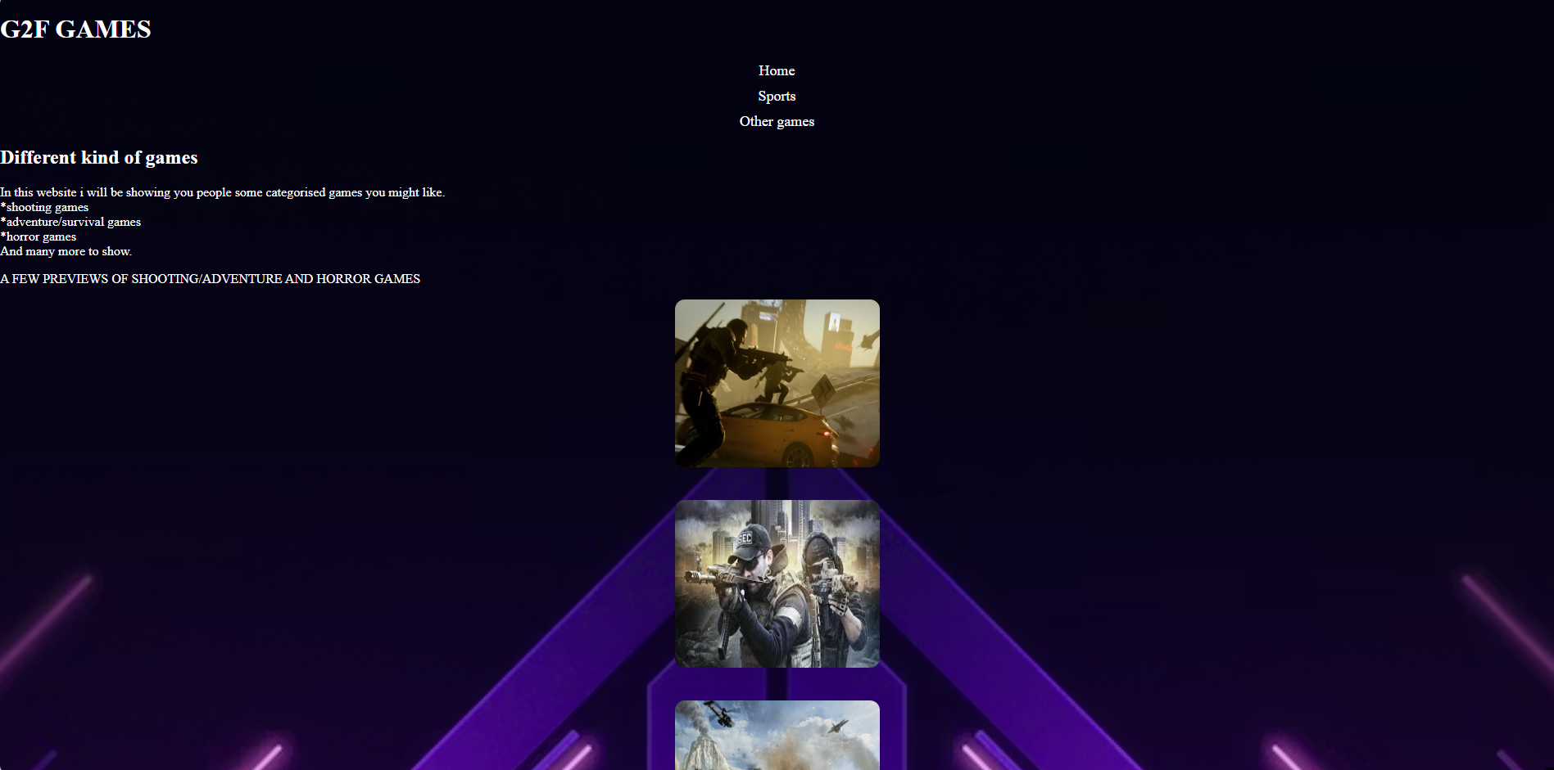
• Include screenshots of all website pages.
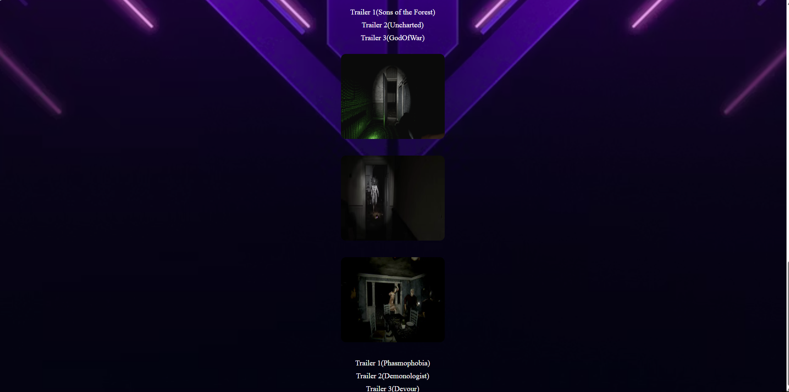
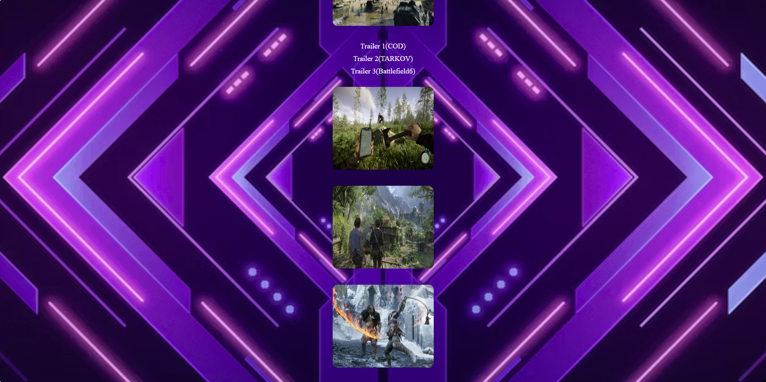
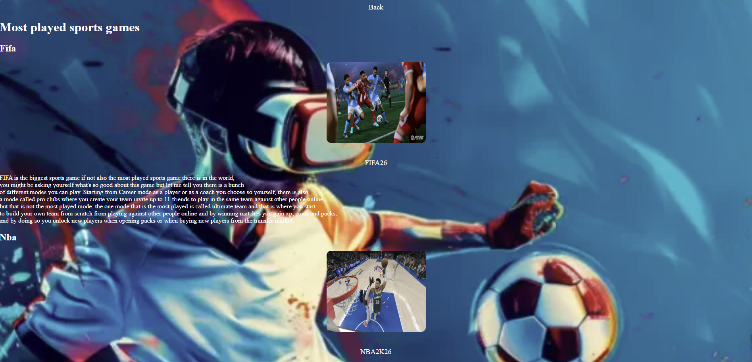
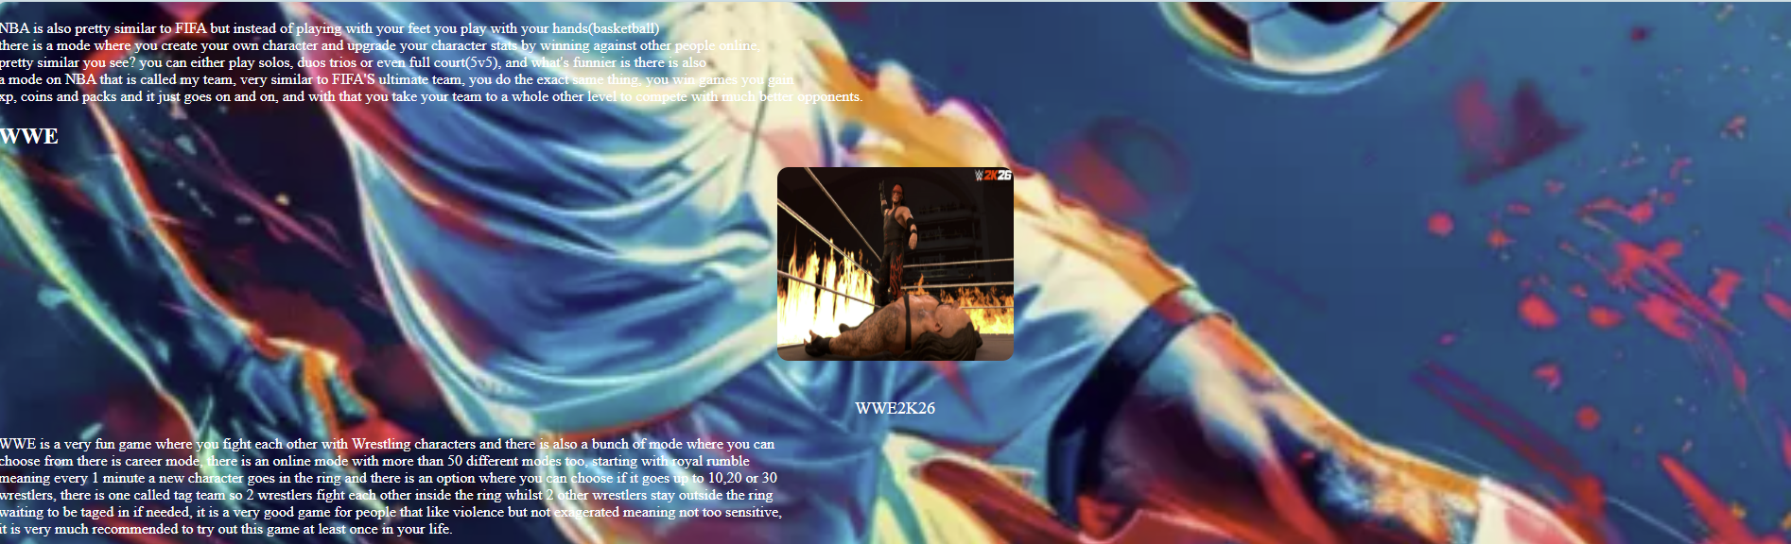
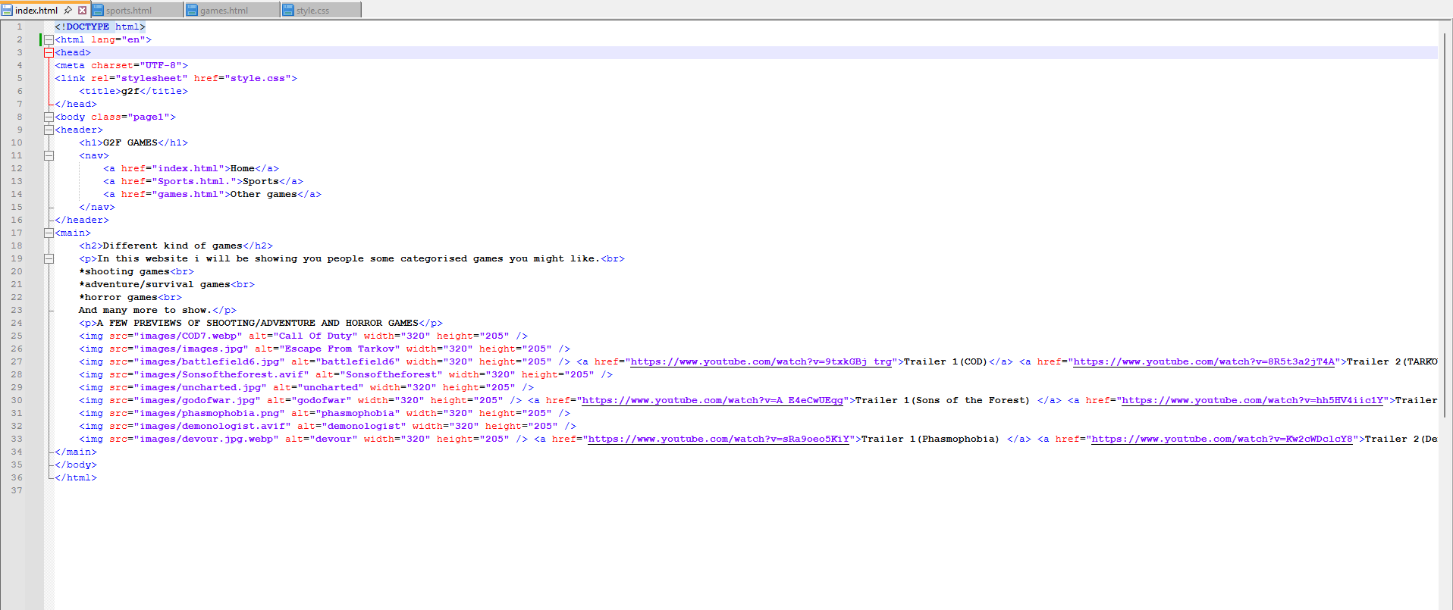
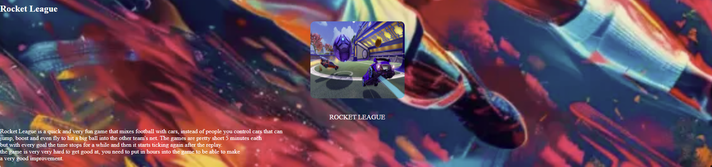
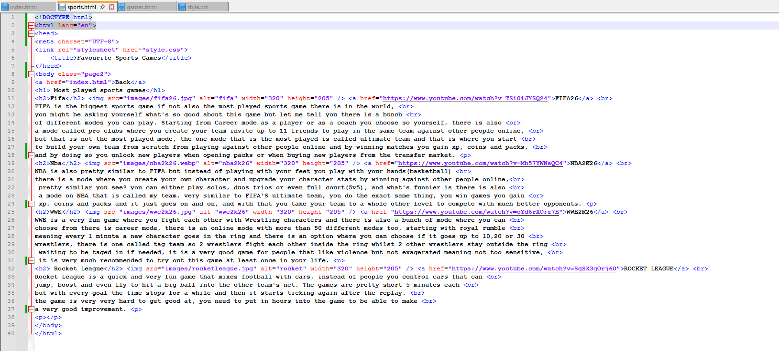
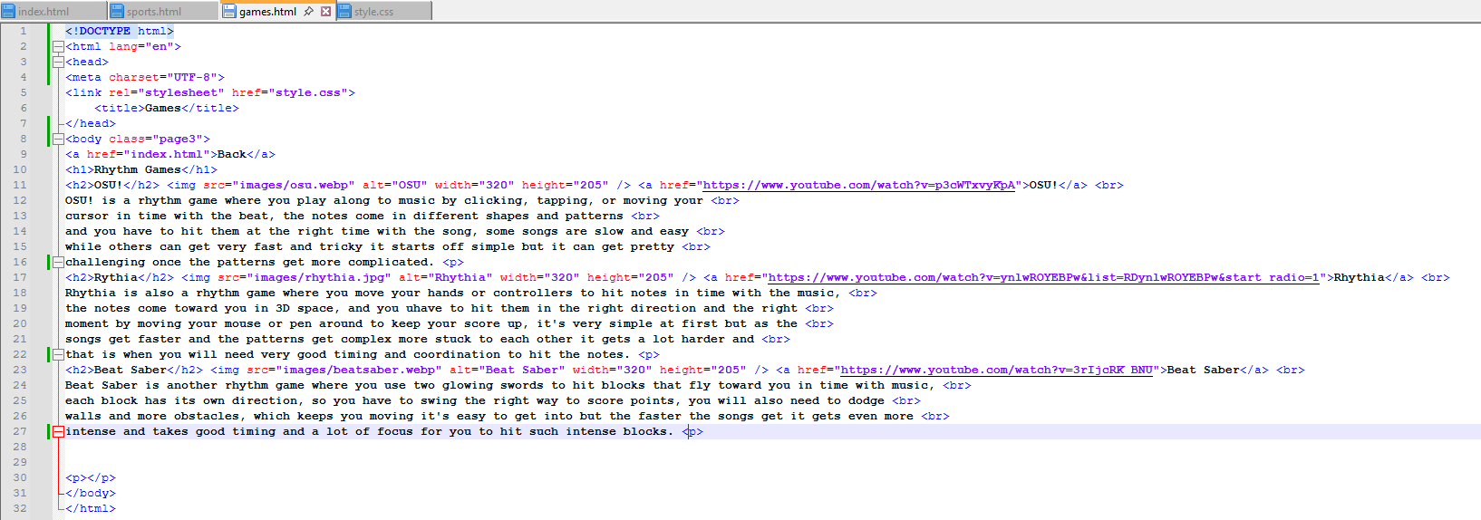
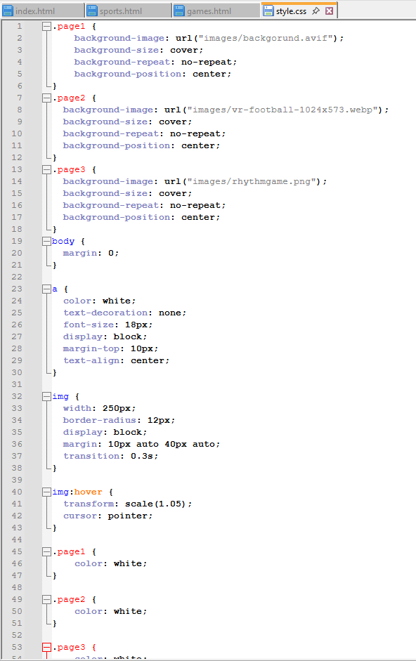
• Provide validation results (HTML & CSS).

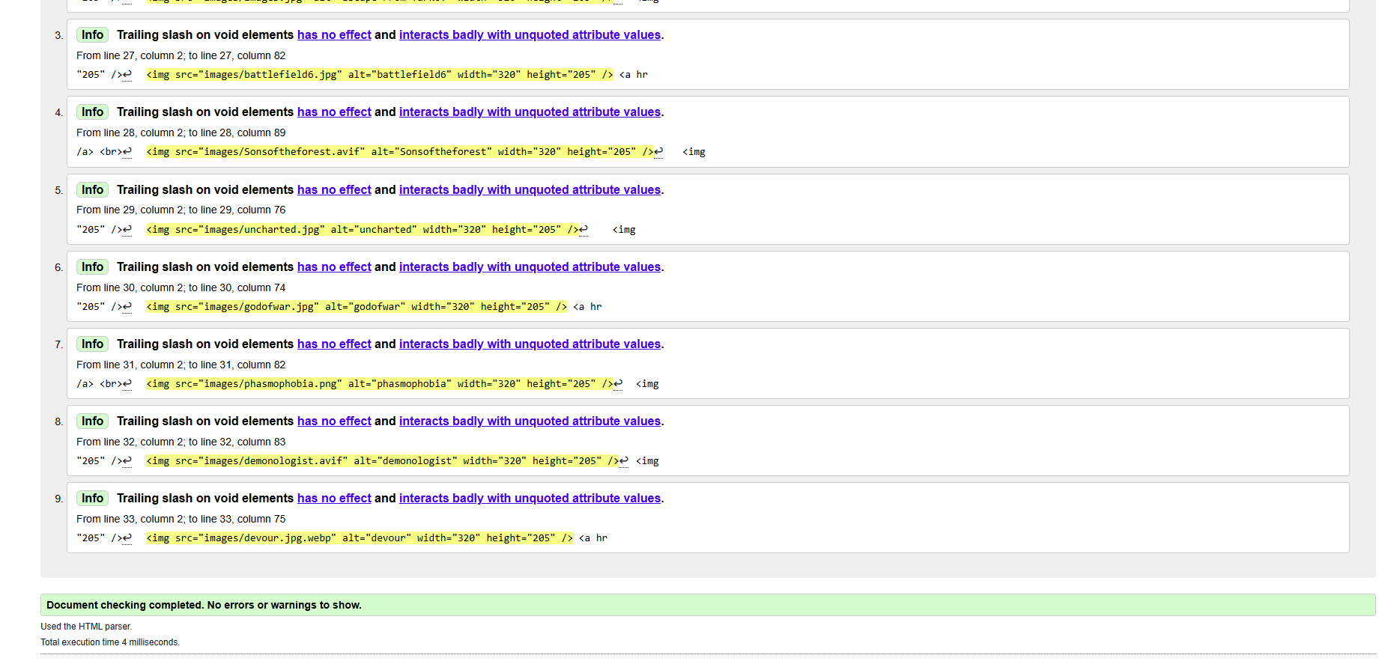
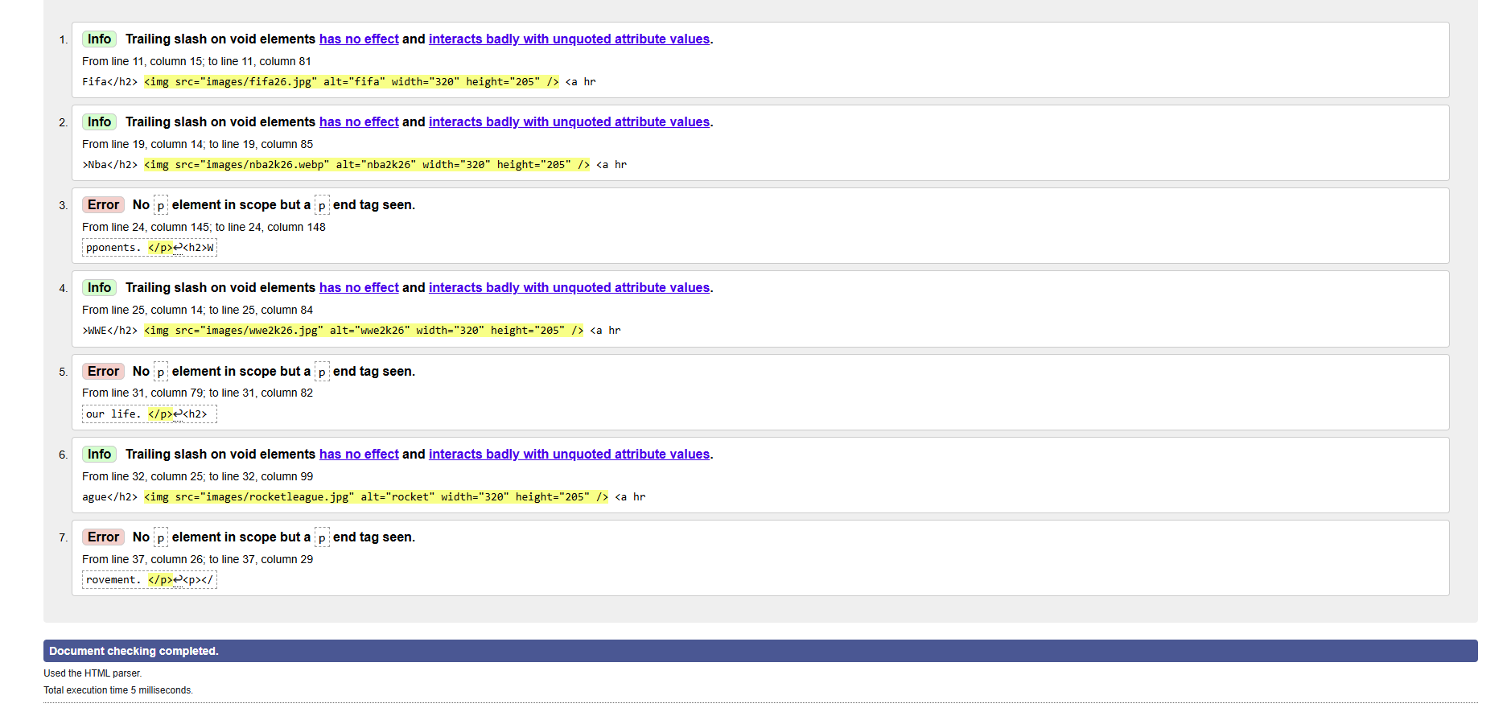
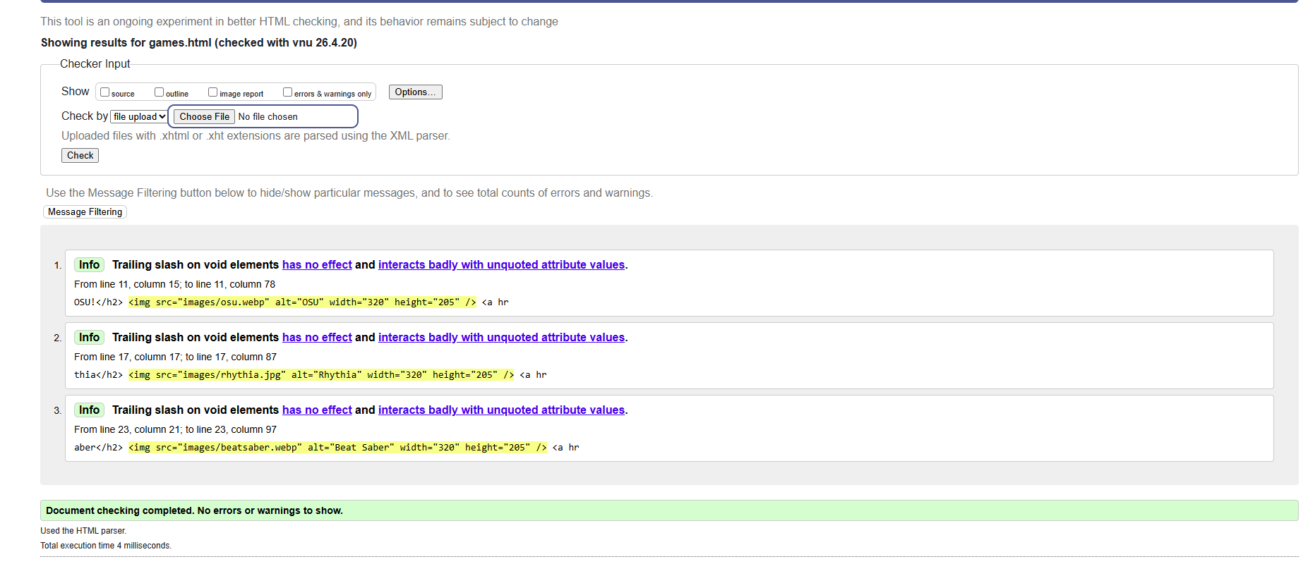
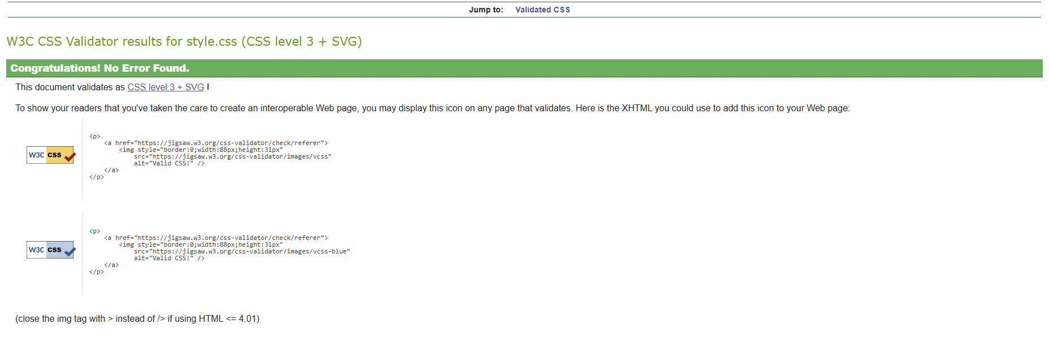

• Explain errors and fixes.
So with this validation there were 3 errors and I solved it by removing the slash inside the code, that is what was giving me the error.
No errors in these that I have submitted apart from the one I have already explained.

4. Evaluation
a) Research:
- Usability
Usability refers to a website's ease of use. A good website should be easy to use, easy to read, and provide fast information retrieval. Usability encompasses user happiness, efficiency, and simplicity of learning, according to Nielsen [1].

- Accessibility
Making a website useful for all users, including those with disabilities, is known as accessibility. The W3C's WCAG rules suggest features like keyboard navigation, high colour contrast, and alt text for images [2].

- SEO
SEO is the process of making a website better so that it ranks higher in search results [3]. This entails employing appropriate headings, meta tags, keywords, and making the website quick and mobile-friendly.
(Include academic sources)

b) Website Evaluation:
- Usability & Utility
Navigating and using the website is simple. It is easy for people to find information because of its straightforward style and consistent pages. The logical organisation of headings and menus enhances usability, so users get more familiar with it. The website is helpful because it offers pertinent content in a structured manner.
- SEO Techniques Used
To increase search exposure, the website employs fundamental SEO strategies. Among them are:
- Using headings (h1, h2) correctly
- Page titles that are descriptive

These characteristics make it easier for search engines to understand the webpage.

- Accessibility (WCAG 2.1)
To increase accessibility, the website goes to fundamental WCAG 2.1 principles. Among these are:
- Including alt text in pictures
- Using distinct headings as a framework
- For readability, use a strong colour contrast.
- Making sure the website supports keyboard navigation

These enhancements improve the website's usability for people with disabilities.

c) Website Comparison:
- Usability
The website is easy to use because of its simple layout and design. Information is available straight away since pages are organised. Even while usability is largely passable, more interactive features and easier-to-understand navigation menus could improve it.
- Accessibility
The website uses clear headings and alt text for images to comply with basic accessibility requirements. Better colour contrast and making sure every piece is completely adapted for screen readers in accordance with WCAG 2.1 rules it could make it better.
- SEO
Descriptive page titles, appropriate heading structure, and pertinent content are examples of basic SEO tactics. However, very much greater optimisation, better image optimisation, and the addition of meta descriptions could enhance SEO’.
- Mobile Friendliness
Although the website functions on mobile devices and is mostly responsive, some parts might not scale flawlessly on smaller displays. The mobile experience would be improved by utilising media and flexible layouts in responsive design.
- Conclusion
Overall I would say the website is useful and satisfies fundamental design standards for SEO, usability and accessibility. But there is still space for development particularly in mobile responsiveness.

5. Conclusion
So I came to a conclusion where I think I did well but there will surely be a lot of improvement as this was one of my first times creating a website using codes, this was a whole different kind of world for me, but with dedication and focus I feel like I can do better next time, so I think I deserve a 50/60% nothing too much and not too less.

6. References (IEEE Format)
[1] J. Nielsen, Usability Engineering. San Francisco, CA, USA: Morgan Kaufmann, 1994.
[2] World Wide Web Consortium (W3C), “Web Content Accessibility Guidelines (WCAG) 2.1,” 2018. [Online]. Available: https://www.w3.org/TR/WCAG21/
[3] E. Enge, S. Spencer, R. Fishkin, and J. Stricchiola, The Art of SEO. Sebastopol, CA, USA: O’Reilly Media, 2012.

7. Appendices
Include full HTML and CSS code listings.
HTML

<!DOCTYPE html>
<html lang="en">
<head>
<meta charset="UTF-8">
<link rel="stylesheet" href="style.css">
<title>g2f</title>
</head>
<body class="page1">
<header>
<h1>G2F GAMES</h1>
<nav>
<a href="index.html">Home</a>
<a href="Sports.html.">Sports</a>
<a href="games.html">Other games</a>
</nav>
</header>
<main>
<h2>Different kind of games</h2>
<p>In this website i will be showing you people some categorised games you might like.<br>
*shooting games<br>
*adventure/survival games<br>
*horror games<br>
And many more to show.</p>
<p>A FEW PREVIEWS OF SHOOTING/ADVENTURE AND HORROR GAMES</p>
<img src="images/COD7.webp" alt="Call Of Duty" width="320" height="205" />
<img src="images/images.jpg" alt="Escape From Tarkov" width="320" height="205" />
<img src="images/battlefield6.jpg" alt="battlefield6" width="320" height="205" /> <a href="https://www.youtube.com/watch?v=9txkGBj_trg">Trailer 1(COD)</a> <a href="https://www.youtube.com/watch?v=8R5t3a2jT4A">Trailer 2(TARKOV)</a> <a href="https://www.youtube.com/watch?v=tPJCvwRrYWo">Trailer 3(Battlefield6) </a> <br>
<img src="images/Sonsoftheforest.avif" alt="Sonsoftheforest" width="320" height="205" />
<img src="images/uncharted.jpg" alt="uncharted" width="320" height="205" />
<img src="images/godofwar.jpg" alt="godofwar" width="320" height="205" /> <a href="https://www.youtube.com/watch?v=A_E4eCwUEqg">Trailer 1(Sons of the Forest) </a> <a href="https://www.youtube.com/watch?v=hh5HV4iic1Y">Trailer 2(Uncharted) </a> <a href="https://www.youtube.com/watch?v=Dc5xOGS1oJ0">Trailer 3(GodOfWar) </a> <br>
<img src="images/phasmophobia.png" alt="phasmophobia" width="320" height="205" />
<img src="images/demonologist.avif" alt="demonologist" width="320" height="205" />
<img src="images/devour.jpg.webp" alt="devour" width="320" height="205" /> <a href="https://www.youtube.com/watch?v=sRa9oeo5KiY">Trailer 1(Phasmophobia) </a> <a href="https://www.youtube.com/watch?v=Kw2cWDclcY8">Trailer 2(Demonologist) </a> <a href="https://www.youtube.com/watch?v=Pbal0EFCzAA">Trailer 3(Devour) </a>
</main>
</body>
</html>

HTML
<!DOCTYPE html>
<html lang="en">
<head>
<meta charset="UTF-8">
<link rel="stylesheet" href="style.css">
<title>Favourite Sports Games</title>
</head>
<body class="page2">
<a href="index.html">Back</a>
<h1> Most played sports games</h1>
<h2>Fifa</h2> <img src="images/fifa26.jpg" alt="fifa" width="320" height="205" /> <a href="https://www.youtube.com/watch?v=TSi0iJYSQ24">FIFA26</a> <br>
FIFA is the biggest sports game if not also the most played sports game there is in the world, <br>
you might be asking yourself what's so good about this game but let me tell you there is a bunch <br>
of different modes you can play. Starting from Career mode as a player or as a coach you choose so yourself, there is also <br>
a mode called pro clubs where you create your team invite up to 11 friends to play in the same team against other people online, <br>
but that is not the most played mode, the one mode that is the most played is called ultimate team and that is where you start <br>
to build your own team from scratch from playing against other people online and by winning matches you gain xp, coins and packs, <br>
and by doing so you unlock new players when opening packs or when buying new players from the transfer market. <p>
<h2>Nba</h2> <img src="images/nba2k26.webp" alt="nba2k26" width="320" height="205" /> <a href="https://www.youtube.com/watch?v=Mh57YWNaQC4">NBA2K26</a> <br>
NBA is also pretty similar to FIFA but instead of playing with your feet you play with your hands(basketball) <br>
there is a mode where you create your own character and upgrade your character stats by winning against other people online,<br>
pretty similar you see? you can either play solos, duos trios or even full court(5v5), and what's funnier is there is also <br>
a mode on NBA that is called my team, very similar to FIFA'S ultimate team, you do the exact same thing, you win games you gain <br>
xp, coins and packs and it just goes on and on, and with that you take your team to a whole other level to compete with much better opponents. <p>
<h2>WWE</h2> <img src="images/wwe2k26.jpg" alt="wwe2k26" width="320" height="205" /> <a href="https://www.youtube.com/watch?v=oYd6rXOrz7E">WWE2K26</a> <br>
WWE is a very fun game where you fight each other with Wrestling characters and there is also a bunch of mode where you can <br>
choose from there is career mode, there is an online mode with more than 50 different modes too, starting with royal rumble <br>
meaning every 1 minute a new character goes in the ring and there is an option where you can choose if it goes up to 10,20 or 30 <br>
wrestlers, there is one called tag team so 2 wrestlers fight each other inside the ring whilst 2 other wrestlers stay outside the ring <br>
waiting to be taged in if needed, it is a very good game for people that like violence but not exagerated meaning not too sensitive, <br>
it is very much recommended to try out this game at least once in your life. <p>
<h2> Rocket League</h2> <img src="images/rocketleague.jpg" alt="rocket" width="320" height="205" /> <a href="https://www.youtube.com/watch?v=SgSX3gOrj60">ROCKET LEAGUE</a> <br>
Rocket League is a quick and very fun game that mixes football with cars, instead of people you control cars that can <br>
jump, boost and even fly to hit a big ball into the other team's net. The games are pretty short 5 minutes each <br>
but with every goal the time stops for a while and then it starts ticking again after the replay. <br>
the game is very very hard to get good at, you need to put in hours into the game to be able to make <br>
a very good improvement. <p>
<p></p>
</body>
</html>

HTML

<!DOCTYPE html>
<html lang="en">
<head>
<meta charset="UTF-8">
<link rel="stylesheet" href="style.css">
<title>Games</title>
</head>
<body class="page3">
<a href="index.html">Back</a>
<h1>Rhythm Games</h1>
<h2>OSU!</h2> <img src="images/osu.webp" alt="OSU" width="320" height="205" /> <a href="https://www.youtube.com/watch?v=p3cWTxvyKpA">OSU!</a> <br>
OSU! is a rhythm game where you play along to music by clicking, tapping, or moving your <br>
cursor in time with the beat, the notes come in different shapes and patterns <br>
and you have to hit them at the right time with the song, some songs are slow and easy <br>
while others can get very fast and tricky it starts off simple but it can get pretty <br>
challenging once the patterns get more complicated. <p>
<h2>Rythia</h2> <img src="images/rhythia.jpg" alt="Rhythia" width="320" height="205" /> <a href="https://www.youtube.com/watch?v=ynlwROYEBPw&list=RDynlwROYEBPw&start_radio=1">Rhythia</a> <br>
Rhythia is also a rhythm game where you move your hands or controllers to hit notes in time with the music, <br>
the notes come toward you in 3D space, and you uhave to hit them in the right direction and the right <br>
moment by moving your mouse or pen around to keep your score up, it's very simple at first but as the <br>
songs get faster and the patterns get complex more stuck to each other it gets a lot harder and <br>
that is when you will need very good timing and coordination to hit the notes. <p>
<h2>Beat Saber</h2> <img src="images/beatsaber.webp" alt="Beat Saber" width="320" height="205" /> <a href="https://www.youtube.com/watch?v=3rIjcRK_BNU">Beat Saber</a> <br>
Beat Saber is another rhythm game where you use two glowing swords to hit blocks that fly toward you in time with music, <br>
each block has its own direction, so you have to swing the right way to score points, you will also need to dodge <br>
walls and more obstacles, which keeps you moving it's easy to get into but the faster the songs get it gets even more <br>
intense and takes good timing and a lot of focus for you to hit such intense blocks. <p>

CSS
<p></p>
</body>
</html>

.page1 {
background-image: url("images/backgorund.avif");
background-size: cover;
background-repeat: no-repeat;
background-position: center;
}
.page2 {
background-image: url("images/vr-football-1024x573.webp");
background-size: cover;
background-repeat: no-repeat;
background-position: center;
}
.page3 {
background-image: url("images/rhythmgame.png");
background-size: cover;
background-repeat: no-repeat;
background-position: center;
}
body {
margin: 0;
}

a {
color: white;
text-decoration: none;
font-size: 18px;
display: block;
margin-top: 10px;
text-align: center;
}

img {
width: 250px;
border-radius: 12px;
display: block;
margin: 10px auto 40px auto;
transition: 0.3s;
}

img:hover {
transform: scale(1.05);
cursor: pointer;
}

.page1 {
color: white;
}

.page2 {
color: white;
}

.page3 {
color: white;
}

